
S
PHASE BEHAVIOUR STUDY ON MEDIUM-CHAIN TRIGLYCERIDE/ SURFACTANT/WATER SYSTEMS CONTAINING GEMCITABINE
USING PHASE INVERSION COMPOSITION TECHNIQUE

(Kajian Tingkah Laku Fasa Bagi Sistem Trigliserida Rantaian Sederhana/Surfaktan/Air yang Mengandungi Gemcitabine dengan Menggunakan Teknik Komposisi Penyongsangan Fasa)

Nadiatul Atiqah Wahgiman, Norazlinaliza Salim*, Mohd Basyaruddin Abdul Rahman

Integrated Chemical BioPhysics Research, Faculty of Science,
University Putra Malaysia, 43400 UPM Serdang, Selangor, Malaysia

*Corresponding author: azlinalizas@upm.edu.my

Received: 20 November 2019; Accepted: 21 April 2020; Published: 9 June 2020

Abstract
In this study, the phase behavior of medium-chain triglyceride (MCT)/surfactant/water containing gemcitabine (GEM) was investigated. Ternary phase diagrams (TPD) were constructed with different surfactants (Span 20, Span 60, Span 80, Tween 80) and a mixture of surfactant (Tween 80:Span 80, at ratio 1:1). Two observations were recorded, isotropic and multilayer regions. The isotropic region was classified as a transparent, translucent or homogeneous mixture, while the multilayer region was classified as an opaque, milky or heterogeneous mixture. From the ternary phase diagrams constructed, it showed that MCT/(Tween 80: Span 80, ratio 1:1)/ GEM in deionized water system gave the largest isotropic region with the minimum usage of mixed surfactant, where 25% area of the isotropic region was formed with 1% of the usage of surfactant. The composition of F1 (selection based on the ternary phase diagram) was 0.02 % w/w of GEM, 19.98 % w/w of deionized water, 5.00 % w/w of Tween 80:Span 80 at ratio 1:1 and 75 % w/w of MCT. Nanoemulsion formulation was prepared by low energy emulsification method (i.e. phase inversion composition (PIC) technique). As the formulation was prepared in large scale with PIC technique, sodium chloride solution (0.1 M NaCl solution) was added to form a stable formulation as stabilizer. Effect of different volume of NaCl solution (0.5, 1.0 and 1.5 mL) added into formulation was investigated. The results showed that the particle size increased as the amount of NaCl increased, the effect of the amount of NaCl solution is significant towards particles size on F1. The F1 was stable in normal storage condition as it remained a homogeneous formulation against centrifugation test and it was also stable in storage stability test at different temperature (4, 25 and 45 °C) within three months.

Keywords: gemcitabine, nanoemulsion, ternary phase diagram

Abstrak
Dalam kajian ini, sifat fasa pada trigliserida rantaian sederhana (MCT)/surfaktan/air yang mengandungi GEM telah dikaji. Gambar rajah fasa ternari (TPD) telah dibina dengan surfaktan yang berbeza (Span 20, Span 60, Span 80, Tween 80) dan campuran surfaktan (Tween 80:Span 80, pada nisbah 1:1). Dua pemerhatian telah direkodkan, rantau isotropik dan pelbagai lapis. Rantau isotropik telah diklasifikasikan sebagai telus, lut atau campuran homogen, manakala rantau pelbagai lapisan telah diklasifikasikan sebagai legap, seperti susu atau campuran heterogen. Daripada gambar rajah fasa ternari yang telah dibina, ianya menunjukkan yang sistem MCT/(Tween 80: Span 80, pada nisbah 1:1)/ GEM dalam air ternyahion telah memberi rantau
isotropik yang paling tinggi dengan penggunaan campuran surfaktan yang minimum, di mana 25% keluasan rantau isotropik telah terhasil dengan 1% penggunaan surfaktan. Komposisi F1 (pilihan berdasarkan pada gambar rajah fasa ternari) ialah 0.02% w/w daripada GEM, 19.98% w/w daripada air ternyahion, 5.00% w/w daripada Tween 80:Span 80, pada nisbah 1:1 dan 75% w/w daripada MCT. Formulasi nanoemulsi telah dihasilkan dengan pengemulsi yang rendah tenaga (fasa penyongsangan (PIC). Formulasi yang dihasilkan dalam skala yang besar dengan teknik PIC, natrium klorida (0.1M larutan NaCl) telah ditambah untuk menghasilkan formulasi yang stabil sebagai penstabil. Kesan tiga isipadu larutan NaCl yang berbeza (0.5, 1.0 dan 1.5 mL) telah ditambah dalam formulasi dan dikaji. Keputusan menunjukkan peningkatan saiz zarah apabila jumlah NaCl meningkat, jumlah larutan NaCl memberi kesan yang signifikan terhadap saiz zarah F1. F1 adalah stabil di dalam penyimpanan keadaan biasa apabila ianya kekal homogen ketika diuji dengan ujian emparan dan stabil dalam ujian penyimpanan kestabilan pada suhu yang berbeza (4, 25 dan 45 °C) selama 3 bulan.

Kata kunci: gemcitabine, nanoemulsi, gambar rajah fasa ternari

Introduction
Gemcitabine (GEM) is an anti-metabolite drug which consists of two fluorine atoms substituted at 2’ position of ribose ring [1, 2]. It is a hydrophilic drug due to the existence of a polar group (Fluorine, OH-group and NH₂ group) in the compound [3]. The high dosage was needed to achieve a therapeutic concentration in vivo, as it was hard to transport into the cancer cell by cross plasma membrane passively [4, 5]. The behavior of GEM in MCT/surfactant/water system was studied by constructing ternary phase diagram.

The ternary phase diagram is a mixture of surfactant-water-oil in various compositions and forms a variety of complex phases [6]. The observations of the ternary phase diagram were visualized by naked eyes and had several classifications such as microemulsions, liquid crystal, emulsion, emollient gel or cream and bi-continues phase [7]. For this study, the observation of the ternary phase diagram was categorized in two regions (isotropic region, Li and multilayer region, M). The isotropic region was identified by their transparent appearance [8] and this region has a high probability of forming nanoemulsion [6, 9].

Nanoemulsion is a colloidal system with high kinetic stability, low viscosity, optical transparency, and range particle size of 20 nm to 200 nm [10, 11] This colloidal system can solubilize hydrophilic and lipophilic drug either in their aqueous phase or oil phase [12]. From previous studies, nanoemulsion has provided a high drug loading such as 5 mg/mL of budesonide and 0.05% of quercetin in nanoemulsion [13, 14]. In this study, the composition of nanoemulsion containing GEM was determined from the ternary phase diagrams. Then nanoemulsion was formulated by the low energy emulsification method namely Phase Inversion Composition (PIC) and the findings was characterized.

Materials and Methods
Materials
Gemcitabine (GEM, purity >90%) was purchased from Sigma-Aldrich (USA). Polysorbate 80 (Tween 80), sorbitan mono-laurate 80 (Span 80) and sodium chloride (NaCl, purity 99.5%) were purchased from Merck (USA). Methanol (95%) and acetonitrile (HPLC grade, 99%) were purchased from J.T. Baker Chemical (USA). Isopropyl myristic (IPM) was purchased from Ak Scientific (USA). Medium-chain triglyceride (MCT) was purchased from Gattefosse Sas (France). The deionized water (DI water, 18.3 MΩcm, Millipore) was prepared using Milli-Q filtration system, EMD Millipore (Billerica, MA, USA).

Solubility of GEM
The solubility of GEM in deionized water, MCT and IPM were performed. The excess of GEM (10 mg) was dissolved in deionized water (0.5 mL) and centrifugated at 4000 rpm for 10 minutes. Then, the aqueous layer was injected to reserve phase high-performance liquid chromatography (RP-HPLC, Waters 1525, Waters Corporation, USA) which was equipped with a Phenomenex Luna C₁₈ column (5µm, 250 x 4.6 mm, Phenomenex, USA) and UV-Vis detector (Waters 2489, Waters Corporation, USA) to measure the absorbance of GEM at a retention time of 3.5 minutes and wavelength of 269 nm. Then, the quantitative value of GEM dissolved in deionized
water was determined based on the standard curve of known GEM with concentration range of 20 to 1000 µg/mL (R² = 0.9995). The mobile phase used for HPLC measurement were deionized water and acetonitrile (DI: ACN, 90:10) with a flow rate of 1 mL/min and ambient temperature.

The solubility of GEM in MCT was performed used stirring, heating and centrifugation method [15]. GEM (1 mg) was added in MCT (50 mL), stirred (10 minutes) and heating while stirring (10 minutes, 40 °C). The mixture was then centrifuged at 4000 rpm for 15 minutes and observed by naked eyes. These methods were repeated using different mass of GEM until GEM did not dissolve. Then, these methods were repeated by replacing MCT with IPM.

The selection ratio of MCT: IPM
MCT and IPM were mixed (at ratio 1:1, total volume 1 mL) and sonicated for 2 mins. GEM (0.9 mg) was added to the mixture. The mixture was sonicated (2 minutes) and stirred while heating (30 minutes, 40 °C). The mixture was then centrifuged at 4000 rpm for 15 minutes and observed as if there were any precipitation and change of color by naked eyes [33]. These methods were repeated using different ratio of MCT: IPM (9:1, 8:2 and 7:3).

Construction ternary phase diagram
GEM (0.015 g) was dissolved in 14.985 g of deionized water. The Span 20 (with HLB value 8.60 respectively) and GEM mixture (dissolved in deionized water) (0.1 %, w/w) were weighed at various ratios ranging from 0:100 to 100:0. The mixture with a total weight of 0.500 g was placed into a 10 mL screw-cap glass tube (total of 11 tubes) and was vortexed using a vortex mixer (VM-300, Gemmy Industrial CORP-Taiwan). The mixture was centrifuged at 4000 rpm using a Hettich centrifuge (Model EBA, Germany) for 15 minutes at room temperature. Medium-chain triglyceride (MCT) was then added into the eleven test tubes separately and were vortexed to homogenize. The samples were centrifuged at 4000 rpm for 15 minutes and then physically observed by the naked eyes to determine the physical phase appearance [16]. The transparent or translucent appearance sample was considered as isotropic region, Li, while milky until separation layers formed was considered as multilayer region, M. The steps were repeated with the addition of 10, 20, 30, 40 until 90% w/w of MCT.

These methods were repeated by replacing surfactants (Span 60, Span 80, Tween 80 with HLB values 4.70, 4.30 and 15.00 respectively) and the mixed surfactant (Tween 80: Span 80, at ratio 1:1 with the HLB values were 9.65 respectively). Tween 80 and Span 80 were mixed well before the construction of ternary phase diagram.

Preparation of nanoemulsion containing gemcitabine
The low energy emulsification techniques were used to prepare nanoemulsion. GEM (0.002 g) was dissolved in deionized water (1.998 g) and 0.1 M NaCl solution (0.5 mL). The mixture was mixed with a mixed surfactant (Tween 80 and Span 80) at room temperature to form an aqueous phase. The oil phase was prepared by mixed MCT and IPM at a ratio of 9:1. Both phases were sonicated for 3 min at a medium level of sonification. The oil phase was added dropwise into a beaker containing an aqueous phase. The mixture was then homogenized at 391 rpm for 3 hours using an overhead stirrer (IKA@ RW 20 Digital, Nara, Japan). The mixture was then stirred by a magnetic stirrer for 1 hour while heated at 40 °C for 5 minutes, and this sample was labelled as F1a. These methods were repeated by replacing the volume of 0.1% NaCl solution (1.0 mL, 1.5 mL) and labelled as F1b and Flc.

Particle size and polydispersity index measurement
Zetasizer Nano ZS (Malvern Instrument Ltd., UK) was used to measure the particle size and polydispersity index (PDI) of the nanoemulsion at a temperature of 25 °C. A dynamic light scattering technique with the scattering angle of 173° was performed for measurement. The samples were diluted with MCT (1:500) and inserted into the sample cell. The intensity distribution was used for the measurement of the mean average (z-average) particle size. The measurement was repeated in triplicate.

Zeta potential measurement
Zetasizer Nano ZS (Malvern Instrument Ltd., UK) was used to measure the zeta potential of the nanoemulsion at a temperature of 25 °C. The calculation of their zeta potential was based on their electrophoretic mobility of dispersed particles in a charged field. The samples were diluted with MCT (1:500). The zeta potential with values higher than + 30.00 mV or lower than ­ 30.00 mV improved the stability of nanoemulsion [17].

Stability study
Centrifugation test was used to predict the shelf life under normal storage condition [18], it was performed by centrifuging the fresh sample at 4000 rpm for 15 minutes, and any physical changes were observed. Besides, the storage stability to observe the physical appearance of samples was done at three different temperature (4, 25 and 45 °C) within three months.

Results and Discussion

The solubility of GEM and the selected ratio of MCT: IPM
The maximum GEM dissolved in deionized water was 10.09 mg/mL, which is slightly higher from reported value [19]. GEM did not dissolve in MCT, this is because GEM is a hydrophilic compound which consists of fluorine, OH-group and NH₂ group [3, 20]. GEM was dissolved at 0.20 mg/mL in IPM. Figure 1 shows the mixtures of MCT and IPM at ratio 1:1, 9:1 and 8:2 were performed where IPM acted as co-surfactant to dissolve GEM in MCT. Based on the result, ration 1:1, 9:1 and 8:2 were clear while 7:3 was cloudy and MCT:IPM with ratio 9:1 was selected to be used for constructing TPD. This is because it showed a clear mixture with less amount of IPM. The less amount of IPM used could decrease to the probability of irritation or allergy [21, 22]. Based on the solubility of GEM in deionized water, MCT and IPM, the amount of GEM used to construct TPD was 0.10 mg/mL of deionized water.

Phase behavior of MCT/surfactants/water system
Ternary phase diagrams were constructed based on different surfactant systems (Span 20, Span 60, Span 80 and Tween 80 and mixture surfactant (Tween 80: Span 80, 1:1) which were represented with different hydrophilic-lipophilic balance (HLB) values (8.60,4.70,4.30, 15.00 and 9.65 respectively).

Figure 2 indicates different surfactant system gives a different percentage area of isotropic regions. Span 20 formed 6% area of the isotropic region with 65% of the lowest usage of surfactant. Span 60 formed 2% area of the isotropic region with 72% of the lowest usage of surfactant. Span 80 formed 5% area of the isotropic region with 38% of the lowest usage of surfactant. Tween 80 formed 34% area of the isotropic region with 45% of the lowest usage of surfactant. While at ratio 1:1 of Tween 80: Span 80, 25% area of the isotropic region was formed with 1% of the lowest usage of surfactant. As HLB value of Span 20 is higher than Span 60, the isotropic region of Span 20 was higher than Span 60. This is due to their lipophilicity, as higher lipophilicity, they attribute to dissolve in oil (MCT) and vice versa. While for Tween 80, it had the highest isotropic region and dissolved in of GEM: water. This is due to having higher hydrophilicity, so it tends to dissolve in GEM: water. Ternary phase diagram of Tween 80: Span 80 at ratio 1:1 (Figure 2e) had the highest isotropic region among all of the samples with the lowest usage of surfactant to form it. This is due to the HLB of Tween 80: Span 80 at ratio 1:1 has higher lipophilicity compared to Span 20, Span 60 and Span 80, but lower hydrophilicity compared to Tween 80.

A point (F1) from ternary phase diagram of Tween 80: Span 80 at ratio 1:1 (Figure 2E) was selected for preparation and future studies as it is the highest amount of percentage area of isotropic region (25%) with the lowest amount of surfactant (1%). The F1 composition was used as it is in the isotropic region, which tends to obtain emulsion with nanoparticles size [6]. The higher use of surfactant could cause toxicity towards normal cell [23, 24]. Thus, lower amount of surfactant was used to prepare the nanoemulsions.

Physicochemical characterization of nanoemulsions
The composition of F1 shows separation as it was formulated in large scale (in double amount compared to during TPD studies). Thus, it was modified by adding 0.1 M NaCl solution as shown in Table 1. The reason of NaCl usage in large formulation scale is because it stabilizes the formulation as electrolytes decrease the attraction forces between the water droplets and the dielectric constant of aqueous phase which leads to a reduction of the collision frequency [25, 26]. The formulations show non separation condition after 0.1 M NaCl solution was added. The effect of different amount of NaCl solution (0.5 mL, 1.0 mL, 1.5 mL) towards particle size was investigated by adding different amount of NaCl during formulation.

The results show the particle size increased when the amount of NaCl increased as shown in Table 1. These might be due to the increment in the amount of electrolyte, the increment of the refractive index of the water phase leading to the increment of particles size, as well as decreasing the refractive index difference between oil and water phases and dielectric constant of the aqueous phase [27, 28]. Besides, the addition of NaCl into the aqueous phase decreased the attractive force between water droplets [29, 30], in turn causing particle size increment.

The particles size of nanoemulsions, F1a (137.77 ± 3.82), F1b (180.53 ± 1.76) and F1c (426.37 ± 5.40) were measured, F1a and F1b were considered as nanoemulsion as they were below 200 nm. The polydispersity index shows F1a and F1b nanoemulsions were monodisperse system as the values were less than 0.2. Based on Table 1, the zeta potential of F1a (- 36.40 mV), F1b (- 54.00 mV) and F1c (-37.80 mV) show stable nanoemulsions [16,31]. The negative value of zeta potential of samples is due to the presence of fatty acids and esters in the oil [32].

Stability analysis
The nanoemulsions had undergone centrifugation test for stability analysis to determine whether the nanoemulsion was stable under normal storage condition. The fresh nanoemulsions remained homogenous with no separation after being centrifuged at 4000 rpm for 15 minutes. The centrifugation is also known as accelerated ageing stability test where the nanoemulsions are subjected to gravitational stress and resistance as if there is any formation of cream or emulsion phase separation [34, 35]. The frequent collision between particles increases by centrifugal, which causes the decrease of colloidal stability [36]. As the nanoemulsion remained stable in centrifugation test which is the similar reported result of literature [3] for their accelerated stability analysis, it indicates the nanoemulsion is stable at the normal condition for up to 6 months [35].While for the storage stability test, it was done to determine their long-term stability by observing if there were any phase separation, sedimentation, flocculation, coalescence or creaming during storage [37]. Based on the results, the nanoemulsions mixture remained homogenous which indicates its stability for one day to 90 days against the temperature of 4, 25 and 45 °C, up to 3 months which are similar with the results reported [37] regarding their storage stability. Table 2 shows the observation of stability against centrifugation test and stability storage against different temperature (4, 25 and 45 °C).

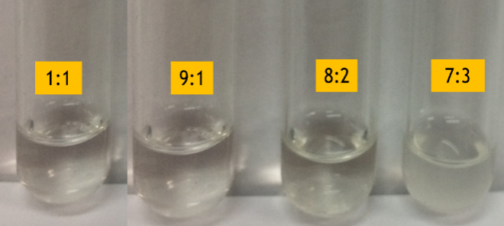
Figure 1. The physical appearance of the mixture ratio of MCT: IPM

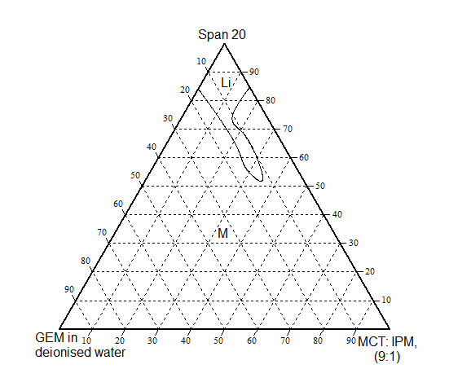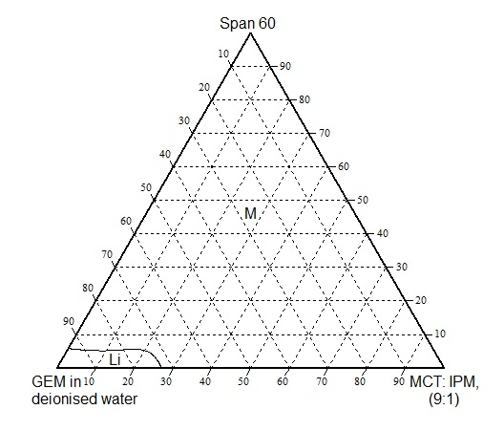
(a) (b)

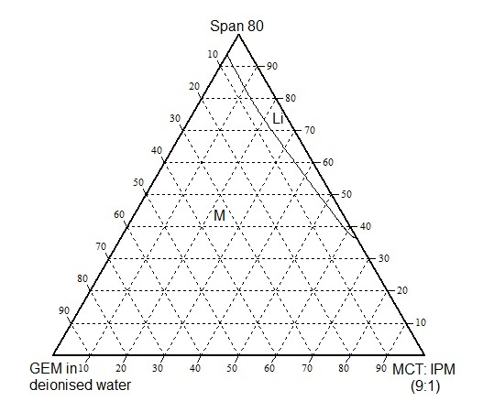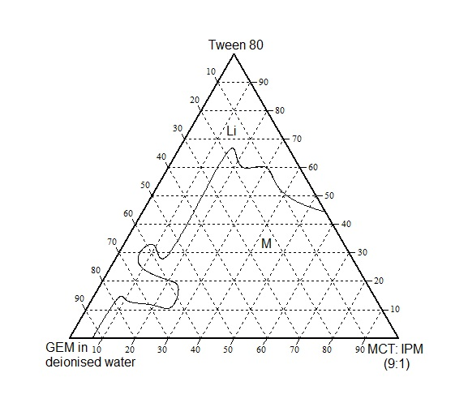
(c) (d)
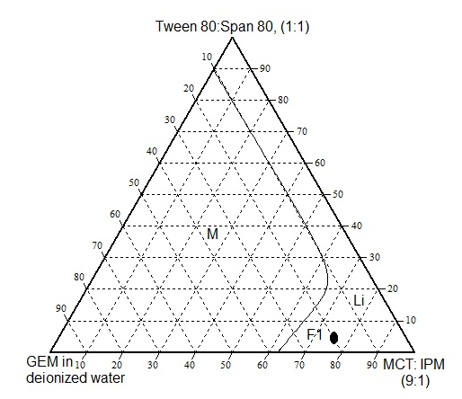
(e)
Figure 2. The ternary phase diagrams of MCT/surfactant/water systems at different surfactant and mixed surfactant (a) Span 20 (b) Span 60 (c) Span 80 (d) Tween 80 (e) T80: S80 at ratio 1:1 where, Li = Isotropic region and M = Multilayer region.

Table 1. Composition and characterization of nanoemulsions
Sample Name | Deionized Water,  (%) | GEM,  (%) | Tween 80:  Span 80,  (1:1, %) | NaCl Solution, (mL) | MCT: IPM  (9:1, %) | Size,  (nm) | PDI | Zeta Potential, (mV)
F1a | 19.98 | 0.02 | 5.0 | 0.5 | 75.0 | 137.77 ± 3.82 | 0.12 | -36.40
F1b | 19.98 | 0.02 | 5.0 | 1.0 | 75.0 | 180.53 ± 1.76 | 0.42 | -54.00
F1c | 19.98 | 0.02 | 5.0 | 1.5 | 75.0 | 426.37± 5.40 | 0.31 | -37.80

Table 2. Physical stability of nanoemulsions
Temperature  (°C) | Stability storage (days)
Temperature  (°C) | F1a |  |  |  |  |  | F1b |  |  |  |  |  | F1c
 | 1 | 7 | 21 | 30 | 60 | 90 | 1 | 7 | 21 | 30 | 60 | 90 | 1 | 7 | 21 | 30 | 60 | 90
4 | √ | √ | √ | √ | √ | √ | √ | √ | √ | √ | √ | √ | √ | √ | √ | √ | √ | √
25 | √ | √ | √ | √ | √ | √ | √ | √ | √ | √ | √ | √ | √ | √ | √ | √ | √ | √
45 | √ | √ | √ | √ | √ | √ | √ | √ | √ | √ | √ | √ | √ | √ | √ | √ | √ | √
Centrifugation test
 | √ |  |  |  |  |  | √ |  |  |  |  |  | √

Conclusion
The ternary phase diagrams showed that the formation of the isotropic liquid region depended on the hydrophilicity and lipophilicity of surfactant. As higher lipophilicity, they attribute to dissolve in oil (MCT) and higher hydrophilicity attribute to dissolve in aqueous solution. The presence of NaCl as an electrolyte also leads to better stability and increases the particles size. Thus, future research on cytotoxicity study, in-vitro and in-vivo study to determine cytotoxicity level towards healthy and abnormal cell and also the efficiency of GEM released to the required area should be conducted. Besides, the research towards various applications such as tropical, oral, injection or aerosol administration should be performed in order to be used in medical industry.

Acknowledgement
The financial assistance provided by Graduate Research Fellowship (GRF) for Wahgiman N. A. by Universiti Putra Malaysia, and LRGS NanoMITe grant from the Ministry of Higher Education, Malaysia (RU029-2014/5526306) was gratefully acknowledged.

References
- Hayashi, H., Kurata, T. and Nakagawa, K. (2011). Gemcitabine: Efficacy in the treatment of advanced stage nonsquamous non-small cell lung cancer. Clinical Medicine Insights: Oncology, 5: 177-184.
- Alvarellos, M. L., Lamba, J., Sangkuhl, K., Thorn, C. F., Wang, L., Klein, D. J., and Klein T. E. (2014). PharmGKB summary. Pharmacogenetics and Genomics, 24(11): 564-574.
- Toschi, L., and Cappuzzo, F. (2009). Gemcitabine for the treatment of advanced non-small cell lung cancer. OncoTargets and Therapy, 2: 209-217.
- Wang, J., Zhang, X., Cen, Y., Lin, X., and Wu, Q. (2016). Biointerfaces antitumor gemcitabine conjugated micelles from amphiphilic comb-like random copolymers. Colloids and Surfaces B. 146: 707-715.
- Parsian, M., Unsoy, G., Mutlu, P., Yalcin, S., and Tezcaner, A. (2016). Loading of gemcitabine on chitosan magnetic nanoparticles increases the anti-cancer efficacy of the drug. European Journal of Pharmacology, 784: 121-128.
- Salim, N., Basri, M., Abdullah, D. K., and Basri, H. (2011). Phase behaviour, formation and characterization of palm-based esters nanoemulsion formulation containing ibuprofen. Journal of Nanomedicine and Nanotechnology, 2(4): 1-4.
- Mahdi, E. and Sakeena, M. (2011). Effect of surfactant and surfactant blends on pseudoternary phase diagram behavior of newly synthesized palm kernel oil esters. Drug Design, Development and Therapy, 5:311-323.
- Izquierdo, P., Esquena, J., Tadros, T. F., Dederen, J. C., Feng, J., Garcia-Celma, M. J. and Solans, C. (2004). Phase behavior and nano-emulsion formation by the phase inversion temperature method. Langmuir, 20(16): 6594-6598.
- Jaiswal, M., Dudhe, R. and Sharma, P. K. (2015). Nanoemulsion: an advanced mode of drug delivery system. 3 Biotechnology, 5(2):123-127.
- Silva, H. D., Cerqueira, M. A., and Vicente, A. A. (2015). Influence of surfactant and processing conditions in the stability of oil-in-water nanoemulsions. Journal of Food Engineering, 167: 89-98.
- Puglia, C., Rizza, L., Drechsler, M., and Bonina, F. (2010). Nanoemulsions as vehicles for topical administration of glycyrrhetic acid: Characterization and in vitro and in vivo evaluation. Drug Delivery, 17(3): 123-129.
- Koroleva, M. Y., Nagovitsina, T. Y., Bidanov, D. A., and Gorbachevski, O. S. (2016). Nano- and microcapsules as drug-delivery systems. Resource-Efficient Technologies, 2(4):233-239.
- Arbain N. H., Salim N., Masoumi H. R. F, Wong T.W., Basri M., and Rahman M. B. A. (2018). In vitro evaluation of the inhalable quercetin loaded nanoemulsion for pulmonary delivery. Drug Delivery and Translational Research, 67: 497-507.
- Amani, A., York, P., Chrystyn, H., and Clark B. J. (2010). Evaluation of a nanoemulsion-based formulation for respiratory delivery of budesonide by nebulizers. American Pharmaceutical Scientists PharmSciTech, 11(3):1147-1151.

- Samiun, W. S., Ashari, S. E., Salim, N. and Ahmad, S. (2020). Optimization of processing parameters of nanoemulsion containing aripiprazole using response surface methodology. International Journal of Nanomedicine. 15: 1585-1594.
- Asmawi, A. A., Salim, N., Ngan, C. L., Ahmad, H., Malek, E. A., Mas, J. M. and Rahman, A. M. B. (2018). Excipient selection and aerodynamic characterisation of nebulised lipid-based nanoemulsion loaded with docetaxel for lung cancer treatment. Drug Delivery and Translational Research, 9(2):543-554.
- Ribeiro, R. C., Barreto, S. M., Ostrosky, E. A., Da Rocho-Filho, P. A., Verissimo, L. M. and Ferrari, M. (2015). Production and characterisation of cosmetic nanoemulsions containing Opuntia ficusindica (L.) mill extract as moisturizing agent. Molecules, 20(2): 2492-2509.
- Hadzir, N. M., Basri M., Rahman, M. B. A., Salleh, A. B., Rahman, R. N. Z. R. A., and Basri H. (2013). Phase behaviour and formation of fatty acid esters nanoemulsions containing piroxicam. AAPS PharmSciTech, 4:456-63.
- Yılmaz, B., Kadıoğlu, Y. and Aksoy, Y. (2003). Simultaneous determination of gemcitabine and its metabolite in human plasma by high-performance liquid chromatography. Journal of Chromatography B, 791(1): 103-109.
- Xu, H., Paxton, J., Lim, J., Li, Y., and Wu, Z. (2014). Development of a gradient high-performance liquid chromatography assay for simultaneous analysis of hydrophilic gemcitabine and lipophilic curcumin using a central composite design and its application in liposome development. Journal of Pharmaceutical and Biomedical Analysis, 98: 371-378.
- Zidan, A. S., Kamal, N., Alayoubi, A., Seggel, M., Ibrahim, S., Cruz, C., and Ashraf, M. (2017). Effect of isopropyl myristate on transdermal permeation of testosterone from carbopol gel. Journal of Pharmaceutical Sciences, 106(7): 1805-1813.

- Oliveira, J. S. L., Lange, S., Dobner, B., and Brezesinski, G. (2017). The effect of non-deuterated and deuterated isopropyl myristate on the thermodynamical and structural behavior of a 2D stratum corneum model with ceramide. Chemistry and Physics of Lipids, 204: 1-9.
- Hwang, T. L, Fang, C. L, Chen, C. H, and Fang, J. Y. (2009). Permeation enhancer containing water-in-oil nanoemulsions as carriers for intravesical cisplatin delivery. Pharmaceutical Research, 26(10): 2314-2323.
- Prajapati, H. N., Dalrymple, D. M., Serajuddin, A. T. M., Agu, R. U., Ugwoke, M. I., Armand, M., and Mehta, S. K. (2016). Formulation and physiochemical study of a-tocopherol based oil in water nanoemulsion stabilised with non-toxic, biodegradable surfactant: Sodium stearoyl lactate. Ultrasonics Sonochemistry, 29(1): 285-305.
- Frasch-Melnik, S., Spyropoulos, F., and Norton, I. T. (2010). W1/O/W2 double emulsions stabilised by fat crystals: Formulation, stability and salt release. Journal of Colloid and Interface Science. 350(1): 178-185.
- Matos, M., Gutierres. G., Coca, and J., Pazos, C. (2014). Preparation of water-in-oil-water (W/O/W) double emulsions containing trans-resveratrol. Colloids and Surfaces A: Physicochemical and Engineering Aspects, (442):69-79.
- Park, C. I., Cho, W., and Lee, S. J. (2003). Emulsion stability of cosmetic creams based on water-in-oil high internal phase emulsions Emulsion stability of cosmetic creams based on water-in-oil high internal phase emulsions. Korea-Australia Rheology Journal, 15(3): 125-130.
- Paunivic, M. and Schlesinger, M. (2006). Fundamentals of deposition (second edition). New Jersey: John Wiley & Sons, Inc.
- Márquez, A. L., Medrano, A., Panizzolo, L. A. and Wagner, J. R. (2010). Effect of calcium salts and surfactant concentration on the stability of water-in-oil (w/o) emulsions prepared with polyglycerol polyricinoleate. Journal of Colloid and Interface Science, 341(1): 101-108.

- Wahgiman, N. A., Salim, N., Abdul Rahman, M. B. and Ashari, S. E. (2019). Optimization of nanoemulsion containing gemcitabine and evaluation of its cytotoxicity towards human fetal lung fibroblast (MRC5) and human lung carcinoma (A549) cells. International Journal of Nanomedicine, 14: 7323-7338.
- Sulaiman, I. S. C., Basri, M., Fard Masoumi, H. R., Ashari, S. E., Basri, H., and Ismail, M. (2017). Predicting the optimum compositions of a transdermal nanoemulsion system containing an extract of Clinacanthus nutans leaves (L.) for skin antiaging by artificial neural network model. Journal of Chemometrics, 31(7): 1-13.
- Shakeel, F., Haq, N., Al-dhfyan, A., Alanazi, F. K. and Alsarra, I. A. (2014). Double w/o/w nanoemulsion of 5- fluorouracil for self-nanoemulsifying drug delivery system. Journal of Molecular Liquids, 200: 183-190.
- Azhar, S. N. A. S., Ashari, S. E., and Salim, N. (2018). Development of a kojic monooleate-enriched oil-in-water nanoemulsion as a potential carrier for hyperpigmentation treatment. International Journal of Nanomedicine, 13: 6465-6479.
- Xavier-Júnior, F. H., Silva, K. G. H., Farias, I. E. G., Morais, A. R. V. and Alencar, E. N. (2012). Prospective study for the development of emulsion systems containing natural oil products. Journal Drug Delivery and Science Technology, 22(4): 367-372.
- Latreille, B., and Paquin, P. (1990). Evaluation of emulsion stability by centrifugation conductivity measurements. Journal of Food Science, 55(6): 1666-1669. Izadiyan, Z., Basri, M., Fard Masoumi, H. R., Abedi Karjiban, R., Salim, N. and Shameli, K. (2017). Modeling and optimization of nanoemulsion containing Sorafenib for cancer treatment by response surface methodology. Chemistry Central Journal, 11(1): 21.
- Ramli, S., Zainuddin, N., Mohamad, S., and Rahman, I. A. (2017). Nanoemulsion based palm olein as vitamin E carrier. Malaysian Journal of Analytical Sciences, 12(6): 1399-1408.

