

STUDY OF CONDUCTIVITY AND THERMAL PROPERTIES OF POLYANILINE DOPED WITH p-TOLUENE SULFONIC ACID

(Kajian Pengaliran Elektrik dan Haba terhadap Polianilina di-Dopkan dengan Asid p-Toluena Sulfonik)

Muhammad Faiz Aizamddin¹, Nazreen Che Roslan¹, Muhammad Asyrap Kamarudin¹, Siti Nurzatul Ikma Omar¹, Muhd Fauzi Safian², Mohamed Izzharif Abdul Halim², Mohd Muzamir Mahat¹*

1School of Physics and Materials Studies, Faculty of Applied Sciences
2School of Chemistry and Environmental Studies, Faculty of Applied Sciences Universiti Teknologi MARA, 40450 Shah Alam, Selangor, Malaysia

*Corresponding author: mmuzamir@uitm.edu.my

Received: 20 November 2019; Accepted: 31 March 2020; Published: June 2020

Abstract
In this study, polyaniline (PANI) was prepared by oxidative polymerization method with aniline salt. p-toluene sulfonic acid (pTSA) acted as the dopant to impart conductive properties. The doping process changed the color of PANI from blue PANI emeraldine base (EB) to green PANI emeraldine salt (ES). The thermal characteristic of the doped PANI was analyzed with thermogravimetric analysis (TGA) and differential scanning calorimetry (DSC). TGA results illustrated two major stages of weight loss of PANI-EB, which were the loss of moisture content and polymer degradation. PANI-ES displayed three stages of degradation, which were the removal of dopant, moisture content and the breakdown of polymer backbone. PANI-ES began to degrade at a higher temperature around 170 to 173 ˚C due to the crosslinking of PANI and pTSA. This result suggested that PANI ES had higher thermal stability compared to PANI-EB, which started deteriorating at a lower temperature range of 160 to 163 ˚C. DSC analysis revealed that PANI with 0.9 wt.% of pTSA portrayed a range of broad peaks in its thermograms which suggested a higher rate of heat transformation (155.35 ˚C) and enthalpy than PANI with different concentrations of pTSA. Furthermore, PANI with 0.9 wt.% of pTSA exhibited the highest thermal stability at 125 ˚C. The prepared PANI was utilised to fabricate conductive fabric by applying the facile immersion technique. Cotton fabric was immersed in PANI-pTSA solution in three different concentrations (0.3, 0.6 and 0.9 wt.%). Based on the findings of electro impedance spectroscopy (EIS) analysis, it can be concluded that PANI with 0.9 wt.% of pTSA demonstrated better conductivity (3.30 x 10-3 S/m) when compared to PANI with 0.3 wt.% of pTSA (1.06 x 10-7 S/m).

Keywords: polyaniline, conductive polymer, thermogravimetric analysis, differential scanning calorimetry, electro impedance spectroscopy

Abstrak
Dalam kajian ini, polianilina (PANI) disediakan menggunakan kaedah pempolimeran oksidatif daripada anilina. Asid p-toluena sulfonik (pTSA) bertindak sebagai dopan yang menyebabkan sifat pengaliran elektrik terhadap polianilina. Proses dop PANI dengan pTSA telah mengubah warna PANI dari PANI emeraldin bes (EB) biru ke warna hijau, PANI garam emeraldin (ES). Analisis-analisis termogravimetrik (TGA) dan kalorimetri pengimbasan berbeza (DSC) digunakan untuk menganalisis ciri -ciri PANI yang didopkan dengan pTSA. Hasil TGA menggambarkan bahawa terdapat dua peringkat utama kehilangan berat pada PANI-EB iaitu kandungan kelembapan air dan rantaian utama polimer. Dari sudut berbeza, PANI-ES menunjukkan tiga peringkat kehilangan berat iaitu penyingkiran kandungan dopan, kandungan kelembapan air dan rantaian utama polimer. Kajian ini mendapati bahawa kehilangan berat PANI-ES bermula pada suhu lebih tinggi sekitar 170 hingga 173 ˚C disebabkan oleh ikatan molekul PANI dan pTSA. Ini menunjukkan bahawa PANI-ES mempunyai kestabilan haba yang lebih tinggi berbanding dengan PANI-EB yang bermula sekitar 160 hingga 163 ˚C. Analisis DSC mendedahkan bahawa 0.9% kepekatan pTSA menggambarkan puncak yang lebar dalam termogram yang menunjukkan bahawa transformasi haba yang tinggi (155.3 5 ˚C) dan entalpi yang tinggi daripada kepekatan lain. Analisis DSC ini mendapati bahawa PANI pada kepekatan 0.9 wt.% mempunyai kestabilan yang tinggi iaitu pada 125 ˚C. Selepas itu, kain PANI yang bersifat konduktif dibuat menggunakan teknik rendaman yang mudah. Kain kapas direndam dalam larutan PANI-pTSA dalam kepekatan yang berbeza (0.3, 0.6 dan 0.9 wt.%). Electro impedes spektroskopi (EIS) digunakan untuk menganalisis kajian pengaliran elektrik pada kain kapas PANI. Berdasarkan keputusan EIS, dapat disimpulkan bahawa PANI dop dengan 0.9 wt.% (3.30 x 10⁻³ S/m) memperlihatkan pengaliran electric yang sangat baik berbanding dengan kepekatan 0.3 wt.% (1.06 x 10⁻⁷ S/m).

Kata kunci: polianilina, polimer pengalir elektrik, analisis termogravimetrik, kalorimetri pengimbasan berbeza, elektro impedans spektroskopi

Introduction
The conductivity of the eponymous conducting polymers (CPs) makes it a common base material for advanced materials [1]. CPs have found their way into a wide range of applications such as electromagnetic interference (EMI) shielding [2], batteries [3], biosensors [4] and electronic devices [5, 6]. Since the discovery of conjugated polymers, research in the field of CPs has been intensified [7]. Researchers have also discovered that certain polymers with an extended π- conjugation along its backbone such as polyaniline, polyethylene or polypropylene exhibit semiconducting behavior [8]. This process requires mobility of charges that originates from the polymer backbone (by the process of doping) which renders the polymer to be able to conduct electricity. Mahat et al. [9] reported that the doping of PANI is a reversible process that is dependent on environmental conditions such as pH and temperature. Conductivity, flexibility, non-toxic and environmental stability [10] would be the compulsory properties of PANI if it were to be a part of biomedical devices [11].

Furthermore, the versatility of PANI processing is the primary driver in the research of its potential applications. Fabric is one of the viable candidates to impart flexibility and non-toxic properties to CPs.

These additional properties can be achieved by incorporating CPs into a fabric. Previously, Zahid et al. [12] reported that the interlacement structure of cotton fabric could exhibit high conductivity after the incorporation of CPs. Thermal properties are equally important as they determine the thermal stability of fabrics. It is also critical to fabricate the conductive PANI at a compatible elevated temperature. The stability at high temperature is crucial since fabrics are easily burnt at low temperature [13]. In their study, Jinsong et al. [14] described the thermal properties of nylon fabric has been prepared using immersion method. They found that the degradation temperature of nylon fabric can reach up to 408 °C. TGA analysis can be used to study the degradation of fabrics by monitoring changes in the weight of the fabric.

In this study, the conductive fabric was created with the immersion technique. PANI was employed as the conductive agent to impart conductivity to the fabrics. pTSA was used as the dopant during the synthesis of PANI. Cotton was immersed in a PANI solution which was followed by drying. The fabricated fabric and powder were characterized with thermogravimetric analysis (TGA), differential scanning calorimetry (DSC) and electro impedance spectroscopy (EIS) to analyze their thermal stability and conductivity.

Materials
Materials and Methods
Thermogravimetric analysis (TGA)
Thermogravimetric analysis (TGA; SETARAM model)


Cotton fabric (50 cm x 60 cm) were purchased from textile company, Kamdar Sdn. Bhd. Aniline water base was purchased from Sigma-Aldrich. Hydrochloric acid (HCl), p-toluene sulfonic acid (pTSA), sodium hydroxide (NaOH), ammonium persulfate (NH₄)₂S₂O₈, sulfuric acid (H₂SO₄) and dimethylformamide (DMF) were sourced from ACROS, United Kingdom.

Synthesis of PANI
An amount 10 mL of aniline was mixed with 100 mL of HCl. The mixture was stirred at room temperature. An amount 22 g of ammonium persulfate (APS) was dissolved in distilled water. The APS solution was added into the aniline solution drop by drop at room temperature and stirred for 4 hours until the mixture turned green. The green solution was filtered with filter paper to separate the solution and precipitate. The precipitate was rinsed with HCl, acetone and distilled water before it was dried for 24 hours. The precipitate was mixed with 1M NaOH, followed by a 4-hour stirring. The solution was dried in a furnace at 60 °C to form the blue-colored polyaniline emeraldine base (PANI-EB) powder. This process was repeated twice.

Preparation of doped and undoped PANI-EB with
pTSA
PANI-EB powder was dissolved in 60 mL of dimethylformamide (DMF). 0.0154 g of pTSA was added into the solution. The solution was labelled as a conductive doped solution once its color changed from blue to green. A similar step was repeated for two concentrations of pTSA (0.6 wt.% and 0.9 wt.%). The undoped PANI without the acid served as the control solution. The PANI solutions were centrifuged for 30 minutes at 400 rpm.

Immersion of cotton fabric in doped and undoped PANI
The dimension of the cotton fabric in this study was 5 cm x 5 cm. The cotton fabrics were immersed in the PANI solution for 15 minutes, followed by drying for 24 hours at room temperature. The dried cotton fabrics were kept in the dark before they were characterized with TGA, DSC and EIS.
measured the weight loss of the sample. An amount 10 mg sample in powder form was measured and alumina pan was used. The temperature was fixed from 27 °C to 300 °C at a heating rate of 20 °C/min. The result of the thermal reaction was reflected as the percentage of weight loss versus temperature or time.

Differential scanning calorimetry (DSC)
DSC (PerkinElmer: PYRIS 1 DSC) measures the heat flow rate of a reference and a sample as a function of temperature. The initial weight of the sample powder was 10 mg. Alumina pans acted as the sample and reference which can conduct heat in the temperature range of 30 to 300 °C with 20 °C/min heating rate. Heat flow of the samples was monitored over course of temperature fluctuations.

Electrochemical impedance spectroscopy (EIS)
HIOKI 3532-50LCR Hi Tester Electrochemical Impedance Spectroscopy was operated at constant room temperature with a frequency range of 100 Hz to 1000 kHz. Two stainless steel disc electrode with a diameter of 2.0 cm were used as the clipper for the 5.0 cm x 5.0 cm PANI fabrics. The impedance and conductivity of the PANI Fabrics were then measured.

Results and Discussion Synthesis of PANI
Synthesis of PANI by chemical polymerization changed its chemical composition by modifying the polymer’s backbone chain. Chemical polymerisation also inevitably introduced conductivity into PANI. An amount 60 mL of dimethylformamide (DMF) was poured into PANI-EB powder which was followed by the addition of 0.3 wt.% of pTSA into the solution. The change in the color of the solution from deprotonated blue emeraldine base to protonated green emeraldine salt verified its conductivity. Another two variants of doped solution were prepared with the addition of 0.6 wt.% and 0.9 wt.% pTSA. The undoped solution acted as the control and was defined by the absence of acid. Figure 1 distinguishes the chemical structure and the polymer’s backbone chain that were modified by the synthesis of PANI.

The green emeraldine salt displayed conductivity due to its oxidised iminium and reduced amine nitrogen [15]. The immersion process transferred the PANI into the cotton fabric (Figure 1c and d). Figure 2 distinguishes the surfaces of bare cotton fabric and cotton fabric that was doped with 0.9 wt.% of PANI- pTSA.

These FESEM micrographs are evidence that precipitates were uniformly distributed on the fibre’s surface. It can be said with certainty that the PANI powder was successfully embedded in the fabrics (Figure 2b). This result is in line with the findings of Bhat et al. [16], who reported that PANI was substantially absorbed within the fibres and had rough with non-uniform surface after fabricated with fabric.

Thermal properties of PANI
Thermogravimetric analysis (TGA)
Thermogravimetric analysis was performed in an atmosphere of nitrogen and air at a heating rate of 20 °C min⁻¹ up to the point of degradation. Figure 3 shows the TGA thermograms of PANI emeraldine base (EB) to PANI emeraldine salt (ES) powder.

Three stages of weight loss were observed in PANI-ES. Meanwhile, PANI-EB exhibited two stages of weight loss. PANI-ES started to lose weight at 38 °C due to the loss of the dopant (pTSA) which 20%. The weight loss of PANI-ES at 75 °C and PANI-EB at 74 °C occurred due to the loss of volatile component, moisture or solvent content. The temperature decomposition of elements in the polymeric (carbon, nitrogen and hydrogen) were recorded at the temperature range of 170 to 173 °C for PANI ES and 160 to 163 °C for PANI-EB with observed weight loss of 42% and 67%, respectively. These phenomena could be credited to inter-chain crosslinking and breakdown of PANI backbone. Fromthe results, there was a direct correlation between the presence of dopant resulting lower weight loss as shown from the TGA study of PANI-ES. Therefore, it was evident that cross-linked of PANI displays better thermal stability in PANI-ES compared to PANI-EB powder [17].
Differential scanning calorimetry (DSC)
DSC thermogram provided information regarding the changes in enthalpy of polyaniline (PANI) emeraldine base (EB) and emeraldine salt (ES) powder. The heat transition of PANI was observed by monitoring the plot of heat flow against temperature. The DSC plot also can be used to interpret changes in physical phase, elimination of moisture and other components. The chemical changes like decomposition depending on the temperature that have been set. Figure 4 represents the DSC analysis of PANI emeraldine base (EB) and emeraldine salt (ES) powder.

PANI-EB displayed peaks at 114 °C and 137 °C and their respective delta enthalpy were 3.969 J/g and 8.701 J/g. These distinct endothermpeaks reflected the loss of some components. The first peak could be attributed to the vaporisation of water. This finding suggested that PANI-EB powder had discernible moisture content [18, 19]. The second, broader peak signalled the presence of lower enthalpy and a lower rate of transformation, which implied the presence of a eutectic impurity in PANI-EB. In contrast, PANI-ES displayed a single broad peak at 107 °C with a delta enthalpy of 67.403 J/g. From the results, PANI-ES needed less heat to transform which resulting the higher thermal stability than PANI-EB [20].

Further analysis was performed on doped PANI by varying concentrations of pTSA with the outcome of broad peaks, as shown in Figure 5.

Results from Table 1 shows that as the concentration of pTSA in PANI-ES increased, the rate of transformation and enthalpy of PANI-ES increased as well. The small endotherm (0.3 wt.%) starts at around 80.65 °C and ends at around 135.55 °C at peak 110.67 °C. The second endotherm (0.6 wt.%) starts at around 77.71 °C and ends at around 142.37 °C with a broad peak at around 115.67 °C. Finally, third endotherm (0.9 wt.%) starts at around 81.45 °C and ends at around 155.35 °C with a peak at around 125 °C. According to Corcione [21], broad peaks are an indication of a partially crystalline polymer. Increasing the concentration of

acid in PANI will promote the excellent crystallinity of PANI.

Conductivity measurements
Electro impedance spectroscopy (EIS) measured the conductivity of all fabricated fabrics. Table 2 shows the conductivity of pTSA-doped PANI-cotton fabric.

The conductive fabrics were fabricated with various value within the acceptable range of conductive state. Yao et al. in 2019 [22] found that the conductivity of doped polymer fell between 10⁻⁵ to 10² S/cm while insulator exhibited conductivities below 10⁻¹² S/cm. Bare and undoped PANI cotton fabric displayed no significant voltage and slight electrical current, respectively. This observation could be attributed to the absence of acids that act as a dopant to alter
conductivity. 0.9 wt.% PANI-pTSA showed a relatively higher conductivity compared to 0.3 wt.% PANI-pTSA. Figure 6 shows a bar chart of conductivity against different concentrations of pTSA. For instance, 0.9 wt.% PANI-pTSA had a conductivity value of 3.30 x 10⁻³ S/m compared to that of 0.3 wt.%, which was 2.35 x 10⁻⁶ S/m. Therefore, the conductivity of doped PANI was proportional to the concentration of acid. This outcome showed that the proportion of doped acid in the fabric has an impact on the fabric’s characteristic. Additionally, 0.9 wt.% of PANI-pTSA showed that the majority of the polymer chain was connected to the cotton fabric through hydrogen bonds [23, 24]. It was also discovered that a high fraction of PANI chain was chemically grafted onto the surface of the cotton fabric.

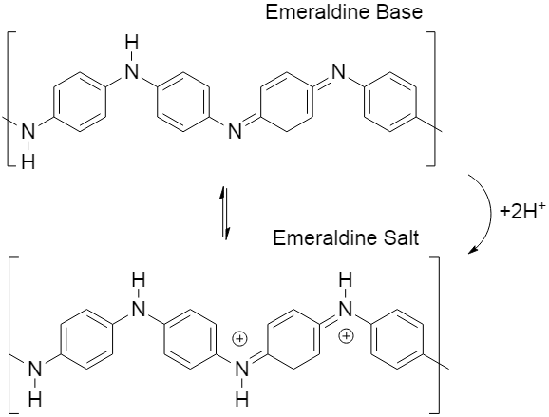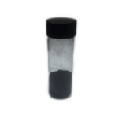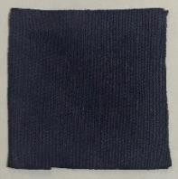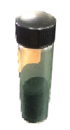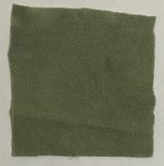

c)
(c)

(a)

(d)

(b)

d)

Figure 1. Chemical structure of PANI (a) PANI-EB (b) PANI-ES (c) PANI-EB fabric (blue colour) and (d) PANI- ES fabric (green colour)

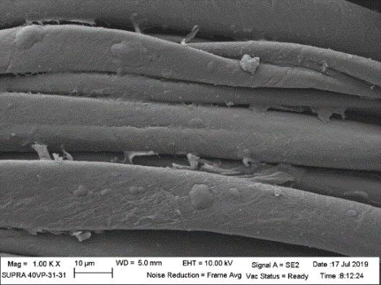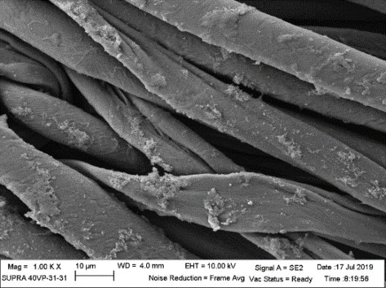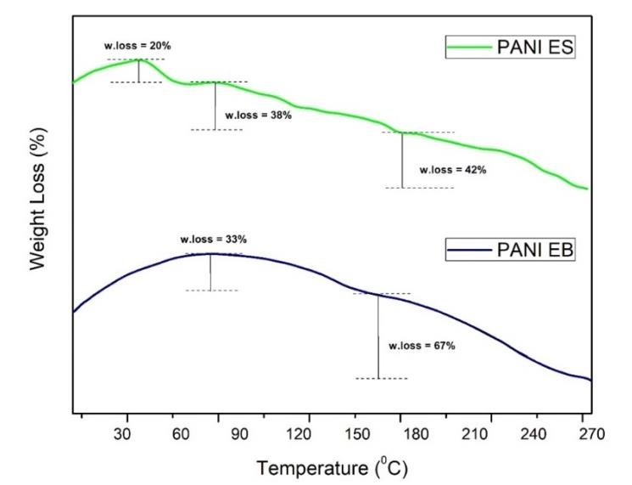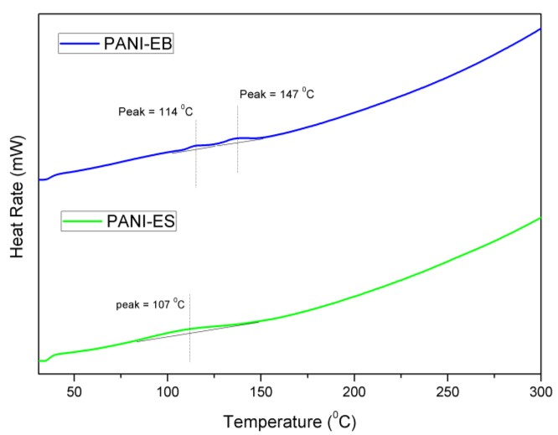
b)
a)

Figure 2. Field emission scanning electron microscope (FESEM) micrographs of (a) bare cotton fabric (b) cotton fabric doped with 0.9 wt% of PANI-pTSA

Figure 3. TGA thermograms of PANI-EB and PANI-ES powder

Figure 4. DSC thermogram of PANI-EB and PANI-ES powder

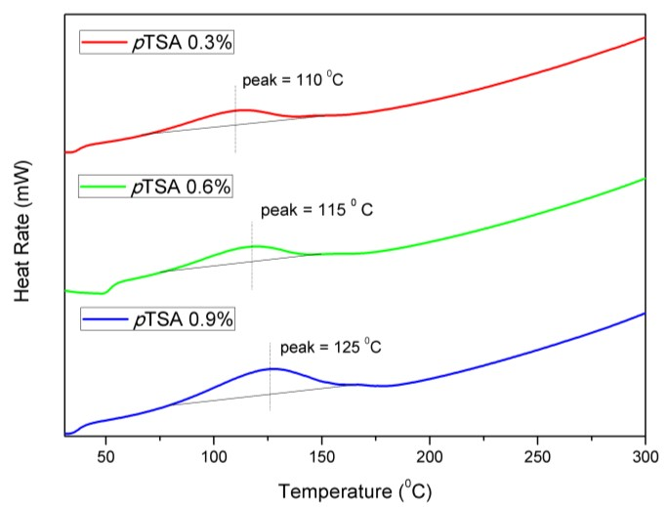Figure 5. DSC thermogram of doped PANI-ES powder with varying concentrations of pTSA (0.3, 0.6, and 0.9 wt.%)

Table 1. The endotherm temperature for doped PANI with pTSA concentrations of 0.3, 0.6 and 0.9 wt.%

Concentration of pTSA
Temperature of Endotherm (°C)

(wt.%) | Beginning | Peak | Final
0.3 | 80.65 | 110.67 | 135.55
0.6 | 77.71 | 115.67 | 142.37
0.9 | 81.45 | 125 | 155.35

Table 2. Conductivity of PANI-cotton fabric doped with different concentrations of pTSA

Doping Condition Weight % Conductivity (S/m)

Bare | - | NIL
Undoped | - | 1.06 x 10⁻⁷ ± 6.38 x 10⁻⁸
Doped PANI with pTSA | 0.3 | 2.35 x 10⁻⁶ ± 7.26 x 10⁻⁷
 | 0.6 | 1.62 x 10⁻⁵ ± 3.13 x 10⁻⁶
 | 0.9 | 3.30 x 10⁻³ ± 1.00 x 10⁻³

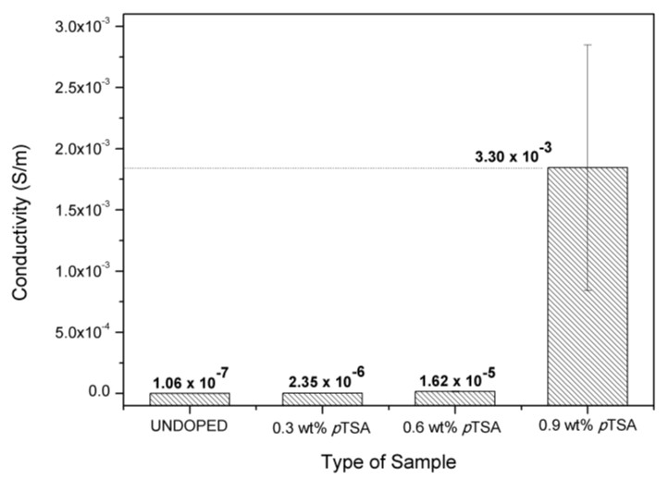Figure 6. Conductivity of PANI cotton fabrics at different weight percentage of pTSA

Conclusion
PANI was synthesized with the chemical oxidation method. Successful doping of pTSA in PANI was confirmed by the change in the color of PANI solution from blue to green. Thermal analysis by TGA illustrated two major stages of weight loss in PANI-EB powder due to the changes in moisture content and breakdown of the polymer backbone. In contrast, PANI-ES had three major stages of weight loss due to the removal of dopant, moisture content and the breakdown of polymer chain. The degradation temperature of PANI-ES began at a higher temperature range of 170 to 173 °C due to the crosslinking between PANI and pTSA. This finding indicated that PANI-ES had higher thermal stability compared to PANI-EB, which began to degrade in the temperature range of 160 to 163 °C. DSC analysis expressed broad peaks for
0.9 wt.%. This result suggested that PANI with this specific concentration of pTSA had a higher rate of heat transformation and enthalpy than PANI with lesser concentrations of pTSA. Furthermore, PANI with 0.9 wt.% concentration displayed the highest thermal stability. Conductive fabrics were fabricated with the prepared PANI by applying facile immersion technique. Cotton fabric was immersed in PANI with varying concentrations of pTSA (0.3, 0.6 and 0.9 wt.%). Based on the EIS results, it can be concluded that PANI with 0.9 wt.% pTSA (3.30 x 10⁻³ S/m)
exhibited superior conductivity compared to PANI with 0.3 wt.% pTSA (1.06 x 10⁻⁷ S/m).

Acknowledgement
The authors are grateful for the funding from Research Management Center UiTM under GIP grant (600-IRMI 5/3/GIP(010/2019)).

References
- Mishra, A. K. (2018). Conducting polymers: Concepts and applications. Journal of Atomic, Molecular, Condensate and Nano Physics, 5(1): 159-193.
- Shacklette, L. W., Colaneri, N. F., Kulkarni, V. G. and Wessling, B. (1992). EMI shielding of intrinsically conductive polymers. Journal of Vinyl and Additive Technology, 14(2): 118-122.
- Rochliadi, A., Akbar S. A. and Suendo. V. (2015). Polyaniline/Zn as secondary battery for electric vehicle base on energy return factor. Proceedings of the Joint International Conference on Electric Vehicular Technology and Industrial, Mechanical, Electrical and Chemical Engineering, Surakarta, 1(13): 353-358.
- Sengupta, P. P., Barik, S. and Adhikari, B. (2006). Polyaniline as a gas-sensor material. Materials and Manufacturing Processes, 21(3): 263-270.

- Wei, R., Hua, X. and Xiong, Z. (2018). Polymers and polymeric composites with electronic applications. International Journal of Polymer Science, 2018: 1.

- Heng Teo, C., Karode, N. S., Abid, K. and Rahman, F. (2011). Interfacial behaviour of polyaniline as an organic electronic material. Journal of Physics and Chemistry of Solids, 72(7): 886-890.
- Ramakrishnan, S. (1997). Conducting polymers.
Inorganic and Physical Chemistry 2(11): 48-58.
- Srinivas, C. H., Srinivani, D., Kavitha, B., Narsimlu, N. and Siva Kumar, K. (2012). Synthesis and characterization of nano size conducting polyaniline. IOSR Journal of Applied Physics, 1(1): 12-15.
- Mahat, M. M., Mawad, D., Nelson, G. W., Fearn, S., Palgrave, R. G., Payne, D. J. and Stevens, M.
M. (2015). Elucidating the deprotonation of
polyaniline films by X-ray photoelectron spectroscopy. Journal of Materials Chemistry C, 3(27): 7180-7186.
- Wang, H., Lin, J. and Shen, Z. X. (2016). Polyaniline (PANI) based electrode materials for energy storage and conversion. Journal of Science: Advanced Materials and Devices, 1(3): 225-255.
- Olad, A. and Azhar, F. F. (2013). Trends in polyaniline research e-book. Hauppauge, New York: pp. 361- 384.
- Zahid, M., Papadopoulou, E., Athanassiou, A. and Bayer, I. (2017). Strain-responsive mercerized conductive cotton fabrics based on PEDOT: PSS/graphene. Materials and Design, 1(2): 135.
- Gorji, M. and Ali J. (2018). The study of burning behavior of cotton/glass woven fabrics. Trends in Textile Engineering& Fashion Technology, 3(5): 2578.
- Jinsong, H., Li, R. and Gu, F. (2012). Preparation
of polyaniline/nylon conducting fabric by layer- by-layer assembly method. Journal of Applied Polymer Science, 3(1): 12-19.
- Zaki, M. R., Anuar, K., Jelas, M. H. and Faiz, M. (2001). Electrical properties and thermal stabilities studies of conducting polyaniline doped with
different sulphonic acids. Malaysian Journal of Analytical Sciences, 7(2): 445-451.
- Bhat, N. V., Seshadri, D. T. and Radhakrishnan, S. (2004). Preparation, characterization, and performance of conductive fabrics: Cotton and PANI. Textile Research Journal, 74(2): 155-166.
- Wang, X., Liu, D., Deng, J., Duan, X., Guo, J. and Liu, P. (2015). Improving cyclic stability of polyaniline by thermal crosslinking as electrode material for supercapacitors. RSCAdvances, 5(96): 78545-78552.
- Yılmaz, F. and Küçükyavuz, Z. (2009). The influence of polymerization temperature on structure and properties of polyaniline. e- Polymers, 16 (3): 225-233.
- Chauhan, N., Ametab, R., Ametac, R. and Ameta,
S. (2011). Thermal and conducting behavior of emeraldine base (EB) form of polyaniline (PANI). Indian Journal of Chemical Technology, 18(1): 118-122.
- Chen, C. H. (2003). Thermal and morphological
studies of chemically prepared emeraldine‐base‐ form polyaniline powder. Journal of Applied Polymer Science, 89(1): 2142-2148.
- Corcione, C. and Frigione, M. (2012). Characterization of nanocomposites by thermal analysis. Materials, 5(12): 2960-2980.
- Yao, C. J., Zhang, H. L. and Zhang, Q. (2019). Recent progress in thermoelectric materials based on conjugated polymers. Journal of Polymers, 11(1): 107.
- David, N. C., Anavi, D., Milanovich, M., Popowski, Y., Frid, L. and Amir, E. (2017). Preparation and properties of electro-conductive fabrics based on polypyrrole: covalent vs. non- covalent attachment. IOP Conference Series: Materials Science and Engineering, 254: 032002.
- Wei, Y., Jang, G. W., Hsueh, K. F., Scherr, E. M., MacDiarmid, A. G. and Epstein, A. J. (1992). Thermal transitions and mechanical properties of films of chemically prepared polyaniline. Journal of Materials Polymer, 1(33): 314.

