
S
STANDARIZATION BASED ON CHEMICAL MARKERS OF Moringa oleifera HERBAL PRODUCTS USING BIOAUTOGRAPHY ASSAY, THIN LAYER CHROMATOGRAPHY AND HIGH PERFORMANCE LIQUID CHROMATOGRAPHY-DIODE ARRAY DETECTOR

(Piawaian Berdasarkan Penanda Kimia bagi Produk Herba Moringa oleifera Menggunakan Ujian Bioautografi, Kromatografi Lapisan Nipis dan Kromatografi Cecair Berprestasi Tinggi-Pengesan Susunan Diod)

Erick Sierra-Campos¹*, Mónica A. Valdez-Solana¹, Claudia I. Avitia-Domínguez², Alfredo Téllez-Valencia²,
Jorge A. Meza-Velázquez¹, Miguel Aguilera-Ortiz¹, Adelma Escobar-Ramírez³

¹Facultad de Ciencias Químicas GP,
Universidad Juárez del Estado de Durango, Av. Artículo 123 S/N Fracc. Filadelfia. Gómez Palacio, Durango. México
²Facultad de Medicina y Nutrición,
Universidad Juárez del Estado de Durango, Av. Universidad y Fanny Anitúa S/N, 34000 Durango. México
³División Académica de Ciencias Básicas,
Universidad Juárez Autónoma de Tabasco, Av. Universidad S/N, Zona de la Cultura, Col. Magisterial, Vhsa, Centro, Tabasco, México

*Corresponding author: ericksier@ujed.mx

Received: 29 December 2019; Accepted: 25 April 2020; Published: June 2020

Abstract
The present study investigated the variation of phytochemical composition, antioxidant activity and chemometric thin layer chromatography (TLC) and high performance liquid chromatography (HPLC) fingerprinting profiles of five Moringa oleifera herbal products. TLC and HPLC along with the PCA and K-mean can adequately discriminate different herbal products. The content of total bioactive compounds of the samples were ranged from 591.5 to 966.1 mg/100 g dried weight. The total antioxidant activity of M. oleifera samples was in the following order: Mas lait > De Font Quer > Akuanandi > Infusionate > Terbal. Wavelength at 352 nm, 75 components were detected in all herbal products; among these, 10 potential biomarkers with higher contents enabled differentiation between each sample and foreign organic matter. HPLC-DAD analysis of the extracts showed a decline in the quality of components in the five commercial products. Thus, this study presents the TLC and HPLC profiles of the Mexican M. oleifera extracts that may serve as a reference for the proper identification, standardization and quality control of this plant. These methods can be used for routine quality control of herbal products and formulations containing this medicinal plant.

Keywords: Moringa oleifera leaves, chemical markers

Abstrak
Kajian ini menyiasat variasi komposisi fitokimia, aktiviti antioksidan dan kemometrik kromatografi lapisan nipis (TLC) dan kromatografi cecair berprestasi tinggi (HPLC) bagi profil pencapjarian lima produk herba berasaskan Moringa oleifera. TLC dan HPLC bersama PCA dan K-min boleh membezalayan secara tepat bagi produk berbeza. Jumlah kandungan sebatian bioaktif bagi sampel berada di dalam julat 591.5 to 966.1 mg/100 g berat kering. Jumlah aktiviti antioksidan bagi sampel M. oleifera seperti tertib berikut: Mas lait > De Font Quer > Akuanandi > Infusionate > Terbal. Para panjang gelombang 352 nm, 75 komponen ditemui dalam semua produk herba; antaranya 10 potensi penanda bio dengan kadungannya yang tinggi membantu membezakan setiap sampel dengan jirim organik asing. Analisis HPLC-DAD terhadap ekstrak menunjukkan penurunan dalam kualiti komponen di dalam lima produk komersial. Kajian ini membentangkan profil TLC dan HPLC bagi ekstrak M. oleifera tulen dari Mexico yang boleh digunakan sebagai rujukan bagi tujuan pengenalpastian, paiwaian dan kawalan kualiti tumbuhan ini. Keadah ini boleh digunakan bagi rutin kawalan kualiti produk herba dan formulasi yang mengandungi tumbuhan perubatan ini.

Kata kunci: daun Moringa oleifera, penanda kimia

Introduction
Plants have primary and secondary metabolite factories for their survival and that play a vital role in the management of human health. Of an estimated 250,000 to 350,000 plant species identified, about 35,000 are used worldwide for medicinal purposes. The World Health Organization (WHO) has confirmed that herbal medicines serve the health needs of about 80% of the world´s population; especially for millions of people in the vast rural areas of developing countries [1]. Additionally, plants and their metabolites are necessary for food supplement and nutrition, and for all type of medicines including traditional, herbal, complementary, natural products related and semi-synthetics [2].

Moringa is a genus of medicinal plants that has traditionally been used to heal wounds and various diseases such as colds and diabetes. The genus consists of 13 species that have been widely cultivated mainly throughout Asia and Africa for their multiple uses. Moringa species are well-known for their antioxidant, anti-inflammatory, anti-cancer, and anti-hyperglycemic activities [3]. Moringa oleifera has been used as a source of medicine to treat different diseases and ailments including wound healing, hypertension, diabetes, obesity and cancer [4]. However, the chemical composition of M. oleifera vary greatly since it has varieties and an extensive distribution. Different chemical composition may lead to significant differences in the effectiveness of the health problems and the safety related to intake. Additionally, only few extracts were evaluated for their chemical constituents and mechanism-based pharmacological activities.

In order to profit from the beneficial therapeutic properties of M. oleifera, Mexican markets are full of various medicinal, dietary, and cosmetic preparations, available to the public. Most of these M. oleifera based products are available in our country as capsules or tea for daily drinking that contain simple powdered leaves. Moreover, there is a huge demand for pharmaceutical, cosmetic, and food products in local and global markets, which create a cutthroat competition between suppliers and manufacturers. However, manufacturers sometimes do not follow the right way to achieve the quality products and some do not have quality control facilities [5, 6]. The proportion of adulterated herbal products varies significantly among continents, higher in Australia (79%) and South America (67%), lower in Europe (47%), North America (33%), Africa (27%) and Asia (23%) [7]. However, adulteration is not necessarily intentional and herbal products may be altered due to accidental adulteration, misidentification and confusion resulting from vernacular names [8, 9].

Moringa oleifera contains a range of polyphenolic compounds that are especially abundant in leaves. These contribute to its high antioxidant activity. Therefore, an evaluation of the diversity of antioxidant
compounds from different sources is desirable to ensure the quality of M. oleifera and its derived edible products. Therefore, interest in the antioxidant activity of M. oleifera leaves is growing. Several investigations have shown that M. oleifera contains strong antioxidant capacity [10-12]. Antioxidants play an important role in inhibiting and scavenging free radicals, thus providing protection to humans against infections and degenerative diseases. Various antioxidant compounds were reported in leaves extract of M. oleifera as gallic acid, chlorogenic acid, kaempferol, quercetin, caffeic acid, luteolin, epicatechin, and others [13-15]. However, it is unknown which is the most important in the antioxidant activity.

The fingerprinting approach has been recently recognized and accepted for quality assessment of traditional medicines. The thin layer chromatography (TLC) fingerprint profile is an important tool that serves as a guideline to the phytochemical profile of the antioxidant compounds in ensuring quality. It provides quantitative and semi-quantitative information of the resolved compounds [16]. The concept of phyto-equivalence was developed to ensure consistency of herbal products. According to this concept, a chemical profile, such as chromatographic fingerprinting, for herbal products, should be constructed and compared with the profile of a clinically proven reference product [17].

TLC is an easy, inexpensive, rapid, and the most widely used method for the analysis and isolation of small organic natural and synthetic products [18,19]. In the screening of antioxidants, the stable free radical 2,2-diphenyl-1-picrylhydrazyl (DPPH) was often used as a derivatization reagent for this purpose [20]. High performance liquid chromatography (HPLC) fingerprinting has been widely used in some studies of natural products [21, 22].

Taken together, the purposes of the present study included: (1) to evaluate the antioxidant potential of different commercial products of Moringa oleifera , with the results compared to standard antioxidants such as quercetin, gallic acid and rutin; (2) to characterize the polyphenols to provide biomarkers using TLC and HPLC-DAD.

Materials and Methods
Reagents
TLC with various solvent systems by using TLC aluminum sheet pre-coated with silica gel 60 F254-Merck. All the solvents (Trichloroacetic acid, ethyl acetate and methanol) used for extraction and isolation of analytic grade or HPLC grade and purchased from Sigma-Merck.

Raw material
Moringa oleifera powder leaves based commercial products were obtained from naturist stores from Mexico; Akuanandi® capsules (Lombardia, Mich); Terbal tea® (Mexico City), Infusionate tea® (Monterrey, NL), De Font Quer® capsules (Zapopan, Jal), and Mas lait® powdered leaves (Monterrey, NL).

Preparation of M. oleifera leaves extract and polyphenolic standards
At first, 0.5 g of powder of dried leaves of M. oleifera was extracted by Ultrasonication assisted extraction with methanol/water (80:20, v/v) for 30 minutes at 30 °C. The extract was filtered through a 0.22 μm nylon filter. The solvent was removed under reduced pressure at 40 °C (rotary evaporator Büchi R-215). The crude extract was kept separately in sterile sample tubes and stored at 4°C. Extracts were performed in triplicate. Each appropriate amount of standard compound was accurately weighed and dissolved in 70% methanol as stock solutions, which were stable for at one week under 4 °C. Linearity range of chlorogenic acid (0.6-23.1 µg/mL), isoquercetin (0.99-3.0 µg/mL), luteolin (0.5-4.0 µg/mL), and apigenin (0.66-3.3 µg/mL).

Phytochemical screening by TLC
The extracts were dissolved in methanol to achieve a concentration of 5 mg/mL. The hydromethanolic extracts of M. oleifera were applied in a concentration of 5 μL using a Hamilton syringe on aluminum sheets pre-coated with silica gel 60 F₂₅₄ of 0.2 mm thick, 5 cm x 7.5 cm used as a stationary phase. The plates were developed in the mobile phase, TCA-ethyl acetate-methanol (1:7.5:1.5 v/v) for the hydromethanolic
extract to a distance of 120 mm trough glass chamber saturated with ternary solvent system consisting of TCA-ethyl acetate-methanol (1:7.5:1.5) at room temperature (25 °C). Daylight, UV 254 nm, UV 366 nm and DPPH stain were used as visualization techniques. To qualitatively screen, it was dipped upside down for 10 seconds in a 0.4 mM DPPH solution. Additionally, standards were used to assist the identification of compounds present in the extract when known compounds were present in the sample. The identification of known polyphenolics was performed by comparison of respective standards through Rf calculation.

The retention factor (Rf) values of the different spots were then calculated using the equation 1:

$Rf=\frac{Distance of spot from origin}{Distance of solvent front from origin}$ (1)

The documented pictures were saved in jpg mode and processed by the digitally enhanced thin-layer chromatography by means of the ImageJ. MATLAB and TLC analyzer – Science Buddies. First, color images were turned into 8-bit type images (Image/type/8-bit). The images obtained were denoised by applying the following steps: Process/Filters/Median/Radius -5 pixels, with the baseline drift then removed (Process/FFT/Bandpass Filter/Filter large structures down to -40 pixels; filter small structures up to -0 pixels).

HPLC-DAD analysis
Seven phenolic standards and samples were dissolved in the mobile phase, yielding concentrations of 25 μg/mL. The solutions were filtered through a 0.45 μm membrane filter, and the evaluation of each calibration curve was fitted by linear regression. An Agilent 1200 HPLC Series (Agilent, Palo Alto, Calif.) was operated at 30 °C, equipped with a degasser, a diode array detector (DAD), a quaternary gradient pump, and a Polaris 5 C₁₈ analytical column of 150 mm × 4.6 mm and a 3.5 μm particle (Agilent, USA). The mobile phase was a binary gradient: methanol and buffer solution. The buffer contained TCA 0.1% solution in water, with its pH adjusted to 2.1. The linear gradient began with 20 to 50% methanol over the first 30 minutes, followed by 70% methanol over the next 30 minutes. The flow rate was 0.8 mL/min. Data were collected at 352 nm. The injection volume was 20 μL. Data acquisition, peak integration, and calibrations were performed with Agilent 1200 Chemstation software. The results are reported as means ± standard deviations of triplicate independent analyses.

Data analysis
The data were expressed as means ± SD, and the correlation of entire chromatographic patterns among the samples were calculated. Principal component analysis (PCA) was performed using XLSTAT software and Past (folk.uio.no/ohammer/past). Additionally, K-mean cluster distribution was applied for raw data to categorize the samples into proper clusters based on the amount and number of main components in the collected samples.

Results and Discussion
Recently, it was described a direct TLC quantitative analysis for some flavonoids as crypto-chlorogenic acid, isoquercetin, and astragalin contents in Moringa oleifera leaf extracts [23]. However, this reported method requires expensive equipment (CAMAG Linomat 5) and resource intensive calibrations. Therefore, attempts were made in this work to develop a fast, sensitive, robust, and cost-effective TLC-densitometric method suitable for semi-quantitative analysis of main flavonoids in the commercial products of M. oleifera.

To develop the TLC-densitometry method for the estimation of flavonoids of M. oleifera, a selection of the mobile phase was carried out based on polarity. Initially, a combination of various proportions of solvents including methanol, acetonitrile, ethyl acetate, hexane and ether of petroleum were tried as mobile phase, but diffusion of the spots and tailing was observed. To avoid this problem trichloroacetic acid (TCA) was added to solvent system. Finally, a mobile phase composed of TCA-ethyl acetate-methanol (1:7.5:1.5 v/v/v) was established as observed with Rf values of 0.75, 0.58, 0.51, 0.48, 0.42, 0.36, 0.14 and 0.07 when plate was developed and scanned at 366 nm
and visible light (Figure 1). At 254 nm, we observed only seven well defined spots, while that at 366 nm, we observed up to 15 spots. Moreover, evaluation of linearity for the TLC assay was done by preparing four dilutions from a stock extract, i.e., 14.2% (1:7), 20% (1:5), 33.3% (1:3) and 50% (1:2). Spots were applied for each concentration starting with lowest concentration to avoid a carryover effect. The results show that the intensity of each compound depends on the amount of sample tested. The best separation and resolution were obtained with the 1:5 dilution, which corresponds to a concentration of 20 μg/spot (Figure 1, left panel). Therefore, this concentration was applied to the follow assays.

Later, five products of M. oleifera from different regions of Mexico were analyzed to develop a standard fingerprint under the established TLC conditions. Seven common peaks were selected as characteristic peaks. Figure 2a shows the suitability of the TLC method to detect and semi-quantify flavonoids presented by different products. TLC clearly revealed that Mas lait (S4) presented high amounts of antioxidant compounds, whereas Terbal (S2) exhibited low amounts of antioxidants. S4 extract exhibited the best DPPH radical scavenging activity, followed by De Font Quer (S5) and Akuanandi (S3) extracts. These results are agrees with that the major antioxidant constituents of M. oleifera include vitamins, micronutrients, polyphenols and isothiocyanates, which are a potent mixture of direct and indirect antioxidants that can explain its various health-promoting effects [24].

The content of total bioactive compounds (TBCC) in the evaluated extracts were as follows, the lower TBCC value of 591.5 ± 1.14 mg/100 g DW for S2 and a higher value of 966.1 ± 2.19 mg/100 g DW for S3, followed by S5, S4 and S1. Depending on fingerprint profile showed the prevalence of different bioactive classes in chemical composition of all samples, with the most quantitatively important classes were flavonols (40%), cinnamic acids (20.5%) and flavones (7.5%). In Table 1, it can be seen that peak 8 was not found in S1, while S1 extract did not contain peak 1.

Although the classical fingerprinting by TLC is done visually and mainly in a non-chemometric way. Several peaks can be proposed as markers, known as substances responsible for differences between discriminated classes. However, the main disadvantage of classical fingerprinting is its subjectivity. Therefore, the chemometric fingerprinting treats the chromatogram as a unique signal, without a need to identify and interpret the peaks [25], for which, we decided to use and validate the chemometric method with the previous results and compare them with other commercial herbal products.

The image processing procedure was based on previously published methods [25-27]. The typical order of preprocessing includes normalization, denoising, and baseline removal, followed by warping/registering. The chromatographic peaks area shown as signals (Figure 2b), and the integration of all peaks was done automatically by TLC analyzer and MATLAB (with Image Processing Toolbox) (Table 1) to characterize their presence in a given sample. The intensity and area of these main peaks in the different samples showed significant changes; however, their peak positions remained unaltered.

A multivariate analysis, the principal component analysis (PCA) is based on the generation of a new set of variables, called principal components to explain the variability of results, besides showing the correlation between the different variables. PCA has been used as an unsupervised technique to evaluate whether the approach TLC/chemometrics may differentiate samples according to different phytochemicals, thus discriminating the original Moringa oleifera leaf products.

The scree plot gave two principal components, where the contribution of variance for individual components was: component 1 explaining 83.75%, and component 2 explaining 13.14%. Furthermore, the total contribution of variance from the two components was 96.99%. In terms of major contribution, compounds 1, 5 and 8 made the greatest contribution towards F1 whereas compounds 4 and 6 were the contributors for F2. It was found that F1 has no associated with peak 9.
Whereas F2 was found to be positively associated with peak 4. In the first quadrant we have the samples of Mas Lait and De Fort Quer that are characterized by compound 6. In contrast, in the fourth quadrant, we have the Infusionate, Terbal and Akanandi samples that are characterized by the compounds 2 and 7 (Figure 4). The results indicated that the chemical composition and content in the M. oleifera herbal products significantly varied.

Additionally, we use the distance metric to measure the similarity or dissimilarities between points. The K-mean cluster showed distribution of data into three clusters: 1 (3), 2 (1) and 3 (1). Cluster 1 shows three samples (Infusionate, Terbal and Akanandi) with minimum distance to centroid of 2,228.76. Cluster 2 shows one sample (Mas lait) with minimum distance to centroid of 2472.88; Cluster 3 shows one sample (De Font Quer) with minimum distance to centroid of 1816.44. According to the inter-cluster distances, it was observed that Mas lait and De Fort Quer, characterized by high values of phytochemicals, differs significantly to the samples from Cluster 1. K-mean analysis clusters M. oleifera samples into different groups, clearly showing that this method can adequately discriminate different products using TLC.

Based on the comparison of the Rfs with standard compounds, the spots obtained in all the tracks were analyzed and the Rf values were compared to the standard. If Rf value of pure compound is matching to any Rf value of extract shows the presence of that standard in the extract. The presence of specific peaks for quercetin, gallic acid and rutin at Rfs around 0.8, 0.5, and 0.32 were recorded and considered a positive result for polyphenols (Figure 4). The spots observed under UV light and DPPH stain indicate the absence or few abundances of these compounds in the De Font Quer sample extract. Natural products are extremely complex, containing many components of various composition, size, and acid-base properties. Additionally, Rf values are affect by several factors such as depth of mobile phase, nature of the TLC plate, and solvent parameters. Therefore, these results indicating that TLC has low resolution and its necessity the confirmation of extract by HPLC-DAD.
When developing a new analytical method, it is desirable to compare the results from the new method with those from an accepted method. The HPLC-DAD chromatogram of the hydroalcoholic extract of M. oleifera revealed the presence of various compounds with corresponding peaks at different times (Figure 5). The compounds identified in the extracts are shown in Table 2. Based on a comparison of the retention times with those of the standards, peaks 1, 2, 4, 5, 7 and 9 were identified as chlorogenic acid, syringic acid, luteolin, rutin, isoquercetin and astragalin, respectively. The most abundant flavonoids in all samples were chlorogenic acid and isoquercetin, while luteolin was found at lower concentration. Among the main detected peaks 3, 4, 7, 8 and 10, did not match any compounds previously identified in our laboratory [14]. However, kaempferol and quercetin derivatives were the most predominant flavonoids in M. oleifera leaves [28, 29]. Therefore, additional mass-spectrometry studies are required to know the identity of the unknown compounds.

The HPLC-DAD fingerprints of herbal products were obtained and are shown in Figure 5. It was found that all samples (S1-S5) had similar spectra which indicated the similar chemical composition of these products. There were 10 main common peaks, which were marked (1-10) in each chromatogram. Peak 7 (TR = 28.49±0.8 min) was selected as the reference peak because it was the maximum peak in each sample.

Statistically significant differences were observed among the different samples for all single bioactive compounds: the most important differences were observed in the concentration of syringic acid, isoquercetin and astragalin. All were previously described in M. oleifera leaves. However, the values are extremely variable across the five samples, most likely because both M. oleifera variety and industrial product manufacturing affect the amount of flavonoids eventually present in the final product.

The major constituents of the extract were:

Peak 1 was found to be chlorogenic acid which is an ester of caffeic acid and quinic acid and is made up of 20.5% of the S1 extract. The chlorogenic acid content did not drastically vary, although S2 and S4 contained slightly lower concentration and it agreed with Vergara-Jimenez [30] which reported higher concentration of cinnamic acids in M. oleifera. This compound is a potent antioxidant that protects plants from lipid peroxidation [31]. Peak 2 was identified as syringic acid a dimethoxybenzene that is 3, 5 dimethyl ether derivatives of gallic acid and it made up 5.37% of the S4 extract. The level of syringic acid was 3.3-times higher in S4 versus S1. Leaves of M. oleifera are a good source of syringic acid and an excellent compound to be used as a therapeutic agent in various diseases [32, 33].

Peak 3 was not identified and made up 6.11% of the 6.49% of the S3 extract. Peak 4 was identified as luteolin, 3´,4´,5,7-tetrahydroxy flavone and it made up 2.31% of the S5 extract. Luteolin (3´,4´,5,7-tetrahydroxyflavone) possesses antioxidant activity [34]. Peak 5 was found to be rutin, a dietary flavonoid and it made up 2.79% of the S5 extract. It has demonstrated that rutin has strong antioxidant properties [35]. Peak 6 was not identified and made up 21.6% of the S3 extract.

Peak 7 was identified as isoquercetin, a flavonoid that makes up 42.15% of the S3 extract. The S3 showed the high amount of isoquercetin. It is well established that one of the mechanisms for cancer development is oxidative stress, therefore the chemopreventive effects of isoquercetin could be attributed to its antioxidant and oxidative damage preventive activities [36]. Peak 8 was not identified and made up 19.26% of the S5 extract. This compound can be tentatively identified as quercetin derivative.

Peak 9 was characterized as astragalin is a 3-O-glucoside of kaempferol and it made up 7.24% of the S5 extract. It has been reported to exhibit multiple pharmacological properties including antioxidant, anti-inflammatory, anticancer, neuroprotective, and cardioprotective property [37]. Peak 10 was not identified and made up 5.97% of the S3 extract. This compound can be tentatively identified as Kaempferol derivative. The peaks remained unidentified: they likely represent other bioactive markers with potential therapeutically important effects on human health.

As expected, the predominant group of phenolic compounds in all samples was flavonols. In recent years, they have been studied primarily for their antioxidant activity, free radical scavenging capacity, coronary heart disease prevention, hepatoprotective anti-inflammatory, anticancer and potential antiviral activities [38].

The scree plot gave two principal components, where the contribution of variance for individual components was: component 1 explaining 59.18%, and component 2 explaining 31.42%. Furthermore, the total contribution of variance from the two components was 90.6%. In terms of major contribution, compounds 2-6 and 9 made the greatest contribution toward F1 whereas compounds 1, 7, 8, and 10 were the contributors for F2. Through PCA, it can be seen that, in plot, the five samples are discernibly separated.

In the first quadrant, we have the samples of Akuanandi and De Fort Quer that are characterized by the compounds 1, 2, 3, 4, 5, 6, 9 and 10. In contrast, Terbal sample is located in the third quadrant, but not it is characterized by some compounds. In the second quadrant we have the Infusionate sample that is characterized by compounds 7 and 8 (Figure 6). The results indicated that the internal qualities of five M. oleifera herbal samples from different sources had market chemical variations. Therefore, this comparative study indicates that Akuanandi, Mas lait, and De Font Quer can be considered appropriate sources of bioactive phytochemicals.

The K-mean cluster showed distribution of data into two clusters: 1 (3) and 2 (2). Cluster 1 shows three samples (Infusionate, Terbal and Akanandi) with minimum distance to centroid of 597.359, 558.341 and 1080.808, respectively. Cluster 2 shows two sample

(Mas lait and De Fort Quer) with minimum distance to centroid of 388.422. According to the inter-cluster distances, it was observed that the Infusionate and Terbal from cluster 1 differ significantly to the samples from cluster 2 except for the Akanandi of Cluster 1, which agrees with the biplot.

In contrast to the allopathic formulations that contain defined amounts of therapeutically active chemistry principles, herbal medicinal products usually comprise a defined amount of plant material but seldom mention the concentration of bioactive principles therein. Similarly, variation of bioactive metabolites in plant material obtained from a different geographical origin eventually incurs great difficulties in determination of potency, purity, consistency, and safety of medicinal plants and herbal products [39].

According to Karlund et al. [40], and Zuhrotum et al. [41] the most common parameters that influence the composition of flavonoids include: variety, growing area, the degree of maturity of leaves, harvesting method, storage conditions, and others. Thus, phyto-equivalence is required due to the following reasons: 1) each product has variation in active constituents; 2) to meet same compendia or other standards; 3) it is necessary to match the products and doses in clinical trials; 4) to achieve the same efficacy in disease management; and 5) extracts of similar drug should demonstrate similar pharmacological and physiological activity [42].

To date, little has been done to study phytochemical profile of M. oleifera. Several variables are important in the formulation of natural products like uniformity of plant material, harvest time, temperature, purity, and identity. Additionally, the market of M. oleifera has grown extensively due to an increased awareness of the potential health benefits of bioactive polyphenols present in leaves. Thus, results obtained from the present study provide important information to the industry and consumers concerning polyphenols, antioxidant capacity and flavonoids composition.

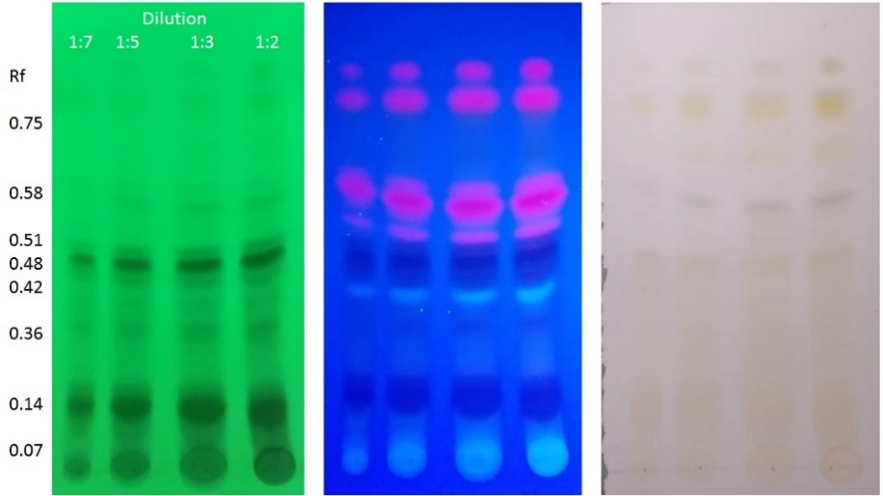
Figure 1. TLC plates of different amounts of Moringa oleifera leaves extracts (Akuanandi) under UV 254 nm (green panel), 366 nm (blue panel) and visible (gray panel) without derivatization.

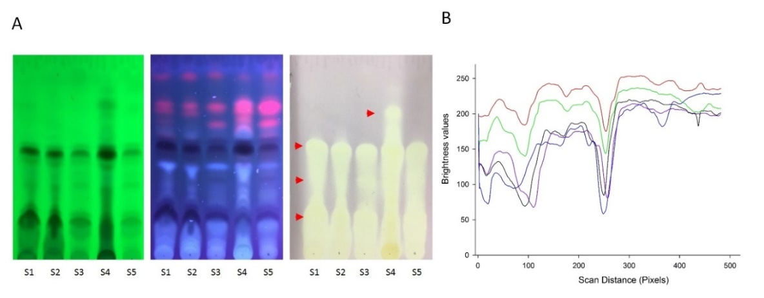
Figure 2. a) Comparative plate of the hydromethanolic extracts of five commercial products of Moringa oleifera revealed with UV 254 nm (green), UV 366 nm (blue), respectively. S1) Infusionate, S2) Terbal, S3) Akuanandi, S4) Mas lait and S5) De Font Quer. Left panel represents staining with DPPH. b) An example of a raw univariate densitogram extracted from image before denoising.

Table 1. Target compounds from different M. oleifera leaves extracts by TLC (254 nm). The retention factor and relative peak are of nine common peaks of different herbal samples
Peak  No. | Retention Factor (Rf) | Relative Peak Area
Peak  No. | Retention Factor (Rf) | S1 | S2 | S3 | S4 | S5
1 | 0.07 | 14.82 | 0 | 23.82 | 490.96 | 27.39
2 | 0.14 | 1,329.85 | 1,007.19 | 1,394.96 | 308.41 | 1,384.61
3 | 0.36 | 36.36 | 30.62 | 33.42 | 11.24 | 475.4
4 | 0.42 | 199.98 | 17.37 | 679.65 | 483.92 | 538.97
5 | 0.48 | 119.47 | 169.72 | 287.34 | 91.79 | 288.08
6 | 0.51 | 875.58 | 999.53 | 2,284.11 | 1,324.93 | 2,982.01
7 | 0.58 | 2,554.42 | 2,666.08 | 3,133.23 | 899.02 | 2,108.75
8 | 0.65 | 0 | 41.28 | 117.06 | 289.88 | 159.46
9 | 0.75 | 465.38 | 393.26 | 641.98 | 49.17 | 557.79

Figure 3. Two-dimensional scatter plots of the loadings of the first two factors. Biplot (axes F1 y F2: 96.9%)

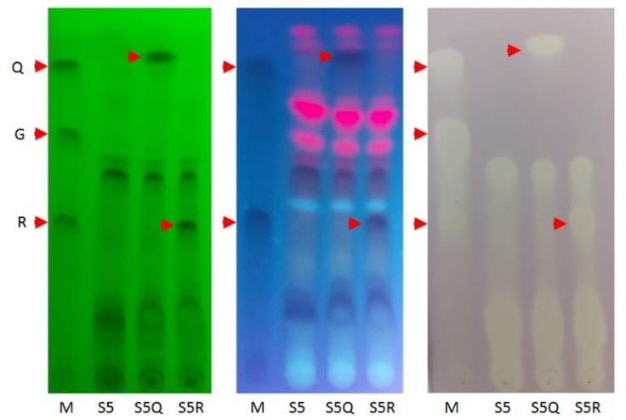
Figure 4. Hydromethanolic extract plate of Moringa oleifera (S5, De Font Quer) revealed with UV 254 nm (green), UV 366 nm (blue) and DPPH (gray), respectively. The red arrow heads indicate the band of each standard (Q, Quercetin; G, Gallic acid and R, Rutin). M, reference antioxidants; S5, De Font Quer; S5Q, sample plus quercetin and S4R, sample plus rutin

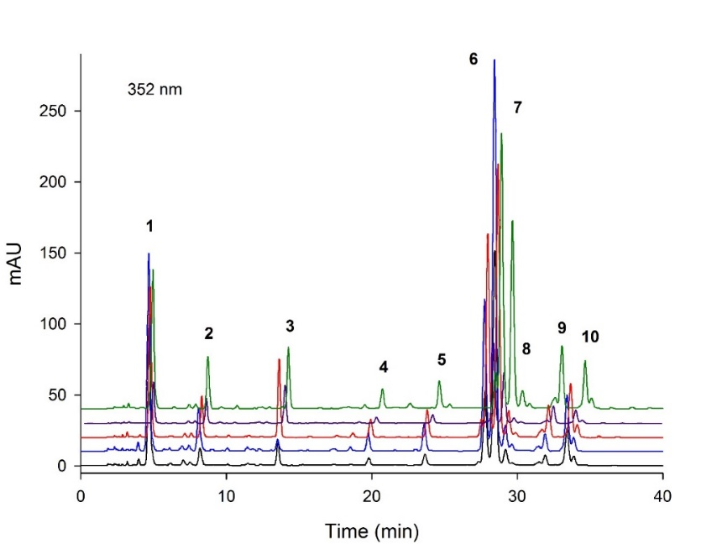
Figure 5. Characterization of gradient HPLC analysis of different M. oleifera leaves extracts. S1) Infusionate (purple), S2) Terbal (black), S3) Akuanandi (green), S4) Mas lait (blue), and S5) De Font Quer (red).

Table 2. Target compounds from different M. oleifera leaves extracts by HPLC-DAD (352 nm). The retention time and relative peak are of 10 common peaks of M. oleifera samples
Biomarkers | Retention time | Relative Peak Area
Biomarkers | (min) | S1 | S2 | S3 | S4 | S5
1 (chlorogenic acid) | 4.79±0.2 | 1329.8 | 1007.2 | 1394.9 | 981.9 | 1384.6
2 (syringic acid) | 8.33±0.3 | 185.2 | 253.8 | 346.7 | 616.8 | 475.4
3 (unknown) | 13.64±0.5 | 199.9 | 58.78 | 679.6 | 967.84 | 538.9
4 (luteolin) | 19.92±1.0 | 77.0 | 110.5 | 186.2 | 185.8 | 193.6
5 (rutin) | 23.81±0.7 | 119.4 | 169.7 | 287.3 | 307.2 | 288.0
6 (unknown) | 27.96±1.2 | 875.6 | 999.5 | 2284.1 | 2649.8 | 2982.0
7 (isoquercetin) | 28.66±0.8 | 2554.4 | 2666.0 | 3133.2 | 1798.0 | 2108.7
8 (unknown) | 29.39±1.9 | 205.3 | 145.3 | 312.7 | 134.9 | 159.4
9 (astragalin) | 32.13±1.5 | 118.8 | 110.6 | 394.6 | 579.76 | 713.6
10 (unknown) | 33.65±1.1 | 465.38 | 393.26 | 642.0 | 450.56 | 557.8

Figure 6. Two-dimensional scatter plots of the loadings of the first two factors. Biplot (axes F1 y F2: 90.6%)

Conclusion
This study indicated that TLC and HPLC-DAD fingerprint analysis can be readily utilized as a quality control method for M. oleifera herbal products. The advantages of using TLC to construct the fingerprints of Moringa oleifera based products are its simplicity, versatility, specific, sensitivity and simple sample preparation. Quantitative data generated by means of an image processing program enabled comparison of phytochemical composition. Furthermore, the clear discrimination of compounds of herbal products in PCA analysis indicated that the internal qualities of five M. oleifera herbal samples from different sources had market chemical variations. Additional researches are required to obtain more detailed identification of unknown peaks by HPLC-MS/MS. Akuanandi, Mas lait, and De Font Quer samples can be considered as appropriate sources of antioxidants. Thus, the proposed TLC and HPLC-DAD screening methods could be an easy way to evaluate the phytochemicals screening and determine the quality and possible adulteration of M. oleifera products.

Acknowledgements
A special acknowledgement is due to Guadalupe Arely Suárez-Adame for his technical assistance in the course of this research. The authors are also grateful to the Mexican Moringa producers for the supply of samples used in this study. They thank Ilse Andrea Marcial-Martínez for her technical support. We thanks to Iván Artemio Corral-Guerrero for helpful discussions and critical reading of this paper.

References
- World Health Organization (2008). Herbal medicine research and global health: an ethical analysis access from https://www.who.int/bulletin/ volumes/86/8/07-042820/en/ [Date access April 2020].
- Zhang, J., Onakpoya, I. J., Posadzki, P. and Eddouks, M. (2015). The safety of herbal medicine: From prejudice to evidence. Evidence-Based Complementary and Alternative Medicine, 2015: 1-3.
- Cimpoiu, C. (2006). Analysis of some natural antioxidants by thin-layer chromatography and high performance thin-layer chromatography. Journal of Liquid Chromatography and Related Technologies, 29: 1125-1142.
- Abd Rani, N.Z., Husain, K. and Kumolosasi, E. (2018). Moringa genus: A review of phytochemistry and pharmacology. Frontiers in Pharmacology. 2018(9: 108.

- Leone, A., Fiorillo, G., Criscuoli, F., Ravasenghi, S., Santagostini, L., Fico, G., Spadafranca A., Battezzati, A., Schiraldi, A., Pozzi, F., di Lello, S., Filippini, S. and Bertoli S. (2015). Nutritional characterization and phenolic profiling of moringa oleifera leaves grown in Chad, Sahrawi refugee camps, and Haiti. International Journal of Molecular Sciences, 16(8): 18923-18937.
- Srirama, R., Kumar, J. U. S., Seethapathy, G. S., Newmaster, S. G., Ragupathy, S., Ganeshaiah, K. N., Uma, S. and Gudasalami, R. (2017). Species adulteration in the herbal trade: Causes, consequences and mitigation. Drug Safety, 40(8): 651-661.
- Ichim, M. C. (2019). The DNA-based authentication of commercial herbal products reveals their globally widespread adulteration. Frontiers in Pharmacology, 10: 1227.
- Saslis-Lagoudakis, C. H., Bruun-Lund, S., Iwanycki, N. E., Seberg, O., Petersen, G., Jäger, A. K. and Rønsted, N. (2015). Identification of common horsetail (Equisetum arvense L.; Equisetaceae) using thin layer chromatography versus DNA barcoding. Scientific Reports, 5: 11942.
- Farah, M. H., Olsson, S., Bate, J., Lindquist, M., Edwards, R., Simmonds, M. S. J., Christine, L., Hugo, J. d. B. and Mats, T. (2006). Botanical nomenclature in pharmacovigilance and a recommendation for standardisation. Drug Safety, 29(11): 1023-1029.
- Wright, R. J., Lee, K. S., Hyacinth, H. I., Hibbert, J. M., Reid, M. E., Wheatley, A. O. and Asemota, H. N. (2017). An investigation of the antioxidant capacity in extracts from Moringa oleifera plants grown in Jamaica. Plants, 6(4): 48.
- Vongsak, B., Mangmool, S. and Gritsanapan, W. (2015). Antioxidant activity and induction of mRNA expressions of antioxidant enzymes in HEK-293 cells of Moringa oleifera leaf extract. Planta Medica, 81 (12–13): 1084-1089.
- Sreelatha, S. and Padma, P. R. (2009). Antioxidant activity and total phenolic content of Moringa oleifera leaves in two stages of maturity. Plant Foods for Human Nutrition, 64(4): 303-311.

- Falowo, A. B., Mukumbo, F. E., Idamokoro, E. M., Lorenzo, J. M., Afolayan, A. J. and Muchenje, V. (2018). Multi-functional application of Moringa oleifera Lam. in nutrition and animal food products: A review. Food Research International, 106: 317–334.
- Valdez-Solana, M. A., Mejía-García, V.Y., Téllez-Valencia, A., García-Arenas, G., Salas-Pacheco, J., Alba-Romero, J. J. and Sierra-Campos, E. (2015). Nutritional content and elemental and phytochemical analyses of Moringa oleifera grown in Mexico. Journal of Chemistry, 2015: 1-9.
- Mao, Q.-Q., Xu, X.-Y., Cao, S.-Y., Gan, R.-Y., Corke, H. and Beta, T. (2019). Bioactive compounds and bioactivities of ginger (Zingiber officinale roscoe). Foods, 8(6): 185.
- Rajani, M. and Kanaki, N. S. (2008). Phytochemical standardization of herbal drugs and polyherbal formulations. Bioactive Molecule and Medicinal Plants: pp. 349-369.
- Hiremath, R., Jalalpure, S. S. and Pethakar, S. (2016). Chromatographic fingerprint analysis of hydroalcoholic extract of medicinally important plant Elephantopus scaber L. using HPTLC technique. Indian Journal of Pharmaceutical Education and Research, 50(4): 689-694.
- Gibbons, S. (2012). An introduction to planar chromatography and its application to natural products isolation. Methods in Molecular Biology, 864: 117-153.
- Marston, A. (2011). Thin-layer chromatography with biological detection in phytochemistry. Journal of Chromatography A, 1218(19): 2676-2683.
- Sarkar, R. and Mandal, N. (2012). Hydroalcoholic extracts of Indian medicinal plants can help in amelioration from oxidative stress through antioxidant properties. Journal of Complementary & Integrative Medicine, 9: 1-9.
- Cieśla, Ł. (2012). Biological fingerprinting of herbal samples by means of liquid chromatography. Chromatography Research International, 2012: 1-9.

- 22. Wang, C., Zhang, C.-X., Shao, C.-F., Li, C.-W., Liu, S.-H., Peng, X.-P. and Xu, Y. Q. (2016). Chemical fingerprint analysis for the quality evaluation of deepure instant pu-erh tea by HPLC combined with chemometrics. Food Analytical Methods, 9(12): 3298-3309.
- 23. Vongsak, B., Sithisarn, P. and Gritsanapan, W. (2013). Simultaneous determination of crypto-chlorogenic acid, isoquercetin, and astragalin contents in Moringa oleifera leaf extracts by TLC-densitometric method. Evidence-Based Complementary and Alternative Medicine, 2013: 1-7.
- 24. Tumer, T. B., Rojas-Silva, P., Poulev, A., Raskin, I. and Waterman, C. (2015). Direct and indirect antioxidant activity of polyphenol- and isothiocyanate-enriched fractions from Moringa oleifera. Journal of Agricultural and Food Chemistry, 63(5): 1505-1513.
- 25. Komsta, Ł. (2012). Chemometrics in fingerprinting by means of thin layer chromatography. Chromatography Research International, 2012: 1-5.
- 26. Olech, M., Komsta, Ł., Nowak, R., Cieśla, Ł. and Waksmundzka-Hajnos, M. (2012). Investigation of antiradical activity of plant material by thin-layer chromatography with image processing. Food Chemistry, 132(1): 549-553.
- 27. Kupski, L. and Badiale-Furlong, E. (2015). Principal components analysis: An innovative approach to establish interferences in ochratoxin A detection. Food Chemistry, 177: 354-360.
- 28. Lin, H., Zhu, H., Tan, J., Wang, H., Wang, Z., Li, P., Zhao, C. and Liu, J. (2019). Comparative analysis of chemical constituents of Moringa oleifera leaves from China and India by ultra-performance liquid chromatography coupled with quadrupole-time-of-flight mass spectrometry. Molecules, 24(5): 942.
- 29. Rodríguez-Pérez, C., Quirantes-Piné, R., Fernández-Gutiérrez, A. and Segura-Carretero, A. (2015). Optimization of extraction method to obtain a phenolic compounds-rich extract from Moringa oleifera Lam leaves. Industrial Crops and Products, 66: 246-254.

- Vergara-Jimenez, M., Almatrafi, M. M. and Fernandez, M. L. (2017). Bioactive components in Moringa oleifera leaves protect against chronic disease. Antioxidants, 6(4): 91.
- 31. Kasai, H., Fukada, S., Yamaizumi, Z., Sugie, S. and Mori, H. (2000). Action of chlorogenic acid in vegetables and fruits as an inhibitor of 8-hydroxydeoxyguanosine formation in vitro and in a rat carcinogenesis model. Food and Chemical Toxicology, 38(5): 467-471.
- 32. Manguro, L. O. A. and Lemmen, P. (2007). Phenolics of Moringa oleifera leaves. Natural Product Research, 21(1): 56-68.
- 33. Srinivasulu, C., Ramgopal, M., Ramanjaneyulu, G., Anuradha, C. M., and Kumar, C. S. (2018). Syringic acid (SA)‒a review of its occurrence, biosynthesis, pharmacological and industrial importance. Biomedicine & Pharmacotherapy, 108: 547-557.
- 34. Wang, H., Yang, L., Zu, Y. and Zhao, X. (2014). Microwave-assisted simultaneous extraction of luteolin and apigenin from tree peony pod and evaluation of its antioxidant activity. Scientific World Journal, 2014: 1-12.
- 35. Ganeshpurkar, A. and Saluja, A. K. (2017). The pharmacological potential of rutin. Saudi Pharmaceutical Journal, 25(2): 149-164.
- 36. di Camillo Orfali, G., Duarte, A. C., Bonadio, V., Martinez, N. P., De Araújo, M. E. M. B., Priviero, F. B. M., Calvalho, P. O. and Priolli, D. G. (2016). Review of anticancer mechanisms of isoquercitin. World Journal of Clinical Oncology, 7(2): 189.
- 37. Riaz, A., Rasul, A., Hussain, G., Zahoor, M. K., Jabeen, F., Subhani, Z., Younis, T., Ali, M., Sarfraz, I. and Selamoglu, Z. (2018). Astragalin: a bioactive phytochemical with potential therapeutic activities. Advances in Pharmacological Sciences, 2018: 1-15.
- 38. Kumar, S. and Pandey, A. K. (2013). Chemistry and biological activities of flavonoids: an overview. The Scientific World Journal, 2013: 1-17.

39. Sidhu, O. P., Annarao, S., Chatterjee, S., Tuli, R., Roy, R. and Khetrapal, C. L. (2011). Metabolic alterations of Withania somnifera (L.) dunal fruits at different developmental stages by NMR spectroscopy. Phytochemical Analysis, 22(6): 492-502.
40. Kårlund, A., Moor, U., Sandell, M. and Karjalainen, R. O. (2014). The impact of harvesting, storage and processing factors on health-promoting phytochemicals in berries and fruits. Processes, 2(3): 596-624.
41. Nisa, F. Z., Astuti, M., Haryana, S. M. and Murdiati, A. (2019). Antioxidant activity and total flavonoid of Carica papaya L. leaves with different varieties, maturity and solvent. AgriTECH, 39(1): 54-59.
42. Anju, D. (2017). Phytoeq uivalence: A balanced perspective. Annals of Pharmacology and Pharmaceutics, 2(6): 2-6.

