

GREEN SYNTHESIZED COPPER NANOPARTICLES FROM Blumea balsamifera LINN. LEAVES AND ITS BIOCIDAL ACTIVITIES AGAINST Bactrocera dorsalis (HENDEL)

(Sintesis Hijau Nanopartikel Kuprum dari Daun Blumea balsamifera Linn dan Aktiviti Biosida Melawan Bactrocera dorsalis (Hendel))

Danila S. Paragas ^{1,2}*, Kathlia D.C. Cruz¹, and Elaida R. Fiegalan³

¹School of Chemical, Biological and Materials Engineering and Sciences,
Mapua University, Intramuros, Manila, Philippines

²Department of Chemistry, College of Arts and Sciences,

Central Luzon State University, Science City of Muñoz, Nueva Ecija, Philippines

³Department of Crop Protection, College of Agriculture,

Central Luzon State University, Science City of Muñoz, Nueva Ecija, Philippines

*Corresponding author: danilaparagas1010@clsu.edu.ph

Received: 20 November 2019; Accepted: 16 April 2020; Published: June 2020

Abstract
The biocidal components of sambong (Blumea balsamifera) leaves against oriental fruit fly, Bactrocera dorsalis (Hendel) (Diptera: Tephritidae), were extracted using four green solvents, namely rice wine, rice wash, apple cider vinegar, and distilled water employing hot infusion, maceration, fermentation, and Soxhlet methods. These extracts were used in the synthesis of copper nanoparticles (CuNPs). The suspensions of nanoparticles were centrifuged, and the aggregates were separated and dried. The dried aggregates and colloidal suspensions of copper nanoparticles were tested on male adult oriental fruit flies. Improvised olfactometer was used to determine the adulticidal activities of the nanoparticles. Both dried aggregates and colloidal suspensions had varying effects on the mortality rates of fruit flies, which ranged from 25-100% within 12 hours exposure. However, dried aggregates yielded higher mortality rates than those of the colloidal suspensions. The researchers concluded that sambong can be used in the preparation of nanoparticle-enhanced biocide either as suspension concentrate or dust or powder with suitable sorption material. Ultimately, sambong can be considered as an alternative in managing the oriental fruit fly.

Keywords: biocide, Blumea balsamifera, nanoparticle, nanosuspension, oriental fruit fly

Abstrak
Komponen biosida bagi daun sambong (Blumea balsamifera) melawan lalat buat oriental, Bactrocera dorsalis (Hendel) (Diptera: Tephritidae), telah diekstrak menggunakan empat pelarut hijau iaitu wain beras, basuhan beras, cuka epal, dan air suling berdasarkan keadah infusi panas, maserasi, penapaian dan Soxhlet. Pengestrakan ini digunakan dalam sistesis nanopartikel kuprum (CuNPs). Nanopartikel terampai telah diempar, dan gumpalan telah diasing dan dikeringkan. Gumpalan kering dan ampaian koloid bagi nanopartikel kuprum telah diuji terhadap lalat buah oriental jantan dewasa. Olfactometer telah digunapakai dalam penentuan aktiviti pendewasaan lalat terhadap nanopartikel. Gumpalan kering dan ampaian koloid, keduanya
menghasilkan kesan yang berbeza terhadap kadar kematian lalat buah, iaitu julat 25-100% dalam tempoh 12 jam pendedahan. Walau bagaimanapun, gumpalan kering menghasilkan kadar kematian yang lebih tinggi berbanding ampaian koloid. Penyelidik membuat kesimpulan bahawa sambong boleh diguna dalam penyediaan nanopartikel-yang diperkaya biosida sama ada ampaian pekat, debu atau serbuk dengan bahan jerapan yang sesuai. Sambong boleh dipertimbangkan sebagai alternatif dalam pengawalan lalat buat oriental.

Kata kunci: biosida, Blumea balsamifera, nanopartikel, nanoampaian, lalat buah oriental

Introduction
Biocides are pesticides derived from natural materials, such as plants, animals, bacteria, and certain minerals. The use of biocides as pest management tools in various cropping systems is becoming increasingly important due to the adverse effects of chemical pesticides on human health causing diseases including cancer [1] and to the environment [2-4]. In addition, the use of chemical pesticides promotes the destruction of beneficial predators of pests, which, in effect, increases virulence in many species of several agricultural pests [5]. Target-specific on pests, biocides are presumed to be relatively safe to nontarget organisms including humans [6]. Therefore, biocides provide a strategic option toward sustainable pest management [7, 8].

Blumea balsamifera, locally known as sambong, was reported to contain more than hundreds of active components [9] that contribute to antibacterial, antiviral, antitumor, anthracycline [10], antioxidation, [11] and wound healing activity in mice [12]. Only a few studies on pesticidal activities of sambong were reported in the late 1980s. Rejesus et al. [13] reported that sambong was toxic to stored grain pests, corn weevil, lesser grain borer, and red flour beetle based on LD₅₀ values. Sambong extract also showed activity against green leaf hopper and was comparable to monocrotophos insecticide activity [14]. Another study conducted on the pesticidal action of botanical plants, including sambong, against Fusarium rot of garlic showed that high concentrations of these botanical extracts are comparable with the activities of benomyl [15]. Moreover, sambong leaves extract was reported as toxic against golden snails [16, 17].

Based on the reports above, no information was published about the effects of B. balsamifera on adult oriental fruit fly. This study aimed to extract the bioactive components of sambong using green solvents and four extraction methods. The extracted insecticidal components of sambong were used in the synthesis of copper nanoparticles, then tested for insecticidal activities against B. dorsalis.

Materials and Methods
Collection, preparation, and extraction of plant materials
Blumea balsamifera, leaves were collected in a hilly place at Balloc, San Clemente, Tarlac, Philippines. Branches were gathered in the morning. The sample was washed thoroughly with tap water and was hung for five days under the shade. Then, the clean leaves were detached from the branches and were ground using a blender. The sample was stored in a tightly covered container until further use.

Four different methods of extractions were performed, namely hot infusion, maceration, Soxhlet (hot continuous extraction), and fermentation. Rice wine, rice wash, apple cider vinegar, and distilled water were then used as green solvents. Hot infusion was conducted by adding 10 g of previously weighed ground leaves into a 100 mL boiling solvent. The mixture was set aside for 15 minutes. Second, maceration was employed by placing 10 g of the plant material into 100 mL of the solvent. Then, the mixture was set aside for 1 hour, and filtered. The Soxhlet method was performed as follows: the ground plant material was loaded into the cellulose thimble, which was placed inside the Soxhlet extractor afterward. Afterward, the solvent was heated using the heating mantle, causing it to evaporate and move through the apparatus to the condenser. The condensation was then allowed to drip into the reservoir containing the thimble. The level of solvent poured back into the flask
upon reaching the siphon, repeating the cycle. This process ran for a total of 8 hour. Fermentation was carried out by soaking 10 g of the plant material into 100 mL of the solvent. The container was wrapped with aluminum foil, stored inside the locker, and set aside for five days. Filter paper was used to filter the extracts. Furthermore, the filtrates were placed in an amber bottle, and stored in the refrigerator until used for nanoparticles preparation.

Preparation of copper nanoparticles using sambong leaves extracts
The method described by Harne et al. [18] was used with some modifications. Copper nanoparticles (CuNPs) were prepared using 1 mM CuSO₄ solution. Volume ratios (extract: CuSO₄) of 1:99, 5:95, 10:90, and 20:80 were tested. The initial pH of each solution was recorded. Then, the mixture was placed in an Erlenmeyer flask, stirred, and heated gradually in a hotplate up to 100 °C. Drop by drop addition of 0.1 M NaOH was done every 10 minutes. When the color of the solution changed from dark to greenish brown, the pH of the mixture was measured. The formation of metal nanoparticles was monitored using UV-Vis spectrophotometer scanning from 800 to 300 nm. Absorption peaks were observed at 500–600 nm for CuNPs at the optimum temperature. The nanoparticle suspension was centrifuged once the peak was observed to be constant, while the aggregates were separated from the colloidal suspension by decantation. Then, the test tubes containing the aggregates were covered with parafilm that was pricked with a needle to allow passage of air. They were stored in a locker and allowed to dry. Moreover, the colloidal suspensions were covered with parafilm and stored in the refrigerator for the insecticidal activity test. The CuNPs were further analyzed using Fourier transform infrared spectroscopy (FTIR) and scanning electron microscopic techniques.

Collection of test insects (male fruit flies)
Male fruit flies were trapped inside a canister with cotton wet with 10 drops of methyl eugenol. The trap was placed under a mango or guava tree before sunrise as more fruit flies are trapped during this time. Then, the canister was covered when there were enough fruit flies inside. Balls of cotton dipped in sugar solution placed on the net covering of the canister served as food for the fruit flies.

Insecticidal effect of extracts
The insecticidal activities of sambong-copper nanoparticles (sambong-CuNPs) were tested in an improvised olfactometer (Figure 1). The olfactometer was made with a transparent plastic food container with the following measurements: 4 in top diameter, 3 in bottom diameter, and 4 in high. Then, the cover was cut, forming a 2 in diameter hole that was replaced with silk fabric to prevent the fruit flies from suffocating during the test.

Male fruit flies were introduced into the plastic container using a transparent tube (acetate). A small cotton ball was doused with ten drops of the colloidal suspension. For the dried nanoparticle aggregates, the cotton ball was dipped into the test tube itself. Then, the cotton ball was placed at the top center of the container 5–10 minutes after the male fruit flies were introduced. The container was covered, and the fruit flies were observed after 6, 12, and 24 hours. The effect of the pure solvents on the mortality of fruit flies, as well as the flies’ reaction toward the nanoparticles, were determined. Moreover, a fruit fly was considered dead when it falls ventral side-up, and no more movement can be observed.

Treatment applications were tabulated below. E stands for extraction; and S, for solvent. The process involved a total of 16 extraction x solvent combinations, as presented in Table 1.

Percent mortality was computed by subtracting the number of dead flies in control from the number of dead fruit flies as affected by the treatment and dividing the difference by the total number of flies inside the plastic container [19]. This was done with sambong-copper nanosuspensions. However, correction using Abbott’s was not applicable to the dried copper nanoparticles. Mortality rates were recorded after 6, 12, and 24 hours exposure to different treatments.
Data analysis
The percent mortality of adult fruit flies in CuNP nanosuspensions and nanopowders were compared per treatment using Analysis of Variance and post hoc using Duncan Multiple Range Test at a 95% level of confidence. Then, the plant that showed the highest mortality rates was further investigated by applying the procedure below. Moreover, those that showed the highest mortality at an earlier exposure time were subjected to efficacy test. The same cotton ball with the extract was moistened with 10 drops of distilled water, and mortality rates were read again after 6, 12, and 24 hours. This process was repeated twice. The plant extract that gave higher mortality rates was subjected to further investigation employing the four solvents and extraction methods.

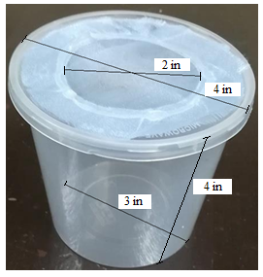
Figure 1. Improvised olfactometer

Table 1. Assignment of treatment application
Method of Extraction | Extracting Solvent
Method of Extraction | Rice Wine  (S₁) | Rice Wash  (S₂) | Apple Cider  (S₃) | Distilled Water  (S₄)
Hot infusion (E₁) | T1 = E₁S₁ | T5 = E₁S₂ | T9 = E₁S₃ | T13 = E₁S₄
Maceration (E₂) | T2 = E₂S₁ | T6 = E₂S₂ | T10 = E₂S₃ | T14 = E₂S₄
Hot reflux (E₃) | T3 = E₃S₁ | T7 = E₃S₂ | T11 = E₃S₃ | T15 = E₃S₄
Fermentation (E₄) | T4 = E₄S₁ | T8 = E₄S₂ | T12 = E₄S₃ | T16 = E₄S₄

Results and Discussion
Sixteen extracts from the extraction x solvent combinations were obtained. The colour, odour, and other characteristics of the extracts are described in Table 2.

Green synthesis of copper nanoparticles
The method described by Harne et al. [18] in the green synthesis of copper nanoparticles (CuNPs) uses 1 mM copper sulfate solution and extracts. Optimum conditions for the CuNP synthesis in each treatment are indicated in Table 3. The optimum pH ranges from 4-11.8, while the optimum temperature falls around 60-100°C. On the other hand, the optimum volume ratio is 20:80, except for E3S1, which is 10:90.

Insecticidal activity
The potential insecticidal activity of the different treatments (Table 4) was performed in three replicated procedures. Test for mortality was observed after 6, 12, and 24 hours after treatment application. Mortality rates were corrected using Abbot’s formula. Analysis of variance revealed that the treatments are significantly different. Post hoc analysis using Duncan multiple range test (DMRT) further revealed which treatment is the most effective. T9 (E₁S₃), which used hot infusion–apple cider vinegar extract copper nanosuspension, produced the highest mortality rate against adult male oriental fruit fly at 91.67% with only 6 hours exposure. Other treatments that showed activity were T2, T3, T13, and T14, but with low percent mortality of 8.33%, 25.00%, 33.33%, and 8.33%, respectively. Rice wine was used as the solvent in treatments T2 and T3; while distilled water, in T13 and T14. The treatments that utilized rice wash as solvents (T5-T8) did not show any activity at 6 hours of exposure.

At 12 hours exposure, the percent mortality of the different treatments ranged from 0% to 91.67%, with T9 showing the highest mortality (91.67%), followed by T4 (41.67%), T13, and T14 (33.33%). Other treatments yielded around 0–25% mortality only.

At 24 hours exposure, only T5 and T11 showed no activity to Oriental fruit fly, while only T4, T9, T14, and T15 yielded mortality rates of 50% and above. Analysis of Variance of the different treatments showed significant differences measured at a level of 5%. Post hoc analysis further identified which treatments produced the highest mortality rates. Table 4 shows the differences in treatments. T15 and T9 were effective against oriental fruit fly. T15 utilized distilled water as solvent and employed continuous reflux for 8 hours. Meanwhile, apple cider vinegar was used in T9 and extracted through hot infusion.

Insecticidal activities of the sambong-CuNP (dried powder) (Table 5) revealed that the mortality rate was at 87.50% at 6 hours exposure, and 100% at 12 hours. Only a few treatments resulted in a mortality of less than 100% after 24 hours exposure. These were T4, T5, T10, T12, and T16. The effectiveness of T9 (apple cider vinegar-sambong extract by hot infusion) may be due to the chemicals released by the apple cider, such as acetic acid, acetone, ethanol, and methanol. These chemicals are key olfactory signals for fruit flies, while related metabolites are specific gene disruptors. In addition to these chemicals, the bioactive components in sambong that were extracted may have had a synergistic effect that caused the mortality of the fruit flies within 6 hours exposure.

T9 still showed the highest mortality rate at 6 hours exposure to the dried nanopowder, but not significantly different from T1, T3, and T14. At 12 hours exposure, T1, T2, T3, T7, and T14 were the most effective treatments resulting in 100% mortality each. T9’s mortality, which yielded the highest within 6 hours exposure only, increased to 100% at 24 hours.

Table 2. Description of different extracts
Method of Extraction | Extracting Solvent
Method of Extraction | Rice Wine (S₁) | Rice Wash (S₂) | Apple Cider (S₃) | Distilled Water (S₄)
Hot infusion (E₁) | Dark brown with aromatic, sweet odor | Dark brown with aromatic odor | Dark brown with aromatic but sour odor | Brown with aromatic odor
Maceration (E₂) | Brown with sweet odor | Brown with sweet odor | Brown with sour odor | Brown with aromatic odor
Hot reflux (E₃) | Blackish brown, sweet caramel odor | Dark brown with aromatic odor | Dark brown with aromatic and sour odor | Dark brown with aromatic odor
Fermentation (E₄) | Brown with sweet odor | Light brown with a little off odor | Brown with sour odor | Brown with strong off odor
Table 3. Optimum conditions for the green synthesis of copper nanoparticles and the corresponding λ_{max}
and absorbance
Treatments | pH | Temperature | Volume Ratio | λ_{max}, nm | Abs
T1 = E₁S₁ | 11 | 97 | 20:80 | 545 | 3.793
T2 = E₂S₁ | 7.81 | 60 | 20:80 | 543 | 3.715
T3 = E₃S₁ | 10 | 80 | 10:90 | 460 | 3.486
T4 = E₄S₁ | 10 | 100 | 20:80 | 591 | 3.769
T5 = E₁S₂ | 11 | 100 | 20:80 | 546 | 3.744
T6 = E₂S₂ | 11.8 | 60 | 20:80 | 530 | 3.597
T7 = E₃S₂ | 10 | 90 | 20:80 | 537 | 3.735
T8 = E₄S₂ | 8.94 | 60 | 20:80 | 526 | 3.663
T9 = E₁S₃ | 11 | 100 | 20:80 | 554 | 3.685
T10 = E₂S₃ | 6.25 | 60 | 20:80 | 534 | 3.772
T11 = E₃S₃ | 4 | 60 | 20:80 | 544 | 4.173
T12 = E₄S₃ | 11.69 | 60 | 20:80 | 483 | 3.475
T13 = E₁S₄ | 11 | 90 | 20:80 | 592 | 3.669
T14 = E₂S₄ | 10.74 | 70 | 20:80 | 539 | 3.785
T15 = E₃S₄ | 10.69 | 80 | 20:80 | 563 | 3.728
T16 = E₄S₄ | 5.36 | 60 | 20:80 | 528 | 3.627

Table 4. Percent mortality of adult male fruit flies observed under different treatments
and exposure times (sambong-copper nanosuspension)
Treatment | Mean Percent Mortality*
Treatment | 6 hours | 12 hours | 24 hours
T1 = E₁S₁ | 0.00^{c} | 0.00^{d} | 41.67^{bc}
T2 = E₂S₁ | 8.33^{c} | 25.00^{bc} | 41.67^{bc}
T3 = E₃S₁ | 25.00^{b} | 25.00^{bc} | 41.67^{bc}
T4 = E₄S₁ | 0.00^{c} | 41.67^{b} | 50.00^{b}
T5 = E₁S₂ | 0.00^{c} | 0.00^{d} | 0.00e
T6 = E₂S₂ | 0.00^{c} | 25.00^{bc} | 41.67^{bc}
T7 = E₃S₂ | 0.00^{c} | 8.33^{cd} | 25.00^{cd}
T8 = E₄S₂ | 0.00^{c} | 0.00^{d} | 16.67de
T9 = E₁S₃ | 91.67ª | 91.67ª | 91.67ª
T10 = E₂S₃ | 0.00^{c} | 0.00^{d} | 16.67de
T11 = E₃S₃ | 0.00^{c} | 0.00^{d} | 0.00e
T12 = E₄S₃ | 0.00^{c} | 0.00^{d} | 16.67de
T13 = E₁S₄ | 33.33^{b} | 33.33^{b} | 33.33^{cd}
T14 = E₂S₄ | 8.33^{c} | 33.33^{b} | 50.00^{b}
T15 = E₃S₄ | 0.00^{c} | 8.33^{cd} | 75.00ª
T16 = E₄S₄ | 0.00^{c} | 8.33^{cd} | 8.33de

*Means with the same letter superscript in a column are not significantly different at 5% level using DMRT

Table 5. Percent mortality of adult male fruit flies observed under different treatments
and exposure times (sambong-CuNP powder)
Treatment | Mean Percent Mortality*
Treatment | 6 hours | 12 hours | 24 hours
T1 = E₁S₁ | 75.00ª | 100.00ª | 100.00ª
T2 = E₂S₁ | 62.50^{ab} | 100.00ª | 100.00ª
T3 = E₃S₁ | 75.00ª | 100.00ª | 100.00ª
T4 = E₄S₁ | 0.00^{b} | 50.00^{abc} | 50.00^{b}
T5 = E₁S₂ | 0.00^{b} | 37.50^{bc} | 62.50^{b}
T6 = E₂S₂ | 50.00^{ab} | 62.50^{ab} | 100.00ª
T7 = E₃S₂ | 25.00^{ab} | 100.00ª | 100.00ª
T8 = E₄S₂ | 50.00^{ab} | 75.00^{ab} | 100.00ª
T9 = E₁S₃ | 87.50ª | 87.50^{ab} | 100.00ª
T10 = E₂S₃ | 0.00^{b} | 12.50^{c} | 62.50^{b}
T11 = E₃S₃ | 0.00^{b} | 37.50^{bc} | 100.00ª
T12 = E₄S₃ | 25.00^{ab} | 62.50^{ab} | 62.50^{b}
T13 = E₁S₄ | 37.50^{ab} | 75.00^{ab} | 100.00ª
T14 = E₂S₄ | 75.00ª | 100.00ª | 100.00ª
T15 = E₃S₄ | 0.00^{b} | 50.00^{abc} | 100.00ª
T16 = E₄S₄ | 25.00^{ab} | 50.00^{abc} | 50.00^{b}
*Means with the same letter superscript in a column are not significantly different at 5% level using DMRT

The sambong-CuNP powder was more effective in eradicating oriental fruit flies compared with the sambong-copper nanosuspension. This result may be due to the higher diffusivity of the powder to the fruit fly than the nanosuspension. The most common means of contact between a toxicant and a living organism is through accidental or deliberate application to the integument (e.g., insect cuticle or vertebrate skin), or ingestion with food followed by absorption through the walls of the alimentary tract. After ingestion, the toxicant enters the hemolymph where it may be carried to all parts of the organism as a dissolved solution, a particle bound to protein, or one dissolved in lipid particles [21]. As the sambong-copper nanosuspension or nanopowder was placed on top of the olfactometer where the fruit flies tended to stay, there was a high possibility that the insects flew near the bait, causing the nanosuspension to accumulate on the wings (Figure 2a), dried nanoparticles gathered on the different parts of the fruit fly’s body (Figure 2b), and on the compound eye (Figure 2c).

Fourier transform infrared (FTIR) spectroscopic and scanning electron microscopic (SEM) analyses
The FTIR spectra of the four solvents are presented in Figure 3. The broad band of the O-H stretching in all the solvents are evident. This band (3000–3500 cm⁻¹) is due to the OH group present in all the solvents. However, the OH for apple cider vinegar and rice wine, respectively, have lower intensities. This can be the alcohol group for the rice wine and the polyphenolics in the apple cider vinegar. The water used to prepare the rice wash was distilled water; hence, there are similarities between the peaks for rice wash and distilled water.

There were changes in the bands at 3300 cm⁻¹ and 1600 cm⁻¹ corresponding to O-H stretching of alcohols and phenols, and carbonyl stretching (Figure 4). These changes in the IR spectra suggested that the CuNPs are being surrounded by different organic molecules present in the different extracts [18]. The spectra also justified the differences among the mortality rates of the nanoparticles against B. dorsalis.

Moreover, mortality may be related to the shape or size of the nanoparticles. The surface morphology of the nanoparticles produced using the different extracts analyzed with SEM is presented in Figure 5.

Based on the insecticidal activities of the extracts and the diameter of the synthesized CuNPs, larger CuNPs resulted in lower insecticidal activities. Among the CuNPs produced, only T9 (E₁S₃) yielded the highest mortality at 91.67%. The CuNP diameters range from 49 to 96 nm, which fall under the range of nanomaterials. Other treatments yielded copper nanoparticles greater than 100 nm. The formation of aggregates can be one explanation for this large particle size, as copper nanoparticles aggregate rapidly in water suspension [22]. Considering the diameter of the nanoparticles above, there were more particles with a diameter greater than 100 nm than those with less than 100 nm.

Studies have also shown that the size of nanoparticles found on the insect’s wings may vary from 200 to 1000 nm. The structures have a rounded shape at the apex and protrude some 150–350 nm out of the surface plane. These wing nanoparticles help with the insect’s aerodynamic efficiency [23].

The nanoparticles produced from different extracts have diverse shapes. Irregular shapes can be observed in E₁S₁, while spherical shapes and flakes can be distinguished in E₁S₃ and E₁S₄, respectively. These three treatments were extracted by hot infusion. Spherical and irregularly shaped nanoparticles were also observed in E₂S₂ and E₂S₄, respectively. Both were prepared by maceration. E₃S₁ and E₃S₂ seemed to have produced blocks or rectangular shapes. Nanoparticles prepared using fermentation had different shapes as well. E₄S₁ produced irregular-shaped particles, while E4S4 had mostly spherical.

Energy dispersive spectroscopic (EDS) analysis
The energy of the characteristic radiation within a given series of lines varies monotonically with the atomic number. This is Moseley’s Law:

E = C₁ (Z – C₂)²

where E is defined as energy of the emission line for a given X-ray series, Z is atomic number of the emitter C₁ and C₂ are constants.

Moseley’s Law is the basis for elemental analysis with EDS. If the energy of a given K, L, or M line is measured, then the atomic number of the element producing that line can be determined. The K, L, and M series X-rays increase in energy with increasing atomic number. The following figures present the EDS analyses of four samples showing the differences in their copper content as affected by the synthesized nanoparticles.

Based on the EDS analysis of the four representative sambong-CuNP (Figure 6), the copper nanoparticles emitted X-rays of the K and L series. The peaks observed at 8 and 9 keV were X-rays from the K series, while the peaks at 1 keV were from the L series. Copper is an intermediate element characterized by these X-ray emissions. X-ray emissions for C and O in the L series indicated that the active components were with the nanoparticle, which means the copper nanoparticle is being capped by the organic components.

The occurrence of small amounts of P, S, Cl, Fe, and Ca (Figure 7) was likely due to some of the macro- and micro-elements needed by the plants, which may have been extracted together with the active components of the sambong leaves. E₁S₁, E₂S₄, E₃S₁, and E₄S₁ have percent Cu of 27.11%, 31.57%, 1.26%, and 17.72%, respectively. E₂S₄ contained the highest amount of Cu but corresponded only to 8.33%, 33.33%, and 50.00% mortality in the nanosuspension. However, the extract rated higher in the powdered nanoparticles, with 75%, 100%, and 100% mortality at 6, 12, and 24 hours, respectively. These were the lumps or aggregates, as
seen in Figure 5e. Moreover, E₃S₁ contained the lowest amount of Cu, but had the highest amount of C. Figure 5f displays the Cu nanoparticles embedded in the organic moieties. This means that the copper nanoparticles formed from rice wine extract by Soxhlet method did not form aggregates or were well-dispersed in the suspension. This may be the reason behind the high percent mortality (75% in 6 hours exposure, and 100% in 12 hours exposure) that was registered in the dried nanoparticles of E₃S₁. In the case of E₃S₁ nanosuspension, lower percent mortality was observed compared with the dried nanoparticles. This contrasts with Singh’s [24] findings that chemicals in solution were more effectively absorbed than chemical powder. Nevertheless, the results conform to Fick’s law of diffusion. The kinetics of penetration into insect cuticle appear to be predictable from this law, which lead to a first-order form in which the rate of penetration at any time is proportional to the amount on the “outside” at that time [21]. As the nanoparticles were attached to the different parts of the fruit fly’s body (Figure 2), penetration into the cuticle most likely occurred, triggering the death of the fly.

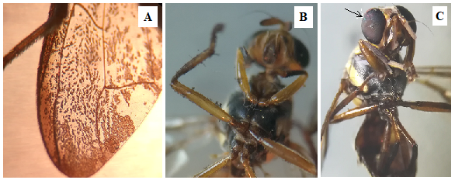
c
b
a
Figure 2. Accumulation of (a) nanosuspension on the wings; nanopowder on the (b) legs; and (c) compound eye

Figure 3. FTIR spectra of the four solvents

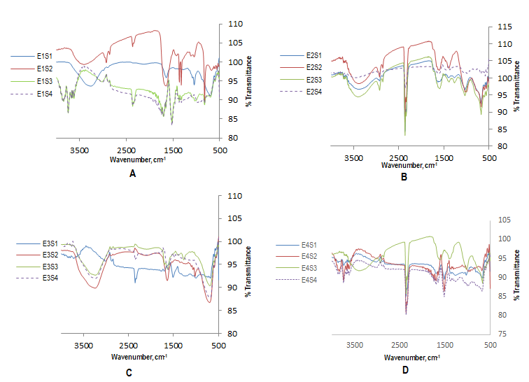
d
c
a
b
d
b
Figure 4. FTIR spectra of the CuNPs as affected by the solvents used in the four methods of extraction: (a) hot infusion; (b) maceration; (c) hot reflux; and (d) fermentation (S1 = rice wine; S2 = rice wash; S3 = apple cider vinegar; S4 = distilled water)

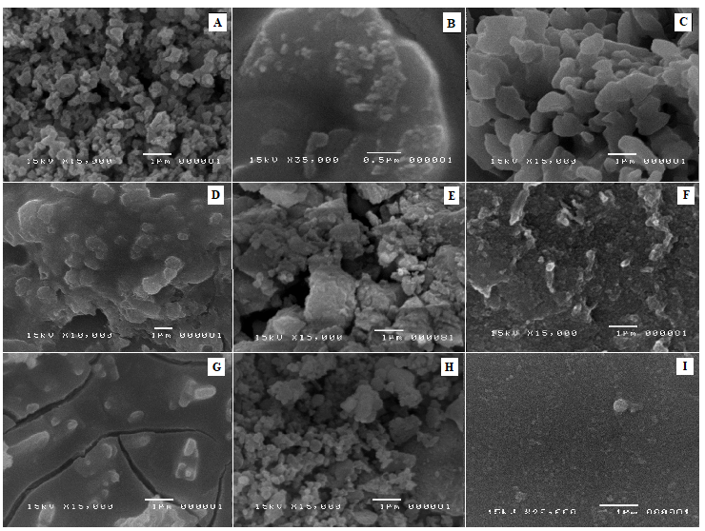
g
a
i
h
f
e
d
c
b
Figure 5. SEM photomicrograph of green synthesized CuNPs using (a) rice wine-hot infusion (E₁S₁); (b) apple cider vinegar-hot infusion (E₁S₃); (c) distilled water-by hot infusion (E₁S₄); (d) rice wash-maceration (E₂S₂); (e) distilled water-maceration (E₂S₄); (f) rice wine-hot reflux (E₃S₁); (g) rice wash-hot reflux (E₃S₂); (h) rice wine-fermentation (E₄S₁); and (i) distilled water-fermentation (E₄S₄)

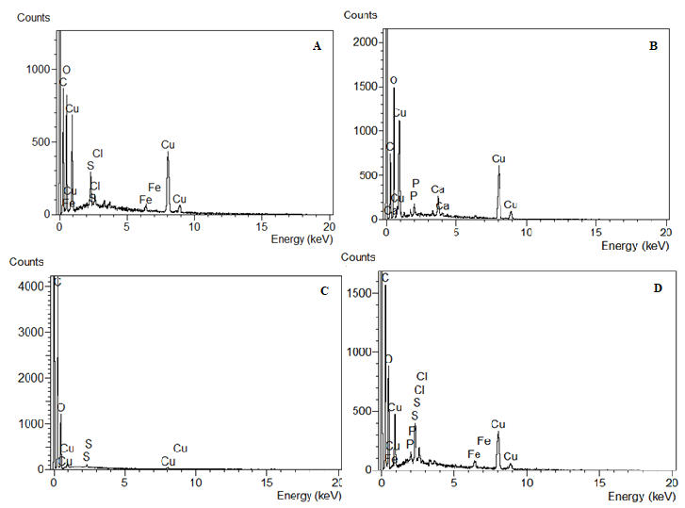
d
b
c
a
Figure 6. EDS analysis for some representative sample (a) E₁S₁; (b) E₂S₄; (c) E₃S₁; and (d) E₄S₁

Figure 7. Elemental percent composition of the four extracts

Conclusion
The insecticidal components of sambong (Blumea balsamifera) leaves against oriental fruit fly, Bactrocera dorsalis (Hendel), were extracted using four green solvents, namely rice wine, rice wash, apple cider vinegar, and distilled water, employing hot infusion, maceration, fermentation, and Soxhlet extraction methods. These extracts were used in the synthesis of copper nanoparticles (CuNPs). The suspensions of nanoparticles were centrifuged, and the aggregates were separated and dried. Then, the dried aggregates and the colloidal suspensions of copper nanoparticles were tested against male adult Oriental fruit flies. Both dried aggregates and nanosuspensions had effects on the fruit flies, with mortality rates ranging from 25% to 100% within 12 hours exposure. However, the dried aggregates yielded higher mortality rates than the nanosuspensions. Thus, sambong can be used in the preparation of nanoparticle-enhanced biocide either as suspension concentrate, or dust or powder with suitable sorption material, and as an alternative method in the management of oriental fruit fly as well.

Acknowledgment
The authors wish to acknowledge Mr. and Mrs. Juanito Palaganas and Dr. Luzviminda S. Quitos for their assistance in the collection of samples. Due appreciation also goes to Dr. Adelina P. Valdez, Dr. Glenn V. Alea, Dr. Marita S. Labe, Ms. Rhanney L. Gonzales, and Ms. Ella Joyce S. Paragas for the assistance they extended in the improvement of this study.

References
- Sharpe, R. M. and Irvine, D. S. (2004). How strong is the evidence of a link between environmental chemicals and adverse effects on human reproductive health?. British Medical Journal, 328(7437): 447.
- Pingali, P. L. and Roger, P. A. (2012). Impact of pesticides on farmer health and the rice environment (Vol. 7). Springer Science & Business Media.
- Mahmood, I., Imadi, S. R., Shazadi, K., Gul, A. and Hakeem, K. R. (2016). Effects of pesticides on environment. In Plant, soil, and microbes. Springer: pp. 253-269.
- Tubbs, C. W. and McDonough, C. E. (2018). Reproductive impacts of endocrine-disrupting chemicals on wildlife species: implications for conservation of endangered species. Annual Review of Animal Biosciences, 6: 287-304.
- Ndakidemi, B., Mtei, K. and Ndakidemi, P. A. (2016). Impacts of synthetic and botanical pesticides on beneficial insects. Agricultural Sciences, 7(06): 364.

- Gupta, S. and Dikshit, A. K. (2010). Biopesticides: an ecofriendly approach for pest control. Journal of Biopesticides, 3(1): 186-188.
- Thakore, Y. (2006). The biopesticide market for global agricultural use. Industrial Biotechnology, 2(3):194-208.
- Lichtfouse, E. (2013). Sustainable agriculture reviews (Vol. 13). Springer Science & Business Media.
- Pang, Y., Wang, D., Fan, Z., Chen, X., Yu, F., Hu, X., and Yuan, L. (2014). Blumea balsamifera - A phytochemical and pharmacological review. Molecules, 19(7): 9453-9477.
- Yuan, N. N., Hou, H. Y., Wang, J., Chen, Y. Z. and Xie, P. B. (2012). The research status of chemical constituents and activities of Blumea DC. [J]. Guangzhou Chemical Industry, 24: 015.
- Nessa, F., Ismail, Z., Mohamed, N. and Haris, M. R. H. M. (2004). Free radical-scavenging activity of organic extracts and of pure flavonoids of Blumea balsamifera DC leaves. Food Chemistry, 88(2): 243-252.
- Pang, Y., Wang, D., Hu, X., Wang, H., Fu, W., Fan, Z. and Yu, F. (2014). Effect of volatile oil from Blumea balsamifera (L.) DC. leaves on wound healing in mice. Journal of Traditional Chinese Medicine, 34(6): 716-724.
- Sivapragasam, A. (2009). Biopesticides from Malaysian flora–resources for sustainable pest management. In Discovering opportunities, expanding the economic horizon. Proceedings of the National Conference on New Crops and Bioresources, Seremban, Malaysia, 15–17 December 2009: pp. 125-132.
- Glova III, F. and Ines, M. C. (1989). Evaluation of selected botanical pesticides against rice green leafhopper Nephotettix virescens. In Pest Control Council of the Philippines, Baguio City (Philippines), 9–12 May 1989.
- Ines, M. C. and Baga, L. P. N. (1990). Evaluation of botanical pesticides against Fusarium rot of garlic. In 21. Pest Control Council of the Philippines Annual Convention, Bacolod City (Philippines), 7–10 May 1990.

- Suharto, H. (2002). Golden apple snail, Pomacea canaliculata (Lamarck) in Indonesia. Los Banos, Laguna, SEAMEO Regional Center for Graduate Study and Research in Agriculture (SEARCA), Philippines, 69–73.
- Sebastian, L. S. (2003). Management options for the golden apple snail. Access from http://issg.org/database/species/reference_files/pomcan/pest_management.pdf. [Access online 05 December 2017].
- Harne, S., Sharma, A., Dhaygude, M., Joglekar, S., Kodam, K. and Hudlikar, M. (2012). Novel route for rapid biosynthesis of copper nanoparticles using aqueous extract of Calotropis procera L. latex and their cytotoxicity on tumor cells. Colloids and Surfaces B: Biointerfaces, 95: 284-288.
- Abbott, W. S. (1978). A method of computing the effectiveness of an insecticide. Journal of the American Mosquito Control Association, 3(2):302-303.

- Cha, D. H., Adams, T., Werle, C. T., Sampson, B. J., Adamczyk, J. J., Jr., Rogg, H. and Landolt, P. J. (2014). A four-component synthetic attractant for Drosophila suzukii (Diptera: Drosophilidae) isolated from fermented bait headspace. Pest Management Science, 70: 324-331.
- Wilkinson, C. F. (1976). Insecticide biochemistry and physiology. Plenum Press.
- Griffitt, R. J., Weil, R., Hyndman, K. A., Denslow, N. D., Powers, K., Taylor, D. and Barber, D. S. (2007). Exposure to copper nanoparticles causes gill injury and acute lethality in zebrafish (Danio rerio). Environmental Science & Technology, 41(23): 8178-8186.
- Ragaei, M. and Sabry, A. K. H. (2014). Nanotechnology for insect pest control. International Journal of Science, Environment And Technology, 3(2): 528-545.
- Singh, A. K. (2015). Engineered nanoparticles: Structure, properties, and mechanisms of toxicity. Academic Press.

