

IDENTIFICATION AND QUANTIFICATION OF FRUCTOSE, GLUCOSE AND SUCROSE IN WATERMELON PEEL JUICE

(Pengenalan dan Pengkuantitian Fruktosa, Glukosa dan Sukrosa di dalam Jus Kulit Tembikai)

Wan Mazlina Md. Saad¹*, Nur Shafinaz Mohamad Salin¹, Ainza Suzila Ramzi¹, Fatimah Salim^{2,3}

¹Centre of Medical Laboratory Technology, Faculty of Health Sciences
²Atta-ur-Rahman Institute for Natural Product Discovery
Universiti Teknologi MARA, Selangor Branch, 42300 Puncak Alam, Selangor, Malaysia
³Centre of Foundation Studies,
Universiti Teknologi MARA, Selangor Branch, Dengkil Campus, 43800 Dengkil, Selangor, Malaysia

*Corresponding author:

Received: 20 November 2019; Accepted: 12 April 2020; Published: June 2020

Abstract
Watermelon (Citrullus lanatus) contains various chemical components with sugar rating the highest. Sugar content in watermelon usually reflects the fruit quality and sweetness. Watermelon sugar is mainly distributed into three types; fructose, glucose and sucrose. This study was conducted to identify and quantify fructose, glucose and sucrose in watermelon peel juice by using a reversed-phase high-performance liquid chromatography (RP-HPLC) method coupled with refractive index detector (RID). The separation of sugars was carried out on NH₂ column thermostatically maintained at 23°C. The flow rate used was 1.00 mL/min on 20 µL sample injection. An isocratic elution mode of mobile phase acetonitrile and water (75:25) was used for duration of 20 minutes. Fructose and glucose were eluted at minutes 8.88 and 10.00, respectively while sucrose was not detected. The amount of quantified fructose (0.60 mg/mL) and glucose (0.50 mg/mL) indicated that fructose was the highest sugar content in the watermelon peel juice, followed by glucose. This study described the ability of HPLC-RID method which is suitable for profiling major sugars content in watermelon peel juice. The analytical method was validated, and the results showed good precision, accuracy, and linearity.

Keywords: watermelon peel, Citrullus lanatus, peel, fructose, glucose, sucrose

Abstrak
Tembikai (Citrullus lanatus) mengandungi pelbagai komponen kimia di mana kandungan gula adalah yang paling tinggi. Kandungan gula di dalam tembikai biasanya menjadi penentu kepada kualiti dan kemanisan buah. Gula di dalam tembikai terbahagi kepada tiga jenis; fruktosa, glukosa dan sukrosa. Kajian ini dijalankan untuk mengenalpasti dan pengkuantitian kandungan fruktosa, glukosa dan sukrosa di dalam jus kulit tembikai dengan menggunakan kaedah fasa terbalik kromatografi cecair berprestasi tinggi (RP-HPLC) digandingkan dengan pengesan indeks biasan (RID). Pemisahan kandungan gula tersebut dilakukan dalam turus NH₂ dengan pengawalan suhu 23°C. Kadar aliran yang digunakan ialah 1.00 mL/min pada muatan sampel 20 μL. Mod elusi isokratik dengan gabungan pelarut asetonitril dan air (75:25) digunakan dalam durasi 20 minit. Fruktosa dan glukosa dielusi masing-masing pada minit ke 8.88 dan 10.00, manakala tiada sukrosa dikesan. Jumlah pengkuantitian fruktosa (0.60 mg/mL) dan glukosa (0.50 mg/mL) dalam jus kulit tembikai menunjukkan bahawa fruktosa adalah gula yang paling banyak di dalam jus kulit tembikai, diikuti oleh glukosa. Dapatan kajian ini menerangkan keupayaan kaedah HPLC-RID dalam memprofil jenis gula utama di dalam jus kulit tembikai. Kaedah analitikal yang digunakan di sini telah divalidasi dan dapatan kajian menunjukkan kejituan, ketepatan dan kelinearan.

Kata kunci: kulit tembikai, Citrullus lanatus, kulit, fruktosa, glukosa dan sukrosa

Introduction
Watermelon or scientifically known as Citrullus lanatus belongs to Cucurbitaceous family. It has been widely cultivated by approximately 7% of the world’s total vegetable production in warm and subtropical countries [1]. Watermelon is also known as “the king of fruits in summer” and contains about 93% of water. Hence the name ‘water’ while melon refers to the large, round, sweet and pulpy flesh [2]. Watermelon beneficial to human health as it contains phytochemicals including lycopene, phytofluene, phytoene, beta-carotene and lutein [3] besides minerals, proteins and fibres [4]. Typically a watermelon weighs from 1.5 to 15 kilogrammes and is elongated, oval or round. Hannah and Krishnakumari supported that an average watermelon contains about 30% peel (also known as rind), 68% flesh and 2% seed [3]. The peel stripes appear from light to dark green with various patterns. The flesh commonly found in yellow, red, orange or white [5], with the flesh colour represents its sweetness [6].

Malaysians usually prefer watermelon as a dessert due to its delicious, sweet and refreshing taste. In addition, it is an affordable fruit that is readily available in the market. The main soluble sugars in watermelon include fructose, glucose and sucrose with the sugar ratio determining the fruit sweetness [7]. Among these sugars, fructose contributes the highest taste of sweetness in the fruit. In the early stage of its growth, a higher concentration of glucose and fructose are found with only sucrose detected when the fruit reaches maturity [4]. In a mature watermelon, sucrose and glucose concentration ranges from 20-40% while fructose concentration is approximately 30-50% [8].

Currently, many types of new instruments and methods are available for sugar analysis [9]. The common method used for determination and separation of fructose, glucose and sucrose is high-performance liquid chromatography (HPLC) with ideal detectors and columns [10, 11]. Columns that are widely used for sugar separation are carbohydrate and amino bonded columns [12]. The most common detectors that could be used for quantification of sugars are pulsed amperometric detector (PAD), evaporative light scattering detector (ELSD) and refractive index detector (RID). In this study, isocratic mode reversed-phase high-performance liquid chromatography (RP-HPLC) method was chosen with ZORBAX NH₂ column and refractive index detector (RID) were used in identifying and quantifying fructose, glucose and sucrose in watermelon juice peel.

Materials and Methods
Chemicals and reagents
Analytical grade powder of D-(-)-Fructose (≥ 99%), D-(+)-Glucose (≥ 99.5%) and sucrose (≥ 99.5%) standards were purchased from Sigma-Aldrich (St. Louis, MO, USA). Acetonitrile (MeCN) and methanol (MeOH) of HPLC grade were purchased from Merck (Germany).

Instrument
The isocratic-mode RP-HPLC was carried out using Agilent 1200 (Agilent Technology, 1200 Series) equipped with an auto-sampler injector (G1330B), column oven and refractive index detector (RID) for detection of fructose, glucose and sucrose. The column used was ZORBAX (Agilent) NH₂ column, 5µm (4.5 x 250mm).

Sample preparation
Four watermelons ranging from 2.0 to 2.8 kg (Citrullus lanatus) were obtained from Selangor Fruit Valley, Selangor, Malaysia and were identified by Forest Research Institute Malaysia (FRIM) with reference no. FRIM394/490/5/17(650). The watermelons were washed and wiped with tissue papers. Then, the watermelon was peeled and weighed before juicing, and filtered with Whatman Filter paper to clarify the sample.
Preparation of standard solution
10 mg of each fructose, glucose and sucrose standard were dissolved in 1.5 mL of MeCN and water solution (2:1), and then filtered through 0.45-µm polyvinylidene fluoride (PVDF) syringe filter. A series of working solutions were prepared by diluting stock solution two-folds in ranges 0.31-5.00 mg/mL.

Sample preparation procedure
150 µL peel juice was filtered using 0.45- µm polyvinylidene fluoride (PVDF) syringe filter into 2 mL HPLC vial prior for injecting into RP-HPLC.

Isocratic mode reverse-phase high-performance liquid chromatography
Identification and quantification of fructose, glucose and sucrose were performed according to a study performed by Sabeetha et al. with slight modification [4]. The isocratic mode of RP-HPLC was conducted using NH₂ column 5 µm (4.5 x 250 mm) (ZORBAX, Agilent) at temperature (23 °C) with flow rate of 1 mL/min of mobile phase MeCN and water (75:25). Separation and detection of fructose, glucose and sucrose was carried out by injecting 20 µL of standard and sample of watermelon peel juice triplicate into NH₂ column coupled with refractive index detector (RID) at 35°C. After each analysis, the column was washed with isopropanol.

Method validation
The validation of this study was achieved by determining the linearity of calibration curve, limit of detection (LOD), limit of quantification (LOQ) and % recovery. The linearity of isocratic-mode RP-HPLC method for fructose, glucose and sucrose detection in watermelon peel juice was determined by injecting triplicate of 20 µL of 5 different concentrations of standards at 0.31, 0.63, 1.25, 2.50, 5.00 mg/mL. Calibration curve of peak area against each standard concentration was constructed to obtain linear equation and regression coefficient (R²). LOD is the lowest amount of sugar that could be detected in the sample while LOQ is the lowest amount of sugar that could be quantitatively determined with suitable precision and accuracy by using statistical calculation [13]. Three different concentration of 5.00, 2.50 and 1.25 mg/mL for each standard solution were injected triplicate to evaluate the accuracy and % recovery of method used as referred to Kayesh et al. [14] .The LOD, LOQ and recovery were calculated using the formula in equations 1-3:

LOD : $\frac{3 x Standard deviation of response}{Slope of calibration curve}$ (1)

LOQ : $\frac{10 x Standard deviation of response}{Slope of calibration curve}$ (2)

% Recovery : $\frac{Recovered concentration}{Injected concentration} x100$ (3)

Statistical analysis
The result of analyses were presented as mean ± standard deviation based on three replicates. Microsoft Excel 2007 (Microsoft Corporation, Redmond, WA, USA) was used for data analysis.

Results and Discussion
Identification of fructose, glucose and sucrose in watermelon juice peel
This study demonstrated the analytical isocratic mode RP-HPLC method for separation of sugars in watermelon peel juice. The representative chromatograms for standards and sample by using RP-HPLC are shown in Figure 1. The chromatographic peaks were identified by comparing the retention time of the injected fructose, glucose and sucrose standards solution against watermelon peel juice. In order to obtain a good analysis of fructose, glucose and sucrose, method was adapted from Veena et al. with slight modification [12]. Triplicated injection of 20 μL standards and sample using isocratic mode RP-HPLC with thermostatic NH₂ column coupled with RID showed the best results with noise eliminated. A flow rate of 1 mL/min pre-mixture of MeCN and water (75:25, v/v) as mobile phase showed the optimum ratio composition that is able to improve the separation and resolution of targeted fructose, glucose and sucrose component as performed by Sabeetha et al. and Karkacier et al. [4,14].

In Figure 1, a good peak separation was presented with the first elution peak detected is fructose followed by glucose and sucrose, which is in line with study by Sabeetha et al. [4]. Figure 1(a) shows RP-HPLC chromatogram of fructose, glucose and sucrose mixed standards were detected at retention time of 8.41, 9.46 and 13.74 minutes, respectively. Figure 1(b) shows RP-HPLC chromatogram peaks of watermelon peel juice with fructose and glucose detected at retention time of 8.88 minutes and 10.00 minutes respectively with no detection of sucrose as tabulated in Table 1. Chromatogram peaks in Figures 1(a) and 1(b) with retention time 3.193 and 3.167 minutes show the mobile peak of MeCN and water solution. The instability of the detector used may possibly cause slight changes in the chromatographic retention time of standards and sample. RID is sensitive to changes in many conditions including optical property of sugar molecule, temperature, pressure and flow rate which can affect chromatogram [15]. To overcome this limitation, an ELSD detector is strongly suggested.

Method validation

The validity of optimized method used in term of linearity, LOD, LOQ and accuracy was evaluated. In Table 2, the regression equations, LOD and LOQ for fructose, glucose and sucrose are shown. Linear equation for fructose, glucose and sucrose were y = 614063x + 152854, y = 135258x +386377 and y = 265249x +35564, respectively. Regression coefficient (R₂) values from this study were compared with data from Zhang et al. where R₂ value for fructose, glucose and sucrose were 0.9997, 0.9997, and 0.9990 respectively. Thus, it indicated that present data is reproducible as R₂ value (≥0.99) [16]. The linear regression in this study reflected a linear relationship between sugars concentration against chromatographic response [17]. The LOD of fructose, glucose and sucrose were found at 0.124, 0.054 and 0.00002 mg/mL with LOQ 0.414, 0.180 and 0.00007 mg/mL, respectively. LOD and LOQ is the lowest concentration detected and quantitatively measured reflecting the precision and accuracy of method used [13]. The lowest LOD and LOQ values in this study indicated that the method used was efficiently sensitive [18].

In Table 3, the data of accuracy for fructose, glucose and sucrose are tabulated. Accuracy was evaluated and expressed in recovery between the mean concentration and the added standard concentration found [19]. Triplicate injection of 5.00, 2.50 and 1.25 mg/mL were analysed before and after the injection of watermelon peel juice. The percentage of recovery for fructose, glucose and sucrose was found ranging from 91 to 99.4%, which is within the range reported by Uney et al. [20]. Kayesh et al. supported that more than 97% recovery demonstrated the accuracy of optimized method used [19]. Hence, the linearity, LOD, LOQ and recovery values showed that the isocratic mode RP-HPLC method used in this study was sensitive and precise in quantification of fructose, glucose and sucrose.

Quantification of fructose, glucose and sucrose in watermelon juice peel

European guidelines advises that 45-60% of our daily energy intake should come from carbohydrates including sugars [21]. The optimized method of NH₂ column and RID were applied to analyse sugar types in watermelon peel juice. In Table 4, the concentration of fructose, glucose and sucrose calculated from the linear equation obtained by calibration curve were tabulated This study reported that watermelon peel juice had the highest concentration of fructose at 0.60 mg/mL followed by glucose 0.50 mg/mL and not detected for sucrose. The result obtained agrees with Sabeetha et al. that reported the sequence of sugar type concentration found in watermelon are fructose, glucose and sucrose [4]. Yau et al. demonstrated that watermelon containing the highest concentration of fructose is in excellent condition since the degree of sweetness for fructose is 1.5-2.0 times higher than sucrose [22]. No detection of sucrose in this study may possibly be due to the negligible concentration of sucrose in the watermelon peel juice which was below the LOD and LOQ limits [4].

In addition, sucrose concentration in watermelon could only be detected after 4 weeks of maturity [4]. Thus, this study found that watermelon used had not attained a full maturity stage due to the absence of sucrose content, and suggests that the consumption of immature watermelon peel could be beneficial due to the low fructose glycaemic index properties. Through this study, the quality and value of Malaysian’s local fruits specifically watermelon, could be highlighted. Not only the flesh, but the peel also has added-value due to its low glycaemic index properties.

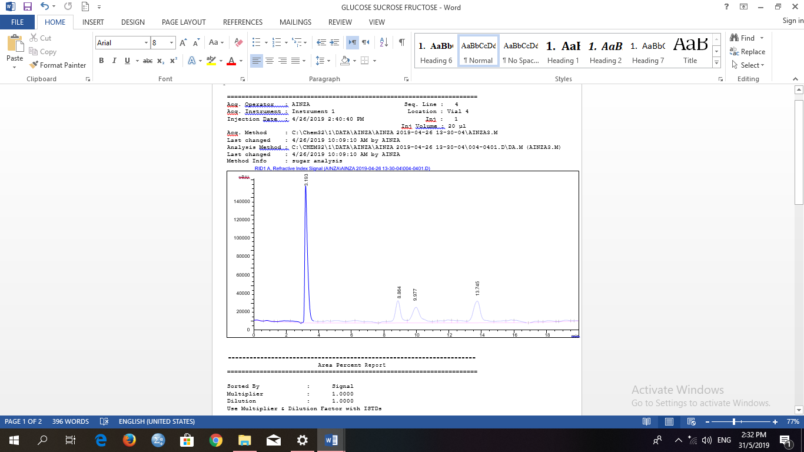
(a)

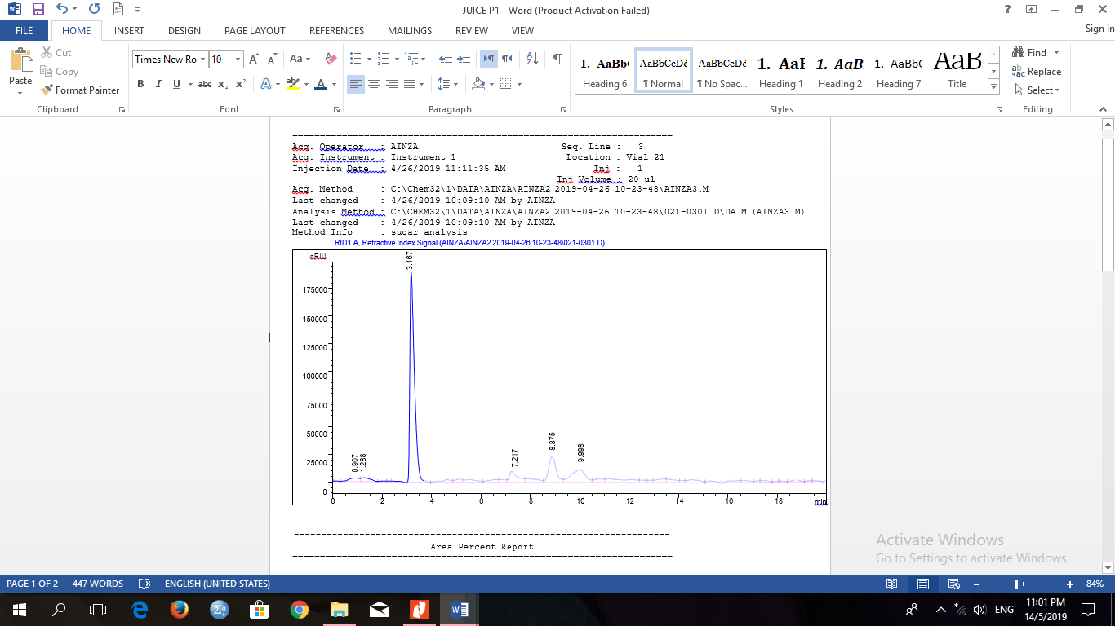
(b)

Figure 1. Comparative chromatogram of fructose, glucose and sucrose. (a) Standard of fructose, glucose and sucrose, and (b) Watermelon juice peel of fructose and glucose peak at 8.88 and 10.00 minutes, respectively with no sucrose peak mode RP-HPLC

Table 1. Retention time (min) of sugar content in standards and sample detected using isocratic
Sample |  | Retention time (minutes)
 | Fructose | Glucose | Sucrose
Standard | 8.41 | 9.46 | 13.74
Watermelon juice peel | 8.88±0.05 | 10.00±0.21 | 0.00

Table 2. Regression parameters, LOD and LOQ for fructose, glucose and sucrose
Compound | Linear Equation | Regression  Coefficient | Linear Range  (mg/mL) | LOD  (mg/mL) | LOQ  (mg/mL)
Fructose | y=614063x + 152854 | 0.9961 | 0.3-5.0 | 0.124 | 0.414
Glucose | y=135258x +386377 | 0.9938 | 0.3-5.0 | 0.054 | 0.180
Sucrose | y=265249x +35564 | 0.9993 | 0.3-5.0 | 0.00002 | 0.00007

Table 3. Recovery data for separation of fructose, glucose and sucrose using isocratic mode RP-HPLC
Sugar | Spiked Concentration  (mg/mL) | Measured Concentration  (mg/mL) | Recovery  (%)
 | 5.00 | 4.97 | 99.4
Fructose | 2.50 | 2.40 | 96.0
 | 1.25 | 1.14 | 91.0
 | 5.00 | 4.90 | 98.0
Glucose | 2.50 | 2.37 | 94.8
 | 1.25 | 1.18 | 94.4
 | 5.00 | 4.96 | 99.2
Sucrose | 2.50 | 2.48 | 99.2
 | 1.25 | 1.22 | 97.6

Conclusion
The RP-HPLC isocratic mode analysis was successfully identified and quantified the respective sugar content in watermelon peel juice in less than 15 minutes. The results showed that this method is accurate and reproducible with an excellent linearity of standards (≥0.99), low LOD and LOQ values in range of 0.00002 and 0.414 as well as accuracy of 91% to 99.4%. Fructose content is the highest in watermelon peel juice followed by glucose and no detection of sucrose. This study shows that watermelon peel has an added-value as it contains significant amount of fructose, which is a potential low glycaemic index energy source. The quality of watermelon peel can thus be highlighted not is just the flesh that is edible. This study also serves as a base reference for future plans to turn local fruit waste into wealth. However, the limitation lies on the slight instability of the RI detector used in this study which could be overcome with ELS detector.
Acknowledgement
The authors would like to acknowledge (1) Ministry of Higher Education, Malaysia, through Lestari Grant Scheme and Institute of Research Management and Innovation (IRMI), Universiti Teknologi MARA for funding the study (IRMI grant no. 600-IRMI5/3/LESTARI.(047/2019); (2) Centre of Medical Laboratory Technology, Centre of Postgraduate Study, Faculty of Health Sciences, Universiti Teknologi MARA, Puncak Alam campus, for providing facilities throughout this study; (3) Atta-ur-Rahman Institute for Natural Product Discovery (AuRIns), Universiti Teknologi MARA Puncak Alam, for workplace, (4) Instrument Laboratory of Faculty of Pharmacy for the HPLC-RID usage, and (5) Prof Dr Mohd Ilham Adenan from Universiti Teknologi MARA, Jengka Campus, Pahang Branch and En. Effendy from Selangor Fruit Valley, Selangor for providing watermelon samples.

References
- Zhang, H. and Ge, Y. U. (2016). Dynamics of sugar-metabolic enzymes and sugars accumulation during watermelon (Citrullus lanatus) fruit development. Pakistan Journal of Botany, 48(6): 2535-2538.
- Kumawat, G., Goyal, M., Mathur, K. and Yadav, S. K. (2017). Citrullus lanatus: An overview on pharmacological activities. International Journal of Pharmaceutical & Biological Archives, 8(1): 6-9.
- Angeline, C. H. M. and Krishnakumari, S. (2015). Qualitative phtochemistry profile of watermelon (Citrullus vulgaris schrad) rind extracts with different solvent. Asian Journal of Pharmaceutical and Clinical Research, 8(4): 62-65.
- Sabeetha, S., Amin, I. and Nisak, M. Y. B. (2017). Physico-chemical characteristics of watermelon in Malaysia. International Food Research Journal, 45(2): 209-223.
- Kyriacou, M. C., Leskovar, D. I., Colla, G. and Rouphael, Y. (2018). Watermelon and melon fruit quality: The genotypic and agro-environmental factors implicated. Scientia Horticulturae, 234: 393-408.
- Naz, A., Butt, M. S., Sultan, M. T., Qayyum, M. M. N. and Niaz, R. S. (2014). Watermelon lycopene and allied health claims. EXCLI Journal, 13: 650-666.
- Brown, A. C. and Summers, W. L. (1985). Carbohydrate accumulation and colour development in watermelon. Journal American Social Horticulture Science, 10: 683.
- Yativ, M., Hanary, I. and Wolf, S. (2010). Sucrose accumulation in watermelon fruits: genetic variation and biochemical analysis. Journal of Plant Physiology, 167:589-596.
- Brokl, M., Hernández-Hernández, O., Soria, A. C. and Sanz, M. L. (2011). Evaluation of different operation modes of high-performance liquid chromatography for the analysis of complex mixtures of neutral oligosaccharides. Journal of Chromatography A, 1218: 7697-7703.

- Ma, C., Sun, Z., Chen, C., Zhang, L. and Zhu, S. (2014). Simultaneous separation and determination of fructose, sorbitol, glucose and sucrose in fruits by HPLC-ELSD. Food Chemistry, 145: 784-788.
- Magwaza, L. S. and Opara, U. L. (2015). Analytical methods for determination of sugars and sweetness of horticultural products-A review. Scientia Horticulturea, 184: 179-192.
- Veena, K. S., Sameena, M. T., Padmakumari, A. K. P., Srinivasa, G. T. K., Nishanth, K. S. and Reshma, M. V. (2018). Development and validation of HPLC method for determination of sugars in palm sap, palm syrup, sugarcane jaggery and palm jaggery. International Food Research Journal, 25(2): 649654.
- Md Saad, W. M., Ridwan, R., Md, Lasim. N. S., Rapi, N. L. and Salim, F (2019). Determination and quantification of p-coumaric acid in pineapples (Ananas comosus) extracts using gradient mode RP-HPLC. Pharmacognosy Research, 2019(11): 78-82.
- Karkacier, M., Erbas, M., Uslu, M. K. and Aksu, M. (2003). Comparison of different extraction and detection methods for sugars using amino-bonded phase HPLC. Journal of Chromatography Science, 41: 331-333.
- Wilson, I. D. (2009). Handbook of methods and instrumentation in separation science. Academic press, London.
- Zhang, C-R., Aldosari, S. A., Vidyasagar, P. S., Shukla, P. and Nair, M. G. (2016). Determination of the variability of sugars in date fruit varieties. Journal of Plantation Crops, 43(1): 53-61.
- Montesano, D., Cossignani, L., Giua, L., Urbani, E., Simonetti, M. S. and Blasi, F. (2016). A simple HPLC-ELSD method for sugar analysis in goji berry. Journal of Chemisry, 2016: 5.
- Ridwan, R., Rashmizal, H., Razak, A., Adenan, M. I. and Saad, W. M. (2018). Development of isocratic RP-HPLC method for separation and quantification of L-citrulline and L-arginine in Watermelons. International Journal of Analytical Chemistry, 2018: 9.

- Kayesh, R., Sultan, M. Z., Rahman, A., Uddin, M. G., Aktar, F. and Rashid, M. A. (2013). 19.Development and validation of a RP-HPLC method for the quantification of omeprazole in pharmaceutical dosage form. Journal of Scientific Research, 5(2): 335-342.
- Uney, K., Altan, F. and Elmas, M. (2011). Development and validation of a high-performance liquid chromatography method for determination of cefquinome concentrations in sheep plasma and its application to pharmacokinetic studies. Antimicrobial Agents and Chemotherapy, 55(2): 854-859.
- EFSA Panel on Dietetic Products, Nutrition, and Allergies (2010). Scientific opinion on dietary reference values of carbohydrates and dietary fibre. EFSA Journal 8(3): 1462.
- Yau, E. W., Rosnah, S., Noraziah, M., Chin, N. L. and Osman, H. (2010). Physio-chemical composition of red seedless watermelons (Citrullus lanatus). International Food Research Journal, 17: 327-33.

