APPLICATION OF BOX-BEHNKEN DESIGN WITH RESPONSE SURFACE METHODOLOGY FOR OPTIMIZING OXYGEN COLOUR INDICATOR FOR ACTIVE PACKAGING

(Aplikasi Reka Bentuk Box-Behnken dengan Kaedah Gerak Balas Permukaan untuk Mengoptimumkan Penunjuk Oksigen Berwarna bagi Pembungkus Aktif)

Aishah Mohd Marsin¹ and Ida Idayu Muhamad^{1,2*}

¹Department of Bioprocess & Polymer Engineering,
School of Chemical and Energy Engineering,
Faculty of Engineering,
Universiti Teknologi Malaysia, 81310 UTM Johor Bahru, Johor, Malaysia
²Biomaterial Cluster, V01, IJN-UTM Cardiovasular Engineering Centre,
Faculty of Engineering,
Universiti Teknologi Malaysia, 81310 UTM Johor Bahru, Johor, Malaysia

*Corresponding author: idaidayu@utm.my

Abstract

The present work develops carrageenan-based oxygen colour indicator strip films using redox dye to improve the mechanical properties and efficiency of the strip in indicating the presence of oxygen. The optimized percentages of carrageenan (0.6-1.0%) as base medium, titanium dioxide (3.2-4.8%) as semiconductor photocatalyst, glycerol (3.6-4.8%) as sacrificial electron donor and methylene blue as redox dye were determined by applying Box-Behnken design and response surface methodology. It aims to achieve optimum film formulation with good mechanical properties and high colour change values after UV-activation compared to original colour. The indicator strip film formed whitish-light blue colour after activated with ultraviolet (UV) light and turned to original blue colour after exposure to oxygen. FTIR result shows higher peak on spectra curve in the range of 500 to 750 cm⁻¹ and 2850 to 3750 cm⁻¹ proving the disruption of H-bonds between glycerol and carrageenan after the glycerol molecules were oxidized by the photogenerated holes in TiO₂. Depending on the ratio of carrageenan, titanium dioxide and glycerol, the optimum formulation that indicates a protrude colour difference (73.9 ± 2.51) with improved tensile properties (3.39 ± 1.76) has the potential to be used as carrageenan-based oxygen indicator film for active packaging.

Keywords: oxygen colour indicator, redox dye, carrageenan, titanium dioxide, methylene blue

Abstrak

Kerja ini menghasilkan filem jalur penunjuk oksigen berwarna berasaskan karagenan menggunakan pewarna redoks untuk meningkatkan sifat mekanikal dan kecekapan filem jalur dalam menunjukkan perubahan warna dengan kehadiran oksigen. Peratusan optimum karagenan (0.6-1.0%) sebagai medium asas, titanium dioksida (3.2-4.8%) sebagai fotomangkin semikonduktor, gliserol (3.6-4.8%) sebagai penderma elektron karbon dan metilena biru sebagai pewarna redoks ditentukan dengan menggunakan reka bentuk Box-Behnken dan kaedah gerak belas permukaan. Ia bertujuan untuk mencapai perumusan filem optimum dengan ciri-ciri mekanikal yang baik dan nilai perubahan warna yang tinggi selepas UV diaktifkan berbanding warna asal. Penunjuk jalur filem bertukar ke warna putih kebiruan selepas diaktifkan dengan cahaya ultraungu (UV) dan bertukar kepada warna biru pekat asal selepas pendedahan kepada oksigen. Keputusan FTIR menunjukkan lengkung spektrum yang lebih tinggi dalam julat panjang gelombang 500 hingga 750 cm⁻¹ dan 2850 hingga 3750 cm⁻¹ yang membuktikan gangguan ikatan-H antara gliserol dan karagenan selepas gliserol terdioksida melalui lubang yang dihasilkan selepas pengaktifan UV di dalam TiO₂. Bergantung kepada nisbah karagenan, titanium dioksida dan gliserol, rumusan optimum yang menunjukkan perbezaan warna yang menonjol (73.9 ± 2.51) dengan sifat tegangan yang lebih baik (3.39 ± 1.76) berpotensi untuk digunakan sebagai penunjuk oksigen berwarna berasaskan karrageenan bagi pembungkus aktif.

Kata kunci: penunjuk warna oksigen, pewarna redoks, karagenan, titanium dioksida, metilena biru

Introduction
Oxygen indicator is one of the communications available through food packaging to notify the customer regarding the presence of oxygen in the packaging. Since oxygen indicator is mainly used in modified atmosphere packaging [1-4], it could monitor the integrity of the packaging due to physical impact, improper sealing or even insect inhibition. Various oxygen indicators have been studied in food packaging including redox reaction oxygen sensors [4-9]. The most common redox dye used as indicator is methylene blue which has the ability to turn into white colour in reduced state and blue in the oxidized state [5, 8, 10].

Previous works [6, 7, 9] have develop oxygen indicators using titanium dioxide (TiO₂) as the semiconductor photosensitizer, methylene blue (MB) as the redox dye and glycerol (Gly) as the sacrificial electron donor in a medium through UV-activation method. As stated by Mills and Hazafy [5], the intelligent system starts with electron-hole pairs created after TiO₂ absorbs UV light through activation step which reduces (bleach) the MB. In the presence of oxygen, Gly reacts rapidly towards the photo-generated holes, thus releasing photo-generated electrons to react with MB which turns into original blue colour [11]. Practically, this system could be used when the intelligent ink is casted and dried to develop UV-activated oxygen indicator film. Among various sources of TiO₂, Degussa P25 TiO₂ was chosen as a research standard due to its high photocatalytic activity compare to other TiO₂ [12]. Its small size (< 21 nm) helps to coordinate with other components to change from octahedral to pentahedral structure, which is more reactive [12]. Carrageenan (Carr) is selected as the medium in oxygen indicator film [7, 10, 14] due to its excellent properties to form gel and film. To develop an efficient indicating film with high mechanical strength, an optimization study was conducted to enhance the indication response.

The optimized formulation of oxygen colour indicator could increase the indication efficacy in detecting oxygen presence and clearly notify the observer. The optimized formulation could also identify the mechanical strength of the indicator to suit the conditions in locating and displaying the indicator in a food packaging. Thus far, no report has described the optimized formulation of carrageenan-based oxygen colour indicator to achieve good properties. Thus, this study investigates the optimization of the formulation of oxygen colour indicator consisting of Carr, TiO₂ and Gly with the highest total colour difference i.e. before and after detection of oxygen, with good mechanical properties by using Box-Behnken design. This formulation could be applied efficiently to the production of carrageenan-based oxygen indicator film in future active food packaging.

Materials and Methods
Materials
Carrageenan, Titanium dioxide (P25), Methylene Blue and Glycerol were purchased from R&M Chemicals (UK), Sigma-Aldrich (USA), Merck (Germany) and QRëC (Thailand) respectively.

Carrageenan-based oxygen indicator film preparation
The initial formulation and casting method followed the study reported by Deshwal et al. [10]. Meanwhile, the range of optimization formulations and conditions were conducted based on preliminary test to achieve film formability. The optimization formulations of Carr, TiO₂, and Gly were varied accordingly using Box-Behnken Design, as shown in Table 2. Selected percentage of Carr (0.6–1.0 w/v%), TiO₂ (3.2-4.8 w/v%) and Gly (3.6-4.8 w/v%) were mixed with 0.08% methylene blue (0.02 g) in 25 mL of distilled water using a magnetic stirrer (IKA C-Mag Hotplate, USA) at 75 - 80°C for 30 minutes. 10 mL of the solution was sieved before casting on 75-mm diameter glass plate and dried in an oven (Memmert Incubator Oven, Schwabach) at 55°C for 8 hours. The film was peeled and stored in desiccator to achieve equilibrium. Film thickness was measured using micrometre screw gauge (Digimatic Micrometer Mitutoyo IP 65, USA) randomly at five different regions of the film.

Preliminary tests were performed using one factor at a time (OFAT) to determine the acceptable range of each component based on ideal colour of the film, film formability and recovery action after UV-activation (Table 1). All the materials was tested by reducing each to one third and two third of the initial formulation (Carr: 1.2%; TiO₂: 7.2%; MB: 0.12%; Gly: 7.2%) [10] for determining a lower usage of materials yet giving an efficient results compared to the existing formulation. Methylene blue was kept constant since the result of one third reduction from the initial formulation shows identical properties as the initial conditions. Despite initial formulation that shows ideal blue colour, film formability, and amount recovered after UV-activation, the one third reduction from the initial formulation was selected as the maximum range for Gly and TiO₂ materials in the formulation as it shows nearly identical properties as the initial formulation. Both materials Gly and TiO₂ minimum ranges were selected from a modified two third reduction from the initial formulation to obtain the applicability of indicator film by 3.6% and 3.2%, respectively. One third reduction of Carr was selected as the minimum range while the initial formulation was selected as the maximum range since lower usage of Carr do not exhibit film properties.

Table 1. Result of preliminary test in identifying the range of optimized formulation.
Materials | Carrageenan |  |  | Titanium dioxide |  |  | Glycerol |  |  | Methylene blue
Ratio w/v% | 0.3 | 0.6 | 1.2 | 3.2 | 4.8 | 7.2 | 3.6 | 4.8 | 7.2 | 0.04 | 0.08 | 0.12
Hue *b angle | -17.3 | -20.9 | -14.5 | -20 | -15.1 | -14.5 | -21.2 | -17.3 | -14.5 | -23.5 | -19.4 | -14.5
Film forming | Pass | Pass | Pass | Pass | Pass | Pass | Pass | Pass | Pass | Fail | Pass | Pass
UV-activation recovery | Fail | Pass | Pass | Pass | Pass | Pass | Pass | Pass | Pass | Fail | Pass | Pass
Selected range | - | Min | Max | Min | Max | - | Min | Max | - | - Constant -

UV-activation and Colour Measurement
For comparison test, carrageenan-based indicator strip film was exposed to photo activation using UV-crosslinker (CL-1000 UV-Crosslinker, UK) equipped with 5 tubes of UVB lamp (8W) for 10 minutes [15].

Hunter CIE *L*a*b values were determined using a colorimeter (Konica Minolta CR 10 Tristimulus, Tokyo) in constant light box. A total of 5 different measurements were taken in each test. The total colour difference, TCD (∆E*) between the photo-activated film compared to the colour of initial film (L₀*= 12.5, a₀*= + 8.05 and b₀* = -14.5) was calculated using Equation 1.

$∆E* = \sqrt{{(Lo*-L*)}^{2}+{(ao*-a*)}^{2}+{(bo*-b*)}^{2}}$ (1)

where in Equation 1, ∆E* is TCD; L* is the brightness of the test specimen; a* is the greenness-redness of the test specimen; and b* is the blueness-yellowness of the test specimen. Since the blue colour loses its colour during photobleaching and regains the colour during recovery, the blue colour, -∆b* change of the optimum formulation was calculated as Equation 2 [7].

-∆b* = b₀* - b_{t}* (2)

where b₀* is the initial b* value of film indicator and b_{t}* is the b* value at a specific time t over 80 min. The difference of the b* value was successfully used as one of the measures towards oxygen indicator film colour.

Mechanical properties
The film tensile strength was measured using Texture Analyzer (CT-3/10,000, Brookfield, USA) equipped with a 10 kg load cell in determination of the ultimate tensile strength (MPa) and elongation percentage (%) of the film. The films were cut into strip sizing dimension of 15 mm wide × 65 mm gauge length, based on the ASTM standard method D882-02 (ASTM D882, 2002). The grip separation was set at 30 mm, with 0.20 mm/s crosshead speed [16] and trigger load 0.05 N using a TA-DGA probe. Triplicate measurements were accomplished for each run test.

FTIR analysis
FTIR analysis was carried out to compare the chemical composition of the original film indicator and the UV-activated film. The chemical characterization was determined using Fourier transform infra-red (FTIR) (Perkin-Elmer Spectrum One FT-IR Spectrometer, USA) with a resolution of 4 cm⁻¹ in the range of 400 – 4000 cm⁻¹ and averaged over 30 scans. The film was cut to 20 × 20 mm sizing and dried overnight in an oven at 40 °C. The film was mounted directly in the sample holder for analysis.

Experimental design and statistical analysis
The response surface methodology was used to study the effect of three factors namely Carr, TiO₂ and Gly on the total colour difference and mechanical properties. An analysis of variance (ANOVA) and multiple comparison test were determined using Design Expert 6.0.4. The means that were statistically different from each other were compared using Tukey’s comparison tests at 5% confidence level (p < 0.05) using IBM SPSS (version 21.0) software. The data were fitted to a second order equation (Equation 3) as a function of the independent variables.

$Y= β_{0}+ \sum_{i=0}^{4}{β_{i}X_{i }}+\sum_{i=0}^{4}{β_{ii}{X_{i }}^{2}}+ \sum_{i=0}^{4}{β_{ij}X_{i }}X_{j }$ (3)

where $β$ is constant regression coefficient, Y is response (TCD, elongation at break, tensile strength) and X is the coded process variables (factors).

Optimization of the process conditions and experimental validation
The optimization of the formulation was accomplished based on desirability generated by Design Expert 6.0.4 software. Desirability was gauged based on the objective with 1 is the closest to the objective set in the beginning and 0 being the most non desired results. Lastly, the carrageenan-based oxygen indicator films were prepared using the optimum formulation to validate the result in triplicate. The resulting films were characterized with respect to their total colour difference and mechanical properties.

Results and Discussion
Full experimental design

Table 2. Box-Behnken design matrix with values of the factors and responses to colour difference, elongation at break and tensile strength
Run | Type | Independent variables |  |  | Response
Run | Type | X1: Carrageenan (%) | X2: Titanium dioxide (%) | X3: Glycerol (%) | Y1:  Colour Differenceª | Y2:  Elongation at Break (%) | Y3:  Tensile Strength (MPa)
1 | Centre | 3.6 | 0.8 | 4.2 | 66.61 | 16.51 | 1.33
2 | IBFact | 3.6 | 0.6 | 4.8 | 36.14 | 12.48 | 1.75
3 | IBFact | 3.2 | 0.8 | 3.6 | 66.14 | 10.26 | 1.73
4 | IBFact | 4 | 0.8 | 4.8 | 68.08 | 12.91 | 3.08
5 | IBFact | 3.2 | 0.6 | 4.2 | 51.66 | 10.23 | 1.43
6 | IBFact | 3.6 | 1 | 3.6 | 82.43 | 19.11 | 1.47
7 | Centre | 3.6 | 0.8 | 4.2 | 68.64 | 13.72 | 1.77
8 | IBFact | 4 | 0.6 | 4.2 | 59.44 | 11.23 | 2.49
9 | IBFact | 3.6 | 1 | 4.8 | 81.77 | 22.38 | 2.05
10 | Centre | 3.6 | 0.8 | 4.2 | 65.27 | 14.77 | 1.85
11 | IBFact | 4 | 0.8 | 3.6 | 71.14 | 12.26 | 2.87
12 | Centre | 3.6 | 0.8 | 4.2 | 64.09 | 12.72 | 1.67
13 | IBFact | 4 | 1 | 4.2 | 70.44 | 18.33 | 2.75
14 | IBFact | 3.2 | 0.8 | 4.8 | 61.41 | 16.91 | 1.33
15 | IBFact | 4 | 1 | 4.2 | 78.70 | 16.00 | 2.62
16 | IBFact | 3.6 | 0.6 | 3.6 | 35.69 | 7.88 | 1.35
ª colour difference between initial colour and UV-activated film at minute 0.

The results of Box-Behnken design are summarized in Table 2. Data regarding the dependent variables (total colour difference, elongation at break, tensile strength) were fitted to a second-order equation (Equation 2) as a function of the independent variables. The statistical analysis of these data was performed at 95% (p <0.05) confidence level and the regression coefficients of the generated data second-order models are listed in Table 3. High precision (R² close to 1) showed by all the models signifies that the variability in the data was explained by the model. Ratio of adequate precision which compares the range of the predicted values at the design points to the average prediction error is greater than 4 hence, proving that the model is in adequate discrimination.

Table 3. Regression coefficients and analysis of variance for responses variables.
Coefficients |  | Y1:  Colour Difference |  | Y2:  Elongation at Break (%) |  | Y3:  Tensile Strength (MPa)
Model |  | 2452.29 | (df:7) | 202.68 | (df:9) | 4.92 | (df:9)
Residual |  | 303.77 | (df:8) | 12.60 | (df:6) | 0.37 | (df:6)
Lack of fit (P)ª |  | 0.06 | (df:4) | 0.70 | (df:2) | 0.18 | (df:2)
Pure error |  | 45.59 | (df:4) | 10.58 | (df:4) | 0.16 | (df:4)
Total |  | 2756.06 | (df:15) | 215.28 | (df:15) | 5.34 | (df:15)
Model P-value |  | 0.0028 |  | 0.0046 |  | 0.0077
Model F-value |  | 9.23 |  | 10.72 |  | 8.82
Critical F-value^{b} |  | 6.09 |  | 6.00 |  | 6.00
R² |  | 0.89 |  | 0.94 |  | 0.93
Adj R-squared |  | 0.79 |  | 0.85 |  | 0.82
Adeq Precision |  | 9.25 |  | 11.88 |  | 9.39
Regression coefficient
β |  | -137.55 |  | -242.42 |  | 49.75
Linear | β₁ | -181.77 |  | 76.32 |  | -21.94
Linear | β₂ | 560.92 |  | 50.75 |  | 1.25
Linear | β₃ | -132.45 |  | 41.27 |  | -5.97
Quadratic | β₁₁ | 38.66 |  | -4.83 |  | 2.80
Quadratic | β₂₂ |  |  | 40.12 |  | -3.70
Quadratic | β₃₃ | -15.69 |  | -1.60 |  | 0.42
Interactions | β₁₂ | -125.81 |  | -21.90 |  | 0.93
Interactions | β₁₃ |  |  | -6.25 |  | 0.64
Interactions | β₂₃ | -2.87 |  | -2.76 |  | 0.37
ª (P) stands for P value lack of fit
^{b} Tabulated for Fisher test using the significance level and degrees of freedom

Colour difference
All UV-activated films showed significantly different value of TCD compared to the initial colour film with high R² (0.85) that indicates significant model. The highest factors which influenced the TCD of the film was β₂ followed by β₁₂, β₁² and β₃² as shown by the 3D response surface graphs and trace plots in Figure 1(a) and Figure 1(b), respectively. Carr commonly forms into transparent and clear film through independent usage. However, higher Carr content could cause greater effect in bleaching process (high colour difference) due to the presence of larger medium of interactions between MB and TiO₂ towards UV crosslinking. Addition of carrageenan affected the colour properties of film based on a study by Pranoto et al. [17] with increasing Carr that darken the film. Factors β₁₂ and β₁² have been eliminated in the total colour difference regression coefficient to improve the model by reducing the insignificant terms.

(a) 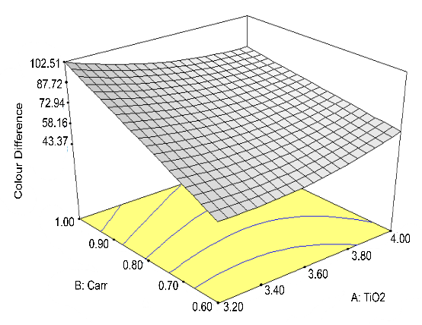 (b) 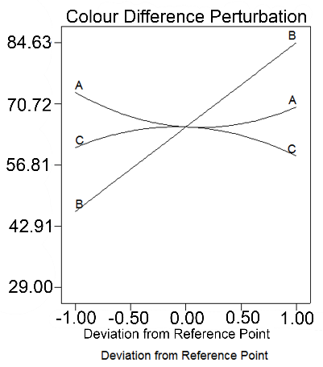

Figure 1. (a) 3D response surfaces for TCD that represent percentages of A: titanium dioxide and B: carrageenan at constant percentage of glycerol of 4.2%.and (b) trace plots showing the effects of each mixture component on TCD (A= TiO₂, B=Carr, C=Gly).

Mechanical properties
Mechanical properties of the strip film (oxygen indicator) involve tensile strength and elongation at break as shown in Figure 2. All the linear and quadratic parameters of both responses were statistically significant (p <0.05) and were considered in the second-order model (Table 3). High R² in elongation at break (94.15%) and tensile strength (92.97%) responses show that these data could be explained by the model.

(a) 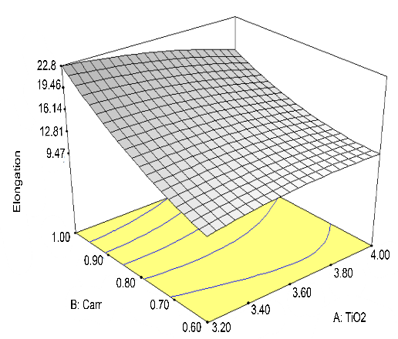 (b) 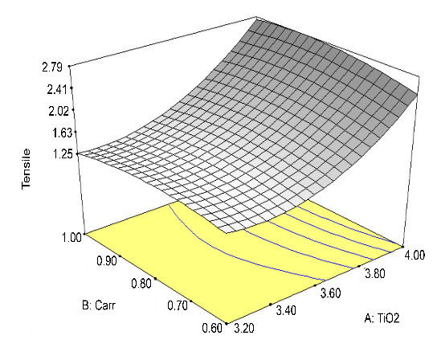
(c) 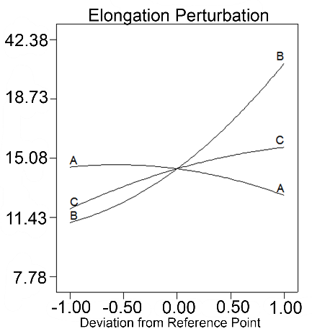 (d) 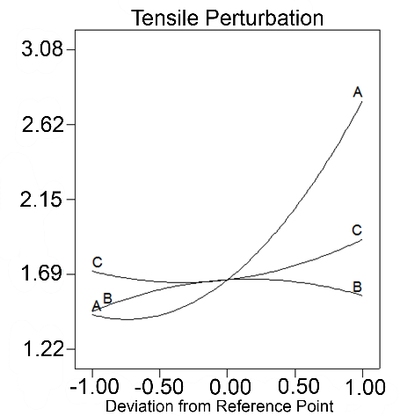

Figure 2. 3D Response surfaces for (a) elongation at break and (b) tensile strength that represent percentage of A: titanium dioxide and B: carrageenan at constant percentage of glycerol of 4.2% and trace plots showing the effects of each mixture component on (c) elongation at break and (d) tensile strength (A= TiO₂, B=Carr, C=Gly).

Two studies on mechanical properties on carrageenan-based film incorporated with TiO₂ obtained elongation at break of 22 to 31% [18] and 19.5± 0.4% [19]. Therefore, this study (7% to 19% elongation at break) is in line with the previous report. Based on Figure 2 (c), the highest factor was shown by β₂ followed by β_{3.} Carr was previously studied as the main factor in influencing the flexibility and mechanical properties of film [1]. The current result is in agreement with a report by Abdou and Sorour [20] which mentioned the carrageenan consists of hygroscopic properties, hence water uptake could explain the plasticization behaviour (increase elongation at break) with higher carrageenan. TiO₂ factor also influencing the elongation at break due to its nanoparticle size that helps to fill in the smaller spaces in the medium, hence reduces the elongation percentage of the film as the film becomes more rigid. The presence of Gly also increases the flexibility by reducing the intermolecular force thus enhances the intermolecular mobility in the medium [17].

The tensile strength results (between 1.0 to 3.5 MPa) correlate with the study by Mohd Marsin and Muhamad [13] and Deshwal et al. [10] who formed a carrageenan-based film using casting method. However, in this study, the tensile strength of the film was mostly influenced by TiO₂ factors (β₁) and interactions between TiO₂ (β₁²) as shown in Figure 2 (d). The presence of nanoparticle component increased the tensile strength of the film by forming a more compact structure. Higher tensile film helps to resist physical impact. The result was in line with Oun and Rhim [21] who reported that the presence of nanoparticle causes electrostatic interactions between the positive charges of nanoparticle and carrageenan biopolymer which increases biopolymer helical aggregation and forms a stronger film.

Optimization of formulation and experimental validation
Design expert 6.0.4 software generated the optimum formulation based on the desired properties, namely highest TCD of the initial film compared to UV-activated film, intermediate elongation at break, and high tensile strength. The optimum formulation consisting of 4.00% of TiO₂, 0.95% of Carr and 4.71% of Gly yielded highest TCD value of75.17, 17.02% elongation and tensile strength of 3.08 MPa. The formulation was experimentally validated, and the results are presented in Table 4. Based on the percentage difference values achieved for each response variable, it can be deduced that the formulation employed for the optimization was satisfactory, and that the surface responses obtained by the full experimental design were suitably validated. Figure 3 shows the obviously colour-distinguishable resulted film using the optimum formulation (i) original and (ii) after UV-activation.

Table 4. Results of experimental validation of the optimal conditions for the development of carrageenan-based oxygen indicator strip film

Responses | Predicted value | Experimental valueª | Difference (%)^{b}
Total colour difference | 74.32 | 73.9 ± 2.51 | -3.02
Elongation (%) | 17.20 | 17.40 ± 0.84 | +1.15
Tensile strength (MPa) | 3.08 | 3.39 ± 1.76 | +9.14
ª Values obtained at optimum formulation 4% of TiO₂, 1% of Carr and 4.69% of glycerol
^{b} Percentage difference = [(experimental value-predicted value)/experimental value]

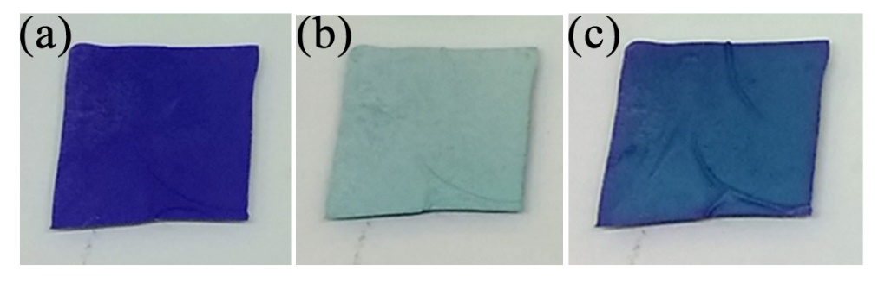

Figure 3. Photographs of carrageenan-based oxygen indicator films before (original) (a) and (b) after UV-activation at 55W for 10 minutes, and (c) recovery film after 80 minutes.

Figure 4 shows recovery behavior of carrageenan-based oxygen indicator strip film in air under ambient conditions in which -∆b* was plotted against recovery time. The carrageenan-based oxygen indicator strip film was recovered within 45 minutes. The bleached MB in the film was reoxidized by oxygen, and the original blue color of the indicator strip film was restored. This recovery is time is close to those reported recovery times of 20 minutes [22] and 60 minutes [10] and much faster than previously reported recovery rate of 5 days [23].

Figure 4. Recovery behavior of carrageenan-based oxygen indicator strip film in air under ambient conditions with a sampling time of 5 minutes.

FTIR analysis of optimum formulation
FTIR spectroscopy is a rapid technique with minimum sample preparation requirements that allows qualitative and quantitative determination of organic compounds in samples as intensities of spectrum bands are proportional to concentration [24]. Control original and UV-activated films were analyzed by FTIR spectroscopy to determine the difference in polymeric structure after UV crosslinking occurred in the indicator film. FTIR spectra for control original and UV-activated film ranging between 4000 and 400 cm⁻¹ are shown in Figure 5. The control original and UV-activated curves were overlapped each other with differences in certain regions. The samples showed difference in absorbance spectra in the range of 500 to 750 cm⁻¹ and 2850 to 3750 cm⁻¹. The result were in agreement with the study reported by Deshwal et al. [10] where the difference in spectra curve occurred between 3000 to 3600 cm⁻¹. An increased absorbance was observed at 992.47 cm⁻¹ after UV-activation, which can be attributed to the stretching of carbonyl band (C=O) for aldehydes. In this case, glycerol which acted as the sacrificial electron donor was oxidized during UV irradiation to form glyceraldehyde, confirming the carbonyl stretching band [25]. The C-O-C vibration band in the film shifts from 3300.20 to 3344.57 cm⁻¹ and from 555.50 to 563.23 cm⁻¹ after UV activation could be due to the disruption of H bonds between glycerol and carrageenan as the glycerol molecules were oxidized by the photogenerated holes in TiO₂ [25]. The presence of titanium dioxide in nanocrystalline form also influenced the changes in spectra curves as penta-coordinated sites in TiO₂ interact with Carr resulting in decreased UV transmission, indicating high UV absorption ability of TiO₂ [26].

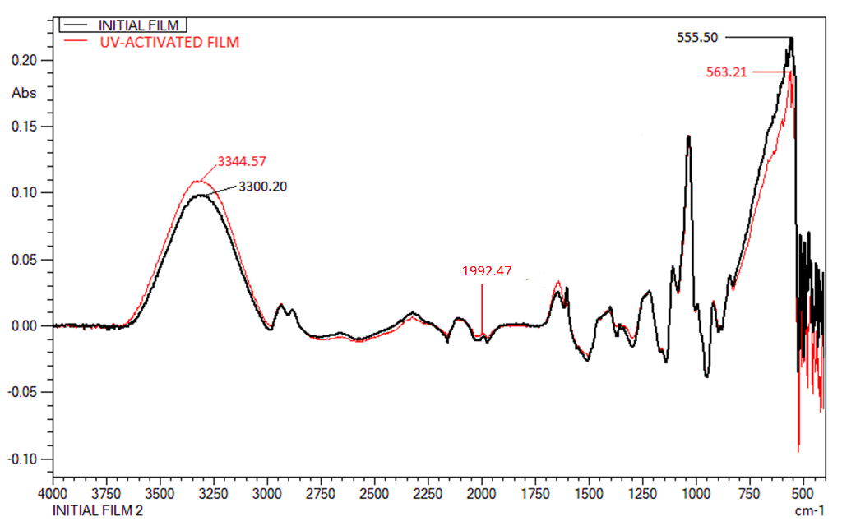

Figure 5. FTIR absorbance spectra of carrageenan-based oxygen indicator strip films; initial original film (bold black line) and UV-activated film (thin red line)
Conclusion
The optimal formulation for the development of carrageenan-based oxygen indicator strip film with enhanced colour difference and good mechanical properties was 4.00% (w/v) of titanium dioxide, 0.95% (w/v) of carrageenan and 4.71% (w/v) of glycerol. The film developed in this work show a significant colour difference between original and UV-activated film. The film could return to its original colour after exposure to oxygen and successfully work as an oxygen indicator. Good mechanical properties of high tensile strength and intermediate elongation at breaks enable the film to withstand physical impact and to be applied in active food packaging film. The data could be used for future reference in performing optimum oxygen indicator using the components proposed. This carrageenan-based oxygen indicator strip film could be used as biodegradable, safe and contemporary indicator in food packaging for future prospect.

Acknowledgment
This research was financially supported by the Project no. RJ130000.7851.4L868 of Research Management Centre, Universiti Teknologi Malaysia (UTM).

References

- Mills, A. (2005). Oxygen indicators and intelligent inks for packaging food. Chemical Society Reviews, 34(12): 1003-1011.
- Biji, K. B., Ravishanka, C. N. and Mohan, C. O. (2015). Smart packaging systems for food applications: a review. Journal Food Science Technology, 52(10):6125-6135.
- Kelly, C., Yusufu, D., Okkelman, I., Banerjee, S., Kerry, J. P., Mills, A. and Papkovsky, D. B. (2020). Extruded phophorescence based oxygen sensors for large-scale packaging applications. Sensors & Actuators: B. Chemicals, 304:1-8.
- Wen, J., Huang, S., Sun, Y., Chen, Z., Wang, Y., Li, H. and Liu, X. (2018). Titanium dioxide nanotube-based oxygen indicator for modified atmosphere packaging: efficiency and accuracy. Materials, 11(12): 1–10.
- Mills, A. and Hazafy, D. (2009). Nanocrystalline SnO₂-based, UVB-activated, colourimetric oxygen indicator. Sensors and Actuators, B: Chemical, 136(2): 344-349.
- Mills, A., Hazafy, D. and Lawrie, K. (2011). Novel photocatalyst-based colourimetric indicator for oxygen. Catalysis Today, 161(1): 59-63.
- Vu, C. H. T. and Won, K. (2013). Novel water-resistant UV-activated oxygen indicator for intelligent food packaging. Food Chemistry, 140 (1-2): 52-56.
- Lee, S. K., Mills, A. and Lepre, A. (2004). An intelligence ink for oxygen. Chemical Communications, 10(17): 1912-1913.
- Lee, S. K., Sheridan, M. and Mills, A. (2005). Novel UV-activated colorimetric oxygen indicator. Chemical Materials, 17(10): 2744-2751.
- Deshwal, G. K., Panjagari, N. R., Badola, R., Singh, A. K., Minz, P. S., Ganguly, S. and Alam, T. (2018). Characterization of biopolymer-based UV-activated intelligent oxygen indicator for food-packaging applications. Journal of Packaging Technology and Research, 2(1): 29-43.
- Roberts, L., Lines, R., Reddy, S. and Hay, J. (2011). Investigation of polyviologens as oxygen indicators in food packaging. Sensors and Actuators, B: Chemical, 152(1): 63-67.
- Bessergenev, V. G., Mateus, M. C., Rego, A. M. B., Hantusch, M. and Burkel, E. (2015). An improvement of photochatalytic activity of TiO₂ Degussa P25 powder. Applied Catalysis A: General, 500: 40-50.
- Mohd Marsin, A. and Muhamad, I. I. (2016). Effects of kappa carrageenan and glycerol in purple sweet potato starch based edible film. Jurnal Teknologi, 78(6): 163-168.
- Liu, J., Wang, H., Wang, P., Guo, M., Jiang, S., Li, X. and Jiang, S. (2018). Films based on K-carrageenan incorporated with curcumin for freshness monitoring. Food Hydrocolloids, 83: 134-142.
- Vu, C. H. T. and Won, K. (2014). Leaching-resistant carrageenan-based colorimetric oxygen indicator films for intelligent food packaging. Journal of Agricultural and Food Chemistry, 62: 7263-7267.
- Avachat, A. M., Gujar, K. N. and Wagh, K. V. (2013). Development and evaluation of tamarind seed xyloglucan-based mucoadhesive buccal films of rizatriptan benzoate. Carbohydrate Polymers, 91(2): 537-542.
- Pranoto, Y., Lee, C. M. and Park, H. J. (2007). Characterizations of fish gelatin films added with gellan and k-carrageenan. LWT - Food Science and Technology, 40:766-774.
- Rukmanikrishnan, B., Soo K., S., Lee, J. and Lee, J. (2019). Effect of TiO₂ on highly elastic, stretchable UV protective nanocomposite films formed by using a combination of k-Carrageenan, xanthan gum and gellan gum. International Journal of Biological Macromolecules, 123: 1020-1027.
- Rhim, J. W. (2012). Physical-mechanical properties of agar/k-carrageenan blend film and derived clay nanocomposite film. Journal of Food Science, 77(12): 66-73.
- Abdou, E. S. and Sorour, M. A. (2014). Preparation and characterization of starch/carrageenan edible films. International Food Research Journal, 21(1): 189-193.
- Oun, A. A. and Rhim, J. W. (2017). Carrageenan-based hydrogels and films: Effect of ZnO and CuO nanoparticles on the physical, mechanical, and antimicrobial properties. Food Hydrocolloids, 67: 45-53.
- Son, E. J., Lee, J. S., Lee, M., Vu, C. H. T., Lee, H., Won, K. and Park, C. B. (2015). Self-adhesive graphene oxide-wrapped TiO₂ nanoparticles for UV-activated colorimetric oxygen detection. Sensors and Actuators, B: Chemical, 213: 322-328.
- Mills, A., Tommons, C., Bailey, R. T., Catriona Tedford, M. and Crilly, P. J. (2008). UV-activated luminescence/colourimetric O₂ indicator. International Journal of Photoenergy, 547301: 1-6.
- Vlachos, N., Skopelitis, Y., Psaroudaki, M., Konstantinidou, V., Chatzilazarou, A. and Tegou, E. (2006). Applications of Fourier transform-infrared spectroscopy to edible oils. Analytica Chimica Acta, 573 (574): 459-465.
- Mihindukularuriya, S. D. F. (2013). Oxygen detection using UV-activated electrospun poly(ethylene oxide) fibers encapsulated with TiO₂ nanoparticles. Journal of Materials Science, 48: 5489-5498.
- Mihailović, D., Šaponjić, Z., Radoičić, M., Radetić, T., Jovančić, P., Nedeljković, J. and Radetić, M. (2010). Functionalization of polyester fabrics with alginates and TiO₂ nanoparticles. Carbohydrate Polymers, 79(3): 526-532.

