Synthesis and SOLID-STATE structurAL ELUCIDATION of rhenium(I) complex with 1-cinnamoyl-3-

(pyridIN-2-YL)pyrazole

(Sintesis dan Penentuan Struktur Pepejal Kompleks Renium(I) dengan 1-Sinamoil-3-

(Piridin-2-il)Pirazol)

Wun Fui Mark-Lee¹, Yan Yi Chong², Azizul Hakim Lahuri¹, Mohammad B. Kassim^{2,*}

¹Department of Basic Science and Engineering,

Faculty of Agriculture and Food Sciences,

Universiti Putra Malaysia Bintulu, 97008 Sarawak, Malaysia

²Centre for Advanced Materials and Renewable Resources,

Faculty of Science and Technology,

Universiti Kebangsaan Malaysia, 43600 Bangi, Selangor, Malaysia

*Corresponding author: mb_kassim@ukm.edu.my

Abstract

Re(I) complexes have been described as a promising tool for DNA probes. Rhenium(I) tricarbonyl complexes have favourable structural features suitable for DNA intercalation such as the new rhenium(I) tricarbonyl complex with polypyridyl ancillary ligand, namely, fac-[Re(CnPyPz)(CO)₃Cl] (CnPyPz = 1-cinnamoyl-3-(pyridin-2-yl)pyrazole). The complex was synthesised from the reaction of 1-cinnamoyl-3-(pyridin-2-yl)pyrazole and rhenium(I) pentacarbonyl chloride in toluene at refluxing temperature and characterised by infrared (IR), ultraviolet-visible (UV-Vis), ¹³C and ¹H NMR spectroscopies and X-ray crystallography. The IR spectrum featured the three ν(C≡O) signal for the rhenium moiety at 1862-2019 cm⁻¹ and other signals for the ligand namely ν(C=O), ν(C=N) and ν(C=C) at 1724, 1609 and 1497 cm⁻¹, respectively. The ¹³C NMR spectra showed three C≡O (190.0 – 198.1 ppm) signals whereas the ¹H spectrum for Re(CO)₃(CnPyPz)Cl exhibited two pairs of doublets (7.81 and 8.18 ppm) for the vinylic H of the cinnamoyl group. The complex exhibited a broad band corresponding to the metal-to-ligand charge transfer (MLCT) in the region of 360-390 nm. The Re(CO)₃(CnPyPz)Cl complex underwent a ligand exchange during the crystallisation process, involving one of the tricarbonyl groups with a chlorine atom to form the Re(CO)₂(CnPyPz)Cl₂ complex. The corresponding, Re(CO)₂(CnPyPz)Cl₂ crystal adopts a triclinic crystal system with a P-1 space group. The implementation of flexible CnPyPz ligand contributes to a dynamic supramolecular arrangement that facilitates both a planar π-π stacking arrangement accompanied with an appreciable globularity character via C−H···π and C≡O···π interconnections.

Keywords: rhenium, carbonyl, π stacking, Hirshfeld, DNA probes

Abstrak

Kompleks Re(I) telah dikenali sebagai bahan yang berpotensi untuk prob DNA. Kompleks trikarbonil Re(I) mempunyai ciri struktur yang sesuai untuk interkalasi DNA seperti mana kompleks renium(I) trikarbonil dengan ligan ansilari polipiridina, fac-[Re(CnPyPz)(CO)₃Cl] (CnPyPz = 1-sinamoil-3-(piridin-2-il)pirazola). Kompleks ini telah disintesis daripada tindak balas 1-sinamoil-3-(piridin-2-il)pirazola dengan pentakarbonilklororenium(I) dalam toluena pada suhu refluks dan telah dicirikan dengan menggunakan spektroskopi inframerah (IR), ultralembahyung-cahaya nampak (UV-Vis), resonans magnet nukleus (NMR) ¹³C dan ¹H dan kristalografi sinar-X. Spektrum IR menunjukkan tiga jalur ν(C≡O) untuk moieti logam renium pada 1862-2019 cm⁻¹, dan isyarat ligan seperti ν(C=O), ν(C=N) dan ν(C=C) masing-masing pada 1724, 1609 dan 1497 cm⁻¹. Spektrum NMR ¹³C menunjukkan tiga isyarat C≡O pada julat 190.0 – 198.1 ppm manakala spektrum ¹H kompleks Re(CO)₃(CnPyPz)Cl menunjukkan proton vinil (CH=CH) kumpulan sinamoil sebagai dua pasangan dublet pada 7.81 dan 8.18 ppm. Kompleks Re(I) ini mempamerkan jalur yang lebar bagi pertukaran cas logam kepada ligan (MLCT) pada julat 360-390 nm. Kompleks Re(CO)₃(CnPyPz)Cl mengalami pertukaran ligan yang melibatkan pengoksidaan pusat logam Re(I) kepada Re(II) semasa proses penghabluran yang melibatkan salah satu daripada kumpulan trikarbonil dengan satu atom klorin untuk membentuk kompleks Re(CO)₂(CnPyPz)Cl₂. Kompleks ini menghablur dalam sistem kristal triklinik dengan kumpulan ruang P-1. Penggunaan ligan CnPyPz yang fleksibel menyumbang kepada susunan supramolekul yang membawa kepada susunan π-π satah berserta dengan sifat globular yang ketara melalui ikatan C−H···π dan C≡O···π.

Kata kunci: renium, karbonil, susunan π, Hirshfeld, prob DNA

Introduction

The Re(I) metal ion has been widely explored as an intercalation agent [1-5] since its d⁶ electron configuration promotes the formation of a low spin metal-ligand complex that prevents metal-DNA interaction, which is typically associated with heavy metal toxicity [6-7]. The Re(I) tricarbonyl complexes, Re(CO)₃(N^N)X where the N^N chelating agent are conventionally polypyridine ligands and X = halide, pyridine, phosphine and alkyl, are known to efficaciously combat different kinds of cancerous cells but has a low toxicity towards normal cell [3]. In general, octahedral complexes such as Re(CO)₃(N^N)X binds to the double-helical DNA in a three-dimension space through three types of interactions namely intercalation, groove binding and external electrostatic binding. The ancillary ligand can be used as a tool to modify or alter the DNA binding interactions and the complex molecule [8, 9] in such a way that an intercalation will spontaneously occur when ancillary ligands such as polypyridine with an almost planar geometry is employed. With regard to the molecular construction, this phenomenon will prompt the binding of rhenium complexes with the DNA interior hydrophobic pockets via π-π interactions [10-13]. At the same time, the corresponding hydrophilic exterior attracts the polar tricarbonyl ligands [14]. Therefore, it is imperative to design a molecule that can offer the characteristic features to facilitate such interaction and act as a potential DNA intercalation agent.

Herein, we present the synthesis and characterisation of the titled rhenium complex along with the description of the non-covalent intermolecular connections, geometry and solid-state architecture. This study discusses the fundamental structural characteristics of a novel rhenium complex and provides quintessential information for future biological application.

Materials and Methods

Instrumentations

The IR spectrum was recorded in the range of 4000-650 cm⁻¹ using Agilent Cary 630 spectrophotometer. The NMR spectra were recorded by Bruker Ascend 400 spectrometer at 400 MHz and 100 MHz for ¹H and ¹³C NMR, respectively by using tetramethylsilane (TMS) as internal standard. The UV-Vis spectrum was recorded in acetonitrile solution using UV-1650 Pc Shimadzu Fision spectrophotometer. The X-ray diffraction data of the single crystal were collected by using Bruket D8 Quest diffractometer using a molybdenum MoKα X-ray source (λ = 0.71073Å). The Hirshfeld surfaces and two-dimensional fingerprints (FPs) were generated using CrystalExplorer17 [15].

Synthesis of 1-cinnamoyl-3-(pyridin-2-yl)pyrazole
The 2-(pyrazol-3-yl)pyridine (PyPzH) ligand was synthesised according to a previous literature method [16]. Next, PyPzH was deprotonated by triethylamine in dichloromethane at room temperature. Then, cinnamoyl chloride was added slowly and the mixture was stirred for 3 hours (Scheme 1). The solvent was reduced under atmospheric pressure and the product was purified by column chromatography with dichloromethane as the eluent.

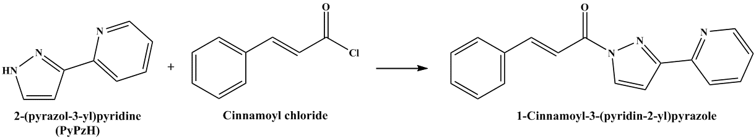

Scheme 1. Synthesis route of 1-cinnamoyl-3-(pyridin-2-yl)pyrazole (CnPyPz)

Synthesis of fac-Re(CO)₃(CnPyPz)Cl complex
The rhenium polypyridyl complex, fac-Re(CO)₃(CnPyPz)Cl was prepared from the reaction of rhenium(I) pentacarbonyl chloride with CnPyPz ligand in dry toluene at 120°C under nitrogen atmosphere for 5 hours (Scheme 2) [17, 18]. The desired product was obtained as a precipitate and washed with an excess volume of n-hexane.

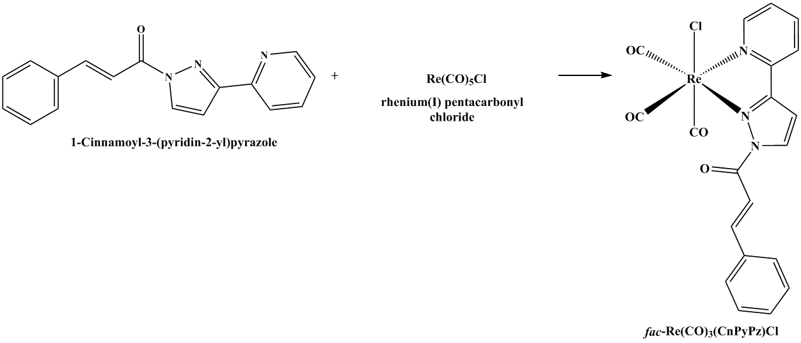

Scheme 2. The reaction scheme for the synthesis of Re(CO)₃(CnPyPz)Cl complex

Results and Discussion
The IR spectra for CnPyPz ligand and Re(CO)₃(CnPyPz)Cl complex are compared as shown in Figure 1. A free CnPyPz ligand showed the characteristic featured signals of C=O, C=N and C=C at 1696, 1613 and 1541 cm⁻¹, respectively. Whereas the Re(CO)₃(CnPyPz)Cl complex showed three v(C≡O) signals at 1862-2019 cm⁻¹ which was defined in Cs symmetry for two A′ mode and one A″ mode [19] indicating the C≡O groups exist in the facial configuration [20]. The presence of the tricarbonyl peaks was further corroborated with ¹³C NMR spectroscopy where the three C≡O signals were observed in the region of 190-198 ppm. In addition, the presence of the cinnamoyl group was also confirmed by the C=O signal at 168 ppm. Upon coordination of the free ligand to the Re(I) metal centre, the ¹H NMR spectrum of Re(CO)₃(CnPyPz)Cl complex showed the shifting of chemical signals corresponding to CnPyPz moiety at a lower field compared to the free ligand. This observation indicates that the ligand has successfully coordinated to the metal ion [21-22]. The vinylic hydrogens of the cinnamoyl group were observed as two pairs of doublets at 7.81 and 8.18 ppm with a coupling constant value of 15.6 Hz, indicating that the vinylic hydrogens were in a trans-configuration. The proton conformation was further supported by X-ray crystallography analysis. The complex showed two main absorption bands at around 330 nm (Figure 2) which was due to the intra ligand transition (π → π*) and a tapered low-lying broad band at 380nm (ε = 2723 L mol⁻¹ cm⁻¹) was ascribed to the MLCT band [dπ(Re) → π*]. This scarcely discernable band is known to overlap with the more stronger intra ligand transition [23].

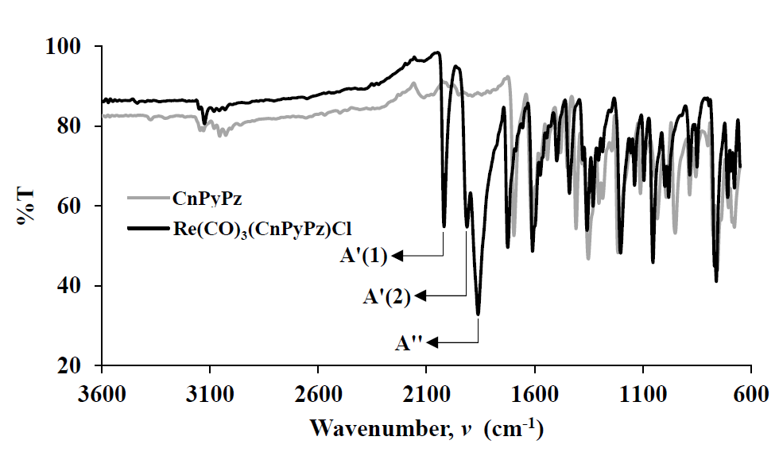

Figure 1. A comparison between the IR spectra of CnPyPz and Re(CO)₃(CnPyPz)Cl

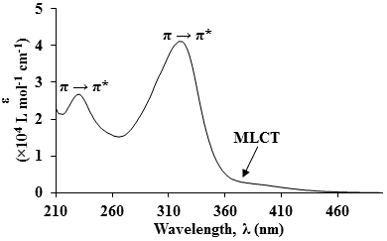

Figure 2. Electronic spectrum of Re(CO)₃(CnPyPz)Cl complex measured in acetonitrile

The X-ray crystal structure of Re(CO)₂(CnPyPz)Cl₂ (Figure 3) adopts a triclinic system with a P-1 space group. Although the infrared spectrum of this complex initially revealed three v(C≡O) signals, the metal centre Re(I) was oxidized to Re(II) in which the carbonyl group on the axial position was substituted by a chloro atom during the crystallization process. Therefore, the three-dimensional complex possesses a distorted octahedral geometry at the metal centre, with two carbonyl and one chelating CnPyPz ligand in the equatorial planes; while, two chloro ligands situated at the axial positions. The bond lengths and angles around the rhenium centre (Table 1) resemble those of related structures, for example, fac-[ReCl(N^N)(CO)₃] (N^N is a polypyridine chelating ligand) [24-27]. The pyridine and pyrazole planes were essentially coplanar [9.0 (4)º] while the mean plane of the cinnamoyl fragment was distorted from the mean plane of the pyridylpyrazole fragment at an angle of 45.5 (3)º. Besides, the vinylic protons of the alkene group demonstrated a trans-configuration with the C11-C12=C13-C14 torsion angle of -176.3 (10)º and the observation agrees with the ¹H NMR spectrum of the complex. The crystal packing of this complex mainly exhibits C−H···O intermolecular hydrogen bonding in which the proton on pyridine (H1) and vinyl group (H8) formed a hydrogen bonding with O2 and O3, respectively, giving a one-dimensional chain viewed from a-axis (Figure 4).

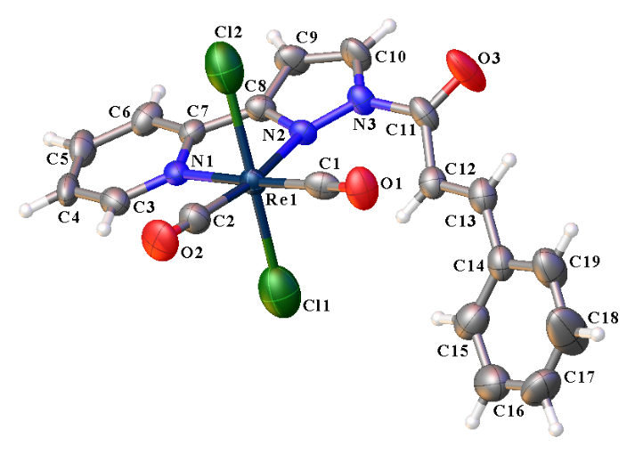

Figure 3. The X-ray crystallographic structure of Re(CO)₂(CnPyPz)Cl₂ complex with displacement ellipsoids drawn at the 50% probability level

Table 1. Selected geometric parameters (Å, º) for Re(CO)₂(CnPyPz)Cl₂
 | Bond Length (Å) |  | Bond Angle (º)
Re1–C1 | 1.928(10) | N1–Re1–N2 | 73.9(3)
Re1–C2 | 1.903(11) | N1–Re1–C2 | 96.1(4)
Re1–N1 | 2.195(7) | C1–Re1–N2 | 103.4(3)
Re1–N2 | 2.223(7) | C1–Re1–C2 | 86.4(4)
Re1–Cl1 | 2.418(6) | N1–Re1–Cl2 | 87.2(2)
Re1–Cl2 | 2.432(6) | N2–Re1–Cl2 | 84.1(2)
C1–O1 | 1.147(13) | C2–Re1–Cl2 | 91.8(4)
C2–O2 | 1.146(14) | C1–Re1–Cl2 | 91.2(3)
 |  | N1–Re1–Cl1 | 88.6(2)
 |  | N2–Re1–Cl1 | 91.9(2)
 |  | C2–Re1–Cl1 | 91.6(4)
 |  | C1–Re1–Cl1 | 92.9(3)
 |  | Cl1–Re1–Cl2 | 174.83(18)

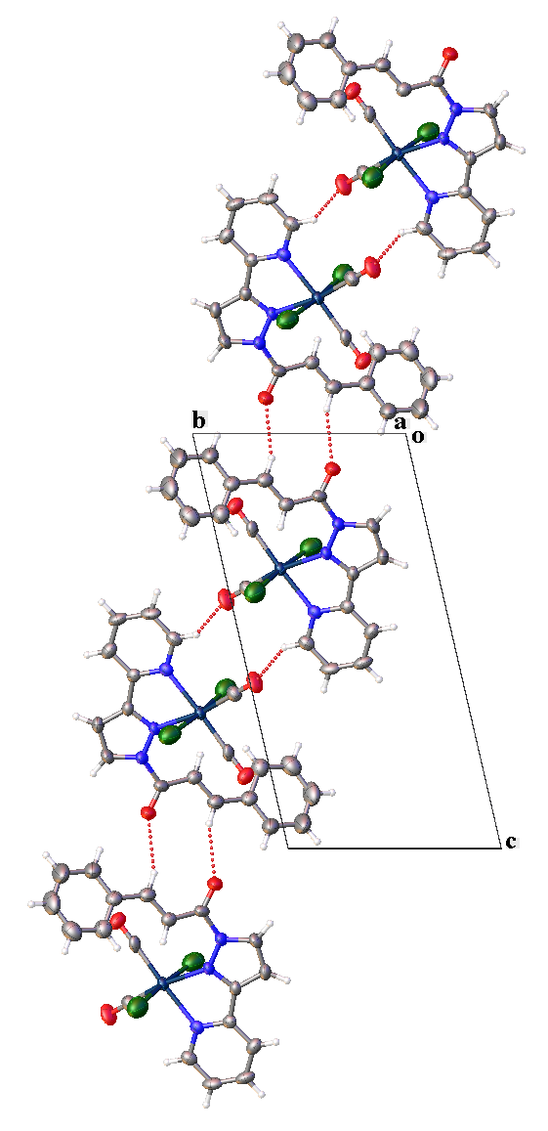

Figure 4. A partial view of the crystal packing of Re(CO)₂(CnPyPz)Cl₂ complex, illustrating one-dimensional chain viewed from a-axis

Further, the Hirshfeld surface analysis was performed on the Re(II) complex. The complex forms a centrosymmetric dimer with C−H···O intermolecular hydrogen bonding. The pair of dark-red spots in Figure 5, indicate that the sum of d_{i} and d_{e} is shorter than the sum of the respective individual vdW radii and this signifies stronger intermolecular interactions in these regions as compared to the ones with faint-red spots. The cinnamoyl ligands from adjacent complexes interconnects to construct the $R_{2}^{2}$(10) loop [28].

Figure 5. The centrosymmetric dimers of Re(CO)₂(CnPyPz)Cl₂ with C−H···O intermolecular contacts depicted by d_{norm} surface contours

The asymmetric unit of the complex is subjected to four intermolecular interactions that involves six-membered aromatic rings namely, Cg3 (centroid of the N1/C3-C7 pyridine ring) and Cg4 (centroid of the C14-C19 benzene ring) (Figure 6). Both sides of the Cg3 plane participates in π-π interaction involving neighbouring Cg3 rings with relatively similar centroid-to-centroid distances recorded at 3.851(6)Å [slippage = 1.454Å; symmetry code: -x,1-y,1-z] and 3.767(6)Å [slippage = 1.692Å, symmetry code: 1-x,1-y,1-z]. The coplanar conformation of pyridine and pyrazole moieties expedite close packing of the π-π stacking arrangement. Interestingly, the pendant cinnamoyl ring allows structural flexibility which elevates the overall globularity character (G = 0.746 a.u.). As a result, the benzene ring promotes C−H···π and C≡O···π interactions. This observations also correspond to rhenium complex analogue where the Re(I) complex with fluorine-substituted cinnamoyl ligand participates more in non π-π interactions i.e. C−H···π and C≡O···π. Moreover, these rhenium complexes can also accommodate a repertoire of non-covalent interactions with the appropriate utilisation of substituents [29].

Figure 6. The intermolecular connections involving pyridine and benzene rings, namely π-π, C−H···π and C≡O···π interactions

In comparison to Re(CO)₂(CnPyPz)Cl₂, the reported Re(I) complex has a cinnamoyl fragment with a higher degree of distortion as a result of the substitution effect. Therefore, the Hirshfeld surface of Re(CO)₂(CnPyPz)Cl₂ exhibits an anisotropic quality in between that of Re(p-NO₂-CnPyPz)(CO)₃Cl (Ω = 0.362 a.u.) and Re(p-F-CnPyPz)(CO)₃Cl (Ω = 0.171 a.u.) with a measured asphericity value (Ω = 0.177 a.u.) [29]. The nature of the intermolecular interaction involves in the supramolecular scaffold along with their percentage contributions were studied with 2-D Hirshfeld surface FPs (Figure 7). Based on Figure 7(a), the two pairs of long sharp spikes labelled as ‘1’ represents the C−H···O hydrogen bonds. The C−H···O hydrogen bonds project the largest contribution with a 27.9% from the overall non-covalent interactions [Figure 7(d)]. These spikes superimpose each other and appear to be complimentary in shape with (d_{i}, d_{e}) (1.3, 1.0Å). The sparsely distributed points located between the ‘1’ spikes revealed that the internal H atoms from the Hirshfeld surface is in relative proximity to the external H atom with 16.9% contribution. The other two major contributors to the overall intermolecular interactions stemmed from the H···Cl (21.4%) and H···π (19.7%) connections [Figure 7(b) and (c)]. As per our earlier discussion, the flexible pendant provided by the cinnamoyl fragment played a significant role to the supramolecular formation. Whereby, the H···π and O···π interactions involving the benzene moiety of the cinnamoyl fragment collectively contributes to 23.3% to the overall interactions.

Figure 7. Fingerprint plots (a)-(c) of non-covalent interactions of Re(CO)₂(CnPyPz)Cl₂ where d_{i} (d_{e}) is the internal (external) distance (Å) from a point on the Hirshfeld surface and (d) represents the percentage contributions of the overall close contacts involving the generated Hirshfeld surface area of the complex

Conclusion

The Re(I) tricarbonyl complex, fac-[Re(CnPyPz)(CO)₃Cl] was successfully synthesised and characterised through spectroscopic methods. The presence of the characteristic tricarbonyl groups and the vinylic H of the cinnamoyl group were evident via IR stretching frequency responses and the NMR chemical shifts. These spectroscopic findings support the complexation of Re(I) tricarbonyl precursor with the CnPyPz ligand. The solid-state analysis demonstrated the occurrence of ligand-exchange phenomenon that produced and oxidised the Re(I) metal centre to Re(II) in the Re(CO)₂(CnPyPz)Cl₂ complex. Besides, the rhenium complex promotes structural synergistic properties through the pyridiylpyrazole moiety and the pendant cinnamoyl fragment that supports both the planar π-π stacking alignment as well as C−H···π and C≡O···π arrangements, respectively. The favourable π-π stacking feature advocates future investigation on the propensity of the title complex towards DNA binding.

Acknowledgement

The authors would like to thank the Ministry of Higher Education, Malaysia for MyPhD support for CYY, Universiti Kebangsaan Malaysia for GGP-2017-091 and MI-2018-012 research grants and Universiti Putra Malaysia for GP-IPM-9657200 research grant. We are grateful to the Centre for Advanced Materials and Renewable Resources, Faculty of Science and Technology and Fuel Cell Institute (UKM) for their provision of experimental facilities.

References

- Balakrishnan, G., Rajendran, T., Senthil Murugan, K., Sathish Kumar, M., Sivasubramanian, V.K., Ganesan, M., Mahesh, A., Thirunalasundari, T. and Rajagopal, S. (2015). Interaction of rhenium(I) complex carrying long alkyl chain with Calf Thymus DNA: Cytotoxic and cell imaging studies. Inorganica Chimica Acta, 434: 51-59.
- Lo, K.K.-W. and Tsang, K.H.-K. (2004). Bifunctional luminescent rhenium(I) complexes containing an extended planar diimine ligand and a biotin moiety. Organometallics, 23(12): 3062-3070.
- Medley, J., Payne, G., Banerjee, H.N., Giri, D., Winstead, A., Wachira, J.M., Krause, J.A., Shaw, R., Pramanik, S. K. and Mandal, S. K. (2015). DNA-binding and cytotoxic efficacy studies of organorhenium pentylcarbonate compounds. Molecular and Cellular Biochemistry, 398(1–2): 21-30.
- Uma Maheswari, P. and Palaniandavar, M. (2004). DNA binding and cleavage properties of certain tetrammine ruthenium(II) complexes of modified 1,10-phenanthrolines - Effect of hydrogen-bonding on DNA-binding affinity. Journal of Inorganic Biochemistry, 98(2): 219-230.
- Yam, V.W.-W., Lo, K.K.-W., Cheung, K.-K. and Kong, R.Y.-C. (1995). Synthesis, photophysical properties and DNA binding studies of novel luminescent rhenium(I) complexes. X-ray crystal structure of [Re(ddpn)(CO)₃(py)](OTf). Journal of the Chemical Society, Chemical Communications, (11): 1191-1193.
- Amoroso, A. J., Coogan, M. P., Dunne, J. E., Fernández-Moreira, V., Hess, J. B., Hayes, A. J., Lloyd, D., Millet, C., Pope, S. J. A. and Williams, C. (2007). Rhenium fac tricarbonyl bisimine complexes: Biologically useful fluorochromes for cell imaging applications. Chemical Communications, (29): 3066-3068.
- Ranasinghe, K., Handunnetti, S., Perera, I. C. and Perera, T. (2016). Synthesis and characterization of novel rhenium(I) complexes towards potential biological imaging applications. Chemistry Central Journal, 10(1): 1-10.
- Ma, D., Che, C., Siu, F., Yang, M. and Wong, K. (2007). DNA binding and cytotoxicity of ruthenium(II) and rhenium(I) complexes of 2-amino-4-phenylamino-6-(2-pyridyl)-1,3,5-triazine. Inorganic Chemistry, 46(3): 740-749.
- Strekowski, L. and Wilson, B. (2007). Noncovalent interactions with DNA: An overview. Mutation Research/Fundamental and Molecular Mechanisms of Mutagenesis, 623 (1–2): 3-13.
- Chan, C. Y., Noor, A., McLean, C. A., Donnelly, P. S. and Barnard, P. J. (2017). Rhenium(I) complexes of N-heterocyclic carbene ligands that bind to amyloid plaques of Alzheimer’s disease. Chemical Communications, 53(15): 2311-2314.
- Egli, M., Tereshko, V., Mushudov, G. N., Sanishvili, R., Liu, X. and Lewis, F. D. (2003). Face-to-face and edge-to-face π-π interactions in a synthetic DNA hairpin with a stilbene diether linker. Journal of the American Chemical Society,125 (36): 10842-10849.
- Selamat, N., Yook Heng, L., Hassan, N. I. and Abd Karim, N. H. (2016). Synthesis and characterization of 6,6’-bis(2-hydroxyphenyl)-2,2’-bipyridyl ligand and its platinum complex for the interaction with CT-DNA. Malaysian Journal of Analytical Science, 20(1): 111-120.
- Shamsuddin, R., Sahudin, M. A., Hassan, N. H. and Abdul Karim, N. H. (2017). Interaction of N,N’-bis[4-[1-(2-hydroxyethoxy)]salicylidene]-phenyldiamine-nickel(II) and copper(II) complexes with g-quadrupex DNA. Malaysian Journal of Analytical Sciences, 21(3): 544-551.
- Ismail, M. B., Booysen, I. N., Hosten, E. and Akerman, M. P. (2017). Synthesis, characterization and DNA interaction studies of tricarbonyl rhenium(I) compounds containing terpyridine Schiff base chelates. Journal of Organometallic Chemistry, 833(1): 1-9.
- Turner, M. J., McKinnon, J. J., Wolff, S. K., Grimwood, D. J., Spackman, P. R., Jayatilaka, D. and Spackman, M. A. (2017). CrystalExplorer17. University of Western Australia.
- Lin, Y. and Lang, S. A. (1977). Novel two step synthesis of pyrazoles and isoxazoles from aryl methyl ketones. Journal of Heterocyclic Chemistry,14(2): 345-347.
- Kianfar, E., Kaiser, M. and Knör, G. (2015). Synthesis, characterization and photoreactivity of rhenium and molybdenum carbonyl complexes with iminopyridine ligands. Journal of Organometallic Chemistry, 799–800: 13-18.
- Mark-Lee, W. F., Chong, Y. Y., Law, K. P., Ahmad, I. B. and Kassim, M. B. (2018). Synthesis, structure and Density Functional Theory (DFT) study of a rhenium(I) pyridylpyrazol complex as a potential photocatalyst for CO₂ reduction. Sains Malaysiana, 47(7): 1491-1499.
- Dattelbaum, D. M., Martin, R. L., Schoonover, J. R. and Meyer, T. J. (2004). Molecular and electronic structure in the metal-to-ligand charge transfer excited states of fac-[Re(4,4’-X₂bpy)(CO)₃(4-Etpy)] (X = CH₃, H, Co₂Et). Application of density functional theory and time-resolved infrared spectroscopy. The Journal of Physical Chemistry A,108(16): 3518-3526.
- Brisdon, B. J., Edwards, D. A. and White, J. W. (1978). Anionic tricarbonyl derivatives of molybdenum and tungsten and their reactions with allyl halides. Journal of Organometallic Chemistry, 156: 427-437.
- Piletska, K. O., Domasevitch, K. V., Gusev, A. N., Shul’Gin, V. F. and Shtemenko, A. V. (2015). fac-Tricarbonyl rhenium(I) complexes of triazole-based ligands: Synthesis, X-ray structure and luminescent properties. Polyhedron, 102 (I): 699-704.
- Subasinghe, A., Perera, I. C., Pakhomova, S. and Perera, T. (2016). Synthesis, characterization, and biological studies of a piperidinyl appended dipicolylamine ligand and its rhenium tricarbonyl complex as potential therapeutic agents for human breast cancer. Bioinorganic Chemistry and Applications, 2016: 1–10.
- Wu, P.-C., Yu, J.-K., Song, Y.-H., Chi, Y., Chou, P.-T., Peng, S.-M. and Lee, G.-H. (2003). Synthesis and characterization of metal complexes possessing the 5-(2-pyridyl) pyrazolate ligands: The observation of remarkable osmium-induced blue phosphorescence in solution at room temperature. Organometallics, 22 (24): 4938-4946.
- Obata, M., Kitamura, A., Mori, A., Kameyama, C., Czaplewska, J. A., Tanaka, R., Kinoshita, I., Kusumoto, T., Hashimoto, H., Harada, M., Mikata, Y., Funabiki, T. and Yano, S. (2008). Syntheses, structural characterization and photophysical properties of 4-(2-pyridyl)-1,2,3-triazole rhenium(I) complexes. Dalton Transactions, 2008: 3292-3300.
- Seridi, A., Wolff, M., Boulay, A., Saffon, N., Coulais, Y., Picard, C., Machura, B. and Benoist, E. (2011). Rhenium(I) and technetium(I) complexes of a novel pyridyltriazole-based ligand containing an arylpiperazine pharmacophore: Synthesis, crystal structures, computational studies and radiochemistry. Inorganic Chemistry Communications, 14(1): 238-242.
- Wei, Q.-H., Xiao, F.-N., Han, L.-J., Zeng, S.-L., Duan, Y.-N. and Chen, G.-N. (2011). Synthesis, structure, photophysical and electrochemiluminescence properties of Re(I) tricarbonyl complexes incorporating pyrazolyl-pyridyl-based ligands. Dalton Transactions, 40(18): 5078-5085.
- Zubaidi, Z. N., Metherell, A. J., Baggaley, E. and Ward, M. D. (2017). Ir(III) and Ir(III)/Re(I) complexes of a new bis(pyrazolyl-pyridine) bridging ligand containing a naphthalene-2,7-diyl spacer: Structural and photophysical properties. Polyhedron, 133: 68-74.
- Etter, M. C., MacDonald, J. C. and Bernstein, J. (1990). Graph-set analysis of hydrogen-bond patterns in organic crystals. Acta Crystallographica Section B, 46(2): 256-262.
- Mark-Lee, W. F., Chong, Y. Y. and Kassim, M. B. (2018). Supramolecular structures of rhenium(I) complexes mediated by ligand planarity via the interplay of substituents. Acta Crystallographica Section C, 74: 997-1006.

