EXTRACTION OF 4-OCTYLPHENOL AND 4-NONYLPHENOL IN RIVER WATER USING SOLID-PHASE EXTRACTION AND HIGH-PERFORMANCE LIQUID CHROMATOGRAPHY

(Pengekstrakan 4-Oktilfenol dan 4-Nonilfenol di dalam Air Sungai Menggunakan Pengekstrakan Fasa Pepejal dan Kromatografi Cecair Prestasi Tinggi)

Mohd Zahid Baharom¹, Nurulnadia Mohd Yusoff^{1,2*}, Wan Mohd Afiq Wan Mohd Khalik¹,

Marinah Mohd Ariffin¹, Jamilah Karim³, Syazrin Syima Sharifuddin³

¹Faculty of Science and Marine Environment,

²Institute of Oceanography and Environment,

Universiti Malaysia Terengganu, 21030 Kuala Nerus, Terengganu, Malaysia

³Water Quality Laboratory,

National Hydraulic Research Institute of Malaysia,

43300 Seri Kembangan, Selangor, Malaysia

*Corresponding author: nurulnadia@umt.edu.my

Abstract

An analytical method based on solid-phase extraction (SPE) combined with high performance liquid chromatography-photometric diode array (HPLC-PDA) was developed to determine 4-octylphenol (4-OP) and 4-nonylphenol (4-NP) in river water samples. The optimum SPE working conditions were secured with 200 mL sample loading and eluted with 10 mL of methanol and acetone (1:1, v/v) as re-constitute solvents. Acetonitrile and deionized water (80:20, v/v) were used as mobile phase with 225 nm set as the optimum wavelength. Good linearity for 4-OP and 4-NP were obtained in the range of 0.001–0.012 mg/L whereby the regression coefficient R² was 0.9988 and 0.9995, respectively. Limit of detections (LOD) and quantifications (LOQ) for 4-OP and 4-NP were calculated at LOD = 0.0006 and 0.0001 mg/L and LOQ = 0.0020 and 0.0005 mg/L, respectively. The recovery percentages obtained for three levels concentrations (0.005, 0.010 and 0.050 mg/L) were ranged from 41.0 to 114%. Repeatability for 4-OP and 4-NP has shown good performance with low relative standard deviation (< 2%). In the real sample, the measured concentrations of 4-OP and 4-NP were detected with 0.001 and 0.0003 mg/L, respectively. Liquid chromatography-mass tandem spectrometry (LC-MS/MS) equipped with Agilent Jet Stream Technology and electrospray ionization (AJS-ESI) was used to confirm the presence of 4-OP and 4-NP in the water sample. Overall, the method proposed can be accepted for further water sample analysis.

Keywords: endocrine-disrupting chemical, water quality, emerging pollutants, liquid chromatography-mass spectrometry

Abstrak

Kaedah analisis berdasarkan gabungan pengesktrakan fasa pepejal (SPE) dengan kromatografi cecair prestasi tinggi susunan diod fotometrik (HPLC-PDA) telah dibangunkan untuk penentuan 4-oktilfenol (4-OP) dan 4-nonilfenol (4-NP) di dalam sampel air sungai. Keadaan optimum SPE telah diperolehi dengan 200 mL sampel air dan dielusi dengan 10 mL metanol dan aseton (1:1, v/v) sebagai pelarut rekonstruksi. Asetonitril dan air suling (80:20, v/v) telah digunakan sebagai fasa gerak di mana panjang gelombang optimum ditetapkan pada 225 nm. Kelinearan yang baik untuk 4-OP dan 4-NP telah diperolehi pada julat 0.001–0.012 mg/L dan nilai pekali regresi R² iaitu masing-masing dengan 0.9988 dan 0.9995. Had pengesanan (LOD) dan kuantifikasi (LOQ) untuk 4-OP dan 4-NP telah dihitung masing-masing pada LOD = 0.0006 dan 0.0001 mg/L dan LOQ = 0.0020 dan 0.0005 mg/L. Peratusan pemulihan yang telah diperolehi pada tiga aras kepekatan (0.005, 0.010 and 0.050 mg/L) adalah pada julat antara 41.0 hingga 114%. Kebolehulangan untuk 4-OP dan 4-NP menunjukkan prestasi yang baik dengan nilai sisihan piawai relatif yang rendah (< 2%). Di dalam sampel sebenar, kepekatan yang diukur untuk 4-OP dan 4-NP adalah dikira masing-masing dengan 0.001 dan 0.0003 mg/L. Spektrometri jisim cecair kromatografi (LC-MS/MS) bersama Teknologi Agilent Jet Aliran pengionan elektro-semburan (AJS-ESI) telah digunakan untuk mengesahkan kehadiran 4-OP dan 4-NP di dalam sampel air. Secara keseluruhannya, kaedah yang telah dibangunkan boleh diterima dan diguna pakai untuk analisis sampel air.

Kata kunci: kimia penganggu endokrin, kualiti air, pencemar memuncul, kromatografi cecair-jisim spektrometri

Introduction

The congeners, 4-octylphenol (4-OP) and 4-nonylphenol (4-NP) are biodegradation products from alkylphenol polyethoxylates which are persistently stable in water with higher bioaccumulative properties [1]. They are chemical substances that are widely used in domestic, industrial and agricultural applications (e.g. byproduct of surfactants in detergent and paint) [2, 3]. The structure and chemical characteristics of 4-OP and 4-NP are shown in Table 1. These chemical substances are known as endocrine-disrupting chemicals (EDCs) or endocrine disruptors (EDs) which are capable of causing adverse effects on the reproductive system of aquatic organisms such as fish [4]. EDCs could affect the organism via binding receptor or hormone-binding protein in the body by mimicking the effects of endogenous hormones [5]. The occurrence of 4-OP and 4-NP in river water comes from various sources such as effluents from sewage treatment plants, surface water run-off from settlements, direct discharge and leakage from septic tanks and landfill sites. The residue of these substances in the Malaysian river waters such as Tuaran River and Salut River in Sabah and Selangor Rivers were recorded at very low concentration level between ng/L to µg/L [6, 7]. Nevertheless, it is still deteriorative to the water quality, thus threatening aquatic organisms such as fish and bivalve [8-11]. Therefore, the determination of EDCs has been widely carried out in many countries.

Since target compound is usually detected low in river water, various water extraction methods such as liquid-liquid extraction [6, 12], steam distillation extraction [13] and solid-phase extraction [14-16] have been established to extract the compound effectively. However, SPE has been proven as the best and commonly used technique of extracting target analyte from water samples due to its ability to clean up interferences with low consumption of solvents and time [17]. Final analysis of EDC has been conducted using various instruments mainly by liquid chromatography [14, 18] and gas chromatography [15, 16, 19]. Nevertheless, the analysis of EDCs in Malaysian river water is mostly carried out using liquid-liquid extraction [6, 7] with high recovery percentage (50-120%). Unfortunately, the method is disadvantageous in terms of cost, time and sustainability of environment. Therefore, this study was aimed at modifying the SPE method towards creating a greener environment and validating the proposed method prior to application in real sample analysis.

Table 1. Structure and chemical characteristics of 4-OP and 4-NP

Name | 4-octylphenol | 4-nonylphenol
IUPAC name | 4-octylphenol | 4-(7-methyloctyl)phenol
CAS number | 1806-26-4 | 26543-97-5
Molecular formula | C₁₄H₂₂O | C₁₅H₂₄O
Molecular weight (g/mol) | 206.32 | 220.35
Structure | 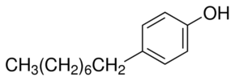 | 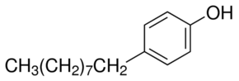

Chemical properties
Water solubility (mg/L) | 12.6ª | 5.4ª
Octanol-water partition coefficient,  log K_{ow} | 4.12^{b} | 4.48^{b}

ª Geyer et al. [5], ^{b} Ahel and Giger [20]

Materials and Methods

Analytical grade standards for 4-OP and 4-NP were purchased from Sigma Aldrich (USA). Acetonitrile, methanol and acetone (HPLC-grade solvents) were purchased from Elite Advance Materials (Malaysia). SPE cartridges, Resprep C₁₈ 1 mL/100 mg were purchased from Restek (USA). GF/C filter membrane with a diameter of 47 mm and pore size of 1.2 microns were purchased from Whatman (UK). Milli-Q water was obtained from Q-POD remote dispenser Merck (Germany).

The stock solution of 4-OP and 4-NP were prepared separately in methanol at 100 mg/L each and stored at 2 °C. A series of dilutions ranged from (0.001-0.012 mg/L, n=5) were prepared to construct the external standard calibration curves. Repeatability test was validated at three concentration levels (0.005, 0.010 and 0.050 mg/L). Limit of detection (LOD) and limit of quantification (LOQ) of the mixture were performed based on 3:1 and 10:1 signal to noise ratios, respectively. The accuracy of the method was validated with recovery percentage (%) at three concentration levels (0.005, 0.010 and 0.050 mg/L) and expressed as relative standard deviation (% RSD).

SPE method

A comparison from previous studies was made to optimize the method [14-16] in order to produce less waste and trap target compounds effectively. The optimization of the method involved changes in volume sample, conditioning and elution volume. Lower volume of samples (100, 200 and 300 mL), different elution (6, 10 and 14 mL) and conditioning volumes (9, 15 and 21 mL) were validated in the present study to enhance the SPE adsorbent for maximum trapping of target analytes. The cartridge was initially conditioned with 15 mL of methanol (MeOH), acetone (ACE) and Milli-Q water (1:1:1, v/v) to activate the adsorbents for trapping the target analytes. Then 200 mL of filtered water sample was loaded into the cartridge at the flow rate of 1 mL/min. The cartridge was washed with 10 mL of Milli-Q water, followed by elution with 10 mL of MeOH and ACE (1:1, v/v). Extract (10 mL) of the extracted sample was pre-concentrated to 1 mL using a rotary evaporator prior to injection to HPLC-PDA. The spiking concentration levels used were 0.005, 0.010 and 0.050 mg/L for each optimization studies.

HPLC-PDA analysis

High performance liquid chromatography-Prominence (Shimadzu) with Phenomenex Luna 5µm C₁₈ 100 A (250 mm x 4.6 mm, 5 µm) column equipped with photometric diode array (PDA) were used in the analysis of the 4-OP and 4-NP. The optimization of chromatographic performance included the peak area response (mAU) of different wavelengths and the mobile phase used was based on previous literature reviews [12, 20] with modification to obtain good separation of target compounds. The column temperature was set at room temperature (< 25 °C) with flow rate of 1.0 mL/min, 20 minutes running time and pressure of ≤ 100 bars. The injection volume used was 20 µL for each sample and tested for a minimum of three times to validate the precision of the data.

LC-MS/MS-AJS ESI analysis

Liquid chromatography-tandem mass spectrometry (LC-MS/MS) was carried out with an Agilent 6470 LC system (Agilent Technologies, USA)—a triple quadrupole mass spectrometer equipped with Agilent Jet Stream Technology and electrospray ionization (AJS-ESI) for the confirmation peaks of 4-OP and 4-NP in river water sample. The results were obtained based on the optimized conditions with the following settings: MS capillary voltages, 3500 V; gas temperature, 300 °C; gas flow rate, 5.0 L/min; nebulizer, 45 psi; charging voltage, 0/500 (PI/NI). The compounds were best shown in ESI (-) mode analysis. The mass-to-charge ratio (m/z) precursor and daughter ions of 4-OP (205, 106) and 4-NP (219, 147) were referred from a study conducted by Yusoff et al. [21].

Statistical analysis

The statistical analysis was carried out using IBM SPSS Statistics (Version 23.0). One-way ANOVA was derived to observe the significant difference using Tukey HSD (p < 0.005) with 95% confidence interval for sample volume, conditioning volume, elution volume and wavelength of 4-OP and 4-NP. The significant difference result will determine which aspect of optimization is best for further analysis.

Collection of water sample

The river water samples were collected from Kuala Terengganu River in selected areas to validate the method for the real sample analysis. Kuala Terengganu is known as the most populated town in Terengganu with new infrastructures developing rapidly. The sampling was done in May 2018 whereby two stations were chosen during the period of the study. The sampling coordinates and physical water parameters are shown in Table 2. The physical water parameters such as temperature, salinity, pH, dissolved oxygen and depth were recorded using Hydrolab Quanta Multi-probe Meter (Sutron Corporation, USA). Water samples were collected using Niskin sampler (Silkeborg, Denmark) and stored in 1 L glass bottles. Then the water sample was placed into an ice chest filled with ice packs at approximately below 10 °C before immediately transferred to the laboratory for further analysis.

Table 2. The description and physical water parameters of sampling location
Station | Sampling Location | Coordinate | Temperature  (°C) | Salinity  (ppt) | pH | Dissolved Oxygen  (mg/L) | Depth  (m) | Remarks
S1 | Upstream | N05°20'24.7''  E103°09'26.0'' | 30.4 | 33.2 | 7.58 | 5.62 | 7.9 | Nearby the breakwater
S2 | Duyong  Marina | N05°20'17.0''  E103°07'48.4'' | 29.0 | 33.6 | 8.05 | 5.62 | 4.0 | Pulau Duyong Port

Results and Discussion

The optimization of solid-phase extraction method: Effect of sample volume

The previous studies consumed a large sample volume (1000 mL) and various types of solvents for the water extraction method [14-16], and consequently produced substantial volume of wastes. Figure 1(a) shows that 200 mL of sample volume is sufficient to determine both 4-OP and 4-NP in a river water sample with higher peak area and good recovery percentage (%) in contrast to the analytical method proposed by Xu et al. [22] which required 1000 mL to determine the concentration of nonylphenol. However, the peak area decreased in 300 mL volume sample is mainly due to unsuitability of using large volume of sample in 1 mL (100 mg) size of cartridge. Al-Qaim et al. [23] also reported that lower size of the cartridge can effectively trap not more than 250 mL of sample volume with higher recovery percentage (> 80%). Therefore, 200 mL of volume sample in the study was considered for further analyses.

Effect of solvent type and volume

Solvents play important roles in extracting and separating specific matrix in order to determine the analytes of interests [24]. Previous methods [14-16] used various solvents (e.g. methanol, dichloromethane, hexane, acetone and ethyl acetate) for conditioning, elution or pre-concentrated processes. In the first trial, acetone was the only solvent used for the conditioning and elution processes but the results were inconsistent and only 4-NP was successfully eluted out from the cartridge. Previous studies [14-16] used methanol as their main solvent throughout the SPE processes. Methanol has the ability to efficiently extracting lower molecular weight compound, whereas acetone is good in extracting higher molecular weight compound [25]. In this case, 4-OP has lower molecular weight with 206.32 g/mol compared to 4-NP with 220.35 g/mol. The intermolecular forces in between solute-solvent molecules have strengthened the dipole-dipole forces. However, 4-OP and 4-NP are both insoluble in water thus, required polar solvents such as methanol and acetone to dissolve the compounds. In addition, methanol with polarity index and dielectric constant (P: 5.1 and ɛ: 32.7) acts as a polar molecule which helps to increase the solubility of the target analytes in water [27]. Meanwhile, acetone (P: 5.1 and ɛ: 20.7) acts as either polar or nonpolar molecules due to the two methyl groups presented in the chain which function relatively as elution solvent to effectively disrupt the nonpolar-nonpolar attractive forces (van der Waals forces) that secure the compounds in the sorbent.

Therefore, the combination of mixed solvent system, namely methanol and acetone obtained a synergistic effect in which the partition coefficient [25] mobilizes the hydrophobic compounds (4-octylphenol and 4-nonylphenol) in nonpolar sorbent (C₁₈) better in the present study. The combination of methanol and acetone was useful in conditioning the cartridge and eluting 4-OP and 4-NP consistently as shown in Figure 1 (b and c). Combination of MeOH, ACE and Milli-Q water were tested for conditioning and elution processes [(9, 15 and 21 mL of MeOH, ACE and Milli-Q water, 1:1:1, v/v) and (6, 10 and 14 mL of MeOH and ACE, 1:1, v/v)]. The combination of 15 and 10 mL of MeOH, ACE and Milli-Q water showed good recovery percentages ranging between 80% and 110% compared to other volumes. Higher elution volume could cause the pre-concentrated process to take longer time than usual, thus leads to neither decomposition of target compounds nor loss through the evaporation process [25]. Therefore, the combination of volumes used for conditioning and elution processes were recommended for further analyses.
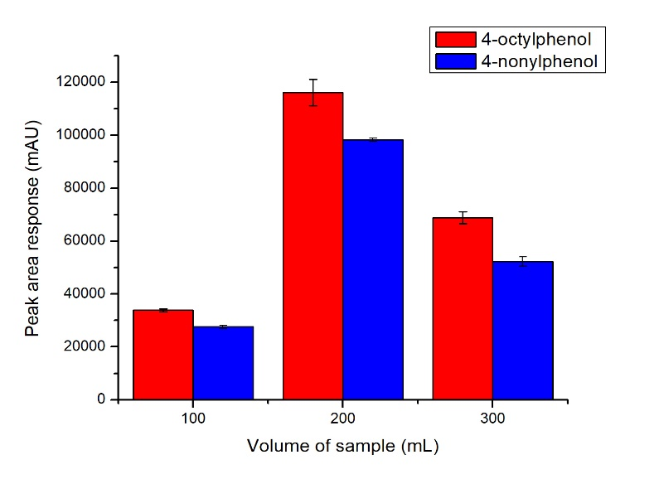
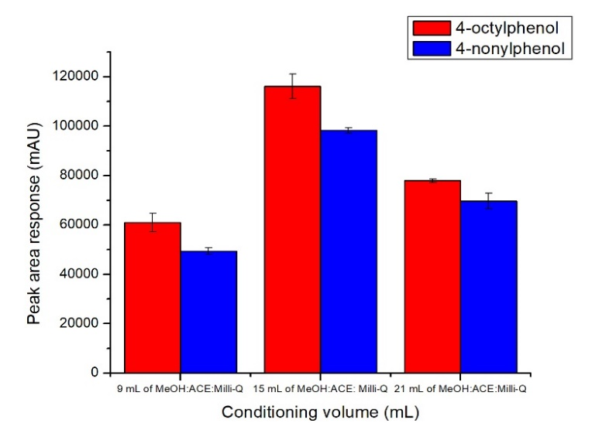
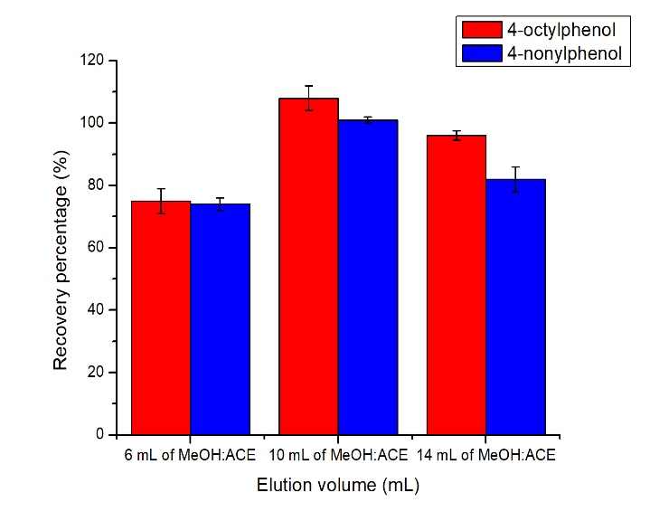
(a)
(b)
(c)

Figure 1. The effect of (a) sample volumes and (b) conditioning volumes and (c) elution volumes on the recovery of 4-OP and 4-NP analyses

In the present study, mobile phases with the composition of 20% water (A) and 80% acetonitrile (B) in an isocratic gradient elution were used based on the best peaks in both 4-OP and 4-NP. Following previous literature reviews [12, 20] with modification made, different wavelengths of 225, 230, 235, 265, 275, 280, 285 and 290 nanometers (nm) were considered and tested to find the highest intensities. By considering the best peak with the highest signal intensities and symmetries, 225 nm wavelength was chosen as optimum for the separation of 4-OP and 4-NP as shown in Figure 2. The peaks for 4-OP and 4-NP were identified based on the retention time of external standards in a chromatogram. Figure 3 shows the chromatographic separation for 4-OP and 4-NP in a single analytical run (a) 5 mg/L pure standard of 4-OP and 4-NP without SPE and (b) 0.050 mg/L pure standard spiked in water with SPE.

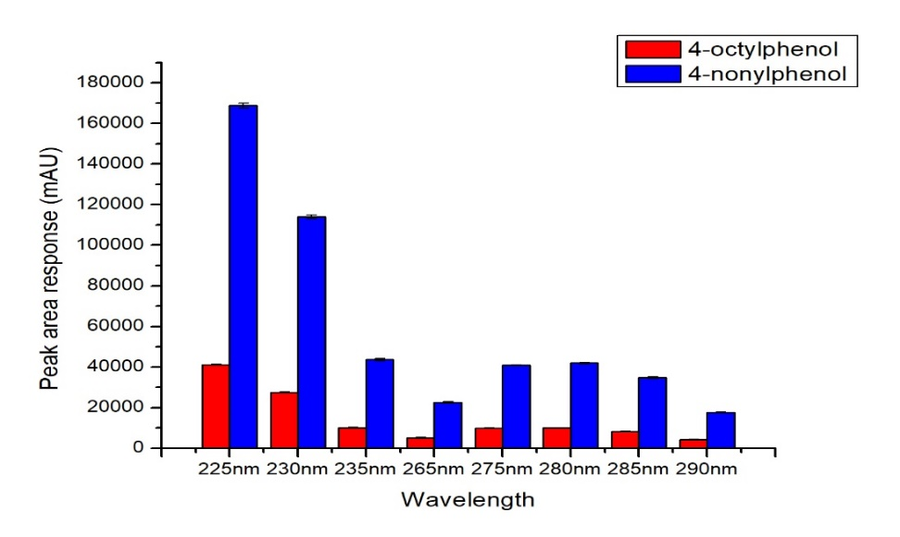

Figure 2. The sensitivity of 4-OP and 4-NP in different wavelengths

4-NP
4-OP
(a)

4-NP
4-OP
(b)

Figure 3. Chromatogram (a) 5 mg/L pure standard of 4-OP and 4-NP without SPE (b) 0.050 mg/L pure standard of 4-OP and 4-NP spiked in water with SPE

Statistical analysis
Statistical analysis was carried out to observe the significant difference among factor values (volume of sample, conditioning volume, elution volume and wavelength of 4-OP and 4-NP). The significant and insignificant values (p < 0.005, p > 0.005) are shown in Table 3 with the indicators such as ‘A’ and ‘B’ to prove the differences within the same group. The different volumes of sample (100, 200 and 300 mL) were significantly different for both 4-OP and 4-NP within the groups. This suggested that different volumes of sample influence the suitability of the size cartridge to trap the target analytes efficiently. In this case, 200 mL is the suitable volume sample to be used for 1 mL with 100 mg sorbent cartridge. The combination volume of conditioning and elution volume, 15 mL (MeOH, ACE and Milli-q water) and 10 mL (MeOH and ACE) were proven significantly different for both compounds. In fact, these combination volumes contribute to the highest peak area response. In addition, the wavelengths of 225, 230 and 285 nm (4-OP) were proven significantly different, likewise the wavelengths of 225, 230, 235, 265, 285 and 290 nm (4-NP) compared to the other wavelengths, as shown in Table 3. Based on higher peak area response, 225 nm of wavelength was chosen. Overall, the aspects chosen were statistically proven and considered for further analysis.

Table 3. Statistical analysis of one-way ANOVA using Tukey’s with 95% interval confidence, (p < 0.05)
Volume of sample (mL)
Factor value | N | 4-OP | 4-NP | 4-OP | 4-NP
Factor value | N | Mean Peak Area | Mean Peak Area | Grouping
100 | 3 | 33868 | 27578 | A | A
200 | 3 | 116143 | 98250 | A | A
300 | 3 | 68846 | 52215 | A | A
Volume of Conditioning (mL)
Factor value | N | Mean Peak Area | Mean Peak Area | Grouping
9 | 3 | 60906 | 49412 | B | A
15 | 3 | 116143 | 98250 | A | A
21 | 3 | 77954 | 69657 | B | A
Volume of elution (mL)
Factor value | N | Mean Peak Area | Mean Peak Area | Grouping
6 | 3 | 60906 | 49412 | B | A
10 | 3 | 116143 | 98250 | A | A
14 | 3 | 77954 | 69657 | B | A
Wavelength of 4-octylphenol and 4-nonylphenol
Factor Value | N | Mean Peak Area | Mean Peak Area | Grouping
225 | 3 | 41091 | 168802 | A | A
230 | 3 | 27557 | 114067 | A | A
235 | 3 | 10084 | 43563 | B | B
265 | 3 | 4998 | 22523 | B | A
275 | 3 | 9893 | 40852 | B | B
280 | 3 | 9978 | 41989 | B | B
285 | 3 | 8267 | 34762 | A | A
290 | 3 | 4142 | 17645 | B | A

‘A’ indicates significant with value p < 0.005, ‘B’ indicates insignificant with p > 0.005, N is the number of replicates

Method validation

The calibration curve for the mixed standard of 4-OP and 4-NP (n=5) were constructed at five different concentrations: 0.001, 0.0012, 0.006, 0.008 and 0.012 mg/L. These curves showed a strong positive and significant linearity for 4-OP and 4-NP (R² values at 0.9988 and 0.9995 with regression equation y = 70000000x + 23021 and y = 10000000x + 1099, respectively). The calibration curves for 4-OP and 4-NP are as shown in Figure 4.

Figure 4. External standard calibration curves 4-octylphenol and 4-nonylphenol

The instrument detection limit (IDL) and method detection limit (MDL) were also validated in the present study. The IDL and MDL results showed low detection at 0.0012 and 0.0001 mg/L. The results were calculated for both limit of detection (LOD) and limit of quantification (LOQ) as shown in Table 4. LOD and LOQ were performed based on 3:1 and 10:1 signal to noise ratios. Compared with the MDL reported by Xu et al. [22] which achieved 0.01 mg/L for nonylphenol, the detection limit that can be achieved in this study is lower than that value.

Table 4. The instrument detection limit and method detection limit for SPE method optimization
Analytes | Instrument Detection Limit |  | Method Detection Limit
Analytes | LOD (mg/L) | LOQ (mg/L) | LOD (mg/L) | LOQ (mg/L)
4-octylphenol | 0.0013 | 0.0043 | 0.0006 | 0.0020
4-nonylphenol | 0.0012 | 0.0041 | 0.0001 | 0.0005

A mixed standard (4-OP and 4-NP) was spiked into the water to validate the method recovery percentage (%). The recovery percentages (%) for 4-OP and 4-NP were spiked in three different concentrations (0.005, 0.010 and 0.050 mg/L) and the calculated results are as shown in Table 5. The recovery percentages are shown good for 4-OP and 4-NP ranged from 41.0 to 114% with lower RSD (< 2%). In the present study, the recovery percentage of 0.050 mg/L was lower for both compounds (< 50%) and this is due to its saturation capacity of sorbent (100 mg). This is supported by Baghdady and Schug [26] who found that the capacity of sorbent can be saturated with maximum number of sorbed analyte by the phase, thus the concentration of analyte passing through the sorbent can be similar with the ones exiting the cartridge. As a result, lower recovery would be achieved if higher concentration level (≥ 0.050 mg/L) was spiked into the sample to go through the SPE. However, lower RSD (< 20%) indicates good reproducibility and consistency [28]. Therefore, the method proposed is acceptable for real water sample analysis.

The precision of SPE method was validated using intra and inter-day reproducibility at 3 level concentrations (0.005, 0.010 and 0.050 mg/L) as shown in Table 6. Good reproducibility with lower RSD (< 2%) was shown between intra and inter-day for both compounds, 4-OP and 4-NP. Compared to previous study conducted by Wang et al. [15] in which the reproducibility in determining 4-OP and 4-NP was achieved with RSD (< 13%), the proposed method in this study can achieve better reproducibility with lower RSD.

Table 5. Mean recovery percentages (%) ± standard deviation and relative standard deviation in water (n = 3)

Analytes | Spiked  Concentration  (mg/L) | Measured  Concentration  (mg/L) | Recovery Percentage ± SD | (%RSD)
4-octylphenol | 0.005 | 0.0048 | 96.7 ± 0.7 | 0.75
 | 0.010 | 0.011 | 114 ± 0.5 | 0.40
 | 0.050 | 0.023 | 46.0 ± 0.2 | 0.52
4-nonylphenol | 0.005 | 0.0045 | 89.8 ± 0.7 | 0.75
 | 0.010  0.050 | 0.0104  0.021 | 104 ± 0.5  41.0 ± 0.1 | 0.50  0.25

SD is standard deviation, RSD is relative standard deviation

Table 6. Precisions (intra and inter-day reproducibility) based on found concentrations and retention times (n=3)
Analytes |  | Intra-day  (n=3) |  | Inter-day  (n=3)
Analytes | Spiked Concentration (mg/L) | Measured Concentration ± SD (mg/L) | (%RSD) | Measured Concentration ± SD (mg/L) | (%RSD)
4-octylphenol | 0.005 | 0.0046 ± 0.00018 | 3.89 | 0.0048 ± 0.00004 | 0.75
 | 0.010 | 0.011 ± 0.00053 | 4.70 | 0.010 ± 0.00005 | 0.40
 | 0.050 | 0.025 ± 0.00474 | 19.17 | 0.020 ± 0.0001 | 0.52
4-nonylphenol | 0.005 | 0.0046 ± 0.00024 | 5.13 | 0.0045 ± 0.00003 | 0.75
 | 0.010 | 0.011 ± 0.00099 | 8.76 | 0.010 ± 0.00005 | 0.50
 | 0.050 | 0.026 ± 0.00536 | 20.67 | 0.020 ± 0.00005 | 0.25

SD is standard deviation, RSD is relative standard deviation

Analysis of water samples from Terengganu River

Analysis of 4-OP and 4-NP in river water was successfully carried out using the optimized method. Two samples (S1 and S2) were taken and extracted to detect the concentration of 4-OP and 4-NP. Both 4-OP and 4-NP were not detected in S1 but presented in S2 with 0.001 and 0.0003 mg/L. Station 2 is located in the combination of residential, recreational and port areas, thus the concentration of 4-OP and 4-NP could be contributed from the available sources. Residential (urban-rural districts) and recreational areas are linked to possible sources of target compounds as Wang et al. [29] stated that the compounds could come from untreated or non-biologically treated domestic wastewater which flows out into the river water without consent. In addition, the target pollutants could also come from port areas (boat and ship) due to the usage of detergents to clean the vessel as reported by Salqueiro-González et al. [30]. Overall, the method proposed is able to detect low level concentration of 4-OP and 4-NP in river water.

LC-MS/MS-ESI screening and confirmation

A mixture standard of 4-OP and 4-NP was first analyzed to optimize the condition of the instrument (mobile phase, gradient elution flow rate and injection volume). After the optimization was completed, one sample (St 2) was confirmed with the presence of 4-OP and 4-NP selected to be analyzed using LC-MS/MS. The compounds of 4-OP and 4-NP were determined using m/z based on a previous study [21]. Figure 5 (A, B, C, D) is the confirmation peak through extracted-ion chromatogram (EIC) and multiple reaction monitoring (MRM) for both 4-OP and 4-NP. The confirmation of 4-OP and 4-NP was further calculated with probability match between the sample and standard due to the unavailable library data installed in the system. The probability match (%) of 4-OP and 4-NP was calculated with 28 and 129%. Therefore, the peaks that appeared in the HPLC chromatogram were confirmed to be 4-OP and 4-NP based on the probability match with the standard.
(a)
4-OP

(b)

(c)
4-NP

(d)

Figure 5. The confirmation peaks of 4-octylphenol and 4-nonylphenol in water sample through LC-MS/MS-ESI

Conclusion

The contribution of this study is apparent in terms of SPE method modification that emphasizes on using less volume of water sample and solvent for 4-octylphenol and 4-nonylphenol. Good validation results were obtained in terms of linearity, precision and sensitivity of the method extraction and HPLC-PDA performances. Trial analysis was proven using low level concentration (≤ 0.001 mg/L) of water sample from Terengganu River. However, further investigation on the other matrices such as sediment and biota need to be considered to report the occurrence and distribution of endocrine-disrupting compounds in the Malaysian river ecosystem.

Acknowledgement
This study has been funded by the Fundamental Research Grant Scheme (FRGS)-FRGS/1/2017/WAB09/UMT/03/3 and High Centre of Excellent (HICoE) in Marine Science, Ministry of Higher Education, Malaysia. Authors would like to acknowledge Centre of Research and Field Service (CRAFS, UMT) and National Hydraulic Research Institute of Malaysia (NAHRIM) staff for assisting this project.

References

- Toor, J. S., & Sikka, S. C. (2017). Developmental and reproductive disorders-role of endocrine disruptors in testicular toxicity. reproductive and developmental toxicology. Elsevier Inc.
- Tapiero, H., Nguyen, B. G. and Tew K. D. (2002). Estrogens and environmental estrogens. Biomedicine & Pharmacotherapy, 56: 36-44.
- Imai, S., Koyama, J. and Fuiji, K. (2007). Effects of estrone on full life cycle of Java medaka, a new marine test fish. Environmental Toxicology & Chemistry, 26: 726-731.
- Yusoff, N. M., Koyama, J. and Uno, S. (2017). Bioaccumulation of sedimentary endocrine disrupting chemicals (EDCs) by the benthic fish, Pleuronectes yokohamae. Malaysian Journal of Analytical Science, 21(3): 535-543.
- Geyer, H. J., Rimkus, G. G., Scheunert, I., Kaune, A., Schramm., K.-W., Kettrup, A., Zeeman, M., Muir, D. C. G. and Mackay, D. (2005). Bioaccumulation and occurrence of endocrine-disrupting chemicals (EDCs), persistent organic pollutants (POPs), and other organic compounds in fish and other organisms including humans. Bioaccumulation – New Aspects and Developments, 2: pp. 1-166.
- Duong, C. N., Ra, J. S., Cho, J., Kim, S. D., Choi, H. K., Park, J. H., Kim, K. W., Inam, E. and Kim, S. D. (2010). Estrogenic chemicals and estrogenicity in river waters of South Korea and seven Asian countries. Chemosphere, 78(3): 286-293.
- Tan, B. L. L. and Mustafa, A. M. (2004). The monitoring of pesticides and alkylphenols in selected rivers in the State of Selangor, Malaysia. Asia-Pacific Journal of Public Health, 16(1): 54-63.
- Jobling, S., Coey, S., Whitmore, J. G., Kime, D. E., Van Look, K. J. W., McAllister, B. G., Beresford, N., Henshaw, A. C., Brighty, G., Tyler, C. R. and Sumpter, J. P. (2002). Wild intersex roach (Rutilus rutilus) have reduced fertility, Biology of Reproduction, 67: 515-524.
- Sumpter, J. P. and Johnson, A. C. (2005). Lessons from endocrine disruption and their application to other issues concerning trace organics in the aquatic environment. Environmental Science & Technology, 39(12): 4321-4332.
- Burki, R., Vermeirssen, E. L. M., Körner, O., Joris, C., Burkhardt-Holm, P. and Segner, H. (2006). Assessment of estrogenic exposure in brown trout (Salmo trutta) in a Swiss midland river: Integrated analysis of passive samplers, wild and caged fish, and vitellogenin mRNA and protein. Environmental Toxicology and Chemistry, 25(8): 2077-2086.
- Cheek, A. O. (2006). Subtle sabotage: endocrine disruption in wild populations, Revista De Biologia Tropical, 54: 1-19.
- Cherniaev, A. P., Kondakova, A. S. and Zyk, E. N. (2016). Contents of 4-nonylphenol in surface sea water of Amur Bay (Japan/East Sea). Achievements in the Life Sciences, 10(1): 65-71.
- Kannan, K., Keith, T. L., Naylor, C. G., Staples, C. A., Snyder, S. A. and Giesy, J. P. (2003). Nonylphenol and nonylphenol ethoxylates in fish, sediment, and Water from the Kalamazoo River, Michigan. Achieve Environmental and Contamination Toxicology, 44: 77-82.
- Wang, W., Ndungu, A. W. and Wang, J. (2016). Monitoring of endocrine-disrupting compounds in surface water and sediments of the three Gorges reservoir region, China. Archives of Environmental Contamination and Toxicology, 71(4): 509–517.
- Wang, B., Dong, F., Chen, S., Chen, M., Bai, Y., Tan, J., Li, F. and Wang, Q. (2016). Phenolic endocrine disrupting chemicals in an urban receiving river (Panlong River) of Yunnan-Guizhou plateau: Occurrence, bioaccumulation and sources. Ecotoxicology and Environmental Safety, 128: 133-142.
- Cheng, J. R., Wang, K., Yu, J., Yu, Z. X. Y., Biao, X. and Zhang, Z. (2018). Distribution and fate modeling of 4-nonylphenol, 4-t-octylphenol, and bisphenol A in the Yong River of China. Chemosphere, 195: 594-605.
- Oluseyi, T., Olayinka, K., Alo, B. and Smith, R. M. (2011). Improved analytical extraction and clean-up techniques for the determination of PAHs in contaminated soil samples. International Journal of Environmental Research, 5(3): 681-690.
- Careri, M., Elviri, L. and Mangia, A. (2001). Development and validation of a method using on-line solid-phase extraction and liquid chromatography with ultraviolet detection for the determination of bisphenol A, octylphenol, and nonylphenol in groundwater. Journal of AOAC International, 84(5): 1383-1392.
- Liu, R., Zhou, J. L. and Wilding, A. (2004). Simultaneous determination of endocrine disrupting phenolic compounds and steroids in water by solid-phase extraction-gas chromatography-mass spectrometry. Journal of Chromatography A, 1022(1-2): 179-189.
- Ahel, M. and Giger, W. (1993). Partitioning of alkylphenols and alkylphenol polyethoxylates between water and organic solvents. Chemosphere, 26(8): 1471-1478.
- Yusoff, N. M., Koyama, J., Uno, S., Kito, A., Kokushi, E., Bacolod, E. T., Ito, K. and Chuman, Y. (2014). Accumulation of endocrine disrupting chemicals (EDCs) in the polychaete Paraprionospio sp. from the Yodo River mouth, Osaka Bay, Japan. Environmental Monitoring and Assessment, 186(3): 1453-1463.
- Xu, J., Wang, P., Guo, W., Dong, J., Wang, L. and Dai, S. (2006). Seasonal and spatial distribution of nonylphenol in Lanzhou Reach of Yellow River in China. Chemosphere, 65(9): 1445-1451.
- Al Qaim, F. F., Jusof, S. H., Abdullah, M. P., Mussa, Z. H., Tahrim, N. A., Khalik, W. M. A. W. M. and Othman, M. R. (2017). Determination of caffeine in surface water using solid phase extraction and high performance liquid chromatography. Malaysian Journal of Analytical Sciences, 21(1): 95-104.
- Moldoveanu, S. and David, V. (2015). Chapter 6 Solvent Extraction. Modern Sample Preparation for Chromatography. Chromatography Elsevier, 2015: pp 131-189
- Dai, J. and Mumper, R. J. (2010). Plant phenolics: Extraction, analysis and their antioxidant and anticancer properties. Molecules, 15(10): 7313-7352.
- Baghdady, Y. Z. and Schug, K. A. (2016). Evaluation of efficiency and trapping capacity of restricted access media trap columns for the online trapping of small molecules. Journal of Separation Science, 39(21): 4183-4191.
- Ying, G. G., Kookana, R. S. and Chen, Z. (2002). On-line solid-phase extraction and fluorescence detection of selected endocrine disrupting chemicals in water by high-performance liquid chromatography. Journal of Environmental Science and Health - Part B Pesticides, Food Contaminants, and Agricultural Wastes, 37(3): 225-234.
- Wee, S. Y., Omar, T. F. T., Aris, A. Z. and Lee, Y. (2016). Surface water organophosphorus pesticides concentration and distribution in the Langat River, Selangor, Malaysia. Exposure and Health, 8(4): 497-511.
- Wang, B., Dong, F., Chen, S., Chen, M., Bai, Y., Tan, J., Li, F. and Wang, Q. (2016). Phenolic endocrine disrupting chemicals in an urban receiving river (Panlong river) of Yunnan-Guizhou plateau: Occurrence, bioaccumulation and sources. Ecotoxicology and Environmental Safety, 128: 133-142.
- Salgueiro-González, N., Turnes-Carou, I., Besada, V., Muniategui-Lorenzo, S., López-Mahía, P. and Prada-Rodríguez, D. (2015). Occurrence, distribution and bioaccumulation of endocrine disrupting compounds in water, sediment and biota samples from a European river basin. Science of the Total Environment, 529: 121-130.

