AGAROSE-CHITOSAN-INTERGRATED MULTIWALLED CARBON NANOTUBES FILM SOLID PHASE MICROEXTRACTION COMBINED WITH HIGH PERFORMANCE LIQUID CHROMATOGRAPHY FOR THE DETERMINATION OF TRICYCLIC ANTIDEPRESSANT DRUGS IN AQUEOUS SAMPLES

(Filem Agarosa-Kitosan Bersepadu Nanotiub Kabon Berbilang Dinding Pengestrakan Mikro Fasa Pepejal Digabungkan Dengan Kromatografi Cecair Prestasi Tinggi-Pengesanan Ultralembayung Untuk Penentuan Anti-Murung Trisiklik Di Dalam Sampel Akueus)

Wan Nazihah Wan Ibrahim^{1,*}, Mohd Marsin Sanagi², Nor Suhaila Mohammad Hanapi¹,

Nursyamsyila Mat Hadzir¹, Noorfatimah Yahaya³, Sazlinda Kamaruzaman⁴

¹Faculty of Applied Science,

Universiti Teknologi MARA, 40450 Shah Alam, Selangor, Malaysia

²Department of Chemistry,

Faculty of Science,

Universiti Teknologi Malaysia, 81310 Johor Bahru, Johor, Malaysia

³Integrative Medicine Cluster, Advanced Medical and Dental Institute,

Universiti Sains Malaysia, 13200 Kepala Batas, Penang, Malaysia

⁴Department of Chemistry,

Faculty of Science,

Universiti Putra Malaysia, 43400 Serdang, Selangor, Malaysia

*Corresponding author: wannazihah@uitm.edu.my

Abstract

Agarose-chitosan-integrated multiwalled carbon nanotubes (Agr-Ch-MWCNTs) film solid phase microextraction (SPME) was developed and applied for the determination of tricyclic antidepressant drugs (TCAs) in aqueous samples using high performance liquid chromatography-ultraviolet detection (HPLC-UV). Integration of highly interconnected pores of MWCNTs in the agarose-chitosan matrix increases the hydrophobic sites, surface area and porosity of the materials and thus enhancing the extraction efficiency. The film of blended agarose and chitosan allows good dispersion of MWCNTs, prevents the leaching of MWCNTs during application and enhances the film mechanical stability. Optimized parameters for SPME parameters were obtained which no addition of salt included, sample pH = 11, 30 minutes extraction time, iso-propanol as desorption solvent and 0.4% w/v MWCNTs loading in agarose-chitosan matrix. The matrix match calibration curves demonstrated good linearity in the range of 10-500 ppb with excellent coefficients determination (r² = 0.9944-0.9961), good limits of detection (LODs) in the range of 3.13-3.60 ppb, high analyte recoveries (92.04-110.00%) and low relative standard deviations (RSD < 6.85).

Keywords: blended agarose/chitosan/multiwalled carbon nanotubes, solid phase microextraction, tricyclic antidepressant drugs

Abstrak

Filem agarosa-kitosan bersepadu nanotiub kabon berbilang dinding (Agr-Ch-MWCNTs) pengestrakan mikro fasa pepejal (SPME) telah dibangunkan dan diaplikasi untuk penentuan anti-murung trisiklik di dalam sampel akueus menggunakan kromatografi cecair prestasi tinggi-pengesanan ultralembayung (HPLC-UV). Persepaduan MWCNTs yang mempunyai liang yang saling berhubung di dalam matriks agarosa/kitosan menambahbaik tapak hidrofobik, luas permukaan dan keliangan bahan dan meningkatkan kecekapan pengestrakan. Filem campuran agarosa dan kitosan membenarkan penyerakan MWCNTs yang baik, menghalang pelunturan MWCNTs semasa aplikasi dan meningkatkan kestabilan mekanikal filem. Optimum parameter untuk SPME telah diperolehi termasuk tiada penambahan garam, pH sampel = 11, masa pengestrakan 30 minit, iso-propanol sebagai pelarut desorpsi dan 0.4% w/v jumlah muatan MWCNTs di dalam matrik agarosa/kitosan. Lengkungan kalibrasi matrik menunjukkan kelinearan yang bagus di dalam skala 10-500 ppb dengan penentuan koefisien yang terbaik (r² = 0.9944-0.9961), had pengesanan yang bagus (LODs) di dalam skala 3.13-3.60 ppb, perolehan semula yang tinggi (92.04-110.00%) dan sisihan piawai relatif yang rendah (RSD < 6.85).

Kata kunci: campuran agarosa/kitosan/nanotiub karbon berbilang dinding, pengestrakan mikro fasa pepejal, anti-murung trisiklik

Introduction

Antidepressants are drugs commonly used by therapeutic patient as prescribed medication. However, uncontrolled intake dosage will cause clinical responses such as sleep problem, headache, eating disorder and other hormone mediated condition [1-3]. Low concentrations of existence of these residues, bring up the challenge of measuring trace levels of tricyclic antidepressants (TCAs) in aqueous matrices [4]. For these reasons, some effort has been devoted on the development of microextraction techniques such as dispersive liquid-liquid phase microextraction (DLLME) [5] and hollow fiber-liquid phase microextraction (HF-LPME) techniques [6] to improve the sensitivity and sufficient selectivity for analysis TCAs present at low concentration.

Previously, our research group was prepared new adsorbent agarose-chitosan-integrated multiwalled carbon nanotubes (MWCNTs) film (Agr-Ch-MWCNT) that has been used for the first time in solid phase microextraction (SPME) of acidic nonsteroidal anti-inflammatory drugs (NSAIDs) in water samples [7]. From the results, the Agr-Ch-MWCNT film offers hydrophobic, π-π and hydrogen bonding in acidic medium. The presence of -NH₂ and -OH group from backbone agarose and chitosan also serve as chelating and reaction sites [8]. These features are potentially beneficial in solid phase extraction as the higher the possible sorbent-sorbate interaction, the faster the sorption process reaches equilibrium. Therefore, it is of interest to investigate the performance of Agr-Ch-MWCNT film in alkaline medium. As the blending method overcomes the pH-sensitiveness of the polysaccharides, it is expected that the composite film would be stable over a wide pH range. Thus, this work was extended study of prepared adsorbent for determination of basic tricyclic antidepressant drugs (TCAs) in water samples. Two TCAs namely amitriptyline (AMIT) and chlorpromazine (CHLO) were selected as model analytes.

Materials and Methods

Chemical and materials

Amitriptyline hydrochloride (AMIT) was purchased from Sigma-Aldrich (St. Louis, USA) while chlorpromazine hydrochloride CHLO was purchased from Clearsynth (Mumbai, India). HPLC grade organic solvents acetonitrile (ACN), methanol (MeOH) and iso-propanol (IPA) were purchased from J.T. Baker (Pennsylvania, USA). Reagent grade sodium chloride was purchased from Bendosen (Selangor, Malaysia). Nylon membrane 0.45 μm (Gelman Sciences, Ann Arbor, MI, USA) was used to filter buffer solutions and samples.

HPLC-UV-Vis analysis

HPLC separations were carried out on a Zorbax Eclipes Plus C₁₈ column (3.5 μm, 100 mm Length × 2.1 mm I.D.) (California, USA) with phosphate buffer (25 mM, pH 6)-acetonitrile-methanol (30:55:15, v/v) as the mobile phase at a flow rate 0.2 mL/min. The HPLC system consisted of a JASCO PU-980 pump (Hachioji, Japan), a Rheodyne 7725 valve with a 20-μL sample loop (Cotati, USA) for sample introduction and a Shimadzu UV-Visible detector (Tokyo, Japan). Both TCA Analytes were detected at 240 nm and were recorded on a Powerchrom data recording system (eDAQ, Australia).

SPME procedure

The SPME procedure is as describe in previous research [7]. Briefly, water sample (10 mL) was pipetted into a 15 mL sample vial and a magnetic stirrer was placed in the vial. A hypodermic needle was inserted through the Parafilm and pierced through four pieces of Agr-Ch-MWCNT film alternately separated by silicon septum. The films were conditioned by dipping in IPA for 2 minutes followed by 1 minute in deionized water before dipping it in the sample solution for extraction. The sample vial was sealed immediately with Parafilm and extraction was carried out by stirring the solution at a speed of 600 rpm for 30 minutes. The films were then removed and sonicated with 100 μL of IPA for 5 minutes. A portion of the IPA (2 μL) was then directly injected for HPLC-UV analysis.

Preparation of standard solutions and water samples

Standard solutions of AMIT and CHLO (1000 μg/mL) were prepared separately in HPLC grade methanol. Fresh tap water sample was obtained from Separation Science Laboratory, Department of Chemistry, Universiti Teknologi Malaysia (Johor, Malaysia). The sample was filtered through a Whatman nylon membrane filter 0.45 μm (Gelman Sciences, Ann Arbor, MI, USA) to remove colloidal particles and stored in freezer at 4°C until analysis.

Validation of analytical method

The analytical parameters such as linearity, limit of detection (LOD), limit of quantification (LOQ), accuracy and precision were determined to ensure the result of the analysis is reliable and the procedure is fit for the intended purpose. The linearity of the method was determined by plotting a calibration curve at five different standard concentrations. The precisions of the method were determined by a triplicate reading of each analyte (n = 3) and for the accuracies, the values were obtained in terms of recoveries where the sample was spiked with minute volume of standard solutions. The LOD was determined based on the Signal (S) to Noise (N) ratio method as 3 × S/N in water samples. The method accuracies (expressed as percent relative recovery, RR%) were calculated by comparing the extracted amounts of TCAs from those samples with the corresponding spiking amounts on the calibration curves.

Results and Discussion

Optimization conditions for SPME procedure

Five parameters have been studied and optimized namely, sample pH, addition of salt, extraction time, desorption solvent and concentration of MWCNTs in composite film. Optimization was carried out using deionized water samples spiked with each TCAs to give concentration of 0.5 μg/mL for AMIT and CHLO. Each experiment was performed in triplicate (n = 3).

Addition of salt

The presence of salt in water sample can disrupt the diffusion rate of analytes from aqueous to solid phase and thus affecting the extraction efficiency. The effect of ionic strength on extraction efficiency was evaluated by increasing sodium chloride (NaCl) concentration in the sample solution in the range 0 to 3% (w/v). This range was chosen based on significant effect on extraction of drugs from previous research [7]. It was found that the addition of salt had a slightly negative effect on the extraction efficiency (Figure 1). This phenomenon might be due to the fact that the aqueous solution viscosity increases with the addition of salt, which results in more difficult mass transfer and low extraction efficiency. It could also be due to competition between the analytes and salt in solution to interact with the sorbent surface that resists the extraction efficiency [9, 10]. Thus, no salt was added in subsequent experiments.

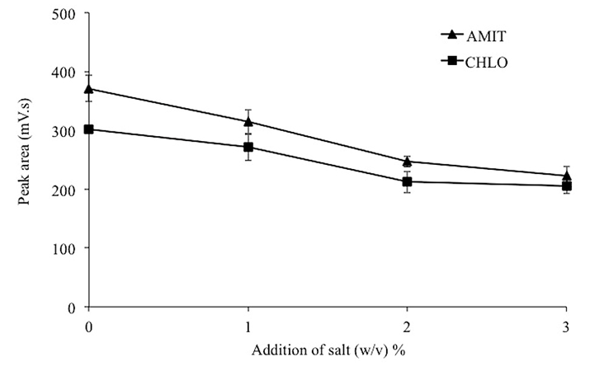

Figure 1. Effect of addition of salt on SPME of TCAs from aqueous samples

Sample pH

Sample pH plays an important role in determining the existing form of the analytes, and it affects the retention of analytes onto the sorbent bed. As the pK_{a} values of AMIT (9.42) and CHLO (9.30) show the basic characteristics, the pHs of the sample solutions were adjusted to pH 9-12 to reduce their water solubility. The results showed that, the peak areas of both analytes significantly increased with pH up to pH 11 (Figure 2). It may be explained as follows: at the beginning, the analytes were in the ionized form and gradually converted to molecular form with the addition of NaOH to the solution. However, at pH of > 11, further addition of NaOH caused the salting out effects due to simultaneous production of NaCl in the solution thus reducing the extraction efficiency [11]. This proved that at optimum pH, the extraction efficiency was governed by π-π and hydrophobic interactions between the MWCNTs and the analytes [12]. Therefore, the pH of sample solution was adjusted to 11 using 0.1 M NaOH in subsequent experiments in order to achieve the best extraction performance.

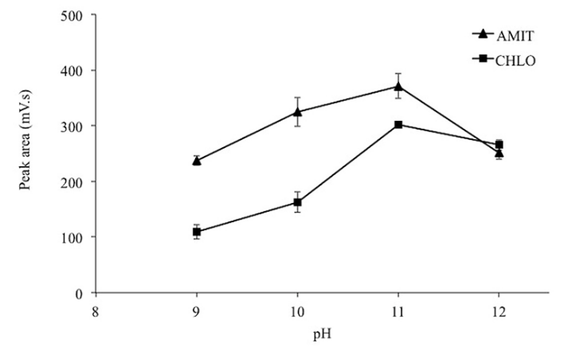

Figure 2. Effect of sample pH on SPME of TCAs from aqueous samples

Extraction time

Extraction times in the range of 10-40 minutes were studied. The result (Figure 3) indicated that the extraction efficiency was enhanced by increasing the extraction time from 10 to 30 minutes, and then a decreased at 40 min which might be due to desorption of analytes [13]. In addition, as SPME is an equilibrium process, 30 minutes is enough for sufficient sorption of analytes from sample solution onto sorbent surface [14]. Thus, 30 minutes was chosen as the optimized extraction time.

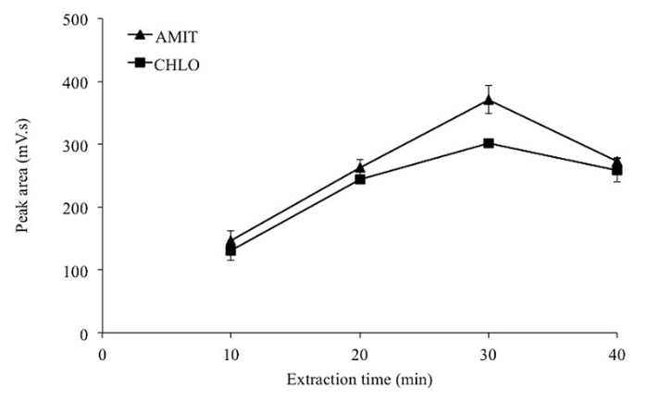

Figure 3. Effect of extraction time on SPME of TCAs from aqueous samples

Desorption solvent

Desorption solvent is one of the important parameters that affect the extraction efficiency in SPME. In this work, three organic solvents that are compatible with LC system namely isopropanol (IPA, polarity index 3.92), methanol (MeOH, polarity index 5.1) and acetonitrile (ACN, polarity index) were evaluated as desorption solvent. The volume of desorption solvent was fixed at 100 μL in all instances. Results showed that non-polar solvent (IPA) gave better desorption as compared to polar solvents (MeOH and ACN) (Figure 4). It proved that the TCAs were strongly sorbed on Agr-Ch-MWCNT film through hydrophobic interactions, thus only non-polar solvent can effectively disrupt the interactions and desorb the analytes [15].

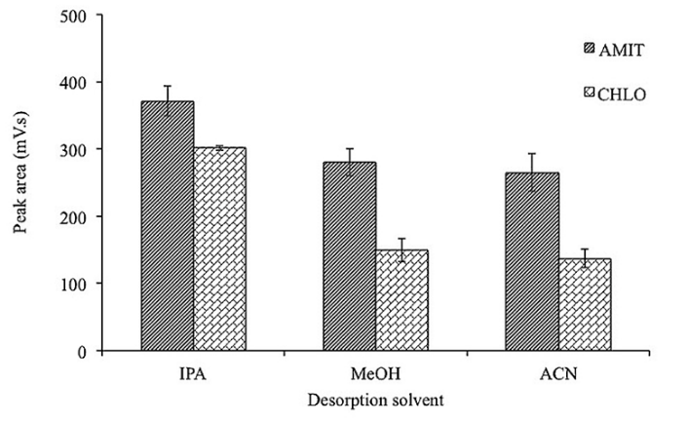

Figure 4. Effect of desorption solvent on SPME of TCAs from aqueous samples

MWCNTs concentration (% w/v) level in the film

To investigate the sorbent capacity in the SPME, different concentration levels of MWCNTs were investigated in the range of 0-0.5% w/v in the Agr-Ch-MWCNT composite film. The results demonstrated that the extraction performance improved considerably with the increasing concentration levels of MWCNTs up to 0.4% w/v. AMIT and CHLO are tricyclic basic molecules and therefore they are expected to be strongly sorbed via hydrophobic and π-π interactions with the MWCNTs in composite film as shown in Figure 5 [16].

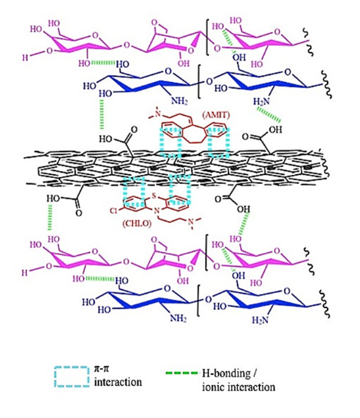

Figure 5. Proposed possible sorbent-sorbate interactions for SPME of TCAs

Method validation and analytical performances

The optimum extraction conditions obtained were as follows: 5 mL iso-propanol as an organic solvent for conditioning composite film, 10 mL of sample solution at pH 11 adjusted using 0.1 M NaCl, no addition of salt, 30 min extraction time at a stirring speed of 600 rpm, 100 μL of iso-propanol as desorption solvent, 5 minutes desorption time with ultrasonication and 0.4% (w/v) MWCNTs loading in composite film. In this study, experiments were carried out under the optimum conditions for the method validation. Matrix-match calibration method was constructed and plotted for laboratory tap water. Matrix-match calibration curves were plotted using water samples at spiked concentration of 10-500 ppb for AMIT and CHLO. The results showed good linearity for all the compounds with coefficients of determination r² > 0.9944 (Table 1). Extraction performances were measured based on recoveries of inter-day (n = 3) of the proposed methods by spiking analytes at two different concentration levels (30 and 400 ppb) into water samples. Good average relative recovery >92.30% and precision with RSDs <6.85% were obtained, indicating that Agr-Ch-MWCNT-SPME method proved high sensitivity, selectivity, and accurate sample preparation technique. Figure 6 illustrates HPLC-UV chromatograms of (i) unspiked and (ii) spiked with TCAs of tap water samples. All peaks in spiked water sample extracts were finely separated with good resolution in <12min. Thus, the overall results suggest that this method could be satisfactorily applied for therapeutic drug analysis and monitoring.

Table 1. Linear range, coefficient of determination (r²), LOD, average relative recoveries (%), and inter-day method precisions (RSD%, n = 3) of the Agr-Ch-MWCNT-SPME-HPLC-UV of spiked tap water samples

Analytes | Linearity Range | r² | LOD  (ppb) | Average RR%, (RSD%)  Spiking Level (n = 3)
 |  |  |  | 30 ppb | 400 ppb
AMIT | 10-500 | 0.9944 | 3.13 | 92.04 (6.85) | 110.00 (4.48)
CHLO | 10-500 | 0.9961 | 3.60 | 97.08 (3.85) | 102.66 (5.72)

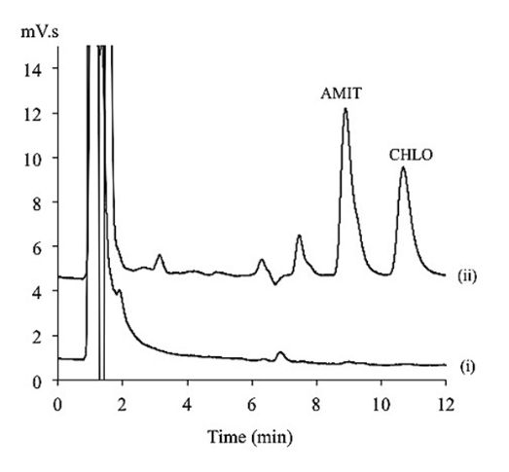

Figure 6. HPLC/UV chromatograms of (i) blank tap water and (ii) spiked tap water at a concentration level of 400 µg/L (AMIT and CHLO) respectively

Comparison with other reported methods

The performance of the proposed Agr-Ch-MWCNT-SPME-HPLC/UV method for the extraction and determination of TCAs was compared with other published methods (Table 2). Conventional SPE procedures with C₂-bond elute cartridges offered high selectivity and high extraction with LODs in the range 0.20-3.00 µg/L. However, it suffered from high amount of sorbent loading (50.0 mg) for each cartridge and involved multi-stage procedures with longer time [17]. The SPME has been successfully applied to the analysis of TCAs by liquid chromatography technique coupling to mass spectrometry. The method utilized PDMS/DVB as sorbent and it offered good detection limit (0.10 μg/L) as well as acceptable extraction efficiencies. However, SPME suffers from sample carry-over and fiber fragility [18]. The SBSE is a sample preparation technique based on the same principles as SPME, i.e. partitioning of the solutes between PDMS/DVB sorbent coated on the stir bar glass surface and the aqueous phase. This technique offers simple, rapid and solvent-free technique but it suffers from a long extraction time (60 minutes) and high limit of detection (40 μg/L) [19].

Meanwhile, membrane assisted micro solid phase extraction (MA-µ-SPE), is a technique where the sorbents are enclosed within a membrane bag that can minimize the loss of sorbent. The MA-µ-SPE with ureidopropyl-grafted silica (UPS) sorbent shows very good detection limit (0.66 μg/L). However, it suffers from long extraction time (60 minutes) probably due to gap between aqueous phases and sorbent that can prolonged the analytes transfer [20]. The Agr-Ch-MWCNT-SPME-HPLC/UV method shows comparable LODs as SPE and SBSE methods but with faster extraction time (30 min). Direct interactions between analytes and sorbent on the composite film increase the mass transfers and allows rapid equilibrium time.

Table 2. Comparison of proposed CFME-HPLC/UV method with other published methods for the analysis of TCAs in water samples

Method | Instruments | Adsorbent | Sorbent Loading (mg) | LOD  (µg/L) | Extraction Time (min) |  | Ref.
SPE | HPLC/UV | C₂-catridges | 50.0 mg | 0.20-3.00 | - | [17]
SPME | HPLC/MS | PDMS/DVB | - | 0.10 | 30 | [18]
SBSE | HPLC/UV | Twister-PDMS | - | 10.0-40.0 | 60 | [19]
MA-µ-SPE | HPLC/DAD | UPS | 20.0 mg | 0.66 | 60 | [20]
SPME | HPLC/UV | Agr-Ch-MWCNT | 0.6 mg | 3.13-4.19 | 30 | This work

Abbreviations: SPE = solid phase extraction, SPME = solid phase microextraction, SBSE = stir bar sorptive extraction, MA-µ-SPE = membrane assisted micro-solid phase extraction, , C₂ = silica dimethyl, PDMS/DVB = polydimethylsiloxane/divinylbenzene, PDMS = polydimethylsiloxane, UPS = ureidopropyl-grafted silica gel, Agr-Ch-MWCNT = agarose-chitosan incorporated multi-walled carbon nanotubes.

Conclusion

The results demonstrate that this method is a simple technique that does not require successive clean up steps. The developed method provided simple procedures utilizing biodegradable polysaccharide materials, no analyte carryover (because of the single-use of the film), and required tiny amounts of organic solvents, thus favorable toward green chemistry. The Agr-Ch-MWCNT-SPME-HPLC-UV method may be used for effective monitoring of pharmaceutical residues in complex aqueous matrix. In addition, the sorbent showed their compatibility in wide range of pH with insignificant of MWCNT leaching during the application.

Acknowledgement

The authors wish to thank the Universiti Teknologi MARA for facilitations and the Ministry of Higher Education Malaysia for their financial support through vote numbers 600-IRMI/FRGS 5/3 (416/2019) [FRGS/1/2019/STG01/UITM/02/16].

References

- Lindqvist, N., Tuhkanen, T. and Kronberg, L. (2005). Occurrence of acidic pharmaceuticals in raw and treated sewages and in receiving water. Water Research, 39: 2219-2228.
- Tambosi, J. L., Yamanaka, L.Y. and Moreira, H. J. J. R. F. P. M. (2010), Recent data on the removal of pharmaceuticals from sewage treatment plants (STP). Química Nova, 33(2): 411-420.
- Lin, A.Y-C., Yu, T-H. and Lateef, S.K. (2009). Removal of pharmaceuticals in secondary wastewater treatment processes in Taiwan. Journal of Hazardous Materials, 167:1163-1169.
- Vas, G. and Vékey, K .J. (2004). Solid-phase microextraction: A powerful sample preparation tool prior to mass spectrometric analysis. Mass Spectrometry, 39: 233-254.
- Pavlović, D. M., Babić, S., Horvat, A. J. M. and Kaštelan-Macan, M. (2007). Sample preparation in analysis of pharmaceuticals. Trends in Analytica Chemistry, 26(11): 1062-1075.
- Jiménez, J. J. (2013). Simultaneous liquid–liquid extraction and dispersive solid-phase extraction as a sample preparation method to determine acidic contaminants in river water by gas chromatography/mass spectrometry. Talanta, 116: 678-687.
- Wan Ibrahim, W. N., Sanagi, M. M., Hanapi, N. S. M, Kamaruzaman, S., Yahaya, N. and Wan Ibrahim, W. A. (2018). Solid-phase microextraction based on an agarose-chitosan-multiwalled carbon nanotube composite film combined with HPLC–UV for the determination of non-steroidal anti-inflammatory drugs in aqueous samples. Journal of Separation Science, 41: 2942-2951,
- Sutirman, Z. A., Sanagi, M. M., Abd Karim, K. J., Abu Naim, A. and Wan Ibrahim, W. A. (2018). Chitosan-based adsorbent for the removal of metal ions from aqueous solutions. Malaysian Journal of Analytical Sciences, 22(5):839-850.
- Dahane, S., Gil García, M. D., Martínez Bueno, M.J., Uclés Moreno, A., Martínez Galera, M. and Derdour, A. (2013). Determination of drugs in river and wastewaters using solid-phase extraction by packed multi-walled carbon nanotubes and liquid chromatography-quadrapole-linear ion trap-mass spectrometry. Journal of Chromatography A, 1297: 17-28.
- Asgharinezhad, A. A., Mollazadeh, N., Ebrahimzadeh, H., Mirbabaei, F. and Shekari, N. (2014). Magnetic nanoparticles based dispersive micro-solid-phase extraction as a novel technique for coextraction of acidic and basic drugs from biological fluids and waste water. Journal of Chromatography A, 1338: 1-8.
- Hamed Mosavian, M. T., Es’haghi, Z., Razavi, N., and Banihashem, S. (2012). Pre-concentration and determination of amitriptyline residues in wastewater by ionic liquid based immersed droplet microextraction and HPLC. Journal Pharmaceutical. Analysis. 2(5): 361-365.
- Luo, Y-B., Zheng, H-B., Wang, J-X., Gao, Q., Yu, Q-W. and Feng, Y-Q. (2011). An anionic exchange stir rod sorptive extraction based on monolithic material for the extraction of non-steroidal anti-inflammatory drugs in environmental aqueous samples. Talanta. 86: 103-108.
- Asgharinezhad, A. A., Karakami, S., Ebrahimzadeh, H., Shekari, N. and Jalilian, N. (2015). Polypyrrole/magnetic nanoparticles composite as an efficient sorbent for dispersive micro-solid phase extraction of antidepressant drugs from biological fluids. International Journal of Pharmaceuticals. 494: 102-112.
- Sarafraz-Yazdi, A., Amiri, A., Rounaghi, G. and Estiagh-Hosseini, H. (2012). Determination of non-steroidal anti-inflammatory drugs in water samples by solid-phase microextraction based sol-gel technique using poly(ethylene glycol) grafted multi-walled carbon nanotubes coated fiber. Analytical Chimica Acta. 720: 134-141.
- Loh, S. H., Sanagi, M. M., Wan Ibrahim, W. A., and Hassan, M. N. (2013). Multi-walled carbon nanotube-impregnated agarose film microextraction of polycylic aromatic hydrocarbons in green tea beverage. Talanta. 105: 200-205.
- Zare, F., Ghaedi, M. and Daneshfar, A. (2015). Solid phase extraction of antidepressant drugs amitriptyline and nortiptyline from plasma samples using core-shell nanoparticles of the type Fe₃O₄@ZrO₂@N-cetylpryridinium, and their subsequent determination by HPLC with UV Detection. Microchimica Acta. 182: 1893-1902.
- Mercolini, L., Mandrioli, R., Finizio, G., Boncompagni, G. and Raggi, M. A. (2010). Simultaneous HPLC determination of 14 tricyclic antidepressants and metabolites in human plasma. Journal of Separation Science 33: 23-30.
- Alves, C., Santos-Neto, A. J., Fernandes, C., Rodrigues, J. C. and Lancas, F. M. (2007). Analysis of tricyclic antidepressant drugs in plasma by means of solid-phase microextraction-liquid chromatography-mass spectrometry. Journal of Mass Spectrometry. 42: 1342-1347.
- Chaves, A. R., Silva, S. M., Queroz, R. H. C., Lanças, F. M. and Queroz, M. E. C. (2007). Stir bar sorptive extraction and liquid chromatography with UV detection for determination of antidepressants in plasma samples. Journal of Chromatography B, 850: 295-302.
- Lim, T. H., Hu, L., Yang, C., He, C. and Lee, H. K. (2013). Membrane assisted micro-solid phase extraction of pharmaceuticals with amino and urea-grafted silica gel. Journal of Chromatography A, 1316: 8-14.

