
S

EFFECT OF BMIM-CHLORIDE ON PHYSIO CHEMICAL PROPERTIES OF NANOFIBER MEMBRANE FOR DOMESTIC WASTEWATER TREATMENT

(Kesan BMIM-Klorida ke atas Sifat-Sifat Fisio-Kimia Membran Nanogentian untuk Rawatan Sisa Air Domestik)

Ahmad Tarmizi Mohd ¹, Nur Syakinah Abd Halim¹, Mohd Dzul Hakim Wirzal^{1,4}*, Muhammad Roil Bilad¹,

Nik Abdul Hadi Md Nordin¹, Zulfan Adi Putra², Abdull Rahim Mohd Yusoff³

¹Chemical Engineering Department,

Universiti Teknologi PETRONAS, 32610 Seri Iskandar, Perak, Malaysia

²PETRONAS Group Technical Solutions (GTS) Process Simulation and Optimization, 50450 Kuala Lumpur, Malaysia

³Faculty of Science,

Universiti Teknologi Malaysia, 81310 Skudai, Johor, Malaysia

⁴Center of Ionic Liquid Research (CORIL),

Universiti Teknologi PETRONAS, 32610 Seri Iskandar, Perak, Malaysia

*Corresponding author: mdzulhakim.wirzal@utp.edu.my

Received: 20 November 2019; Accepted: 21 January 2020

Abstract

Water is a vital source that is essential for all living things. With increasing demand towards water consumption, wastewater treatment is necessary. Nanofiber membrane (NFM) fabricated by electrospinning is suitable to be used as a filter especially for water treatment since it has huge surface area and high permeability compared to conventional membrane. However, fouling issue has always become a threat as it reduces membrane permeability over time. Therefore, surface modification methods are being applied to NFM where membrane surface property will be improved in order to reduce fouling. In this study, nylon 6,6 NFM was fabricated and soaked in 1-butyl-3-methylimidazolium chloride (BMIM-Cl). The coating layer of BMIM-Cl will reduce the effect of fouling while increasing membrane performance. This study also compares the ionic liquid concentration to nylon 6,6 NFM with respect to its performance and rejection. Based on the results, the coated layer of BMIM-Cl increases the permeability up to >400 L/m² .h.bar while having superior rejection of chemical oxygen demand (COD) and phosphorus content over 90%. Furthermore, the time taken to reach steady-state (relates to fouling effect) increased with ionic liquid concentration, signifying the increase of BMIM-chloride concentration will reduce the effect of cake formation.

Keywords: nanofiber membrane, BMIM-chloride, wastewater

Abstrak

Air adalah sumber penting yang diperlukan oleh semua hidupan. Dengan meningkatnya permintaan terhadap penggunaan air, rawatan sisa air diperlukan. Membran nanogentian (NFM) yang diperbuat oleh putaran elektrik sesuai digunakan sebagai penapis terutama untuk rawatan air kerana ia mempunyai permukaan yang luas dan kebolehtelapan tinggi berbanding dengan membran konvensional. Walau bagaimanapun, masalah kerosakan (kotoran) sentiasa menjadi ancaman kerana ia mengurangkan kebolehtelapan membran dari masa ke semasa. Oleh itu, kaedah pengubahsuaian permukaan digunakan untuk NFM di mana sifat permukaan membran akan dipertingkatkan untuk mengurangkan kerosakan. Dalam kajian ini, nilon 6,6 NFM dihasilkan dan direndam di dalam 1-butil-3-metilimidazolium klorida (BMIM-Cl). Lapisan BMIM-Cl akan mengurangkan kesan kerosakan di samping meningkatkan prestasi membran. Kajian ini juga membandingkan kepekatan cecair ionik ke atas nilon 6,6 NFM sesuai dengan prestasi dan penyingkirannya. Berdasarkan hasil kajian, lapisan BMIM-Cl meningkatkan kebolehtelapan hingga > 400 L/m². h.bar sementara mempunyai penyingkiran yang tinggi terhadap permintaan oksigen kimia (COD) dan kandungan fosforus lebih dari 90%. Tambahan pula, masa yang diambil untuk mencapai keadaan stabil (berkaitan dengan kesan kerosakan) meningkat dengan kepekatan cecair ionik, menandakan peningkatan kepekatan BMIM-Klorida akan mengurangkan kesan pembentukan kek.

Kata kunci: membran nanogentian, BMIM-klorida, sisa air

Introduction

Nowadays, water shortages is a crisis that is encountered by most population in the world [1]. Change in climate, advance in industrial development and growth of world population increase the demand for clean and safe freshwater. In order to solve this problem, numerous water treatment technologies have been carried out and one of them would be membrane technology [2].

Membrane technology are currently being studied on its potential application on many fields including the separation process and selectivity of materials. Membrane technology proves to have low energy consumption, mild operating condition for separation, and optimization of membrane with diverse requirements [3]. The core application of membrane is to have high permeation rate for the targeted separation, selectivity, and versatility in different module, as well as the ability to tolerate against thermal excursion [4].

However, the major problem in membrane technology is membrane fouling. Fouling greatly affect the membrane’s effectiveness and life span in industrial usage. Membranes fouling could occur in various unwanted events which cost the company through maintenance and replacement [5, 6]. The fouling occurs when deposition of particles and macromolecules from the feed stream forming a layer at the surface of the membrane and its pores causing the entering part to be partially blocked. This reduce the usage of membrane to perform separation and resulting in flux declination [7].

To address this issue, nanofiber membrane (NFM) has great potential to be used as a filter since it has high porosity, huge surface area to volume ratio [8], incredibly high flux [9] and is found to be more effective approach to reduce fouling [8, 10]. Nevertheless, membrane fouling will decrease the performance of the membrane throughout period of time. This problem can be solved by utilizing membrane surface modification where it will improve the membrane property by optimizing the surface morphology and chemical composition of the membrane [11, 12]. Apart from that, the characteristic of membrane surface has a huge role in most of the fluid separation during membrane filtration process [13]. Membrane surface modification can be categorized into two main processes; physical and chemical methods [14]. Physical surface modification includes blending, coating, plasma, heat and solvent vapor treatment [15,16] while chemical surface modification includes chemical coupling, free radical graft polymerization and atom transfer radical polymerization [17]. Choosing the best surface modification method is important since nanofibers require less harsh condition and controlled reaction. This to prevent deterioration of membrane morphology because of their nanoscale size [18, 19].

In this study, coating has been chosen as a post surface modification method for NFM. Park et al. [20] studied on the performance of polyvinylidene fluoride nanofiber support coated with polyvinyl alcohol for forward osmosis application. It is reported that the modified nanofiber support has higher hydrophilicity, porosity and mechanical strength with excellent flux performance at 34.2 L/m²/h. As for the usage of ionic liquid as the coating layer of electrospun NFM, it does not usually be applied for treatment of wastewater.

In this study, direct immersion of electrospun nylon 6,6 NFM into 1-butyl-3-methylimidazolium chloride (BMIM-Cl) was applied for wastewater treatment. BMIM-Cl has great effect in NFM in the aspect of viscosity and conductivity of the membrane, as well as the morphology of membrane [21]. Nylon 6,6 polymer is chosen since it has great hydrophilicity [22,23] and great resistance to chemicals. Materials that have good hydrophilicity are more resistant to fouling problems [24]. To date, BMIM-Cl has never been used as a coating layer for electrospun nylon 6,6 NFM. Apart from that, characterization of membrane such as surface morphology, porosity and contact angle were studied together with wastewater permeability and its rejection performance.

Materials and Methods

Materials
Materials used for this research are formic acid (98-100%, MERCK, Kenilworth, NJ, USA), glacial acetic acid (99.85%, VWR Chemicals, Radnor, PA, USA), nylon 6,6 pellets (Sigma Aldrich, St. Louis, MO, USA), 1-Butyl-3-methylimidazolium chloride ≥98.0% (HPLC, MERCK, Kenilworth, NJ, USA), De-ionized water (PURELAB flex, ELGA LabWater, United Kingdom).

.

Preparation of nylon 6,6 solution

Nylon 6,6 solution was prepared by dissolving nylon 6,6 pellets (14.0 wt. %) in a mixture of glacial formic acid and acetic acid with ratio of 1:1. Nylon 6, 6 pellets was gradually added into the mixture of formic acid and acetic acid. The solution was then stirred at 180 rpm with temperature of 60 ºC and left overnight for 12 hours until homogenous solution was formed.

Electrospinning of nylon 6,6 NFM

A 5 mL syringe was used as the solution container which was attached with capillary needle with tip of 0.8 mm inner diameter. The flowrate was set at 0.4 mL hr⁻¹. For the voltage, it was set at 20.0 kV and the distance from the tip of the needle to the collector was set at 15 cm. The collector was covered with aluminium foil and the rotation was set at 500 RPM. The setup of electrospinning is shown in Figure 1.

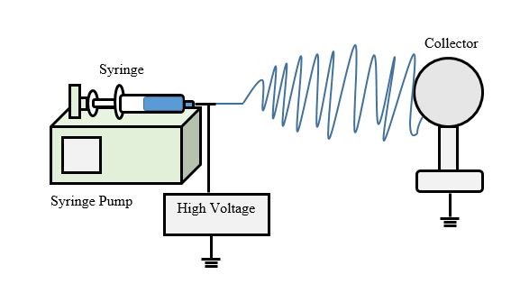

Figure 1. Setup of electrospinning

Coating of nylon 6,6 NFM with BMIM-chloride

BMIM-chloride was diluted into de-ionized water with concentration of 1%, 2%, 3%, 4%, and 5% as shown in Table 1. The membranes with same area size were immersed directly into each ionic liquid concentration for 12 hours. All of the membranes were then taken out and exposed to open air to dry for 3 hours.

Table 1. Preparation of BMIM-Cl based on concentration
Concentration  (%) | Volume of Ionic Liquid  (mL) | Volume of De-Ionized Water  (mL)
1 | 1 | 99
2 | 2 | 98
3 | 3 | 97
4 | 4 | 96
5 | 5 | 95

Characterization

The membranes were characterized based on surface morphology, Fourier infrared spectra (FTIR), porosity and water contact angle. Field Emission Scanning Electron Microscope (FESEM, Model: VPFESEM, Zeiss Supra55 VP, Feldbach, Switzerland) was used to study the surface of the electrospun nylon 6,6. Fourier transform infrared spectroscopy (FTIR, Model: Thermo Scientific Nicolet, United State) was used to study the interaction between BMIM-chloride and nylon 6,6. Apart from that, dry-wet method was used to measure membrane porosity where the membrane weight and volume were measured. Goniometer was used to find the water contact angle of membrane by using interfacial tension method (IFT, Model: OCA 20, Data Physics, Filderstadt, Germany).

Permeability analysis for wastewater treatment

For this test, the wastewater was obtained from Universiti Teknologi PETRONAS wastewater treatment plant. The permeability test for membrane was measured by using Cross-flow Microfiltration Testing Unit (the model was made and provided by Engineering, Prototyping & Innovation Centre (EPIC), one of the Universiti Teknologi PETRONAS service centre) with pressure of 0.1 bar. The effective membrane filtration area was 9 cm². The membrane was put between the set-up casing and the feed was pumped through the membrane. Then, the permeate volume was measured each 10 minutes until it reaches steady-state.

Rejection analysis for wastewater treatment

Some permeate samples after permeability analysis were kept for rejection analysis. This analysis included turbidity, chemical oxygen demand (COD) and phosphorus analysis. They were measured by using turbidity meter (Hach 2100Q Turbidity Meter) and Hach-Lange kits for COD and phosphorus.

Results and Discussion

Membrane properties

Table 2 shows the summary of the membrane properties for NFM. From the table, it is found that, the pore size and porosity of the membrane decrease as the concentration of BMIM-Cl increases. This is due to the increase of fiber diameter when BMIM-Cl is added as shown in Figure 2. By using ImageJ software, the fiber diameter of the membrane is found to be in the range of 600 to 1300 nm.

Table 2. Summary of membrane properties
Membrane | BMIM-Cl concentration  (%) | Fiber Diameter  (μm) | Pore Size  (μm) | Porosity  (%)
M-0 | 0 | 600±80 | 0.07 | 85.6
M-1 | 1 | 800±60 | 0.06 | 82.3
M-2 | 2 | 1100±30 | 0.06 | 76.8
M-3 | 3 | 1100±70 | 0.05 | 77.4
M-4 | 4 | 1200±100 | 0.04 | 79.7
M-5 | 5 | 1200±100 | 0.04 | 65.2

Figure 2 shows the images of untreated nylon 6,6 NFM and treated nylon 6,6 NFM at 10.0 kx magnification. From the figures, it can be clearly seen that the diameter of fiber increases as the membranes were soaked with BMIM-Cl due to BMIM-Cl nanoparticles coated onto the fiber surface [25]. By increasing the concentration of BMIM-Cl, the fiber diameter will also increases. Apart from that, it can be observed that the number of coating layers which has a honeycomb structure increase as the concentration of BMIM-Cl increases (see the red arrows). From here, it indicates that the coating layer of BMIM-Cl has successfully attached to the surface of NFM.

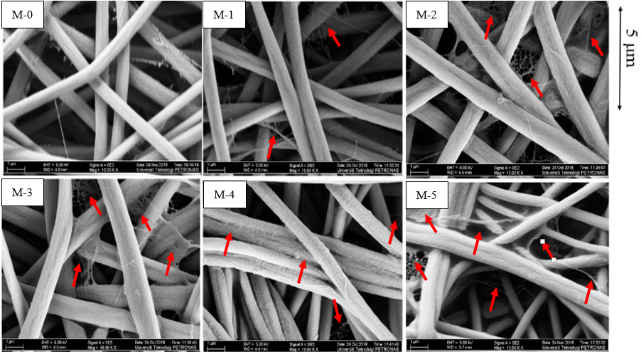

Figure 2. The FESEM images of untreated nylon 6,6 NFM and treated nylon 6,6

Figure 3 shows the graph of water contact angle vs time for untreated nylon 6,6 NFM and treated nylon 6,6 NFM. This is common for hydrophilic membrane as it will absorb the water over time. Based on the figure, the higher the concentration of BMIM-Cl, the faster the time taken for the membrane to reach 0°. In other words, the presence of BMIM-Cl improves the membrane hydrophilicity due to hydrophilic nature of BMIM-Cl [26]. Nevertheless, all of the membranes have contact angle of less than 90° which indicate that nylon 6,6 NFM exhibited good hydrophilic properties [27, 28].

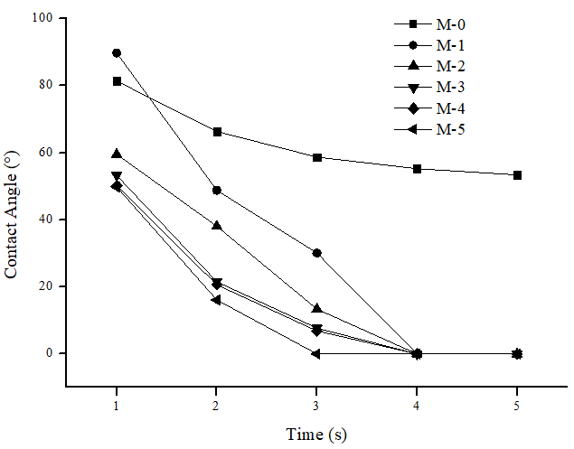

Figure 3. Water contact angle vs time for untreated nylon 6,6 NFM and treated nylon 6,6 NFM

Fourier-transform infrared spectroscopy (FTIR)

Figures 4 and 5 show the comparison of FT-IR graphs between M-0 and M-1 NFM. As can be observed from the figures, M-1 NFM has similar characteristics peaks as M-0 NFM. Based on both patterns, N-H stretching is indicated by the significant band at 3299 cm⁻¹. Same as CH₂ stretching, it can be observed at peaks 2933 cm⁻¹ for both patterns. The peaks observed at 1634 cm⁻¹ (M-0) and 1632 cm⁻¹ (M-1) are attributed by the amide I band. For amide II band, it can be observed at peak 1536 cm⁻¹ (M-0) and 1535 cm⁻¹ (M-1). From these patterns, it can be concluded that the addition of BMIM-Cl does not bring any significant difference in terms of chemical properties of nylon 6,6 NFM and only coat the outer layer of the membrane as can be observed in the increase number of web pattern on the surface of NFM in Figure 2.

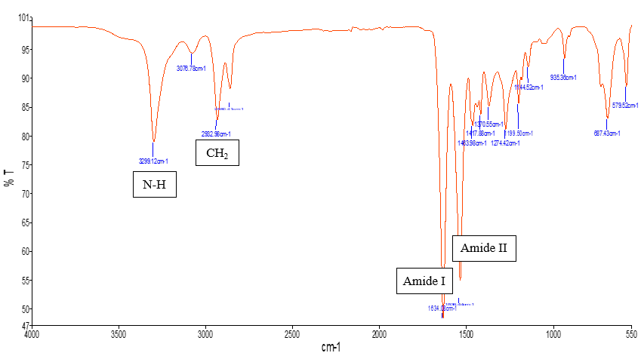

Figure 4. FT-IR pattern for M-0

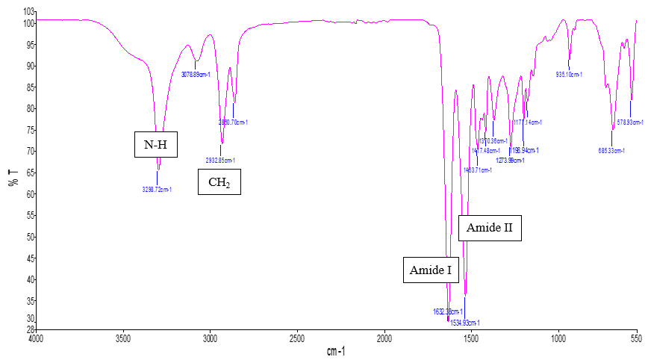

Figure 5. FT-IR pattern for M-1

Permeability test with wastewater

Figure 6 shows the wastewater permeability for untreated nylon 6,6 NFM and treated nylon 6,6 NFM. Based on the figure, the time taken for each membrane to reach steady-state varies where M-5 took the longest time to reach steady-state. This indicates that the soaking of BMIM-chloride prolongs the time taken for the membrane to get fouled. This is due to increase in membrane hydrophilicity where the waste particles unable to adsorb onto the membrane surface. As for the final permeability, all the membranes soaked with BMIM-chloride has the same value of permeability at 400 L/m².h.bar. As for M-0, it has the lowest final permeability of 333 L/m².h.bar. Note that the final permeability for all NFM coated with BMIM-Cl reached 400 L/m²h.bar. Despite the small difference of final permeability between the membranes, the results significantly proved that soaking method affect the permeability of the membrane as there is large gap of time taken to reach steady state between M-0 and M-5.

Figure 6. Wastewater permeability of nylon 6,6 with ranges of BMIM-Cl concentration from 0% to 5%

Rejection analysis

The permeate from the permeability test has been collected to be analysed for turbidity, COD and phosphorus test. The results in Table 3 show that more than 90% of rejection able to be achieved for turbidity, COD and phosphorus when nylon 6,6 NFM is coated with BMIM-chloride. This is due to the increase in fiber diameter and reduce in membrane pore size which enable the membranes to reject smaller particles inside the wastewater. From these results, it can be concluded that the soaking of BMIM-chloride onto the NFM is effective in treating wastewater as smaller particles inside the wastewater able to be rejected.

Table 3. Rejection analysis
Sample | Turbidity  (NTU) | Rejection Analysis
Sample | Turbidity  (NTU) | COD Rejection  (%) | Phosphorus Rejection  (%)
Wastewater | 2.72 | - | -
Pure water | 0.14 | - | -
Permeate 0% | 0.64 | 88.0 | 88.0
Permeate 1% | 0.27 | 99.9 | 99.9
Permeate 2% | 0.25 | 99.9 | 99.9
Permeate 3% | 0.24 | 99.9 | 99.9
Permeate 4% | 0.23 | 99.9 | 99.9
Permeate 5% | 0.23 | 99.9 | 99.9

Conclusion

In this study, the soaking method by using BMIM-Cl has proven to be successfully influence the physio chemical of nylon 6,6 NFM. The soaking of BMIM-Cl increases the fibre diameter and hence reduce the pore size of the membrane. FT-IR results also concludes that the BMIM-chloride interaction only occur on the surface of nylon 6, 6 NFM. For the permeability analysis, M-5 NFM took the longest time to reach steady-state. The rejection test results also show that the soaked membrane able to achieve more than 90% of rejection for turbidity compared to absence of BMIM-Cl. As for COD and phosphorus test, all of the treated membranes able to achieve 100% of rejection. For further study, it is suggested to make other comparison with other surface modification methods such as solvent vapour treatment and blending methods. As for example, for solvent vapor treatment, the time taken for the exposure of ionic liquid to the nanofiber membrane should be taken into consideration and on how it can affect the nanofiber membrane properties and characterization.

Acknowledgement

We would like to acknowledge Universiti Teknologi PETRONAS for providing grants (UTP grant number (YUTP): 0153AA-H29) for conducting the research activities.

References
- Ibrahim, N. A., Wirzal, M. D. H., Nordin, N. A. H., and Halim, N. S. A. (2018). Development of polyvinylidene fluoride (PVDF)-ZIF-8 membrane for wastewater treatment. IOP Conference Series: Earth and Environmental Science, 140(1): 012021.
- Bae, J., Baek, I. and Choi, H. (2016). Mechanically enhanced PES electrospun nanofiber membranes (ENMs) for microfiltration: The effects of ENM properties on membrane performance. Water Research, 105: 406-412.
- Liao, Y., Loh, C., Tian, M., Wang, R., and Fane, A. G. (2018). Progress in electrospun nanofibrus membranes for water treatment: Fabrication, modification and applications. Progress in Polymer Science, 77: 69-94.
- George, G., Bhoria, N., Alhallaq, S., Abdala, A. and Mittal, V. (2016). Polymer membranes for acid gas removal from natural gas. Separation and Purification Technology, 158: 333-356.
- Singh, R. (2006). Hybrid membrane systems for water purification: Technology, systems design and operations. Elsevier.
- Eliseus, A., Bilad, M. R., Nordin, N. A. H. M., Putra, Z. A. and Wirzal, M. D. H. (2017). Tilted membrane panel: a new module concept to maximize the impact of air bubbles for membrane fouling control in microalgae harvesting. Bioresource Technology, 241 (Supplement C): 661-668.
- Chang, I. S., Le Clech, P., Jefferson, B., and Judd, S. (2002). Membrane fouling in membrane bioreactors for wastewater treatment. Journal of Environmental Engineering, 128(11): 1018-1029.
- Foong, C. Y., Wirzal, M. D. H., and Bustam, M. A. (2020). A review on nanofibers membrane with amino-based ionic liquid for heavy metal removal. Journal of Molecular Liquids, 297: 111793.
- Al-Husaini, I. S., Yusoff, A. R. M., Lau, W.J., Ismail, A. F., Al-Abri, M. Z., and Wirzal, M. D. H. (2019). Iron oxide nanoparticles incorporated polyethersulfone electrospun nanofibrous membranes for effective oil removal. Chemical Engineering Research and Design, 148: 142-154.
- Bilad, M. R., Westbroek, P. and Vankelecom, I. F. J. (2011). Assessment and optimization of electrospun nanofiber-membranes in a membrane bioreactor (MBR). Journal of Membrane Science, 380(1): 181-191.
- Qin, Y., Yang, H., Xu, Z, and Li, F. (2018). Surface modification of polyacrylonitrile membrane by chemical reaction and physical coating: comparison between static and pore-flowing procedures. ACS Omega, 3(4): 4231-4241.
- Al-Husaini, I. S., Yusoff, A. R. M., Lau, W. J., Ismail, A. F., Al-Abri, M. Z., Al-Ghafri, B. N., and Wirzal, M. D. H. (2019). Fabrication of polyethersulfone electrospun nanofibrous membranes incorporated with hydrous manganese dioxide for enhanced ultrafiltration of oily solution. Separation and Purification Technology, 212: 205-214.
- Kochkodan, V., Johnson, D. J., and Hilal, N. (2014). Polymeric membranes: Surface modification for minimizing (bio) colloidal fouling. Advances in Colloid and Interface Science, 206 (Supplement C): 116-140.
- Kim, H.J., Park, S. J., Park, C. S., Le, T.-H., Hun Lee, S., Ha, T. H., Kim, H., Kim, J., Lee, C.S., Yoon, H., and Kwon, O. S. (2018). Surface-modified polymer nanofiber membrane for high-efficiency microdust capturing. Chemical Engineering Journal, 339: 204-213.
- Vanangamudi, A., Yang, X., Duke, M. C., and Dumee, L. F. (2018). Nanofibers for membrane applications. In A. Barhoum, M. Bechelany, and A. Makhlouf (Eds.), Handbook of Nanofibers Springer International Publishing: pp. 1-24.
- Nasreen, S. A. A. N., Sundarrajan, S., Nizarm, S. A. S., Balamurugan, R. and Ramakrishna, S. (2013). Advancement in electrospun nanofibrous membranes modification and their application in water treatment. Membranes (Basel), 3 (4): 266-284.
- Asadollahi M., Bastani, D., and Musavi, S. A. (2017). Enhancement of surface properties and performance of reverse osmosis membranes after surface modification: A review. Desalination, 420: 330-383.

- Hilal, N., Khayet, M. and Wright, C. J. (2016). Membrane modification: Technology and applications. CRC Press.
- Khayet, M. (2013). Polymeric nano-fibers and modified nano-fibers assembly in 3D network for different potential applications. Journal of Materials Science & Nanotechnology, 1 (1): 1-4.
- Park, M. J., Gonzales, R. R., Abdel-Wahab, A., Phuntsho, S., and Shon, H. K. (2018). Hydrophilic polyvinyl alcohol coating on hydrophobic electrospun nanofiber membrane for high performance thin film composite forward osmosis membrane. Desalination, 426: pp. 50-59.
- Javed, K., Krumme, A., Krasnou, I., Mikli, V., Viirsalu, M., Plamus, T., Mendez, J. D. (2017). Impact of 1-butyl-3-methylimidazolium chloride on the electrospinning of cellulose acetate nanofibers. Journal of Mactomolecular Science, Part A: Pure and Applied Chemistry, 2017: 1-6.
- Abd Halim, N. S., Wirzal, M. D. H., Bilad, M. R., Md Nordin, N. A. H., Adi Putra, Z., Mohd Yusoff, A. R., Narkkun, T., and Faungnawakij, K. (2019). Electrospun nylon 6,6/ZIF-8 nanofiber membrane for produced water filtration. Water, 11(10): 2111.
- Abd Halim, N. S., Wirzal, M. D. H., Bilad, M. R., Md Nordin, N. A. H., Adi Putra, Z., Sambudi, N. S., and Mohd Yusoff, A. R. (2019). Improving performance of electrospun nylon 6,6 nanofiber membrane for produced water filtration via solvent vapor treatment. Polymers, 11(12): 1-11.
- Bilad, M. R., Azizo, A. S., Wirzal, M. D. H., Jia Jia, L., Putra, Z. A., Nordin, N. A. H. M. and Yusoff, A. R. M. (2018). Tackling membrane fouling in microalgae filtration using nylon 6,6 nanofiber membrane. Journal of Environmental Management, 223: 23-28.
- Yang, J., He, F., Wu, H., Liang, Y., Wang, Y., and Sun, Z. (2018). Engineering surface and optical properties of TiO₂-coated electrospun PVDF nanofibers via controllable self-assembly. Nanomaterials (Basel), 8(9): 794.
- Shrotri, A., Kobayashi, H., and Fukuoka, A. (2017). Chapter Two - Catalytic Conversion of Structural Carbohydrates and Lignin to Chemicals, in Advances in Catalysis, vol. 60, C. Song, Ed. Academic Press: pp. 59–123.
- Zhang, M., Liao, B., Zhou, X., He, Y., Hong, H., Lin, H. and Chen, J. (2015). Effects of hydrophilicity/hydrophobicity of membrane on membrane fouling in a submerged membrane bioreactor. Bioresource Technology, 175: 59-67.
- Fujioka, T. and Nghiem, L. (2013). Modification of a polyamide reverse osmosis membrane by heat treatment for enhanced fouling resistance. Water Science and Technology: Water Supply, 13(6): 1553-1559.

