

PREPARATION AND CHARACTERISATION OF pH PROBE MEMBRANE FOR DETERMINATION OF TOTAL ALKALINITY IN SEAWATER

(Penyediaan dan Pencirian Membran Prob pH bagi Penentuan Jumlah Kealkalian dalam Air Laut)

Noor Sheryna Jusoh, Azrilawani Ahmad*, Marinah Mohd Ariffin, Hafiza Mohamed Zuki

Faculty of Science and Marine Environment,
Universiti Malaysia Terengganu, 21030 Kuala Nerus, Terengganu, Malaysia

*Corresponding author: azrilawani.ahmad@umt.edu.my

Received: 20 November 2019; Accepted: 16 January 2020

Abstract
A pH probe membrane was successfully synthesised using polyvinyl chloride (PVC), chromoionophore I (CI), different additives (KTFPB and ETH500), plasticiser 2-nitrophenyl octyl ether (NPOE) and tetrahydrofuran (THF). Membrane casting method was applied during the preparation of the membrane. In order to evaluate the performance of the functional PVC membrane, physical characterisation such as scanning electron microscopy (SEM), attenuated total reflectance-Fourier transform infrared spectroscopy (ATR-FTIR), ultraviolet-visible spectroscopy (UV-Vis), fluorescence spectroscopy and tensile strength were conducted. Electrochemical characterisation was carried out using glassy carbon (GC) and gold (Au) electrodes, in order to identify the presence of electroactive species and to examine the behaviour of the membrane under electrochemical environment. The voltammetric measurement was conducted in 2.5 mM ferricyanide/ferrocyanide in 0.1 M KCl redox probe, at potential range of -0.2 - +0.6 V with the scan rate of 50 mV/s. The performance of PVC membrane using different additives was compared and analysed.

Keywords: polymeric functional membrane, PVC, voltammetry, total alkalinity

Abstrak
Membran prob pH telah berjaya disintesis menggunakan polivinil klorida (PVC), kromoionofor I (CI), aditif yang berbeza (KTFPB dan ETH500), pemplastik 2-nitrofenil oktil eter (NPOE) dan tetrahidrofuran (THF). Kaedah penuangan membran telah diaplikasi semasa penyediaan membran. Bagi menilai prestasi membran PVC berfungsi, pencirian fizikal seperti mikroskopi elektron pengimbasan (SEM), pantulan keseluruhan dikecilkan-spektroskopi inframerah jelmaan Fourier (ATR-FTIR), spektroskopi ultralembayung-nampak (UV-Vis), spektroskopi pendafluoran dan kekuatan tensil telah dijalankan. Pencirian elektrokimia telah dilakukan menggunakan elektrod karbon berkaca (GC) dan emas (Au), untuk menentukan kehadiran spesis elektroaktif dan menguji tindakan membran di bawah persekitaran elektrokimia. Pengukuran voltametri telah dilakukan dalam 2.5 mM ferisianida/ferosianida dalam 0.1 M KCl prob redoks, pada julat keupayaan -0.2 V - +0.6 V dengan kadar imbasan 50 mV/s. Prestasi membran PVC menggunakan aditif yang berbeza telah dibandingkan dan dianalisa.

Kata kunci: membran polimerik berfungsi, PVC, voltametri, jumlah kealkalian

Introduction
Effect of seawater acidification in decreasing pH of oceans is an ongoing process that potentially threaten productivity of the ocean [1]. Measuring the degree of seawater acidification first requires understanding of carbonate chemistry in seawater and it is impossible to directly measure all carbon species in marine environment [2]. Carbon variables in ocean can be defined by measuring pH, dissolve inorganic carbon, partial CO₂ and total alkalinity in seawater [3]. Recent development on the sensing system for total alkalinity determination has evolved with the usage of membrane as an alternative approach less prone to interferences involves the electrochemically driven transport of ions across ion-selective membranes [4]. However, little are reported on the more complex matrices such as in seawater. The important goal in membrane technology is to control the membrane structure, which affects its performance [5]. A comprehensive understanding between composition and the performance of the membranes is crucial for further development of membranes and optimisation of fabrication processes. The primary objective of this research is to study the behaviour of different composition of PVC pH probe membrane under physical, mechanical and electrochemical characterisation to measure total alkalinity in seawater.

Total alkalinity is an important parameter for describing the marine inorganic carbon system and the measurement of the total alkalinity in the surface seawater is particularly useful because it will give information with respect to water mass mixing and also advancing our understanding on the ocean carbon cycle and marine geochemistry [6]. However, the measurement of total alkalinity is limited, partly due to laborious processes of collecting and analysing samples [7]. Conventional titration method of analysing total alkalinity is time consuming and can only be applied for a single measurement at one time. Recently, polymeric membrane has been widely used in measurement of total alkalinity in lake and seawater due to its excellent chemical and mechanical properties [8]. However, the strong hydrophobicity contributed to the flux decline and frequent back-flushing operation resulting in the deterioration of membrane mechanical strength and cause the membrane to rupture. Therefore, it is very important to control the membrane structure, in the aspects of hydrophobicity, mechanical strength, and stability, which strongly influence its performance. For the preparation of polymeric membranes, the blending ratio, polymer concentration and the selection of solvent and non-solvent play a crucial role in influencing the thermodynamic and kinetic properties of the casting solution, which influence the morphology and properties of the final membranes [9]. However, in order to obtain the desired membrane pore structure, the application of different additives is essential, as well as the usage of suitable plasticiser and ionophore. Further improvement of existing membrane fabrication methods as well as the development of new fabrication techniques are essential, hence this study is necessary to get a better understanding on the synthesis and preparation of polymeric functional membranes for measurement of total alkalinity in seawater samples.

A membrane is an interphase between two adjacent phases acting as a selective barrier, regulating the transport of substances between the two compartments [10]. Membrane are generally classified by the nature of the materials, the membrane morphology, geometry, preparation method, separation regime and processes [11]. The role of plasticiser in the membrane preparation is to improve the characteristics of the polymers such as the elasticity and their mechanical properties [12-13]. The performance of plasticiser could be influenced by the lipophilicity of the plasticiser compound used, the amount of ionophore incorporated in the polymer membrane, type of support polymer and the inclusion of ion exchange sites in the form of lipophilic salts. By providing the properties as softening the polymeric membrane, solubilizes the ionophore and insoluble in water, it is considered as an ideal plasticiser. However, with the characteristics mentioned above, often does not prevent the loss of ionophore to the sample [14]. In order to obtain the desired membrane structure, the application of different additives is essential. An additive can function as a pore former, increase solution viscosity or accelerate the phase inversion process [15]. In the research conducted by Fadilah and Hassan, it was reported that by combining the surfactant to the polymeric solutions, the thickness of the prepared membranes significantly increases and hence, probably enhanced membrane performance for protein rejection [16]. Meanwhile, inorganic additives could accelerate the phase separation rate and contribute to a membrane structure with lots of interconnected pores, resulting the membrane exhibits excellent mechanical strength and thermal stability [17]. This research is important to study the optimum parameters required for the construction of a reliable and high performance polymeric functional membranes, hence would be of crucial information needed for further study for total alkalinity determination in ocean.

Materials and Methods
Chemicals and reagents
2-nitrophenyl octyl ether, potassium tetrakis[3,5-bis(trifluoromethyl)phenyl]borate, tetradodecylammonium tetrakis(4-chlorophenyl) borate and chromoionophore I were purchased from Sigma-Aldrich (Switzerland). Tetrahydrofuran, potassium ferricyanide, potassium ferrocyanide and potassium chloride were purchased from Merck (Germany). Polyvinyl chloride (high molecular weight) and alumina slurry were purchased from Aldrich and Metrohm, respectively. All chemicals and reagents used were of analytical grade and better.

Preparation of pH probe membrane
1% CI, 30% PVC, 63% plasticiser (NPOE) and 7% additives (ETH500 and KTFPB) were dissolved in 1 mL THF. The mixture then was poured into glass ring. Filter paper and weight were placed on top of the glass ring. The solution was left to dry for 24 h. Control membrane was prepared without CI and additives in order to compare the performance of the ionophore and additives in the membrane.

Characterisation of pH probe membrane
ATR-FTIR was conducted using Fourier Transform Infrared Spectrophotometer IRTracer-100 (Shimadzu) equipped with Lab Solutions IR software. The membranes were scanned 40 times in the spectral range from 4000 cm⁻¹ to 400 cm⁻¹ with resolution of 4 cm⁻¹ and Happ-Genzel apodisation via diamond attenuation total reflectance method.

UV-Vis measurement was carried out using dual beam UV-Vis Spectrophotometer UV-1800 (Shimadzu) equipped with UV Probe 2.43 software. Absorbance was measured at wavelength from 800 nm to 190 nm through 1 cm quartz cuvette. Concentration of sample used was 0.01 mM and THF was used as blank. Fluorescence was conducted using Cary Eclipse Fluorescence Spectrophotometer (Varian) equipped with Cary Eclipse software, through 1 cm quartz cuvette. Concentration of CI used was 0.01 mM.

Morphology of the membrane was investigated using Scanning Electron Microscope JSM-636OLA (JEOL) at various magnifications. SC7620 Mini Spurter coater was used to coat the membranes with gold. Mechanical measurement was carried out using Tensile Tester (Shimadzu) EZ500-NLX, equipped with TRAPEZIUMX software. Cross speed was set at 10 mm/min. Electrochemical measurement (CV) was conducted using AUTOLAB B.V. PGSTAT204 (AUT51243) (Metrohm). Membrane was deposited on electrodes (GC and Au) and measurement was conducted in 2.5 mM ferricyanide/ferrocyanide in 0.1 M KCl from potential of -0.2 V to 0.6 V at scan rate of 50 mV/s for five cycles. GC and Au electrodes were polished with alumina slurry prior to measurement.

Results and Discussion
ATR-FTIR spectroscopy
Spectral analysis was carried out on all prepared PVC membranes in order to identify the functional groups presence in the membranes. The result was shown in Figure 1. Control membrane was prepared with only PVC and NPOE, while ETH500 and KTFPB membranes were prepared with all reagents. All PVC membranes showed almost similar FTIR spectra, with the presence functional groups peaks at same wavenumber. An increase in transmittance was recorded for both ETH500 and KTFPB membranes at 3600–3000 cm⁻¹, which was not presence in the control spectrum. The peak was probably due to the presence of either CI (Figure 2) or additives (Figure 3) or both. KTFPB membrane displayed minor difference of peak transmittance from 1800-800 cm⁻¹. However, no significant presence of other functional group was detected in the range.

Recorded functional groups and respective wavenumbers were summarised in Table 1. Peaks at 2926-2856 cm⁻¹ were assigned to alkane C-H stretching [18,19], which might come from NPOE (Figure 4) or ETH500 or both. Aromatic-related peaks were observed at 2000-1900 cm⁻¹ and 987-744 cm⁻¹, which were assigned to C-H bending and benzene disubstituted, respectively. These peaks might come from all compounds since all the compounds has one or more benzene ring in the structure. Both nitro N-O stretching and aliphatic ether C-O stretching, which appeared at 1523 cm⁻¹ and 1089 cm⁻¹, respectively, were from NPOE.

Figure 1. FTIR spectra of different composition of PVC membranes

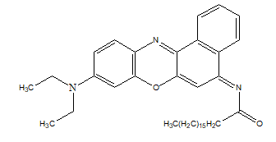
Figure 2. Chemical structure of CI (ionophore)

- (b)

Figure 3. Chemical structure of additives; (a) KTFPB and (b) ETH500.
Table 1. List of functional groups of PVC membranes assigned to respective wavenumbers
Wavenumber (cm⁻¹) | Functional Group | Compound
2926-2856 | Alkane sp3 C-H stretching | NPOE, ETH500
2000-1900 | Aromatic C-H bending (overtone) | All
1523 | Nitro N-O stretching (asymmetric) | NPOE
1089 | Aliphatic ether C-O stretching | NPOE
987-744 | Aromatic disubstitute benzene (ortho, meta, para) | All

Figure 4. Chemical structure of NPOE (plasticiser).

UV-Vis spectroscopy
Absorption of PVC membranes was studied in UV-Vis region and the spectra were displayed in Figure 5. Two excitation peaks were observed at 318 nm and 526 nm, with the presence of CI. Membrane without CI did not present any noticeable peak. Thus, excitation was contributed by electrons in CI.

Figure 5. UV excitation peaks of CI in PVC membranes. Solvent: THF

Fluorescence spectroscopy
Further photophysical properties of CI has been performed using fluorescence spectroscopy. Figure 6 demonstrated that the maximum intensity of fluorescence emission at 528 nm was in corresponding with maximum excitation at 427 nm.

Figure 6. Excitation and emission peaks of CI in THF

Scanning electron microscopy
Surface morphology of PVC membranes was thoroughly studied using SEM at different magnifications. Table 2 displayed the micrographs of all PVC membranes. At x100 magnification, difference morphology of the membranes can be clearly seen, especially for KTFPB membrane. At closer view, both control and ETH500 membranes have similar surface morphology, with line-like structure. However, the position and arrangement of the line-like structure were different for both membranes. The lines in control membrane appeared to be more visible compared to ETH500 membrane. In contrast, the surface micrograph for KTFPB membrane showed the presence of crater-like structures, which were not observed in control and ETH500 membranes.

Table 2. Surface morphology of PVC membranes at different magnification (a) x 2000, (b) x 1000, (c) x 500,
(d) x 100, (e) x 23
Control | ETH500 | KTFPB
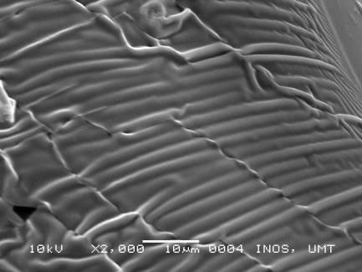  a | 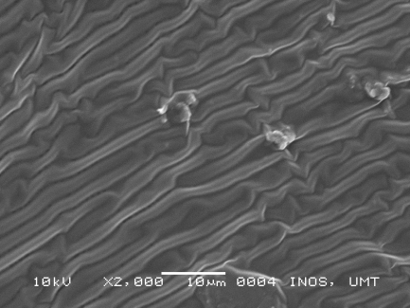 | 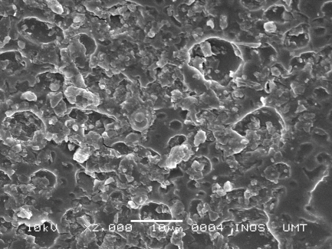
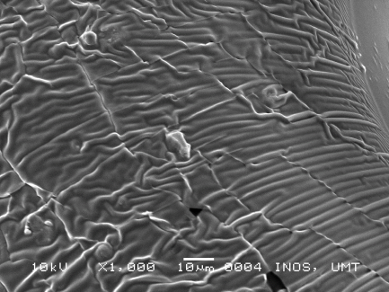  b | 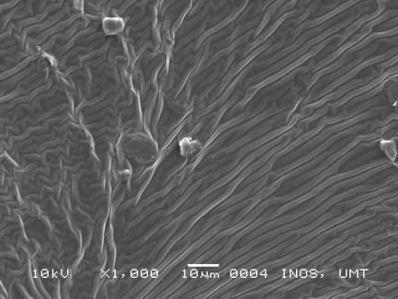 | 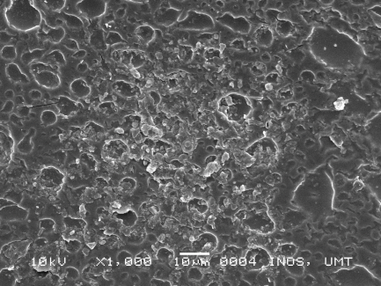
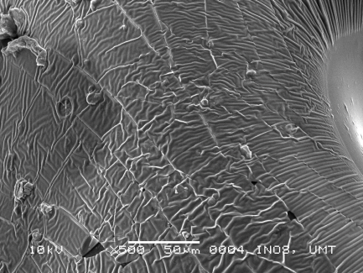  c | 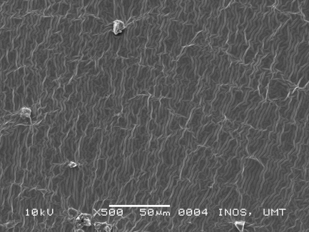 | 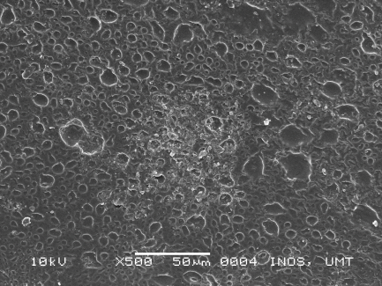
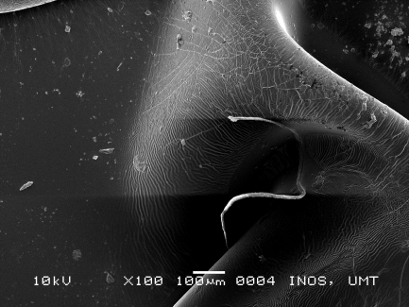  e  d | 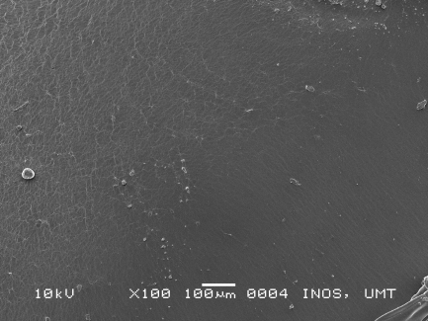 | 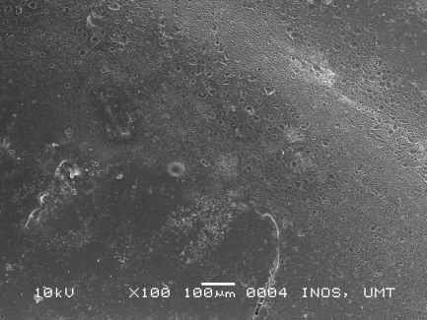
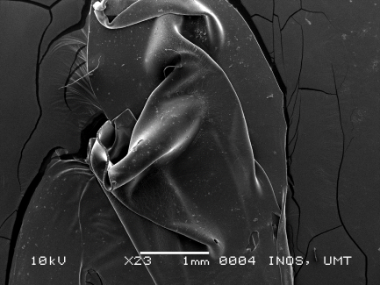 | 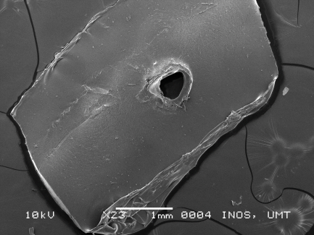 | 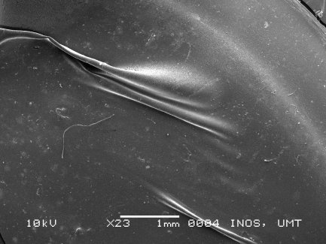

Tensile strength test
Mechanical strength of prepared PVC membranes was evaluated using tensile analysis. During measurement, each membrane was stretched at 10 mm/min. All results were tabulated in Table 3. Low initial force was recorded for all PVC membranes because the membranes was relatively thin. During elongation process, the membranes were easily stretched and broken, even at low force. Control membrane can be stretched up to 44 mm, which made it the longest among the PVC membranes, followed by KTFPB and ETH500 membranes. In addition, control membrane took the highest force to break the membrane at 38 mm. The toughness and flexibility of control membrane might be related to percentage of plasticiser used during the membrane preparation [20, 21]. The role of plasticiser is not only to increase elasticity, but also slightly contributes to the strength of the membrane. Even though KTFPB membrane can be stretched two times longer than ETH500 membrane, the force required to break the membranes were almost similar. Moreover, the length for both membranes during break was also similar.

Table 3. Parameters measured during tensile analysis for PVC membranes
Membrane | Maximum Displacement Force (N) | Maximum Displacement Stroke (mm) | Maximum Force at Break (N) | Maximum Displacement at Break (mm)
Control | -0.024 | 44.083 | 0.787 | 37.855
ETH500 | 0.062 | 21.147 | 0.308 | 18.736
KTFPB | 0.103 | 42.044 | 0.430 | 17.798
Cyclic voltammetry
Electrochemical behaviour of PVC membranes was evaluated through CV measurement of GC and Au electrodes in 2.5 mM ferricyanide/ferrocyanide redox probe in 0.1 M KCl, from -0.2 V to +0.6V at 50 mV/s. As displayed in Figure 7a and Figure 8a, both bare GC and Au electrodes showed the highest current reading, with distinct presence of both oxidation and reduction peaks in the voltammogram. However, after the immobilisation of PVC membranes onto the electrode surface, current reading was significantly decreased (Figure 7b and Figure 8b). The values were excessively small, which implies that almost no current was recorded during the measurement. During the immobilisation, the membranes successfully occupied all the electrode surface, preventing any form of electron transfer to occur. Electrochemical measurement of PVC membranes was in complementary with SEM analysis, where there was no cavity or open area in the membrane that could exposed the electrode surface to the redox solution. In addition, there was no component in the membranes that can promote redox reaction.

(a) (b)
Figure 7. Electrochemical behaviour of PVC membranes using GC electrode; (a) Voltammograms of bare GC and GC with PVC membranes and (b) Closer view of voltammograms of GC with PVC membrane

- (b)
Figure 8. Electrochemical behaviour of PVC membranes using Au electrode; (a) Voltammograms of bare Au and Au with PVC membranes and (b) Closer view of voltammograms of Au with PVC membrane

Conclusion
PVC pH probe membranes with different compositions were successfully prepared and characterised. ATR-FTIR analysis showed no significant difference in functional groups presence in control, ETH500 and KTFPB membranes. However, main bands of the membranes were clearly observed in the spectra. Membranes with CI displayed positive results for UV-Vis and fluorescence, where active excitation and emission were recorded for both measurements. Surface morphology investigation indicated major difference between ETH500 and KTFPB membranes, which might be contributed by the nature of the additives used in the membrane. During mechanical analysis, the force taken to break all the membranes was considerably low, but control membrane showed higher tensile property compared to ETH500 and KTFPB membranes. Electrochemical investigation concluded that all membranes completely hindered redox reaction, which contributed to low current reading. The successful developed membrane could be used as potential membrane for pH prob for total alkalinity measurement in seawater.

Acknowledgement
The authors would like to thank Ministry of Higher Education of Malaysia for the research grant FRGS/1/2017/WAB09/UMT/02/4 (FRGS59487). Special thanks goes to Central Laboratory and Faculty of Science and Marine Environment for providing research laboratories and analytical instruments.

References
- Lohbeck, K. T., Riebesell, U. and Reusch T. B. H. (2012). Adaptive evolution of a key phytoplankton species to ocean acidification. Nature Geoscience, 5: 346-351.
- Anthony, K. R. N., Kleypas, J. A. and Gattuso, J. P. (2011). Coral reefs modify their seawater carbon chemistry- implications for impacts of ocean acidification. Global Change Biology, 17(12): 3655-3666.
- Dickson, A. G., Sabine, C. L. and Christian, J. R. (2007). Guide to best practices for ocean CO₂ measurement. North Pacific Marine Science Organization, Sidney, British Columbia: pp. 191.
- Crespo, G. A., Afshar, M. G. and Bakker, E. (2012). Direct detection of acidity, alkalinity and pH with membrane electrodes. Analytical Chemistry, 84(23): 10165-10169.
- Byrne, R. H. (2014). Measuring ocean acidification: New technology for a new era of ocean chemistry. Environmental Science & Technology, 48: 5352-5360.
- Riebesell, U. F., Victoria, J., Hansson, L. and Gattuso, Jean-Pierre (2011). Guide to best practices for ocean acidification research and data reporting. Office for Official Publications of the European Communities, Luxembourg: pp 258.
- Spaulding, R. S., DeGrandpre, M. D., Beck., J. C., Hart., R. D., Peterson, B., De Carlo, E. H., Drupp, P. S. and Hammar, T. R. (2014). Autonomous in situ measurements of seawater alkalinity. Environmental Science and Technology, 48(16): 9573-9581.
- Afshar, M. G., Waeber, M. L. T., Wehrli, B. and Bakker, E. (2017). Direct sensing of total alkalinity profile in a stratified lake. Geochemistry Perspectives Letters, 3: 85-93.
- Tan, X. M. and Rodrigue, D. (2019). A review on porous polymeric membrane preparation. Part 1: Production techniques with polysulfone and poly (vinylidene fluoride). Polymers, 11: 1-39.
- Ulbricht, M. (2006). Advances functional polymer membranes. Polymer, 47(7): 2217-2262.
- Ren, J. and Wang, R. (2010). Preparation of polymeric membranes. Membrane and Desalination Technologies, Handbook of Environmental Engineering, 13: 47-100.
- Vihali, C. and Vaum, N. (2012). Use of plasticizers for electrochemical sensors: Recent advances in plasticisers. Intech Open: pp. 125-140.
- Othman, M. A. F., Ahmad, A. and Zuki, H. M. (2016). Dithizone modified electrode for the determination of metals ion in aqueous solution. Malaysian Journal of Analytical Sciences, 20(1): 197-204.
- Carey, C. (2015). Plasticizer effects in the PVC membrane of the dibasic phosphate selective electrode. Chemosensors, 3: 284-294.
- Lalia, B. S., Kockodan, V., Hashaikeh, R. and Hilal, N. (2013). A review on membrane fabrication: Structure, properties and performance relationship. Desalination, 326: 77-95.
- Fadilah, N. I. M. and Hassan, A. R. (2016). Preparation, characterization and performance studies of active PVDF ultrafiltration-surfactants membranes containing PVP as additive. Malaysia Journal of Analytical Sciences, 20(2): 335-341.
- Zhang, Y.J., Lin, R., and Yuan, M.Y. (2013). Effects of Pore-Forming Additives on Structures and Properties of PVDF/Fe3+/Cu2+ Hollow Fiber Membranes. Desalination. Water Treat, 51: 3903–3908.
- Tooma, M. A., Najim, T. S., Alsalhy, Q. S., Marino, T., Criscuoli, A., Giorno, L. and Figoli, A. (2015). Modification of polyvinyl chloride (PVC) membrane for vacuum membrane distillation (VMD) application. Desalination, 373: 58-70.
- Ismayil, K. M. M., Manaf, O., Sujith, A. and Antony, R. (2019). Polymer thin films for chromatographic separation of plant pigments. Materials Letters, 252: 321-324.
- Yu, Q. and Selvadurai, A. P. S. (2005). Mechanical behaviour of plasticized PVC subjected to ethanol exposure. Polymer Degradation and Stability, 89: 109-124.
- Das, P. and Ray, S. K. (2016). Pervaporative recovery of tetrahydrofuran from water with plasticized and filled polyvinyl chloride membranes. Journal of Industrial and Engineering Chemistry, 34: 321-336.

