

MAGNETIC KAOLINITE COMPOSITE FOR LEAD REMOVAL IN AQUEOUS SOLUTION

(Komposit Kaolinit Bermagnetik Untuk Penyingkiran Plumbum Dari Larutan Akueus)

Izzan Salwana Izman, Siti Nor Atika Baharin, Ruhaida Rusmin*

School of Chemistry and Environment, Faculty of Applied Sciences

Universiti Teknologi MARA, Negeri Sembilan Branch, Kuala Pilah Campus, 72000 Kuala Pilah, Negeri Sembilan, Malaysia

*Corresponding author: ruhaida@uitm.edu.my

Received: 20 November 2019; Accepted: 21 January 2020

Abstract

Magnetic kaolinite composite was successfully synthesized using combination of kaolinite and iron oxide through co-precipitation method. The synthesized kaolinite-iron oxide (Kao-IO) and raw kaolinite (Kao) was characterized using X-ray diffractometer (XRD), scanning electron microscope (SEM), and Fourier-transform infrared spectroscopy (FTIR). The Kao-IO composite was used to remove Pb²⁺ ions from aqueous solution through adsorption studies under various experimental conditions (e.g. pH, contact time, and initial Pb concentration). Meanwhile the desorption studies of Pb loaded Kao-IO were performed with different desorbing agents. The optimum experimental condition was achieved at pH 6, reaction time of 120 min at initial concentration ranged from 10 to 70 mg/L. Kao-IO composite has a higher adsorption capacity (30.93 mg g⁻¹) compared to Kao (25.04 mg g⁻¹). Ethylenediaminetetraacetic acid (EDTA) was the best desorbing agent with the highest desorption efficiency (39.18%). Overall, Kao-IO composite demonstrated high potential as suitable adsorbent to treat Pb contaminated water.

Keywords: kaolinite, magnetic, iron oxide, lead, adsorption

Abstrak

Komposit kaolinit bermagnetik telah berjaya disintesis menggunakan gabungan kaolinit dan ferum oksida melalui kaedah pemendakan bersama. Kaolinit-ferum oksida (Kao-IO) dan kaolinit asli (Kao) dicirikan menggunakan pembelauan sinar-X (XRD), Mikroskop imbasan elektron (SEM) dan spektroskopi inframerah transformasi Fourier (FTIR). Komposit Kao-IO digunakan untuk menyingkirkan ion Pb²⁺ dari larutan akueus melalui kajian penjerapan dengan menggunakan pelbagai parameter eksperimen (contohnya pH, masa tindak balas dan kepekatan awal Pb). Sementara itu, kajian nyahjerapan Pb yang terjerap pada Kao-IO dilakukan menggunakan pelbagai ejen nyahjerapan. Parameter eksperimen yang optima dicapai pada pH 6, masa tindak balas 120 minit dan pada kepekatan awal antara 10 hingga 70 mg/L. Komposit Kao-IO menunjukkan kapasiti penjerapan yang lebih tinggi (30.93 mg g⁻¹) berbanding dengan Kao (25.04 mg g⁻¹). Asid etilinadiaminatetraasetik (EDTA) merupakan ejen nyahjerapan yang terbaik dengan kecekapan nyahjerapan tertinggi (39.18%). Secara keseluruhan, komposit Kao-IO menunjukkan potensi yang tinggi sebagai penjerap yang sesuai untuk merawat air yang tercemar dengan Pb.

Kata kunci: kaolinit, magnetik, ferum oksida, plumbum, penjerapan

Introduction

Uncontrolled release of heavy metals into environment from industries and domestic activities has become a serious global problem. Toxic heavy metal like lead (Pb) is categorized as one of the major pollutants in wastewater due to their non-biodegradable and persistence [1]. Lead poisoning is known to be hazardous and could cause severe health issues especially in children [2].

In order to remediate heavy metal contaminated water, treatments that are reliable, cost-effective and efficient are of great interest. Various methods have been used for this purpose, such as adsorption, solvent extraction, chemical precipitation, ion exchange, ultrafiltration, and reverse osmosis [3]. Adsorption technique has been reported as the most effective and economical way to remove heavy metals due to simplicity, ease of modification and regeneration potential. Adsorption using low cost adsorbents such as clays, fly ash, and agro-waste has been extensively reviewed and is continuously in demand to reduce the high cost of water treatment. Natural aluminosilicates like clay minerals have received much attention as an alternative adsorbent due to their efficiency, stability and high availability compared to other material like activated carbon [4].

Kaolinite (chemical composition of Al₂Si₂O₅(OH)₄) [5] is one of the natural clay minerals belong to a 1:1 (1 tetrahedral sheet and 1 octahedral sheet) with non-swelling properties. Kaolinite (Kao) has been previously used in water treatment industry with advantages such as large surface area, and good mechanical and chemical stability [6].To enhance the adsorption characteristics, Kao is usually chemically modified, this includes through the impregnation of clays with iron oxide particles nanoparticles forming a magnetic composite [4]. This magnetic modification has gained significant interest as the magnetic material is capable to address the difficult separation and recoveries of spent adsorbent from the reaction media. The centrifugation and sedimentation method commonly used to recover adsorbent is either costly, time or energy consuming hence is not practical in industries.

Due to the magnetism properties, magnetic materials like iron-based composites could be separated and collected easily by applying an external magnetic field [7]. Furthermore, iron oxide-based clay nanocomposite were reported to have a high surface area stable with low toxicity [8]. While several types of clay minerals like montmorillonite, bentonite and palygorskite has been used to prepare magnetic clays nanocomposite, little attention is given to kaolinite, especially those originated from Malaysia. Hence this research attempts to provide an insight on the potential industrial applications of locally available kaolinite as versatile adsorbent in treating contaminated water.

In this study, the magnetic kaolinite composite will be prepared, characterized and evaluated for its efficiency in removing Pb²⁺ ions from aqueous solution. Adsorption profile of composite and its nature of the interaction mechanism with Pb²⁺ will be deduced through the isothermal adsorption model and kinetic studies. In order to evaluate the potential of spent Kao-IO for regeneration, desorption test is being carried out using selected eluents.

Materials and Methods

Materials and reagents

Kaolinite (Kao) clay mineral purchased from MyLab Supplier (Johor, Malaysia) was used without further purification. Lead (II) nitrate (Pb(NO₃)₂) is supplied by R&M Chemicals (United Kingdom). Meanwhile the iron (III) chloride hexahydrate (FeCl₃.6H₂O) is from HmbG® Chemicals (Germany) and iron(II) sulphate heptahydrate (FeSO₄.7H₂O) is supplied by Bendosen (Malaysia). The ethylenediaminetetraacetic acid (EDTA) is obtained from Sigma-Aldrich (USA) while sodium hydroxide (NaOH, 96%) is by R&M Chemicals (United Kingdom). Ammonium hydroxide (NH₄OH, 25%) was from Systerm® (Malaysia) and nitric acid (HNO₃, 65%) were purchased from QReC (Malaysia). Other reagents (e.g. hydrochloric acid and ethanol are of analytical grade).

Preparation of kaolinite-iron oxide (Kao-IO) composite

Kao-IO composite was prepared according to previous proposed method [9] using a one-pot synthesis route. In this approach, the iron oxide was directly synthesized in-situ in kaolinite suspension through the co-precipitation method. Briefly, a 3.1 g of FeCl₃.6H₂O and 2.4 g of FeSO₄.7H₂O were respectively dissolved in 50 mL of deionized water. The Fe³⁺ solution was then mixed with a 4 g of raw kaolinite (Kao) and the suspension was placed in ultrasonic bath at 40ºC for 15 min. Next, the mixture was transferred to water bath and the Fe²⁺ solution prepared earlier was then being added into the Fe³⁺⁻Kao mixture. The Fe²⁺- Fe³⁺⁻Kao suspension were agitated (200 rpm) at 60 ºC in 30 minutes. The agitation speed was then increased (400 rpm) and a 10 mL of NH₄OH (25 %v/v) was added dropwise to the suspension for 60 min. Then, the suspension could react for another 120 minutes to produce black precipitation (known as Kao-IO composite). The precipitate was filtered and washed thoroughly with deionized water and ethanol (100 mL) until a neutral pH of supernatant was achieved. The Kao-IO was dried at 110 ºC for 3 hours, grind and kept in seal container for further use.

Material characterization
The surface morphology was examined using Scanning Electron Microscope (SEM) (Quanta 450 FEG). The powder X-ray Diffraction (XRD) patterns were collected using X-ray diffractometer in the 2θ range 10° to 80° using Bruker D8 Advance (Bruker AXS, Germany) operating at 40 kV under Cu Kα radiation (λ = 0.15406 nm). The Fourier Transform Infra-Red (FTIR) analysis was performed using Perkin-Elmer infrared spectrophotometer (ATR mode) with resolution of 4 cm-1 in the range of 4000-650 cm-1.

Adsorption experiment

Aqueous solutions of Pb²⁺ were prepare by dissolving 100 mg/L of Pb(NO₃)₂ in deionized water followed by subsequent dilutions. A 0.05 g adsorbent immersed in 50 mL of Pb²⁺ at predetermined concentration was used as the adsorbent loading. Experiments were performed through batch method at 25^{ο}C at pH 4, 6, and 8 (adjusted using 0.01 M NaOH or HCl) to study the effect of pH. The contact time was varied from 10 to 240 minutes until equilibrium was reached. The kinetic study was performed at optimised condition at the initial concentration of 50 mg/L. After each completed adsorption reaction, the spent Kao-IO composite was separated from the reaction media through the magnetic separation process (using a magnet bar) followed by filtration. Meanwhile, for Kao, the spent adsorbent was collected through centrifugation (2500 rpm) up to 30 minutes until the solid was fully suspended. The initial and equilibrium concentrations of Pb²⁺ in the supernatant were determined using the atomic absorption spectroscopy (AAS) (Perkin Elmer).

The amount of Pb²⁺ adsorbed denoted as adsorption capacity, q (mg/g), onto raw kaolinite (Kao) and Kao-IO was calculated using the Equation 1,

${\text{ Adsorption capacity, q}}_{e}\text{ =}\frac{\left({\left[\text{Pb}\right]}_{\text{i}}\text{-}{\left[\text{Pb}\right]}_{\text{f}}\right)\text{V}}{\text{m}}$ (1)

where the [Pb]_{i} and [Pb]_{f} are the concentration of Pb in the reaction solution before and after treatment (mg/L), respectively, m is the mass (g) of adsorbent, and V is the volume of the solution (L).

The adsorption data was fitted into selected adsorption isotherm model (Langmuir, Freundlich and Dubinin–Radushkevich). Chi- square test, x², (Equation 2) was used to evaluate the fitness of the isotherm data with the regression coefficient, r², determined from the linearized model.

(2)
where q_{e,meas,} and q_{e, calc} is the equilibrium adsorption capacity (mg/g) that is measured experimentally and calculated from the isotherm adsorption model, respectively, while n denotes the number of experimental observations.

Desorption experiment

The Pb²⁺ loaded Kao-IO retrieved from the adsorption experiment was washed thoroughly with deionized water. A deionized water with pH 4 and 8, 0.1 M NaCl and 0.1 M of EDTA were used as the desorption eluent. Desorption experiment was carried out identical to adsorption experiment described previously at an initial Pb concentration of 50 mg/L. The amount of Pb released in the supernatant was measured using the AAS. Desorption efficiency was calculated using equation 3, where [Pb]_{d} is the concentration of Pb desorbed while [Pb]_{a} is denoted as the amount of Pb²⁺ adsorbed initially.

$\text{ Desorption percentage (\%)=}\frac{{\left[\text{Pb}\right]}_{\text{d}}}{{\left[\text{Pb}\right]}_{\text{a}}}\text{×10}\text{0}$ (3)

Results and Discussion
Physicochemical characteristics and surface morphology of Kao-IO

While the Kao is appeared as a white powder, the Kao-IO has a dark brown color (Figure 1a) due to iron oxide presence. From the physical observation, the impregnation of the iron particles in the Kao-IO composite was confirmed through its attraction towards the external magnetic field applied (i.e. magnetic bar) (Figure 1b and c). The surface morphology analysis through the SEM showed that the raw kaolinite (Kao) particles were closely-packed in platelet shape of sheets (Figure 2a). However, in the KaO-IO, the packed layers of Kao particles were loosening and more distributed (Figure 2b). The iron oxide particles appeared as agglomerates (Figure 2b) and their presence was further confirmed by the EDX analysis (Figure 2c) having an average of 17.10% wt. (Figure 2 c, inset).

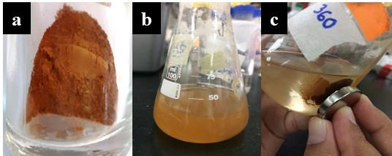
Figure 1. Image of (a) Kao-IO, (b) Kao-IO in Pb suspension, and (c) magnetic separation of spent Kao-IO from supernatant (after adsorption experiment)

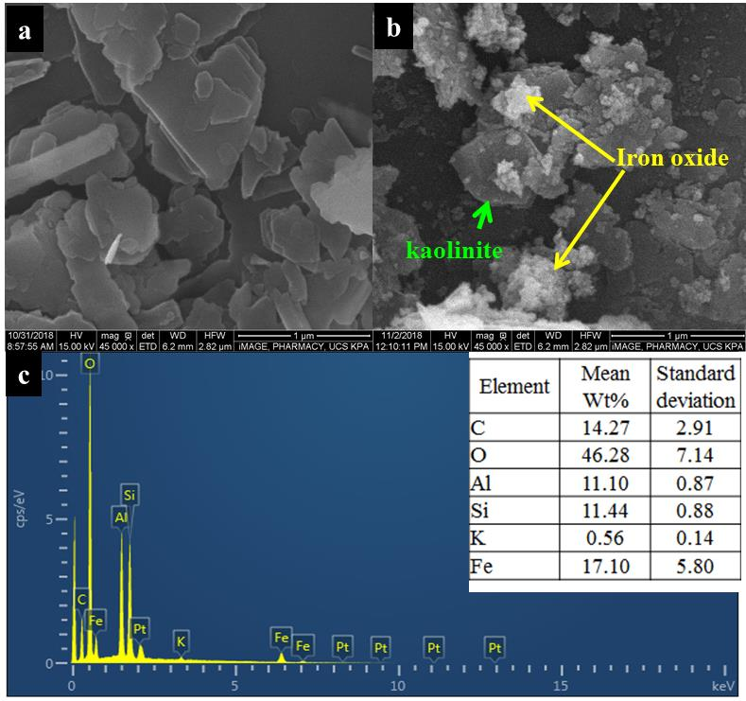
Figure 2. SEM image of Kao (a), Kao-IO (b) and EDX analysis of KaO-IO (c)

Fourier transform-infrared (FTIR) analysis

Both the Kao and Kao-IO showed an almost similar FTIR spectra (Figure 3) with the presence of typical absorption bands of hydroxyl group in the range of 3700-3620 cm⁻¹associated with kaolinite [10][18,19]. The absorption band at 3692 and 3683 cm⁻¹ (Figure 3a) represents the interlayer –OH stretching vibration of Al-OH whereas band at 3621 cm⁻¹ was assigned to inner hydroxyl group[20] [4]. The spectral bands at around 1009, 1115, and 1030 cm⁻¹ were assigned to the Si-O-Si/Al asymmetric bending vibrations, while the Si-O stretching was observed at 794 cm⁻¹ [4] The bending of the inner and-surface hydroxyls groups of Al-OH were appeared at 911 cm⁻¹ and 941 cm⁻¹. The Si-O-Al vibrations was observed at 751 cm⁻¹ in Kao (Figure 3a) and has slightly shifted to 748 cm⁻¹ in Kao-IO. Overall, it was observed that the Al-OH stretching mode (at 3695- 3620 cm⁻¹), Al-OH bending (941-911 cm⁻¹) and Si-O-Si/Al asymmetric (1115 & 1030 cm⁻¹) bands in Kao was much more intense as compared to those in Kao-IO (Figure 3b). These observation suggested the penetration of Fe^{2+/}Fe³⁺ on the crystal structure of kaolinite [11].

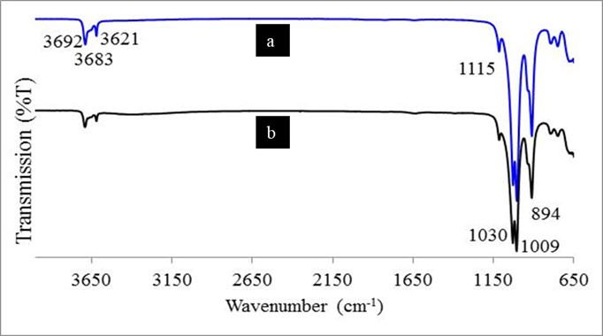

Figure 3. FTIR spectra of (a) Kao, and (b) Kao-IO

X-ray diffractometer (XRD) analysis

The sharp and intense peaks appeared at the 2θ = 12.3° and 26.6° in Kao (Figure 4a) represent the typical diffraction peak associated with kaolinite [12]. Those peaks were less intense (especially at the 26.6°) in the XRD patterns of Kao-IO (Figure 4b) implying a decrease in the clays’ crystallinity. The diffraction peak for iron oxide (2θ around 35°, 57°, and 62°) [13] are difficult to trace probably due to only small quantity of iron oxide present. Furthermore, overlapping of those peaks with kaolinite peak was also possible, as being shown at the position around 2θ = 35°. No peak shifting or broadening was recorded for the composite since the kaolinite is a 1:1 layer type of clay minerals. The interaction between iron oxide and kaolinite was reported to occur only on the surface of kaolinite particles without involving the interlayer space.

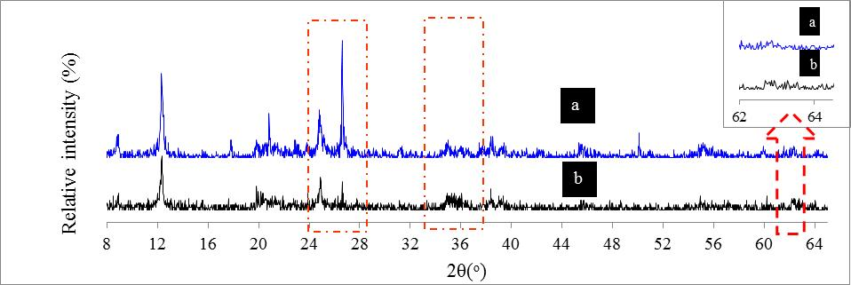
Figure 4. XRD spectrogram of (a) Kao and (b) Kao-IO

Optimization of experiment parameters: Effect of pH, contact time, and initial concentration

The adsorption of Pb²⁺ by Kao-IO was increased at pH 4 to 6, and then was dramatically decrease (Figure 5a). At a very acidic pH, the competition between H⁺ and Pb²⁺ for active sites caused the adsorption capacity to be low [14]. In contrast, at high alkaline pH, changes in cationic metal speciation and ion precipitation could occur. The precipitation of metal hydroxide (such as Pb(OH)₂ ) would likely start to occur at pH above 6 [14]; causing a potential misleading result in the adsorption capacity calculation. Therefore, pH 6 was used as the optimum pH throughout this study.

The adsorption capacity was increase as the concentration was increased from 10 up to 50 mg/L for both Kao-IO and Kao (Figure 5b). An increase in initial concentration will allow more Pb²⁺ capable of being adsorbed to the adsorption sites [15]. At 60 mg/L, both Kao-IO and Kao reached a constant adsorption capacity, which implies saturation of their active sites [14]. Nevertheless, the equilibrium profile of Kao-IO demonstrated a lower C_{e} which yields a higher adsorption capacity, q_{e} (Figure 5c). This finding indicates that the KaO-IO has a higher affinity towards Pb²⁺ as compared to its pristine clay. The highest q_{max} achieved for Kao-IO and Kao was 30.93 and 25.04 mg g⁻¹, respectively (Figure 5c). The adsorption capacity of Kao-IO was fast and increases with the increment of adsorption time until equilibrium was reached at 120th minutes (Figure 5d).

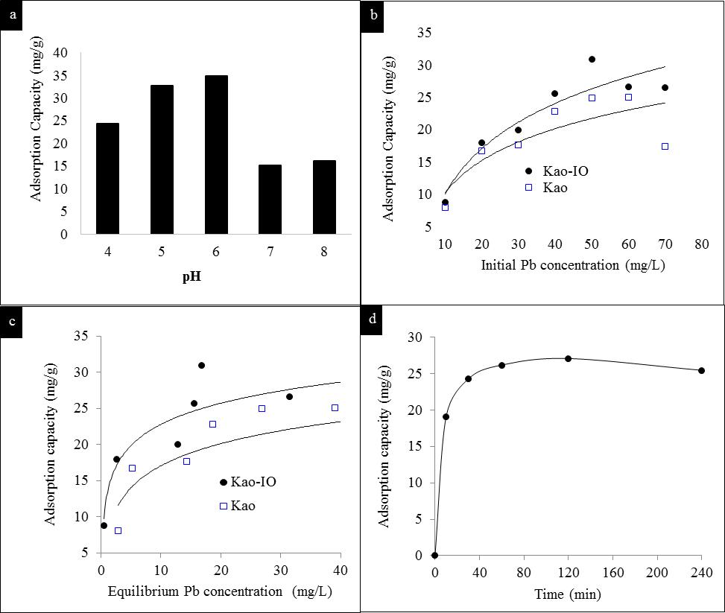
Figure 5. (a) Effect of pH values, (b) initial Pb concentration, (c) equilibrium adsorption isotherm and (d) reaction time on adsorption capacity of Kao-IO

Adsorption isotherm
The experimental adsorption data was fitted into three adsorption isotherms, namely the Langmuir, Freundlich and Dubinin–Radushkevich (D–R) model (Table 1). Based on the high regression coefficient (r², >0.95), satisfactory low chi-square (x²) value and close agreement to experimental maximum adsorption capacity (q_{max}), the Langmuir isotherm model is considered the best fit model for both adsorbents (Table 1). The strong agreement of the experimental data with Langmuir model signifies a monolayer adsorption with homogenous adsorption sites. The Kao-IO has a larger K_{L} value showing a greater affinity of adsorbate (Pb) towards its active sites. A dimensionless constant called separation factor (R_{L}) to predict the adsorption favorability was calculated using the K_{L} value (L/mg) and was presented in the Table 1. A favorable adsorption is predicted if the R_{L} value is between 0 to 1 (0 < R_{L} < 1); unfavorable if R_{L} > 1; linear if R_{L}=1; or irreversible when R_{L} = 0 [16]. The R_{L} value obtained from this experiment was in the range of 0 to 1 (Table 1) which confirms a favorable nature of Pb uptake by the adsorbents.

Table 1. Parameters adsorption isotherm model for all adsorbents
Isotherm model | Equation | Parameters | Adsorbent
Isotherm model | Equation | Parameters | Kao | Kao-IO
Langmuir
 |  | q_{max}(mg/g) | 29.59 | 28.09
 |  | K_{L} (L/mg) | 0.1538 | 0.6953
 |  | r² | 0.9781 | 0.9638
 |  | R_{L} value range (min – max) | 0.0197 - 0.2150 | 0.0432 - 0.7591
 |  | Chi-square (x²) | 1.3604 | 2.9294
Freundlich
 |  | 1/n | 0.3960 | 0.2684
 |  | K_{f} (L/g) | 6.571 | 11.92
 |  | r² | 0.8390 | 0.8875
 |  | Chi-square (x²) | 2.071 | 2.575
D–R
 |  | q_{max} (mg/g) | 23.21 | 24.28
 | E=1/(2 β)^{0.5} | E (kJ/mol) | 22.94 | 22.36
 |  | r² | 0.9320 | 0.8453
 |  | Chi-square (x²) | 1.411 | 4.212
* q_{e} = the adsorbed amount of Pb (mg/g), C_{e} = concentration of Pb (mg/L) at equilibrium, K_{L} = Langmuir constant, q_{max} = maximum adsorption capacity (mg/g), K_{f} = Freundlich constant (L/g), 1/n = adsorption intensity constant , β = coefficient related to the mean free energy of adsorption per mol of the adsorbate (mol²/J²), R = gas constant (J/mol K),T = the absolute temperature(K), and E = sorption energy (kJ/ mol).

The parameters of Freundlich isotherm model also give some beneficial information on the adsorption process. The value of 1/n obtained by the Kao-IO was approaching more closely towards the zero, in which indicates that the surface of Kao-IO was more heterogeneous than Kao. The higher K_{f} value also showed the tendency of Kao-IO to uptake more Pb that was portrayed through the slightly higher q_{max} obtained by this composite. The D-R isotherm model could be used to deduce the mechanism of adsorption. The E value (sorption energy) which is less than an 8 kJ/mol indicates physical adsorption; a value between 8 to16 kJ/mol is related to ion-exchange, whereas for E value in the range of 20-40 kJ/mol, chemisorption was predicted [17]. According to the analysis, Pb²⁺ adsorption towards Kao and Kao-IO was suggested as chemisorption with formation of specific chemical bonds like electrostatic bond and chemical bonding. Adsorption mechanism of Pb towards Kao-IO was deduced to occur via surface complexation between the Pb²⁺ and the hydroxyl group (silanol and aluminol) of clay minerals [18]. The Fe-OH functional group of iron oxide embedded on the clay’s surface of Kao-IO may also likely participate in the adsorption [8]. However further investigation is warranted to provide a precise understanding on the adsorption mechanism pathway.

Kinetic studies
The adsorption data was fitted into two common kinetic models; the pseudo first order and second order model. The adsorption data has strong agreement with the pseudo second order kinetic model (Table 2). This finding indicated that the adsorption mechanism is depended on the adsorbate-adsorbent interaction. Furthermore, pseudo second order model deduced chemisorption as the rate determining step, which agreed with the adsorption isotherm analysis described previously.

Table 2. Kinetic analysis on the Pb adsorption by Kao-IO (performed at initial [Pb] = 50 mg/L,
at 0.1 g/mL loading, 25 ºC)
Kinetic Model | Equation** | Parameters
Pseudo first order |  | q_{e} (mg/g) | 5.4953
 |  | k₁ (min⁻¹) | 0.0173
 |  | r² | 0.6632
 |  | Chi-square (x²) | 0.4798
Pseudo second order |  | q_{ev}(mg/g) | 28.16
 |  | k₂ (g/mg.min) | 0.0075
 |  | r² | 0.9999
 |  | Chi-square (x²) | 1.6160
** q_{e} = the adsorbed amount of Pb (mg/g) at equilibrium, q_{t} = the adsorbed amount of Pb (mg/g) at time t, K₁ is pseudo first order adsorption rate constant (min⁻¹), t = time (min), h = the initial sorption rate, (mg/g.min)

Desorption study
The desorption of Pb from spent Kao-IO using EDTA showed the highest percentage (39.18%) (Figure 6) compared to other eluents. EDTA solution can efficiently desorb Pb²⁺ due to the its ligand properties that capable to form chelation with metal cations [14]. A negligible percentage of Pb desorption was recorded in NaCl indicating that ion exchange between Pb and Na ions is less preferable. A slight Pb released in acidic water (pH 4) might be due to the protonation of the adsorbent’s surface by H⁺ that weakened the Pb-Kao interaction followed by Pb²⁺desorption [8]. Hence it could be concluded that Pb²⁺ ions have a strong retention towards Kao-IO surface that prevent easy leaching of the adsorbed Pb back to the treated metal contaminated water.

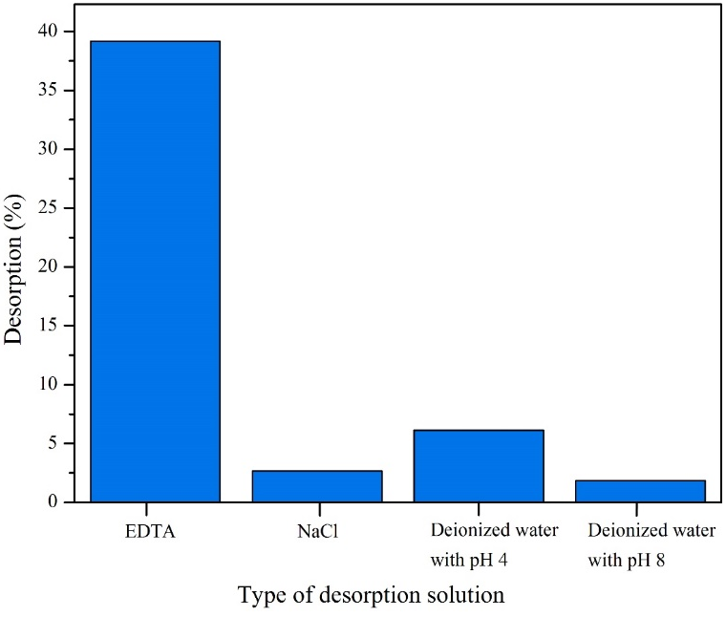
Figure 6. Desorption of Pb²⁺ from Kao-IO using various desorbing agent

Conclusion

The Kao-IO composite with magnetic properties was successfully prepared and characterized. Kao-IO showed a higher affinity in Pb²⁺ uptake and easy to be retrieved from the reaction media through the external magnetic separation. Pb retention on Kao-IO surface was stable thus require further optimization for desorption process to allow for possible regeneration of this material. Since raw kaolinite is abundance in Malaysia, the research findings will pave a way for more diversified application of the country’s natural resources. Due to the simple synthesis route and high efficiencies towards Pb removal as demonstrated in this study, the Kao-IO hence has the potential to become a cost effective and environmental benign adsorbent to be used in water treatment.

Acknowledgement

The authors would like to thank Universiti Teknologi MARA, Negeri Sembilan branch, for technical facilities and financial support through internal training scheme. Partial funding from the research grant (FRGS/1/2019/STG07/UITM/02/15) sponsored by the Ministry of Education of Malaysia is greatly acknowledged.

References
1. Ali, R. M., Hamad, H. A., Hussein, M. M. and Malash, G. F. (2016). Potential of using green adsorbent of heavy metal removal from aqueous solutions: Adsorption kinetics, isotherm, thermodynamic, mechanism and economic analysis. Ecological Engineering, 91: 317-332.
2. Landrigan, P. J., Fuller, R., Fisher, S., Suk, W. A., Sly, P., Chiles, T. C. and Bose-O’Reilly, S. (2019). Pollution and children’s health. Science of the Total Environment, 650: 2389-2394.
3. Sari, A. and Tuzen, M. (2014). Cd(II) adsorption from aqueous solution by raw and modified kaolinite. Applied Clay Science, 88: 63-72.
4. Tokarčíková, M., Tokarský, J., Kutláková, K.M. and Seidlerová, J. (2017). Testing the stability of magnetic iron oxides/kaolinite nanocomposite under various pH conditions. Journal of Solid State Chemistry, 253: 329-335.
5. Gao, W., Zhao, S., Wu, H., Deligeer, W. and Asuha, S. (2016). Direct acid activation of kaolinite and its effects on the adsorption of methylene blue. Applied Clay Science, 126: 98-106.
6. Duarte-Silva, R., Villa-García, M. A., Rendueles, M. and Díaz, M. (2014). Structural, textural and protein adsorption properties of kaolinite and surface modified kaolinite adsorbents. Applied Clay Science, 90: 73-80.
7. Yuan, P., Fan, M., Yang, D., He, H., Liu, D., Yuan, A., Zhu, J. X. and Chen, T. H. (2009). Montmorillonite-supported magnetite nanoparticles for the removal of hexavalent chromium [Cr(VI)] from aqueous solutions. Journal of Hazardous Materials, 166(2-3): 821-829.
8. Rusmin, R., Sarkar, B., Tsuzuki, T., Kawashima, N. and Naidu, R. (2017). Removal of lead from aqueous solution using superparamagnetic palygorskite nanocomposite: Material characterization and regeneration studies. Chemosphere, 186: 1006-1015.
9. Liu, H., Chen, W., Liu, C., Liu, Y. and Dong, C. (2014). Magnetic mesoporous clay adsorbent: Preparation, characterization and adsorption capacity for atrazine. Microporous and Mesoporous Materials, 194: 72-78.
10. Frost, R. L. (1997). The structure of the kaolinite minerals - a FT-Raman study. Clay Minerals, 32(1): 65-77.
11. Magdy, A., Fouad, Y. O., Abdel-Aziz, M. H. and Konsowa, A. H. (2017). Synthesis and characterization of Fe₃O₄/kaolin magnetic nanocomposite and its application in wastewater treatment. Journal of Industrial Engineering Chemistry, 56: 299-311.
12. Hu, P. and Yang, H. (2013). Insight into the physicochemical aspects of kaolins with different morphologies. Applied Clay Science, 74: 58-65.
13. Mirbagheri, N. S. and Sabbaghi, S. (2018). A natural kaolin/γ-Fe₂O₃ composite as an efficient nano-adsorbent for removal of phenol from aqueous solutions. Microporous Mesoporous Materials, 259: 134-141.
14. Rashidi, F., Sarabi, R. S., Ghasemi, Z. and Seif, A. (2010). Kinetic, equilibrium and thermodynamic studies for the removal of lead(II) and copper(II) ions from aqueous solutions by nanocrystalline TiO₂. Superlattices and Microstructures, 48 (6): 577-591.
15. Jiang, M., Jin, X., Lu, X.-Q. and Chen, Z. (2010). Adsorption of Pb(II), Cd(II), Ni(II) and Cu(II) onto natural kaolinite clay. Desalination, 252(1-3): 33-39.
16. Arias, F. and Sen, T. K. (2009). Removal of zinc metal ion (Zn²⁺) from its aqueous solution by kaolin clay mineral: A kinetic and equilibrium study. Colloids Surfaces A: Physicochemical and Engineering Aspects, 348 (1-3): 100-108.
17. Desta, M. B. (2013) Batch sorption experiments: Langmuir and Freundlich Isotherm studies for the adsorption of textile metal ions onto teff straw (Eragrostis tef) agricultural waste. Journal of Thermodynamics, 2013: 1-6.
18. Liu, X., Lu, X., Sprik, M., Cheng, J., Meijer, E. J. and Wang, R. (2013). Acidity of edge surface sites of montmorillonite and kaolinite. Geochimica et Cosmochimica Acta, 117: 180-190.

