
S

PHYTOCHEMICAL SCREENING AND FTIR SPECTROSCOPY ON CRUDE EXTRACT FROM Enhalus acoroides LEAVES

(Saringan Fitokimia dan Spektroskopi FTIR Ekstrak Mentah Daun Enhalus acoroides)

Made Pharmawati¹* and Luh Putu Wrasiati²

¹Biology Department, Faculty of Mathematics and Natural Sciences

²Department of Agro-Industrial Technology, Faculty of Agricultural Technology

Udayana University, Kampus Bukit Jimbaran, Badung, 80361, Bali, Indonesia

*Corresponding author: made_pharmawati@unud.ac.id

Received: 25 November 2019; Accepted: 9 January 2020

Abstract

Seagrass provides key ecological services in marine ecosystems, such as stabilising sediment, providing oxygen and acting as a nursery ground for marine biota. Seagrass has also been reported to have antioxidant activity that is useful for humans. One seagrass species, Enhalus acoroides, is widely distributed in Indonesia. This study aims to screen the phytochemical compounds, determine the functional groups and evaluate the profile of pigments present in E. acoroides leaf extract, which were collected from Semawang Beach, Sanur, Bali, Indonesia. The leaf extract was prepared using chloroform: ethanol (9:1) and tested for the presence of saponin, phenols, tannins and flavonoids. The functional groups and pigment profile were determined via Fourier-transform infrared spectroscopy (FTIR) and thin-layer chromatography (TLC), respectively. The results showed that the E. acoroides leaf extract contained phenols, tannins and flavonoids. The major functional groups found in the leaf extract were hydroxyl groups, lipids, alkanes, secondary amines, fatty acids, benzenoid compounds and phenols. The FTIR analysis also identified the presence of chlorophyll and carotenoids in the extract, which was further supported by the TLC analysis. This research shows that E. acoroides is a potential source of antioxidants and provides an opportunity for the development of natural products from E. acoroides in drug discovery.

Keywords: Enhalus acoroides, FTIR, chromatography, phytochemical compound, seagrass

Abstrak

Rumput laut memainkan peranan penting dalam ekosistem marin yang menstabilkan sedimen, membekalkan oksigen dan berfungsi sebagai halaman bagi biota marin. Rumput laut juga dilaporkan mengandungi aktiviti antioksidan yang bermanfaat bagi manusia. Spesis rumput laut, Enhalus acoroides di jumpai meluas di Indonesia. Kajian ini bertujuan menyaring sebatian fitokimia, penentuan kumpulan berfungsi dan menilai profil pigmen yang wujud di dalam ekstrak daun E. acoroides, yang diambil dari Pantai Semawang, Sanur, Bali, Indonesia. Ekstrak daun disediakan menggunakan klorofom: etanol (9:1) dan diuji untuk penentuan kehadiran saponin, fenol, tannin dan flavonoid. Kumpulan berfungsi dan profil pigmen telah ditentukan masing-masing melalui spektroskopi inframerah transformasi Fourier (FTIR) dan kromatografi lapisan nipis (TLC). Hasil kajian menunjukkan ekstrak daun E. acoroides mengandungi fenol, tannin dan flavonoids. Kumpulan berfungsi utama yang dijumpai dalam ekstrak daun adalah kumpulan hidroksil, lipid, alkana, amina sekunder, asid lemak, sebatian benzoid dan fenol. Analisis FTIR juga mengenalpasti kehadiran klorofil dan karotenoid di dalam ekstrak, yang mana ia juga disokong oleh hasil analisis TLC. This research shows that E. acoroides is a potential source of antioxidants and provides an opportunity for the development of natural products from E. acoroides in drug discovery. Hasil kajian mendapati E. acoroides berpotensi sebagai sumber antioksidan dan potensinya dalam pembangunan sumber semulajadi dalam penemuan ubat.

Kata kunci: Enhalus acoroides, FTIR, kromatografi, sebatian fitokimia, rumput laut

Introduction

Plant extracts have great potency and can be used for a variety of purposes. Approximately 80% of the world’s population relies on traditional medicine for health care, and most therapies use plant extracts and their active compounds [1], suggesting that two-thirds of all plant species have medicinal value [2]. Research has shown that most medicinal plants contain antioxidant properties [3]. Nowadays, natural antioxidants are used in cosmetics, foods and pharmaceutical products due to the antioxidants’ free radical scavenger activity. Exposure to environmental pollution, dietary xenobiotics and radiation leads to the generation of reactive oxygen species (ROS), which induce oxidative stress [4]. Antioxidants prevent the formation of ROS, neutralise ROS and repair the damage caused by ROS [5].

There are many plant species whose phytochemical content is unknown. One group of plants that has not yet been explored in depth is seagrass, which is the only flowering plant (Angiospermae) that grows in a marine environment. It can form a seagrass meadow that consists of one or a few dominant species [6]. In Indonesia, 13 seagrass species have been reported [7, 8], and nine species have been found in Bali alone [9]. One such species is Enhalus acoroides (L.f.) Royle, the largest tropical seagrass species in Southeast Asian waters [10]. A previous study on E. acoroides from India has reported that this species contains alkaloids, phenols, flavonoids, steroids, tannins and saponin. Furthermore, it has been shown that aqueous extracts of E. acoroides have a high radical scavenging activity [11]. Several studies on E. acoroides from Indonesia have shown that methanol extract of E. acoroides contains phenols, flavonoids and terpenes [12-14].

Several techniques are available to identify the phytochemical compounds in plant extracts. For example, Fourier-transform infrared spectroscopy (FTIR) is a method used to identify the functional groups in gaseous, liquid and solid materials via infrared radiation beams [15]. It has been used previously to identify the biomolecules present in plant extracts from Erythrina variegata [16], Myristica dactyloides [17] and Urtica dioica [18] among others. Thin-layer chromatography (TLC) is another method used to identify the compounds in a mixture via separating non-volatile mixtures. Many previous studies have employed TLC to analyse the bioactive compounds in medicinal plants [19, 20], plant pigments [21] and food additives and processing [22].

The objectives of this study were to screen the phytochemical compounds in the leaf extract of E. acoroides from Semawang Beach, Sanur, Bali, Indonesia, identify the pigments contained in the leaf extract and determine the functional groups present in the E. acoroides leaves before and after extraction with chloroform: ethanol (9:1).

Materials and Methods

Preparation of extract

The E. acoroides leaves were collected from Semawang Beach, Sanur, Bali, Indonesia, washed and air-dried for three days. The leaves were further dried in an oven at 50 ºC for one day until brittle. The dried leaves were disrupted using a blender and sieved with a 60-mesh sieve. The voucher specimen was deposited in the herbarium collection at Herbarium Biologi Udayana (HBU-MP10), Biology Department, Udayana University. The identification of E. acoroides based on morphological characteristics was conducted following the processes of den Hartog and Kuo [23] and McKenzie and Yoshida [24].

As much as 20 g of dried powder was extracted from 200 mL of chloroform: ethanol with a ratio of 9:1 (v/v). The extraction was performed using a Soxhlet extractor for three hours. The solvent was filtered using Whatman filter paper, and the filtrate was evaporated under a vacuum using a rotary evaporator at 40 ºC and 100 mbar (IKA®, RV10). The extraction was performed three times.

Yield and phytochemical screening

The yield was expressed as a percentage and calculated by dividing the weight of the E. acoroides extract by the weight of plant powder used and, then, multiplying by 100%. A preliminary phytochemical screening of the E. acoroides extract was performed in triplicate using various chemical tests following standard methods [25] to determine the presence of saponin, phenols, tannins and flavonoids. Saponin was tested via a foam test. As much as 2 ml of extract was added to water, and the mixture was shaken. The presence of saponin was indicated by the formation of foam. Phenols were determined by the ferric chloride test, in which ferric chloride was added to the E. acoroides extract. A positive result was shown by the change of colour from green to black. The presence of tannins was tested by the addition of ferric chloride and sulphuric acid to diluted the extract, and a positive result was shown by black colouring and the formation of black deposits. Flavonoids were tested by adding ammonia and sulphuric acid to diluted extract; a yellow colour indicated the presence of flavonoids.

FTIR analysis

The FTIR analysis was conducted on non-extracted leaf powder and the chloroform: ethanol-extracted sample. The 50 ºC oven-dried E. acoroides leaves were blended into a fine powder. As much as 1 mg of the sample was mixed with 50 mg KBr (FTIR-grade); then, some of the mixture was placed into the sample holder. All investigations were performed with an IRPrestige-21 (Shimadzu). The chloroform: ethanol-extracted E. acoroides leaf paste was diluted with two drops of chloroform: ethanol (9:1). One drop of the diluted extract was then mixed with 50 mg KBr. The scanning absorption range was 400 to 4000 cm⁻¹.

TLC separation

The separation and identification of pigments were performed using TLC on a 20-cm x 20-cm cellulose plate (Merck). The solvent mixture consisted of petroleum ether, acetone and n-propanol at a ratio of 90:10:0.45 [26]. The TLC cellulose plate was first activated by drying the plate in an oven at 105 °C for at least 45 minutes. The extract was applied on the plate and allowed to dry. Then, the plate was placed in the TLC tank, and the spots were migrated.

Results and Discussion

The yield of the extract was 1.57% ± 0.23. The yield from this study, wherein chloroform: ethanol (9:1) was used, was higher than the yields of previous E. acoroides extracts from Wakatobi, Sulawesi, Indonesia, and Madura, East Java, Indonesia, wherein only chloroform was used as a solvent. The yield of the crude extract from Wakatobi was 0.55%, while that from Madura was 0.8% [27]. Chloroform is a non-polar solvent; therefore, it only extracts non-polar compounds. Ethanol is a polar solvent, so the addition of ethanol in the present study caused the extraction of more polar compounds in the leaf sample. Additionally, it is possible that the environmental growth conditions of E. acoroides affected the extraction yield.

The phytochemical compounds contained in the extract of E. acoroides are shown in Table 1. Saponin was not considered to be present in the extract because foam stability was not detected, i.e. the foam lasted less than five minutes. However, phenols, tannins and flavonoids were detected in the chloroform: ethanol (9:1) E. acoroides leaf extract. The presence of phenols and tannins in E. acoroides leaves from Indonesian coastal waters has been previously reported as well [13, 27]. A previous methanol extract of E. acoroides leaves from East Lombok, Nusa Tenggara Barat, Indonesia, was shown to contain phenols, tannins and terpenes, but flavonoids were not detected [13]. Another study tested a methanol extract of E. acoroides leaves from the coastal waters of Ambon, Indonesia, and found the presence of flavonoids [14]. Furthermore, a previous chloroform extract of E. acoroides leaves from India was reported to contain flavonoids [11]. The presence of phenols, tannins and flavonoids in E. acoroides indicates the seagrass species’ potential as a source of antioxidants.

Table 1. Qualitative phytochemical composition of chloroform: ethanol (9:1) leaf extract of E. acoroides
Compounds | Colour Change | Results
Saponin | Unstable foam | -
Phenols | Dark green to black | +
Tannins | Dark green to black and black deposits formed | +
Flavonoids | Dark green to yellow | ++

˗ = undetected, + = low, ++ = moderate

The chemical bonds or functional groups present in the dried leaf powder and leaf extract of E. acoroides were predicted using FTIR. The bonds were determined by interpreting the infrared absorption spectra. Figure 1 shows the FTIR spectrum of the dried leaf powder, while Table 2 shows the interpretation of the chemical bonds in the non-extracted leaf powder of E. acoroides. Strong bonds were found at 3552 cm⁻¹, 1654.92 cm⁻¹ and 2054 cm⁻¹, while the others varied from weak to medium. These results demonstrated the presence of hydroxyl groups, lipids, alkanes, amino acids and phosphorus compounds.

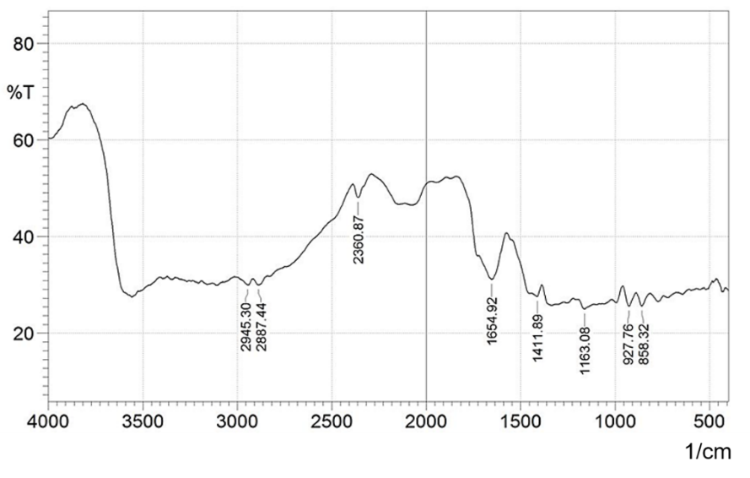

Figure 1. FTIR spectrum of dried leaf powder of E. acoroides

Table 2. FTIR spectral peak values and functional groups of dried leaf powder of E. acoroides
Spectrum No. | Wave Number cm⁻¹ | Wave Number cm⁻¹ [28, 29] | Functional Group Assignment | Predicted Compound
1 | 3552 | 3500–3650 | v; O-H stretching vibration (free) | Hydroxyl group
2 | 2945.30 | ~2955 | m; CH₃ asymmetry stretching | Lipid
3 | 2887.44 | 2880–2890 | w; C-H stretching vibration | Alkane
4 | 2360.87 | 2250–2700 | m; NH component | Amino acid, amino-related component
5 | 2054 | 2050–2140 | m-w; symmetry -NH₃⁺ stretching vibration; broad | Free amino acid and their hydrohalides
6 | 1654.92 | 1580–1660 | s; C=C stretching vibration | C=C conjugated with C=O
7 | 1411.89 | 1350–1410 | w; C-H deformation vibration | Secondary alcohol-free
8 | 1163.08 | 1155–1165 | w-m; CH₃ rocking vibration | P-O-C₂H₅; Organic phosphorus compound
9 | 927.76 | 925–930 | m; C-C skeletal vibration | Alkane
10 | 858.32 | 820–920 | w-m; C-C skeletal vibration | Alkane

v = variable, m = medium, s = strong

Table 3 demonstrates the functional groups of the chloroform: ethanol leaf extract of E. acoroides. The FTIR spectra are shown in Figure 2. The peaks at 1743 cm⁻¹, 1219 cm⁻¹ and 771 cm⁻¹ were strong, while the others varied from weak to medium. Various compounds were found, including hydroxyl groups, lipids, alkanes, secondary a mines, benzenoid compounds and phenols.

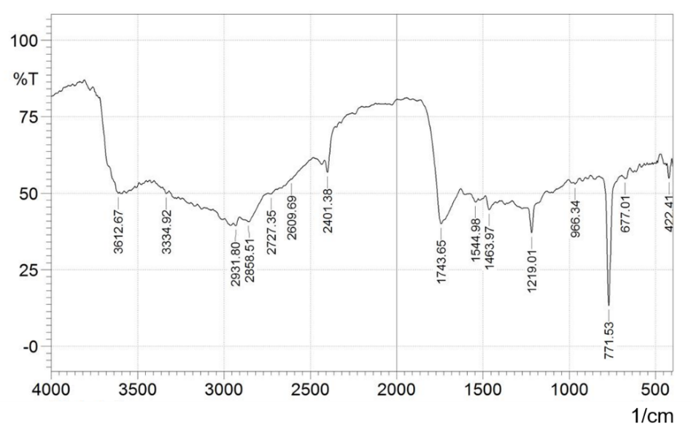

Figure 2. FTIR spectrum of E. acoroides leaf extract

Table 3. FTIR spectral peak values and functional groups of E. acoroides leaf extract
Spectrum No. | Wave Number cm⁻¹ | Wave Number cm⁻¹ [28, 29] | Functional Group Assignment | Predicted Compound
1 | 3612.67 | 3500–3650 | v; O-H stretching vibration (free) | Hydroxyl group
2 | 2931.80 | ~2930 | m; CH₂ asymmetry stretching | Lipid
3 | 2858.51 | 2800–2900 | w; C-H stretching vibration | Alkane
4 | 2401.38 | 2400–2600 | w-m; N-D stretching vibration | Imine
5 | 1743.65 | 1734–1745 | v; C=O of esters | Membrane lipid, fatty acid
6 | 1544.98 | 1490–1580 | w; N-H deformation vibrations | Secondary amine
7 | 1463.97 | 1440–1465 | m; C-H deformation vibration | R-CH₃; Alkane
8 | 1219.01 | 1165–1225 | C-C skeletal vibration | -C(CH₃)₃ Alkane
9 | 771.53 | 700–900 | s; C-H out-of-plane bending (oop) vibration for substituted benzenes ring | Benzenoid
10 | 677.01 | 610–690 | w; C-H wagging vibration | Vinyl hydrocarbon compounds
11 | 422.41 | 375–450 | w; aromatic C-OH in-plane bending vibration | Phenol

v = variable, m = medium, s = strong

As can be seen in Tables 2 and 3, there were differences in the functional groups present between the dried leaf powder and the chloroform: ethanol (9:1) leaf extract of E. acoroides. The FTIR identified that the leaf extract contained strong C-H out-of-plane bending (oop bend) vibration for substituted benzene ring, indicating the presence of phenols and flavonoids in the crude E. acoroides extract. Flavonoids are polyphenols characterised by two benzene rings joined by a linear carbon chain [30]. The identification of benzenoid compounds via FTIR spectrophotometry supported the findings from the phytochemical screening, which detected the presence of phenols and flavonoids. The amines, imines, alkanes and phenols present were considered the major functional groups of bioactive compounds [31].

The peak around 1734–1745 cm⁻¹ was assigned as C=O ester [31], which may be related to pheophytin and chlorophyll [32]. In this study, the position of the peak was at 1743 cm⁻¹ (Table 3). The carotenoids were predicted to be present in the dried leaf powder of E. acoroides. The FTIR spectrum at 1654 cm⁻¹ (Table 2) was assigned as the C=O conjugate. The conjugated double bond in carotenoids has been reported as the structure responsible for light absorption [33]. A previous study stated that a peak at 1654 cm⁻¹ is due to chlorophyll and protein content [34].

The separation of the E. acoroides extract via TLC is presented in Table 4. Eight spots were detected, and the Rf values ranged from 0.11 to 0.94. The colours were separated into bluish-green, dark green, yellow and yellowish-grey, and the predicted pigments included chlorophyll b, ethyl-chlorophyllide a, Mg-free chlorophyll b, lutein, Mg-free chlorophyll a, pheophytin and β-carotene.

Table 4. Identification of compounds based on Rf values and colour from TLC profiling
Fraction No. | Rf Value | Colour | Colour from Reference [26] | Identification | Maximum Spectra (nm)
1 | 0.11 | Bluish-green | Blue-green | Chlorophyll a | 655
2 | 0.21 | Dark green | Green | Chlorophyll b | 435 and 645
3 | 0.24 | Bluish-green | Blue-green | Ethyl-chlorophyllide a | 434 and 654
4 | 0.28 | Yellow | Yellow | Mg-free chlorophyll b | 654
5 | 0.33 | Light yellow | Yellow | Lutein | 649
6 | 0.39 | Yellowish-grey | Grey | Mg-free chlorophyll a | 630 and 656
7 | 0.53 | Grey | Grey | Pheophytin | 424 and 658
8 | 0.94 | Orange | Yellow-orange | β-carotene | 425

The maximum spectra for each spot of TLC for fractions one to eight are presented in Table 4. Based on a comparison to Lichtenthaler and Buschmann [35], fraction five with a maximum absorption at 654 nm was identified as chlorophyll b, and fraction eight with a maximum absorption at 425 nm was identified as β-carotene. The other fractions were unidentified. The presence of β-carotene was in agreement with the results from the FTIR analysis, which confirmed the presence of chlorophyll, pheophytin and carotenoids in the E. acoroides extract, wherein a functional group of C=O ester was identified (Table 3).

Based on the phytochemical compounds discovered in the FTIR and TLC analyses, E. acoroides has the potential to be used for biomedicinal applications, as phenolic compounds, tannins, flavonoids, chlorophyll and carotenoids are known to have antioxidant activities [36]. These findings provide an opportunity for the development of natural products from E. acoroides in drug discovery.

Conclusion

The phytochemical compounds present in the chloroform: ethanol (9:1) leaf extract of E. acoroides were phenols, tannins and flavonoids. The major functional groups identified were hydroxyl groups, lipids, alkanes, secondary amines, fatty acids, benzenoid compounds and phenols. The FTIR analysis also identified the presence of chlorophyll and carotenoids in the extract, which was then confirmed by TLC profiling. Further studies will focus on the fractionation and purification of potential bioactive compounds present in the extract.

Acknowledgement

This research was funded by Ministry of Research, Technology and Higher Education of the Republic of Indonesia with Grant Number 492.27/UN14.4.A/LT/2019

References
- Winston, J. C. (1999). Health-promoting properties of common herbs. The American Journal of Clinical Nutrition, 70(3): 491s-499s.
- Krishnaiah, D., Sarbatly, R. and Nithyanandam, R. (2011). A review of the antioxidant potential of medicinal plant species. Food and Bioproducts Processing, 89(3): 217-233.
- Saeed, N., Khan, M. R. and Shabbir, M. (2012). Antioxidant activity, total phenolic and total flavonoid contents of whole plant extracts Torilis leptophylla L. BMC Complementary and Alternative Medicine, 12: 221.
- Al-Gubory, K. H. (2014). Environmental pollutants and lifestyle factors induce oxidative stress and poor prenatal development. Reproductive BioMedicine Online, 29: 17-31.
- Ighodaro, O. M. and Akinloye, O. A. (2018). First line defence antioxidants-superoxide dismutase (SOD), catalase (CAT) and glutathione peroxidase (GPX): Their fundamental role in the entire antioxidant defence grid. Alexandria Journal of Medicine, 54(4): 287-293.
- Björk, M., Short, F., Mcleod, E. and Beer, S. (2008). Managing seagrasses for resilience to climate change. IUCN, Gland, Switzerland: pp. 8-18.
- Kuriandewa, T. E., Kiswara, W., Hutomo, M. and Soemodihardjo, S. (2003). The seagrasses of Indonesia. In: Green, E. P. and Short, F. T., Eds., World Atlas of Seagrasses, University of California Press, Barkeley: pp. 172-182.
- Kuo, J. (2007). New monoecious seagrass of Halophila sulawesii (Hydrocharitaceae) from Indonesia. Aquatic Botany, 87(2): 171-175.
- Pharmawati, M., Nurkamila, U. S. and Stevanus. (2016). RAPD fingerprinting key and phylogenetic of nine seagrass species from Sanur coastal water, Bali, Indonesia using matK sequences. Biodiversitas, 17(2): 687-693.
- Ogawa, H. and Namba, N. (2002). Ecological characteristics of tropical seagrasses, especially Enhalus acoroides. Fisheries Science, 68(sup2): 1767-1770.
- Amudha, P., Vanitha, V., Mohanasundaram, S, Bharathi N. P. and Jayalakshmi, M. (2017). Phytochemical analysis and invitro antioxidant screening of seagrass Enhalus acoroides. International Journal of Research and Pharmaceutical Science, 8(2): 251-258.
- Santoso, J., Anwariyah, S., Rumiantin, R. O., Putri, A. P., Ukhty, N. and Yoshie-Stark, Y. (2012). Phenol content, antioxidant activity and fiber profile of four tropical seagrasses from Indonesia. Journal of Coastal Development, 15(2): 189-196.
- Windyaswari, A. S., Purba, J. P., Nurrahmah, S. S., Ayu, I. P., Imran, Z., Amin, A. A., Kurniawan, F., Pratiwi, N. T. M. and Iswantari, A. (2019). Phytochemical profile of seagrass extract (Enhalus acoroides): A new marine source from Ekas Bay, East Lombok. IOP Conference Series: Earth and Environmental Science, 278, 012081.
- Tuapattinaya, P. M. J. and Rumahlatu, D. (2019). Analysis of flavonoid levels of Enhalus acoroides in different coastal waters in Ambon Island, Indonesia. International Journal of Applied Biology, 3(1): 70-80.
- Khan, S. A., Khan, S., B., Khan, L. U., Farooq, A., Akhtar, K. and M. Asiri A. M. (2018). Fourier transform infrared spectroscopy: Fundamentals and application in functional groups and nanomaterials characterization. In: S. K. Sharma, S. K., Ed., Handbook of Materials Characterization. Springer International Publishing AG, Springer Nature, Switzerland: pp.317-344.
- Hemmalakshmi, S., Priyanga, S. and Devaki, K. (2017). Fourier transform infra-red spectroscopy analysis of Erythrina variegata L. Journal of Pharmaceutical Sciences and Research, 9(11): 2062-2067.
- Rajiv, P., Deepa, A., Vanathi, D. P. and Vidhya, D. (2017). Screening for phytochemicals and FTIR analysis of Myristica dactyloids fruit extract. International Journal of Pharmacy and Pharmaceutical Sciences, 9(1): 315-318.
- Maobe, M. A. G. and Nyarango, R. M. (2013). Fourier transformer infra-red spectrophotometer analysis of Urtica dioica medicinal herb used for the treatment of diabetes, malaria and pneumonia in Kisii region, Southwest Kenya. World Applied Sciences Journal, 21(8): 1128-1135.

- Kumar, S., Jyotirmayee, K. and Sarangi, M. (2013). Thin layer chromatography: A tool of biotechnology for isolation of bioactive compounds from medicinal plants. International Journal of Pharmaceutical Science Review and Research, 18(1): 126-132.
- Porika, R., Poojari, S., Lunavath, V. and Mamidala, E. (2014). Preliminary phytochemical investigation and TLC analysis of P. angulata fruit extract. IOSR Journal of Pharmacy and Biological Sciences, 9(2): 11-14.
- Forgacs, E. and Cserhati, T. (2002). Thin-layer chromatography of natural pigments: New advances. Journal of Liquid Chromatography and Related Technologies, 25(10-11): 1521-1541.
- Zahra, N., Alim-un-Nisa, Fatima, Z., Kalim, I. and Saeed, K. (2015). Identification of synthetic food dyes in beverages by thin layer chromatography. Pakistan Journal of Food Science, 25(4): 178-181.
- den Hartog, C. and Kuo, J. (2006). Taxonomy and biography of seagrasses. In Larkum, T., Orth, R. J. and Duarte, C. M., Eds. Seagrasses: Biology, ecology and conservation. Springer, The Netherlands: pp. 1-23.
- McKenzie, L J. and Yoshida, R. L. (2009). Seagrass-watch. Proceeding of a workshop for monitoring seagrass habitats in Indonesia. The Nature Conservancy, Coral Triangle Center, Sanur, Bali: pp. 29-32.
- Harborne, J. B. (1984). Phytochemical methods: A guide to modern technique of plant analysis. (2nd ed). Chapman and Hall. London. pp. 37-168.
- Bacon, M. F. and Holden, M. (1967). Changes in chlorophylls resulting from various chemical and physical treatments of leaves and leaf extracts. Phytochemistry, 6: 193-210.
- Dewi, C. S. U., Kasitowati, R. D. and Siagian, J. A. (2018). Phytochemical compounds of Enhalus acoroides from Wanci Island (Wakatobi) and Talango Island (Madura) Indonesia. IOP Conference Series: Earth and Environmental Science, 137: 012045.
- Spectroscopic Tools. Access from http://www.science-and-fun.de/tools/. [Access online 21-25 October 2019]
- Socrates, G. (2004). Infrared and Raman characteristic group frequencies tables and charts. John Wiley & Sons Ltd, Baffins Lane, Chichester, West Sussex PO19 IUD, England: pp. 1-340.
- Corcoran, M. P., McKay, D. L. and Blumberg, J. B. (2012). Flavonoid basics: Chemistry, sources, mechanisms of action, and safety. Journal of Nutrition in Gerontology and Geriatrics, 31(3): 176-189.
- Pratheeba, T., Ragavendran, C. and Natarajan, D. (2015). Larvicidal, pupicidal and adulticidal potential of Ocimum gratissimum plant leaf extracts against filariasis inducing vector. International Journal of Mosquito Research, 2 (2): 1-8.
- Li, X., Zhou, R., Xu, K., Xu, J., Jin, J., Fang, H. and He, Y. (2018). Rapid determination of chlorophyll and pheophytin in green tea using Fourier transform infrared spectroscopy. Molecules, 23: 1010.
- Mezzomo, N. and Ferreira, S. R. S. (2016). Carotenoids functionality, sources, and processing by supercritical technology: A review. Journal of Chemistry, 2016: 1-16.
- Kushwaha, K., Saxena, J., Tripathi, B. K. and Agarwal, M. K. (2014). Detection of carotenoids in psychrotrophic bacteria by spectroscopic approach. Journal of BioScience and Biotechnology, 3(3): 253-260.
- Lichtenthaler, H. K. and Buschmann, C. (2001). Chlorophylls and carotenoids: Measurement and characterization by UV-VIS spectroscopy. In: Wrolstad, R. E., Acree, T. E., An, H., Decker, E. A., Penner, M. H., Reid, D. S., Schwartz, S. J., Shoemaker, C. F. and Sporns, P., Eds., Current protocols in food analytical chemistry (CPFA), John Wiley and Sons, New York: pp. F4.3.1-F4.3.8.
- Lachowicz, S., Oszmiański, J. and Wiśniewski, R. (2018). Determination of triterpenoids, carotenoids, chlorophylls, and antioxidant capacity in Allium ursinum L. at different times of harvesting and anatomical parts. European Food Research Technology, 244(7): 1269-1280.

