

ELECTROCHEMICAL DETERMINATION OF DOPAMINE AND URIC ACID IN BLOOD SERUM USING ANIONIC SURFACTANTS AT CARBON PASTE ELECTRODES

(Penentuan Dopamin dan Asid Urik dalam Serum Darah Secara Elektrokimia Menggunakan Surfaktan Anionik pada Perekat Elektrod Karbon)

Liridon Berisha¹, Egzontina Shabani¹, Arsim Maloku¹*, Granit Jashari², Tahir Arbneshi¹

¹Department of Chemistry, Faculty of Mathematical and Natural Sciences,

University of Prishtina, 10000 Prishtinë, Kosovo

²Department of Analytical Chemistry, Faculty of Chemical Technology,

University of Pardubice, Studentská 573, 532 10 Pardubice, Czech Republic

*Corresponding author: arsim.maloku@uni-pr.edu

Received: 20 October 2019; Accepted: 9 December 2019

Abstract

A selective and sensitive method was developed for the simultaneous electrochemical determination of dopamine and uric acid by using a sodium dodecylbenzenesulfonate (SDBS) and sodium dodecyl sulfate (SDS) as a surface modifier of carbon paste electrodes (CPEs). At lower concentration of SDS and SDBS they form a negatively charged monolayer on CPE surface because of surfactants’ hydrophobic chain interaction with paraffin of CPE. Optimized concentration of surfactants was 2 mM for SDS and 1 mM for SDBS in phosphate buffer solution (0.1 M, pH = 7 and pH = 6, respectively). Compared with plain CPE, CPE modified with SDS (CPE-SDS) and CPE modified with SDBS (CPE-SDBS) have shown the improved electrochemical response of dopamine (DA) at 0.230 V and uric acid (UA) at 0.345 V due to electrostatic interactions between positively charged analytes and surface negatively charged of SDBS and SDS. Under optimal experimental conditions, the designed electrodes exhibited a wide range of linear response to DA from 0.53 μM to 31.64.0 μM and UA from 5.95 μM to 118.97 μM. The detection limits for DA and UA were found to be 0.26 and 1.10 µM with CPE-SDS, whilst 0.22 and 0.38 µM with CPE-SDBS. The CPE-SDBS and CPE-SDS showed good reproducibility, repeatability, stability and high selectivity for determination of DA and UA in blood serum samples.

Keywords: dopamine, uric acid, carbon paste electrode, sodium dodecyl sulfate, sodium dodecylbenzenesulfonate

Abstrak

Kaedah sensitif dan selektif telah dibangun untuk penentuan serentak dopamin dan asid urik menggunakan sodium dodekilbenzenasolfonat (SDBS) dan sodium dodekil sulfat (SDS) sebagai perekat elektrod karbon yang diubah permukaan. Pada kepekatan rendah SDS dan SDBS membentuk cas negatif lapisan mono pada permukaan CPE disebabkan interaksi rantaian hidrofobik dengan paraffin CPE. Kepekatan optimum surfaktan ialah 2 mM SDS dan 1 mM SDBS dalam larutan penimbal fosfat (masing-masing 0.1 M, pH = 7 dan pH = 6). Berbanding CPE kosong, CPE yang terubahsuai dengan SDS (CPE-SDS) dan CPE terubahsuai dengan SDBS (CPE-SDBS) telah menunjukkan peningkatan respons elektrokimia bagi dopamin (DA) pada 0.230 V dan asid urik (UA) pada 0.345 V disebabkan oleh interaksi elektrostatik di antara cas positif analit dan cas negatif permukaan SDBS dan SDS. Pada keadaan optimum, elektrod yang dibangun menghasilkan julat respons kelinearan yang besar terhadap DA dari 0.53 μM to 31.64.0 μM hingga UA dari 5.95 μM hingga 118.97 μM. Had pengesanan DA dan UA didapati pada 0.26 dan 1.10 µM bagi CPE-SDS, manakala 0.22 and 0.38 µM bagi CPE- SDBS. CPE-SDBS dan CPE-SDS telah menghasilkan kebolehhasilan, kebolehulangan, kestabilan yang baik dan kepilihan yang tinggi bagi penentuan DA dan UA di dalam sampel serum darah.

Kata kunci: dopamin, asid urik, perekat elektrod karbon, sodium dodekil sulfat, sodium dodekilbenzenasolfonat

Introduction

Dopamine (DA) is an organic compound of catecholamine and phenethylamine families, as an important hormone and neurotransmitter have a crucial role in central nervous, renal, hormonal and cardiovascular systems [1]. Abnormal concentrations of DA may cause some neurodegenerative human diseases like Alzheimer’s, Parkinson’s and Schizophrenia [2, 3]. Uric acid (UA) is usually considered as the primary product of purine metabolism in the human body [4]. Its abnormal levels in human body fluids may lead to the occurrence of gout, hyperuricemia, Lesch-Nyhan syndrome or pneumonia [4, 5]. Due to those effects DA and UA are considered as crucial molecules for physiological processes in human metabolism. Therefore, the simultaneous determination of DA and UA is of great importance for analytical application and diagnostic research [6]. Several methods have been developed for the DA and AU determination, namely fluorometry [7], chemiluminescence [8], spectrophotometry [9], liquid chromatography [10], and electrochemical methods [11, 12].

Compared with other methods, the electrochemical methods are more accessible for dopamine and uric acid determination due to their low price, fast response, trouble-free operation, good stability, and convenient for in-situ detection [2, 13]. However, the major problem for simultaneous determination of DA and UA is the interference of ascorbic acid (AA) in high concentrations, because oxidation peak currents of ascorbic acid are overlapped with those of DA and UA at conventional electrodes [14]. To overcome this problem various electrodes have been developed, using different modification materials such as metal oxides [15], metal nanoparticles [14], nanosheets [16], polymers [17, 18], enzymes [19], and anionic or cationic surfactants as surface modifiers [3, 20].

This work describes simultaneous determination of DA and UA in presence of AA as an anionic interferent. using anionic surfactants (SDS and SDBS) as surface modifier of CPE. Anionic surfactants decreased electrode response to AA in neutral pH because of negatively charged electrode surface and give well defined peaks for dopamine and uric acid. New method was successfully applied on determination of DA and UA in blood serum. Surfactants are a special type of amphiphilic molecules that possess charged or polar head groups and long hydrocarbon end [21]. They have been widely used in electroanalysis to improve the properties of the electrode/solution interface and subsequently influence the electrochemical processes of other substances by charging electrode’s surface i.e., cationic surfactant gives it positively charged and anionic surfactants make electrode surface negative charged [22–24]. Few studies reported the application of anionic surfactants as sensing materials only for quantification of dopamine, therefore it is necessary to develop a method which can quantify DA and UA in the same time in presence of ascorbic acid [20, 25]. Based on surfactants’ properties, a selective and sensitive method was developed for the simultaneous electrochemical determination of dopamine and uric acid in the presence of ascorbic acid by using sodium dodecylbenzenesulfonate (SDBS) and sodium dodecyl sulfate (SDS) as surface modifiers of carbon paste electrodes.

Materials and Methods

Reagents and chemicals

Graphite powder (particle size <20 µm, synthetic), sodium dodecylbenzenesulfonate (C₁₈H₂₉NaO₃S), sodium dodecyl sulfate (NaC₁₂H₂₅SO₄) and dopamine hydrochloride (C₈H₁₁NO₂•HCl) were obtained from Sigma-Aldrich. Uric acid (C₅H₄N₄O₃) and paraffin oil were from Merck. Ascorbic acid (C₆H₈O₆) (AA) was supplied by Lach-Ner. Phosphate buffer solution (PBS, 0.1 M) on a range of pH values from 3 to 9 was used as supporting electrolyte was prepared by mixing aqueous solutions of 3.0 M NaOH and 0.1 M H₃PO₄. DA, UA, AA, SDS, and SDBS solutions were freshly prepared in supporting electrolyte solutions prior to use. All the aqueous solutions were prepared with deionized water (18.5 MΩ).

Apparatus

Cyclic voltammetry and differential pulse voltammetry were performed on potentiostat/galvanostat with multiplexer EmStatMUX8 controlled with PSTrace software. The conventional three-electrode system consists of an Ag/AgCl (KCl 3M) reference electrode, a platinum wire as the counter electrode and a bare or modified carbon paste electrode (A= 12.57 mm2) used as working electrode. A pH-Ion meter 301 HANNA Instruments was used for pH measurements. All electrochemical studies were performed at room temperature.

Preparation of working electrodes

Bare carbon paste was prepared by mixing 1.000 g of graphite powder with 360 μL paraffin oil in an agate mortar and gently mixing with a pestle until uniformity and proper compactness was obtained. Then carbon paste was transferred to glass vials (15 mL) and allowed to stand overnight in a refrigerator. Prepared pastes were packed into the cavity of a Teflon tube as an electrode holder. Modified electrodes, CPE-SDS and CPE-SDBS were prepared by adding a certain amount of SDS or SDBS in solution where measurements were conducted and stirring for optimal equilibration time.

Real samples preparation

Determination of dopamine and uric acid in blood serum was performed without sample pretreatment, 300 µL of blood serum was transferred into a 10 mL volumetric flask and diluted to the mark with PBS pH 6.0 and PBS 7.0. These diluted blood serum samples were analyzed with the standard addition method with the addition of 50 µL of 5.3 mM dopamine and five additions of 200 µL of 1.5 mM uric acid were used.

Results and Discussion

Cyclic voltammetry

Effects of SDS and SDBS in the detection of dopamine and uric acid were tested on cyclic voltammetry in phosphate buffer solution 0.1 M, pH 7.50. Surfactants as an electrode surface modifier were used to maintain dopamine and uric acid linkage on the electrode/solution interface, and also as electron exchange facilitators between them and the surface of the electrode. In Fig. 1. is shown the electrochemical response of dopamine (0.25 mM) and uric acid (0.30 mM) on bare carbon paste electrode (CPE), carbon paste electrode modified with SDS (CPE-SDS) and carbon paste electrode modified with SDBS (CPE-SDBS) where can be seen that modified carbon paste electrodes show well-defined peaks for DA and UA compared to unmodified electrode surface. Also, increased reversibility on dopamine and uric acid redox signals it is shown while using modified carbon paste electrode. SDS and SDBS critical micelle concentration (CMC) is around 1 and 2 mM and in the concentration higher than CMC hydrophobic chains of surfactant interacts and didn't make uniform layer adsorbed on CPE surface. In lower concentration than the critical micelle concentration surfactants form a monolayer with a high density of negative charges on the CPE surface via hydrophobic interaction of their hydrophobic chain and CPE [25]. Negatively charged electrode surface via electrostatic interaction with positive charge ions of analyte provide a more effective electron transfer channel for oxidation of dopamine and uric acid and currents are increased significantly.

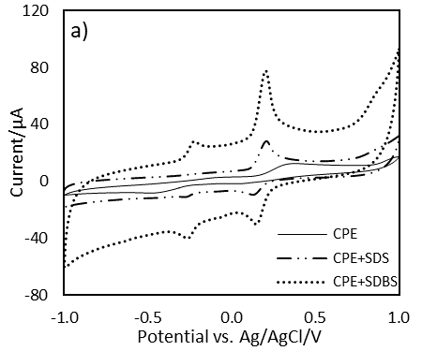
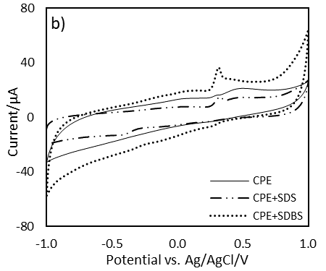

Figure 1. Cyclic voltammograms of (3rd scan) a) dopamine (0.25 mM) and b) uric acid (0.30 mM) gained at bare carbon paste electrode (CPE), carbon paste electrode modified with SDS (CPE-SDS) and carbon paste electrode modified with SDBS (CPE-SDBS) in pH 7.5 PBS. Scan rate: 50mV/s

Figures 1a and b shows that CPE-SDBS versus CPE-SDS exhibits higher sensitivity to DA and UA, resulting from the phenyl ring in the SDBS structure which makes it more hydrophobic than SDS and enables stronger interaction with CPE. During the first scan in cyclic voltammetry dopamine gives the oxidation peak at 0.209 V, and in reverse scan appear two cathodic peaks at 0.154 V and -0.260 V. Electrochemical reaction of dopamine goes through several steps. First, involving two protons and two electrons DA is oxidized to o-dopaminequinone and after cyclation process (leucodopaminechrome) goes through oxidation to dopaminechrome. Further oxidation mechanism starts the polymerization process. Reduction of DA to dihydroxzindole and aminochrome gives the cathodic peaks in Fig.1a. involving two electrons for each reduction process [26].

Differential pulse voltammetry

It is known that AA coexists with DA and UA in real samples, hence AA electrochemical response was studied in our further work. The differential pulse voltammograms of dopamine, uric acid and ascorbic acid at the bare carbon paste electrode and in presence of surfactants are shown in Figure 2. At the bare CPE, the oxidation peak potentials of DA, UA, and AA appeared at 170 mV, 310 mV, and 330 mV respectively, indicating the possibility of simultaneous determination of DA and AU, but not in the presence of AA because of its broad oxidation peak. Compared to results obtained on bare CPE, CPE-SDS, and CPE-SDBS the anodic peaks potential of DA and UA were shifted negatively and two well-separated peaks were obtained with a difference of 115 mV in potentials between DA and UA peaks at CPE-SDS and 130 mV at CPE-SDBS (Figure 2). Voltammograms obtained at CPE-SDS and CPE-SDBS depict clear that AA has no electrochemical response according to the repulsion of ascorbate ion with a negatively charged electrode surface because at pH 7 ascorbic acid exists in its anionic form. These results mean that modified CPE-s can be used in order to the simultaneous determination of DA and UA in presence of ascorbic acid.

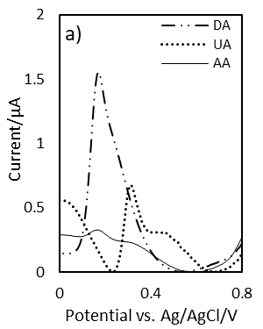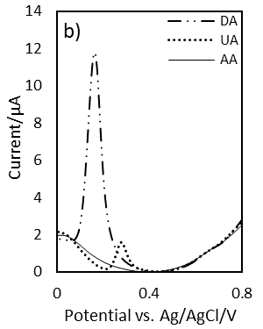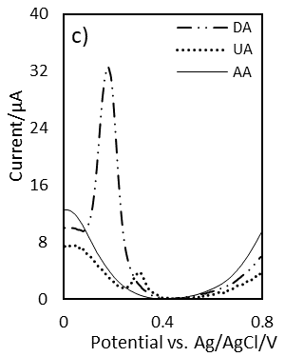

Figure 2. Differential pulse voltammograms of bare CPE (a), CPE-SDS (b), and CPE-SDBS (c) in 0.1 M PBS (pH 7.0) in presence of 50 µM DA (blue line), 60 µM AU (green line) and 60 µM AA (red line). Scan rate: 20 mV/s

Effect of pH
The effect of pH value of 0.1 M PBS to an electrochemical response of 50 µM DA and 60 µM UA at CPE, CPE-SDS, and CPE-SDBS was investigated by DPV over pH range from 3 to 9. In Figure 3a and 3b can be seen the effect of pH value on the anodic peak current of DA and UA with three working electrodes (CPE, CPE-SDS, and CPE-SDBS). Comparing results obtained on three electrodes (Figure 3) depicts clearly that peak currents of DA and UA were the highest with CPE-SDBS. Due to better sensitivity and clearly peaks separation of DA and UA, pH 7 with CPE-SDS and pH 6 with CPE-SDBS were taken in our following investigation.

Due to linear relationships of anodic peak potentials of DA and UA as function of pH value, with increasing pH values on range from 3 to 9 the oxidation peak potentials of DA and UA with CPE-SDS were shifted to more negative potentials with a slope of 55.9 mV/pH and 55.5 mV/pH and with CPE-SDBS 54.1 mV/pH and 50.2 mV/pH. Slopes for DA and UA on both modified electrodes were closed to the theoretical value of 59 mV/pH, which indicated that an equal number of protons and electrons are involved in electrochemical reactions [4]. In further experiments the electrolyte pH was chosen to be 7 for CPE-SDS and pH 6 for CPE SDBS, because the oxidation peaks of DA and UA are more separated and peak width were smaller compared to response in other pH.

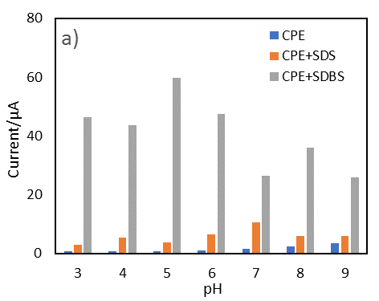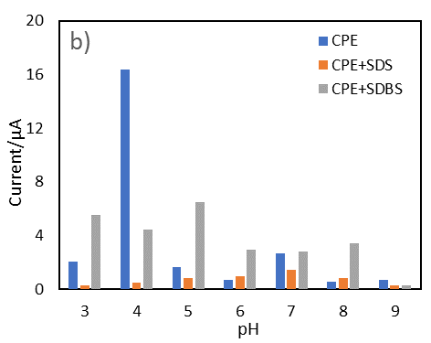

Figure 3. Effect of pH on the peak current (a) dopamine 50 µM, (b) uric acid 60 µM

Optimization of surfactants’ concentration and equilibration time

The concentration of surfactants was optimized by varying their concentration in the range of 0.05-5.00 mM in 0.1M PBS at pH 7.00 using CPE-SDS and pH 6 for CPE-SDBS as working electrodes. Figure 4 shows the effect of surfactants concentration on the peak current of 50 µM DA and 60 µM UA in differential pulse voltammetry. Using CPE-SDS as working electrode a linear relationship is established between SDS concentration versus DA and UA peaks current up to 2 mM of SDS, while at CPE-SDBS linearity is up to 1 mM of SDBS and they are chosen as optimal concentrations for certain cases of surfactants. The influence of equilibration time on electrochemical response of DA and UA was investigated by DPV in a range of equilibration time from 30 to 360 seconds. Considering the relationship between equilibration time and peaks current of DA (50 µM) and UA (60 µM), in following measurements was chosen 100- and 150-seconds equilibration time for CPE-SDS and CPE-SDBS, respectively.
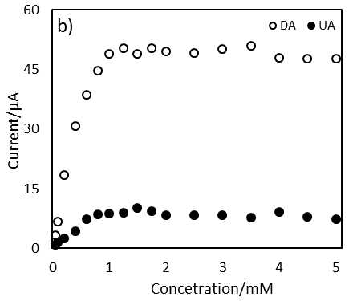
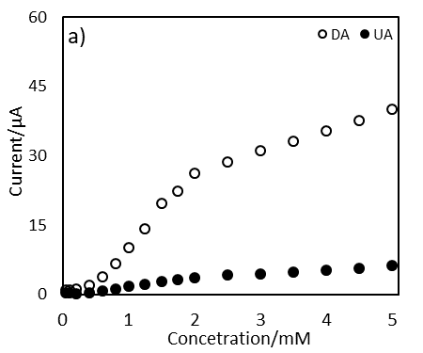

Figure 4. Effects of surfactants concentration a) SDS and b) SDBS on the peak current of DA 50 µM and AU 60 µM

Concentration of AA was chosen 50 ppm based on CPE-SDBS electrode response to dopamine in different concentration of AA and for CPE-SDS concentration of AA was 25 ppm. In higher concentration of AA, electrode response was reduced significantly, and damaged electrode surface was observed.

Simultaneous determination of DA and UA in presence of AA

Simultaneous determination of DA and UA in presence of AA was performed by DPV in a range of potential from 0.10 V to 0.50 V, at a scan rate of 20 mV/s by keeping the constant concentration of one analyte and changing the concentration of the other. Figure 5 show voltammograms obtained with CPE-SDS (pH 7) with a difference on potentials about 105 mV between voltammetric responses of DA and UA, better results were obtained with CPE-SDBS (pH 6), where the peaks separation is about 115 mV. These voltammograms gained with CPE-SDS and CPE-SDBS depict clearly that high concentrations of AA have no influence on peaks potentials and currents of DA and UA. The linear response equations using CPE-SDS are I(µA) = 0.804·CDA[µM] + 0.9634 and I(µA) = 0.0716·CUA[µM] - 0.1116. While with CPE-SDBS was found higher sensitivity, better linearity and lower limit of detection for DA and UA, where regression equations are I(µA) = 1.0306·CDA[µM] -0.8492 and I(µA) = 0.1048·CUA[µM] - 0.6922. The detection limits for DA and UA were found to be 0.26 and 1.10 µM with CPE-SDS, whilst 0.22 and 0.38 µM with CPE-SDBS. CPE-SDS and CPE-SDBS can be applied for simultaneous determination of DA and UA in presence of AA with high sensitivity, good linearity and low limit of detection.

Figure 1. Differential pulse voltammograms at CPE-SDS a) 142 µM AA, 5 µM DA and 6-210 µM UA, b) 142 µM AA, 60 µM UA and 0.5-42 µM DA. Differential pulse voltammograms at CPE-SDBS c) 284 µA AA, 5 µM DA and 6-210 µM UA, d) 284 µM AA, 60 µM UA and 0.5-105 µM DA. Linear relationship of e) DA and f) UA concentration and current intensity in presence of ascorbic acid

Recovery and real samples analysis

Under optimized conditions has been performed the recovery test for the mixture of dopamine and uric acid in the presence of ascorbic acid. Results of recovery tests presented in Table 1 shows the recovery result for DA and UA found in the range 96.5% to 102.1% for 5 replicated measurements. Hence, the obtained results show that the DPV method could be applied successfully for the determination of dopamine and uric acid simultaneously in presence of ascorbic acid. Further, the method was used for determination of DA and UA in blood serum using standard addition method. A sample was spiked with UA and recovery percentages for CPE SDBS was 99.1% and CPE SDS 82.9% (Figure 6). In the same sample was spiked DA which shows a clear peak (Figure 7) and we conclude that method in the quantification of them simultaneously is applicable.

Table 1. Determination of dopamine and uric acid in model samples using CPE-SDS and CPE-SDBS

(n=5)
Electrode | Analyte | Added (µM) | Found (µM) | Recovery
CPE SDBS | Dopamine | 0.53 | 0.54±0.01 | 102±1.9
CPE SDBS | Uric acid | 59.5 | 57.4±0.8 | 97±1.4
CPE SDS | Dopamine | 5.27 | 5.18±0.03 | 98.3±0.6
CPE SDS | Uric acid | 59.5 | 59±4.4 | 99±7.4

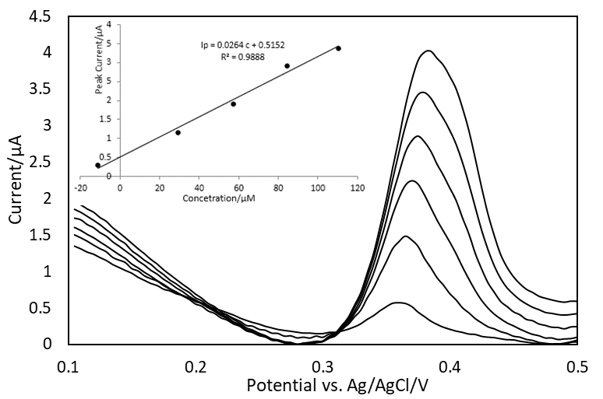

Figure 6. CPE-SDBS voltammograms of uric acid analyzed by standard addition method in blood serum

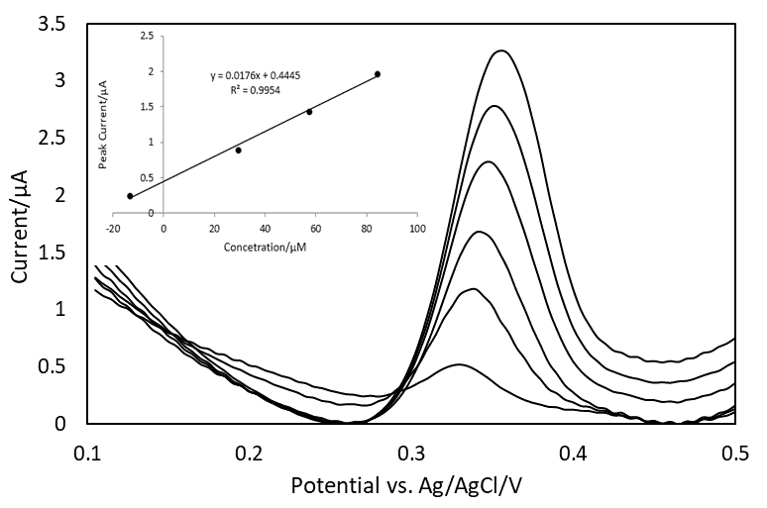
Figure 7. CPE-SDS voltammograms of uric acid analyzed by standard addition method in blood serum

Conclusion

In this paper, is presented a voltammetric method developed for simultaneous determination of dopamine and uric acid in presence of ascorbic acid. Carbon paste electrode surface via hydrophobic interaction with a hydrophobic chain of surfactant create a high density of negatively charged monolayer. Electrostatic interaction of analytes’ positive ions with electrode surface provide more effective electron transfer channel for electrochemical oxidation and make the method applicable for simultaneous determination. Due to the repulsion of negatively charged of ascorbic acid with electrode surface, it is possible to determinate dopamine and uric acid in his presence. The CPE-SDS and CPE-SDBS have shown good reproducibility, repeatability, and stability. Based on recovery test for mixture and real sample analysis we conclude that applied electrochemical method is practically applicable. Simple electrode surface modification makes it useful for determination of other dopamine and uric acid derivatives in different matrix media where almost interferents are anionic species. Modification of screen-printed carbon electrodes with surfactants will reduce sample volume for electrochemical determination of DA and UA.

References
- Zhang, J., Song, X., Ma, S., Wang, X., Wang, W. and Chen, Z. (2017). A novel sodium dodecyl benzene sulfonate modified expanded graphite paste electrode for sensitive and selective determination of dopamine in the presence of ascorbic acid and uric acid. Journal of Electroanalytical Chemistry, 795: 10-16.
- Zhang, K., Chen, X., Li, Z., Wang, Y., Sun, S., Wang, L., Guo, T., Zhang, D., Xue, Z., Zhou, X. and Lu, X. (2018). Au-Pt bimetallic nanoparticles decorated on sulfonated nitrogen sulfur co-doped graphene for simultaneous determination of dopamine and uric acid. Talanta, 178: 315-323.
- Sharath, S., Swamy, B. E. K., Chandra, U., Manjunatha, J. G. and Sherigara, B. S. (2009). Simultaneous determination of dopamine, uric acid and ascorbic acid with CTAB modified carbon paste electrode. International Journal of Electrochemical Science, 4: 592-601.
- Yang, L., Liu, D., Huang, J. and You, T. (2014). Simultaneous determination of dopamine, ascorbic acid and uric acid at electrochemically reduced graphene oxide modified electrode. Sensors and Actuators, B: Chemical, 193: 166-172.
- Zhang, Y., Lei, W., Xu, Y., Xia, X. and Hao, Q. (2016). Simultaneous detection of dopamine and uric acid using a poly (L -lysine)/graphene oxide modified electrode. Nanomaterials, 178: 1-17.
- Wu, D., Li, Y., Zhang, Y., Wang, P., Wei, Q. and Du, B. (2014). Sensitive electrochemical sensor for simultaneous determination of dopamine, ascorbic acid, and uric acid enhanced by amino group functionalized mesoporous Fe₃O₄@graphene sheets. Electrochimica Acta, 116: 244-249.
- Wang, H. Y., Sun, Y. and Tang, B. (2002). Study on fluorescence property of dopamine and determination of dopamine by fluorimetry. Talanta, 57(5): 899-907.
- Yu, J., Wang, S., Ge, L. and Ge, S. (2011). A novel chemiluminescence paper microfluidic biosensor based on enzymatic reaction for uric acid determination. Biosensors and Bioelectronics, 26(7): 3284-3289.
- Guo, L., Zhang, Y. and Li, Q. (2009). Spectrophotometric determination of dopamine hydrochloride in pharmaceutical, banana, urine and serum samples by potassium ferricyanide-Fe(III). Analytical Sciences, 25 (12): 1451-1455.
- Zhao, H.-X., Mu, H., Bai, Y.-H., Yu, H. and Hu, Y.-M. (2011). A rapid method for the determination of dopamine in porcine muscle by pre-column derivatization and HPLC with fluorescence detection. Journal of Pharmaceutical Analysis, 1(3): 208-212.
- Han, D., Han, T., Shan, C., Ivaska, A. and Niu, L. (2010). Simultaneous determination of ascorbic acid, dopamine and uric acid with chitosan-graphene modified electrode. Electroanalysis, 22(17–18): 2001-2008.
- Kang, G. and Lin, X. (2006). RNA modified electrodes for simultaneous determination of dopamine and uric acid in the presence of high amounts of ascorbic acid. Electroanalysis, 18(24): 2458-2466.
- Khudaish, E. A., Al-Nofli, F., Rather, J. A., Al-Hinaai, M., Laxman, K., Kyaw, H. H. and Al-Harthy, S. (2016). Sensitive and selective dopamine sensor based on novel conjugated polymer decorated with gold nanoparticles. Journal of Electroanalytical Chemistry, 761: 80-88.
- Xu, T.-Q., Zhang, Q.-L., Zheng, J.-N., Lv, Z.-Y., Wei, J., Wang, A.-J. and Feng, J.-J. (2014). Simultaneous determination of dopamine and uric acid in the presence of ascorbic acid using Pt nanoparticles supported on reduced graphene oxide. Electrochimica Acta, 115: 109-115.
- Wang, G., Sun, J., Zhang, W., Jiao, S. and Fang, B. (2009). Simultaneous determination of dopamine, uric acid and ascorbic acid with LaFeO₃ nanoparticles modified electrode. Microchimica Acta, 164(3–4): 357-362.
- Sun, H., Chao, J., Zuo, X., Su, S., Liu, X., Yuwen, L., Fan, C. and Wang, L. (2014). Gold nanoparticle-decorated MoS₂ nanosheets for simultaneous detection of ascorbic acid, dopamine and uric acid. RSC Advances, 4(52): 27625-27629.
- Wang, S., Zhang, W., Zhong, X., Chai, Y. and Yuan, R. (2015). Simultaneous determination of dopamine, ascorbic acid and uric acid using a multi-walled carbon nanotube and reduced graphene oxide hybrid functionalized by PAMAM and Au nanoparticles. Analytical Methods, 7(4): 1471-1477.
- Zheng, X., Zhou, X., Ji, X., Lin, R. and Lin, W. (2013). Simultaneous determination of ascorbic acid, dopamine and uric acid using poly(4-aminobutyric acid) modified glassy carbon electrode. Sensors and Actuators, B: Chemical, 178: 359-365.
- Njagi, J., Chernov, M. M., Leiter, J. C. and Andreescu, S. (2010). Amperometric detection of dopamine in vivo with an enzyme-based carbon fiber microbiosensor. Analytical Chemistry, 82(3): 989-996.
- Zheng, J. and Zhou, X. (2007). Sodium dodecyl sulfate-modified carbon paste electrodes for selective determination of dopamine in the presence of ascorbic acid. Bioelectrochemistry, 70 (2): 408-415.
- Dang, X., Hu, C., Wei, Y., Chen, W. and Hu, S. (2004). Sensitivity improvement of the oxidation of tetracycline at acetylene black electrode in the presence of sodium dodecyl sulfate. Electroanalysis, 16 (23): 1949-1955.
- Thomas, T., Mascarenhas, R. J., D’Souza, O. J., Detriche, S., Mekhalif, Z. and Martis, P. (2014). Pristine multi-walled carbon nanotubes/SDS modified carbon paste electrode as an amperometric sensor for epinephrine. Talanta, 125: 352-360.
- Manjunatha, J. G., Kumara Swamy, B. E., Gilbert, O., Mamatha, G. P. and Sherigara, B. S. (2010). Sensitive voltammetric determination of dopamine at salicylic acid and TX-100, SDS, CTAB modified carbon paste electrode. International Journal of Electrochemical Science, 5(5): 682-695.
- Teradale, A. B., Lamani, S. D., Ganesh, P. S., Kumara Swamy, B. E. and Das, S. N. (2017). CTAB immobilized carbon paste electrode for the determination of mesalazine: A cyclic voltammetric method. Sensing and Bio-Sensing Research, 15: 53-59.
- Sancy, M., Francisco Silva, J., Pavez, J. and Zagal, J. H. (2013). Simultaneous electrochemical detection of dopamine, ascorbic acid and uric acid using copper-phthalocyanine functionalized MWCNTs. Journal of the Chilean Chemical Society, 58(4): 2117-2121.

