TEMPORAL VARIABILITY OF PHYTOPLANKTON BIOMASS IN RELATION TO SALINITY AND NUTRIENTS IN A SHALLOW
COASTAL LAGOON

(Kepelbagaian Temporal Biojisim Fitoplankton Berdasarkan Kemasinan dan Nutrien
di Lagun Pesisir Pantai yang Cetek)

Zuraini Zainol and Mohd Fadzil Akhir*

Institute of Oceanography and Environment,
Universiti Malaysia Terengganu,
21030 Kuala Nerus, Terengganu, Malaysia.

*Corresponding author: mfadzil@umt.edu.my

Abstract
With agriculture and aquaculture activities in proximity, the unique feature of Setiu Lagoon, which is an almost closed system and connected to the coastal sea with only one inlet leaves a huge question on how this ecosystem maintains its productivity under restricted conditions. In this study, results of three field samplings carried out during the southwest monsoon (August 2017), wet period of northeast monsoon (December 2017), and dry period of northeast monsoon (February 2018) are used to examine the differences in phytoplankton biomass in relation to salinity and nutrients under different monsoonal settings. These samplings are representative of typical conditions existing during a dry season (southwest monsoon) and a rainy one (northeast monsoon). In the lagoon, the most determinant factor affecting the phytoplankton biomass distribution is the freshwater intrusion, strengthened by increased rainfall amount and strong flow that brings along nutrients from land resulting in higher chlorophyll a concentrations. As per classification of Malaysia Marine Water Quality Criteria and Standard (MWQCS), mean nutrient concentrations at the study area were in Classes 1 and 2, which are suitable for local aquaculture activities. However, conservation actions must also be in line with the economic development.

Keywords: salinity, tidal, freshwater intrusion, nutrients, chlorophyll a, shallow coastal lagoon

Abstrak
Dengan dikelilingi dengan aktiviti akuakultur dan pertanian di kawasan terdekat, persekitaran unik Lagun Setiu - yang merupakan sebuah sistem yang hampir tertutup dan hanya mempunyai satu muara yang menghubungkan lagun dengan laut - meninggalkan satu persoalan yang besar tentang bagaimanakah ekosistem ini mengekalkan produktiviti dalam keadaan yang terbatas. Dalam kajian ini, hasil kajian melalui tiga pensampelan lapangan yang dijalankan sewaktu monsun barat daya (Ogos 2017), musim hujan monsun timur laut (Disember 2017), dan musim kering monsun timur laut (Februari 2018) digunakan untuk mengkaji perubahan biojisim fitoplankton berdasarkan kemasinan dan nutrien di bawah pengaruh monsun yang berbeza. Pensampelan ini mewakili keadaan biasa yang wujud semasa musim kering (monsun barat daya) dan musim hujan (monsun timur laut). Di dalam lagun ini, kemasukan air tawar yang dipengaruhi oleh pertambahan air hujan dan nutrien dari daratan yang dibawa oleh aliran air yang kuat merupakan faktor yang paling mempengaruhi penghasilan biojisim fitoplankton yang tinggi. Merujuk kepada Kriteria dan Piawaian Kualiti Air Marin, Malaysia (MWQCS), purata kepekatan nutrien di kawasan kajian berada di dalam Kelas 1 dan 2, yang sesuai untuk aktiviti akuakultur tempatan. Walaubagaimanapun, usaha pemuliharaan juga haruslah seiring dengan perkembangan ekonomi.

Kata kunci: kemasinan, pasang surut, kemasukan air tawar, nutrien, klorofil a, lagun pesisir pantai yang cetek

Introduction
Occupying approximately 13% of the world’s coastal area, coastal lagoons are known as shallow water bodies with an average depth of less than 2m and are connected to the ocean by one or more inlets [1]. Generally, the ecology of a coastal lagoon is highly variable, depending on its prevalent physical and chemical environment [2]. Within this shallow transitional water system, seasonal changes in phytoplankton biomass are believed to be under the influence of site-specific hydrological characteristics such as river discharge and salinity [3]. A coastal lagoon normally has limited points of water exchange, which make them a good shelter for the accumulation of nutrients [4]. Furthermore, due to this unique coastal feature, it is believed that coastal lagoons are able to promote effective use and recycling of nutrient inputs, which contribute to high levels of primary production [1].

Despite being shallow in depth, a coastal lagoon that has close proximity to land is more vulnerable to anthropogenic activities such as enhanced input of nutrients that stimulate primary producers growth [3]. This sheltered ecosystem also provides a variety of goods and services to fisheries, aquaculture, tourism, and other sectors, at local, regional, and national levels [5]. Moreover, despite its role in supporting a rich biodiversity of aquatic plants and animals [6], a coastal lagoon, which is composed of a mixture of brackish and sea water, also serves as a buffer zone for storage of nutrients and fluxes originating from adjacent continental drainage to the marine environment [7].

Setiu Lagoon has received significant attention since the 1990’s due to its unique habitat, which consists of sizable array of biological diversities [8]. Somehow, Setiu Lagoon had experienced shoreline changes in 2015 due to the continuous action of wind, current, and nearshore waves, especially during the northeast monsoon [9], which led to the closing of the old inlet and the opening of a new inlet as shown in Figure 1. To the best of our knowledge, as of now, almost all previous studies on Setiu Lagoon such as Ong et al. [10], Suratman and Latif [11], and Bakar et al. [12] are focused on the old inlet, which was closed naturally in 2015 (Figure 1). No prior study has acknowledged the interaction between the localised physical properties and nutrients in shaping the productivity in Setiu Lagoon at the current inlet. In this regard, the present work aims to understand the hydrodynamics, the distribution of nutrients and chlorophyll a (a proxy for phytoplankton biomass [13]) within the study area, and further uncover the mechanisms that shape the dynamics in this unique shallow coastal lagoon.

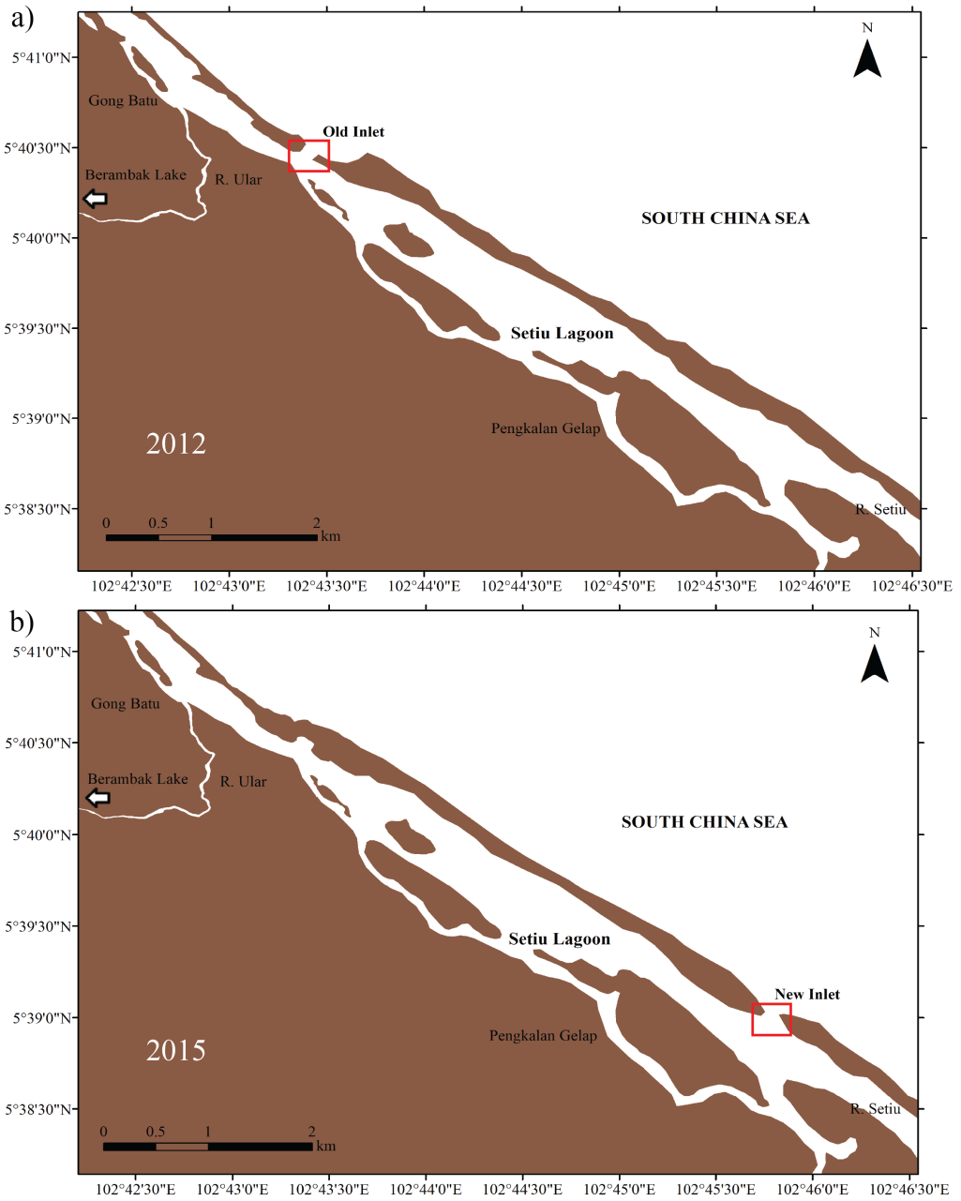

Figure 1. The coastline changes observed in Setiu Lagoon during (a) 2012 and (b) 2015. Strong seasonal wind, wave, and current in the study area has resulted in the closing of the old inlet and the opening of the new inlet, which is located approximately 4 km away from each other

Materials and Methods

Description of the study area
Setiu Lagoon is situated within the Setiu Wetland area, which is approximately 23,000 hectares in size and extends from 5° 35’ N to 5° 45’ N latitude and 102° 41’ E to 102° 49’ E longitude. This lagoon is a shallow basin with a depth of 0.5 – 3.0 m, with a dependent tidal state [14]. With a mean spring tide of 1.8 m and a tidal range that rarely exceeds 2 m, the Setiu Lagoon is classified as a low mesotidal coastal type [15]. Its main source of freshwater comes from the Setiu River that flows directly into the lagoon (Figure 2). Meanwhile, another freshwater input comes from the natural lake (Berambak Lake), which is connected to the lagoon through the Ular River (Figure 2). The upstream activities are dominated by agriculture, mainly the palm oil plantations and aquaculture activities, which dominate the area within the wetland [8]. Since Setiu Lagoon is located in the South China Sea (SCS) region, it is therefore subjected to alternating southwest (May – September) and northeast monsoons (November – March). Salinity within the lagoon varies between 0 – 30 psu, where a higher salinity condition is restricted to the region closer to the inlet [16]. Somehow, during the northeast monsoon, river discharges as a result of heavy rainfall restricts the extension of the salt wedge at the study area [17].

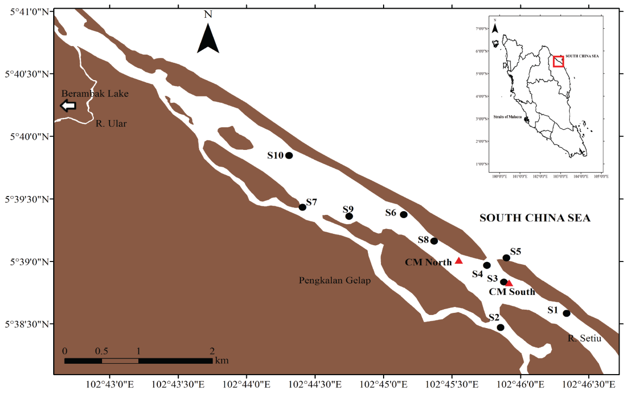

Figure 2. Location of the study site (red box), which faces the South China Sea. The main freshwater input in the study area comes from Setiu River, while another source of freshwater comes from Ular River. The dot indicate the stations for salinity data and water samples collection meanwhile the triangle indicate the stations for current meters deployment

Sampling procedure
The first field sampling was carried out from 7th to 8th of August 2017, which represented the southwest monsoon. A total of 7 stations (S1 – S7) were set up for the purpose of salinity, chlorophyll a, and nutrient analysis in August 2017. Another station (S8) was added in the salinity characteristic analysis during August 2017. The second and third research sampling was carried out from 27th to 28th December 2017 and 12th to 13th February 2018, which represented the wet and dry periods of the northeast monsoon, respectively. In December 2017 and February 2018, S9 and S10 were added as sampling stations to capture the interaction between seawater and freshwater. The total of number of sampling stations was increased to 10 stations (Figure 2). Unfortunately, there was no data available for S3 and S5 during December 2017 and for S2, S3, and S5 during February 2018, due to shallow water that made it difficult to access the stations. In terms of tidal circulation, the spring tide occurred during 7 – 8 August 2017, with a tidal range of 1.4 m for both days. Neap tide occurred during 27 – 28 December 2017 and 12 – 13 February 2018. During 27 and 28 December 2017, the tidal range was 0.8 m and 0.7 m, respectively. On the other hand, during 12 and 13 February 2018, the tidal range was 1.2 m and 1.4 m, respectively.

Salinity data (indirectly through water conductivity) was taken from the SonTek CastAway Conductivity, Temperature, and Depth (CTD) profiler. The flow conditions were estimated from the moored data of two units of Valeport Model 308 at CM North and CM South (Figure 2). Hourly water level data was obtained from the tide tables provided by the National Hydrographic Centre, Malaysia. Water samples for nutrients and chlorophyll a analysis were collected at 0.5 m depth using a Van-Dorn water sampler. Samples collected were filtered through pre-combusted Sartorius Stedim glass fibre GF/F filter papers (47 mm diameter, nominal pore size 0.7 µm) using a vacuum pump. The filter papers for chlorophyll a analysis were rolled and kept in a 15 mL centrifuge tube, and were then wrapped with aluminium foil and stored in a freezer until they were returned to laboratory, to prevent pigments degradation. Meanwhile, filtered water samples for nutrient analysis were transferred into 250 mL acid-washed high density polyethylene (HDPE) bottles and stored in a freezer until further analysis. Concentrations of chlorophyll a were analysed using a UV-VIS Spectrophotometer with an adopted procedure from the American Public Health Association (APHA), 2005 method [18]. Laboratory analyses for nitrate, phosphate, ammonium, and silicate were conducted using Westco SmartChem 200 Discrete Analyser (AMS-Alliance) with U.S. Environmental Protection Agency (EPA) methods [19].

Results and Discussion

Salinity in the lagoon
The hourly flows during the study period of August 2017 can be seen in Figure 3a. It can be observed that the flows were characterised by strong hourly irregularities. At the north of the inlet, the daily flow oscillated between 0 – 389 m³/s with an average flow of 215 m³/s. Meanwhile, at the south of the inlet, the average flow was 302 m³/s with minimum and maximum daily values of 0.4 m³/s and 667 m³/s, respectively. To identify the influencing factor that shapes the flow within the lagoon, the daily flow is compared with the water level data (Figure 3b). The figure clearly shows that the highest peaks of the flows occurred during the high tide, which indicated a strong seawater inflow. Interestingly, there were few peaks observed during the ebbing, which indicated a presence of small river discharges into the lagoon. In Setiu Lagoon, the penetration of seawater, with an average value of 32.4 psu during the high tide of August 2017, had reached S7, which was located approximately 2.5 km away from the inlet (Figure 4a). This condition agreed well with strong seawater inflow at the north (average flow of 303 m³/s) and south (average flow of 494 m³/s) of the inlet during the period where data collection was made (0920 – 1000 hours; Figure 3a). During the low tide of August 2017, slightly saline water (average of 31.0 psu) was observed at stations closer to the inlet (S4 – S6 and S8), while less saline water (average of 25.4 psu) was observed at stations away from the inlet (Figure 4b). This was expected since river discharge is a common feature during low tides [20]. Furthermore, as mentioned earlier, small river discharges were observed at both north and south of the inlet during data collection (1510 – 1610 hours), with average flows of 330 m³/s and 452 m³/s respectively (Figure 3a). The presence of this river discharge is believed to have been the causative factor that prevented the salt water intrusion into stations further away from the inlet (S1, S2, and S7; Figure 4b).

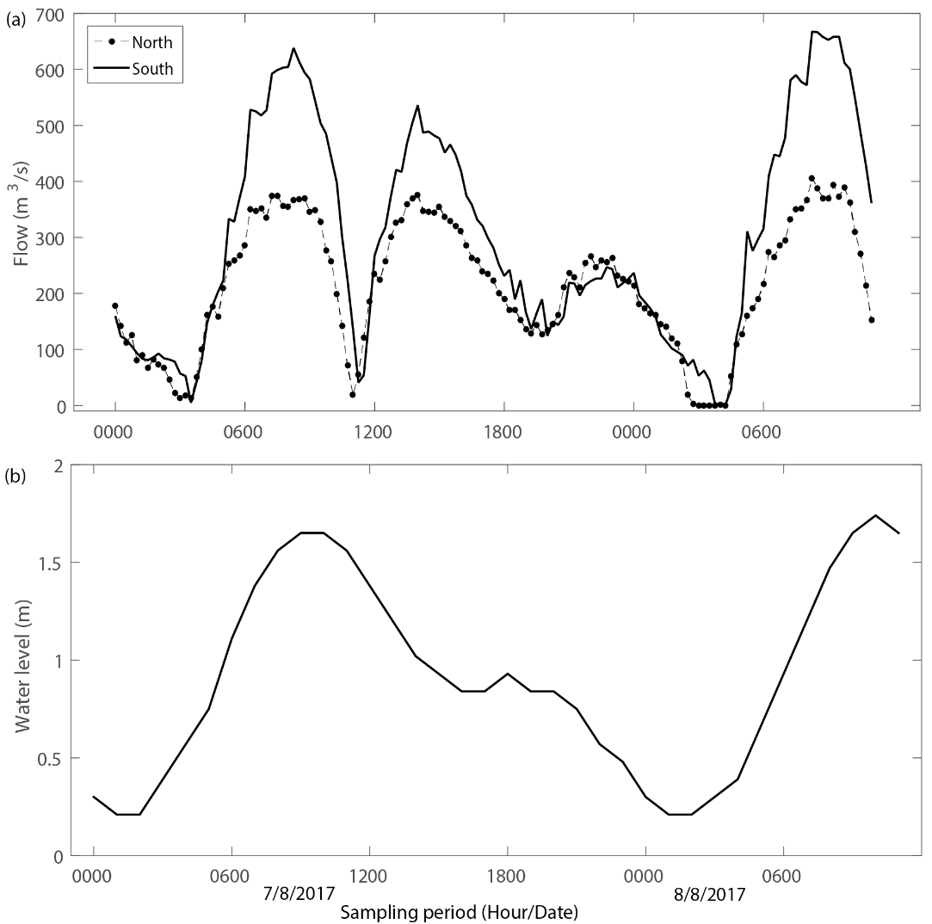

Figure 3. (a) Hourly flow at the north and south of inlet and (b) water level at Setiu Lagoon during 7-8 August 2017

During the second field sampling exercise, surface salinity distribution in Setiu Lagoon on December 2017 was plotted in Figure 5. An average flow rate of 144 m³/s (north) and 238 m³/s (south) was recorded during the second visit (Figure 6a). As it can be observed, freshwater flooded the whole study area with an average salinity of 8.8 psu during the high tide (Figure 5a) and 12.9 psu during the low tide (Figure 5b). This was possible due to two main reasons - river discharge and increase in rainfall amount. Comparing the flow rates with water level data (Figure 6b) clearly demonstrated the influence of river discharges from both sources (Setiu and Ular Rivers). During the low tide of the visiting period (0930 – 1010 hours), average critical flux of 242 m³/s (north) and 369 m³/s (south) was recorded, compared to average flux of 27 m³/s (north) and 135 m³/s (south) during high tide (1530 – 1605 hours), indicating that large river discharges do not allow the penetration of seawater into the lagoon. The record of daily rainfall amounts in Setiu, obtained from the Department of Irrigation and Drainage, Terengganu (Table 1), also proved the increased amount of freshwater input during December 2017, where the average daily rainfall amount within a 3-day visiting period was 42.2 mm/day compared to 17.0 mm/day during February 2018 and 0.0 mm/day during August 2017.

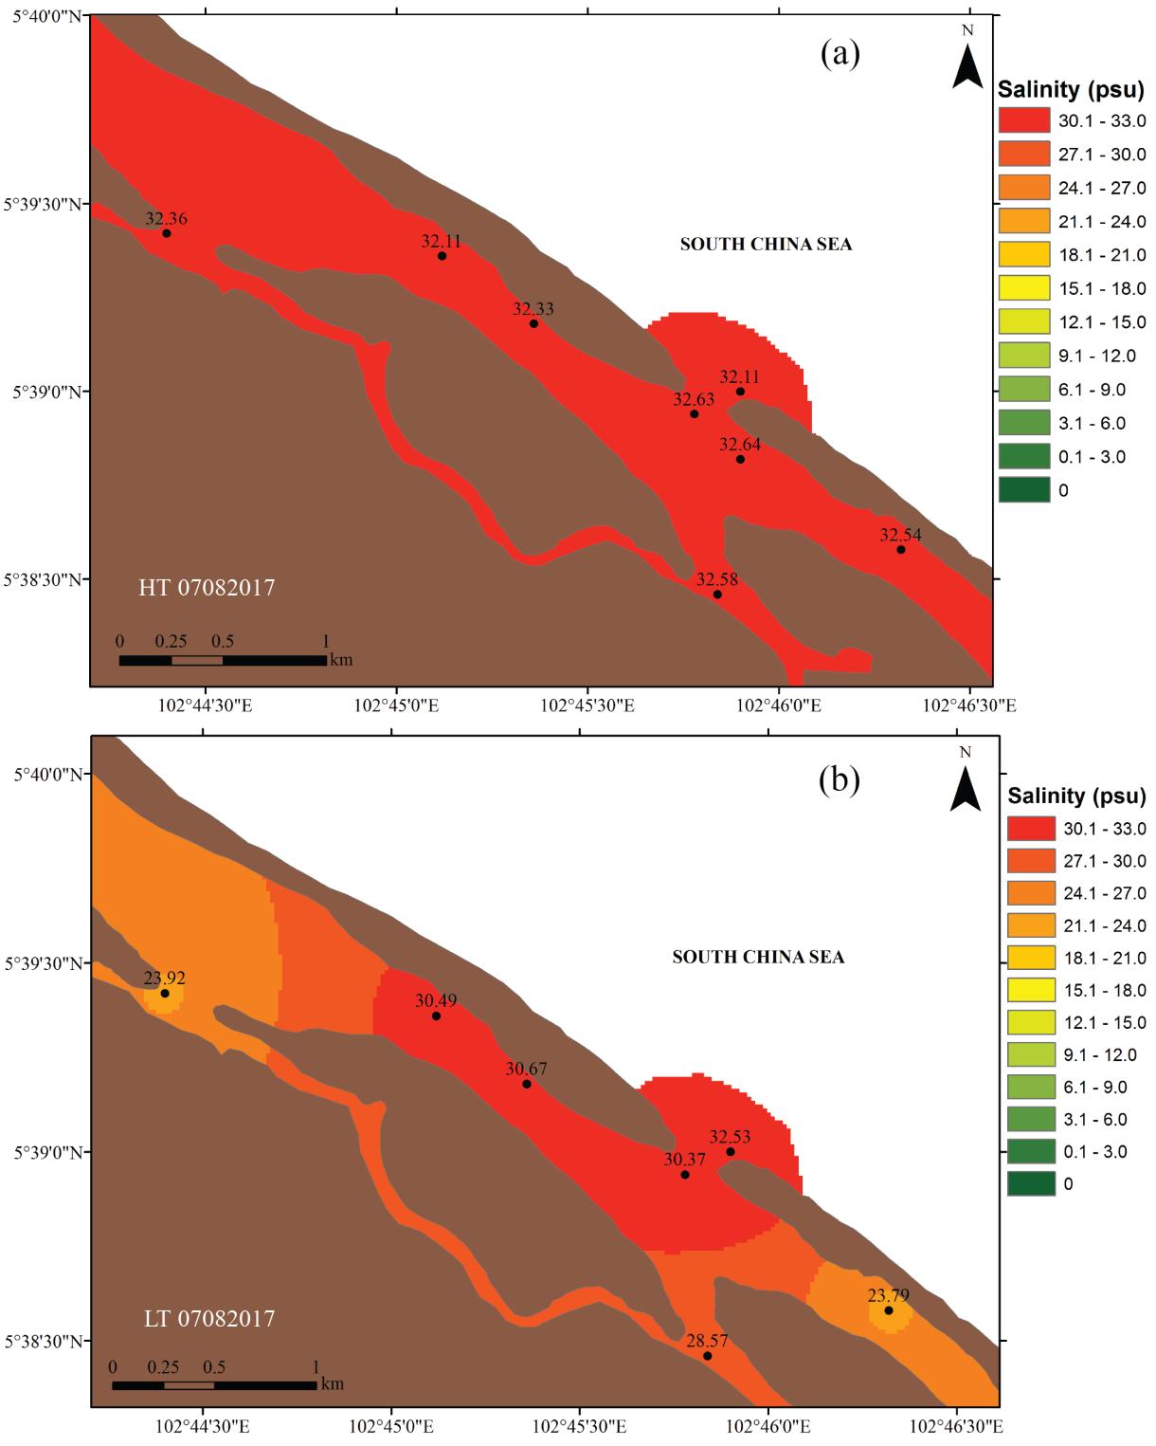

Figure 4. Salinity distribution in Setiu Lagoon during (a) high and (b) low tides on 7 August 2017

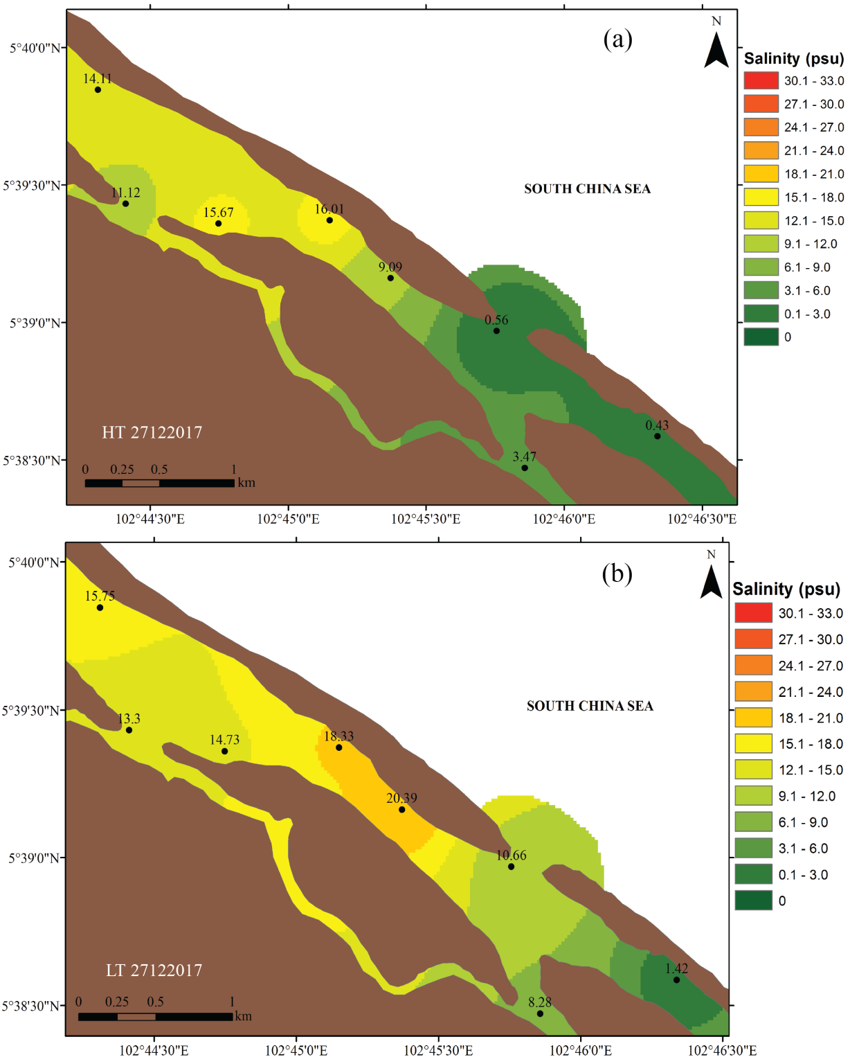
Figure 5. Salinity distribution in Setiu Lagoon during (a) high and (b) low tides on 27 December 2017

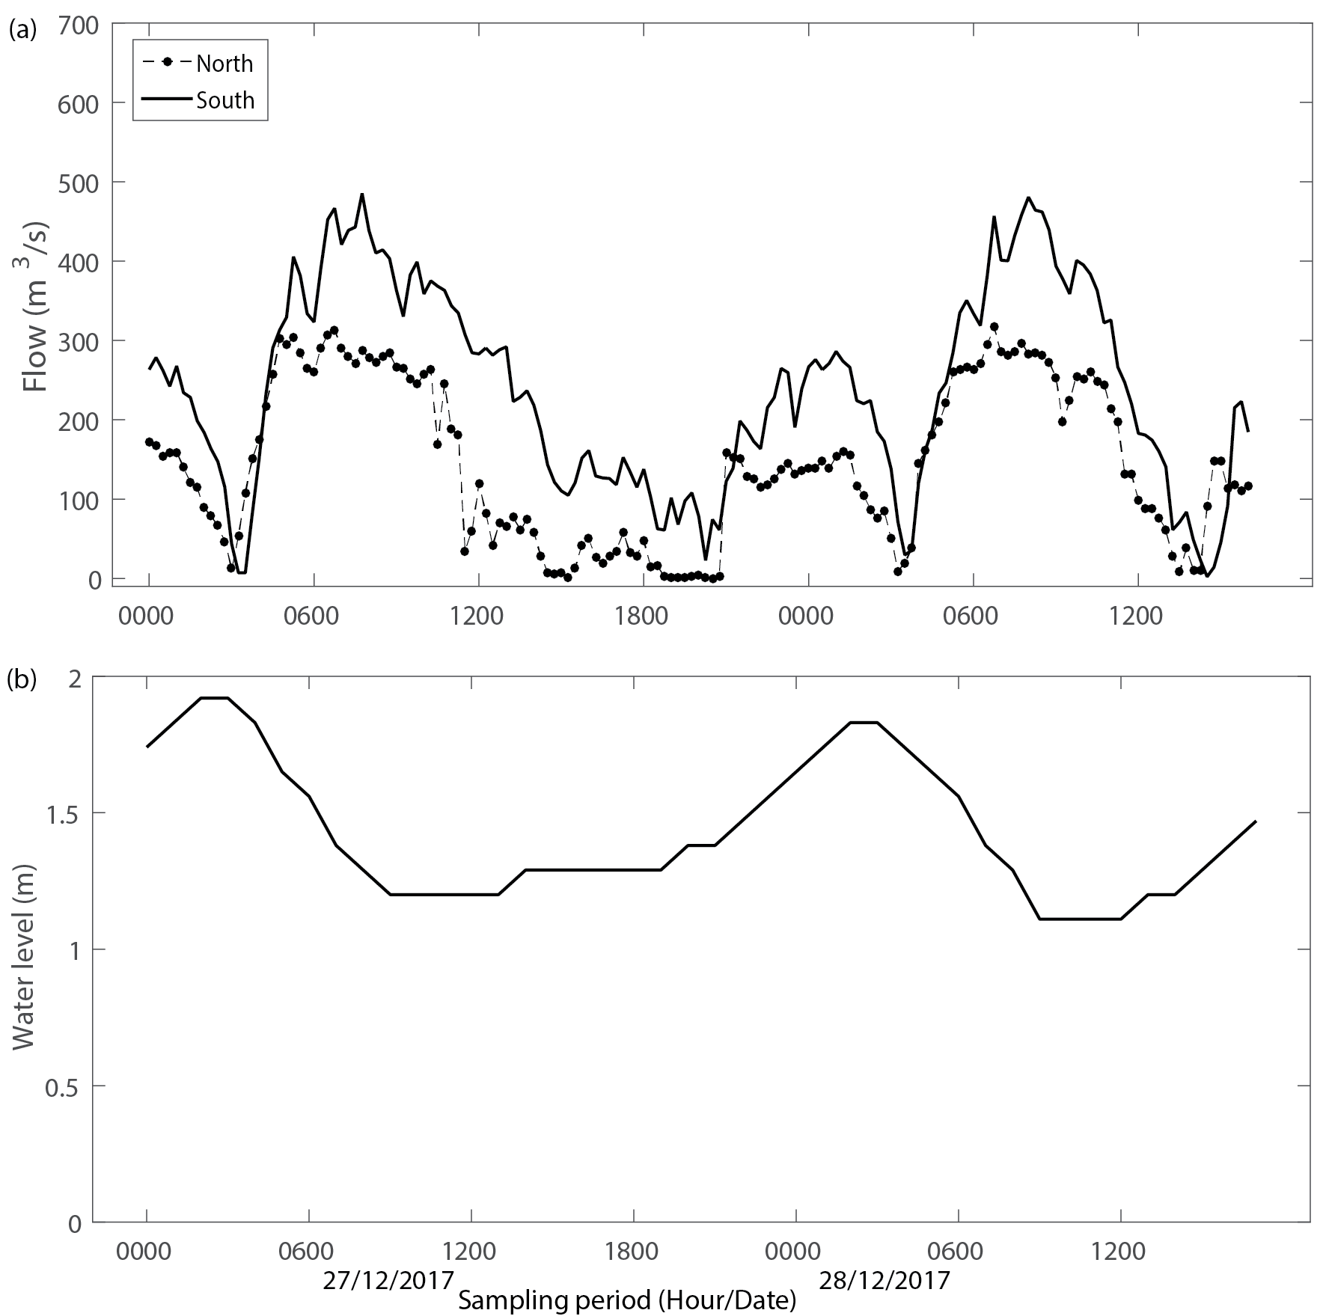

Figure 6. (a) Hourly flow at the north and south of inlet and (b) water level at Setiu Lagoon during 27-28 December 2017

Table 1. 3-days average daily rainfall amount during visiting period
Date | 3-Days Average Rainfall Amount  (mm/day)
6 – 8 Aug 2017 | 0.0
26 – 28 Dec 2017 | 42.2
11 – 13 Feb 2018 | 17.0

During the third field sampling (February 2018), as the northeast monsoon started to reduce in strength, slightly saline water (29.0 psu) as a result of seawater intrusion, began to dominate the southern area of the study site during high tide, while the effects of river discharge were slightly reduced (Figure 7a). However, on the northern part of the study area, the domination of freshwater was still prominent (22.2 psu). Through the observation of the flow rate at the north (Figure 8a), it was discovered that the flow rate was almost constant throughout the study period within a range of 15 – 193 m³/s, with an average value of 125 m³/s. The only possible reason for this condition was the siltation process, where accretion occurred at the river mouth, which resulted in the accumulation of sand and the formation of a sand spit during the sampling period, that lead to the narrow waterway at the north. A previous study by Kasawani et al. [9] showed that the movement of sediments such as accretion is a general phenomenon in Setiu Lagoon, especially during the northeast monsoon due to wave action. During low tide, the salinity was slightly fresher, which was believed to be associated with the presence of a small amount of freshwater intrusion, as the documented rainfall amount in that particular period was 2.0 mm.

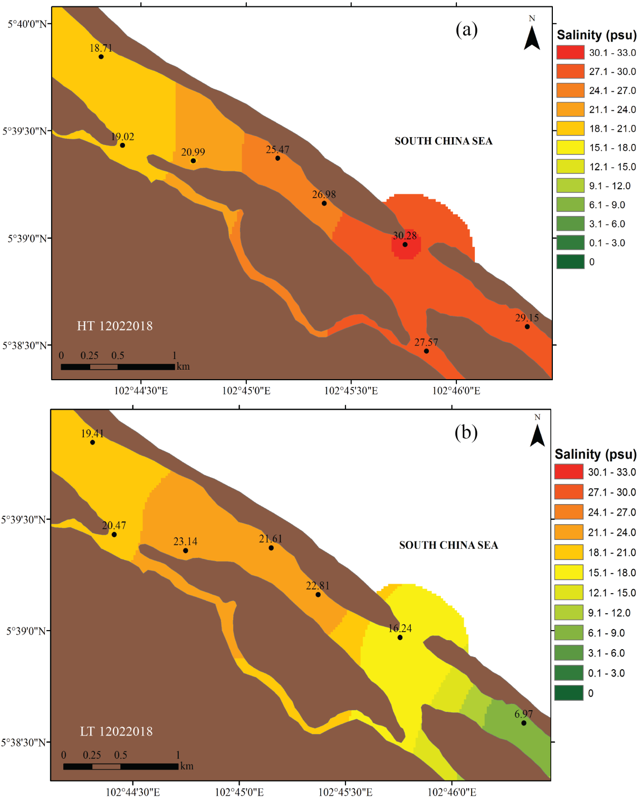
Figure 7. Salinity distribution in Setiu Lagoon during (a) high and (b) low tides on 12 February 2018

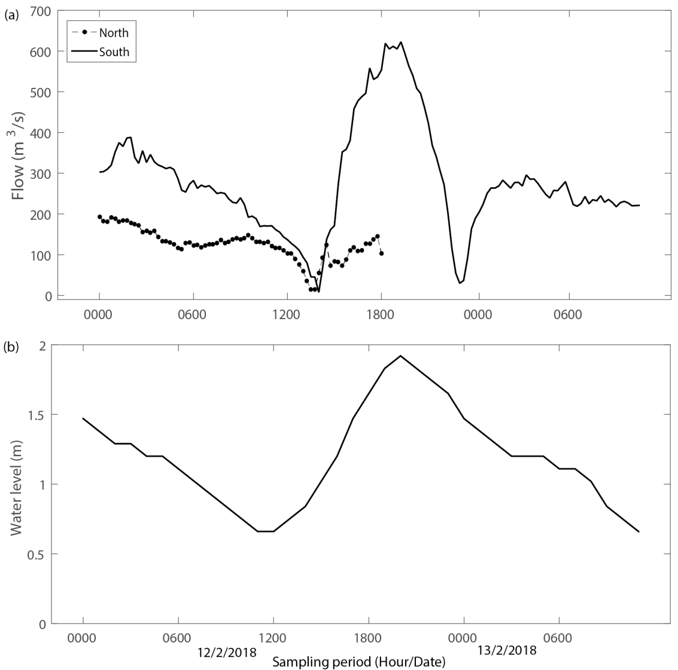

Figure 8. (a) Hourly flow at the north and south of inlet and (b) water level at Setiu Lagoon during 12-13 February 2018

Nutrients in the lagoon
The concentrations of nitrate, phosphate, ammonium, and silicate during southwest monsoon (August 2017), wet period of northeast monsoon (December 2017), and dry period of northeast monsoon (February 2018) are shown in Table 2. Surface nutrients were relatively high during the low tide compared to the high tide, which suggested that the major input of nutrients in Setiu Lagoon originated from the freshwater region. A similar observation was obtained by Bakar et al. [12], where mostly the lowest nutrient concentrations were found around the high tide, and the highest concentrations were found at the low tide, due to the increased nutrient input from inland river runoff. Inter-seasonally, higher surface nutrients were observed during the wet period of the northeast monsoon (December 2017) compared to the dry period of the northeast monsoon (February 2018) and the southwest monsoon (August 2017). This strengthens the fact that the main source of nutrients was coming from the land runoff, which flows into the lagoon through the rivers. Increased rainfall amount during the northeast monsoon, especially in December 2017 as documented in Table 1, is believed to be the main reason resulting in the supply of large river discharge, which brought along nutrients from land into the lagoon.

Few studies have acknowledged heavy rainfalls as the responsible factor that leads to the wash out of large amounts of terrestrial organic matter into the rivers, resulting in increased nutrient input in the lagoon [21, 22, 23]. Furthermore, higher nutrient concentrations observed during the northeast monsoon compared to the southwest monsoon, were also believed to be associated with the unique feature of Setiu Lagoon, which is characterised to be a closed system with only an inlet that connects this area to the sea. Therefore, this unique feature may have caused high amounts of nutrients to be flushed from rivers and to be concentrated in the lagoon, since the water movement and exchange flow was restricted [24]. In an evaluation with the Malaysia Marine Water Quality Criteria and Standards (MWQCS; Table 3), the mean concentrations of ammonium (42 µg/L) and nitrate (30 µg/L) in Setiu Lagoon were found to be in Class 2, which represents suitability for marine life, fisheries, coral reefs, recreational activities, and mariculture. On the other hand, the mean phosphate concentration (5 µg/L) in this study was found to be in Class 1, which represents areas that are for preservation, marine protected areas, and marine parks (Table 3).

Table 2. Mean (±SD) of surface nutrient concentrations during the study
Parameter | Tidal range | August 2017 | December 2017 | February 2018
Nitrate (µg/L) | HT | 11.26 ± 6.99 | 38.16 ± 17.88 | 14.82 ± 10.95
Nitrate (µg/L) | LT | 26.27 ± 19.12 | 55.19 ± 34.76 | 35.34 ± 26.58
Phosphate (µg/L) | HT | 4.01 ± 1.38 | 3.51 ± 1.67 | 4.62 ± 2.12
Phosphate (µg/L) | LT | 3.46 ± 1.91 | 6.09 ± 2.18 | 9.46 ± 7.00
Ammonium (µg/L) | HT | 34.76 ± 13.59 | 52.00 ±17.82 | 10.47 ± 5.33
Ammonium (µg/L) | LT | 66.50 ± 40.43 | 62.71 ± 24.23 | 23.96 ± 16.60
Silicate (µg/L) | HT | 646.80 ± 391.43 | 1519.34 ± 693.23 | 1493.67 ± 546.56
Silicate (µg/L) | LT | 1804.05 ± 571.04 | 2312.44 ± 446.94 | 2927.94 ± 1978.15

Table 3. Marine Water Quality Criteria and Standard (MWQCS) for Malaysia
Parameter (µg/L) | Class
Parameter (µg/L) | 1 | 2 | 3 | E
Ammonia | 35 | 70 | 320 | 70
Nitrate | 10 | 60 | 1000 | 60
Phosphate | 5 | 75 | 670 | 75
Beneficial uses
Class 1 | Preservation, marine protected area, marine parks
Class 2 | Marine life, fisheries, coral reefs, recreational, and mariculture
Class 3 | Ports, oil & gas fields
Class E | Mangroves, estuarine & river-mouth water

Phytoplankton biomass in the lagoon
Chlorophyll a is an indicator of biological activity, whose surface concentrations during August 2017, December 2017, and February 2018 are presented in Figures 9 – 11. During August 2017, the chlorophyll a concentration during the high tide was slightly low, with an average value of 0.63 mg/L compared to the concentrations during the low tide (average value of 0.78 mg/L; Figure 9). A similar observation was made by Shamsudin and Ambak [25], where a lower rate of photosynthetic values were documented at Sungai Ibai Estuary, Terengganu during high tide compared to low tide. Besides this, Krumme et al. [21] suggested that sufficient light and reduced current flow during spring tides enhanced phytoplankton activity, especially during late ebb tides in the afternoon. This statement coincided well with the timing of our first field sampling (1510 – 1610 hours), where the flows were slightly slow (Figure 3a) and high solar radiation was observed.

During December 2017, chlorophyll a concentrations were highly variable during the high tide, ranging from 0.38 – 3.85 mg/L, while during the low tide it was within the range of 0.19 – 1.31 mg/L (Figure 10). This shows that the concentrations of chlorophyll a during the high tide were generally high compared to the low tide, with an average difference of 1.06 mg/L. During the low tide, it was believed that freshwater outflow from the rivers had lead to the dilution of the chlorophyll a concentrations during the sampling trip (0930 – 1010 hours), as documented in the flow rate of the lagoon (Figure 6a). On top of that, the chlorophyll a distribution pattern during February 2018 was relatable to December 2017, where the concentrations during the high tide (average of 2.75 mg/L) were slightly high than those during the low tide (average of 1.83 mg/L; Figure 11). Low chlorophyll a concentrations as a result of the dilution factor were also observed in the Merbok Estuary, Kedah, Malaysia, where increased water mixing and tidal flushing diminished the bloom, resulting in low phytoplankton biomass [26].

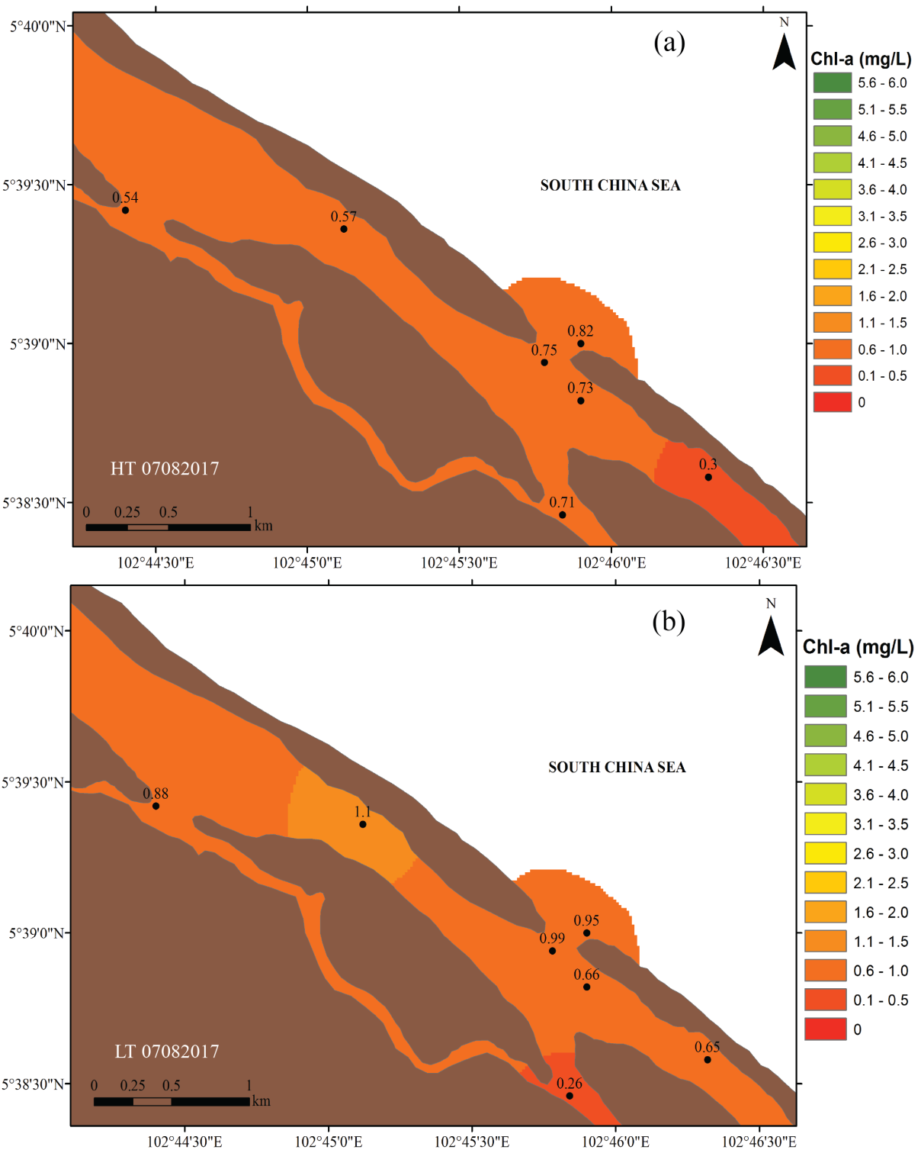

Figure 9. Chlorophyll a distribution in Setiu Lagoon during (a) high and (b) low tides on 7 August 2017

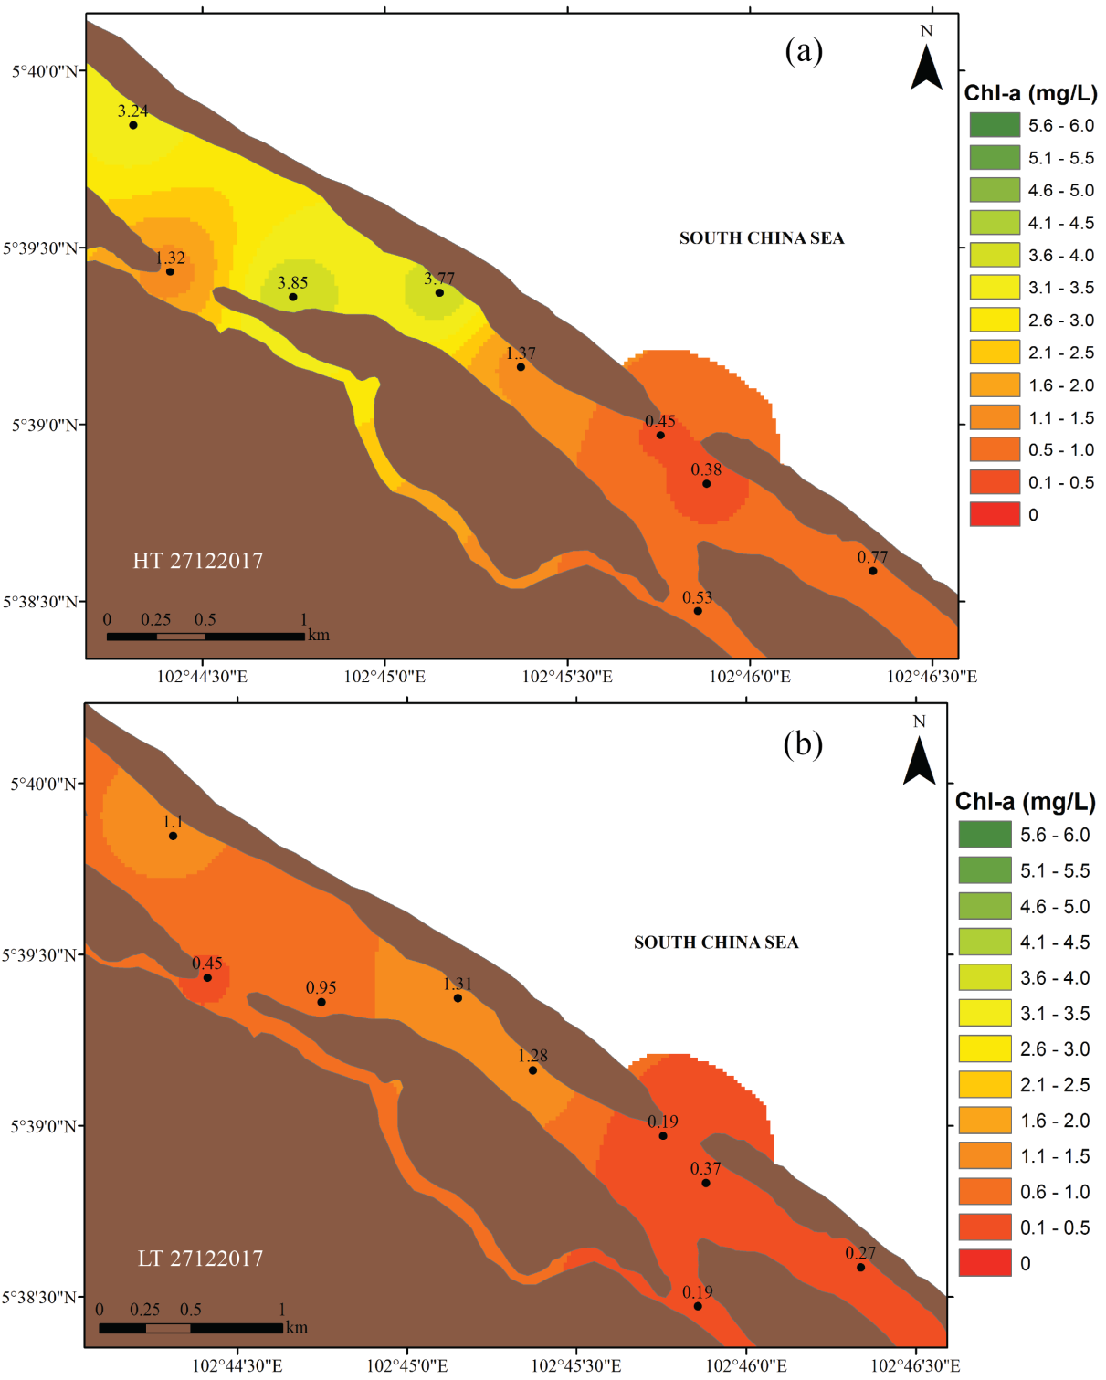

Figure 10. Chlorophyll a distribution in Setiu Lagoon during (a) high and (b) low tides on 27 December 2017

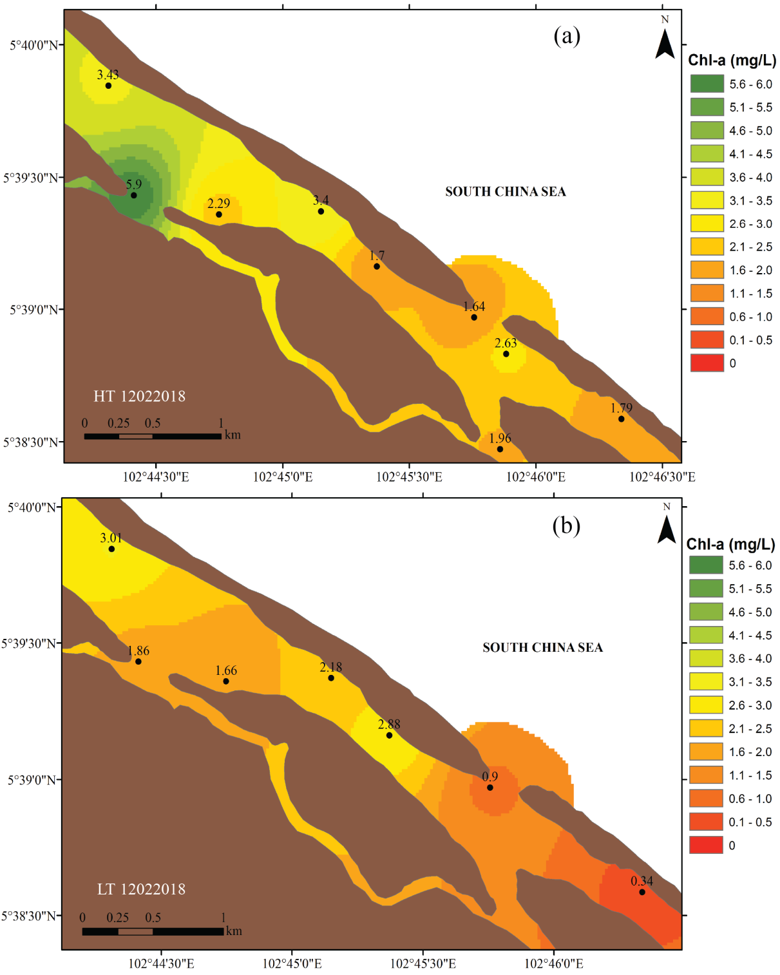

Figure 11. Chlorophyll a distribution in Setiu Lagoon during (a) high and (b) low tides on 12 February 2018
To confirm the main influencing parameter affecting the phytoplankton biomass in Setiu Lagoon, the R² was calculated and tabulated in Table 4. During the high tide of August 2017, only nitrate showed slightly significant correlation with chlorophyll a (R² = 0.397). On the other hand, during the low tide of the same day, chlorophyll a was significantly correlated with nitrate and ammonium, with R² of 0.336 and 0.386 respectively. During the high tide of December 2017, a strong positive correlation was noted between chlorophyll a with salinity (R² = 0.837) and ammonium (R² = 0.657). Meanwhile, during the low tide, chlorophyll a was positively and significantly correlated to salinity (R² = 0.714) and phosphate (R² = 0.689). In February 2018, chlorophyll a was significantly correlated to salinity (R² = 0.557) and nitrate (R² = 0.370) during the high tide. During the low tide, chlorophyll a showed a strong postive correlation with all parameters.

Our study showed that the wet season freshwater flows of the northeast monsoon (December 2017) resulted in significantly high phytoplankton biomass. Therefore, it is believed that the phytoplankton in the study area are affected by the duration and magnitude of the freshwater flow and the nutrients supply. For example, despite having low salinities, the chlorophyll a concentrations in the study area were the highest during December 2017, which indicate that the high nutrients supply, which was as a result of heavy rainfall enhanced the phytoplankton growth [21]. Furthermore, a previous study by Suratman et al. [24] inferred that in Setiu Lagoon, large freshwater inputs as a results of heavy rainfall flushed the nutrients from land, which is surrounded by palm oil plantation and aquaculture activities.

Table 4. Correlation matrix (R²) for surface water quality parameters in Setiu Lagoon
Parameter |  | Chlorophyll a Concentrations
 |  | August 2017 |  | December 2017 |  | February 2018
 |  | HT | LT | HT | LT | HT | LT
Salinity | HT | 0.005 |  | 0.837 |  | 0.557
Salinity | LT |  | 0.110 |  | 0.714 |  | 0.576
Nitrate | HT | 0.397 |  | 0.202 |  | 0.370
Nitrate | LT |  | 0.336 |  | 0.068 |  | 0.704
Phosphate | HT | 0.093 |  | 0.104 |  | 0.036
Phosphate | LT |  | 0.002 |  | 0.689 |  | 0.336
Ammonium | HT | 0.061 |  | 0.657 |  | 0.125
Ammonium | LT |  | 0.386 |  | 0.261 |  | 0.872
Silicate | HT | 0.022 |  | 0.261 |  | 0.130
Silicate | LT |  | 0.212 |  | 0.200 |  | 0.652

Conclusion
Setiu Lagoon is a shallow, almost closed and tidally dominated system with a significant nutrient input from aquaculture and agriculture activities. The salinity, chlorophyll a, and nutrients varied between high and low tidal cycles. Patterns were site-specific and altered by freshwater discharges. Less saline water with high nutrients entered the lagoon through the rivers during the ebb tides. Somehow, increased rainfall manifested through the daily rainfall amount and strong flow, increased the freshwater discharges into the lagoon, which blocked the penetration of seawater. Furthermore, increased rainfall amount was also the causative factor that shaped the dynamics of the lagoon during the northeast monsoon. Large freshwater discharges into the lagoon as a result of heavy rainfall, brought along nutrients from terrestrial areas, which resulted in a high concentration of nutrients that enhanced the phytoplankton biomass. Referring to the Malaysia MWQCS scale, nutrients in Setiu Lagoon are classified under Classes 1 and 2, suggesting that aquaculture activities and conservation actions should take place concurrently.

Acknowledgement
The authors wish to thank the staff, especially Mr Roslan Latif and Mr Afifi Johari, from the Institute of Oceanography and Environment (INOS), Universiti Malaysia Terengganu, for their contribution in data collections of this research. This research was supported by the Tuanku Canselor Scholarship (BTC), Universiti Malaysia Terengganu and Higher Institution Centre of Excellence (HICoE) grant vote no. 66928 awarded to INOS.

References

- de Brito Jr., A. N., Fragoso Jr., C. R. and Larson, M. (2018). Tidal exchange in a choked coastal lagoon: A study of Mundaú Lagoon in northeastern Brazil. Regional Studies in Marine Science, 17: 133-142.
- Hemraj, D. A., Hossain, M. A., Ye, Q., Qin, J. G. and Leterme, S. C. (2017). Plankton bioindicators of environmental conditions in coastal lagoons. Estuarine, Coastal and Shelf Science, 184: 102-114.
- Haraguchi, L., Carstensen, J., Abreu, P. C. and Odebrecht, C. (2015). Long-term changes of the phytoplankton community and biomass in the subtropical shallow Patos Lagoon Estuary, Brazil. Estuarine, Coastal and Shelf Science, 162: 76-87.
- Brito, A. C., Newton, A., Tett, P. and Fernandes, T. F. (2012). How will shallow coastal lagoons respond to climate change? A modelling investigation. Estuarine, Coastal and Shelf Science, 112: 98-104.
- Pagano, M., Rodier, M., Guillaumot, C., Thomas, Y. and Henry, K. (2017). Ocean-lagoon water and plankton exchanges in a semi-closed pearl farming atoll lagoon (Ahe, Tuamotu archipelago, French Polynesia ). Estuarine, Coastal and Shelf Science, 191: 60-73.
- Mahanty, M. M., Mohanty, P. K., Pattnaik, A. K., Panda, U. S., Pradhan, S. and Samal, R. N. (2016). Hydrodynamics, temperature/salinity variability and residence time in the Chilika lagoon during dry and wet period: Measurement and modeling. Continental Shelf Research, 125: 28-43.
- Panda, U. S., Mahanty, M. M., Ranga Rao, V., Patra, S. and Mishra, P. (2015). Hydrodynamics and water quality in Chilika Lagoon-A modelling approach. Procedia Engineering, 116: 639-646.
- Suratman, S., Tahir, N. M. and Latif, M. T. (2012). A preliminary study of total petrogenic hydrocarbon distribution in Setiu Wetland, southern South China Sea (Malaysia). Bulletin of Environmental Contamination and Toxicology, 88: 755-758.
- Kasawani, I., Kim Asbiyallah Shah, A., Sulong, I., Mohd Hasmadi, I. and Kamaruzaman, J. (2010). Coastal change detection using GIS in Setiu Lagoon, Terengganu, Malaysia. Journal of GIS Trends, 1(1): 20-26.
- Ong, M. C., Kamaruzzaman, B. Y. and Joseph, B. (2009). Geochemical studies of Setiu lagoon, Terengganu, Malaysia. Malaysian Journal of Science, 28(2), 217-222.
- Suratman, S. and Latif, M. T. (2015). Reassessment of nutrient status in Setiu Wetland, Terengganu, Malaysia. Asian Journal of Chemistry, 27(1), 239–242.
- Bakar, N. H. A., Jusoh, A., Ahmad, M. F., Noor, M. J. M. M. and Norzilah, A. (2016). A spatial nutrient distribution due to seabass aquaculture activities at Setiu, Terengganu, Malaysia. Journal of Fisheries and Aquatic Science, 11: 332-348.
- Zainol, Z. and Akhir, M. F. (2016). Coastal upwelling at Terengganu and Pahang coastal waters: Interaction of hydrography, current circulation and phytoplankton biomass. Jurnal Teknologi, 78(8), 11-27.
- Culver, S. J., Leorri, E., Mallinson, D. J., Corbett, D. R. and Shazili, N. A. M. (2015). Recent coastal evolution and sea-level rise, Setiu Wetland, Peninsular Malaysia. Palaeogeography, Palaeoclimatology, Palaeoecology, 417: 406-421.
- Yaacob, R. and Mustapa, M. Z. (2010). Grain-size distribution and subsurface mapping at the Setiu wetlands, Setiu, Terengganu. Environmental Earth Sciences, 60: 975-984.
- Culver, S. J., Leorri, E., Corbett, D. R., Mallinson, D. J., Shazili, N. A. M., Mohammad, M. N. and Yaacob, R. (2013). Infaunal mangrove swamp foraminifera in the Setiu Wetland, Terengganu Malaysia. Journal of Foraminiferal Research, 43(3): 262-279.
- Culver, S. J., Mallinson, D. J., Corbett, D. R., Leorri, E., Rouf, A. A., Shazili, N. A. M. and Parham, P. R. (2012). Distribution of foraminifera in the Setiu estuary and lagoon, Terengganu, Malaysia. The Journal of Foraminiferal Research, 42(2): 109-133.
- APHA (2005). Standard Methods for the Examinations of Water and Wastewater (20th ed.). New York: American Public Health Association.
- U.S. Environmental Protection Agency. (1993). Methods for chemical analysis of water and wastes. Cincinnati, Ohio.
- Garrison, T. (2010). Oceanography: An invitation to marine science (7th edition). Yolanda Cossio.
- Krumme, U., Herbeck, L. S. and Wang, T. (2012). Tide- and rainfall-induced variations of physical and chemical parameters in a mangrove-depleted estuary of East Hainan (South China Sea). Marine Environmental Research, 82: 28-39.
- Cervantes-Duarte, R., Prego, R., López-López, S., Aguirre-Bahena, F. and Ospina-Alvarez, N. (2013). Annual patterns of nutrients and chlorophyll in a subtropical coastal lagoon under the upwelling influence (SW of Baja-California Peninsula). Estuarine, Coastal and Shelf Science, 120: 54-63.
- Suratman, S. and Aziz, A. A. (2017). Spatial and seasonal variations of organic carbon-based nutrients in Setiu Wetland , Malaysia. Sains Malaysiana, 46(6): 859-865.
- Suratman, S., Hussein, A. N. A. R., Mohd Tahir, N., Latif, M. T., Mostapa, R. and Weston, K. (2016). Seasonal and spatial variability of selected surface water quality parameters in Setiu Wetland, Terengganu, Malaysia. Sains Malaysiana, 45(4): 551-558.
- Shamsudin, L. and Ambak, M. A. (1983). The diurnal variation in photosynthetic values, inorganic nutrient contents and other environmental factors within a tidal cycle of Sungai Ibai, Trengganu. Pertanika, 6(2): 39-44.
- Wan Maznah, W. O., Rahmah, S., Chiew, C. L., Wang, P. L., Fatema, K. and Isa, M. (2016). Effects of tidal events on the water quality in the Merbok Estuary, Kedah, Malaysia. Tropical Ecology, 57(2): 213-229.

