THE COMBINED EFFECT OF ZINC AND pH ON GROWTH RATE AND CHLOROPHYLL CONTENT OF BROWN SEAWEED, Padina boryana

(Kesan Gabungan Zink dan pH ke Atas Kadar Pertumbuhan dan Kandungan Klorofil
Rumpai Laut Perang, Padina boryana)

Nabeela Ali Nasser Al-Awlaqi^{1*}, Noor Azhar Mohamed Shazili¹, Nurulnadia Mohd Yusoff²

¹Institute of Oceanography and Environment
²Faculty of Science and Marine Environment
Universiti Malaysia Terengganu,
21030 Kuala Nerus, Terengganu, Malaysia

*Corresponding author: Nabeela.awlaqi@gmail.com

Abstract
Brown seaweed, Padina boryana is found along the coast of Terengganu, Malaysia and may serve as a potential heavy metal biomonitor in the coastal zones. To better understand the impact of heavy metal pollution on P. boryana at varying seawater pH levels, the combined effect of zinc (Zn) and pH on its growth rate and chlorophyll content was investigated in laboratory exposures. After exposure for 21 days in a mixed treatment of 6 pH variations (4 to 9) and three Zn concentrations (30, 150, 300 ppb), maximum growth rate was observed in controlled treatments at pH 8 with no added Zn, whereas treatments at pH 4 and 9 showed negative growth rates after 18 days. The growth rate and chlorophyll content of P. boryana decreased significantly with an increase in Zn concentration. At pH 6, 7 and 8, P. boryana showed significant decreases (p < 0.05) in growth rates and chlorophyll content in all concentrations of Zn compared with control plants (no Zn). At pH of 6.0 and below, controls were also affected with significantly reduced growth rates and chlorophyll contents while Zn treated seaweed showed significant effects compared to these controls. The effect of pH and Zn on all measured factors was obvious on Day 6 onwards, whereas the interaction effect between them was significant on chlorophyll content throughout the experiment. From Day 9 onwards, the growth rate and chlorophyll content showed significant correlation among each other.

Keywords: brown seaweed, Padina boryana, zinc, pH, growth

Abstrak
Rumpai laut Perang, Padina boryana ditemui di sepanjang pantai Terengganu, Malaysia dan boleh menjadi biopemantauan logam berat yang berpotensi di kawasan pantai. Untuk lebih memahami kesan pencemaran logam berat terhadap P. boryana pada pH air laut yang berbeza, kesan gabungan zink (Zn) dan pH terhadap kadar pertumbuhan, kandungan klorofil telah disiasat dalam makmal. Selepas pendedahan selama 21 hari dalam rawatan campuran 6 variasi pH (4 hingga 9) dan tiga kepekatan Zn (30, 150, 300 ppb), kadar pertumbuhan maksimum diperhatikan dalam rawatan kawalan pada pH 8 tanpa tambahan Zn, manakala rawatan di pH 4 dan 9 menunjukkan kadar pertumbuhan negatif selepas 18 hari. Kadar pertumbuhan, kandungan klorofil P. boryana menurun dengan ketara dengan peningkatan kepekatan Zn. Pada pH 6, 7 dan 8, P. boryana menunjukkan penurunan ketara (p < 0.05) dalam kadar pertumbuhan, kandungan klorofil dalam semua kepekatan Zn berbanding dengan rawatan kawalan (tiada Zn). Pada pH 6.0 dan ke bawah, rumpai laut dalam rawatan kawalan juga terjejas dengan kadar pertumbuhan dan kandungan klorofil yang merosot manakala rumpai laut yang didedah kepada Zn menunjukkan kesan yang lebih ketara berbanding dengan rawatan kawalan. Kesan pH dan Zn terhadap semua faktor yang diukur adalah jelas pada hari ke-6 dan seterusnya, manakala kesan interaksi di antara mereka adalah signifikan terhadap kandungan klorofil di sepanjang eksperimen. Pada hari ke-9 dan seterusnya, kadar pertumbuhan dan kandungan klorofil menunjukkan korelasi yang signifikan antara satu sama lain.

Kata kunci: rumpai laut perang, Padina boryana, zink, pH, pertumbuhan

Introduction
With the advent of technology and industrialization, heavy metal pollution has become a pressing problem worldwide. Among the most common pollutants found in industrial effluents are zinc (Zn), lead (Pb), copper (Cu), cadmium (Cd) and nickel (Ni) [1]. Although some such as Zn and Cu are essential trace elements that are needed for human health, the concentrations of these naturally occurring elements are rising rapidly due to anthropogenic activities, including mining and shipping activities. Zn in particular could cause serious health problems on overexposure. Severe exposure to Zn could cause pancreatic damage, arteriosclerosis and respiratory disorders [2]. Additionally, the concentration of Zn could be bio-magnified up the food chain when it is absorbed by primary producers such as microalgae and macroalgae, and travels from fish to humans.

It has been proven that instead of directly measuring water samples, the use of bioindicators to assess marine pollution, particularly metal contamination in water columns, is more economical, in which high-sensitivity methods required for water analysis are not required and seasonal or spatial fluctuations in concentrations could be integrated [3]. Marine seaweeds have been used as bioindicators due to their various benefits and suitability, including their accessibility, presence at locations that are prone to pollution such as estuaries and coastal zones, and their benthic and hardy nature [3]. However, different seaweed species are known to exhibit different responses to varying Zn concentrations, with brown seaweeds of the genus Padina and Sargassum and the red seaweed Spyridia being more tolerant than green seaweed Ulva and Enteromorpha [4]. In a more detailed study, Sheng et al. [1] also reported that brown seaweeds (Padina sp. and Sargassum sp.) exhibited better metal removal abilities compared to green seaweed (Ulva sp.) and red seaweed (Gracillaria sp.), with both uptake capacity and affinity constants of Padina sp. and Sargassum sp. following the order Pb > Cu > Zn > Cd > Ni and Pb > Cu > Cd > Ni > Zn, respectively. Additionally, the release of heavy metals, including Zn, into water bodies is affected by pH, with increasing concentrations of metal released as pH is decreased [5]. As reported by Adams and Sanders [5], the threshold release pH for Zn-loaded sludge into water bodies is 5.8. However, no literature has reported on the combined effect of Zn and pH on the growth of P. boryana.

pH plays a crucial role in the growth of seaweed. Hence it has an impact on biochemical process of marine organisms [6]. It affects this growth in different ways such as alteration in the distribution of carbon dioxide species, availability of carbon [7] and, availability of trace metals and essential nutrients [8]. High pH levels can cause direct physiological changes [9].

As a native seaweed species in the coastal zones of Terengganu, Malaysia, P. boryana is found abundantly in shallow waters. The heavy metal contents of P. boryana from the coastal waters of the Gulf of Aden [10], the Persian Gulf [11] and the Suez Gulf [12] were previously assessed. The level of heavy metals, especially Zn, exceeded the maximum level allowed according to the Malaysian Food Act of 1983 in the tissue of oysters from Setiu Lagoon, Terengganu [13] whereas its level is still acceptable in several fish species from Mengabang Telipot and Paka estuary, Terengganu [14,15]. However, the specific effect of heavy metals on the growth of P. boryana is still unclear. Thus, the objective of the present study is to assess the combined effect of Zn and pH on growth rate and chlorophyll content of brown seaweed, P. boryana.

Materials and Methods
Sampling
Wild brown seaweed P. boryana were collected by hand in a depth of 0.5 m during low tide at Kuala Abang (N 4° 51’6.49’’ E 103° 24’ 11.36’’) off the coast of Terengganu, Malaysia (Figure 1). Samples were identified to the species level based on the taxonomic key provided by Geraldino et al. [16]. All collected seaweeds were of the same size (within the range of 8 cm from top to bottom) and had a normal healthy appearance, i.e. normal and evenly distributed green coloration. Only samples from clear distinct patches were collected to avoid collecting samples from the same individuals [17]. The collected samples were transported to the laboratory in 50 L seawater containers within 2 hours of collection. Studies have shown that due to several factors such as variability in growth rates, the analysis of different plant parts, plant age and collection location’s habitat, seaweeds collected from the same site might differ in their metal absorption properties [3, 18, 19]. Thus, to minimize such variations, only seaweeds of the same size and growth stage were collected from the same shore levels (habitat) at the same site.
The water quality parameters were recorded during each field trip [20]. Briefly, during each sampling trip, measurements of temperature, salinity, pH, total dissolved solids (TDS), and dissolved oxygen (DO) were taken using YSI, 556 MPS (YSI Inc, Ohio, USA).

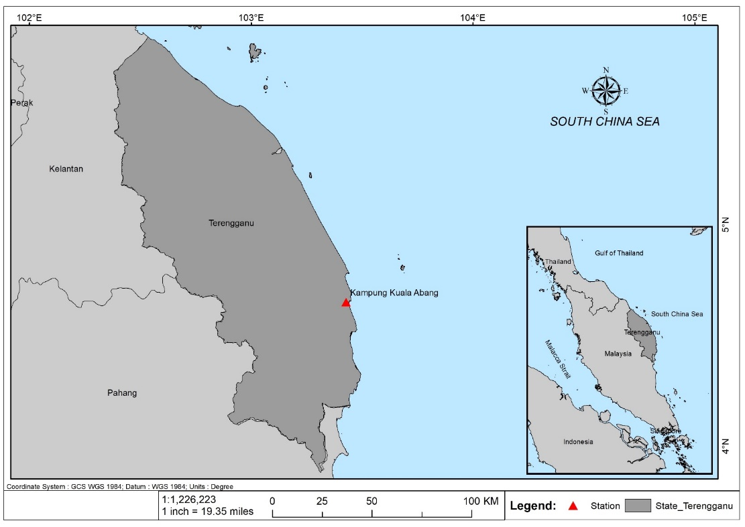
Figure 1. Map illustrating the Terengganu coast and the location of sample collection
Experimental setup
All samples were divided into sixty 1 L transparent aquarium tanks with each tank holding approximately 14 g of thalli, i.e. holdfast, stipe and blades. The shared culture parameters were: artificial seawater with water salinity of 33 ppt, room temperature, photoperiod of 12/12 hours dark/light (illumination of 120 μmol photons m⁻²s⁻¹) [21, 22]. The cultures were continuous aeration (supplied with sterilized dry air (97%) and CO₂ (97:3, % v/v) [21]. Samples were cultured in six pH levels, i.e. pH 4, 5, 6, 7, 8 and 9. pH was adjusted by the addition of HNO₃ or KOH. Furthermore, there were three varying Zn concentrations ((30, 150 and 300 ppb (there concentrations are 10, 50 and 100 times, the measured Zn concentration in seawater from the study sites 2.96±1.57 µg L⁻¹)) within each pH level. Each treatment was conducted in triplicate and a treatment without addition of Zn was considered as control. Zn was prepared from zinc sulphate heptahydrate (ZnSO₄.7H₂O). Seawater renewal was conducted every three days. The whole experiment was carried out for a period of 21 days [23].

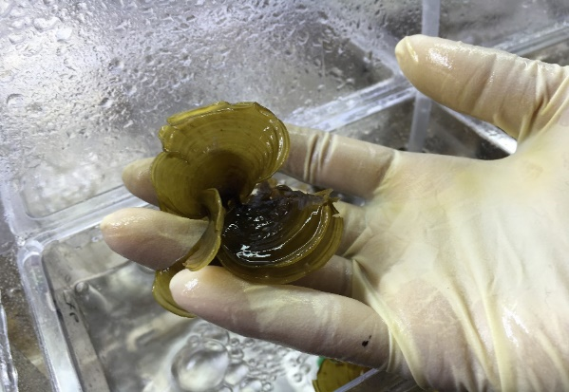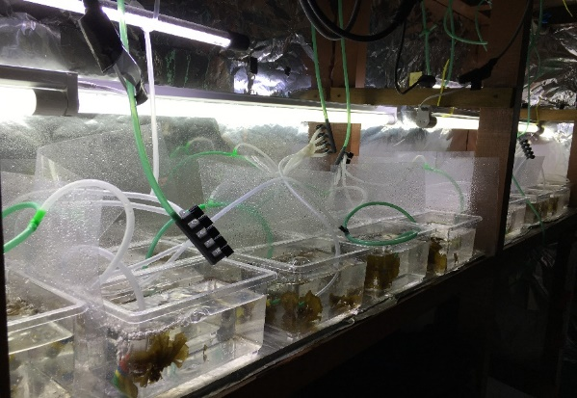

Figure 2. Experimental setup of P. boryana treatments

Growth rate, chlorophyll content and photosynthesis activity
The weight of each thallus was recorded every three days [23]. Prior to weighing, the samples were gently blotted using filter papers to remove excess water retained on their surfaces. The calculation of growth rate is as follows:

$Growth rate \left(\%\right)=100×\frac{ln\frac{W_{t}}{W_{0}}}{t}$ (1)

where W₀ is the initial biomass (mg) and W_{t} is the biomass (mg) after t days [23, 24].

Chlorophyll content was determined based on the method of Liu et al. [25]. Briefly, the chlorophyll levels of P. boryana were determined by taking six readings for each leaf using a Chlorophyll Meter SPAD-502 (Minolta Corporation, NJ, USA), and the average value for treatment was used in the following equation 2:

Y=X0.996-1.52

where Y is the chlorophyll concentration and X is the SPAD-502 chlorophyll readings (µg cm⁻²).

Statistical analysis
All statistical analyses were conducted using SPSS version 23. All data was tested for normality. Two-way analysis of variance (ANOVA) was used to test for any significant differences among treatments. To understand the effect of pH and Zn concentrations on three different dependent factors (growth rate and chlorophyll content) at any given time interval, general linear model was used. Post-hoc Tukey’s test was carried out if significant differences among treatments were observed. Pearson’s correlation was used to determine if growth rate and chlorophyll content correlate among each other at different time intervals.

Results and Discussion
Growth rate and chlorophyll content comparison based on pH: Treatment at pH 4
The introduction of Zn in treatment at pH 4 had significant effects on all measured parameters. The growth rate of P. boryana decreased with increasing Zn concentration (Figure 3a). As for chlorophyll concentration, treatments with 150 ppb and 300 ppb Zn were lower than that of 30 ppb Zn and control groups, starting day 9 onwards (Figure 3b).

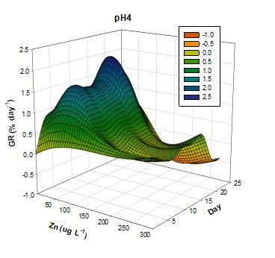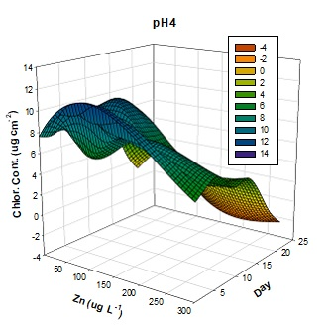
Figure 3. The (a) growth rate (GR, %), and (b) chlorophyll content of P. boryana cultured for 21 days at pH 4
(a)
(b)
Treatment at pH 5
At pH 5, the growth rate of P. boryana in all treatments and control showed positive values, with control showing the highest growth rate, followed by Zn with increasing concentrations (Figure 4a). The pattern of chlorophyll content which was observed in treatments at pH 5, was similar to those in pH 4, where P. boryana cultured in Zn with 30 ppb and control were of higher chlorophyll contents compared to those cultured in Zn with 150 ppb and 300 ppb, starting from day 6 onwards (Figure 4b).

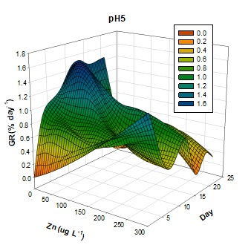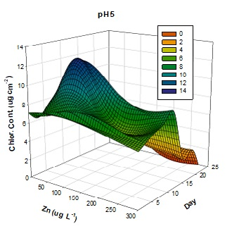
(a)
(b)
Figure 4. The (a) growth rate (GR, %), and (b) chlorophyll content of P. boryana cultured for 21 days at pH 5

Treatment at pH 6
At pH 6, only the growth rate of the control showed increasing values, whereas that of treatments with various concentrations of Zn increased slightly until half of the culture period and decreased towards the end, with decreasing growth rate values with increasing Zn concentrations (Figure 5a). The chlorophyll content was well above 5 μg cm⁻² for all treatments, except treatments with 150 ppb and 300 ppb Zn which dropped below 5 μg cm⁻² after 18 days (Figure 5b).

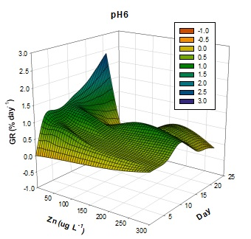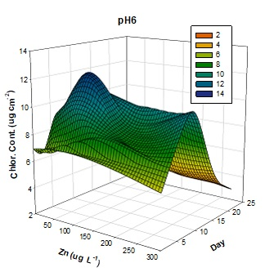
(a)
(b)
Figure 5. The (a) growth rate (GR, %), and (b) chlorophyll content of P. boryana cultured for 21 days at pH 6

Treatment at pH 7
The growth rates of P. boryana in treatments at pH 7 showed similar trends as those in pH 6, with only the control exhibiting a positive increase in growth rate (Figure 6a). The chlorophyll content values were the highest in control at the end of the experiment, whereas treatments showed decreasing values in chlorophyll content values with increasing Zn concentrations (Figure 6b).

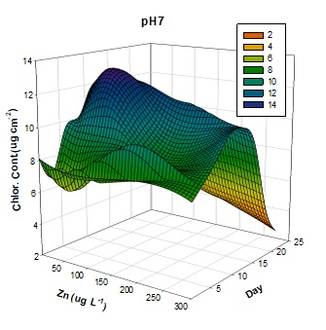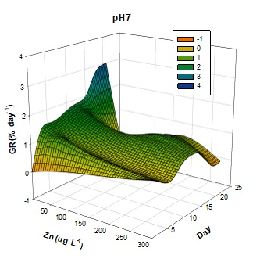
(a)
(b)
Figure 6. The (a) growth rate (GR, %), and (b) chlorophyll content of P. boryana cultured for 21 days at pH 7

Treatment at pH 8
The growth rates, and chlorophyll content values in treatments at pH 8 were similar to that of pH 7, with chlorophyll content production significantly reduced from Day 6 onwards (Figure 7).

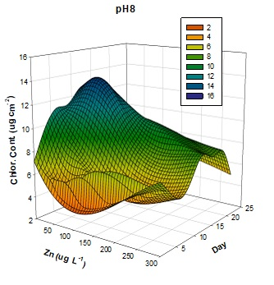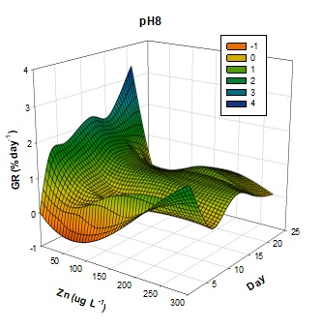
Figure 7. The (a) growth rate (GR, %), and (b) chlorophyll content of P. boryana cultured for 21 days at pH 8
(a)
(b)
Treatment at pH 9
Significant decreases in values of growth rate (Figure 8a) were observed in treatments with 150 ppb and 300 ppb Zn from Day 6 onwards. Chlorophyll content reduced significantly from Day 9 onwards in treatments with 300 ppb Zn (Figure 8b).

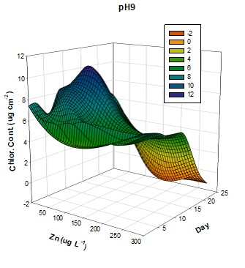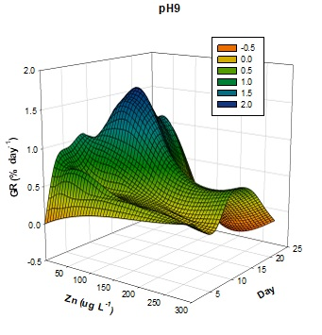
(a)
(b)
Figure 8. The (a) growth rate (GR, %), and (b) chlorophyll content of P. boryana cultured for 21 days at pH 9

Combined effect of Zn and pH
At 3 days of exposure, pH and Zn had no significant effect on the growth rate, but both influenced the chlorophyll content of P. boryana, and their interaction effect was also significant (Table 1). Zn at concentration of 150 ppb and pH between 4-7 showed significantly higher chlorophyll content (Figure 9).

Table 1. The General linear model analysis of pH and Zn concentration on two dependent factors (growth rate and chlorophyll content). Significance level was at p < 0.05.
 | Growth Rate and Chlorophyll Content | Day 3 | Day 6 | Day 9 | Day 12 | Day 15 | Day 18 | Day 21
 | Growth Rate and Chlorophyll Content | P value
pH | Growth rate  Chlorophyll content | 0.570  0.001 | 0.001  0.001 | 0.001  0.001 | 0.001  0.001 | 0.001  0.001 | 0.001  0.001 | 0.001  0.001
Zn | Growth rate  Chlorophyll content | 0.915  0.001 | 0.117  0.001 | 0.001  0.001 | 0.001  0.001 | 0.001  0.001 | 0.001  0.001 | 0.001  0.001
pH × Zn | Growth rate  Chlorophyll content | 0.885  0.001 | 0.693  0.001 | 0.558  0.001 | 0.048  0.001 | 0.001  0.001 | 0.001  0.001 | 0.015  0.001

On Day 6, pH and Zn significantly affected all dependent factors except Zn on growth rate. The interaction effect of pH × Zn was significant in influencing the chlorophyll content (Table 1). Growth rate of P. boryana increased to a maximum at 8 before dropping drastically to its lowest at pH 9. Similarly, low chlorophyll content was recorded at pH 9, although it peaked at pH 7. Lowest Zn concentration of 30 ppb showed the highest chlorophyll content (Figure 9).

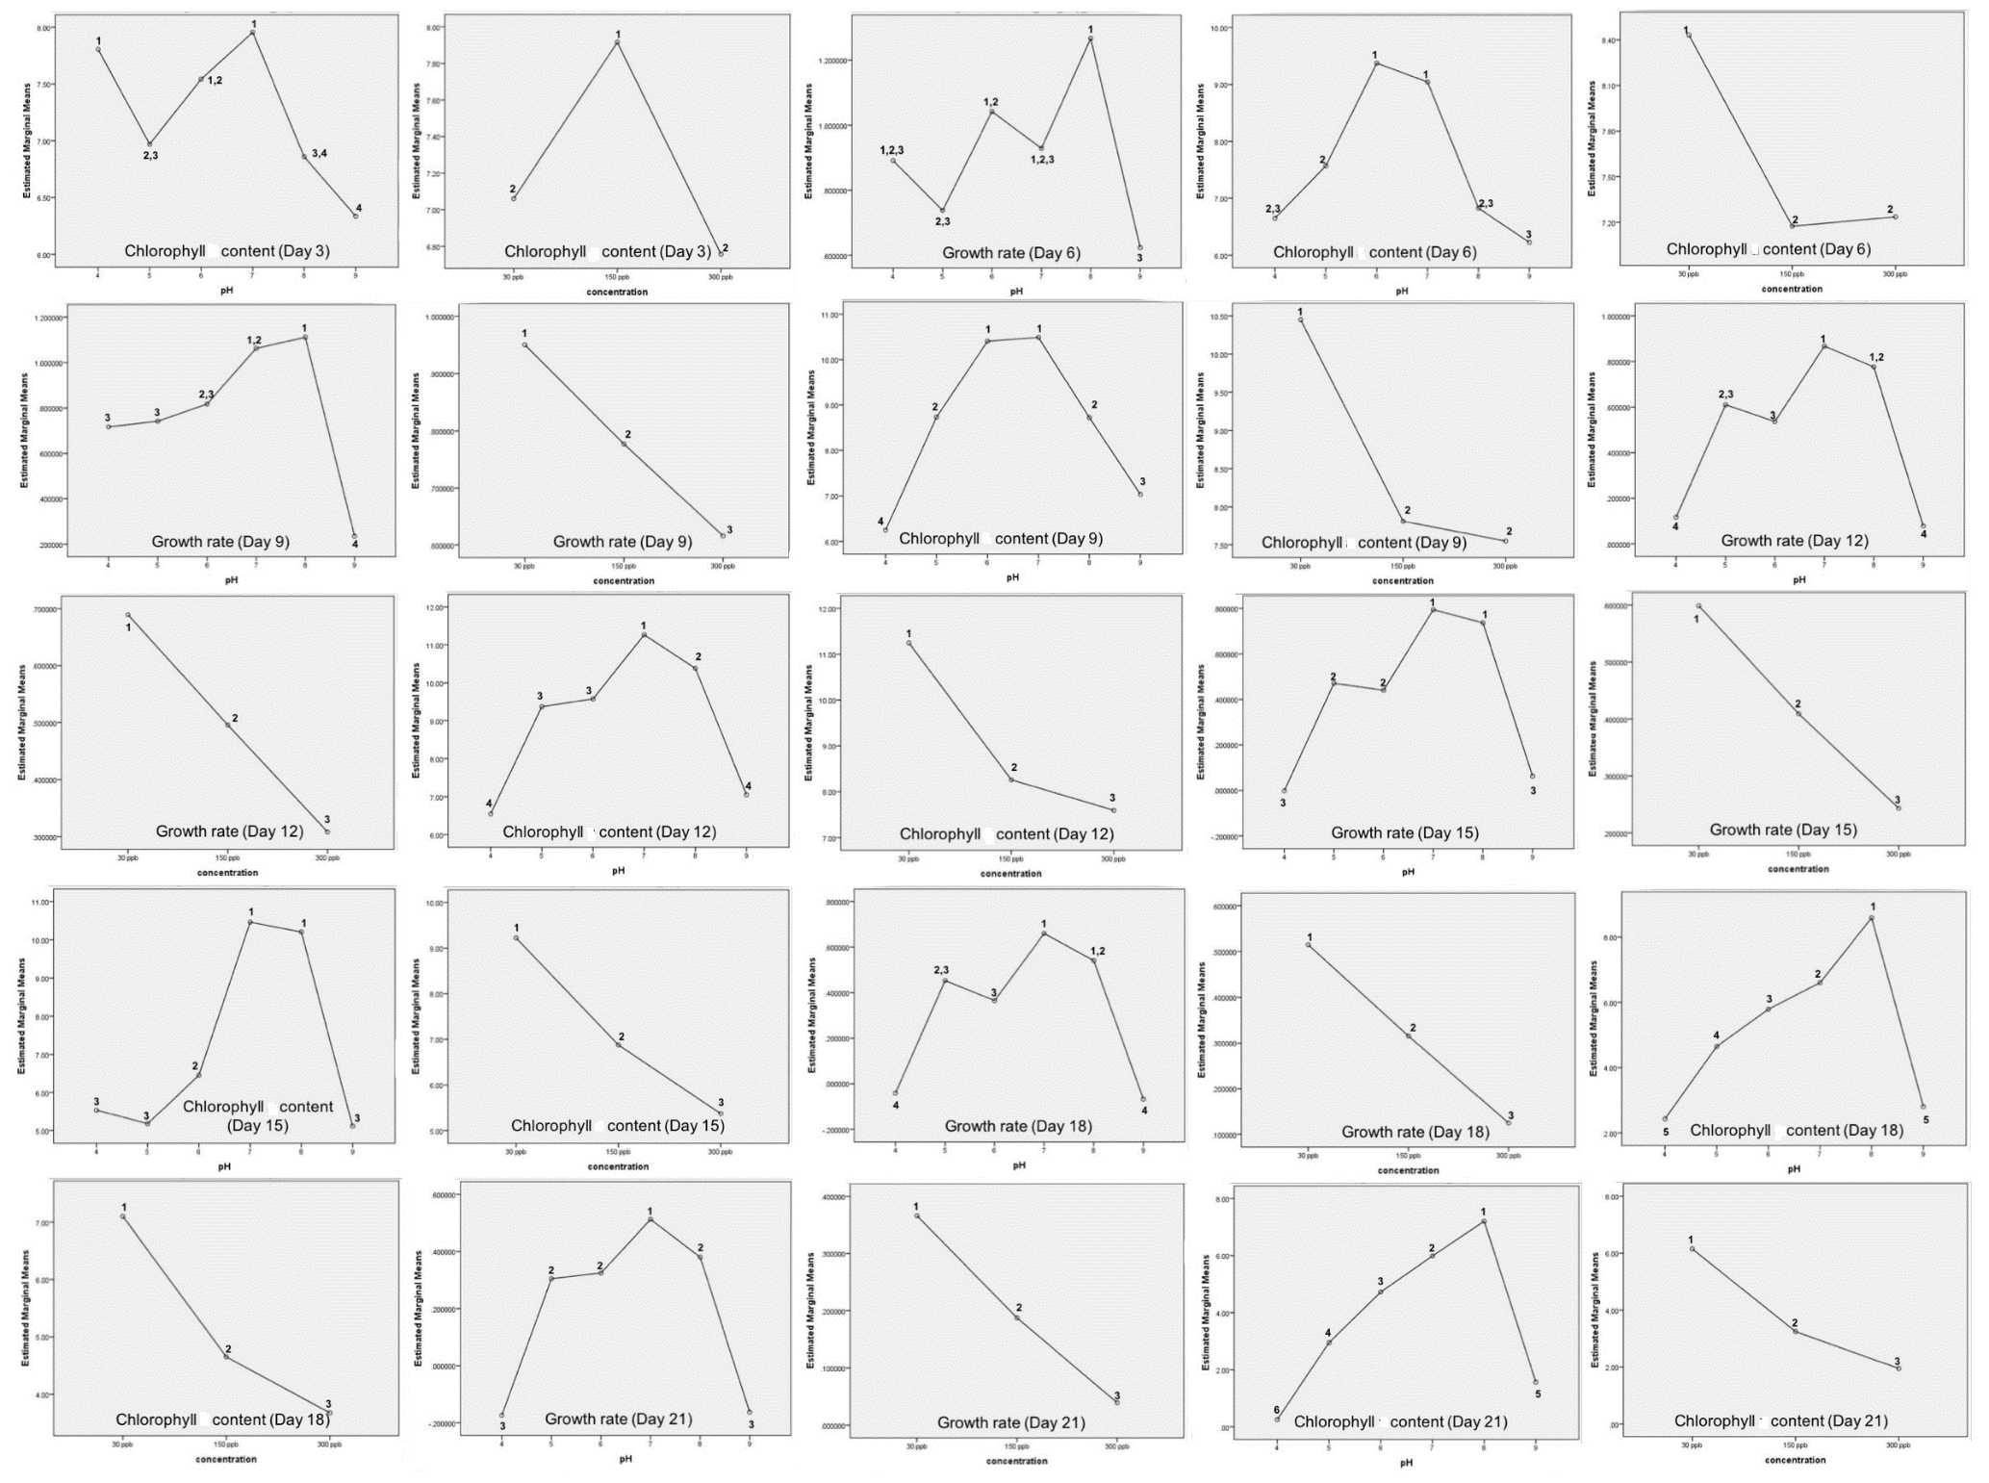
Figure 9. The effect of pH and Zn concentration on the estimated marginal means of growth rate and chlorophyll content at different day period. Different numberings on one figure indicates significant difference (p < 0.05)

From Day 9 onwards, the effect of pH and Zn concentrations on the growth rate and chlorophyll content of P. boryana were almost similar: pH and Zn concentrations significantly affected all two dependent factors (Table 1). Similarly, the interaction between pH and Zn had affected the growth rate and the chlorophyll content of P. boryana on Day 12 onwards. Overall, pH 8 and Zn concentration of 50 ppb were the best conditions for P. boryana’s growth, as measured by growth rate and chlorophyll content (Figure 9).

Correlation among growth rate and chlorophyll content
At 3 days’ post exposure to a combination of various pH and Zn concentration treatments, no significant correlation was found among growth rate and chlorophyll content of P. boryana (all p > 0.05). On Day 6, chlorophyll content and growth rate were significantly correlated (r = 0.51, p < 0.001). On Day 9 onwards, growth rate and chlorophyll content showed significant correlation among each other (all p < 0.05).

Overall, results in this study showed that the growth rate, and chlorophyll content of P. boryana decreased significantly with the increase in Zn concentration and at increasing acidity levels (pH 6, 5 and 4), as well as at a high pH level (pH 9). The detrimental effects of lower pH on P. boryana are expected as decrease in water pH is known to adversely affect the growth, development and reproduction of seaweeds. For example, red seaweed Gracilaria secundata and Kappaphycus alvarezii exhibited bell-shaped growth curves from pH 7.0 to 9.0 which peaked at 8.2, and from pH 6.0 to 9.0 which peaked at 8.4, respectively [26, 27]. Similarly, higher growth rates were observed in juvenile coralline alga Arthrocardia corymbose maintained under pH 8.05 compared to those under pH 7.65 [28]. Also, Roleda et al. [29] reported that lowered pH (7.59-7.60) significantly reduced the germination process of giant kelp Macrocystis pyrifera.

The pH range for most seaweed cultures is recommended to be in between 7 and 9, although the optimum range is narrowly between 8.2-8.7 [27]. Normal seawater is of slightly alkaline nature, with a pH of approximately 8.07, of which a huge portion (91%) is made up of total dissolved inorganic carbon, and the rest are carbonate ions (8%) and dissolved CO₂ (1%) [29]. Any fluctuation in the pH of seawater may disrupt the equilibrium of the carbonate system and alter the percentage of inorganic carbon species, thereby negatively affecting the growth of carbon-depending photosynthetic seaweeds [30]. At pH above 8.5, the photosynthetic activity of seaweeds was reported to decline rapidly due to the reduction in dissolved CO₂ and carbonate ions’ concentrations [31]. This explains the zero growth of P. boryana in both treatments of pH 4 and 9 after 18 days, as these extreme pHs disrupted their normal physiological and growth processes. Such zero growth was also reported in the adult algae A. corymbose maintained at lower pH 7.65 [28].

The growth rates of P. boryana were adversely affected when they were exposed to Zn from 30 to 300 ppb at all pH levels, except in treatments with 30 ppb Zn which showed slightly stimulated algal growth at pH 4 and pH 9. The feasibility of P. boryana to survive and in treatments with varying Zn concentrations and pH levels are expected as they are the more tolerant seaweed species compared to others [4]. Their higher tolerant characteristics towards adverse conditions might be contributed to the high polysaccharide content in their cell walls. Using analytical electron microscopy techniques, Amado Filho et al. [32] found that Zn was present as dense granules along cell walls but absent in the cytoplasm, indicating that cell walls play a major role in the Zn accumulation in Padina sp. In addition to this, Zn deficiency is known to reduce the chlorophyll content and adversely affect plant growth, whereas an excess in Zn concentration could be toxic to plant and damage the plant’s metabolism [33]. Thus, the reduced performance in terms of growth rates and chlorophyll content when P. boryana was exposed to increasing concentrations of Zn suggests that Zn might alter the permeability of the cell membrane, leading to a sharp reduction in potassium and sodium content of the cell. This eventually inhibits photosynthesis and nitrogen fixation, and ultimately affects cell multiplication. The adverse effects of increasing Zn concentration on the growth rate were also reported in another important bio-monitor species, the microalgae [34].

The combined effect of pH and Zn on chlorophyll content of P. boryana was highlighted in the results of our study, where significant interaction effect of pH and Zn on chlorophyll content was observed throughout the 21-days treatment period (Table 2). Additionally, the growth rate of P. boryana was also affected by the interaction effect between pH and Zn from Day 12 onwards. Thus, when heavy metal accumulation is high (resulting in acidic pH), the growth rate and chlorophyll content of P. boryana will be greatly affected, with a greater effect observed at lower pH and/or higher heavy metal concentrations [18, 31]. Apart from pH, it is well known that correlation also exists among heavy metals. For example, Fe concentrations in seaweeds of Marsa-Matrouh beaches, Egyptian Mediterranean Sea were positively correlated with Cu and Pb, but negatively correlated between Cu and Ni, Pb and Zn [35].

The ability of the cells to accumulate Zn is important since algae are a major vector for transferring the metal from the abiotic environment into food webs. In the natural environment, red algae exhibit higher Zn accumulation properties compared to green and brown algae [3]. The variation among species of Rhodophyta, however, was large [3]. As shown in another brown seaweed species, Laminaria digitata, once Zn is absorbed from the aquatic environment, it shows little tendency to be lost from the plant [35]. Additionally, it was reported that the growing region above the stipe of L. digitata exhibited significantly higher Zn absorption compared to the more distal part of the lamina (slower growing region) [36]. Furthermore, Munda [37] showed that the accumulation of heavy metals is higher in vegetative parts of the thalli than in receptacles of brown seaweed Fucus spiralis. Thus, although this study showed that the increasing concentration of Zn negatively affects the growth and chlorophyll content of P. boryana, future studies on the retention of accumulated Zn and the different absorption capabilities of various plant parts and growth stages are recommended, if P. boryana is to be used in heavy metal biomonitoring in Terengganu coastal waters.

Conclusion
This study provides useful data on Zn tolerance and effect of Zn on the growth and chlorophyll content of P. boryana, a seaweed species that could serve as a suitable bioindicator along the coasts of Terengganu. While the adverse effects of extreme pH and high Zn concentrations is observed, the ability of P. boryana to survive these treatments highlights the sturdiness of this species and its potential in future heavy metal biomonitoring. Additional research regarding the effect of other heavy metals on the growth of P. boryana is recommended to better understand its metal accumulation ability and coping mechanism towards various heavy metal exposures. Future research should also look into the effect of pH fluctuations on the growth of P. boryana, as ocean acidification is a growing concern, especially in coastal zones.

Acknowledgement
This study was supported by the Ministry of Education Higher Institution Centre of Excellence Grant (Vote No. 66928). We would like to thank the staff of the Institute of Tropical Aquaculture (AKUATROP), Universiti Malaysia Terengganu for technical support provided throughout the study.

References

- Sheng, P. X., Ting, Y.-P., Chen, J. P. and Hong, L. (2004). Sorption of lead, copper, cadmium, zinc and nickel by marine algal biomass: characterization of biosorptive capacity and investigation of mechanisms. Journal of Colloid and Interface Science, 275: 131-141.
- Plum, L. M., Rink, L. and Haase, H. (2010). The essential toxin: Impact of Zinc on human health. International Journal of Environmental Research and Public Health, 7(4): 1342-1365.
- Stengel, D. B., Macken, A., Morrison, L. and Morley, N. (2004). Zinc concentrations in marine macroalgae and a lichen from western Ireland in relation to phylogenetic grouping, habitat and morphology. Marine Pollution Bulletin, 48: 902-909.
- Amado Filho, G. M., Karez, C. S., Andrade, L. R., Yoneshigue-Valentin, Y. and Pfeiffer, W. C. (1997). Effects on growth and accumulation of zinc in six seaweed species. Ecotoxicology and Environmental Safety, 37: 223-228.
- Adams, T. Mc. and Sanders, J. R. (1984). The effect of pH on the release to solution of zinc, copper and nickel from metal-loaded sewage sludges. Environmental Pollution Series B, Chemical and Physical, 8(2): 85 – 99.
- Visviki, I. and Palladino, J. (2001). Growth and cytology of Chlamydomonas acidophila under acidic stress. Bulletin of Environmental Contamination and Toxicology, 66(5): 623-630.
- Fabry, V. J., Seibel, B. A., Feely, R. A. and Orr, J. C. (2008). Impacts of ocean acidification on marine fauna and ecosystem processes. ICES Journal of Marine Science, 65(3): 414-432.
- Gensemer, R. W., Smith, R. E. and Duthie, H. C. (1993). Comparative effects of pH and aluminum on silica-limited growth and nutrient uptake in Aastrionella ralfsii var americana (Bacillariophyceae) 1. Journal of Phycology, 29(1): 36-44.
- Hansen, P. J. (2002). Effect of high pH on the growth and survival of marine phytoplankton: implications for species succession. Aquatic Microbial Ecology, 28(3): 279-288.
- Al-Shwafi, N. A. and Rushdi, A. I. (2008). Heavy metal concentrations in marine green, brown, and red seaweeds from coastal waters of Yemen, the Gulf of Aden. Environmental Geology, 55(3): 653-660.
- Faedeh, A., Hossein, R. and Hossein, Z. (2013). Metal concentrations in Padina species and associated sediment from Nayband Bay and Bostaneh Port, Northern Coast of the Persian Gulf, Iran. Journal of the Persian Gulf, 4(11): 17-24.
- Mohamedein, L. I., El-Moselhy, K., Diab, A. A. and Tolba, M. R. (1999). Levels of some heavy metals in coastal water, sediment and the Limpet Patella sp. from the northern part of the Suez Gulf (Suez Bay). Egyptian Journal of Aquatic Research, 3(2): 69-84.
- Azlisham, M., Vedamanikam, V. J. and Shazili, N. A. M. (2009). Concentrations of cadmium, manganese, copper, zinc, and lead in the tissues of the oyster (Crassostrea iredalei) obtained from Setiu Lagoon, Terengganu, Malaysia. Toxicological and Environmental Chemistry, 91(2): 251-258.
- Kamaruzzaman, Y., Ong, M. C. and Jalal, K. C. A. (2008). Levels of copper, zinc and lead in fishes of Mengabang Telipot River, Terengganu, Malaysia. Journal of Biological Sciences, 8(7): 1181-1186.
- Kamaruzzaman, Y., Zaleha, K., Ong, M. C. and Willison, K. (2007). Copper and zinc in three dominant brackish water fish species from Paka estuary, Terengganu, Malaysia. Malaysian Journal of Science, 26(2): 65 – 70.
- Geraldino, P. J. L., Liao, L. M. and Boo, S. M. (2005). Morphological study of the marine algal genus Padina (Dictyotales, Phaephyceae) from Southern Philippines: 3 species new to Philippines. Algae, 20(2): 99-112.
- Wichachucherd, B., Prathep, A. and Zuccarello, G. C. (2014). Phylogeography of Padina boryana (Dictyotales, Phaeophyceae) around the Thai-Malay Peninsula. European Journal of Phycology, 49(3): 313-323.
- Bryan, G. W. and Hummerstone, L. G. (1973). Brown seaweeds as an indicator of heavy metals in estuaries in southwest England. Journal of the Marine Biological Association of the United Kingdom, 53: 705-720.
- Stengel, D. B. and Dring, M. J. (2000). Copper and iron concentrations in Ascophyllum nodosum (Fucales, Phaeophyta) from different sites in Ireland and after culture experiments in relation to thallus age and epiphytism. Journal of Experimental Marine Biology and Ecology, 246: 145-161.
- Qadir, A., Malik, R. N. and Husain, S. Z. (2008). Spatio-temporal variations in water quality of Nullah Aik-tributary of the river Chenab, Pakistan. Environmental Monitoring and Assessment, 140(1-3), 43-59.
- El-Sheekh, M. M., El-Naggar, A. H., Osman, M. E. H. and El-Mazaly, E. (2003). Effect of cobalt on growth, pigments and the photosynthetic electron transport in Monoraphidium minutum and Nitzchia perminuta. Brazilian Journal of Plant Physiology, 15(3): 159-166.
- Zou, D. (2005). Effects of elevated atmospheric CO₂ on growth, photosynthesis and nitrogen metabolism in the economic brown seaweed, Hizikia fusiforme (Sargassaceae, Phaeophyta). Aquaculture, 250(3-4): 726-735.
- Mamboya, F., Pratap, H., Mtolera, M. and Björk, M. (2007). Accumulation of copper and zinc and their effects on growth and maximum quantum yield of the brown macroalga Padina gymnospora. Western Indian Ocean Journal of Marine Science, 6(1): 17-28.
- Nielsen, M. M., Bruhn, A., Rasmussen, M. B., Olesen, B., Larsen, M. M. and Møller, H. B. (2012). Cultivation of Ulva lactuca with manure for simultaneous bioremediation and biomass production. Journal of Applied Phycology, 24(3): 449-458.
- Liu, M., Liu, X., Li, M., Fang, M. and Chi, W. (2010). Neural-network model for estimating leaf chlorophyll concentration in rice under stress from heavy metals using four spectral indices. Biosystems Engineering, 106(3): 223-233.
- Lignel, A. and Pedersén, M. (1989). Effects of pH and inorganic carbon concentration on growth of Gracilaria secundata. British Phycological Journal, 24: 83-89.
- Tee, M. Z., Yong, Y. S., Rodrigues, K. F. and Yong, W. T. L. (2015). Growth rate analysis and protein identification of Kappaphycus alvarezii (Rhodophyta, Gigartinales) under pH induced stress culture. Aquaculture Reports, 2: 112-116.
- Roleda, M. Y., Cornwall, C. E., Feng, Y., McGraw, C. M., Smith, A. M. and Hurd, C. L. (2015). Effect of ocean acidification and pH fluctuations on the growth and development of coralline algal recruits, and an associated benthic algal assemblage. PLoS ONE, 10(10): e0140394.
- Roleda, M. Y., Morris, J. N., McGraw, C. M. and Hurd, C. L. (2012). Ocean acidification and seaweed reproduction: increased CO₂ ameliorates the negative effect of lowered pH on meiospore germination in the giant kelp Macrocystis pyrifera (Laminariales, Phaeophyceae). Global Change Biology, 18(3): 854-864.
- Cornwall, C. E., Hepburn, C. D., Pritchard, D., Currie, K. I., McGraw, C. M., Hunter, K. A. and Hurd, C. L. (2012). Carbon-use strategies in macroalgae: differential responses to lowered pH and implications for ocean acidification. Journal of Phycology, 48: 137-144.
- Menéndez, M., Martinez, M. and Comin, F. A. (2001). A comparative study of the effect of pH and inorganic carbon resources on the photosynthesis of three floating macroalgae species of a Mediterranean coastal lagoon. Journal of Experimental Marine Biology and Ecology, 256: 123-136.
- Amado Filho, G. M., Karez, C. S., Pfeiffer, W. C., Yoneshigue-Valentin, Y. and Farina, M. (1996). Accumulation, effects on growth, and localization of zinc in Padina gymnospora (Dictyotales, Phaeophyceae). Hydrobiologia, 326/327: 451-456.
- Radić, S., Babića, M., Škobićb, D., Roje, V. and Pevalek-Kozina, B. (2010). Ecotoxicological effects of aluminum and zinc on growth and antioxidants in Lemna minor L. Ecotoxicology and Environmental Safety, 73: 336-342.
- Ouyang, H. L., Kong, X. Z., He, W., Qin, N., He, Q. S., Wang, Y., Wang, R. and Xu, F. L. (2012). Effects of five heavy metals at sub-lethal concentrations on the growth and photosynthesis of Chlorella vulgaris. Chinese Science Bulletin, 57(25): 3363-3370.
- Khaled, A., Hessein, A., Abdel-Halim, A. M. and Morsy, F. M. (2014). Distribution of heavy metals in seaweeds collected along Marsa-Matrouh beaches, Egyptian Mediterranean Sea. The Egyptian Journal of Aquatic Research, 40(4): 363-371.
- Bryan, G. W. (1969). The absorption of zinc and other metals by the brown seaweed Laminaria digitata. Journal of the Marine Biological Association of the United Kingdom, 49: 225-243.
- Munda, I. M. (1986). Differences in heavy metals accumulation between vegetative parts of thalli and receptacles in Fucus spiralis L. Botanica Marina, 29(4): 341-350.

