PALEOPRODUCTIVITY VARIATION IN TERENGGANU OFFSHORE DURING HOLOCENE BASED ON TOTAL ORGANIC CARBON
AND CaCO₃ RECORDS

(Variasi Paleoproduktiviti di Luar Pesisir Pantai Terengganu Ketika Holosen Berdasarkan Rekod Jumlah Karbon Organik dan CaCO₃)

Erick Naim¹, Hasrizal Shaari^{1,2*}, Mohd Fadzil Akhir¹

¹Institute of Oceanography and Environment
²Faculty of Science and Marine Environment
Universiti Malaysia Terengganu, 21030 Kuala Nerus, Terengganu, Malaysia.

*Corresponding author: riz@umt.edu.my

Abstract
In this study, a sediment core (TER16-GC13C) length 180 cm was sampled in the offshore area of Terengganu, southern South China Sea (SSCS) with RV Discovery to establish the paleoproductivity records during the Holocene. The concentrations of total organic carbon (TOC) and calcium carbonate (CaCO₃) were analyzed by using a Shimadzu TOC Analyzer. The age model was established from carbon-14 data of the intact shells (Anadara sp., Mactra sp., Meiocardia sp., Pecten sp.) found within the sediment core. The time frame of the analyzed sediment core sample covered the Northgrippian (~7840 cal yr BP). Average TOC value was 0.23±0.07% with a decreasing trend towards Meghalayan. CaCO₃ content ranged from 3.38% to 12.05% with an average of 6.95±2.05% with an increasing trend towards Meghalayan. We suggested that TOC and CaCO₃ represent the organic and carbonate-based organisms, respectively. This scenario suggested that a change in community structure had occurred in the study site in which organic (calcareous) organism population had remained low (increased) from Northgrippian towards Meghalayan. This work is the first attempt in reconstructing paleoproductivity records in Malaysian waters.

Keywords: paleoproductivity, total organic carbon, calcium carbonate, Holocene, southern South China Sea

Abstrak
Dalam kajian ini, teras sedimen (TER16-GC13C) sepanjang 180 cm telah disampel di kawasan luar pesisir pantai Terengganu, selatan Laut China Selatan (SSCS) dengan RV Discovery untuk menyediakan rekod-rekod paleoproduktiviti ketika Holosen. Kandungan jumlah karbon organik (TOC) dan kalsium karbonat (CaCO₃) telah dianalisa menggunakan penganalisa TOC Shimadzu. Model usia telah dihasilkan daripada data karbon-14 cengkerang sempurna (Anadara sp., Mactra sp., Meiocardia sp., Pecten sp.) yang dijumpai di dalam teras sedimen. Jangka usia teras sedimen yang dikaji meliputi tempoh Northgrippian (~7840 cal yr BP). Nilai purata TOC adalah 0.23±0.07% dengan pola pengurangan ke arah Meghalayan. Kandungan CaCO₃ berjulat daripada 3.38% hingga 12.05% dengan purata 6.95±2.05%, dan meningkat ke arah Meghalayan. Kami berpendapat bahawa TOC dan CaCO₃ mewakili organisma-organisma berasaskan organik dan karbonat secara relatifnya. Senario ini menggambarkan suatu perubahan dalam struktur komuniti telah berlaku di kawasan kajian di mana populasi organisma organik (karbonat) kekal rendah (meningkat) dari Northgrippian menuju Meghalayan. Kajian ini merupakan percubaan pertama dalam pembinaan semula rekod-rekod paleoproduktiviti di perairan Malaysia.

Kata kunci: paleoproduktiviti, jumlah karbon organik, kalsium karbonat, Holosen, selatan Laut China Selatan

Introduction
Paleoproductivity reconstruction provides insights into the past fertility of an area of interest with focus on the primary producers. Over time, many approaches have been developed to measure ocean paleoproductivity, including the utilization of total organic carbon (TOC) [1, 2, 3] and calcium carbonate (CaCO₃) as reliable proxies [4] which were used in this study. It is very important that the paleoproductivity of an area of interest is assessed by using more than one proxy because each proxy is subjected to multiple influencing factors and has varying sensitivities which may change temporally and spatially [5-7]. This argument was introduced by Averyt and Paytan [6] who reported conflicting results among proxies studied in a common core.

TOC (CaCO₃) is derived from the organic (carbonate) remains of primary producers which have accumulated on the seabed over time. Microscopic calcareous organisms i.e. coccolithophores (algae) and foraminifera which live in the water column, form their shells from CaCO₃ [8]. Wang and Lin [9] stated that the major factors controlling the proxies are surface water productivity and/or sediment preservation, on top of other influencing aspects. Additionally, despite being influenced by a number of factors, TOC in sediment is mainly governed by three master variables which are the input, the preservation, and the dilution of organic matter, with the latter two influenced by sedimentation rate [10]. Despite being preserved in only a small portion from the initial amount, the total amount of organic carbon preserved in sediment is still a reliable proxy of palaeoceanographic and paleoenvironmental conditions [11].
Both biogenic proxies were used to reconstruct the surface ocean productivity in the past at the study area in Terengganu water. To date, no published data is available on the past surface productivity of Malaysian waters. The focus area is generally relatively poor in productivity as compared to main fishing grounds (e.g. west coasts of South America and Africa). Here we present the records of TOC and CaCO₃ over the last 7840 cal yr BP from a sediment core recovered from the southern South China Sea (SCS), specifically from an area which was part of the landmass known as Sundaland before being flooded during the early Holocene sea level transgression which took place between 11650 yr BP and 7000 yr BP [12, 13]. This research aims to seek knowledge on the site productivity status during Holocene, filling in the research gap as well as providing a baseline for future studies in the region.

Materials and Methods
Study area
The SCS is one of the largest marginal basins in the Pacific Ocean, encompassing an area of 3.5×10⁶ km² [14] and subjected to northeast monsoons and southwest monsoons, with the former having stronger influence over the region in terms of precipitation (Figure 1). The study area is located within the shallow Sunda shelf at the SSCS.
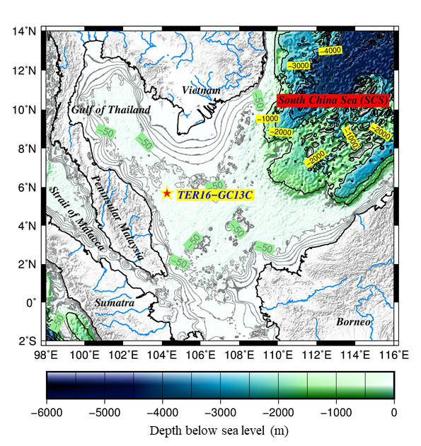
Figure 1. Bathymetric map of South China Sea showing core sampling location on the Sunda Shelf

Sample collection and preservation
A 180 cm marine sediment core (TER16-GC13C) was retrieved at ~70 nautical miles (5°39.993 N, 104°15.632 E, 73 m water depth) from the Kuala Terengganu coastline in 2016, on board of a Universiti Malaysia Terengganu (UMT) research vessel, RV Discovery, by using gravity corer (Figure 1). The collected sediment core was brought back to the laboratory for subsampling. The sediment core was sliced at 2 cm intervals, bringing a total of 90 samples. The subsampled sediments were frozen at -20 °C for 24 hours before being freeze-dried for 3 days and stored in clean labelled containers to prevent possible contamination. Samples for TOC/CaCO₃ analysis were powdered and homogenized using an agate mortar, and sifted through a sieve with 150 μm mesh size. Meanwhile, samples for particle size analysis and radiocarbons were kept in clean containers without powdering and homogenizing.

Laboratory analysis: Total carbon analysis
Sediment samples were analyzed for total carbon (TC) and inorganic carbon (IC) contents using Shimadzu TOC Analyzer with an accompanying Shimadzu Solid Sample Module SSM-5000A. Ceramic sample boats and glass wool used in the analysis were combusted at 400 °C for 4 hours. For TC analysis, 10 mg of the homogenized sample was combusted at 900 °C. For IC analysis, 10 mg of homogenized sample was digested using 60% phosphoric acid at 200 °C. For the purpose of quality control, standard research materials (glucose and sodium carbonate for TC and IC analysis) were analyzed at every analysis session in which 100% recovery was achieved. The TOC values were obtained by subtracting the IC value from the TC value. CaCO₃ values were obtained by multiplying IC values with 8.33 (the ratio of molecular mass of CaCO₃ to carbon, 100/12), with the assumption that all inorganic carbon is pure calcite.

Grain size analysis
Grain size analysis was performed following the procedure in [15] with some modifications. About 2 g of dried sample was weighed in clean plastic containers. 10 drops of undiluted hydrogen peroxide were added into the samples, followed by 5 mL of 20% sodium hexametaphosphate. Distilled water was then added to the volume and the samples were left to stand for 24 hours. Next, the samples were analyzed using Malvern Mastersizer 2000™ laser diffraction particle size analyzer.

AMS ¹⁴Carbon analysis
Sediment core age was determined using accelerated mass spectrometry (AMS) radiocarbon dating facility available at International Chemical Analysis (ICA), Miami, U.S. Age samples composed of intact shells of Anadara sp., Mactra sp., Meiocardia sp. and Pecten sp. were picked at corresponding depths as shown in Table 1. The shells were identified based on references from the Natural History Museum, Rotterdam [16]. The age model was plotted using the data of ¹⁴C age calendar against core depth (Figure 2). Due to the lack of intact carbonate shell samples, the age model could only be established between the depth of 32 and 168 cm covering ~ 76% of total core length. The calibrated ages were calculated by using the Calib 7.1 calibration program based on Marine13 calibration curve and 2 sigma calibrations [17] with delta-R -15±38. The sediment ages refer to the calibrated year Before Present (cal yr BP).

Table 1. TER16-GC13C radiocarbon dating samples
Depth (cm) | Dated shell genus
32 | Pecten
44.5 | Meiocardia
77 | Anadara
101 | Mactra
155 | Anadara
168 | Mactra

Results and Discussion
Age models and sedimentation rate
The six point of AMS¹⁴C dates for TER16-GC13C range from 2560 to 7370 yr BP (Table 2 and Figure 2). The AMS¹⁴C dates of TER16-GC13C provide age controls for the stratigraphic interval between 32 and 168 cm depth of the core. The calibrated AMS¹⁴C age model reveals that the mean sedimentation rate of TER16-GC13C occurred at 0.05 cm yr⁻¹ since 7840 cal yr BP.

Table 2. TER16-GC13C radiocarbon age estimates. The calibrated age ranges reported following Reimer et al. [17]

Depth  (cm) | AMS ¹⁴C age  (yr BP) | 2σ age  (cal yr BP) (Calib 7.1)
32 | 2560 | 2232
44.5 | 3920 | 3922
77 | 6310 | 6791
101 | 6610 | 7133
155 | 6980 | 7492
168 | 7370 | 7840

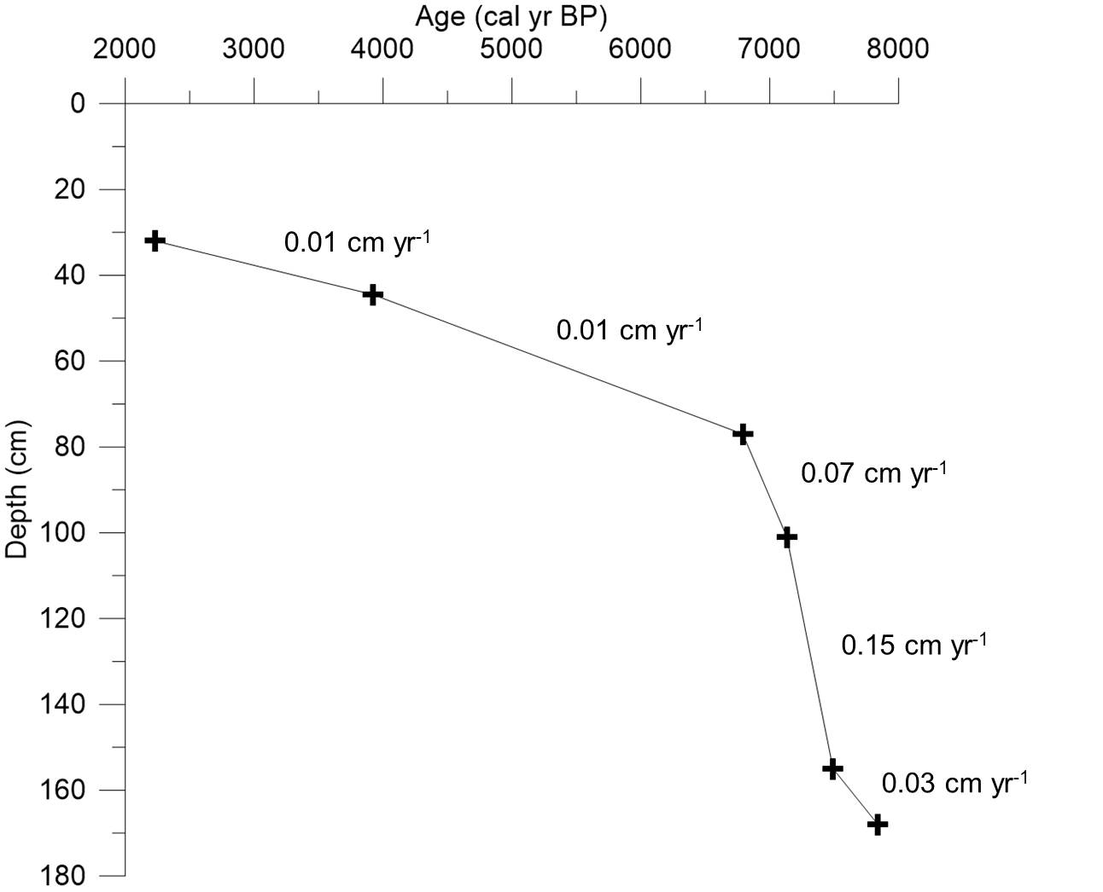

Figure 2. Age model of TER16-GC13C with corresponding sedimentation rates

TOC, CaCO₃ and mean grain size
The vertical profiles of TOC, CaCO₃ content and mean grain sizes for core TER16-GC13C are shown in Figure 3. The TOC concentration varied from 0.11% and 0.39% with mean values of 0.23 ± 0.07%. The highest and lowest concentration of TOC for the studied core was recorded at 93 cm and 111 cm. However, the variation of TOC content across the core is small, as determined by the very low standard deviation. Therefore, we interpret the TOC signal as being low (<0.4%) with insignificant fluctuations. The values of CaCO₃ varied from 3.38% to 12.05%, with an average value of 6.95 ± 2.05%. The concentrations of CaCO₃ in sediment cores increased towards the core top. High values of CaCO₃ were recorded at the top section of the sediment core (0 cm to 52 cm). The mean grain size ranged from 3.87 phi to 7.63 phi, with an average value of 6.18 phi, indicating an increase in grain size towards the core top (Figure 3c).

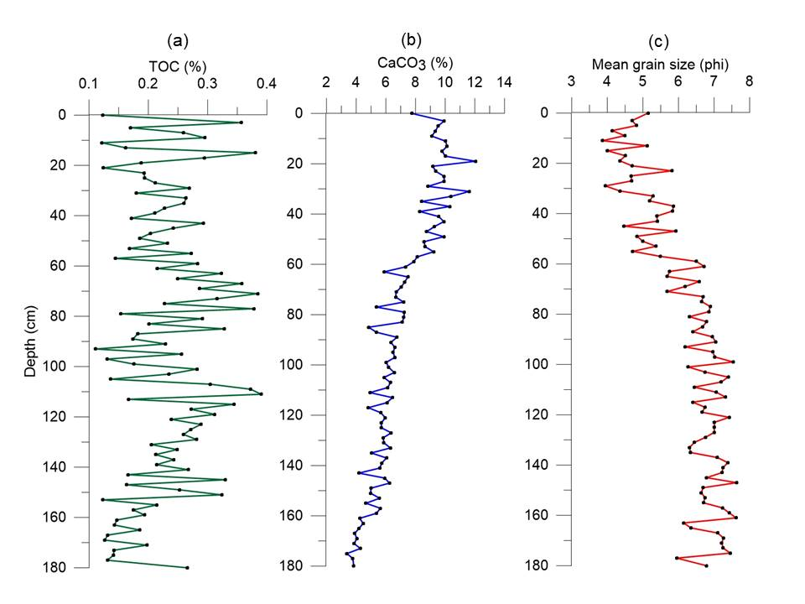
Figure 3. Vertical profiles of TOC content, CaCO₃ content and mean grain size of core TER16-GC13C

Pearson’s correlation indicates that there is no significant relationship between TOC and grain size, implying that grain size had no appreciable influence on TOC concentration in sediment (Table 3). Meanwhile, there is a strong negative correlation between CaCO₃ and grain size (Table 3 and Figure 4).

Table 3. Pearson’s correlation coefficient between proxies
 | CaCO₃ | Grain Size
TOC | -0.0035(p=0.9776) | -0.1072 (p=0.3841)
CaCO₃ |  | -0.5955 (p=8.4726E-08)
Note: Bold type designates significant negative correlations at the significance level of 0.05

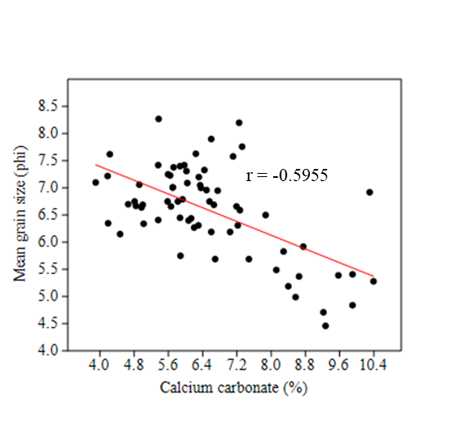

Figure 4. Scatterplot of CaCO₃ against mean grain size

Holocene sedimentation rate
Based on the age model, the average sedimentation rate of TER16-GC13C was 0.06 cm yr⁻¹ (Figure 2). The sedimentation rate in this study was relatively lower compared to the ²¹⁰Pb excess age estimation from short sediment core of EC02 (0.34 cm yr⁻¹) and EC03 (0.38 cm yr⁻¹) in the East Coast of Peninsular Malaysia, which was established by Mohamed et al. [18]. The difference can be attributed to the distance of sampling locations from the shoreline. Szmytkiewicz and Zalewska [19] stated that shorter distances of core location to the source of sediment lead to high accumulation rate of sediment. The locations of core EC02 and EC03 are closer to the terrestrial area compared to core TER16-GC13C. TER16-GC13C sedimentation rate was relatively lower at 0.07 cm yr⁻¹ – 0.15 cm yr⁻¹, which covers the age between 2560 and 7370 yr BP. Sedimentation rate decreased to 0.01 cm yr⁻¹ between 6310 and 3190 yr BP. The sea level rise which flooded the region during Holocene deglaciation caused the study area to be at a further distance than the new land-sea border, limiting sediment sources from the terrestrial environment [19]. This is the reason why the sedimentation rate is relatively lower at the upper part than bottom part of the sediment core.

Paleoproductivity variability
The concentration of TOC in marine sediment cores is widely used as a proxy for surface water paleoproductivity; high (low) TOC value is linked to high (low) paleoproductivity [20, 21, 23]. However, this study reveals that it is inaccurate to generally deduce the paleoproductivity record based solely on the TOC content. The value of CaCO₃ content had been steadily increasing since the last 7840 cal yr BP (Figure 5b), implying higher carbonate production, while TOC content remained low (Figure 5a). This finding is consistent with the previous finding that the primary productivity of poor nutrient surface water in the ocean was dominated by carbonate-based primary producer [5]. The production of organic matter by primary producers converts CO₂ into organic matter while CaCO₃ production in the ocean photic zone counteracts by releasing CO₂ [5].

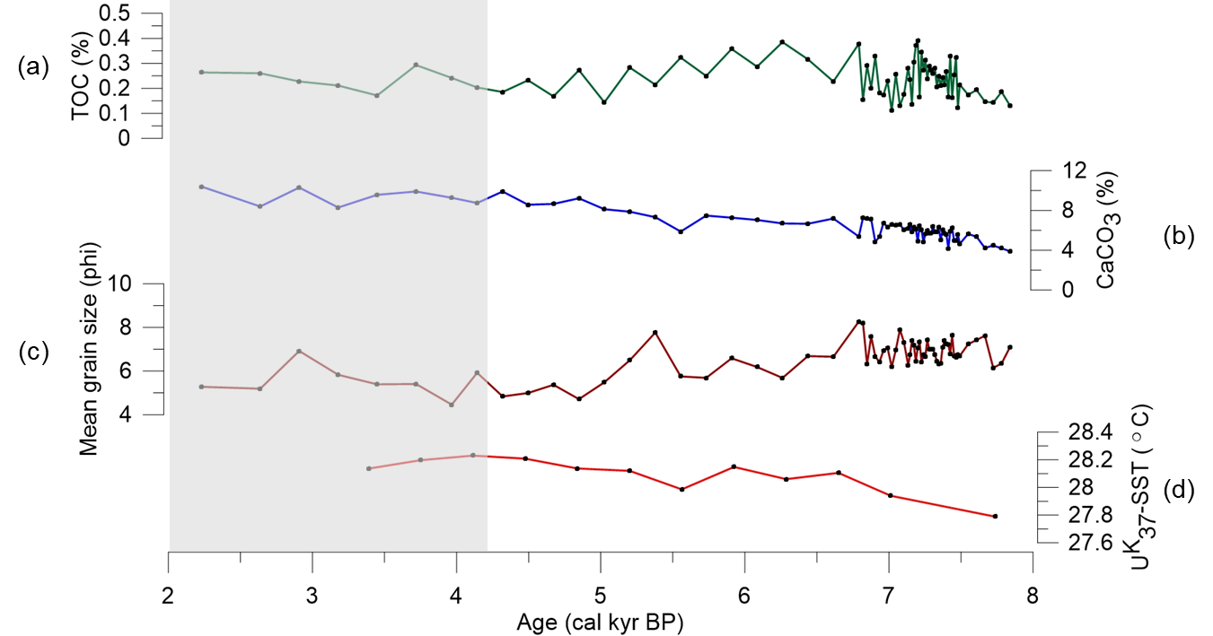
Figure 5. Profiles of (a) TOC content, (b) CaCO₃ content, (c) mean sediment grain size and (d) U^{K}₃₇-SST during the last 7840 cal yr BP. U^{K}₃₇-SST from core 18287-3 was supplied by Kienast et al. [23]. Shaded region marks Meghalayan while unshaded region represents Northgrippian

In high productivity areas, the surplus in organic matter supply to marine sediment results in high production of metabolic CO₂ [24]. The excess CO₂ contributes to higher carbonate ions (CO₃²⁻), which increases the dissolution of CaCO₃ by binding with calcium ion (Ca²⁺⁾ in sediment. The low TOC content observed from the study area helped promote the preservation of CaCO₃ in sediment as low CO₂ was produced from the degradation of organic matter.

The similarity in trend and the strong negative correlation between CaCO₃ content and mean grain size (Figure 5c) might be caused by the contribution of CaCO₃ to the coarser fraction of sediment. Similar phenomenon was also reported by Wang and Lin [9] in which the downcore content of coarse fraction mimicked the CaCO₃ content. This finding can be inferred to the increase in CaCO₃ rain from the photic zone.

The Holocene sea surface temperature (SST) of SCS reported by Kienast et al. [23] (Figure 5d) shows that the SST trend is synchronous with the increasing trend of CaCO₃. This is in agreement with Rühlemann et al. [5] which stated that higher SST promotes primary productivity, and in this case, it is carbonate-based primary productivity. We postulate that the poor nutrient surface water in Terengganu offshore inhibited organic-based primary productivity and therefore, the increase in SST did not cause an increase in primary productivity magnitude. The results of this study also suggest that the community structure in the surrounding area had changed from organic- to calcareous-based producers.

Comparison with regional studies
This study generally reported relatively low TOC and CaCO₃ contents as compared to other studies in the region (Table 4) and therefore has lower paleoproductivity signal. It is important to note the time scale of the core used in different studies. Previous studies listed in Table 4 are related to cyclic glaciation-deglaciation events while our study was not influenced by similar events due to a shorter temporal resolution.

Table 4. A comparison of TOC and CaCO₃ concentration with the other studies
 | Site | TOC  (%) | CaCO₃  (%) | Temporal Resolution
This study | Terengganu waters | 0.11 - 0.39 | 3.38 - 12.05 | Holocene  (Northgrippian – Meghalayan)
Black et al. [25] | Japan Sea | 0.16 - 6.36 | 0 - 44.29 | Pliocene - Holocene
 | East China Sea | 0.10 - 2.85 | 0.70 - 42.84 | Middle Pleistocene - Holocene
Shiau et al.  [26] | SSCS | 0.2 - 1.6 | ~20 - 50 | Middle Pleistocene - Holocene
Wang and Lin [9] | Nansha area, SSCS | Generally <0.5 | 6.03 - 59.02 | Miocene - Holocene

Conclusion
The paleoproductivity of the study site was justified with regards to TOC and CaCO₃ content. The TOC content decreased from Northgrippian to Meghalayan. The CaCO₃ content increased with time and showed parallelism with the increasing trends of SST. Primary producer community structure might have changed during the Holocene, which resulted in more calcareous-based primary producers during Meghalayan, and the population is expected to further increase based on current trend. This study is limited on both spatial and temporal aspects and therefore, future studies using cores from multiple sites and longer cores are recommended.

Acknowledgement
This project was funded by the Higher Institute Centre of Excellence (HICoE) Grant (Vote No. 66928) awarded to Institute of Oceanography and Environment (INOS), Universiti Malaysia Terengganu and Fundamental Research Grant Scheme (FRGS/1/2015/WAB09/UMT/02/1) provided by Ministry of Education Malaysia. The authors are grateful to INOCEM Research Station, Kuliyyah of Science, International Islamic University Malaysia, for granting access to Malvern Mastersizer 2000™.

References

- Müller, P. J. and Suess, E. (1979). Productivity, sedimentation rate, and sedimentary organic matter in the oceans-I. Organic carbon preservation. Deep Sea Research Part A, Oceanographic Research Papers, 26(12): 1347-1362.
- Canfield, D. E. (1994). Factors influencing organic carbon preservation in marine sediments. Chemical Geology, 114: 315-329.
- Zonneveld, K. A. F., Versteegh, G. J. M., Kasten, S., Eglinton, T. I., Emeis, K. C., Huguet, C., Koch, B. P., de Lange, G. J., Middelburg, J. J., Mollenhauer, G., Prahl, F. G., Rethemeyer, J. and Wakeham, S. G. (2010). Selective preservation of organic matter in marine environments; processes and impact on the sedimentary record. Biogeosciences, 7: 483-511.
- Rühlemann, C., Frank, M., Hale, W., Mangini, A., Mulitza, S., Müller, P. J. and Wefer, G. (1996). Late quaternary productivity changes in the western equatorial Atlantic: Evidence from ²³⁰Th-normalized carbonate and organic carbon accumulation rates. Marine Geology, 135: 127-152.
- Rühlemann, C., Muller, P. J. and Schneider, R. R. (1999). Organic carbon and carbonate as paleoproductivity proxies: Examples from high and low productivity areas of the tropical Atlantic. In 1999, Use of Proxies in Paleoceanography: Examples from the South Atlantic (Fischer, G. and Wefer, G. (eds), Springer-Verlag Berlin Heidelberg, pp. 315-344.
- Averyt, K. B. and Paytan, A. (2004). A comparison of multiple proxies for export production in the equatorial Pacific, Paleoceanography, 19: PA4003.
- Anderson, R. F. and Winckler, G. (2005). Problems with paleoproductivity proxies. Paleoceanography, 20: PA3012.
- Su, X., Liu, C., Beaufort, L., Tian, J. and Huang, E. (2013). Late quaternary coccolith records in the South China Sea and East Asian monsoon dynamics. Global and Planetary Change, 11: 88-96.
- Wang, L. W. and Lin, H. L. (2004). Data report: Carbonate and organic carbon contents of sediments from Sites 1143 and 1146 in the South China Sea. In: Prell, W. L., Wang, P., Blum, P., Rea, D. K., and Clemens, S. C. (Eds.), ODP Proceedings, Scientific Results, 184: 1-9.
- Tyson, R. V. (2001). Sedimentation rate, dilution, preservation and total organic carbon: some results of a modelling study. Organic Geochemistry, 32: 333-339.
- Meyers, P. A. and Eadie, B. J. (1993). Sources, degradation and recycling of organic matter associated with sinking particles in Lake Michigan. Organic Geochemistry, 20(1): 47-56.
- Sathiamurthy, E. and Voris, H. K. (2006). Maps of Holocene sea level transgression and submerged lakes on the Sunda shelf. The Natural History Journal of Chulalongkorn University, Supplement 2: 1-44.
- Smith, D. E., Harrison, S., Firth, C. R. and Jordan, J. T. (2011). The early Holocene sea level rise. Quaternary Science Reviews, 30: 1846-1860.
- Tamburini, F., Adatte, T., Föllmi, K., Bernasconi, S. M. and Steinmann, P. (2003). Investigating the history of East Asian monsoon and climate during the last glacial-interglacial period (0-140 000 years): Mineralogy and geochemistry of ODP Sites 1143 and 1144, South China Sea. Marine Geology, 201: 147-168.
- Kamaruzzaman, B. Y., Ong, M. C., Noor Azhar, M. S., Shahbudin, S., and Jalal, K. C. A. (2008). Geochemistry of sediment in the major estuarine mangrove forest of Terengganu region, Malaysia. American Journal of Applied Sciences, 5(12): 1707-1712.
- Natural History Museum Rotterdam (2018). Collection database. Retrieved from http://www.marinespecies.org/nmr [Accessed online March 2018].
- Reimer, P., Bard, E., Bayliss, A., Beck, J., Blackwell, P. and Ramsey, C. (2013). IntCal13 and Marine13 radiocarbon age calibration curves 0–50,000 Years cal BP. Radiocarbon, 55(4): 1869-1887.
- Mohamed, C. A. R., Mahmood, Z. U. W. and Ahmad, Z. (2008). Recent sedimentation of sediments in the coastal waters Peninsular Malaysia. Pollution Research, 27(1): 27-36.
- Szmytkiewicz, A. and Zalewska, T. (2014). Sediment deposition and accumulation rates determined by sediment trap and ²¹⁰Pb isotope methods in the Outer Puck Bay (Baltic Sea). Oceanologia, 56(1): 85-106.
- Reichart, G. J., den Dulk, M.,Visser, H. J., Van der Weijden, C. H. and Zachariasse, W. J. (1997). A 225 kyr record of dust supply, paleoproductivity and the oxygen minimum zone from the Murray ridge (Northern Arabian Sea), Palaeogeography Palaeoclimatology Palaeoecology, 134(1-4): 149-169.
- Schulz, H., von Rad, U. and Erlenkeuser, H. (1998). Correlation between Arabian Sea and Greenland climate oscillations of the past 110,000 years. Letters to Nature, 393: 54-57.
- von Rad, U., Schaaf., M., Michels, K. H., Schulz, H., Berger, W. H. and Sirocko, F. (1999). A 5000-yr Record of climate change in varved sediments from the oxygen minimum zone off Pakistan, Northeastern Arabian Sea. Quaternary Research, 51: 39-53.
- Kienast, A. M., Steinke, S., Stattegger, K., Calvert, S. E., Tto, S. and Chandra, S. (2001). Synchronous Tropical South China Sea SST change and Greenland warming during deglaciation. Science, 291(5511): 2132-2134.
- Meyers, P. A. and Robinson, R. S. (2001). Data report: Carbonate and organic carbon contents of sediments from Site 1087, Southern Cape Basin. In Wefer, G., Berger, W. H., and Richter, C. (Eds.), Proceedings of the Ocean Drilling Program, Scientific Results, 175: 1-11.
- Black, H. D., Anderson, W. T. and Alvarez Zarikian, C.A. (2018). Data report: organic matter, carbonate, and stable isotope stratigraphy from IODP Expedition 346 Sites U1426, U1427, and U1429. In Tada, R., Murray, R.W., Alvarez Zarikian, C.A., and the Expedition 346 Scientists (Eds.), Proceedings of the Integrated Ocean Drilling Program, 346: 1-9.
- Shiau, L. J., Yu, P. Sen, Wei, K. Y., Yamamoto, M., Lee, T. Q., Yu, E. F., Fang, T. and Chen, M. T. (2008). Sea surface temperature, productivity, and terrestrial flux variations of the southeastern South China Sea over the past 800000 years (IMAGES MD972142). Terrestrial, Atmospheric and Oceanic Sciences, 19(4): 363-376.

