

MALAYSIAN JOURNAL OF ANALYTICAL SCIENCES
ISSN 1394 - 2506

Published by The Malaysian Analytical Sciences Society

DISTRIBUTION OF PHYTOPLANKTON IN KUANTAN PORT, MALAYSIA DURING NORTHEAST MONSOON SEASON

(Taburan Fitoplankton di Pelabuhan Kuantan, Malaysia Semasa Musim Monsun Timur Laut)

Amir Safwan Hamzah, Normawaty Mohammad-Noor, Aimimuliani Adam*, Zuhairi Ahmad

Department of Marine Science, Kulliyah of Science,
International Islamic University Malaysia, 25200 Kuantan, Pahang, Malaysia.

*Corresponding author: aimiadam@iium.edu.my

Received: 30 October 2018; Accepted: 26 September 2019

Abstract
Harmful algal bloom (HAB) is a proliferation of phytoplankton that can produce bio toxins and cause harm to human health, as well as the environment and the organisms associated with it. The first case of HAB in Kuantan Port was recorded in November 2013, followed by another outbreak in August 2014. This study aims to investigate the phytoplankton distribution and dispersal in the Kuantan Port during the Northeast monsoon season in order to identify the extent of the spread of HAB, should such an event occur again. Phytoplankton samples were taken at Kuantan Port from three levels of depth (surface, middle, and bottom) at every hour during a period of 24 hours. Samples were preserved in Lugol’s iodine. Chemical properties such as phosphorus, nitrate, nitrite, and ammonia were also taken during each sampling. Phytoplankton samples were counted and identified up to genus level. Simulation of phytoplankton dispersal in Kuantan Port was conducted using the program MIKE 21. RMSE error was conducted to improve accuracy between ADCP data and simulated data, and was found to be within acceptable range. The MIKE 21 simulation showed that the algal bloom would remain inside the port and would not spread out to the sea. Thirty-seven taxa of phytoplankton were identified. Phytoplankton concentrations ranged from 124 cells/L to 775 cells/L. TSS value ranged from 0.0110 mg/L to 0.0345 mg/L. Phosphorus concentration ranged from 0.075 mg/L PO₄ to 3.82 mg/L PO₄. Nitrate concentration ranged from 1.05 mg/L NO₃⁻N to 2.45 mg/L NO₃⁻N. Nitrite concentration ranged from 0.0040 mg/L NO₂⁻N to 0.0095 mg/L NO₂⁻N. Ammonia concentration ranged from 0.045 mg/L NH₃⁻N to 0.140 mg/L NH₃⁻N. A positive correlation was found between phytoplankton abundance and nutrient concentration of phosphorus, nitrate and ammonia, with a slightly negative correlation for nitrite. This study recorded the presence of several HAB species such as Dinophysissp, Noctillucasp, and Prorocentrum sp. The presence of these species further indicates that several safety measures need to be considered to safeguard public health, particularly in the coastal waters of Pahang.

Keywords: phytoplankton, harmful algal bloom, Northeast monsoon, Kuantan Port, simulation

Abstrak
Mekar alga berbahaya (HAB) adalah perkembangan fitoplankton yang boleh menghasilkan biotoksin dan menyebabkan kemudaratan kepada kesihatan manusia, serta alam sekitar dan organisma yang berkaitan dengannya. Kes pertama mekar alga berbahaya di Pelabuhan Kuantan telah direkodkan pada November 2013, diikuti dengan wabak lain pada bulan Ogos 2014. Kajian ini bertujuan untuk menyiasat taburan dan penyebaran fitoplankton di Pelabuhan Kuantan semasa musim monsun Timur Laut untuk mengenal pasti sejauh mana HAB dapat tersebar sekiranya berlaku kejadian seperti itu lagi. Sampel fitoplankton diambil di Pelabuhan Kuantan dari tiga tahap ke dalaman (permukaan, tengah, dan bawah) dari setiap jam dalam tempoh 24 jam. Sampel dipelihara dalam iodin Lugol. Sifat kimia seperti fosforus, nitrat, nitrit, dan ammonia juga diambil untuk pensampelan. Sampel fitoplankton dikira dan dikenalpasti sehingga tahap genus. Simulasi penyebaran fitoplankton di Pelabuhan Kuantan dijalankan dengan menggunakan program MIKE 21. Ralat punca kuasa dua telah dijalankan untuk memastikan data antara ADCP dan simulasi adalah tepat, dan didapati jumlahnya dalam nilai berpatutan. Simulasi menunjukkan bahawa mekar alga akan berada di dalam Pelabuhan Kuantan dan tidak akan merebak kepada perairan persekitaran. Tiga puluh tujuh taksonomi fitoplankton telah dikenalpasti. Kepekatan fitoplankton berkisar dari 124 sel/L hingga 775 sel/L. Nilai TSS adalah dari 0.0110 mg/L kepada 0.0345 mg/L. Kepekatan fosforus berkisar dari 0.075 mg/L PO₄ kepada 3.82 mg/L PO₄. Kepekatan nitrat adalah dari 1.05 mg/L NO₃⁻N hingga 2.45 mg/L NO₃⁻N. Kepekatan nitrit adalah dari 0.0040 mg/L NO₂⁻N hingga 0.0095 mg/L NO₂⁻N. Kepekatan ammonia adalah dari 0.045 mg/L NH₃⁻N hingga 0.140 mg/L NH₃⁻N. Korelasi positif telah didapati antara kelopak fitoplankton dan kepekatan fosforus, nitrat dan ammonia, serta korelasi negatif untuk nitrit. Kajian ini mencatatkan kehadiran beberapa spesies mekar alga berbahaya seperti Dinophysissp, Noctillucasp, dan Prorocentrum sp. Kehadiran spesies ini terus menunjukkan bahawa beberapa langkah keselamatan perlu dipertimbangkan untuk melindungi kesihatan awam, khususnya di perairan pantai Pahang.

Kata kunci: fitoplankton, mekar alga berbahaya, monsun timur laut, Pelabuhan Kuantan, simulasi

Introduction
Phytoplankton, also known as microalgae, are free floating unicellular, filamentous and colonial autotrophic organisms that grow in aquatic environments, whose movement is more or less dependent on water currents [1]. According to Sze [2], phytoplankton swim and move with the water flow, but they cannot move against the ocean current as their size is small and they have insufficient energy. Most phytoplankton are buoyant and float in the upper part of the ocean, where sunlight penetrates the water. Phytoplankton also require inorganic nutrients such as nitrates, phosphates, and sulfur which they convert into proteins, fats, and carbohydrates.

A rapid increase or accumulation of phytoplankton population is known as algal blooms. Certain algal blooms, particularly ones caused by dinoflagellates, are known as harmful algal blooms (HAB), due to the threat and danger that they pose to humans and marine species alike. HAB species are capable of generating potent toxins that can influence the well-being of humans through the consumption of contaminated shellfish and/or fish, or through water and aerosol exposure [3]. In addition to their harmful effects on humans, these toxins also contribute to the death of fishes and shellfishes, as well as marine mammals, birds, and other animals that depend on the marine food web [4, 5].

One way of predicting the dispersal of algal blooms is through hydrodynamics. Hydrodynamics is the study of the movement of liquid, and in oceanic studies this usually revolves around wind stress and tidal stress. A high wind and tidal stress will cause the phytoplankton to be dispersed and spread out due to the shear strain and active movement of water, reducing the chances of causing a bloom due to them being dispersed. On the other hand, a low wind and tidal stress would allow the water to stabilize, and the phytoplankton to be less spread out. On another note, wind movements can also cause the phytoplankton to travel towards the direction the wind is blowing, either because of the wind directly pushing them or because of the shift in nutrients from the wind breeze, causing the phytoplankton to naturally follow suit [6]. Changes in these hydrodynamic patterns can be linked to different monsoon seasons.

The monsoon system in Malaysia is characterized by two monsoon regimes, which are, the Northeast monsoon, lasting from November to March, and the Southwest monsoon, lasting from May to October. During the Northeast monsoon, the area in the east coast of Peninsular Malaysia normally receives a large amount of rainfall [7], along with strong northeastern winds.

The purpose of this study is to investigate the phytoplankton and nutrient distribution and dispersal in the Kuantan Port during the Northeast monsoon season. With this, we can predict the period where harmful algal blooms are most likely to happen via hydrodynamic simulation, and take precautionary steps to mitigate the bloom. Kuantan Port has been chosen as the location of the study due to the port acting like a semi-enclosed body of water, while also being connected to the South China Sea. Furthermore, ships that dock at Kuantan Port may also introduce phytoplankton species that are not native to the area from their ballast water discharge. A study conducted by Mohammad-Noor et al. [8] has also shown that the Kuantan Port has a history of HAB outbreaks, which confirms the presence of HAB species. Mohammad-Noor et al. [8] also discovered that in the 12 month period of sampling, the HAB species A. tamiyavanichiiwas found to be most abundant during September 2014, which was during the Northeast monsoon season. This study also investigates the correlation between phytoplankton count and nutrients (phosphorus, nitrate, ammonia and nitrite) during Northeast monsoon in Kuantan Port.

Materials and Methods
Study area
This study was conducted at Kuantan Port (Latitude 3º58’N, Longitude 103º 26’E), Pahang, which is about 25 km to the north of Kuantan city. This port is a multipurpose port which offers container handling and one of the longest free storage periods in Malaysia. Previously run by the Kuantan Port Authority, the busy port was privatized in 1988 and is currently operated by Kuantan Port Consortium Sdn Bhd. Samples were taken on the 1st
of February 2017, starting at 12.00 pm until 11.00 am of the 2nd of February 2017.

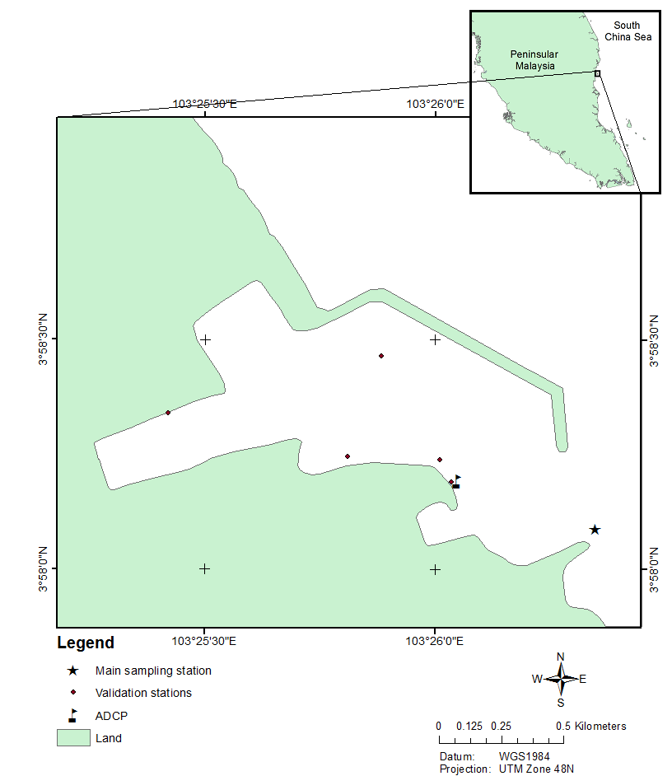

Figure 1. Map of the study area

Sample collection
Water samples were collected from the main station, which is located at the model boundary (Figure 1) in an hourly interval for up to 24 hours, at coordinates 3° 58.090'N 103° 26.353'E, starting from 12:00 pm on 1st February until 12:00 pm on 2nd February. An acoustic Doppler current profiler was also deployed at the same time at coordinates 3° 58.265’N 103° 26.120'E to record the current speed and direction. Samples were also taken from validation stations located inside the port at random intervals.

Water samples were collected at three different depths (surface, middle, and bottom) using a 5 L Niskin water sampler. Average water depth of Kuantan Port was found to be at 15 meters below surface. Samples for identification and counting were immediately preserved in Lugol’s iodine for phytoplankton identification and quantification. For nutrient analysis, 1 L of water sample was collected for each depth. An extra 1 L of water sample was collected on the surface depth for chlorophyll-a analysis. The water samples were then filtered using Whatman Glass Microfiber filters with a diameter of 47 mm before further analysis was conducted. The filters were collected and stored for TSS analysis.

Phytoplankton analysis
Phytoplankton samples that were preserved in Lugol’s iodine were transferred into measuring cylinders for a sedimentation process until the concentration of samples was approximately 50 mL. Samples were then observed under a Leica DME Light Microscope under 100x magnification using a Sedgewick Rafter Counting Cell Chamber. The counting procedure was done twice for each sample. Phytoplankton samples were identified up to the genus level based on Tomas [9] and Omura et al. [10].

Nutrient analysis
Nutrient analysis was conducted via colorimetry using the HACH DR900 Multiparameter Portable Colorimeter and its corresponding powder pillow reagents. Phosphorus was analyzed with PhosVer® 3 reagent powder pillows using HACH method 8048. Nitrate was analyzed with NitraVer® 5 reagent powder pillows using HACH method 8171. Ammonia was analyzed using HACH nitrogen-ammonia reagent set using HACH method 8155. Nitrite was analyzed with NitriVer® 3 reagent powder pillows using HACH method 8507.

Total suspended solid analysis
The filters used for total suspended solids (TSS) analysis had been labeled and dried overnight in a Memmert laboratory oven at a temperature of 103 ºC. After that, each filter was weighed using an AND HR-200 Digital Analytical Balance. Then, each of the filters was used to filter the water samples. Following that, the filters are again dried overnight at a temperature of 103 ºC, and were weighed again. TSS was calculated using the following formula in equation 1:

$\text{TSS (mg/L)=}\frac{(\text{final weight of filter}-\text{initial weight of filter})}{\text{volume of sample filtered}}$ (1)

Simulation
Simulation was conducted using the program MIKE 21 with the purpose of predicting the spread of algal bloom in Kuantan Port. The point of origin for the a mulated data for surface elevation, current speed and current direction were compared with the data obtained from the ADCP device with RMSE error for higher accuracy. The phytoplankton dispersal simulation was set to the following parameters:

- Minimum plankton weight of 0.25 µg [11],
- Doubling time, the period of time required for phytoplankton to double in value, set to 1 day [12],
- Sinking rate, the estimated rate for phytoplankton to settle down in the water column, set to 1 m/day [13], and
- Death rate, the life expectancy of the simulated phytoplankton, set to 5 days.

Secondary data such as tide data, bathymetry data and wind data for Kuantan Port were obtained through external sites and programs. Tide data was obtained using the program ADMIRALTY Total Tide. Bathymetry data was obtained from the website General Bathymetric Chart of the Oceans (GEBCO). Wind data was obtained from the website Iowa Environmental Mesonet. RMSE error with data obtained from ADCP was calculated to increase the accuracy of the model.

Data analysis
Significant tests for phytoplankton abundance and nutrient concentration between depths were carried out using PAST (Paleontological Statistic), with one way ANOVA for parametric data and Kruskal-Wallis for nonparametric data. Pearson correlation test between phytoplankton abundance and nutrient concentration was also conducted.

Results and Discussion
A total of thirty-seven phytoplankton genera were identified during the study period. Most of these genera belonged to Diatoms (24 genera), followed by Dinoflagellates (12 genera) and blue-green algae (1 genus).

Table 1 shows the list of all thirty-seven phytoplankton genera found in Kuantan Port. The most dominant genus found was Thalassionema spp (67.48%), followed by Nitzchia spp (17.43%), Coscinodiscus spp (16.72%), and Chaetoceros spp (6.21%). Study conducted by Mohammad-Noor et al. [14] in Kuantan coastal waters had also encountered a high abundance of diatoms. Several potential harmful species were identified in this study, such as Prorocentrummicans, Dinophysis spp., and Chaetoceros spp.

Table 1. Phytoplankton genera recorded in Kuantan Port during sampling

Phytoplankton Genus
Thalassionema (Thalassionemataceae) | Nitzschia (Basillariaceae)
Coscinodiscus (Coscinodiscaceae) | Chaetoceros (Chaetocerotaceae)
Ditylum (Lithodesmiaceae ) | Odontella (Eupodiscaceae)
Pleurosigma (Naviculaceae) | Amphiprora (Amphipleuraceae )
Amphora (Catenulaceae) | Prorocentrum (Prorocentraceae)
Bacteriastrum (Chaetocerotaceae) | Detonula (Thalassiosiraceae)
Ceratium (Ceratiaceae) | Protoperidinium (Protoperidinaceae)
Pyrocystis (Pyrocystaceae) | Dinophysis (Dinophysaceae)
Gonyaulax (Gonyaulacaceae) | Hemiaulus (Hemiaulaceae)
Guinardia (Rhizosoleniaceae) | Rhizosolenia (Rhizosoleniaceae)
Lauderia (Thalassiosiraceae) | Dictyocha (Dictyochophyceae)
Noctilluca (Noctilucaceae) | Skeletonema (Thalassiosiraceae)
Asteromphalus (Coscinodiscophyceae) | Histoines (Dinophysaceae)
Meauniera (Naviculaceae) | Gyrodinium (Gymnodiniaceae)
Thalassiosira (Thalassiosiraceae) | Podolampas (Podolampadaceae)
Stephanopyxis (Melosiraceae) | Nematodinium (Warnowiaceae)
Planktoniella (Thalassiosiraceae) | Dactyliosolen (Rhizosoleniaceae)
Asterionellopsis (Fragilariaceae ) | Cochlodinium (Gymnodiniaceae)
Corethron (Leptocylindraceae)

Figure 2 shows that the total highest amount of phytoplankton individuals observed according to depth is the middle area, at 8504 cells L⁻¹, while the lowest is the surface area at 5426 cells L⁻¹. Likewise, the total highest amount of phytoplankton individuals observed according to time is at 13:00 at 1365 cells L⁻¹, while the lowest is at 14:00 at 679 cells L⁻¹.

The difference of phytoplankton abundance across each water depth is not statistically significant (p > 0.05). This means that the water column is homogenous and well-mixed, most likely due to the port itself being quite shallow compared to the open ocean.

This simulation model was validated by simulating the surface elevation, current speed and current direction of the sampling period. The data obtained between modeled and measured flows were compared, and RMSE error was calculated to increase the accuracy of the model (Table 2). All RMSE values were found to be within the acceptable limits.

Figure 2. Phytoplankton abundance (cells L⁻¹) obtained over sampling time

Table 2. RMSE error calculation for surface elevation, current speed and current direction
for Northeast monsoon
 | Measurement | RMSE % | JPS Limit
 | Surface elevation | 5.10% | ≤10%
 | Current speed | 7.14% | ≤20%
 | Current direction | 18.44% | ≤20%

Figure 3 and Figure 4 show the distribution of phytoplankton during low tide and high tide. Figure 3 shows that the phytoplankton distribution is higher in the port during low tide. However, Figure 4 shows that phytoplankton distribution is much more concentrated at the port mouth, and surpasses even the highest count of phytoplankton inside the port during low tide. The reasoning behind this is that during high tide, water from the open ocean flows inside the port, bringing in a high amount of phytoplankton from the sea along with it, which remain around the port mouth. During low tide, the seawater does not flow very well due to lower surface elevation, causing the phytoplankton count inside the port to become higher, relative to the area near the port mouth. The lack of significant phytoplankton abundance across each depth also shows that the phytoplankton abundance is not affected by the water column, and instead is more affected by the current movement. The results of phytoplankton dispersal simulation in Kuantan Port suggest that should an algal bloom ever occur in Kuantan Port, the bloom will remain inside the port and will not spread out to the open ocean (Figures 5 and 6).

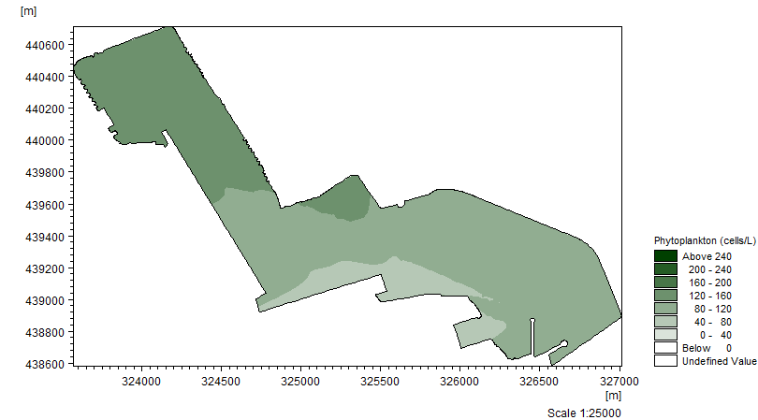

Figure 3. Phytoplankton abundance (cells) observed during low tide in Kuantan Port

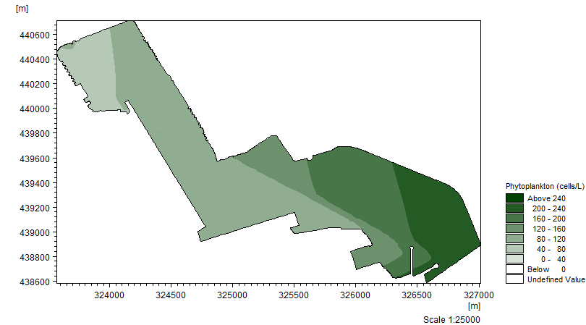

Figure 4. Phytoplankton abundance (cells) observed during high tide in Kuantan Port

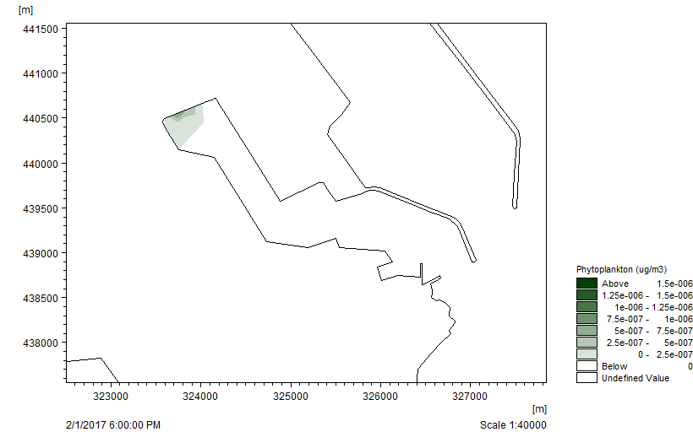

Figure 5. Simulation of phytoplankton dispersal (µg/m³) observed during low tide in Kuantan Port

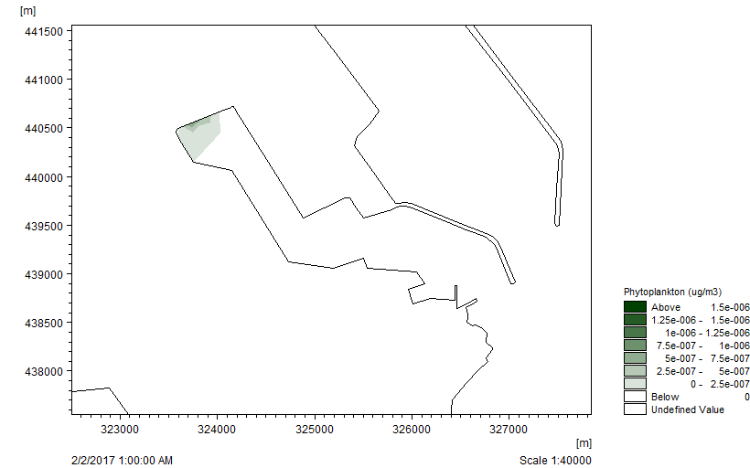

Figure 6. Simulation of phytoplankton dispersal (µg/m³) during high tide in Kuantan Port

For phosphorus, the difference in phosphorus concentrations across each depth was not found to be statistically significant (p > 0.05). This means that the water column was homogenous and well-mixed, most likely due to the port itself being quite shallow compared to the open ocean. However, phosphorus concentration across different sampling times (Figure 7) was statistically significant (p < 0.05). There were no significant differences in the interaction between depth and sampling time.
Based on the Pearson test with count which returns a value of 0.054, there is a positive correlation between phytoplankton abundance and phosphorus. According to Jalal et al. [15], phosphorus is considered to be the most significant among other nutrients responsible for eutrophication, as it is the primary initiating factor.

Figure 7. Phosphorus content in Kuantan Port over time for each depth

The nitrate concentration across each water depth was not found to be statistically significant (p > 0.05). This means that the water column was homogenous and well-mixed, most likely due to the port itself being quite shallow compared to the open sea. However, nitrate concentration across different sampling times (Figure 8) was statistically significant (p < 0.05). There were also significant differences in the interaction between depth and sampling time.

Pearson test with count returns a value of 0.014, indicating positive correlation between phytoplankton abundance and nitrates. According to Jalal et al. [15], an abundance of nitrates in combination with phosphorus will stimulate the excessive growth of algae.

The ammonia concentration across each water depth was not statistically significant (p > 0.05). This means that the water column was homogenous and well-mixed, most likely due to the port itself being quite shallow compared to the open ocean. However, ammonia concentration across different sampling times (Figure 9) was statistically significant (p < 0.05). There were no significant differences in the interaction between depth and sampling time. Pearson test with count returns a value of 0.233, which indicates positive correlation between phytoplankton abundance and ammonia. According to Jalal et al. [15], an abundance of ammonia will stimulate the growth of algae and can result in algal blooms.

Figure 8. Nitrate content in Kuantan Port over time for each depth

Figure 9. Ammonia content in Kuantan Port over time for each depth

The nitrite concentration across each water depth (Figure 10) was statistically significant (p < 0.05). Nitrite concentration across different sampling times was found to be statistically significant as well (p < 0.05). There were also significant differences in the interaction between depth and sampling time. This means that the water column was not homogenous and well-mixed for nitrite. A likely explanation is that the nitrate analysis method was not sensitive enough, leading to a large difference in the number of nitrite concentration between water depths.

Pearson test with count returns a value of -0.007, which indicates a slight negative correlation between phytoplankton abundance and nitrites. This is highly likely due to the fact that nitrifying microorganisms usually thrive at depths where phytoplankton are light-limited [16], and Kuantan Port’s shallow water ensures that the phytoplankton receive enough sunlight.

Figure 10. Nitrite content in Kuantan Port over time for each depth

The highest amount of TSS value obtained (Figure 11) was 0.0345 mg/L, which was for the sample taken at 23:00 at the bottom layer. According to Jalal et al. [15], even a TSS value of 0.044 g is still favorable for aquatic life, which means that the Kuantan Port is very favorable for phytoplankton. Pearson test conducted between total suspended solids and phytoplankton count returns a value of 0.207, which indicates positive correlation between phytoplankton abundance and total suspended solids.

Figure 11. Total suspended solids in Kuantan Port over time for each depth

Conclusion
This research confirms the existence of harmful algal bloom species in Kuantan Port. Results also confirm that phytoplankton counts have a positive correlation with phosphorus, nitrate and ammonia, showing that these nutrients can influence phytoplankton density in Kuantan Port during Northeast monsoon. Based on the MIKE 21 simulated model, the algal bloom will remain inside the Kuantan Port and will not spread out to the open sea during Northeast monsoon. It is strongly suggested that the previous occurrence of HAB in Kuantan Port was not caused by a native species. Instead, it could have possibly been caused by a foreign HAB species being introduced into the port via ballast water from international ships. It is also possible that human activities surrounding Kuantan Port may have contributed towards the algal bloom.

Acknowledgement
This study was conducted under RIGS 16-105-0269 and RIGS 16-102-0266 of International Islamic University Malaysia Kuantan, Malaysia.

References
- Millman, M., Cherrier, C. and Ramstack, J. (2005). The seasonal succession of the phytoplankton community in Ada Hayden Lake, North Basin, Ames, Iowa. Limnology Laboratory, Iowa State University, Ames Iowa.
- Sze, P. (1998). Biology of the Algae. 3rd Edition. McGraw Hill Inc, USA.
- Van Dolah, F. M. (2000). Diversity of Marine and Freshwater Algal Toxins. In: Botana L., editor. Seafood Toxicology: Pharmacology, Physiology and Detection. Marcel Dekker, New York: pp. 19-43
- Scholin, C.A., Gulland, F., Doucette, G.J., Benson, S., Busman, M., Chavez, F.P. and Van Dolah, F.M. (2000). Mortality of sea lions among the central California coast linked to a toxic diatom bloom. Nature, 430: 80-84.
- Flewelling, L. J., Naar, J. P., Abbott, J. P., Baden, D. G., Barros, N. B., Bossart, G. D. and Landsberg, J.H. (2005). Brevetoxicosis: red tides and marine mammal mortalities. Nature, 435: 755-756.
- Buranapratheprat, A., Yanagi, T., Niemann, K.O., Matsumura, S. and Sojisuporn, P. (2008). Surface chlorophyll-a dynamics in the upper Gulf of Thailand revealed by a coupled hydrodynamic-ecosystem model. Journal of Oceanography, 64: 639.
- Yoshida, T., Toda, T., Yusoff, F. M. and Othman, B. H. R. (2006). Seasonal variation of zooplankton community in the coastal waters of the Straits of Malacca. Coastal Mar Sci, 30: 320-327.
- Mohammad-Noor, N., Adam, A., Lim, P.T., Leaw, C.P., Lau, W.L.S., Liow, G.R., Muhammad-Bunnori, N., Hamdan, N., Md-Nor, A., Kemat, N. and Muniandi, D. (2018). First report of paralytic shellfish poisoning (PSP) caused by Alexandrium tamiyavanichii in Kuantan Port, Pahang, East Coast of Malaysia. Phycological Research, 66: 37-44.
- Tomas, C. R. (1997). Identifying marine phytoplankton. Florida Marine Research Institute, Florida.
- Omura, T., Iwataki, M., Borja, V.M., Takayama, H. and Fukuyo, Y. (2012). Marine phytoplankton of the Western Pacific. Kohseisha Kouseikaku, Japan.
- González, E. J. and Tundisi, J. G. (2008). Size and dry weight of main zooplankton species in Bariri reservoir (SP, Brazil). Brazilian Journal of Biology, 68(1): 69-75.
- Laws, E. A. (2013). Evaluation of in situ phytoplankton growth rates: a synthesis of data from varied approaches. Annual Review of Marine Science, 5:247-268.
- Peperzak, L., Colijn, F., Koeman, R., Gieskes, W. W. C and Joordens, J. C. A. (2003). Phytoplankton siking rates in the Rhine region of freshwater influence. Journal of Plankton Research, 25(4): 365-383.
- Mohammad-Noor, N., Harun, S. N. R., Mat Lazim, Z., Mukai, Y., Mohammad, N. T. and Saad, S. (2013). Diversity of phytoplankton in coastal water of Kuantan, Pahang, Malaysia. Malaysian Journal of Analytical Sciences, 32(1): 29-37.
- Jalal, K. C. A., Akbar John, B. Hassan I. Sheikh, Shahbudin S., and Nor Hafiza, Y. A. A. (2017). Study on physiochemical parameters and distribution of phytoplankton in Kuantan Estuary, Pahang. Environment and Ecosystem Science, 1(1):8-12.
- Zakem, E. J., Al-Haj, A., Church, M. J., Dijken, G. L., Dutkiewicz, S., Foster, S. Q. and Follows, M. J. (2018). Ecological control of nitrite in the upper ocean. Nature communications, 9(1): 1206.

