

MALAYSIAN JOURNAL OF ANALYTICAL SCIENCES
ISSN 1394 - 2506

Published by The Malaysian Analytical Sciences Society

DISTRIBUTION OF DISSOLVED ALUMINIUM (dAl) IN SEAWATER AT PULAU PERHENTIAN, TERENGGANU

(Taburan Aluminium Terlarut (dAl) di dalam Air Laut di Pulau Perhentian, Terengganu)

Khairul Nizam Mohamed^{1,2}*, Edriana Godon¹, Shamsuddin Johan^{1,2}, Fairuza Shaheera Jaafar¹

¹Department of Environmental Sciences, Faculty of Environmental Studies
²Environmental Forensic Research Unit, Faculty of Environmental Studies
Universiti Putra Malaysia, 43400 UPM Serdang, Selangor, Malaysia.

*Corresponding author: k_nizam@upm.edu.my

Received: 30 October 2018; Accepted: 26 September 2019

Abstract
The distribution of dissolved aluminum (dAl) was determined in seawater collected from Pulau Perhentian in November 2015 and April 2016, in order to identify a possible effect of the Northeast monsoon on dAl. Seawater sample profiles were collected at five different stations at 4-5 different depths. The concentration of dAl was determined directly by using cathodic stripping voltammetry on the hanging mercury drop electrode. This method was optimized in order to fit the determination of dAl concentration in seawater at this study area. During the measurements in November 2015, the concentration of dAl was found to be between 31.1 μg/L and 98.7 μg/L at that surface layer, and was found to be increasing with depth. On the other hand, the concentration ranged between 30.9 μg/L and 167.3 μg/L at surface layer and decreased with depth in April 2016. This indicates that the distribution of dAl throughout the water column was different between the two periods. It suggests that there was a possible source of Al from the surface sediment due to the high current turbulence during the Northeast monsoon season in this area, as mentioned by previous studies.

Keywords: dissolved aluminium, seawater, biological uptake, atmospheric input, monsoon

Abstrak
Taburan aluminium terlarut (dAl) telah ditentukan di dalam air laut yang diperolehi dari Pulau Perhentian pada November 2015 dan April 2016 bagi menentukan kebarangkalian kesan Monsun Timur laut ke atas dAl. Sampel air laut secara turus telah diambil di lima stesen yang berbeza pada 4-5 kedalaman yang berbeza. Kandungan kepekatannya telah ditentukan secara terus dengan menggunakan kaedah pelucutan voltametri pada hujung elektrod merkuri. Kaedah ini telah dioptimumkan bagi menentuukur kandungan kepekatan dAl di dalam air laut di kawasan ini. Kandungan kepekatan dAl adalah julat diantara 31.1-98.7 μg/L pada lapisan permukaan dan ianya meningkat dengan kedalaman air pada November 2015. Di sebaliknya pula, kandungan kepekatannya adalah diantara 30.9-167.3 μg/L pada lapisan permukaan dan berkurang dengan kedalaman air pada April 2016. Ini menunjukkan bahawa, taburan dAl di sepanjang turus air adalah berbeza di antara kedua-dua masa tersebut. Ini mencadangkan bahawa kemugkinan sumber Al adalah dari permukaan sedimen yang disebabkan oleh arus pergolakan yang tinggi semasa musim monsun Timur laut di kawasan ini, sepertimana yang telah dicadangkan sebelum ini.

Kata kunci: aluminium terlarut, air laut, pengambilan secara biologi, input atmosfera, monsun

Introduction
Aluminum (Al) is the third most abundant element in the earth’s crust, and its hydrolysis states of Al(OH)⁴⁻ and Al(OH)₃⁰ are the dominant species in seawater (pH 8). Since Al is a particle-reactive element similar to Thorium (Th) and Ferum (Fe), its concentration is low due to its ready removal from seawater. According to previous studies [1, 2], the behavior of Al in high-productivity coastal regions is not well characterized. Investigation of the sources of both dissolved and particulate Al in coastal waters is needed in order to understand their biogeochemistry process and for gaining an insight into the behavior of these Al fractions, in both surface waters and at depths.

Al is the best illustration of a trace metal with a scavenged-type distribution in the oceans. The major external input of aluminum is from the partial dissolution of atmospheric dust delivered to the surface ocean [1]. Trace metals are able to penetrate the food web in oceans through the direct intake of water or uptake by marine organisms [2]. According to Riley and Roth [3], dissolved aluminum (dAl) is an important tracer of atmospheric dust input in the oceans. The global pattern of atmospheric dust deposition is therefore a crucial component in models of global biogeochemical cycles, such as the global carbon cycle, which in turn, has a direct bearing on constraining future monsoon scenarios. In seawater, Al only exists in nanomolar concentrations [4]. The low concentration of dissolved Al in the oceans is the result of multiple biogeochemical processes.

Because of the low concentrations of dAl in seawater and the presence of a matrix of major ions such as Ca²⁺, Mg²⁺, Na⁺, and Cl⁻, at concentrations of six or seven orders of magnitude greater than the dAl concentrations, a method that provides for the removal of the seawater matrix and increases the concentration of the analyte such as dAl is highly desirable [5]. Furthermore, dAl concentrations in surface waters of the open ocean can provide reliable estimates of atmospheric dust fluxes in the world’s oceans [6]. This relationship between dAl concentrations and atmospheric dust deposition is of interest in a time when global estimates of the delivery of bio-limiting elements such as iron via dust deposition to global surface waters are greatly needed. Thus, the ability to accurately measure dAl in seawater is very valuable, and therefore significant interest has been shown in understanding the marine biogeochemistry of Al in oceanic waters.

In Malaysia, most of the current trace metal studies focus on sediments and freshwater [7-11]. The latest study of Al in seawater was by Godon and Mohamed [12], that studied the distribution of dissolved Fe, Cu and Al at Pulau Perhentian, Terengganu by using pre-concentrate of seawater on Chelex-100 resin and Inductive Couple Plasma-Mass Spectrometry (ICP-MS) as detector. However, this method requires complex and expensive analytical equipment, thereby limiting their potential application. Therefore, a lack of data on dissolved Al in seawater samples might be due to the analytical method, where the sample itself (seawater) has a high metric and contains higher salt levels, which is something that is challenging to analyze directly. Therefore, a direct analysis of dissolved Al in seawater is needed in order to increase our understanding of its biogeochemistry cycle in our coastal water regions.

This study was proposed to determine levels of dissolved Al in seawater by optimizing the electrochemistry method. Due to the high salt content, this technique can be conducted directly in seawater, as the pre-concentration is performed, and followed by a potential scan towards more negative potentials which helps in determining the cathodic (reductive) currents. The measurement will be done by using cathodic stripping voltammetry (CSV) preceded by adsorptive collection of complex ions with 1,2-dihydroxyanthraquinone-3-sulphonic acid (DASA), on the hanging mercury drop electrode. This method is based on the measurement of current response as a function of the potential applied to a voltammetric cell.

Pulau Perhentian, Terengganu is located on the southern side of the South China Sea and exposed to both the atmospheric and oceanic impacts of the monsoon. This region is strongly affected by severe weather during the northeast monsoon from November to March [13]. During this event, the near coastal areas of the continental shelves tend to have high concentrations of chlorophyll and phytoplankton [14]. The possible effect of Malaysia’s climate to dAl distribution in this area is high because the monsoon brings heavy rain and wind which change considerably in strength owing to variations in the distribution of atmospheric pressure. Determination of dAl is needed in this area in order to understand the possible influence of the Northeast monsoon event on dust deposition, which links the nutrient sources to the surface water. Thus, we are conducting this study by measuring dAl and particulate Al through-out the water column at a few selected stations. Therefore, the objective of this study is to determine the concentration of dAl in seawater profiles during pre-monsoon and post-monsoon seasons.

Materials and Methods
Seawater samples (1 L) were collected at 5 different stations (Figure 1) in November 2015 and April 2016 at Pulau Perhentian, Terengganu. The profile samples were taken at 4-5 depths (depending on the water depth) at each station by using van dorm water sampler. In-situ parameters such as dissolved oxygen, pH, salinity, turbidity and conductivity were measured in each water sample by using YSI Pro Plus. Filtration on seawater sample was carried out through 0.45μM Whatman® glass microfiber (25 mm diameter, grade GF/F, Sigma- Aldrich, Buchs, Switzerland) fitted with a peristaltic pump, forcing the seawater from the bottle samplers. Samples for dAl analyses were acidified to pH 2 using ultra clean HCl (Romil UHP grade), and stored in Low Density Polyethylene (LDPE) bottles (Nalgene) which had been cleaned according to a standard protocol [15].

For the dAl concentration in seawater samples, we applied an adsorptive stripping voltammetry measurement by using 3,4-dihydroxy-2-anthraquinonsulfonic acid Na-salt (DASA) solution and N, N-bis-(2-hydroxyethyl)-2-aminoethansulfonic acid (BES) as a buffer [16]. A Metrohm Model VA 797 automated hanging mercury drop electrode (HDME) (Figure 2) was used throughout the analysis. The reference electrode was Ag/AgCl, saturated AgCl,

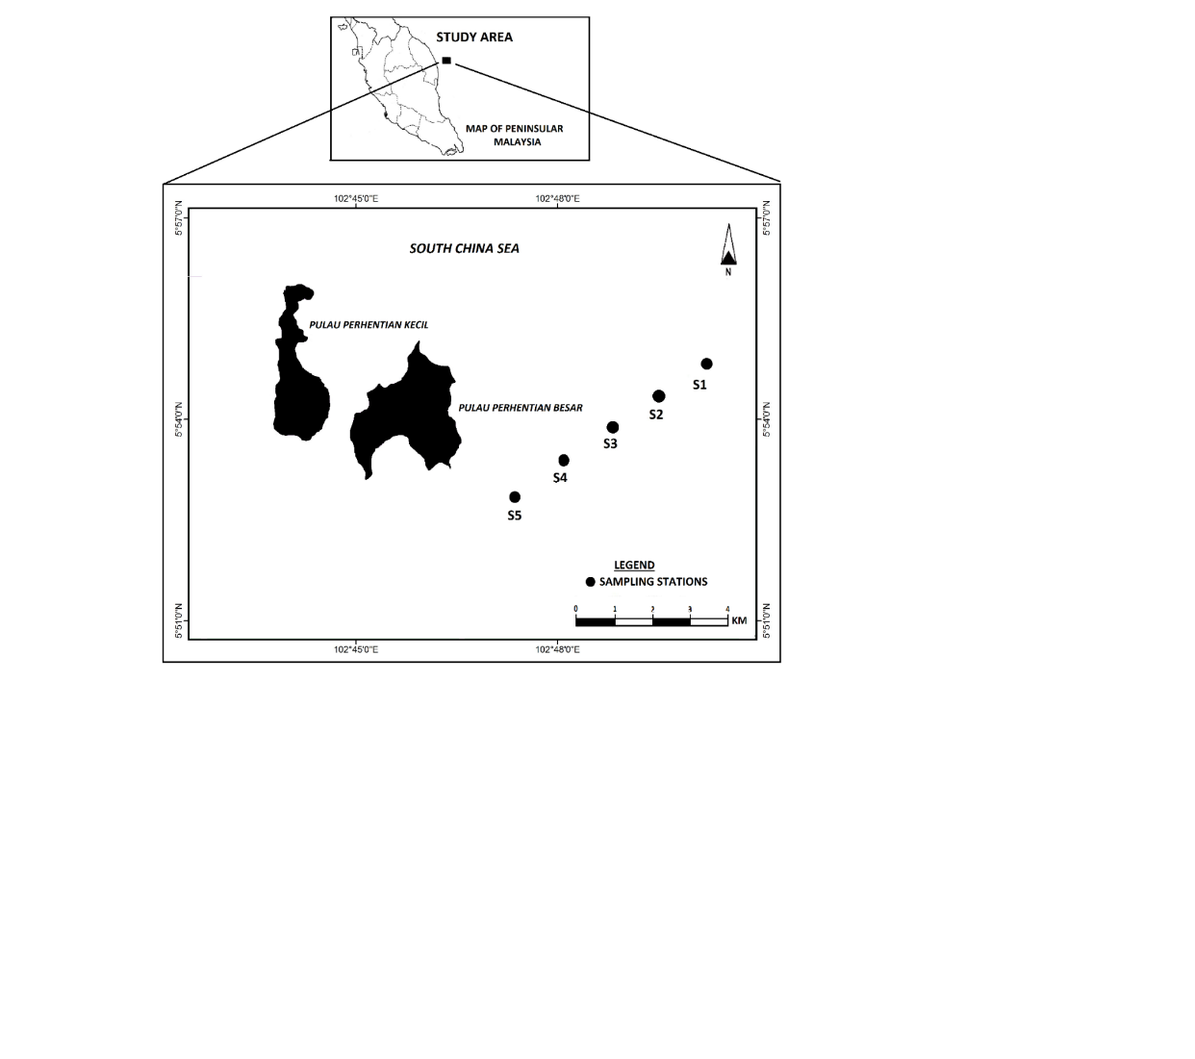
Figure 1. Location of our sampling stations at Pulau Perhentian, Terengganu, Malaysia during sampling activity in November 2015 and April 2016

A seawater sample (10 mL, pH 2) was pipetted into the voltammetry cell and its pH was adjusted to normal seawater pH by adding ammonium hydroxide. A 10 μL of the BES pH buffer was added, followed by a DASA stock solution at final concentration of 10⁻⁵ M. After deaeration of the solution with inert gas (99.999% pure nitrogen) for 5 minutes, the stirrer was started, and the potentiostat was set to -0.9 V. A new mercury drop was then extruded, which signified the beginning of the adsorption time. The stirrer was stopped after 60 s, and 10 s was allowed for the solution to become quiescent. The differential-pulse cathodic-stripping scan was then started, at a rate of 20 mVs⁻¹, with a pulse height of 25 mV and a pulse time of 0.1 s. The aluminium- DASA complex peak appeared at –0.3 V in the seawater sample (Figure 3). The aluminum concentration in the sample was then evaluated from a repeated measurement after adding standard Al, twice.

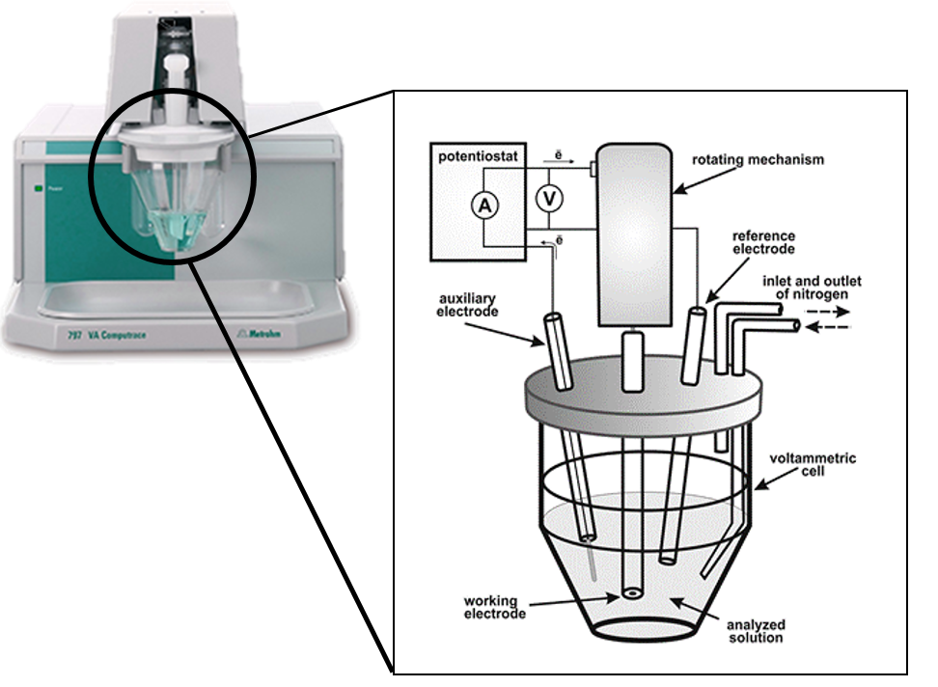
Figure 2. The voltammetry Metrohm Model VA 797 instrument used in dissolved aluminum (dAl) in seawater by using hanging mercury drop electrode (HMDE) as working electrode 1 M KCl, with a platinum wire as the counter electrode. The drop surface area of the HDME was 0.45 mm². A rotating PTFE rod was used to stir the solutions during the deposition step

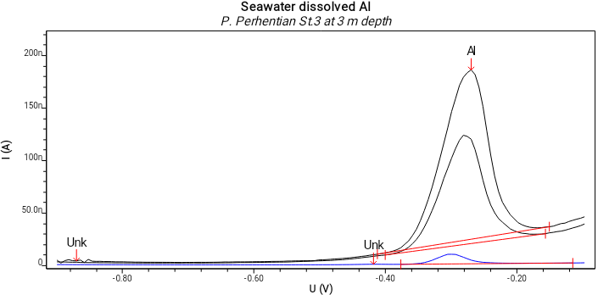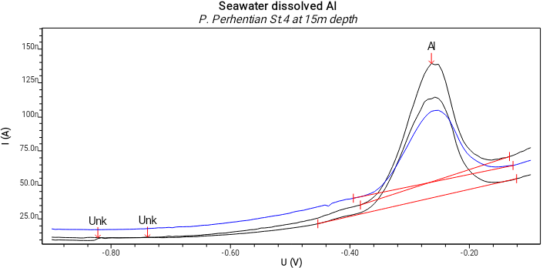
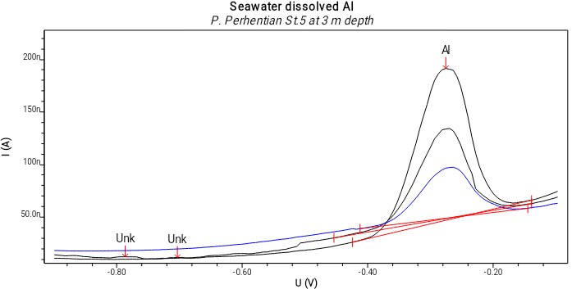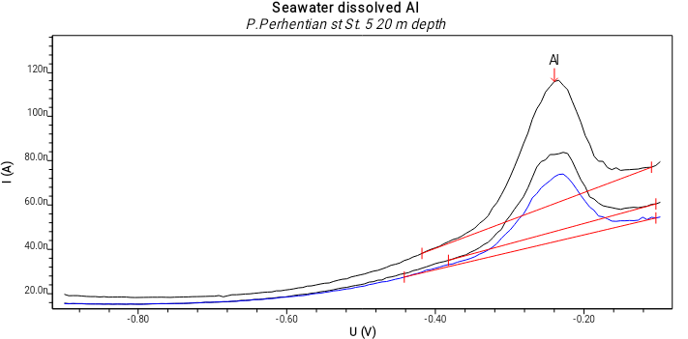
Figure 3. Voltammogram of Al peak under differential pulse mode from seawater sample from St. 3, St. 4 and St.5 at Pulau Perhentian, Terengganu. Voltammetric parameters: deposition time 120 s; deposition potential -1.1 V and start potential -0.15 V

Data for dAl was compared between both sampling periods (November 2015 and April 2016) in order to identify the possible influence of Northeast monsoon on dAl distribution on the surface and throughout the water column. Our sampling during November 2015 and April 2016 was represented as pre-monsoon and post-monsoon events, respectively.

Results nd Discussion
The concentrations of dAl in seawater were determined by cathodic stripping voltammetry, preceded by adsorptive collection of complex ions with 1,2-dihydroxyanthraquinone-3-sulphonic acid (DASA) on the hanging mercury drop electrode. Complexation of aluminium by DASA is rapid and no waiting period or heating of the sample is required. Optimal conditions are achieved with a DASA concentration of 10⁻⁵ M, a solution pH of 7.1-7.3 and an adsorption potential of -0.3 V (Figure 2). The limit of detection is 1 nM aluminium for an adsorption time of 45 s. The total time needed, including 5 minutes deaeration and a standard addition, is 10-15 minutes per sample. No serious interferences were found, and hence we did not need to apply U.V. irradiation on our samples as recommended by Van den Berg et al. [16] for samples containing high levels of organic materials.

Our station was located at the south-east part of Pulau Perhentian, Terengganu which faces the South China Sea (Figure 1) in a transect line. Each station was located approximately 2.0 km away from another station, in order to identify the possible changes between stations. Table 1 below shows the physical parameters at each station during our sampling in April 2016.

Our data for in-situ parameters were plot throughout the column at each station, as shown in Figure 4 below. For temperature, the warmer seawater was recorded in November 2015 from surface to the bottom layer (Figure 2). It was between 29.8ºC - 29.9ºC during November 2015 and 29.3ºC - 29.4ºC during April 2016 at St. 1 (Table 1). The low-temperature value during April 2016 might have been due to the strong land sea breeze and precipitation, as suggested by Govindasamy [17]. We also recorded a higher conductivity condition at St. 1, St. 2 and St. 3 during April 2016 throughout the water column. It was between 22.9 mS/cm - 48.3 mS/cm during November 2015, and between 62.3 mS/cm - 63.4 mS/cm during April 2016 (Table 1) at St. 1.

The range of pH throughout the water column was 8.2-8.3 (Table 1, Figure 4) and 8.0–8.5 (Table 3, Figure 4a) during November 2015 and April 2016, respectively. This indicated that the pH throughout the water column in our study area had remained alkaline during both sampling occurrences. The difference in pH values during both the sampling periods was attributed to factors like removal of CO₂ by photosynthesis through bicarbonate degradation, reduction in salinity and temperature and decomposition of organic matter [18]. A slightly constant pH was recorded during November 2015, compared to April 2016 (Figure 4).

The seawater salinity throughout our study area during November 2015 was slightly low and generally consistent (31.0-32.0 ppt) (Table 1, Figure 4), as compared to the salinity during April 2016 (37.1-39.0 ppt) (Table 1, Figure 4). This could suggest that there was an input of saline water from the South China Sea, resulting from the Northeast monsoon.

During the Northeast monsoon in 2016, a strong El Niño episode had occurred. This episode was among the top 3 strongest episodes since 1979. The duration of this monsoon was longer than usual, in agreement with the finding that monsoons generally last longer during El Niño episodes. It happened in line with a very strong El Niño episode [29]. The wind data from February 2016 review showed pressure level at 850-hPa, indicating a stronger than normal northerly flow over South China Sea, Indochina and Borneo, which converged over the southern South China Sea, Indian Ocean, and the southern Sarawak [29]. Interestingly, a high tide phenomenon also occurred during this month at the Peninsular East Coast, as reported by the Malaysian Meteorological Department and the local news. This condition would contribute to the significantly high readings on all the in-situ parameters on April 2016.

The distribution of dissolved oxygen was observed to be more consistent during November 2015, as compared to April 2016. The range of dissolved oxygen was 5.4 mg/L - 5.9 mg/L (Table 1, Figure 4) and 3.7 mg/L - 6.3 mg/L (Table 1, Figure 4) during November 2015 and April 2016, respectively. In aquatic systems, oxygenation results from an imbalance between the process of photosynthesis, degradation of organic matter [19], and physicochemical properties of water [10, 20].

Table 1. Physical parameters observed at stations during our sampling in November 2015 and April 2016
at Pulau Perhentian, Terengganu
Station (Depth)  Coordinate | Sample  Depth (m) | Temp. (°C) |  | Cond. (mS/cm) |  | pH |  | Salinity (ppt) |  | DO (mg/L) |  | dAl conc. (μg/L)
Station (Depth)  Coordinate | Sample  Depth (m) | Nov. 15 | Apr. 16 | Nov. 15 | Apr. 16 | Nov. 15 | Apr. 16 | Nov. 15 | Apr. 16 | Nov. 15 | Apr. 16 | Nov. 15 | Apr. 16
1 (45.0 m) | 3 | 29.8 | 29.4 | 28.7 | 63.4 | 8.3 | 8.4 | 31.3 | 38.4 | 5.9 | 6.3 | 98.7±0.4 | 74.1±0.2
N 05⁰ 54.791' | 6 | 29.9 | 29.3 | 28.7 | 63.4 | 8.2 | 8.4 | 31.1 | 38.7 | 5.9 | 5.7 | 152.6±1.2 | 55.0±0.1
E 102⁰ 50.563' | 15 | 29.9 | 29.3 | 22.9 | 63.5 | 8.2 | 8.5 | 31.1 | 38.4 | 5.9 | 5.0 | 150.9±0.6 | 39.0±0.5
 | 20 | 29.9 | 29.4 | 48.3 | 63.2 | 8.2 | 8.3 | 31.4 | 38.5 | 5.9 | 3.7 | 208.4±0.9 | 40.7±0.0
 | 30 | 29.9 | 29.3 | 31.4 | 62.3 | 8.2 | 8.3 | 32.0 | 38.5 | 5.9 | 5.5 | 123.3±0.8 | 68.6±0.8
2 (40.2m) | 3 | 30.4 | 30.1 | 47.9 | 63.0 | 8.3 | 8.2 | 31.3 | 38.5 | 5.9 | 5.0 | 92.4±0.4 | 32.7±0.2
N 05⁰ 54.207' | 6 | 30.3 | 30.2 | 47.7 | 63.5 | 8.2 | 8.4 | 31.0 | 38.3 | 5.9 | 3.5 | 117.5±0.4 | 23.0±0.2
E 102⁰ 50.477' | 15 | 30.3 | 29.9 | 47.8 | 63.3 | 8.3 | 8.3 | 31.0 | 39.0 | 5.9 | 3.8 | 256.3±2.9 | 13.1±0.5
 | 20 | 30.1 | 29.3 | 48.0 | 62.4 | 8.2 | 8.3 | 31.2 | 37.4 | 5.9 | 4.3 | 80.7±1.2 | 39.0±0.0
 | 30 |  | 28.9 |  | 62.1 |  | 8.5 |  | 38.3 |  | 4.4 |  | 22.0±0.4
3 (36.5m) | 3 | 30.2 | 29.7 | 47.8 | 63.5 | 8.3 | 8.0 | 31.0 | 38.5 | 5.4 | 4.3 | 88.0±1.8 | 167.3±1.0
N 05⁰ 53.410' | 6 | 30.3 | 29.6 | 43.8 | 63.4 | 8.3 | 8.3 | 31.0 | 38.4 | 5.4 | 4.9 | 43.4±0.2 | 150.2±1.7
E 102⁰ 49.525' | 15 | 30.0 | 29.6 | 48.0 | 63.4 | 8.2 | 8.4 | 31.3 | 38.5 | 5.4 | 4.5 | 59.4±1.0 | 77.7±1.4
 | 20 | 30.1 | 29.7 | 48.0 | 63.3 | 8.2 | 8.4 | 31.3 | 38.5 | 5.4 | 4.5 | 112.1±0.6 | 34.0±0.0
 | 30 |  | 29.2 |  | 62.6 |  | 8.5 |  | 38.4 |  | 4.6 |  | 52.4±0.7
4 (33.30m) | 3 | 33.3 | 29.9 | 47.5 | 63.5 | 8.3 | 8.3 | 30.8 | 38.5 | 5.4 | 6.1 | 16.2±0.4 | 50.8±0.3
N 05⁰ 53.227' | 6 | 33.0 | 29.9 | 47.7 | 63.3 | 8.3 | 8.5 | 30.9 | 38.3 | 5.4 | 4.6 | 22.7±0.1 | 47.4±0.3
E 102⁰ 48.344' | 15 | 33.1 | 30.0 | 47.8 | 63.0 | 8.3 | 8.4 | 31.0 | 38.2 | 5.4 | 4.7 | 23.5±0.2 | 65.6±0.8
 | 20 |  | 29.5 |  | 62.5 |  | 8.1 |  | 38.2 |  | 4.4 |  | 114.9±0.6
5 (29.1m) | 3 | 29.8 | 30.1 | 47.9 | 63.3 | 8.3 | 8.2 | 31.1 | 38.4 | 6.4 | 4.4 | 31.1±0.5 | 31.0±0.3
N 05⁰ 52.746' | 6 | 29.0 | 30.0 | 48.0 | 63.3 | 8.3 | 8.5 | 31.1 | 38.4 | 6.4 | 5.8 | 32.4±0.8 | 31.7±0.0
E 102⁰ 47.048' | 15 |  | 29.7 |  | 63.4 |  | 8.4 |  | 38.5 |  | 4.5 |  | 37.2±0.2
 | 20 |  | 29.8 |  | 63.3 |  | 8.2 |  | 38.5 |  | 5.3 |  | 59.4±0.7

Based on our present in-situ data, it could be suggested that the water column condition at our study area was warmer and slightly stable (less turbulence) during November 2015, as compared to its condition in April 2016, probably due to the Northeast monsoon event, as suggested by Godon and Mohamed [12].

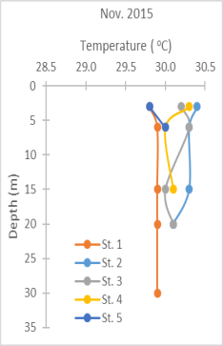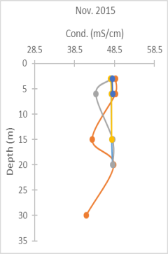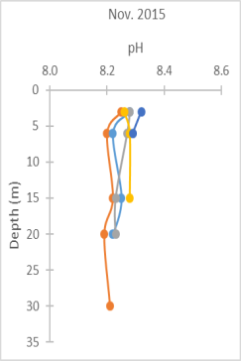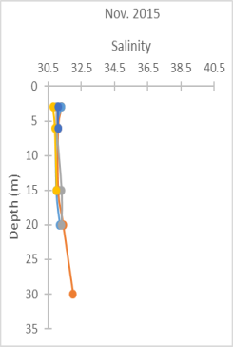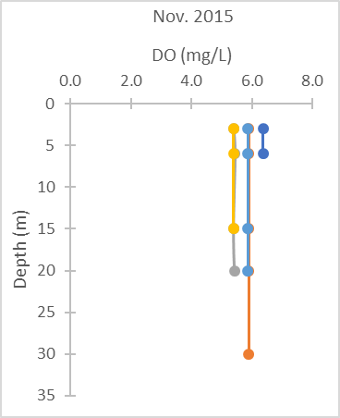
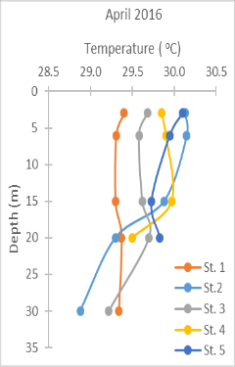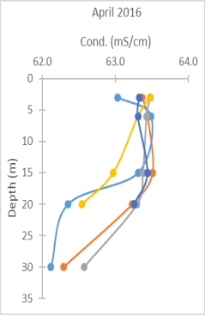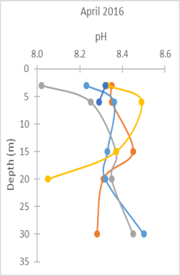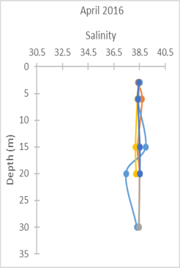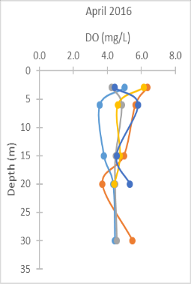
Figure 4. In-situ parameter recorded during our sampling activities at Pulau Perhentian, Terengganu in November 2015 and April 2016

Dissolved Aluminium (dAl) distribution
The concentration of dAl was measured throughout the water column at our study area. The concentrations of dAl during November 2015 and April 2016 are shown in Table 1.

During November 2015, dAl ranged between 31.1 μg/L - 98.7 μg/L at the surface layer (3-meters depth) (Table 1) before it was observed to increase with depth at most of the stations (Figure 5). Its concentration was between 59.4 μg/L - 256.3 μg/L at 15-meter depth (Table 1). On the other hand, dAl concentration ranged between 30.9 μg/L - 167.3 μg/L at the surface (Table 1) and 13.1 μg/L - 77.7 μg/L at 15-meter depth (Table 1) respectively, in April 2016. This shows that the distribution of dAl throughout the water column between both sampling periods differed significantly (p>0.05). During November 2015, its distribution depleted at the surface and increased with depth until the middle layer. On the other hand, its distribution was higher at surface and decreased with depth during April 2016 (Figure 5).

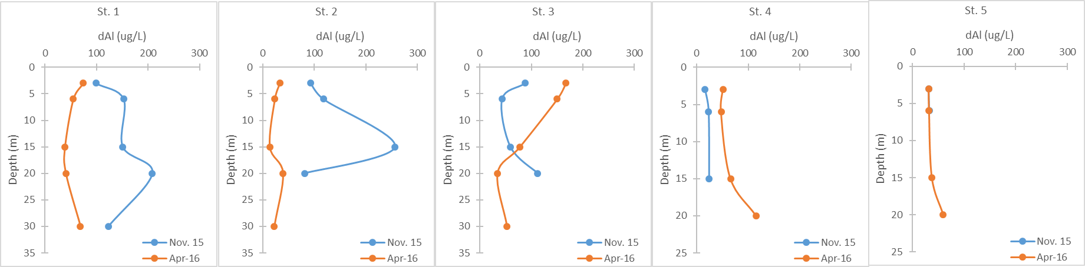
Figure 5. Distribution of dissolved aluminium (dAl) throughout the column at each station at Pulau Perhentian, Terengganu in November 2015 and April 2016

The distribution of dAl was higher in November 2015 as compared to April 2016, throughout the water column at St. 1 and St. 2 (Figure 5). The dAl concentration in November 2015 was about 1.3-19.5 times higher than that in April 2016 at these stations (St. 1 and St. 2). The highest concentration of dAl at 15 m depth (St. 2) during November (Figure 5) was an outlier due to it being unaffected by any in-situ parameters. On the other hand, a significantly different (p>0.05) distribution was recorded at St. 4 and St. 5, where its concentration was higher in April 2016 compared to that in November 2015. The concentration of dAl was about 0.3-3.3 times higher in April 2016. This indicated that a possibly huge input of Al, probably from surface sediment, had enriched its dissolved concentration throughout the water columns at St. 1 and St. 2 (Figure 5) in November 2015.

The increasing concentration of trace metals was due to the high current turbulence during the Northeast monsoon season (October-March), which led to a resuspension of surface sediment. A strong current velocity had released some metals from suspended particulate matter in the water column [8]. However, this input of Al from bottom sediments was less at stations near to the island, resulting in the low and slightly constant dAl concentrations throughout the water columns at St. 4 and St. 5 (Figure 5). According to Hydes [21], dAl is supplied from rivers and the atmosphere to the ocean surface. However, because riverine dAl is rapidly removed within estuaries, its signal in the ocean surface transported by advection-diffusion processes from coastal areas cannot be recognized. Based on our present data, there was a small difference in concentration of dAl at the surface layer (3 m depth) during both periods (Figure 5). There might have been less input from the partial dissolution of Al from atmospheric mineral dust into this area, which indicated that dissolution of aerosol aluminum was a less important source of dAl to these waters.

Our present data was in line with our previous study at the area [12]. During the previous study (October 2014 and April 2015), we also recorded a similar distribution pattern of dAl throughout the water column (Figure 6). The concentration of dAl at the surface layer was low, and at a wider range in the middle depth regions, during October 2014. However, during April 2015 (Figure 6), its concentration was higher at surface layer and slightly constant in the middle depth. This could be the cause of the additional input of dAl into surface layer during April, and different distributions of dAl throughout the water columns during both sampling periods.

Figure 6. Distribution of dAl throughout water column at our study area during November 2015 and April 2016. The distribution of dAl during October 2014 and April 2015 [12]

A low concentration of dAl at the surface layer and high concentration in the middle of the water column during November 2015 (Figure 6) is due to the active biological uptake by phytoplankton at surface layer and remineralization in deeper layer. Biological processes in the coastal ocean can remove dAl. Plankton incorporate significant quantities of aluminum into biological tissue [3, 22-25]. Previously, it was suggested that the dAl concentration in the oceans is controlled by biological activity and the aluminum cycles in the oceans are linked through the activity of diatoms [26]. Lewin [27] suggested that Al and Fe are necessary for the formation of diatom frustules because the adsorption of these cations onto the silica frustules renders them resistant to dissolution. According to the current study by Ramjam and Mohamed [28], they discovered that about 70% of the population was composed of phytoplankton and 30% of zooplankton. The phytoplankton composition mostly consisted of diatoms, followed by cyanobacteria and dinoflagellates. This suggests that during this period in our study area, the dAl was taken up from near-surface waters by diatoms during growth, and was then returned to the solution as dead organisms which decayed and sank through the water columns.

The highest dAl concentration was recorded at St. 3 (167.3 μg/L; Table 1) at the surface layer during April 2016. This station is far away from the island, compared to St. 4 and St. 5 (Figure 1), which have dAl concentrations of 50.8 μg/L and 30.9 μg/L at the surface (Table 1), respectively. Interestingly, the highest dAl concentration was also recorded at the same station previously in April 2015 [12]. Based on in-situ parameters, St. 3 had a lower pH during April 2016 (pH=8.0, Table 1). According to Paquin [2], Al can exist as organic complexes in natural waters and it is thought to be dominated largely by the dissolved inorganic hydrolysis species Al(OH)₂⁺, Al(OH)₃⁰, and Al(OH)₄⁻. However, at pH 8.2, that Al exists entirely in complexes with hydroxide ion, OH⁻, forming the hydrolysis species. At low pH (< 4) it is dominated by the free Al³⁺ ion. At higher pH (≥ 7), the Al speciation is thought to be dominated by Al (OH)₄⁻ or aqueous Al(OH)₃⁰ [30]. This indicates that pH plays an important role in dAl speciation distribution, and this might be an explanation for the highest dAl concentration at our St. 3.

Conclusion
Our present data on dAl distribution has suggested that there is a certain biological processes that occurs in the surface water to remove dAl from the water column. An active biological uptake of dAl by phytoplankton (diatoms) takes place during pre-monsoon seasons (November 2015) in the surface layer. This dAl is then returned to the water column in a deeper layer by the remineralization process. However, during post-monsoon seasons (April 2016), an additional input of Al from surface sediments results in the enrichment of the concentration of dAl in surface water. This indicates the influence of Northeast monsoons, which had resulted in high current turbulences and resuspension of surface sediments, which played an important role in the Al biogeochemistry distribution at Pulau Perhentian. However, further studies on dissolved Al and its speciation are needed to gain better information on its bioavailability to the primary producer in this region during both seasons.

Acknowledgment
Special thanks to Department of Marine Park Malaysia, Ministry of Natural Resources and Environment, and Department of Environmental Sciences, Faculty of Environmental Studies, Universiti Putra Malaysia, for assistance given during the analysis. This study was funded by the Ministry of Higher Education (07-02-14-1533FR).

References
- Bruland K. W. and Lohan M. C. (2003). Controls of trace metals in seawater. Pergamon, Oxford. 23-47.
- Paquin, P. R., Santore, R. C., Wu, K. B., Kavvadas, C. D. and Di Toro, D. M. (2003). The biotic ligand model: A model of the acute toxicity of metals to aquatic life. Environment Science Policy, 3: 175-182.
- Riley, J. P. and Roth, I. (1971). The distribution of trace elements in species of phytoplankton grown in culture. Journal of Marine Biological Association U.K., 51: 63-72.
- Middag, R., De Baar, H. J. W., Laan, P. and Bakker, K. (2009). Dissolved aluminium and the silicon cycle in the Arctic Ocean. Marine Chemistry, 115 (3–4): 176-195.
- Matthew P. M., Diane, M. M., Steven, C. C. and Mark W. W. (2009). A model of degradation and production of three pools of dissolved organic matter in an alpine lake. Limnology and Oceanography, 54(6): 2213-2227.
- Measures, C. I. and Vink, S. (2000). The use of dissolved aluminum in surface waters to estimate dust deposition to ocean. Global Biogeochemical Cycles, 14(1): 317-327.
- Koh, M. K., Suratman, S. and Mohd Tahir, N. (2015). Dissolved and suspended particulate metals in Setiu River Basin, Terengganu. Sains Malaysiana, 44(7): 957-964.
- Adiana, G., Shazili, N.A.M., Marinah, M.A. and Bidai, J. (2013). Effects of northeast monsoon on trace metal distribution in the South China Sea of Peninsular Malaysia. Environmental, Monitoring and Assessment, 186: 421-431.
- Yap, C. K., Chee, M. W., Shamarina, S., Edward, F. B., Chew, W. and Tan, S. G. (2011). Assessment of surface water quality in the Malaysian coastal waters by using multivariate analyses. Sains Malaysiana, 40(10): 1053-1064.
- Ahmad, A. K., Musrifah, L. and Othman, M. S. (2009). Water quality and heavy metal concentrations in sediment of Sungai Kelantan, Kelantan, Malaysia: A Baseline study. Sains Malaysiana, 38(4): 435-442.
- Yusof, N., Haraguchi, A., Hassan, M. A., Othman, M. R., Wakisaka, M. and Shirai, Y. (2009). Measuring organic carbon, nutrients and heavy metals in rivers receiving leachate from controlled and uncontrolled municipal solid waste (MSW) landfills. Waste Management, 29: 2666-2680.
- Godon, E. and Mohamed, K. N. (2016). Distribution of dissolved Fe, Al and Cu at Perhentian Island, Terengganu. In-house Seminar of the Chemical Oceanography Laboratory, Issue 1, Vol. II: pp. 12-18.
- Lim, J. T. and Azizan, A. S. (2004). Weather and Climate of Malaysia. University of Malaya Press.
- Stewart C. R. (2008). Proline accumulation: Biochemical aspects. In: Paleg LG, Aspinall D (Eds), Physiology and Biochemistry of Drought Resistance in Plants. 243-251.
- Achterberg, E. P. and Braungardt, C. (2001). Stripping voltammetry for the determination of trace metal speciation and in-situ measurements of trace metal distributions in marine waters. Analytical Chemical Acta, 400: 381-397.
- Van den Berg, C. M. G., Buckley, P. J. M., Huang, Z. Q. and Nimmo, M. (1986). An electrochemical study of the speciation of copper, zinc and iron in two estuaries in England. Estuarine and Shelf Science, 22: 479-486.
- Govindasamy, C., Kannan, L. and Azariah, J. (2000). Seasonal variation in physico- chemical properties and primary production in the coastal water biotopes of Coromandel Coast, India. Journal Environment Biology, 21: 1-7.
- Rajasegar, M., Srinivasan, M. and Rajaram, R. (2003). Phytoplankton diversity associated with the shrimp farm development in Vellar estuary, south India. Seaweed Research, 22: 125-131.
- Granier, A., Biron, P. and Lemoine, D. (2000). Water balance, transpiration and canopy conductance in two beech stands. Agricultural and Forest Meteorology, 100: 291-308.
- Aston, S. R. (1980). Evaluation of the chemical forms of plutonium in seawater. Marine Chemistry, 8: 319- 325.
- Hydes, D. J. (1989). Seasonal variation in dissolved aluminium concentrations in coastal waters and biological limitation of the export of the riverine input of aluminium to the deep sea. Continental Shelf Research, 9: 919 -929.
- Martin, J. H. and Knauer, G. A. (1973). The elemental composition of plankton. Geochimica Cosmochimica Acta, 37: 1639-1653.
- Bostrom, K., Burman, B., Ponter, C., Brandlof, S. and Alm, B. (1978). Geochemistry, minerology, and origin of the sediments in the Gulf of Bothnia. Finnish Marine Research, 224: 8-36.
- Collier, R. and Edmond, J. (1984). The trace element geochemistry of marine biogenic particulate matter. Progress in Oceanography, 13: 113-199.
- Noriki, S., Ishimori, N, Harada, K. and Tsunogai, S. (1985). Removal of trace metals from sea water during phytoplankton bloom as studied with sediment traps in Funka bay, Japan. Marine Chemistry, 17: 75-89.
- Mackenzie, F. T., Stoffyn, M. and Wollast, R. (1978). Aluminum in seawater: control by biological activity. Science, 199: 680-682.
- Lewin, J. C. (1961). The dissolution rate of silica from diatom walls. Geochimica Cosmochimica Acta, 21: 182-195.
- Ramjam, J. and Mohamed, K. N. (2017). Determination of dissolved nutrients at Pulau Redang, Terengganu. Thesis of Bachelor in Environmental Science and Technology, Universiti Putra Malaysia.
- Sang, Y. W., Adam, M. K. M., Fakaruddin, F. J., Saleh, F. Z., Chang, N. K., Yunus, F. and Abdullah, M. H. (2016). Review of The November 2015 – March 2016 Northeast Monsoon in Malaysia. Malaysian Meteorological Department, MOSTI Research Publication 4/2016
- Turner, D. R., Whitfield, M. and Dickson, A. G. (1981). The equilibrium speciation of dissolved components in freshwater and seawater at 25 ºC and 1 atm pressure. Geochimica Cosmochimica Acta, 45: 855-881.

