

MALAYSIAN JOURNAL OF ANALYTICAL SCIENCES
ISSN 1394 - 2506

Published by The Malaysian Analytical Sciences Society

DISTRIBUTION AND SOURCEs OF POLYCYCLIC AROMATIC HYDROCARBONS IN COASTAL SURFACE SEDIMENTS OFF TERENGGANU

(Taburan dan Sumber Hidrokarbon Polisiklik Aromatik dalam Sedimen Permukaan Pesisir Pantai Terengganu)

Mohd Mursyid Mohd Sanip¹, Muhammad Fais Fadzil¹, Suhaimi Suratman¹, Shahirah Rozmi²,
Norhayati Mohd Tahir²*

¹Institute of Oceanography and Environment
²Faculty of Science and Marine Environment
Universiti Malaysia Terengganu, 21030 Kuala Nerus, Terengganu, Malaysia

*Corresponding author: hayati@umt.edu.my

Received: 30 October 2018; Accepted: 26 September 2019

Abstract
PAHs (Polycyclic Aromatic Hydrocarbons) are a group of pollutants that are of concern in the marine environment. This study determines the distribution and sources of PAHs in surface sediments of the Terengganu coast. Sediments from sixteen stations along the Terengganu coast were collected using Smith Mclntyre grab. PAHs in the sediment samples were extracted using the ultra-sonication method, with dichloromethane (DCM): methanol (MeOH) (3:1 v/v) as solvent. After cleaning up using the saponification technique, the nonpolar component was fractionated using a silica column; and the PAH compounds were eluted using DCM: hexane (1:1 v/v) mixture. Nineteen PAH compounds were determined using a Shimadzu gas chromatography which was fitted with a mass spectrometer detector (Shimadzu GC-2010 Plus). The total concentration of PAHs detected ranged between 20-790 ng/g. Calculation of several molecular ratios for PAHs such as Anthracene/ (Anthracene+Phenanthrene) (Ant/(Ant+Phe)), Phenanthrene/Anthracene (Phe/Ant), Benzo(a)anthracene/Chrysene (BaA/Chr), (Benzo(a)anthracene/(Benzo(a)anthracene+Chrysene)) (BaA/(BaA+Chr)), and low molecular weight/high molecular weight of PAHs (LMW/HMW), yielded values ranging from 0.10–0.97, 0.03-9.40, 0.13-51.4, 0.12-0.98, and 0.03-1.26, respectively. These values suggested that the PAHs found in the surface sediments of the study area mainly originated from pyrolytic sources. The level of PAH contamination in the sediments was between low to moderate. Retene was also detected throughout the study area, indicating a minor contribution of biogenic PAHs to the sediment.

Keywords: surface sediments, polycyclic aromatic hydrocarbons, east coast Peninsular Malaysia, pyrolytic sources, PAHs diagnostic ratios

Abstrak
PAH (Hidrokarbon Aromatik Polisiklik) adalah salah satu pencemaran yang menjadi kerisauan pada alam marin. Tujuan kajian ini adalah untuk mengkaji taburan dan sumber PAH di sedimen persisir pantai Terengganu. Sampel sedimen dari 16 stesen sepanjang persisir pantai Terengganu telah diambil dengan menggunakan pencakup Smith Mclntyre. PAHs dari sedimen diekstrak melalui teknik ultra sonikasi, dengan mengunakan diklorometana (DCM): metanol (MeOH) (3:1 v/v) sebagai pelarut. Selepas pembersihan melalui teknik saponifikasi, komponen yang tak berkutub telah dipisahkan dengan mengunakan turus silika; PAH telah dialirkan keluar dengan pelarut DCM: heksana (1:1 v/v). Sebanyak 19 sebatian PAH telah ditentukan dengan menggunakan Shimadzu kromatografi gas disuaipadankan bersama pengesan spektrometer jisim (Shimadzu GC-2010 Plus). Jumlah kepekatan PAH yang dikesan adalah dalam lingkungan 20-790 ng/g. Beberapa nisbah molekul bagi PAH seperti Antracena/(Antracena+Fenantrena) (Ant/(Ant+Phe)), Fenantrena/Antracena (Phe/Ant), Benzo(a)antracena/Chrysene (BaA/Chr), (Benzo(a)antracena/(Benzo(a)antracena+Chrysene)) (BaA/(BaA+Chr)), dan berat molekul rendah/berat molekul tinggi bagi PAH (LMW/HMW) telah dikira. Nilai nisbah yang dikira masing-masing adalah 0.10–0.97, 0.03-9.40, 0.13-51.4, 0.12-0.98, dan 0.03-1.26 menyarankan PAH yang dijumpai pada sedimen permukaan di kawasan kajian adalah berasal dari sumber pirolitik. Kadar pencemaran PAH dalam sedimen permukaan adalah di antara rendah dan sederhana. Retene turut dikesan di seluruh kawasan kajian menunjukkan terdapat sumbangan kecil PAH biogenik kepada sedimen.

Kata kunci: sedimen permukaan, polisiklik aromatik hidrokarbon, pantai timur Semenanjung Malaysia, sumber pirolitik, nisbah diagnostik PAH

Introduction

PAHs are a group of anthropogenic pollutants that are widely distributed in the environment. Their presence is of concern because many of these PAHs have carcinogenic and mutagenic properties [1]. In the marine ecosystem itself, PAH contaminants may cause long-term adverse effects to the marine life [2]. PAHs in the marine ecosystem generally can be classified into two major sources, viz. natural, also known as biogenic, and anthropogenic sources [1]. Biogenic PAHs such as Retene and Perylene naturally exist at low concentrations in water and sediments. The sources of natural PAHs may come from the biosynthesis processes of marine organisms, terrestrial plant waxes, and through diagenesis transformations of organic matter (after deposited in sediment) into PAHs [3, 4]. On the other hand, the anthropogenic PAHs are introduced into the marine ecosystem through human activities such as domestic and industrial wastewater discharges, oil exploration, and harbor activities. In aquatic environments, due to the hydrophobic characteristics of PAHs, these compounds are rapidly deposited in sediment as a final sink [1, 3]

The sources of anthropogenic PAHs in the environment can be classified according to their formation mechanism, as petrogenic or pyrolytic sources. The petrogenic sources are mainly derived from unburned fossil fuel or crude oil itself, whereas the pyrolytic PAHs are formed through incomplete combustion of organic matter (e.g. wood, coal, petroleum) [4, 5]. In order to distinguish the differences between PAH origins and sources, previous researchers have used several molecular diagnostic ratios to identify PAHs derived from petrogenic and pyrolytic sources. Yunker et al. [6] proposed several diagnostic ratios; among the proposed ratios were Anthracene/(Anthracene+Phenanthrene) (Ant/(Ant+Phe)), Phenanthrene/Anthracene (Phe/Ant), (Benzo(a)anthracene/(Benzo(a) +Chrysene)) (BaA/(BaA+Chr)), and Benzo(a)anthracene/Chrysene (BaA/Chr). Other researchers [3-5, 7, 8] also used similar ratios to determine sources of PAHs formed in their sediments. Additionally, Lukman [5], Mohd Tahir et al. [3] and Topal [4] used the ratio value of low molecular weight/high molecular weight PAHs (LMW/HMW) to differentiate between petrogenic and pyrolytic sources. These diagnostic ratios and their proposed values are listed in Table 1.

Table 1. PAHs diagnostic ratios
Ratio | Petrogenic | Mixed | Pyrolytic | References
Ant/(Ant+Phe) | <0.1 |  | >0.1 | [6]
Phe/Ant | >10 |  | <10 | [6,7]
BaA/(BaA+Chr) | <0.2 | 0.2-0.35 | >0.35 | [3,5,6]
BaA/Chr | <1 |  | >1 | [6,8]
LMW/HMW | >1 |  | <1 | [3-5]
Ant: Anthracene, Phe: Phenanthrene, BaA: Benzo(a)anthracene,
Chr: Chrysene, LMW/HMW: PAHs with 2-3 rings relative to PAHs with 4-6 rings

The Terengganu coast is located in the east coast of Peninsular Malaysia. Main human activities that might contribute to the presence of PAHs in the area are operational discharge from fishing vessels, tourist boats and ferries activities plying between the mainland and several nearby islands (Pulau Tenggol, Pulau Kapas, Pulau Redang, and Pulau Perhentian), oil and gas exploration, and other maritime activities. Furthermore, human activities on land such as fuel combustion (vehicle-powered by diesel or gasoline fuel), forest or grass burning, and surface runoff from urban areas also tend to contribute PAHs into the marine ecosystem. Studies on PAH contaminations at the Terengganu coast are still limited. Elias et al. [2] reported on the contamination of PAHs in the surface sediment of east coast of peninsular Malaysia. The concentration of total PAHs in the surface sediment of Kuala Terengganu and Kuala Dungun coast are 270 ng/g and 290 ng/g, respectively.

Mohd Tahir et al. [9] had reported on the distribution and sources of PAHs in sediment cores from the Southern Terengganu coast, covering an area from Dungun to Kemaman coast. The concentration of total PAHs from the sediment cores that were collected during May and September 2007 ranged from 6.01 ng/g - 20.2 ng/g and 4.89 ng/g - 34.7 ng/g, respectively. Likewise, Chiu et al. [10] had reported on the distribution of PAHs in surface sediments of the Pulau Kapas area. The reported concentration of total PAHs from 12 stations ranged from 43 ng/g - 336 ng/g. These three studies suggested that the Terengganu coast is contaminated with a large number of pyrolytic PAH sources [2, 9, 10]. This present study, on the other hand, focuses on a wider area covering the whole coast of Terengganu state, starting from near the coast to approximately 100 km towards offshore. The main objective of this study is to fill the data gap for future references on the monitoring of our coastal environments, specifically on natural and anthropogenic PAHs off the Terengganu coast.

Materials and Methods

Study area

Sampling was carried out during 6th-13th May 2014 using the RV Discovery. Sixteen sampling sites (station 1-16) were selected along the Terengganu coast, covering an area from Bachok (Tok Bali) to Kemaman (Kerteh) (Figure 1). The coordinates of the stations are shown in Table 2. Water depth was generally shallow near the shore and deeper offshore, with depths ranging from 15.6 m to 59.8 m. Surficial samples were collected using a Smith Mc-Intyre grab sampler. Sediment samples were then transferred into a pre-cleaned aluminum foil container (pre-rinsed with hexane) using a stainless-steel spatula, refrigerated at -20 ºC, and then transported to the laboratory.

Figure 1. Sampling stations at Terengganu coast

Table 2. Coordinates and water depth of chosen sampling stations at Terengganu coast
Station | Latitude (DD) | Longitude (DD) | Water Depth (m)
1 | 6.083790000 | 102.5906830 | 22.2
2 | 6.505767000 | 102.9297950 | 59.8
3 | 7.088330000 | 103.3979570 | 55.5
4 | 6.727781000 | 103.6850770 | 43.6
5 | 6.157149000 | 103.2265030 | 55.2
6 | 5.769532000 | 102.9150040 | 15.6
7 | 5.544715000 | 103.0227370 | 25.0
8 | 5.479661000 | 103.2829690 | 33.6
9 | 5.822548000 | 103.6430020 | 39.1
10 | 6.194689000 | 104.0337520 | 54.3
11 | 6.061839000 | 104.5462690 | 55.5
12 | 5.550546000 | 104.0094080 | 48.4
13 | 4.970750000 | 103.4006389 | 31.4
14 | 4.494508333 | 103.5289111 | 16.5
15 | 4.563722222 | 103.8404917 | 31.0
16 | 4.696044444 | 104.6261278 | 45.5

Sample pre-treatment
The sediment samples were freeze-dried and then sieved using a 500 µm sieve. Analysis was carried out on the fraction <500 µm [11].

Extraction and fractionation
After freeze-drying, 20 g of sediments was extracted using the ultra-sonication method with dichloromethane (DCM): methanol (MeOH) (3:1 v/v) as solvent. Before extraction, internal standards Phenanthrene-d₁₀ and Perylene-d₁₂, were spiked into the sediment samples for recovery assessment [11]. The extracts were concentrated to about 3 mL using a rotary evaporator (at temperature <35 °C) then cleaned up using the saponification technique (isolation of polar and non-polar compounds) [12]. The non-polar component was concentrated to about 1 mL and fractionated into sub fractions on a silica column (5% deactivated using deionized water). Alkanes (fraction 1) was eluted using 3.5 mL of hexane, followed by PAHs (fraction 2) using 4 mL of 10% DCM in hexane and 3 mL of 50% DCM in hexane. Only the PAHs fraction was analyzed in this study.

A total of 19 PAHs were analysed in this study. The sum of these compounds is reported as total PAHs (∑PAH). Out of the 19 compounds analysed, 16 of them are classified as priority PAH pollutants by the United States Environmental Protection Agency (USEPA), based on their most harmful characteristics and their existence in the environment [11]. These 16 PAHs are; Naphthalene (Nap), Acenaphtylene (Acp), Acenaphtene (Ace), Fluorene (Flo), Phenanthrene (Phe), Anthracene (Ant), Fluoranthene (Fla), Pyrene (Pyr), Benzo(a)anthracene (BaA), Chrysene (Chr), Benzo(b)fluoranthene (BbF), Benzo(k)fluoranthene (BkF), Benzo(a)pyrene (BaP), Indeno(1,2,3–cd)pyrene (IcP), Dibenzo(a,h)anthracene (DaA) and Benzo(g,h,i)perylene (BgP). The sum of these 16 PAHs is denoted as ${∑PAH}_{16}$. The other three PAHs that were analysed were Retene (Retene), Perylene (Pery) and Benzo(e)pyrene (BeP).

Gas chromatography-mass spectroscopy analysis
The identification and quantification of PAHs was carried out using Shimadzu GC-2010 Plus. The GC-MS operating conditions were as follows: SGE BP5MS fused silica capillary column (29.7 m length x 0.32 mm internal diameter, 0.25 μm filmed thicknesses); injection temperature was set at 290 ˚C using splitless mode; the column temperature for the analysis was programmed as follows: hold for 1 minute at 50 ˚C; 60 ˚C – 290 ˚C at 5 ˚C/min; maintained at 290 ˚C for 15 minutes; GC-MS interface was set to 300 ˚C; helium gas was used as the carrier gas at a constant pressure of 500 kPa with a column flow rate of 1.19 mL/min. The identification and quantification of PAHs was based on ion fragmentation, and retention time compared to the external PAHs standard [13].

Recovery and limit of detection
The recovery of the internal standards, Phenanthrene-$d_{10}$ and Perylene-$d_{12}$, ranged from 70% - 81% and 85% - 96%, with an average value of 72% and 92%, respectively. The sample was then corrected for analytical loss [11]. The ranges for Limit of Detection (LOD) and Limit of Quantitation (LOQ) in this study were 0.01 ng/g - 0.23 ng/g and 0.03 ng/g - 0.76 ng/g, respectively.

Results and Discussion
Total PAHs (ΣPAH) detected in this study is shown in Figure 2 and Table 3. The ΣPAH detected ranged between 20.0 ng/g and 790 ng/g, with an average concentration 131 ng/g. The highest ΣPAH detected was at station 14 and station 7, with values of 790 ng/g and 541 ng/g, respectively. Both stations were located in the coastal area that could potentially receive PAH sources from the nearest river mouth; Sungai Kerteh and Sungai Merang, respectively. On the other hand, station 11 recorded the lowest ΣPAH at 20.0 ng/g. It is located farthest from the coast (offshore). According to Baumard et al. [14], the level of PAHs pollution is considered low if the value of sum PAHs concentration < 100 ng/g, and moderate if the concentration < 1000 ng/g. Tolosa et al. [7] also used these criteria to evaluate the level of PAHs pollution. Using the criteria proposed by Baumard et al [14], the level of PAHs contamination in the surface sediment of the Terengganu coast can be concluded to be between low and moderate. This finding is consistent with the findings reported by earlier researchers in the Terengganu coast [2, 9, 10].

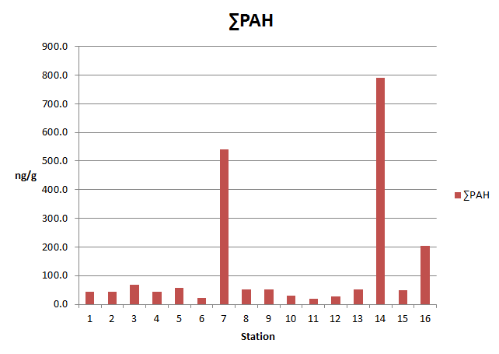
Figure 2. Concentration and distribution of ΣPAH with station

The composition of PAHs in sediments may reveal the sources from which these PAHs were derived [15, 16]. Higher concentrations of low molecular weight (LMW) PAHs (2- and 3-ring compounds) such as Nap, Acp, Ace, Flo, Phe, and Ant most commonly occur in sample matrices contaminated with petrogenic sources. On the other hand, PAHs originating from pyrolytic sources often contain elevated concentrations of high molecular weight (HMW) PAHs (4- to 6-ring compounds) such as Fla, Pyr, BaA, Chr, BbF, BkF, BaP, IcP, DaA, and BgP [17]. Figure 3 shows the distribution of a PAH compound according to the number of benzene rings in its molecular structure. In this study, the distributions of PAH compounds was found to vary with station. While a majority of the stations showed an abundance of HMW PAHs (4- to 6-rings), only stations 3, 8, and 11 showed the abundance of LMW PAHs (3-rings). The overall order of abundance of PAHs detected in the sediments was 6 rings> 5 rings> 3 rings> 4 rings. The abundance of total HMW PAH compounds detected in the majority of the stations suggested that there were significant inputs of pyrolytic sources in the Terengganu coast.

The calculated values of selected diagnostic ratios are shown in Table 3. In the case of LMW/HMW ratio, values obtained ranged from 0.03-1.26. LMH/HMW <1 has been suggested as an input from pyrolytic sources, whereas ratio values >1 are derived from petrogenic sources [3-5]. In this study, the majority of the sampling area showed the input of the pyrolytic PAH sources (Figure 4). Only stations 8 and 11 indicated a slight petrogenic PAH contamination, with the ratio values of 1.21 and 1.26, respectively.

Table 3. Concentration level PAHs (ng/g), sum (ng/g), and selected diagnostic ratios
 | PAH Compounds | Station
 |  | 1 | 2 | 3 | 4 | 5 | 6 | 7 | 8 | 9 | 10
LMW | Napthalene (Nap) | 3.14 | 6.41 | 9.30 | 6.69 | 2.67 | 5.12 | 6.82 | 3.78 | 5.07 | 2.30
LMW | Acenaphthene (Ace) | 1.14 | 0.34 | 0.89 | 0.61 | 0.29 | 0.10 | 0.11 | 0.63 | 4.07 | BDL
LMW | Acenaphthylene (Acp) | 0.75 | 2.16 | 2.36 | BDL | 0.22 | 1.02 | 0.074 | 0.72 | BDL | 0.52
LMW | Fluorene (Flo) | 0.42 | 1.20 | 0.53 | 0.22 | 0.20 | 0.40 | 0.52 | 0.83 | BDL | 0.35
LMW | Phenanthrene (Phe) | 2.91 | 1.21 | 5.83 | 4.15 | 0.75 | 1.64 | 4.83 | 0.62 | 4.94 | 0.53
LMW | Anthracene (Ant) | 1.12 | 2.97 | 3.79 | 1.68 | 0.43 | 0.28 | 1.05 | 20.8 | 1.25 | 0.28
LMW | Retene (Retene) | 1.63 | 6.65 | 2.95 | 1.25 | 16.7 | 1.58 | 3.99 | 0.74 | 13.7 | 1.51
HMW | Fluoranthen (Fla) | 0.38 | 0.96 | 1.14 | 0.80 | 0.26 | 0.17 | 43.0 | 0.34 | 2.69 | 0.59
HMW | Pyrene (Pyr) | 1.53 | 1.23 | 4.20 | 6.35 | 0.69 | 0.62 | 0.54 | 2.75 | 0.30 | 0.61
HMW | Benzo(a)anthracene (BaA) | 0.26 | 0.24 | 1.80 | 1.12 | 1.02 | 0.86 | 9.46 | 0.03 | 0.04 | 0.47
HMW | Chrysene (Chr) | 0.98 | 0.35 | 1.94 | 0.30 | 1.02 | 0.01 | 3.93 | 0.16 | 0.32 | 0.38
HMW | Benzo(b)fluoranthene (BbF) | 13.3 | 1.59 | 5.43 | ND | 2.34 | ND | 43.5 | 8.27 | 1.28 | 2.13
HMW | Benzo(k)fluoranthene (BkF) | 1.55 | 0.69 | 1.92 | 2.76 | 1.88 | ND | 39.8 | 0.95 | 0.86 | 6.28
HMW | Benzo(e)pyrene (BeP) | 0.34 | 0.08 | 3.03 | 0.44 | 2.27 | ND | 106 | 0.06 | 1.25 | 2.52
HMW | Benzo(a)pyrene (BaP) | 1.45 | 2.27 | 2.47 | 6.46 | 3.07 | ND | 53.6 | 0.89 | 0.94 | 0.98
HMW | Perylene (Pery) | 0.80 | 1.01 | 13.0 | 1.76 | 15.1 | 3.53 | 97.0 | 0.09 | 0.85 | 4.58
HMW | Indeno(1,2,3-cd)pyrene (IcP) | 1.11 | 9.15 | 4.63 | 8.04 | 7.96 | 2.96 | 35.2 | 7.37 | 9.51 | 2.67
HMW | Dibenzo(a,h)anthracene (DaA) | 5.93 | 3.86 | 0.68 | 1.19 | 1.42 | 2.89 | 31.2 | ND | 1.59 | 2.25
HMW | Benzo(g,h,i)perylene (BgP) | 4.91 | 2.30 | 2.82 | ND | ND | ND | 59.9 | 1.63 | 2.88 | 1.39
 | ∑PAH | 43.7 | 44.7 | 68.7 | 43.8 | 58.3 | 21.2 | 541 | 50.7 | 51.6 | 30.4
 | LMW | 9.48 | 14.3 | 22.7 | 13.4 | 4.59 | 8.56 | 13.4 | 27.4 | 15.3 | 4.00
 | HMW | 32.6 | 23.7 | 43.1 | 29.2 | 37.0 | 11.1 | 523 | 22.6 | 22.5 | 24.9
PAHs Indices | LMW/HMW | 0.29 | 0.60 | 0.52 | 0.45 | 0.12 | 0.77 | 0.03 | 1.21 | 0.68 | 0.16
PAHs Indices | Phe/Ant | 2.59 | 0.40 | 1.54 | 2.47 | 1.76 | 5.70 | 4.62 | 0.03 | 3.96 | 1.87
PAHs Indices | Ant/(Ant+Phe) | 0.27 | 0.71 | 0.39 | 0.28 | 0.36 | 0.14 | 0.17 | 0.97 | 0.20 | 0.34
PAHs Indices | BaA/Chr | 0.26 | 0.69 | 0.92 | 3.73 | 1.00 | 51.4 | 2.41 | 0.20 | 0.13 | 1.25
PAHs Indices | BaA/(BaA+Chr) | 0.21 | 0.40 | 0.48 | 0.78 | 0.49 | 0.98 | 0.70 | 0.17 | 0.11 | 0.55
BDL= below detection limit; ND = not detected; Phe/Ant = Phenanthrene/Anthracene;
Ant/(Ant+Phe) = Anthracene/(Anthracene+Phenanthrene); BaA/Chr = Benzo(a)anthracene/Chrysene;
BaA/(BaA+Chr) = (Benzo(a)anthracene/(Benzo(a)anthracene+Chrysene));
LMW/HMW = low molecular weight/high molecular weight

Table 3 (cont’d). Concentration level PAHs (ng/g), sum (ng/g), and selected diagnostic ratios
 | PAH Compounds | Station
 |  | 11 | 12 | 13 | 14 | 15 | 16
LMW | Napthalene (Nap) | 5.12 | 4.42 | 4.39 | 6.29 | 5.14 | 6.64
LMW | Acenaphthene (Ace) | 3.56 | 1.64 | 5.44 | 0.35 | 0.16 | 1.28
LMW | Acenaphthylene (Acp) | 1.38 | 1.69 | 3.82 | 10.8 | 1.06 | 2.10
LMW | Fluorene (Flo) | 0.21 | 0.11 | 1.02 | 31.9 | 8.46 | 4.46
LMW | Phenanthrene (Phe) | 0.66 | 0.61 | 0.96 | 3.12 | 1.19 | 0.80
LMW | Anthracene (Ant) | 0.07 | 1.32 | 1.88 | 2.36 | 2.62 | 4.69
LMW | Retene (Retene) | 0.23 | 3.84 | 1.11 | 3.35 | 0.64 | 5.42
HMW | Fluoranthen (Fla) | 0.56 | 0.36 | 0.31 | 0.47 | 0.49 | 0.14
HMW | Pyrene (Pyr) | 2.94 | 1.28 | 1.62 | 0.95 | 22.3 | 7.73
HMW | Benzo(a)anthracene (BaA) | 0.17 | 0.85 | 0.59 | 9.17 | 0.04 | 7.62
HMW | Chrysene (Chr) | 0.21 | 0.29 | 2.42 | 2.47 | 0.17 | 5.66
HMW | Benzo(b)fluoranthene (BbF) | 0.71 | 3.47 | 2.34 | 670 | 1.23 | 4.13
HMW | Benzo(k)fluoranthene (BkF) | 1.27 | 1.41 | 1.07 | 12.3 | ND | 14.1
HMW | Benzo(e)pyrene (BeP) | 0.72 | 0.81 | 1.01 | 2.18 | 0.05 | 6.60
HMW | Benzo(a)pyrene (BaP) | 0.46 | 1.14 | 0.34 | 10.4 | ND | 31.2
HMW | Perylene (Pery) | 1.30 | 0.03 | ND | 4.57 | 0.01 | 27.8
HMW | Indeno(1,2,3-cd)pyrene (IcP) | 0.30 | 3.39 | 19.8 | 5.21 | 1.29 | 30.7
HMW | Dibenzo(a,h)anthracene (DaA) | ND | 0.14 | ND | 6.63 | 2.37 | 26.2
HMW | Benzo(g,h,i)perylene (BgP) | 0.04 | 1.57 | 2.39 | 7.20 | 2.43 | 16.9
 | ∑PAH | 20.0 | 28.4 | 50.6 | 790 | 49.7 | 204
 | LMW | 11.0 | 9.79 | 17.5 | 54.8 | 18.6 | 20.0
 | HMW | 8.71 | 14.8 | 32.0 | 731 | 30.4 | 179
PAHs Indices | LMW/HMW | 1.26 | 0.66 | 0.54 | 0.07 | 0.61 | 0.11
PAHs Indices | Phe/Ant | 9.40 | 0.46 | 0.51 | 1.32 | 0.45 | 0.17
PAHs Indices | Ant/(Ant+Phe) | 0.09 | 0.68 | 0.66 | 0.43 | 0.68 | 0.85
PAHs Indices | BaA/Chr | 0.81 | 2.91 | 0.24 | 3.71 | 0.24 | 1.35
PAHs Indices | BaA/(BaA+Chr) | 0.45 | 0.74 | 0.19 | 0.78 | 0.19 | 0.57
BDL= below detection limit; ND = not detected; Phe/Ant = Phenanthrene/Anthracene;
Ant/(Ant+Phe) = Anthracene/(Anthracene+Phenanthrene);
BaA/Chr = Benzo(a)anthracene/Chrysene;
BaA/(BaA+Chr)= (Benzo(a)anthracene/(Benzo(a)anthracene+Chrysene));
LMW/HMW = low molecular weight/high molecular weight

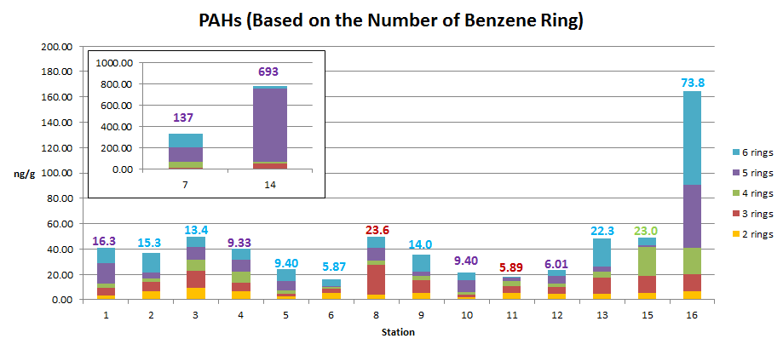

Figure 3. The relative abundance of PAHs compounds with station (based on the number of benzene ring)

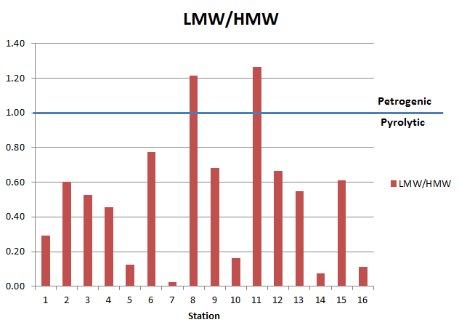

Figure 4. Distribution of LMW/HMW ratio with station

The diagnostic ratios of Ant/(Ant+Phe) (Figure 5) and Phen/Ant (Figure 6) found in this study ranged from 0.10-0.97 and 0.03-9.40, respectively. The Ant/(Ant+Phe) values being > 0.1 imply pyrolytic sources, whereas values < 0.1 imply petrogenic sources [6]. On the other hand, the diagnostic ratio of Phen/Ant being < 10 implies pyrolytic sources, whereas values of >10 are a characteristic of petrogenic sources [7]. The results from Ant/(Ant+Phe) and Phen/Ant diagnostic ratios suggest that the PAHs in all sampling areas were derived from pyrolytic sources.

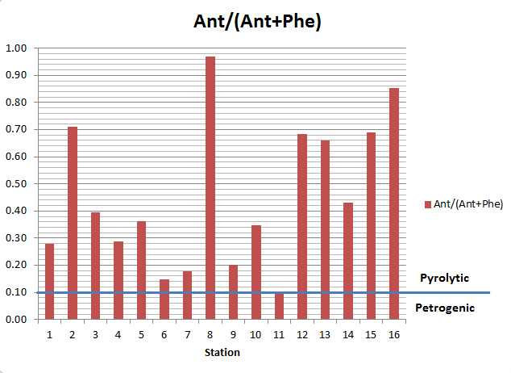

Figure 5. Distribution of Ant/(Ant/Phe) ratio with station

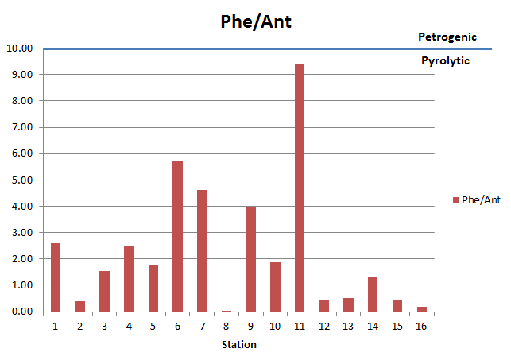

Figure 6. Distribution of Phe/Ant ratio with station

The calculated isomer pairs ratios of BaA/Chr and BaA/(BaA+Chr) ranged between 0.13-51.4 and 0.12-0.98, respectively. The BaA/Chr diagnostic ratio value was also used to suggest the origin of PAH sources; petrogenic <1 and pyrolytic >1[8]. On the other hand, BaA/(BaA+Chr) ratios were used to narrow down the sources into the following three categories [5]. The ratio implies pyrolytic sources if the value is > 0.35, while a value of < 0.2 implies petrogenic sources. However, a value ranging from 0.2 to 0.35 is indicative of a mixture of petrogenic and pyrolytic sources. Results from the BaA/Chr diagnostic ratios (Figure 7) showed that half of the study areas (station 1, 2, 3, 8, 9, 11, 13 and 15) were contaminated with significant amounts of petrogenic sources, while the other half (station 4,5,6,7,10,12,14 and 16) were contaminated with pyrolytic sources. In the case of BaA/(BaA+Chr) ratio (Figure 8), values at station 1 (0.21), 13 (0.20) and 15 (0.20) suggested a mixture of petrogenic and pyrolytic sources, values at station 8 (0.17) and 9 (0.12) suggested petrogenic sources, and values at the remaining stations suggested that the PAH compounds were mainly derived from pyrolytic sources.

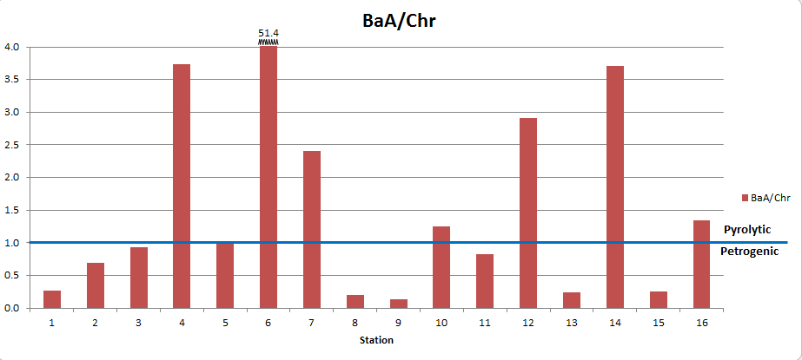

Figure 7. Distribution of BaA/Chr ratio with station

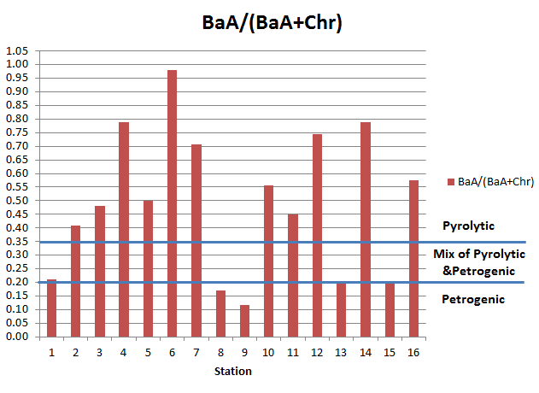
Figure 8. Distribution of BaA/(BaA+Chr) ratio with station

The presence of PAH compounds, Retene (m/z 234) and Perlyene (m/z 252) has often been associated with the natural (biogenic or diagenetic) PAH sources [7]. Retene is a PAH compound that consists of a 3-benzene ring structure and acts as a PAH biomarker for terrestrial plants. On the other hand, Perylene is a compound that can also be related to the pyrolytic sources. In this study, all of the sampling sites show the presence of Retene ranging from 0.24 ng/g to16.7 ng/g (Figure 9). With exception of station 13, Perylene was detected in all stations with concentrations ranging from 0.01 ng/g to 97.01 ng/g (Figure 10). According to Bakhtiari et al. [18], the percentage ratio of Perylene to Σ${PAH}_{16}$ is considered as pyrolytic if the value ranges from 1% to 4% and biogenic if the value is > 4%. In this study, the percentage of Perylene to Σ${PAH}_{16}$ ranged from 0.03% to 62.2%. Most of the stations indicated contamination from pyrolytic sources. With the exception of stations 3,4,5,6,7,10, and 11, which indicated that the Perylene was derived from biogenic sources, other remaining stations indicated that the Perylene contamination was from pyrolytic sources. Tolosa et al. [7] suggested another ratio to evaluate the sources of Perylene in marine sediments. This ratio is the percentage of Perylene to the sum of pentacyclic aromatic isomers (PAI) (BbF, BkF, BeP, BaP, Pery) (%Pery/PAI). A %Pery/PAI > 20% would indicate a diagenetically derived Pery, whereas a value < 20% would indicate a pyrolytically derived Pery. In this study, the values of %Pery/PAI ranged from 0.39% to 100%. Most of the stations indicate the pyrolytic sources of Pery, except for stations 3,4,5,6,7,10, and 11. This finding is consistent with the conclusion drawn from the percentage ratio of Perylene to Σ${PAH}_{16}$.

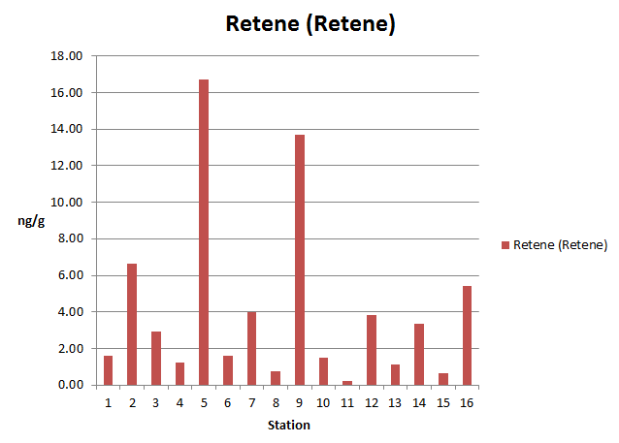

Figure 9. Concentration and distribution of Retene with station

Figure 10. Concentration and distribution of with station

Overall result from the selected PAHs diagnostic ratios suggested the dominance of pyrolytic PAH sources over the petrogenic sources in sediments of the Terengganu coast. According to Abdel-Shafy et al. [1] the pyrolytic PAHs are formed when organic substances are exposed to high temperature combustion under insufficient oxygen conditions which created an incomplete combustion process. The dominance of pyrolytic PAHs the in Terengganu coast sediment, suggested that these PAH compounds were derived from human activities. Maritime activities such as fishing boats, oil and gas exploration and production and shipping industries were main possible contributors to the presence of PAHs in the study area. Human activities on land such as incomplete combustion of wood in forest fires and fireplaces, and incomplete combustion of fuels in vehicular engines, could also contribute PAHs to the marine environment through atmospheric deposition and/or riverine discharge of urban run-offs. Thus, it is not surprising that station 7 (Merang) and 14 (Kemaman), which are located in the vicinity of a jetty and a port, showed the highest ΣPAH concentration in this study.

Conclusion

The ΣPAH concentration found in this study ranged from 20-790 ng/g, with a mean concentration of 131 ng/g. Evaluation of selected PAH diagnostic ratios suggested that pyrolysis was the main source of the 16 USEPA priority pollutant PAHs, with minor contributions from petrogenic sources. Evaluation of Pery indices suggested that, depending on stations, Pery was derived from either pyrolytic or biogenic sources. On the hand, the presence of Retene in all stations, albeit in minor amounts, clearly indicated the important contribution of biogenic PAHs to the marine environment.

Acknowledgement

Financial support from INOS (UMT) through a HICoE research grant vote no. 66928 and the use of facilities at the UMT Central Laboratory is kindly acknowledged. Inputs from Dr. T. F.T. Omar, Ms. Pang Swee Yun and Mr. Mohd Fathi Azmi on some aspects of this research are kindly acknowledged.

References
- Abdel-Shafy, H. I. and Mansour, M. S. (2016). A review on polycyclic aromatic hydrocarbons: source, environmental impact, effect on human health and remediation. Egyptian Journal of Petroleum, 25(1): 107-123.
- Elias, M. S., Wood, A. K., Hashim, Z., Siong, W. B., Hamzah, M. S., Rahman, S. A. and Talib, A. (2007). Polycyclic aromatic hydrocarbon (PAH) contamination in the sediments of East Coast Peninsular Malaysia. Malaysian Journal of Analytical Sciences, 11(1): 70-75.
- Tahir, M. N., Fadzil, F. M., Ariffin, J. Maarop, I. H. and Wood, H. K. A. (2011). Sources of polycylic aromatic hydrocarbons in mangrove sediments of Pulau Cik Wan Dagang, Kemaman. Journal of Sustainability Science and Management, 6: 98-106.
- Topal, T. (2011) Investigation of extraction methodologies for quantitative determination of polycyclic aromatic hydrocarbons in sediments. Thesis Degree of Doctor Philosophy, Middle East Technical University.
- Lukman, M. (2010). Distribution and sources of polycyclic aromatic hydrocarbons in sediments, suspended particulate matter and waters from the Siak River system, estuary and coastal area of Sumatra, Indonesia. Thesis Degree of Doctor Philosophy, Universität Bremen, Bremen.
- Yunker, M. B., Macdonald, R. W., Vingarzan, R., Mitchell, R. H., Goyette, D. and Sylvestre, S. (2002). PAHs in the Fraser River basin: A critical appraisal of PAH ratios as indicators of PAH source and composition. Organic Geochemistry, 33: 489-515.
- Tolosa, I., Mora, S. D., Sheikholeslami, M. R., Villeneuve, J. P., Bartocci, J., Cattini, C. (2004) Aliphatic and aromatic hydrocarbons in coastal Caspian Sea sediments. Marine Pollution Bulletin, 48: 44-60.
- Sulej, A. M., Polkowska, Ż. and Namieśnik, J. (2011). Contamination of runoff water at Gdańsk Airport (Poland) by polycyclic aromatic hydrocarbons (PAHs) and polychlorinated biphenyls (PCBs). Sensors, 11(12): 11901-11920.
- Tahir, N. M., Pang, S. Y., Hii, Y. S. and Simoneit, B. R. (2014). Distribution and sources of perylene and other polycyclic aromatic hydrocarbons (PAHs) in South China Sea sediments off Southern Terengganu Coast, Malaysia. In: From Sources to Solution. Springer, Singapore: pp. 463-467.
- Chiu, T. R., Nanyan, N. F. M. and Ali, M. M. (2015). Distribution of polycyclic aromatic hydrocarbons (PAHs) in surface sediments of Kapas Island, Terengganu, Malaysia. Procedia Environmental Sciences, 30: 162-167.
- United Nations Environment Programme (UNEP). (1992) Determination of petroleum hydrocarbons in sediments. Reference Methods for Marine Pollution Studies No. 20.
- Tolosa, I. and de Mora, S. (2004). Isolation of neutral and acidic lipid biomarker classes for compound-specific-carbon isotope analysis by means of solvent extraction and normal-phase high-performance liquid chromatography. Journal of Chromatography A, 1045(1-2): 71-84.
- Tan. H. S. (2012) Extractable organic compound in smoke particulate matter from burning of three tropical wood species. Thesis of Master Degree, Universiti Malaysia Terengganu, Terengganu, Malaysia.
- Baumard, P., Budzinski, H., Michon, Q., Garrigues, P., Burgeot, T. and Bellocq, J. (1998). Origin and bioavailability of PAHs in the Mediterranean Sea from mussel and sediment records. Estuarine, Coastal and Shelf Science, 47(1): 77-90.

- Simpson, C. D., Harrington, C. F., Cullen, W. R., Bright, D. A. and Reimer, K. J. (1998). Polycyclic aromatic hydrocarbon contamination in marine sediments near Kitimat, British Columbia. Environmental Science & Technology, 32(21): 3266-3272.
- Yan, W., Chi, J., Wang, Z., Huang, W. and Zhang, G. (2009). Spatial and temporal distribution of polycyclic aromatic hydrocarbons (PAHs) in sediments from Daya Bay, South China. Environmental Pollution, 157(6): 1823-1830.
- La Nafie, N., Asmawati, M. R. and Arief, A. (2016). Distribution of polycyclic aromatic hydrocarbons (PAHs) in sediments of Losari Beach and adjacent areas, South Sulawesi, Indonesia. International Journal of Applied Chemistry, 12(4): 675-682.
- Bakhtiari, A. R., Zakaria, M. P., Yaziz, M. I., Lajis, M. N. H., Bi, X. and Rahim, M. C. A. (2009). Vertical distribution and source identification of polycyclic aromatic hydrocarbons in anoxic sediment cores of Chini Lake, Malaysia: perylene as indicator of land plant-derived hydrocarbons. Applied Geochemistry, 24(9): 1777-1787.

