

MALAYSIAN JOURNAL OF ANALYTICAL SCIENCES
ISSN 1394 - 2506

Published by The Malaysian Analytical Sciences Society

ANALYSIS OF VOLATILE COMPOUNDS OF SPICES GROWN IN BANYUMAS DISTRICT, JAWA TENGAH, INDONESIA USING SOLID PHASE MICROEXTRACTION-GAS CHROMATOGRAPHY MASS SPECTROMETRY

(Analisis Sebatian Meruap bagi Rempah yang Tumbuh di Daerah Banyumas, Jawa Tengah, Indonesia Menggunakan Pengekstrakan Mikro Fasa Pepejal-Kromatografi Gas Spektrometri Jisim)

Fajar Hardoyono¹*, KikinWindhani², Herman Sambodo², Hary Pudjianto²

¹Laboratory of Physics, Faculty of Islamic Education and Teaching Sciences,
Institut Agama Islam Negeri Purwokerto, Jalan A. Yani 40 A, Purwokerto, Indonesia
²Department of Economics and Development Studies, Faculty of Economics and Business,
Universitas Jenderal Soedirman, Jalan HR. Bunyamin 708, Purwokerto, Indonesia

*Corresponding author: hardoyono@iainpurwokerto.ac.id

Received: 14 October 2018; Accepted: 31 October 2019

Abstract
Indonesia is well-known as one of high-quality spices producers in the world. Some of the spices products from Indonesia show high economic value in the European market due to their taste, flavour, and deliciousness. The quality of Indonesian spices was contributed by specific volatile constituents identified in the essential oils. This paper investigated major volatile constituents from seven types of spice grown in Banyumas District, Jawa Tengah, i.e. pepper, nutmeg, cinnamon, clove, chilli pepper, ginger, and turmeric. For experiment, 5 kg of each spice was collected from the farm surrounding Banyumas District, Jawa Tengah. Specific parts of these materials were selected. Pepper, nutmeg, and cloves used the seeds; ginger and turmeric used the rhizomes; while cinnamon used the bark. Each spice was prepared separately through these procedures: (1) slicing the spices; (2) drying the spices in a drying cabinet for 24 hours at 40 °C; (3) grinding the dried spices to powder for 5 minutes at 2500 rpm. For solid phase microextraction-gas chromatography mass spectrometry (SPME-GC/MS) analysis, 200 mg of spice powder was put in a vial glass. The fibre extracted volatile compounds of spice. Mass spectrometry detector identified the volatile compounds based on molecularly mass of molecules. Data tabulation of seven SPME-GC/MS chromatograms identified 69 volatile compounds in seven types of spice. Major volatile compounds dominant in pepper were caryophyllene and δ-limonene. Myristicin, methyl-eugenol, terpinene-4-ol, and asarone were major compounds in nutmeg. Cinnamon and clove were dominated by cinnamaldehyde and γ-muurolene, respectively. β-elemene and α-muurolene were identified as major compounds in chilli pepper. Meanwhile, ginger and turmeric were dominated by sesquiphellandrene and ar-tumerone, respectively. Some major compounds identified in these spices were bioactive and efficacious for human health as anticancer, antioxidant, and antitumor.

Keywords: Indonesian spices, volatile compounds, solid phase microextraction-gas chromatography mass spectrometry

Abstrak
Indonesia terkenal dengan produk rempah berkualiti tinggi. Beberapa produk rempah dari Indonesia menunjukkan nilai ekonomi yang tinggi di pasar Eropha kerana rasa, aroma dan kelazatannya. Kualiti rempah Indonesia disebabkan oleh juzuk sebatian meruap yang dikenalpasti di dalam minyak pati. Kajian ini menyiasat sebatian meruap utama pada 7 jenis rempah Indonesia yang tumbuh di daerah Banyumas, iaitu lada hitam, buah pala, kayu manis, cengkih, cili, halia dan kunyit. Untuk penelitian, setiap 5 kg rempah diperoleh dari kebun di sekitar daerah Banyumas, Jawa Tengah. Bahagian khusus dari bahan mentah dipilih untuk eksperimen. Untuk lada hitam, buah pala, dan cengkih menggunakan biji, halia dan kunyit menggunakan rhizom, manakala kayu manis menggunakan pelepah. Selanjutnya, setiap rempah disiapkan untuk analisa pengekstrakan mikro fasa pepejal-kromatografi gas spektrometri jisim (SPME-GC/MS) melalui prosedur berikut: (1) Pengirisan rempah; (2) pengeringan rempah selama 24 jam pada suhu 40 °C; (3) Penggilingan rempah kering menjadi serbuk selama 5 minit pada kelajuan 2500 rpm. Bagi analisa pengekstrakan mikro fasa pepejal-kromatografi gas spektrometri jisim SPME-GC/MS, 10 mg serbuk rempah diletakkan di dalam vial kaca. Spektrometer jisim mengenalpasti sebatian meruap berdasarkan berat molekul. Olahan data kromatogram SPME-GC/MS merekodkan 60 sebatian meruap pada 7 jenis rempah Indonesia. Sebatian utama bagi lada hitam ialah kariofelena dan δ-limonena. Miristisin, metil-eugenol, terpinen-4-ol dan asaron merupakan sebatian utama bagi buah pala. Kayu manis dan cengkih, masing -masing mengandungi sinamaldehid dan γ-muurolena. β-elemene dan α-muurolene dikenalpasti sebagai sebatian utama bagi sampel cili. Manakala, halia dan kunyit masing-masing mengandungi seskuifelandrena dan ar-tumeron. Semua sebatian yang dikenalpasti pada rempah ini bersifat bioaktif dan berkhasiat bagi kesihatan manusia sebagai antikanser, antioksidan, dan antitumor.

Kata kunci: rempah Indonesia, sebatian meruap, pengekstrakan mikro fasa pepejal-kromatografi gas spektrometri jisim

Introduction
Indonesia is well known as one of the spices producing countries in the world. High quality of spices from Indonesia has invited European countries for hunting spices in the Indonesian archipelago. In ancient time, the history of Indonesian civilization through Srivijayan and Majapahit Empire corresponded with spice trade [1]. The colonialism in Indonesia since the 15th century by the Portuguese, British, and Dutch Indies was also stimulated by the volition for dominating and controlling spice trade in the European market [2, 3].

In the modern era, spices are still the prime commodities of agro-industry that supporting income for the Indonesian government [4]. The total national income obtained from exporting spice products reaches more than US $801 million. The eight top highest values of exported Indonesian spice products in 2015 were pepper (US $535.37 million), nutmeg (US $106.97 million), cinnamon (US $100.55 million), clove (US$46.36 million), dried chilli (US $22.11 million), vanilla (US $16.55 million), ginger (US $12.25 million), and turmeric (US $10.23 million). The majority of these products are exported to the European market [5]. Even though there are some other spice producing countries including India, Madagascar, and Comoros, the European market still prefers Indonesian spice products than those of other countries [6]. In 2012, Indonesia was the biggest supplier of turmeric and cinnamon. The contribution of turmeric and cinnamon from Indonesia in the European market was almost 78% and 63%, respectively. Moreover, the market share of clove commodities from Indonesia has contributed 21% to the European market. These cases indicated that the quality of clove and other spices grown in Indonesia is unique, tasteful, and preferred by the customer.

Spice commodities have been well-known as the tasteful and aromatic agro-industry products. Delicious taste and spicy aroma in spice commodities promise worth the price of these products. On the other hand, the composition of volatile organic compounds is worth the flavour and the taste of spices. Different composition of major compounds generates different odour description in some spices. Commonly, spices odour exhibits a warm, sweet, bitter, and spicy taste with a slightly pungent mouth [7]. Spices widely grow in some regions in the world, e.g. Central America, Mexico, India, Iran, Africa, Mediterranean countries, Europe, Africa, China, and Southeast Asian countries. Some spices, e.g. pepper, nutmeg, cinnamon, clove, chilli pepper, vanilla, ginger, and turmeric are well-grown in Indonesia, China, India, Thailand, Brazil, and Madagascar, Central America, and other countries [8]. Commonly, the composition of volatile organic compounds also depends on the growing location of these plants. The similar spice grown in the different regions has a different composition of volatile compounds, flavour, and taste. Indonesia is well-known as one of the aromatic and tasteful spices producing countries in the world. These main spices commodities exported to the overseas are pepper, nutmeg, cinnamon, clove, chilli pepper, vanilla, ginger, and turmeric. Based on the data from Food and Agriculture Organization (FAO), Indonesia is the largest producer of vanilla and clove, and also the second-largest producer of pepper and nutmeg [5]. The growing location of these spice commodities is widely spreading in almost all Indonesian archipelagos, especially in Sumatera, Maluku, Sulawesi, and Papua [1]. The total production of these spices commodities from Indonesia was almost 216,000 tons in 2014 [5].

Previous research reported the composition of volatile organic compound of some spices as follows pepper [9, 10], nutmeg [11, 12], cinnamon [13, 14], clove [15, 16], chilli pepper [17, 18], ginger [19, 20] and turmeric [21, 22]. However, the previous articles that especially reported the identification of chemical constituents of Indonesian spices were still rare in International Journal. Some of them were reported by [23, 24, 25]. Dupuy et al. [23] that described the composition of the volatile compound of Indonesian nutmeg essential oil based on gas chromatography and chemometric analysis of mid-infra-red. Amelia et al. [24] reported the volatile composition of Indonesian clove bud essential oil grown in Java and Manado. Meanwhile Retnowati et al. [25] investigated the chemical constituents of the essential oil of white turmeric (zedoary) from Indonesia and its toxicity toward Artemia salina lench. Other Indonesian spices, i.e. pepper, cinnamon, chilli pepper, ginger and also turmeric have not been reported yet in the paper.

Indonesia as one of the biggest producing spice commodities in the world must take care of the quality of the spices as the raw material of food flavouring, herbal drink, and herbal medicine. Investigation of chemical compounds of the main Indonesia spices grown in Indonesia is necessarily conducted. Based on previous references, the composition of chemical compounds in the spices essential oil was commonly identified using chromatographic techniques and non-chromatographic techniques. The most common chromatographic techniques for identification of volatile compounds in ginger used solid-phase micro-extraction gas chromatography/mass spectroscopy (SPME-GC/MS) [17, 26] thin layer chromatography (TLC) [27] and high-performance liquid chromatography (HPLC) [28, 29]. In addition, Fourier transforms infrared spectroscopy (FTIR) [30] and electronic noses [31] were also used as common techniques of non-chromatographic used for identifying chemical components in spice essential oils.

SPME-GC/MS is a technique of quantitative analysis most commonly used for identifying the composition of the chemical compound for spices in the solid phase. The employing of this instrument has been used for identifying the chemical composition of pepper [32] cinnamon [33], ginger [34], and chilli pepper [17, 35]. SPME-GC/MS is equipped with fibres for extracting the volatile organic compound of the solid sample and mass spectroscopy detector for calculating molecular mass. This instrument is also possible for obtaining information on the name of identified chemical compounds and their quantities rapidly in a solid phase [36]. The aim of this study is to identify the composition of the volatile organic compound of the main spice commodities grown in Indonesia and also estimate the odour profile and the efficaciousness of spices for health. In the experiment, seven types of spice, i.e. pepper, nutmeg, cinnamon, clove, chilli pepper, ginger, and turmeric were analysed using solid phase micro-extraction gas chromatography-mass spectrometry (SPME-GC/MS). The identification of major compounds in the spices was conducted by analysing the chromatogram obtained from GC/MS. Based on the quantity of volatile compounds identified in spices, the aroma profile and the potency of spices can be estimated.

Materials and Methods
Materials
We used seven types of spice grown in Indonesia, i.e. pepper (Piper nigrum), nutmeg (Myristica fragrans), cinnamon (Cinnamomum verum), clove (Syzygium aromaticum), chilli pepper (Capsicum frutescens), ginger (Zingiber officinale), and turmeric (Curcuma longa). Five kg of raw material were taken out for each type of spice. These raw materials were collected from seven different farms, surrounding Banyumas district, Jawa Tengah, Indonesia from February 2017 until April 2017. The locations of farms for collecting the materials were presented in Table 1. The part of the spices that yielded a strong aroma is used as a sample. Pepper, nutmeg, and clove were taken part of the seeds. Ginger and turmeric were taken part of the rhizome, while cinnamon was taken part of the bark. We selected only fresh, wet, tasteful and aromatic spices for obtaining the optimum concentration of the essential oil in these materials.

Table 1. List of location for obtaining sample of seven types of spice grown in Indonesia
Date of collection | Variety | Location | Latitude Longitude | Altitude  (m) | Weight  (kg)
February 2, 2017 | Pepper  (Pipper nigrum) | Cingebul village, surrounding Lumbir, Banyumas district, Jawa Tengah | S: 7.458248  E: 108.913593 | 580 | 1.20
February 10, 2017 | Nutmeg  (Myristica fragrans) | Kemawi village, surrounding Somagede, Banyumas district, Jawa Tengah | S: 7.536195  E: 109.366314 | 760 | 2.45
March 3, 2017 | Cinnamon (Cinnamomum verum) | Krajan village, surrounding Pekuncen, Banyumas district, Jawa Tengah | S: 7.335283  E: 109.083641 | 860 | 3.50
March 15, 2017 | Clove  (Syzygium aromaticum) | Klinting, surrounding Somagede, Banyumas district, Jawa Tengah | S: 7.543079  E: 109.334887 | 765 | 2.10
March 27, 2017 | Chilli pepper (Capsicum frutescens) | Kemutug lor village, surrounding Baturaden, Banyumas district, Jawa Tengah | S: 7.293833  E: 109.228711 | 760 | 3.50
April 8, 2017 | Ginger  (Zingiber officinale var officinale) | Karang gondang , Sambirata village, surrounding Cilongok, Banyumas district, Jawa Tengah | S: 7.313662  E: 109.147474 | 580 | 10.80
April 21, 2017 | Turmeric  (Curcuma longa) | Gunung lurah village, surrounding Cilongok, Banyumas district, Jawa Tengah | S: 7.379301  E: 109.151232 | 410 | 2.50

Preparation of sample
All spices collected from the farm were washed using water to remove the soil which adhered to the surface of the spices. After finishing the washing process, the spices were dried in a drying cabinet for 24 hours at 40 °C. For ginger, turmeric, and cinnamon these materials were sliced before dried in drying cabinet. The slicing dimension was set up at 1 cm x 1 cm x 0.1 mm. The spices were grinded to powder using a blender machine (Philips, Netherlands) for 5 minutes at 2500 rpm. Thus, the powder was kept in a-100 mL glass bottle and put in a storage box at 25 °C. The procedure of sample preparation of the spices was conducted separately to avoid cross-contamination of odour and volatile organic compounds among spices.

SPME-GC/MS instrument
SPME-GC/MS analyses were carried out using Shimadzu GC/MS-QP-2010 (Kyoto, Japan), equipped with auto-sampler Agilent 7683b and MSD Agilent 5975C mass spectroscopy. GC/MS was coupled to QP 2010 SE mass spectrometer (Compaq-Pro Linear data system, class 5 K software). It was equipped with Agilent- DB-1 column (30m x 0.25mm i.d. x 0.2μm film thickness Crossband R 100% dimethylpolysiloxane). A manual SPME holder, a type of fibre (65 µm-blue hub plain, polydimethylsiloxane/divinyl-benzene (PDMS/DVB)) and 10 mL vials from Supelco (Bellefonte, USA) were used for the extraction procedures.

Identification of volatile compound with SPME-GC/MS
The fibres were conditioned for 10 minutes at 250 °C in the GC/MS injector before SPME-GC/MS analysis. Two hundred mg of spice powder was put in a 10-mL of the vial. The fibre coating was embedded into the headspace to determine temperature and time value set in the experiment. The temperature was set at 50 ºC while incubation and extraction time were set 5 minutes and 10 minutes, respectively. The fibre containing the extracted volatile compounds of ginger was injected into GC/MS. The direct injection of helium was used as the carrier gas in the split mode. Injector and detector temperature were maintained at temperature between 200 ºC and 280 ºC. The measurement of each spice sample using GC/MS equipped with auto-sampler was set for about 60 minutes. The temperature of the column was programmed initially at 70 ºC and then increased at 250 ºC for 10 minutes (at a rate of 18 °C min⁻¹). Mass conditions were followed: ionization voltage, 70 eV; ion source temperature, 200 °C; full scan mode in the 30-450 amu mass ranges with 0.2 s scan⁻¹ velocities. The identification of compounds was identified by using NIST 08 database (NIST mass spectral database, PC Version 2008). The total ion current from GC/MS spectra was used to calculate the relative percentages of separated compounds by a computerized integrator. This procedure of SPME-GC/MS analysis was similar for all spices samples and it was replicated three times for each type of spice. Thus, the average quantity of volatile compounds from three times measurement was used for data tabulation.

Results and Discussion

Composition of volatile constituents
The chromatograms obtained from SPME-GC/MS analyses of seven types of spice are shown in Figures 1-3. Moreover, data tabulation of major volatile compounds of them is presented in Table 2. Pepper, the first variety of Indonesian main spices was dominated by caryophyllene and δ-limonene. The abundances of these compounds in pepper were 45.10% and 26.11%, respectively (Table 2). Other lower quantities of major compounds identified in pepper were: caryophyllene oxide (5.10%), 3-carene (4.12%), α-caryophyllene (3.55%), β-pinene (2.76%), tetracyclo [6.3.2.0(2,5).0(1,8)] tridecan-9-ol, 4,4-dimethyl] (1.97%), β-myrcene (1.90%), δ-elemene (1.71%), δ-cadinene (1.67%), spathulenol (1.47%), and aroma dendrene (1.16%).

Caryophyllene, the largest quantity of volatile compounds identified in pepper was a member of the class of compounds known as sesquiterpene. Previous research reported that the odour description of caryophellene was spicy, woody and cider wood odour [8]. Consequently, the presence of caryophellene that was more than 45% contributed to appearing the spicy taste in pepper. Moreover, this compound has potency for the human as antimicrobial [37, 38]. Furthermore, the taste of sour and lemon-like in pepper was contributed by δ-limonene [8]. Based on previous studies this compound was efficacious as antibacterial [39], antitumor [40], and anticancer [41]. Other chemical compounds identified in lower quantities in pepper were caryophyllene oxide (5.10%) and 3-carene (4.12%). Caryophyllene oxide is categorized as a cannabinoid. It is a metabolite of β-caryophyllene, which is an essential oil found in C. sativa and other plants [42]. These bioactive compounds have potency as an anti-inflammatory [43]. While 3-carene, is a bicyclic monoterpene, contributed a sweet and pungent turpentine-like odour [44, 45].

The composition of volatile compounds identified in nutmeg was dominated by myristicin (24.55%), methyl-eugenol (21.24%), terpinen-4-ol, and asaron (14.20%) (Table 2). The myristicin, the largest quantity identified in the nutmeg is a phenylpropane. This compound is commonly found in the essential oil of nutmeg, parsley, and dill that contributes to spicy odour [45]. Myristicin has been investigated as a bioactive compound used for antioxidant and anticancer [46, 47]. Methyl-eugenol was also identified almost as same as concentration to myristicin. This compound was well-known as allylveratrol. In the nutmeg essential oil, this compound has a delicate clove-carnation odour with a bitter and burning taste [44]. It also had bioactive properties like antioxidant, antibacterial, antifungal, and bioinsecticide [48, 49]. Furthermore, terpinen-4-ol, the third major compound identified in nutmeg, contributed to sweet, and citrus green with the fruity character [44]. This bioactive compound has potency as antioxidant [50], antifungal [51], antibacterial [52], and antiviral [53].

Four major compounds were identified in cinnamon, i.e. cinnamaldehyde (65.38%), copaene (8.02%), α-bergamotene (7.95%), and α-bisabolene (5.13%) ( (Table 2). Other lower quantities of volatile compounds identified in cinnamon were: β-bisabolene, δ-cadiene (2.71%), eugenol (1.80%) and β-cadiene (1.02%). Cinnamaldehyde, a flavonoid, was identified as the highest quantity compound in cinnamon. Due to appear significantly, this compound contributes to the specific odour and flavour in cinnamon [44]. This compound has potency as antimicrobial properties [54]. Besides the cinnamaldehyde, the copaene and α-bergamotene appeared also in the cinnamon. Even these compounds appeared around 8%, the copaene and α-bergamotene contributed to woody type odour, respectively. Other volatile compounds identified in the cinnamon were α-bisabolene and β-bisabolene. These two compounds are isomers and sesquiterpenes. The total quantity of these compounds in the cinnamon was around 5.13% and contributed to a pleasant, warm, sweet-spicy-balsamic odour [44]. Based on the previous investigation, β-bisabolene was exhibited cytotoxicity in breast cancer cell lines, and also antitumor agent [55, 56].

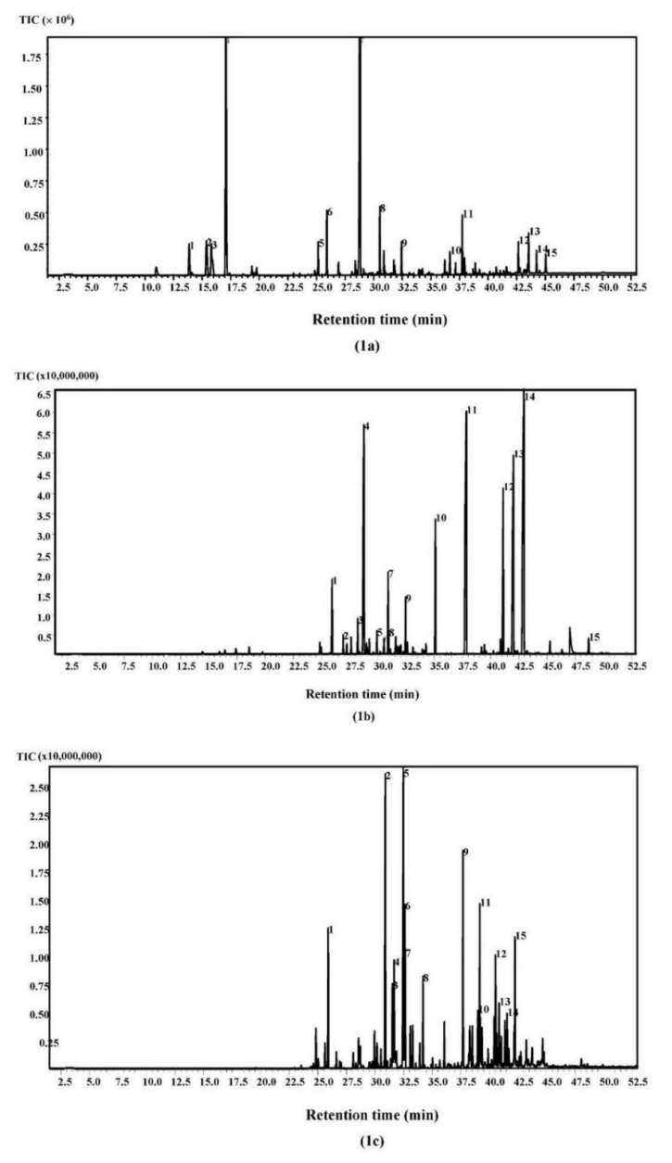
Figure 1. SPME-GC/MS chromatogram of the spices grown: (1a) pepper, (1b) nutmeg, (1c) cinnamon
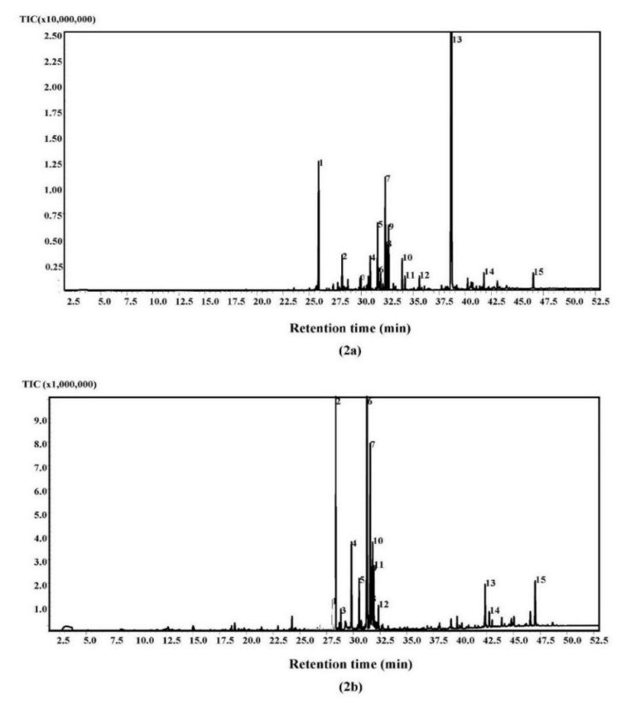
Figure 2. SPME-GC/MS chromatogram of the spices: (2a) clove, (2b) chilli pepper

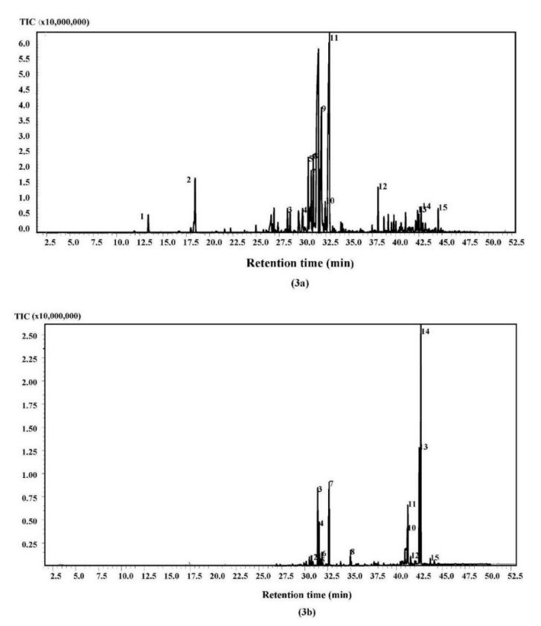
Figure 3. SPME-GC/MS chromatogram of dried spices grown in Banyumas District, Jawa Tengah, Indonesia: (3a) ginger, and (3b) turmeric
Table 2. List of major volatile organic compound in the spices
Compound Name | Concentration of TIC (%)
Compound Name | Pepper | Nutmeg | Cinnamon | Clove | Chilli | Ginger | Turmeric
2-methoxycinnamaldehyde | - | - | 0.87 | - | - | - | -
3-carene | 4.12 | - | - | - | - | - | -
α-terpineol | - | 3.28 | - | - | - | - | -
α-bergamotene | - | 1.14 | 7.95 | - | - | - | -
α-bisabolene | - | - | 5.13 | - | - | - | -
α-bisabolol | - | - | 0.71 | - | - | - | -
α-bulsenene | - | - | - | - | 1.01 | - | -
α-cadinol | - | - | - | 10.28 | - | - | -
α-caryophyllene | 3.55 | 0.45 | - | - | - | - | -
α-eudesmol | - | - | - | - | 1.88 | - | -
α-farnesene | - | - | - | - | - | 14.01 | 1.55
α-muurolene | - | - | - | 4.56 | 27.83 | - | -
α-selenine | - | - | - | - | 20.37 | - | -
α-terpineol | - | - | - | - | - | 3.88 | -
Aromadendrene | 1.16 | - | 0.62 | - | - | - | -
Artemisia ketone | - | - | - | - | - | - | 4.37
Ar-tumerone | - | - | - | - | - | - | 32.46
Asarone | - | 14.20 | - | - | - | - | -
Benzene, 1,3,5-trimethoxy- | - | - | - | 4.76 | - | - | -
Benzene, 1-methoxy-4-  (1-propenyl)- | - | - | - | - | - | - | -
β-bisabolene | - | - | - | - | - | - | 6.02
β-cadinene | - | - | 1.02 | - | - | - | -
β-elemene | - | - | - | - | 31.55 | 2.03 | -
β-eudesmol | - | - | - | - | - | 1.91 | -
β-farnesene | - | 0.57 | - | - | - | - | -
β-himachalene | - | - | - | - | - | 3.73 | 1.10
β-myrcene | 1.90 | - | - | - | - | - | -
β-pinene | 2.76 | - | - | - | - | - | -
β-selenine | - | - | - | - | 3.44 | - | -
Borneol | - | - | - | - | - | 5.79 | -
Calamenene | - | - | 0.69 | 4.13 | - | - | -
Camphene | - | - | - | - | - | 1.44 | -
Caryophyllene | 45.10 | - | - | - | - | - | -
Caryophyllene oxide | 5.10 | - | - | - | - | - | -
Cedrene | - | - | - | 7.68 | - | - | -
Cinnamaldehyde | - | - | 65.38 | - | - | - | -
Citral | - | - | - | - | - | 5.10 | -
Copaene | 3.38 | 2.88 | 8.02 | 6.56 | - | - | -
Curcumene | - | - | - | 2.42 | - | - | 17.16
Curlone | - | - | - | - | - | - | 14.40
Cyclopentanecarboxylic acid, 3-isopropylidene-, bornyl ester | - | - | - | - | - | - | 0.73
Dehydronerolidol | - | - | - | - | - | 1.72 | 0.85
δ-cadinene | 1.67 | 1.86 | 2.71 | 17.15 | - | - | -
δ-elemene | 1.71 | - | - | - | - | - | -
δ-limonene | 26.11 | - | - | - | - | - | -

Table 2 (cont’d). List of major volatile organic compound in the spices
Compound Name | Concentration of TIC (%)
Compound Name | Pepper | Nutmeg | Cinnamon | Clove | Chilli | Ginger | Turmeric
Eucalyptol | - | - | - | - | - | 4.97 | -
Eugenol | - | - | 1.80 | 2.39 | - | - | 1.02
γ-muurolene | - | - | - | 30.94 | - | 1.89 | -
Globulol | - | - | - | - | - | 2.40 | -
Humulene | - | - | - | - | 4.93 | - | -
Isolongifolene, 4,5-dehydro- | - | - | - | - | 4.61 | - | -
Juniper-camphor | - | - | - | - | 0.69 | - | -
Linalool | - | 0.54 | - | - | - | - | -
Methyleugenol | - | 21.24 | - | 9.13 | - | - | -
Methylisoeugenol | - | 8.03 | - | - | - | - | -
m-Toluic acid, tridec-2-ynyl ester | - | - | - | - | - | - | 0.95
Myristicine | - | 24.55 | - | - | - | - | -
Nerolidol | - | - | - | - | - | 3.02 | -
Phenol, 2,6-dimethoxy-4-  (2-propenyl)- | - | 0.68 | - | - | - | - | -
p-Menthane, 2,3-dibromo-8-phenyl- | - | - | - | - | - | - | 1.74
Safrole | - | 4.99 | - | - | - | - | -
Selinadiene | - | - | - | - | 2.72 | - | -
(-)-spathulenol | 1.47 | - | - | - | - | - | -
β-sesquiphellandrene | - | - | - | - | - | 48.11 | -
Terpinen-4-ol | - | - | - | - | - | - | -
Tetracyclo[6.3.2.0(2,5).0(1,8)]tridecan-9-ol, 4,4-dimethyl- | 1.97 | - | - | - | - | - | -
Tumerone | - | - | - | - | - | - | 8.89
Xenitorin A | - | - | - | - | 3.49 | - | -
Zingiberene | - | - | - | - | - | - | 9.78

The clove is mainly used for the cigarette industry as well as for food flavouring and seasoning. SPME-GC/MS analysis of clove identified four major compounds, i.e. γ-muurolene (30.94%), δ-cadinene (17.15%), α-cadinol (10.28%), methyl-eugenol (9.13%), cedrene (7.68%), and copaene (6.56%) (see Table 2). Other compounds identified less than 5% were: α-muurolene (4.56%), curcumene (2.42%), and eugenol (2.39%). A compound of γ-muurolene was identified as the largest quantity in the clove that contributes woody type odour [44]. The compound of δ-cadinene appeared in appreciable content, contributed to herbal-type odour [44]; Previous studies showed that efficaciousness of this compound as anti-insecticide for eradicating of malaria, dengue, and filariasis mosquitoes [57], inhibited the growth of ovarian cancer [58], antifungal [59] and antibacterial [60]. The methyl-eugenol was also identified in the clove. This compound was well-known as allylveratrol. Similar to the nutmeg essential oil, this compound has a delicate clove-carnation odour with a bitter and burning taste [44]. It also had bioactive properties such as antioxidant, antibacterial, antifungal, and bioinsecticide [48, 49]. Meanwhile, the cedrene, identified in clove was a sesquiterpene that had cedar wood-like odour.

The SPME-GC/MS analysis of chilli pepper showed that this spice contained four volatile compounds, i.e. β-elemene (31.55%), α-muurolene (27.83%), α-bulsenene (1.01%), and α-selenine (20.37%). Other volatile compounds identified less than 5% were: humulen-(v1) (4.93%), Isolongifolene, 4,5-dehydro- (4.61%), xenitorin A (3.49%), β-selenine (3.44%), selenadiene (2.72%), α-eudesmol (1.88%) (see Table 2). β-elemene, the largest quantity in the chilli pepper is a sesquiterpene that has a floral odour. Previous research reported that the β-elemene has been used as medicinal plants due to efficacious as anticancer [61], antioxidant [62], antitumor [63] and anti-proliferative agent [64]. The α-muurolene was also identified in the chilli pepper as well as in the clove. The α-bulnesene and α-selinene, the other major compounds identified in the chilli pepper contributed to floral odour, respectively.

Ginger was one of the well-known herbal medicines used by people for hundreds of years. In Indonesia, ginger is usually used for spice, food flavouring, or beverages. The pharmaceutical industry in Indonesia has also utilized ginger as the raw material for producing herbal drink and herbal medicine. SPME-GC/MS analysis identified four major volatile compounds in ginger, i.e. sesquiphellandrene (48.11%), α-farnesene (14.01%), borneol (5.79%), and citral (5.10%). Other compounds identified less than 5% in ginger were: eucalyptol (4.97%), α-terpineol (3.88%), β-himachalene (3.73%), nerolidol (3.02%), globulol (2.40%), β-elemene (2.03%), β-eudesmol (1.91%), γ-muurolene (1.89%), dehydronerolidol (1.72%) and camphene (1.44%) (Table 2). Sesquiphellandrene was identified as the largest quantity in ginger. The sesquiphellandrene was a sesquiterpene that had herbal type odour. The previous study showed the efficaciousness of this compound as an anticancer [21]. Furthermore, α-farnesene, a sesquiterpene, was also identified in ginger. This compound releases green apple odour, and also has potency for antioxidant [65]. In addition, other chemical compounds identified in lower quantities were borneol and neral. Borneol is a bicyclic organic compound and a terpene derivative. This compound has a camphor-like odour and burning taste somewhat reminiscent of mint [44] and also has potency as anti-influenza virus [66] and antidepressant [67]. Meanwhile, citral has a spicy, fruity odour with a woody and balsamic odour. This compound has potency as antimicrobial, antioxidant, and antitumor [68].

The turmeric has been widely used in Indonesia mainly for food colouring, herbal beverages, and herbal medicines. SPME-GCMS analysis of turmeric identified five major volatile compounds, i.e. ar-turmerone (32.46%), curcumene (17.16%), curlone (14.40%), tumerone (8.89%), and β-bisabolene (6.02%) (Table 2). Other volatile compounds identified less than 5% were: artemisia ketone (4.37%), p-Menthane, 2, 3,-dibromo-8-phenyl- (1.74%), α-farnesene (1.55%). β-himachalene (1.10%), and eugenol (1.02%). Ar-turmerone, a sesquiterpene, identified as the most abundant in turmeric. Ar-turmerone has isomeric to turmerone. The total quantity of ar-turmerone and its isomer in turmeric essential oil was around 39%. The specific odour and taste of the turmeric were contributed by ar-turmerone [8]. This compound was also efficacious for human health as antitumor [69], antimicrobe [70], antiplatelet [71], and anti-venom [72]. The curcumene, another major compound in turmeric, contributed to yellow-bright colour in turmeric essential oil. This compound release turmeric-like odour, efficacious as antitoxic for malaria, chikungunya, and St. Louis encephalitis mosquito vectors [73]. Furthermore, curlone and zingiberene also appeared in turmeric essential oil even the quantity of them was not as much as ar-turmerone and curcumene. Curlone was commonly found in turmeric essential oils besides ar-turmerone and turmerone, while zingiberene was commonly identified as one of the major compounds in ginger. α-zingiberene has been reported as a bioactive compound that is efficacious for anti-aggregate, anticancer, anti-inflammatory, and antioxidant [46, 47].

Estimation of odour profile and the potency of spices for human based on the quantity of compounds
Burdock [44] has been investigated odour profile of pure organic volatile compounds. Several references also investigated the efficaciousness of volatile compounds of phytomedicine for human health. Both of them are presented simultaneously in Table 3. In this study, we estimate the odour profile of spices by looking through the number of volatile compounds in Table 2. Pepper and nutmeg have combination of woody, spicy and clove-like odour. The presence of caryophyllene in large quantity (45.10%) contributes for appearing strong woody, spicy and clove-like odour in pepper. Meanwhile, myristicine identified 24.55% contributes for moderate woody, spicy and clove-like odour in nutmeg.

Table 3. Odour description and efficaciousness of bioactive compound in spices based on previous research
Spice Name | Major Compound | Odour Description [44] | Benefit for Human Health
Pepper | caryophyllene | woody-spicy, dry, clove-like aroma | antimicrobial [37, 38]
Pepper | δ-limonene | citrus | antibacterial , antitumour, anticancer [39, 40]
Nutmeg | myristicine | woody-spicy [45] | antioxidant [46], anticancer [47]
Nutmeg | methyl-eugenol | clove-like | antifungal [48], bioinsecticide [49].
Cinnamon | cinnamaldehyde | spicy, cinnamons odour | antimicrobial [54]
Cinnamon | copaene | woody | -
Cinnamon | α-bergamotene | woody | -
Cinnamon | α-bisabolene | balsamic spicy floral | anticancer [55], antitumour [56].
Clove | δ-cadinene | woody-longifolone | antimalarial, dengue and filariasis mosquitoes [57], anti- ovarian cancer [58], antifungal[59], and antibacterial [60].
Clove | γ-muurolene | woody | -
Clove | methyl-eugenol | clove-like | antioxidant, antibacterial, antifungal [48], and bioinsecticide [49].
Clove | cedrene | ceder wood-like | -
Clove | copaene | - | -
Clove | α-cadinol | herbal-type | -
Chilli pepper | β-elemene | floral-type | anticancer [61], antioxidant [62], antitumour[63], anti-proliferative agent [64].
Chilli pepper | α-muurolene | woody-type | -
Chilli pepper | α-bulnesene | floral | -
Chilli pepper | α-selenine | amber | -
Ginger | sesquiphellandrene | herbal-type | anticancer [21]
Ginger | α-farnesene | green apple odour | antioxidant [65]
Ginger | borneol | camphor-like odour | anti-influenza virus [66], antidepressant [67]
Ginger | citral | spicy odour | antimicrobial, antioxidant, and antitumor [68]
Turmeric | ar-turmerone | spicy woody | antitumour[69], antimicrobial [70], antiplatelet [71], and anti-venom [72]
Turmeric | curcumene | herbal-type | antimalarial, anti-chikungunya, and anti- St. Louis encephalitis mosquito [73].
Turmeric | curlone | -
Turmeric | zingiberene | spicy | anti-aggregate, anticancer [46], anti-inflammatory, and antioxidant [47]
Turmeric | tumerone | spicy woody | -
Turmeric | β-bisabolene | balsamic spicy floral | -

Cinnamon, clove, chilli pepper, ginger, and turmeric have also specific odour, respectively. The strong odour of cinnamon is contributed by cinnamaldehyde in appreciable quantity (65.38%). The combination of γ-muurolene and δ-cadinene that appear 48.09% contribute strong woody odour in clove. Moreover, chilli pepper yields strong floral and moderate green apple combined by woody odour due to the presence of β-elemene and α-muurolene, respectively. In addition, sesquiphellandrene identified 48.11% in ginger contributes to strong herbal type odour. Strong spicy combined with moderate herbal-type released in turmeric was contributed by ar-turmerone, tumerone, curcumene, and zingiberene.

We also predict the level potency of spices for human health and presented in Table 4. The level potency of spice for human health is not analysed based on empirical data obtained from an experiment involving efficaciousness measurement of bioactive compounds in spices for human metabolism. Nevertheless, it is estimated by looking through previous studies that investigated spice potency for human health and presented in Figure 4. Thus, the level of efficaciousness of spice is also estimated by looking through the number of bioactive compounds identified in the spices listed in Table 2. Based on data in Table 2 and Table 3 it can be estimated that pepper and cinnamon have high potency for antimicrobial due to the presence of caryophyllene and cinnamaldehyde in large amount, respectively. Pepper is also predicted moderately efficacious as anti-bacteria, anticancer, and antitumor existence of δ-limonene. The presence of 24.55% of myristicine in nutmeg renders it has high potency for anti-bacteria, antioxidant, antifungal, antiviral, and bio-insecticides at moderate level. Chilli pepper is moderately efficacious for antitumor, anticancer, antioxidant, anti-proliferative agent due to the presence of β-elemene for 31.55%. Ginger is predicted highly efficacious as anticancer due to the presence large amount of β-sesquiphellandrene, it was also moderately effectual as antioxidant due to the presence 14.01% of α-farnesene. Meanwhile, compound of ar-turmerone identified 32.46% in turmeric render it highly potent as antimicrobial, antitumor, antiplatelet, and antivenom. In addition, Curcuma in turmeric contributes as bio-insecticides in moderate potency.
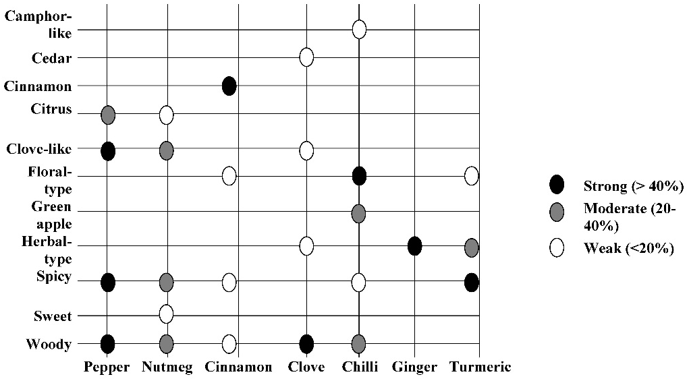
Figure 4. Odour profile estimation released from the spices grown by looking through the quantity of volatile compounds and compared them to reference

Table 4. Potency estimation of spices for human health by looking through the quantity of volatile compounds
and compared them to previous studies
Potency | Pepper | Nutmeg | Cinnamon | Clove | Chilli | Ginger | Turmeric
Antibacterial | ▲ | ▲ |  | □
Anticancer | ▲ |  | □ |  | ▲ | █ | □
Antidepressant |  |  |  |  |  | □
Antifungal |  | ▲
Anti-inflammatory | □ |  |  |  |  |  | □
Antimicrobial | █ |  | █ |  |  |  | █
Antioxidant |  | ▲ |  | □ | ▲ | ▲ | □
Anti-platelet |  |  |  |  |  |  | █
Anti-proliferative agent |  |  |  |  | ▲
Antitumour | ▲ |  |  |  | ▲ | □ | █
Antivenom |  |  |  |  |  |  | █
Antiviral |  | ▲ |  |  |  | □
Bioinsecticide |  | ▲ |  | □ |  |  | ▲
█ Strong; presence of volatile compound was more than 40%
▲ Moderate; presence of volatile compound was 20% up to 40%
□ Weak; presence of volatile compound was less than 20%

Conclusion
Seven types of spice grown in Banyumas District, Jawa Tengah, Indonesia have been analysed using SPME-GC/MS. Based on mass spectroscopy analysis, 69 compounds were identified from the spices. Caryophyllene and δ-limonene dominated in pepper. Myristicin, methyl-eugenol, terpinen-4-ol and asaron were highly abundant in nutmeg. Cinnamon and clove were dominated by cinnamaldehyde and γ-muurolene, respectively. Moreover, β-elemene and α-muurolene were identified as major compounds in chilli pepper. Meanwhile, ginger and turmeric were dominated by sesquiphellandrene and ar-tumerone, respectively. By looking through the quantity of bioactive compound identified in GC/MS experiment, then compare it to previous studies that investigated the efficaciousness of spice for human health, it can be estimated that pepper and cinnamon were highly efficacious as antimicrobe, whereas ginger and turmeric were highly potent as anti-tumour. In addition, turmeric has high potency as anticancer, antiplatelet, and antivenom. Based on analysis of these potencies, it is necessary to change the habit and cultivation culture of local farmers in Indonesia for cultivating these herbal medicines for phytomedicine utilization and or raw material supplier for the pharmaceutical industry. This policy also increases the economic value and benefit of Indonesian spices for local people in the future.

Acknowledgment
This work was fully funded by the project of “Penelitian Kompetensi 2017, BLU Universitas Jenderal Soedirman Purwokerto”. The authors are thankful to SPME-GC/MS technician from the Laboratory of Organic Chemistry, Faculty of Mathematics and Natural Science, Universitas Gadjah Mada, Yogyakarta, Indonesia who have conducted SPME-GC/MS analysis for seven types of spice.

References
- Hannigan, T. A. (2015). Brief history of Indonesia, sultans, spices, and tsunamis: the incredible story of southeast asia largest nation. Tuttle Publishing, Vermont. pp: 50-55.
- Drakeley, S. (2005). The history of Indonesia. Greenwood Press, Connecticut. pp: 23-37.
- Ricklefs, M.C. (2001). A history of modern Indonesia since c. 1200. Palgrave, London. pp: 26-30.
- Gerard, F. and Ruf, F. (2001). Agriculture in crisis: People, Commodities and Natural Resources in Indonesia, 1996-2000. Curzon Press, Richmond. pp.384-395
- Ardiyanti, S.T. (2018). Potency of Indonesian Spices Exported Products. Leaflet Publishing of Agency for the Assessment and Development of Trade, Ministry of Trade Republic of Indonesia, 2018. Retrieved from http://bppp.kemendag.go.id/leaflet_artikel_perdagangan/view/MjI%3D. [Accessed online 26 January 2018].
- CBI Ministry of Foreign Affair (2018). Market Insight for Indonesian Spices. Tailored market intelligence: EU market insights for Indonesian spices). Retrieved from https://www.cbi.eu/ sites/default/files/ market_information/researches/tailored-information-indonesian-spices-eu-market-insights-indonesia-europe-spices-herbs-2013.pdf. [Accessed online 26 January 2018].
- Raghavan, S. (2007). Handbook of spices, seasoning, and flavorings. CRC Press, New York. pp: 36-38.
- Peter, K.V. (2004). Handbook of herbs and spices. CRC Press, New York. pp: 14-15.
- Yu, G.-W., Cheng, Q., Nie, J., Wang, P., Wang, X.-J., Li, Z.-G. and Lee, M.-R. (2001). DES-based microwave hydro-distillation coupled with GC-MS for analysis of essential oil from black pepper (Piper nigrum) and white pepper. Analytical Methods, 9(48): 6777-6784.
- Marques, A. M., Fingolo, C. E. and Kaplan, M. A. C. (2017). HSCCC separation and enantiomeric distribution of key volatile constituents of Piper claussenianum (Miq.) C. DC. (Piperaceae). Food and Chemical Toxicology, 109: 1111-1117.
- Muchtaridi, Subarnas, A., Apriantono, A. and Mustarichie, R. (2010). Identification of compounds in the essential oil of nutmeg seeds (Myristica fragrans Houtt.) that inhibit locomotor activity in mice. International Journal of Molecular Sciences, 11: 4771-4781.
- Verma, R. S., Padalia, R. C. and Chauhan, A. (2012). Fragrant volatile oil composition of nutmeg geranium (Pelargonium fragrans Willd.) from India. Natural Product Research, 27(8): 761-766.
- Malsawmtluangia, L., Nautiyala, B. P., Hazarikaa, T., Chauhan, R. S. and Tavac, A. (2016). Essential oil composition of bark and leaves of Cinammoum verum Bertch from Mizoram, North East India. Journal of Essential Oil Research, 28 (6): 551-556.
- Sandner, D., Krings, U. and Berger, R. G. (2017). Volatiles from Cinnamomum cassia buds. Zeitschrift fur Naturforschung, C. 73(1): 67-75.
- Kasai, H., Shirao, M. and Ikegami-Kawai, M. (2016). Analysis of volatile compounds of clove (syzygium aromaticum) buds as influenced by growth phase and investigation of antioxidant activity of clove extracts. Flavour Fragrance Journal, 31: 178-184.
- El-Mesallamy, L. A. M. D., El-Gerby, M., Abd El Azim, M. H. M, and Awad, A. (2012). Antioxidant, antimicrobial activities and volatile constituents of clove flower buds oil. Journal of Essential Oil Bearing Plants, 15(6), 900-907.
- Patel, K., Ruiz, C., Calderon, R., Marcelo, M. and Rojas, R. (2016). Characterisation of volatile profiles in 50 native Peruvian chili pepper using solid phase microextraction–gas chromatography mass spectrometry (SPME–GCMS). Food Research International, 89(1): 471-475.
- Gurnani, N., Gupta, M., Mehta, D. and Mehta, B. K. (2016). Chemical composition, total phenolic and flavonoid contents, and in vitro antimicrobial and antioxidant activities of crude extracts from red chilli seeds (Capsicum frutescens L.). Journal of Taibah University for Science, 10: 462–470.
- Toure, A. and Xiaomin, Z. (2007). Gas chromatographic analysis of volatile components of Guinean and Chinese ginger oils (Zingiber officinale) extracted by steam distillation. Journal of Agronomy, 6: 350-355.
- Mesomo, M. C., Corazza, M. L., Ndiaye, P. M. and Santa, O. R. D. (2013). Supercritical CO₂ extracts and essential oil of ginger (Zingiber officinale R.): Chemical composition and antibacterial activity. The Journal of Supercritical Fluids, 80: 44-49.
- Tyagi, A. K., Pasad, S., Yuan, W., Li, S. and Aggarwal, B. B. (2015). Identification of a novel compound (β-sesquiphellandrene) from turmeric (Curcuma longa) with anticancer potential: Comparison with curcumin. Investigational New Drugs, 33(6), 1175:1186.
- Xiang, H., Zhang, L., Yang, Z., Chen, F., Zheng, X. and Liu, X. (2017). Chemical compositions, anti-oxidative, antimicrobial, anti-inflammatory and antitumor activities of Curcuma aromatic Salisb. essential oils. Industrial Crops and Products, 108: 6-16.
- Dupuy, N., Molinet, J., Mehl, F., Nanlohy, F., Le Dreau, Y. and Kister, J. (2013). Chemometric analysis of mid infrared and gas chromatography data of Indonesian nutmeg essential oils. Industrial Crops and Products, 43: 596–601.
- Amelia, B., Saepudin, E., Cahyana, A. H., Rahayu, D. U., Sulistiyoningrum, A. S. and Haib, J. (2017). GC-MS analysis of clove (syzygium aromaticum) bud essential oil from Java and Manado. AIP Conference Proceedings, 1862: 030082.
- Retnowati, R., Rahman, M. F. and Yulia, D. (2014). Chemical constituents of the essential oils of white turmeric (Curcuma zedoaria (Christm.) Roscoe) from Indonesia and its toxicity toward artemia salina leach. Journal of Essential Oil Bearing Plants, 17 (3): 393-396.
- Jelen, H. and Gracka, A. (2015). Analysis of black pepper volatiles by solid phase micro extraction–gas chromatography: A comparison of terpenes profiles with hydrodistillation. Journal of Chromatography A, 1418: 200-209.
- O’Shea, S. K., Riesen, D. V. and Ross, L. L. (2012). Isolation and analysis of essential oils from spices. Journal of Chemical Education, 89(5): 665–668.
- Bag, A. and Chattopadhyay, R. R. (2015). Evaluation of synergistic antibacterial and antioxidant efficacy of essential oils of spices and herbs in combination. PLoS ONE, 10(7): 1-17.
- Damašius, J., Venskutonis, P. R., Kaškonienėb, V. and Maruškab, A. (2014). Fast screening of the main phenolic acids with antioxidant properties in common spices using on-line HPLC/UV/DPPH radical scavenging assay. Analytical Methods, 6(8): 2774-2779.
- Gad, H. A. and Bouzabata, A. (2017). Application of chemometrics in quality control of turmeric (Curcuma longa) based on ultra-violet, Fourier transform-infrared and ¹H NMR spectroscopy. Food Chemistry, 237: 857-864.
- Liu, H., Zeng, F. K., Wang, Q. H., Wu, H. S. and Tan, L. H. (2013). Studies on the chemical and flavor qualities of white pepper (Piper nigrum L.) derived from five new genotypes. European Food Research and Technology, 237: 245–251.
- Junior, S. B., Tavares, A. M., Filho, J. T., Zini, C. A. and Godoy, H. T. (2012). Analysis of the volatile compounds of Brazilian chilli peppers (Capsicum spp.) at two stages of maturity by solid phase micro-extraction and gas chromatography-mass spectrometry. Food Research International, 48(1): 98-107.
- Golmohammad, F., Eikani, M. H., and Maymandi, H. M. (2012). Cinnamon bark volatile oils separation and determination using solid-phase extraction and gas chromatography. Procedia Engineering, 42: 247 – 260.
- Shao, Y. L., Marriott, P., Shellie, R. and Hugel, H. (2003). Solid-phase micro-extraction comprehensive two-dimensional gas chromatography of ginger (Zingiber officinale) volatiles. Flavour and Fragrance Journal, 18: 5-12.
- Aziz, K., Hayaloglu, A. A. and Atasoy, A. F. (2017). Evaluation of the volatile compounds of fresh ripened Capsicum annuum and its spice pepper (dried red pepper flakes and isot). LWT - Food Science and Technology, 84: 842-850.
- McMaster, M. C., 2016. GC/MS: A Practical User’s Guide. John Wiley and Sons, New York. pp. 9-10
- Sabulal, B., Dan, M., John J, A., Kurup, R., Pradep, N.S., Valsama, R. K. and George, V. (2006). Caryophyllene-rich rhizome oil of Zingibernimmonii from South India: Chemical characterization and antimicrobial activity, Phytochemistry, 67: 2469-2473.
- Myszka, K., Schmidt, M. T., Majcher, M., Juzwa, W. and Czaczyk, K. (2017). β-Caryophyllene-rich pepper essential oils suppress spoilage activity of Pseudomonas fluorescens KM06 in fresh-cut lettuce. LWT - Food Science and Technology, 83:118-126.
- Montironi, I. D., Cariddi, L. N. and Reinoso, E. B. (2016). Evaluation of the antimicrobial efficacy of Minthostachysverticillata essential oil and limonene against Streptococcus uberis strains isolated from bovine mastitis. Revista Argentina de Microbiología, 48(3): 210-216.
- Vandresen, F., Falzirolli, H., Batista, S. A. A., da Silva-Giardini, A. P. B., de Oliveira, D. N., Catharino, R. R., Ruiz, A. L. T. G., de Carvalho, J. E., Foglio, M. A. and da Silva, C.C. (2014). Novel R-(þ)-limonene-based thiosemicarbazones and their antitumor activity against human tumor cell lines. European Journal of Medicinal Chemistry, 79: 110-116.
- Chen, J. J., Lu, M., Jing, Y. and Dong, J. (2006). The synthesis of L-carvone and limonene derivatives with increased antiproliferative effect and activation of ERK pathway in prostate cancer cells. Bioorganic and Medicinal Chemistry, 14: 6539-6547.
- Gertsch, J., Leonti, M. and Raduner, S. (2008). β-caryophyllene is a dietary cannabinoid. Proceeding National Academy Science USA, 105(26): 9099-9104.
- Chavan, M. J., Wakte, P. S. and Shinde, D. B. (2010). Analgesic and anti-inflammatory activity of caryophyllene oxide from Annonasquamosa L. bark. Phytomedicine, 17:149-151.
- Burdock, G. (2010). Fenaroli’s Handbook of Flavor Ingredients. CRC Press, Florida, pp. 201-230.
- Teranishi, R., Wick, E. L., and Horstein, I. (1999). Flavor chemistry thirty years of progress. Kluwer Academic/Plenum Publisher, New York. pp. 301-302.
- Rahman, N., Xin, T. B., Kamilah, H. and Arifin, F. (2018). Effects of osmotic dehydration treatment on volatile compound (Myristicin) content and antioxidants property of nutmeg (Myristica fragrans) pericarp. Journal of Food Science and Technology, 55(1): 183-189.
- Martins, C., Doran, C., Silva, I. C., Miranda, C., Rueff, J. and Rodrigues, A. S. (2014). Myristicin from nutmeg induces apoptosis via the mitochondrial pathway and down regulates genes of the DNA damage response pathways in human leukaemia K562 cells. Chemico-Biological Interactions, 218: 1-9.
- Siddique, S., Parveen, Z., Bareen, F. E., Chaudhary, M. N., Mazhar, S. and Nawaz, S. (2017). The essential oil of Melaleuca armillaris (Sol. ex Gaertn.) Sm. leaves from Pakistan: A potential source of eugenol methyl ether. Industrial Crops and Products, 109: 912-917.
- Xu, H., Zheng, X., Yang, Y., Tian, J., Lu, Y., Tan, K., Heong, K. and Lu, Z. (2015). Methyl eugenol bioactivities as a new potential botanical insecticide against major insect pests and their natural enemies on rice (Orizasativa). Crop Protection, 72: 144-149.
- Souza, C. F., Baldissera, M. D., de L. Silva, L., Geihs, M. A. and Baldisserotto, B. (2018). Is monoterpene terpinen-4-ol the compound responsible for the anesthetic and antioxidant activity of melaleuca alternifolia essential oil (tea tree oil) in silver catfish? Aquaculture, 486: 217-233.
- Brilhante, R. S. N., Caetano, E. P., de Lima, R. A. C., de Farias Marques, F. J., Castel-Branco, D. C. M., de Melo, C. V. S., Guedes, G. M., de Olievera, J. S., de Camargo, Z. P., Moriera, J. L. B., Monteiro, A. J., Bandeira, T. P. G., Cordeiro, R., Rocha, M. F. G. and Sidrim, J. J. C. (2016). Terpinen-4-ol, tyrosol, and -lapachone as potential antifungals against dimorphic fungi. Brazilian Journal of Microbiology, 47: 917-924.
- Baldissera, M. D., Grando, T. H., Souza, C. F., Gressier, L. T., Stefani, L. M., da Silva, A. S. and Monteiro, S. G. (2016). In vitro and in vivo action of terpinen-4-ol, γ-terpinene, and α-terpinene against Trypanosomaevansi. Experimental Parasitology, 162: 43-48.
- Govindarajan, M., Mohan, R. and Giovanni, B. (2016). Delta-cadinene, calarene and delta-4-carene from Kadsura heteroclita essential oil as novel larvicides against malaria, dengue and filariasis mosquitoes. Combatorial Chemistry and High Throughput, 19(7): 565-571.
- Muller, J., Quesada, A. C., Martinez, C.G. and Chiralt, A. (2017). Antimicrobial properties and release of cinnamaldehyde in bilayer films based on polylactic acid (PLA) and starc. European Polymer Journal, 96: 316-325.
- Yeo, S. K. Ali, A. Y., Hayward, O. A., Turnham, D., Jackson, T., Bowen, I. D. and Clarkson, R. (2016). β-Bisabolene, a sesquiterpene from the essential oil extract of opoponax (Commiphoraguidottii), exhibits cytotoxicity in breast cancer cell lines. Phototherapy Research, 30: 418-425.
- Rodrigues, A. C. B. C., Bomfim, L. M., Neves, S. P., Menezes, L. R. A., Dias, R. B., Soares, M. B. P., Prata, A. P. N., Rocha, C. A. G., Costa, E. V. and Berezza, D. P. (2015). Antitumor properties of the essential oil from the leaves of Duguetia gardneriana. Planta Medica, 81(10): 798-803.
- Govindarajan, M., Rajeswari, M., Hoti, S. L. and Benelli, G. (2016). Larvicidal potential of carvacrol and terpinen-4-ol from the essential oil of Origanum vulgare (Lamiaceae) against Anopheles stephensi, Anopheles subpictus, Culexquinque fasciatus and Culex tritaeniorhynchus (Diptera: Culicidae). Research in Veterinary Science, 104: 77-82.
- Hui, L. M., Zhao, G. D. and Zhao, J. J. (2015). Delta-cadinene inhibits the growth of ovarian cancer cells via caspase-dependent apoptosis and cell cycle arrest. International Journal of Clinical and Experimental Pathology, 8(6): 6046-6056.
- Kundu, A., Saha, S., Walia, S., Shakil, N. A., Kumar, J. and Annapurna, K. (2013). Cadinene sesquiterpenes from Eupatorium adenophorum and their antifungal activity. Journal of Environmental Science and Health Part B: Pesticides Food Contaminants and Agricultural Wastes, 48(6): 516-522.
- Perez-Lopes, A., Cirio, A. T., Ravas-Galindo, V. M., Aranda, R. S. and de Torres, N.W. (2011). Activity against Streptococcus pneumoniae of the essential oil and delta-cadinene isolated from Schinus molle fruit. Journal of Essential Oil Research, 23 (5): 25-28.
- Chang, Z., Gao, M., Zhang, W., Song, L., Jia, Y. and Qin, Y. (2017). β-Elemene attenuates atherosclerosis in apolipoprotein e-deficient mice via restoring no levels and alleviating oxidative stress. Surgical Oncology, 26(4): 333-337.
- Ji-Chao, C., Wen-Li, D., Ren-Ren, B. A. I., He-Quan, Y., Xiao-Ming, W., Jing, S. and Jin-Yu, X. (2015). Synthesis of 13-β-elemene ester derivatives and evaluation of their antioxidant activity in human umbilical vein endothelial cells. Chinese Journal of Natural Medicines, 13(8): 618-627.
- Qin, Y., Guo, Y., Wei, W., Wang, B., Jin, H., Sun, J., Qi, X., Ren, S. and Zuo, Y. (2012). Anti-tumor effect of β-elemene in murine hepatocellular carcinoma cell line H22 depends on the level of c-Met down regulation. Biomedicine and Preventive Nutrition, 2(2): 91-98.
- Sun, Y., Liu, G., Zhang, Y., Zhu, H., Ren, Y. and Shen, Y. (2009). Synthesis and in vitro anti-proliferative activity of β-elemene mono substituted derivatives in hela cells mediated through arrest of cell cycle at the G1 phase. Bioorganic and Medicinal Chemistry, 17(3): 1118-1124.
- Yazdani, D., Arzani, K., Mostofi, Y. and Shekarchi, M. (2011). α-farnesene and antioxidative enzyme systems in Asian pear (Pyrusserotina Rehd.) fruit. Postharvest Biology and Technology, 59(3): 227-231.
- Sokolova, A. S., Yarofaya, O. I, Semenova, M. D., Shtro, A. A., Orshanskaya, R., Zarubaev, V.V. and Salakhudinov, N. F. (2017). Synthesis and in vitro study of novel borneol derivatives as potent inhibitors of the influenza a virus. Medical Chemistry Communication, 8(5): 960-963.
- Huo, T., Li, X. and Peng, C. (2017). Borneol enhances the antidepressant effects of asiaticoside by promoting its distribution into the brain. Neuroscience Letters, 646: 56-61.
- Shi, C., Zhao, X., Zonghui, L., Chen, X., Guo, N. and Rizeng, M. (2016). Antimicrobial, antioxidant, and antitumor activity of epsilon-poly-l-lysine and citral, alone or in combination. Food & Nutrition Research, 60: 1-8.
- Kim, D., Suh, Y., Lee, H. and Lee, Y. (2012). Immune activation and antitumor response of ar-turmerone on P388D1 lymphoblast cell implanted tumors. International Journal of Molecular Medicine, 29: 386-392.
- Lee, H. S. (2006). Antimicrobial properties of turmeric (Curcuma longa L.) rhizome-derived ar-turmerone and curcumin. Food Science and Biotechnology, 15(4): 559-563.
- Lee, H. S. (2006). Antiplatelet property of Curcuma longa L. rhizome-derived ar-turmerone. Bioresource Technology, 97(12): 1372-1376.
- Fereira, L. A. F., Henriques, O. B., Andreoni, Vital, G. R. F., Campos, M. M. C., Habermehl, G. G. and de Moraes, V. L. G. (1992). Antivenom and biological effects of ar-turmerone isolated from Curcuma longa (zingiberaceae). Toxicon, 30(10): 1211-1218.
- AlShelby, M. M., AlQahtani, F. S., Govindarajan, M., Gopinanth, K., Vijayan, P. and Benelli, G. (2017). Toxicity of ar-curcumene and epi-β-bisabolol from hedychiumlarsenii (Zingiberaceae) essential oil on malaria, chikungunya and St. Louis encephalitis mosquito vectors. Ecotoxicology and Environmental Safety, 137: 149-157.

