

MALAYSIAN JOURNAL OF ANALYTICAL SCIENCES
ISSN 1394 - 2506

Published by The Malaysian Analytical Sciences Society

MODIFICATION OF GOLD SCREEN PRINTED ELECTRODE FOR THE DETECTION OF TOXIC DOMOIC ACID

(Pengubahsuaian Elektrod Cetakan Skrin Emas bagi Pengesanan Asid Domoik Toksik)

Hafiza Mohamed Zuki*, Norhidayah Mohd Nasri, Fatin Nabilah Muhamad, Noor Sheryna Jusoh,
Azrilawani Ahmad, Marinah Mohd Ariffin

Faculty of Science and Marine Environment,
Universiti Malaysia Terengganu, 21030 Kuala Nerus, Terengganu, Malaysia

*Corresponding author: hafiza@umt.edu.my

Received: 30 October 2018; Accepted: 26 September 2019

Abstract
Entrapped ninhydrin in polyvinylchloride (PVC) film is directly immobilized on the surface of gold screen printed electrodes (Au-SPE). Ninhydrin acts as a potential reagent for the detection of toxic Domoic Acid (DA) on the modified Au-SPE sensing system. The modified Au-SPE was characterized using cyclic voltammetry (CV), where the electrochemical behavior of ninhydrin-DA on modified Au-SPE surface was investigated in the potential range of -0.6 V to +0.85 V at a 50 mVs⁻¹ scan rate, in the presence of 10 mM potassium ferricyanide in 0.1 M potassium chloride (KCl). Good responses were observed for ninhydrin-DA redox reactions with a linear relationship forming between peak currents and concentrations. The obtained limit of detection (LOD) for the sensing system was 7.64 x 10⁻⁵ M. The developed sensing system of modified Au-SPE exhibited excellent reproducibility with RSD obtained between 0.8% to 1.2%.

Keywords: domoic acid, ninhydrin, modified gold screen printed electrode, cyclic voltammetry

Abstrak
Ninhidrin yang diperangkap dalam lapisan filem polivinilklorida (PVC) dipegunkan secara langsung pada permukaan elektrod cetakan skrin emas (Au-SPE). Ninhidrin bertindak sebagai reagen yang berpotensi untuk mengesan asid domoik (DA) toksik diatas sistem pengesan Au-SPE yang diubahsuai. Au-SPE yang diubahsuai dicirikan dengan menggunakan voltametri kitaran (CV) di mana sifat elektrokimia ninhidrin-DA pada permukaan Au-SPE yang diubahsuai telah dikaji dalam julat keupayaan antara -0.6 hingga +0.85 V pada kadar imbasan 50 mVs⁻¹ dalam kehadiran 10 mM kalium ferisianida dalam 0.1 M kalium klorida (KCl). Rangsangan yang baik telah dicerap bagi tindak balas redoks ninhidrin-DA dengan hubungan linear diperoleh antara arus puncak dan kepekatan. Had pengesanan (LODs) yang diperolehi bagi system pengesan adalah 7.64 x 10⁻⁵ M. Sistem pengesan Au-SPE diubahsuai yang dibangunkan, mempamerkan kebolehulangan yang sangat baik dengan julat nilai RSD diperolehi antara 0.8% hingga 1.2%.

Kata kunci: asid domoik, ninhidrin, elektrod cetakan skrin emas, voltametri kitaran

Introduction
Marine toxins, also known as phycotoxins, are potent organic compounds harbored by almost 100 different species of diatoms and dinoflagellates species [1]. Toxicosis in human, other mammals, birds and fishes from marine phycotoxin producers can occur via direct contact, inhalation, or ingestion of toxigenic organisms. Shellfish poisoning threats in humans occur by ingestion, after passage of the toxins through food chains to shellfish [2]. This shellfish poisoning threat is greatly affecting human health as the reported poisoning cases by consumption of shellfish seafood have increased significantly around the globe [3]. There are seven different types of identified seafood poisoning, which are based on the specific toxins or chemicals that are responsible for different specific and nonspecific symptoms. Those types are; Diarrheic Shellfish Poisoning (DSP), Paralytic Shellfish Poisoning (PSP), Amnesic Shellfish Poisoning (ASP), Neurologic Shellfish Poisoning (NSP), Azaspiracid Shellfish Poisoning (AZP), Ciguatera Fish Poisoning (CFP) and puffer fish poisoning [2].

ASP or domoic acid (DA) poisoning is caused by a potent neurotoxin water-soluble acidic amino acid (Figure 1a) and its derivatives. Humans affected by ASP could experience nausea, vomiting, abdominal cramps, temporary memory loss as well as death [2]. However, DA had been used in Japan as an anthelmintic drug back in 1958 [4]. DA was originally isolated from diatoms of red microalgae species known as Pseudo-nitzschia [5] and Chondria armata [6]. The first reported DA poisoning was observed in Prince Edward Island, Canada, in 1987, causing illnesses in over 143 individuals and deaths in about 4, after the consumption of DA contaminated mussels [7]. In 1991, the outbreak of DA poisoning produced by a related diatom Pseudo-nitzschia australis caused the deaths of more than 100 brown pelicans (Pelecanus occidentalis) and cormorants (Phalacrocorax penicillatus) that consumed the anchovies which had consumed the toxic diatom in Monterey Bay, California [8]. Several cases of DA poisoning were discovered in different animals such as crabs, anchovies, sardines, seabirds and sea lions between the years 1990 and 1998 [8]. Since the occurrence of these incidents, global awareness of DA has been raised and its producing sources have been identified. Up until now, many occurrence of ASP toxins (DA) in coastal waters have been recorded around the globe in places such as Iceland [9], Angola [10], Belgium [11], Great Britain [12], France [13], Scotland [14], China [15], Argentina [16] as well as in South East Asia [17] and Malaysia [18]. Additionally, recent publications have identified potential DA producers in Malaysian waters such as in Johor [19] and Malacca [20].

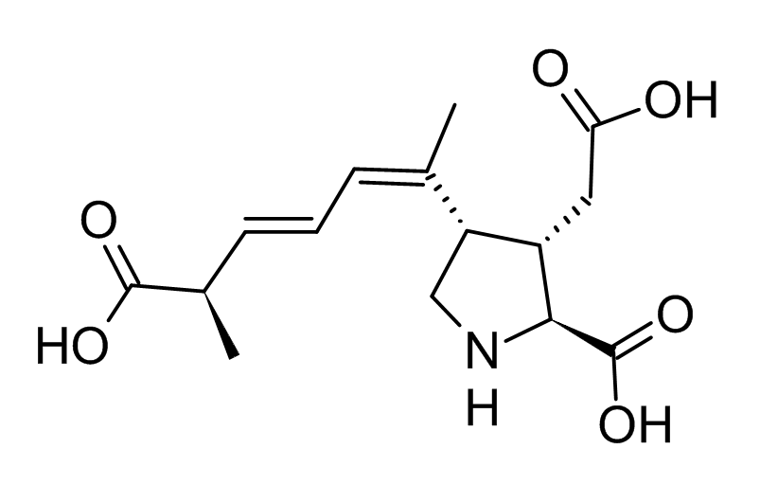
(a) (b)

Figure 1. Structure of domoic acid (a) normal structure and (b) zwitterionic form

DA’s toxicity can be explained by its structural similarity with the excitatory neurotransmitters of glutamic and kainic acids. Due to the stronger receptor affinity of DA which is more potent than kainic and glutamic acid, DA binds predominately to N-methyl-D-aspartate (NMDA), kainite and α-amino-3-hydroxy-5-methyl-4-isoxazolepropionic acid (AMPA) receptors [21], causing excitotoxic effects towards these receptors, where the damaged receptors are unable to control the excessive influx of Ca²⁺ and Na⁺ into neurons [22, 23]. The normal impulse balance is disturbed, which eventually kills the nerve cell [24]. The affected neurons are mainly located in the hippocampus, an area in the brain which is responsible for learning and memory processing. Thus, DA poisoning may lead to neurological distortions including seizures and other uncontrolled movements, brain lesions and permanent memory loss.

At present, chromatographic techniques have been widely used for the detection of marine toxins [2, 25, 26]. Although chromatography is one of the best techniques for domoic acid detection, it requires expensive equipment, trained personnel, sophisticated methods of preparation of samples and is time consuming. In this research, an electrochemical approach of detecting DA was attempted using immobilized ninhydrin in PVC film coated on the surface of working electrodes of Au-SPE. Chemically, ninhydrin reacts with primary amino acids to produce both hydrindantin [27] and Ruhemann’s purple [7] (Figure 2), which is a reliable method to detect amino acids in samples. However, DA is a secondary amino acid, in which the reaction with ninhydrin is almost impossible. Fortunately, besides its neutral molecular structure, DA also possesses a zwitterionic form (Figure 1b), which provides additional hydrogen and nitrogen at physiological pH [28, 29], which suggests that the optimum condition for a DA-ninhydrin interaction would give a yellow colored product. The interactions between DA and ninhydrin on the modified Au-SPE were measured using cyclic voltammetry (CV) responses. CV is widely known for its ability to detect target analytes in low concentrations. This study is important as it supports the need of developing an electrochemical sensor using modified electrodes for monitoring DA in seafood markets, in order to prevent the potential ASP outbreak in Malaysia.

Figure 2. Standard reactions of ninhydrin with primary amino acids

Materials and Methods
Domoic acid, sodium tetraphenyl borate, tetrahydrofuran and tributyl phosphate were purchased from Merck, Germany. Polyvinylchloride was purchased from Sigma-Aldrich, Italy. Ninhydrin was purchased from R&M, UK. All reagents used were of analytical grade.

Instrumentation
Au-SPE was purchased from DropSens, Spain. A mini Potensiostat (Metrohm, Switzerland) was used for electrochemical cyclic voltammetry measurement. Cable connectors (DropSens, Spain) were used to connect the instrument and the electrode. The surface morphology of screen-printed gold electrode (SPGE) was investigated using a Scanning Electron Microscope (SEM) JSM-6360 JEOL, from Japan.

Preparation of thin film cocktail
10 µL of 5 mM ninhydrin, 1.5 g of sodium tetraphenyl borate, 1.2 g of polyvinyl chloride and 2.4 g of tributyl phosphate were mixed with 20 mL of tetrahydrofuran. The mixture was stirred for one hour to make sure it was completely dissolved.

Electrode modification
1 µL of ninhydrin-PVC film cocktail was spread on the working electrode surface of Au-SPE. The modified Au-SPE was dried in an oven at 50 °C for 1 hour and left overnight at room temperature before use.

Cyclic voltammetry measurement
CV measurements were carried out at a scan rate of 50 mV/s at a potential range of -0.6 V to 0.85 V in the presence of 10 mM potassium ferricyanide in 0.1 M KCl.

Results and Discussion

Scanning electron microscope
The surface morphology of bare and modified Au-SPEs was investigated using SEM at different levels of magnifications (Figure 3). At 5000 times magnification, aggregates of different sizes and forms were clearly observed on the surface of modified ninhydrin-Au-SPE, as a result of the stacking of ninhydrin in the PVC film. The smooth surface of bare Au-SPE changed to rumples after the immobilization of PVC film containing ninhydrin.

Bare Au-SPE
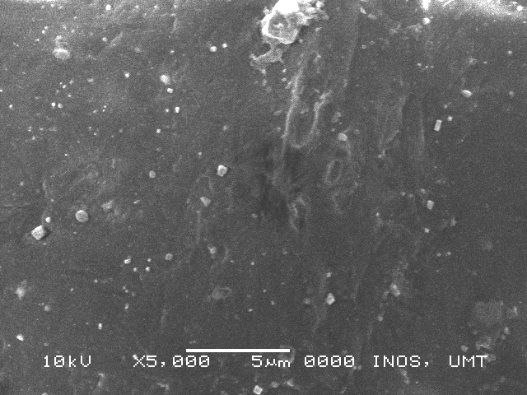 | 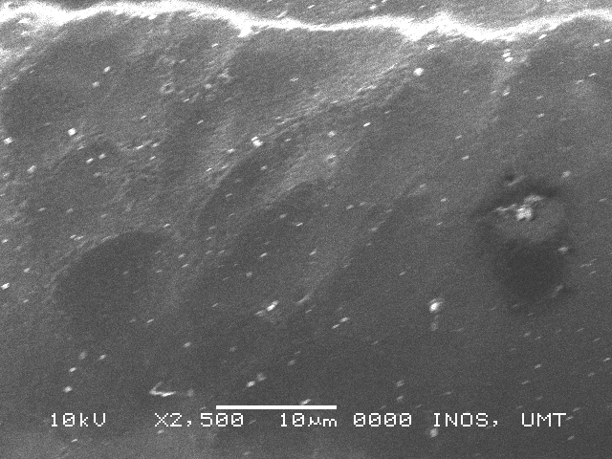 | 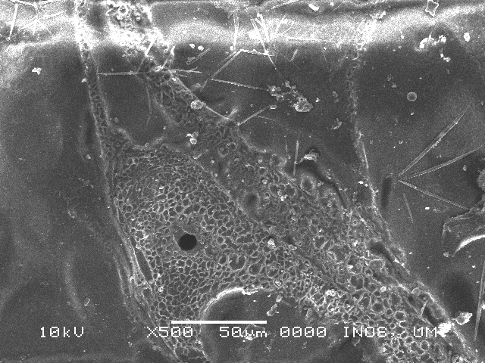
Modified Au-SPE
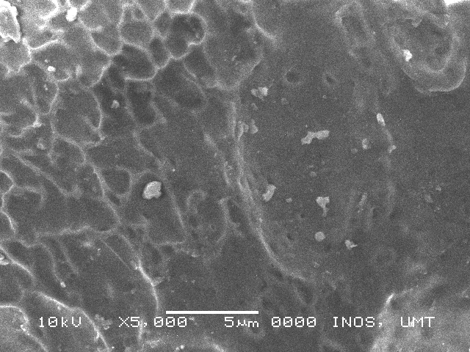 | 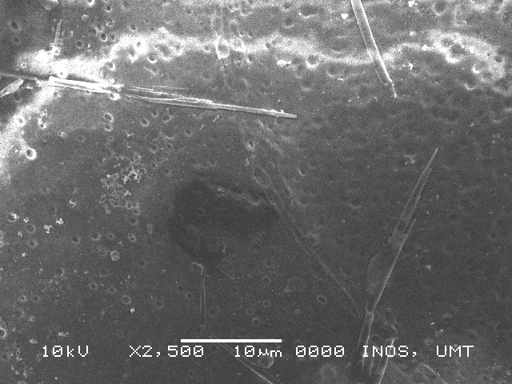 | 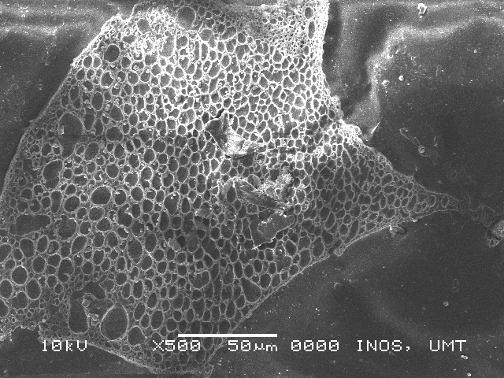
Figure 3. SEM images of bare and modified Au-SPE at different magnifications

Cyclic voltammetry test

The electrochemical characterization of modified Au-SPE was done using a cyclic voltammetry (CV) technique, where the electrochemical behavior of ninhydrin-DA on modified Au-SPE surface was investigated as discussed in the following subsection.

Bare electrode versus modified Au electrode

The performance of bare electrode and modified Au-SPEs was compared using a 10 mM potassium ferricyanide in 0.1 M KCl electrolyte solution with a scan rate of 50 mV/s. The electron-transfer kinetic of ferricyanide redox couple was greatly decreased for modified Au-SPE (Figure 4). The blocking of access of ferricyanide redox couple to the gold electrode is due to the present of a coated ninhydrin-PVC membrane on the Au-SPE.

Figure 4. Voltammograms of bare and modified Au-SPEs at scan rate of 50 mV/s in 10 mM potassium ferricyanide in 0.1 M KCl

Effect of scan rate
The electrochemical behavior of a species generated at the modified Au-SPE can be studied using a scan rate analysis of cyclic voltammetry [30]. The diffusion behavior of DA was investigated by conducting CV with different scan rates ranging from 50-100 mV/s, in 0.3 M DA solution containing 10 mM potassium ferricyanide in 0.1 M KCl. From the results obtained, the peak currents recorded were directly proportional to the scan rate (Figure 5). High peak currents obtained at higher scan rates and low peak current obtained at lower scan rates were measured due to fast and slow redox reactions on the electrode surface.

Figure 5. Voltammogram of different scan rates in 10 mM potassium ferricyanide in 0.1 M KCl

Table 1 displays the peak potential separation (∆E_{p}) and peak current ratio (I_{p}) of different scan rates. The values of ∆E_{p} and I_{p} indicate that the electron transfer process was irreversible. The recorded ∆E_{p} values of all scan rates exceeded both the theoretical (59 mV) and quasi-reversible values (120 mV) [31]. A relationship between the peak current densities (i_{p}) and the square root of scan rate (v)^{1/2} was determined by the Randles-Sevcik equation, which shows a linear relationship. The values of correlation coefficient (R²) of anodic peak (0.9624) and cathodic peak (0.8825) confirm that the electrochemical system of the DA with modified electrode was under the diffusion control process [32].

Table 1. Peak potential separation and peak current ratio values of different scan rates
Scan Rate  (mV/s) | E₀  (mV) | ΔE_{p}  (mV) | I_{c}  (µA) | I_{a}  (µA) | I_{p} | ν^{1/2}
50 | 90 | 180 | 18 | 19 | 0.95 | 7.07
60 | 95 | 170 | 22 | 25 | 0.88 | 7.75
70 | 105 | 150 | 26 | 27 | 0.96 | 8.37
80 | 100 | 160 | 28 | 32 | 0.88 | 8.94
100 | 115 | 130 | 31 | 32 | 0.97 | 10.00

Effect of coating time
The influence of coating time of PVC film on Au SPE was examined in 10 mM potassium ferricyanide in 0.1 M KCl in presence of 10 µM ninhydrin. As shown in Figure 6, the electrochemical measurement shows a direct perpendicular trend between the peak current and coating time. Maximum peak current was recorded at 2 hours, which indicates that the film was firmly attached on the Au-SPE.

Figure 6. Voltammograms of different immobilisation time in 10 mM potassium ferricyanide in 0.1 M KCl. Scan rate: 50 mV/s

Sensing response
Diffusion of DA through the PVC film allowed the reaction of DA with immobilized ninhydrin inside the film. Reaction of zwitterionic DA with ninhydrin resulted in the oxidation of DA and reduction of ninhydrin, which showed a yellow color formation of the film. In Figure 7 and Figure 8, by progressively increasing the amount of DA, a steady increase in current reading was observed. This shows that the sensing response towards DA, of the immobilized ninhydrin on the surface of the modified Au-SPE electrode, was successfully developed.

Figure 7. Voltammogram of different concentration of DA in 10 mM potassium ferricyanide in 0.1 M KCl. Scan rate: 50 mV/s

Figure 8. Calibration plot for different concentration of DA in 10 mM potassium ferricyanide in 0.1 M KCl. Scan rate: 50 mV/s

The sensitivity of the modified Au-SPE towards DA was determined by calculating the limit of detection (LOD) of the sensing responses. Table 2 shows the value of LOD calculated from the sensing responses of DA analysis (anodic response). An LOD value of 7.64 x 10⁻⁵ M shows that the modified sensing system is relatively sensitive where it can measure concentrations of DA as low as 10⁻⁵ M.

Table 2. Reaction response of DA analysis
Standard Deviation, σ | Slope, s | LOD (M)
0.75 | 29.45 | 7.64 x 10⁻⁵

Reproducibility

Reproducibility is defined as the closeness of agreement between independent results, obtained from the same method, on identical test materials, but under different conditions [33]. In this study, the purpose of the reproducibility test was to examine the capability of every single modified AU-SPE prepared, in providing similar responses towards 0.1 mM DA in each test. Figure 9 shows the reproducibility of modified Au-SPE prepared in two batches. Both batches were able to produce almost uniform modified AU-SPEs that can sense DA with very low relative standard deviations (RSD) in each batch. The RSD values calculated were 0.88 % and 1.15% for films in batch 1 and films in batch 2 respectively. However, the difference in current readings between batches (1 and 2) indicate that the uniformity of the modified AU-SPE preparation in different batch conditions is still difficult to achieve. Several factors, such as film thickness and coated surface areas resulting from the preparation techniques, need to be improved in order to achieve the reproducibility of the modified AU-SPE.

Figure 9. Reproducibility of modified Au-SPE with DA

Stability
The stability of modified Au-SPE was studied in 10 mM potassium ferricyanide in 0.1 M KCl, at a scan rate of 50 mV/s. The purpose of the stability test is to examine the capability of each single modified AU-SPE prepared, to be used repetitively in measuring responses towards DA. In this study, 20 repetitive measurements of DA were conducted daily for 20 days using the same modified Au-SPE. Figure 10 shows that the response signal had slightly increased from its initial response over the testing period with a calculated RSD value of 7.47%, thus indicating that the modified Au-SPE is still not stable to be used repetitively. However, since the modified Au-SPEs are reproducible, it is suitable for the electrode to be used as a one-off electrode.

Figure 10. Stability of modified Au-SPE in 10 mM potassium ferricyanide (in 0.1 M KCl) for 20 days. Scan rate: 50 mV/s

Conclusion
A modified Au-SPE for the detection of DA was successfully developed by immobilizing a ninhydrin reagent into a thin film of PVC coated onto the surface of Au-SPE working electrode. The modified Au-SPE was capable of sensing DA by exhibiting irreversible electrochemical signals in a potential ranging from -0.6 to +0.85 V. The sensing system of the modified electrode showed excellent electrochemical characteristics with a good detection limit, efficient reproducibility and suitability to be used as one-off sensor. Further modifications can be studied in order to develop its stability. An active electrochemical interaction shows that the combination of ninhydrin and Au-SPE promises to be a simpler and easier detection method with reliable results.

Acknowledgement
The authors would like to acknowledge the Ministry of Education Malaysia through Fundamental Research Grant Scheme of FRGS/1/2015/ST04/UMT/02/1 (FRGS 59409) and Universiti Malaysia Terengganu for providing support, laboratory facilities and instrumentation.

References
- Rodriguez, I., Vieytes, M.R. and Alfonso A. (2017). Analytical challenges for regulated marine toxins: Detection methods. Current Opinion in Food Science, 18: 29-36.
- Campas, M., Prieto-Simon, B. and Marty, J-L. (2007). Biosensors to detect marine toxins: Assessing food safety. Talanta, 72: 884-895.
- Nicolas, J., Hoogenboom, R. L. A. P., Hendriksen, P. J. M., Bodero, M., Bovee, T. F. H., Rietjens, I. M. C. M. and Gerssen, A. (2017). Marine biotoxins and associated outbreaks following seafood consumption: Prevention and surveillance in the 21st century. Global Food Security, 15: 11-21.
- Saeed, A. F., Awan, S. A., Ling, S., Wang, R. and Wang, S. (2017). Domoic acid: Attributes, exposure risks, innovative detection techniques and therapeutics. Algal Research, 24: 97-110.
- Bates, S. S., Garrison, D. L. and Horner, R. A. (2008). Bloom dynamics and physiology of domoic acid producing Pseudo-nitzschia species, Physiological Ecology of Harmful Algal Blooms, Springer-Verlag, Heidelberg: pp. 267-292.
- Jiang, S., Kuwano, K., Ishikawa, N., Yano, M., Takatani, T. and Arakawa, O. (2014). Production of domoic acid by laboratory culture of the red alga Chondria armata. Toxicon, 92: 1-5.
- Friedman, M. (2004). Applications of the ninhydrin reaction for analysis of amino acids, peptides, and proteins to agricultural and biomedical sciences. Journal of Agriculture and Food Chemistry, 52: 385-406.
- Mos, L. (2001). Domoic acid: A fascinating marine toxin. Environmental Toxicology and Pharmacology, 9: 79-85.
- Jamesa, K. J., Gillman, M., Amandi, M. F., Lopez-Rivera, A., Puente, P. F., Lehane, M., Mitrovic, S. and Furey, A. (2005). Amnesic shellfish poisoning toxins in bivalve molluscs in Ireland. Toxicon, 46: 852-858.
- Blanco, J., Livramento, F. and Rangel, I. M. (2010). Amnesic shellfish poisoning (ASP) toxins in plankton and molluscs from Luanda Bay, Angola. Toxicon, 55: 541-546.
- Anjelkovic, M., Vandevijvere, S., Klaveren, J. V., Oyen, H. V. and Loco, J. V. (2012). Exposure to domoic acid through shellfish consumption in Belgium. Environment International, 49: 115-119.
- Johnson, S., Harrison, K. and Turner, A. D. (2016). Application of rapid test kits for the determination of amnesic shellfish poisoning in bivalve molluscs from Great Britain. Toxicon, 117: 76-83.
- Thorel, M., Claquin, P., Schapira, M., Gendre, R. L., Riou, P., Goux, D., Roy, B. L., Raimbault, V., Deton-Cabanillas, A. F., Bazin, P., Kientz-Bouchart, V. and Fauchot, J. (2017). Nutrient ratios influence variability in Pseudo-nitzschia species diversity and particulate domoic acid production in the Bay of Seine (France). Harmful Algae, 68: 192-205.
- Bresnan, E., Fryer, R. J., Fraser, S., Smith, N., Stobo, L., Brown, N. and Turrell, E. (2017). The relationship between Pseudo-nitzschia (Peragallo) and domoic acid in Scottish shellfish. Harmful Algae, 63: 193-202.
- Li, Y., Huang, C. X., Xu, G. S., Lundholmc, N., Teng, S. T., Wue, H. and Tan, Z. (2017). Pseudo-nitzschia simulans sp. nov. (Bacillariophyceae), the first domoic acid producer from Chinese waters. Harmful Algae, 67: 119-130.
- D’Agostinoa, V. C., Degratia, M., Sastrec, V., Santinellic, N., Krockd, B., Krohnd, T., Dansa, S. L. and Hoffmeyer, M. S. (2017). Domoic acid in a marine pelagic food web: Exposure of southern right whales Eubalaena australis to domoic acid on the Península Valdés calving ground, Argentina. Harmful Algae, 68: 248-257.
- Romero, M. L. J., Kotaki, Y., Lundholm, N., Thoha, H., Ogawa, H., Relox, J. R., Terada, R., Takeda, S., Takata, Y., Haraguchi, K., Endo, T., Lim, P. T., Kodama, M. and Fukuyo, Y. (2011). Unique amnesic shellfish toxin composition found in the South East Asian diatom Nitzschia navis-varingica. Harmful Algae, 10: 456-462.
- Tan, S. N., Teng, S. T., Lim, H. C., Kotaki, Y., Bates, S. S., Leaw, P. C. and Lim, P. T. (2016). Diatom Nitszia navis-varingica (Bacillariophyceae) and its domoic acid production from the mangrove environments of Malaysia. Harmful Algae, 60: 139-149.
- Suriyanti, S. N. P. and Usup, G. (2015). First report of the toxigenic Nitszia navis-varingica (Bacillariophyceae) isolated from Tebrau Strait, Johor, Malaysia. Toxicon, 108: 257-263.
- Teng, S. T., Lim, H. C., Lim, P. T., Dao, B. H., Bates, S. S. and Leaw, C. P. (2014). Peudo-nitszia kodamae sp. nov. (Bacillariophyceae), a toxigenic species from the Strait of Malacca. Harmful Algae, 34: 17-28.
- Lefebvre, K. A. and Robertson, A. (2010). Domoic acid and human exposure risks: A review. Toxicon, 56: 218-230.
- Tasker, R. A. R., Perry, M. A., Doucette, T. A. and Ryan, C. L. (2005). NMDA receptor involvement in the effects of low dose domoic acid in neotanal rats. Amino Acids, 28: 193-196.
- Zabaglo, K., Chrapusta, E., Bober, B., Kaminski, A., Adamski, M. and Bialczyk, J. (2016). Environmental roles and biological activity of domoic acid: A review. Algal Research, 13: 94-101.
- Costa, L. G., Giordano, G. and Faustman, E. M. (2010). Domoic acid as a developmental neurotoxin. NeuroToxicology, 31: 409-423.
- Mohd Syaifudin A. R., Jayasundera K. P. and Mukhopadhyay S. C. (2009). A low cost novel sensing system for detection of dangerous marine biotoxins in seafood. Sensors and Actuators B: Chemical, 137: 67-75.

- Lotierzo M., Henry O. Y. F., Piletsky S., Tothill I., Cullen D., Kania M., Hock B. and Turner A. P. F. (2004). Surface plasmon resonance sensor for domoic acid based on grafted imprinted polymer. Biosensors & Bioelectronics, 20: 145-152.
- Anantharaman, S., Padmarajaiah, N., Al-Tayar, N. G. S. and Shrestha, A. K. (2017). Ninhydrin-sodium molybdate chromogenic analytical probe for the assay of amino acids and proteins. Spectrochimica Acta Part A: Molecular and Biomolecular Spectroscopy, 173: 897-903.
- Djaoued, Y., Balaji, S. and Priya, S. (2007). Non-resonance micro-Raman spectroscopic studies on crystalline domoic acid and its aqueous solutions. Spectrochimica Acta Part A, 67: 1362-1369.
- Kimura, O., Kotaki, Y., Hamaue, N., Haraguchi, K. and Endo, T. (2011). Transcellular transport of domoic acid across intestinal Caco-2 cell monolayers. Food and Chemical Toxicology, 49: 2167 – 2171.
- Othman, M. A. F., Othman, A. A. and Zuki H. M. (2016). Dithizone modified silver electrode for the determination of metal ions in aqueous solution. Malaysian Journal of Analytical Sciences, 20(1): 197-204
- Scholz, F. (2009). Electroanalytical Methods. (2nd edition). Berlin: Springer German.
- Dossi, C., Monticelli, D., Pozzi, A. and Recchia, S. (2016). Exploiting chemistry to improve performance of sceen-printed, bismuth film electrodes (SP-BiFE). Biosensors, 6(3): 38.
- Pellizzari, E., Lohr, K., Blatecky, A. and Creel, D. (2017). Reproducibility: A primer on semantics and implications for research. New Castle: RTI Press.

