

MALAYSIAN JOURNAL OF ANALYTICAL SCIENCES
ISSN 1394 - 2506

Published by The Malaysian Analytical Sciences Society

CHEMICAL CONSTITUENTS AND ANTIOXIDANT POTENTIALS
OF SEVEN PHILIPPINE MOSSES

(Juzuk Kimia dan Potensi Antioksidan bagi Tujuh Lumut Filipina)

Mary Stephanie S. Carranza¹, Virgilio C. Linis², Consolacion Y. Ragasa^{1,3}, Maria Carmen S. Tan¹*

¹Chemistry Department,
De La Salle University, 2401 Taft Avenue, Manila 1004, Philippines
²Biology Department,
De La Salle Araneta University, 303 Victoneta Avenue, Potrero Malabon City 1475, Philippines
³Chemistry Department,
De La Salle University Science & Technology, Complex Leandro V. Locsin Campus, Biñan City, Laguna 4024, Philippines

*Corresponding author: maria.carmen.tan@dlsu.edu.ph

Received: 23 May 2019; Accepted: 1 October 2019

Abstract
Seven species of Philippine mosses, namely Calyptothecium ramosii Broth., Gymnostomum recurvirostum Hedw., Hypnum plumiforme Wilson, Leucobryum scalare Müll.Hal. ex M.Fleisch., Meteoriopsis reclinata (Müll.Hal.) M.Fleisch., Mitthyridium undulatum (Dozy & Molk.) H.Rob. and Pelekium boniamum (Besch) were examined in this study. The mosses were analyzed using a gas chromatography equipped with a mass spectrometer (GC-EI-MS) and an energy dispersive X-ray fluorescence spectrometer (EDX) to substantiate their possible usage as dietary supplements. EDX results displayed that calcium was the major mineral found in all the moss samples (1.199% to 11.427%). The free radical scavenging activity of the dried dichloromethane moss extracts was highest for G. recurvirostum indicative of the lowest IC₅₀ concentration at 0.236 mg/mL followed by C. ramosii at 0.306 mg/mL and P. boniamum at 0.315 mg/mL. M. undulatum (IC₅₀ = 1.360 mg/mL) and M. reclinata (IC₅₀ = 1.544 mg/mL) had moderate antioxidant activity, whereas, L. scalare (IC₅₀ = 2.120 mg/mL) and H. plumiforme (IC₅₀ = 2.213 mg/mL) had minimal free radical scavenging potential. The possible antioxidant capabilities of each respective bryophyte were correlated to the presence of the following major constituents from GC-EI-MS investigation: in P. boniamum, α-cadinol, (9.11%), caryophyllene (6.39%) and (-)-spathulenol (5.52%); in G. recurvirostum, pentanoic acid, 2,2,4-trimethyl-3-carboxyisopropyl, isobutyl ester (56.26%), caryophyllenyl alcohol (5.96%) and α-cadinene (5.88%); in C. ramosii, phytol (17.86%), and phytol acetate (14.03%). 7,9-di-tert-butyl-1-oxaspiro (4,5) deca-6,9-diene-2,8-dione (9.59%), and 4,8,12,16-tetramethylheptadecan-4-olide (6.11%). Apart from H. plumiforme, all the samples contained considerable concentrations of n-hexadecanoic acid (range from 3.76% to 29.03%).

Keywords: bryophyte, free radical scavenging activity, gas chromatography - mass spectrometry, energy dispersive x-ray fluorescence spectroscopy

Abstract
Tujuh spesis lumut Filipina iaitu Calyptothecium ramosii Broth., Gymnostomum recurvirostum Hedw., Hypnum plumiforme Wilson, Leucobryum scalare Müll.Hal. ex M.Fleisch., Meteoriopsis reclinata (Müll.Hal.) M.Fleisch., Mitthyridium undulatum (Dozy & Molk.) H.Rob. dan Pelekium boniamum (Besch) telah diuji dalam kajian ini. Lumut telah dianalisa menggunakan kromatografi gas dilengkapi spectrometer jisim (GC-EI-MS) dan spektrometer pendaflour tenaga serakan sinar-X (EDX) untuk melihat potensi digunakan sebagai makanan tambahan. Keputusan EDX menunjukkan kalsium merupakan mineral utama yang dijumpai dalam semua sampel lumut (1.199% to 11.427%). Aktiviti pemerangkapan radikal bebas melalui ekstrak lumut menggunakan diklorometana telah memberikan G. recurvirostum hasil paling tinggi pada kepekatan IC₅₀ iaitu 0.236 mg/mL diikuti C. ramosii pada 0.306 mg/mL and P. boniamum pada 0.315 mg/mL. M. undulatum (IC₅₀ = 1.360 mg/mL) dan M. reclinata (IC₅₀ = 1.544 mg/mL) menghasilkan aktiviti antioksidan yang sederhana, manakala L. scalare (IC₅₀ = 2.120 mg/mL) dan H. plumiforme (IC₅₀ = 2.213 mg/mL) mempunyai potensi pemerangkapan radikal bebas yang minumum. Keupayaan antioksidan setiap briofit adalah dikaitkan dengan kehadiran juzuk utama iaitu hasil analisa GC-EI-MS seperti di dalam P. boniamum, mengandungi α-kadinol, (9.11%), kariofilena (6.39%) dan (-)-spathulenol (5.52%); di dalam G. recurvirostum seperti asid pentanoik, 2,2,4-trimetil-3-karboisopropil, isobutil ester (56.26%), kariofilenil alkohol (5.96%) dan α-kadinena (5.88%), di dalam C. ramosii, fitol (17.86%), fitol asetat (14.03%). 7,9-di-tert-butil-1-oksaspiro (4,5) deka-6,9-diena-2,8-dion (9.59%), dan 4,8,12,16-tetrametillheptadekan-4-olida (6.11%). Selain dari H. plumiforme, semua sampel mengandungi kepekatan asid n-heksadekanoik (julat dari 3.76% hingga 29.03%).

Keywords: briofit, aktiviti pemerangkapan radikal bebas, kromatografi gas-spektrometri jisim, spektroskopi pendaflour tenaga serakan sinar-X

Introduction
There has not been much research done on non-vascular plants, particularly on mosses which belong to the division Bryophyta [1], primarily because moss samples are usually small and are considered insignificant [2]. Traditionally, Native Americans are known to have used mosses as concoctions for treating tuberculosis, pneumonia, neurasthenia, wounds and burns [3, 4]. Large mosses such as Polytrichum commune Hedw. have been confirmed to have antimicrobial activity on several bacteria strains (Bacillus cereus Frankland & Frankland 1887, Pseudomonas aeruginosa (Schröter 1872) Migula 1900, Staphylococcus aureus Rosenbach 1884, and Escherichia coli (Migula 1895) Castellani and Chalmers 1919) by exhibiting inhibition zone diameters which varied from 9 to 15 mm [5]. Other mosses such as Sphagnum magellanicum Brid., Dicranum polysetum Sw., Pleurozium schreberi (Brid.) Mitt.) displayed high antiproliferative activity (0.9–5 μg/mL) on rat glioma cells [5]. Some work has been specifically done on the use of mosses as biomonitors to short-term responses and antioxidant fluctuations due to heavy metal damage [6]. For instance, allelochemicals (phytoalexins in rice) momilactone A and B have been isolated from Hypnum plumiforme Wilson [7]. Short–term responses of H₂O₂ concentration have been found to increase in the presence of Pb and Ni induced stress in H. plumiforme [8]. LC-ToF-MS analysis of ethanolic moss extracts, on the other hand, revealed that the most abundant constituents are fatty acids (329–1707 mg/100 g dry moss), sterols (632–2130 mg/100 g dry moss), and amino acids (590–3266 mg/100 g dry moss) [5].

In this study, seven Philippine mosses specifically Calyptothecium ramosii Broth. (CR), Gymnostomum recurvirostum Hedw. (GR), Hypnum plumiforme Wilson (HP), Leucobryum scalare Müll.Hal. ex M.Fleisch. (LS), Meteoriopsis reclinata (Müll.Hal.) M.Fleisch. (MR), Mitthyridium undulatum (Dozy & Molk.) H.Rob. (MA), and Pelekium boniamum (Besch.) (PB) were gathered from several localities in Central Luzon Region, Philippines and were selected for investigation. Furthermore, all these mosses are essentially extra-Philippine species occurring throughout Southeast Asia and none are endemics.

Chemical characterization of the seven moss species was achieved using gas chromatograph in tandem with a mass spectrometer (GC-EI-MS) and energy dispersive X-ray spectroscopy (EDX) technique. Free radical scavenging capacity was ascertained in the dichloromethane extracts from these mosses. To the best of our knowledge, this is the first reported study using this methodology of antioxidant activity on the aforementioned crude bryophyte extracts and chemical analyses of the samples.

Materials and Methods
The mat or aerial portion taken from each moss samples was pulverized into a powdered biomass. The powder was used for the stipulated analytical techniques to characterize the aforementioned mosses gathered from Central Luzon Region, Philippines.

Solvent extraction
Each moss sample was grounded followed by soaking 3.0 grams of the powdered biomass in 20 mL of dichloromethane (DCM) for three hours. Extracts were filtered and then dried under nitrogen for one hour. The crude extracts from PB (0.4 mg), HP (0.5 mg), GR (0.3 mg), LS (0.5 mg), MR (0.4 mg), CR (0.4 mg) and MA (0.3 mg) were dissolved in one millilitre of dichloromethane for subsequent GC-EI-MS analyses.

GC-EI-MS parameters
Crude extracts from DCM soaked moss samples were analysed by gas chromatography – electron ionization - mass spectrometry analysis. An Agilent GC MS 7890B with a HP-5 ms (5% phenyl methyl siloxane) ultra-inert column (30 m x 250 mm x 0.25 mm) with ultra-high purity grade helium as a gas carrier was used for the analysis of the volatile constituents. The flow rate of the helium gas was set at 1.0587 mL/min, pressure was made to be at 9.4889 psi, with an average velocity of 37.862 cm/sec and hold time of 1.3206 minute. The initial setpoint temperature was at 70 ºC. The program was as followed: first ramp was set at 2 ºC /min to 135 ºC and held for 10 minutes, second ramp had a rate of 4 ºC/min to 220 ºC and held for 10 minutes, and finally, the last ramp had a rate of 3.5 ºC/min to 270 ºC and held for 37 minutes. The heatmap was generated from the software XLSTAT v. 2015.1.

Compound identification was done using the NIST library v. 2.0 and peak areas were processed from the resultant total ion chromatograms as total correlation maximum percentage. The resultant data was confirmed by the comparison of the compounds according to their elution order with their relative retention indices on a non-polar stationary phase. The retention indices were computed for all of the volatile constituents’ utilizing a homologous series of n-alkanes. All tests were performed in triplicates and data (retention time) were shown as mean ± SEM.

Free radical scavenging assay
The free radical scavenging activity of moss extracts was carried out using a modified DPPH assay protocol by Jose Prieto [9]. Powdered moss samples (15 g) were incubated in 20 mL of dichloromethane (DCM) for three hours. Extracts were filtered and then dried under nitrogen for one hour. The crude extracts from PB (4.0 mg), HP (4.0 mg), GR (3.6 mg), LS (6.9 mg), MR (5.7 mg), CR (4.8 mg) and MA (6.40 mg) were dissolved in 4.5 mL of methanol for DPPH analyses.

A 0.2 mM DPPH solution was prepared by diluting 3.94 mg of 1, 1-diphenyl-2-picrylhydrazyl (DPPH) in 50 mL of methanol in a volumetric flask. A stock solution for each moss was prepared at 4 mg of crude extract in one mL of methanol. The blank was made to be 1 mL of this solution in addition to 1 mL of methanol. 1 mL of the 4 mg/mL stock was added to a 10 mL test tube along with one mL of the 0.2 mM DPPH solution. A total of eight concentrations from 17.5 to 0.27 mg/mL were made by serial dilution. The absorbances were read at 515 nm (UV-VIS Shimadzu 2900) after samples were incubated at room temperature for 30 minutes. Statistical analyses and graphs were done using GraphPad Prism 7.01 (GraphPad Software, Inc.). Results were considered significant at p < 0.05. The IC₅₀ value of the sample, or the concentration of the sample which can inhibit 50% of the DPPH free radicals, was determined by calculating the percent DPPH scavenging effect which was calculated by the following formula in equation 1;

DPPH scavenging effect (%) or Percent inhibition = (A_{o} - A₁/ A_{o}) x 100 (1)

Results and Discussion
GC-MS analysis revealed a total of 56 compounds determined from the seven species of mosses as seen in Table 1 and 2 and Figure 1 and 2, respectively. In PB, 11 constituents were found which were primarily composed of (3) sesquiterpenes, (3) alcohols, (2) compounds with diverse functional groups, (1) saturated fatty acid, (1) hydrocarbon and an ester. In another moss, HP, a total of 9 constituents were found to consist of (4) sesquiterpene alcohols, (3) diverse functional groups, (1) sesquiterpene and (1) steroid alcohol. GR, on the other hand, had a total of 7 constituents and these were (2) sesquiterpene alcohols, (2) diverse functional groups, (1) saturated fatty acid, (1) sesquiterpene and (1) hydrocarbon. In LS, 8 constituents were found and these are (2) diverse functional groups, (2) alcohols, (1) sesquiterpene, (1) ester, (1) saturated fatty acid and (1) ketone while in MR, 11 constituents were found and these are the (4) saturated fatty acids, (2) alcohols, (1) aldehyde, (1) diverse functional group, (1) ester, (1) polyunsaturated fatty acid and (1) hydrocarbon. Meanwhile, CR was found to contain 7 constituents, and these were (2) esters, (1) diterpenoid, (1) diverse functional group, (1) saturated fatty acid, (1) alcohol and (1) hydrocarbon. Lastly, moss MA was found to contain only three primary constituents: (1) diverse functional group, (1) saturated fatty acid and (1) alcohol.

All seven mosses were observed to contain compounds exhibiting wide range of structures. Most notable were the sesquiterpenes and compounds with diverse functional groups which were found to primarily constitute the composition of the samples. In PB, for instance, saturated fatty acids such as palmitic acid (16.28%) and formic acid, the 3,7,11-trimethyl-1,6,10-dodecatrien-3-yl ester (9.29%), phytol (9.12%), and a sesquiterpenoid alcohol, alpha-cadinol, (9.11%) were its major components. Interestingly, -cadinol was also observed to be one of the four major components of the essential oil derived from Strawberry guava (Psidium cattleyanum Sabine) from Southern Brazil which exhibited high anti-microbial activity against gram-negative and gram-positive bacterium strains [10]. Two compounds classified to have diverse functional groups, pentanoic acid, 2,2,4-trimethyl-3-carboxyisopropyl, isobutyl ester and methyl retinoate were discovered to have the highest intensity values for HP at 28.69% and 21.16%, respectively. Methyl retinoate, which was also found in the Brazilian green bee propolis, has been linked to have a positive correlation with the anti-oxidant capacity linked to the extensive conjugated pi-electron system which through donation of electrons can oxidize radical species [11].

The moss GR, on the other hand, was identified to contain bioactive compounds naphthalene, 1,2,3,5,6,8a-hexahydro-4,7-dimethyl-1-(1-methylethyl)-, (1S-cis)- (5.88%) and caryophyllenyl alcohol (5.96%). Naphthalene, 1,2,3,5,6,8a-hexahydro-4,7-dimethyl-1-(1-methylethyl)-, (1S-cis)-, also known as beta-cadinene, was reported to be a component of the commonly used basil (Ocimum basilicum L.). This essential oil is largely known for its anti-oxidant properties [12]. Similar to HP, LS also contained pentanoic acid, 2,2,4-trimethyl-3-carboxyisopropyl, isobutyl ester (56.26%) and n-hexadecanoic acid (13.37%). MR was established to contain squalene (45.26%) and n-hexadecanoic acid (16.21%) while the major constituents of CR were found to be composed of the saturated fatty acid, n-hexadecanoic acid (29.03%) and squalene (18.81%). Likewise, n-hexadecanoic acid (15.83%) was detected in moss MA.

Table 1. The chemical constituents of PB, HP, and GR moss extracts
Constituent | RT (minute) | RIª | % Peak Area | Compound Class
Pelekium bonl amum, PB
Caryophyllene | 18.67 | 1425 | 6.39 | bicyclic sesquiterpene
1H-Cyclopenta[1,3]cyclopropa[1,2]benzene, octahydro-7-methyl-3-methylene-4-(1-methylethyl)-, [3aS-(3aα,3bβ,4β,7α | 20.2 | 1488 | 5.52 | diverse functional groups
Naphthalene, 1,2,3,4,4a,5,6,8a-octahydro-7-methyl-4-methylene-1-(1-methylethyl)-, (1α,4aβ,8aα)- | 21.2 | 1528 | 4.97 | bicyclic sesquiterpene
(-)-Spathulenol | 22.51 | 1581 | 5.52 | tricyclic sesquiterpene
Pentanoic acid, 2,2,4-trimethyl-3-carboxyisopropyl, isobutyl ester | 22.9 | 1600 | 8.85 | diverse functional groups
Formic acid, 3,7,11-trimethyl-1,6,10-dodecatrien-3-yl ester | 24.05 | 1650 | 9.29 | terpene ester
α-Cadinol | 24.25 | 1659 | 9.11 | sesquiterpenoid alcohol
Heptadecane, 8-methyl- | 26.07 | 1747 | 6.88 | Hydrocarbon
4,4,8-Trimethyltricyclo[6.3.1.0(1,5)]dodecane-2,9-diol | 28.88 | 1883 | 1.27 | polycyclic diol
n-Hexadecanoic acid | 30.56 | 1966 | 16.82 | saturated fatty acid

Table 1 (cont’d). The chemical constituents of PB, HP, and GR moss extracts
Constituent | RT (minute) | RIª | % Peak Area | Compound Class
Hypnum plumaeforme, HP
Phytol | 33.33 | 2058 | 9.12 | diterpene alcohol
Naphthalene, 1,2,3,5,6,8a-hexahydro-4,7-dimethyl-1-(1-methylethyl)-, (1S-cis)- | 21.63 | 1572 | 3.57 | diverse functional groups
(-)-Spathulenol | 22.55 | 1616 | 5.18 | tricyclic sesquiterpene alcohol
Globulol | 22.99 | 1630 | 3.82 | tricyclic hydroazulene sesquiterpene
Pentanoic acid, 2,2,4-trimethyl-3-carboxyisopropyl, isobutyl ester | 22.9 | 1627 | 28.69 | diverse functional groups
Cubenol | 23.65 | 1652 | 5.55 | sesquiterpene alcohol
.tau.-Muurolol | 23.96 | 1662 | 8.59 | sesquiterpene alcohol
α-Cadinol | 24.25 | 1671 | 14.83 | sesquiterpene alcohol
β-Sitosterol | 36.84 | 3017 | 8.98 | steroid alcohol
Rectinoic acid, methyl ester | 42.75 | 3351 | 21.16 | diverse functional groups
Gymnostomum recurvirostum, GR
Naphthalene, 1,2,3,5,6,8a-hexahydro-4,7-dimethyl-1-(1-methylethyl)-, (1S-cis)- | 21.20 | 1547 | 5.88 | sesquiterpene
Caryophyllenyl alcohol | 22.33 | 1583 | 5.96 | sesquiterpene alcohol
Pentanoic acid, 2,2,4-trimethyl-3-carboxyisopropyl, isobutyl ester | 22.89 | 1601 | 56.26 | diverse functional groups
α-Cadinol | 24.24 | 1661 | 5.83 | sesquiterpene alcohol
7,9-Di-tert-butyl-1-oxaspiro(4,5)deca-6,9-diene-2,8-dione | 29.73 | 1923 | 2.45 | diverse functional groups
n-Hexadecanoic acid | 30.47 | 1961 | 3.76 | saturated fatty acid
Squalene | 44.59 | 2832 | 13.37 | triterpene
ª Retention Index (HP-5ms column), ^{b} Compounds listed in order of elution from a HP-5ms column

Table 2. The chemical constituents of LS, MR, and CR moss extracts
Constituent | RT (minute) | RIª | % Peak Area | Compound Class
Leucobryum scalore, LS
Naphthalene, 1,2,3,5,6,8a-hexahydro-4,7-dimethyl-1-(1-methylethyl)-, (1S-cis)- | 21.20 | 1519 | 5.88 | sesquiterpene
Caryophyllenyl alcohol | 22.33 | 1551 | 5.96 | sesquiterpenoid alcohol
Pentanoic acid, 2,2,4-trimethyl-3-carboxyisopropyl, isobutyl ester | 22.89 | 1567 | 56.26 | diester
α-Cadinol | 24.24 | 1618 | 5.83 | sesquiterpenoid alcohol
2-Butyloxycarbonyloxy-1,1,10-trimethyl-6,9-epidioxydecalin | 29.73 | 1653 | 2.45 | diverse functional groups
2-Pentadecanone, 6,10,14-trimethyl- | 30.47 | 1846 | 3.76 | aliphatic ketone
7,9-Di-tert-butyl-1-oxaspiro(4,5)deca-6,9-diene-2,8-dione | 40.54 | 1922 | 6.12 | diverse functional groups
n-Hexadecanoic acid | 44.59 | 1961 | 13.37 | saturated fatty acid
Meteoriopsis reclinate, MR
Nonanal | 10.16 | 1105 | 10.88 | aldehyde
Nonanoic acid | 14.83 | 1276 | 6.78 | saturated fatty acid
3,7,11,15-Tetramethyl-2-hexadecen-1-ol | 28.09 | 1840 | 2.64 | polyprenol
Pentadecanoic acid | 28.37 | 1854 | 2.33 | saturated fatty acid
7,9-Di-tert-butyl-1-oxaspiro(4,5)deca-6,9-diene-2,8-dione | 29.74 | 1922 | 1.59 | diverse functional groups
n-Hexadecanoic acid | 30.58 | 1966 | 16.21 | saturated fatty acid
Arachidonic acid | 32.06 | 2044 | 3.10 | polyunsaturated fatty acid
Phytol | 33.35 | 2114 | 4.11 | diterpene alcohol
9,12-Octadecadienoic acid (Z,Z)- | 33.74 | 2136 | 4.66 | saturated fatty acid
4,8,12,16-Tetramethylheptadecan-4-olide | 37.48 | 2355 | 2.44 | aliphatic lactone
Squalene | 46.38 | 2961 | 45.26 | triterpene

Table 2 (cont’d). The chemical constituents of LS, MR, and CR moss extracts
Constituent | RT  (minute) | RIª | % Peak  Area | Compound Class
Calyptotheciom ramosii, CR
Phytol acetate | 28.088 | 1839 | 14.03 | diterpene ester
7,9-Di-tert-butyl-1-oxaspiro(4,5)deca-6,9-diene-2,8-dione | 29.75 | 1922 | 4.57 | diverse functional group
Oxacycloheptadec-8-en-2-one, (8Z) | 30.008 | 1936 | 9.59 | cyclic ester
n-Hexadecanoic acid | 30.577 | 1965 | 29.03 | saturated fatty acid
Phytol | 33.3525 | 2114 | 17.86 | diterpene alcohol
4,8,12,16-Tetramethylheptadecan-4-olide | 37.4895 | 2355 | 6.11 | diterpenoid
Squalene | 44.6135 | 2831 | 18.81 | triterpene
Mitthydridium andulatum, MA
Benzoic acid, 2,4-dihydroxy-3,6-dimethyl-, methyl ester | 25.4237 | 1712 | 12.89 | diverse functional groups
n-Hexadecanoic acid | 30.561 | 1964 | 15.83 | saturated fatty acid
Phytol | 33.359 | 2114 | 12.13 | diterpene alcohol
ª Retention Index (HP-5ms column), ^{b} Compounds listed in order of elution from a HP-5ms column

(PB) (HP)

(GR)
Figure 1. Total ion chromatogram of DCM extracts of dried PB, HP and GR with n-alkanes

(LS) (MR)

(CR) (MA)
Figure 2. Total ion chromatogram of DCM extracts of dried MR, CR, and MA with n-alkanes
Elemental composition by energy dispersive X-ray spectroscopy analysis
Dehydrated samples from the seven mosses were subjected to elemental analysis using energy dispersive X-ray spectrometry (Shimadzu EDX-7000) in 10mm Mylar cups. Table 3, Figure 3 and 4 shows the chemical compositions of the adsorbents in elemental percentage (<ppm). For all species, C₆H₁₀O₅ (polydextrose units) were found to be dominant in the biomass ranging from ~51% to ~96%. Tukey’s post hoc multiple analyses showed significant differences in silicon concentration in GR vs. LS, CR, MR, and MA. Multiple comparisons in C₆H₁₀O₅ displayed disparate differences in GR vs. PB, HP, LS, MR, CR, and MA. The moss GR was found to be the most unique as it contained elements, Ir (0.003%) and V (0.045%), which are not detected in the other samples.

Hierarchical clustering has been utilized to interpret data through calculating the distance matrices of data objects and then merging objects that are close to each other to form sub-clusters [13]. The heatmap (Figure 3) demonstrated a pattern in element composition between LS and MA and were found comparable to HP and MR. PB and CR, on the other hand, were grouped in one cluster due to the shared intensity in percent element composition of the elements Cl, K, Br, P, S and Sr. In addition, PB and CR were within the same range of percent polydextrose units present at 89.597% and 92.353%, respectively. Furthermore, the heatmap proved the distinguishable characteristic of GR which was found to contain a significantly larger amount of the same elements detected in the other moss samples. GR was grouped in its own cluster and was also found to contain the lowest amount of cellulose (at 51.987%) among the other elements detected including Ca (11.427%), Si (19.361%), Fe (5.995%), Al (6.589%), Mg (2.903%) and Ti (0.561%).

Table 3. Elemental analysis (EDX) of mosses
 | PB | HP | GR | LS | MR | CR | MA
Analyte | Elemental %
Ca | 4.497 | 1.856 | 11.427 | 1.192 | 6.518 | 2.780 | 1.994
Si | 1.923 | 2.032 | 19.361 | 1.007 | 0.282 | 1.212 | 0.437
K | 1.504 | 0.458 | 0.419 | 0.534 | 0.622 | 0.717 | 0.718
Fe | 0.675 | 0.575 | 5.995 | 0.354 | 0.043 | 0.138 | 0.118
S | 0.606 | 0.195 | 0.440 | 0.161 | 0.433 | 0.878 | 0.556
Al | 0.471 | 1.965 | 6.589 | 0.533 | 0 | 0.252 | 0.421
P | 0.400 | 0.181 | 0 | 0.041 | 0.193 | 0.513 | 0.077
Cl | 0.244 | 0.110 | 0 | 0.082 | 0.117 | 0.152 | 0.117
Ti | 0.033 | 0.072 | 0.561 | 0.031 | 0 | 0.017 | 0.011
Mn | 0.013 | 0.017 | 0.147 | 0.009 | 0.010 | 0.016 | 0.007
Mg | 0 | 0 | 2.903 | 0.329 | 0.805 | 0.743 | 0.434
Zn | 0.013 | 0.013 | 0.016 | 0.004 | 0.011 | 0.022 | 0.005
Sr | 0.013 | 0.009 | 0.014 | 0 | 0.012 | 0.014 | 0.007
Cu | 0.007 | 0.006 | 0.065 | 0.005 | 0.007 | 0.006 | 0.005
Br | 0.003 | 0.001 | 0.001 | 0.001 | 0 | 0.002 | 0.002
Cr | 0.002 | 0.002 | 0.026 | 0.003 | 0.002 | 0.002 | 0
Ir | 0 | 0 | 0.003 | 0 | 0 | 0.001 | 0
V | 0 | 0 | 0.045 | 0 | 0 | 0 | 0
C₆H₁₀O₅ | 89.597 | 92.507 | 51.987 | 95.7123 | 90.945 | 92.353 | 95.090

Elevated percentages of calcium (Ca) in all of moss samples indicated that each moss species metabolized a high consumption of mineral nutrients absorbed from the substrates as demonstrated by Figure 3. It has been reported that calcium ingestion in healthy elderly women are beneficial in the normalization of lipid profiles, glucose metabolism, and reduction in blood pressure [14, 15].

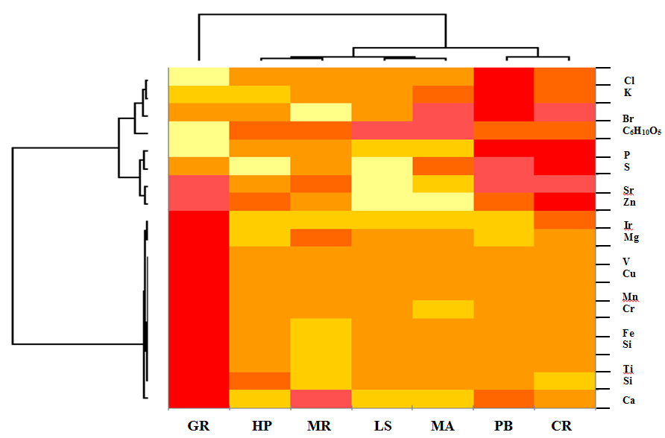
Figure 3. A hierarchically clustered heat map of the element analyses inherent in mosses.

Moss | EDX image | X-ray energy spectrum
(PB) | 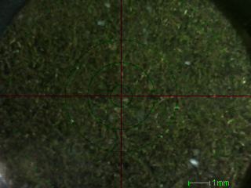 | 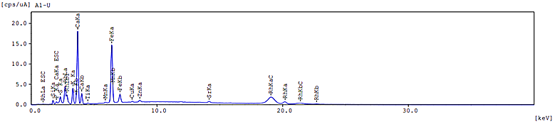
(HP) | 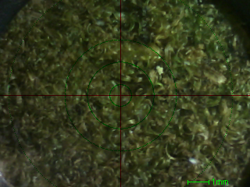 | 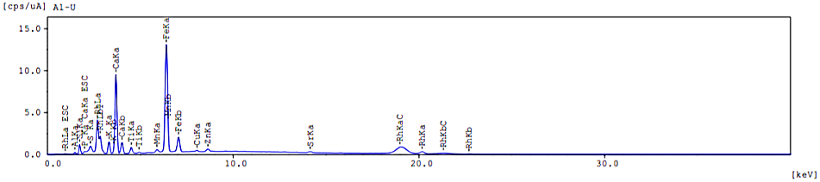
(GR) | 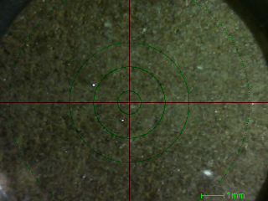 | 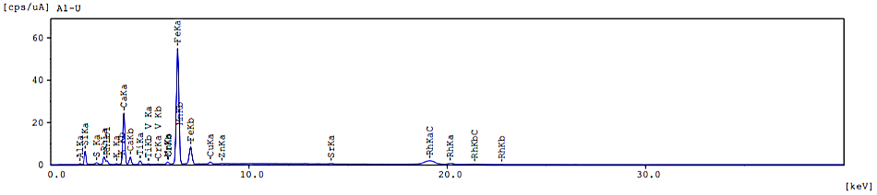
(LS) | 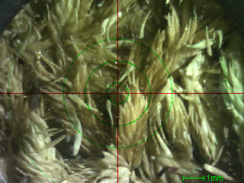 | 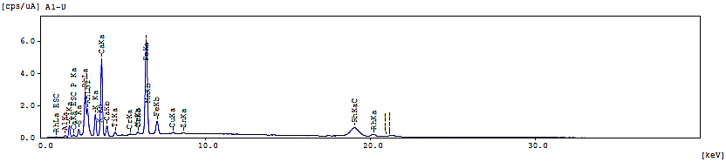
(MR) | 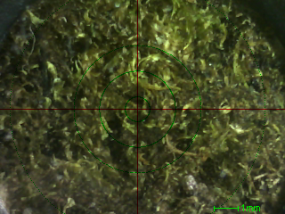 | 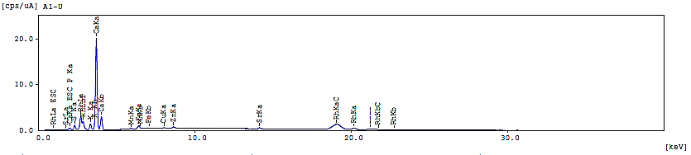
(CR) | 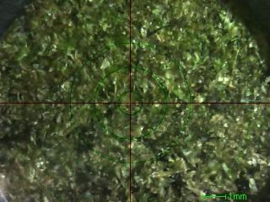 | 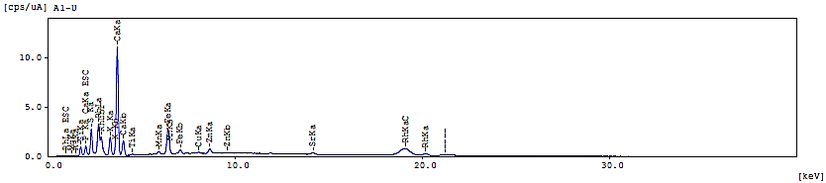
(MA) | 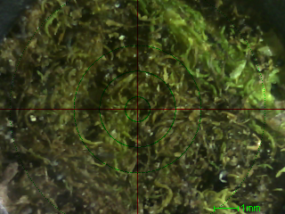 | 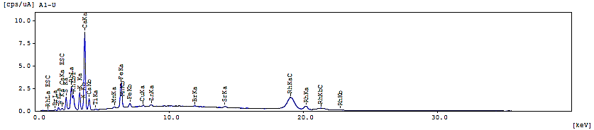

Figure 4. EDX image and X-ray energy spectrum of PB, HP, GR, LS, MR, CR, and MA

Free radical scavenging activity
DCM extracts of the mosses were tested for their free radical scavenging activity as seen in Figure 5. The inhibitory activity of the mosses was found to vary in range starting with GR demonstrating the lowest IC₅₀ at 0.236 mg/mL followed by CR at 0.306 mg/mL and then PB at 0.315 mg/mL. MA and MR both have moderate antioxidant activity exhibiting IC₅₀ = 1.360 mg/mL and 1.554 mg/mL, respectively while LS and HP exhibited the highest half maximum inhibitory concentration values at 2.120 mg/mL and 2.213 mg/mL respectively. The IC₅₀ value of all seven mosses was found to be primarily constituted by oxygenated sesquiterpenes which was also observed to exhibit high anti-oxidant activity. Even at low concentrations, these low-weight, volatile molecules were capable of either reducing or preventing oxidative damage caused by the production of reactive oxygen species [16]. These free radicals are typically produced in the intracellular compartments as by-products of the plant cell biochemistry. GR, which displayed the lowest IC₅₀ value, was composed primarily of γ-cadinene or naphthalene, 1,2,3,5,6,8a-hexahydro-4,7-dimethyl-1-(1-methylethyl)-, (1S-cis)- (Peak area: 5.88%). This compound, also known as beta-cadinene, was found to be a component in the most commonly used basil, Ocimum basilicum L. The essential oil is largely known for its anti-oxidant properties [12].

Figure 5. DPPH assay IC₅₀ values of mosses

Conclusion
The focus of this study was to ascertain if mosses PB, HP, GR, LS, MR, CR, and MA could possess nutritive values based on chemical characterization and free radical scavenging assay. Among these seven mosses, GR, PB, and CR exhibited exceptionally low half maximal inhibitory potential against free radicals (IC₅₀ less than 0.032 mg/mL). The half maximum inhibitory concentrations of GR (G. recurvirostum), PB (P. boniamum), and CR (C. ramosii) were better than the accepted values of other medicinal plants [17]. In all the seven moss species analysed in this study, C₆H₁₀O₅ were found to be the most dominant component ranging from ~51% to ~96% followed by calcium content which ranged from 1.199% to 11.427%. The following were the bioactive constituents found among the seven mosses analysed: PB, α-cadinol, caryophyllene and (-)-spathulenol; GR, pentanoic acid, 2,2,4-trimethyl-3-carboxyisopropyl, isobutyl ester, caryophyllenyl alcohol, and β-cadinene; LS predominately comprised of pentanoic acid, 2,2,4-trimethyl-3- carboxyisopropyl, isobutyl ester (56.26%) and n-hexadecanoic acid (13.37%); and CR, 4,8,12,16-tetramethylheptadecan-4-olide, 7,9-di-tert-butyl-1-oxaspiro (4,5) deca-6,9-diene-2,8-dione, phytol, and phytol acetate. The pharmacognosy of these mosses could be linked to the capabilities of each in the quenching of free radicals and could add to the furtherance of the utilization of these plants as pharma supplements. Future research should be directed towards the application of these moss extracts on diseases associated with oxidative stress or injury such as atherosclerosis, diabetes, and cancer.

Acknowledgement
A research grant, project number 10 IR 2TAY16-3TAY17 from De La Salle University Science Foundation through the University Research Coordination Office, is gratefully acknowledged.

References
- Goffinet, B. and Buck, W. R. (2004). Molecular systematics of bryophytes. Missouri Botanical Garden Press, Illinois: pp. 205-239.
- Dey, A. and Mukherjee, A. (2015). Therapeutic potential of bryophytes and derived compounds against cancer. Journal of Acute Disease, 4(3): 236-248.
- Singh, M., Govindarajan, R., Nath, V., Rawat, A. K. S. and Mehrotra, S. (2006). Antimicrobial, wound healing and antioxidant activity of Plagiochasma appendiculatum Lehm. et Lind. Journal of Ethnopharmacology, 107: 67-72.
- Saboljevic, A., Sokovic, M., Glamočlija, J., Čirič, A., Vujičic, M., Pejin, B. and Saboljevic, M. (2010). Comparison of extract bio-activities of in-situ and in vitro grown selected bryophyte species. African Journal of Microbiology, 4: 808-812.
- Klavina, L., Springe, G., Nikolajeva, V., Martsinkevich, I., Nakurte, I., Dzabijeva, D. and Steinberga, I. (2015). Chemical composition analysis, antimicrobial activity and cytotoxicity screening of moss extracts (moss phytochemistry). Molecules, 20: 17221-17243.
- Sun, S.-Q., He, M., Cao, T., Zhang, Y. C. and Han, W. (2008). Response mechanisms of antioxidants in bryophyte (Hypnum plumiforme) under the stress of single or combined Pb and/or Ni. Environmental Monitoring and Assessment, 149: 291-302.
- Nozaki, H., Hayashi, K., Nishimura, N., Kawaide, H., Matsuo, A. and Takaoka, D. (2007). Momilactone A and B as allelochemicals from moss Hypnum plumiforme: First occurrence in bryophytes. Bioscience Biotechnology Biochemistry, 71(12): 3127-3130.
- Sun, S.-Q., He, M., Cao, T., Yusuyin, Y., Han, W. and Li, J. L. (2010). Antioxidative responses related to H₂O₂ depletion in Hypnum plumiforme under the combined stress induced by Pb and Ni. Environmental Monitoring and Assessment, 163(1-4): 303-312.
- Blois, M. S. (1958). Antioxidant determinations by the use of a stable free radical. Nature, 29: 1199-1200.
- Scur, M. C., Pinto, F. G. S., Pandini, J. A., Costa, W. F., Leite, C. W. and Temponi, L. G. (2016). Antimicrobial and antioxidant activity of essential oil and different plant extracts of Psidium cattleyanum Sabine. Brazilian Journal of Biology, 76(1): 101-108.
- Bittencourt, M. L. F., Ribeiro, P. R., Franco, R. L. P., Hilhorst, H. W. M., de Castro, R. D. and Fernandez, L.G. (2015). Metabolite profiling, antioxidant and antibacterial activities of Brazilian propolis: Use of correlation and multivariate analyses to identify potential bioactive compounds. Food Research International, 76(2015): 449-457.
- Chávez-Gonzáles, M. L., Rodríguez-Herrera, R. and Aguilar, C. N. (2016). Essential oils: A natural alternative to combat antibiotics resistance antibiotic resistance in mechanisms and new antimicrobial approaches in antibiotic resistance. Academic Press, Massachusetts: pp. 227–237.
- Moon, J. Y., Jung, H. J., Moon, M. H., Chung, B. C. and Choi, M. H. (2009). Heat-map visualization of gas chromatography-mass spectrometry based quantitative signatures on steroid metabolism. Journal of American Society Mass Spectrometry, 20(9):1626-1637.
- Reid, I. R., Horne, A., Mason, B., Ames, R., Bava, U. and Gamble, G. D. (2005). Effects of calcium supplementation on body weight and blood pressure in normal older women: a randomized controlled trial. Journal of Clinical Endocrinology Metabolism, 90: 3824-3829.
- Reid, I. R., Mason, B., Horne, A., Ames, R., Clearwater, J., Bava, U., Orr-Walker, B., Wu, F., Evans, M. C. and Gamble, G. D. (2002). Effects of calcium supplementation on serum lipid concentration on serum lipid concentrations in normal older women: a randomized controlled trial. American Journal of Medicine, 112: 343-347.
- Khan, N., Afaq, F. and Mukhtar, H. (2008). Cancer chemoprevention through dietary antioxidants: Progress and promise. Antioxidant Redox Signal, 10: 475-510.
- Pourmorad, F., Hosseinimehr, S. J. and Shahabimajd, N. (2006). Antioxidant activity, phenol and flavonoid contents of some selected Iranian medicinal plants. African Journal of Biotechnology, 5(11): 1142-1145.

