

MALAYSIAN JOURNAL OF ANALYTICAL SCIENCES
ISSN 1394 - 2506

Published by The Malaysian Analytical Sciences Society

DISTRIBUTION OF NUTRIENTS CONCENTRATION IN THE UPWELLING AREA OFF THE EAST COAST OF PENINSULAR MALAYSIA DURING THE SOUTHWEST MONSOON

(Taburan Kepekatan Nutrien di Kawasan Julang Air di Pantai Timur Semenanjung Malaysia Semasa Monsun Barat Daya)

Azyyati Abdul Aziz¹, Suhaimi Suratman^{1,2}*, Poh Heng Kok¹, Mohd Fadzil Akhir¹

¹Institute of Oceanography and Environment
²Institute of Tropical Biodiversity and Sustainable Development
Universiti Malaysia Terengganu, 21030 Kuala Nerus, Terengganu, Malaysia

*Corresponding author: miman@umt.edu.my

Received: 30 October 2018; Accepted: 26 September 2019

Abstract
An oceanographic survey was conducted with RV Discovery at the east coast of Peninsular Malaysia (ECPM) (i.e. Kelantan and Terengganu) facing the South China Sea during the southwest monsoon in July 2017, to understand the variations in the distribution of phosphate, silicate, dissolved organic carbon (DOC), and chlorophyll-a (chl-a) in response to coastal upwelling events. Seawater samples were collected from five transects, consisting of 27 sampling stations within the area from 4.0ºN - 6.5ºN and 102.3ºE - 106.0ºE. The data collection was organized into horizontal and vertical distributions. Physico-chemical parameters like temperature and salinity were also studied. We found that the horizontal distribution of phosphate and chl-a was significantly higher in the coastal area as compared to the offshore area. An irregular distribution pattern of DOC and silicate was also observed. Additionally, higher concentrations of phosphate, silicate, DOC and chl-a were observed at the northern area (nearby Gulf of Thailand) as compared to the southern area. It is possible that the northern area received a high input of nutrients from the Gulf of Thailand. Generally, the vertical distributions of nutrients show a tendency to be lower in surface water areas and increase towards deep water areas. An upwelling event was observed in Terengganu waters as a sudden decrease in temperature (from 29.85 to 24.89 ºC) was found at 4.0ºN -5.0ºN here, as compared to other areas in the ECPM. The results from this study can be used in comparisons as there is no baseline of nutrient concentrations available for this area at the moment.

Keyword: phosphate, silicate, dissolved organic carbon, upwelling, vertical and horizontal distribution, southwest monsoon

Abstrak
Kajian oseanografi telah dijalankan dengan RV Discovery di Pantai Timur Semenanjung Malaysia (ECPM) (iaitu Kelantan dan Terengganu) yang menghadap ke Laut China Selatan semasa monsun barat daya pada bulan Julai 2017 untuk memahami taburan variasi fosfat, silikat, karbon organik terlarut (DOC) dan klorofil-a (chl-a) yang bertindak balas terhadap julang air pantai. Sampel-sampel air laut diambil dari lima transek yang terdiri daripada 27 stesen pensampelan yang merangkumi kawasan dari 4.0 - 6.5 ºN dan 102.3 -106.0 ºE. Himpunan data telah disusun secara taburan mendatar dan menegak. Parameter fiziko-kimia seperti suhu dan saliniti turut dikaji. Kami mendapati taburan mendatar fosfat dan klorofil-a adalah secara signifikan lebih tinggi di kawasan pantai berbanding kawasan luar pesisir, dan diperhatikan corak taburan tidak teratur untuk DOC dan silikat. Di samping itu, kepekatan fosfat, silikat, DOC dan chl-a adalah tinggi di kawasan utara (berhampiran Teluk Thailand) berbanding dengan kawasan selatan. Adalah kemungkinan kawasan utara menerima kemasukan nutrien yang tinggi dari Teluk Thailand. Umumnya, taburan nutrien di permukaan air secara menegak menunjukkan kecenderungan untuk menurun dan meningkat ke arah air dalam. Julang air diperhatikan di perairan Terengganu apabila terdapatnya penurunan suhu secara mendadak (dari 29.85 hingga 24.89 ºC) yang ditemui di 4.0-5.0 ºN berbanding dengan kawasan lain di ECPM. Hasil dari kajian ini boleh digunakan sebagai perbandingan kerana setakat ini tiada kepekatan dasar mengenai nutrien di kawasan ini.

Kata kunci: fosfat, silikat, karbon organik terlarut, julang air, taburan menegak dan mendatar, monsun barat daya

Introduction
The east coast of Peninsular Malaysia (ECPM) is situated in the southwestern part of the South China Sea (SCS) and it lies within the shallow continental shelf of the Sunda shelf. The SCS is one of the largest semi-enclosed marginal seas in the tropical northwest Pacific Ocean, with a total area of about 3.8 million km² and an average depth of about 200 m. The SCS is regulated by the East Asian monsoon [1]. In boreal winter, north-easterly winds prevail over the SCS (termed as northeast monsoon), whereas in boreal summer, the prevailing winds reverse their courses into south-westerly (termed as southwest monsoon) [2, 3]. The prevailing winds during the southwest monsoon with the north-south orientation of the coastline induced offshore Ekman transport, thus being favourable for upwelling along the ECPM [4, 5]. The upwelling area along the ECPM was represented by an elongated cooler water spread, from the southern tip of Johor until Dungun, between June to September during the southwest monsoon [4-6]. This cooler upwelling water deviated offshore at about 5°N and continued to flow north-eastward before joining the cooler upwelling water in the Vietnamese coast [6].

Nutrients are the essential elements which strongly influence primary production in aquatic environments. Nitrogen (N), phosphorus (P) and silicon (Si) are examples of elements that play a key role in marine primary productivity [7, 8]. Nitrogen and phosphorus have been the subject of much research due to their major impact on net primary productivity and as a limiting nutrient in the marine environment. Previous studies in East China [9] and South China Sea [10] have shown that nitrogen had short supply for phytoplankton growth. Meanwhile, phosphorus occasionally replaces nitrogen as the limiting nutrient in marine environments such as in the North Sea [11] and the Mediterranean Sea [12]. However, the study on Si has received little attention, even though this nutrient is also important as the potential limiting nutrient for diatomaceous algae [13, 14]. As nutrients strongly influence phytoplankton growth and have an indirect impact on food web dynamics, the study of variations in nutrient distributions is important for understanding this marine ecosystem.

The distributions of nutrients in the ocean in response to upwelling events is a well-known phenomenon in oceanography [15, 16] and the nutrients have also been used as tracers for upwelling identification in the continental shelf [17]. Upwelling is a term used to describe a natural process in the marine environment involving the transport of cold and nutrient-rich water from the deeper layer to replace the warm and nutrient-depleted surface water [18, 19]. Upwelling usually possesses a significant impact on fishery production since it sustains a higher level of primary productivity. The information on nutrients in the upwelling system of the ECPM is still poorly understood due to the lack of nutrient data for vertical distribution. Zainol & Akhir [20] did find that the nutrient and chlorophyll-a (chl-a) concentration was slightly higher during upwelling, but their study only focuses on surface water at the ECPM coast. Coastal upwelling is a well-known phenomenon to induce a higher concentration of nutrients in the surface water, and hence it often results in the increase of biological productivity [21, 22]. These nutrient waters are considered as ‘new’ nutrients and they can be recycled within the water column [23]. This greatly enhances phytoplankton biomass and also contributes ~11% to global new production [24]. However, coastal upwelling waters do not necessarily contain higher nutrients or chlorophyll-a, as the upwelling events have different consequences on the environment depending on physical processes, ecosystem types and basin scale [25]. For example, in Makassar, Indonesia [26], southern Taiwan Strait [27], and Nanwan Bay, Taiwan [28], they found low concentrations of nutrients during the upwelling event.

This study is the first attempt to understand both, the chemical and the physical interaction based on in-situ data from the ECPM upwelling region. The main aim of this study was to investigate the distribution of nutrients, focusing on phosphate, silicate and dissolved organic carbon (DOC), and also to relate this to phytoplankton biomass and to understand the relationship between physical governing factors of the upwelling and nutrients availability.

Materials and Methods
Oceanographic sampling
A cruise survey with RV Discovery was carried out between 4/7/2017 and 8/7/2017 during the southwest monsoon. The sampling area is at the east coast of Peninsular Malaysia (Kelantan and Terengganu). The area spans from approximately 4.0ºN – 6.5ºN to 102.3ºE -106.0ºE. Sampling activities were organized into five transects covering 27 stations which range from near coast to about 290 km offshore (Figure 1). At each sampling station, surface water samples (~ 0.5 m) were collected for horizontal distribution. Vertical distribution at a different depth was performed only at two transects (Transects A and D). Transect A is located at the Kelantan waters and transect D was within a smaller area of reported upwelling activity (104ºE - 105ºE, out to 100 km from the coast) in Terengganu waters [6]. For both transects, water samples were collected from the depths of 0.5, 5, 10, 20, 30, 45 and 60 m (depending on the bottom depth). For both surface and vertical water, samples were collected using a Niskin bottle (20 L). Vertical distributions of temperature and salinity were measured by calibrated Sea-Bird conductivity-temperature-depth (CTD). The samples for phosphate, DOC, and chl-a analyses were filtered onboard, through pre-combusted (5 hours at 450 ºC) and pre-weighed Whatman GF/F filters (nominal pore size 0.7 µm), while samples for silicate were filtered through a cellulose membrane filter. The filtered samples were stored in acid-washed polyethylene bottles and frozen at –20 °C until analysis. Filter paper for chlorophyll-a was folded, wrapped in foil squares and immediately preserved in the dark under low temperature and returned to the laboratory for analysis.

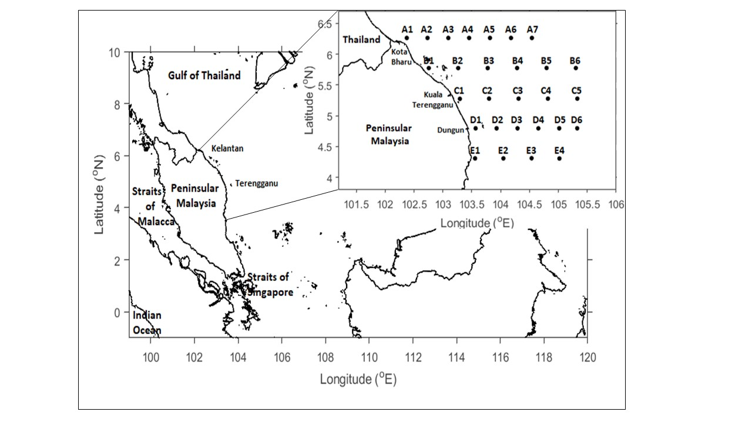
Figure 1. Map of the study area. Transect and stations are shown in the inset

Upwelling signature (Ekman transport)
Average wind data at 10 m height with a resolution of 0.125° × 0.125° within the period of study were obtained from the European Centre for Medium-range Weather Forecast (ECMWF) Interim Reanalysis (ERA-Interim) (https://www.ecmwf.int) and further analysis were conducted to obtain Ekman transport, as such, to provide knowledge on the upwelling-driven mechanism. The Ekman transport are calculated by the mean of:

$Q_{x}=\frac{{ρ_{a}C_{d}({W_{x}}^{2}+{W_{y}}^{2})}^{1/2}W_{x}}{ρ_{w}f}$ (1)

$Q_{y}=-\frac{{ρ_{a}C_{d}({W_{x}}^{2}+{W_{y}}^{2})}^{1/2}W_{y}}{ρ_{w}f}$ (2)

where $ρ_{a}$ is the density of air (1.22 kg m⁻³), $C_{d}$ is the dimensionless drag coefficient (1.3 × 10⁻³), W is the wind speed at 10m height, $ρ_{w}$ is the density of seawater (1025 kg m⁻³), $f=2Ωsinθ$ is the Coriolis parameter, where $Ω$ is the Earth’s angular velocity (7.292 × 10⁻⁵ rad s⁻¹), $θ$ is the latitude, x and y subscripts are zonal and meridional components, respectively.

Laboratory analysis of phosphate, silicate, DOC and chlorophyll-a
Dissolved phosphate and silicate were analysed based on standard colorimetric methods described by EPA [29] using a SmartChem 200 discrete autoanalyzer (AMS Alliance) and detected spectrophotometrically as a colored complex. DOC analyses were made by high temperature catalytic oxidation (HTCO) using a Shimadzu TOC-L analyser (furnace temperature: 680 ± 10 ºC, catalyst: 0.5% Pt/Al₂O₃) coupled to a non-dispersive infrared (NDIR) detector for CO₂ analysis arising from DOC oxidation [30, 31]. Before analysis, acidification and sparging of samples was carried out to eliminate inorganic C by adding 10% HCl to a sample and sparged with high purity N₂ to eliminate all inorganic C. DOC concentration was determined by subtracting system blank area from the average peak area and dividing by the slope of the calibration curve [32]. The certified reference material (CRM) of deep seawater from the Sargasso Sea was obtained from the Hansell’s laboratory, University of Miami, in order to monitor analytical accuracy. The DOC concentrations obtained for the CRM were between 45-52 µM (mean 47 ± 3 µM, n=8) after blank correction, close to the agreed value of the CRM (43-44 µM). The chl-a was determined using a Shimadzu 1201 spectrophotometer after 20-24 hours extraction into 90% acetone following Parsons et al. [33] method and calculated according to Jeffrey and Humphrey [34].

Results and Discussion
Horizontal distribution
The horizontal distributions of temperature, salinity, phosphate, silicate, DOC and chl-a in Kelantan and Terengganu waters are shown in Figure 2. The surface temperature is typically warm with very slight variation between 29.39 ºC and 30.70 ºC (mean 30.00 ± 0.29 ºC) (Figure 2a). The surface salinity ranged from 29.68 psu to 33.39 psu (mean 32.95 ± 0.76 psu) with lower salinity found in the northern compared to the southern area (Figure 2b). Among the nutrients measured, DOC recorded higher concentrations, ranging from 1.55 µM to 14.22 µM (mean 11.33 ± 2.44 µM) (Figure 2e), followed by silicate and phosphate where the concentration varied from 0.57 µM to 15.90 µM (mean 4.83 ± 3.80 µM) (Figure 2d) and 0.03 µM to 0.32 µM (mean 0.14 ± 0.08 µM) (Figure 2c), respectively. Additionally, the chl-a concentration in the study area varied from 0.01 µgL⁻¹ to 0.14 µgL⁻¹ (mean 0.06 ± 0.03 µgL⁻¹).

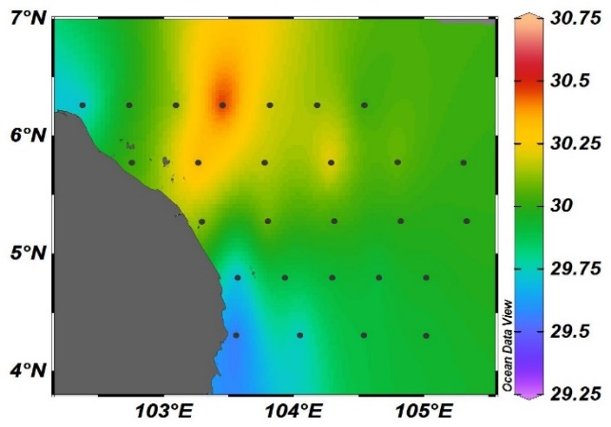  (a) | 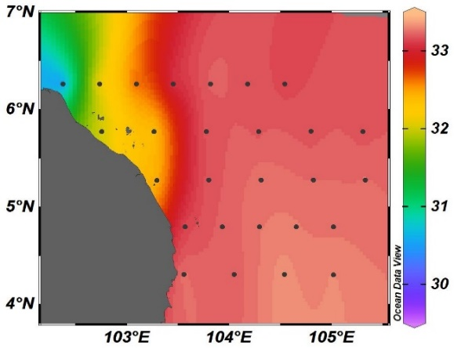  (b)
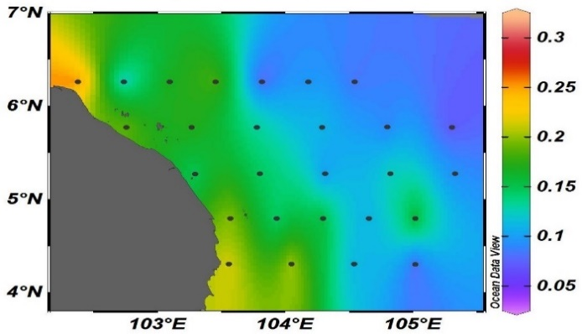  (d)  (c) | 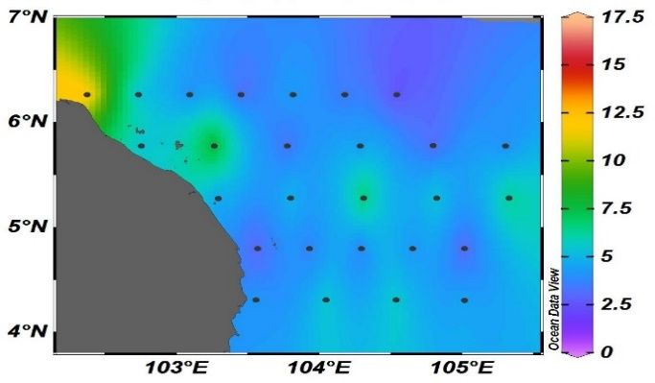
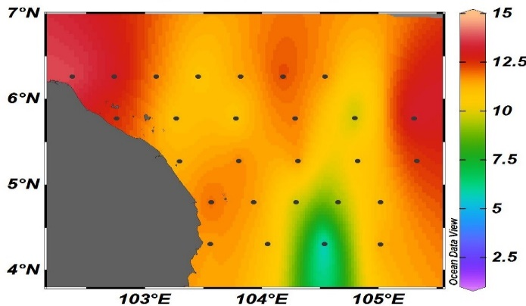  (f)  (e) | 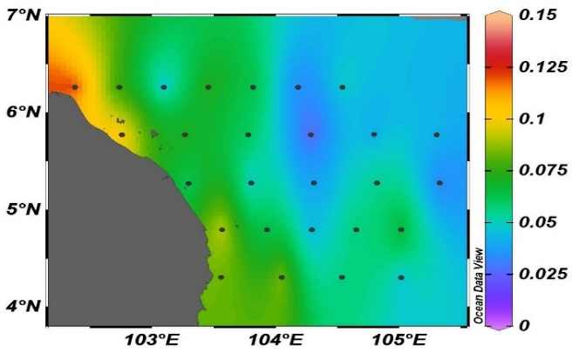

Figure 2. The horizontal distribution of (a) temperature (ºC); (b) salinity (psu); (c) phosphate (µM); (d) silicate (µM); (e) DOC (µM); (f) chl-a (µgL⁻¹) along Kelantan and Terengganu waters

In general, the observed nutrients demonstrated a higher concentration in the northern area and were identified associated with low salinity waters (6 – 6.5 latitude), probably attributed to the higher input from Kelantan River and/ or Gulf of Thailand (GoT), associated with the effluent from untreated domestic sewage, industrial activities and agriculture activities. The distribution of surface phosphate was somewhat similar to chl-a (Figures 2(c) and 2(f)), especially in the southern part until about 5°N. This pattern may be due to two possible reasons; (a) chl-a distribution was influenced by phosphate, where chl-a was found to be strongly correlated with phosphate (Figure 3 (R²=0.4457; R=0.6676)) as compared to silicate (R²=0.0554; R=0.2353) and DOC (R²=0.008; R=0.089). The result implying that phosphate is an important nutrient regulating the phytoplankton biomass, (b) higher phosphate and chl-a also appears in the area that was categorised with cooler water and high salinity, which was located at transect D near Dungun. This is probably due to the presence of coastal upwelling in this particular area. The coastal upwelling eventually transports high phosphate concentrations from the deeper layer (i.e. indicated by cool and high salinity water) to the surface, which encourages the phytoplankton growth, concurrently leading to the high chl-a concentrations.

(a)

Figure 3. The relationship between chl-a and phosphate (a) silicate (b) and DOC (c) for horizontal distribution

Evidence of upwelling
The Ekman transport was calculated based on the surface wind data obtained from the ECMWF (Figure 4). Based on the figure, there is an evident of upwelling occurred along the ECPM as observed by previous studies [4-6]. The upwelling was driven by offshore Ekman transport that was roughly perpendicular to the coastline in the Terengganu waters from the southern part up to until about 5°N. Consequently, the coastal water was pushed away from the coast and replaced by the underneath cooler and saltier waters in the inshore region (Figure 2a and 2b). A contradictory situation occurred at the north of 5°N, where the Ekman transport in this region was orientated roughly parallel to the coast, which was less favourable for upwelling and hence pronounced slightly warmer and fresher water. Additionally, this region (i.e. north of 5°N) is located near to the GoT where it was predominantly influenced by the riverine runoff that carried warmer and fresher waters [6].

Figure 4. Ekman transport (m³ s⁻¹ m⁻¹) along the Terengganu and Kelantan waters

Vertical distribution
The two vertical profiles (transects A and D) for temperature, salinity, phosphate, silicate, DOC and chl-a are illustrated in Figure 5. Both transects showed variation in their spatial distribution in the water column. In transect A, the temperature ranged from 25.91 °C to 30.70 °C, with an average of 29.07 ± 1.19 ºC. Besides this, isotherm of 29.5 °C was shoaled until 10 m in the region of 103°E, and it bent downward as it approached the coast (Figure 5a). The salinity recorded was from 29.6 psu to 34.5 psu (33.38 ± 0.59 psu). The isohaline of 32.5 psu displayed the similar onshore shoaling tendency with the isotherm. There was a freshwater lens with warmer water (> 30 °C) and fresher water (31.1 psu – 33.3 psu) located at above 10 m into Transect A, which showed a typical feature of riverine outflow from the GoT as discussed in the previous section (horizontal distribution).This feature was also observed by Kok et al. [6], where freshwater lens had played an important role to restrict the water underneath from reaching the surface. Moreover, this region was less favourable for upwelling since the Ekman transport was roughly parallel to the coast (Figure 4), which also explained why the underneath water did not reach the surface.

Nutrients and chl-a in Transect A varied remarkably from the surface to the bottom. The vertical profile of phosphate (0.03 µM to 0.45 µM (mean 0.20 ± 0.12 µM)) in Figure 5e shows that the concentrations are fairly enriched in the area near the coast and depleted in areas beyond the continental shelf. The phenomenon of high phosphate concentration in the coastal area in Transect A indicates that the riverine input from Kelantan River estuary or GoT is the main source for phosphate. This is further supported by less saline water observed (Figure 5c) in the area as evidence of the riverine plume. In contrast to the pattern of phosphate, the vertical profiles of silicate (Figure 5g) displayed a maximum concentration close to the bottom, followed by a rapid decrease towards the surface, with concentrations varying between 1.07 µM to 39.00 µM (mean 7.32 ± 9.57 µM). In the case of DOC, there was no clear trend; DOC fluctuated with a concentration in the range of 6.80 µM to 14.30 µM (mean 11.01 ± 1.57 µM). The trend of chl-a (Figure 5k) was similar, with highest concentrations at the bottom water areas, especially at the middle of the transect. The chl-a concentrations in Transect A were in the range of 0.01 µgL⁻¹ to 0.63 µgL⁻¹ (mean 0.16 ± 0.16 µgL⁻¹).

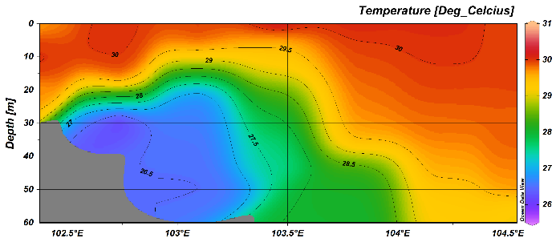  (b)  (a) | 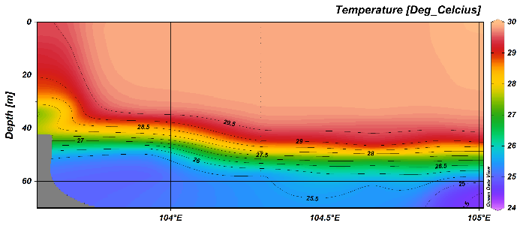
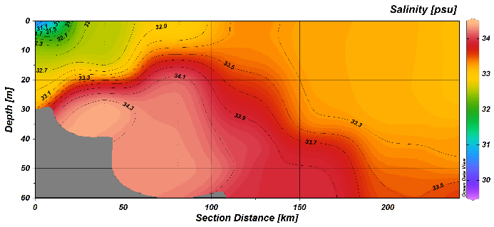  (e)  (c) | 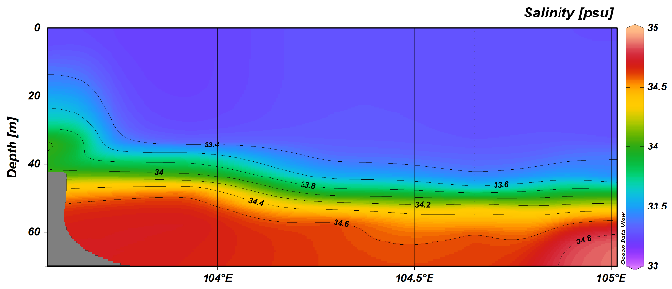  (d)
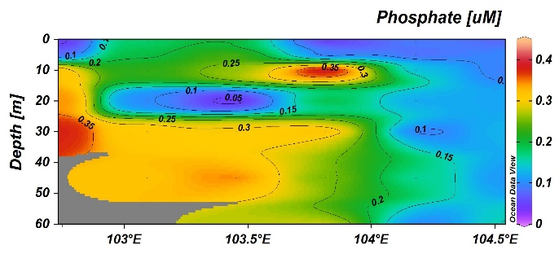  (f) | 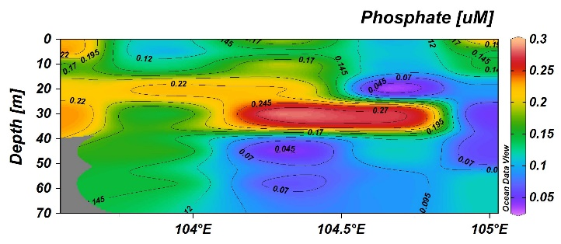
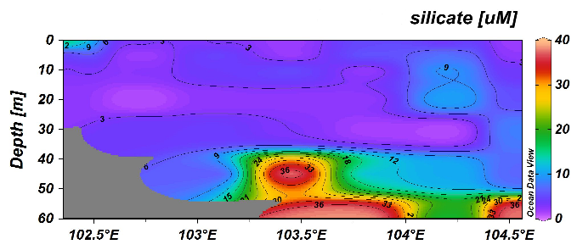  (h)  (g) | 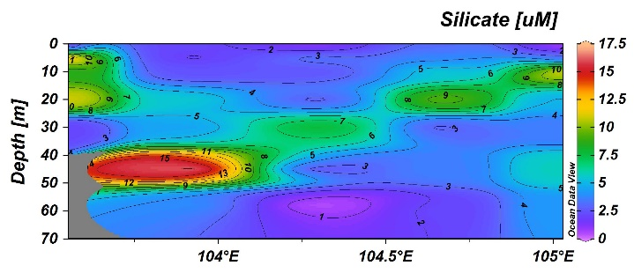
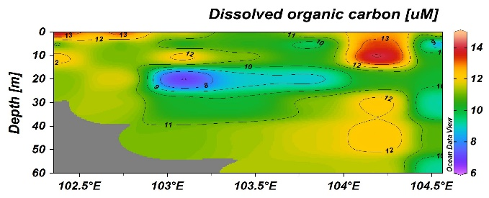  (i)  (j) | 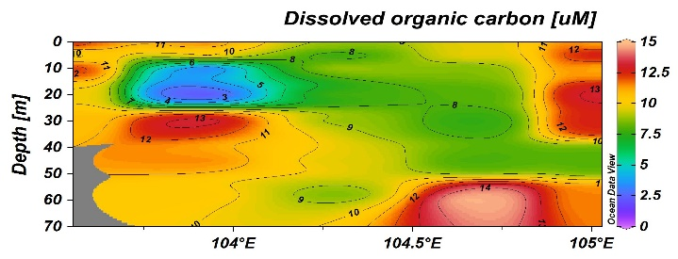
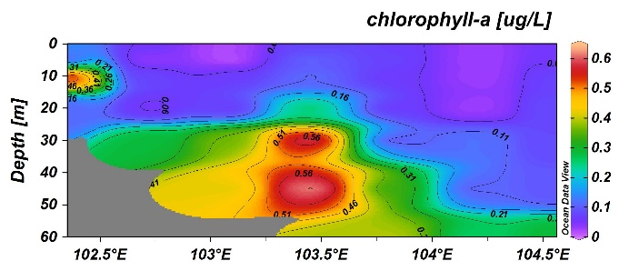  (l)  (k) | 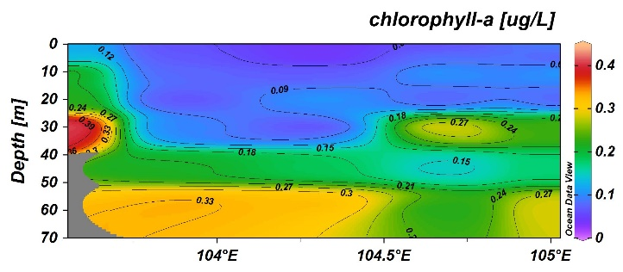
Transect A | Transect D
Figure 5. Cross-sectional for transect A; (a) temperature (c) salinity (e) phosphate (g) silicate (i) DOC (k) chl-a and transect D; (b) temperature (d) salinity (f) phosphate (h) silicate (j) DOC (l) chl-a
(a)
(b)

For Transect D, the temperature varied from 24.95 ºC to 29.95 ºC, with an average of 28.85 ± 1.64 ºC, where the isotherm of 29.5 °C was shoaled towards the coast and surface, which typically showed the classical sign of upwelling. Astonishingly, cross-sectional distribution of salinity (33.22 psu - 34.91 psu (mean 33.59 ± 0.51 psu)) showed that the isohaline of 33.4 psu was only shoaled until about 13 m, which was probably due to the sparse spatial coverage or due to the small amount of freshwater discharge from the Dungun River, which was indicated by the freshwater lens floating between surface and 30 m into the region between the coastal area and 104.2°E, which restricted isohaline from reaching the surface. Both features of abnormal temperature and salinity in this transect indicate the existence of coastal upwelling in this study area. With the exception of DOC, nutrient concentrations decreased with distance for all depths, with high concentrations at the coastal and low concentrations at offshore stations. The results are consistent with the observation at the horizontal water distribution. Concentration of phosphate ranged from 0.025 µM to 0.294 µM (mean 0.149 ± 0.07 µM). A maximum was found between 30 m and 40 m depth in the region between 104.2°E and 104.8°E and was not rigidly predictable. In contrast, silicate recorded the highest concentration at 40 m to 50 m, with a wide range of 0.35 µM to 16.79 µM, with a mean of 4.75 µM ± 3.90 µM. For DOC, patchy trends of high and low concentrations were found in this transect with values ranging from 1.81 µM to 14.91 µM (mean 9.83 ± 2.83 µM). Additionally, concentrations of chl-a in this transect were found to vary between 0.03 µgL⁻¹ and 0.40 µgL⁻¹ (mean 0.15 ± 0.10 µgL⁻¹).

The relationship between nutrients and chl-a is presented in Figure 6. For both transects, no correlation occurred between nutrients and chl-a. Supposedly, high nutrients are expected to increase the phytoplankton growth (i.e. high chl-a concentration) and vice versa [35-37]. Polat and Terbiyik [31] found that chl-a increased with increasing nitrate and silicate, and enhanced phytoplankton growth in the North-eastern Mediterranean Sea. Similarly, chl-a concentrations were strongly associated with the high silicate concentrations in in the southwest of East China Sea, where high chl-a concentrations were observed at the area that contained high concentrations of silicate, and these resulted in diatoms or chain-forming phytoplankton capable of more rapid growth [36, 37]. However, this was not observed in the present study, probably due to the consumption or exhaustion of nutrients for the growth of phytoplankton. This is consistent with Kang et al. [38], who found that nutrients in the deeper water were quickly absorbed by phytoplankton and caused nutrient concentrations to rapidly decrease.

The nutrient distributions in this present study during the upwelling event might, not be so obvious as compared to the typical coastal upwelling systems such as Oregon upwelling [39], Peru upwelling [40] and California upwelling [41] which recorded high concentrations of nutrients and chl-a. It is difficult to explain as this is a unique phenomenon and it is rarely found, because upwelling had been synonymous with triggering nutrients to the surface layer. In this study, there was an increase in nutrients, especially phosphate near the shore of Transect D (Dungun), which corresponds with lower temperature (27.0 ºC - 29.5 ºC) and high salinity (33.4 psu - 34.0 psu). Higher concentrations of chl-a (0.2 µgL⁻¹ - 0.4 µgL⁻¹) were also recorded at this particular section. Kok et al. [6] revealed that upwelling intensity increased from June and reached its peak in August before declining in September. Thus, the present study suggests that the low strength of the upwelling could be due to the sampling period which was carried out in early July 2017, as this period was considered as a preliminary stage of upwelling.

Transect A Transect B
Figure 6. The relationship between chl-a and nutrients for vertical distribution

It is important to compare the nutrients and chl-a concentrations obtained in the present study with other upwelling systems nearby the ECPM. The nutrients and chl-a information for these upwelling areas are listed in Table 1. No comparisons could be made for DOC concentrations as other studies did not measure this parameter. In general, phosphate concentrations in the study area were 2 to 3 times lower than other upwelling regions. Meanwhile, apart from the Vietnamese coast, silicate concentration in this present study was also recorded to be lower as compared to other upwelling regions nearby. This is probably due to the consumption of nutrients by phytoplankton during the early stages of the upwelling event, thereby leading to low levels of the nutrients. The chl-a values were relatively low in comparison to values reported by others, but slightly higher than those found in Southern Makassar Strait, Indonesia [26]. The strong intensity of upwelling events could be the reason that contributes to the high nutrients and chl-a in the Vietnamese coast [42], Changjiang [43] and East China Sea [44]. For example, Dipper et al. [42] found that the clockwise rotation and stretching deformation-induced upwelling due to the circulation pattern, were the main causes that contributed to the maximum chl-a and nutrient concentrations in the Vietnamese coast.

Table 1. Comparison of nutrients and chl-a among coastal upwelling system
Upwelling region | Phosphate (µM) | Silicate (µM) | Chl-a (µgL⁻¹) | Reference
Vietnamese coast, Vietnam | 0.0-1.4 | 0.0-24.7 | 0.0-1.6 | [42]
Changjiang, China | 0.4-1.4 | 15-100 | 0.1-19.5 | [43]
East China Sea, China | 0.2-0.8 | 2-50 | n.a | [44]
Southern Taiwan Strait, Taiwan | <0.5 | n.a | 1-8.51 | [27]
Southern Makassar Strait, Indonesia | 0.001-1.89 | 0.157-54.53 | 0.1-0.44 | [26]
ECPM | 0.03 - 0.45 | 0.35 - 39.00 | 0.01-0.63 | Present study
n.a = not available

Additionally, the deeper water in the East China Sea is able to uplift until about a depth of around 10 m, and tends to bring up high nutrient-rich water to the surface, hence contributing to the high phytoplankton biomass [44]. Despite low nutrient values, the Southern Taiwan Strait [27] contained higher chl-a concentration as compared to this present study. Hu et al. [27] indicated that upwelling events did not always bring the high concentration of nutrients, and suggested that the high rate of phytoplankton growth was due to suitable conditions during the upwelling process, such as the suitability of N/P ratio, temperature and light intensity. Similarly, Rosdiana et al. [26] also found out about the low nutrient events with high chl-a during upwelling and suggested that the phytoplankton biomass controlled nutrients in this short term. Thus, there were several different factors that controlled nutrients and chl-a in the upwelling region, depending on biological and physical processes, ecosystem types and basin scale.

Conclusion
Horizontal surface distribution has demonstrated that the concentrations of nutrients were higher at the coastal waters in comparison to offshore areas, which indicates that the freshwater inputs are the major sources of nutrients in the coastal areas. Additionally, water from the GoT also played a major role as a contributor of nutrients to the northern part of the ECPM. Vertical profiling showed the normal condition, where high concentrations of nutrients were recorded in the deeper layer compared to the surface water. An upwelling event which was characterised by cool and high salinity water at the surface occurred near Dungun. However, nutrients did not follow the same trend in response to coastal upwelling events i.e. high concentrations that were supposedly recorded at the surface water. This is probably due to the weak upwelling intensity which was unable to draw up nutrients from the deeper layer to the surface layer, while the sampling was performed during the early stages of the upwelling event. The data obtained was based on a single sampling with a limited number of stations, and depth profiling, to reveal the distribution of nutrients during the coastal upwelling event. However, this data is expected to provide preliminary results about physicals, chemicals and phytoplankton biomass during the early upwelling event.

Acknowledgements
This work was supported by the Higher Institution Centre of Excellence (HICoE) Research Grant (Vote No. 66928) and National Scientific Cruise Expedition (Vote No. 53209) awarded to the Institute of Oceanography and Environment, Universiti Malaysia Terengganu.

References
- Wyrtki, K. (1961). Physical oceanography of the Southeast Asian waters. In: NAGA report Vol. 2. University of California, La Jolla: pp. 195.
- Morgan, J. R. and Valencia, M. J. (1983). The natural environmental setting. In: Morgan, J. R. and Valencia, M.J. (Eds.), Atlas for Marine Policy in Southeast Asian Seas. University of California Press, California: pp. 4-17.
- Taira, K., Saadon, M. N. B., Kitagawa, S. and Yanagi, T. (1996). Observation of temperature and velocity in the coastal water off Kuala Terengganu, Malaysia. Journal of Oceanography, 52: 251–257.
- Akhir, M. F., Daryabor, F., Husain, M. L., Tangang, F. and Qiao, F. (2015). Evidence of upwelling along Peninsular Malaysia during southwest monsoon. Open Journal of Marine Science, 5: 273–279.
- Kok, P. H., Fadzil, M., Akhir, M., Tangang, F. and Husain, M. L. (2017). Spatiotemporal trends in the southwest monsoon wind-driven upwelling in the southwestern part of the South China Sea. PLos ONE, 12(2): e0171979.
- Kok, P. H., Akhir, M. F. and Tangang, F. T. (2015). Thermal frontal zone along the east coast of Peninsular Malaysia. Continental Shelf Research, 110: 1-15.
- Suratman, S., Weston, K., Greenwood, N., Sivyer, D. B., Pearce, D. J. and Jickells, T. (2010). High frequency measurements of dissolved inorganic and organic nutrients using instrumented moorings in the southern and central North Sea. Estuarine, Coastal and Shelf Science, 87(4): 631-639.
- Nausch, M. and Nausch, G. (2011). Dissolved phosphorus in the Baltic Sea - occurrence and relevance. Journal of Marine Systems, 87(1): 37-46.
- Chen, Y. L. L., Chen, H. Y., Gong, G. C., Lin, Y. H., Jan, S. and Takahashi, M. (2004). Phytoplankton production during a summer coastal upwelling in the East China Sea. Continental Shelf Research, 24(12):1321-1338.
- Lee Chen, Y. (2005). Spatial and seasonal variations of nitrate-based new production and primary production in the South China Sea. Deep Sea Research Part I, 52(2): 319-340.
- Riegman, R., Colijn, F., Malschaert, J. F. P., Kloosterhuis, H. T. and Cadée, G. C. (1990). Assessment of growth rate limiting nutrients in the North Sea by the use of nutrient-uptake kinetics. Netherlands Journal of Sea Research, 26(1): 53-60.
- Thingstad, T. F. and Rassoulzadegan, F. (1995). Nutrient limitations, microbial food webs, and biological C-pumps: Suggested interactions in a P-limited Mediterranean. Marine Ecology Progress Series, 117(1-3), 299-306.
- Suratman, S. and Mohd Tahir, N. (2012). Concentrations of silicate compounds in surface water of Setiu Wetland: a preliminary study. Journal of Sustainability Science and Management, 7(2): 128-130.
- Trommer, G., Leynaert, A., Klein, C., Naegelen, A. and Beker, B. (2013). Phytoplankton phosphorus limitation in a north Atlantic coastal ecosystem not predicted by nutrient load. Journal of Plankton Research, 35(6): 1207-1219.
- D’Croz, L. and O’Dea, A. (2007). Variability in upwelling along the pacific shelf of Panama and implications for the distribution of nutrients and chlorophyll. Estuarine, Coastal and Shelf Science, 73(1–2): 325-340.
- Cravo, A., Relvas, P., Cardeira, S. and Rita, F. (2013). Nutrient and chlorophyll a transports during an upwelling event in the NW margin of the Gulf of Cadiz. Journal of Marine Systems, 128: 208-221.
- Braga, E. S., Chiozzini, V. C., Berbel, G. B. B., Maluf, J. C. C., Aguiar, V. M. C., Charo, M., Molina, D., Romero, S. I. and Eichler, B. B. (2008). Nutrient distributions over the southwestern south Atlantic continental shelf from Mar del Plata (Argentina) to Itajaí (Brazil): winter–summer aspects. Continental Shelf Research, 28(13): 1649-1661.
- Lehmann, A. and Myrberg, K. (2008). Upwelling in the Baltic Sea - A review. Journal of Marine Systems, 74: S3-12.
- Mann, K. H. and Lazier, J. R. N. (2006). Dynamics of marine ecosystems (3rd ed.). Massachusetts: Blackwell Publishing, pp. 163-215.
- Zainol, Z. and Akhir, M. F. (2016). Coastal upwelling at Terengganu and Pahang coastal waters: Interaction of hydrography, current circulation and phytoplankton biomass. Jurnal Teknologi, 78(8): 11-27.
- Duarte, C., R., Prego, R., López-López, S., Aguirre-Bahena, F. and Ospina-Alvarez, N. (2013). Annual patterns of nutrients and chlorophyll in a subtropical coastal lagoon under the upwelling influence (SW of Baja-California Peninsula). Estuarine, Coastal and Shelf Science, 120: 54-63.
- Tremblay, J.-É., Raimbault, P., Garcia, N., Lansard, B., Babin, M. and Gagnon, J. (2014). Impact of river discharge, upwelling and vertical mixing on the nutrient loading and productivity of the Canadian Beaufort Shelf. Biogeosciences, 10(10): 16675-16712
- Benavides, M., Santana-Falcón, Y., Wasmund, N. and Arístegui, J. (2014). Microbial uptake and regeneration of inorganic nitrogen off the coastal Namibian upwelling system. Journal of Marine Systems, 140: 123-129.
- Clark, D. R., Miller, P. I., Malcolm, E., Woodward, S. and Rees, A. P. (2011). Inorganic nitrogen assimilation and regeneration in the coastal upwelling region of the Iberian Peninsula. Limnology and Oceanography, 56(3): 1689-1702.
- Fuchs, R., Pinazo, C., Douillet, P., Fraysse, M., Grenz, C., Mangin, A. and Dupouy, C. (2013). Modelling ocean-lagoon interaction during upwelling processes in the South West of New Caledonia. Estuarine, Coastal and Shelf Science, 135: 5-17.
- Rosdiana, A., Prartono, T., Atmadipoera, A.S. and Zuraida, R. (2017). Nutrient and chlorophyll-a distribution in Makassar upwelling region: From MAJAFLOX CRUISE 2015 A. IOP Conference Series. Earth and Environmental Science, 9(1): 3-10.
- Hu, J., Lan, W., Huang, B., Chiang, K. P. and Hong, H. (2015). Low nutrient and high chlorophyll a coastal upwelling system – A case study in the southern Taiwan Strait. Estuarine, Coastal and Shelf Science, 166: 170-177.
- Chen, C. T. A., Wang, B. J. and Hsing, L. Y. (2004). Upwelling and degree of nutrient consumption in Nanwan Bay, southern Taiwan. Journal of Marine Science and Technology, 12(5): 442-447.
- Environment Protection Agency (1993). Method 365.1, revision 2.0: Determination of phosphorus by semi-automated colorimetry.
- Suzuki, Y. and Sugimura, Y. (1988). A high-temperature catalytic oxidation method for the determination of non-volatile dissolved organic carbon in seawater by direct injection of a liquid sample. Marine Chemistry, 24: 105-131.
- Cauwet, G. (1994). HTCO method for dissolved organic carbon analysis in seawater: influence of catalyst on blank estimation. Marine Chemistry, 47(1): 55-64.
- Thomas, C., Cauwet, G. and Minster, J.-F. (1995). Dissolved organic carbon in the equatorial Atlantic Ocean. Marine Chemistry, 49(2–3): 155-169.
- Parsons, T. R., Maita, T. and Lalli, C. M. (1984). Plant pigment. In: A manual of chemical and biological method for seawater analysis. Oxford: Pergamon Press: pp. 173.
- Jeffrey, S. W. and Humphrey, G. F. (1975). New spectrophotometric equations for determining chlorophylls a, b, c1 and c2 in higher plants, algae and natural phytoplankton. Biochemie und Physiologie der Pflanzen, 167: 191-194.
- Polat, S. and Terbiyik, T. (2013). Variations of planktonic chlorophyll- a in relation to environmental factors in a Mediterranean coastal system (Iskenderun Bay, Northeastern Mediterranean Sea). Sains Malaysiana, 42(10): 1493-1499.
- Fu, D., Huang, Z., Zhang, Y., Pan, D., Ding, Y., Liu, D., Zhang, Y., Mao, Z. and Chen, J. (2015). Factors affecting spring bloom in the South of Cheju Island in the East China Sea. Acta Oceanologica Sinica, 34(3): 51-58.
- Zhang, Y., Huang, Z., Fu, D., Tsou, J. Y., Jiang, T., Liang, X. S. and Lu, X. (2018). Monitoring of chlorophyll-a and sea surface silicate concentrations in the south part of Cheju Island in the East China sea using MODIS data. International Journal of Applied Earth Observation and Geoinformation, 67: 173-178.
- Kang, J., Chen, X. and Zhang, M. (2014). The distribution of chlorophyll a and its influencing factors in different regions of the Bering Sea. Acta Oceanologica Sinica, 33(6): 112-119.
- Geen, V. A., Takesue, R. K., Goddard, J., Takahashi, T., Barth, J. A. and Smith, R. L. (2000). Carbon and nutrient dynamics during coastal upwelling off Cape Blanco, Oregon. Deep-Sea Research II, 47: 975-1002.
- Silva, N., Rojas, N. and Fedele, A. (2009). Water masses in the Humboldt current system: Properties, distribution, and the nitrate deficit as a chemical water mass tracer for equatorial subsurface water off Chile. Deep-Sea Research II: Topical Studies in Oceanography, 56(16): 992-1008.
- Pennington, J. T. and Chavez, F. P. (2000). Seasonal fluctuations of temperature, salinity, nitrate, chlorophyll and primary production at station H3/M1 over 1989-1996 in Monterey Bay, California. Deep Sea Research II, 47: 947-973.
- Dippner, J. W., Nguyen, K. V., Hein, H., Ohde, T. and Loick, N. (2007). Monsoon-induced upwelling off the Vietnamese coast. Ocean Dynamics, 57(1): 46-62.
- Pei, S., Shen, Z. and Laws, E. A. (2009). Nutrient dynamics in the upwelling area of Changjiang (Yangtze River) estuary. Journal of Coastal Research, 253: 569-580.
- Wang, B. and Wang, X. (2007). Chemical hydrography of coastal upwelling in the East China Sea. Chinese Journal of Oceanology and Limnology, 25(1): 16-26.

