

MALAYSIAN JOURNAL OF ANALYTICAL SCIENCES
ISSN 1394 - 2506

Published by The Malaysian Analytical Sciences Society

DISTRIBUTION AND BEHAVIOR OF NUTRIENTS IN BESUT RIVER ESTUARY, TERENGGANU, MALAYSIA

(Taburan dan Perlakuan Nutrien di Muara Sungai Besut, Terengganu, Malaysia)

Fatin Adlina Md Nasir¹, Suhaimi Suratman¹*, Dung Quang Le²

¹Institute of Oceanography and Environment,
Universiti Malaysia Terengganu,
21030 Kuala Nerus, Terengganu, Malaysia.
²Health and Safety, Group Health, Safety, Security and Environment,
Tower 1, PETRONAS Twin Towers, Kuala Lumpur City Centre,
50088 Kuala Lumpur, Malaysia.

*Corresponding author: miman@umt.edu.my

Received: 30 October 2018; Accepted: 26 September 2019

Abstract
This study was designed to determine the distribution and behaviour of nitrogen-, phosphorus- and silicon- based nutrients, chlorophyll-a and physical parameters in the Besut River estuary area (southern water of South China Sea). Surface water samples at a depth of 1 meter were collected using a Van Dorn sampler along the salinity gradient. All nutrients behaved in a non-conservative manner in the study area. The concentrations of nitrite, ammonia, dissolved inorganic phosphate, total dissolved phosphate, silicate, total dissolved silicate and total particulate silicate showed positive deviation from the theoretical dilution line. Their concentrations ranged from 3.02 µM - 12.75 µM (mean 0.137 ± 0.137 µM), 0.45 µM - 5.21 µM (mean 2.80 ± 1.40 µM), 0.02 µM - 0.75 µM (mean 0.32 ± 0.17 µM), 0.05 µM - 0.98 µM (mean 0.54 ± 0.23 µM), 0.03 µM - 10.32 µM (mean 3.61 ± 2.10 µM), 0.01 µM - 5.27 µM (mean 2.66 ± 1.01 µM) and 0 µM - 6.30 µM (mean 2.90 ± 1.29 µM), respectively. In contrast, the concentrations of nitrate, total dissolved nitrogen and total particulate phosphate were found to be in the negative deviation region, with concentrations ranging from 3.02 µM to 12.75 µM (mean 6.65 ± 1.27 µM), 4.54 µM to 15.83 µM (mean 9.28 ± 2.16 µM) and 0.06 µM to 2.26 µM (mean 0.65 ± 0.32 µM), respectively. Based on the Redfield molar ratio, dissolved inorganic phosphate was the nutrient limiting factor for phytoplankton growth in this estuary.

Keywords: nutrients, surface water, distribution, behaviour, Besut River estuary

Abstrak
Tujuan kajian ini dijalankan adalah untuk menentukan taburan dan perlakuan sebatian berasaskan nitrogen, fosforus dan silikon, klorofil-a dan parameter fizikal di muara Sungai Besut (bahagian selatan Laut China Selatan). Sampel air telah diambil dengan menggunakan pensampel Van Dorn pada kedalaman 1 meter di bawah permukaan air pada saliniti yang berbeza. Kesemua sebatian nutrien berkelakuan tak konservatif di muara sungai ini. Kepekatan nitrit, ammonia, fosfat takorganik terlarut, jumlah terlarut fosfat, silikat dan jumlah terlarut silikat menunjukkan sisihan positif daripada garisan pencairan teori di mana kepekatan masing-masing berada berjulat dari 3.02 µM - 12.75 µM (purata 0.137 ± 0.137 µM), 0.45 µM - 5.21 µM (purata 2.80 ± 1.40 µM), 0.02 µM - 0.75 µM (purata 0.32 ± 0.17 µM), 0.05 µM - 0.98 µM (purata 0.54 ± 0.23 µM), 0.03 µM - 10.32 µM (purata 3.71 ± 2.13 µM), 0.01 µM - 5.27 µM (purata 2.66 ± 1.01 µM) dan 0 µM - 6.30 µM (purata 2.90 ± 1.29 µM). Walau bagaimanapun, nitrat, jumlah nitrogen terlarut, jumlah partikulat nitrogen dan jumlah partikulat fosfat masing-masing berada dalam kawasan sisihan negatif dengan kepekatan di antara 3.02 µM hingga 12.75 µM (purata 6.65 ± 1.27 µM), 4.54 µM hingga 15.83 µM (purata 9.28 ± 2.16 µM) dan 0.06 µM hingga 2.26 µM (purata 0.65 ± 0.32 µM). Berdasarkan nisbah molar Redfield, fosfat takorganik terlarut, adalah nutrien penghad untuk pertumbuhan fitoplankton di muara ini.

Kata kunci: nutrien, air permukaan, taburan, perlakuan, muara Sungai Besut

Introduction
Estuarine environments are among the most productive on earth, creating more organic matter each year than comparably sized areas of forests, grasslands or agricultural lands [1]. It is a zone of high biological productivity compared to rivers and oceans, as it controls the quantity of nutrient input from river to reach the ocean [2]. According to Wan Omar et al. [3], an estuary receives continuous mixed inflow from both sea and fresh water, which is influenced by high tides and low tides. This causes the estuary to receive nutrients from land-based points and nonpoint sources, atmospheric and groundwater inputs, where each source contributes different amount of specific nutrients, which varies their proportional ratio to that of other nutrients in that source [4]. Nutrients such as nitrogen (nitrate, nitrite and ammonia), phosphate and silicate are used as a benchmark to indicate the water quality of estuaries and whether the water bodies can maintain their designated uses or not.

However, the rapid population growth is upsetting the natural balance of estuarine ecosystems and threatening their integrity [5], as it has increased the demand for fertilizer use, sewage output, untreated effluents from industries, runoff from agriculture land and use of freshwater [4]. According to Patricia et al. [4], this condition could lead to eutrophication, landscape changes, invasive species, and alterations to hydrology, overfishing and climate change. Eutrophication is a major type of water pollution where excessive richness of nutrients in water encourages algae growth, causing algae to bloom over the water surface [6]. Due to recent rapid industrial and agricultural developments, there are many tropical rivers in Southeast Asia that have suffered serious eutrophication [7], as estuaries receive substantial amounts of anthropogenic inputs from both point and non-point upstream sources of pollution from industrialization and urbanization activities [2].

A previous study by Smith [8] revealed that nitrogen and phosphorus are chosen as the limiting factors that help control the biological activity such as phytoplankton growth in marine systems. It is believed that nitrogen availability limits the net organic production in marine ecosystems, and that phosphorus availability limits the net organic production in freshwater ecosystems [8]. During the transportation from the freshwater i.e. river to the estuary and coastal area, the nutrients can behave either conservatively or non-conservatively, depending upon environmental conditions such as precipitation, change in river flow and biological activities [9].

In Malaysia, many studies on the distribution of nutrients and impacts of human activities on water quality have been done in many locations such as on Merbuk River estuary [10], Selangor River estuary [11], and Kuala Sibuti river estuary [12]. However, their behaviour in the estuaries during the mixing process between the fresh and saline waters is not well documented. This study focuses on the determination of the distribution and behaviour of nitrogen (N)-, phosphorus (P)- and silicon (Si)- based nutrients, chlorophyll-a (chl-a) content and physical parameters in Besut River estuary.

Materials and Methods
The Besut river estuary is located on the east coast part of Peninsular Malaysia, an area of tropical climate, which is strongly influenced by the Northeast (NE) monsoon from November to February and Southwest (SW) monsoon from March to September. The NE monsoon brings heavy rain and strong wind, affecting the estuary physically and chemically; while SW monsoon is known as the dry season. There are few rivers that flow into the Besut River such as, Pelagat River, Jertih River, Tenang River, Angga River, Peda River, La River and Keriuk River. All constitutes in Besut River then flow to the coastal area of the South China Sea.

The early objective of this study was to know the effect of monsoon season on the distribution and behaviour of nutrients and the related parameters, but due to bad weather and heavy rainfall in the wet season, we only managed to get samples in the dry season. Samplings were carried out three times on 1/4/2003, 31/5/2003 and 27/8/2003, at 17 sampling stations along the salinity gradient in the Besut River estuary as shown in Figure 1. No fixed stations were sampled in this estuary as the main objective was to know the distribution and behaviour of the parameters measured and this is based on the concentration at different salinity regions [9]. The sampling started at the freshwater area (station 1) and ended at coastal area (station 17). Water samples were collected at the surface water at about ~0.5 m depth using a Van Dorn Sampler, and stored in acid-washed high-density polyethylene (HDPE) bottles. The bottles then were kept in an ice chest during the sampling trip. The physical parameters were measured in situ using YSI Multiparameter Data Logger, which had been calibrated before the sampling. The parameters measured were salinity, temperature, dissolved oxygen (DO), pH and redox potential.

Water samples that were to be used for the determination of dissolved inorganic and organic nutrients were filtered through pre-combusted (450 ˚C) Whatman GF/F glass fibre filters using a vacuum pump. The filtration was carried out under low vacuum (<50 mm Hg) to avoid rupture of the filter, which would have resulted in the loss of dissolved organic nutrients. After that, all filtered and unfiltered water samples were stored frozen in HDPE bottles at -20 ˚C before analysis. The nutrients of dissolved and particulate forms were analysed using the standard colorimetric method [13], while the chlorophyll-a was determined spectrophotometrically [14]. In brief, the determination of nitrite, nitrate, ammonia, DIP and DISi was based on azo dye method, cadmium reduction column method, indophenol method, ascorbic acid method and molybdenum method, respectively. In order to know the concentration of total dissolved (TDN, TDP and TDSi) and particulate (TPP and TPSi) nutrients, water samples were persulphate wet digested so as to change the organic nutrients to inorganic form and analysed subsequently [13]. Concentrations of TPN were not presented due to data loss.

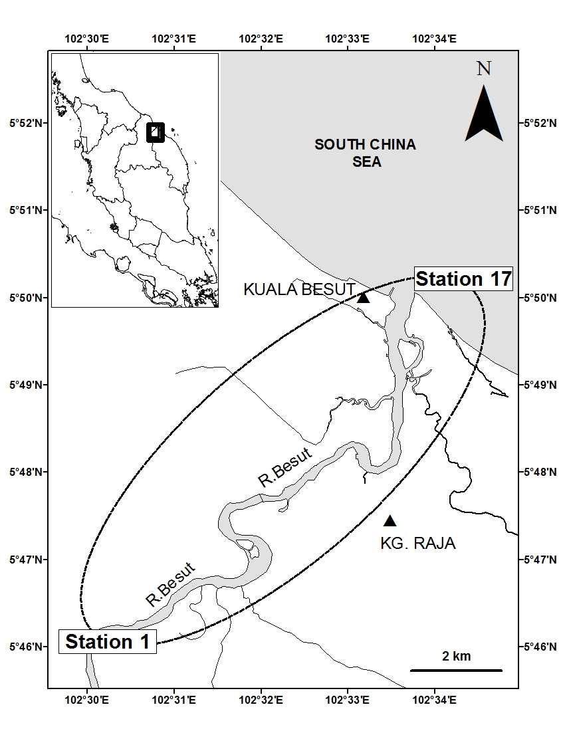
Figure 1. Location of sampling stations in Besut River estuary

Results and Discussion
Physical parameters
The physical parameters at different stations within the Besut River estuary are shown in Figure 2. Based on the ANOVA test, the salinity levels showed no significant differences among the dates (p > 0.05) and station points (p > 0.05). The data showed that the salinity levels increased in going from the freshwater to the coastal area due to the intrusion of more saline water with high salt content as compared to the low salt content at freshwater area. Salinity of an estuary is influenced by depth, daily tides and the volume of fresh water flowing into the estuary [15]. It can also be affected by rainfall loading, which can dilute the saline water, and evaporation, which leads to concentrated salt formation [16]. In this study, the values of salinity between the three samplings were not different as the samplings were performed at the same tide conditions and the same dry season.

The water temperature was in the range of 29.81 ˚C to 30.47 ˚C (mean 30.19 ± 0.61 ˚C). There were no significant differences between sampling dates (p > 0.05) and sampling points (p > 0.05) based on the ANOVA test. The water temperature showed constant values for every sampling location, as the sampling was carried out during the daytime in the dry season.

Based on the ANOVA analysis, the DO concentrations showed that there were no significant differences among the dates of sampling (p > 0.05) and sampling points (p > 0.05). The DO concentrations varied from 92.87% to 107.17% (mean 98.12 ± 6.63%), where relatively higher concentrations were detected at the freshwater region, and the lowest concentrations were detected at the coastal area. This is because, as the salinity of water increases, the solubility of oxygen in water decreases [17]. DO also has a negative correlation to the water temperature, where, the amount of oxygen dissolved in water decreases as the temperature increases [10]. However, this trend is not observed in this study as the temperature values were almost constant.

The values of pH were in the range of 7.13 to 8.21 (mean 7.80 ± 0.87). It showed no significant differences among the dates (p > 0.05) and sampling points (p > 0.05) based on the ANOVA test. The pH values had shown no variation throughout the sampling locations, due to the mixing of fresh and sea water, especially in the estuary as there was turbulence during the mixing. Generally, streams and rivers transport large quantities of dissolved and particulate constituents, which consist largely of humic materials, which are acidic in nature [10]. The average pH of seawater is typically around 8.2 [18].

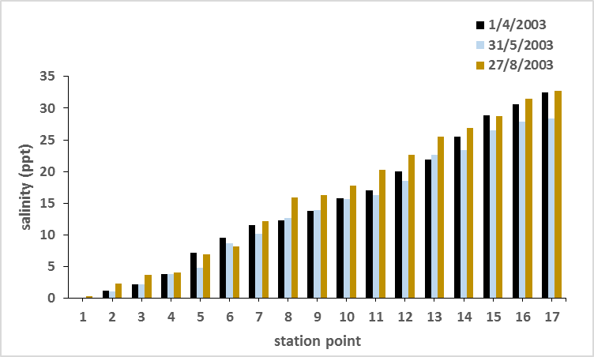 | 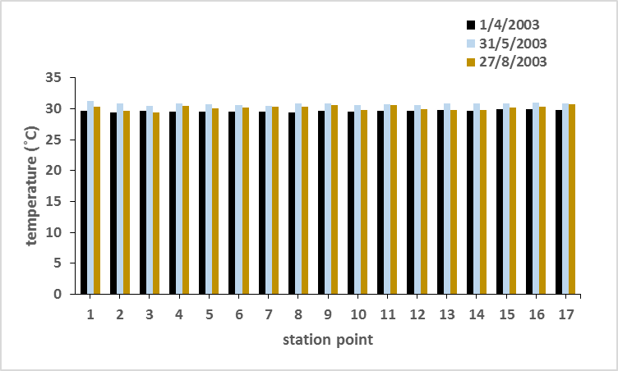
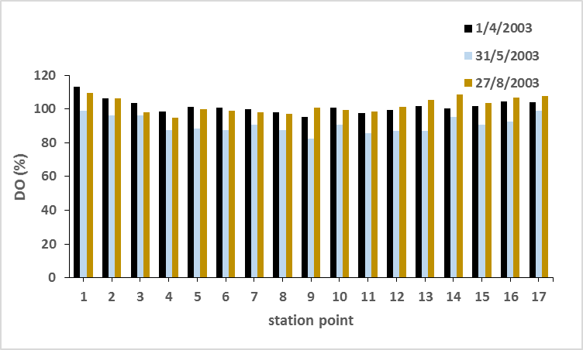 | 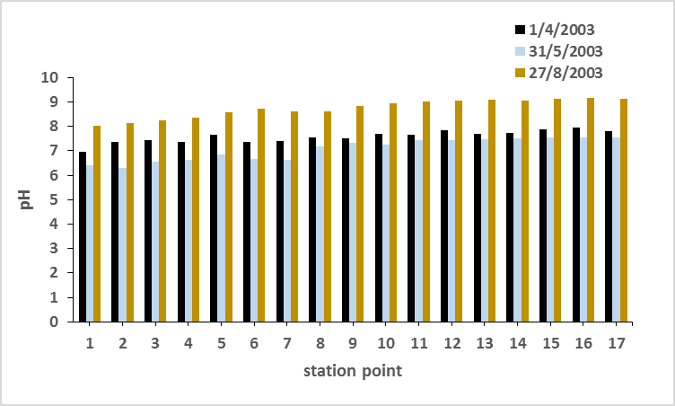
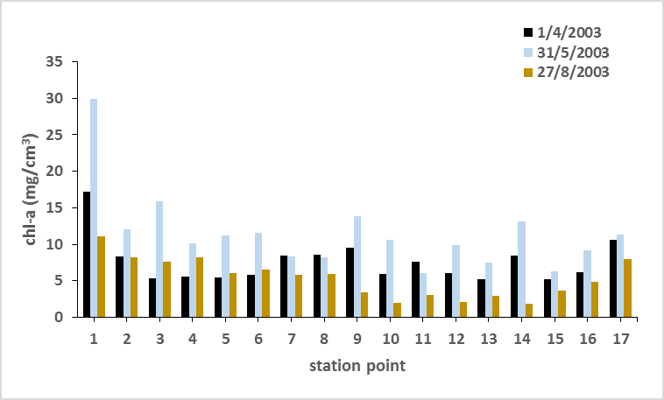 | 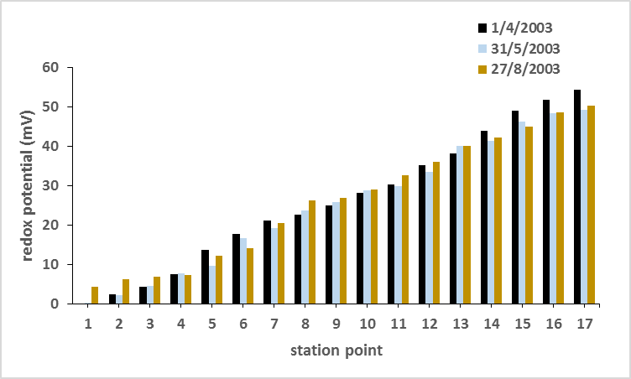
Figure 2. Variations of physical parameters at Besut River estuary

Therefore, the mixture of freshwater with low pH values and saltwater with high pH values causes the increase of pH values at the estuary. This occurs almost constantly due to turbulence mixing.

The chl-a concentration was recorded in the range of 5.05 mg/cm³ to 19.40 mg/cm³ (mean 8.16 ± 3.40 mg/cm³). Based on the ANOVA test, the distribution of chl-a showed a significant difference (p < 0.05) between sampling stations but no difference (p > 0.05) between sampling dates. Relatively, higher chl-a concentration was found at the upstream area. This may be due to high nutrients at this area, as the nutrients such as nitrate and phosphate are known as the required nutrients for reproduction and growth of phytoplankton in an estuarine environment [19].

Based on the ANOVA analysis, the redox potential values showed that there were no significant differences among the dates of sampling (p > 0.05) and sampling points (p > 0.05). Redox potentials were found in the range from 1.55 mV to 51.25 mV (mean 25.91 ± 1.54 mV). The highest redox potential value was recorded at the coastal area, while the lowest value was recorded at the freshwater area. It showed that the redox potential values increased with the increasing salinity of water. The greater the salt contents, the higher the redox potential values.

Nutrients distribution
Figures 3, 4 and 5 shows the distribution of N-, P- and Si- based nutrients in the Besut River estuary, respectively. From the figure, it can be seen that Total Dissolved Nitrogen (TDN) recorded the highest concentration, ranging from 4.54 µM to 15.83 µM (mean 9.28 ± 2.16 µM), followed by nitrate, ammonia, and nitrite with the values of 3.02 µM - 12.75 µM (mean 6.65 ± 1.27 µM), 0.45 µM - 5.21 µM (mean 2.80 ± 1.40 µM) and 0.01 µM - 0.18 µM (mean 0.101 ± 0.023 µM), respectively. Among the P-based nutrients, Total Particulate Phosphate (TPP) was found to be the highest, ranging between 0.06 µM to 2.26 µM (mean 0.65 ± 0.33 µM), followed by Total Dissolved Phosphate (TDP) and Dissolved Inorganic Phosphate (DIP), with values of 0.05 µM to 0.98 µM (mean 0.54 ± 0.23 µM) and 0.02 µM to 0.75 µM (mean 0.32 ± 0.17 µM), respectively. Meanwhile for Si-based nutrients, Dissolved Inorganic Silicate (DISi) showed the highest concentration, ranging between 0.03 µM and 10.32 µM (mean 3.61 ± 2.10 µM). This was followed by Total Particulate Silicate (TPSi) and Total Dissolved Silicate (TDSi), with values of 0 µM to 6.30 µM (mean 2.90 ± 1.29 µM) and 0.01 µM to 5.27 µM (mean 2.66 ± 1.01 µM), respectively. TDSi concentration for third sampling was not included because the values were significantly lower than those in other sampling occasions due to sample loss during the analysis.

In general, the distributions of nutrients were fluctuated, where most of the nutrient compounds were found to increase towards the estuary area and decrease when reaching the coastal area. The mixing between fresh and seawater in the estuary will create water turbulence, and this process tends to release the nutrients from the resuspension of bottom sediment to the surface water. Differently from the middle estuary, the lower part of the estuary was strongly influenced by sea water, which then would dilute and lower the concentrations of nutrients in this lower part. These phenomena which recorded high nutrient concentrations due to the water turbulence and mixing in estuary, coincide with the results for many other estuaries [20-22].

However, unlike other nutrient compounds, the concentration of TPP showed a different trend, where it was lowest at the freshwater region and highest at the coastal area. This may suggest that the coastal area is the main contributor of TPP in the Besut River estuary, especially during the flood tides. A previous study in Humber estuary reported that TPP was found to be the highest at low salinity due to flocculation, and phosphate being trapped in the sediment of the estuary [23]. However, this condition was not observed in this study as the highest concentration of TPP was found at the highest salinity.

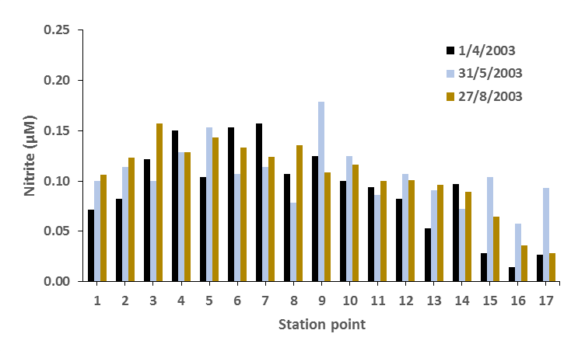
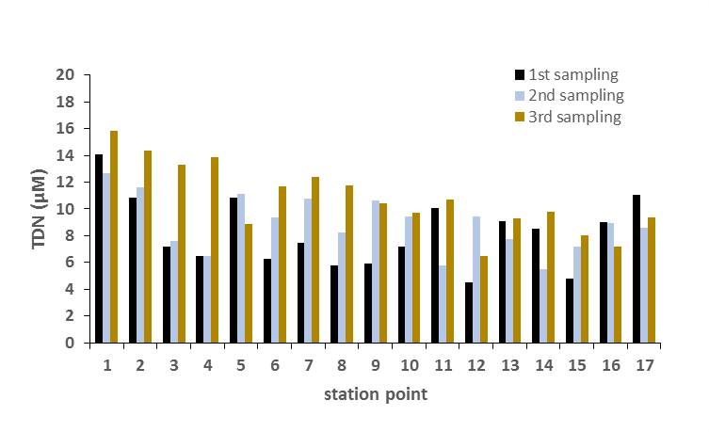

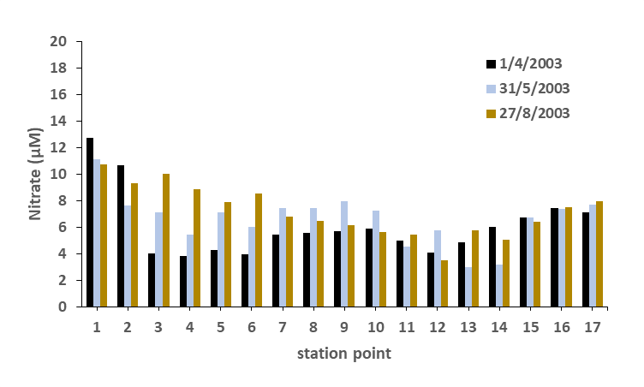
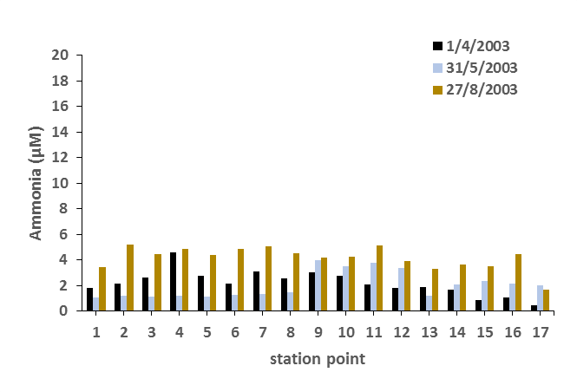
Figure 3. Variations of N-based nutrient concentration in Besut River estuary

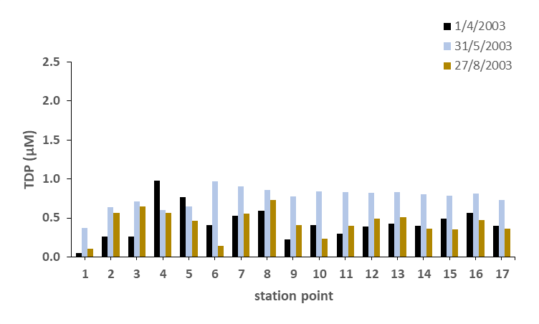
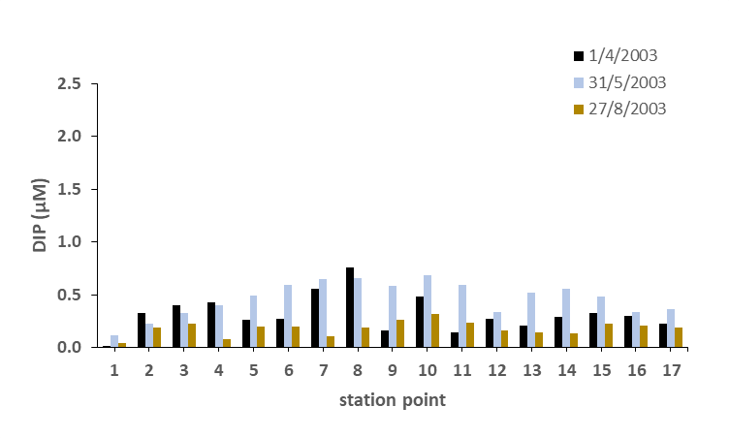
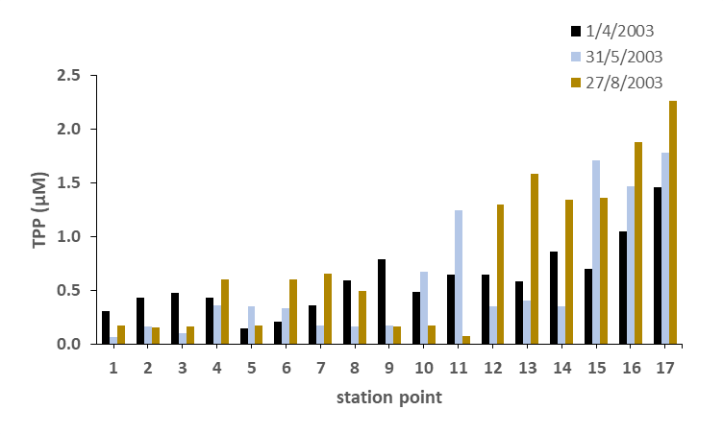

Figure 4. Variations of P-based nutrient concentrations in Besut River estuary

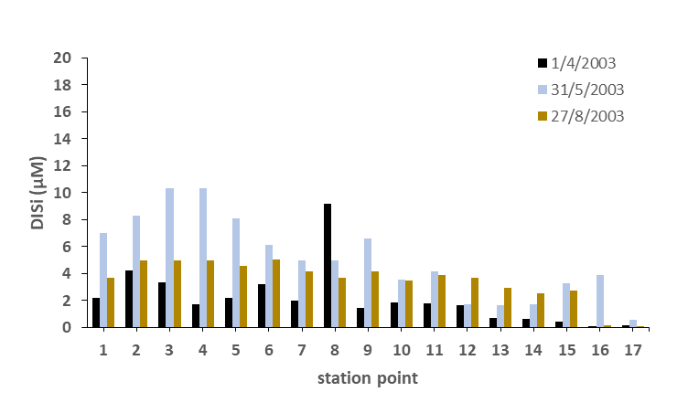 | 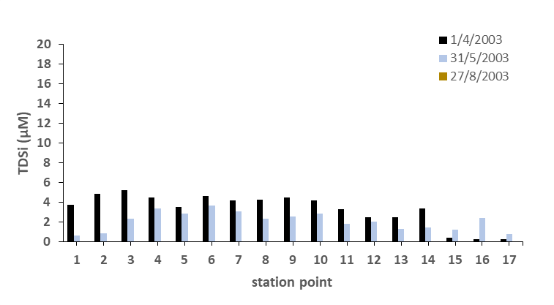
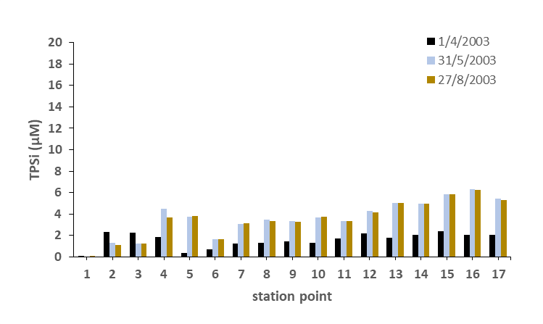
Figure 5. Variations of Si-based nutrient concentrations in Besut River estuary

In this study, the main activity of the residents around the estuary is from agricultural-related activities. High loading of anthropogenic nutrients such as the discharges of untreated domestic sewage from the urban and rural areas, and agricultural run-off, where fertilizer residues which contain high ammonium are leached out into the upstream of the river, could increase the nutrient concentrations. Suratman et al. [11] previously reported that human activities like industrial and agricultural activities would increase the concentration of N-based nutrients in the Selangor River, while Mohd Tahir et al. [24] also found that untreated effluent discharges caused the high concentration of N-based nutrients at the Paka River. It is believed that most of the sewage waste in the Besut town was discharged into the river as there was no proper waste management.

Data obtained from this study was compared with other areas (Tables 1, 2 and 3). In general, the Besut River estuary recorded lower concentrations of most nutrients compared to other estuaries, except in the case of nitrate. This is because, although there was less anthropogenic disturbance around the estuary, there were the agriculture-related activities at the upstream of the river system and boat activities within the estuary. Merbok [10] and Kuala Sibuti River estuaries [12] were also reported to have similar ranges of concentration values of inorganic nutrients, especially ammonia. Merbok River estuary is a mangrove estuary and the main source of nutrients was from the domestic wastewater discharges [10], while the Kuala Sibuti estuary is bordered by pristine mangrove forests and hence there are no major anthropogenic activities there [12]. Studies carried out by Suratman et al. [25] and Salum [26] at the Terengganu River estuary revealed that the concentrations of most nutrients were higher due the presence of the breakwater at the end of the estuary. Thus, nutrients were trapped in the Terengganu River estuary and were not able to be flushed out into the open sea. Meanwhile, unlike other estuaries, the Selangor River estuary showed the highest concentration of nutrients, as most of the area was occupied by agriculture, most of which were oil palm and rubber estates [11].

Table 1. Comparison of N-based nutrients (µM) within selected area in Malaysia river estuary
Estuary | Nitrate | Nitrite | Ammonia | TDN
Besut River (Present study) | 3.02-12.75 | 0.01-0.18 | 0.45-5.21 | 4.54-15.83
Merbok River [10] | 0.05-0.21 | 0.10-0.19 | 0.10-1.18 | NA
Selangor River [11] | 7.71-56.79 | 0.05-2.13 | 0.36-17.00 | 18.93-75.07
Kuala Sibuti River [12] | 0.40-3.53 | NA | 0.06-1.24 | NA
Terengganu River [26] | 0.30-4.70 | 0.002-0.39 | 1.00-35.40 | 3.20-40.60
NA: not available

Table 2. Comparison of P-based nutrients (µM) within selected area in Malaysia river estuary
Estuary | DIP | TDP | TPP
Besut River (Present study) | 0.02-0.75 | 0.05-0.98 | 0.06-2.26
Merbok River [10] | 0.06-0.08 | NA | NA
Selangor River [11] | 0.07-0.32 | 0.14-0.46 | NA
Kuala Sibuti River [12] | 0.01-1.92 | NA | NA
Terengganu River [26] | 0.38-2.83 | 0.38-3.20 | 0.50-3.34
NA: not available

Table 3. Comparison of Si-based nutrients (µM) within selected area in Malaysia river estuary
Estuary | DISi | TDSi | TPSi
Besut River (Present study) | 0.03-10.32 | 0.01-5.27 | 0-6.30
Merbok River [10] | NA | NA | NA
Selangor River [11] | NA | NA | NA
Kuala Sibuti River [12] | NA | NA | NA
Terengganu River [26] | 20.28-324.4 | 33.72-375.0 | 43.14-488.50
NA: not available
Behaviour of nutrients
All nutrients behaved in a non-conservative manner in this study during the mixing between saline and freshwater (Figure 6). Nitrite, ammonia, DIP, TDP, DISi, TDSi and TPSi showed an addition manner, whilst nitrate, TDN and TPP showed a removal trend. A previous study by Nilva et al. [24] reported that the nutrient behaviours in an estuary are greatly influenced by the changes of pH, turbidity and ecosystem metabolism during the estuarine mixing between fresh and saltwater’s, other than tidal variations. There are also several processes which affect the behaviour of nutrients in an estuary, such as, precipitation, adsorption and desorption, biological assimilation and denitrification, and organic matter degradation and excretion [27].

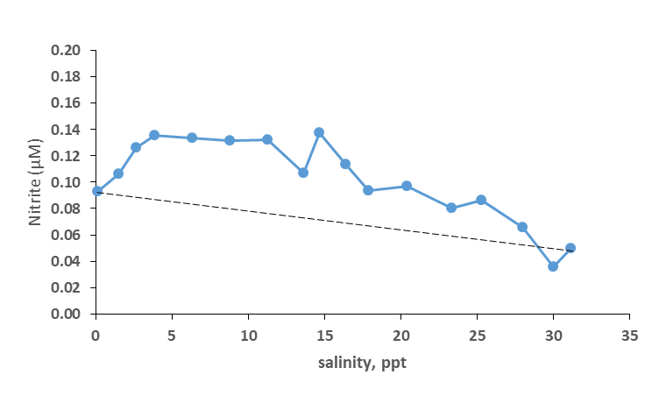 | 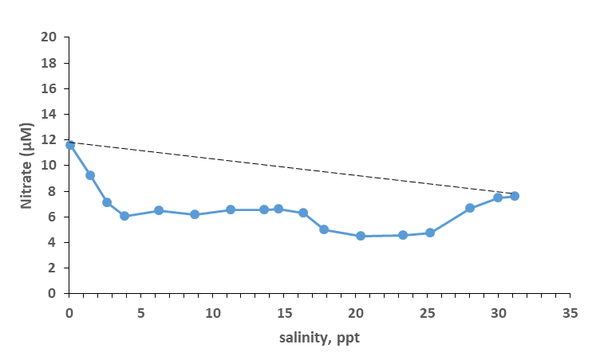
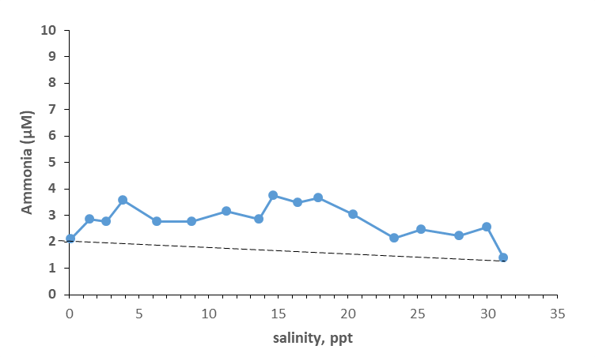 | 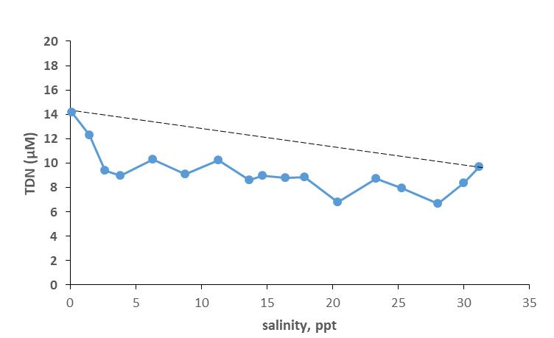
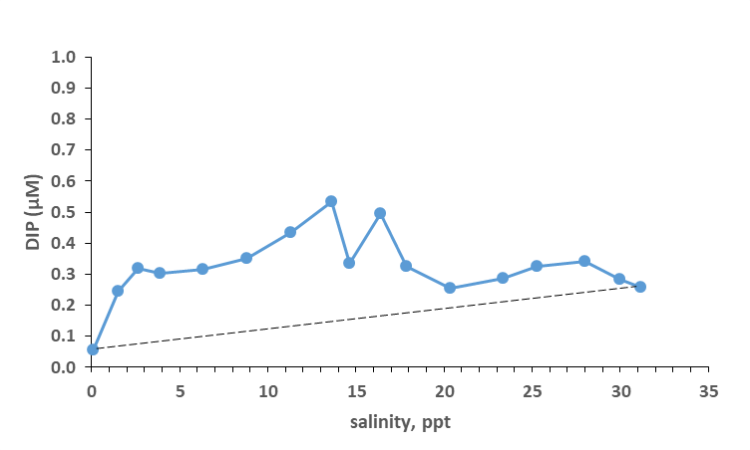 | 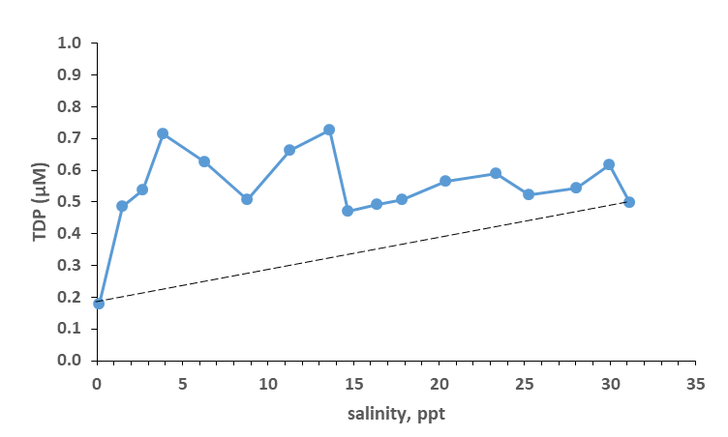
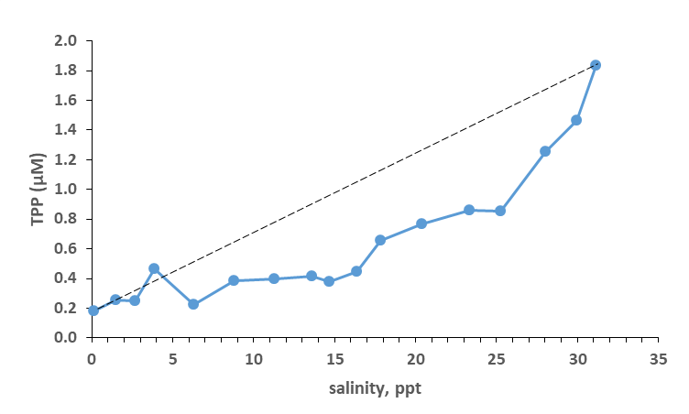 | 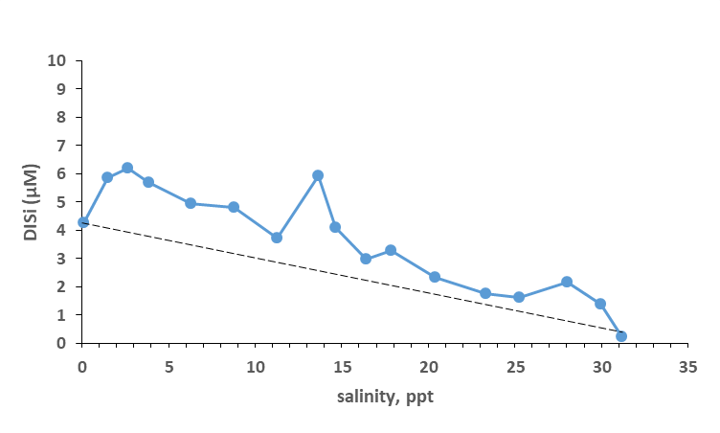
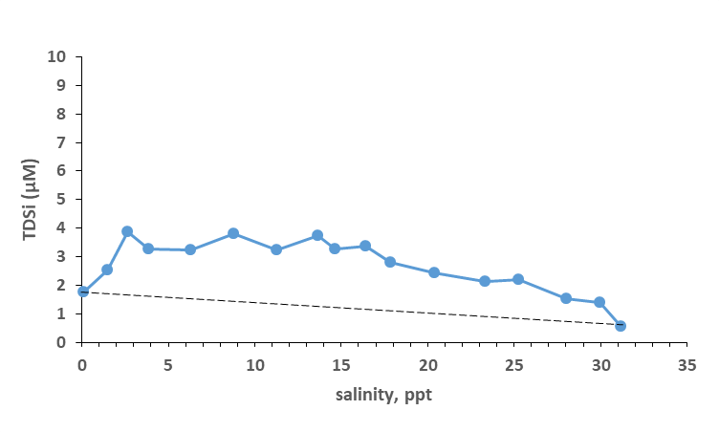 | 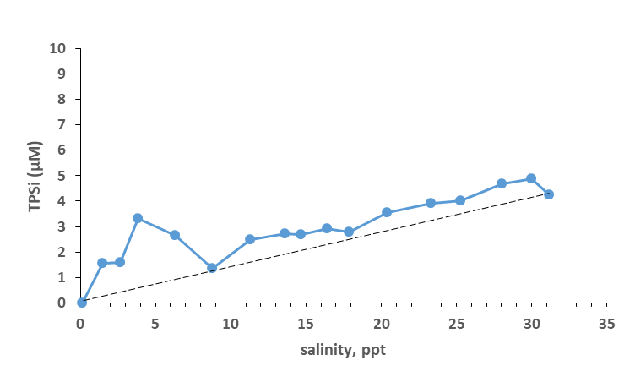
Figure 6. Distribution of nutrients across salinity gradients during the estuarine mixing

The additional source of nutrients could probably relate to the input of organic matter and nutrients from anthropogenic activities such as agricultural run-off, which flowed into the low and middle salinity regions of the Besut River estuary. This was similar to the studies done in the Selangor River estuary [11] and the Terengganu River estuary [25], where nutrients were observed to behave non-conservatively with an addition of N-based nutrient compounds, due to anthropogenic activities such as direct disposal of domestic sewage and runoff from urban areas, and tourism in Kuala Terengganu. Chemical processes such as oxidation of ammonia, reduction of nitrate, recycling of nitrogen and bacterial decomposition also contributed to the additional trend during estuarine mixing [28]. In this study, the addition of ammonia could be due to the denitrification process inside the estuary, as the removal of nitrate occurred in parallel with the increment of ammonia and nitrite. Resuspension of bottom sediment could also account for the additional source of nutrients into surface water, as the previous study in Severn estuary, UK, revealed that the higher input of nutrients were influenced by the resuspension from estuary bed [29].

The denitrification process could be a major influence for nitrate removal during estuarine mixing. This was because, the non-conservative additional of nitrite and ammonia, occurred simultaneously with the nitrate removal as shown in the mixing diagram above. In the nitrogen cycle, denitrification may occur under low oxygen conditions and lead to the rapid conversion of nitrate (oxides form) to ammonia and nitrite under anoxic conditions [30]. The findings of the present study showed the same pattern in which low concentration nitrate lead to a high ammonia concentration with low DO concentration. According to Suratman et al. [25], the denitrification process has been proven and cited widely as an efficient mechanism for nitrate removal during estuarine mixing such as in Cachoeira River estuary in Brazil [30] and Elbe River estuary in Germany [31].

TPP which also showed a removal trend during the estuarine mixing, might be influenced by the desorption process, where phosphorus absorbed particles in low salinity water but released it on reaching highly saline water, due to the density of water. The previous study done in Elbe estuary [28] also observed the same pattern, where low concentrations of phosphate absorbed the riverine particulate matter until it became saturated. Later, the particles were discharged on reaching the coastal area, as the salinity increased, which reduced the particles’ solubility effects.

N:P ratio
The relationship between nitrogen (nitrate + nitrite + ammonia) and DIP was obtained by calculating the ratio of mean dissolved inorganic N:P as in Table 4. Redfield ratio suggests that the nutrient limiting factor for phytoplankton growth in marine is 16:1 (based on molecular concentrations) [32]. Large differences from 16 at low N:P ratios can be an indication of a potential nitrogen limitation, and at high N:P ratios, the potential phosphorus limitation is the primary production of phytoplankton. From Table 4, it can be seen that the N:P ratio was higher than 16:1, thus indicating that P was the limiting factor in the Besut River estuary. This finding was similar to the findings of other freshwater environments such as Setiu River [33], where phytoplankton growth was also be controlled by P-based nutrients.

Table 4. Ratio of mean nitrogen to mean phosphate (N:P)
Station | Nitrogen (µM) | Phosphate (µM) | N:P ratio
1 | 13.74 | 0.06 | 241:1
2 | 12.18 | 0.25 | 50:1
3 | 9.96 | 0.32 | 31:1
4 | 9.78 | 0.30 | 32:1
5 | 9.36 | 0.32 | 30:1
6 | 9.09 | 0.35 | 26:1
7 | 9.86 | 0.44 | 23:1
8 | 9.50 | 0.53 | 18:1
9 | 10.50 | 0.34 | 31:1
10 | 9.87 | 0.49 | 20:1
11 | 8.76 | 0.33 | 27:1
12 | 7.59 | 0.25 | 30:1
13 | 6.76 | 0.29 | 24:1
14 | 7.31 | 0.33 | 22:1
15 | 8.94 | 0.34 | 26:1
16 | 10.09 | 0.28 | 36:1
17 | 9.05 | 0.26 | 35:1

Conclusion
In general, the nutrient parameters were higher at the upstream and middle of the estuary than at the coastal areas. This shows that the concentration of nutrients was controlled by the freshwater input and surface runoff from the anthropogenic activities within the area. Comparisons with other study areas revealed that the nutrient concentrations in the Besut River estuary were among the lowest due to low anthropogenic activities. The mixing pattern obtained in this study revealed that all the nutrients behaved non-conservatively i.e. the estuary acted as a source for nitrite, ammonia, DIP, TDP, DISi, TDSi and TPSi and a sink for nitrate, TDN and TPP. This study also provides the information that the growth of phytoplankton in the Besut River estuary was controlled by P-based nutrients.
Acknowledgements
This work was partly supported by the Higher Institution Centre of Excellence (HICoE) research grant (Vote no. 66928) awarded to the Institute of Oceanography and Environment, Universiti Malaysia Terengganu. We are grateful for the helpful comments on the manuscript from anonymous reviewers.

References
- Pereira-Filho, J., Schettini, C.A.F., Rorig, L. and Siegle, E. (2001). Intertidal variation and net transport of dissolved inorganic nutrients, POC and chlorophyll a in the Camboriu river estuary, Brazil. Estuarine, Coastal and Shelf Science, 53: 249-257.
- Jickells, T. D., Weston, K., Fernand, L. and Parker, E. R. (2004). Nitrogen cycling in the southern North Sea: consequences for total nitrogen transport. Estuarine, Coastal and Shelf Science, 59: 559-573.
- Wan Omar, W. M., Rahmah, S., Lim, C. C., Lee, W. P., Fatema, K. and Mat Isa, M. (2016). Effects of tidal events on the composition and distribution of phytoplankton in Merbok river estuary Kedah, Malaysia. Tropical Ecology, 57: 213-229.
- Patricia, M. G., Christopher, J. M., Walter, B. David, F., Cynthia, H. and Jonathan, S. (2010). Nutrients in estuaries. National Estuarine Experts Workgroup, 2005-2007.
- Huang, X. P., Huang, L. M. and Yue, W. Z. (2003). The characteristics of nutrients and eutrophication in the Pearl River estuary, South China. Marine Pollution Bulletin, 47: 30-36.
- Chen, Y., Liu, R., Sun, C., Zhang, P., Feng, C. and Shen, Z. (2012). Spatial and temporal variations in nitrogen and phosphorus nutrients in the Yangtze River Estuary. Marine Pollution Bulletin, 64: 2083-2089.
- Kawasaki, N., Kushairi, M. R. M., Nagao, N., Yusoff, F., Imai, A. and Kohzu. A. (2016). Seasonal changes of nutrient distributions along Selangor River, Malaysia. International Journal of Advances in Chemical Engineering and Biological Sciences, 7(2): 113-116.
- Smith, S. V. (1984). Phosphorus versus nitrogen limitation in the marine environment. Limnology and Oceanography, 29(6): 1149-1160.
- Liss, P. S. (1967). Conservative and non-conservative behaviour of dissolved constituents during estuarine mixing. In: Estuarine Chemistry. Burton, J.D. and Liss, P.S.(eds.). Academic Press, London: pp. 229.
- Kaniz, F., Wan Omar, W. M. and Mat Isa, M. (2014). Spatial and temporal variation of physico-chemical parameters in the Merbok Estuary, Kedah, Malaysia. Tropical Life Sciences Research, 25(2): 1-19.
- Suratman, S., Mohd Tahir, N. and Tong, S.L. (1996). Tidal variations of some physico-chemical and nutrient parameters in Selangor River estuary. Malaysian Journal Analytical Sciences, 2(2): 317-326.
- Saifullah, A. S. M., Mustafa Kamal, A. H., Idris, M. H., Rajaee, A. H. and Ismail, J. (2014). Seasonal variation of water characteristics in Kuala Sibuti River estuary in Miri, Sarawak, Malaysia. Malaysian Journal of Science, 33(1): 9-22.
- Grasshoff, K., Ehrhardt, M. and Kremling, K. (1983). Methods of seawater analysis. 2nd edition. Weinheim: Verlag Chernie.
- Parsons, T. R., Maita, T. and Lalli, C. M. (1984). Plant pigment. A manual of chemical and biological method for seawater analysis. Oxford: pp. 173.
- Nursuhayat, A. S., Yusoff, F. M. and Shariff, M. (2013). Spatial and temporal distribution of phytoplankton in Perak Estuary, Malaysia, during monsoon season. Journal of Fisheries and Aquatic Science, 8: 480-493.
- Savenije, H. H. G. (2005). Salinity and tides in alluvial estuaries. 1st edition. Elsevier: pp. 1-50.
- Satpathy, K. K., Mohanty, A. K., Sahu, G., Sarkar, S. K., Natesan, U., Venkatesan, R. and Prasad, M.V.R. (2010). Variations of physiochemical properties in Kalpakkam coastal waters, east coast of India, during southwest to northeast monsoon transition period. Environmental Monitoring and Assessment, 171(1-4): 411-24.
- Santana-Casiano, J. M. and González-Dávila, M. (2010). pH decrease and effects on the chemistry of seawater. In book Oceans and the Atmospheric Carbon Content, Springer: pp. 95-114.
- Spatharis, S., Tsirtsis, G., Danielidis, D.B., Chi T. D. and Mouillot, D. (2007). Effects of pulsed nutrient inputs on phytoplankton assemblage structure and blooms in an enclosed coastal area. Estuarine Coastal and Shelf Science, 73: 807-815.
- Pereira-Filho, J., Schettini, C. A. F., Rorig, L. and Siegle, E. (2001). Intratidal variation and net transport of dissolved inorganic nutrients, POC and chlorophyll a in the Camboriu River estuary, Brazil. Estuarine, Coastal and Shelf Science, 53: 249-257.
- Davies, O. A. and Ugwumba, O. A. (2013). Tidal influence on nutrients status and phytoplankton population of Okpoka Creek, Upper Bonny Estuary, Nigeria. Journal of Marine Biology, 2013: 1-16.
- Suratman, S., Abdul Aziz, A., Mohd Tahir, N. and Hin Lee, L. (2018). Distribution and behavior of nitrogen compounds in the surface water of Sungai Terengganu estuary, southern waters of South China Sea, Malaysia. Sains Malaysiana, 47(4): 651-659.
- Prastka, K. E. and Malcolm, S. J. (1994). Particulate phosphorus in the Humber estuary. Netherlands Journal of Aquatic Ecology, 28(3-4): 397-403.
- Mohd Tahir, N., Suratman, S., Awang, M. and Ang, K. T. (2004). Studies on nitrogen-based nutrients of Paka River system, Terengganu. Proceeding in KUSTEM Annual Seminar on Sustainability Science and Management, 407-411.
- Suratman, S., Abdul Aziz, A., Mohd Tahir, N. and Lee, H. L. (2018). Distribution and behaviour of nitrogen compounds in the surface water of the Sungai Terengganu Estuary, Southern Waters of South China Sea, Malaysia. Sains Malaysiana, 47: 651-659.
- Salum, S. S. (2015). Distribution and behaviour of phosphate- and silicate-based nutrients with respect to tidal variations in the surface water of the Terengganu River estuary. Thesis of degree of Master of Science. Universiti Malaysia Terengganu, pp. 78-86.
- Nilva, B., Ana-Paula, C. R., Ilene, M. A., Luiz, C. C. J., Bastiaan, A. K. and Wilson, M. (2016). Nutrient behaviour in a highly-eutrophicated tropical estuarine system. Acta Limnologica Brasiliensia, 28: 21.
- Mansor, M., Mohammad-Zafrizal, M., Nur-Fadhilah, M., Khairun, Y. and Wan-Maznah, W. O. (2012). Temporal and spatial variations in fish assemblage structures in relation to the physicochemical parameters of the Merbok Estuary, Kedah. Journal of Natural Sciences Research, 2(7): 110-127.
- Kadiri, M., Bockelmann-Evans, B. and Rauen, W. B. (2014). Assessing the susceptibility of two UK estuaries to nutrient enrichment. Continental Shelf Research, 88: 151-160.
- Silva, M. A. M., Souza, M. F. L. and Abreu, P. C. (2015). Spatial and temporal variation of dissolved inorganic nutrients and chlorophyll-a in a tropical estuary in Northeastern Brazil: dynamics of nutrient removal. Brazilian Journal of Oceanography, 63(1): 1-15.
- Dahnke, K., Bahlmann, E. and Emeis, K. (2008). A nitrate sink in estuaries? An assessment by means of stable nitrate isotopes in the Elbe estuary. Limnology and Oceanography, 53: 1504-1511.
- Redfield, A.C. (1958). The biological control of chemical factors in the environment. American Scientist, 46(3): 205-221.
- Suratman, S., Mohd Tahir, N. and Suriyati, S. (2004). Dissolved nutrients and chlorophyll a status of the Setiu River, Terengganu, Malaysia. Bulletin of Environmental Contamination and Toxicology, 73: 1094-1100.

