EXTRACTION AND CHARACTERIZATION OF MICROFIBRILLATED AND NANOFIBRILLATED CELLULOSE FROM OFFICE PAPER WASTE

(Pengekstrakan dan Pencirian Mikrofibril dan Nanofibril Selulosa

daripada Sisa Kertas Pejabat)

Siti Fatimah Md Hanafiah¹, Wan Hazman Danial^{1*}, Mohd Armi Abu Samah¹, Wan Zurina Samad¹,

Deny Susanti¹, Rosliza Mohd Salim¹, Zaiton Abdul Majid²

¹Department of Chemistry,

Kulliyyah of Science,

International Islamic University Malaysia,

25200 Kuantan, Pahang, Malaysia

²Department of Chemistry,

Faculty of Science,

Universiti Teknologi Malaysia,

81310 UTM Johor Bahru, Johor, Malaysia

*Corresponding author: whazman@iium.edu.my

Abstract

The tremendous increase in papermaking and cellulose production, both of which are sourced from wood pulp, has resulted in the severe exploitation of trees, thereby leading to environmental problems, including deforestation. Besides, the reduction of paper usage is not on the horizon. Thus, when it comes to the environmental issue, the extraction of cellulose from paper waste can be an alternative initiative to mitigate the negative impact of deforestation via the reuse of paper waste. In this study, the extraction of cellulose microfibres and nanofibres was achieved through the use of office paper waste as the source material. Alkali and bleaching treatments were employed for the extraction of cellulose fibres, followed by acid hydrolysis under controlled conditions for the isolation of the cellulose nanofibres. The alkali treatment was carried out using various concentrations of 2%, 4%, 8% and 16% of sodium hydroxide (NaOH) solution, while the bleaching treatment was carried out using sodium hypochlorite (NaClO) solution. The extraction of nano-fibrillated cellulose was achieved by means of acid hydrolysis with various concentrations of 5%, 15%, 30% and 60% sulphuric acid (H₂SO₄) under controlled conditions. The structural and functional groups were analysed using attenuated total reflection Fourier transform infra-red (ATR-FTIR) imaging, while a morphological analysis was performed using optical microscopy and transmission electron microscopy (TEM). The FTIR analysis indicated that the lignin, ink, fillers and other components had been removed after the alkali and bleaching treatments. The imaging analysis using an optical microscope showed that the extracted cellulose had a fibrous and rod-like structure, while the TEM images showed that the extracted cellulose ranged from micro to nano size down to ~20-30 nm depending on the concentration of acid used. The extraction of either micro-fibrillated or nano-fibrillated cellulose from office paper waste in this work might pave the way towards the alternative reuse of office paper waste for the production and application of cellulose materials.

Keywords: cellulose, microfibrillated, nanofibrillated, office paper waste

Abstrak

Peningkatan besar dalam penghasilan kertas dan selulosa, di mana kedua-dua sumber berasal dari pulpa kayu telah menyebabkan eksploitasi hutan yang teruk membawa masalah alam sekitar, iaitu penebangan hutan. Selain itu, pengurangan penggunaan kertas agak tidak seimbang. Oleh itu, berhubung dengan isu alam sekitar, pengambilan selulosa dari sisa kertas boleh menjadi inisiatif alternatif untuk mengurangkan kesan negatif melalui kitar semula sisa kertas. Dalam kajian ini, pengekstrakan selulosa mikrofibril dan nanofibril telah dicapai menggunakan bahan buangan kertas sebagai sumber. Rawatan alkali dan pelunturan digunakan untuk pengestrakan serat selulosa diikuti oleh kaedah hidrolisis asid yang terkawal untuk pengasingan selulosa nanofibril. Rawatan alkali dijalankan menggunakan pelbagai kepekatan 2%, 4%, 8% dan 16% natrium hidroksida (NaOH) manakala rawatan pelunturan dilakukan dengan menggunakan larutan natrium hipoklorit (NaClO). Pengekstrakan selulosa nanofibril dicapai dengan menggunakan kaedah hidrolisis asid yang terkawal dengan pelbagai kepekatan 5%, 15%, 30% dan 60% asid sulfurik (H₂SO₄). Analisa kumpulan struktur dan fungsi dianalisis dengan menggunakan pantulan keseluruhan dikecilkan spektroskopi infra-merah transformasi Fourier (ATR-FTIR) manakala pengimejan dan analisis morfologi diperiksa menggunakan mikroskop optik dan mikroskop elektron transmisi (TEM). Analisis FTIR menunjukkan lignin, dakwat, pengisi dan komponen lain dikeluarkan selepas rawatan alkali dan pelunturan. Analisa pengimejan menggunakan mikroskop optik menunjukkan struktur berserat dan rod seperti selulosa dapat diekstrak manakala imej TEM menunjukkan saiz selulosa yang diekstrak dari mikro ke saiz nano hingga ~20-30 nm bergantung kepada kepekatan asid yang digunakan. Pengekstrakan selulosa microfibril atau nanofibril dari sisa kertas pejabat dalam kajian ini mungkin membuka jalan ke arah penggunaan semula sisa kertas pejabat dalam pengeluaran dan aplikasi bahan selulosa.

Kata kunci: selulosa, microfibril, nanofibril, sisa kertas pejabat

Introduction

Cellulose is an organic polymer consisting of high-molecular weight β-glucopyranose rings, as the repeating unit structure, which is covalently linked together by β-1-4 glucosidic bonds [1]. Besides being commonly used in the production of paperboard and paper [2], cellulose is also used in various applications such as in biomedical materials, nanocomposites, reinforcing fillers in polymers, drugs, rubber, gas barrier films and optically transparent functional materials [3]. Cellulose is being used in a wide range of applications due to its geometrical characteristics and mechanical properties [3]. It can be extracted from various sources including wood pulp, cotton, ramie, sisal, pineapple leaves, and mengkuang leaves, which are all mainly sourced from plants or trees [4]. However, some of these source materials may not be readily accessible. Alternatively, paper waste, which contains an abundance of cellulosic components, is easily accessible and readily available.

Paper is being used throughout the world, and its consumption is not limited to workplaces, schools, universities, and industries. Millions of tons of paper are being produced each year (and the amount is increasing yearly), and the reduction of paper usage is not on the horizon. As a consequence, there is currently paper pollution due to paper waste. In fact, millions of tons of solid municipal waste are composed of paper waste. Paper waste keeps increasing and is flooding landfills. Nowadays, the generation of waste, especially paper waste, is increasing tremendously, and is contributing to health problems and continuous harm to the land [5] due to the additional hazard of toxic inks, dyes and polymers. Besides, the huge increase in papermaking and cellulose production, both of which are sourced from wood pulp, has also resulted in the severe exploitation of trees, leading to environmental problems, including deforestation. Thus, when it comes to environmental issues, an initiative such as the utilization of paper waste to lower the rising negative impact would be significant. Thus, this work addressed the idea and effort to utilize paper waste for the extraction of cellulose to mitigate the impact of waste generation as well as deforestation.

In this research, micro-fibrillated and nano-fibrillated cellulose were extracted from office paper waste. The method of extraction was carried out using several stages of treatments, including alkali treatment with various concentrations of sodium hydroxide (NaOH) solution, and bleaching treatment with sodium hypochlorite (NaClO) solution. The extraction process was followed by acid hydrolysis with various acid concentrations to investigate the effect of the removal of the amorphous region of the cellulose on the cellulose dimension. The extracted cellulose was analysed using attenuated total reflection Fourier transform infra-red (ATR FT-IR) spectroscopy, optical microscopy and transmission electron microscopy (TEM). It is worth mentioning that the cellulose extracted in this work was produced by means of a top-down approach, and thus, the identification of the presence of cellulose was reliable, as generally discussed in the literature.

Materials and Methods

Pre-treatment

Office paper, consisting of printed and non-printed papers, was used to represent the office paper waste. About 25 g of office paper waste was cut into small pieces. The cut paper was then boiled for 1 hour. Then, the paper was mechanically ground into slurry using a blender (Khind) and filtered and rinsed several times with distilled water [4] in order to partially disperse the fibrous materials prior to the next treatment. Then, the slurry was boiled again for about 1 hour to remove any excess dirt. The boiled paper was then filtered and rinsed with distilled water and dried in an oven at about 80 ºC for 2 hours. Next, the raw and pre-treated samples were analysed using ATR-FTIR spectroscopy and observed under an optical microscope.

Alkali treatment

Sodium hydroxide solution, NaOH (Merck), was used for the alkali treatment. The slurry prepared from the previous pre-treatment was treated with NaOH to remove inks, fillers (i.e. kaolin, talc, calcium carbonate and TiO₂) [6], and hemicellulose from the office paper matrix [4]. Besides, this treatment disrupted the hydrogen bonds [6] between the different cellulose chains prior to the next treatment. As shown in Table 1, the treatment was carried out under reflux at 100 ºC for 90 minutes with a paper to NaOH solution ratio of 1:20 (w/v), and involved various concentrations of 2 wt.%, 4 wt.%, 8 wt.%, and 16 wt.% of NaOH solution. The mixture was then filtered through a filter paper, and the filtrate was washed with distilled water until a neutral pH was reached. The samples were dried in an oven for 2 hours at 50ºC. Next, the samples were analysed using ATR-FTIR spectroscopy, and were observed under an optical microscope to compare their sizes.

Table 1. Alkali treatments’ parameters

Part of Office Waste Paper | Concentration of Sodium Hydroxide Solution (NaOH wt.%) |  |  |  | Temperature (ºC) | Time (minutes)
Printed | 2 | 4 | 8 | 16 | 100  100 | 90  90
Non- printed | 2 | 4 | 8 | 16 | 100  100 | 90  90

Bleaching treatment

The samples were chosen according to the optimum concentration of NaOH for the treatment, which was based on the FT-IR analysis results of the composition of the cellulose. The samples were then treated with sodium hypochlorite, NaClO (R&M Chemicals), in order to remove any lignin [4]. The concentration of the NaClO solution was fixed at 2 wt.%. The mixture was then filtered and washed with distilled water until a neutral pH was achieved. Then, the samples were analysed using ATR-FTIR spectroscopy, and were compared to pure cellulose (Sigma-Aldrich) as a reference. An optical microscope was used to observe and investigate the size of the cellulose fibres after the bleaching treatment.

Acid hydrolysis

The treatment continued with acid hydrolysis using sulphuric acid, H₂SO₄ (QreC) to investigate the effects of acid treatment on the cellulose structure. The acid treatment was expected to result in the production of nano-sized cellulose via the removal of the amorphous region of the cellulose. The cellulose was mixed with different concentrations of 5 wt.%, 15 wt.%, 30 wt.%,and 60 wt.% of H₂SO₄ solution for 20 minutes (see Table 2) under reflux at 100ºC. Then, the mixture was diluted with distilled water to remove the spent acid, and it was stored for about 1 day to allow the deposit to settle at the bottom of the beaker, with the water being changed five times. The samples were then dialysed in a dialysis membrane to neutralize the suspension, during which time, the water was changed about five times. The samples were then analysed using optical microscopy and transmission electron microscopy for the imaging and morphological analysis.

Table 2. Acid hydrolysis treatments’ parameters

Part of Office Waste Paper | Concentration of Sulphuric Acid  (H₂SO₄ wt.%) |  |  |  | Temperature (ºC) | Time (minutes)
Printed | 5 | 15 | 30 | 60 | 100  100 | 20  20
Non- printed | 5 | 15 | 30 | 60 | 100  100 | 20  20

Optical microscopy

Optical microscopy (Leica) was used to observe the morphology (dimensions, size and structure) of the extracted cellulose after each chemical treatment. Only a few drops of cellulose suspension were required to be placed on the microscope slide for the observation process. The average size and diameter of the fibres were recorded using ImageJ software.

Transmission electron microscopy

Since a high-magnification imaging analysis could not be achieved via optical microscopy, a detailed structural analysis of the cellulose extracted from the office paper waste was carried out using transmission electron microscopy (TEM) (Zeiss). The cellulose samples extracted after the acid hydrolysis treatment using 5 wt.%, 30 wt.% and 60 wt.% of acid were compared and analysed using TEM. The cellulose suspension was deposited on the TEM grid and dried before the analysis. The diameter of the observed cellulose fibres was recorded using ImageJ software.

Results and Discussion

The ATR-FTIR spectra of the raw office paper waste (printed), and alkali-treated office paper waste using 2%, 4%, 8% and 16% NaOH are shown in Figure 1. The C-O-C glycoside ether band and C-C ring breathing band observed at ~1105 cm⁻¹ and ~1160 cm⁻¹, respectively for the printed raw office paper waste spectrum in Figure 1a indicated the presence of cellulose [4]. The presence of the C-O-C pyranose ring skeletal vibration of the cellulose band could also be observed around ~1027 [7]. The band observed at ~2899 cm⁻¹was assigned to the C-H stretching vibration band, which represents the general organic content [4]. Besides, the observed band at ~3333 cm⁻¹ referred to the O-H stretching vibration, indicating the presence of hydrogen bonds in the samples. There were two types of hydrogen bonding, one located at 3285 cm⁻¹ (attributed to the intermolecular hydrogen bond) and the other at 3335cm⁻¹ (attributed to the intramolecular hydrogen bond) [8]. On the other hand, the hemicellulose band, which can usually be found around ~1735 cm⁻¹, was assigned to the C=O band from acetyl stretching [4]. However, in the raw office paper waste spectrum, no sign of hemicelluloses could be observed. This indicated the absence of hemicellulose in the raw office paper waste that was used, and it was expected that the hemicellulose had been removed previously during the papermaking process.

.

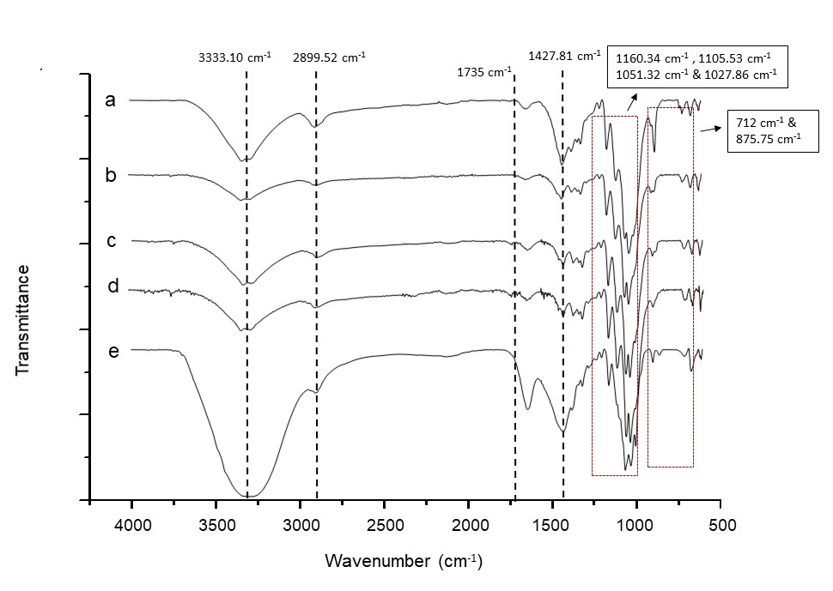

Figure 1. FT-IR spectra for printed (a) raw office paper waste, and alkali treated office paper waste using b) 2% NaOH, c) 4% NaOH, d) 8% NaOH, and e) 16% NaOH

The C=C in-plane aromatic vibration band, which could be observed at 1427 cm⁻¹,indicated the presence of lignin in the raw office paper waste, while the band located around ~1263 cm⁻¹,was assigned to the C-O-C stretching from the ether linkage in lignin [4]. The band at 875.75 cm⁻¹ indicated the presence of calcite in relation to the symmetric C-O stretching of calcite, while the band located at ~712 cm⁻¹ referred to the O-C-O bending mode of calcite [6], which were both ascribed to the presence of fillers or calcite used in the papermaking process. The pre-treatment process (where the samples were boiled and ground) was carried out in order to remove foreign substances, but the cellulose, calcite and lignin remained intact in the sample. The alkaline treatment using various concentrations of 2%, 4%, 8% and 16% of sodium hydroxide was carried out in order to investigate the suitable and optimum concentration of sodium hydroxide for the extraction of cellulose. The FTIR spectrum for each concentration can be observed in Figures 1 b-e, respectively. It can be seen that the bands assigned for the lignin, fillers and calcite were considerably decreased after the treatment with 2% sodium hydroxide. However, the bands remained similar at sodium hydroxide concentrations of 4%, 8% and 16%. This indicated that a concentration of 4% of NaOH was sufficient and could be considered as a suitable and optimum concentration for the alkaline treatment.

The ATR-FTIR spectra of the non-printed raw office paper waste and alkali-treated office paper waste using various concentrations of NaOH are shown in Figure 2. The observed bands around 1106.21 cm⁻¹, 1160.82 cm⁻¹, 1028.67 cm⁻¹and 1052.22 cm⁻¹ in Figure 2a (non-printed raw office paper waste) indicated the presence of cellulose, as was similarly observed in the printed raw office paper waste spectrum (see Figure 1a). The band located at 2898.47 cm⁻¹ corresponded to the C-H stretching vibrations of the alkyl groups in the aliphatic bonds, while the 3333.10 cm⁻¹ band that was attributed to the O-H band was mainly due to the cellulose-hydrogen bonding. However, the C-H band in the non-printed raw office paper waste spectrum was lower compared to the printed raw office paper spectrum (see Figure 1a) due to the presence of aliphatic groups associated with the ink components [6].

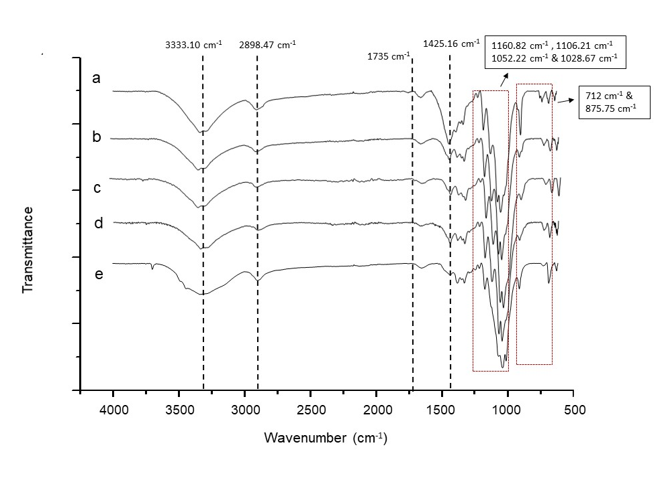

Figure 2. FT-IR spectra for non-printed, (a) raw office paper waste, and alkali treated office paper waste using b) 2% NaOH, c) 4% NaOH, d) 8% NaOH, and e) 16% NaOH

Similar to the printed raw paper, the absence of a hemicellulose band around ~1735 cm⁻¹ indicated that there was no hemicellulose present in the sample. The band at 1425.16 cm⁻¹ showed the presence of lignin in the raw office paper waste, while the band around 1300-1375 cm⁻¹ corresponded to the S=O band and N-H band, both of which were ascribed to the presence of ink compounds. The band at 875.75 cm⁻1, which was assigned to the presence of calcite, could also be observed in the non-printed raw office paper waste. The ATR-FTIR spectra after the alkali treatment using 2%, 4%, 8% and 16% of NaOH can be seen in Figures 2 b-e, respectively. Similar to the printed paper waste spectra, the bands representing lignin, ink compounds and fillers (calcite) were markedly reduced after the treatment with 2% sodium hydroxide. Thus, it could be concluded that the sodium hydroxide concentration of 4% was the optimum concentration to be used for the alkali treatment of the non-printed office paper waste.

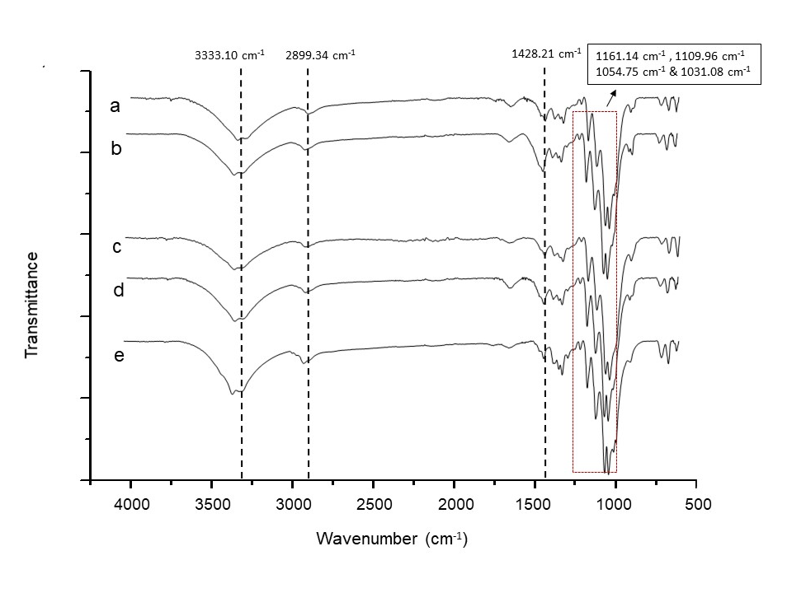

Figure 3. FT-IR spectra of office paper waste treated with a) 4% NaOH (printed), b) NaCIO (printed), c) 4% NaOH (non-printed), d) NaCIO (non-printed) and e) pure cellulose standard

Figures 3b and 3d show that the bands at 1109.96cm⁻¹, 1161.14cm⁻¹, 1031.08cm⁻¹ and 1054.75cm⁻¹ remained in the spectrum that corresponded to the existence of cellulose [6]. Moreover, the band at 2899.34 cm⁻¹ represented the C-H band, while the band at 3333.10 cm⁻¹ corresponded to the O-H band, similar with the pure cellulose (reference) spectrum. The band at 1428.21cm⁻¹, which was assigned to lignin, decreased slightly after the bleaching treatment.

In conclusion, the raw office paper waste contained cellulose, lignin, calcite, and other organic contents, such as sulfone, amine groups and filler or ink components. The difference between the printed and non-printed paper was that the ink intensity at 2899.52 cm⁻¹ was more noticeable for the printed paper. Originally, the alkali treatment was aimed at the removal of hemicellulose. However, it was found that no hemicellulose was present in the paper, since it was processed paper, in which hemicellulose had been removed during the papermaking process. Based on the FTIR analysis, the treatment reduced the intensity of the lignin and calcite bands and removed the organic contents and ink components. The sodium hydroxide concentration of 4% was found to be the optimum concentration for the alkali treatment as a higher concentration would have resulted in a processing cost. It was also expected that some of the lignin would have already been dissolved during the alkali treatment due to the alkali-sensitive linkages formed by the lignin [9].

Morphology analysis using optical microscope

Figure 4 shows the image of the cellulose structure of the printed raw paper and the non-printed raw paper waste, and the cellulose structures of the printed and non-printed paper after the pre-treatment process.

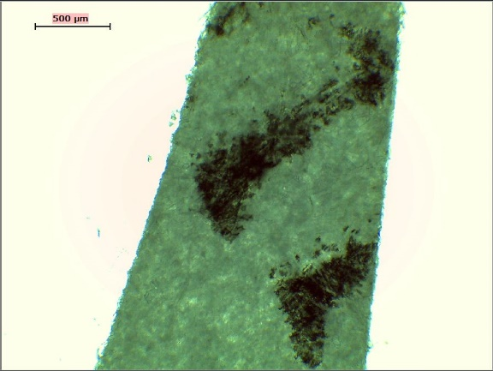  (a) | 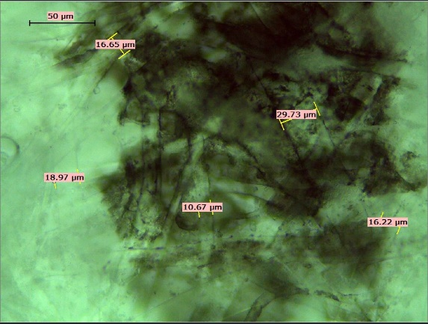  (b)
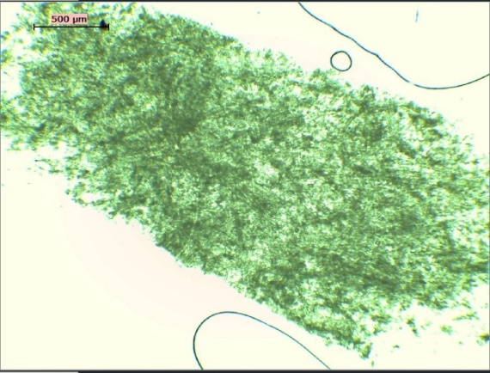  (c) | 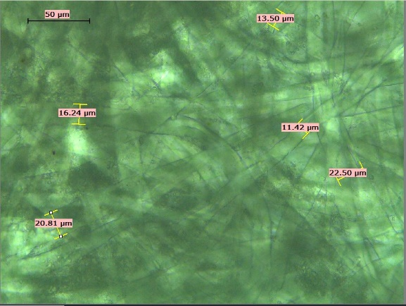  (d)
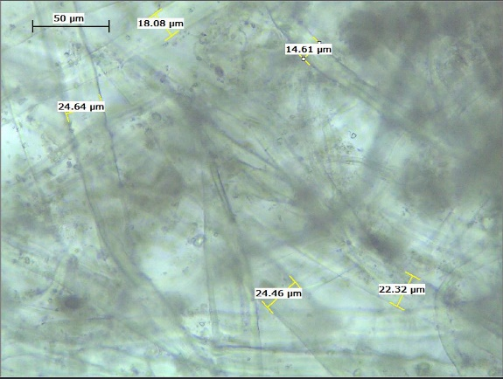  (e) | 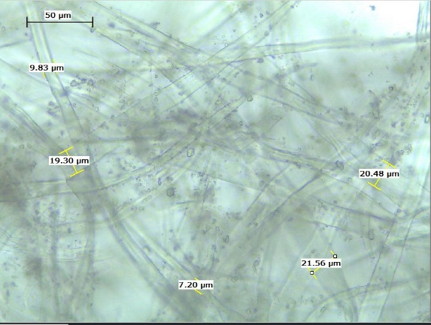  (f)

Figure 4. Optical microscope images of (a) Printed raw paper at 4x magnification, (b) Printed raw paper at 40x magnification, (c) Non-printed raw paper at 4x magnification, (d) Non-printed raw paper at 40x magnification, (e) Pre-treatment (printed) at 40x magnification, (f) Pre-treatment (non-printed) at 40x magnification

Figure 4 shows that the cellulose extracted from the office paper waste after all the treatments had a fibrous, rod-like structure, with some of the fibres being arranged longitudinally and attached to each other by hydrogen bonds [4]. The printed raw paper is shown in Figures 4a and 4b, where the black ink could be clearly observed on the fibres. No ink could be observed on the fibres shown in Figures 4c and 4d, which represented the non-printed raw paper. The fibrous structure of the cellulose could be clearly observed in the optical images. After the pre-treatment process, the cellulose fibres came apart loosely due to the boiling and grinding processes, as shown in Figures 4e and 4f. The ink components on the fibres of the printed paper had also been partially removed after the pre-treatment process prior to the alkali treatment.

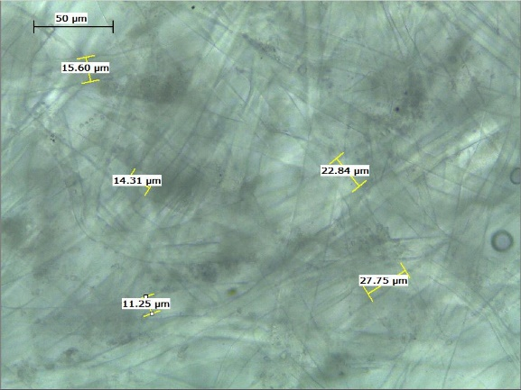  (a) | 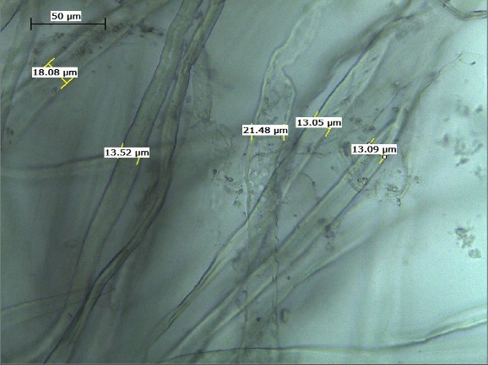  (b)
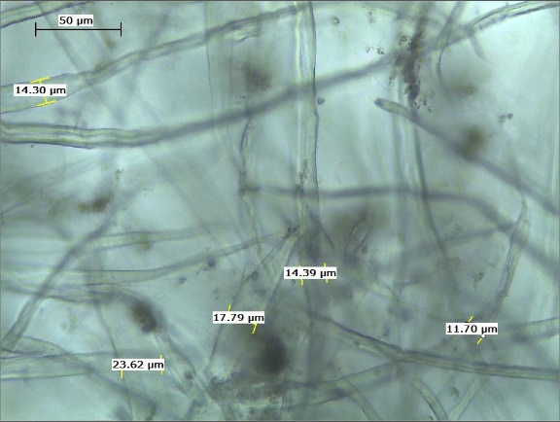  (c) | 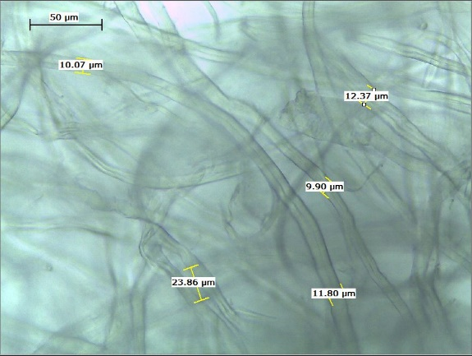  (d)

Figure 5. Optical microscope images of printed office paper after alkaline treatment using (a) 2% NaOH, (b) 4% NaOH, (c) 8% NaOH, and (d) 16% NaOH (all at 40x magnification)

The optical images of the cellulose fibres for the printed office paper and alkali-treated office paper using various concentrations of sodium hydroxide are shown in Figure 5. Figures 5a-d show the images of the cellulose fibres after being treated with 2%, 4%, 8% and 16% NaOH, respectively. At a NaOH concentration of 4% and above, no significant differences could be observed between the cellulose fibres, despite the use of a higher concentration of alkali (16% NaOH) for the treatment. This further supported the finding that a sodium hydroxide concentration of 4% is sufficient and optimum for the alkali treatment. However, at a NaOH concentration of 2%, the cellulose fibres still looked closely packed, which suggested the expected ineffectiveness of the 2% NaOH treatment due to the stronger hydrogen bonding remaining between the adjacent fibres. Thus, a concentration of 4% NaOH is a suitable and optimum concentration for the alkali treatment and cellulose extraction.

Figure 6 shows the image of the cellulose fibres of the non-printed paper, and of the non-printed paper after the treatment with various concentrations of alkali. Figures 6a, 6b, 6c and 6d indicate the images of the cellulose fibres after having been treated with 2%, 4%, 8% and 16% NaOH, respectively. The cellulose fibres of the non-printed paper were similar, and no significant differences could be observed when compared to the printed paper fibres shown in Figure 5.

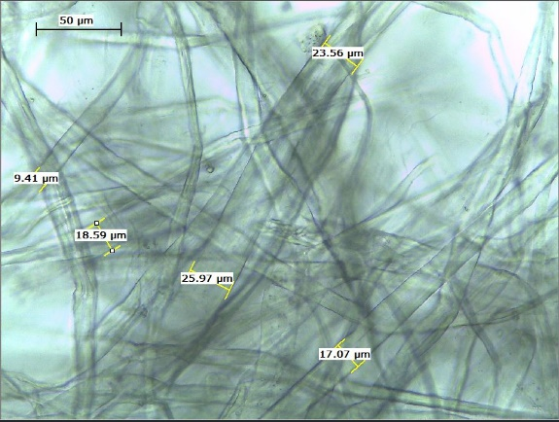  (a) | 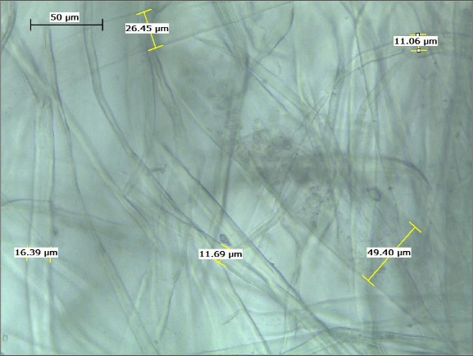  (b)
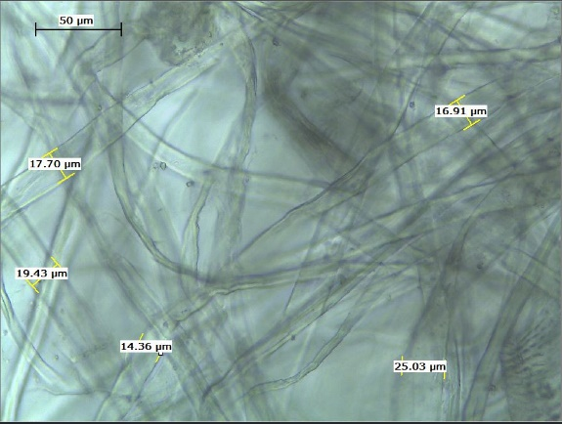  (c) | 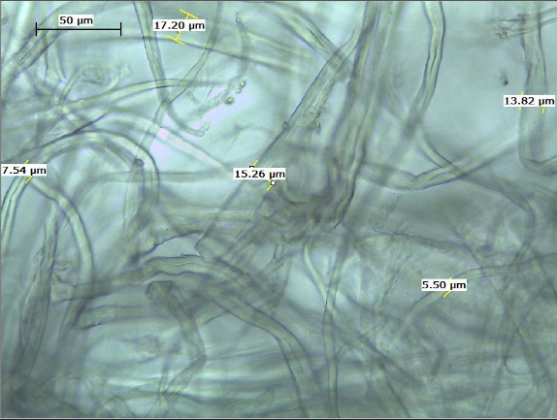  (d)

Figure 6. Optical microscope images of non-printed paper after alkaline treatment using (a) 2% NaOH, (b) 4% NaOH, (c) 8% NaOH, and (d) 16% NaOH (all at 40x magnification)

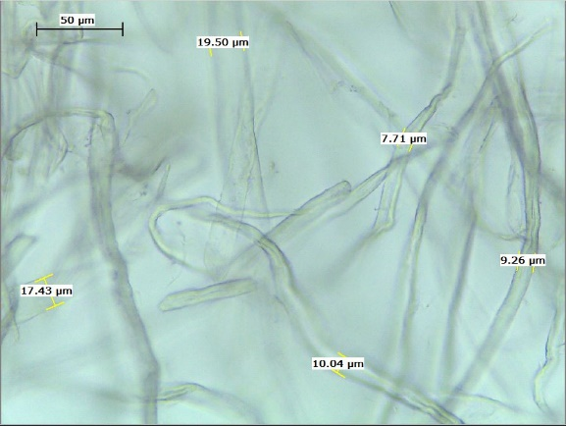  (a) | 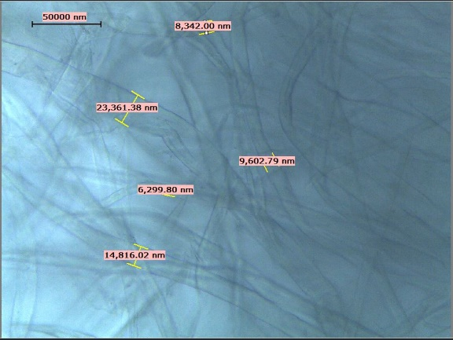  (b)

Figure 7. Optical microscope images of paper after bleaching treatment with NaClO (a) printed paper (b) Non-printed paper (both at 40x magnification)

The optical images of the cellulose fibres for the printed and non-printed office paper after the bleaching treatment are shown in Figures 7a and 7b, respectively. The individual cellulose fibres could be clearly observed, and the individual fibres were separated from each other following the bleaching treatment. The bleaching treatment was aimed at removing any undesirable components such as lignin, and to loosen the interactions between the adjacent fibres, leaving behind the cellulose fibres.

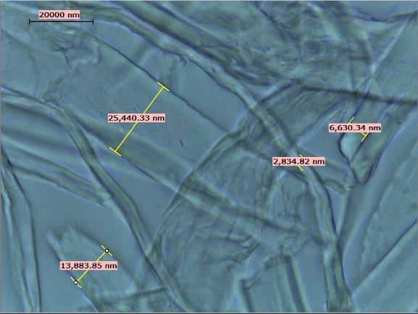  (a) | 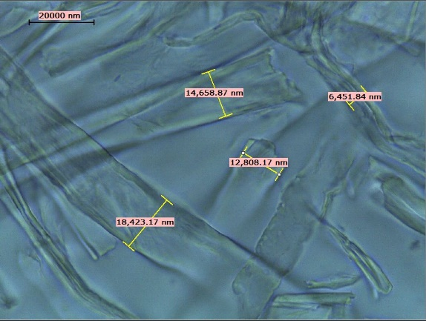  (b)
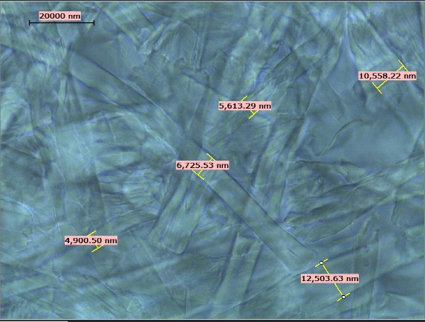  (c) | 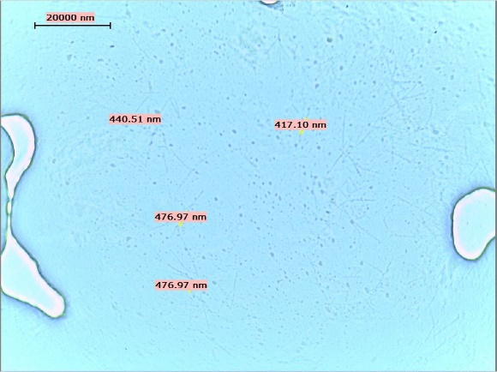  (d)

Figure 8. Optical microscope images of the samples after acid hydrolysis treatment using (a) 5%, (b) 15%, (c) 30%, and (d) 60% sulphuric acid (all at 100x magnification)

The acid hydrolysis treatment was aimed at breaking the strong hydrogen bonds between the cellulose fibres and to reduce the micro-sized cellulose to nano-scale by removing the amorphous structure of the cellulose. Figure 8 clearly indicates that the size of the cellulose was reduced as the concentration of acid used was increased. The higher the concentration of acid, the smaller the diameter of the cellulose. Unfortunately, for an acid concentration of 60%, the cellulose could no longer be observed through the use of an optical microscope, and instead, a transmission electron microscope (TEM) had to be used for the analysis to allow a precise examination of the nano-sized cellulose to be made.

Table 3 shows the trend in the sizes using an optical microscope for the analysis of raw office waste paper until the acid hydrolysis treatment. From the results, the diameter of the fibres in the raw paper samples until the NaCIO treatment remained unchanged at around 12-16 μm. Then, the size of the cellulose changed after the treatment with acid, and this varied according to the concentration of the acid used. The higher the concentration of acid, the smaller the diameter of the fibres. The diameter of the cellulose fibres after treatment with 5% and 15% acid showed no significant difference as compared to the size after the bleaching treatment. However, the size was reduced significantly following treatment with acid concentrations of 30% and 60%.

Table 3. Average diameter of cellulose fibres for printed and non-printed paper for all stages of treatments

Printed Paper | Average Diameter (μm) | Non- Printed Paper | Average Diameter (μm)
Raw paper | 16.32 | Raw paper | 16.02
Pre-treatment paper | 16.82 | Pre-treatment paper | 14.81
NaOH 2 % | 15.52 | NaOH 2 % | 13.83
NaOH 4 % | 14.72 | NaOH 4 % | 13.35
NaOH 8 % | 13.15 | NaOH 8 % | 12.57
NaOH 16 % | 11.81 | NaOH 16 % | 11.28

After Treatment with 4% NaOH
NaCIO | 12.38 | NaCIO | 11.56
Acid 5 % | 13.96 N.C None
Acid 15 % | 12.54 N.C None
Acid 30 % | 9.91 N.C None
Acid 60 % | 5.87 N.C None

*N.C = Not Conducted

TEM analysis: Nano scale of cellulose

Figure 9 show the morphology of cellulose samples after acid hydrolysis treatment with different concentrations. All samples were observed using transmission electron microscope (TEM).

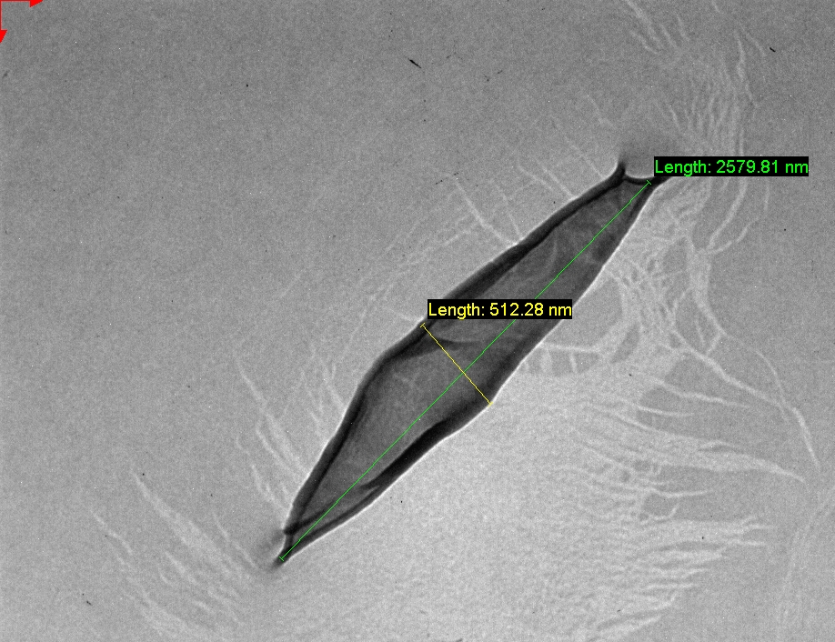  (a) | 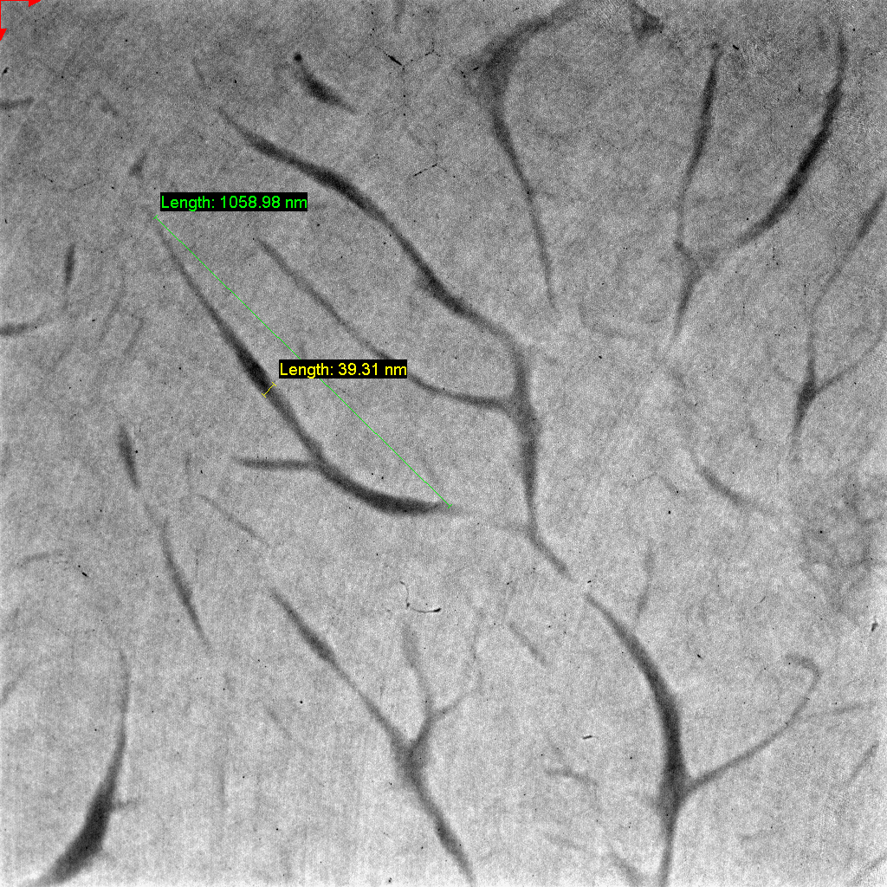  (b)

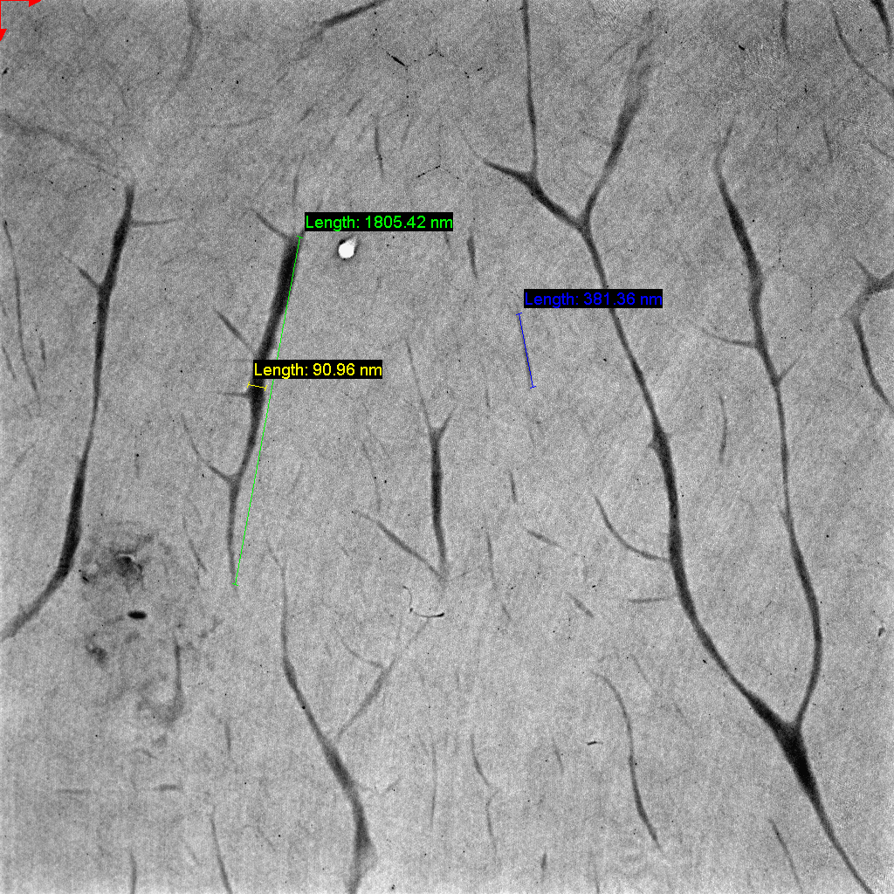
(c)

Figure 9. TEM images after acid hydrolysis treatment using (a) 5% acid at 10kx magnification, (b) 30% acid at 20kx magnification and (c) 60% acid at 10kx magnification.

Table 4 indicates the average diameter of the cellulose fibres after treatment with various concentrations of acid. The acid treatment was expected to affect the size of the cellulose fibres to nano-scale, based on a previous study [6]. TEM was used in this analysis due to the high magnification required for the imaging analysis, which could not be achieved previously using an optical microscope. Until the bleaching treatment, the size and morphology of the cellulose fibres could still be observed using an optical microscope. After the acid hydrolysis treatment, a TEM analysis was much more reliable, and was recommended for the detailed imaging of the nano-sized cellulose.

Table 4. Size comparison on average diameter using TEM and optical microscopy

Acid Concentration  (%) | TEM: Average Diameter (nm) | (OM) Average Diameter (μm)
5 | 512.28 | 13.96
30 | 30.89 | 9.91
60 | 25.62 | 5.87

Figure 9 shows the fibrous structure of the cellulose that was extracted from the office paper waste after all the treatments until the acid hydrolysis, which was the last stage of the treatment. Table 4 shows that the diameter of the cellulose fibres varied depending on the concentration of acid used. The higher the concentration of acid used, the smaller the diameter of the cellulose fibres that were obtained after the treatment. The average diameters of the cellulose fibres obtained using acid concentrations of 5%, 30% and 60% were 512 nm, 30 nm and 25 nm, respectively. The average diameter of the CNCs obtained using 60% acid concentration is slightly lower than the value of ~33 nm for CNCs obtained from office waste reported by Orue et. al. [6]. However, the value is higher as compared to the average value of 17nm reported for CNCs extracted from wood pulps [10]. Unlike the alkali and bleaching treatments, the acid hydrolysis process allowed the production of nano-fibrillated cellulose to a certain extent, depending on the technique or process applied. This was due to the removal of the amorphous region in the cellulose fibres that was susceptible to the acid treatment. In this study, the treatment produced nano-sized cellulose fibres, but in a small fraction, throughout the cellulose sample. Some of the micro-sized fibres were mixed with a fraction of the nano-sized cellulose fibres, thereby explaining the co-mixture of both micro-fibrillated and nano-fibrillated cellulose in the samples.

Conclusion

Micro-fibrillated and nano-fibrillated cellulose were obtained from office paper waste by subjecting the paper to an alkaline treatment (with sodium hydroxide solution, NaOH), bleaching treatment (with sodium hypochlorite solution, NaCIO) and acid hydrolysis treatment (with sulphuric acid, H₂SO₄). Cellulose was successfully extracted from the office paper waste as the FT-IR analysis indicated that lignin, ink and other components had been removed and reduced after the alkali and bleaching treatments. The spectrum of the treated office paper waste was similar to that of pure cellulose, thereby indicating that cellulose can be obtained from office paper waste. The analysis revealed that a sodium hydroxide concentration of 4% is an adequate and optimum concentration of alkali to be used for the extraction of cellulose from office paper waste. The morphology of the cellulose in the paper waste showed that it had a fibrous, long and rod-like structure. On the other hand, the size of the cellulose decreased as the concentration of acid used was increased, thereby suggesting that acid hydrolysis treatment is required for the production of nano-sized cellulose. The results showed that the extracted cellulose had sizes ranging from micro- to nano-scale, which was around ~20-30 nm. Further research on the extraction of nanocellulose from office paper waste, such as the reaction time and temperature, should be pursued and optimized since this work only focused on its extraction using different concentrations of NaOH in order to reuse and mitigate environmental issues concerning waste paper.

Acknowledgement

This study was supported by the Fundamental Research Grant Scheme (FRGS19-015-0623), Ministry of Education, Malaysia and International Islamic University Malaysia.

References

- Nguyen, S. T., Feng, J., Li Ai, T. T., Hoang, N., Vincent Tan, B. C. and Duong Hai, M. (2013). Cellulose aerogel from paper waste for crude oil spill cleaning. Industrial & Engineering Chemistry Research, 52: 18386-18391.
- Riyad, A. S. M. (2014). Scenario of paper waste recycling and reuse practices in Khulna City of Bangladesh. International Journal of Scientific & Engineering Research, 5(3): 705-711.
- Chirayil, C. J., Mathew, L., and Thomas, S. (2014). Review recent research in nanocellulose preparation from different lignocellulosic fibers. Review Advance Materials Science, 37: 20-28.
- Danial, W. H., Majid, Z. A., Mohd Muhid, M. N., Triwahyono, S., Bakar, M. B., and Ramli, Z. (2015). The reuse of wastepaper for the extraction of cellulose nanocrystals. Carbohydrate Polymers, 118: 165-169.
- Jannatun, N. I., and Zulhabri, I. (2014). Sustainable construction waste management strategic implementation model. WSEAS TRANSACTIONS on Environment and Development, 10: 48-58.
- Orue, A., Santamaria-Echart, A., Eceiza, A., Pena-Rodriguez, C. and Arbelaiz, A. (2017). Office waste paper as cellulose nanocrystal source. Journal of Applied Polymer Science, 134: 45257.
- Nguyen, H. D., Mai, T. T. T., Nguyen, N. B., Dang, T. D., Le, M. L. P., Dang, T.T., and Tran, V. M., (2013). A novel method for preparing microfibrillated cellulose from bamboo fibers. Advanced in Natural Sciences: Nanoscience and Nanotechnology, 4: 1-9.
- Hathama, R. H., and Muna, H. S. (2014). Novel method for extraction of cellulose from agricultural and industrial wastes. Chemical Technology an Indian Journal, 9(4): 148-153.
- Cherian, B. M., Leão, A. L., de Souza, S. F., Thomas, S., Pothan, L. A., and Kottaisamy, M. (2010). Isolation of nanocellulose from pineapple leaf fibres by steam explosion. Carbohydrate Polymers, 81: 720-725.
- Dong, H., Strawhecker, K. E., Snyder, J. F., Orlicki, J. A., Reiner, R. S., and Rudie, A. W. (2012). Cellulose nanocrystals as a reinforcing material for electrospunpoly(methyl methacrylate) fibers: Formation, properties and nanomechanical characterization. Carbohydrate Polymers, 87: 2488-2495.

