GLYCEROL DEGRADATION IN THE ABSENCE OF EXTERNAL HYDROGEN GAS BY USING WASTE EGGSHELL AS HETEROGENEOUS CATALYST
(Degradasi Gliserol Tanpa Kehadiran Hidrogen Luaran dengan Menggunakan
Sisa Kulit Telur sebagai Mangkin Heterogen)

Mohamad Imran Firdaus Mhd Sawal¹, Ahmad Irfan Oslan¹, Muhammad Hazwan Muhamad Hatta¹,
Noraini Hamzah², Norazzizi Nordin³, Norsaliyana Jumali¹, Wan Zurina Samad^{1*}

¹Department of Chemistry, Kulliyyah of Science,
International Islamic University Malaysia,
Bandar Indera Mahkota, 25200 Kuantan, Pahang, Malaysia
²Faculty of Applied Sciences,
University of Technology MARA,
40450 Shah Alam, Selangor, Malaysia
³School of Chemical Sciences,
Universiti Sains Malaysia,
11800 Minden, Pulau Pinang, Malaysia

*Corresponding author: wzurina@iium.edu.my

Abstract
The demand of biodiesel production nowadays is increasing every day. However, the booming of biodiesel demand resulted in the increase of glycerol production as a major by-product. Although glycerol could serve in various industries, the demand and usage are still limited. Therefore, an alternative method was proposed in this research in order to convert glycerol into more value-added chemicals such as methanol (MeOH), propanol (1-PrOH), and 1,2-propanediol (1,2-PDO) through a new low cost and simple approach which is the reflux technique in the absence of external hydrogen gas. Due to the concern of global food waste issues, calcium oxide (CaO) catalyst derived from waste eggshells is utilized as a possible heterogeneous catalyst. This preliminary research studied the influence of reaction temperature and reaction time whereas catalyst weight and glycerol concentration were fixed as independent variables. Overall, the three chemicals were successfully synthesized with different optimum conditions. The formation of 1,2-PDO is more preferred at lower temperature (130 °C and 5 hours) with glycerol conversion and selectivity of 53.70% and 64.76%, respectively. However, the formation of MeOH and 1-PrOH are preferred at higher temperature. The formation of 1-PrOH (170 °C and 5 hours) resulted in glycerol conversion and selectivity of 81.64% and 70.85%, respectively. Meanwhile, the best condition in the formation of MeOH is at 190 °C and 7 hours reaction time with glycerol conversion and selectivity of 65.8 % and 46.44%, respectively.
Keywords: glycerol, degradation, external hydrogen, waste eggshell, heterogeneous catalyst
Abstrak
Permintaan pengeluaran biodiesel semakin meningkat setiap hari. Fungsi biodiesel itu sendiri sebagai bahan api alternatif untuk menggantikan penggunaan bahan api fosil adalah salah satu teknik terbaik untuk mengurangkan pembebasan gas karbon dioksida (CO₂) yang dikeluarkan di atmosfera. Walau bagaimanapun, permintaan biodiesel yang tinggi menyebabkan peningkatan penghasilan gliserol sebagai produk sampingan utama. Walaupun gliserol boleh digunakan dalam pelbagai industri, permintaan dan penggunaannya masih terhad. Oleh itu, satu alternatif telah diambil dalam penyelidikan ini untuk menukar gliserol menjadi bahan kimia yang lebih bernilai seperti metanol (MeOH), propanol (PrOH) dan 1,2-propanediol (1,2-PDO) melalui pendekatan baharu yang lebih murah dan lebih mudah iaitu dengan menggunakan teknik refluks. Penukaran gliserol juga dilakukan tanpa kehadiran gas hidrogen luaran. Dengan mengambil kira mengenai isu kenaikan sisa makanan global, mangkin kalsium oksida (CaO) yang diperoleh daripada sisa kulit telur telah digunakan sebagai mangkin heterogen. Penyelidikan awal ini bertumpu mengkaji parameter pengaruh suhu tindak balas dan masa tindak balas, manakala berat mangkin dan kepekatan gliserol dijadikan sebagai pemboleh ubah tidak bersandar. Secara keseluruhan, ketiga-tiga bahan kimia telah berjaya disintesis dengan keadaan optimum yang berbeza. Pembentukan 1,2-PDO lebih baik pada suhu yang rendah (130 °C dan 5 jam) dengan penukaran gliserol dan selektiviti pada 53.70% dan 64.76%. Walau bagaimanapun, penghasilan MeOH dan 1-PrOH lebih baik pada suhu yang lebih tinggi. Penghasilan 1-PrOH (170 °C dan 5 jam) mencatatkan penukaran gliserol pada 81.64% dan selektiviti pada 70.85%. Sementara itu, keadaan terbaik dalam pembentukan metanol adalah pada 190 °C, dan masa reaksi 7 jam dengan penukaran gliserol pada 65.87% dan selektiviti produk masing-masing 46.44%.
Kata kunci: gliserol, degradasi, hidrogen luaran, sisa kulit telur, mangkin heterogen
Introduction
Recently, glycerol or also known as 1,2,3-propanetriol is used globally. For example, in food production, glycerol is used to produce sweeteners, humectants and solvents. Glycerol is also used in skin protection, cosmetic and pharmaceutical products. In medical and skin protection, glycerol is used to increase smoothness and also acts as a moisturizer [1]. The main activity that generates glycerol is biodiesel production. The increase in the production of biodiesel generates more glycerol as a major by-product. Biodiesel is one of the biofuels that can be used to replace fossil fuels as a source of energy because biodiesel produces less emission of hydrocarbons, particulate matters, and carbon monoxide, as well as has excellent lubricant properties. Other than that, biodiesel can be used in cosmetics, tobacco, cellulose firms, and paper industries [2-4]. In fact, glycerol is also primarily derived from animal fats and vegetable oils. To note, one mole of glycerol is produced for every three moles of biodiesel produced. It is estimated that glycerol contributes to approximately 10% as a by-product in biodiesel production [5]. It is reported by Anand and Saxena [6] that, on average, 5-10 gallons of crude glycerol are produced for every 100 gallons of biodiesel produced. From the projection on the world biodiesel market based on previous statistical data, it is estimated that approximately 4 billion gallons of crude glycerol will be produced in 2016 [6, 7]. Although glycerol could serve in various industries, the drawbacks still occur as the demand for glycerol is still limited, thus, there is abundance of glycerol in nature. The price of glycerol will be affected due to the excessive amount of glycerol produced, as well as the difficulties and high cost of glycerol refinery processes [8]. Apart from that, the excess of glycerol in nature can bring harm to the environment as glycerol is very hard to be disposed in the environment [8, 9]. Referring to these drawbacks, an approach is taken in order to convert glycerol to more valuable chemicals through catalytic activity.
For catalytic approach, calcium oxide (CaO) basic heterogeneous catalyst derived from waste chicken eggshells is chosen due to the availability in obtaining eggshells around us. Generally, eggshells consist of mainly calcium carbonate (CaCO₃), amino acid groups such as methionine (Met), alanine (Ala), and histidine (His), and a small amount of sodium (Na), magnesium (Mg), and potassium (K) [10]. Eggshells are available from any places such as markets, restaurants, and poultry farms. Besides, the price of eggshells is also reasonable and affordable, and eggshells are harmless to the environment [11]. Despite that, waste eggshells are also categorized in food waste, which, can be considered as one of the green catalysts. Furthermore, waste eggshell derived catalysts can be classified as safe, inhibit high catalytic activity, cheap and known as renewable resources [12].
There are a lot of methods involving chemical reactions in glycerol conversion. For example, glyceric acid, acrolein and methanol can be obtained from oxidation, dehydration, and hydrogenation processes, respectively [13]. However, these reactions occur in extreme conditions and mostly require stainless steel reactors particularly batch and flow reactors. For instance, previous researchers [13] stated that, studies conducted using supercritical process require extreme temperature ranges (676–726.85 °C), high pressure (24-27 MPa) and also the use of CO/CO₂ gaseous for reactions and separation. Thus, the current study is conducted to propose a new and low cost method under a mild condition and without the presence of a reactor to perform glycerol conversion, which is through a simple reflux method. Basically, reflux technique involves the condensation of vapor and the energy that accelerates the reaction, which is supplied by thermal heating [14]. Although this technique is widely used in industries and laboratories, its usage in catalytic conversion is still limited, primarily in glycerol conversion. Commonly, reflux technique is regularly used to synthesize and control various nanostructures, nanocatalyst materials, and its particle size [15]. By applying this method, no external hydrogen is needed during the conversion and it can be done in the laboratory scale. Currently, CaO as a solid base catalyst has been studied in many processes, especially in biodiesel production [16], synthesis of dimethyl carbonate (DMC), and synthesis of syngas [13, 17, 18]. Meanwhile, for glycerol conversion, to the best of the author’s knowledge, only glycerol conversion to lactic acid has been reported [19]. Therefore, this research might be the starting point in converting glycerol to more value-added products, which are methanol, 1-propanol and 1,2-propanediol.
MeOH, 1-PrOH, and 1,2- PDO have a lot of functions. For example, 1,2-PDO or also known as propylene glycol, is a non-toxic chemical mainly used in liquid detergents, pharmaceuticals, cosmetics, tobacco products, fragrances, flavours and humectants [3]. Another function of 1,2-PDO is this diol is the main component in the production of resins, polyesters and polyurethanes [20]. It is extensively used as a monomer for polyester resins, as an antifreeze agent, in liquid detergents, paints, cosmetics, food and others [5]. Meanwhile, MeOH and 1-PrOH can be used as a major chemical intermediates in a wide range of utilities [13]. They are also important as alternatives for transportation fuels, polymers, paintings and alcohols [4].
The present study focus on the preliminary investigation of the conversion of glycerol by eco-friendly CaO catalyst derived from waste chicken eggshells as a promising solid base catalyst. The used of a simple, reactorless and low cost reflux technique in the absence of external hydrogen has been attempted. To the best of our knowledge, these approaches still have limited resources and reliability, thus need to be investigated. Suitable operating parameters under two dependent variables which are reaction temperature and reaction time are also studied respectively.
Materials and Methods
List of chemicals
The experiment was carried out by using refined glycerol from Sigma Aldrich, paraffin oil (for oil bath), 1,4-butanediol (as an internal standard for gas chromatography-flame ionization detector (GC-FID), and distilled water. The chemicals were reagent grade and used without further purification.
Catalyst preparation
The method used was adapted from previous researchers with slightly modification [21]. Chicken eggshells (approximately 1-2 kg) obtained from nearby restaurants were washed thoroughly by distilled water and repeatedly three times in order to eliminate any impurities. After that, the eggshells were boiled at 100 °C by using a water bath to kill any bacteria and microorganisms. Then, the eggshells were dried at the temperature range of 100 to 110 °C in an oven overnight. Next, the dried eggshells were ground by using a blender (domestic Pensonic small-scale grinder) to fine and random size powder. Lastly, the powder was calcined at 900 °C in a furnace for approximately 120 minutes to produce the final as-prepared CaO catalyst powder.
General Procedure of Glycerol Conversion
In order to prepare 20 wt.% of glycerol feedstock, 4.0 g of glycerol was added to 20 mL of distilled water and stirred until a homogeneous solution was formed. Then, 1.0 g of CaO catalyst was added. The amount of catalyst was fixed for each reaction. The conversion of glycerol was carried out by using a 50 mL of round bottom flask, a hot plate, a digital thermometer, an Allihn condenser, and a magnetic stirrer. Figure 1 shows the set-up for the reflux apparatus used. The dependent variables used in this conversion were reaction temperature (130, 150, 170, and 190 °C) and reaction time (1, 3, 5, and 7 hours). These parameter ranges were chosen by considering the average minimum and maximum conditions of glycerol conversion reaction conditions used in previous studies [13, 20, 22, 23].
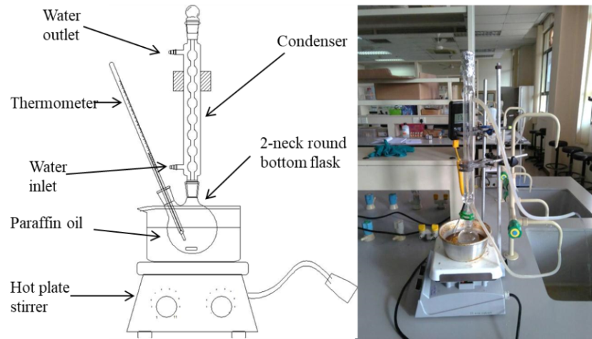
Figure 1. The set-up of reflux apparatus for glycerol conversion
Instrumentation
The instrumentation can be divided into catalyst characterization and product characterization (i.e. catalytic activity). For catalyst characterization, surface morphology study was conducted using scanning electron microscope (SEM) technique (Carl Zeiss brand, evo50 model). For elemental composition characterization, the analyses were conducted using energy dispersive X-ray (EDX), and CHNS/O analysis using Perkin-Elmer Series II, 2400 instrument. In order to identify the functional groups of the prepared CaO catalyst, the characterization was performed using the Fourier-transform infrared (FTIR) spectroscopy from Perkin-Elmer (96255) with the wavelength from 4000 to 500 cm⁻¹.
Meanwhile, for product characterization, the instruments used were gas chromatography-mass spectroscopy (GC-MS) by Clarus 680GC and GC-FID from Agilent Technologies (model 7890A). A similar column was used for both GC-MS and GC-FID (HP-INNOWAX) with the specifications of 30 m length, 0.250 mm diameter, and 0.50 µm inner diameter. For oven temperature, the initial temperature was set at 45 °C for 3 minutes before it was increased to 240 °C at a rate of 5 °C/min. Ramping time was constant at 240 °C for 5 min using splitless injection. The overall time required for one sample was 47 minutes and the maximum temperature of the oven was 260 °C.
Solid-phase micro extraction method (SPME) was used to determine conversion of products. For SPME, polyacrylate fiber was used with the thickness of 85 µm. The fiber was withdrawn from the syringe and soaked in the sample vial for 5 minutes with stirring for the extraction of conversion product. Then, the fiber was removed from the vial and inserted to the GC inlet and left for 10 minutes. Lastly, the fiber was removed and washed by using distilled water at 100 °C for 30 minutes to remove previous extraction products and the same steps were repeated for other product samples.
Results and Discussion
Catalyst characterization
For surface morphology analysis using SEM, both samples of non-calcined and calcined eggshell (CaO) catalyst were characterized. It is inferred that both non-calcined and calcined catalysts have irregular shape comprises spherical and flake shapes with various sizes in the range of 0.4 to 2.0 µm, and it is also supported by previous researchers [21, 24]. It can also be observed that the catalysts possessed porous surfaces as it could be clearly seen from the existence of pores as shown in Figure 2.
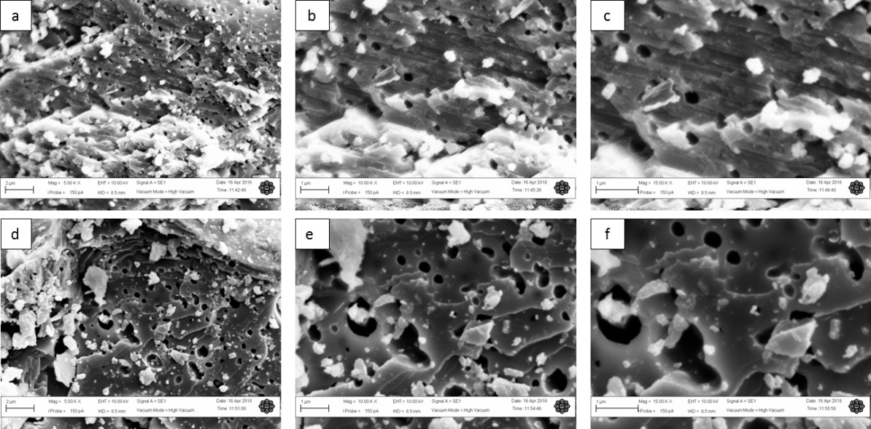
Figure 2. SEM images of non-calcined catalyst at different magnification (a) 5.00 kx (b) 10.00 kx and (c) 15.00 kx and SEM images of calcined catalyst at different magnification (d) 5.00 kx (e) 10.00 kx and (f) 15.00 kx
However, based on the images shown in Figure 2, the biggest difference between both non-calcined (CaCO₃) and calcined eggshells (CaO) catalysts is the calcined eggshell catalyst has high apparent porosities. In fact, it is obviously observed that there is an increasing of pore diameter from non-calcined to calcined samples. It is measured that the pore diameter in non-calcined samples has an average diameter of 0.3 µm, whereas for calcined samples the average diameter is 1.4 µm. The enlarged pores after calcination might be due to heating process expanded and activated the pores. Thus, more active areas for reaction are available. Other than that, it is also due to the decomposition of CaCO₃ to CO₂ during calcination. Therefore, the larger contact area is a result of a large number of pits and pores distributed over the entire eggshell surface [21]. The higher the contact surface area, the more reaction could occur at active sites of the catalyst. Other than that, physically, it is observed that the number of pores and pore diameters of calcined eggshells (CaO) are higher compared to non-calcined eggshells.
Next, for elemental analysis, the result of EDX analysis is supported with the CHNO/S analysis. From the EDX results, it is shown that in non-calcined eggshells (CaCO₃) in Figure 3(a), carbon (C) element shows higher peaks than calcium (Ca) and oxygen (O) elements, whereas for calcined eggshells in Figure 3(b), O element shows the higher peaks than C and Ca. It is clearly demonstrated that thermal degradation occurred during calcination process. The full results of elemental composition (%) for both techniques are summarized in Table 1 and 2.
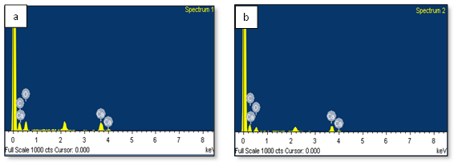
Figure 3. EDX spectrum for (a) non-calcined (CaCO₃) and (b) calcined (CaO) eggshells
Table 1. Percentage compositions for non-calcined (CaCO₃) and calcined eggshells (CaO) by using EDX technique
Sample | Element (atomic %)
Sample | Carbon (C) | Oxygen (O) | Calcium (Ca)
Non-calcined (CaCO₃) | 43.74 | 36.75 | 19.52
Calcined catalyst (CaO) | 34.99 | 46.50 | 18.51

However, the percentage for Ca remain unchanged in both non-calcined (CaCO₃) and calcined samples (CaO), which suggests that the metal cluster bonded strongly in the catalyst system. In order to support the elemental analysis and to assure the existence of other important element in the samples, further composition analysis was then carried out and supported with CHNS/O analysis as shown in Table 2.
Table 2. Results of compositional analysis using CHNSO technique
Run/Sample Details |  | Element Composition (%)
Run | Weight  (g) | Carbon | Hydrogen | Nitrogen | Sulphur | Oxygen
Non-Calcined eggshells (CaCO₃) | 1.909 | 9.274 | 0.030 | 3.163 | -0.118 | 87.651
Calcined catalyst (CaO) | 1.940 | 6.692 | 0.186 | 2.201 | -0.105 | 91.026

Table 2 present the percentage C, H, N, S, and O elements. Again, the reduction of C percentage from non-calcined eggshells (9.274%) to calcined eggshells (6.692%) shows the occurrence of decarbonation process. However, the percentage for H increased significantly from 0.0030% to 0.186%, which shows the impurities originated from sample preparation. This is because the O in CaO adsorbed water vapor from the surrounding to form calcium hydroxide (Ca(OH)₂). The presence of nitrogen is also noticeable. It is due to the presence of amino acids such as methionine (Met), alanine (Ala), histidine (His), and others in the membrane of eggshells [10]. Furthermore, it is also noticed that the percentage of N in CaO catalyst (calcined) is lower compared to non-calcined eggshells. The suggested reason is some nitrogen has been oxidized in the calcination process to produce NO₂.

FTIR analysis was conducted for further determination of any changes in the functional groups between non-calcined catalyst (CaCO₃) and calcined CaO catalyst samples. Figure 4 shows the overlaid of FTIR spectra for non-calcined eggshells (CaCO₃) and calcined eggshells (CaO). From the spectra, both samples have quite similar peaks at specific bands. However, there is a new significant peak at 3641 cm⁻¹ in the CaO catalyst spectrum. This peak is attributed to the hydroxide (OH) in Ca(OH)₂ due to the adsorption of water by CaO [21]. Therefore, that peak could confirm the existence of Ca-O phase. Next, a similar band also existed for both spectra of non-calcined eggshells and calcined eggshells at 712.30 cm⁻¹ in which the band corresponds to Ca-O bond. For non-calcined eggshells, well‐defined IR bands at 1401.35 cm⁻¹ and 872.66 cm⁻¹ indicated asymmetric C-O bond in stretching mode for CO₃²⁻ molecules [21]. Besides, the peaks at 2972, 2878, 2516, and 1795 cm⁻¹ are due to amines and amides present in eggshells [25]. Furthermore, the Figure 4 also shows the spectrum of calcined CaO. A similar range of peak is noticeable for CaO catalyst (calcined) at 1405.37 cm⁻¹ and 872.43 cm⁻¹ for asymmetric C-O bond in stretching mode.

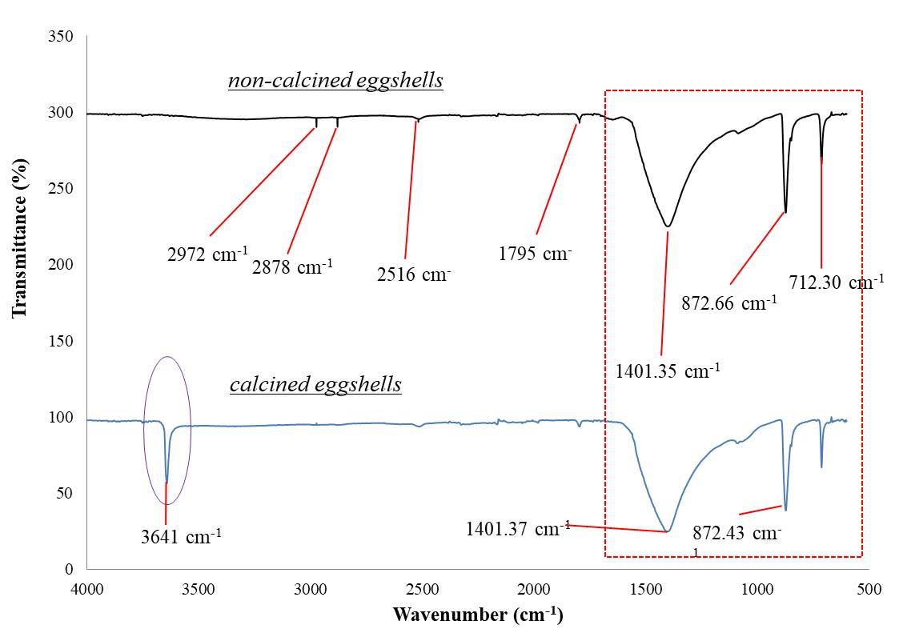
Figure 4. FTIR spectra for non-calcined eggshells and calcined CaO catalyst
Catalytic activity (Glycerol conversion): Catalytic activity for CaO catalyst (calcined eggshell) at 130 °C
The percentage of conversion at 130 °C is quite constant from 1 to 5 hours with the highest conversion of 69.03% recorded at 7 hours. Selectivity towards MeOH shows a constant trend around 19.27% to 22.77% from 1 h to 7 hours. Unlike MeOH, the selectivity to 1-PrOH and 1,2-PDO increased and decreased throughout 7 hours reaction time. For 1-PrOH, the selectivity at 1 hour is quite high (50.39%) before it decreased steeply to 15.97% at 5 hours. However, the selectivity of 1-PrOH increased significantly again to 68.93% at 7 hours. Meanwhile, for 1,2-PDO, it started with low selectivity at 26.84% during 1 hour before increased significantly to 64.76% after 5 hours of reaction time. Then, the selectivity of 1,2 PDO dropped very steeply to only 10.76% at 7 hours.
For the highest total yield, it could be seen that 1-PrOH has the highest values of 47.58% at 7 hours since it has the highest percentage of glycerol and selectivity of the product. The lowest total yield is 7.43% for 1,2-PDO at 7 hours.
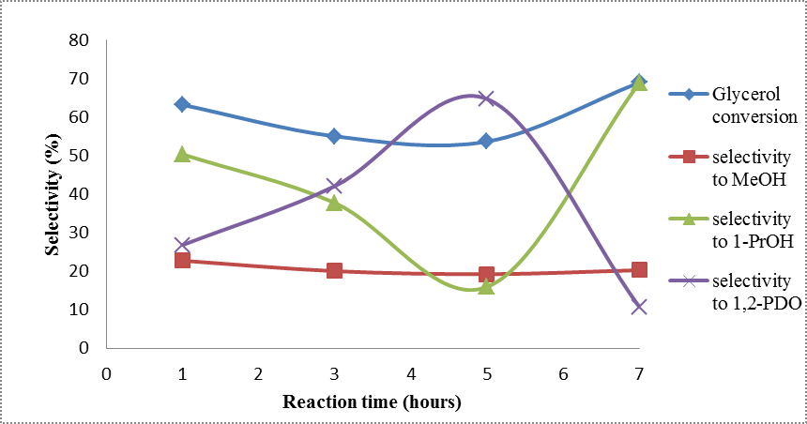
Figure 5. Catalytic profile effect of reaction time at 130 °C
The decrease in selectivity and total yield of 1-PrOH from 1 to 5 hours of reaction time is due to the high formation of 1,2-PDO at that time. It is also noticed that the conversion to 1,2-PDO is only active at 130 °C, then, for the rest of experimental temperatures, the conversion to 1,2-PDO is low and remained constant. The optimum period for C-O at glycerol to split in order to form 1,2-PDO is 5 hours. However, longer reaction time would make more another C-O at 1,2-PDO to be broken, which explains the increase of the percentage of 1-PrOH at 7 hours. Besides, at lower temperature, the kinetic energy for collision to occur is low, hence only one C-O bond at glycerol molecule is able to be removed. The percentage of selectivity and MeOH yield seemed to be constant throughout 7 hours. It shows that the temperature of 130 °C is not suitable for breaking C-C bond at glycerol composition. Overall, the conversion at 130 °C is suitable for the formation of 1,2-PDO at shorter reaction time (1 to 5 hours) and 1-PrOH (longer than 5 hours).
Catalytic activity for CaO catalyst (calcined eggshells) at 150 °C
At 150 °C, different patterns can be seen for glycerol conversion, selectivity and yield percentage for each product. It is observed that glycerol conversion increased as reaction time increased. The highest percentage of glycerol conversion is at 7 hours (73.91%). However, there is a little drop in glycerol conversion at 3 hours from 69.61% to 59.91% which might be due to experimental error. Errors such as rate of stirring, rate of water flow (for cooling system), and catalysts attached to the wall of round-bottom flask might occur while conducting experiment. Therefore, some deviated data are obtained. Besides, at this temperature, the selectivity and total yield towards 1-PrOH are the highest compared to MeOH and 1,2-PDO. The highest selectivity of 1-PrOH is at 7 hours with 77.51% and the lowest is at 3 hours.
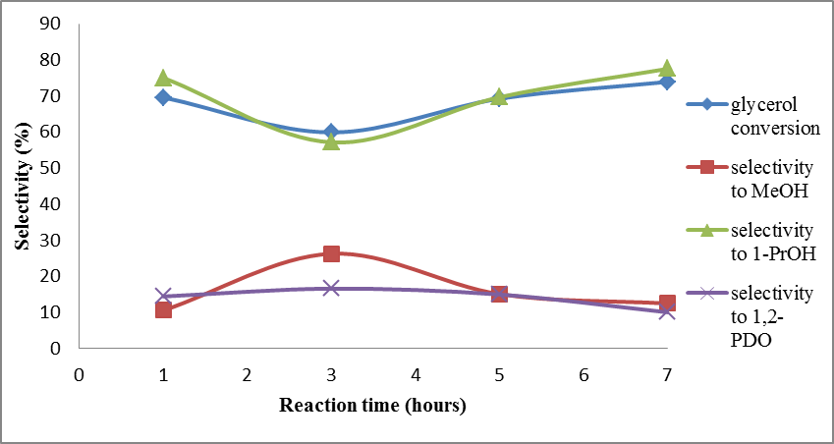
Figure 6. Catalytic profile effect of reaction time at 150 °C
Overall, Figure 6 shows that glycerol conversion at 150 °C is higher compared to 130 °C. The selectivity and total yield of 1-PrOH also increased. This is because the energy supply to break C-O bond at glycerol was sufficient to form 1-PrOH. The formation of 1,2-PDO is also lower at 150 °C compared to 130 °C. This is probably because most of 1,2-PDO have successfully converted to 1-PrOH. The selectivity and total MeOH yield at 150 °C are quite similar with 130 °C. It shows that there is still noticeable MeOH present from the reaction, yet the formation is not significant at this reaction temperature in which the chemical reaction still focuses on 1-PrOH (C-OH bond breaking).
Catalytic activity for CaO catalyst (calcined eggshell) at 170 °C
Next, the conversion was conducted at 170 °C. It can clearly be seen that 1-PrOH is still a major product formed at this reaction temperature. There are still traces of MeOH and 1,2-PDO left throughout 7 hours reaction time. It is clearly observed that MeOH showed an increasing pattern at this temperature. The highest percentage of glycerol conversion is recorded at 5 hours with 81.64% followed by 3, 1, and 7 hours with the conversion of 69.57%, 61.43%, and 54.67%, respectively. Throughout the first 5 hours of reaction, the conversion seemed to increase, probably due to enough time for a reaction to occur for glycerol to be adsorbed on the surface of catalyst to release a product. However, at 7 hours reaction time, the conversion percentage dropped because at this temperature, the reaction might focus on product formation rather than bond breaking. The conversion of glycerol at 5 hours for this temperature is the best conversion achieved among all the conversion in this study. Therefore, it can be concluded that reaction temperature of 170 °C and 5 hours reaction time are the optimum conditions.
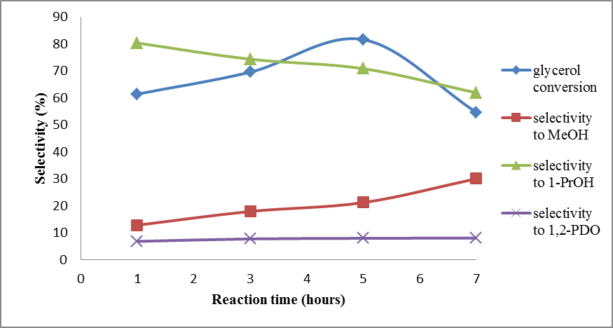
Figure 7. Catalytic profile effect of reaction time at 170 °C
From Figure 7, it can be clearly seen that the reaction is no more selective to 1,2-PDO compared to at 130 °C, and the selectivity maintained from 1 to 7 hours. Meanwhile, the selectivity of 1-PrOH dropped from 80.35% at 1 hour to 61.9 % at 7 hours whereas the product selectivity of MeOH increased by time. An almost similar pattern is also observed for yield percentage, except the value of 1–PrOH increased slightly at 7 hours. The best reason is probably because a large number of 1,2-PDO have converted to 1- PrOH before converting to MeOH. This is because higher temperature and longer time give enough energy to degrade the product by splitting either C-O bond for 1,2-PDO or C-C bond for 1-PrOH in the formation of MeOH. The increase in temperature also allows more frequent collision between glycerol particles. This collision would give enough energy to be used in breaking the C-C bond to form MeOH. Thus, the higher temperature is very suitable for bond dissociation from three carbons to only one carbon.
Catalytic activity for CaO catalyst (calcined eggshells) at 190 °C
The last conversion was conducted at 190 °C. A similar trend of result for each product at 170 °C can be clearly seen. Glycerol conversion still shows an increasing trend as reaction time increased from 1 to7 hours. However, the average glycerol conversion at 190 °C is slightly lower compared to at 170 °C. The best conversion is recorded at 7 hours (65.87 %) followed by 5 hours (58.89 %), 3 hours (57.44 %) and the least is at 1 hour (53.77 %). Following the pattern throughout 7 hours, the conversion seemed to increase probably due to enough time for a reaction to occur and for glycerol to be adsorbed on the surface of catalyst to release a product. Besides, increasing the temperature would give more energy for glycerol particles to collide with each other to break and form new bonds in order to produce new products.
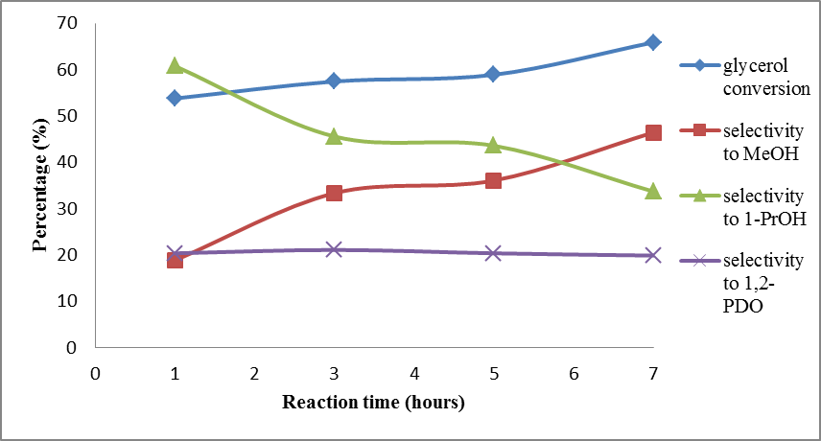
Figure 8. Catalytic profile effect of reaction time at 170 °C
Referring to Figure 8, the selectivity of 1,2-PDO dropped slightly from 1 h to 7 hours from 20.37% to 19.87%, respectively. Meanwhile, the selectivity of 1-PrOH decreased significantly from 60.76% at 1 hour to 33.69% at 7 hours. However, the product selectivity of MeOH increased gradually from 18.87% at 1 hour to 46.44% at 7 hours. For 1,2-PDO, the selectivity towards this product is the lowest compared to MeOH and 1-PrOH. The range of reduction of 1,2-PDO is between 20.37% at 1 hour and 19.87% at 7 hours. Similar pattern is also shown in the percentage yield for every product throughout 7 hours of reaction. Comparable to reaction temperature of 170 °C, higher temperature and longer time give enough energy to degrade the product by splitting either C-O bond for 1,2-PDO and 1-PrOH, and C-C bond in the formation of MeOH. The decline of 1-PrOH and 1,2-PDO is noticed as major conversion into MeOH.
Comparison of the reactions in the presence and absence of catalyst at optimum conditions
The comparison of the reactions with and without catalyst was investigated to observe the efficiency of using the catalyst. The optimum condition for both reactions was identified. For the reaction without catalyst under hydrogenolysis, the optimum condition is at 170 °C, 7 hours and 20 wt.% glycerol concentration. Meanwhile, for this experiment, the best optimum condition for glycerol conversion by using CaO as the catalyst is at 170 °C, 5 hours and 20 wt.% glycerol concentration. The data obtained are shown in Table 3.

Table 3. Catalytic activity result for reactions with and without catalyst
Condition | Glycerol  Conversion (%) | Selectivity (%) |  |  | Total Yield (%)
Condition | Glycerol  Conversion (%) | MeOH | 1-PrOH | 1,2-PDO | MeOH | 1-PrOH | 1,2-PDO
Without catalyst | 45.64 | 3.89 | 16.01 | 80.10 | 1.78 | 7.31 | 36.56
With catalyst | 81.64 | 7.95 | 70.85 | 21.20 | 6.49 | 57.84 | 17.31

Based on the data in Table 3, it is clearly seen that the use of catalyst almost doubled the conversion of glycerol from 45.64% to 81.64% for reactions without and with catalyst, respectively. For selectivity towards products, it can be noticed that the reaction with catalyst produced products with a lower number of carbon and oxygen. For example, in this experiment, the production of MeOH and 1-PrOH is higher in the reaction with catalyst compared to the reaction without catalyst. However, 1,2-PDO shows a different trend. It can be clearly seen that the conversion to 1,2-PDO is higher in the reaction without catalyst compared to the reaction with catalyst.
The reason for the results of both reactions is because; the use of a catalyst could provide an alternative route for the reaction with lower activation energy (Ea) of the reactant. Thus, the reaction could appear more efficiently in order to convert glycerol to more value-added chemicals. This is because, by lowering the Ea, there would be more successful collisions from particles, which generated enough energy for bond dissociation of C-C and C-O to occur. Hence, the percentage conversion and selectivity to MeOH and 1-PrOH are higher in the reaction with catalyst compared to the reaction without catalyst. The CaO catalyst is known to have basic sites that consist of Ca²⁺ and O^{2-.} Therefore, it is suggested that the surface of O²⁻ would extract H⁺ from H₂O in order to form hydroxide ions (OH⁻). Next, OH⁻ would extract H⁺ and then remove one hydroxyl group from glycerol to form 1,2-PDO. The same process would be repeated in order to form 1-PrOH from 1,2-PDO.
Comparison of the reactions for all reaction temperatures
Next, the comparison of the reactions for all reaction temperatures (130, 150, 170 and 190 °C) in this study was carried out. Figure 9 illustrates the results for different temperatures towards glycerol conversion. Based on Figure 9, temperature plays an important role in glycerol conversion. Higher conversion could occur at higher temperature. This is because temperature induces the collision between particles in glycerol to collide faster and more frequently. As a result, more products could be formed by breaking the bonds in glycerol structure as sufficient kinetic energy is supplied due to increasing temperature. However, at 190 °C, the reaction is lower because at that temperature, the reaction is more focused on product formation rather than breaking the bond in glycerol.
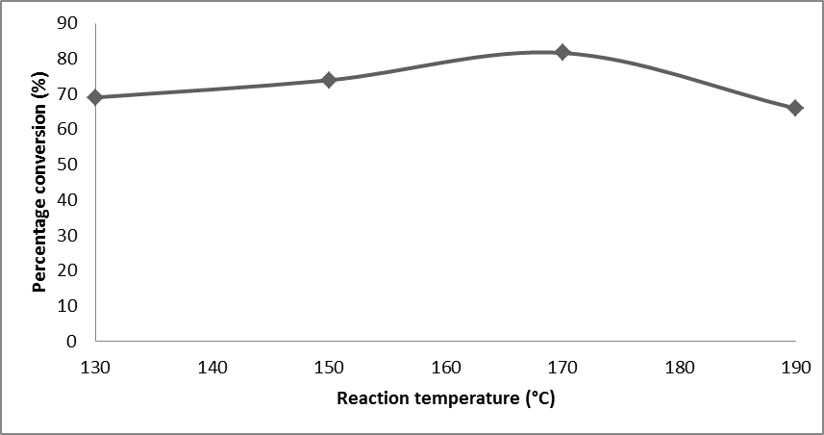
Figure 9. Effect of reaction temperature on glycerol conversion
Conclusion
Generally, CaO as a catalyst from waste chicken eggshells has been prepared. Based on the results obtained, CaO catalyst gives a positive result in hydrogenolysis of glycerol. The formation of 1,2-PDO is more preferred at lower temperature, whereby the selectivity and yield percentage are considerably higher compared to 1-PrOH and MeOH. The highest formation of 1,2-PDO is at 130 °C in 5 hours. The conversion is 53.70% with selectivity of 64.76% and total percentage yield of 34.78%. However, the formation of MeOH and 1-PrOH are preferred at higher temperature. The best condition for 1-PrOH is at 170 °C and 5 hours reaction time. The glycerol conversion is 81.64% with product selectivity of 70.85% and total percentage yield of 57.84%. Meanwhile, at 190 °C and 7 hours reaction time, the glycerol conversion and selectivity of MeOH are 65.87% and 46.44%, respectively. The catalyst used can also be considered very useful since three products can be formed in each reaction, whether at low or high temperature. Therefore, the use of eggshells as a catalyst in the industrial sector is possibly good due to its properties and activity in forming more value-added products. This preliminary study has proved that, glycerol conversion can be successfully conducted through a reactorless method which is by reflux technique. No external hydrogen gas is utilized in this study and it could open up a new interest in glycerol conversion study. This study will be expanded in the future by the utilization of other reaction parameters, such as catalyst weight, glycerol concentration, and recyclability test.
Acknowledgement
This research was supported by the grant of RIGS16-304-0468. The authors would also like to acknowledge the Ministry of Education Malaysia (Higher Education) and Dr Norsaliyana Jumali for the financial support under the grant of FRGS17-016.
References

- Qadariyah, L., Mahfud., Sumarno., Mahmudah, S., Wahyudiono., Sasaki. M. and Goto M. (2011). Degradation of glycerol using hydrothermal process. Bioresource Technology, 102: 9267 - 9271.
- Johnson, D. T. and Taconi, K. A. (2007). The glycerin glut: options for the value‐added conversion of crude glycerol resulting from biodiesel production. Environmental Progress & Sustainable Energy, 26(4): 338-348.
- Nanda, M. R., Yuan, Z., Shui, H. and Xu, C. (2017). Selective hydrogenolysis of glycerol and crude glycerol (a by-product or waste stream from the biodiesel industry) to 1,2-propanediol over B₂O₃ promoted Cu/Al₂O₃ catalysts. Catalysts, 7(7): 196.
- Nanda, M. R., Yuan, Z., Qin, W. and Xu, C. (2016). Recent advancements in catalytic conversion of glycerol into propylene glycol: A review. Catalysis Review, 58(3): 309 - 336.
- Samad, W. Z., Salleh, M. M., Shafiee, A. and Yarmo, M. A. (2011). Structural, optical and electrical properties of fluorine doped tin oxide thin films deposited using inkjet printing technique. Sains Malaysiana, 40(3): 251 - 257.
- Anand, P. and Saxena, R. K. (2012). A comparative study of solvent-assisted pretreatment of biodiesel derived crude glycerol on growth and 1,3-propanediol production from Citrobacter freundii. New Biotechnology, 29(2): 199 - 205.
- Yang, F., Hanna, M. A. and Sun, R. (2012). Value-added uses for crude glycerol–A byproduct of biodiesel production. Biotechnology for Biofuels, 5(1): 13.
- Quispe, C. A. G., Coronado, C. J. R. and Carvalho, J. A. J. (2013). Glycerol: production, consumption, prices, characterization and new trends in combustion. Renewable and Sustainable Energy Reviews, 27: 475 - 493.
- Da Silva, G. P. D., Mack, M. and Contiero, J. (2009). Glycerol: A promising and abundant carbon source for industrial microbiology. Biotechnology Advances, 27: 30 - 39.
- Nakano, T., Ikawa, N. I. and Ozimek, L. (2003). Chemical composition of chicken eggshell and shell membranes. Poultry Science, 82(3): 510 - 514.
- Buasri, A., Chaiyut, N., Loryuenyong, V., Worawanitchaphong, P. and Trongyong, S. (2013). Calcium oxide derived from waste shells of mussel, cockle, and scallop as the heterogeneous catalyst for biodiesel production. The Scientist World Journal, 2013: 1 - 7.
- Verma, P., Sharma, M. P. and Dwivedi, G. (2016). Impact of alcohol on biodiesel production and properties. Renewable and Sustainable Energy Reviews, 56: 319 - 333.
- Haider, M. H., Dummer, N. F., Knight, D. W., Jenkins, R. L., Howard, M., Moulijn, J., Taylor, S. T. and Hutchings, G. J. (2015). Efficient green methanol synthesis from glycerol. Nature Chemistry, 7 (12): 1028.
- Henry, Z. K. (1992). Distillation design. McGraw Hill, United State of America: pp. 2 - 3.
- Aditha, S. K., Kurdekar, A. D., Chunduri, L. A. A., Patnaik, S. and Kamisetti, V. (2016). Aqueous based reflux method for green synthesis of nanostructures: Application in CZTS synthesis. MethodsX, 3: 35 - 42.
- Hassan, S. T. and Nageswara, R. L. (2018). Utilization of modified eggshells as a solid catalyst for the conversion of waste cooking oil to biodiesel. Austin Chemical Engineering, 5(1): 1 - 8.
- Praikaew, W., Kiatkittipong, W., Kiatkittipong, K., Laosiripojana, N., Viriya-empikul, N., Boonyasuwat, S., Aiouache, F., Najdanovic, V. and Assabumrungrat, S. (2018). Synthesis of glycerol carbonate from dimethyl carbonate and glycerol using CaO derived from eggshells. MATEC Web of Conferences, 192(03045): 1 – 4.
- Renita, A., Chowdhury, P. P., Sultana, P., Phukan, P. and Hannan, A. (2016). Utilization of waste eggshells for production of renewable catalyst for transesterification. International Journal of Pharmacy and Pharmaceutical Sciences, 8(7): 143 -146.
- Chen, L., Ren, S. and Ye, X. P. (2014). Lactic acid production from glycerol using CaO as solid base catalyst. Fuel Processing Technology, 120: 40 - 47.
- Feng, J., Zhang, Y., Xiong, W., Ding, H. and He B. (2016). Hydrogenolysis of glycerol to 1,2-propanediol and ethylene glycol over Ru-Co/ZrO₂ catalysts. Catalysts, 6(4): 51.
- Mosaddegh, E. and Hassankhani, A. (2014). Preparation and characterization of nano-CaO based on eggshell waste: novel and green catalytic approach to highly efficient synthesis of pyrano [4, 3-b] pyrans. Chinese Journal of Catalysis, 35(3): 351 - 356.
- Maris, E. P. and Davis, R. J. (2007). Hydrogenolysis of glycerol over carbon-supported Ru and Pt catalysts. Journal of Catalysis, 249(2): 328 - 337.
- Samad, W. Z., Goto, M., Kanda, H., Wahyudiono., Nordin, N., Liew, K. H., Yarmo, M. A. and Yusop, M. R. (2017). Fluorine-doped tin oxide catalyst for glycerol conversion to methanol in sub-critical water. The Journal of Supercritical Fluids, 120: 366 - 378.
- Borhade, A. V., Uphade, B. K. and Gadhave, A. G. (2016). Calcinized eggshell: An environmentally benign green catalyst for synthesis of 2-arylbenzothiazole derivatives. Research on Chemical Intermediates, 42(7): 6301 - 6311.
- Tsai, W. T., Yang, J. M., Lai, C. W., Cheng, Y. H., Lin, C. C. and Yeh, C. W. (2006). Characterization and adsorption properties of eggshells and eggshell membrane. Bioresource technology, 97(3): 488 - 493.

