SURFACTANT-BOUND Fe₃O₄ NANOPARTICLES AS CATALYST SUPPORT: SYNTHESIS AND PHYSICOCHEMICAL PROPERTIES

(Nanopartikel Fe₃O₄ Surfaktan Terikat Sebagai Sokongan Mangkin:

Sintesis dan Ciri Fizikokimia)

Hassanain Hafiz Mohd Asnan¹, Siti Kamilah Che Soh^{1*}, Wan Fatihah Khairunisa Wan Nor¹,

Sabiqah Tuan Anuar¹, Uwaisulqarni M. Osman¹, Mohd Hasmizam Razali¹,

Mohd Zul Helmi Rozaini², Mustaffa Shamsuddin³

¹Faculty of Science and Marine Environment, Universiti Malaysia Terengganu,

21030 Kuala Nerus, Terengganu, Malaysia.

²Institute of Marine and Biotechnology, Universiti Malaysia Terengganu,

21030 Kuala Nerus, Terengganu, Malaysia.

³Department of Chemistry, Faculty of Science, Universiti Teknologi Malaysia,

81310 Skudai, Johor, Malaysia.

*Corresponding author: sitikamilah@umt.edu.my

Abstract

Magnetic nanoparticles are highly valuable solid support for the attachment of homogeneous inorganic catalyst and organocatalyst. In this study, surfactant-bound Fe₃O₄ nanoparticles were successfully synthesized via a co-precipitation method between FeCl₃.6H₂O and FeCl₂.4H₂O, in which sodium dodecyl sulfate (SDS) was applied as a stabilizing agent. The use of surfactant was also to avoid the agglomeration process during the catalytic activity. Different techniques were employed to characterize the synthesized magnetic nanoparticles, such as Fourier Transform Infrared Spectroscopy (FTIR), Thermogravimetric Analysis (TGA), X-ray Diffraction (XRD), Field Emission Scanning Electron Microscopy/Electron Dispersive X-ray (FESEM/EDX), Vibrating Sample Magnetometer (VSM), and Brunauer–Emmett–Teller (BET) Surface Area Analysis. The specific surface area analysis of surfactant-bound Fe₃O₄ nanoparticles gave a higher value (117 m²/g) with large pore volume (0.40 cm³/g) compared to bare iron oxide. The VSM pattern demonstrates superparamagnetic properties of magnetic nanoparticles with saturation magnetization M_{s}, 53.98 emu/g. The analyses obtained recommended the surfactant-bound Fe₃O₄ nanoparticles potentially to be used as solid support for catalytic applications due to their unique properties, for example high surface area, superparamagnetism, and well-dispersed material.

Keywords: magnetite nanoparticles, catalyst support, heterogeneous catalysis

Abstrak
Nanopartikel magnet merupakan penyokong padu yang berharga untuk pengikatan mangkin homogen tak organik dan mangkin homogen organo. Dalam kajian ini, nanopartikel Fe₃O₄ surfaktan terikat berjaya disintesis melalui kaedah pemendakan bersama antara FeCl₃.6H₂O dan FeCl₂.4H₂O, yang menggunakan natrium dodesil sulfat sebagai agen penstabilan. Penggunaan surfaktan juga untuk mengelak proses aglomerasi semasa aktiviti pemangkinan. Pelbagai teknik digunakan untuk pencirian nanopartikel magnet yang disintesis seperti Spektroskopi Inframerah Penjelmaan Fourier (FTIR), Analisis Gravimetri Terma (TGA), Pembelauan Sinar-X (XRD), Mikroskopi Elektron Pengimbasan Pancaran Medan/Sinar-X Sebaran Elektron (FESEM), Magnetometer Sampel Bergetar (VSM), dan Analisis Luas Permukaan Brunauer–Emmett–Teller(BET). Analisis luas permukaan khusus bagi nanopartikel Fe₃O₄ surfaktan terikat memberikan suatu nilai yang tinggi (117 m²/g) dengan isi padu liang besar (0.40 cm³/g) berbanding dengan oksida besi tanpa surfaktan. Pola VSM mempamerkan sifat superparamegnetik bagi nanopartikel magnetik dengan nilai pemagnetan tepu M_{s}, 53.98 emu/g. Analisis yang diperolehi mengesyorkan bahawa nanopartikel Fe₃O₄ surfaktan terikat berpotensi digunakan sebagai penyokong padu untuk aplikasi pemangkinan disebabkan oleh sifat-sifat uniknya seperti luas permukaan yang tinggi, superparamagnet dan sebagai bahan terserak yang baik.

Kata kunci: nanopartikel magnetit, sokongan mangkin, mangkin heterogen

Introduction

The use of magnetic nanoparticles as solid support materials is considered as a bridge between homogeneous and heterogeneous catalysts. Today, the development of iron oxide (Fe₃O₄) nanoparticles has led to the dramatic expansion of their applications by enabling environmentally-friendly and sustainable catalytic processes [1]. Having unique properties such as superparamagnetism, high surface area, low toxicity and economical, Fe₃O₄ nanoparticles possess numerous benefits for isolation and separation from desired mixtures using an external magnet [2,3]. Consequently, Fe₃O₄ nanoparticles are widely employed as solid support materials for homogeneous catalysts in the cross-coupling reactions [4].

Previous works reported that the synthesized Fe₃O₄ nanoparticles contributed to the spontaneous agglomeration in the catalytic system, which later became a critical problem [5]. Iron oxides have bare surface potential to agglomerate due to van der Waals forces, high energy surface, and strong magnetic attraction among particles [6,7]. The agglomeration of the nanoparticles may reduce the total exposed surface area of the catalyst as well as affect its magnetic properties [8,9]. Therefore, a modification for protection strategies has been made as a prerequisite to synthesise stable and effective catalyst support materials [5]. Hence, stabilizers such as surfactant were employed at the time of preparation. By coating and protecting the surface of Fe₃O₄ nanoparticles, the agglomeration and aggregation of the solid support materials could be reduced, and particle size could also be controlled in order to achieve compatibility and stability [10,11].

This study reported the synthesis and physicochemical properties of surfactant-bound Fe₃O₄ nanoparticles potentially used as solid support materials for homogeneous catalyst. The synthesized catalyst support was spectroscopically characterized by Fourier Transform Infrared Spectroscopy (FTIR), X-ray Diffraction (XRD), Thermogravimetric Analysis (TGA), Field Emission Scanning Electron Microscopy (FESEM), Vibrating Sample Magnetometer (VSM),and Brunauer–Emmett–Teller (BET) Surface Area Analysis.

Materials and Methods
Chemicals and reagents
Iron(III) chloride hexahydrate, iron(II) chloride tetrahydrate, and sodium dodecyl sulphate were purchased from Sigma Aldrich, USA. Aqueous ammonia and absolute ethanol were supplied from MERCK Chemical Co. All chemicals were used as received without any purification or any special precaution during the experimental procedure.

Characterization
The synthesized surfactant-bound Fe₃O₄ nanoparticles were successfully characterized using several spectroscopic and analytical techniques. The infrared spectrum of sample was collected on a Perkin Elmer 100 Fourier Transform Infrared Spectroscopy in the range of 4000-400 cm⁻¹ by using potassium bromide (KBr) pellets. The thermal properties were investigated using Perkin Elmer TGA Analyser (Perkin Elmer Pyris 6 TGA) from 30 °C to 900 °C at the heating rate of 10 °C/min under nitrogen atmosphere. The XRD pattern was recorded on a Rigaku Miniflex II X-ray diffractometer with an X-ray of the Cu Kα radiation filtered by a Ni filter and had a wavelength of γ = 1.54. An estimation of particle size was performed using Scherrer equation:

(1)

where d is the particle size; k is the Scherrer constant which is 0.9; λ is the wavelength (Cu Kα = 1.54); β is the full width at half maximum (FWHM); and θ is the corresponding Bragg diffraction. The surface area and pore size measurement were performed using Micromeritics ASAP 2020 instrument. The morphological structure was observed by JEOL JSM-6701F Field Emission Scanning Electron Microscope (FESEM) at a 10kV acceleration voltage with magnifications n of 50000x and 100000x attached with Electron Dispersive X-ray. The magnetization analysis was performed using a Lake Shore vibrating sample magnetometer (VSM) 7404 model at room temperature.

Synthesis of Fe₃O₄ nanoparticles
The preparation of Fe₃O₄ nanoparticles was accomplished via modified co-precipitation method [12,13]. Equimolar amounts of FeCl₂.4H₂O (1.0 g, 5.0 mmol) and FeCl₃.6H₂O (2.6 g, 9.6 mmol) were mixed together in 100 mL of distilled water with vigorous stirring. The mixture was then treated with 100 mL of 0.5% SDS as a surfactant. An amount 10 mL of NH₄OH was added dropwise into the mixture. The reaction was heated at 70 °C for 2 hours under nitrogen atmosphere. The black precipitate was thoroughly washed with deionized water and ethanol until a neutral pH was reached. Finally, the product was separated from the reaction mixture and dried at 60 °C for 24 hours.

Scheme 1. Preparation of surfactant-bound Fe₃O₄ nanoparticles

Results and Discussion

Surfactant-bound Fe₃O₄ nanoparticles were successfully synthesized using a simple chemical co-precipitation method of Fe(II) and Fe(III) in alkaline pH under nitrogen atmosphere. This study provided physicochemical results of Fe₃O₄ nanoparticles by adding surfactants of sodium dodecyl sulfate (SDS) that could effectively prompt the formation of monodispersed nanoparticles [11]. This research was promising and produced favorable findings as compared to previous works, which were focused on synthesizing Fe₃O₄ nanoparticles without a surfactant [13]. The use of surfactants could give better control for the particle size distribution and represented better dispersibility [14] since SDS is an anionic surfactant that could also form complex with Fe²⁺ via ionic bonds [4]. The interaction occurred may lead to a strong ionic repulsion that could prevent close contact of the Fe₃O₄ nanoparticles [10] and become better catalyst support.

Figure 1 shows the FTIR spectra of surfactant-bound Fe₃O₄ nanoparticles and pristine Fe₃O₄ as well as pure SDS included for comparison. For both iron oxide samples, the analysis indicated absorption peaks at the range of 530 cm⁻¹ – 593 cm⁻¹ corresponding to the Fe-O vibration related to the magnetic phase [1,14]. For the SDS-Fe₃O₄ spectrum, the peak around 1224 cm⁻¹ could be assigned for the characteristics of sulfate group SO₄²⁻ of SDS. The stretching vibration of S-O bond could be attributed by the peak of around 895 cm⁻¹, which confirmed that the surfactant was successfully immobilized on the synthesized iron oxides. These results are in close agreement with previous reported articles [15, 16].

(c)
(b)
(a)
Fe-OH
Fe-O
S-O
SO₄²⁻

Figure 1. FT-IR spectrum of (a) pure SDS, (b) Fe₃O₄ nanoparticles, and (c) SDS-Fe₃O₄

The XRD pattern of Fe₃O₄ nanoparticles synthesized with SDS is shown in Figure 2. The red line pattern of bare Fe₃O₄ nanoparticles was also attached for comparison. Six characteristic peaks at 2θ: 30.1°, 35.4°, 43.1°, 53.4°, 57.0° and 62.6° were corresponding to the diffractions of (220), (311), (400), (422), (511), and (440) crystal planes of Fe₃O₄ with spinel structure [17]. The results obtained were in good agreement and matched well between the pattern of the standard Fe₃O₄ (JCPDS CARD NO. 19-629). Peak broadening observed was reflected by small-sized particles [18]. Taking into account, the synthesized catalyst support showed the normal and typical XRD pattern with no impurity peaks were detected in the sample [19]. The relative intensity of reflection peaks in the surfactant-bound Fe₃O₄ nanoparticles were dramatically decreased, promoting an interaction between the surfactant and iron oxide [20]. The approximate diameter of the surfactant-bound Fe₃O₄ using the Scherrer equation (Eqn. 1) was 6 nm, which was smaller than previously reported [13].

Figure 2. XRD patterns of bare Fe₃O₄ nanoparticles and surfactant-bound Fe₃O₄ nanoparticles

The morphology of synthesised catalyst support was obtained by using a Field Emission Scanning Electron Microscopy/Electron Dispersive X-ray (FESEM/EDX). As shown in Figure 3, the micrographs displayed that the surfactant-bound Fe₃O₄ nanoparticles were composed of small particles with nearly spherical shape [16]. The nanoparticles appeared as clustered together and loosely distributed which could prevent the agglomerations of the nanoparticles. The EDX spectrum clearly showing the appearance of surfactant-bound Fe₃O₄ nanoparticles by indicating Fe-O group of the element with the corresponding peaks of Na, S and C are the main constituents in the synthesized of magnetic nanoparticles.

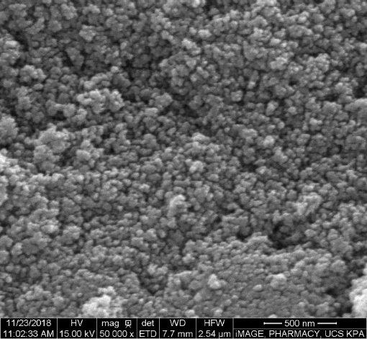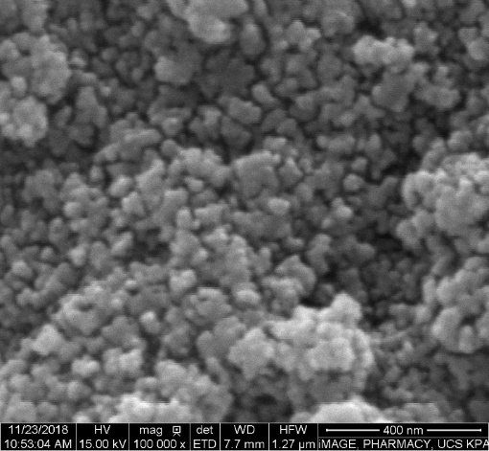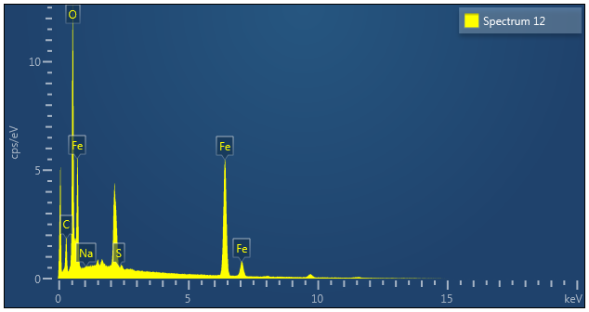
(c)
(b)
(a)

Figure 3. FESEM images of Fe₃O₄ nanoparticles with scale bar (a) 500 nm (b) 400 nm and (c) the EDX image of surfactant-bound Fe₃O₄ nanoparticles

The TGA curve of surfactant-bound Fe₃O₄ nanoparticles with SDS is shown in Figure 4. It can be seen that there is a slightly different thermal behavior as compared with bare Fe₃O₄ nanoparticles. The TGA result showed that the surfactant-bound Fe₃O₄ nanoparticles were stable up to 200 °C. The difference might originate from the presence of SDS coated on the surface of nanoparticles [16]. Three sharp weight losses were also observed in the TGA curve with a total loss of 6%. The initial weight loss occurred at the temperature range of 25 °C – 200 °C, which was possibly due to the removal of adsorbed water and/or solvent on the surface of nanoparticles [20,21]. The second decomposition around 250 °C to 300 °C indicated SDS degradation in Fe₃O₄ nanoparticles with the percentage of mass loss about 3%. The third peak derived at 600 °C – 700 °C was attributed to the phase transition from Fe₃O₄ to FeO, because FeO was thermodynamically stable above 570 °C in the phase diagram of Fe-O system [22].

SDS

Figure 4. TGA curve of bare Fe₃O₄ nanoparticles and surfactant-bound Fe₃O₄ nanoparticles

The BET surface area and pore size measurements of the surfactant–bound and bare Fe₃O₄ nanoparticles are tabulated in Table 1. The addition of a stabiliser onto the magnetite nanoparticles gave a significant influence on the surface area and size. Surfactant-bound Fe₃O₄ nanoparticles were found to possess a higher surface area and pore volume as compared to bare magnetite nanoparticles at 117 m²g⁻¹ and 0.4 cm³g⁻¹, respectively [13]. Gupta and co-workers reported that the synthesis of Fe₃O₄ nanoparticles without a surfactant had a tendency for agglomeration due to the hydrophobic bonds between the particles in the surface [23]. Hence, the magnetite nanoparticles existed in obviously large clusters. Consequently, surfactants play a vital role as stabilisers and particle protection from flocculation and agglomeration [10].

Table 2. BET results of Fe₃O₄
Sample | Specific surface area  (m²/g) | Pore volume  (cm³/g)
Fe₃O₄ | 94 | 0.3
SDS-Fe₃O₄ | 117 | 0.4

The magnetic properties of the synthesised surfactant-bound Fe₃O₄ (Figure 5) was examined by vibrating sampling magnetometer (VSM) at room temperature. The magnetisation curve of bare iron oxides was included for comparison. From the curve, it was confirmed that the synthesised Fe₃O₄ nanoparticles possessed nearly superparamagnetic behaviour. It was found that the saturation magnetisation value of the studied sample was 53. 98 emu/g, which was lower than that reported for pure Fe₃O₄ nanoparticles [14]. This can be explained as the introduction of non-magnetic materials (surfactants) on the synthesised compound leading to the diminution of magnetisation. Another factor that leads to the gradual decline in the saturation magnetisation value of the sample is that the surface is influenced by the reduced particle sizes, which caused the magnetic moments to be canted [15].

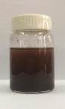
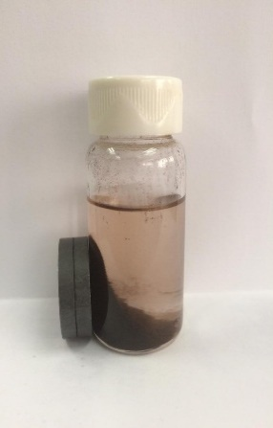
(b)
(a)

Figure 5. Magnetization curve of surfactant-bound Fe₃O₄ and bare Fe₃O₄ (a) and photograph of the magnetic separation of surfactant-bound Fe₃O₄ using an external magnetic field (b)

Conclusion
A recoverable surfactant-bound Fe₃O₄ nanoparticle as catalyst support was successfully synthesized via simple chemical co-precipitation method and the synthesized particles were characterized using several spectroscopic and analytical techniques. The physicochemical properties of the surfactant-bound Fe₃O₄ nanoparticles as catalyst support showed promising properties for homogeneous catalyst. Thus, the nanoparticles obtained could be potentially used as catalyst support that could easily be separated by an external magnetic field.

Acknowledgement

The authors wish to thank the Ministry of Higher Education (FRGS) for funding under Grant No. 59456 and Universiti Malaysia Terengganu (UMT) for the use of research facilities.

References
- Rezaei, G., Naghipour, A. and Fakhri, A. (2017). Catalytic performance studies of new Pd and Pt Schiff base complexes covalently immobilized on magnetite nanoparticles as the environmentally friendly and magnetically recoverable nanocatalyst in C–C cross coupling reactions. Catalysis Letters, 148(2): 732 - 744.
- Dehghani, F., Sardarian, A. R. and Esmeilpour M. (2013). Salen complex of Cu(II) supported on superparamagnetic Fe₃O₄@SiO₂ nanoparticles: an efficient and recyclable catalyst for synthesis of 1- and 5- substituted 1H-tetrazoles. Journal of Organometallic Chemistry, 743: 87 - 96.
- Rayati, S., Khodaei E., Jafarian M. and Wojtczak A. (2017). Mn-Schiff base complex supported on magnetic nanoparticles: synthesis, crystal structure, electrochemical properties and catalytic activities for oxidation of olefins and sulfides. Polyhedron, 133: 27 - 335.
- Sydnes, M. O. (2017). The use of palladium on magnetic support as catalyst for Suzuki–Miyaura cross-coupling reactions. Catalysts, 7(1): 35.
- Feng, X. and Lou, X. (2015). The effect of surfactants-bound magnetite (Fe₃O₄) on the photocatalytic properties of the heterogeneous magnetic zinc oxides nanoparticles. Separation and Purification Technology, 147: 266 - 275.
- Ali A., Zafar H., Zia M., Haq I., Phull A. R., Ali J. S. and Hussain A. (2016). Synthesis, characterization, applications, and challenges of iron oxide nanoparticles. Nanotechnology, Science and Applications, 9: 49 - 67.
- Yang Q., Dai Z., Yang K. and Li Y. (2015). Preparation of magnetic Fe₃O₄ microspheres using different surfactant and silica-coated magnetic particles. Atlantis Press, London: pp. 47 - 51.
- Ng, K., Kok, K. and Ong, B. (2017). Facile synthesis of self-assembled cobalt oxide supported on iron oxide as the novel electrocatalyst for enhanced electrochemical water electrolysis. ACS Applied Nano Materials, 1(1): 401 - 409.
- Sievers C., Noda Y., Qi L., Alburquerque E. M., Riuox R. M. and Scott S. L. (2018). Phenomena affecting catalytic reactions at solid-liquid interfaces. ACS Catalytic, 6 (12): 8286 - 8307.
- Tan, W. L. and Bakar M. A. (2006). The effect of additives on the size of Fe₃O₄ particles. Journal of Physical Sciences, 17(2): 37 - 50.
- Han, D., Yang, S., Yang, J., Zou, P., Kong, X., Yang, L. and Wang, D. (2016). Synthesis of Fe₃O₄ nanoparticles via chemical coprecipitation method: Modification of surface with sodium dodecyl sulfate and biocompatibility study. Nanoscience and Nanotechnology Letters, 8(4): 335 - 339.
- Petcharoen, K. and Sirivat, A. (2012). Synthesis and characterization of magnetite nanoparticles via the chemical co-precipitation method. Materials Science and Engineering: B, 177 (5): 421 - 427.
- Nor W. F. K. N., Soh S. K. C., Azmi A. A. A., Yusof M. S. M. and Shamsuddin M. (2017). Synthesis and physicochemical properties of magnetite nanoparticles (Fe₃O₄) as potential solid support for homogeneous catalysts. Malaysian Journal of Analytical Sciences, 2(5): 768 - 774.
- Riva’i, I., Wulandari, I. O., Sulistyarti, H. and Sabarudin, A. (2018). Ex-situ synthesis of polyvinyl alcohol (PVA)-coated Fe₃O₄ nanoparticles by co precipitation-ultrasonication method. IOP Conference Series: Materials Science and Engineering, 299: 1 - 8.
- Arévalo, P., Isasi, J., Caballero A.C., Marco, J. F. and Martín-Hernández, F. (2017). Magnetic and structural studies of Fe₃O₄ nanoparticles synthesized via co precipitation and dispersed in different surfactants. Ceramics International, 43(13): 10333 - 10340.
- El-kharrag, R., Amin, A. and Griesh, Y. E. (2011). Synthesis and characterization of mesoporous sodium dodecyl sulfate-coated magnetite nanoparticles. Journal of Ceramic Science and Technology, 02(04): 203 - 210.
- Liu, X., Kaminski, M. D., Guan, Y., Chen, H., Liu, H. and Rosengart, A. J. (2006). Preparation and characterization of hydrophobic superparamagnetic magnetite gel. Journal of Magnetism and Magnetic Materials, 306(2): 248 - 253.
- Mascolo, M. C., Pei, Y. and Ring, T. A. (2013). Room temperature co-precipitation synthesis of magnetite nanoparticles in a large pH window with different bases. Materials, 6(12): 5549 - 5567.
- Mürbe, J., Rechtenbach, A. and Töpfer, J. (2008). Synthesis and physical characterization of magnetite nanoparticles for biomedical applications. Materials Chemistry and Physics, 110(2-3): 426 - 433.
- Dick, K., Dhanasekaran, T., Zhang, Z. and Meisel, D. (2002). Size-dependent melting of silica-encapsulated gold nanoparticles. Journal of American Chemical Society, 124(10): 2312 - 2317.
- Villa, S., Riani, P., Locardi, F. and Canepa, F. (2016). Functionalization of Fe₃O₄ NPs by Silanization: Use of amine (APTES) and thiol (MPTMS) silanes and their physical characterization. Materials, 9(10): 826.
- Mahdavi, M., Ahmad, M. B., Haron, M. J., Namvar, F., Nadi, B., Rahman, M. Z. and Amin, J. (2013). Synthesis, surface modification and characterisation of biocompatible magnetic iron oxide nanoparticles for biomedical applications. Molecules, 18(7): 7533 - 7548.
- Gupta, A. K., and Gupta, M. (2005). Synthesis and surface engineering of iron oxide nanoparticles for biomedical applications. Biomaterials, 26(18): 3995 - 4021.

