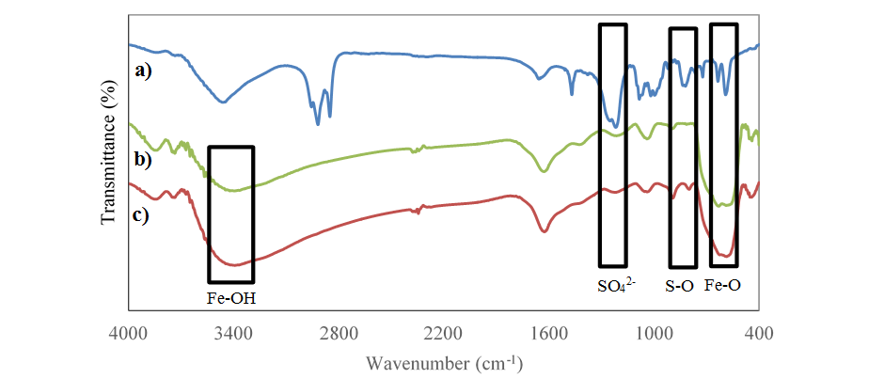

Figure 1. FT-IR spectrum of (a) pure SDS, (b) Fe₃O₄ nanoparticles, and (c) SDS-Fe₃O₄

