

MALAYSIAN JOURNAL OF ANALYTICAL SCIENCES
ISSN 1394 - 2506

Published by The Malaysian Analytical Sciences Society

THIOL MODIFIED AMPEROMETRIC IMMUNOSENSOR FOR BENZO[a]PYRENE DETECTION IN SURFACE RIVER WATER SAMPLES

(Immunosensor Amperometrik Diubahsuai Tiol untuk Pengesanan Benzo[a]pirina dalam Sampel Air Sungai Permukaan)

Noor Sheryna Jusoh, Tuan Fauzan Tuan Omar, Azrilawani Ahmad*

Faculty of Science and Marine Environment,
Universiti Malaysia Terengganu, 21030 Kuala Nerus, Terengganu, Malaysia

*Corresponding author: azrilawani.ahmad@umt.edu.my

Received: 27 May 2019; Accepted: 28 August 2019

Abstract
An amperometric immunosensor for the determination of benzo[a]pyrene (BaP) in surface river water samples was developed using screen-printed gold electrodes (SPGEs). The SPGE was modified with 11-mercaptoundecanoic acid (11-MUA) and immobilised the biomolecules on SPGE by applying an indirect competitive enzyme-linked immunosorbent assay (ELISA). The sensitivity of the competitive assay on bare and modified electrodes was compared electrochemically by conducting an amperometric measurement at 300 mV. The limit of detection (LOD) recorded for the bare SPGE was 0.26 mg/L and that for the modified SPGE was 0.01 mg/L. The lower LOD value proved the better sensitivity of the biosensor in the presence of 11-MUA. The recovery study carried out for water samples showed good recovery, ranging from 97%–114%. The improved biosensor method was tested using real water samples collected from Semerak River, Kelantan. An amperometric detection of real water samples showed no BaP for all the sampling stations. The developed immunosensor was then compared with a gas chromatography-flame ionisation detector (GC-FID); the corresponding results revealed that the developed amperometric immunosensor showed higher sensitivity than the GC-FID in the determination of BaP in environmental water.

Keywords: amperometric measurement, enzyme-linked immunosorbent assay, benzo(a)pyrene, gas chromatography-flame ionisation detector

Abstrak
Imunosensor amperometrik untuk penentuan benzo[a]pirina (BaP) dalam sampel air sungai permukaan dibangunkan menggunakan elektrod emas skrin tercetak (SPGE). SPGE telah diubahsuai dengan asid 11-merkaptoundekanoik (11-MUA) dan pemegunan biomolekul pada SPGE dengan menggunakan asai imunojerapan berpaut enzim berpesaingan tak langsung (ELISA). Kepekaan ujian kompetitif pada elektrod kosong dan diubahsuai telah dibandingkan secara elektrokimia dengan menjalankan pengukuran amperometrik pada 300 mV. Had pengesanan (LOD) yang direkodkan untuk SPGE kosong adalah 0.26 mg / L dan bagi SPGE diubah suai adalah 0.01 mg / L. LOD rendah membuktikan kepekaan biosensor yang lebih baik dengan kehadiran 11-MUA. Kajian perolehan semula yang dijalankan untuk sampel air menunjukkan perolehan semula yang baik, dari 97%-114%. Kaedah biosensor yang lebih baik telah diuji menggunakan sampel air sebenar yang diambil dari Sungai Semerak, Kelantan. Pengesanan amperometrik sampel air sebenar menunjukkan tiada BaP untuk semua stesen pensampelan. Imunosensor yang dibangunkan kemudiannya dibandingkan dengan kromatografi gas pengesan nyala pengionan (GC-FID); keputusan mendedahkan bahawa imunosensor amperometrik yang dibangunkan menunjukkan kepekaan yang lebih tinggi berbanding teknik kromatografi untuk penentuan BaP dalam air alam sekitar.

Kata kunci: pengukuran amperometrik, asai imunojerapan berpaut enzim, benzo[a]pirina, kromatografi gas pengesan nyala pengionan

Introduction
An immunosensor is an affinity-based biosensor designed to detect the direct binding of an antibody or an antigen [1]. The biological reactions on the surface of an electrode can be detected by a transducer and are converted into physical signals. The development of immunosensors for determining polycyclic aromatic hydrocarbon (PAH) compounds in water samples has attracted considerable attention from researchers in many fields, and several latest studies have reported an improved performance of these biosensors [2, 3]. Sun et al. successfully designed a whole-cell bioreporter to detect naphthalene in natural water and soil samples [4]. Interestingly, the designed sensor was only selective towards naphthalene, which made it highly sensitive for a real sample analysis. Further, cell-based biosensors are capable of distinguishing cell complex responses for environmental monitoring, particularly in PAH assessments [5]. In a different study, the researchers utilised a biorecognition element combined with a fluorescence sensor and reported a rapid and sensitive detection of fluorene in water samples [6]. Because of their selectivity, sensitivity, reliability, ease of handling, and short analysis time, and because they do not require the pre-treatment of samples, immunosensors have the potential to replace conventional methods such as gas chromatography-flame ionisation detectors (GC-FIDs) as alternative detection systems.

A screen-printed electrode (SPE) is made from the deposition of several layers of special inks on an inert solid substrate. The production of disposable SPE has gained considerable attention from researchers and SPE manufacturing companies. Many companies put an extra effort in designing and developing an applicable SPE, such as the printing media (inks) and substrates. Such enhancement in designing is done to minimise the volume of samples and to particularly improve the sensing performance of SPE [7]. SPGE consists of a gold working electrode. In particular, the application of SPGE in analytical measurement is increasing, because of the high conductance of gold as compared to that of carbon. However, because of the high cost of production and as a new product, not many studies have utilised SPGE. Thus, at the beginning of the production of SPGE, electrochemical characterisation was conducted to test the performance of SPGE [8, 9]. Gold has been well known to provide excellent sensing performance in the monitoring of mercury [7]. Other applications of SPGE include those related to heavy metals [10], organophosphorus [11], medicine [12, 13], and DNA [14].

The modification of an electrode’s surface can provide a good attachment site for the immobilisation of biomolecules. This modification is important for enhancing the performance of the electrode, and the process varies for different applications. Thus far, researchers have developed and found more efficient and selective sensing materials. An amperometric biosensor was developed by Hatefi-Mehjardi to determine carbaryl in fruit juice samples using 3-MPA on a polycrystalline gold electrode, where the 3-MPA-modified gold electrode showed a considerable decrease in the current reading [15]. In a different approach, Sherdevani and Poubeyram developed a method for DNA determination by immobilizing Zr(IV) on a gold electrode using 3-MPA-modified electrode [16]. Othman and co-workers constructed a dithizone-PVC membrane that is used as an ionophore reagent material for a chemically modified silver (Ag) electrode to determine the metal ions in an aqueous solution [17].

Amperometry is a form of voltammetry where current is measured as a function of time, while applying a constant potential. It is a technique which is vastly applied in chemical sensors, because of its considerable sensitivity and selectivity. An electrochemical method is commonly paired with bioassays to improve the selectivity and sensitivity of compound detection. For example, an amperometric immunosensor has been developed to detect phenanthrene in river water and tap water [18]. An indirect competitive assay is combined with an amperometric measurement to provide a sensitive detection of the target analyte. Another research includes the modification of a gold electrode before conducting an amperometric immunosensor measurement for naphthalene detection [19]. The developed immunosensor was highly sensitive, stable, and regenerative towards the target analyte.

Among the 16 listed priority compounds, BaP has predominantly attracted the most attention from researchers. Previous studies have reported that BaP was normally utilised in carcinogenic tests in animals using various carcinogenicity bioassays. The results from these studies showed that BaP actively produced tumours in every experimented animal, including the presence of physical defects in new born animals. Fortunately, these effects were not observed in humans. The recent research conducted by Li et al. utilised a fluorescence immunoassay for determining BaP in an aqueous solution [20]. The results exhibited that the assay was highly sensitive and selective towards BaP in low concentration. An approach by Beloglazova et al. utilised both polymer and monoclonal antibodies for developing an electrochemical biosensor for BaP detection in river water [21]. This study proved that the immobilisation of a biorecognition element on the electrode surface provided more sensitive and selective results towards BaP than a polymer. In a different study, Li et al. successfully established a rapid and sensitive immunosensor for evaluating 3–5-ring PAHs, including BaP, pyrene, phenanthrene, anthracene, and chrysene [22]. The 10-minutes analysis revealed that the developed monoclonal antibody was more sensitive in determining 3–5-ring PAHs than the commercially available monoclonal antibodies. The modification of electrodes for electrochemical immunosensor development was conducted and examined with respect to BaP, resulting in a low detection limit with high stability and good reproducibility [23].

The selectiveness of an electrochemical immunoassay is contributed by the enzyme label used, which can exhibit a higher catalytic activity toward the substrate. In this study, an alkaline phosphatase (AP) enzyme label was selected with 4-aminophenyl phosphate (4-APP) as the corresponding substrate. In the presence of AP, 4-APP was hydrolysed to produce an electroactive product, 4-aminophenol (4-AP) (Figure 1). At 300 mV, 4-AP was oxidised by losing two electrons, resulting in the catalytic conversion of 4-AP into 4-quinone imine (4-QI) [24].

Figure 1. Catalytic activity of AP with 4-APP to produce 4-AP, which then oxidised into 4-QI at 300 mV.

The objective of this research was to develop an amperometric immunosensor by modifying SPGE to enhance the performance of the sensor. The presence of BaP in the surface river water sample was tested using the developed amperometric immunosensor detection.

Materials and Methods
Materials and reagents
Sulphuric acid, hydrogen peroxide, absolute ethanol, anhydrous sodium sulphate, and nitric acid were purchased from R&M, UK. N-hydroxysuccinimide (NHS), acenaphthylene, and fluorene were purchased from Aldrich, Japan. Diethanolamine (DEA), Tween 20, phenanthrene, naphthalene, acenaphthene, dichloromethane (DCM), methanol (MeOH), and ethyl acetate (EtAc) were purchased from Merck, Germany. Goat anti-mouse IgG AP and mouse monoclonal antibody (4D5) were purchased from Santa Cruz Biotechnology, USA. 11-MUA and 4-APP were purchased from Sigma-Aldrich, Switzerland. Bovine serum albumin (BSA), BaP, and phosphate buffer saline (PBS) were purchased from Sigma, USA. Pyrene (Acros Organics, USA), fluoranthene (Aldrich, China), N-(3-dimethylaminopropyl)-N'-etylcarbodiimide hydrochloride (EDC) (Sigma-Aldrich, Japan), hexane (for liquid chromatography, Fisher Scientific), and tris(hydroxymethyl)aminomethane (Tris) (Sigma-Aldrich, USA) were purchased for the experiment. All the reagents were of analytical grade or better.

Instrumentation
A mini incubator (VWR, China) was used to incubate samples at 37°C. SPGE (DRPC220BT) was purchased from DropSens, Spain. An Autolab PGSTAT30 (Metrohm, Switzerland) instrument was used for the amperometric measurement. A ProPlus instrument was used to test the physicochemical parameters (temperature, pressure, dissolved oxygen, conductivity, salinity, and pH) of the water at each sampling point. A chromatographic analysis of all the samples was carried out using GC-FID Q2010Plus (Shimadzu, Japan).

River water collection
Water sampling was conducted at Semerak River in Tok Bali, Kelantan, Malaysia. The sampling was carried out in January 2016. Five sampling points were selected along the Semerak River (Figure 2). Table 1 lists the coordinates for each sampling point.

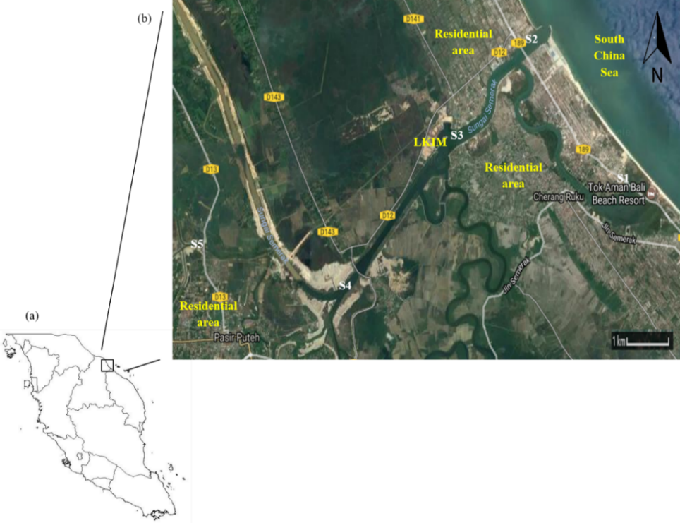
Figure 2. Map of (a) peninsular Malaysia and (b) sampling stations along Semerak River, Kelantan.

Table 1. Coordinates and brief description of all sampling stations.
Station | Coordinates |  | Description
 | Latitude | Longitude
1 | 5.865733 | 102.5061 | Lagoon of the river, a popular spot for clam searching
2 | 5.896389 | 102.4821 | Nearest to the sea, a recreation place
3 | 5.877756 | 102.4616 | Near Lembaga Kemajuan Ikan Malaysia, a boat parking site
4 | 5.845452 | 102.4326 | Near border that separates salty and fresh water
5 | 5.853874 | 102.3990 | Near residential area

All the water samples were collected using grab sampling. In all, three 500-mL bottles (glass) of water samples were taken at each point. Approximately, 1 mL of 2-M nitric acid was added into the water samples for preservation. Then, the bottles were wrapped with aluminium foil and stored in an ice box. The bottles were then transferred into a 4 °C chiller for storage until further analysis.

Water extraction (Disk extraction)
Water samples were extracted using disk extraction following US EPA Method 525.2 [25]. The solid-phase extraction disk (Empore C₁₈) was inserted into the filler apparatus. The disk was then washed with 5 mL of DCM, half of the solvent was pulled, and the disk was soaked for 1 minute before pulling out the remaining solvent. The disk was pre-wetted with 5 mL of MeOH, half of the solvent was pulled, and the disk was soaked for 1 minute before pulling out the remaining solvent, leaving a thin layer of MeOH on the disk. Deionised water (5 mL) was used to rinse the disk and mostly pulled out, leaving a thin layer of deionised water on the disk.

In each water sample, 2.5 mL of MeOH was added and mixed well. Approximately 100 µL of a 100-mg/L BaP standard was added into the sample for the recovery studies. The water sample was then added into the reservoir, and full vacuum was applied. The disk was dried by maintaining the vacuum for 10 minutes. The filtration top was removed, and a collection tube was inserted to the filtration top to contain the eluant.

Next, 5 mL of EtAc was added to the sample bottle, rinsed thoroughly and allowed to settle at the bottom of the bottle, and then transferred to the disk. The sides of the filtration reservoir were rinsed with a pipette. Half of the solvent was pulled out, and the disk was allowed to soak for 1 minutes before drawing the remaining solvent. This step was repeated using DCM. With a pipette, the filtration reservoir was rinsed twice with 3-mL portions of 1:1 EtAc: DCM. The solvent was pulled into the collector tube. The eluant was then poured through the drying tube containing 3 g of anhydrous sodium sulphate. The drying tube and the anhydrous sodium sulphate were rinsed twice with 3-mL portions of 1:1 EtAc: DCM. All the extracts and washings were collected and were concentrated to 0.5–1 mL by using a hot plate at 50 °C. The concentrated extract was stored at 4 °C before the analysis.

Electrode modification
SPGE was cleaned using a piranha solution (mixture of 3 mL of 1.5-M sulphuric acid and 1 mL of 30% hydrogen peroxide) for 2 minutes and then rinsed with deionised water. The cleaned SPGE was modified with 5-mM 11-MUA in an ethanolic solution for 20 hours. The modified SPGE was rinsed with absolute ethanol to remove any unbound 11-MUA and then air-dried at room temperature. Next, the 11-MUA-modified SPGE was activated with a 50-mM EDC and 50-mM NHS solution for 6 h [26].

Preparation of buffers
Buffer solutions and substrates were freshly prepared prior to the assay. For the blocking solution, 0.3029 g (50 mM) of Tris was dissolved in deionised water, and then, the solution was used to dissolve 0.5 g of BSA (1% in Tris buffer) (pH 7.4). For the washing buffer, 0.3029 g (50 mM) of Tris was dissolved in deionised water. The Tris solution (50 μL) was pipetted out and replaced with 50 μL of Tween-20 (pH 7.4).

Immobilisation of biomolecules
Biomolecules were immobilised on the modified SPGE by applying indirect competitive ELISA (Figure 3). The gold working electrode was coated with 5 μL of a bovine serum albumin-phenanthrene (BSA-PHEN) coating conjugate (n=3) and then incubated for 1 hour at 37 °C. After incubation, the electrode was washed with 20 μL of the washing buffer. Five (5) μL of the blocking buffer was added onto the electrode and incubated again for 1 hour at 37 °C. Thereafter, the electrode was washed again. Serial dilutions of BaP standards were mixed with the 4D5 monoclonal antibody (diluted in PBS) and were left for 15 min to react. The mixture was prepared at a concentration two times higher than the desired concentration. Then, 5 μL of each solution was added onto the electrode and incubated at 37 °C for 1 hour. After washing, 5 μL of the AP labelled antibody (diluted in PBS) was added and allowed to react at 37 °C for 1 hour. After 1 hour, the electrode was washed and stored at 4 °C prior to the amperometric measurement. The indirect competitive assay was repeated with seven other PAH compounds, namely acenaphthene, acenaphthylene, pyrene, phenanthrene, naphthalene, fluorene, and fluoranthene, for the cross-reactivity study [27].

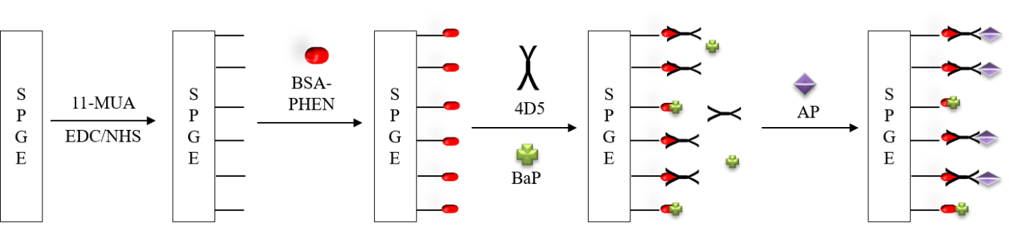
Figure 3. Modification and immobilisation of biomolecules on SPGE

Amperometric measurement
Amperometric detection was carried out in 8 mL of a 1-M DEA buffer (pH 9.5) with 4-APP as the substrate. The measurement was set to 80 s, and a potential of 300 mV was applied. At 60 s, 78.4 µL of 4-APP was injected into the DEA buffer. The peak current produced after the injection of 4-APP was recorded.

Chromatographic analysis with GC-FID
A chromatographic analysis was carried out using GC-FID Q2010Plus (Shimadzu, Japan) equipped with an auto injector. All the BaP standards and water samples were analysed using the same parameters. A BPX5 column (30.0 m × 0.025 µm × 0.2 mm ID) with the column temperature range from 40 – 300°C was used. The gases involved in the analysis included helium gas (carrier gas, 3 mL/min), nitrogen gas (make-up gas, 30 mL/min), hydrogen gas (40 mL/min), and compressed air (400 mL/min). The measurement took 37 minutes for every sample to finish. Hexane was selected as the mobile phase solvent.

Results and Discussion
River water sampling
All the data of the water parameters at each station are recorded in Table 2. Station 1, Station 2, and Station 3 recorded high salinity, which proved that salty water was collected from the sampling points. In contrast, low salinity was measured at Station 4 and Station 5, which were located in the freshwater area. In terms of pH, compared with Station 1, Station 2, and Station 4, Station 3 and Station 5 recorded slightly acidic water because of the nature of the sampling site. The presence of many boats at Station 3 and the location of Station 5, which was near to a residential area, contributed to the faintly low pH values.

Table 2. River water parameters of all sampling stations
Station | Station 1 | Station 2 | Station 3 | Station 4 | Station 5
Temperature (°C) | 30.2 | 28 | 28 | 27.8 | 27.4
Pressure (mmHg) | 763.9 | 762.9 | 762.8 | 762.7 | 762.4
Dissolved Oxygen (%L) | 66.1 | 83.8 | 63.6 | 52.4 | 66.3
Dissolved Oxygen (mg/L) | 4.55 | 6.33 | 4.81 | 3.99 | 5.01
Specific Conductance (μS/cm) | 20507 | 8386 | 9671 | 119.4 | 44.1
Salinity (ppt) | 12.7 | 4.65 | 5.44 | 0.05 | 0.02
pH | 7.25 | 7.52 | 6.6 | 7.26 | 6.53
pH (mV) | −66.4 | −80.4 | −31.5 | −65.4 | −27.6

Amperometric detection
The amperometric measurement for a competitive assay was carried out by comparing the electrochemical performance of the bare and the modified SPGE. Figure 4 shows that the current reading of the assay with the modified SPGE was significantly higher than that in the case of the bare SPGE. The presence of 11-MUA increased the sensitivity of the assay, where a lower IC₅₀ value was recorded (Table 3). In addition, the LOD and limit of quantification (LOQ) values for the modified electrode were lower than those for the bare electrode. This implied that the 11-MUA-modified SPGE gave strong binding sites for biomolecules compared with the bare SPGE. The obtained LOD values were higher than those reported in the study conducted by Ahmad and Moore using an integrated electrode [28]; however, the application of SPGE was far more cost effective. In addition, the immunosensor developed in this study was highly stable for real sample determination.

(a) bare electrode (b) 11-MUA-modified electrode
Figure 4. Indirect competitive assay of (a) bare and (b) modified SPGE at potential of 300 mV in 1-M DEA buffer (pH 9.5)

Table 3. Comparison of competitive assay between bare and modified SPGE
SPGE | LOD  (mg/L) | LOQ  (mg/L) | IC₅₀  (mg/L) | Linear Range  (mg/L) | R²
Bare | 0.26 | 0.79 | 39.39 | 20-40 | 0.8642
Modified | 0.01 | 0.04 | 11.85 | 40-60 | 0.9530

Measurement with river water samples
The amperometric detection of BaP in the river water samples was conducted, and the results were tabulated in Table 4. All the sampling sites had a strong contribution as BaP sources, as they were near a residential area and there were fishing and boating activities along the river. However, there was no BaP detected in the river water samples. This was attributed to the fact that no BaP was found despite all the fishing and boating activities. The other reason was the very low concentration of BaP in the river water samples, which could not be detected by the developed biosensor. The water samples were spiked with 20-mg/L BaP, and all the samples showed good recovery from 97% to 114%.

Table 4. Recovery studies of spiked river water samples using amperometric detection
Station | Added: 20 mg/L
Station | Found (mg/L) | Recovery (%)
1 | 19.46 | 97.3
2 | 22.93 | 114.7
3 | 22.41 | 112.1
4 | 22.75 | 113.7
5 | 22.47 | 112.3

Stability study of coated electrode
The stability of the coated SPGE was studied by comparing the amperometric measurements of the electrode for seven days at two different storage temperatures. The coated electrodes were stored in 1-M DEA buffer (pH 9.5) at 4°C and −20 °C. As recorded in Figure 5, 4 °C displayed a higher current reading than −20 °C, for all the measured days. The higher current reading represented the greater stability of the assay, where the enzymatic cleavage was measured [24]. However, a drastic decline in the current reading was observed on Day 2 and Day 3 for 4 °C and −20 °C, respectively. This was attributed to the fact that the isoenzymes of AP were considerably unstable, resulting in a reduction in stability, particularly when stored at −20 °C [29, 30]. However, the stable enzymatic reaction of AP was recorded to be better at the refrigerated temperature (4 °C–9 °C), and 4 °C was the best storage temperature to store the AP-related samples [31]. This study showed that the coated SPGE was not suitable for reuse.

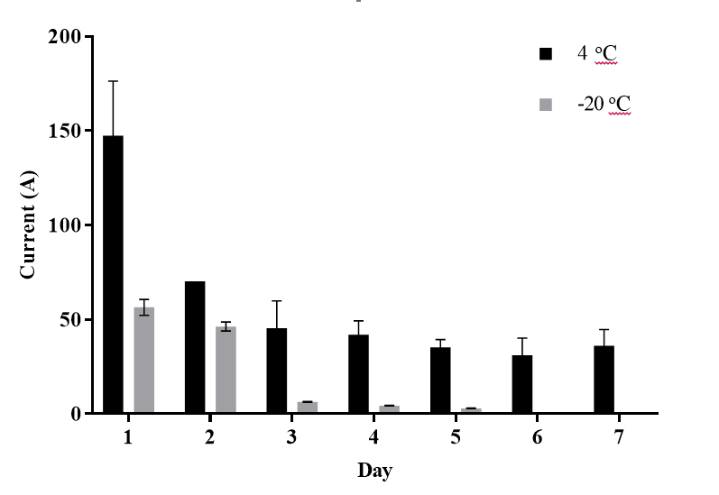
Figure 5. Stability of coated SPGE at different storage temperatures in 1-M DEA buffer (pH 9.5)

Cross-reactivity study
The cross-reactivity of seven PAH compounds against BaP was measured, and the results are displayed in Table 5. A low IC₅₀ value was recorded for BaP, which proved the sensitivity of the assay toward the BaP detection. Even though pyrene has one benzene ring less than BaP, it showed the highest cross-reactivity because of the similar structure arrangement. Fluorene recorded the lowest cross-reactivity with BaP because of the significant difference in their molecular structures.

Table 5. Cross-reactivities of seven PAH compounds against BaP for amperometric measurement
PAH Compounds | IC₅₀ (mg/L) | Cross-Reactivity (%)
Benzo(a)pyrene | 11.9 | 100.0
Acenaphthene | 111.6 | 10.7
Acenaphthylene | 80.6 | 14.8
Pyrene | 12.4 | 95.9
Phenanthrene | 197.6 | 6.0
Naphthalene | 66.1 | 18.0
Fluorene | 242.3 | 4.9
Fluoranthene | 181.5 | 6.6
Chromatography analysis
Serial dilutions of the BaP standard ranging from 10 mg/L to 50 mg/L were analysed using a gas chromatography-flame ionisation detector (GC-FID). The GC-FID chromatograms of the standards are shown in Figure 6. A complete single measurement of the sample took 37 minutes. At 27.50 minutes, a clear BaP peak was detected for all the standards. The peak area of each standard was recorded, and the calibration curve was plotted as shown in Figure 7. The LOD, LOQ, and linear range recorded were 10.24 mg/L, 31.04 mg/L, and 10 mg/L–30 mg/L, respectively.

The results of the analysis conducted using GC-FID showed that no BaP peak was observed in all the river water samples at 25–30 minutes. Even though a few peaks were detected, the peaks were not considerable and might be attributed to the column background noise. Further, the GC-FID analysis revealed that no BaP was found in all the water samples, even though some potential sources of BaP were present along all the sampling sites for examples at Station 1, which is the main route for boats from and to the sea, as well as Station 3, which is the parking site for those boats.

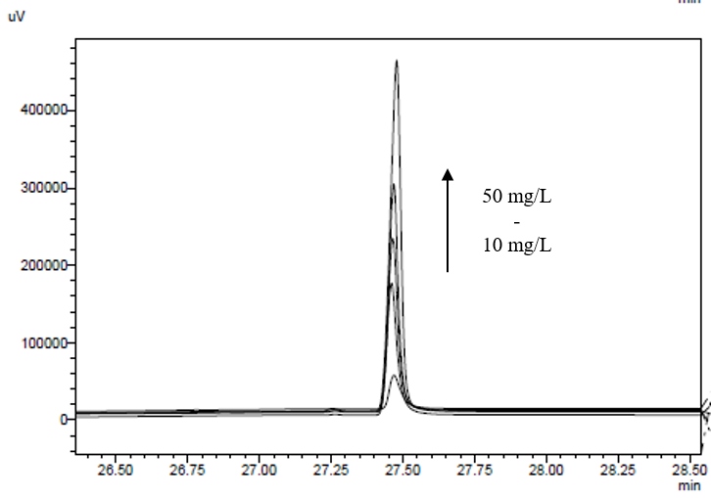
Figure 6. Chromatogram of BaP peaks of 10 mg/L–50 mg/L BaP standards recorded at 27.50 minutes

Figure 7. Calibration curve of BaP standards using GC-FID analysis

A recovery study was conducted by spiking 100 mg/L of BaP in the river water samples. The recovery results are depicted in Table 6. Overall, the samples showed good recoveries in the range of 80%–120 %. The low recovery for the solid phase extraction was contributed by the analyte lost during the extraction process and the weak solvent used for the elution of the analyte [32]. Three main issues must be considered while measuring PAHs in water samples: (i) low solubility of PAH compounds, which is below the detection limit of the analytical instruments, (ii) commonly combined with other materials to form aggregates of colloidal particles, and (iii) sample loss due to absorption to glassware containers [33]. Thus, special precaution has been taken in order to limit the disadvantages of the solid phase extraction.

Table 6. Recovery studies for river water samples spiked with 100 mg/L of BaP
Station | Added: 100 mg/L
Station | Found (mg/L) | Recovery (%)
1 | 112.12 | 112.1
2 | 99.43 | 99.4
3 | 86.54 | 86.5
4 | 81.83 | 81.8
5 | 95.20 | 95.2

Comparison of developed method with GC-FID
Table 7 shows the comparison of all the detection methods. Overall, the modified electrode showed better results than the bare electrode and the chromatographic measurements. This was attributed to the presence of 11-MUA, which enhanced the performance of the sensor. A high LOD value was recorded for chromatographic detection because of the low instrument precision.

Table 7. Comparison between electrochemical and chromatographic measurements
Measurement | LOD  (mg/L) | LOQ  (mg/L) | IC₅₀  (mg/L) | Linear Range  (mg/L) | R²
Electrochemical
Bare
Modified
Electrochemical  Bare  Modified | 0.26 | 0.79 | 48.3 | 20–40 | 0.8642
Electrochemical  Bare  Modified | 0.01 | 0.04 | 11.9 | 40–60 | 0.9530
Chromatographic | 10.24 | 31.04 | 3.72 | 10–30 | 0.9881

Conclusion
An ideal biosensor is a device with high stability and reproducibility while maintaining its sensitivity for a long period of time. The main challenge for the development of biosensor devices is to achieve these characteristics. In this research, an immunosensor was successfully developed by modifying SPGE with 11-MUA and immobilising biomolecules. The developed enzyme-based biosensor using SPGE provided good sensitivity and selectivity towards BaP detection in water samples. Even though this method was not as precise as the chromatographic technique, amperometric detection offers wide opportunities for further improvements in electrochemical detection. Besides the commonly used chromatographic technique, this developed biosensor method can be applied as an alternative because of its operational cost efficiency.

Further improvement in immunosensors should be considered by implementing the current trends in biosensors such as genetic engineering of biomolecules and incorporation of nanomaterials on electrodes. The genetic engineering of enzymes has been developed to enhance the efficiency, sensitivity, and selectivity of the enzymes toward the target analytes. Carbon-based nanomaterials such as graphene, fullerene, and carbon nanotubes have been applied in electrochemical biosensors because of their excellent electrochemical properties and high stability. Metal nanomaterials such as metal oxides and nanocomposites are preferred in electrode modification, as they provide an ideal environment for the immobilisation of biomolecules.

Acknowledgements
The authors would like to acknowledge the financial support received from Ministry of Higher Education, Malaysia for Research Acculturation Grant Scheme (RAGS 57093) and Fundamental Research Grant Scheme (FRGS 59487), and Universiti Malaysia Terengganu for providing laboratory facilities and instrumentation.

References
- Moina, C. and Ybarra, G. (2012). Fundamentals and applications of immunosensors: Advances in Immunoassay Technology. Croatia: InTech. pp. 65 – 80.
- Behera, B. K., Das, A., Sarkar, D. J., Weerathunge, P., Parida, P. K., Das, B. K., Thavamani, P., Ramanathan, R. and Bansal, V. (2018). Polycyclic aromatic hydrocarbons (PAHs) in inland aquatic ecosystems: Perils and remedies through biosensors and bioremediation. Environmental Pollution, 241: 212 – 233.
- Nsibande, S. A., Montaseri, H. and Forbes, P. B. C. (2019). Advances in the application of nanomaterial-based sensors for detection of polycyclic aromatic hydrocarbons in aquatic systems. Trends in Analytical Chemistry, 115: 52 – 69.
- Sun, Y., Zhao, X., Zhang, D., Ding, A., Chen, C., Huang, W.E. and Zhang, H. (2017). New naphthalene whole-cell bioreporter for measuring and assessing naphthalene in polycyclic aromatic hydrocarbons contaminated site. Chemosphere, 186: 510 – 518.
- Ahmad, A. and Moore, E. J. (2009). Comparison of cell-based biosensors with traditional analytical techniques for cytotoxicity monitoring and screening of polycyclic aromatic hydrocarbons in the environment. Analytical Letters, 42: 1 – 28.
- Qiao, B., Li, Y., Hu, P., Sun, Y., Si, Z., Lu, S., Ren, H., Liu, Z., Zhang, Y. and Zhou, Y. (2018). EuNPs-MAb fluorescent probe based immunochromatographic strip for rapid and sensitive detection of fluorene. Sensors and Actuators B: Chemical, 262: 221 – 227.
- Hayat, A. and Marty, J.L. (2014). Disposable screen-printed electrochemical sensors: Tools for environmental monitoring. Sensors, 14: 10432 – 10453.
- Bernalte, E., Marín-Sánchez, C., Pinilla-Gil, E. and Brett, C.M.A. (2013). Characterisation of screen-printed gold and gold nanoparticle-modified carbon sensors by electrochemical impedance spectroscopy. Journal of Electroanalytical Chemistry, 709: 70 – 76.
- García-González, R., Fernández-Abedul, M.T., Pernía, A. and Costa-García, A. (2008). Electrochemical characterization of different screen-printed gold electrodes. Electrochimica Acta, 53(8): 3242 – 3249.
- Wan, H., Sun, Q., Li, H., Sun, F., Hu, N. and Wang, P. (2015). Screen-printed gold electrode with gold nanoparticles modification for simultaneous electrochemical determination of lead and copper. Sensors and Actuators B: Chemical, 209: 336 – 342.
- Arduini, F., Guidone, S., Amine, A., Palleschi, G. and Moscone, D. (2013). Acetylcholinesterase biosensor based on self-assembled monolayer-modified gold-screen printed electrodes for organophosphorus insecticide detection. Sensors & Actuators: B. Chemical, 179: 201 – 208.
- Cordeiro, T. A. R., Goncalves, M. V. C., Franco, D. L., Reis, A. B., Martins, H. R. and Ferreira, L. F. (2019). Label-free electrochemical impedance immunosensor based on modified screen-printed gold electrodes for the diagnosis of canine visceral leishmaniasis. Talanta, 195: 327 – 332.
- Pandey, P., Pandey, A. and Shukla, N. K. (2018). Screen printed gold electrode with cysteamine and single walled carbon nanotubes for the recognition of prostate specific antigen. Materials Today: Proceedings, 5: 15311 – 15318.
- Malecka, K., Stachyra, A., Góra-Sochacka, A., Sirko, A., Zagórski-Ostoja, W., Radecka, H. and Radecki, J. (2016). Electrochemical genosensor based on disc and screen printed gold electrodes for detection of specific DNA and RNA sequences derived from Avian Influenza Virus H5N1. Sensors and Actuators B: Chemical, 224: 290 – 297.
- Hatefi-Mehrjardi, A. (2013). Bienzyme-self assembled monolayer on gold electrode: An amperometric biosensor for carbaryl determination. Electrochimica Acta, 114: 394 – 402.
- Shervedani, R.K. and Pourbeyram, S. (2010) Electrochemical determination of calf thymus DNA on Zn(IV) immobilized on gold-mercapropropionic-acid self-assembeled monolayer. Bioelectrochemistry, 77 (2): 100 – 105.
- Othman, M. A. F., Ahmad, A. and Zuki, H. M. (2016). Dithizone modified electrode for the determination of metals ion in aqueous solution. Malaysian Journal of Analytical Sciences, 20(1): 197 – 204.
- Fahnrich, K. A., Pravda, M. and Guilbault, G. G. (2003). Disposable amperometric immunosensor for the detection of polycyclic aromatic hydrocarbons (PAHs) using screen-printed electrodes. Biosensors and Bioelectronics, 18: 73 – 82.
- Zhang, Y. and Zhuang, H. S. (2010). Amperometric immunosensor based on layer-by-layer assembly of thiourea and nano-gold particles on gold electrode for determination of naphthalene. Chinese Journal of Analytical Chemistry, 38(2): 153 – 157.
- Li, T., Choi, Y. H., Shin, Y. B., Kim, H. J. and Kim, M. G. (2016). A fluorescence enhancement-based label-free homogeneous immunoassay of benzo[a]pyrene (BaP) in aqueous solutions. Chemosphere, 150: 407 – 413.
- Beloglazova, N. V., Lenain, P., Rycke, E. D., Goryacheva, I. Y., Knopp, D. and Saeger, S. D. (2018). Capacitive sensor for detection of benzo(a)pyrene in water. Talanta, 190: 219 – 225.
- Li, X., Kaattari, S. L., Vogelbein, M. A., Vadas, G. G. and Unger, M. A. (2016). A highly sensitive monoclonal antibody based biosensor for quantifying 3-5 ring polycyclic aromatic hydrocarbons (PAHs) in aqueous environmental samples. Sensing and Bio-Sensing Research, 7: 115 – 120.
- Wang, C., Lin, M., Liu, Y. and Lei, H. (2011). A dendritic nanosilica-functionalized electrochemical immunosensor with sensitive enhancement for the rapid screening of benzo[a]pyrene. Electrochimica Acta, 56: 1988 – 1994.
- Ronkainen-Matsuno, N. J., Thomas, J. H., Halsall, H. B. and Heineman, W. R. (2002). Electrochemical immunoassay moving into the fast lane. Trends in Analytical Chemistry, 21(4): 213 – 225.
- USEPA (1995). Method 525.2: Determination of Organic Compounds in Drinking Water by Liquid-Solid Extraction and Capillary Column Gas Chromatography/Mass Spectrometry, Revision 2.0. Cincinnati, OH: USA.
- Jusoh, N. S., Azmi, A. A. and Ahmad, A. (2017). Enzyme-linked immunosorbent assay (ELISA)-based-sensor for determination of benzo[a]pyrene in river water using screen-printed gold electrode. Malaysian Journal of Analytical Science, 21(3): 518 – 526.
- Ahmad, A., Lee, P. K. and Jusoh, N. S. (2016). A comparative study of thiols self-assembled monolayers on gold electrode. Middle-East Journal of Scientific Research, 24 (6): 2152 – 2158.
- Ahmad, A. and Moore, E. J. (2012). Electrochemical immunosensor modified with self-assembled monolayer of 11-mercaptoundecanoic acid on gold electrodes for detection of benzo[a]pyrene. Analyst, 137: 5839 – 5944.
- Heins, M., Heil, W. and Withold, W. (1995). Storage of serum or whole blood samples: Effects of time and temperature on 22 serum analytes. European Journal of Clinical Chemistry Clinical Biochemistry, 33 (4): 231 – 238.
- Cray, C., Rodriguez, M., Zaias, J. and Altman, N. H. (2009). Effects of storage temperature and time on clinical biochemical parameters from rat serum. Journal of the American Association for Laboratory Animal Science, 48 (2): 202 – 204.
- Divya, P. D. and Jayavardhanan, K. K. (2010). Effect of temperature and storage time on Hepatobiliary enzyme activities in Goat serum. Veterinary World, 3(6): 277 – 279.
- Cosby, C. N., Troiano, N. W. and Kacena, M. A. (2008). The effects of storage conditions on the preservation of enzymatic activity in bone. Journal of Histotechnology, 31(4): 169 – 173.
- McGowin, A. E. (2006). Polycyclic aromatic hydrocarbons: Chromatographic analysis of the environment. CRC Press, Florida. pp. 555 – 616.

