

MALAYSIAN JOURNAL OF ANALYTICAL SCIENCES
ISSN 1394 - 2506

Published by The Malaysian Analytical Sciences Society

REMOVAL OF PHTHALATES IN AQUEOS SAMPLES USING NON-IONIC SILICONE SURFACTANT MEDIATED CLOUD POINT EXTRACTION VIA SPECTROPHOTOMETRY

(Penyingkiran Ftalat dalam Sampel Akues Menggunakan Teknik Pengekstrakan Titik Awan Surfaktan Silikon Tidak Berionik dengan Spektrofotometri)

Pei Wan Ooi¹, Muggundha Raoov Ramachandran², Noorfatimah Yahaya¹, Nik Nur Syazni Mohamed Kamal¹, Kasturi Gopal¹, Nor Aniisah Husin¹, Nur Nadhirah Mohamad Zain¹*

¹Integrative Medicine Cluster, Advanced Medical and Dental Institute,
Universiti Sains Malaysia, 13200 Kepala Batas, Penang, Malaysia
²Department of Chemistry, Faculty of Science,
Universiti Malaya, 50603 Kuala Lumpur, Malaysia

*Corresponding author: nurnadhirah@usm.my

Received: 16 April 2019; Accepted: 29 July 2019

Abstract
Removal of phthalates in environmental compartments become crucial in recent years due to the growing global concern about the health effects of phthalates. In this study, a greener method based on cloud point extraction procedure was developed for the removal of selected phthalates in environmental samples using non-ionic silicone surfactant (DC193C). The parameters affecting the extraction efficiency, such as the surfactant concentration, salt types, salt concentration, temperature and incubation time were evaluated and optimized. Good linearity with correlation coefficients (R²) in the range of 0.9963 – 0.9988 for all calibration curves was obtained. The proposed method was applied in removing the diethhylhexyl phthalate and dibutyl phthalate in river water samples under optimized conditions with satisfactory recoveries in the range of 82 – 98%.

Keywords: cloud point extraction, non-ionic silicone surfactant, phthalates, spectrophotometry

Abstrak
Penyingkiran ftalat dalam alam sekitar menjadi satu isu yang penting kebelakangan ini disebabkan peningkatan kesedaran global mengenai kesan-kesan ftalat terhadap kesihatan. Dalam kajian ini, satu teknik pengekstrakan titik awan yang lebih mesra alam telah dibangunkan untuk penyingkiran ftalat tertentu daripada sampel alam sekitar dengan menggunakan surfaktan silikon tidak berionik (DC193C). Faktor-faktor yang mempengaruhi kecekapan pengekstrakan seperti kepekatan surfaktan, jenis garam, kepekatan garam, suhu dan masa keseimbangan telah dikaji dan dioptimumkan. Kelinearan baik dengan pekali korelasi (R²) dalam julat 0.9963 – 0.9988 telah dicapai untuk semua lengkung tara. Kaedah yang dicadangkan telah digunakan untuk penyingkiran dietilheksil ftalat dan dibutil ftalat dalam sampel alam sekitar yang telah dipilih di bawah keadaan yang optimum dengan perolehan semula yang memuaskan dalam julat 82 – 98 %.

Kata kunci: pengekstrakan titik awan, surfaktan silikon tidak berionik, ftalat, spektrofotometri

Introduction
Phthalates, also known as phthalic acid esters, are a class of chemical compounds used widely in industrial and domestic applications to increase the flexibility and durability of the product [1]. Phthalates are esters manufactured through reaction of phthalic anhydride with oxo alcohol through esterification which occurs in two successive steps: (1) the formation of monoester by alcoholysis of phthalic acid, and (2) the conversion of the monoester to the di-ester [2]. Since the chemical and physical properties of the individual phthalates depend on the functional group, the types of phthalates added to the products are determined by their function and properties [3]. Phthalates are not covalently attached, therefore significant amount have leached into the environmental compartment during the process of their production, usage and disposal, mainly via natural and anthropogenic combustion processes [4].

Despite their short half-lives in the human body, phthalates are found to be capable of causing adverse effects and are toxic to many species including protozoans, fishes and invertebrates due to the intensive and continuous release of these pollutants into the environments [5, 6]. The United State Environmental Protection Agency (USEPA) has included an initial list of chemicals, which include phthalates, into a program under the Toxic Substances Control Act (TSCA) [7]. Among all the phthalates used worldwide, diethylhexyl phthalate (DEHP) is the one that causes most concern since DEHP is the most commonly produced and used. It is reported that more than two million tons of DEHP has been produced worldwide [2]. Even though no criterion have been set for saltwater aquatic life, the water quality criteria for dibutyl phthalate (DBP) and DEHP are determined to be 5 mgL⁻¹ and 10 mgL⁻¹ respectively by USEPA for protection of human health [8].

In order to monitor these contaminants in the environment, many extraction methods have been employed. Among the traditional liquid-liquid extraction (LLE) methods, cloud point extraction (CPE) requires a very small amount of relatively nonflammable and nonvolatile surfactant that is environmentally-friendly. Another important merit is that no analytes is lost because it is unnessary to evaporate the solvents. CPE is a technique that use surfactant and manipulate temperature to induce formation of micellar environment [9]. Surfactants consists of amphiphilic molecules that assemble in various shapes, which then self-organize to form micelle when the concentration of the surfactant is above critical micellar concentration (CMC). When the surfactant solution was heated to cloud point temperature (CPT), the solution will become turbid and separate into two immiscible phases; surfactant rich phase (small volume) and aqueous phase (bulk amount). This method is based on the principle of decreasing solubility of the surfactant in the water at certain temperature, thus separation into two phases [10].

Well-known previous non-ionic surfactants, such as Triton X and PONPE series, have a high background absorbance in the ultraviolet region, due to the presence of an aromatic moiety in their structure. Using a surfactant without ultraviolet absorbance signals is considered to be the best way to avoid the absorbance interference. Silicone surfactant has gained attention since it is not only endowed with the common features of conventional non-ionic surfactants but also posseses some unique properties. It is reported that silicone surfactants are known to be equally surface active in both water and non-aqueous solvents besides their ability to remain as liquid even with high molecular weights [11]. Non-ionic silicone DC193C surfactant, which is also referred to as polyethylene glycol (PEG), PEG-12 Dimethicone and polydimethylsiloxane copolymer polyols, has a wide range of applications in personal care products as well as in automotive and household cleaning products. Even though this surfactant is yet to be fully studied for its application in CPE, this surfactant has the potential to be a green alternative as their safety to human and environmental friendly has been recognized [12]. In this study, the main objectives is to develop a new approach of CPE method by using non-ionic silicone surfactant DC193C for removing DBP and DEHP in water samples. The developed method was then applied on selected river water samples around industrial areas for the removal of selected phthalates.

Materials and Methods
Instrumentation
A Perkin Elmer Precisely, Model Lambda 25 UV-Vis spectrophotometer (Massachusetts, U.S.) was used for the measurement of selected DBP and DEHP. A Memmert water bath (Schwabach, Germany) was used to maintain the desired temperature.

Chemicals and reagents
Dow Corning DC193C, also known as polyethylene glycol (PEG) silicone, was supplied by Ingredients Plus, (Selangor, Malaysia). The values of x, y and molecular weight of this compound was available from the manufacturer. Triton X-114 was supplied from Sigma Aldrich (St. Louis, MO, USA). Triton X-100 was obtained from R&M Chemicals (Essex, UK). Surfactant sodium dodecyl sulphate (SDS) was purchased from Fisher Chemical (Pittsburgh, USA). Tween-80 and Tween-20 were purchased from Fisher Chemical (Pittsburgh, USA). Tween-80 and Tween-20 were purchased from Merck (Darmstadt, Germany). Dibutyl phthalate (molecular weight: 278.34 g/mol, λ_{max}: 230 nm) was purchased from Sigma Aldrich (St. Louis, MO, USA; 99% purity) while diethylhexyl phthalate (molecular weight: 390.56 g/mol, λ_{max}: 228 nm) was purchased from Dr Ehrenstorfer GmBH (Augsburg, Germany; 98.5% purity). Figure 1 shows the absorption of the UV-Vis spectra for DBP and DEHP. Stock solutions of each phthalates (1000 ppm) were prepared in methanol. Working solution were prepared daily by appropriate dilution of the stock solutions with deionized water. Potassium hydroxide (KOH), potassium chloride (KCl), sodium chloride (NaCl), sodium nitrate (Na₂NO₃) and sodium sulphate (Na₂SO₄) (QRec, Malaysia) were prepared by dissolving an appropriate amount in deionized water.

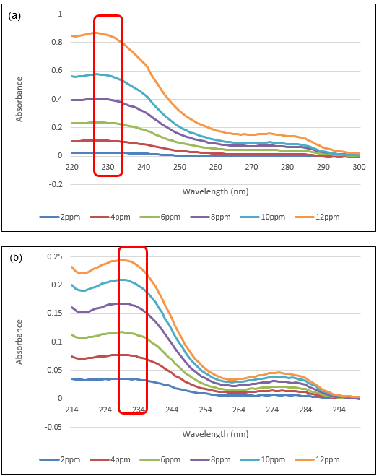
Figure 1. Absorption of the UV-Vis spectra for (a) DEHP and (b) DBP

Cloud point extraction
An aliquot of 1.0 mL of sample containing the analyte (10 ppm), 1.0 mL of surfactant DC 193C (0.1% v/v) and 0.5 mL of 1.5 M of Na₂SO₄ were mixed and sonicated for 6 minutes in a glass centrifuge tube. Then, the phase separation was induced by heating the content in a water bath at 50 °C for 20 minutes. Surfactant rich phase was at the top layer and aqueous phase was at the bottom after two phases were formed. The surfactant rich phase was then separated by using a syringe needle for minimizing the possibility of cross contaminating the analyte. After that, the surfactant rich phase was diluted 5-fold with deionized water to reduce its viscosity and to make the final volume feasible to be transferred into the optical cell to be measured at respective maximum absorption. Three replicate experimental data (n=3) was collected in each optimization. Standard solutions containing 5, 50 and 300 μg L⁻¹ of DEHP and DBP were added to a real water samples for the recovery test, respectively.

Sample collection
Water samples (1L) were taken and collected in Duran® bottles from five selected rivers in industrial area in Penang, Malaysia, namely Sungai Derhaka Juru (5.3500° N, 100.4167° E), Sungai Juru (5.3333° N, 100.4000° E), Sungai Nibong Kecil (5.3422°, 100.3028° E), Sungai Ara (5.44187° N, 100.3167° E) and Sungai Perai (5.3833° N, 100.3833°E). Prior to analysis, the water samples were first filtered using a 0.45 μm nylon membrane filter to remove any suspended particulate materials and then stored at 4 °C before extraction.

Results and Discussion
Optimization of parameters in CPE
The influential factors that affect the extraction efficiency in CPE such as temperature, incubation time, type of salt and concentration of salt used have been optimized in this study. The extraction efficiency was calculated using Eq. (1):

Extraction efficiency, (%) = $\frac{C_{S}V_{S}}{C_{0}V_{0}}×100\%$ (1)

where C_{S} represents the phthalates concentration in the surfactant rich phase volume V_{S}; C₀ represents the phthalates concentration in the initial sample-surfactant mixture of volume V₀.

Screening of surfactant types
Six types of non-ionic surfactants such as Triton X-114, Triton X-100, sodium dodecyl sulphate (SDS), Tween 80, Tween 20 and DC193C were compared. In this study, non-ionic silicone DC193C was chosen as CPE surfactant due to its non-toxic, non-flammable and greener properties as compared to Triton X series and Tween series surfactants used previously in CPE [13, 14]. Triton surfactants are found to have aromatic chromophore that will interfere with the ultraviolet absorbance or fluorescence signals [15] while Tween surfactants are well known for their high viscosity [16]. The absorbance spectrum of different types of surfactant was shown in Figure 2.

Figure 2. Absorbance spectrum of different types of surfactants

Effect of surfactant concentration
Surfactants are amphiphilic molecules that can interact with both polar and non-polar groups in the surrounding environment. The molecules undergo self-assembly and form well defined aggregates, known as micelles, when the concentration reaches CMC [17]. Since the concentration of surfactant plays important role in formation of micelles, 0.1% v/v to 1.0% v/v of non-ionic silicone DC193C surfactant were studied to select suitable surfactant concentration. Based on Figure 3, the extraction efficiency slightly increased as the concentration of surfactant increased. However, there was no significant difference on the extraction efficiency in the range of surfactant concentration studied. Since CPE is a greener method, minimum concentration of surfactant used was desired in this study to obtain maximum extraction of selected phthalates. Thus, since 0.1% v/v of DC193C was able to obtain more than 75% of recovery, 0.1% v/v was selected in this part as an approach for an optimal consumption of raw materials, solvents and energy.

Figure 3. Effect of concentration of DC193C on extraction efficiency of DBP in CPE. Condition: 10 ppm of phthalates, 1.5 mol L⁻¹ of Na₂SO₄ at 50 °C

Effect of temperature and incubation time
Cloud point temperature (CPT) is another important characteristic for non-ionic surfactants whereby the surfactants will be separated into two phases at this point temperature. Increasing the temperature will reduce the interaction between the surfactant and water through breakdown of the hydrogen bonds between the water molecules and the hydrophilic part of surfactant [18]. The clouding process is also ascribed as the efficient and effective dehydration of hydrophilic portion of micelles at higher temperature condition [19]. As a result, the external layer of the rapidly increasing number of micelles can be dehydrated with the approach of CPT and the mixture can be separated into phases. Non-ionic silicone DC193C surfactant used in this study has a high cloud point temperature, which is approximate 87 ºC [12]. However, adding salt to the surfactant micellar solution can decrease the CPT and facilitates the separation of the two phases by altering the density of the bulk aqueous phase. Thus, different temperatures were studied in this part of experiment starting from room temperature, 25 ºC to 80 ºC. Figure 4(a) shows the extraction efficiency for both DEHP and DBP increased as the temperature increased from 25 ºC to 50 ºC and yet started to decrease when the temperature was above 50 ºC. Non-ionic silicone surfactant appears moderately more hydrophobic at higher temperatures owing to an equilibrium shift that favours dehydration of the ether oxygens. This leads to an increase in the number concentration of micelles. Hence, the solubilization capability of the micellar solution increases with temperature leading to increase in the DBP and DEHP extraction. Unfortunately, elevated temperature may lead to decomposition of the analytes even though raising of temperature may improve the interaction between surfactant molecules and analytes [20].

Incubation time is another parameter optimized in the CPE since employment of shortest equilibration time is one of the compromise between efficient separation of phases and completion of extraction [21]. The shortest incubation time with high extraction efficiency is preferable in CPE [22]. Thus, the study was carried out in the range from 5 to 30 minutes at 50 ºC as shown in Figure 4(b). Based on the result, the extraction efficiency increased as the incubation time increased to 20 minutes and decreased when the incubation time continued to increase. Hence, 20 minutes at 50 ºC was chosen as an incubation time for both analytes since this is the lowest possible temperature and shortest incubation time with higher extraction efficiency.

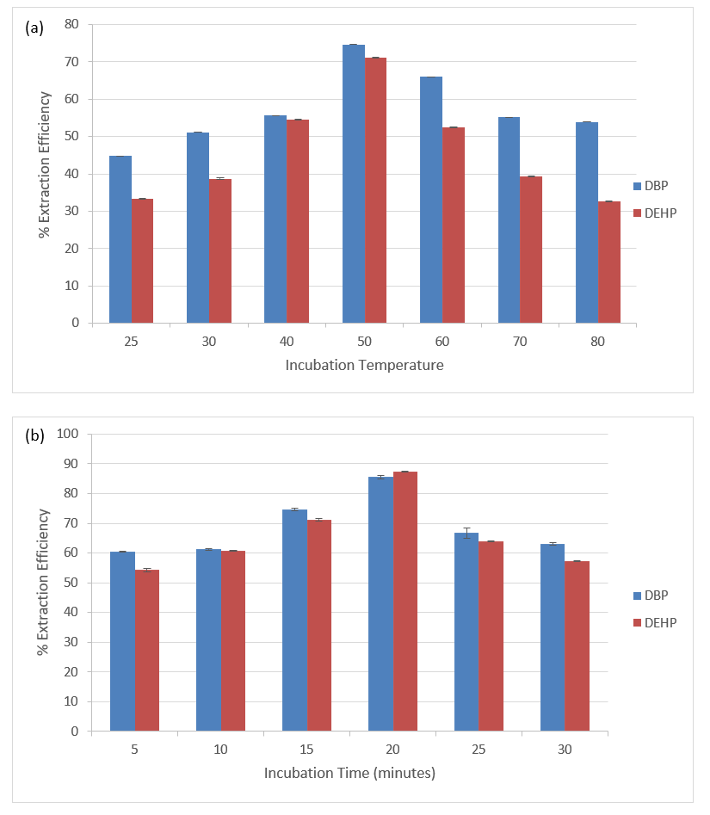
Figure 4. Effect of (a) temperature and (b) incubation time on extraction efficiency of phthalates in CPE. Condition (a): 10 mg L⁻¹ of phthalates, 0.1 %v/v of DC193C, 1.5 mol L⁻¹ of Na₂SO_{4.} Condition (b): 10 mg L⁻¹ of phthalates, 0.1 %v/v of DC193C, 1.5 mol L⁻¹ of Na₂SO₄ at 50 ºC

Effect of salt types
Generally, CPE can be carried out without additives. However, the addition of salt to the solution may influence the extraction process. In the case of most non-ionic surfactants, the presence of salt may facilitate phase separation since it increases the density of the aqueous phase. Available electrolytes can also change the CPT of non-ionic surfactants [10]. This is because salt will decrease the solubility of surfactant in water and can alter the CPT and facilitate the separation of two phases by altering the density of the bulk aqueous phase [23]. This will then lead to the easier formation of two phases, which are surfactant rich phase and aqueous phase. Based on Table 1, only sodium sulphate (Na₂SO₄) helped in transferring the selected phthalates and formed surfactant rich phase while there is no phase formation when other salts were employed. This finding is in agreement with other study which also reported that Na₂SO₄ salt may enhance the solubility of analytes in the surfactant rich phase through increasing the size of the micelles and aggregation number [24]. Enhanced solubility will result in higher extraction efficiency since there will be lesser water in the surfactant rich phase. The enhanced solubility is due to the ability of kosmotropic ions such as carbonate (CO₃²⁻) and sulphate (SO₄²⁻) in interacting with water molecules [25]. The unique characteristics of sodium sulphate which is comprised of Na⁺ cation and SO₄²⁻ anion play some roles [26]. Na⁺ cation is found to have the ability to reduce the cloud point temperature while SO₄²⁻ anion can speed up the dehydration of the micelle since it is a polyvalent ion.

Table 1. Effect of Salt (% Extraction efficiency ± RSD)
Salts | Dibutyl Phthalate (DBP) | Diethylhexyl Phthalate (DEHP)
Na₂NO₃ | No phase formation | No phase formation
KCl | No phase formation | No phase formation
NaCl | No phase formation | No phase formation
KOH | No phase formation | No phase formation
Na₂SO₄ | 83.64 ± 0.21 | 87.83 ± 0.41

Effect of salt concentration
Ghasemi and Kaykhaii reported that salt concentration can change the ionic strength of the sample solution which then helped in reducing the cloud point [13]. Thus, different concentration of Na₂SO₄, ranging from 0.5 M to 3.0 M, were studied. However, phase separation did not occur when 0.5 M and 1.0 M of salt were employed (not shown in Figure 5). Based on the result obtained, 1.5 M of salt gave the greatest extraction efficiency among all concentrations. However, the percentage of recovery decreased as the concentration of salt employed increased. This result agreed with other study [27] which reported on the usage of calcium chloride to facilitate the extraction of congo red. The addition of excessive Na₂SO₄ ( > 1.5 M) to the micellar solution will lead to very low CPT and, thus, render the formation of unwanted and very viscous surfactant rich phase [28]. Therefore, 1.5 M has been chosen as the concentration of salt to be employed for this study. Figure 6 shows the proposed mechanism between non-ionic silicone surfactant of DC193C and DBP.

Figure 5. Effect of salt concentration on extraction efficiency of phthalates in CPE. Condition: 10 mg L⁻¹ of phthalates, 0.1 %v/v of DC193C, 50 ºC

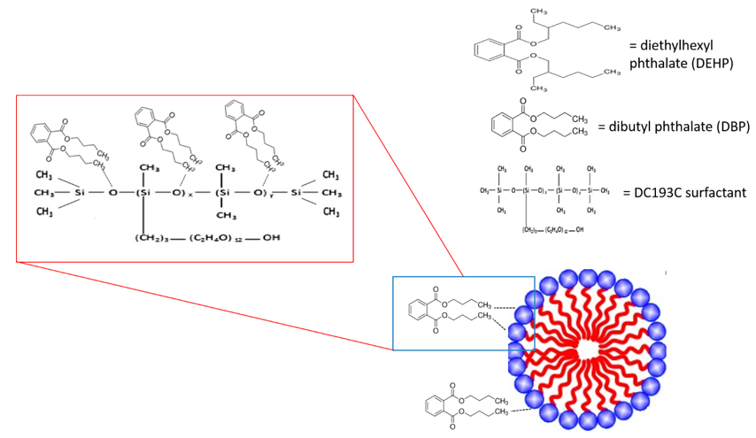
Figure 6. Proposed mechanism between non-ionic silicone surfactant and DBP

Method validation
Under the optimized conditions, the calibration graphs were constructed by plotting the absorbance signal against the concentrations of each analyte according to the general procedure for the CPE. The measurement of each analyte spectrophotometrically at the respective absorption maxima against a reagent blank were prepared under similar conditions. The calibration data are summarized in Table 2.

Table 2. Method validation of spectrophotometric of phthalates species using CPE
Analytes | Linear Equation | Linear Range  (μg L⁻¹) | R²
DEHP | y = 0.0001 x + 0.0065 | 1 – 500 | 0.9963
DBP | y = 0.0002 x + 0.0029 | 1 – 500 | 0.9988

Application in real samples
The calibration graphs in the range of 1 – 500 μg L⁻¹ were constructed by plotting the absorbance signal against the concentration of each phthalate sample according to the general procedure under the optimized conditions. The developed method was applied to evaluate its feasibility by spiking each phthalate to the water sample. The results were summarized in Table 3 and the recoveries for all phthalates were calculated to be in the range of 82 – 98%. Therefore, the method can be considered as a reliable method for the removal of phthalates in water samples.

Table 3. Recovery of phthalates species in spiked environmental waters
Analytes | Added  (μg L⁻¹) | % Recovery  (% RSD, n=3)
 |  | Sungai Derhaka Juru | Sungai Juru | Sungai Nibong Kecil | Sungai Ara | Sungai Perai
 | 5 | 83 (7.18) | 94 (8.65) | 84 (10.39) | 82 (10.16) | 94 (2.74)
DEHP | 50 | 86 (1.96) | 96 (2.22) | 91 (7.18) | 91 (6.41) | 93 (6.45)
 | 300 | 87 (2.22) | 92 (0.87) | 98 (1.28) | 82 (2.45) | 98 (1.30)
 | 5 | 83 (4.51) | 85 (4.91) | 88 (4.46) | 85 (6.11) | 91 (5.09)
DBP | 50 | 85 (0.96) | 85 (1.68) | 87 (1.90) | 83 (2.56) | 84 (4.96)
 | 300 | 94 (2.18) | 86 (2.12) | 88 (0.87) | 83 (0.50) | 91 (0.79)

Conclusion
The non-ionic surfactant-based polyethylene glycol silicone has been demonstrated to be useful in the extraction of DBP and DEHP from water samples. Under the optimized conditions (1 mL of 0.1% v/v DC193C surfactant; 1.5 mol L⁻¹ of Na₂SO₄; 50 ºC of incubation temperature and 20 minutes of incubation time), the extraction efficiency for both phthalates were in the satisfactory range of 82% to 98% with relative standard deviation (RSD) value less than 10.39%. The proposed CPE is an easy, safe and inexpensive methodology for the extraction of DBP and DEHP from water samples using non-ionic silicone surfactant. Therefore, the DC193C non-ionic silicone surfactant as an extractant in the CPE has a great potential to be explored for removing contaminants and pollutants from water samples due to their unique structure molecules that could entrap hydrophobic and as well as hydrophilic substances.

Acknowledgement
The authors gratefully acknowledge Universiti Sains Malaysia and the Ministry of Education Malaysia for financial support through the Bridging Grant (304.CIPPT.6316266) and Fundamental Research Grant Scheme (FRGS: 203.CIPPT.6711661). The authors also acknowledge the Advanced Medical and Dental Institute, Universiti Sains Malaysia for the facilities provided.

References
- Pérez-Outeiral, J., Millán, E. and Garcia-Arrona, R. (2016). Determination of phthalates in food simulants and liquid samples using ultrasound-assisted dispersive liquid–liquid microextraction followed by solidification of floating organic drop. Food Control, 62: 171-177.
- Mariana, M., Feiteiro, J., Verde, I., and Cairrao, E. (2016). The effects of phthalates in the cardiovascular and reproductive systems: A review. Environment International, 94: 758-776.
- Chen, B. and Zhang, L. (2013). An easy and sensitive analytical method of determination of phthalate esters in children's toys by UPLCMS/MS. Polymer Testing, 32(4): 681-685.
- Zhang, L., Dong, L., Ren, L., Shi, S., Zhou, L., Zhang, T., and Huang, Y. (2012). Concentration and source identification of polycyclic aromatic hydrocarbons and phthalic acid esters in the surface water of the Yangtze River Delta, China. Journal of Environmental Sciences, 24(2): 335-342.
- Chen, X., Xu, S., Tan, T., Lee, S. T., Cheng, S. H., Lee, F. W. F., and Ho, K. C. (2014). Toxicity and estrogenic endocrine disrupting activity of phthalates and their mixtures. International Journal of Environmental Research and Public Health, 11(3): 3156-3168.
- Koch, H. M. and Calafat, A. M. (2009). Human body burdens of chemicals used in plastic manufacture. Philosophical Transactions of the Royal Society B: Biological Sciences, 364(1526): 2063-2078.
- Schecter, A., Lorber, M., Guo, Y., Wu, Q., Yun, S. H., Kannan, K., and Cheng, D. (2013). Phthalate concentrations and dietary exposure from food purchased in New York State. Environmental Health Perspectives, 121(4): 473.
- Regulations, U.S.E.P.A. (1980). Ambient water quality criteria for Phthalate Esters. 1980: The Division.
- Souza, V.S., Teixeira, L.S. and Bezerra, M.A. (2016). Application of multivariate designs in the development of a method for vanadium determination in natural waters by HR-CS GF AAS after cloud-point extraction. Microchemical Journal, 129: 318-324.
- Santalad, A., Burakham, R., Srijaranai, S., Srijaranai, S., and Deming, R. L. (2012). Role of different salts on cloud-point extraction of isoprocarb and promecarb insecticides followed by high-performance liquid chromatography. Journal of Chromatographic Science, 50(6): 523-530.
- Soni, S., Panjabi, S. and Sastry, N. (2011). Effect of non-electrolyte additives on micellization and clouding behavior of silicone surfactant in aqueous solutions. Colloids and Surfaces A: Physicochemical and Engineering Aspects, 377(1): 205-211.
- Bingjia, Y., Li, Y., Qiong, H., & Shigendo, A. (2007). Cloud point extraction of polycyclic aromatic hydrocarbons in aqueous solution with silicone surfactants. Chinese Journal of Chemical Engineering, 15(4): 468-473.
- Ghasemi, E. and Kaykhaii, M. (2016). Application of micro-cloud point extraction for spectrophotometric determination of malachite green, crystal violet and rhodamine B in aqueous samples. Spectrochimica Acta Part A: Molecular and Biomolecular Spectroscopy, 164: 93-97.
- Zain, N., Abu Bakar, N. and Mohamad, S. (2016). Study of removal of phenol species by adsorption on non-ionic silicon surfactant after cloud point extraction methodology. Desalination and Water Treatment, 57(8): 3532-3543.
- Zain, N., Bakar, N. A., Mohamad, S., and Saleh, N. M. (2014). Optimization of a greener method for removal phenol species by cloud point extraction and spectrophotometry. Spectrochimica Acta Part A: Molecular and Biomolecular Spectroscopy, 118: 1121-1128.
- Hollis, G.L. (2007). Surfactants Europa. Royal Society of Chemistry Publishing.
- Salem, J. K., El-Nahhal, I. M., Najri, B. A., and Hammad, T. M. (2016). Utilization of surface Plasmon resonance band of silver nanoparticles for determination of critical micelle concentration of cationic surfactants. Chemical Physics Letters, 664: 154-158.
- Ren, Y., Zhao, B., Chang, Q., and Yao, X. (2011). QSPR modeling of nonionic surfactant cloud points: An update. Journal of Colloid and Interface Science, 358(1): 202-207.
- Samaddar, P. and Sen, K. (2014). Cloud point extraction: A sustainable method of elemental preconcentration and speciation. Journal of Industrial and Engineering Chemistry, 20(4): 1209-1219.
- Tang, X., Zhu, D., Huai, W., Zhang, W., Fu, C., Xie, X., and Fan, H. (2017). Simultaneous extraction and separation of flavonoids and alkaloids from Crotalaria sessiliflora L. by microwave-assisted cloud-point extraction. Separation and Purification Technology, 175: 266-273.
- Pirdadeh-Beiranvand, M., Afkhami, A. and Madrakian, T. (2017). Cloud point-magnetic dispersive solid phase extraction for the spectrofluorometric determination of citaloperam. Journal of Molecular Liquids, 241: 43-48.
- Yang, X., Li, G., Yang, X., Jia, Z., and Luo, N. (2015). Determination of manganese in environmental samples by UV-Vis after cloud point extraction. 2nd International Conference on Green Materials and Environmental Engineering, 2015: 91-94.
- Sato, N., Mori, M. and Itabashi, H. (2013). Cloud point extraction of Cu (II) using a mixture of triton X-100 and dithizone with a salting-out effect and its application to visual determination. Talanta, 2013. 117: 376-381.
- Purkait, M., DasGupta, S. and De, S. (2006). Performance of TX-100 and TX-114 for the separation of chrysoidine dye using cloud point extraction. Journal of Hazardous Materials, 137(2): 827-835.
- Hunger, J., Neueder, R., Buchner, R., and Apelblat, A. (2013). A conductance study of guanidinium chloride, thiocyanate, sulfate, and carbonate in dilute aqueous solutions: ion-association and carbonate hydrolysis effects. The Journal of Physical Chemistry B, 117(2): 615-622.
- Purkait, M., DasGupta, S. and De, S. (2009). Determination of thermodynamic parameters for the cloud point extraction of different dyes using TX-100 and TX-114. Desalination, 244(1-3): 130-138.
- Purkait, M. K., Vijay, S. S., DasGupta, S., and De, S. (2004). Separation of congo red by surfactant mediated cloud point extraction. Dyes and Pigments, 63(2): 151-159.
- Wang, L., Jiang, G.-B., Cai, Y.-Q., He, B., Wang, Y.-W., and Shen, D.-Z. (2007). Cloud point extraction coupled with HPLC-UV for the determination of phthalate esters in environmental water samples. Journal of Environmental Sciences, 19(7): 874-878.

