

MALAYSIAN JOURNAL OF ANALYTICAL SCIENCES
ISSN 1394 - 2506

Published by The Malaysian Analytical Sciences Society

SPECTROSCOPIC STUDIES OF INCLUSION COMPLEX GLIPIZIDE
AND β-CYCLODEXTRIN

(Kajian Spektroskopik Kompleks Kemasukan Glipizida dan β-siklodekstrin)

Nurul Yani Rahim*, Fatin Hamizah Samad, Asmaa’ Mardhiah Rohisham

School of Chemical Sciences,
Universiti Sains Malaysia,
11800 Gelugor, Pulau Pinang, Malaysia

*Corresponding author: nurulyanirahim@usm.my

Received: 8 May 2019; Accepted: 3 September 2019

Abstract
The complex between hypoglycemic drug, glipizide, and β-cyclodextrin (β-CD) was prepared using the kneading method with aliquot addition of ethanol. The product was characterized using Fourier Transform Infrared (FTIR) spectrometer and Thermogravimetric Analysis (TGA). ¹H and NOESY Nuclear Magnetic Resonance (NMR) and UV-Vis spectroscopy were used to determine the interaction involved in the formation of inclusion complex β-CD/glipizide. ¹H and NOESY NMR results indicated that the hydrophobic interaction occurred between glipizide and β-CD. The formation constant values of complex β-CD/glipizide at pH 9 and 4 were close to each other. The stoichiometry ratio for the inclusion complex between β-CD with glipizide was 1:1.

Keywords: β-CD, antidiabetic drug, formation constant, cavity, kneading

Abstrak

Kompleks antara ubat hipoglisemia, glipizida, dan β-siklodekstrin (β-CD) telah disediakan dengan cara menguli bersama penambahan etanol alikuot. Produk ini dicirikan menggunakan spektrometer inframerah transformasi Fourier (FTIR) dan analisis termogravimetrik (TGA). Resonan Magnetik Nuklear (NMR) ¹H dan NOESY dan spektroskopi UV-Vis telah digunakan untuk menentukan interaksi yang terlibat dalam pembentukan kompleks kemasukan β-CD/glipizida. Hasil NMR ¹H dan NOESY menunjukkan bahawa interaksi hidrofobik berlaku antara glipizida dan β-CD. Nilai pemalar pembentukan kompleks β-CD/glipizida pada pH 9 dan 4 adalah lebih kurang sama. Nisbah stoikiometri untuk kompleks kemasukan antara β-CD dan glipizida ialah 1: 1

Kata kunci: β-CD, ubat antidiabetik, pemalar pembentukan, kaviti, menguli

Introduction
β-Cyclodextrins (β-CD) are cyclic oligosaccharides that contain seven units of glucose joined through α-1,4 linkage [1]. β-CD is produced from intramolecular transglycolation reaction from the degradation of starch by CD glucanotransferase(CGTase) enzyme. β-CD has a toroidal shape with a free hydroxyl group at two rims. β-CD is referred to as an all-purpose molecular container for organic, inorganic, organometallic, and metalloorganic compounds that may be neutral, cationic, anionic or even radical. The hydrophobic cavity inside of β-CD allows them to form inclusion complexes with hydrophobic compounds in aqueous environments [2]. The inclusion complex formation affects the physical, chemical, and biological properties of guest molecules. Moreover, it improves the application characteristics of guest molecules [3]. Based on various methods construct, β-CD has received considerable attention in the pharmaceutical field for the past few years due to its extensive use in drug delivery processes [4-9]. Smart drug carriers can act as a new weapon for treating diseases. It is difficult to build up this kind of drug carrier by general synthetic chemistry due to its complex structure. However, the appearance of β-CD supramolecular self-assembly provides a fast, convenient, and flexible way to construct a biological simulative-responsive drug carrier.

Glipizide is a second-generation sulfonylurea hypoglycemic drug that can acutely lower the blood glucose level in humans by stimulating the release of insulin from the pancreas [10]. It is typically prescribed to treat non-insulin-dependent diabetes mellitus [11]. It is a whitish, odourless powder with pKa of 5.9 and belongs to Class II of the Biopharmaceutical Classification System (BCS). It is insoluble in water, and its dissolution is a rate-determining step in its absorption from the gastrointestinal fluids [12]. This is considered to be a main factor contributing to its very limited oral bioavailability, thus resulting in delayed absorption [11]. Several studies have been developed for the enhancement of the dissolution rate, solubility, and bioavailability of glipizide through inclusion complex formation [13-17].

Inclusion complexes are a type of complex in which one compound (the host) contains a cavity or spaces where another molecular entity (the guest) is located. This is with the consideration that no covalent bonding occurs between the host and the guest. The inclusion complexation of these host-guest systems occurs through various interactions such as hydrogen bonding, Van der Waals, and electrostatic or hydrophobic interactions. Previously, the improved bioavailability of glipizide complexed with β-CD and β-CD derivatives has been documented in several articles [13, 17, 18]. However, there is no information available on the study of interactions involved in the formation of complex between β-CD and glipizide. In this study, the inclusion complex of glipizide and β-CD was evaluated using spectroscopy techniques. The result provides information on the intermolecular interaction between glipizide and β-CD.

Materials and Methods
Materials
The present study utilized β-cyclodextrin (C₄₂H₇₀O₃₅), glipizide (C₂₁H₂₇N₅O₄S), ethanol (C₂H₆O), and methanol (CH₃OH). Ultra-pure water was used to dilute the solutions.

Characterization of samples
The formation of inclusion complexes was studied via an analysis of the peaks. Infrared (IR) absorption spectra were determined by using Perkin-Elmer 2000 system spectrometer in the range of 4000 cm⁻¹ to 600 cm⁻¹. The thermal analysis was conducted through the Thermogravimetric Analysis (TGA) using Mettler Toledo TGA/SDTA 851E Thermogravimetric Analyzer. The analysis was done over the ambient temperature range of 30 °C to 920 °C in N₂ atmosphere to understand the weight loss profile for β-CD, glipizide, and β-CD/glipizide complex. The Bruker Avance spectrometer 500 MHz was used to determine ¹H NMR spectra of the β-CD, glipizide, and β-CD/glipizide complex by employing dimethyl sulfoxide-d₆ (DMSO-d₆) as a solvent. Absorption spectra measurements were carried out with Shimadzu UV2600 spectrometer in the range of 200 nm ‒ 800 nm.

Preparations of β-CD/glipizide complex
The complex was prepared as previously reported using the kneading method. β-CD and glipizide were put in a ceramic mortar with a molar ratio of 1:1 and grounded with additional few drops of ethanol to form a homogeneous paste [19]. This process was continued for 30 minutes and the product was placed in a desiccator to the final mass.

Determination of the formation constant of β-CD/glipizide complex
The formation constant was determined as mention in the previous procedure [20]. In 10.0 mL of volumetric flask, 2.0 mL of 0.01 mM glipizide and 3.2 mL of 0.003 M of β-CD were added to form β-CD/glipizide solution. The solution was diluted using ultra-pure water to the mark. The absorption spectra of β-CD and glipizide were recorded against a reagent blank, which was prepared with the same reagent concentration but without the addition of glipizide. The absorption spectra of β-CD and glipizide alone were also recorded. The formation constant, K of β-CD and glipizide could be obtained from the slope of Benesi-Hildebrand plot that was generated using Eqs (1) and (2). For the formation constant curve, the concentration of glipizide was held firmly at 0.01 mM, while the concentration of β-CD was varied (0.001, 0.002, 0.003, and 0.005 M).

$\frac{1}{A-A_{0}}= \frac{1}{\left(A^{'}-A_{0}\right)}+ \frac{1}{K\left(A^{'}-A_{0}\right)\left[β-CD\right]}$ (1)
K=$\frac{1}{Slope(A-A_{0})}$ (2)

where A₀ and A are the absorbance of the free guest and β-CD, respectively. A’ is the absorbance at the maximum concentration of β-CD.

Results and Discussion
FT-IR
The FT-IR spectra and main frequencies of β-CD, glipizide, and complex of β-CD/glipizide are reported in Figures 1 (a)-(c) and Table 1, respectively. The frequencies for β-CD were observed at 3292.81 cm⁻¹, 2924.94 cm⁻¹, and 1152.37 cm⁻¹, which corresponded to the broad peaks of OH, CH_{2,} and -C-C, respectively. The spectrum of glipizide (Figure 1 (b)) showed absorption bands at 1687.51 cm⁻¹ (for C=O stretching vibration), 1331.94 cm⁻¹ (for -C-N stretching vibration), and 1484.95 cm⁻¹ (for aromatic C=C groups stretching vibration).

In the spectrum of β-CD/glipizide complex (Figure 1 (c)), the frequencies of S=O (1157.21 cm⁻¹) for glipizide and C-O group (1334.23 cm⁻¹) disappeared, whereas the frequency of C-N, -CH₃, and -C=O shifted from 1331.94 cm⁻¹ to 1332.52 cm⁻¹, 2944.00 cm⁻¹ to 2927.26 cm⁻¹ and 1687.51 cm⁻¹ to 1689.38 cm⁻¹ respectively. Besides, a broad hydroxyl band of pure β-CD at 3292.81 cm⁻¹ was found to be narrowed in the spectrum of the β-CD/glipizide complex (Figure 1 (c)), which was a good indication of the formation of the inclusion complex. This is a common phenomenon observed by many researchers in synthesizing the inclusion complex between β-cyclodextrin as host and guest molecules [21-24]. The changes in the FT-IR spectrum of complex shown in Figure 1 (c) were due to the change of microenvironment with the formation of inclusion complex. Thus, the result of FT-IR spectroscopy indicated that the inclusion complex of glipizide with β-CD was formed.

Figure 1. FTIR spectrums of a) β-CD b) glipizide c) β-CD/glipizide.

Table 1. Main FTIR frequencies for β-CD, glipizide and β-CD/glipizide
Wavenumber  (cm⁻¹) | Assignments | β-CD | Glipizide | β-CD/glipizide
3292.81 | O-H stretch | √
2944.00 | C-H stretch |  | √
2927.26 | C-H stretch |  |  | √
2924.94 | C-H stretch | √
1689.38 | C=O stretch |  |  | √
1687.51 | C=O stretch |  | √
1484.95 | C=C stretch |  | √
1332.52 | C-N stretch |  |  | √
1331.94 | C-N stretch |  | √
1157.21 | S=O |  | √
1152.37 | C-C | √

Thermal analysis
TGA analyses were performed on the β-CD, glipizide, and β-CD/glipizide complex in the temperature range of 30 ºC - 900 ºC. Based on the thermogram shown in Figure 2, there was an initial loss of weight at temperature below 100 ºC for β-CD, glipizide, and β-CD/glipizide complex due to the loss of water molecules. The weight losses of β-CD starting from 328.90 ºC to 800 ºC were attributed to the decomposition of β-CD, while glipizide started to decompose around 220 ºC. The weight loss for β-CD/glipizide complex that occurred at the range of 210 ºC - 400 ºC could be related to the decomposition of organic moieties at the surface. The result showed that the β-CD/glipizide complex had the least pronounced weight loss than β-CD and glipizide. Apart from that, the high stability of β-CD/glipizide could be due to the strong hydrophobic interaction between β-CD and glipizide, which enabled this material to be used in high-temperature applications. The temperature of weight loss with detailed assignment is shown in Table 2.

Figure 2. TGA for β-CD, glipizide and β-CD/glipizide

Table 2. The assignment for temperature of weight loss
Samples | Region  (°C) | Weight Loss  (%) | Assignment
β-CD | <100 | 29.46 | Water loss
 | 328.9-800 | 81.35 | β-CD decomposition
glipizide | <100 | 29.52 | Water loss
 | 220 | 96.96 | Glipizide decomposition
β-CD/glipizide | <100 | 29.45 | Water loss
 | 210-400 | 91.73 | Glipizide decomposition

¹H NMR analysis
¹H NMR spectroscopy was introduced to study the inclusion complex formation. The deduced structures of β-CD and glipizide with the spectra of ¹HNMR are shown in Figure 3. Chemical shift (δ) variations provided evidence for the formation of inclusion complex. The values of chemical shifts obtained from ¹H NMR for each β-CD, glipizide, and β-CD/glipizide are listed in Table 3. The method relied on changes in chemical shift caused by the glipizide (guest) and β-CD (host) of one another. The difference in chemical shift for the protons of β-CD in the presence or absence of glipizide was defined as induced shift (∆δ). In this case, the induced shift was calculated using Eq 3:

∆δ=δ (complex)-δ (free) (3)

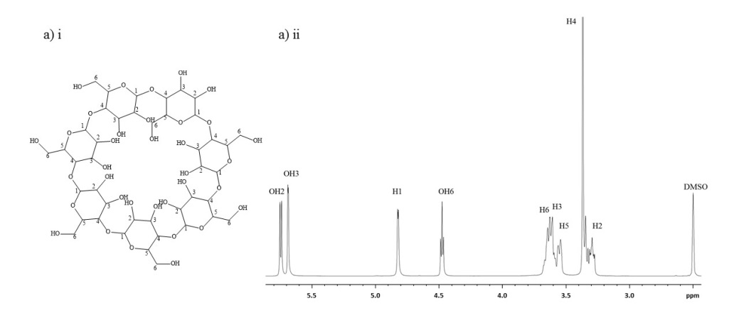

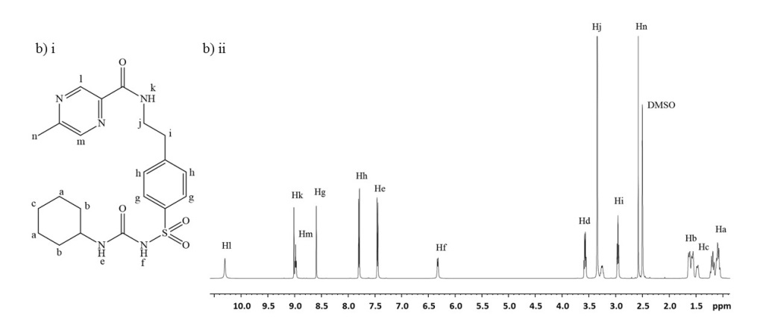

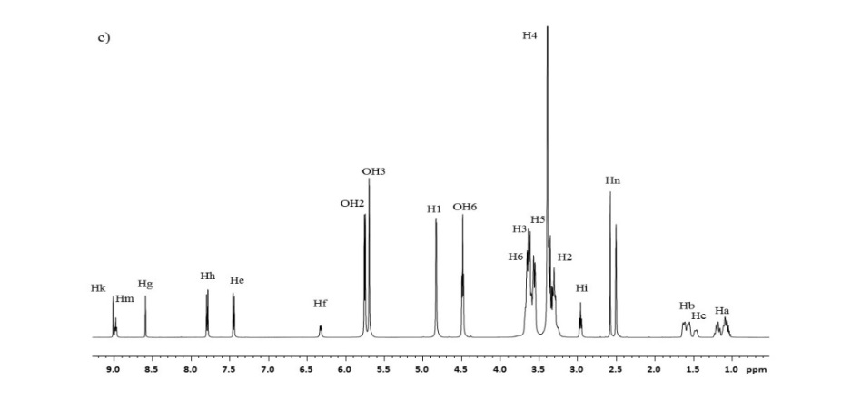
Figure 3. ¹ H NMR spectra of a) β-CD, b) glipizide and c) β-CD/glipizide

Table 3. Chemical shift corresponding to β-CD and glipizide
Proton | β-Cyclodextrin  δ | Glipizide  δ |  | Inclusion Complex  δ |  | Induced Shift  ∆δ
H1 | 4.826 |  |  |  | 4.829 | 0.003
H2 | 3.295 |  |  |  | 3.299 | 0.004
H3 | 3.606 |  |  |  | 3.610 | 0.004
H4 | 3.367 |  |  |  | 3.384 | 0.017
H5 | 3.542 |  |  |  | 3.563 | 0.021ª
H6 | 3.643 |  |  |  | 3.629 | -0.014
Ha |  |  | 1.097 |  | 1.092 | -0.005
Hb |  |  | 1.554 |  | 1.551 | -0.003
Hc |  |  | 1.462 |  | 1.459 | -0.003
Hd |  |  | 3.565 |  | - | -
He |  |  | 7.461 |  | 7.458 | -0.003
Hf |  |  | 6.319 |  | 6.317 | -0.002
Hg |  |  | 8.597 |  | 8.593 | -0.004
Hh |  |  | 7.790 |  | 7.785 | -0.005
Hi |  |  | 2.961 |  | 2.958 | -0.003
Hj |  |  | 3.346 |  | - | -
Hk |  |  | 9.017 |  | 9.012 | -0.005
Hl |  |  | 10.307 |  | - | -
Hm |  |  | 8.983 |  | 8.978 | -0.005
Hn |  |  | 2.579 |  | 2.575 | -0.004
ª Values in bold refer to the highest induced shift of that particular proton

In the structure of β-CD (Figure 4), the protons H3 and H5 were located inside the cavity. Meanwhile, the other protons (H1, H2, and H4) were located at the exterior of the cavity. Normally, the inclusion of the non-polar region of an analyte into hydrophobic cavity would affect the inner protons of the glucose units of β-CD, which were H3 and H5 [19-20, 25]. For β-CD/glipizide complex, there was a significant shift at H5 (Table 3). However, there was no significant change of chemical shift for H3. This revealed that there was a partial penetration of glipizide into the cavity of β-CD. 2D NMR, which is NOESY, was studied to obtain detailed information of the interaction involved. The cross peak (Figure 5) between Hm (proton of glipizide) and H5 (proton of β-CD) confirmed the aromatic moiety penetration of glipizide into the β-CD cavity.

Figure 4. β-CD with proton numbering

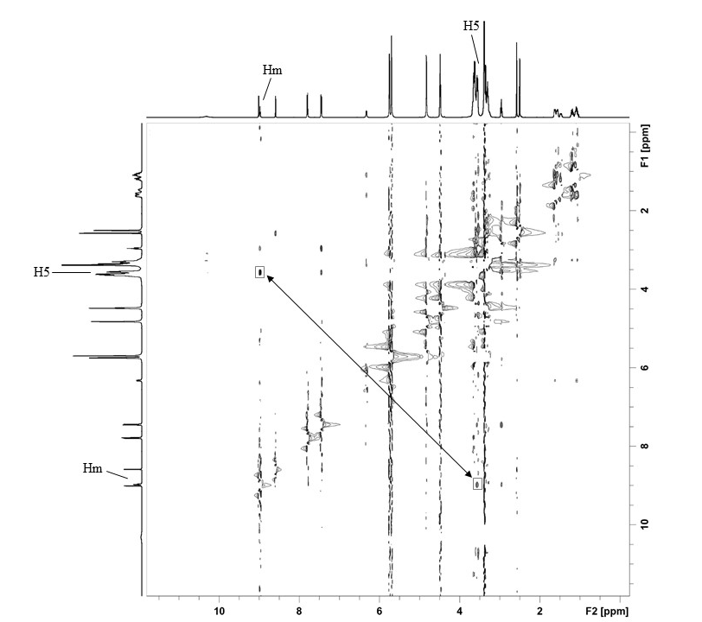

Figure 5. 2D NOESY spectra of complex β-CD/glipizide

UV-Vis
The stoichiometric ratios and formation constants describing the extent of formation of the complexes were obtained by measuring the changes in UV-Vis absorbance of the substrates, in the presence of increasing concentrations of β-CD. Figure 6 showed the absorbance increased by increasing the β-CD concentrations at pH 4 and pH 9. The absorption spectra of β-CD, glipizide, and β-CD/glipizide complexes are shown in Figure 7. The results indicated that β-CD/Glipizide had λ_{max} in the range of 250 nm ‒ 300 nm. The absorbance of β-CD/glipizide complex underwent the hyperchromic effect, which increased the value of absorbance. The effect observed was due to π-π* transition of dipole-dipole moments of aromatic ring. The formation constant, K values are shown in Table 4. The formation constant was carried out at two different pH values to find out whether the strength of binding between glipizide and β-CD was affected in acidic or basic condition. However, it was found that the binding strength was not affected in both acidic and basic conditions. The double reciprocal plot shown in Figure 8 clearly indicated that the stoichiometry ratio for the inclusion formation between glipizide and β-CD was 1:1.

Figure 6. Absorption spectra of glipizide in the presence of increasing concentration of a) β-CD (0.001-0.005M) pH 4 and b) β-CD (0.001-0.005M) pH 9

Figure 7. Absorption spectra of β-CD, Glipizide and β-CD/Glipizide at a) pH 4 and b) pH 9

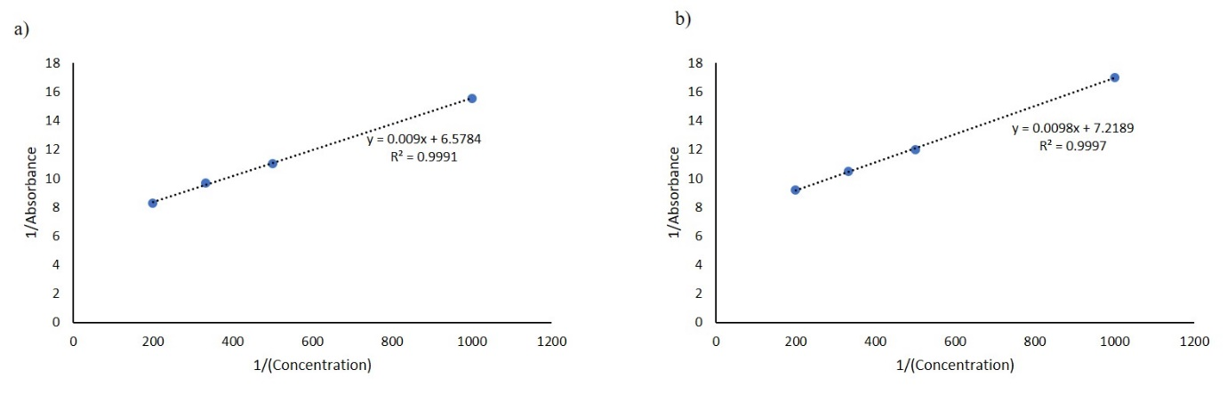
Figure 8. The double reciprocal plot of $\frac{1}{A}$ against $\frac{1}{[β-CD]}$ in a) pH 4 and b) pH 9

Table 4. Formation constant (K) values for β-CD/glipizide at differents pH
pH | Formation Constant, K
4 | 730.93
9 | 743.47

Conclusion
The inclusion complex between β-CD and glipizide was prepared using the kneading method and the determinations of formation constant were studied at pH 4 and 9. The results obtained from FT-IR and TGA proved that β-CD formed the inclusion complex with glipizide. From ¹H NMR determination, a large shift was observed at H5 proton of β-CD, proving the partial penetration of glipizide into the cavity of β-CD. This was strengthened by the cross-peak proton of aromatic glipizide with inner protons of β-CD from the NOESY experiment. β-CD/glipizide complex performed 1:1 host-guest interaction at pH 4 and 9 with apparent formation constants of 730.93 and 743.47, respectively, calculated from the Hildebrand-Benesi equation. This integrated experimental method revealed the molecular inclusion mechanism of β-CD with glipizide that would benefit the future formulation development of the drug carrier system.

Acknowledgement
Authors would like to seize this opportunity to express their gratitude to the Universiti Sains Malaysia for the Short-Term Grant (304/PKimia/6315106) and Ministry of Education for FRGS Grant (203.PKIMIA.6711641).

References
- Bender, M. L. and Komiyama, M. (2012). Cyclodextrin chemistry. Springer Berlin Heidelberg, New York: pp. 2 – 3.
- Abarca, R. L., Rodriguez, F. J., Guarda, A., Galotto, M. J. and Bruna, J. E. (2016). Characterization of beta- cyclodextrin inclusion complexes containing an essential oil component. Food Chemistry, 196: 968 – 975.
- Zhu, X., Sun, J. and Wu, J. (2007). Study on the inclusion interactions of β-cyclodextrin and its derivative with dyes by spectrofluorimetry and its analytical application. Talanta, 72(1): 237 − 242.
- de Paula, E., Cereda, C., Tofoli, G. R., Franz-Montan, M., Fraceto, L. F. and de Araújo, D. R. (2010). Drug delivery systems for local anesthetics. Recent Patents on Drug Delivery & Formulation, 4(1): 23 − 34.
- Loftsson, T. and Duchene, D. (2007). Cyclodextrins and their pharmaceutical applications. International Journal of Pharmaceutics, 329(1-2): 1 − 11.

- Machelart, A., Salzano, G., Li, X., Demars, A., Debrie, A. S., Menendez-Miranda, M., and Belhaouane, I. (2019). Intrinsic antibacterial activity of nanoparticles made of β-cyclodextrins potentiates their effect as drug nanocarriers against tuberculosis. ACS Nano, 13(4): 3992 − 4007.
- Rasheed, A. (2008). Cyclodextrins as drug carrier molecule: A review. Scientia Pharmaceutica, 76(4): 567 − 598.
- Crini, G., Fourmentin, S., Fenyvesi, E., Torri, G., Fourmentin, M. and Morin-Crini, N. (2018). Cyclodextrin fundamentals, reactivity and analysis. Springer Cham, Besancon: pp. 1 – 55.
- Stella, V. J. and He, Q. (2008). Cyclodextrins. Toxicologic Pathology, 36(1): 30 − 42.
- Bui, T. T., Ngo, D. Q., Tran, V. L., Nguyen, T. N. and Do, T. T. (2019). Acute and subacute toxic study on mice of glipizide synthesized in Vietnam. Vietnam Journal of Science and Technology, 57(1): 15 − 21.
- Tan, B., Yang, A., Yuan, W., Li, Y., Jiang, L., Jiang, J., and Qiu, F. (2017). Simultaneous determination of glipizide and its four hydroxylated metabolites in human urine using LC–MS/MS and its application in urinary phenotype study. Journal of Pharmaceutical and Biomedical Analysis, 139: 179 − 186.
- Nie, S., Zhang, S., Pan, W. and Liu, Y. (2011). In vitro and in vivo studies on the complexes of glipizide with water-soluble β-cyclodextrin–epichlorohydrin polymers. Drug Development and Industrial Pharmacy, 37(5): 606 − 612.
- Huang, T., Zhao, Q., Su, Y. and Ouyang, D. (2018). Investigation of molecular aggregation mechanism of glipizide/cyclodextrin complexation by combined experimental and molecular modeling approaches. Asian Journal of Pharmaceutical Sciences (Article in Press).
- Gan, Y., Pan, W., Wei, M. and Zhang, R. (2002). Cyclodextrin Complex Osmotic Tablet for Glipizide Delivery. Drug Development and Industrial Pharmacy, 28 (8): 1015 − 1021.
- Chadha, R., Arora, P., Saini, A. and Jain, D. (2010). Inclusion parameters of pioglitazone hydrochloride and glipizide with β-cyclodextrin and its methyl derivative: Calorimetric and spectroscopic studies. International Journal of Biological and Chemical Sciences, 4(2): 258 − 273.
- Ammar, H. O., Salama, H. A., Ghorab, M., El-Nahhas, S. A. and Elmotasem, H. (2006). A transdermal delivery system for glipizide. Current Drug Delivery, 33(3): 333 − 341.
- Huang, H., Wu, Z., Qi, X., Zhang, H., Chen, Q., Xing, J., and Rui, Y. (2013). Compression-coated tablets of glipizide using hydroxypropylcellulose for zero-order release: in vitro and in vivo evaluation. International Journal of Pharmaceutics, 446(1-2): 211 − 218.
- Gidwani, B. and Vyas, A. (2014). Synthesis, characterization and application of epichlorohydrin-β-cyclodextrin polymer. Colloids and Surfaces B: Biointerfaces, 114: 130 – 137.
- Rahim, N. Y., Tay, K. S. and Mohamad, S. (2016). β-cyclodextrin functionalized ionic liquid as chiral stationary phase of high performance liquid chromatography for enantioseparation of β-blockers. Journal of Inclusion Phenomena and Macrocyclic Chemistry, 85(3-4): 303 − 315.
- Rahim, N. Y., Tay, K. S. and Mohamad, S. (2016). Chromatographic and spectroscopic studies on β-cyclodextrin functionalized ionic liquid as chiral stationary phase: enantioseparation of favonoids. Chromatographia, 79(21-22): 1445 − 1455.
- Li, N., Liu, J., Zhao, X., Gao, Y. A., Zheng, L., Zhang, J. and Yu, L. (2007). Complex formation of ionic liquid surfactant and β-cyclodextrin. Colloids and Surfaces A: Physicochemical and Engineering Aspects, 292(2-3): 196 − 201.
- Li, W., Lu, B., Sheng, A., Yang, F. and Wang, Z. (2010). Spectroscopic and theoretical study on inclusion complexation of beta-cyclodextrin with permethrin. Journal of Molecular Structure, 981(1-3): 194 – 203.
- Li, J., Ni, X., Zhou, Z. and Leong, K. W. (2003). Preparation and characterization of polypseudorotaxanes based on block-selected inclusion complexation between poly (propylene oxide)-poly (ethylene oxide)-poly (propylene oxide) triblock copolymers and α-cyclodextrin. Journal of the American Chemical Society, 125(7), 1788 − 1795.
- Rusa, C. C., Luca, C. and Tonelli, A. E. (2001). Polymer-cyclodextrin inclusion compounds: Toward new aspects of their inclusion mechanism. Macromolecules, 34(5): 1318 − 1322.
- Rahim, N. Y., Tay, K. S. and Mohamad, S. (2018). Chromatographic and spectroscopic studies on β-cyclodextrin functionalized ionic liquid as chiral stationary phase: enantioseparation of NSAIDs. Adsorption Science & Technology, 36(1-2): 130 − 148.

