

MALAYSIAN JOURNAL OF ANALYTICAL SCIENCES
ISSN 1394 - 2506

Published by The Malaysian Analytical Sciences Society

AN ASSESSMENT OF FT-IR AND FT-NIR CAPABILITY IN SCREENING CRUDE PALM OIL AUTHENTICITY AND QUALITY COMBINED
WITH CHEMOMETRICS

(Satu Penilaian Terhadap Kebolehan FT-IR Dan FT-NIR Untuk Menyaring Kesahihan dan Kualiti Minyak Sawit Mentah Digabung Dengan Kemometri)

Ng Jing Sheng¹, Widad Fadhullah^{1,2}, Mohd Omar Ab Kadir¹, Ainolsyakira Mohd Rodhi³,
Noor Hana Hanif Abu Bakar⁴, Syahidah Akmal Muhammad^{1,3}*

¹Environmental Technology Division, School of Industrial Technology,
Universiti Sains Malaysia, 11800 USM, Penang, Malaysia
²Environmental and Occupational Health Program, School of Health Sciences, Health Campus,
Universiti Sains Malaysia, 16150 USM, Kubang Kerian, Kelantan, Malaysia.
³Analytical Biochemistry Research Centre
⁴School of Chemical Sciences
Universiti Sains Malaysia, 11800 USM, Penang, Malaysia

*Corresponding author: syahidah.muhammad@usm.my

Received: 16 January 2019; Accepted: 26 August 2019

Abstract
This study was conducted to assess the authenticity and evaluate the quality of palm oil with the aid of mid-infrared and near-infrared spectroscopy. Experiments were carried out to imitate the effect of frying in food service industry, therefore crude palm oil (CPO) samples were fried with different meat products (beef, mutton, fish, pork) at varying frequency of 3, 10, 20 and 30 times. Then the used frying oils were mixed with fresh and authentic CPO at different proportions, 5, 10, 20 and 30 (m/m %). Discriminant analysis on the infrared spectrum was carried out and the analysis was based on two class classification, which is to separate between 2 classes of samples. The results showed that the analysis with mid-IR spectrum successfully classified the adulterated oil samples from the authentic CPO with 2 misclassifications of adulterated oil into the authentic group out of 66 samples. The performance index of this model was 95.1 based on the Mahanalobis distance. The success rate of authentication was 96.7% for the mid-IR spectrum. However, the NIR spectrum analysis showed different results from the mid-IR as 11 adulterated samples out of 66 samples showed false positive result. The performance index of this model was 85.7 and the success rate of authentication was 83.3%. On the other hand, for the work on the classification of oil quality using mid-IR, the success rate was only 42.4% with the performance index of 73.4. Additionally, the NIR model for oil quality discrimination had 36.4% of success rate with a performance index of 56.4. The evaluation of oil quality based on the frequency of frying was not very successful and further work will be carried out. Overall, the authentication of palm oil was quite successful, but the evaluation of the quality of palm oil did not achieve our current objective. These rapid screening techniques, which are mid-infrared and near infrared spectroscopy have been proven to be useful for the authentication of edible palm oil but the evaluation of quality has to be further improved.

Keywords: crude palm oil, authenticity, mid-infrared, near-infrared, discriminant analysis

Abstrak
Kajian ini telah dijalankan untuk menilai kesahihan dan kualiti minyak sawit dengan bantuan spektroskopi inframerah-tengah dan hampir. Eksperimen dijalankan dengan menggoreng minyak sawit mentah (CPO) dengan beberapa jenis produk daging haiwan (daging lembu, kambing, ikan dan khinzir) bertujuan untuk meniru kesan menggoreng makanan dalam industri perkhidmatan makanan, dengan kekerapan yang berbeza iaitu 3, 10, 20 dan 30 kali. Minyak goreng tersebut kemudian telah dicampur dengan minyak sawit mentah dengan peratusan berbeza iaitu 5, 10, 20 dan 30 (m/m %). Selepas itu, spektrum inframerah telah digunakan untuk menjalankan analisis diskriminan dengan menggunakan kemometrik. Analisis diskriminan ini merupakan analisis berasaskan 2 kelas, dan analisis ini berkeupayaan untuk membezakan 2 kelas yang berbeza. Keputusan menunjukkan bahawa analisis specktrum inframerah-tengah telah berjaya mengasingkan minyak goreng terpakai daripada minyak tulen dengan hanya 2 pengelasan salah daripada 66 sampel. Indeks prestasi untuk model ini ialah 95.1 berdasarkan jarak Mahalonobis. Kadar berjaya bagi model ini ialah 96.7%. Seterusnya, model spektrum inframerah-hampir menunjukkan keputusan yang berbeza daripada inframerah-tengah kerana terdapat 11 sampel daripada 66 sampel telah diklasifikasi sebagai positif palsu. Indeks prestasi untuk model ini merupakan 85.7 dan kadar berjaya untuk klasifikasi kesahihan minyak ialah 83.3%. Manakala, dalam bahagian penilaian kualiti minyak menggunakan inframerah-tengah, kadar berjaya hanya 42.4% dengan indeks prestasi sebanyak 73.4. Seterusnya, penilaian kualiti minyak goreng dengan menggunakan model inframerah-hampir menunjukkan kadar berjaya sebanyak 36.4% dan indeks prestasi serendah 56.4. Penilaian kualiti minyak goreng berdasarkan kekerapan menggoreng adalah kurang berjaya dan kajian lebih lanjut akan dijalankan pada masa yang akan datang. Secara keseluruhannya, pengesahan kesahihan minyak sawit adalah berjaya tetapi penilaian kualiti minyak masih tidak dapat mengecapi objektif kajian ini. Teknik pemeriksaaan pantas ini, iaitu spektroskopi inframerah-tengah dan hampir telah dibuktikan berkesan untuk pengesahan kesahihan minyak sawit tetapi penilaian kualiti masih memerlukan penambahbaikan.

Kata kunci: minyak sawit mentah, kesahihan, inframerah-tengah, inframerah-hampir, analisis diskriminan

Introduction
Malaysia is one of the major producers of palm oil. In 2015, the price of crude palm oil peaked at MYR 2294/tonne and a total export of 25.37 million tonnes of crude palm oil was recorded [1]. Crude palm oil can be classified into two groups, which are palm kernel oil from the kernel and crude palm oil from the mesocarp. The palm kernel oil is rich in lauric and myristic acids while crude palm oil is rich in palmitic acid, though both of them mainly consist of triglyceride. Palm oil plays a crucial role in many consumer products. The consumer palm oil products available in the market such as cooking oil are used to meet our daily needs for example in food preparation. In Malaysia, frying during food preparation is very popular. This method enhances the taste and crispiness of food and requires a relatively short time for food preparation. However, frying at high temperature will cause changes in the chemical properties and structure of fatty acid which may cause harmful effects to consumers. Therefore, it is not suitable to reuse used frying oil for consumption purposes as the oil had lost its value for cooking. Hence it would lead to unimaginable repercussion if the waste oils were reprocessed and consumed by consumers. It is also unethical for manufacturers to adulterate brand new palm oil products with used frying oil for the sake of making more profits. When an oil of cheaper value is added to another oil with higher value illegally, the practice is considered as adulteration [2].

The quality of palm oil is determined by a few parameters such as free fatty acid content, peroxide value, moisture and impurities. In Malaysia, Malaysia Palm Oil Board (MPOB) is the government agency responsible for developing national objectives and policies for the palm oil industry to ensure their well-being. The determination of oil quality can be done via distinct types of wet chemistry methods, for instance, mass spectrometry, High Performance Liquid Chromatography (HPLC) and gas chromatography techniques [3, 4]. These methods are time consuming, required skilled technicians and the disposal of reagents need to be done cautiously [5]. Nevertheless, in this 21st century, speed and efficiency matter the most. The methods mentioned above are time consuming and involve a lot of laboratory procedures, solvents and glassware [6]. It may not be suitable to send those suspicious samples for further investigation without a proper indicator which might end up wasting resources and money if the samples turn out to be genuine.

Hence, the use of a rapid screening technique can be useful to red-flag a suspected sample, remove it from the shelf or any other stage in the supply chain before proceeding to confirmation analyses for quality and authenticity test. A screening technique is very useful to prevent a suspected sample from reaching a customer, to avoid a brand controversy and safeguard consumer’s trust. An option for this kind of screening technique is vibrational spectroscopy. The advancement in vibrational spectroscopy in terms of measurement speed and the minimal disposal of waste has gained popularity in research, control and industrial laboratories [7]. Specifically, mid-infrared (MIR) and near-infrared (NIR) techniques are the common implementations in research work related to food application, pharmaceutical industry and others. In contrast to conventional analytical methods, for example, wet lab analysis and chromatography technique which involve chemical reagents and separation of components, these techniques are advantageous in terms of their rapid scanning instrumental nature, high resolution and wide wavelength number interval covered by infrared radiation [7].

Near infrared spectroscopy is a fast and non-destructive technique that provides multi-constituent analysis to virtually any matrix [8]. Meanwhile, the mid-infrared is more frequently used for qualitative work which include the identification of functional groups and molecular characterization [9]. The relative easiness to operate and nearly without complex samples preparation have made mid-infrared technique a favorable option [10]. Mid-infrared spectroscopy equipped with attenuated total reflectance (ATR) crystal enables the minimal sample preparation to obtain spectral information and can be done within a relatively short time. Moreover, the ATR-FTIR is able to perform quantitative studies involving solid and liquid samples. Recent studies have shown that the adulteration of different types of edible oil could be detected with mid-infrared technique [6, 11, 12] and near infrared technique [13-15]. Given the complexity of the infrared spectra, chemometric software has been developed to support the statistical analysis. Hence, the objective of this study is to assess the capability of FT-IR and FT-NIR in screening the authenticity and quality of crude palm oil combined with chemometric analysis.

Materials and Methods
Sampling
The sample used in this study was fresh and authentic crude palm oil (CPO) obtained from Malaysia Palm oil Board (MPOB) northern region branch, located in Penang, Malaysia. This MPOB branch received CPO directly from palm oil mills under their purview, thus ensuring the authenticity of these CPO samples.

Sample preparation
Prior to sending CPO samples to MPOB, the palm oil mills extracted the CPO using mechanical extraction process. Once samples were received in our laboratory, they were subsequently stored in the fridge at 4 °C prior to simulation test.

Simulation test
In this study, simulation test was designed to produce CPO which has similar properties to the used frying oil. Therefore, 10 mL of CPO was fried with different meat products (lard, fish, beef, lamb) which were purchased from local markets and had been cut into approximately 0.5×1 cm (width x length). Each type of meat was fried at different frequencies, 3, 10, 20, 30 times in which the meat cube was fried twice before being discarded. The time interval for each frying was 1 minute. This process was to simulate the frying process done in the food service industry, where the oil was repeatedly fried with food. Nevertheless, this experiment was done on a small scale; thus, to reduce the losses of oil through evaporation, the frying interval for the meat had to be short (Σ1 minute) and the meat was fried twice to ensure that the meat was thoroughly cooked.

Adulteration of oil
The used frying oil produced was allowed to cool to room temperature, then mixed with fresh and authentic CPO at different proportions of 5, 10, 20 and 30 (weight/weight) (m/m %). All the samples were kept separately in 15 mL polypropylene containers and refrigerated at 4°C prior to spectroscopic analyses.

Spectra acquisition of oil samples: Fourier transform-infrared spectroscopy
Spectra was obtained with PerkinElmer Frontier MIR spectrometer equipped with an optical system with KBr beam splitter with the best resolution at 0.4 cm⁻¹ coupled to the universal attenuated total reflectance (UATR) adapter. The configuration of the recording of spectra was 4 cm⁻¹ resolution, 32 scan, transmission mode at the range of 4000 cm⁻¹ to 600 cm⁻¹ [16] and recorded using Spectrum® software. A drop of oil sample, coming from different sample populations, where one population represents the fresh and authentic oil samples and the other represents used oils that were fried with different meats spiked into fresh and authentic CPO to become our adulterated sample population, was placed on the ATR surface. A spectrum of each run was obtained and recorded. The surface of the ATR was then cleansed with wipes and ethanol before proceeding to the next sample scan.

Fourier transform-near infrared spectroscopy
Thermo Scientific Nicolet™ iS™5N Near infrared spectrometer with heated transmission accessory was used to obtain spectra of the oil samples in the wavenumber range of 10000 cm⁻¹ to 4000 cm⁻¹. The detector used in this instrument was Deuterated Triglycine Sulfate (DTGS), KBr beam splitter, and white light source. The instrument software and data processor is TQ Analyst 10. Blank spectrum was first collected against the background in absorbance mode. The oil samples were filled up in a quartz cuvette (10 mm x 10 mm x 50 mm) and the spectrum was obtained and saved in absorbance mode at a resolution of 4 cm⁻¹, after 32 scans. The heated transmission accessory was used to maintain the temperature of the sample at 40 °C because the sample transparency decreased with temperature drop thus affecting the spectrum obtained. Cleaning of the cuvette was done each time before a new scan was performed by washing the cuvette with 5% Decon solution and ethanol. The spectrum in absorbance mode was converted to the first derivative with the help of Thermo Scientific TQ Analyst® 10 software. The purpose of pre-processing of spectrum was to remove the scattering and pathlength effect on the spectra and ease the process of identifying the most vital factor that contributes to the variability.

Statistical analysis was done with Thermo Scientific TQ Analyst 10. This software package was designed for spectroscopic application, namely, mid-infrared and near infrared. The technique used in this study was discriminant analysis (DA), which classifies the unknown samples to the closest group of known samples. Both the MIR and NIR spectra underwent the analysis using TQ Analyst 10. The spectra were divided into 2 sets, which were the calibration set and the validation set. The ratio of calibration set to validation set was 7:3 [10], which is the ratio commonly used to establish the calibration and validation set. In total, there were 66 samples, where 47 and 19 samples made up the calibration and validation set, respectively. Out of the 66 samples, 64 samples were adulterated samples and 2 samples were fresh and authentic samples. The calibration set was constructed based on the characteristics of known group of samples (authentic and used frying oil) while the validation set was used to determine if the samples in this set could be correctly classified.

Results and Discussion
Authentication of CPO: Fourier transform-infrared spectroscopy
Peaks were detected at wavenumber of 2922 cm⁻¹ (C-H stretching (asymmetrical)), 2853 cm⁻¹ (C-H stretching (symmetrical)), 1744 cm⁻¹ (C=O stretching), 1417 cm⁻¹ (C-H rocking), 1377 cm⁻¹ (C-H bending (symmetrical)), 1160 cm⁻¹ and 1116 cm⁻¹ (C-H and C-O stretching and bending) as well as 721 cm⁻¹ (C-H rocking (overlapping)). Figure 1 shows the stack up of multiple spectrum in an overlay view. The spectra demonstrated a very similar profile to other adulterated CPOs and the differences were almost impossible to be differentiated without the magnification of the peak positioned at 1744 cm⁻¹ (Figure 1). This is surprising considering the fact that other works have reported changes in several peaks such as at 3012 cm⁻¹ which is being attributed to C-H stretching of cis double bond. A previous study [17] also showed a significant decrease in the intensity of the same peak due to the breakage of the cis double bond, as a result of extensive heating and oxygen uptake effect. In this work, as the oil was fried with different meat products at different time interval, the intensity of the peak at 1744 cm⁻¹ underwent slight changes which could be picked up by chemometric analysis. The inset in Figure 1 shows the stack up of this peak from multiple spectrums in an overlay view.

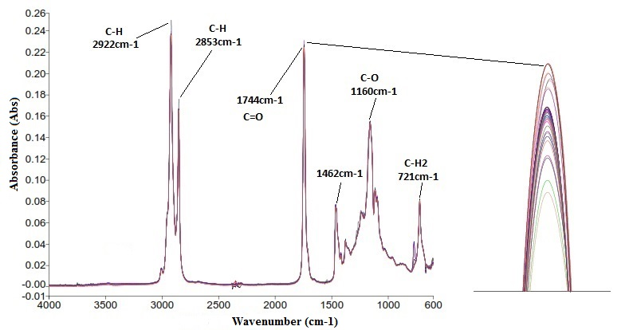
Figure 1. The FT-IR spectra of typical used frying oil. [Inset: Magnification of peak at wavenumber 1744 cm⁻¹]

Fourier transform-near infrared spectroscopy
Figure 2 shows the NIR spectra of used frying oil in the range of 10000 cm⁻¹ to 4000 cm⁻¹. From the spectra, significant absorption bands which are observed at around 8135 cm⁻¹ (C-H stretching second overtone), 7231 cm⁻¹, 7130 cm⁻¹ and 7058 cm⁻¹ are related to the hydroxyl group stretching in first overtone. The absorption band at 5959 cm⁻¹ is assigned to the first overtone of C-H stretching vibration. The small peak around 5330 cm⁻¹ to 5303 cm⁻¹ is attributed to the C=O stretching second overtone. The absorption bands at 4798 cm⁻¹ (C-H stretching absorption (terminal double bond cis-unsaturation)) and 4550 cm⁻¹ (combination of C-H asymmetric stretching in C=C stretching vibration) were also detected. From observation, it was found that the spectra had an extensive overlapping of bands in the overtones and combination region. Therefore, chemometric analysis is an integral part which ensures that the spectroscopic data makes sense due to its power to detect the slightest differences in each sample spectrum obtained by the NIR instrument. The first derivative was applied to the spectra to remove the effect of scattering and noise in the spectra.

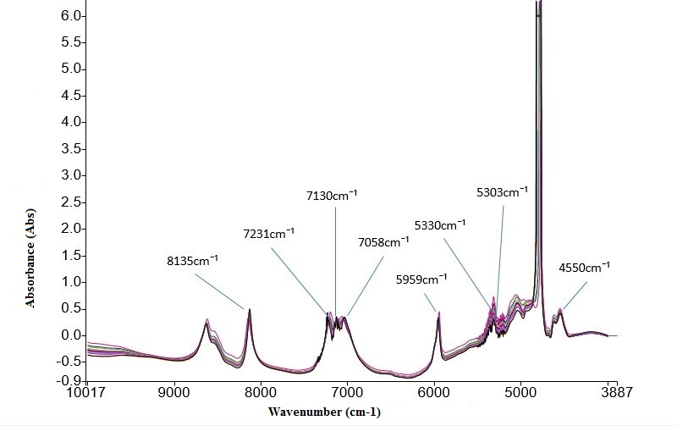
Figure 2. FT-NIR spectra overlay of typical used frying oil

Discriminant analysis (DA) of spectroscopic data for authenticity screening
The discriminant analysis (DA) in the TQ Analyst 10 was adopted using a similar mathematical algorithm as Soft Independent Modelling of Class Analogy (SIMCA). It was needed to classify the authentic oil samples from that of the adulterated oil samples based on selected region or fingerprints. The region of 3934 to 669 cm⁻¹ was used to perform the analysis and different class distribution was calculated for each class, in this case, the authentic and adulterated oil spectra. This discriminant model was set with the confidence level of 95% and the maximum number principal component was 10 by default. Basically, our model was designed to pull the adulterated CPO to the y-axis and away from the x-axis. The higher the concentration of adulteration, the closer they are to the y-axis. On the other hand, the lower the concentration of adulteration, the closer they are to the x-axis.

Fourier transform-infrared spectroscopy
In Figure 3, results show that only two samples were misclassified, whereby the two adulterated samples in the calibration set were classified as authentic. It can be observed from Figure 3 that the authentic samples (triangle) cannot be clearly distinguished from the adulterated samples. Nevertheless, the calculated Mahanolobis distance value of majority of the samples was above 0.7 from the authentic class which implied that the authentic samples could be differentiated from the adulterated samples. The calibration model had a performance index score of 95.1 based on the calculated Mahanolobis distance while the model had explained 99% of the variation. This model could differentiate most of the adulterated samples from the authentic samples with some exception, even though from the visual inspection of the Cooman plot, there is no distinguishable class that can be observed from the result of analysis. The Mahalanobis distance was useful to classify unknown samples into different groups of known measured samples. The rate of successful classification was 96.7% and this rate is comparable to a previous study [18].

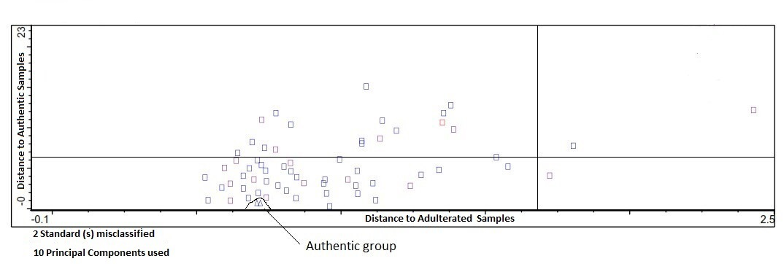
Figure 3. Cooman plot of discriminant analysis of FT-IR (3934 cm⁻¹ to 669 cm⁻¹). The squares represent the calibration set of adulterated samples. The triangles represent the authentic CPO. Blue colour represents calibration set. Black colour represents validation set

Fourier transform-near infrared spectroscopy
Figure 2 shows that NIR spectra consists of broad and overlapping peaks which happened to be the overtone of the fundamental absorption bands. Hence, the spectra had undergone pre-processing of spectrum so that the overlapping peaks could be revealed, and the differences could be picked up by the chemometric analysis. The NIR spectra were treated with the first derivative before the spectral information undergone DA analysis. Discriminant analysis was carried out between 9879 cm⁻¹ to 5000 cm⁻¹ of NIR spectra of Figure 2. The Cooman plot derived from this analysis is presented in Figure 4. The choice of region is due to the fact that a peak where the absorbance exceeded the detection limit existed in the region of 5000 to 4000 cm⁻¹. Hence inclusion of this result would affect the result of the analysis. The outcome of the analysis showed that from a total of 64 samples, 11 adulterated samples were misclassified as authentic samples. The percentage of successful classification was 83.3%.

This model had explained 99% variation of the samples analysed. The 11 misclassified samples consisted of 1 sample adulterated with fish frying oil (10 times,20%), pork frying oil (30 times, 5% and 30 times,10%), mutton frying oil (3 times, 5%, 3 times, 20%, 3 times, 30%, 10 times, 5%, 10 times, 10%, 10 times, 20%, 30 times, 5%, 30 times, 20%). The small number of repetitive frying could be the possible cause of this false positive result. The time interval of frying process was also too short to give a significant impact on the composition of the CPO. Besides, the low percentage of adulteration could also contribute to the misclassification. Previous work has shown that the performance of NIR analysis in the authentication of vegetable oil was lower in comparison to FT-IR and FT-Raman as NIR is more commonly used for quantitative study due to its broad and overlapping spectrum [18].

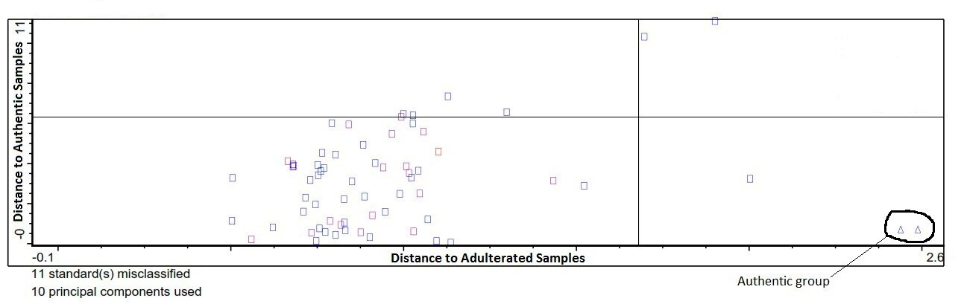
Figure 4. Cooman plot of discriminant analysis of FT-NIR (9879 cm⁻¹-4119 cm⁻¹). The squares represent the calibration set of adulterated samples. The triangles represent the authentic CPO. Blue colour represents calibration set. Black colour represents validation set

Discriminant analysis (DA) of spectroscopic data for quality screening
The discriminant analysis used to assess the spectroscopic data for quality screening of CPO adopted a similar approach to the one used in the discriminant analysis of spectroscopic data for authenticity screening. The MIR model had a misclassification of 38 samples with performance index of 73.4. The success rate of classification was 42.4%. Meanwhile, the model built based on the NIR spectra had misclassified 42 samples into the wrong categories with performance index of 56.4. The Cooman plot of these models is shown in Figure 5 and Figure 6. These two models are considered unsuccessful as the samples could not be correctly classified into their categories. A previous study [19] has shown that the authenticity and evaluation of used oil can be completely distinguished. Hence it might be possible that the short time interval of frying as well as the low temperature used may have caused the indistinguishable results.

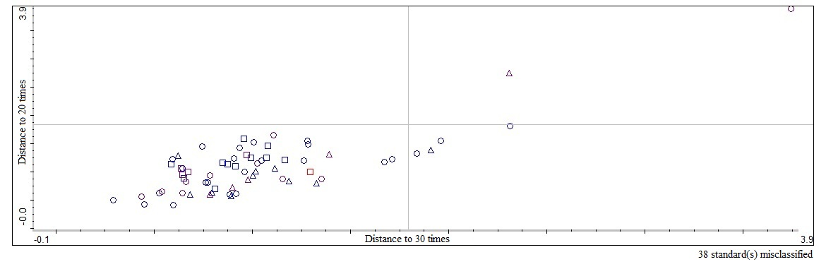
Figure 5. Cooman plot of discriminant analysis of FT-IR (3934 cm⁻¹ to 669 cm⁻¹). The squares represent the oil samples of 30 times frying. The triangles represent the oil samples of 20 times frying. The circles represent the other oil samples (10 times, 5 times and authentic)

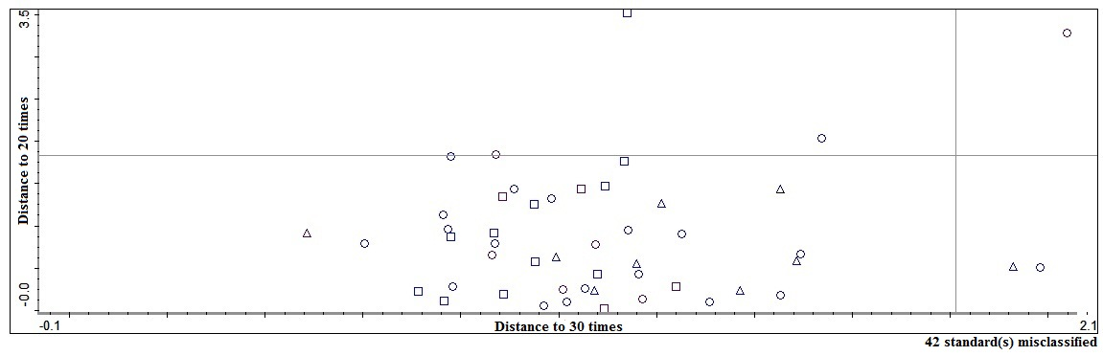
Figure 6. Cooman plot of discriminant analysis of FT-NIR (9879 cm⁻¹- 4119 cm⁻¹). The squares represent the oil samples of 30 times frying. The triangles represent the oil samples of 20 times frying. The circles represent the other oil samples (10 times, 5 times and authentic)

Conclusion
Mid-Infrared and near-infrared spectroscopy combined with chemometrics were assessed to screen for authenticity and quality of CPO. The techniques were successful for authenticity screening with 96.7% correct classification on FT-IR and 83.3% correct classification on FT-NIR, whilst for quality screening, they were not satisfactory with only 42.4% and 36% of successful classification on both FT-IR and FT-NIR. The time taken for the infrared spectrum to be obtained was roughly 3 min for FT-IR and merely 30 s for FT-NIR. This work demonstrated the rapidness, non-destructive, and minimal sample preparation for the screening to take place. These techniques could help to identify the adulteration of edible palm oil which is considered unfit for human consumption. Nevertheless, a lot of improvements can be made to increase the reliability of this classification model for this spectroscopy techniques to be employable for the authenticity and quality screening of edible palm oil in the future.

Acknowledgement
The authors would like to extend their deepest gratitude to the International Atomic Energy Agency (IAEA) for the funding obtained under Coordinated Research Project (CRP) G42007/D52040 with grant number: USM 304/PTEKIND/650887/I111. The authors would also like to appreciate the additional financial assistance given by Universiti Sains Malaysia under the USM bridging grant (304/PTEKIND/6316075). Lastly, the authors are grateful to Nexus Analytic Sdn. Bhd. for the usage of Thermo NIR (Thermo Scientific Nicolet™ iS™5N) for the NIR work.

References
- Malaysia Palm Oil Board. (2015). Overview of the Malaysia Oil Palm Industry 2015. http://palmoilis.mpob.gov.my/index.php/overview-of-industry/408-overview-of-industry-2015. Access online 30/10/2017.
- Nunes, C. A. (2014). Vibrational spectroscopy and chemometrics to assess authenticity, adulteration and intrinsic quality parameters of edible oils and fats. Food Research International, 60: 255-261.
- Park, Y. W., Chang, P.-S. and Lee, J. (2010). Application of triacylglycerol and fatty acid analyses to discriminate blended sesame oil with soybean oil. Food Chemistry, 123(2): 377-383.
- Lerma-García, M. J., Herrero-Martínez, J. M., Ramis-Ramos, G. and Simó-Alfonso, E. F. (2008). Evaluation of the quality of olive oil using fatty acid profiles by direct infusion electrospray ionization mass spectrometry. Food Chemistry, 107(3): 1307-1313.
- Bertran, E., Blanco, M., Coello, J., Iturriaga, H., Maspoch, S. and Montoliu, I. (1999). Determination of olive oil free fatty acid by Fourier transform infrared spectroscopy. Journal of the American Oil Chemists' Society, 76(5): 611-616.
- Yang, H., Irudayaraj, J. and Paradkar, M. M. (2005). Discriminant analysis of edible oils and fats by FTIR, FT-NIR and FT-Raman spectroscopy. Food Chemistry, 93(1): 25-32.
- Moros, J., Garrigues, S. and Guardia, M. D. l. (2010). Vibrational spectroscopy provides a green tool for multi-component analysis. TrAC Trends in Analytical Chemistry, 29(7): 578-591.
- Reich, G. (2005). Near-infrared spectroscopy and imaging: Basic principles and pharmaceutical applications. Advanced Drug Delivery Reviews, 57(8): 1109-1143.
- van de Voort, F. R., Ghetler, A., García-González, D. L. and Li, Y. D. (2008). Perspectives on quantitative Mid-FTIR spectroscopy in relation to edible oil and lubricant analysis: Evolution and Integration of analytical methodologies. Food Analytical Methods, 1(3): 153-163.
- Maggio, R. M., Kaufman, T. S., Carlo, M. D., Cerretani, L., Bendini, A., Cichelli, A. and Compagnone, D. (2009). Monitoring of fatty acid composition in virgin olive oil by Fourier transformed infrared spectroscopy coupled with partial least squares. Food Chemistry, 114(4): 1549-1554.
- Rohman, A., Che Man, Y. B., Hashim, P. and Ismail, A. (2011). FTIR spectroscopy combined with chemometrics for analysis of lard adulteration in some vegetable oils Espectroscopia FTIR combinada con quimiometría para el análisis de adulteración con grasa de cerdo de aceites vegetales. CyTA - Journal of Food, 9(2): 96-101.
- Rohman, A., Che Man, Y. B., Ismail, A. and Hashim, P. (2010). Application of FTIR Spectroscopy for the determination of virgin coconut oil in binary mixtures with olive oil and palm oil. Journal of the American Oil Chemists' Society, 87(6): 601-606.
- Wang, L., Lee, F. S. C., Wang, X. and He, Y. (2006). Feasibility study of quantifying and discriminating soybean oil adulteration in camellia oils by attenuated total reflectance MIR and fiber optic diffuse reflectance NIR. Food Chemistry, 95(3): 529-536.
- Basri, K. N., Hussain, M. N., Bakar, J., Sharif, Z., Khir, M. F. A. and Zoolfakar, A. S. (2017). Classification and quantification of palm oil adulteration via portable NIR spectroscopy. Spectrochimica Acta Part A: Molecular and Biomolecular Spectroscopy, 173: 335-342.
- Blanco, M. and Pagès, J. (2002). Classification and quantitation of finishing oils by near infrared spectroscopy. Analytica Chimica Acta, 463(2): 295-303.
- Che Man, Y. B., Syahariza, Z. A., Mirghani, M. E. S., Jinap, S. and Bakar, J. (2005). Analysis of potential lard adulteration in chocolate and chocolate products using Fourier transform infrared spectroscopy. Food Chemistry, 90(4): 815-819.
- Goburdhun, D., Jhaumeer-Laulloo, S. B., Musruck, R. (2001). Evaluation of soybean oil quality during conventional frying by FTIR and some chemical indexes. International Journal of Food Sciences and Nutrition, 52(1): 31-42.
- Yang, H. and Irudayaraj, J. (2001). Comparison of near-infrared, fourier transform-infrared, and fourier transform-raman methods for determining olive pomace oil adulteration in extra virgin olive oil. Journal of the American Oil Chemists' Society, 78(9): 889.
- Innawong, B., Mallikarjunan, P., Irudayaraj, J. and Marcy, J. E. (2004). The determination of frying oil quality using Fourier transform infrared attenuated total reflectance. LWT - Food Science and Technology, 37(1): 23-28.

