PSYCHROTOLERANT ACTINOBACTERIA Barrientosiimonas humi 39^{T}
AS A SOURCE OF DIKETOPIPERAZINE

(Aktinobakteria Psikrotoleran Barrientosiimonas humi 39^{T} Sebagai
Sumber Sebatian Diketopiperazin)

Andi Rifki Rosandy¹, Yeoh Chiann Ying², Cheah Yoke Kqueen², Muntaz Abu Bakar¹,
Azira Muhamad³, Rozida Mohd Khalid^{1*}

¹School of Chemical Science and Food Technology, Faculty of Science and Technology

Universiti Kebangsaan Malaysia, 43600 Bangi, Malaysia

²Department of Biomedical Sciences, Faculty of Medicine and Health Sciences

Universiti Putra Malaysia, 43400 Serdang, Malaysia

³Malaysia Genome Institute (MGI) National Institute of Biotechnology Malaysia (NIBM),

Malaysia, 43000 Bangi, Malaysia

*Corresponding author: rozidakhalid@ukm.edu.my

Abstract

Barrientosiimonas humi 39^{T} (B. humi) is a psychrotolerant actinobacteria from the family Dermacoccaceae, was first isolated from Antarctica. Five diketopiperazine derivatives: cyclo(-Pro-Val) (1), (-)-cyclo(-Pro-Tyr) (2), cyclo(-Pro-Phe) (3), (+)-cyclo(-Pro-Leu) (4), and L-tyrosine (5) were isolated from the crude extract of B. humi, and this is the first reported compounds isolated from B. humi. The crude extracts were obtained via liquid-liquid fractionation using ethyl acetate as the organic solvent. The compounds were isolated and purified using chromatographic methods such as vacuum liquid chromatography and radial chromatography. The chemical structures were elucidated by nuclear magnetic resonance (NMR) spectroscopy and mass spectrometry.

Keywords: Barrientosiimonas humi 39^{T}, diketopiperazine, Dermacoccaceae

Abstrak

Barrientosiimonas humi 39^{T} (B. humi) merupakan aktinobakteria psikrotoleran termasuk dalam famili Dermacoccaceae, asalnya dipencilkan dari Antartika. Lima terbitan diketopiperazin; siklo(-Pro-Val) (1), (-)-siklo(-Pro-Tir) (2), (-)-siklo(-Pro-Phe) (3), (+)-siklo(-Pro-Leu) (4) dan L-tirosina (5) diasingkan daripada ekstrak mentah B. humi, dan ini merupakan laporan pertama sebatian dipencilkan dari B. humi. Ekstrak mentah diperolehi melalui fraksi cecair-cecair menggunakan etil asetat sebagai pelarut. Sebatian-sebatian dipencilkan dan ditulenkan menggunakan kaedah kromatografi seperti kromatografi cecair vakum dan kromatografi jejari. Struktur kimia ditentukan menggunakan spektroskopi resonans magnetik nuklear (RMN) dan spektrometri jisim.

Kata kunci: Barrientosiimonas humi 39^{T}, diketopiperazine, Dermacoccaceae

Introduction
Psychrotolerant microorganisms are mostly present in the extremely cold environment [1, 2] but exhibit slower growth rates, as they automatically encounter number of growths limiting conditions such as reduced efficiency of nutrient uptake, membrane disorders and decrease in the enzyme activity [3]. The psychrotolerants survive at low temperature due to their better nutritional adaptability [4] and have unique cold shock and cold acclimation proteins and enzymes [5]. In this century, actinobacteria derived from polar region have yielded an array of interesting new metabolites, genes, proteins, and other products with potential for commercial uses [6]. Polar actinobacteria often provide plentiful and diverse two bioactive alkaloids which are medicinally important such as nitrosporeusines A and nitrosporeusines B produced by Streptomyces nitrosporeus CQT14-24 [7].

The search for new and bioactive secondary metabolites is still going on, particularly from the extremophilic microorganisms. The psychrotolerant actinobacteria can be a good tool to explore the new bioactive metabolites of pharmaceutical importance due to uniqueness of their habitat and changes in the metabolic systems, amenable for their adaptation to extreme cold environmental conditions. The genus Barrientosiimonas (Bar.ri.en.to.si.i.mo′nas. N.L. n. Barrientosia Barrientos Island, an island in the Antarctic; L. fem. n. monas a unit, a monad; N.L. fem. n. Barrientosiimonas a bacterium isolated from Barrientos Island) was validly published early in the year 2013 with Barrientosiimonas humi 39^{T} (actinobacteria/gram-positive) as the type and only species [8]. Barrientosiimonas humi 39^{T} belongs to the family Dermacoccaceae [9] and was isolated from soil in Barrientos Island, Antarctica [8]. It is growth optimally at temperatures less than 15 °C and able to grow above 20 °C was called psychrotolerant [10]. So far, the chemical structures from Barrientosiimonas humi 39^{T} have not reported. The main objective of this paper is to describe the isolation and structure characterization from the ethyl acetate extract of Barrientosiimonas humi 39^{T}.

Materials and Methods

Biological materials

The B. humi 39^{T} was isolated from soil sampled at Barrientos Island (Antarctica) (62° 24ʹ 26.0ʺ S 59° 44ʹ 49.1ʺ W, 62° 24ʹ 24.4ʺ S 59° 44ʹ 44.2ʺ W and 62° 24ʹ 28.5ʺ S 59° 44ʹ 52.3ʺ W) during the XI Ecuadorian Antarctic Expedition in 2007. The cultural characteristics of strain 39^{T} were determined following growth on tap-water agar [11], solidified rich R medium [12] and ISP 2–7 [13] for 7 days at 28 °C. The culturing of B. humi 39^{T} was conducted in collaboration with the Department of Biomedical Sciences, UPM, Serdang Malaysia.

Cultivation of yeast

A single bacterial colony of B. humi 39^{T} will be inoculated into an Erlenmeyer flask (500 mL) containing 100 mL of actinomyces broth and incubated in an orbital shaker at 28 °C, 200 rpm for 72 hours. The seed culture (5%) will be then inoculated into Erlenmeyer flasks (1 L × 4) containing same media (300 mL × 4) and incubated at 28 °C with shaking at 200 rpm for 7 days [13, 14].

Extraction and isolation
The production culture was centrifuged (10,000 rpm, 4 °C, 5 minutes). The supernatant was extracted three times with ethyl acetate, and concentrated using a rotary evaporator. The EtOAc extract (300 mg) of B. humi 39^{T} was subjected to radial chromatography (RC) with 1 mm thickness silica gel on a round glass plate and eluted with the mixtures of CHCl₃ and MeOH with increasing polarity (started with CHCl₃/MeOH, 9 :1). The eluates showing the same profile on thin layer chromatography (TLC) were combined to give three fractions (I-III). Purification of fraction I (1-4) (29.7 mg) was carried out using RC with a silica gel plate of 0.5 mm thickness eluted with CHCl₃ and MeOH (9.2:0.8) in 5% polarity increment to yield compound 1 (1 mg).and 2 (1.5 mg). Purification of fraction III (5-7) (48.8 mg) was conducted utilizing another RC with silica gel plate of 0.5 mm thickness. Elution with CHCl₃ and MeOH (8.5:1.5) produced compounds 3 (1.5 mg), 4 (2 mg), and 5 (2 mg), respectively.

Results and Discussion
Characterization study
Cyclo(-Pro-Val) (1) is a needle crystal. m.p.: 218-219 °C. ESI-MS [M + H]⁺ at m/z: 197. IR ῡ_{max} (ATR) cm⁻¹: 3191, 2956, 1640, 1453, 1110, 922. ¹H NMR (DMSO, 700 MHz): δ_{H} 3.92 (d, J = 7 Hz, 1H, H-3), 7.93 (br-s, 1H, 4-NH), 4.11 (t, J = 7 Hz, 1H, H-6), 1.82 (m, 1H, H-7), 2.14 (m, 1H, H-7), 1.86 (m, 1H, H-8), 1.80 (m, 1H, H-8), 3.33 (t, J = 7 Hz, 1H, H-9), 3.38 (t, J = 7 Hz, 1H, H-9), 2.32 (m, 1H, H-10), 0.99 (d, J = 7 Hz, 3H, H-11), 0.83 (d, J = 7 Hz, 3H, H-12) ppm. NMR APT (DMSO,175 MHz) (Figure 2): δ_{C} 165.8 (Cq-2), 59.9 (CH-3), 170.9 (Cq-5), 58.7 (CH-6), 28.3 (CH₂-7), 22.4 (CH₂-8), 45.1 (CH₂-9), 28.2 (CH-10), 18.7 (CH₃-11), 16.8 (CH₃-12) ppm.

(-)-Cyclo(-Pro-Tyr) (2) is a colorless amorphous solid. ${[α]}_{D}^{20}$ -43.1 (c 0.14, ethanol). ESI-MS [M + H]⁺ ion at m/z: 261. IR ῡ_{max} (ATR) cm⁻¹: 3248, 2927, 2853, 1747, 1658, 1449, 1252, 1174, 1114, 1017, 858. ¹H NMR (CD₃OD, 700 MHz) δ_{H} 4.37 (t, J = 7 Hz, 1H, H-3), 7.65 (br-s, 1H, 4-NH), 4.05 (t, J = 7 Hz, 1H, H-6), 1.25 (q, J₁ = 7 Hz, 1H, H-7), 2.12 (m, 1H, H-7), 1.82 (m, 2H, H-8), 3.57 (t, J = 7 Hz, H-9), 3.36 (t, J = 7 Hz, H-9), 3.07 (d, J = 7 Hz, 2H, H-10), 7.06 (d, J = 7 Hz, 2H, H-2`/6`), 6.74 (d, J = 7 Hz, 2H, H-3`/5`), 9.15 (br-s, 1H, 4`-OH) ppm. NMR APT (CD₃OD, 175 MHz) (Figure 5): δ_{C} 165.7 (Cq-2), 56.6 (CH-3), 169.6 (Cq-5), 58.7 (CH-6), 28.0 (CH₂-7), 21.4 (CH₂-8), 44.6 (CH₂-9), 36.3 (CH₂-10), 126.3 (Cq-1`), 130.7 (CH-2`/6`), 115.0 (CH-3`/5`), 156.1 (Cq-4`) ppm.

(-)-Cyclo(-Pro-Phe) (3) is a colorless solid. m.p.: 144-145 °C. ${[α]}_{D}^{20}$-70.00 (c 0.02, MeOH). Turned to yellow with anisaldehyde/sulphuric acid. ESI-MS [M + H]⁺ ion at m/z 245. ¹H NMR (CD₃OD, 700 MHz): δ_{H} 4.38 (t, 7) 1H (H-3), 7.78 (br-s) 1H (4-NH), 4.06 (t, 7) 1H (H-6), 1.23 (m) 1H (H-7a), 2.11 (m) 1H (H-7b), 1.82 (m) 2H (H-8), 3.57 (m) 1H (H-9a), 3.37 (m) 1H (H-9b), 3.30 (dd, 7, 14) 1H (H-10a), 2.98 (dd, 7, 14) 1H (H-10b), 7.22 (d, 7) 2H (H-2`/6`), 7.27 (t, 7) 2H (H-3`/5`), 7.32 (t, 7) 1H (H-4`) ppm. NMR APT (CD₃OD, 175 MHz) (Figure 8): δ_{C} 165.6 (Cq-2), 56.5 (CH-3), 169.4 (Cq-5), 58.7 (CH-6), 28.0 (CH₂-7), 21.3 (CH₂-8), 44.5 (CH₂-9), 38.9 (CH₂-10), 126.2 (Cq-1`), 130.4 (CH-2`/6`), 126.9 (CH-3`/5`), 128.1 (CH-4`) ppm.

(+)-Cyclo(-Pro-Leu) (4) is a white powder. ${[α]}_{D}^{20}$ +28.1 (c 0.032, ethanol). ESI-MS [M + H]⁺ ion at m/z: 211. IR ῡ_{max} (ATR) cm⁻¹: 3222, 2958, 2930, 2872, 1686, 1676, 1426, 1302, 1275, 1235, 1157, 1102, 1032, 996-919. ¹H NMR (DMSO, 700 MHz): δ_{H} . 4.00 (t, J = 7 Hz, 1H, H-3), 7.99 (br-s, 1H, 4-NH), 4.18 (t, J = 7 Hz, 1H, H-6), 2.12 (m, 1H, H-7), 1.89 (m, 1H, H-7), 1.80 (m, 2H, H-8), 3.37 (t, J = 7 Hz, 1H, H-9), 3.36 (t, J = 7 Hz, 1H, H-9), 1.75 (m, 1H, H-10), 1.36 (m, 1H, H-10), 1.85 (m, 1H, H-11), 0.86 (d, J = 7 Hz, 3H, H-12), 0.85 (d, J = 7 Hz, 3H, H-13) ppm. NMR APT (DMSO, 175 MHz): δ_{C} 167.1 (Cq-2), 53.1 (CH-3), 171.1 (Cq-5), 58.9 (CH-6), 27.9 (CH₂-7), 22.9 (CH₂-8), 45.3 (CH₂-9), 38.1 (CH₂-10), 24.5 (CH-11), 23.2 (CH₃-12), 22.3 (CH₃-13) ppm.

L-Tyrosine (5) is a colorless amorphous solid. m.p.: 343-344 °C. ESI-MS [M + H]⁺ at m/z: 182. ¹H NMR (CD₃OD, 700 MHz): δ_{H} 6.84 (d, J = 7 Hz, 2H, H-2/6), 6.68 (d, J = 7 Hz, 2H, H-3/5), 9.23 (br-s, 1H, 4-OH), 2.51 (d, J = 7 Hz, H-7), 2.11 (dd, J₁ = 7 Hz, J₂ = 14 Hz, 1H, H-7), 3.85 (t, J = 7 Hz, 1H, H-8), 7.77 (br-s, 2H, 8-NH₂), 10.88 (br-s, 1H, 9-OH) ppm. NMR APT (CD₃OD, 175 MHz): δ_{C} 127.0 (Cq-1), 131.2 (CH-2/6), 115.5 (CH-3/5), 156.5 (CH-4), 39.3 (CH₂-7), 56.2 (CH₂-8), 166.7 (Cq-9) ppm.

Fraction I was applied to PF254 Gypsum (Merck 7749, size 0.040-0.063 mm) followed by TLC to afford compound 1 that turned to blue with chlorine/anisidine and violet when sprayed with anisaldehyde/sulphuric acid. The ¹H NMR (Figure 1) spectrum of 1 contained three methine proton signals; two methines δ_{H} 4.11 (H-6), 3.92 (H-3) were possibly connected to heteroatoms. A further methine signal was found at δ_{H} 2.32 (H-10) bind a geminal dimethyl proton at δ_{H} 18.7 (CH₃-11) and 16.8 (CH₃-12). Additionally, three saturated non-equivalent methylenes signals at δ_{H} 1.82-2.14 (H-7), (H-7), 1.80-1.86 (H-8), and 3.33-3.38 (H-9) were attributed to a pyrrolidine ring. The ESI mass spectrum (Figure 3) showed molecular ion peaks at m/z ESI-MS [M + H]⁺ which fixed the molecular weight as 197 Dalton. Compound 1 was found to have a molecular formula of C₁₀H₁₆N₂O₂ by LRESIMS. A search in the Anti-Base using all of the spectroscopic data above led to cyclo(-Pro-Val) (1) as a result. Cyclo(-Pro-Val) (1) was previously isolated from Alternaria altenata [15], Aspergillus fumigatus Brazilian strain [16] and Pseudomonas aeruginosa [17].

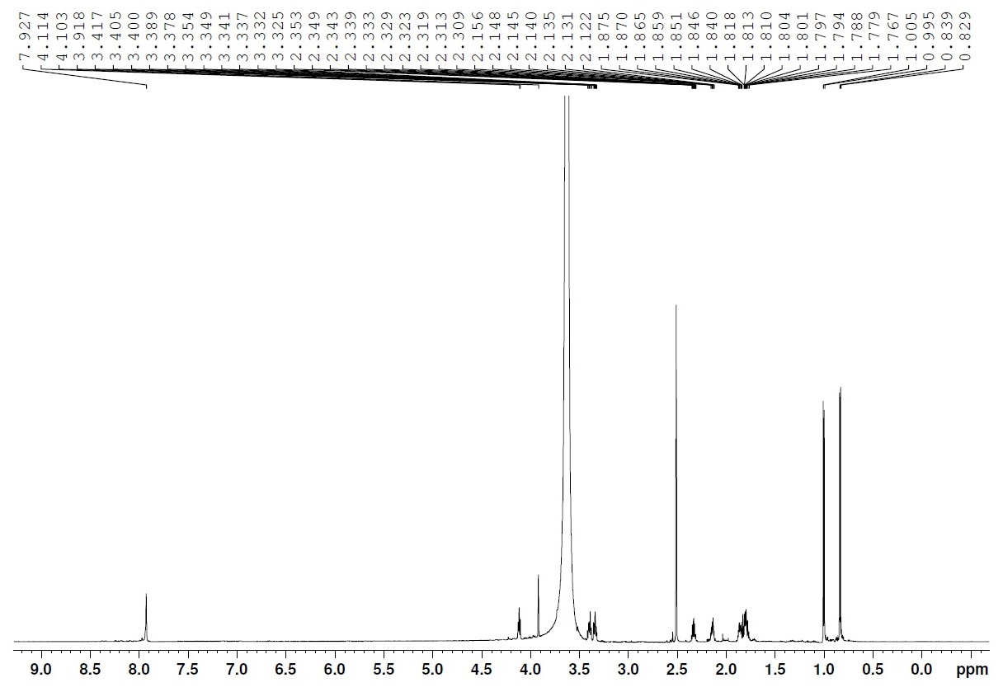
4-NH

H-11

H-12

H-9

H-3

H-6

H-10

H-7 & H-8

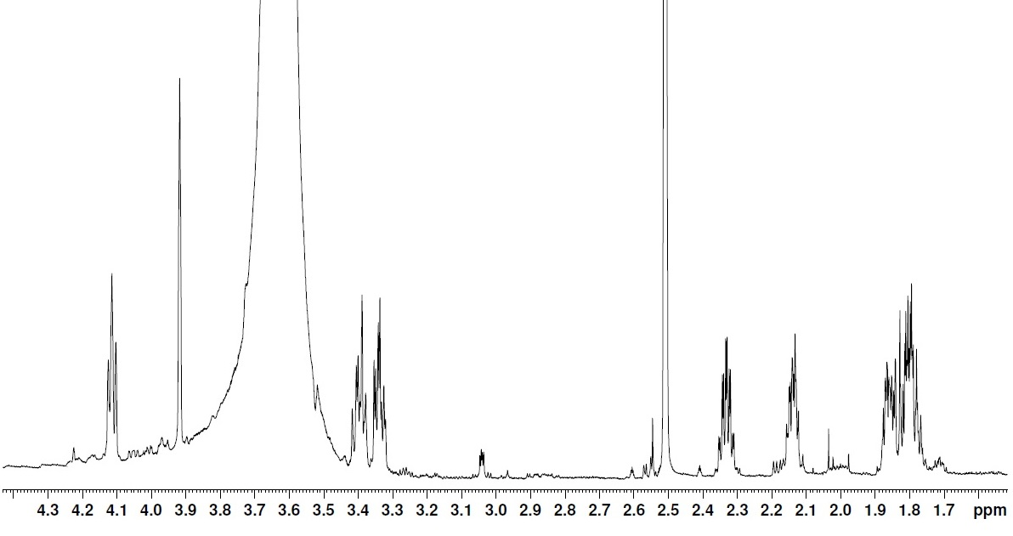
Figure 1. The ¹H-NMR (DMSO, 700 MHz) Spectrum of Cyclo(-Pro-Val) (1)
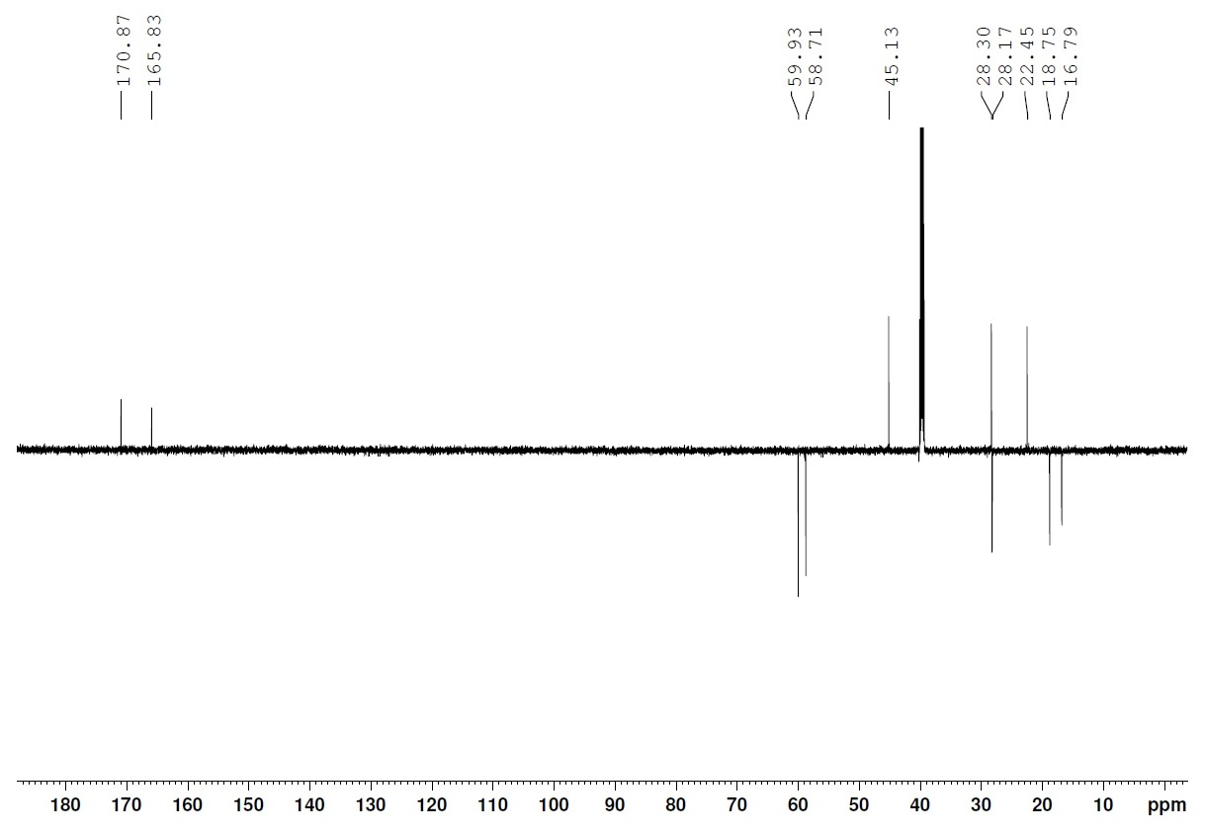
CH₂/Cq = ↑
CH₃/CH = ↓
C-5
C-2
C-3
C-6
C-9
C-7
C-10
C-8
C-11
C-12
Figure 2. The ¹³C NMR-APT (DMSO, 175 MHz) Spectrum of Cyclo(-Pro-Val) (1)
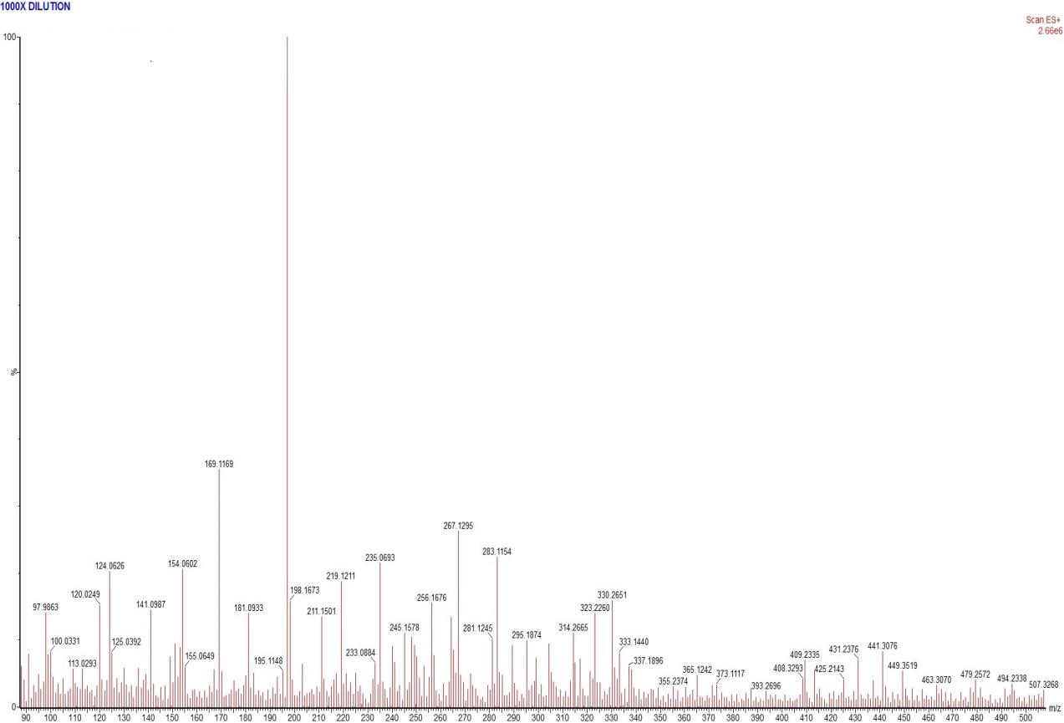
[M+H]⁺ m/z 197

Figure 3. The LC-MS Spectrum of Cyclo(-Pro-Val) (1)
Compounds 2 was found in Fraction I as a UV absorbing spot, which stained to violet with sulphuric acid. The ¹H NMR spectrum (Figure 4) of Compound 2 showed two ortho-coupled signals at δ_{H} 7.05 (H-2', 6') and 6.79 (H-3', 5'), which illustrated as an AA'-BB' system of a 1,4-disubstituted aromatic ring, as well as two signals at δ_{H} 4.37 and 4.05 for two methines attached to electron withdrawing substituents. The spectrum proton of Compound 2 showed also two doublet of doublets for an ABX system of a methylene group at δ_{H} 3.46 and 2.79 (CH2-10), as well as three methylene multiplets (CH₂-7) (δ_{H} 2.33, 1.99) attached to a heteroatom and CH2-8, 9 (δ_{H} 2.01, 1.93, 3.63, 3.57). The ESI mass spectra (Figure 6) determined the molecular weight of Compound 2 as 261 Dalton by (+)-ESI mode. The structure was further confirmed as cyclo(-Pro-Tyr) (2) by comparison with an authentic sample and spectra from our collection [18]. (-)-Cyclo(-Pro-Tyr) (2) was previously isolated from Pseudomonas fluorescens GcM5-1A [19], Streptomyces sp. H7372 and ML 1532 [20, 21], Pseudomonas aeruginosa [17] and Lysobacter capsici AZ78 [22].

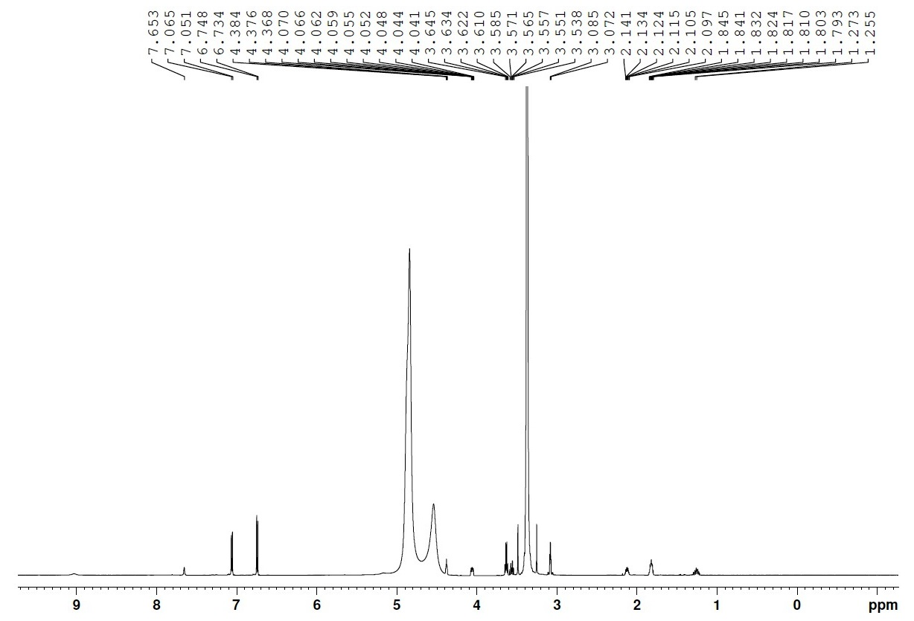
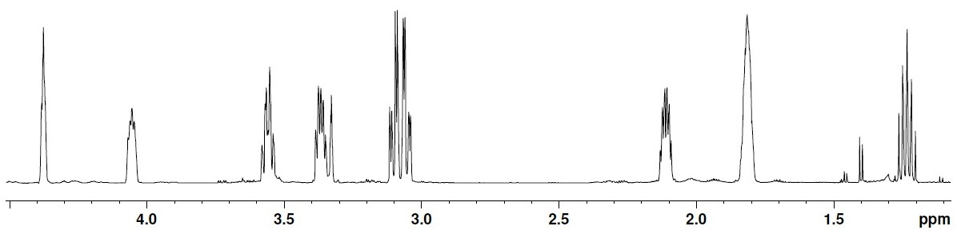
H-3`/5`

H-2`/6`

4`-OH

4-NH

H-7 & H-8

H-9

H-10

H-3

H-6

Figure 4. The ¹H-NMR (CD₃OD, 700 MHz) Spectrum of (-)Cyclo(-Pro-Tyr) (2)
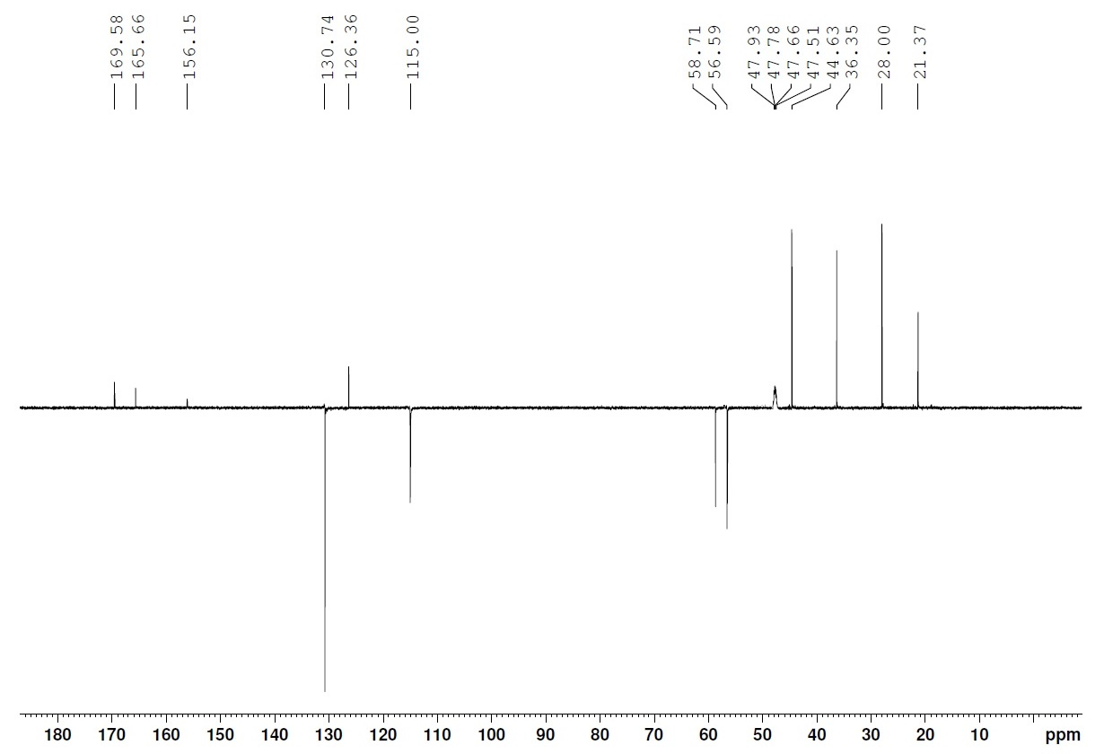
C-9

C-10

C-7

C-8

C-3

C-6

C-1`

C-3`/5`

C-2`/6`

C-4`

C-2

C-5

CH₂/Cq = ↑
CH₃/CH = ↓

Figure 5. The NMR-APT(CD₃OD, 175 MHz) Spectrum of (-)Cyclo(-Pro-Tyr) (2)
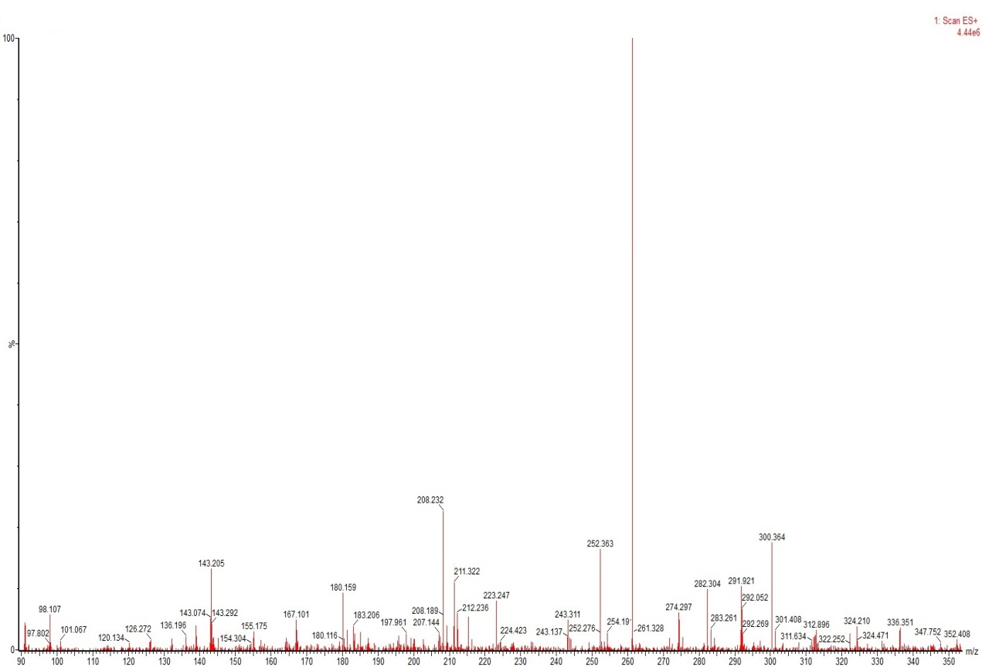
[M+H]⁺ m/z 261

Figure 6. The LC-MS Spectrum of (-)Cyclo(-Pro-Tyr) (2)
Compounds 3 were found in Fraction III as a UV absorbing spot, which stained to violet with anisaldehyde/sulphuric acid. The ¹H NMR spectrum (Figure 7) of compound 2 showed two ortho-coupled signals at δ_{H} 7.22 (H-2', 6') and 7.27 (H-3', 5'), which pointed to an AA'-BB' system of a 1,4-disubstituted aromatic ring, as well as two signals at δ_{H} 4.38 and 4.06 for two methines attached to electron withdrawing substituents. The spectrum proton of Compound 2 also depicted two doublet of doublets for an ABX system of a methylene group at δ_{H} 3.30 and 2.98 (CH₂-10), as well as three methylene multiplets (CH₂-7) (δ_{H} 1.23, 2.11) attached to a heteroatom and CH₂-8, 9 (δ_{H} 1.82, 3.57, 3.37). The ESI mass spectra (Figure 9) determined the molecular weight of Compound 3 as 245 Dalton by (+)-ESI mode. The structure was further confirmed as (-)-cyclo(-Pro-Phe) (3) previously isolated from microbial Streptomyces sudanensis. A4.4 [23].

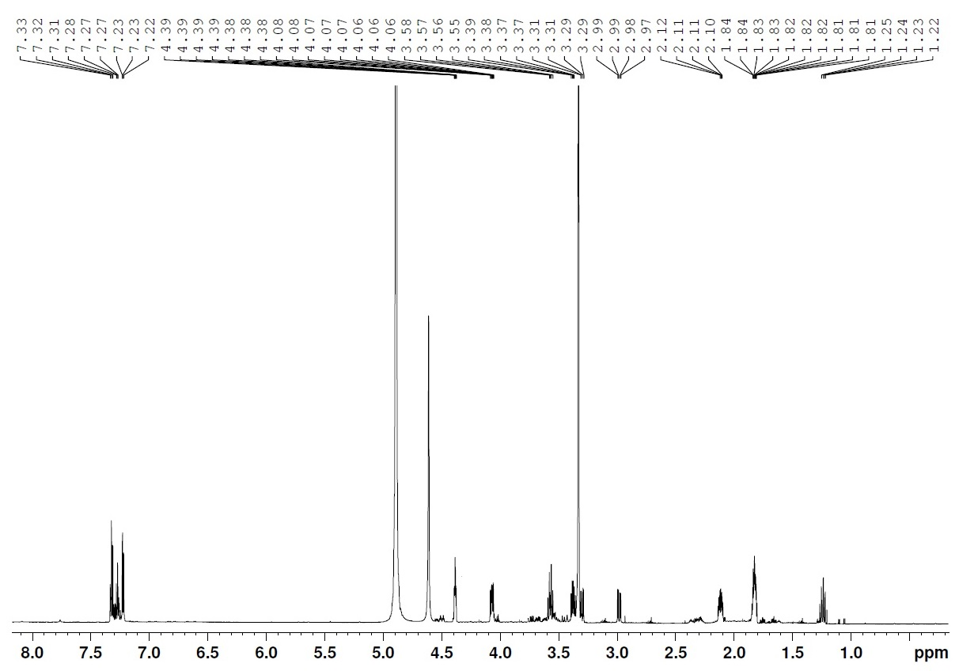
H-6
H-3
H-9
H-10
H-7
H-8
H-7
Aromatic region

Figure 7. The ¹H-NMR (CD₃OD, 700 MHz) Spectrum of Cyclo(-Tyr-Phe) (3)
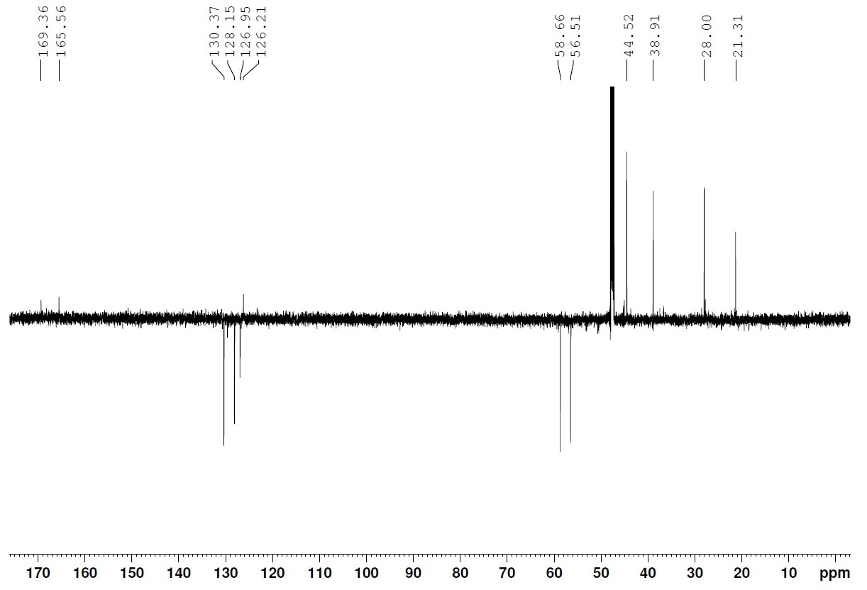
C-9
C-10
C-7
C-8
C-6
C-3
C-1`
C-3`/5`
C-4`
C-2`/6`
C-5
C-2
CH₂/Cq = ↑
CH₃/CH = ↓
Figure 8. The NMR-APT (CD₃OD, 175 MHz) Spectrum of Cyclo(-Tyr-Asn) (3)
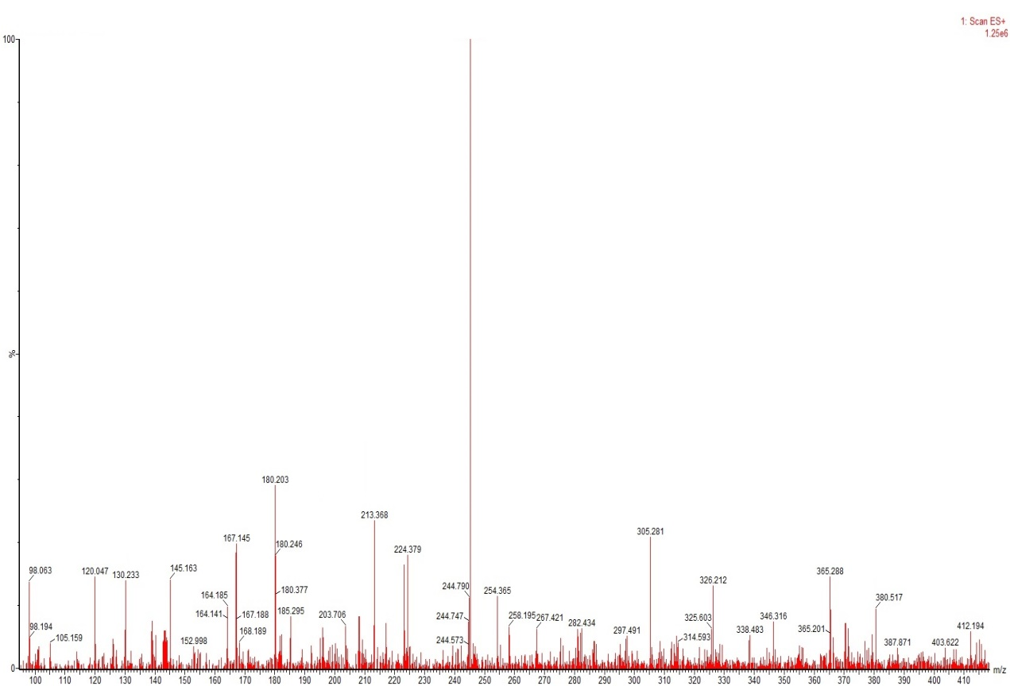
[M+H]⁺ m/z 245
Figure 9. The LC-MS Spectrum of Cyclo(-Tyr-Phe) (3)
(+)-Cyclo(-Pro-Leu) (4), ${[α]}_{D}^{20}$ +28.1 (c 0.032, ethanol), was isolated as a white amorphous material with molecular formula C₁₁H₁₈N₂O₂, obtained by ESI–MS (Figure 11) [M + H]⁺ m/z 211. The IR spectrum showed bands attributed to the aliphatic carbons (2958, 2930, 2872 cm⁻¹) and amide (1686, 1676 cm⁻¹) functional groups. The ¹H NMR spectrum (Figure 10) of compound 4 indicated the presence of three methines at H-3, H-6 and H-11; four methylenes at H-7, H-8, H-9 and H-10; and two non-equivalents dimethyl at H-12 and H-13 (Table 1). NMR APT spectrum (Figure 12) exhibited the presence of 11 carbon signals corresponding to two methyls, four methylenes, three methines and two quaternary carbons. The observation of the quaternary carbons at δ_{C} 167.1 (C-2) and 171.1 (C-5) suggested that these carbon signals were due to the carbonyl carbon of the amide groups. The DBE value of four indicated that this compound was containing two double bonds and two cyclic aliphatic. (+)-Cyclo(Pro-Leu) previously isolated from the Gram-negative Proteobacteria of Burkholderia cenocepacia and Serratia marcescens [15], Alternaria alternata [24], the bacteria Pseudoalteromonas sp. [25] and Vibrio alginolyticus [26].
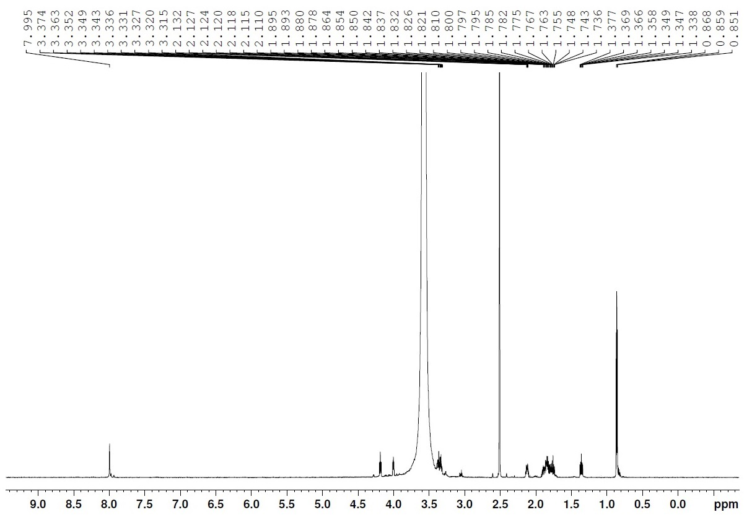
4-NH

H-9

H-7, H-8 & H-11

H-3

H-6

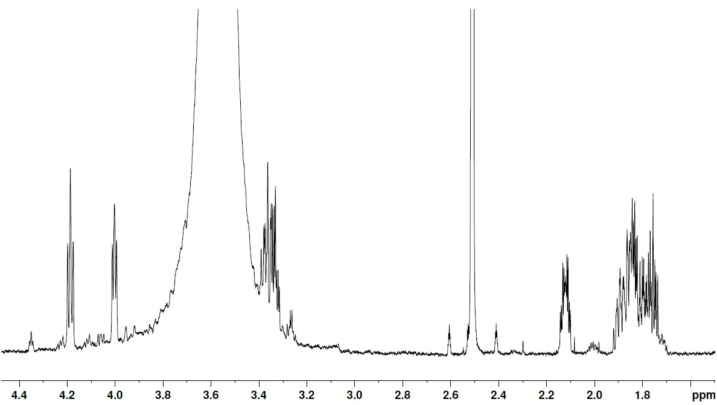
Figure 10. The ¹H-NMR (DMSO, 700 MHz) Spectrum of (+)Cyclo(-Tyr-Leu) (4)
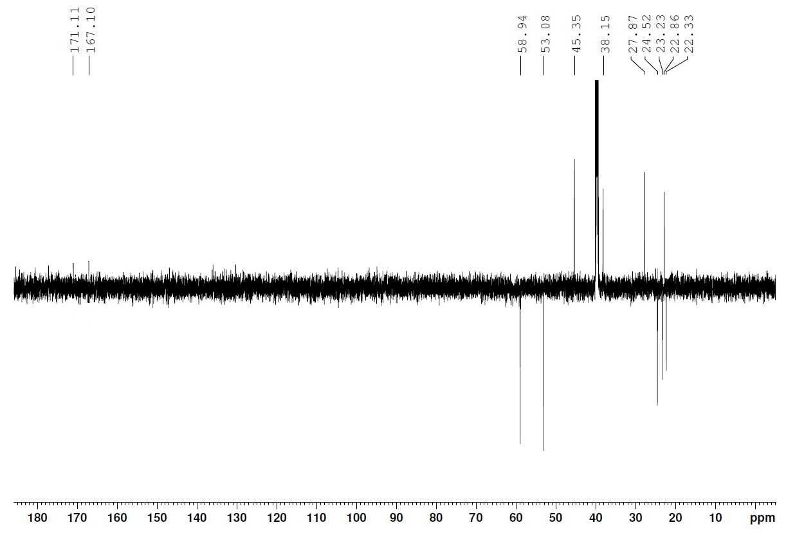
C-11

C-12

C-13

C-9

C-10

C-7

C-8

C-6

C-3

C-5

C-2

CH₂/Cq = ↑
CH₃/CH = ↓
Figure 11. The NMR-APT (DMSO, 175 MHz) Spectrum of (+)Cyclo(-Tyr-Leu) (4)

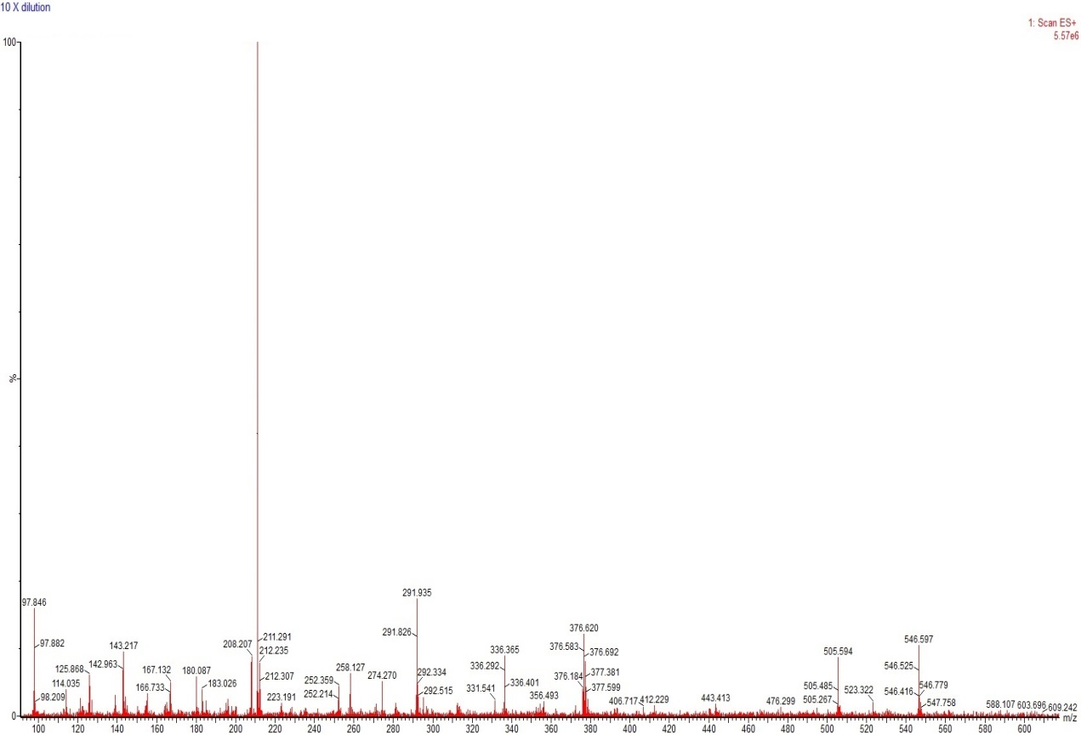
[M+H]⁺ m/z 211

Figure 12. The LC-MS Spectrum of (+)Cyclo(-Tyr-Leu) (4)
Compound 5 was isolated as white amorphous from a UV absorbing zone in fraction III, which turned to violet with anisaldehyde reagent. The ¹H NMR spectrum (Figure 13) of compound 5 showed two ortho-coupled signals at δ_{H} 6.84 (H-2, 6) and 6.68 (H-3, 5), which pointed to an AA'-BB' system of a 1,4-disubstituted aromatic ring. In aliphatic region there was a methylene group at δ_{H} 2.11 and a methine at δ_{H} 3.85 ppm in the amino acid group. The NMR APT spectrum (Figure 14) exhibited seven carbon signals, among them the carbonyl signal of an amino acid derivative at δ_{C} 166.7 ppm and a methylene (C-7) as a link between amino acid with phenol. The ESI mass spectrum (Figure 15) indicated the peak at m/z 182 [M + H]⁺ established the molecular formula as C₉H₁₁NO₃. A search in Anti-Base supported by ¹H, ¹³C NMR, and MS spectroscopic data led to L-tyrosine (5) [27]. This compound previously isolated from bacteria B. flavus AJ-11955 [28] and Klebsiella sp. [29].
Out of five compounds, four are dipeptides with proline as one of its amino acid, and this is probably due to the nature of this microbe that can survive very low temperature. Some microbes were reported to produce higher amounts of L-proline at very low temperature as a cold adaptation mechanism (Terao et al. 2003; Chen & Dickman 2005). L-proline is a protectant stress agent that can moderate stability of cell membrane and control cell damage due to freeze-thaw mechanism during extreme low temperature (Takagi 1997; Ando et al. 2007; Takagi 2008).

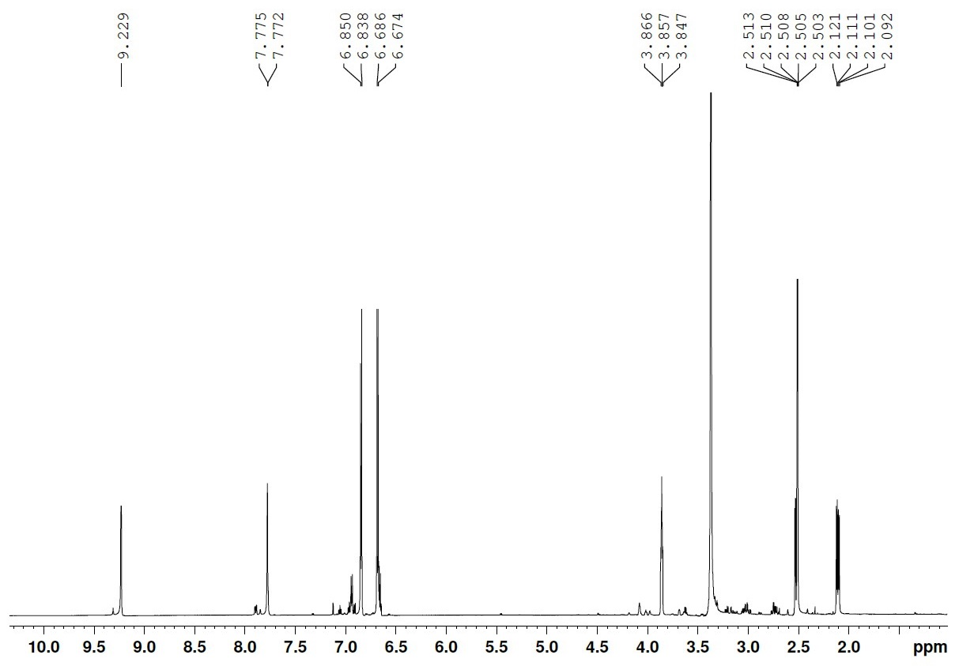
9-OH

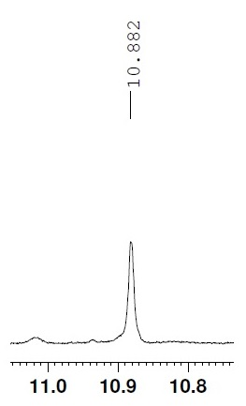
4-OH

8-NH₂

H-2/6
H-3/5
H-8

H-7

Figure 13. The ¹H-NMR (DMSO, 700 MHz) Spectrum of L-Tyrosine (5)
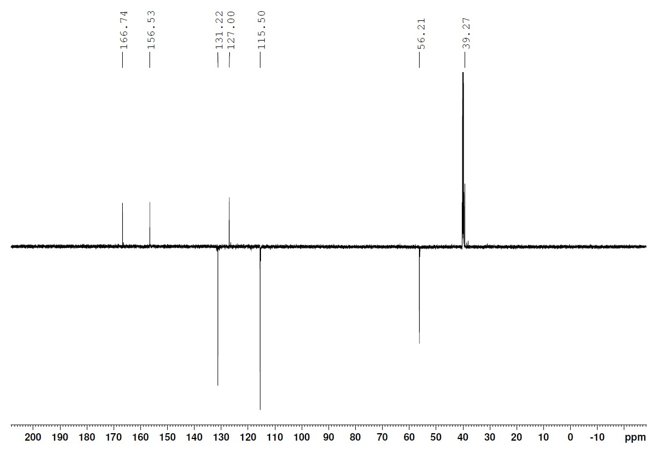
C-9

C-4

C-1

C-2/6

C-3/5

C-8

C-7
CH₂/Cq = ↑
CH₃/CH = ↓
Figure 14. The NMR-APT (DMSO, 175MHz) Spectrum of L-Tyrosine (5)
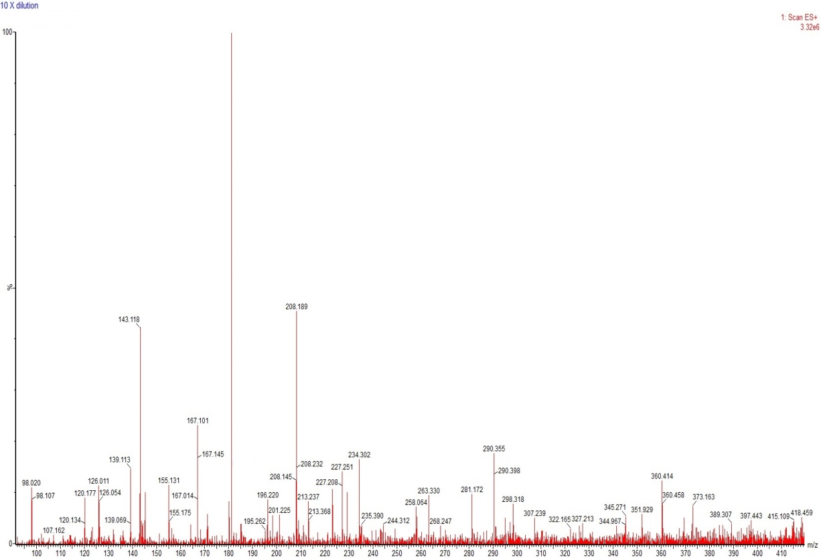
[M + H]⁺ = m/z182
Figure 15. The LC-MS Spectrum of L-Tyrosine (5)

Conclusion
Five diketopiperazine derivatives namely cyclo(-Pro-Val) (1), (-)-cyclo(-Pro-Tyr) (2), (-)-cyclo(-Pro-Phe) (3), (+)-cyclo(-Pro-Leu) (4), and L-tyrosine (5) were isolated and reported for the first time from psychrotolerant actinobacteria Barrientosiimonas 39^{T}. These proline-based diketopiperazines probably act as modulators or molecules that play a part in cold-adaptation of psychrotolerant. All the compounds reported in the present study were not subjected to further bioactivity studies due to insufficient amounts.

Acknowledgement
We would like to thank the School of Chemical Sciences and Food Technology, Faculty of Science and Technology, Universiti Kebangsaan Malaysia (UKM); Malaysia Genome Institute (MGI) for providing research facilities. We would also like to express our gratitude to the Indonesia Endowment Fund for Education (LPDP), and Yayasan Penyelidikan Antartika Sultan Mizan for the financial support through the following research grant ST-2017-017.

References

- Afzal, O., Kumar, S., Haider, M. R., Ali, M. R. and Kumar, R. (2015). A review on anticancer potential of bioactive heterocyclic quinoline. European Journal of Medicinal Chemistry, 97: 871-910.
- Anderson, B., Smedsgaard, J. and Frisvad, J. C. (2004). Penicillium expansum: Consistent production of patulin, chaetoglobosins, and other secondary metabolites in culture and their natural occurrence in fruit products. Journal of Agricultural and Food Chemistry, 52: 2421-2428.
- Ando, A., Nakamura, T., Murata, Y., Takagi, H. and Shima, J. (2007). Identification and classification of genes required for tolerance to freeze–thaw stress revealed by genome-wide screening of Saccharomyces cerevisiae deletion strains. FEMS Yeast Research 7: 244-253.
- Antipova, T. V., Zhelifonova, V. P., Baskunov, B. P., Ozerskaya, S. M., Ivanushkina, N. E. and Kozlovsky, A. G. (2011). New producers of biologically active compounds-fungal strains of the genus Penicillium isolated from permafrost. Applied Biochemistry and Microbiology, 47(3): 288-292.
- Araki, K. (1986). Tryptophan, phenylalanine, and tyrosine. In: Aida et al. (eds) Biotechnology of amino acid production. Kodansha/Elsevier; Tokyo: p. 247-256.

- Archer, D. B., Connerton, I. F. and MacKenzie, D. A. (2008). Filamentous fungi for production of food additives and processing aids. Advances in Biochemical Engineering/Biotechnology, 111: 99-147.
- Atlas, R. M. (1993). Handbook of microbiological media. Edited by L.C. Parks, CRC Press, Boca Raton.
- Cheenpracha, S., Borris, R. P., Tran, T. T., Jee, J. M., Seow, H. F., Cheah, H. Y., Ho, C. C. and Chang, L. C. (2011). Three new amides from Streptomyces sp. H7372. Journal of the Brazilian Chemical Society, 22(2): 223-229.
- Chen, C. and Dickman, M. B. (2005). Proline suppresses apoptosis in the fungal pathogen Colletotrichum trifolii. Proceedings of the National Academy of Sciences, 102(9): 3459-3464.
- Cole, R. J. and Cox, R. H. (1981). Handbook of toxin fungal metabolites. Academic Press, New York.
- De Pascale, D., De Santi, C., Fu, J. and Landfald, B. (2012). The microbial diversity of Polar environments is a fertile ground for bioprospecting. Marine Genomics, 8: 15-22.
- Frisvad, J. C., Larsen, T. O., Dalsgaard, P. W., Seifert, K. A., Louis-Seize, G., Lyhne, E. K., Jarvis, B. B., Fettinger, J. C. and Overy, D. P. (2006). Four psychrotolerant species with high chemical diversity consistently producing cycloaspeptide A, Penicillium jamesonlandense sp. nov., Penicillium ribium sp. nov., Penicillium soppii and Penicillium lanosum. International Journal of Systematic and Evolutionary Microbiology, 56: 1427-1437.
- Furtado, N. A. J. C., Pupo, M. T., Carvalho, I., Campo, V. L., Duarte, M. C. T., and Bastos, J. K. (2005). Diketopiperazines produced by an Aspergillus fumigatus Brazilian strain. Journal of the Brazilian Chemical Society, 16(6B): 1448-1453.
- Gordon, R. E., Barnett, D. A., Handerhan, J. E. and Pang, C. (1974). Nocardia coeliaca, Nocardia autotrophica, and the nocardin strain. International Journal of Systematic and Evolutionary Microbiology, 24: 54-63.
- Guo, Q., Guo, D., Zhao, B., Xu, J. and Li, R. (2007). Two cyclic dipeptides from Pseudomonas fluorescens GcM5-1A carried by the pine wood nematode and their toxicities to Japanese black pine suspension cells and seedlings in vitro. Journal of Nematology, 39(3): 243-247.
- Hamza, A. A., Ali, H. A., Clark, B. R., Murphy, C. D. and Elobied, E. A. (2013). Cyclo (L-phenyl, L-prolyl). Diketopiperazines from a newly isolated Streptomyces sudanensis. A4.4. Journal of Biotechnology and Pharmaceutical Research, 4(1): 1-7.
- Hagino, H. and Nakayama, K. (1973). L-Tyrosine production by analog-resistant mutants derived from a phenylalanine auxotroph of Corynebacterium glutamicum. Agricultural and Biological Chemistry, 37(9): 2013-2023.
- Laatsch, H. (2010). AntiBase a data base for rapid dereplication and structure determination of microbial natural products. Wiley-VCH. Wein-heim. Germany.
- Lee, L. H., Cheah, Y. K., Sidik, S. M., Xie, Q. Y., Tang, Y. L., Lin, H. P., Ab Mutalib, N. S. and Hong, K. (2013). Barrientosiimonas humi gen. nov., sp. nov., an actinobacterium of the family Dermacoccaceae. International Journal of Systematic and Evolutionary Microbiology, 63: 241 – 248.
- Luis, S. M., Ballesteros, J. and Gutiérrez, M. (2011). Antibacterial constituents from the octocoral associated bacterium Pseudoalteromonas sp. Revista Latinoamericana de Química, 39: 1-2.
- Macherla, V. R., Liu, J., Bellows, C., Teisan, S., Nicholson, B., Lam, K. S. and Potts, B. C. M. (2005). Glaciapyrroles A, B, and C, pyrrolosesquiterpenes from a Streptomyces sp. isolated from an Alaskan marine sediment. Journal of Natural Products, 68: 780-783.
- Munekata, M. and Tamura, G. (1981). Selective inhibition of SV40-transformed cell growth by diketopiperazines Agricultural and Biological Chemistry, 45(11): 2613-2618.
- Musetti, R., Polizzotto, R., Vecchione, A., Borselli, S., Zulini, L., D’Ambrosio , M., di Toppi, L. S. and Pertot, I. (2007). Antifungal activity of diketopiperazines extracted from Alternaria alternata against Plasmopara viticola: An ultrastructural study. Micron, 38: 643-650.
- Puopolo, G., Cimmino, A., Palmieri, M. C., Giovannini, O., Evidente, A. and I. Pertot, I. (2014). Lysobacter capsici AZ78 produces cyclo(L-Pro-L-Tyr), a 2,5-diketopiperazine with toxic activity against sporangia of Phytophthora infestans and Plasmopara viticola. Journal of Applied Microbiology, 117: 1168-1180.
- Ruckmani, A., Kaur, I., Schumann, P., Klenk, H. P. and Mayilraj, S. (2011). Calidifontibacter indicus gen. nov., sp. nov., a member of the family Dermacoccaceae isolated from a hot spring, and emended description of the family Dermacoccaceae. International Journal of Systematic and Evolutionary Microbiology, 61: 2419-2424.
- Shirling, E. B. and Gottlieb, D. (1966). Methods for characterization of Streptomyces species. International Journal of Systematic and Evolutionary Microbiology, 16: 313-340.
- Stierle, A. C., Cardellina, J. H. and Strobelt, G. A. (1988). Maculosin, a host-specific phytotoxin for spotted knapweed from Alternaria Alternata. Proceedings of the National Academy of Sciences of the United States of America, 85: 8008-8011.
- Shiio, I. (1986). Tryptophan, phenylalanine, and tyrosine. In: Aida et al. (eds) Biotechnology of amino acid production. Kodansha/Elsevier; Tokyo, p. 188-206.
- Takagi, H., Iwamoto, F. & Nakamori, S. (1997). Isolation of freeze-tolerant laboratory strains of Saccharomyces cerevisiae from prolineanalogue-resistant mutants. Applied in Microbiology and Biotechnology 47: 405-411.
- Takagi, H. (2008). Proline as a stress protectant in yeast: physiological functions, metabolic regulations, and biotechnological applications. Applied in Microbiology and Biotechnology 81: 211-223.
- Terao, Y., Nakamori, S. and Takagi, H. (2003). Gene dosage effect of L-proline biosynthetic enzymes on L-proline accumulation and freeze tolerance in Saccharomyces cerevisiae. Applied and Environmental Microbiology 69(11): 6527-6532.
- Vasquez-Rivera, D., González, O., Guzmán-Rodríguez, J., Diaz-Pérez, A. L., Ochoa-Zarzosa, A., Lopez-Bucio, J., Meza-Carmen, V. and Campos-García, G. (2015). Cytotoxicity of cyclodipeptides from Pseudomonas aeruginosa PAO1 leads to apoptosis in human cancer cell lines. BioMed Research International, 2015: 1-9.
- Yamada, K. and Komagata, K. (1972). Taxonomic studies on coryneform bacteria. IV. Morphological, cultural, biochemical, and physiological characteristics. The Journal of General and Applied Microbiology, 18: 399-416.
- Yap, A. C., Kok-Gan Chan, K. G. and Choo, Y. M. (2016). Isolation and identification of metabolites from the Gram-negative proteobacteria of Burkholderia cenocepacia and Serratia marcescens. Sains Malaysiana, 45(7): 1073-1077.

