EFFECT OF PLASTICIZERS AND LITHIUM PERCHLORATE ON POLY(L-LACTIC ACID)-POLY(PROPYLENE GLYCOL) SOLID POLYMER ELECTROLYTE

(Kesan Pemplastik dan Litium Perklorat terhadap Elektrolit Polimer Pepejal
Poli(L-Asid Laktik)-Poli(Propilena Glikol))

Siti Munirah Manap¹, Azizan Ahmad¹, Mohd Sani Sarjadi², Farah Hannan Anuar¹*

¹Faculty of Science and Technology,
Universiti Kebangsaan Malaysia, 43600 UKM Bangi, Selangor, Malaysia
²Faculty of Science and Natural Resources,
Universiti Malaysia Sabah, 88400 Kota Kinabalu, Sabah, Malaysia

*Corresponding author: farahhannan@ukm.edu.my

Abstract
Solid polymer electrolyte (SPE) films were developed from poly(L-lactic acid)-poly(propylene glycol) (PLLA-PPG) with ethylene carbonate (EC) or propylene carbonate (PC) as plasticizer and lithium perchlorate (LiClO₄) salt using solution casting method. The conductivity behaviours of the samples prepared were studied by electron impedance spectroscopy (EIS). From the EIS analysis, PLLA-PPG with 30 wt.% of EC and 25 wt.% of LiClO₄ shows the highest conductivity value of 4.57 × 10⁻⁵ S cm⁻¹ at room temperature. The attenuated total reflection-Fourier transform infrared spectroscopy (ATR-FTIR) confirm that there is chemical interaction between polymer host and lithium cation from lithium perchlorate. The shift of wavenumber for carbonyl (C=O) and ether (C-O-C) can be seen in ATR-FTIR spectrum. The crystallinity of PLLA was studied using X-ray diffraction (XRD) analysis. The absence of diffraction peaks corresponding to LiClO₄ in SPE, which indicates that LiClO₄ solvates well in the PLLA-PPG film. Thermal study by TGA indicated that PLLA-PPG SPE was thermally stable up to 270 ºC.

Keywords: poly(l-lactic acid), poly(propylene glycol), solid polymer electrolyte, plasticizer

Abstrak
Filem elektrolit polimer pepejal (EPP) dihasilkan daripada poli(L-asid laktid)-poli(propilena glikol) (PLLA-PPG) dengan etilena karbonat (EC) atau propilena karbonat (PC) sebagai pemplastik dan garam litium perkhlorat (LiClO₄) menggunakan kaedah pengacuanan larutan. Kekonduksian ionik bagi sampel yang disediakan dikaji menggunakan spektroskopi elektron impedan (EIS). Berdasarkan analisis EIS, PLLA-PPG dengan 30 bt.% EC dan 25 bt.% LiClO₄ menunjukkan nilai kekonduksian ionik tertinggi iaitu 4.587 × 10⁻⁵ S cm⁻¹ pada suhu bilik. Spektroskopi inframerah transformasi Fourier (ATR-FTIR) memberi kepastian bahawa terdapat interaksi kimia di antara hos polimer dan kation litium daripada litium perklorat. Perubahan nombor gelombang pada kumpulan berfungsi karbonil (C=O) dan eter (C-O-C) dapat dilihat pada spektrum ATR-FTIR. Kehabluran PLLA dikaji menggunakan analisis pembelauan sinar-X (XRD). Kehilangan puncak LiClO₄ dalam EPP menunjukkan bahawa percampuran di antara garam LiClO₄ dan filem PLLA-PPG berlaku dengan baik. Analisis terma menunjukkan bahawa EPP PLLA-PPG adalah stabil secara terma sehingga suhu 270 ºC.

Kata kunci: poli(l-asid laktik), poli(propilena glikol), elektrolit polimer pepejal, pemplastik

Introduction
Solid polymer electrolyte (SPE) are a kind of solid state coordination compounds, consisting of a polymer host and a complexing lithium salt. Studies on SPE are more focused on the use of lithium ion batteries due to several advantages over liquid electrolytes, such as more stable, more flexible, spill proof and have a high resistance to heat [1]. Other advantages of SPE are wide operating temperature range, no vapour pressure, low volatility, ease of handling and manufacturing, high energy density and high ionic conductivity at ambient temperature. Study on SPE has been developed in order to improve its application in the production of electrochemical devices such as display, sensors, electrochemical window, super-capacitor, rechargeable battery and photoelectrochemical cell [2].

Poly(ethylene oxide) (PEO) and poly-ε-caprolactone (PCL) are the most common polymer used in SPE research. The research and development of SPE began when Wright found ion conductivity in a PEO-alkaline metal ion complex in 1975 [3]. The ionic conductivity of PEO-LiCF₃SO₃ with PEO molecular weight of 600000 g/mol and 15 wt.% LiCF₃SO₃ was 2.1 × 10⁻⁶ S cm⁻¹. The highest room temperature conductivity of 4.2 × 10⁻⁵ S cm⁻¹ was achieved at 70:30 composition of PEO-ENR50 with the same wt.% of LiCF₃SO₃ [1]. Other than PEO, poly(ethylene glycol) (PEG) based SPE are also widely studied. The difference between PEO and PEG is PEG has molecular weight of less than 100000 g/mol, while PEO has molecular weight higher than 100000 g/mol. Based on Cha & Park, the best ionic conductivity of PEG with LiClO₄ has been determined to be 4.7 × 10⁻⁵ S cm⁻¹. The molecular weight of PEG used was 10000 g/mol while the O:Li ratio for PEG-LiClO complexes was 13:1 [4].

In particular, biodegradable polymer materials from renewable sources are of interest. The belief is that renewable biodegradable polymer materials will reduce the usage of polymer based on petroleum, thereby producing a positive effect to environment. Ng et al. used PCL which is a biodegradable polymer as a polymer host with lithium triflate and ethylene carbonate as a plasticizer to produce SPE [5]. The highest ionic conductivity of this SPE at room temperature is 3.48 × 10⁻⁴ S cm⁻¹. Another example of biodegradable polymer that also widely used in SPE research are cellulose and starch.

Since PEG is semi crystalline, it is challenging to get high ionic conductivity when using this polymer. In an approach report by Tan et al., PDLLA was copolymerized with PEG to improve the ionic conductivity. The resulted SPE with 25 wt.% of lithium iodide was found to achieve optimum ionic conductivity of 4.16 × 10⁻⁶ S cm⁻¹ at room temperature [6]. In this study, PPG is used, which is an amorphous polyether and has T_{g} of - 60 to -75°C at molecular weight ranging from 150 g/mol to 4000 g/mol [7]. However, PPG by itself is not reliable to get a free standing SPE film, thus poly(L-lactic acid) (PLLA) was introduced to enhance the physical properties of SPE film. PLLA is a semi crystalline biodegradable polymer that has T_{g} of 60-70ºC and T_{m} of 170-180ºC [8].

The main purpose of this study is to develop SPE system using PLLA and PPG. Thus, in order to improve the ionic conductivity, plasticizer was introduced to increase the segmental motion of polymer backbone. Subsequently, it also can reduce crystallinity and increase amorphous phase of polymer host in order to promote ions mobility and generate higher ionic conductivity [9]. Ethylene carbonate (EC) is an effective plasticizer used in preparation of SPE. For example, Chew et al. used EC together with PLA to improve the ionic conductivity [10]. 35 wt.% of EC blended with PLA showed the highest ionic conductivity of 1.908 × 10⁻¹⁰ S cm⁻¹. In this study, SPE based on PLLA-PPG as the host polymer and lithium perchlorate (LiClO₄) as the charge carrier is expected to generate SPE with high ionic conductivity and better mechanical properties. The suitable type of plasticizer (EC or propylene carbonate (PC)) and the suitable wt.% of plasticizer to get the best ionic conductivity is investigated and presented in this finding.

Materials and Methods
Materials
Poly(L-lactic acid) (PLLA) was supplied by ESUN, China. Poly(propylene glycol) (PPG) with number average molecular weight, M_{n} of 4000, tin(II)2-ethylhexanoate (Sn(Oct)₂) (~95 %) catalyst and lithium perchlorate (LiClO₄) (≥98 %) salt were supplied by Sigma Aldrich (M) Sdn Bhd. 4,4’-Polymeric diphenylmethane diisocyanate (4,4’-PMDI) that act as chain extender was obtained from Behn Meyer. Ethylene carbonate (EC) and propylene carbonate (PC) were supplied by Fluka. Dichloromethane (DCM) and tetrahydrofuran (THF) were supplied by R&M Chemical. All chemicals were used as received.

Methods
In this work, three types of polymer electrolyte systems were prepared. The first system consists of PLLA-PPG system with the variation of plasticizer types; ethylene carbonate (EC) and propylene carbonate (PC)) with 0 and 15 wt.% of LiClO₄. For second system, PLLA-PPG system with different wt.% of EC were prepared. The third system consist of PLLA-PPG with 30 wt. % EC and 0, 5, 10, 15, 20, 25 and 30 wt.% of LiClO₄.The films were prepared using solution casting method. First, 30 wt.% of EC (0.6 g) and 0 wt.% of LiClO₄ (0 g) were dissolved in THF (15 mL) and stirred for 24 hours. In a second flask, PLLA (0.4 g) was dissolved in DCM (15 mL). The solution was stirred with magnetic bar. Then, PPG (1.6 g) was added into PLLA solution. After that, chain extender,4,4’-PMDI (163 µL) was added into the PLLA-PPG solution followed by catalyst, Sn(Oct)₂ (2.6 µL). The solution was stirred for 2 hours at room temperature. Then, the solution of EC and LiClO₄ were added to PLLA-PPG solution. The solution was stirred for 24 hours to achieve a homogenous mixture. Finally, the solution was casted in a Teflon petri dish (diameter = 10 cm) and left overnight in the fume hood at rt to make sure all the solvent evaporates. Residual solvents were further removed by vacuum for 24 hours. The film was peeled and stored in a desiccator until further use. This step was repeated using EC, PC and LiClO₄ of different amount as listed in Tables 1-3 for the three working systems.

Table 1. Variation of EC and PC with 0 and 15 wt.% of LiClO₄
PLLA-PPG + EC/PC | wt. % of LiClO₄
PLLA-PPG + 30 wt.% of EC | 0
 | 15
PLLA-PPG + 30 wt.% of PC | 0
 | 15

Table 2. Variation wt.% of EC with 15 wt.% of LiClO₄
PLLA-PPG + wt. % of EC | wt. % of LiClO₄
PLLA-PPG + 20 | 15
PLLA-PPG + 25 | 15
PLLA-PPG + 30 | 15
PLLA-PPG + 35 | 15

Table 3. Variation wt.% of LiClO₄ with 30 wt.% of EC
PLLA-PPG + wt. % of EC | wt. % of LiClO₄
PLLA-PPG + 30 | 0
PLLA-PPG + 30 | 5
PLLA-PPG + 30 | 10
PLLA-PPG + 30 | 15
PLLA-PPG + 30 | 20
PLLA-PPG + 30 | 25
PLLA-PPG + 30 | 30

Characterization of polymer electrolyte films
ATR-FTIR analysis was conducted using Spectrum 400 Perkin Elmer GX Spectrometer. The prepared samples were analyzed with infrared ranged from the frequency of 4000 to 650 cm⁻¹. The ionic conductivity of synthesized polymer electrolyte was analysed using VersaSTAT 4 impedance analyser. The measurement was taken from frequency range of 0.1 to 1000000 Hz. The prepared SPE were cut and sandwiched between two stainless steel electrodes. The ionic conductivity, $σ$ was calculated according to the equation $σ$ = [l//(R_{b}·A)], where l/ represents the film thickness (cm), R_{b} is the bulk resistance while A is the effective contact area between electrode and the electrolyte (1.7671 cm²). X-ray diffraction pattern of the prepared samples were analysed using Bruker D8-Advance diffractometer. Cu anode were used to study the diffraction pattern and the samples were scanned from diffraction angle, 2θ of 5° to 80° at scanning rate 0.025° s⁻¹. Thermal behaviour of the prepared samples was analysed using a Shimadzu TGA-50 instrument. The heating rate used was 10 °C/min, under nitrogen atmosphere and the range of measurement was started from room temperature up to 600 °C.

Results and Discussion

Polymer host synthesis
The polymer host, PLLA-PPG copolymer was synthesized through chain extension reaction by PMDI. The reaction is shown schematically in Figure 1. PLLA and PPG linear chains bear hydroxyl (-O-H) groups at both ends, whereas 4,4’-PMDI contains multiple isocyanate (˗N˗C=O) groups along the molecule. During the reaction, the O-H group from PLLA or PPG reacted with isocyanate group to form urethane bond. Repetitions of this reaction produces crosslinked polyester-polyether polyurethane where PLLA and PPG chains are connected randomly by PMDI crosslinker. The presence of new functional group urethane in the reaction product can be determined using ATR-FTIR analysis that will be presented at a later section of this paper.

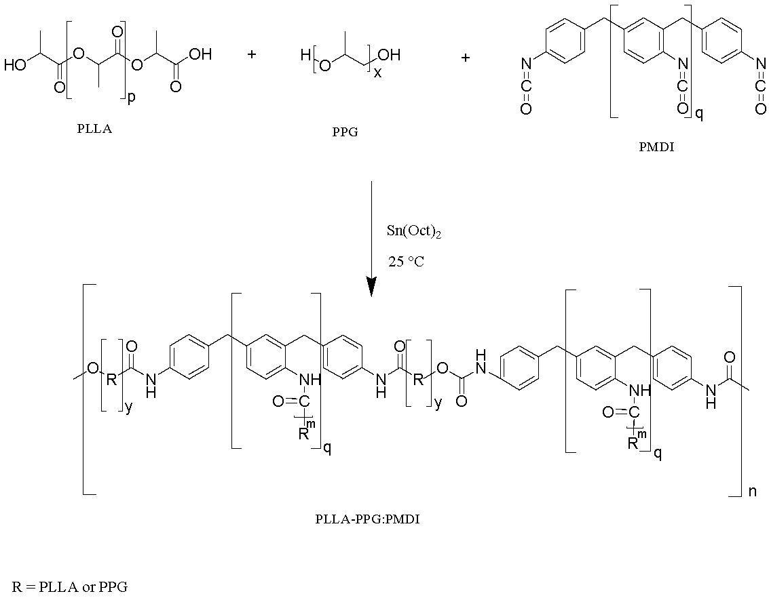
Figure 1. Reaction scheme between PLLA, PPG and PMDI

Ionic conductivity of PLLA-PPG SPE film with different plasticizer
Plasticizer was added to PLLA-PPG based polymer electrolyte to evaluate the ionic conductivity enhancement. LiClO₄ was chosen as dopant salt for all the system in this research. According to Rodrigues et al. LiClO₄ is a salt that is often used to produce SPE [1]. LiClO₄ salt is very stable at ambient moisture and less hygroscopic in comparison to LiCF₃SO₃ salt [11, 12]. Ji et al. also used LiClO₄ salt in the production of SPE based PEO-b-PE [13]. The ionic conductivity of PLLA-PPG SPE without the addition of plasticizer is low even with 30 wt.% of LiClO₄, which is 9.96 × 10⁻⁶ S cm⁻¹. For this system, four types of film were produced. Ethylene carbonate (EC) and propylene carbonate (PC) were used to identify which plasticizer is the most suitable to produce SPE film with better ionic conductivity. EC and PC are widely used as plasticizer in SPE [14-18]. Based on the EIS analysis conducted (Table 4), the film with EC has better conductivity than PC which is 2.69 × 10⁻¹⁰ S cm⁻¹ and 2.46 × 10⁻⁶ S cm⁻¹ for 0 and 15 wt.% of LiClO₄. Therefore, EC is selected to be used in the production of these PLLA-PPG SPE films because it gives a better conductivity and physical properties. Pitawala et al. also used EC and PC in their study to prepare (PEO)₉LiTf:Al₂O₃ composite polymer electrolyte. The ionic conductivity of (PEO)₉LiTf + 15 wt.% Al₂O₃ + 50 wt.% of EC is 4.98 × 10⁻⁵ S cm⁻¹ whereas the ionic conductivity of (PEO)₉LiTf + 15 wt.% Al₂O₃ + 50 wt.% of PC is 1.29 × 10⁻⁵ S cm⁻¹. The result of ionic conductivity from the study showed that the composite polymer electrolyte using EC has higher conductivity compared to PC [19].

Table 4. Ionic conductivity of PLLA-PPG SPE film with different plasticizer and wt. % LiClO₄
PLLA-PPG + 30 % EC/PC + 0 or 15 % LiClO₄ | Conductivity (S cm⁻¹)
PLLA-PPG + 30 % EC + 0 % LiClO₄ | 2.69 × 10⁻¹⁰
PLLA-PPG + 30 % EC + 15 % LiClO₄ | 2.46 × 10⁻⁶
PLLA-PPG + 30 % PC + 0 % LiClO₄ | 1.03 × 10⁻¹⁰
PLLA-PPG + 30 % PC + 15 % LiClO₄ | 4.20 × 10⁻⁷

Ionic conductivity of PLLA-PPG SPE film with different wt.% of EC
For the second system, the percentage of EC was reviewed to identify the most suitable wt.% of EC in the production of PLLA-PPG SPE film. Based on the EIS analysis conducted (Table 5), the highest ionic conductivity was at 30 wt.% of EC which is 2.80 × 10⁻⁶ S cm⁻¹. However, the ionic conductivity decreased after the optimum value at 30 wt.% of EC. Ibrahim et al. stated that an optimum composition is reached as the amount of plasticizer is increased, in which ion interactions between the solubilizing polymer and the plasticizer as such that ion mobility is maximized. A further increase in plasticizer content may eventually cause displacement of the host polymer by plasticizer molecules within the salt complexes and a decrease in ionic mobility eventually will contribute to decrease in ionic conductivity [18]. The similar observation was reported by Johan et al. which the highest conductivity of PEO-LiCF₃SO₃-EC system is obtained at 20 wt.% of EC, which is 8.12 × 10⁻⁵ S cm⁻¹. The conductivity decreases beyond 20 wt.% of EC [20].

Table 5. Ionic conductivity of PLLA-PPG SPE film with different wt.% of EC
PLLA-PPG + Variation wt. % of EC and 15 % LiClO₄ | Conductivity (S cm⁻¹)
PLLA-PPG + 20 % EC + 15 % LiClO₄ | 6.43 × 10⁻⁷
PLLA-PPG + 25 % EC + 15 % LiClO₄ | 1.70 × 10⁻⁶
PLLA-PPG + 30 % EC + 15 % LiClO₄ | 2.80 × 10⁻⁶
PLLA-PPG + 35 % EC + 15 % LiClO₄ | 1.73 × 10⁻⁶

Ionic conductivity of PLLA-PPG/EC and different wt. % of LiClO₄
For the third system, the concentration of EC was kept constant at 30 wt.% whereas the different wt.% of LiClO₄ are used. The ionic conductivity of the PLLA-PPG SPE film increased with wt.% of lithium perchlorate and reached an optimum value, 4.57 × 10⁻⁵ S cm⁻¹, at 25 wt.% of LiClO₄ (Figure 2). This optimum value signifies the maximum effective interaction between oxygen atoms and lithium cation in electrolyte system [6]. The ionic conductivity of PLA-PPG film is increased due to the increase in charge carrier as the number of free cations increases in the system. The presence of 25 wt.% of LiClO₄ increased the conductivity up to four magnitudes in comparison to PLLA-PPG without LiClO₄ salt, which is 1.29 × 10⁻⁹ S cm⁻¹. Lithium salt loaded in the polymer system was dissociated into conducting species due to the presence of ether and ester oxygen atom in PPG and PLLA, respectively.

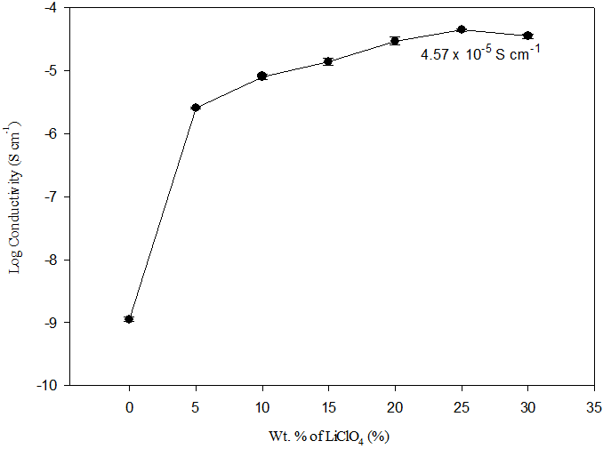

Figure 2. Variation of ionic conductivity of PLLA-PPG SPE film with 30 wt.% of EC and different wt.% of LiClO₄

Fourier transformed infrared analysis
In this study, FTIR spectroscopy has been used to confirm the coordination or the complexation of lithium salt with PLLA-PPG film. Oxygen atoms acted as an electron donor in the solid polymer electrolyte system. Lone pair electron of oxygen atom was donated to Li⁺ from the dissociated lithium perchlorate and formed polymer-salt complex through dative bond. Figure 3 represents the FTIR spectra of PLLA-PPG film with 30% of EC and different wt.% of LiClO₄ salt at (a) 1850-1700 cm⁻¹ and (b) 1120-1040 cm⁻¹. Table 6 showed that after LiClO₄ was added in PLLA-PPG system, the carbonyl band of EC shifted from 1806 cm⁻¹ to lower wavenumber at 1801 cm⁻¹ and carbonyl band of PLLA shifted from 1774 cm⁻¹ to lower wavenumber at 1773 cm⁻¹. For C-O-C functional group, the stretching mode shifted to the left as the wt.% of LiClO₄ increased from 1072 to 1067 cm⁻¹. This shown that Li⁺ interact more with PPG compared to PLLA.

The functional groups of PLLA-PPG film with 30% of EC and LiClO₄ (Table 7) can be described as: bands at around 3368-3590 cm⁻¹ representing O-H from water or moisture; at around 2978-2970 cm⁻¹ representing C-H stretching; at 1806 cm⁻¹ representing C=O from EC; at 1774 cm⁻¹ representing C=O from PLLA, at 1651 cm⁻¹ representing C=O from urethane bond and 1074-1066 cm⁻¹ representing C–O–C asymmetric stretching vibrations from PPG.

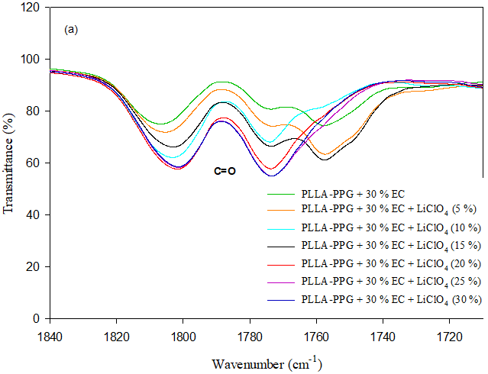

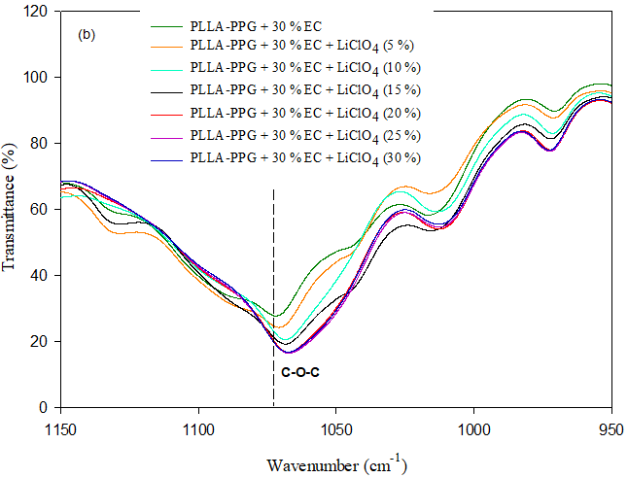

Figure 3. FTIR spectra of PLLA-PPG film with 30% of EC and different wt.% of LiClO₄ at (a) 1850-1700 cm⁻¹ and (b) 1120-1040 cm⁻¹

Table 6. Wavenumber of functional group from PLLA-PPG SPE film with 30% of EC and LiClO₄ or without LiClO₄

Wt. % of LiClO₄ | C=O (EC)  (cm⁻¹) | C=O (ester)  (cm⁻¹) | C=O (urethane)  (cm⁻¹) | C-O-C  (cm⁻¹)
Without LiClO₄ | 1806 | 1774 | 1651 | 1072
With LiClO₄ | 1801 | 1773 | 1651 | 1067

Table 7. Wavenumber of functional group from PLLA-PPG SPE film with 30% of EC and LiClO₄
Functional Group | O-H | C-H | C=O  (EC) | C=O  (PLLA) | C=O  (urethane) | C-O-C
Wavenumber (cm⁻¹) | 3368-3590 | 2978-2970 | 1806 | 1774 | 1651 | 1074-1066

X-Ray diffraction analysis
X-Ray diffraction analysis was performed to study the structure and crystallization behaviour of the polymer-salt complexes. Figure 4 (a) shows the X-ray diffraction pattern of PLLA-PPG film with 30 wt.% of EC and different wt. % of lithium perchlorate in the range of 2θ = 5° to 80°. Pure PLA peaks appear at 16.6° and 18.9°. It reveals that the prominent peaks appear at 2θ values of 16.6° and 19.1° are representatives of PLLA since PPG are in amorphous phase. The PLLA crystalline peak remained exist even after the copolymerization reaction with PPG.

Pure LiClO₄ (Figure 4 (b)) shows high intense peak at 2θ = 21.1°, 23.1°, 25.7°, 31.4°,36.3°, 39.5° and 52.8°. From previous study, LiClO₄ was obtained at angles of 2θ = 21.1°, 23.2°, 31.3°, 35.7° and 39.3° [21]. The amorphous phase of PLLA-PPG film with 30 wt.% of EC increased with addition of LiClO₄. Meanwhile, the absence of diffraction peaks corresponding to LiClO₄ in LiClO₄ loaded SPE indicates that LiClO₄ solvates well in the PLLA-PPG film.

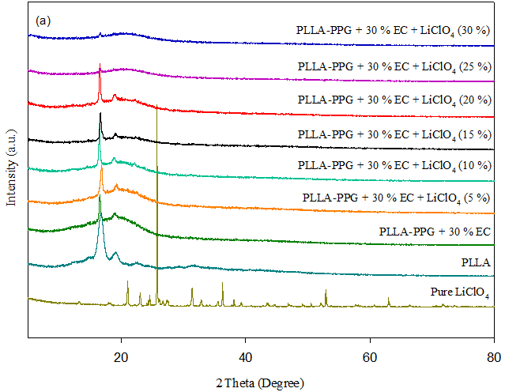

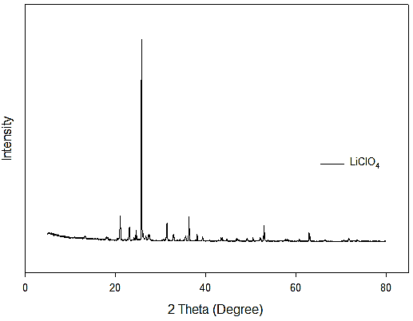
(b)
Figure 4. X-ray diffraction patterns of PLLA-PPG film with 30 wt.% of EC and different wt.% of LiClO₄ salt (a) and LiClO₄ salt (b)

Thermogravimetric analysis
Thermogravimetric analysis (TGA) has been used to investigate the thermal degradation, phase transition and crystallization of the polymers. The thermogravimetric curve for EC, PPG and PLLA was given in Figure 5. It is apparent that the EC start to decompose around 90 ºC while PPG only starts to decompose after 276 ºC. In addition, the weight of PLLA is almost constant up to 357 ºC. Above 357 ºC, PLLA start to decompose. EC, PPG and PLLA were observed to display a single step of decomposition. At temperature around 400 ºC, all sample were almost completely decomposed.

The TGA curve which contain 0, 15 and 30 wt.% of LiClO₄ in PLLA-PPG films with 30 wt.% of EC were illustrated in Figure 6(a). There were multi step decomposition from PLLA-PPG thin film with different wt.% of LiClO₄. The weight loss at around 100 ºC were caused by trapped moisture. There was no major weight loss for all the polymer electrolytes until around 270-280 °C and this suggested that the prepared SPE was thermally stable up to 270 °C. With the addition of salt, the thermal stability of material was reduced. This can be seen from the TGA curve for 0% sample, where major decomposition starts at 285 °C but after addition of salt, the major decomposition starts at around 265 to 270 ºC. LiClO₄ start to decompose at around 470 °C.

DTG thermogram from Figure 6 (b) shows that PLLA-PPG SPE with 30 wt.% of EC and without LiClO₄ salt was more stable compared to PLLA-PPG SPE with 30 wt.% of EC and LiClO₄ salt. The decomposition of all stage occurred more faster after the addition of LiClO₄ salt. This showed that the addition of LiClO₄ salt have decreased the decomposition temperature and lowered the thermal stability of SPE.

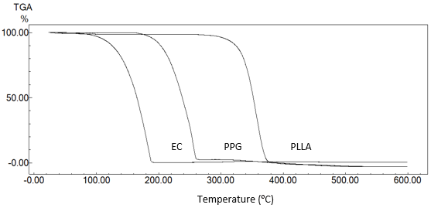
Temperature (ºC)
EC
PLLA
PPG
Figure 5. TGA thermogram of EC, PPG and PLLA
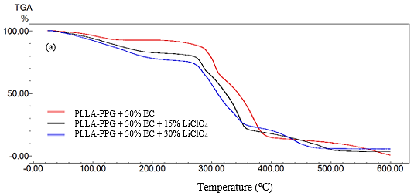

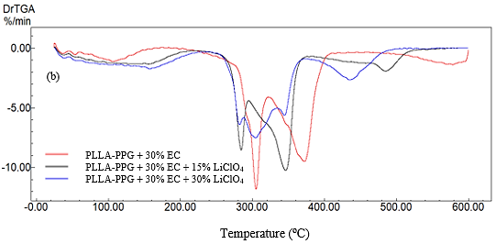

Figure 6. TGA (a) and DTG (b) thermogram of PLLA-PPG with 30 wt.% of EC and 0, 15 and 30 wt.% of LiClO₄

Conclusion
The solid polymer electrolyte PLLA-PPG with 30 wt. % of EC and different weight percent of LiClO₄ was successfully prepared by a solution casting method. The optimum ionic conductivity was estimated to be 4.57 × 10⁻⁵ S cm⁻¹ at 25 wt.% of LiClO₄. Infrared analysis showed evidence for polymer-salt complex formation. Meanwhile, thermal analysis showed that the PLLA-PPG SPE film was stable up to 270 ºC. Lastly, XRD analysis proved that the crystallinity of the SPE film decreases with the addition of salt.

Acknowledgement
The authors would like to thank the Universiti Kebangsaan Malaysia (UKM) for providing analytical equipment used in this research. This work was supported by the Universiti Kebangsaan Malaysia and the Ministry of Higher Education under research grant numbers ERGS/1/2013/TK07/UKM/03/1 and GUP-2016-060.

References

- Rodrigues, L. C., Silva, M. M. and Smith, M. J. (2012). Synthesis and characterization of amarphous poly(ethylene oxide)/poly(trimethylene carbonate) polymer blend electrolytes. Electrochimica Acta, 86: 339-345.
- Noor, S. A. M., Ahmad, A., Rahman, M. Y. A and Talib, I. A. (2010b). Solid polymeric electrolyte of poly(ethylene)oxide-50% epoxidized natural rubber-lithium triflate (PEO-ENR50-LiCF₃SO₃). Natural Science, 3: 190-196.
- Murata, K., Izuchi, S. and Yoshihisa, Y. (2000). An overview of the research and development of solid polymer electrolyte batteries. Electrochimica Acta, 45:1501-1508.
- Cha, D. K. and Park, S. M. (1998). Electrochemical characterization of polyethylene glycols as solid polymer electrolytes. Journal of Electroanalytical Chemistry, 459: 135-144.
- Ng, B. C., Wong, H. Y., Chew, K. W. and Osman, Z. (2011). Development and characterization of poly-$ε$-caprolactone-based polymer electrolyte for lithium rechargeable battery. International Journal of Electrochemical Science, 6: 4355-4364.
- Tan, C. H., Ahmad, A. and Anuar F. H. (2014). Synthesis and characterization of polylactide-poly(ethylene glycol) block copolymer as solid polymer electrolyte. Asian Journal of Chemistry, 26: 230-236.
- Piorkowska, E., Kulinski, Z., Galeski, A. and Masirek, R. (2006). Plasticization of semicrystalline poly(l-lactide) with poly(propylene glycol). Polymer, 47: 7178-7188.
- Gupta, B., Revagade, N. and Hilborn, J. (2007). Poly(lactic acid) fiber: An overview. Progress in Polymer Science, 32: 455-482.
- Su’ait, M. S., Ahmad, A., Badri, K. H., Mohamed, N. S., Rahman, M. Y. A., Ricardo, C. L. A. and Scardi, P. (2014). The potential of polyurethane bio-based solid polymer electrolyte for photoelectrochemical cell application. International Journal of Hydrogen Energy, 39: 3005-3017.
- Chew, K. W., Ng, T. C. and How Z. H. (2013). Conductivity and microstructure study of PLA-based polymer electrolyte salted with lithium perchlorate, LiClO₄. International Journal of Electrochemical Science, 8: 6354-6364.
- Ahmad, A., Rahman, M. Y. A., Harun, H., Su’ait, M. S. and Yarmo, M. A. (2012). Preparation and characterization of 49% poly(methyl methacrylate) grafted natural rubber (MG49)-stannum (IV) oxide (SnO₂)-lithium salt based composite polymer electrolyte. International Journal of Electrochemical Science, 7: 8309-8325.
- Su’ait, M. S., Ahmad, A., Hamzah, H. and Rahman, M. Y. A. (2011). Effect of lithium salt concentrations on blended 49% poly(methyl methacrylate) grafted natural rubber and poly(methyl methacrylate) based solid polymer electrolyte. Electrochimica Acta, 57: 123-131.
- Ji, J, K. and Zhong, W. H. (2011). Simultaneous improvement in ionic conductivity and mechanical properties of multi-functional block-copolymer modified solid polymer electrolytes for lithium ion batteries. Journal of Power Sources, 196: 10163-10168.
- Isa, K. B. M., Othman, L. and Osman Z. (2011). Comparative studies on plasticized and unplasticized polyacrylonitrile (pan) polymer electrolytes containing lithium and sodium salts. Sains Malaysiana, 40: 695-700.
- Pandey, K., Asthana, N., Dwivedi, M. M. and Chaturvedi, S. K. (2013). Effect of plasticizers on structural and dielectric behaviour of [PEO + (NH₄)₂C₄H₈(COO)₂] polymer electrolyte. Journal of Polymers, 2013: 752596.
- Dash. S. and Ghosh. A. (2015). Ionic conductivity and dielectric permittivity of PEO-LIClO₄ solid polymer electrolyte plasticized with propylene carbonate. AIP Advances 5: 027125.
- Pradhan, D. K., Choudhary, R. N. P., Samantaray, B. K., Karan, N. K. and Katiyar, R. S. (2007). Effect of plasticizer on structural and electrical properties of polymer nanocomposite electrolytes. International Journal of Electrochemical Science, 2: 861-871.
- Ibrahim, S., Yasin, S. M. M., Ahmad, R. and Johan M. R. (2012). Effects of various ec plasticizer concentrations on salted PEO based solid polymer electrolytes. International Journal of Plastic Technology, 16(2): 125-135.
- Pitawala, H. M. J. C., Dissanayake, M. A. K. L., Seneviratne, V. A., Mellander, B. -E. and Albinson I. (2008). Effect of plasticizers (EC or PC) on the ionic conductivity and thermal properties of the (PEO)₉LiTf: Al₂O₃ nanocomposite polymer electrolyte system. Journal of Solid State Electrochemistry, 12: 783-789.
- Johan, M. R., Shy, O. H., Ibrahim, S., Yassin, S. M. M. and Hui, T. Y. (2011). Effects of Al₂O₃ nanofiller and EC plasticizer on the ionic conductivity enhancement of solid PEO-LiCF₃SO₃ solid polymer electrolyte. Solid State Ionics, 196: 41-47.
- Lim, C. S., Teoh, K. H., Ng, H. M., Liew, C. W. and Ramesh, S. (2017). Ionic conductivity enhancement studies of composite polymer electrolyte based on poly(vinyl alcohol)-lithium perchlorate-titanium oxide. Advanced Materials Letters, 8(4): 465-471.

