THE INTERACTION BETWEEN FIREFLY LUCIFERIN WITH

G-QUADRUPLEX DNA AND CT-DNA

(Interaksi antara Lusiferin Kunang-Kunang bersama

DNA G-Kuadrupleks dan CT-DNA)

Nurul Huda Abd Karim*, Roshatiara Shamsuddin, Aida Mastura Mohd Yussof,

Nur Amirah Harunar Rashid

Centre for Advanced Materials and Renewable Resources,

Faculty of Science and Technology

Universiti Kebangsaan Malaysia, 43600 Bangi, Selangor, Malaysia

*Corresponding author: nurulhuda@ukm.edu.my

Abstract

Firefly bioluminescence gives fascinating challenges and great interest for fundamental sciences. The luciferase enzyme which emits colour for firefly bioluminiscence has been intensively studied by chemists in various applications. Luciferin the substrate of luciferase, is also responsible for the characteristic of yellow light emission from many firefly species. In recent years, the binding of small molecules with DNA has been receiving great attention due to the potential of such binding to inhibit cancer cell growth. G-quadruplex DNA has been discovered as an interesting target since stabilizing its formation in telomere can inhibit the elongation of telomere in cancer cell where enzyme telomerase is 85% activated. Here, we investigate the binding properties between luciferin compound with G-quadruplex DNA. The binding interaction was studied using UV/Vis spectra and fluorescence. The results indicate that luciferin is more selective to stabilize G-quadruplex DNA with K_{b} = 2.02 ± 0.59 × 10⁵ M⁻ ¹ compared to CT-DNA.

Keywords: luciferin, bioluminescence, CT- DNA, G-quadruplex DNA

Abstrak

Kunang-kunang biopendarkilau memberikan cabaran yang menarik dan menyumbang kepentingan yang besar dalam bidang sains. Enzim lusiferase yang mengeluarkan pancaran warna bagi kunang-kunang biopendarkilau telah dikaji secara intensif oleh ahli kimia dalam pelbagai aplikasi. Lusiferin merupakan substrat bagi lusiferase yang bertanggungjawab untuk menghasilkan cahaya kekuningan daripada spesis kunang-kunang. Beberapa tahun kebelakangan ini, kajian pengikatan molekul kecil bersama DNA mula menarik perhatian kerana keupayaan pengikatannya dapat merencatkan tumbesaran sel kanser. DNA G-kuadrupleks dijadikan sebagai sasaran utama kerana kestabilan pembentukannnya dalam jujukan telomer dapat merencatkan pemanjangan sel kanser yang diaktifkan oleh 85% enzim telomerase. Melalui kajian ini, interaksi antara sebatian lusiferin dengan DNA G-kuadrupleks telah dikaji. Kajian pengikatan ini dianalisis menggunakan spektrum UV/ Vis dan pendarfluor. Hasil menunjukkan bahawa lusiferin lebih selektif berikat bersama DNA G- kuadrupleks dengan nilai pemalar pengikatan, K_{b} = 2.02 ± 0.59 × 10⁵ M⁻ ¹ berbanding CT-DNA.

Kata kunci: lusiferin, biopendarkilau, CT-DNA, DNA G-kuadrupleks

Introduction

Deoxyribonucleic acid (DNA) is as a double helical structure with its crucial role as genetic information storage. In the last several years, studies on the interaction between ligand and DNA have increased with improved instruments for DNA binding analysis. Many studies involving the interaction between DNA and small molecules, such as metal complexes that act as metal-based drugs [1] were carried out due to its major role in the life process as cancer inhibitors [2]. Organic and inorganic molecules were reported to interact with DNA via three possible binding methods; (i) groove binding, where the small molecules interact with the grooves of the DNA chain, (ii) intercalative binding (π-π stacking), where the small molecules intercalate into the base pairs of DNA nucleotide base, (iii) electrostatic interaction, where the small molecules are adsorbed on the phosphates of DNA by electrostatic interaction [3,4]. DNA is an important target for several drugs [5]. Steroidal compounds are essential to life in many ways [6]. One of the example, anticancer drugs which are selectively interacting with DNA can inhibit the duplication or transcription of DNA [7]. In recent years, the search for suitable drug candidates, such as DNA G- quadruplex stabilization has led to the founding of several compounds including BRACO 19, TMPyP4 and 2,6-disubstituted anthraquinone, all of which have good binding constants between G-quadruplexes DNA and ligands.

Cancer cells have the ability to elongate the telomere due to the presence of a reverse transcriptase enzyme known as telomerase. Stabilization of telomeric G-quadruplex DNA can inhibit telomerase enzyme activity and finally lead to the cell cancer death [8]. G-quadruplexes DNA are planar G-quartet motifs which can be formed in guanine-rich DNA sequence like the telomeres. These structures interact with the inhibitor (ligands or complex) via π-π stacking, thereby stabilizing the G-quadruplex–inhibitor complex [9]. Suprisingly, many animals and plants in this world are bioluminiscent. Bioluminiscent mean the light emitted by living organisms results from oxidation of light-producing substance like luciferine by enzyme luciferase[10]. Firefly is a bioluminescent organism. The light emission by this organism results from the reaction between oxygen and an oxidizable substrate (a luciferin), and catalyzed by enzyme (a luciferase). The interaction between the luciferase (enzyme) and D-luciferin (LH₂) to generate light is generally proposed as equation 1 [11]:

E + LH₂ + ATPMg ↔ E-LH₂-AMP + O₂→ OxL + light + AMP + CO₂ + Ppi (1)

Usually the functions of bioluminescence are to warn or evade predators, to lure or detect prey and to communicate between members of the same species. The most interesting aspect of fireflies bioluminiscence is that it is applicable for various applications, such as in biomedical, pharmaceutical, bioanalytical, bioimaging applications[12], clinical and biochemical[13]. Although there are various applications regarding fireflies bioluminiscence, research on the interaction between luciferin (Figure 1) and DNA has not been yet reported. Thus, in this work, the interaction using UV/Vis and fluorescence spectroscopy was studied.

Figure 1. Chemical structure of D-luciferin

Materials and Methods

All chemicals (for compound and DNA titration) were purchased from Sigma-Aldrich. DNA binding experiments were carried out in Tris-KCl buffer at pH 7.4. pH measurements were carried out with PHM 210, while the UV/Vis absorption spectra were measured on a Shimadzu UV-1650 spectrophotometer using a 1 mL cuvette. Fluorescence spectra were measured using Perkin Elmer LS55 Luminescence Spectrophotometer.

Oligonucleotides preparation

The oligonucleotide, 22 bp human telomeric G-Quadruplex DNA (H-telo DNA), 5’-AGGGTTAGGGTTAGGGTTAGGG -3’ was purchased from Sigma Aldrich. H-telo DNA was dissolved in 10 mM Tris-HCl/100 mM KCl (pH 7.4) buffer to yield a 1 mM solution. The oligonucleotide was annealed by heating it to 90 ºC for 5 min and then cooled to room temperature overnight. Duplex DNA, CT-DNA was also purchased from Sigma-Aldrich and dissolved overnight in a 10 mM Tris-HCl /100 mM KCl (pH7.4) buffer to yield 5 M solution. The DNA concentration was determined from the band intensity at 260 nm with the molar extinction coefficient values for CT-DNA and H-Telo are 6600 M⁻¹ cm⁻¹ and 0.2285 mM⁻¹ cm⁻¹, respectively.

Sample preparation

The luciferin compound was dissolved in a mixture of DMSO (95% by volume) and 10 mM Tris-HCl /100 mM KCl (pH 7.4) buffer to produce 5 mM stock solution. This solution was stored at -20°C and defrosted prior to use. Upon usage, the stock solution was thawed and diluted to 1 mM using DMSO. This was further diluted with a buffer to the appropriate concentrations.

UV/Vis titration studies procedure

The absorption titrations of the luciferin compound with H-Telo and CT-DNA were performed at room temperature. All experiments were repeated at least three times. The compound (30 μM) was titrated with concentrated solutions of DNA (0.39 mM Htelo G-Quadruplex DNA or 5 mM CT-DNA) 10 mM in Tris HCl/100 mM KCl buffer pH 7.4. The binding affinity between the compound and the DNA was determined with a constant concentration of compound. Absorbance values were recorded after each successive addition of DNA solution and equilibration (Figures 2 and 3). A 1 cm pathlength quartz cuvette was used to conduct the measurements. The percentage of hypochromicity was calculated according to equation 2:

% hypochromicity = [(ɛ free - ɛ bound)/ ɛ free] x 100 (2)

The intrinsic binding constant K_{b} of the ligand–DNA was determined according to equation 3:

D/Δεap=D/Δε + 1/(Δε x K) (3)

where the concentration of DNA is expressed in terms of base pairs (determined by measuring the absorption at 260 nm and the appropriate extinction coefficients), the apparent molar extinction coefficient εa =A observed/[Complex], Δεap = [εa - εf] and Δε = [εb -εf]. εb is the extinction coefficient of the DNA bound complex, and εf is the extinction coefficient of the free complex. From the plotted graph of [DNA]/(Δεap) versus [DNA], the y-intercept is equal to 1/ (Δεap × K) whereas the slope is equal to 1/Δεap. K is obtained by dividing the slope value by the y-intercept.

Emission titration procedure

Aliquots of a millimolar stock solution of DNA in Tris/KCl buffer (0–100 μM) were added to the solutions containing the test compounds (30 μM). The emission spectra were recorded at λ= 400–700 nm after equilibration for 1 min and the luminescence enhancement at λ max = 520 nm for luciferin was determined. Percentage of emission enhancement was determined for complex-H-telo DNA and complex-CT-DNA bindings, respectively.

Results and Discussion

UV-Vis titration study

Usually, compounds which bind with DNA through intercalation mode results in hypochromism and bathochromism (red shift). In weaker interaction, hypochromic or hyperchromic effect can only be observed without any change of shift in the spectrum [14, 15]. Generally, intercalative binding mode happens due to the strong interaction between molecules with DNA base pairs [4, 16]. Meanwhile, hyperchromism effect arises from the damage on DNA double helix structure or uncoiling of DNA helix structure, as well as different binding modes [17, 18]. Usually, compounds with an aromatic group bind with DNA via intercalation of an aromatic moeity [19].

The interaction between luciferin and G-Quadruplex DNA was identified through the changes in luciferin absorption spectra in the absence and presence of increasing DNA concentration. From the electronic absorption spectra of luciferin in Figure 2a and b, the titration of luciferin with G-Quadruplex DNA resulted in hypochomism (3%) and a slight red shift. This is the characteristics of intercalative binding mode between the compound to H-Telo G Quadruplex DNA [4, 20]. Luciferin has a binding constant K_{b} of 7.46 ± 1.67 × 10⁵ M⁻¹ upon binding with G-Quadruplex DNA. The binding constant suggests that the interaction between luciferin and DNA is moderately intercalative mode.

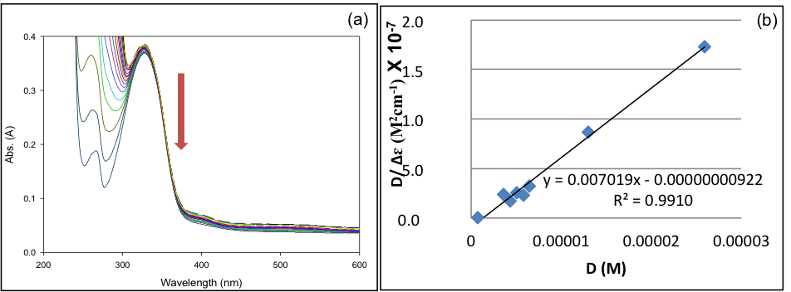

Figure 2. (a) Absorption spectral changes of luciferin (30 μM) in Tris/KCl buffer (pH 7.4) in the absence and presence of increasing concentration of H-Telo (0.328 mM - 0.39 mM); (b) The reciprocal plot that fits the absorbance data to obtain the binding constant

For comparison, the interaction between luciferin and duplex DNA, CT-DNA was identified through the changes in luciferin absorption spectra in the absence and presence of increasing concentration of CT-DNA. From the electronic absorption spectra of luciferin in Figure 3a and b, it was observed that the additional amount of DNA resulted in hypochromism (3%) at 331 nm, where a gradual decrease in molar absorptivity as well as a slight red shift (1.5 nm) occurred. The results confirmed the mode interacion between luciferin with ct-DNA is intercalation. Luciferin has a binding constant K_{b} = 2.02 ± 0.59 × 10⁵ M⁻¹ upon binding with CT-DNA. This type of shift and hypochromism have been associated with intercalative interaction mode with CT-DNA [21, 22]. These results suggest that luciferin shows higher binding affinity with G- Quadruplex DNA compared to CT- DNA.

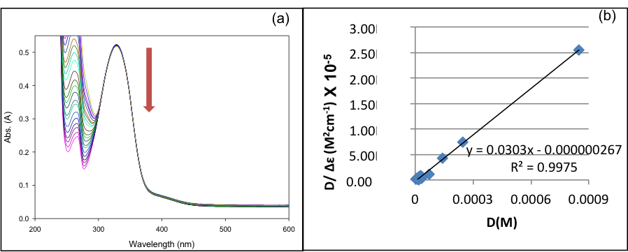

Figure 3. (a) Absorption spectral changes of luciferin (30 μM) in TRIS.HCl buffer (pH = 7.4) in the absence and presence of increasing concentration of CT-DNA (4 mM - 5 mM ); (b) The reciprocal plot which fits the absorbance data to obtain the binding constant

Emission titration

The DNA-binding modes of luciferin compound were further monitored by emission titration using spectrofluorometer. It is well known that luciferin emits intense fluorescence since it has bioluminiscence character. Emission titration experiments were conducted to investigate whether their optical properties would change upon interaction with DNA (particularly G-quadruplex DNA). An increasing amount of G-quadruplex DNA and CT-DNA were added to luciferin solutions until saturation of compound emission was observed. The changes in intensity with increasing amounts of DNA are shown in Figure 4a and b.

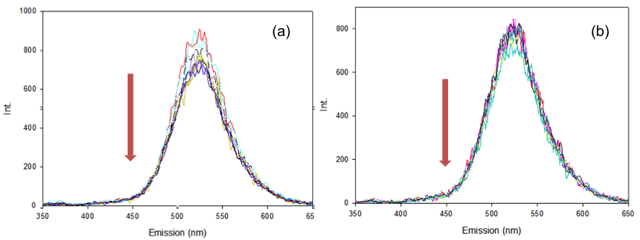

Figure 4. The emission spectra of luciferin compound (2 μM) in Tris/KCl buffer (pH 7.4) with increasing concentrations of (a) H-telo DNA (b) CT-DNA at 25 °C. The intensity of emission band of luciferin compound was reduced with increasing DNA concentration

The results of the emission titration of complexes showed that luciferin binds to both G-quadruplex and CT-DNA and decreased in emission intensity was observed. Increasing amount of G-quadruplex DNA and CT-DNA caused decrease in luciferin intensity by approximately 24% and 18%, respectively, which suggests that with regard to binding specificity, luciferin compound is not too selective of G-Quadruplex DNA.

Conclusion

DNA binding studies of luciferin were carried out using UV-Vis study and emission titration which suggested that luciferin bound moderately to G-quadruplex DNA with 4-fold selectivity over CT-DNA. However, 24-fold decrease in emission intensity was observed upon luciferin-G-quadruplex binding compared to 18-fold decrease in emission intensity observed for luciferin-CT-DNA binding. The results propose that luciferin as a promising candidate for further applications, namely as a DNA binder and an anticancer drug but not as fluorescence probe. Modification of luciferin compounds is suggested to improve G-quadruplex DNA binding ability.

Acknowledgement
The authors would like to acknowledge Ministry of Higher Education of Malaysia and Universiti Kebangsaan Malaysia for research grant LAUREATE 2013-002, FRGS/1/2016/STG01/UKM/02/1 dan GUP-2017-067.

References

- Juan, C. G-R., Rodrigo, G-M., Fernando, C-G and Lena, R-A. (2013). Metal-based drug-DNA interactions. Journal of Mexican Chemical Society, 57: 245-259.
- Xiaoyan, Z., Yong, W., Qianru, Z. and Zhousheng, Y. (2010). The interaction of taurine–salicylaldehyde Schiff base copper(II) complex with DNA and the determination of DNA using the complex as a fluorescence probe. Spectrochimica Acta Part A, 77: 1–5.
- Janati Fard, F., Mashhadi Khoshkhoo, Z., Mirtabatabaei, H., Housaindokht, and Jalal, M. R. (2013). Synthesis, characterization and interaction of N, N0- dipyridoxyl(1,4-butanediamine) Co (III) salen complex with DNA and HAS. Spectrochimica Acta Part A: Molecular and Biomolecular Spectroscopy, 97: 74–82.
- Dik-Lung, M., Daniel, S-H. C., Paul, L., Maria, H-T. K., and Chung-Hang, L. (2011). Molecular modeling of drug-DNA interactions: Virtual screening to structure-based design. Biochimie, 93: 1252-1266.
- Ricci, C. G and Netz, P. A. (2009). Docking studies on DNA- ligand interactions: Building and application of a protocol to identify the binding mode. Journal of Chemical Information and Modeling, 49: 1925-1935.
- Sultanat, Dar A. M, Rizvi, A. and Naseem, I. (2014). Synthesis, evaluation and docking studies of cholecalciferol derivative. Oriental Journal Chemistry, 30(3): 1-6.
- Zhanguang, C., Yurui, P., Maohuai, C., Xi, C. and Guomin, Z. (2010). DNA as a target for anticancer compounds screening directly by resonance light scattering technique. The Royal Society of Chemistry, 135: 2653-2660.
- Rahim S, Antony A, Lukose G, Mohanan K, Joe I. H and Joseyphus R. S. (2015). Synthesis, spectral characterization and computational studies of metal chelates of 4-n-(2-thienylidene)aminoantipyrine. Oriental Journal Chemistry, 31(4): 1-10.
- Taetz, S., Murdter, T. E., Zappc, J., Boettcher, S., Baldes, C., Kleideiter, E., Piotrowska, K., Schaefer, U. F., Klotz, U., Lehr and C.-M. (2008). Decomposition of the telomere-targeting agent BRACO19 in physiological media results in products with decreased inhibitory potential. International Journal of Pharmaceutics, 357: 6-14.
- Steven, H. D. H., Mark, A. M. and James, F. C. (2010). Bioluminescence in the Sea. Annual Review of Marine Science, 2: 443–493.
- Fre´de´ric, B., Bernengo, J.-C., Min, K.-L. and Steghens, J.-P. (2000). Firefly luciferase generates two low-molecular-weight light-emitting species. Biochemical and Biophysical Research Communications, 270: 247-253.
- João, V., Luís, P. da. S., Joaqui. and da Silva, C.G. E. (2012), Advances in the knowledge of light emission by firefly luciferin and oxyluciferin. Journal of Photochemistry and Photobiology B: Biology, 117: 33-39.
- Takayuki, M., Hiroshi, O., Katsushi, A., Hiroaki, M. and Hidetoshi. (2010). Practical application of bioluminescence enzyme immunoassay using enhancer for firefly luciferine-luciferase bioluminescence. The Journal of Biological and Chemical Luminiscence, 26: 167-171.
- Muhammad, S., Saqib, A. and Amin, B. (2013). Drug–DNA interactions and their study by UV–Visible, fluorescence spectroscopies and cyclic voltammetry. Journal of Photochemistry and Photobiology B: Biology, 124: 1–19.
- Nahid, S., Somaye, M. and Robabeh A. (2011). DNA interaction studies of a new platinum (II) complex containing different aromatic dinitrogen ligands. Bioinorganic Chemistry and Applications, 2011: 1-8.
- Xu-Jian, L., Qi-Pin, Q., Yan-Cheng, L. and Hong, L. (2012). Synthesis, antitumor activity and G-quadruplex DNA/ct-DNA binding properties of a cationic platinum (II) complex of 2-(4-nitro)-imidazole-[5, 6-f][1,10]-phenanthroline. Indian Journal of Chemistry, 53: 787-792.
- Lingthoingambi, N., Singh, N. R. and Damayanti, M. (2011). DNA interaction and biological activities of Copper (II) complexes of alkylamidio-O-methylurea, Journal of Chemical and Pharmaceutical Research, 3(6): 187-194.
- Nahid, S. and Somaye, M. (2012). Synthesis characterization and DNA interaction studies of a new zn (ii) complex containing different dinitrogen aromatic ligands. Bioinorganic Chemistry and Applications, 2012: 1-6.
- Giampaolo, B., Alessio, T., Antonino, L., Anna, M. A., José, M. L., Natalia, B. and Bego˜na G. (2013). DNA-binding of nickel (II), copper (II) and zinc (II) complexes: Structure–affinity relationships. Coordination Chemistry Reviews, 2013: 1-15.
- Shamsuddin, R., Sahudin, M. A., Hassan, N. H., and Abd Karim, N. H. (2017). Interaction of N, N’-Bis[4-[1-(2-hydroxyethoxy)]Salicylidene]-phenyldiamine-nickel(II) and copper(II) complexes with G-Quadruplex DNA. Malaysian Journal of Analytical Sciences, 21(3): 544-551.
- Mariappan, M., Masahiko, S., Abhik, M. and Bhaskar, G. M. (2012). Synthesis, structure, DNA binding and photonuclease activity of a nickel(II) complex with a N,N-Bis(salicylidene)-9-(3,4-diaminophenyl)acridine ligand, Inorganica Chimica Acta, 390: 95-104.
- Narayanaperumal, P. and Natarajan. P. (2013). DNA interaction and antimicrobial activity of novel tetradentate imino-oxalato mixed ligand metal complexes. Inorganic Chemistry Communications, 36: 45-50.

