HYDROSILYLATION OF ALDEHYDES CATALYZED BY DIETHYL
2-PYRIDYLPHOSPHONATE

(Hidrosililasi Aldehida Bermangkin Dietil 2-Piridilfosfonat)

Natsuhisa Oka^{1,2*}, Kousuke Ito¹, Kaori Ando^{1*}

¹Department of Chemistry and Biomolecular Science,
Faculty of Engineering,
²Center for Highly Advanced Integration of Nano and Life Sciences,
Gifu University, 1-1 Yanagido, Gifu 501-1193, Japan

*Corresponding author: ando@gifu-u.ac.jp

Abstract
We studied the catalytic activity of diethyl pyridylphosphonates in the hydrosilylation of aldehydes using HSiCl₃ as a hydride source. Diethyl 2-pyridylphosphonate was found to be a good catalyst, while 2-pyridylthiophosphonate, 3- and 4-pyridylphosphonates, and phenylphosphonate showed much lower catalytic activity. The study shows that diethyl 2-pyridylphosphonate works as a bidentate Lewis base catalyst to activate HSiCl₃. A complete chemoselective hydrosilylation of benzaldehyde in the presence of acetophenone was also demonstrated.

Keywords: hydrosilylation, aldehyde, pyridyl, phosphonate, chemoselective

Abstrak
Kami mengkaji aktiviti pemangkinan dietil piridilfosfonat di dalam hidrosililasi aldehida telah dikaji dalam makalah ini menggunakan HSiCl₃ sebagai sumber hidrida. Dietil 2-piridilfosfonat didapati merupakan pemangkin yang baik sementara 2-piridiltiolfosfonat, 3- dan 4- piridilfosfonat, dan fenilfosfonat menunjukkan aktiviti pemangkinan yang lebih rendah. Kajian ini menunjukkan dietil 2-piridilfosfonat berfungsi sebagai pemangkin Lewis bes bidentat untuk mengaktifkan HSiCl₃. Satu hidrosililasi kemoselektif lengkap benzaldehida dengan kewujudan asetofenon juga telah dapat ditunjukkan dalam kajian ini.

Kata kunci: hidrosililasi, aldehida, piridil, fosfonat, kemoselektif

Introduction
Lewis base-catalyzed metal-free hydrosilylation is a useful alternative to the reduction using metal hydrides and transition metal-catalyzed hydrogenation. It is often used for the chemoselective reduction of aldehydes, ketones, and imines to the corresponding alcohols and amines in the presence of various functional groups which are susceptible to other kinds of reducing agents. Many kinds of Lewis base catalysts have been developed for this reaction so far [1-8]. However, there is still a need for the development of new catalysts with improved activity and selectivity.

In order to develop a new class of Lewis base catalyst, we focused on pyridylphosphonate derivatives [9]. A variety of Lewis base catalysts carrying pyridyl or P=O groups have been developed and applied to the hydrosilylation of aldehydes, ketones, and imines [10-18]. Both functional groups are usually used in combination with other kinds of coordinating groups such as carbonyl groups in the design of Lewis base catalysts. However, the combination of pyridyl and P=O groups has been scarcely used and, to the best of our knowledge, pyridylphosphonates have not yet been studied for their catalytic activity. We have recently directed our efforts to the synthesis of 2-pyridylphosphonates and 2-pyridylphosphinates [19-20]. These compounds can be easily synthesized from low-cost starting materials, H-phosphonates and N-methoxypyridinium salts [9, 21-23] and thus can be cost-effective catalysts. In this study, we investigated the potential of diethyl 2-pyridylphosphonate and some relevant phosphonates as Lewis base catalysts in the hydrosilylation of aldehydes.

Materials and Methods
General information
Commercially available reagents were used without purification. Dry organic solvents were prepared by appropriate procedures prior to use. The other organic solvents were reagent grade and used as received. All reactions in dry solvents were carried out under argon. Analytical thin-layer chromatography (TLC) was performed on Merck TLC plates (No. 5715) precoated with silica gel 60 F₂₅₄. Column chromatography on silica gel was carried out using Kanto silica gel 60N (spherical, neutral, 63–210 μm). The ¹H (400 MHz) spectra were recorded on a JNM-ECS-400 spectrometer (JEOL). Diethyl 2-pyridylphosphonate 1a [23], diethyl 2-pyridylthiophosphonate 1b [24], diethyl 3-pyridylphosphonate 2 [25], and diethyl 4-pyridylphosphonate 3 [26] were synthesized according to the procedures reported in the literature.

General procedure for the hydrosilylation of aldehydes
An aldehyde (1.0 mmol) and HSiCl₃ (1.2 or 2.0 mmol) were added dropwise to a solution of 1a (0.20 mmol) in dry CH₂Cl₂ (2.0 mL) under stirring at RT and stirring was continued for 20 hours. The mixture was then washed with a 1 M aqueous solution of HCl (10 mL). The aqueous layer was extracted with CH₂Cl₂ (5 × 10 mL). The organic layers were combined, dried over Na₂SO₄, filtered, and concentrated under reduced pressure. The residue was then purified by column chromatography on silica gel (hexane/ethyl acetate) to afford the corresponding alcohols in 27%–94% yield. Identities of the products were confirmed by comparison of ¹H NMR data with those of commercial samples.

Results and Discussion
Initially, we examined the hydrosilylation of benzaldehyde using HSiCl₃ and diethyl 2-pyridylphosphonate 1a as a reducing agent and a catalyst, respectively (Figure 1 and Table 1). As shown in entries 1 and 2, benzaldehyde was completely reduced in the presence of 2 equiv. of HSiCl₃ and 20 mol% of 1a in CH₂Cl₂ at RT within 20 h and benzyl alcohol was isolated in 70% yield. The reaction was also practically completed in CHCl₃, Et₂O, and toluene under the same conditions (entries 3–5). It was found that the reaction was slower in toluene than in CH₂Cl₂ by reducing the catalyst loading from 20 mol% to 10 mol% (entries 6, 7). Next, we used diethyl 2-pyridylthiophosphonate 1b, diethyl 3-pyridylphosphonate 2, diethyl 4-pyridylphosphonate 3, diethyl phenylphosphonate 4, and pyridine as catalysts in place of 1a to investigate the structure–activity relationship of the catalyst (entries 8–13). The lower conversion of benzaldehyde (8%–47%) shows that these catalysts are much less effective than 1a in this reaction. These results also indicate that 1a promotes the reaction as a bidentate Lewis base catalyst which coordinates to the silicon atom of HSiCl₃ with its 2-pyridyl and P=O groups. The catalyst activity of 1b is much lower (entry 8) because the coordination of the soft sulfur to the hard silicon of HSiCl₃ is weaker than that of the hard oxygen of 1a [27,28]. Compounds 2 and 3 cannot work as bidentate Lewis bases due to their structural limitations. The low conversions by 4 and pyridine even with 40 mol% catalyst loading (entries 11–13) show that the pyridyl and phosphonate groups do not promote the reaction effectively when they work independently. It was also confirmed that the reaction did not proceed at all without catalyst (entry 14). Finally, the isolated yield of benzyl alcohol was improved from 70% to 80% as the amount of HSiCl₃ was reduced from 2.0 equiv. to 1.2 equiv. It is because the amount of polysiloxane produced by the hydrolysis of HSiCl₃ during aqueous workup was reduced and the isolation of the product became easier (entries 2 and 15).

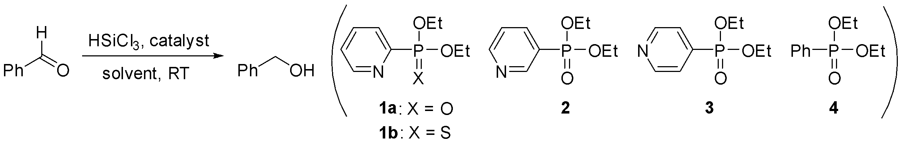

Figure 1. Hydrosilylation reaction of benzaldehyde

Table 1. Hydrosilylation of benzaldehyde
Entry | HSiCl₃ (equiv) | Catalyst (mol%) | Solvent | Time (hour) | Conversion (%)ª | Isolated Yield (%)^{b}
1 | 2.0 | 1a (20) | CH₂Cl₂ | 8 | 84 | –
2 | 2.0 | 1a (20) | CH₂Cl₂ | 20 | >99 | 70
3 | 2.0 | 1a (20) | CHCl₃ | 20 | 98 | –
4 | 2.0 | 1a (20) | Et₂O | 20 | 99 | –
5 | 2.0 | 1a (20) | toluene | 20 | >99 | –
6 | 2.0 | 1a (10) | CH₂Cl₂ | 20 | 98 | –
7 | 2.0 | 1a (10) | toluene | 20 | 52 | –
8 | 2.0 | 1b (20) | CH₂Cl₂ | 20 | 19 | –
9 | 2.0 | 2 (20) | CH₂Cl₂ | 20 | 47 | –
10 | 2.0 | 3 (20) | CH₂Cl₂ | 20 | 25 | –
11 | 2.0 | 4 (40) | CH₂Cl₂ | 20 | 30 | –
12 | 2.0 | pyridine (40) | CH₂Cl₂ | 20 | 14 | –
13 | 2.0 | pyridine (20) | CH₂Cl₂ | 20 | 8 | –
14 | 2.0 | – | CH₂Cl₂ | 20 | 0 | –
15 | 1.2 | 1a (20) | CH₂Cl₂ | 20 | >99 | 80
ª Determined by ¹H NMR. ^{b} Isolation was not attempted except for entries 2 and 15

The optimized conditions were then applied to several aromatic aldehydes, cinnamaldehyde, and cyclohexanecarboxaldehyde to examine the scope of substrates (Figure 2 and Table 2). As shown in entries 1–6, the aromatic aldehydes and cinnamaldehyde were completely converted into the corresponding alcohols, though some proportions of them were lost during purification procedures. The difficulty of isolation was partly due to the production of polysiloxane as described above and the reduction of the amount of HSiCl₃ from 2 equiv. to 1.2 equiv. greatly improved the isolated yield of p-chlorobenzaldehyde (entries 2, 3), though it did not improve the result with 1-naphthaldehyde (entries 4, 5). Contrary to the complete conversion of aromatic and α,β-unsaturated aldehydes, the reaction of cyclohexanecarboxaldehyde was not completed under the same conditions and the isolated yield of the desired alcohol was only 27% (entry 7).

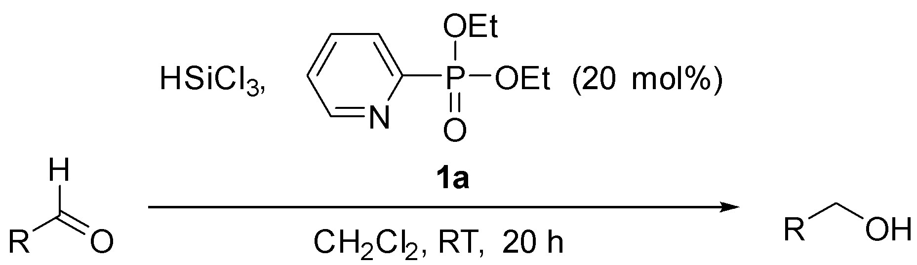

Figure 2. Hydrosilylation reaction of aldehydes

Table 2. Hydrosilylation of aldehydes

Entry | HSiCl₃ (equiv) | R | Conversion (%)ª | Isolated Yield (%)
1 | 2.0 | p-MeOC₆H₄ | >99 | 50
2 | 2.0 | p-ClC₆H₄ | >99 | 62
3 | 1.2 | p-ClC₆H₄ | >99 | 94
4 | 2.0 | 1-naphthyl | >99 | 87
5 | 1.2 | 1-naphthyl | >99 | 83
6 | 2.0 | (E)-PhCH=CH | >99 | 78
7 | 2.0 | c-Hex | 62 | 27
ª Determined by ¹H NMR

Next, we investigated the hydrosilylation of acetophenone using 1a as a catalyst (Figure 3 and Table 3). As expected from the result obtained with cyclohexanecarboxaldehyde, the hydrosilylation of acetophenone, which is less reactive than cyclohexanecarboxaldehyde, was very slow. Only 5% of acetophenone was converted into 1-phenylethanol under the conditions optimized for aldehydes (entry 1). The reaction was equally sluggish in CHCl₃ (entry 2) and toluene (entry 3) and promoted a little further in Et₂O (entry 4) and 1,4-dioxane (entry 5), though only up to 15%. The reaction did not occur when diethyl phenylphosphonate 4 was used as a catalyst in toluene (entry 6).

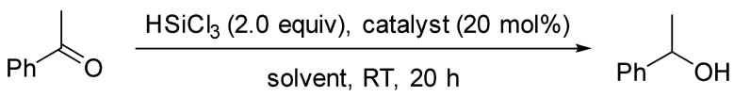

Figure 3. Hydrosilylation reaction of acetophenone

Table 3. Hydrosilylation of acetophenone

Entry | Catalyst | Solvent | Conversion (%)^{A}
1 | 1a | CH₂Cl₂ | 5
2 | 1a | CHCl₃ | 4
3 | 1a | toluene | 3
4 | 1a | Et₂O | 11
5 | 1a | 1,4-dioxane | 15
6 | 4 | toluene | 0
ª Determined by ¹H NMR

The marked difference in the reactivity of aldehydes and acetophenone suggested the possibility of chemoselective reduction of aldehydes over ketones. Therefore, we carried out the hydrosilylation of a 1:1 mixture of benzaldehyde and acetophenone in the presence of 20 mol% of 1a (Scheme 1). As we expected, benzaldehyde was completely reduced to benzyl alcohol while acetophenone was recovered quantitatively. This result shows that 1a will be useful for the chemoselective reduction of a formyl group over a keto group [29-31].

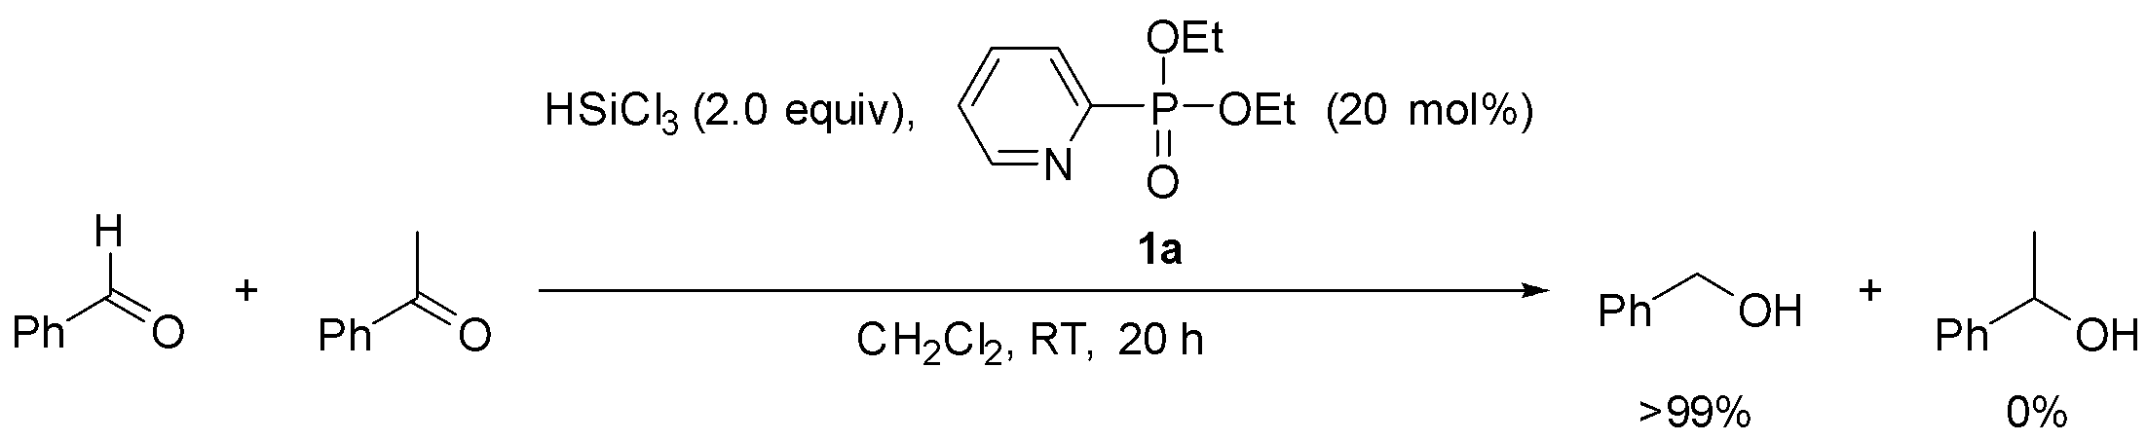

Scheme 1. Chemoselective hydrosilylation of benzaldehyde in the presence of acetophenone

Conclusion
In conclusion, we have found that diethyl 2-pyridylphosphonate works as an efficient catalyst for the hydrosilylation of aldehydes using HSiCl₃ as a reducing agent. A comparative study on the structure and activity of catalysts suggested that diethyl 2-pyridylphosphonate works as a bidentate Lewis base catalyst to activate HSiCl₃. The hydrosilylation was found to be completely chemoselective for an aldehyde over a ketone.

Acknowledgement
This research was partially supported by a Grant-in-Aid for Scientific Research on Innovative Areas “Advanced Molecular Transformations by Organocatalysts” from MEXT, Japan (Grant Number JP24105510).

References

- Herrera, R. P. (2016). Organocatalytic transfer hydrogenation and hydrosilylation reactions. Topics in Current Chemistry, 374(29): 1-40.
- Kocovsky, P. and Malkov, A. V. Edited by Vedejs, E. and Denmark, S. E. (2016). Lewis bases as catalysts in the reduction of imines and ketones with silanes (n → σ*). Lewis base catalysis in organic synthesis. Wiley-VCH, Germany: pp. 1077-1112.
- Boyer, J., Corriu, R. J. P., Perz, R. and Reye, C. (1979). Catalyse heterogene en presence de sels et sans solvant: II. Hydrosilylation d'aldehydes et de cetones satures et α,β ethyleniques. Journal of Organometallic Chemistry, 172(2): 143-152.
- Corriu, R. J. P., Perz, R. and Reye, C. (1983). Activation of silicon-hydrogen, silicon-oxygen, silicon-nitrogen bonds in heterogeneous phase: some new methods in organic synthesis. Tetrahedron, 39(6): 999-1009.
- Fujita, M. and Hiyama, T. (1984). Highly diastereocontrolled reduction of ketones by means of hydrosilanes. practical synthesis of optically active 1,2-diols and 2-amino alcohols of threo or erythro configuration. Journal of the American Chemical Society, 106(16): 4629-4630.
- Fujita, M. and Hiyama, T. (1988). Erythro-directive reduction of α-substituted alkanones by means of hydrosilanes in acidic media. The Journal of Organic Chemistry, 53(23): 5415-5421.
- Kohra, S., Hayashida, H., Tominaga, Y. and Hosomi, A. (1988). Pentaco-ordinate organosilicon compounds in synthesis: Asymmetric reduction of carbonyl compounds with hydrosilanes catalyzed by chiral bases. Tetrahedron Letters, 29(1): 89-92.
- Hojo, M., Fujii, A., Murakami, C., Aihara, H. and Hosomi, A. (1995). Divergent stereoselectivity in the reduction of α,β-epoxy ketones using hydridosilicates. Tetrahedron Letters, 36(4): 571-574.
- Van der Jeught, S. and Stevens, C. V. (2009). Direct phosphonylation of aromatic azaheterocycles. Chemical Reviews, 109(6): 2672-2702.
- Onomura, O., Kouchi, Y., Iwasaki, F. and Matsumura, Y. (2006). New organic activators for the enantioselective reduction of aromatic imines with trichlorosilane. Tetrahedron Letters, 47(22): 3751- 3754.
- Onomura, O., Kirira, P. G., Tanaka, T., Tsukada, S., Matsumura, Y. and Demizu, Y. (2008). Diastereoselective arylation of l-proline derivatives at the 5-position. Tetrahedron, 64(32): 7498-7503.
- Zheng, H., Deng, J., Lin, W. and Zhang, X. (2007). Enantioselective hydrosilylations of ketimines with trichlorosilane promoted by chiral n-picolinoylaminoalcohols. Tetrahedron Letters, 48(45): 7934-7937.
- Zheng, H.-J., Chen, W.-B., Wu, Z.-J., Deng, J.-G., Lin, W.-Q., Yuan, W.-C. and Zhang, X.-M. (2008). Highly enantioselective synthesis of β-amino acid derivatives by the Lewis base catalyzed hydrosilylation of β-enamino esters. Chemistry – A European Journal, 14(32): 9864-9867.
- Guizzetti, S., Benaglia, M. and Rossi, S. (2009). Highly stereoselective metal-free catalytic reduction of imines: an easy entry to enantiomerically pure amines and natural and unnatural α-amino esters. Organic Letters, 11(13): 2928-2931.
- Xiao, Y.-C., Wang, C., Yao, Y., Sun, J. and Chen, Y.-C. (2011). Direct asymmetric hydrosilylation of indoles: combined Lewis base and Brønsted acid activation. Angewandte Chemie International Edition, 50(45): 10661-10664.
- Malkov, A. V., Stewart-Liddon, A. J. P., McGeoch, G. D., Ramirez-López, P. and Kočovský, P. (2012). Catalyst development for organocatalytic hydrosilylation of aromatic ketones and ketimines. Organic & Biomolecular Chemistry, 10(25): 4864-4877.
- Malkov, A. V., Liddon, A. J. S., Ramírez-López, P., Bendová, L., Haigh, D. and Kočovský, P. (2006). Remote chiral induction in the organocatalytic hydrosilylation of aromatic ketones and ketimines. Angewandte Chemie International Edition, 45(9): 1432-1435.
- Bonsignore, M., Benaglia, M., Annunziata, R. and Celentano, G. (2011). New, readily available organocatalysts for the enantioselective reduction of α-imino- and β-imino esters. Synlett, (8): 1085- 1088.
- Oka, N., Ito, K., Tomita, F. and Ando, K. (2012). Synthesis of 2-pyridylphosphinate and thiophosphinate derivatives by nucleophilic aromatic substitution of n-methoxypyridinium tosylates. Chemistry Letters, 41(12): 1630-1632.
- Oka, N., Ori, K. and Ando, K. (2017). Synthesis of 2-pyridylthiophosphinic acids and 2-pyridylthiophosphonate monoesters via nucleophilic aromatic substitution. Phosphorus, Sulfur, and Silicon and the Related Elements, 192(4): 454-463.
- Redmore, D. (1970). Phosphorus derivatives of nitrogen heterocycles. 2. pyridinephosphonic acid derivatives. The Journal of Organic Chemistry, 35(12): 4114-4117.
- Chen, D., Martell, A. E., Motekaitis, R. J. and McManus, D. (1998). Syntheses and Fe(II)/Fe(III) equilibria of the new multidentate ligands pyridine-2-phosphonic-6-carboxylic acid and 2,6-pyridinediphosphonic acid for the use of their iron chelates as catalysts for the oxidation of H₂S to S₈ by air. Canadian Journal of Chemistry, 76(4): 445-451.
- Johansson, T., Kers, A. and Stawinski, J. (2001). 2-pyridylphosphonates: A new type of modification for nucleotide analogues. Tetrahedron Letters, 42(11): 2217-2220.
- Pitt, L. S., Large, G. B. and MacDonald, A. A. (1978). Insecticidal diethyl 2-​pyridinethionophosphonate. German Offen., CAN: 89: 18370.
- Hirao, T., Masunaga, T., Yamada, N., Ohshiro, Y. and Agawa, T. (1982). Palladium-catalyzed new carbon-phosphorus bond formation. Bulletin of the Chemical Society of Japan., 55(3): 909-913.
- Kalek, M., Jezowska, M. and Stawinski, J. (2009). Preparation of arylphosphonates by palladium(0)-catalyzed cross-coupling in the presence of acetate additives: Synthetic and mechanistic studies. Advanced Synthesis & Catalysis, 351(18): 3207-3216.
- Brook, M. A. (2000). Atomic and molecular properties of silicon. silicon in organic, organometallic, and polymer chemistry. Wiley-Interscience, New York: pp. 27-38.
- Theis, B., Metz, S., Burschka, C., Bertermann, R., Maisch, S. and Tacke, R. (2009). Neutral pentacoordinate silicon(iv) complexes with silicon-chalcogen (S, Se, Te) bonds. Chemistry – A European Journal, 15(30): 7329-7338.
- Hosomi, A., Hayashida, H., Kohra, S. and Tominaga, Y. (1986). Pentaco-ordinate silicon compounds in synthesis: chemo- and stereo-selective reduction of carbonyl compounds using trialkoxy-substituted silanes and alkali metal alkoxides. Journal of the Chemical Society, Chemical Communications, (18): 1411-1412.
- Kobayashi, S., Yasuda, M. and Hachiya, I. (1996). Trichlorosilane-dimethylformamide (Cl₃SiH-DMF) as an efficient reducing agent. reduction of aldehydes and imines and reductive amination of aldehydes under mild conditions using hypervalent hydridosilicates. Chemistry Letters, 25(5): 407-408.
- Zhao, M., Xie, W. and Cui, C. (2014). Cesium carbonate catalyzed chemoselective hydrosilylation of aldehydes and ketones under solvent-free conditions. Chemistry – A European Journal, 20(30): 9259-9262.

