INTERACTION STUDIES OF PUTATIVE CHEMICAL LIGANDS IN BINDING SITES OF THERMOSTABLE LIPASE FROM

Geobacillus zalihae STRAIN T1

(Kajian Interaksi Ligan Kimia pada Tapak Pengikatan Lipase Termostabil daripada Geobacillus zalihae Stren T1)

Mohd Basyaruddin Abdul Rahman^{1,2} and Muhammad Alif Mohammad Latif ^{1,2,3}

¹Integrated Chemical BioPhysics Research,

²Department of Chemistry,

Faculty of Science,

³Centre of Foundation Studies for Agricultural Science,

Universiti Putra Malaysia, 43400 UPM Serdang, Selangor, Malaysia

*Corresponding author: basya@upm.edu.my

Abstract

Industrial biotechnology focusing on the usage of enzyme as the catalyst in many chemical reactions, however enzyme stability remains a major challenge. Enzyme can be modified via genetic or chemical methods by manipulating its structure. A potential biocatalyst based on lipase enzyme was designed by in silico approach. The enzyme-ligand interactions between selected chemical ligands and a thermostable lipase from Geobacillus zalihae strain T1 were studied by using molecular docking, AutoDock 3.0.5. The T1 lipase structure (PDB ID: 2DSN) was predicted to have 65 pockets in the structure, with nine of them have the potential binding sites for ligands based on their surface area, volume and number of residues. The characteristics of each selected binding site and chemical ligands were analyzed. Types of enzyme-ligand interactions involved in binding sites were determined and co-related with the final docked energies. All these discoveries may prove useful for designing novel binding sites, in particular as new biocatalyst.

Keywords: Thermostable lipase, binding site, protein-ligand interaction, docking, biocatalyst

Abstrak

Industri bioteknologi memberi tumpuan kepada penggunaan enzim sebagai pemangkin dalam banyak tindak balas kimia, namun mengekalkan kestabilan enzim menjadi cabaran utama. Enzim boleh diubah melalui kaedah genetik atau kimia dengan memanipulasi struktur asasnya. Biokatalis yang berpotensi berdasarkan enzim lipase direka bentuk dengan menggunakan pendekatan berkomputer. Interaksi enzim-ligand antara ligan kimia dipilih dan lipase termostabil dari Geobacillus zalihae stren T1 telah dikaji dengan menggunakan pendokkan molekul, AutoDock 3.0.5. Struktur lipase T1 (PDB ID: 2DSN) diramalkan mempunyai 65 poket dalam struktur, dengan sembilan daripadanya mempunyai tapak pengikat yang berpotensi untuk ligan berdasarkan luas permukaan, jumlah dan bilangan residu. Ciri-ciri setiap tapak pengikat dan ligan kimia tersebut dipilih untuk dianalisis. Jenis-jenis interaksi enzim-ligan yang terlibat dalam tapak pengikat telah ditentukan dan berkait dengan tenaga berlabuh yang paling akhir. Semua penemuan ini terbukti bermanfaat bagi membentuk tapak mengikat novel, khususnya sebagai biokatalis yang baru.

Kata kunci: Lipase termostabil, tapak pengikat, interaksi protein-ligan, pendokkan, biokatalis

Introduction

Lipases are water-soluble enzymes (EC 3.1.1.3) that catalyze the hydrolysis of ester bonds in triglycerides into free fatty acids and glycerol. Besides hydrolysis, lipases can catalyze esterification, transesterification and polyesterification reactions. Lipases are widely used in the production of cocoa butter substitutes, oleochemical products, detergents, surfactants, as well as the production of biodegradable polymers, lubricants and solvents [1]. Lipases from extreme thermophiles are special due to their inherent thermostability and resistance against chemical denaturants, such as extremely acidic and alkaline conditions, detergents, chaotropic reagents, organic solvents and protein inhibitors [2, 3]. They should be exploited extensively to maximize the potential and capability as industrial biocatalysts.

The thermoalkalophilic lipase (PDB ID: 2DSN) from Geobacillus zalihae strain T1 contains 388 amino acids. It has two metal ions, Ca²⁺ and Zn²⁺, which are seldom found in bacterial lipases [4]. Sharing 30-35% homology with the Gram-positive Staphylococcus lipases [5], T1 lipase is classified under lipase family I.5 [6]. The Geobacillus lipase is larger in molecular size due to the presence of dimer interface and its structural zinc site [7]. Its metal binding site plays a major role in thermostability at elevated temperatures. Like P1 and L1 lipases (PDB ID: 1KU0 and 1JI3 respectively) [8, 9], there are conserved hydrophobic tryptophan residues around the zinc domain of the lipase [10]. Its active site is formed by Ser113, Asp317 and His358 [4]. The active site residues are covered by a long helix from residue 175 to 191. This area is not accessible by solvents, indicating that the T1 lipase structure is a closed conformation at room temperature [11].

Molecular modeling techniques are used to study macromolecular binding sites and predict their interactions with the bioactive conformers of ligands [12]. Previous research reported that a trypsin structure (PDB ID: 1AUJ) was successfully docked with ligands including 1,10-phenanthroline, ethanolamine, benzamidine, ethanol, propanol, 1,3-propandiol, phosphoethanolamine, p-aminobenzamidine, phenylacetic acid and phenylalanine at different pockets [13]. New binding pockets near the active site in peptide deformylase (PDF) was also discovered and explored to design potent inhibitors by using ZINC screening database and AutoDock software [14, 15]. Docking studies on lipase could provide further insight into the conformation and functional changes of lipase. To date, docking studies on T1 structure using AutoDock have not been reported. In this work, interactions between the pocket residues and docked ligands were investigated by exploring their binding modes.

Materials and Methods

Determination of pocket cavities of T1 lipase

The 3D coordinates of T1 lipase was sent to pocket and void Surfaces of Amino acid Residues (pvSOAR) (now known as pevoSOAR; http://sts.bioe.uic.edu/pevosoar/) [16, 17], a web server to determine the total pockets in the lipase and to search for macromolecular structures with high similarity in terms of atom coordination and surface pattern. The surface pattern of T1 lipase, which was then referred as 'pocket' in the selected surface database was compared, along with the surface patterns of the entire structure within the database [18]. Nine largest pockets defined from pvSOAR were then selected as possible binding sites of the protein structure.

Screening and selection of suitable chemical ligands for docking

Ten ligand structures were selected from Protein Data Bank (www.rcsb.org) based on their properties and functional groups such as amine, hydroxyl or both functional groups, to be used in the molecular docking stage. The ten ligands namely benzamidine (BEN), p-aminobenzamidine (PBZ), 1,10-phenanthroline (PHN), 1-propanol (POL), phenylacetic acid (PAC), 1,3-propandiol (PDO), ethanol (EOH), ethanolamine (ETA), o-phosphoethanolamine (PSE) and phenylalanine (PHE). Their structures are depicted in Table 1.

Preparation of T1 lipase and selected chemical ligands

After all the structures were obtained, T1lipase was protonated and solvated by using protonate and addsol tools in AutoDock 3.0.5 to generate a pdbqt file as the docking platform for selected ligands. Meanwhile, the selected chemical ligand structures were transferred into InsightII software for structural and force field correction procedures. The ligands.mol2 file was generated for each selected ligand. This ligand.mol2 files were transferred to AutoDock 3.0.5 and the autotors tool was used to determine their torsions. Lastly, pdbqt files were also generated for each ligand to be used in the molecular docking stage.

Docking of each ligand onto potential pocket cavities in T1 lipase structure

Each ligand structure was docked into the targeted potential binding sites using AutoDock 3.0.5, and the final docked energy of each successful docking was recorded. The grid map was sized at 60 x 60 x 60 with a grid point spacing of 0.375 Å. A total of 100 runs was performed for each ligand at different pockets. For each of the independent runs, up to 27,000 Lamarckian Genetic Algorithm (LGA) operations were generated on a single population of 50 individuals. The operator weights for crossover, mutation and elitism were 0.80, 0.02 and 1, respectively [19].

Table 1. Selected chemical ligands for molecular docking onto T1 lipase binding sites. The ligand selections were based on small molecules with amine or hydroxyl or both groups

Functional Group | Name | PDB ID | Structure
Amine | Benzamidine  p-aminobenzamidine  1,10-phenanthroline | BEN  PBZ  PHN
Hydroxyl | 1-propanol  Phenylacetic acid  1,3-propandiol  Ethanol | POL  PAC  PDO  EOH
Amine and hydroxyl | Ethanolamine  o-phosphoethanolamine  Phenylalanine | ETA  PSE  PHE

Results and Discussion

Structural studies of T1 lipase

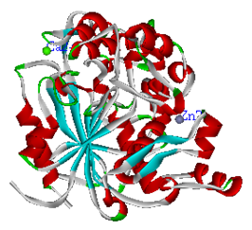
A highly thermostable enzyme extracted from Geobacillus zalihae strain T1 was discovered by Abdul Rahman and co-researchers [4] and it’s structural was simulated in detail [20]. As a thermophilic and alkaliphilic lipase, it can withstand denaturation at 65 ˚C and pH 9.0. Like other Bacillus lipases, an Ala replaces the first Gly residue in the Gly-Xaa-Ser-Xaa-Gly (Xaa refers to any amino acid) sequence, which is conserved among microbial and mammalian lipases. The three-dimensional structure of thermostable T1 lipase is displayed in Figure 1.

Figure 1. 3D lipase structure from Geobacillus zalihae Strain T1

The T1 lipase structure was uploaded onto pvSOAR and it predicted a total of 65 pockets in the structure. Querying the surface pattern of T1 lipase against the PDB database generated a list of macromolecule structures with high similarities to T1 lipase. Two structures with the highest similarities over 95% were lipases from Bacillus stearothermophilus P1 (1JI3) and Bacillus stearothermophilus L1 (1KU0) [8,9]. Like the T1 lipase, 1KU0 and 1JI3 structures also possess one each of Ca²⁺ and Zn²⁺ metal ions, which are not usually found in other lipases.

The nine largest pockets from T1 lipase were selected as the potential binding sites for ligands (Figure 2) and their surface area, volume and number of residues were analyzed. Pocket 65 was the largest pocket with the surface area of 296.1 Å², volume of 494.3 Å³ and a total of 17 amino acids forming the concaved area. Pocket 64, the second largest pocket was formed by 12 amino acids and followed by pocket 63 with 14 amino acids. Although the number of amino acids in pocket 64 was fewer than pocket 63, pocket 64 had bigger volume at 335.9 Å³ than pocket 63 at 187.8 Å³. Pocket 59 was formed by 12 amino acids in which two residues, Ser113 and His358 were members of the catalytic triad [3,4]. Its surface area was 159.0 Å² and pocket volume was 144.6 Å³. Both pockets 58 and 57 possessed 12 amino acid residues but the surface area and pocket volume of pocket 58 were much smaller than pocket 57. It might be due to the denser configuration of the amino acids formed in pocket 58 than in pocket 57.

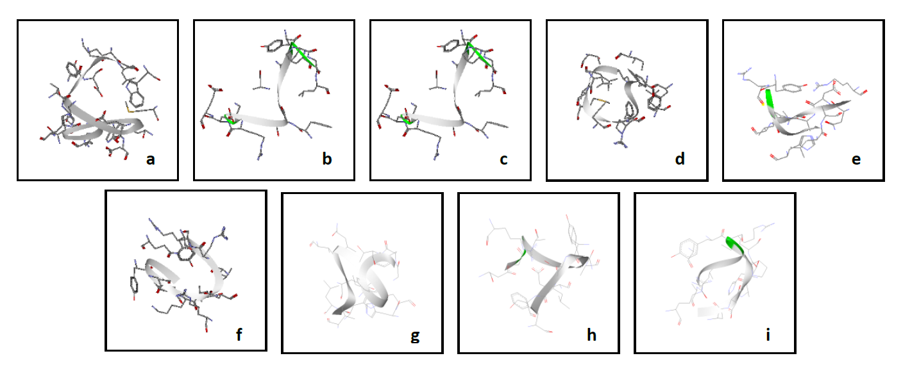
Figure 2. Nine potential binding sites in T1 lipase (2DSN). Each pocket was presented separately as secondary structure with stick display: (a) pocket 65 (the largest pocket) (b) pocket 64 (c) pocket 63 (d) pocket 62 (e) pocket 61 (f) pocket 60 (g) pocket 59 (h) pocket 58 and (i) pocket 57

Table 2 contains the number of amino acid residues in each selected binding site of thermostable T1 lipase structure. The amino acids with hydrophobic side groups are valine, leucine, isoleucine, methionine and phenylalanine while amino acids with hydrophilic side groups are asparagine, glutamic acid, glutamine, histidine, lysine, arginine and aspartic acid. These side groups play a vital role in ligand docking into potential binding sites.

Pocket 65 is a hydrophilic binding site due to the high number of hydrophilic residues on the pocket surface. It had eight amino acids with hydrophilic groups while only two amino acids contain hydrophobic groups. Pocket 64 was slightly hydrophilic due to the small difference of number of hydrophobic and hydrophilic groups. For pockets 63 and 62, both possessed seven hydrophilic amino acids, with two and three hydrophobic amino acids, respectively. These two pockets were highly hydrophilic.

Pocket 61 also showed more hydrophilic properties with six hydrophilic amino acid residues compared to two hydrophobic amino acid residues in the pocket. Pockets 65, 64, 63, 62 and 61 had hydrophilic properties, possibly due to their pocket positions, lying on the outer surface of the structure. Most folded proteins have a hydrophobic core in which the side chain stabilizes the folded state, and the charged or polar side chains are usually found on the solvent-exposed surface that interact with surrounding water molecules. It is generally accepted that minimizing the number of hydrophobic side chains exposed to water is the principal driving force behind the folding process [21, 22].

Pocket 60 was hydrophobic due to the presence of ten hydrophobic amino acid residues. The hydrophobic amino acids account for 76.92 % of the total residues. The hydrophobic surface of enzymes may increase the affinity with both the organic solvents and hydrophobic substrates [23]. Pocket 59 is considered hydrophobic as amino acid residues with hydrophobic groups outnumbered the hydrophilic groups. Pockets 58 and 57 possessed 5 amino acid residues each with hydrophobic groups but they were not highly hydrophobic due to the minor difference between the effects of hydrophobicity and hydrophilicity

Table 2. List of the nine largest potential binding sites in T1 lipase (2DSN) by their residue constituents, volume and surface area

Pocket | Amino Acid Constituents | Number of Residues | Surface Area  (Å²) | Volume  (Å³)
65 | S58, W60, H81, K84, H85, M121, S130, E132, E133, T237, D238, Y242, D243, G248, T251, L252, W255 | 17 | 296.1 | 494.3
64 | G20, R21, E22, E23, F49, T50, A52, Q69, Y94, P95, G96, L97 | 12 | 181.7 | 335.9
63 | H14, W19, G20, R21, E22, E23, F27, K28, Y29, W30, D36, E38, T50, L51 | 14 | 236.7 | 187.8
62 | R92, Q202, Y204, D205, F206, K207, L208, D209, L213, R214, R215, Y224 | 12 | 183.6 | 157.0
61 | A52, V53, W65, Q69, V75, Y77, G91, R92, Y94, K207, D209, Q210 | 12 | 194.3 | 165.5
60 | F16, T168, L170, V171, M173, F176, R179, F180, L183, L244, F290, C295, I319 | 13 | 163.8 | 118.0
59 | G15, F16, T17, Y29, H112, S113, L183, V187, I319, H358, L359, I362 | 12 | 159.0 | 144.6
58 | D76, G78, A79, R89, E133, Y136, A137, V142, S143, L144, S145, F148 | 12 | 108.1 | 83
57 | R4, N6, D7, A8, P9, I10, Y46, R47, H108, A380, L383, A384 | 12 | 123.3 | 109.9

*Amino acids in bolded form are hydrophobic type

All necessary information needed to identify the binding sites in T1 lipase were gathered and the locations of each of the selected binding sites were determined by using Accelrys Discover Studio 1.0 (DS Modeling 1.0) and UltraEdit. UltraEdit was applied in this study to edit the atomic information in the T1 lipase structural file for the construction of involved amino acid residues to form a binding site of T1 lipase.

Docking to the T1 lipase

Four ligands remark as POL, PHE, PDO and BEN were able to dock into pocket 65. PHE docked with the lowest final docked energy at -6.16 kcal/mol (Table 3). Four hydrogen bonds were established through hydrogen from amine and hydroxyl of PHE with carbonyl oxygen from THR237 and ASP243. BEN, like PHE with an aromatic ring and two amine groups, only managed to produce a final docked energy of 2.82 kcal/mol. Both ligands POL and PDO (Figure 3) docked with almost the same final docked energies, -4.04 and -3.99 kcal/mol, but lower than BEN. PHE formed a π-π stacking with TRP60 which explained the higher binding affinity of PHE towards pocket 65. Ligands containing hydroxyl group produce a lower final docked energy compared to ligands with an amine group. It is worth noting that the hydroxyl groups are important as they form H-bonds with the residues of the receptor to increase the binding affinity [13, 24].

Table 3. AutoDock calculated final docked energy for each ligand bind to a binding site. The lowest final docked energy for each ligand determined the most favorable binding pocket.

Pocket | Docked Ligand | Final Docked Energy (kcal/mol) | Torsion
65 | POL  PHE  PDO  BEN | -4.04  -6.16  -3.99  -2.82 | 1  3  2  2
64 | POL  PHE  PDO | -3.43  -4.96  -2.13 | 1  3  2
63 | POL  PHE  PDO  BEN | -3.56  -5.56  -3.65  -3.03 | 1  3  2  2
62 | POL  PHE  PDO  BEN | -3.34  -6.71  -4.04  -2.10 | 1  3  2  2
61 | POL  PHE  PDO  BEN  ETA  EOH  PAC | -3.09  -3.26  -3.81  -3.78  -2.24  -2.38  -3.80 | 1  3  2  2  1  1  2
60 | POL  PHE  PDO | -3.78  -6.21  -4.69 | 1  3  2
59 | POL  PDO  BEN  ETA | -3.55  -2.85  -2.65  -2.28 | 1  2  2  1
58 | POL  PHE  PDO | -3.07  -5.58  -4.16 | 1  3  2
57 | POL  PHE | -3.39  -2.14 | 1  3

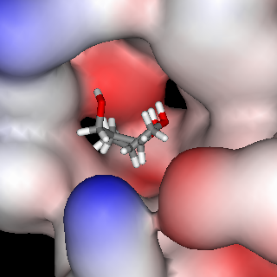

Figure 3. The hydroxyls of POL and PDO point to the surface area in pocket 65.

Ligands PHE, POL and PDO were docked into pocket 64. Ligand PHE produced the lowest final docked energy at -4.96 kcal/mol. There was 1 H-bond between carbonyl oxygen of PHE and hydrogen from primary amine of ARG21 (1.84 Å). A hydrogen bond (2.17 Å) was formed between hydroxyl hydrogen of POL and the nitrogen atom of the indole ring from TRP30. PDO formed 2 H-bonds with carbonyl oxygen from GLU38 (2.05 Å) and GLN39 (1.98 Å). The final docked energy of POL was lower than PDO due to the presence of hydrophobic interaction. Only GLN39 was involved in the hydrophobic interaction of PDO while POL had residues THR50, TRP30, LYS28 and ARG21 for the same type of interaction. PHE made the highest number of hydrophobic interactions when compared with PDO and POL (Figure 4).

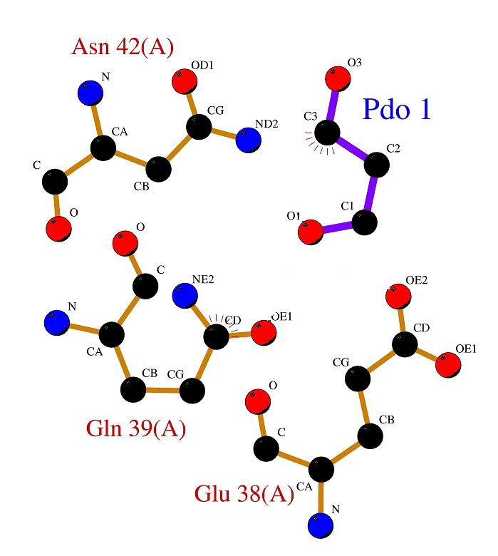
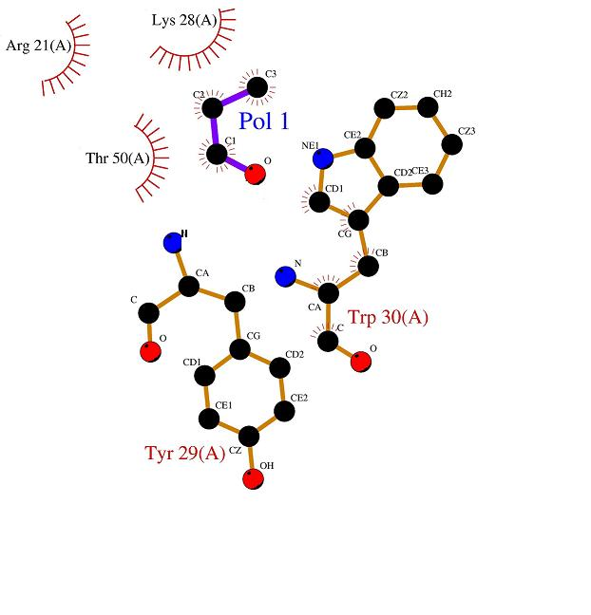
(b)
(a)

Figure 4. Hydrophobic interaction for ligand (a) POL and (b) PDO with their surrounding pocket residues in pocket 64

Four ligands were successfully docked into pocket 63. PHE led with the lowest final docked energy of -5.56 kcal/mol. Two H-bonds were formed between PHE and pocket residues. The first H-bond was formed between the hydroxyl hydrogen of PHE and the carbonyl oxygen of GLU22 (1.85 Å). The second H-bond was formed between the amine hydrogen of MET24 and the hydroxyl oxygen of PHE (2.28 Å). BEN produced the highest final docked energy among the four docked ligands at -3.03 kcal/mol. The amine hydrogen of BEN established a H-bond with the hydroxyl oxygen of SER201 (2.17 Å), showing again that ligands with –COO- or –CO- groups have better binding affinity than those with amine groups. The final docked energies of POL and PDO were similar because both ligands had the same number of hydrophobic interactions, despite the extra H bonding between PDO with pocket residues.

In pocket 62, PHE led the other 3 ligands (PDO, BEN and POL) with the lowest final docked energy at -6.71 kcal/mol, while BEN produced the highest final docked energy. PHE and POL made 3 H-bonds each while PDO and BEN had 1 H-bond each. Yet, the final docked energy of PDO was lower than POL. The numbers of hydrophobic interactions for both ligands were almost the same. Here, Van der Waals forces or London dispersion forces were considered to explain the differences of final docked energies. They are a class of intermolecular forces which arise from the polarization of molecules into dipoles or multipoles. The interaction distance for the van der Waals was within 4.00 Å. PDO had van der Waals interactions with 27 amino acid residues and only 18 residues for POL (Figure 5).

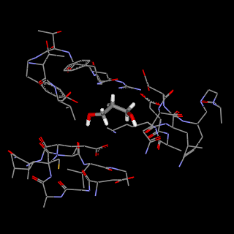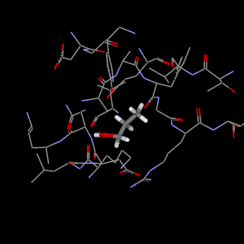
(b)
(a)

PDO
POL

Figure 5. (a) POL had van der Waals interactions with 18 residues of pocket 62 while (b) PDO interacted with 27 pocket residues

Four ligands (PDO, BEN, PHE and POL) were successfully docked into pocket 61. The lowest final docked energy was scored by PDO at -3.81 kcal/mol which was slightly lower than BEN at -3.78 kcal/mol. Both PDO and BEN formed 3 hydrogen bonds each with pocket residues. Hydroxyl hydrogen from PDO bonded to the carbonyl oxygen groups of VAL171 (1.99 Å) and VAL174 (2.16 Å). An amine hydrogen of ARG241 also interacted with a carbonyl oxygen of PDO (1.98 Å). Meanwhile, the 3 H-bonds in BEN were from the amine hydrogen interactions with carbonyl oxygen groups of ASN172 (2.39 Å), MET173 (2.24 Å) and VAL174 (2.31 Å). The final docked energy of PHE was lower than POL, which might be due to the higher number of hydrophobic interactions between PHE and pocket residues although both ligands shared the same number of electrostatic interactions. The amine nitrogen of ARG241 made an electrostatic interaction with the hydroxyl oxygen of PDO at 2.80 Å while the amine nitrogen from PHE made the same interaction with the carbonyl oxygen of ASP182 at 3.20 Å. Electrostatic interactions occur between opposite charged atoms, or a dipole or an induced dipole where charges on nuclei and electrons interact according to Coulomb’s law.

PHE, PDO and POL ligands were successfully docked into pocket 60 with PHE producing the lowest final docked energy at -6.31 kcal/mol. PHE and PDO made 3 hydrogen bonds with the pocket residues while POL had only 2 hydrogen bonds. The reason of PHE having the lowest final docked energy might be due to the inferior number of hydrophobic interactions over the other 2 ligands. The 2 H-bonds from POL were found between its hydroxyl oxygen and the amine hydrogen of ARG92 (2.25 Å), and its hydroxyl hydrogen with the amine nitrogen of LEU208 (2.35 Å). The 3 H-bonds formed between PDO and pocket residues were hydroxyl hydrogen of PDO and carbonyl oxygen of ASP205 (1.74 Å), amine hydrogen of PHE206 and hydroxyl oxygen of PDO (1.83 Å), as well as hydroxyl hydrogen of PDO and carbonyl oxygen of ASP209 (1.69 Å). Both PDO and POL had the same number of hydrophobic and electrostatic interactions with pocket residues.

In pocket 59, the successfully docked ligands were POL, PDO and BEN. POL scored the lowest final docked energy at -3.55 kcal/mol. PDO had 3 hydrogen bonds while POL and BEN had 2 hydrogen bonds. PDO made H-bonds through its hydroxyl hydrogen with the carbonyl oxygens of ALA186 (1.99 Å) and ASN288 (1.69 Å), as well as its hydroxyl oxygen with the amine hydrogen of PHE290 (2.16 Å). However, POL had more hydrophobic interactions than PDO. The difference between the hydrophobic interactions of POL and PDO could compensate the lack of binding affinity with a single hydrogen bond only. Same reason could be applied to the difference of final docked energies between POL and BEN, although both ligands had the same number of hydrogen bonds with pocket residues.

Three ligands were able to dock into pocket 58 with PHE generating the lowest final docked energy at -5.58 kcal/mol. POL docked with highest final docked energy in pocket 58 at -3.07 kcal/mol and formed 2 hydrogen bonds with pocket residues. Both PHE and PDO had 3 hydrogen bonds each with pocket residues. For PDO, the distances of hydrogen bonds were 1.94 Å and 2.18 Å, between its hydroxyl hydrogen and the carbonyl oxygen of CYS6, THR74, respectively. Between amine hydrogen of ASP76 and hydroxyl oxygen of PDO, the H-bond distance was 1.68 Å Å. The higher number of hydrophobic and van der Waals interactions also contributed to the increase of the binding affinity of PHE, compared to PDO [25]. Lastly in pocket 57, the 2 docking ligands were POL and PHE. POL produced the lower final docked energy at -3.39 kcal/mol while PHE had -2.14 kcal/mol. Both POL and PHE formed 2 hydrogen bonds each with the pocket residues. But the binding affinity for POL was stronger due to a higher number of hydrophobic interactions (Figure 6).

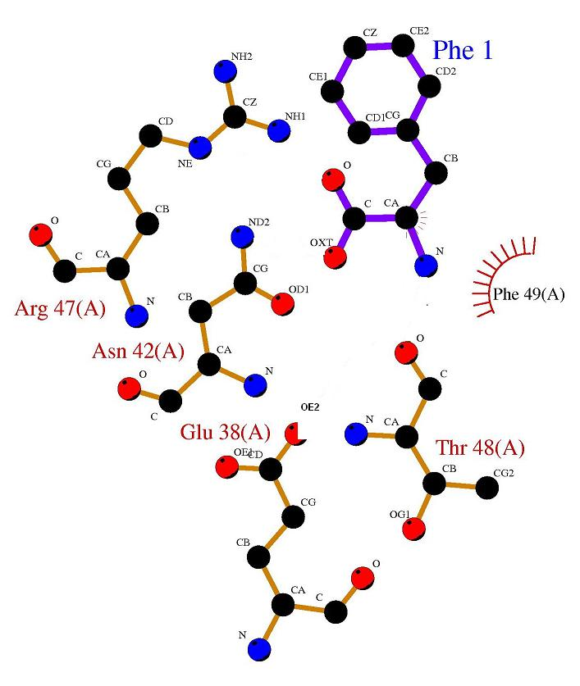
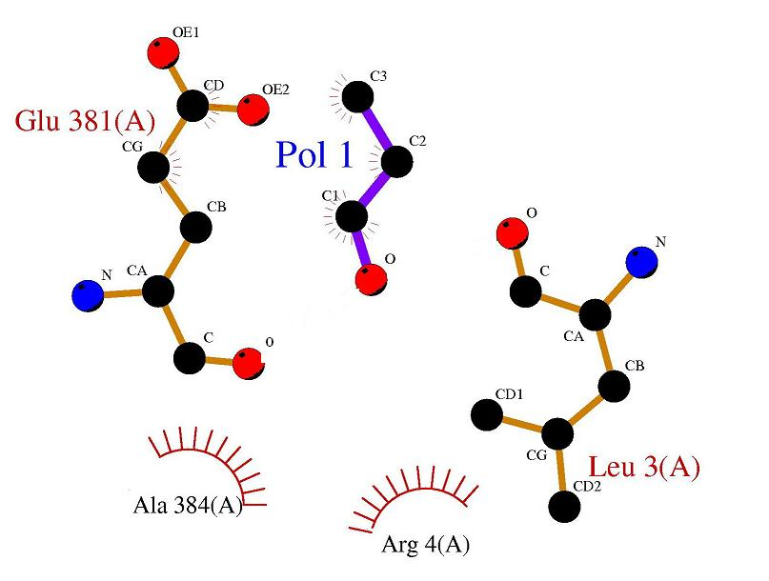
(b)
(a)

Figure 6. Hydrophobic contacts of ligands (a) POL and (b) PHE with surrounding residues in pocket 57

Conclusion

Selected binding sites of T1 lipase were investigated for ligand binding. The characteristics of each binding site and chemical ligand produced the latent information to determine the protein-ligand interactions. The binding modes of a series of chemical ligands with aromatic rings, amine and hydroxyl groups were explored using AutoDock software. Ligands PHE and BEN docked in the pockets with lowest final docked energy when compared to other selected ligands. Interactions like hydrogen bonds, electrostatic interactions, van der Waals and hydrophobic contacts played very important roles in the protein-ligand interaction studies. By employing in silico molecular docking, screening of putative ligands for possible interactions may enhance the discovery of novel semisynthetic enzymes and lead to new protein functions.

Acknowledgement

This work was supported by a grant from the Universiti Putra Malaysia, GP-IPB/2017/9581000.

References

- Choudhury, P. and Bhunia, B. (2015). Industrial application of lipase: A review. Biopharm Journal. (2): 41-47.
- Aliyu, S. and Md. Zahangir, A. (2015). Thermostable lipases: An overview of production, purification and characterization. Biosciences Biotechnology Research Asia, 11(3):1095-1107.
- Abedi Karjiban, R., Abdul Rahman, M. B., Basri, M., Salleh, A. B., Jacobs, D. and Abdul Wahab, H. (2009). Molecular dynamics study of the structure, flexibility and dynamics of thermostable L1 lipase at high temperatures. Protein Journal, 28(1): 14-23.
- Leow, T. C., Abdul Rahman, R. N. Z., Basri, M. and Salleh, A. B. (2004). High level expression of thermostable lipase from Geobacillus sp. strain T1. Bioscience. Biotechnology and Biochemistry. 68: 96-103.
- Bertoldo, J. B., Razzera, G., Vernal, J., Brod, F. C., Arisi, A. C. and Terenzi, H. (2011). Structural stability of Staphylococcus xylosus lipase is modulated by Zn(II) ions. Biochimica et Biophysica Acta 1814, 9:1120-1126.
- Jaeger, K. E., Dijkstra, B. W. and Reetz, M. T. (1999). Bacterial biocatalysts: molecular biology, three-dimensional structures, and biotechnological applications of lipases. Annual Review of Microbiology. 53: 315-351.
- Timucin, E. and Sezerman, O. U. (2015). Zinc modulates self-assembly of Bacillus thermocatenulatus lipase. Biochemistry. 2015, 54(25): 3901-3910.
- Tyndall, J. D. A., Sinchaikul, S., Forthergill-Gilmore, L. A., Taylor, P. and Walkinshaw, M. D. (2002) Crystal structure of a thermostable lipase from bacillus stearothermophilus P1. Journal of Molecular Biology, 323: 859-869.
- Choi, W. C., Kim, M. H., Ro, H. S., Ryu, S. R., Oh. T. K. and Lee, J. K. (2005). Zinc in lipase L1 from Geobacillus stearothermophillus L1 and structural implications on thermal stability. FEBS Letters, 579 (16): 3461-3466.
- Timucin, E., Cousido-Siah, A., Mitschler, A., Podjarny, A. and Sezerman, O. U. (2016). Probing the roles of two tryptophans surrounding the unique zinc coordination site in lipase family I.5. Proteins: Structure Function and Bioinformatics, 84(1): 129-142.
- Abdul Rahman, M. Z., Salleh, A. B., Abdul Rahman, R. N. Z., Abdul Rahman, M. B., Basri, M. and Thean Chor, A. L. (2012). Unlocking the mystery behind the activation phenomenon of T1 lipase: A molecular dynamics simulations approach. Protein Science 21(8): 1210-1221.
- Medina-Franco, J., Mendez-Lucio, O. and Martinez-Mayorga, K. (2014). Chapter one – the interplay between molecular modeling and cheminformatics to characterize protein-ligand and protein-protein interactions landscapes for drug discovery interactions. Advances in Protein Chemistry and Structural Biology, 96: 1-37.
- Abdul Rahman, M. B., Misran, A., Basri, M., Abdul Rahman, R. N. Z., Salleh, A. B. and Abdul Wahab, H. (2005). Screening and docking chemical ligands onto pocket cavities of a protease for designing a biocatalyst. Biocatalysis and Biotransformation, 23: 211-216.
- Chikhi, A. and Benseguemi, A. (2010). In silico study of the selective inhibition of bacteria peptide deformylases by several drugs. Journal of Proteomics and Bioinformatics 3: 061-065.
- Gao, J., Liang, L., Zhu, Y., Qiu, S., Wang, T. and Zhang, L. (2016). Ligand and structural-based approaches for the identification of peptide deformylase inhibitors as antibacterial drugs. International Journal of Molecular Science, 17: 1141.
- Binkowski, T. A., Freeman, P. and Liang, J. (2004). pvSOAR: detecting similar surface patterns of pocket and void surfaces of amino acid residues on proteins. Nucleic Acids Research, 32: W555-W558.
- Binkowski, T. A., Adamian, L. and Liang, J. (2003). Inferring functional relationships of proteins from local sequence and spatial surface patterns. Journal of Molecular Biology. 332: 505-526.
- Kumar, S. and Nussinov, R. (2002). Close-range electrostatic interactions in proteins. ChemBioChem. 23(7): 604-617.
- Morris, G. M., Goodsell, D. S., Halliday, R. S., Huey, R., Hart, W. E., Belew, R. K. and Olson, A. J. (1998). Automated docking using a Lamarckian genetic algorithm and an empirical binding free energy function. Journal of Computational Chemistry, 18: 1639-1662.
- Abdul Rahman, M. B., Karjiban, R. A., Salleh, A. B., Jacobs, D., Basri, M., Thean Chor, A. L., Abdul Wahab, H. and Abdul Rahman, R. N. Z. (2009). Deciphering the flexibility and dynamics of Geobacillus zalihae strain T1 lipase. Protein and Peptide Letters, 16(11):1460-1370.
- Pace, C. N., Shirley, B. A., McNutt, M. and Gajiwala, K. (1996). Forces contributing to the conformational stability of proteins. The FASEB Journal, 10: 75-83.
- Rose, G. D., Fleming, P. J., Banavar, J. R. and Maritan, A. (2006). A backbone-based theory of protein folding. Proceedings of the National Academy of Sciences U.S.A, 103(45): 16623-16633.
- Sugimura, Y., Fukunaga, K., Matsuno, T., Nakao, K., Goto, M. and Nakashio, F. (2000). A study on the surface hydrophobicity of lipases. Biochemical Engineering Journal, 5: 123-128.
- Abdul Rahman, M. B., Jaafar, A. H., Basri, M., Abdul Rahman, R. N. Z. and Salleh, A. B. (2014). Biomolecular design and receptor-ligand interaction of a potential industrial biocatalsyt: A thermostable thermolysin-phosphoethanolamine-Ca²⁺ protein complex. Journal of Advanced Catalysis Science and Technology, 2014: 1-5.
- Panagiotis, L. K. and Alexandre M. J. J. B. (2013). On the binding affinity of macromolecular interactions: daring to ask why proteins interact. Journal of The Royal Society Interface,10: 20120835.

