AN OPTICAL SENSOR BASED ON GRAPHENE QUANTUM DOTS FOR HYDROGEN PEROXIDE DETECTION

(Sensor Optik berasaskan Titik Kuantum Grafin untuk Pengesanan Hidrogen Peroksida)

Amiruddin Ashil Mastar¹, Jaafar Abdullah^{1,2}*, Nor Azah Yusof^{1,2}, Yap Wing Fen^{1,3},

¹Department of Chemistry,
²Institute of Advanced Technology,
³Department of Physic, Faculty of Science
Universiti Putra Malaysia, 43400 UPM Serdang, Selangor, Malaysia

*Corresponding author: jafar@upm.edu.my

Abstract
Graphene quantum dots (GQDs) is a zero-dimensional material of the carbon family and considered as a small cutting fragment from graphene sheet. It has unique electronic and optical properties due to electron confinement in the finite size of graphene cluster that leads to the opening of energy gap and quantization of electronic energy. In this study, biosensing based on GQDs in combination with enzyme (horseradish peroxidase, HRP) for the determination of hydrogen peroxide (H₂O₂) has been presented. The GQDs was used as an indicator reveals the fluorescence property of the system based on fluorescence quenching of GQDs which is induced from the enzymatic reaction. The presence of H₂O₂ quenches the fluorescence intensity of GQDs system which is proportional to the concentration of H₂O₂. Parameters optimization such as response time, enzyme concentrations, pH of buffer have been investigated. For linear calibration graph, it showed a linear dependence on the H₂O₂ concentration ranging from 1.0 to 100.0 μM with the detection limit of 1.0 μM.

Keywords: Quantum dots, fluorescence, hydrogen peroxide, quenching, sensor

Abstrak
Titik kuantum grafin (GQDs) adalah bahan dimensi-sifar keluarga karbon dan dianggap sebagai serpihan kecil dari lembaran grafin. Ia mempunyai ciri-ciri elektronik dan optik yang unik disebabkan oleh pengasingan elektron dalam saiz finit kelas grafin yang membawa kepada pembukaan jurang tenaga dan pengkuantuman tenaga elektronik. Dalam kajian ini, biopenderiaan berasaskan GQDs digabungkan dengan enzim (peroksidase horseradish, HRP) untuk penentuan hidrogen peroksida (H₂O₂) telah dibentangkan. GQDs digunakan sebagai penunjuk mempamerkan sifat pendarfluor sistem berasaskan pendarfluor pelindapkejutan GQD yang diaruhkan dari tindak balas enzim. Kehadiran H₂O₂ mengurangkan keamatan pendarfluor sistem GQD yang berkadaran dengan kepekatan H₂O₂. Pengoptimuman parameter seperti masa tindak balas, kepekatan enzim, pH penimbal telah dikaji. Bagi graf penentukuran linear, ia menunjukkan kebergantungan kelinearan terhadap kepekatan H₂O₂ di antara 1.0 hingga 100.0 μM dengan had pengesanan 1.0 μM.

Katakunci: Titik kuantum, pendarfluor, hidrogen peroksida, pelindapkejutan, sensor

Introduction
As a new member of the graphene family, graphene quantum dots (GQDs), which combine the excellent properties of graphene and quantum dots, have attracted considerable attention from scientists in the fields of chemistry, physics, materials, biology and etc [1]. GQDs represent single-layer to tens of layers of graphene of a size less than 30 nm. Its exceptional properties such as low toxicity, stable photoluminescence, chemical stability and better resistance to photo bleaching making them promising in biocompatibility and applied in many applications such as bio-imaging, optoelectronics, photovoltaics, controlled drug delivery, energy conversion storage devices and sensor [2].

GQD exhibiting fluorescence has recently aroused increasing interest in their optical and electronic properties [3, 4]. Quantum confinement, edge effects, oxygen-containing groups, structural defects, and doping elements contribute considerably to the luminescent properties of the GQD [5, 6]. With excellent characteristics like large surface area and diameter, fine surface grafting using the π-π conjugated network, and other special physical properties. In addition, the carboxyl and hydroxyl groups at their edge enable them to display excellent water solubility and render them suitable for successive functionalization with various organic, inorganic, polymeric, or biological species [7]. GQD are increasingly considered to be a promising material to replace the commonly used semiconductor for biosensing and bioimaging related applications, detection of glucose and sensing for metal ions [8, 9].

Hydrogen peroxide (H₂O₂) plays a vital role in many different fields like biological, clinical, environmental, pharmaceutical and food industries. Moreover, it is also a very important species in biology and biochemical reactions. For example, a higher concentration of H₂O₂ contributes to the oxidative damage of many different enzymes and proteins leading to atrocious effects in human health, and in some cases, it may even lead to cancer. In the context of chemistry, it is a main by-product in catalytic reactions of oxidase enzymes. So, it is very important not only to sense and detect H₂O₂ but also to determine its exact concentration. Basically, there are several methods such as spectrophotometry, titration methods, luminescent techniques and electrochemical methods for the detection and quantification of H₂O₂ that have been reported in literature. Among these methods, optical techniques offer simplicity, selectivity, a fast response time, less laborious work and involve no reference electrode. Usually, these methods employ enzymes for the detection because of its specificity and effective binding towards particular functional group.

In this work, we explore the use of GQDs for the determination of H₂O₂ and its role in advanced sensing applications. We demonstrated the fluorescence quenching of GQDs induced by H₂O₂ with the presence of HRP. The idea of the system is to utilize the GQDs as a fluorescence indicator, which can provide sensitive biological analysis. Another advantage of the system is its high resistance to photo-bleaching and intense light emission by high quantum efficiency [6].

Materials and Methods

Reagents
Graphene quantum dots was purchased from ACS material (USA). Peroxidase from horseradish was bought from Sigma-Aldrich (USA). Hydrogen peroxide solution was acquired from Sigma-Aldrich (Germany). Phosphate buffer was prepared by mixing monosodium phosphate (Na₂HPO₄) and disodium phosphate (NaH₂PO₄) (Schmidt) solutions. Deionize water for preparation of aqueous solution was purified using Thermo Scientific water purification system (18.2 MΩ cm).

Instrument
The fluorescence intensity was recorded using SYNERGY H1 Hybrid Multi-Mode Reader. UV-Vis spectrometer PerkinElmer Lambda 35 was used to analyse the sample. The FTIR spectra of the samples were obtained at ambient temperature using the KBr disc method. The disk containing 1 mg of the sample was recorded in the wavelength range of 500-4000 cm⁻¹ using a series 100 Perkin Elmer FTIR 1650 spectrophotometer.

Procedure of hydrogen peroxide determination
For preparation of 1000 U/mL of peroxidase from horseradish (HRP) (EC 1.11.1.7, 146 U/mg), 0.8 mg of HRP was dissolved in 238.4 mL of phosphate buffer solution (PBS) pH 7.0. Stock solution of H₂O₂ in the concentration of 1.0-100 μM was prepared daily. GQD was sonicated for 10 min every time before mixing with the enzyme and H₂O₂.

For the assay procedure, 20 μL of HRP (20 unit) and 30 μL H₂O₂ was mixed in PBS pH 7.0. The mixture was incubated for 2 minutes and then 50 μL of GQD (0.5 mg/mL) was added. The fluorescence intensity of the mixture was recorded in the wavelength of 400-800 nm. The excitation was fixed at 400 nm and the fluorescence intensity of the mixture was measured at wavelength of 524 nm. The quenching effect was calculated based on the following equation 1:

Net fluorescence intensity (at 524 nm) = T₀ - T₂₀ (1)
where T₀ = intensity at 0 min and T₂₀ = intensity after 20 min reaction.

Parameter optimization study
For reaction time optimization, the reaction of the GQD/HRP towards H₂O₂ (100 µM) was recorded at specific wavelength (524 nm) every 5 minutes for 25 minutes reaction time. The graph of net fluorescence intensity versus time was plotted to obtain optimize reaction time for the system. Effect of pH buffer on the GQDs/HRP system was also studied in this work. The intensity of GQDs-HRP towards H₂O₂ (100 µM) was recorded by varying the pH in the range of 6 to 8. In order to achieve maximum response of the GQDs/HRP system, the effect of HRP concentration was investigated in the range of 5 to 50 units.

Results and Discussion

Characterization GQD
Figure 1 shows GQDs was characterized using UV-Vis absorption spectroscopy and spectrofluorometry. As shown, the absorption of GQDs was observed at wavelength of 380 nm, while maximum fluorescence emission peak was obtained at wavelength of 524 nm. The surface morphology of GQDs was also studied by using transmission electron microscopy (TEM). The TEM image of GQDs shows well-dispersed spherical shape with diameter ranging from 10-15 nm (Figure 2). To further understand functional group attached on the surface of GQDs, Fourier Transform Infrared Spectroscopy (FTIR) was investigated. As shown in Figure 3, the FTIR spectrum of GQDs shows a broad band of O-H at 2495 cm⁻¹, C-H (3023 cm⁻¹), C=O (1580 cm⁻¹), C=C (1427 cm⁻¹). Functional groups presence in the spectrum shows the GQDs have carbonyl group. Similar observation was also report by Shen [9] and Tetsuka [11] where the presence of these groups makes the GQDs well soluble in water, improve adsorbing ability to biomolecules and has potential application for biosensing.

Figure 1. The absorption and fluorescence spectra of GQDs
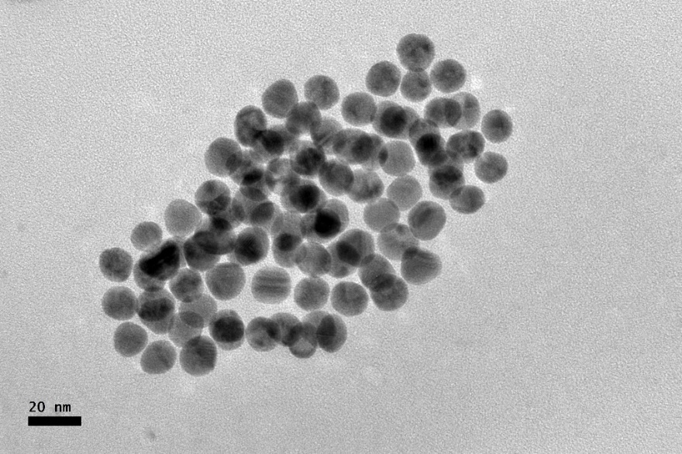
Figure 2. The TEM image of GQDs (100,000x magnification)
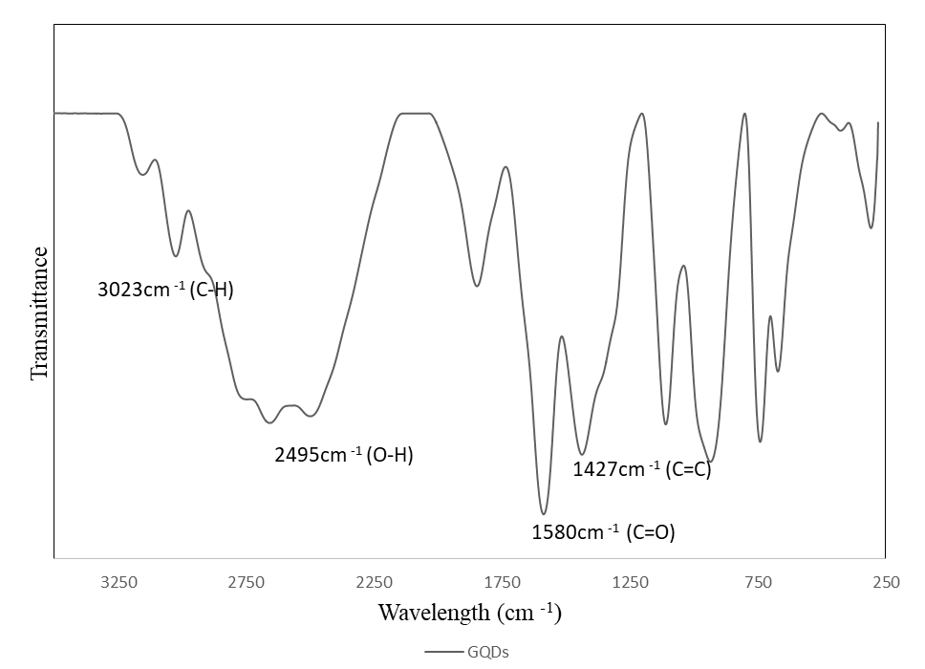
Figure 3. FTIR spectra of GQDs

The basic principle of detection
The basic principle of the reaction of GQD-HRP in the presence of H₂O₂ is illustrated in Figure 4. In the presence of the HRP, H₂O₂ will be oxidized to form H₂O and O₂. At the same time the GQDs is quenched and the ﬂuorescence emission produced is decreased. Usually, the quenching of fluorescence emission of GQDs occurs due to either energy transfer [10], charge diverting [11], and surface absorption [12], which could change the surface state of GQDs. In this study, the possible mechanism for GQD/HRP quenching is related to H₂O₂ existence as the quencher. When there is an interaction between the GQDs and H₂O₂, it is assumed to undergo collisional quenching causing fluorescence intensity to decrease. Collisional quenching occurs when the excited state of GQDs is neutralized by the H₂O₂ molecules, prompting to the reduction of the GQDs fluorescence intensity [13]. The quenching effect in the absence of HRP was also evaluated and it shows no significant quenching (data not shown). When the HRP enzyme was added into the reaction system, significant reduction of fluorescence intensity was obtained (quenching effect). Thus, this observation shows that the HRP enzyme is important in the quenching effect of the system.

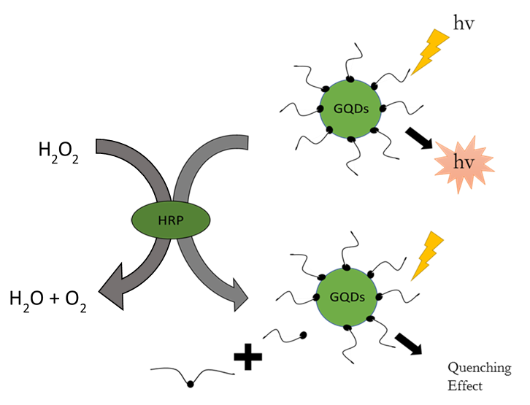
Figure 4. Possible mechanism of the GQDs/HRP system in the presence of H₂O₂, where H₂O₂ quenched the GQDs and leading to reduction of the fluorescence intensity of the system

Parameter optimization
The experimental parameter was optimized in order to improve the performance of the prepared GQDs/HRP system for the determination of H₂O₂. Figure 5 depicts the effect of reaction time towards the fluorescence intensity of the GQDs. It can be noted that as the time increase the fluorescence intensity was gradually increased until reaction time of 20 minutes. Above 20 minutes, the response of the system approaching saturation point. Therefore, response time of 20 minutes was chosen for further experiment.

The effect of pH on the GQDs/HRP response is very important because the enzyme activity of HRP and GQDs are dependent on the pH condition. The experiment was carried out in the range of pH 6.0 to 8.0 as illustrated in Figure 6. The pH of the reaction solution shows a significant influence on the response of GQDs/HRP assay system. The optimum pH value was observed at pH 7 which is agreed with work reported previously [14], which explored QDs-HRP/uricase hybrid system for uric acid detection.

To further increase the sensitivity of the prepared hybrid system, the effect of concentration of HRP was investigated. From Figure 7, the intensity of the system increases as the concentration of HRP increases. From this study, we decided to choose concentration of HRP of 20 units for the assay because the amount used is sufficient for the reaction system to produce significant quenching effect for determination of H₂O₂.

Figure 5. Effect of response time

Figure 6. Effect of pH on the response of GQDs/HRP system

Figure 7. Effect of HRP concentration on the GQDs/HRP system towards H₂O₂ (100.0 µM)

Analytical performance of the GQDs/HRP towards H₂O₂
The performance of the prepared GQDs/HRP system towards different concentration of H₂O₂ in the dynamic range of 1.0 to 500.0 µM was evaluated. As shown in Figure 8, the linearity of the GQDs/HRP system towards H₂O₂ was in the concentration range of 1.0-100.0 µM with linear regression equation of y = 11.18x -2.11 (R² =0.9939). Limit of detection (LOD) was calculated according to 3S_{b}/b, where S_{b} is the standard deviation of the blank measurements (n=3), b is the slope of the calibration curve [5] and the calculated LOD was found to be at 1.0 µM. Reproducibility study of the GQDs/HRP was evaluated at H₂O₂ concentration of 10 µM in phosphate buffer solution (pH 7.0) and the relative standard deviation (RSD) of 9.75% (n=5) was obtained.

(a)

- µM

500 µM

(b)

Figure 8. (a) Quenching effects of QDs towards different concentrations of H₂O₂, (b) Calibration curve of the developed GQDs/HRP system towards different concentration of H₂O₂ (1.0-100.0 µM)

Conclusion
A simple and convenient technique for H₂O₂ determination based on quenching of the fluorescence of GQDs has been developed. Under the optimum conditions, the GQDs/HRP system achieved a good linear relationship between the net fluorescence intensity of the system and the concentration of H₂O₂ in the range of 1.0 to 100 µM with LOD of 1.0 µM. The developed method has shown its potential to determining the concentration of hydrogen peroxide.

Acknowledgements
The authors are gratefully acknowledged the financial support provided by Universiti Putra Malaysia under Putra Grant (GP-IPB/2016/9515403).

References

- Azmi, N. E., Ramli, N. I., Abdullah, J., Abdul Hamid, M. A., Sidek, H., Abd Rahman, S. and Yusof, N. A. (2015). A simple and sensitive fluorescence based biosensor for the determination of uric acid using H₂O₂-sensitive quantum dots/dual enzymes. Biosensors and Bioelectronics, 67: 129-133.
- Dong, C., Qian, H., Fang, N. and Ren, J. (2006). Study of fluorescence quenching and dialysis process of CdTe quantum dots, using ensemble techniques and fluorescence correlation spectroscopy. Journal of Physical Chemistry B, 110(23):11069-11075.
- He, S., Song, B., Li, D., Zhu, C., Qi, W., Wen, Y. and Fan, C. (2010). A graphene nanoprobe for rapid, sensitive, and multicolor fluorescent DNA analysis. Advanced Functional Materials, 20(3): 453-459.
- Ji, X., Zheng, J., Xu, J., Rastogi, V. K., Cheng, T. C., DeFrank, J. J. and Leblanc, R. M. (2005). (CdSe)ZnS quantum dots and organophosphorus hydrolase bioconjugate as biosensors for detection of paraoxon. Journal of Physical Chemistry B, 109(9): 3793-3799.
- Kim, K. E., Kim, T. G. and Sung, Y. M. (2012). Fluorescent cholesterol sensing using enzyme-modified CdSe/ZnS quantum dots. Journal of Nanoparticle Research, 14(1179): 1-9.
- Lu, C.-H., Yang, H.-H., Zhu, C.-L., Chen, X. and Chen, G.-N. (2009). A graphene platform for sensing biomolecules. Angewandte Chemie, 48(26): 4785-4787
- Ponomarenko, L. A., Schedin, F., Katsnelson, M. I., Yang, R., Hill, E. W., Novoselov, K. S. and Geim, A. K. (2008). Chaotic dirac billiard in graphene quantum dots. Science, 320(5874): 356-358.
- Razmi, H. and Mohammad-Rezaei, R. (2013). Graphene quantum dots as a new substrate for immobilization and direct electrochemistry of glucose oxidase: Application to sensitive glucose determination. Biosensors and Bioelectronics 41: 498-504.
- Shen, J., Zhu, Y., Yang, X., Zong, J., Zhang, J. and Li, C. (2012). One-pot hydrothermal synthesis of graphene quantum dots surface-passivated by polyethylene glycol and their photoelectric conversion under near-infrared light. New Journal of Chemistry 36: 97-101.
- Tang, J. and Marcus, R. A. (2006). Determination of energetics and kinetics from single-particle intermittency and ensemble-averaged fluorescence intensity decay of quantum dots. The Journal of Chemical Physics, 125 (044703): 1-8.
- Tetsuka, H., Asahi, R., Nagoya, A., Okamoto, K., Tajima, I., Ohta, R. and Okamoto, A. (2012). Optically tunable amino-functionalized graphene quantum dots. Advanced Materials, 24(39): 5333-5338.
- Wang, D., Wang, L., Dong, X., Shi, Z. and Jin, J. (2012). Chemically tailoring graphene oxides into fluorescent nanosheets for Fe³⁺ion detection. Carbon, 50(6): 2147-2154.
- Xie, R., Wang, Z., Zhou, W., Liu, Y., Fan, L., Li, Y. and Li, X. (2016). Graphene quantum dots as smart probes for biosensing. Analytical Methods, 8(20): 4001–4016.
- Zhuo, S., Shao, M. and Lee, S. T. (2012). Upconversion and downconversion fluorescent graphene quantum dots. Ultrasonic preparation and photocatalysis. ACS Nano, 6(2): 1059-1064.

