

MALAYSIAN JOURNAL OF ANALYTICAL SCIENCES
ISSN 1394 - 2506

Published by The Malaysian Analytical Sciences Society

SOLUTION CASTING EPOXIDIZED NATURAL RUBBER/POLY(VINYLIDINE FLUORIDE) MEMBRANE FOR PALM OIL EFFLUENT TREATMENT

(Pengacuanan Larutan Membran Getah Asli Terepoksida/Poli(Vinilidina Fluorida) untuk Rawatan Efluen Kilang Minyak Sawit)

Norliyana Mod, Farah Hannan Anuar, Rizafizah Othaman*

School of Chemical Sciences and Food Technology, Faculty of Science and Technology,
Universiti Kebangsaan Malaysia, 43600 UKM Bangi, Selangor, Malaysia

*Corresponding author: rizafizah@ukm.edu.my

Received: 31 March 2018; Accepted: 17 April 2019

Abstract
Poly(vinylidine fluoride) PVDF membrane is generally a chosen membrane for Palm Oil Mill Effluent (POME) treatment. The main focus is to make freestanding and robust PVDF based composite membranes with different ratio of epoxidized natural rubber (ENR) (ENR/PVDF: 0/100 wt.%, 20/80 wt.%, 40/60 wt.%, 60/40 wt.%, 80/20 wt.%, 100/0 wt.%) by solution casting method. Subsequently, these membranes were characterized using Fourier transform infrared spectroscopy (FTIR), differential scanning electron (DSC) and vapor pressure scanning electron microscope (VPSEM). The FTIR spectrums showed that ENR blended well with PVDF and the peak intensity followed the composition of the membranes. Meanwhile, the ENR and PVDF mixtures were miscible due to the formation of single peak glass transition temperature (T_{g}) as observed in DSC thermogram. Shifting in peaks of T_{g} suggested important interaction taking place between polymers. Surface morphology by SEM displayed the formation of random pores caused by the nature of PVDF polymer and phase inversion process. High composition of ENR caused a dense membrane and vice-versa while phase inversion contributed to the pores existences. The fluxes during POME treatment were lower than water fluxes. Higher flux was a sign of higher rejection which is efficient for separation of water and effluents. Thus, ENR/PVDF 40/60 wt.% has been selected as promising membranes to be applied for POME treatment.

Keywords: membrane, epoxidised natural rubber, poly(vinylidine fluoride)

Abstrak
Membran poli(vinilidina fluoride) PVDF umumnya adalah membran terpilih untuk rawatan efluen kilang minyak sawit (POME). Tumpuan adalah untuk membuat membran komposit berasaskan PVDF yyang fleksibel dan kuat dengan pelbagai nisbah ENR (ER/PVDF: 0/100 wt.%, 20/80 wt.%, 40/60 wt.%, 80/20 wt.%, 100/0 wt.%) dengan kaedah pengacuanan larutan. Selepas itu, membran ini dicirikan menggunakan spektroskopi inframerah transformasi Fourier (FTIR), kalorimeter imbasan pembeza (DSC), mikroskop elektron pengimbasan pelbagai tekanan (VPSEM). Spektrum FTIR menunjukkan bahawa ENR dicampur dengan baik dengan PVDF dan intensiti puncak mengikut komposisi membran. Sementara itu, ENR dan PVDF campuran adalah terlarut campur disebabkan oleh pembentukan puncak tunggal suhu peralihan kaca (T_{g}) sebagaimana yang berlaku di DSC termogram. Anjakan puncak T_{g} menandakan berlakunya interaksi antara polimer. Morfologi permukaan oleh SEM menunjukkan pembentukan liang yang rawak hasil daripada sifat polimer PVDF dan proses penyongsangan fasa. Komposisi ENR yang tinggi menyebabkan membran yang padat dan sebaliknya, manakala penyongsangan fasa menyebabkan pembentukan liang. Fluks semasa rawatan POME adalah lebih rendah daripada fluks air. Fluks tinggi adalah tanda penolakan yang lebih tinggi yang cekap untuk pemisahan air dan efluen. Oleh itu, ENR/PVDF 40/60 wt.% telah dipilih sebagai membran yang menyakinkan untuk digunakan bagi rawatan POME.

Kata kunci: membran, getah asli terepoksida, poli(vinilidina fluorida)

Introduction
Polymer composite is a process where two or more polymers are combined together using various methods such as internal mixture and solution casting. This combination can improve the properties of individual polymer at the end of processing. Membrane is one of the examples that can be made through the process of composite. It can be used as a selective barrier for various separation in industries such as for wastewater [1] and gas separation [2]. Membrane is a layer that allows permeation and selection of certain components in the fluid and it also has a porous support layer to provide mechanical strength of the membrane [3]. There are various methods that can be used for the preparation of membranes and in this study the method used is the phase inversion method. In all phase separation processes, a liquid polymer solution is precipitated into two phases: a solid, polymer-rich phase that forms the matrix of the membrane and a liquid, polymer-poor phase that forms the membrane pores [4].

Epoxidised natural rubber (ENR) is a modified natural rubber (NR) by addition of epoxide group in the chains via performic epoxidation process [5]. In most industries such as automotive, ENR-50 contains of 50 mol% epoxide group is used to react with other polar polymers. Thus, it will give more advantages for tensile strength, oil resistance, and fluid permeability [6]. ENR-50 also has been reported provides finer co-continuous structure and better mechanical properties than blend with ENR-25 [7]. ENR has good properties such as low glass transition temperature, T_{g}, good elasticity, and soft elastomer characteristics at room temperature [8]. Blending it with another polymer like poly(vinylidine fluoride) (PVDF) is believed will improve some properties blends and give good thermal stability to the polymer composite membrane. PVDF is a semi-crystalline polymer that contains crystalline and amorphous phases. Crystalline phase provides thermal stability, while amorphous phase has flexibility towards membranes. Phase of crystalline formed are named α (form II), β (form I), and γ (form III) [9]. Various ways can be used to control the crystallization, as such by using suitable temperature [10, 11], solvent [3], and addition of additives [12]. PVDF is easy to dissolve in many solvents, has chemical resistivity and thermal stability. PVDF is very high in modulus that makes it brittle to apply as it is.

However, PVDF is widely used in polymer industries as a membrane by combining with other polymers for example poly(methyl methacrylate) (PMMA) [13], poly(ethylene glycol) (PEG) [14], and poly(vinyl chloride) (PVC) [15]. PVDF has also been used for microfiltration (MF), ultrafiltration (UF), gas separation and pollutant removal from wastewater. Preparation of thermoplastic elastomer based on PVDF and ENR blends at 50/50 by weight with different type of ENR (i.e. ENR with 25 and 50 mol% epoxide) has been reported using melt blending method. The combination between thermoplastic and rubber produces thermoplastic rubber (TPR) composite that exhibits the properties of elastomeric materials with possibility of thermoplastic at the ambient temperature [7]. Moreover, preparation of PVDF membranes without support can be enhanced by the addition of ENR because ENR has elastic properties and can produce membranes that have durability and toughness [16]. There are many recent studies of composite membrane based ENR with various types of polymer for palm oil mill effluent (POME) treatment such as ENR/PVC/MCC [17] and ENR/PVC [18]. However to our best knowledge, the preparation of ENR/PVDF composite membrane for palm oil mill effluent (POME) treatment has not been reported yet.

POME is one of the effluents that contains high value of oil, chemical oxygen demand (COD), biological oxygen demand (BOD) and total suspended solid (TSS) which leads to water pollution [19]. As reported from Malaysian Palm Oil Board (MPOB), POME can be treated by ponding system, open tank digester and extended aeration system, and closed anaerobic system and land application system [20]. This system is less efficient to be used for nowadays because it takes large area for treatment, produce unpleasant smell, and it takes a long time to treat [20, 21]. So that, the membrane was introduced to replace this conventional system. Advantages of using membrane for fluid separation are minimum energy consumption, no addition of chemical is required and separation can be done continuously under controlled operation [22].

The focus of this study is to prepare ENR/PVDF composite membrane with various composition by using solution casting method and inversion method to generate pores in membranes. Then the effect of different compositions of ENR/PVDF on chemical, physical and properties of the membranes were studied. The composite membranes were characterized using Fourier Transform Infrared spectroscopy (FTIR), Differential Scanning Electron (DSC), and Vapor Pressure Scanning Electron Microscope (VPSEM) before applying as the membranes for Palm Oil Mill Effluent (POME) treatment.

Materials and Methods
Raw materials
ENR with 50% mol of epoxidation level (ENR-50) (M_{w} = 640 000 g/mol) was obtained from Rubber Research Institute of Malaysia (RRIM). PVDF (M_{w} = 543 000 g/mol) was purchased from Sigma-Aldrich (M) Sdn. Bhd in powder formed. Tetrahydrofuran (THF) was purchased from Systerm Sdn. Bhd with purity 99.8%. N,N-dimethylacetamide (DMAC) was purchased from Merck with purity 99%. Distilled water was used as a coagulation bath for exchanging between solvent and non-solvent.

Membrane preparation
ENR/PVDF was prepared in different compositions (0/100 wt.%, 20/80 wt.%, 40/60 wt.%, 60/40 wt.%, 80/20 wt.%, 100/0 wt.%). ENR was swelled in THF for 24 hours and subsequently stirred until homogeneous. At the same time, PVDF was stirred in DMAC solution in a separate container until homogeneous. Then, the PVDF solution was poured into ENR solution and vigorously stirred. Once the membrane solution was homogeneous, the solution was degassed to eliminate the bubbles. Next, the solution was cast onto a glass plate with thickness of 0.15 mm using a casting knife. After casting, the solution was left to stand and the solvent evaporated into the air for 2 minutes before the sample was transferred to the coagulation bath. When the white solid membrane was formed, the sample was removed from coagulation bath and dried at ambient temperature. The average thickness of membrane after dried was about 0.05 mm.

Membrane characterization
Chemical characterization of ENR/PVDF membrane was performed by using Fourier transform infrared spectroscopy (FTIR). FTIR spectra were recorded by using Perkin Elmer (GX FTIR System) in wavelength between 4000 cm⁻¹ to 400 cm⁻¹. FTIR characterization was conducted to analyze functional group that present in the membrane. The absorption band in the spectrum resulted from the change in energy caused by vibration of the molecules either stretching or bending.

Differential scanning calorimeter (DSC) is a thermal study that was used to characterize homogeneity of the sample via glass transition temperature (T_{g}). The DSC analyzer used was Mettler Toledo using STARe software. Samples were weighted between 6 – 9 mg with rate of heating 20 °C/min. Temperature used for cooling and heating was in the range of – 70 to 200 °C and the carrier gas was nitrogen gas.

Morphology of the membrane was studied by using variable pressure scanning electron microscope (VPSEM) with energy dispersion X-ray (EDX). The VPSEM model was ZEISS EVO MA 10 (UK) with EDAX APOLLO X (USA). The sample used for analyzing cross section was prepared by breaking the membrane after immersing in liquid nitrogen. Then, all the samples were sputter coated with gold before testing. Magnification for membrane surface sample is 5000 magnification, while for cross section is 1000 magnification.

Palm oil mill effluent (POME) treatment
Permeation test was done to study the flux of the membrane by using dead end stirred cell model HP4750. Membrane was cut into size of 49 mm in diameter and then tested under nitrogen gas at pressure of 0.5 bar at ambient temperature. POME sample from final discharge pond from Malaysian Palm Oil Board (MPOB) at Labu Negeri Sembilan was used in the experiment. The flux value can be calculated as equation 1 below [23]:

$\text{Fluxs=} \frac{\text{Q}}{\text{A∆T}}$ (1)

where Q (L) is the volume of permeate, A (m²) is the active surface area of the membrane, and ∆T (h) is the time taken for permeation.

Chemical oxygen demand (COD) is measured by the amount of oxygen supplied by oxidizing agents such as potassium dichromate used to decompose pollutants [24]. The percentage of COD removal can be calculated using equation 2 below where the pollutant sample is POME taken before and after treatment. Method 8000 (HACH standard method, DR 3900) is used to measure the value of COD content.

Removal percentage of COD (%) = (2)

where COD₀ is the initial COD value of POME before treatment and COD_{f} is final COD value POME after treatment.

The biological oxygen demand (BOD) is defined as the amount of oxygen required by the microorganism to decompose the organic matter found in the pollutants [24]. The treatment method used is APHA 2520 D [25]. The percentage of removal (%) can be calculated by taking pollutants samples (POME) before being treated and after treatment as shown in equation 3.

Removal BOD (%) = (3)

where BOD₀ is initial BOD value for untreated POME and BOD_{f} is final BOD value for treated POME.

Results and Discussion
Functional group analysis
Figure 1 shows the FTIR spectrum for different ratio of ENR/PVDF membranes (0/100 wt.%, 20/80 wt.%, 40/60 wt.%, 60/40 wt.%, 80/20 wt.%, 100/0 wt.%). Peaks for pure ENR (100/0 wt.%) are 3498 cm⁻¹, 3022 cm⁻¹, 2960 cm⁻¹, 1664 cm⁻¹, 1452 cm⁻¹, 1379 cm⁻¹, 1252 cm⁻¹ and 876 cm⁻¹. Meanwhile, peaks for pure PVDF (0/100 wt.%) are 2960 cm⁻¹, 1452 cm⁻¹, 1182 cm⁻¹, 1066 cm⁻¹, 876 cm⁻¹ and 761 cm⁻¹ can be attributed to CH₂ asymmetric, CH₂ wagging, C-C band, C-C-C asymmetrical stretching and C-F stretching, respectively. It can be seen that there are significant changes of peaks between IR spectrums of all ratios for ENR/PVDF membrane. Peak at 3498 cm⁻¹ is correspond to the stretching of -OH group in the ENR. This peak was due to the ENR characteristic which tend to absorb water from surrounding [26].
In contrast, there are no peak of 3498 cm⁻¹ when ENR/PVDF membranes 40/60 wt.% and 20/80 wt.% were used. This is due to PVDF hydrophobic properties, that indicated no absorbtion of water was occurred. Peak for ~3022 cm⁻¹ was referred to =CH stretching from ENR and PVDF. This peak can be referred to the olefinic unsaturation for the pure ENR and other peaks also can be seen at 1664 cm⁻¹, while for PVDF due to the end chain of PVDF polymer. Stretching of C–H at peak 2960 cm⁻¹ and bending of C–H at 1452 cm⁻¹ referred to ENR and PVDF. However, the intensity of those peaks for PVDF is lower because of crystallization of PVDF [27]. Peaks at 1252 cm⁻¹ and 876 cm⁻¹ were obtained due to C-O stretching from epoxy group in ENR. Intensity peak at 876 cm⁻¹ also present due to the PVDF crystallization [28]. Two strong peaks at 1182 cm⁻¹ and 1066 cm⁻¹ were referred to polyfluoroalkane group in PVDF. All the described peaks were proportional with the amount of ratio ENR and PVDF in the composite membranes. The lower the amount (wt.%) of PVDF used, the lower the intensity peak for polyfluoroalkane group, and the higher the amount of (wt.%) of ENR used, the bigger the intensity peak for –OH stretching group.

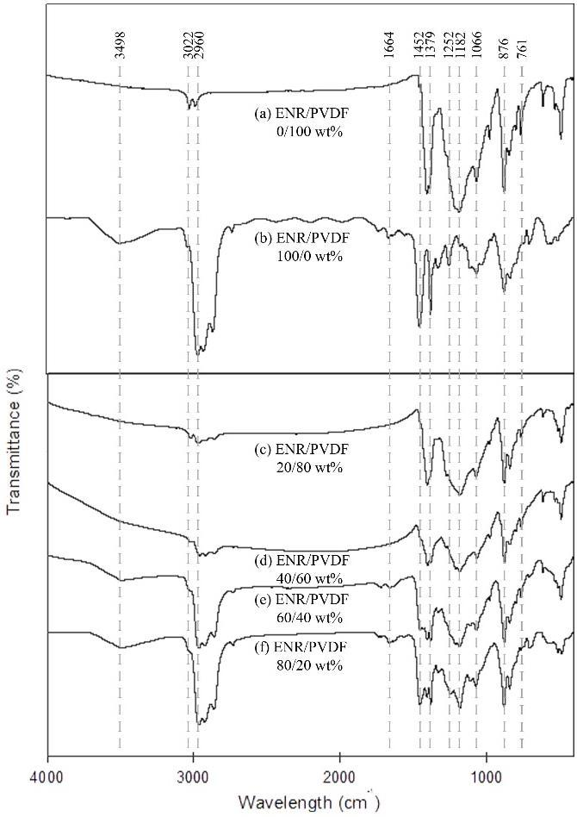

Wavenumber ( cm⁻¹)

Figure 1. FTIR for ENR/PVDF membrane at different ratio of ENR/PVDF: (a) 0/100 wt.%; (b) 100/0 wt.%; (c) 20/80 wt.%; (d) 40/60 wt.%; (e) 60/40 wt.% and (f) 80/20 wt.%

Thermal properties
DSC is an analysis to study the homogeneity of the composite in terms of thermal stability. Homogeneity of the sample membrane from polymer or ENR mixing is very important for physical, rheology, and chemical properties of the sample. Single peak of T_{g} is an indicator for the miscibility of composite [29]. Figure 2 shows the DSC thermograms for ENR/PVDF membrane at different ratio and it can be seen that T_{g} appeared as a single peak for all ratios.
Additionally, shifting in peaks occurred when ratio of ENR increased due to the existence of interfacial adhesion between ENR and PVDF [7]. Based on the T_{g} values tabulated in Table 1, T_{g} for pure PVDF membrane was the lowest (-32.19 ⁰C) because of the semi-crystalline property of PVDF. Meanwhile, T_{g} for pure ENR is higher (-19.67 ⁰C) due to amorphous structure from ENR tends to absorb heat that has been supplied to become soft. T_{g} for all the composites were higher than the pure polymer. It implies that there was interaction between ENR and PVDF, which has resulted in a shifted and single peak to deduce the T_{g} value.

(a)  (b)  (d)  (e)  (c)  (f) | 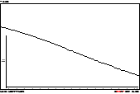
 | 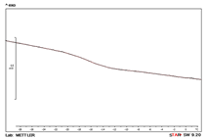

Figure 2. DSC thermograms for ENR/PVDF membranes at ratio (a) 0/100 wt.%; (b) 20/80 wt.% (c) 40/60 wt.% (d) 60/40 wt.% (e) 80/20 wt.% (f) 100/0 wt.%

Table 1. Glass transition (T_{g}) for ENR/PVDF membrane
ENR/PVDF (wt%) | T_{g} (ºC)
0/100 | -32.19
20/80 | -16.19
40/60 | -15.64
60/40 | -14.03
80/20 | -15.12
100/0 | -19.67

Surface morphology
SEM micrograph for ENR/PVDF membranes with different ratio were shown in Figure 3. PVDF in nature is a porous membrane (Figure 3(a)) and ENR is a nonporous membrane (Figure 3(b)). The combination of these two polymers had produced composite membranes with random pores as can be seen from the micrographs. However as the amount of ENR increased, the pores size became smaller. This might due to the phase inversion, which is the exchange between solvents and non-solvents that induced pores [14]. Thus, choice of solvent for the membrane will affect the formation of pore [30]. When ENR predominant the membrane, it caused no pore formation on the surface as shown in Figure 3(f) for ENR/PVDF membrane at ratio 80/20 wt.%. In Figure 3(e) for ENR/PVDF membrane 60/40 wt.%, there was a layer of dense structure sandwiched between the porous layer (as shown in cross section), showing that the non-solvents did not reach some of the middle part of the membrane. This will affect the membrane porosity and permeability. In contrast, Figure 3(c) and Figure 3(d) shows that, 20/80 wt.% and 40/60 wt.% ENR/PVDF membranes relatively have good distribution of pores from surface to another surface and could be adopted as membrane.

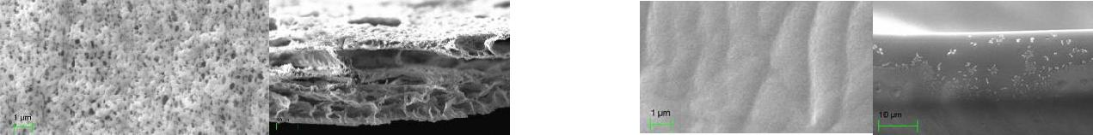
(b)
(a)

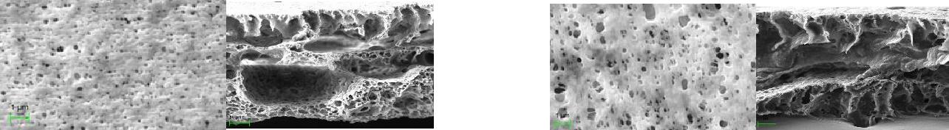
(d)
(c)

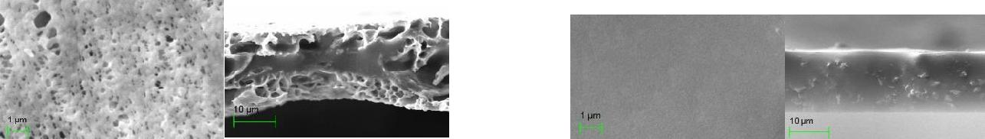
(e)
(f)

Figure 3. SEM micrograph for ENR/PVDF membrane free surface (5000 × magnification) and cross section (1000 × magnification): (a) 0/100 wt.% (b) 100/0 wt.% (c) 20/80 wt.% (d) 40/60 wt.% (e) 60/40 wt.% (f) 80/20 wt.%

Application of membrane
Flux is used to express the rate of permeates through membrane and were calculated by using equation 1. This permeation test is one of the important method for structural determination and membrane morphology. Formation of pores are very important for water to permeate through membrane especially for wastewater like POME. Figure 4 shows the water flux value for all ENR/PVDF membranes except for pure ENR membrane (100/0 wt.%). Since membrane ratio for 100/0 wt.% was a dense membrane without pore, thus water were unable to permeate through the membrane within the experimental conditions. ENR/PVDF 80/20 wt.% membrane showed the lowest flux since the membrane was still dense.The highest water flux was for ENR/PVDF 0/100 wt%, and followed closely by 60/40 wt.% composition.

In comparison, the fluxs for POME sample as shown in Figure 5 was lower than the water flux. Initially, the flux was higher but slowly reduced and maintained after some time. We reasoned that, the pores of the membrane was filled with suspended solid in POME to some extent. After a while, particles begin to block the pores causing the pore size to reduce, further decreased in the value of flux. Based on the results, ENR/PVDF 100/0 wt.% and 80/20 wt.% membranes could not be used for POME treatment since no water permeated. The trends of the fluxes were the same with water fluxes for respective membranes. The pure PVDF (0/100 wt.%) membrane has highest flux compare to other composition, but due to semi-crystalline properties of pure PVDF that have the lowest T_{g} values, ENR/PVDF membranes with mixing ratios 40/60 wt.% showed the possibility to be applied for POME treatment.

Figure 4. Water flux value for ENR/PVDF membranes

Figure 5. POME flux for ENR/PVDF membranes

A thick brownish liquid waste of POME that is viscous, slurry and has unpleasant odour can be seen in Figure 6(a). After permeation test is conducted, the appearance of POME liquid waste has been improved. As we can seen from Figure 6(b), the colour intensity of POME change to brighter colour, and the viscous concentration of POME is reduced and become less smelly. These sample was stored in cool place prior to following analysis. The level of COD and BOD for raw and treated POME has been analyzed from the first filtration cycle and ENR/PVDF membranes with composition 0/100 wt.%, 20/80 wt.%, 40/60 wt.% and 60/20 wt.% were used for this analysis. COD analysis test was conducted to quantify the amount of organic matter in the POME using an oxidizing agent. Initial COD value of POME is 18600 mg/L while BOD value is 1100 mg/L and as shown in Table 2, all the prepared membranes were successfully reduced COD and BOD level of POME. The declined in BOD value might be due to the reduction of organic matter that gives blackish colour in POME sample. Membrane PVDF (0/100 wt.%) shows the highest removal percentage of both COD and BOD level by 93.6% and 80.5%, respectively. In addition, ratio 40/60 wt.% membrane give higher removal percentage than 20/80 wt.% due to morphology of membrane layer that more dense and better micropore distribution. As compared to the pure PVDF membrane, addition of ENR is believed to increase the denseness of membrane and enhance the durability and strength of membrane [16].

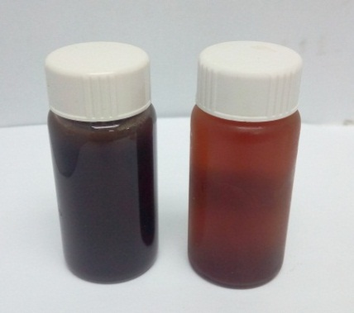
(a)
(b)

(b)

(a)

Figure 6. Observation on liquid waste POME (a) before and (b) after treatment

Table 2. Removal percentage (%) for COD and BOD of POME by ENR/PVDF membranes
ENR/PVDF  (%wt) | Chemical Oxygen Demand  (COD) |  |  | Biological Oxygen Demand  (BOD)
 | Raw POME  (mg/L) | Treated POME  (mg/L) | Removal Percentage  (%) |  | Raw POME  (mg/L) | Treated  POME  (mg/L) | Removal Percentage  (%)
0/100 | 18 600 | 1183 | 93.6 |  | 1100 | 215 | 80.5
20/80 | 18 600 | 1270 | 93.2 |  | 1100 | 275 | 75.0
40/60 | 18 600 | 1212 | 93.5 |  | 1100 | 235 | 78.6
60/40 | 18 600 | 1276 | 93.1 |  | 1100 | 245 | 77.7

Conclusion
ENR/PVDF membranes with different ratio of ENR/PVDF (0/100 wt.%, 20/80 wt.%, 40/60 wt.%, 60/40 wt.%, 80/20 wt.%, 100/0 wt.%) were successfully prepared using solution casting method. FTIR detected the functional groups present for ENR and PVDF and the intensity of the peaks was proportional with the compositions. Analysis from DSC showed that there was single peak of T_{g} for each of sample and proved that ENR and PVDF composites were miscible. T_{g} of the composite membranes shifted from each single polymer showed the existence of interaction between ENR and PVDF. The membrane with smaller ENR composition displayed porous structure with random pores formed due to the PVDF nature and the solvents exchanged during phase inversion. It has been proven that these pores helped to increase the flux for water and during POME treatment. Thus, it can be concluded that the ENR/PVDF, 40/60 wt.% membranes will give higher rejection with slightly lower flux from permeation test to be able to separate water and other components in POME.

Acknowledgement
The authors gratefully acknowledged the financial support from grant ST-2017-008, Universiti Kebangsaan Malaysia (UKM), UKM-UCA International Joint Seminar on Science and Technology 2016, Fuel Cell Institute (SELFUEL) and Polymer Research Centre (PORCE) for the facilities that was given to do this project.

References
  - Medeiros, K. M., Araujo, E. M., Lira, H. L., Lima, D. F., Lima, C. A. P. (2017). Hybrid membranes of polyamide applied in treatment of waste water. Material Research, 20(2): 308-316.
  - Shilton, S. J., Ismail, A. F., Gough, P. J., Dunkin, I. R. and Gallivan, S. L. (1997). Molecular orientation and the performance of synthetic polymeric membranes for gas separation. Polymer, 38(9): 2215-2220.
  - Bottino, A., Camera-Rodab, G., Capannelli, G. and Munari, S. (1991). The formation of microporous polyvinylidene difluoride membranes by phase separation. Journal of Membrane Science, 57: l-20.
  - Baker, R. W. (2004). Membrane technology and applications, John Wiley & Sons, Ltd..
  - Yoksan, R. (2008). Epoxidized natural rubber for adhesive applications. Kasetsart Journal (Natural Science), 42: 325-332.
  - Ismail, H. and Chia, H. H. (1998). The effects of multifunctional additive and epoxidation in silica filled natural rubber compounds. Polymer Testing, 17: 199-210.
  - Salaeh, S., Nakason, C., Boiteu, G. and Cassagnau, P. (2013). Co-continuous phase structure and properties of poly(vinylidene fluoride)/epoxidized natural rubber blends. Advanced Materials Research, 626: 71-74.
  - Chinnasa, P., Ponhan, W., Sarasee, P., Phoemphun, Y. and Swatsitang, E. (2016). Electrospun of epoxidized natural rubber with polyvinylpyrrolidone (PVP) composites membrane for PEMFC application. Journal of Science & Technology,Ubon Ratchathani University, 2016: 61-65.
  - Hasegawa, R., Takahashi, Y., Chatani, Y. and Tadokoro, H. (1972). Crystal structures of three crystalline forms of poly(vinylidine fluoride). Polymer Journal, 3(5): 600-610.
  - Salaeh, S., Boiteux, G., Gain, O., Cassagnau, P. and Nakason, C. (2014). Dynamic mechanical and dielectric properties of poly(vinylidene fluoride) and epoxidized natural rubber blends. Advanced Materials Research, 844: 97-100.
  - Tao, M., Liu, F., Ma, B. and Xue, L. (2013). Effect of solvent power on PVDF membrane polymorphism during phase inversion. Desalination, 316: 137-145.
  - Wang, X., Zhang, L., Sun, D., An, Q. and Chen, H. (2009). Formation mechanism and crystallization of poly(vinylidene fluoride) membrane via immersion precipitation method. Desalination, 236: 170-178
  - Cao, X., Ma, J., Shi, X. and Ren, Z. (2006). Effect of TiO₂ nanoparticle size on the performance of PVDF membrane. Applied Surface Science, 253: 2003-2010.
  - Freire, E., Bianchi, O., Monteiro, E. E. C., Nunes, R. C. R. and Forte, M. C. (2009). Processability of PVDF/PMMA blends studied by torque rheometry. Materials Science and Engineering C, 29: 657-661.
  - Wang, P., Tan, K. L., Kangb, E. T. and Neohb, K. G. (2002). Plasma-induced immobilization of poly(ethylene glycol) onto poly(vinylidene fluoride) microporous membrane. Journal of Membrane Science, 195: 103-114.
  - Abdullah, I. (2002). Strategi penyelidikan kimia getah asli. Bangi: Penerbit Universiti Kebangsaan Malaysia.
  - Alim, A. A. A., & Othaman, R. (2018). Epoxidized natural rubber/polyvinyl chloride/microcrystalline cellulose (ENR/PVC/MCC) composite membrane for palm oil mill effluent (POME) treatment. Sains Malaysiana, 47(7):1517-1525.
  - Shamsuddin, M. R., Abdullah, I., Othaman, R. (2013). Cellulose filled ENR/PVC membranes for palm oil effluent (POME) treatment. AIP Conference Proceedings, 1571: 897.
  - Igwe, J. C. and Onyegbado, C.C. (2007). A review of palm oil mill effluent (POME) water treatment. Global Journal of Environmental Research 1(2): 54-62.
  - Malaysia Palm Oil Board (MPOB) (2014). Access from http://www.mpob.gov.my/ms/info-sawit/alam-sekitar/520-achievements.
  - Chin, K. K., Lee, S. W. and Mohammad, H. H. (1996). A study of palm oil mill effluent treatment using a pond system. Water Science Technology 34(11): 119-123.
  - Yan, L., Honga, S., Li, M. L. and Li, Y. S. (2009). Application of the Al₂O₃–PVDF nanocomposite tubular ultrafiltration (UF) membrane for oily wastewater treatment and its antifouling research. Separation and Purification Technology, 66: 347-352.
  - Saljoughi, E., Sadrzadeh, M. and Mohammadi, T. (2009). Effect of preparation variables on morphology and pure water permeation flux through asymmetric cellulose acetate membranes. Journal of Membrane Science, 326: 627-634.
  - Kassim, M.A., Salim, M. R. and Othman, M. N. (1994). Rawatan kumbahan dalam iklim panas. Skudai: Universiti Teknologi Malaysia.
  - APHA (2005). Standard methods for the examination of water and wastewater. 21st edition American Public Health Association. Washington, DC.
  - Zurina, M., Ismail, H. and Bakar, A. A. (2004). Rice husk powder–filled polystyrene/styrene butadiene rubber blends. Journal of Applied Polymer Science, 92: 3320-3332.
  - Boccaccio, T., Bottino, A., Capannelli, G. and Piaggio, P. (2002). Characterization of PVDF membranes by vibrational spectroscopy. Journal of Membrane Science, 210: 315–329.
  - Ma, W., Yuan, H. and Wang, X. (2014). The effect of chain structures on the crystallization behavior and membrane formation of poly(vinylidene fluoride) copolymers. Membranes 4:243-256.
  - Bourara, H., Hadjout, S., Benabdelghani, Z. and Etxeberria, A. (2014). Miscibility and hydrogen bonding in blends of poly(4-vinylphenol)/poly(vinyl methyl ketone). Polymers, 6: 2752-2763.
  - Bottino, A., Capannelli, G., Munari, S. and Turturro, A. (1988). High performance ultrafiltration membranes cast from LiCI doped solutions. Desalination, 68: 167-177.

