

MALAYSIAN JOURNAL OF ANALYTICAL SCIENCES
ISSN 1394 - 2506

Published by The Malaysian Analytical Sciences Society

REMOVAL OF PARAQUAT HERBICIDE BY CETYLTRIMETHYL AMMONIUM BROMIDE MODIFIED PINEAPPLE LEAVES

(Penyingkiran Herbisid Parakuat oleh Daun Nanas yang Diubahsuai dengan Setiltrimetil Ammonium Bromida)

Nik Ahmad Nizam Nik Malek^{1,2}*, Muhd Hafiz Jusoh², Auni Afiqah Kamaru³

¹Centre for Sustainable Nanomaterials (CSNano), Ibnu Sina Institute for Scientific and Industrial Research (ISI-ISIR)

²Department of Biosciences, Faculty of Science

Universiti Teknologi Malaysia, 81310 UTM Sekudai, Johor, Malaysia

³Geomatika University College,

Prima Peninsula, Jalan Setiawangsa 11, Taman Setiawangsa, 54200 Kuala Lumpur, Malaysia

*Corresponding author: niknizam@utm.my

Received: 19 August 2018; Accepted: 7 July 2019

Abstract

Paraquat herbicide is categorised under contaminants of emerging concern (CEC) that can cause serious environmental problem and toxic effects towards human and animals. Also, the decomposing of pineapple leaves by burning in the field could create environmental problems such as air pollution. Therefore, in the present study, the pineapple leaves powder (PLP) was utilised as a low-cost adsorbent to remove paraquat from aqueous solution. The adsorption of paraquat from aqueous solution by PLP and surfactant-modified PLP (SMPLP) was examined. A series of SMPLP was prepared by reacting PLP with different concentrations of cationic surfactant cetyltrimethyl ammonium bromide (CTAB) (0.5, 1.0, 2.5, and 4.0 mM). The PLP and SMPLP were characterised using Fourier transform infrared (FTIR) spectroscopy after the modification process with CTAB and after adsorption with paraquat. The results show no significant changes in the chemical structure of pineapple leaves after modification. The SMPLP exhibited higher adsorption affinity towards paraquat herbicide. The adsorption experiments of paraquat were carried out in a batch mode at room temperature. The effect of paraquat concentrations (2–20 mg/mL) on the adsorption capacity of PLP and SMPLP were investigated. The suitability of adsorbent was tested by fitting the adsorption data into Langmuir and Freundlich isotherm equilibrium models. The experimental adsorption data well fitted to Freundlich isotherm with multilayer adsorption capacity of 13.0 mg/g. The highest adsorption of paraquat was obtained by SMPLP treated with 2.5 mM CTAB while the lowest adsorption was obtained by PLP. As a conclusion, the utilisation of surfactant-modified pineapple leaves powder can become an alternative adsorbent for the removal of herbicide compound in aqueous solution.

Keywords: paraquat, pineapple leaves, surfactant, adsorption

Abstrak

Herbisid parakuat dikategorikan sebagai kemunculan bahan pencemar (CEC) yang boleh menyebabkan masalah pada alam sekitar dan memberikan kesan toksik terhadap manusia dan haiwan. Pada masa yang sama, pelupusan daun nanas melalui cara pembakaran boleh menyebabkan masalah kepada alam sekitar seperti pencemaran udara. Oleh yang demikian, dalam kajian ini serbuk daun nanas (PLP) telah digunakan sebagai bahan penjerap kos rendah untuk menyingkirkan parakuat dalam larutan akueus. Penjerapan parakuat dari larutan akueus oleh PLP dan PLP diubahsuai dengan surfaktan (SMPLP) telah dikaji. SMPLP dihasilkan melalui tindak balas PLP pada kepekatan surfaktan setiltrimetil ammonium bromida (CTAB) yang berbeza (0.5, 1.0, 2.5, dan 4.0 mM). PLP dan SMPLP telah dicirikan dengan menggunakan kaedah spektroskopi inframerah transformasi Fourier (FTIR) selepas proses pengubahsuaian dengan CTAB dan selepas proses penjerapan dengan parakuat. Keputusan FTIR menunjukkan tiada perubahan ketara pada struktur kimia daun nanas selepas pengubahsuaian. SMPLP menunjukkan keupayaan penjerapan yang tinggi terhadap herbisid parakuat yang bercas positif. Proses penjerapan secara berkelompok telah dijalankan pada suhu bilik. Kesan terhadap keupayaan penjerapan PLP dan SMPLP pada kepekatan larutan parakuat (2–20 mg/mL) telah dikaji. Kesesuaian bahan penjerap yang digunakan telah diuji dengan menggunakan model Langmuir dan Freundlich. Data eksperimen berpadanan dengan model Freundlich dengan penjerapan berbilang lapis pada kapasiti 13.0 mg/g. Penjerapan tertinggi parakuat ialah dengan menggunakan SMPLP yang diubahsuai dengan 2.5 mM CTAB manakala PLP menunjukkan penjerapan yang terendah. Kesimpulannya, aplikasi daun nanas yang diubahsuai dengan surfaktan boleh dijadikan sebagai bahan penjerap alternatif untuk menyingkirkan herbisid dalam larutan akueus.

Kata kunci: parakuat, daun nanas, surfaktan, penjerapan

Introduction

Agriculture industry is the largest consumer that uses chemical pesticides to control various pests. About 85% of the world production of pesticide is used to reduce the population of pests [1]. Pesticides are defined as one of a few toxic substances that released deliberately into the environment to kill living organisms. Pesticides are not only related to insecticides, but also applicable to herbicides, fungicides, and various other substances used to control pests. One of the most widely used herbicides is paraquat (PQ) (1,10-dimethyl-4,40-bipyridinium chloride), also known as methyl viologen, which is effectively used against grasses and most broad-lead plant species [2]. However, the release of paraquat to the environment and its breakdown products could threaten life forms due to their toxic, carcinogenic, and mutagenic properties [3]. Therefore, several techniques have been used to reduce this problem such as degradation [4] and adsorption [5]. The adsorption method is preferable as this process is more efficient and economical compared to the other methods [5]. Besides, paraquat also is categorised under contaminants of emerging concern (CEC) because it can be detected in the flowing surface water and groundwater. This can bring adverse effects towards human life and environment. The chemical structure of paraquat as shown in Figure 1 reveals that it possesses positive charges from ammonium group and counter-balanced by chloride anions as well as aromatic rings.

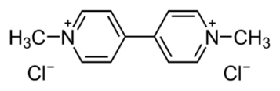

Figure 1. Chemical structure of paraquat (1,10-dimethyl-4,40-bipyridinium chloride)

Agricultural wastes are categorised as bio-based products which currently become popular among the researchers because it is considered as a part of green technology. The agriculture wastes such as pineapple leaves are considered as the other source of adsorbent due to its low operating cost, abundantly available and its regeneration capability [6]. Pineapple leaves in natural form possess a high tendency to remove cationic compounds rather than anionic compounds [7]. The modification of negatively charged adsorbent by cationic surfactant has been proven to be more efficient in increasing the adsorption affinity of biomass towards diverse contaminants [8]. Hence, in this research, the pineapple leaves were modified with cationic surfactant called cetyltrimethyl ammonium bromide (CTAB) to investigate the effect of different concentrations of surfactant in the adsorption capacity of pineapple leaves towards paraquat compound in water.

Materials and Methods

Preparation and characterisation of modified pineapple leaves

The pineapple leaves from Josapine type were provided by MARDI (Malaysian Agricultural Research and Development Institute) station in Pontian, Johor. The preparation of raw sample (UPLP) and its pre-treatment process were carried out based on previous work [8]. Four series of surfactant-modified pineapple leaf powder (SMPLP) were prepared by mixing the pre-treated pineapple leaf powder (PLP) with four different concentrations of CTAB aqueous solutions (0.5, 1.0, 2.5, and 4.0 mM). About 1000 mg of PLP was added with 100 mL CTAB solution and the mixture was stirred constantly for 15 minutes and the resulting SMPLP was filtered and dried at 90 °C overnight. After that, the dried SMPLP was ground into fine powder using pestle and mortar.

The amount of CTAB adsorbed onto the PLP was determined by calculating the differences in the remaining concentrations of CTAB in the solution before and after modification process. The procedure for the determination of CTAB in the solution involved the complexation of CTAB molecules by acid orange 7 in chloroform phase [9]. The samples were characterised using Fourier-transform infrared spectroscopy (FTIR) (Nicolet iS5 FT-IR Spectrometer, Thermo Fisher Scientific, USA) using attenuated total reflectance (ATR) method. The FTIR spectrum was recorded using OMNIC software in the range of 400 to 4000 cm⁻¹.

Adsorption of paraquat

The effect of the paraquat concentrations on the adsorption capacity of pineapple leaves was studied by adding different paraquat concentrations. The paraquat solution with the concentrations of 2, 5, 8, 10, and 20 mg/mL were prepared by diluting the stock solution (SP PARAQUAT 13%, Malaysia) in 100 mL volumetric flask. The fixed parameters were adsorbent dosage (250 mg), room temperature (24 °C), adsorption time (2 hours), and rate of stirring (200 rpm). The pH value of the paraquat solution was around 6.5 to 7.0. The removal test was performed by adding 250 mg of PLP and SMPLP samples with 25.0 mL of paraquat solution. The mixture was agitated at 200 rpm for 2 hours under room temperature and then it was separated by a single filtration through the Whatman filter paper (125 mm, pore size 11 μm). The concentration of paraquat in the filtrate solution was measured using a visible spectrophotometer (NANOCOLOR VIS, Macherey-Nagel) at λ_{630 nm}. Each experiment was done in triplicate. The selected solid portion was dried in an oven and characterised using FTIR spectrophotometer. The calculation of the paraquat adsorption capacity from the solution on the adsorbent was calculated based on Eq. 1:

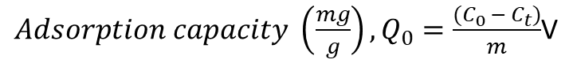$Adsorption capacity \left(\frac{mg}{g}\right), Q_{e}=\frac{\left(C_{0}-C_{t}\right)}{m}. V$ (1)

where C₀ is the initial paraquat concentration (mg/L), C_{t} is the residual concentration of the paraquat (mg/L) at different concentrations, V is volume (mL), and m is the adsorbent dose (mg).

Results and Discussion

Characterisation of samples

Figure 2 shows the amount of CTAB adsorbed on PLP with different initial concentrations of CTAB ([CTAB]_{initial}). This was done to observe the effect of different amounts of CTAB loading in their adsorption capacity towards paraquat. It is clear that the amount of CTAB adsorbed on PLP increased with the increased of [CTAB]_{initial}. These [CTAB]_{initial} (0.5, 1.0, 2.5 and 4.0 mM) were selected based on the critical micelle concentration (CMC) of CTAB at around 1.0 mM. Therefore, at [CTAB]_{initial} equal to 0.5 mM, the arrangement of CTAB molecules in the solution is in monomer and the micelles are formed at CTAB concentrations of 1.0 mM and above. In this experiment, the highest [CTAB]_{initial} was 4.0 mM due to higher number of micelles in the solution and it affected the adsorption behaviour of CTAB molecules on the PLP surfaces. At a much higher concentration of more than the CMC of CTAB, the CTAB molecules will arrange in the form of aggregation and the CTAB molecules will adsorb on the surfaces via physical attachment and tend to release into the solution easily and eventually decrease its adsorption capacity. Furthermore, our previous study has proven that the modified PLP with CTAB at [CTAB]_{initial} 4.0 mM showed the highest adsorption towards methylene blue and acid orange in aqueous solution [8]. The proposed mechanism of CTAB molecules adsorbed on PLP surfaces is given in the final section.

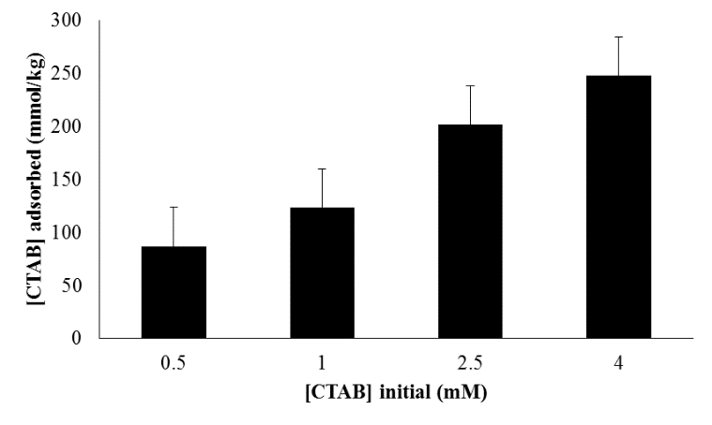

Figure 2. Amount of CTAB adsorbed onto pineapple leaf powder at different CTAB initial concentrations

Figure 3 shows the FTIR spectra for all of the samples to obtain information about the bonding presented in the PLP and also to observe the presence of CTAB molecules on the modified PLP. There will be higher amount of C–H bonds on the modified PLP with CTAB as the molecular structure of CTAB composes of 16 hydrocarbon (C–H) chain in its tail and they tend to form aggregate on the surfaces of PLP.

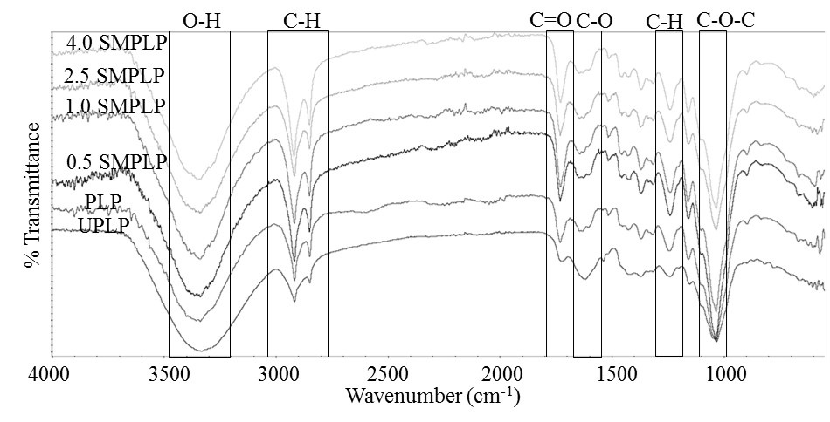

Figure 3. FTIR spectra of untreated PLP (UPLP), PLP, and SMPLP with different CTAB adsorbed

Based on Figure 3, strong broad peaks ranging from 3340 to 3350 cm⁻¹ represent hydroxyl (O–H) vibration mode in cellulose and lignin structure [10] which could interact with each other through strong hydrogen bonding. The –OH stretching vibration is identical to the intermolecular and intramolecular hydrogen bond [11] of hydroxyl group at carbon number six in glucopyranose unit of cellulose component [12]. The strong and sharp band in the range of 1725 to 1732 cm⁻¹ indicates carbonyl (C=O) stretching vibration mode representing acetyl or ester groups in hemicellulose [10] and ester linkage of lignin [11]. Furthermore, the bands at around 1625 to 1647 cm⁻¹ represent carbon oxygen bonding (C–O–O) from the lignin aromatic C–C bond [13]. Furthermore, the peaks at 1420 to 1448 cm⁻¹ are due to asymmetric carbon hydrogen bond (–CH₂) deformation in methyl and methylene groups of lignin and hemicellulose as well as the stretching of the benzene rings in the lignin structure [14]. The peak in the range of 1369 to 1373 cm⁻¹ is attributed to the carbon hydrogen (C–H) deformation of cellulose and xylan while the peak between 1240 and 1243 cm⁻¹ can be assigned as ether (C–O–C) bond of the cellulose chain or stretching of aryl group in lignin [11]. The shallow peaks in the range of 1150 to 1160 cm⁻¹ can be assigned to the antisymmetric ether (C–O–C) bridge pyranose rings cellulose [14, 15]. The overall FTIR spectra show that the important chemical nature and properties of pineapple leaves are composed of functional groups exist in cellulose, hemicellulose, and lignin [11, 13, 15].

The appearance of strong and sharp peaks at around 2900–2800 cm⁻¹ indicates the presence of methyl (–C–H) stretching vibration from the CH₂ group of hemicellulose and cellulose which are also the main composition of PLP [14,15]. Besides that, the intensity of –C–H vibration peaks increased from PLP to SMPLP 4.0 is due to the increased in the aliphatic carbon content on SMPLP, indicating that the CTAB molecules are attached on the PLP surfaces [8]. This result is in accordance with that of Figure 2 where there is increased amount of CTAB molecules attached on PLP with higher [CTAB]_{initial}.

The results of FTIR spectroscopy especially at their fingerprint regions (below 1500 cm⁻¹) for each sample demonstrate that the chemical structure of the pineapple leaves remained unchanged after the pre-treatment process and surface modification. The PLP and SMPLP samples were then studied for their adsorption capacities towards herbicide paraquat solution. Figure 4 shows the adsorption capacity of the samples towards different concentrations of paraquat.

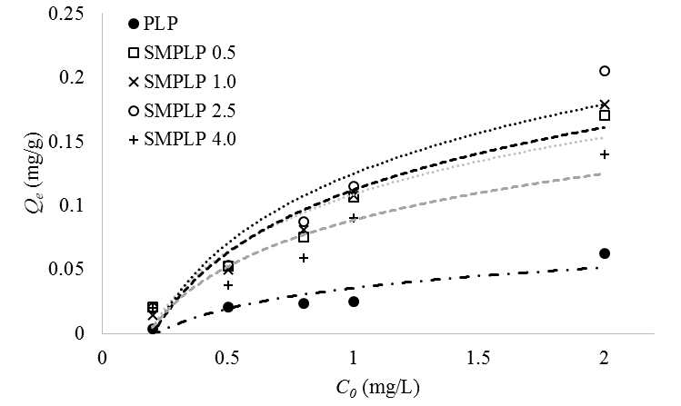

Figure 4. Adsorption capacity of PLP and SMPLP at different concentrations of paraquat

Figure 4 clearly shows that the SMPLP samples have higher adsorption capacity for paraquat compared to PLP and sample SMPLP 2.5 exhibited the highest adsorption of paraquat. The adsorption affinity of pineapple leaves towards paraquat compound followed this trend: SMPLP 2.5 > SMPLP 1.0 > SMPLP 0.5 > SMPLP 4.0 > PLP. Detailed mechanisms of paraquat adsorbed on PLP and SMPLP is discussed in the final section.

Adsorption of paraquat

The adsorption isotherm describes the distribution of adsorbates between liquid and solid phases and the behaviour of the adsorption system. The adsorption capacities of PLP and SMPLP towards paraquat were determined through isotherm studies. The data on adsorption capacity of paraquat were further analysed using Langmuir and Freundlich adsorption isotherm models. The Langmuir isotherm model is established based on the assumption that a monolayer adsorption occurs on the homogenous surface of adsorbent with constant adsorption energy and no transmigration or lateral interaction between adsorbates in the plane of the surface [16]. The Langmuir equation is given in Eq. 2:

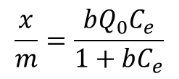$\frac{x}{m}= \frac{bQ_{O}C_{e}}{1+bC_{e}}$ (2)

where x is the mass of adsorbates adsorbed (mg), m is the mass of adsorbent (g), C_{e} is the equilibrium concentration (mg/L), b is the Langmuir constant related to the affinity of the binding site, and Q₀ is the maximum adsorption at monolayer coverage (mg/g). Eq. 2 can be simplified if:

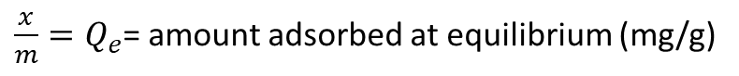 (3)

Thus, the Eq. 2 can be linearized into:

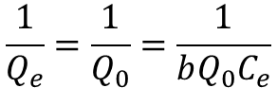$\frac{1}{Q_{e}}= \frac{1}{Q_{0}}= \frac{1}{bQ_{o} C_{e}}$ (4)

The plot of $\frac{1}{Q_{e}}$ against $\frac{1}{C_{e}}$ gives a straight-line graph with $\frac{1}{{bQ}_{0}}$ and $\frac{1}{Q_{0}}$ are slope and Y-intercept, respectively.

The Freundlich isotherm model is a nonlinear empirical equation developed based on the assumption that a monolayer adsorption occurs at heterogeneous surface of the adsorbent with inconsistent binding energy and unequal available active sites on the surface of adsorbent [17]. The Freundlich isotherm model is given in Eq. 5.:

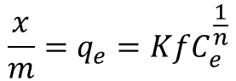$\frac{x}{m}= q_{e}=Kf C_{e}^{\frac{1}{n}}$ (5)

where n is the favourability of the adsorption process and K_{f} is the maximum adsorption at monolayer coverage (mg/g). Eq. 5 can be linearized into:

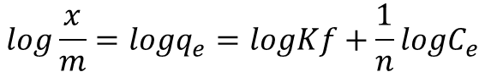$\log{\frac{x}{m}}=\log{q_{e}}=\log{kf+ \frac{1}{n}}\log{C_{e}}$ (6)

The plot of $\log{\frac{x}{m}}$ or $\log{q_{e }}$against $\log{C_{e}}$gives a straight-line graph with $\frac{1}{n}$ and $\log{kf }$ are slope and Y-intercept, respectively. The values for adsorption isotherm parameters for both models are provided in Table 1.

Table 1. Fitted Langmuir and Freundlich parameters for paraquat adsorbed on PLP and SMPLP
Samples | Langmuir isotherm model |  |  | Freundlich isotherm model
Samples | Q₀ (mg/g) | b (1/g) | R² | K_{f} (mg/g) | n (1/g) | R²
PLP | 0.027 | 0.568 | 0.951 | 33.744 | 0.830 | 0.928
SMPLP 0.5 | 1.645 | 0.064 | 0.999 | 10.425 | 1.076 | 0.992
SMPLP 1.0 | 0.199 | 0.347 | 0.989 | 10.322 | 0.904 | 0.983
SMPLP 2.5 | 1.095 | 0.091 | 0.999 | 13.004 | 0.969 | 0.997
SMPLP 4.0 | 0.260 | 0.402 | 0.975 | 12.634 | 0.463 | 0.980

The correlation coefficient (R²) values for Freundlich isotherm indicate that this model fits all the experimental data better than the Langmuir isotherm model. The fitted adsorption data into Freundlich isotherm model describes the heterogeneous nature of PLP and SMPLP surfaces in which adsorption of paraquat onto both types of the adsorbents are assumed to have uniform adsorption activation energies [18] with no transmigration of paraquat molecules on the plane of the adsorbent surface. The Freundlich adsorption isotherm results also demonstrate the formation of multilayer coverage on the outer surfaces of PLP and SMPLP. Furthermore, this also rectifies the inconsistent values of Q₀ (Table 1) for each sample when the adsorption data were fitted with Langmuir isotherm equation particularly the Q₀ for SMPLP 0.5 is much higher than those for SMPLP 1.0 and SMPLP 2.5. The value of R² of less than 0.95 for PLP for Freundlich isotherm shows that the adsorption behaviour of PLP is different with that of SMPLP as there is no additional compound (CTAB molecules) on the PLP surfaces. Detailed mechanism of paraquat adsorption on different concentrations of surfactant is explained in the next section.

The characterisation of the samples after adsorption of paraquat was performed using FTIR spectroscopy to determine the changes occurred in the chemical structure of pineapple leaves. The FTIR spectra after adsorption of paraquat by PLP and SMPLP are presented in Figure 5.

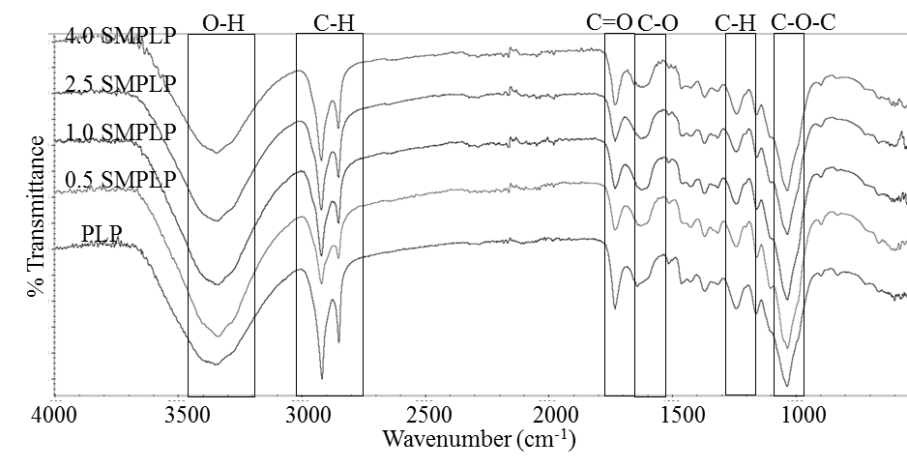

Figure 5. FTIR spectra of the samples after adsorption with paraquat

The appearance of strong sharp peaks at 2916 and 2850 cm⁻¹ indicates the presence of methyl (–CH) stretching vibration from CH₂ group of hemicellulose and cellulose [10]. Additionally, another contribution that causes a high intensity of –C–H vibration peaks is due to the paraquat molecules because the paraquat structure consists many –C–H groups and causes the –C–H vibration peaks to be more intense. Although paraquat structure contains two aromatic rings, the peaks representing C=C or =CH did not appear in the FTIR spectra of the samples after the adsorption process may be due to the low amount of paraquat molecules that adsorbed on the sample. In addition, some of the peaks in the FTIR spectra overlapped with the same functional groups in the PLP as the PLP composed of several organic compounds. Importantly, the structure of the SMPLP sample after adsorption remains unchanged because paraquat molecules bound in between the surfactant layer on the surface of pineapple leaves. The adsorption also did not involve any changes on the major component of the pineapple leaves.

Proposed mechanism of adsorption

Figure 6 shows the proposed mechanism of CTAB adsorption on PLP and paraquat adsorption on SMPLP at (a) below the CMC level (0.5 mM), (b) near CMC, and (c) above CMC. At a lower CTAB concentration (0.93 mM and below), the CTAB molecules exist as monomers and form monolayer at the outer surface of PLP. The paraquat retained on the surface of the adsorbent via ion-exchange interaction and electrostatic forces while the interaction between paraquat molecules and hydrophobic tails involves hydrophobic interaction and van der Waals forces [19]. This resulted in the formation of surfactant monolayer on the surface of adsorbent and led to the lower adsorption capacity towards paraquat.

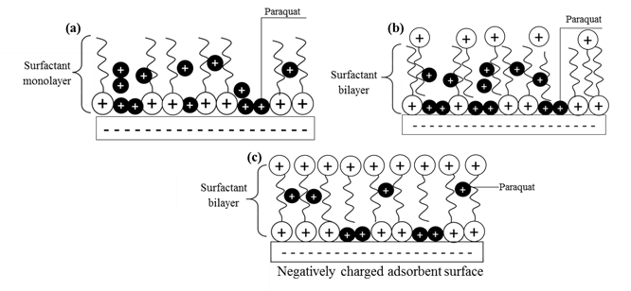

Figure 6. Proposed adsorption mechanism of CTAB and paraquat onto PLP for (a) SMPLP 0.5, (b) for SMPLP 1.0 and SMPLP 2.5, and (c) SMPLP 4.0

The surface of PLP which are not occupied by CTAB molecules possesses numerous hydroxyl groups of cellulose and lignin which gives the PLP surface its negative potential characteristics [8]. The negatively charged hydroxyl group acts as an active site to adsorb paraquat molecules with positively charged functional groups. For all SMPLP samples, some of the paraquat molecules are attached to hydrophobic tails of the surfactant. The molecules of paraquat are retained on the surface of pineapple leaves through ion-exchange mechanism or electrostatic force [19, 20, 21] while the interaction between paraquat molecules and hydrophobic tails involves hydrophobic interaction and van der Waals forces [19].

However, the adsorption mechanism of paraquat onto SMPLP 4.0 is different. At 4.0 mM, the CTAB molecules start to form bilayer formation at the outer surface of the adsorbent. From Figure 5(c), as the paraquat molecule is positively charged, it cannot bind to the positive hydrophilic head of CTAB molecules [22]. This resulted in the rejection of paraquat molecules towards the surfactant positive hydrophilic head. Moreover, the formation of the bilayer also hinders the paraquat molecules to penetrate the surface of PLP and thus reduced its adsorption capacity.

Conclusion

This study concludes the ability of pineapple leaves powder (PLP) in adsorbing CTAB surfactant and the CTAB adsorbed PLP enhanced the adsorption of paraquat in aqueous solution. The adsorption capacity of SMPLP towards paraquat also depended on the amount of CTAB adsorbed on the PLP where the highest adsorption was found for PLP adsorbed with 2.5 mM of CTAB. Therefore, the PLP modified CTAB could be used as an alternative adsorbent to remove paraquat herbicide released into the environment. Furthermore, the agricultural wastes modified with a suitable amount of surfactant can also be used to remove other organic contaminants in water.

Acknowledgement

This work was financially supported by the Universiti Teknologi Malaysia under the Research University Grant (Vot 18H87 and 08H01) and Ministry of Higher Education Malaysia.

References
- Gilden, R. C., Huffling, K. and Sattler, B. (2010). Pesticides and health risks. Journal of Obstetric, Gynecologic, and Neonatal Nursing, 39(1): 103-110.
- Posecion, N., Ostrea, E. and Bielawski, D. (2008). Quantitative determination of paraquat in meconium by sodium borohydride-nickel chloride chemical reduction and gas chromatography/mass spectrometry (GC/MS). Journal of Chromatography B, 862 (1-2): 93-99.
- Huang, C. L., Lee, Y. C., Yang, Y. C., Kuo, T. Y. and Huang, N. K. (2012). Minocycline prevents paraquat-induced cell death through attenuating endoplasmic reticulum stress and mitochondrial dysfunction. Toxicology Letters, 209(3): 203-210.
- Phuinthiang, P. and Kajitvichyanukul, P. (2019). Degradation of paraquat from contaminated water using green TiO₂ nanoparticles synthesized from Coffea arabica L. in photocatalytic process. Water Science and Technology, 79(5): 905-910.
- Zbair, M., Anfar, Z., Ahsaine, H. A. and Khallok, H. (2019). Kinetics, equilibrium, statistical surface modeling and cost analysis of paraquat removal from aqueous solution using carbonated jujube seed. RSC Advances, 9(2): 1084-1094.
- Chowdhury, S., Chakraborty, S. and Saha, P. (2011). Biosorption of basic green 4 from aqueous solution by Ananas comosus (pineapple) leaf powder. Colloids and Surfaces B: Biointerfaces, 84(2): 520-527.
- Salleh, M. A. M., Mahmoud, D. K., Karim, W. A. W. A. and Idris, A. (2011). Cationic and anionic dye adsorption by agricultural solid wastes: A comprehensive review. Desalination, 280 (1–3): 1-13.
- Kamaru, A. A., Sani, N. S. and Malek, N. A. N. N. (2016). Raw and surfactant-modified pineapple leaf as adsorbent for removal of methylene blue and methyl orange from aqueous solution. Desalination and Water Treatment, 57(40): 18836-18850.
- Malek, N. A. N. N., Yusof, M. H. and Kamaru, A. A. (2019). Simultaneous action of surfactant modified sugarcane bagasse: adsorbent and antibacterial agent. Malaysian Journal of Fundamental and Applied Sciences, 15(1): 32-37.
- Kassim, N. A., Mohamed, A. Z., Zainudin, E. S., Zakaria, S., Azman, S. K. Z. and Abdullah, H. H. (2018). Isolation and characterization of macerated cellulose from pineapple leaf. BioResources, 14(1): 1198-1209.
- Nayan, N., Sharif, N., Razak, S., Wan Abdul Rahman, W. and Abd Majid, R. (2013). Effect of mercerization on the properties of paper produced from Malaysian pineapple leaf fibers. International Journal of Engineering and Technology, 13(4): 1-6.
- Samal, R. and Ray, M. (1997). Effect of chemical modifications on FTIR spectra. II. Physicochemical behavior of pineapple leaf fiber (PALF). Journal of Applied Polymer Science, 64(11): 2119-2125.
- Banerjee, R., Chintagunta, A. D. and Ray, S. (2019). Laccase mediated delignification of pineapple leaf waste: An ecofriendly sustainable attempt towards valorization. BMC Chemistry, 13(1): 58-69.
- Maniruzzaman, M., Rahman, M. A., Gafur, M. A., Fabritius, H. and Raabe, D. (2012). Modification of pineapple leaf fibers and graft copolymerization of acrylonitrile onto modified fibers. Journal of Composite Materials, 46(1): 79-90.
- Weng, C. H. and Wu, Y. C. (2012). Potential low-cost biosorbent for copper removal: Pineapple leaf powder. Journal of Environmental Engineering, 138(3): 286-292.
- Masel, R. I. (1996). Principles of adsorption and reaction on solid surfaces. John Wiley & Sons, Illinois: pp. 239-245
- Jaroniec, M. (1975). Adsorption on heterogeneous surfaces: The exponential equation for the overall adsorption isotherm. Surface Science, 50(2): 553-564.
- Mas, H. M. and Sathasivam, K. (2009). The removal of methyl red from aqueous solutions using banana pseudostem fibers. American Journal of Applied Sciences, 6(9): 1690-1700
- Martins, D., Simões, M. and Melo, L. (2015). Adsorption of paraquat dichloride to kaolin particles and to mixtures of kaolin and hematite particles in aqueous suspensions. Journal of Water Security, 1(1): 25-36.
- Han, R., Han, P., Cai, Z., Zhao, Z. and Tang, M. (2008). Kinetics and isotherms of neutral red adsorption on peanut husk. Journal of Environmental Sciences, 20(9): 1035-1041.
- Janoš, P., Coskun, S., Pilařová, V. and Rejnek, J. (2009). Removal of basic (methylene blue) and acid (egacid orange) dyes from waters by sorption on chemically treated wood shavings. Bioresource Technology, 100(3): 1450-1453.
- Paria, S. and Khilar, K. C. (2004). A review on experimental studies of surfactant adsorption at the hydrophilic solid - water interface. Advances in Colloid and Interface Science, 110(3): 75–95.

