

MALAYSIAN JOURNAL OF ANALYTICAL SCIENCES
ISSN 1394 - 2506

Published by The Malaysian Analytical Sciences Society

UTILIZATION OF DEEP EUTECTIC SOLVENT (DES) AS POROGEN

IN THE FABRICATION OF POLYMERIC MONOLITHIC CAPILLARY COLUMN

(Penggunaan Pelarut Eutektik Dalam (DES) Sebagai Porogen Dalam Fabrikasi Turus Kapilari Monolitik Polimerik)

Nabilah Suhaili¹, Lee Wah Lim¹*, Takeuchi Toyohide¹, Rizafizah Othaman²

¹Graduate School of Engineering, Faculty Engineering,

Gifu University, 1-1,Yanagido, Gifu-shi, 501-1193, Japan

²Faculty of Science and Technology,

Universiti Kebangsaan Malaysia, 43600 UKM Bangi, Selangor, Malaysia

*Corresponding author: lim@gifu-u.ac.jp

Received: 31 April 2018; Accepted: 17 April 2019

Abstract

Deep eutectic solvents (DESs) from quaternary salts and hydrogen bond donors (HBDs) formation are widely known as an alternative for ionic liquid (IL) and commonly introduced in the synthesis of mesoporous materials. In this study, four types of choline chloride (ChCl) based DESs were prepared, and their utilization as porogens in fabricating methacrylate-based monolithic capillary columns was investigated. The selected DESs were prepared from different HBDs, including from organic acid (methacrylic acid MAA), alcohol (ethylene glycol EG), organic base (urea), and also combination of alcohol and organic base (EG and urea). This study found that the type of HBDs used have a crucial impact on the pore formation, and the results showed that DES A (ChCl:urea:EG) could effectively improve the structure of the monoliths and enhanced chromatographic separation for non-polar polycyclic aromatic hydrocarbons (PAHs). For repeatability evaluation using DES A in separation analysis, five PAHs achieved relative standard deviations (RSDs) of retention time in the range of 1.39 – 1.91%. Due to the lowest backpressure value (0.4 MPa) compared to other types of DESs, DES A that contained both HBDs from organic base and alcohol is believed to inherit both feature characteristics such as formation of through-pore and mesopore skeletal in monoliths column. A novel green stationary phase for separation of PAHs compounds was successfully synthesized using simple one-step polymerization with low cost and toxicity of DESs mixture as porogenic solvents instead of using traditional organic solvents.

Keywords: deep eutectic solvents, pore forming agent, monoliths, methacrylate, chromatography

Abstrak

Pelarut eutektik dalam (DESs) daripada pembentukan garam kuaternari dan penderma ikatan hidrogen (HBDs) dikenali secara meluas sebagai alternatif untuk cecair ionik dan biasanya diperkenalkan dalam pembuatan bahan mesoporos. Dalam kajian ini, empat jenis DESs berasaskan kolin klorida telah disediakan, dan penggunaannya sebagai porogen dalam fabrikasi turus kapilari monolit berasaskan metakrilat telah dikaji. DESs yang terpilih telah disediakan daripada HBDs yang berbeza, termasuklah daripada asid organik (asid metakrilik MAA), alkohol (etilena glikol EG), bes organik (urea) dan juga gabungan alkohol dan bes organik (EG dan urea). Kajian ini mendapati bahawa jenis HBDs yang digunakan memberikan impak penting ke atas pembentukkan liang dan hasil menunjukkan bahawa DES A (ChCl:urea:EG) boleh memperbaiki struktur monolit secara efektif dan memperbaiki pemisahan kromatografi hidrokarbon aromatik polisiklik (PAHs). Bagi ujian pengulangan menggunakan DES A dalam analisis pemisahan lima PAHs mencapai sisihan piawai relatif (RSDs) masa tahanan didalam lingkungan 1.39 – 1.91%. Disebabkan oleh nilai tekanan balik terendah (0.4 MPa) berbanding dengan jenis DESs lain, DES A yang mengandungi kedua-dua HBDs bes organik dan alkohol, dipercayai mewarisi kedua-dua ciri seperti pembentukan liang-liang dan rangka mesopor dalam turus monolit. Fasa pegun hijau yang baru untuk pemisahan sebatian PAHs berjaya disintesis menggunakan pempolimeran satu langkah mudah dengan kos dan ketoksikan yang rendah campuran DESs sebagai pelarut porogenik daripada menggunakan larutan organik tradisional.

Kata kunci: pelarut eutektik dalam, agen pembentukan liang, monolit, metakrilat, kromatografi

Introduction

Due to increasing demand for green and sustainable analytical methods, many researchers have been using different attempts to improve and design environmentally friendly chemical processes and synthetic methodologies. Nowadays, preparation of porous polymer monolithic column aims to eliminate or reduce the use of hazardous and toxic chemicals at any stage of production in the industry or laboratory [1]. Organic solvents such as hexane, tetrahydrofuran, toluene, acetonitrile or methanol among the conventional solvents used as porogen due to dissolution ability, high boiling point and inertness. However, they are generally volatile, flammable, explosive and toxic for human beings, animals and plants. In addition, they also show acute and chronic toxicity, carcinogenicity, ecological toxicity and non-biodegradability [2]. To improve the protection of human health and the environment from the risks related with the use of hazardous organic solvents, substitution of these solvents with ones that show better Environmental, Health and Safety (EHS) properties are needed. One of the sustainable alternative solvents is deep eutectic solvents (DESs).

DESs have attracted considerable attention in the area of synthesis, electrochemistry, materials, biochemistry and separation [3-6] in recent years. Most type of DESs could be prepared handily, low volatility, high biodegradability and inexpensive. According to that, DESs have emerged as an interesting type of ionic liquid (IL) and have shown their usefulness as environmentally benign solvents and sustainable alternative to the conventional organic solvents in synthetic chemistry to increase efficiency of organic transformations [2]. Based on flexible structure of DESs which containing both an organic group and an anion, DESs might be a potential porogen and surfactant in the preparation of mesoporous polymer and siliceous materials. The application of DESs in preparation of mesoporous materials has been reported in several studies [7-10]. In 2016, Li et al. reported synthesis of mesoporous materials in choline chloride deep eutectic solvents by triblock copolymer-templated hydrothermal synthesis [8]. According to the research, DES-based mesoporous siliceous material with uniform pore structure and excellent stability were successfully produced. Herein, in this study, different types of DESs were used to investigate their effect on the porosity of the polymer monolith. To the best of our knowledge, it was the first time to use DESs as a porogen in preparation of methacrylate –based polymer monolithic column in capillary liquid chromatography (cLC).

There are some advantages of monolithic columns over packed columns, especially in capillary format, where the frits were absence. Also, due to the presence of macro-pores and meso-pores, lower backpressures were usually obtained and therefore higher flow rates could be applied. Based on the nature matrix chemistry, monolith columns can mainly be classified as organic polymer-based monolithic columns and silica-based monolithic columns [11]. Polymer-based monolithic columns have gained increasing attention in capillary liquid chromatography (cLC) and common capillary electro-chromatography (CEC) since they were first prepared in the early 1990s [12]. Polymer monoliths have feature that possess a large number of smaller pores, which furnishes them with a higher surface area thus leading to better separation efficiencies. Monolithic columns are often prepared by polymerization of functional monomers for generation of the chromatographic interaction sites, via in situ polymerization with a cross-linking agent, monomers and some porogens in a capillary tube [13].

The methacrylate polymers have received more attention than others in the diverse range of monolith materials. This can be accredited to their relatively ease of preparation, functionalization, and also ability to be fabricated with high degree of macro-porosity. Methacrylate is a term for any derivative of methacrylic acid, such as glycidyl methacrylate (GMA) and methyl methacrylate (MMA), which are common monomer precursors [14]. The epoxy group in GMA can be further modified and they have been processed successfully as the stationary for the separation of various compounds [15]. Due to the presence of carbonyl and ester bonds, methacrylates are moderately polar and in spite of the fact, they are popular and commonly used in reverse phase chromatography [14]. As a result of the mixed polar or non-polar groups and ease of preparation and functionalization, methacrylate monoliths have been prepared for a number of different methods of chromatographic separation, such as ion exchange and hydrophilic interaction liquid chromatography (HILIC) [13].

Polycyclic aromatic hydrocarbons (PAHs) are organic compounds composed of two or more aromatic rings. PAHs are persistent, toxic and carcinogenic environmental pollutants and estimation of their toxicity can be challenging and time consuming due to the complexity of PAH-mixtures found in the environment. Due to that, the U.S Environmental Protection Agency (EPA) identified sixteen of PAHs as priority pollutants. Two common techniques are normally used to separate PAHs – gas chromatography (GC) and liquid chromatography (LC) [16]. In this study, separation and fractionation of five EPA’s priority PAHs naphthalene, fluorene, anthracene, fluoranthene and pyrene were evaluated by methacrylate-based polymer monolith column in cLC.

The focus on this research is to synthesize a green methacrylate polymer monolith as stationary phase for cLC with emphasis on the two main goals of designing a monolith for LC application, i.e. optimizing the porous structure to allow the mobile phase to percolate through the monolithic bed by using DESs as a binary porogen with decanol and tailoring the surface chemistry to obtain the desired chromatographic separation of non-polar compounds polycyclic aromatic hydrocarbons (PAHs). The characterization of morphology and physical properties of the poly(GMA-PEGDMA) monolith capillary columns also have been investigated by using different types of DESs. Noteworthy to remember is that performance characteristics, such as stability, porosity and permeability, play a more important role in column performance in LC compared to CEC, because hydraulic pressure is used to drive the mobile phase. The main objective of this research is to synthesize a stationary phase for cLC which is green to environment by using simple step polymerization, low cost, low toxicity, and high efficiency for separation of non-polar compounds (PAHs).

Materials and Methods

Materials

Choline chloride (ChCl), 3-(trimethoxysilyl)-propylmethacrylate (γ-MAPS, 98%), poly(ethylene glycol) dimethacrylate (PEGDMA), methacrylic acid (MAA), 1-decanol, and ethylene glycol (EG) were purchased from Tokyo Chemical Industry (Tokyo, Japan). Anthracene, fluoranthene, fluorine, naphthalene, pyrene and urea were purchased from Nacalai Tesque Inc. (Kyoto, Japan). Glycidyl methacrylate (GMA, 95%), azobisisobutyronitrile (AIBN), acetonitrile (ACN, HPLC grade), methanol (MeOH, HPLC grade), acetone, 1 M hydrochloric acid and sulphuric acid were supplied by Wako Pure Chemical Industry, Ltd. (Japan). Bare fused silica capillary tubing (0.320 mm I.D., 0.450 mm O.D.) was supplied by GL Sciences Inc. (Tokyo, Japan).

The chromatographic measurements were carried out by using a cLC system that was constructed by an L.TEX 8301 Micro Feeder (LTEX, Corp., Tokyo, Japan) equipped with gas-tight syringe (0.5 mL; Ito, Fuji, Japan) as a pump, a model micro injection valve with an injection volume 0.2 μL (Upchurch Scientific, Oak Harbour, WA) as an injector, a 0.32 mm I.D. x 0.45 mm O.D. fused silica capillary column, a Model Detector UV-2075 (JASCO, Japan) and all data were collected by a CDS data processor (LASOFT, Chiba, Japan). Schematic diagram of a cLC laboratory-assembled instrumentation with a polymer monolithic column was shown in Figure 1. The morphology of the monolith was characterized by an SU-3500 scanning electron microscopy (SEM) purchased from Hitachi, Tokyo, Japan.

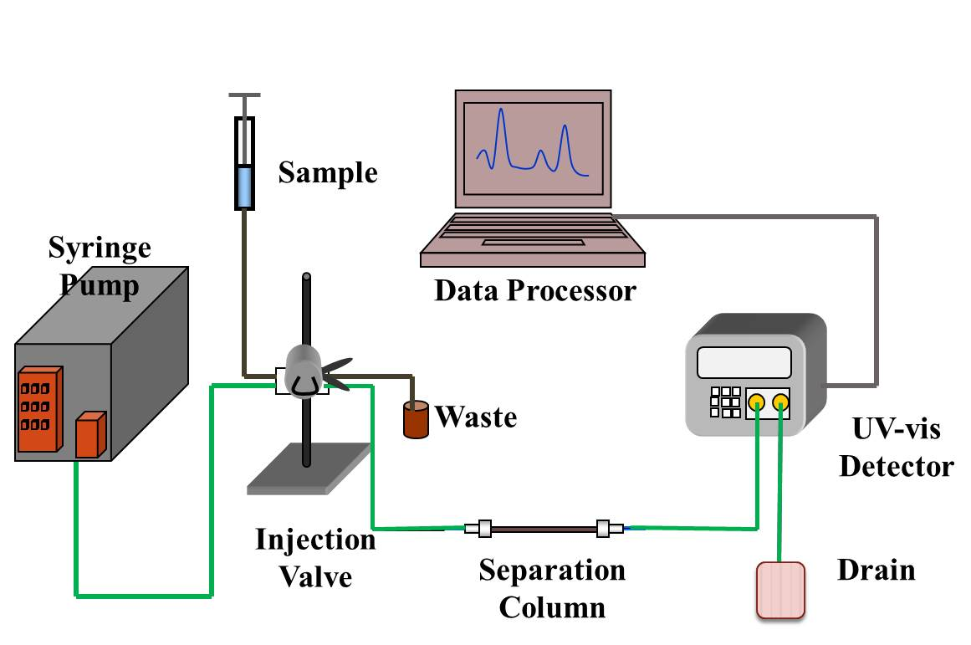

Figure 1. Schematic diagram of a capillary liquid chromatography (cLC) laboratory-assembled instrumentation with a polymer monolithic column

DESs preparation

The DESs were prepared by mixing the choline chloride (ChCl) as hydrogen bond acceptor (HBA) with the corresponding hydrogen bond donor (HBD) according to the molar ratio provided in Table 1. Four different types of DESs were used; DES A (ChCl: Urea: EG), DES B (ChCl: MAA), DES C (ChCl: EG), and DES D (ChCl: Urea). After weighing in the particular amounts of HBA and HBD in the 20 mL vial, the crimp cap was closed before the mixture was constantly stirred with a magnetic stirrer and heated at 80-90˚C until single clear liquid phase was formed [4]. The DESs were then stored in the desiccator prior used in this experiment as a binary porogen with decanol.

Preparation of poly(GMA-PEGDMA) monolithic capillary columns for PAHs

To obtain anchoring sites for the chemical grafting of the polymer at the inner wall of the capillary, the capillary was filled with 30% v/v of 3-trimethoxysilylpropyl methacrylate (γ-MAPS) in acetone after being rinsed with sodium hydroxide (NaOH), water, hydrochloric acid (HCl) for 45 min each. The silanization reaction was carried out in water bath at 60 ˚C for 24 hours and then capillary column washed and dried with acetone and nitrogen gas (N₂), respectively.

The poly(GMA-PEGDMA) monolith was prepared by one-step polymerization method, in which a polymerization mixture containing 12% v/v GMA, 20% v/v PEGDMA, 20% v/v DES and 45% v/v decanol as the binary porogenic solvents and 1% (w/v) AIBN (with respect to the total volume) as initiator was filled into a silanized capillary. After that, both ends of the capillary were sealed and it was placed in a water bath at 60 ˚C for 20 hours. The resulting monolith was carefully washed with acetonitrile (ACN) to eliminate the unreacted porogenic solvents and other soluble compounds [13].

For the preparation of poly(GMA-PEGDMA)-diol, the monolith capillary columns were flushed with 0.2 mol/L sulphuric acid (H₂SO₄) solution at room temperature for two hours to open the epoxide groups in order to form diols at the surface of the polymeric skeleton [17]. The resulting poly(GMA-PEGDMA)-diol monolith capillary column was then applied for determination and separation of non-polar compounds PAHs which are carcinogenic contaminants that produced as a by-product of combustion and normally found in drinking water, soils and sludge [16]. Five types of PAHs consist of 0.1% (w/v) of naphthalene, fluorine, anthracene, fluoranthene and pyrene were prepared for chromatographic separation.

Results and Discussion

DESs that were investigated in this experiment are based from the quaternary ammonium cation choline chloride (ChCl) which also known as cholinium cation. In comparison with imidazolium and pyridinium, this cation is nontoxic and has a comparatively low cost. It is classified as a pro-vitamin in Europe and is produced on the megaton scale as an animal feed supplement [4].

The selected DESs were prepared from different HBDs as shown in Table 1, and DES A with combination of choline chloride with urea and EG are first time reported and synthesized in this research. DESs are defined as combination of two or three safe and cheap components which are capable of self-association, through hydrogen bond interactions to form a eutectic mixture [18]. After heating at 80 °C for one hour and cool down to room temperature, the resulting molten salt were formed. By mixing ChCl with HBDs, a disruption on the crystalline structure of the quaternary ammonium salt was created which triggering a depression in the melting point and thus generating liquids at room temperature [18]. The cloudy formation of polymerization mixture of poly(GMA-PEGDMA) with DES B as porogen was observed and this result are believed due to its high viscosity compared to other types of DESs. Viscosity of binary eutectic mixture is essentially governed by hydrogen bonds, van der Waals and electrostatic interactions [2]. These types of DESs then are explored to determine their influence on the morphology and chromatographic performance of the poly(GMA-PEGDMA)-diol monolithic columns.

Table 1. The effects of four types of DESs on the performances of poly(GMA-PEGDMA)-diol monolithic columns
Column | DES (HBA : HBD) | Molar Ratio | Chromatographic  Separation | Pressure (mPa)
DES A | ChCl : Urea : Ethylene Glycol | 1 : 2 : 1 | Good peak | 0.4
DES B | ChCl : Methacrylic Acid | 1 : 2 | Peak overlapping | 3.3
DES C | ChCl : Ethylene Glycol | 1 : 2 | Peak overlapping | 1.5
DES D | ChCl : Urea | 1 : 2 | Peak overlapping | 1.9

Characterization and evaluation of poly(GMA-PEGDMA) monolithic capillary columns

Morphological features of the poly(GMA-PEGDMA)-diol monolith were examined by scanning electron microscopy (SEM) at 250$×$ and 1000$×$ magnification.

Based on the wide-view images on Figure 2, a good monolith structure was formed on each type of the prepared columns and the monoliths were observed have attached tightly to the inner-wall of the capillary. The results indicated that the monoliths were covalently bonded to the capillary wall and this successful attachment was influenced by the pre-treatment step of the capillary column. Furthermore, it can be seen and observed from the SEM images, the monoliths and through-pores in the polymer skeletons are highly interconnected due to utilization of DES as porogen.

Li et al. has reported that the ChCl DESs with organic base-HBD (urea) and organic acid-HBD (acetic acid) interacted with PEG-PPG-PEG copolymer to shape the uniform mesoporous spheres [6]. The SEM images shown in Figure 2 proved this statement where the monolith materials synthesized with DES B (ChCl: MAA) and DES D (ChCl: urea) porogen, displays uniform mesoporous spheres with smaller interstitial porosity and skeletal structures. Furthermore, by using DES with alcohol-HBD (DES C) and organic base/alcohol-HBD (DES A) as porogen, larger micro-globular structures and larger number of through-pore skeletons were formed. The presence of through-pores and larger pores are very important in synthesis of monolith to prevent high backpressure during chromatographic separation and structural defects in the monolith, pump and tubing connection to cLC instrument [14]. Based on these results, it can be seen that different HBDs of DES may affect the particle morphologies of these mesoporous monolith formation and it can be concluded that, DES A (ChCl: urea: EG) that contained both organic base and alcohol HBDs are believed to inherit both feature characteristics such as through-pore and mesopore skeletal monoliths column.

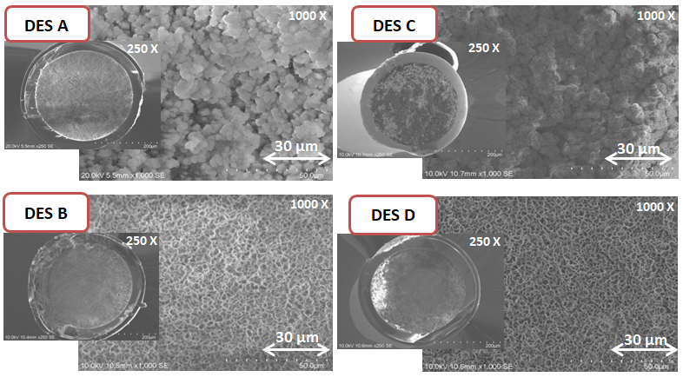

Figure 2. Wide-view (250$×$) and close-up-view (1000$×$) of scanning electron microscopy image of the poly(GMA-PEGDMA)-diol monolithic capillary columns with four types of DES; DES A (ChCl:urea:EG), DES B (ChCl:MAA), DES C (ChCl:EG), and DES D (ChCl:urea) respectively.

The poly(GMA-PEGDMA)-diol monolith was used in this experiment as stationary phase for the separation of non-polar compounds polycyclic aromatic hydrocarbons (PAHs). PAHs are consisted of fused aromatic rings, which are produced by incomplete combustion of carbon-containing fuels such as diesel and coal. Some of them are carcinogenic compounds and exist in a wide range of environmental matrices. Regarding to the toxic and carcinogenic properties of PAHs, the U.S Environmental Protection Agency (EPA) has identified sixteen of PAHs as priority pollutants and Figure 3 displays molecular structure of five out of sixteen EPA’s priority pollutants of PAHs compounds that have been used in this experiment as analytes. These types of PAHs are highly hydrophobic, non-ionic and soluble in nonpolar organic solvents [19].
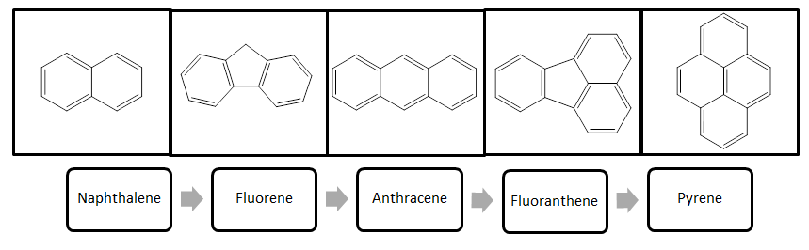

Figure 3. Molecular structure of 5 of the 16 EPA’s priority PAHs and their elution order

Figure 4 shows four chromatograms of the prepared poly(GMA-PEGDMA)-diol monolith capillary columns by different types of DES as porogens on the separation of five typical PAHs with isocratic elution method. The diol groups at the surface of the polymer skeleton are expected to show separation ability towards polar compounds due to the specific interactions such as dipole–dipole and hydrogen bonding interactions [13]. acetonitrile mobile phase 70% that was used in this experiment is more polar than the stationary phase. Therefore, more polar compounds would theoretically migrate at higher rates through the column and elute first [16].

Signal intensity / mV

Figure 4. The effects of using four different types of DES as porogen on chromatographic separation of five types of PAHs. Poly(GMA-PEGDMA)-diol monolith column (100 x 0.32 mm I.D); Eluent, 70% acetonitrile (ACN); flow-rate, 3.0 µL/min; UV detection (λ), 254 nm; analytes, naphthalene (1), fluorene (2), anthracene (3), fluoranthene (4), pyrene (5) 0.1 % (w/v) each

PAHs were eluted in order of naphthalene, fluorene, anthracene, fluoranthene and pyrene according to their level of hydrophobicity in this experiment. When the elution process in reverse phase liquid chromatography (RP-LC) undergo either by isocratic condition or by gradient elution, the solute will be eluted in order of increasing molecular hydrophobicity [20]. Based on Pearlman et al., larger PAHs are generally more hydrophobic than the smaller ones [19]. Therefore, out of five PAHs used, the smaller 2-ringed naphthalene eluted first and pyrene that has larger four-ringed eluted last.

Furthermore, the chromatogram results show that different DESs may affect the chromatographic separation of non-polar compounds PAHs. By using DES C (ChCl: EG) as a porogen, only four clear sample peaks were appeared in chromatogram, while when using DES D (ChCl: urea), five peaks were appeared at short retention time but unable to be separated successfully. Interestingly, when using ternary DES A (ChCl: urea: EG), it can be observed from this chromatogram that five PAHs has been separated completely in reasonable retention time. The morphology of the monolithic column is an important parameter that can affect the efficiency of chromatographic separation. As shown in Table 1, column DES A has the lowest back pressure (0.4 MPa) while column-DES B has the highest (3.3 MPa) when they were used at flow-rate 3 µL/min. The morphology shown in Figure 2 and the chromatography separation shown in the Figure 4 have proved that the DES A is the best porogen for the preparation of polymer monoliths column for the separations of PAHs in this experiment.

Reproducibility of poly(GMA-PEGDMA)-diol based DES A monolithic column

Due to the good results of poly(GMA-PEGDMA) based DES A monolithic column on surface morphology, lowest backpressure and good chromatographic separation, the column reproducibility was investigated further. The run-to-run repeatability of the retention time of PAH analytes was calculated under the same operating conditions for DES A-column. The relative standard deviations (RSDs) of the retention time of each PAHs used are shown in Table 2. The RSDs of the retention time for the four successive chromatographic runs under the optimum condition were in the 1.39% - 1.91% range. The RSD results for all five analytes PAHs were less than 2% and this showed that DES A-column had good repeatability.

Table 2. Relative standard deviations (RSDs) of retention time (R_{t}) for four successive chromatographic runs

under the optimum condition of DES A column
Peak | Naphthalene | Fluorene | Anthracene | Fluoranthene | Pyrene
R_{t} (min) | 6.73 | 7.43 | 8.91 | 10.14 | 11.62
RSD (%)/(n=4) | 1.41 | 1.39 | 1.53 | 1.72 | 1.91

Comparison on chromatographic separation between DES A and methanol as porogen
With the same polymerization mixture contents and porogen volume, comparison on chromatographic separation between utilization of DES 2 and methanol as porogen was evaluated and showed in in the following chromatogram (Figure 5). It was found that by replacing the traditional organic solvent (methanol) to the novel DES porogen (DES A), separation retention time and baseline separation were improved. This chromatogram shows that by using DES A (a) the chromatographic separation takes shorter retention time (13 minutes) while methanol (b) 18 minutes for separation of PAHs (reproduced from ref. [13] with permission).
(a)

Signal intensity / mV

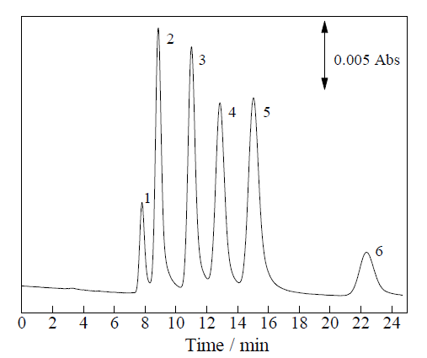
(b)

Source: Linda et al. [13]

Figure 5. Chromatographic separation of PAHs using DES and methanol as porogen. Poly(GMA-PEGDMA)-diol monolith column, a) DES A, b) methanol (100 x 0.32 mm I.D); Eluent, 70% acetonitrile (ACN); flow-rate, 3.0 µL/min; UV detection (λ), 254 nm; analytes, naphthalene (1), fluorene (2), anthracene (3), fluoranthene (4), pyrene (5), benzo[a]pyrene (6), 0.1 % (w/v) each

Conclusion
It was found that, the type of HBD have a crucial impact on the pore formation, and the results showed that DES A (ChCl:urea:EG) with molar ratio 1:2:1 could effectively improve the structure of the monoliths and enhanced chromatographic separation for non-polar polycyclic aromatic hydrocarbons (PAHs) compare to other type of DESs. Based on the scanning electron microscopy (SEM) images of poly(GMA-PEGDMA) monolith columns, DES A porogen that contained both organic base and alcohol HBDs produced a monolith that inherited both feature characteristics such as through-pore and mesopore skeletal monoliths column. Furthermore, for repeatability evaluation of poly(GMA-PEGDMA)-diol for DES A-column, five PAHs achieved retention time relative standard deviations in the range of 1.39 – 1.91%. DES A-column also gives the lowest backpressure compare to other types of DESs with 0.4 MPa for PAHs separation. In comparison with methanol as porogen, chromatographic separation based on poly(GMA-PEGDMA)-DES A give better separation baseline and shorter retention time analysis. To the best of our knowledge, this is the first time that DESs were used as a porogen in the preparation of methacrylate-based polymer monolithic columns in cLC and for the first time DES A was synthesized. A novel green stationary phase for separation of PAHs compounds was synthesized successfully using simple step polymerization, low cost and toxicity of DESs mixture as porogenic solvents instead of traditional organic solvents.

Acknowledgement

The authors gratefully acknowledged the financial support from grant Gifu University, Japan and the facilities that was given to do this project. The acknowledgement also goes to Dr. Fusheng Li for his willingness to help in this research by making facilities available in River Basin Research Center, Gifu University.

References
- Anastas, P. T. (1998). Green Chemistry: Theory and practice, J. Warner (Eds.). Oxford University Press, New York.
- Khandelwal, S., Tailor, Y. K. and Kumar, M. (2016). Deep eutectic solvents (DESs) as eco-friendly and sustainable solvent/ catalyst systems in organic transformations. Journal of Molecular Liquids, 215: 345-386.
- Durand, E., Lecomte, J. and Villeneuve, P. (2013). Deep eutectic solvents: Synthesis, application, and focus on lipase-catalyzed reactions. European Journal of Lipid Science and Technology, 115: 379.

- Smith, E. L., Abbott, A. P. and Ryder, K. S. (2014). Deep eutectic solvents (DESs) and their applications. Chemical Reviews, 114: 11060-11082.
- Garcia, G., Aparicio, S., Ullah, R. and Atilhan, M. (2015). Deep eutectic solvents: Physicochemical properties and gas separation applications. Energy Fuel, 29(4): 2616-2644.
- Li, X., and Row, K. H. (2016). Development of deep eutectic solvents applied in extraction and separation. Journal of Separation Science, 39: 3505-3520.
- Tang, B., and Row, K. H. (2015). Exploration of deep eutectic solvent-based mesoporous silica spheres as high-performance size exclusion chromatography packing materials. Journal of Applied Polymer Science, 2015: 44203.
- Li, X., Lee, Y. R. and Row, K. H. (2016). Synthesis of mesoporous siliceous materials in choline chloride deep eutectic solvents and the application of these materials to high‑performance size exclusion chromatography. Chromatographia, 79: 375-382.
- Zhang, L. S., Zhao, Q. L., Li, X. X., Li, X. X., Huang, Y. P. and Liu, Z. S. (2016). Green synthesis of mesoporous molecular sieve incorporated monoliths using room temperature ionic liquid and deep eutectic solvents. Talanta, 161: 660-667.
- Zhang, J., Wu, T., Chen, S., Feng, P. and Bu, X. (2009). Versatile structure-directing roles of deep eutectic solvents and their implication in generating of porosity and open metal sites for gas storage. Angewandte Chemie International Edition in English, 48(19): 33486-3490.
- Diaz-Bao, M., Barreiro, R., Miranda, J. M., Cepeda, A. and Regal, P. (2015). Recent advances and uses of monolithic columns for the analysis of residues and contaminants in food. Chromatography, 2: 79-95.
- Tennikova, T. B., Belenkii, B. G. and Svec, F. (1990), High-performance membrane chromatography: A novel method of protein separation. Journal of Liquid Chromatography,13: 63-70.
- Linda, R., Lim, L. W., Takeuchi, T. (2013). Methacrylate-based diol monolithic stationary phase for the separation of polar and non-polar compounds in capillary liquid chromatography. Analytical Science, 29: 631-635.
- Groarke, R. J. and Brabazon, D. (2016). Methacrylate polymer monoliths for separation applications. Materials, 9(6): 446.
- Dittmann, M. M., Masuch, K. and Rozing, G. (2000). Separation of basic solutes by reversed-phase capillary electrochromatography. Journal of Chromatography, A, 887: 209.
- Sinioja, T. (2016). Development of a liquid chromatography method and fractionate EPA’s 16 priority polycyclic aromatic hydrocarbons (PAHs). Project in Chemistry. Orebro University.
- Wen, Y., and Feng, Y. Q. (2007). Preparation and evaluation of hydroxylated poly(glycidyl methacrylate-co-ethylene dimethacrylate) monolithic capillary for in-tube solid-phase microextraction coupled to high-performance liquid chromatography. Journal of Chromatography A, 1160: 90-98.
- Liu, P., Hao, J. W., Mo, L. P., and Zhang, Z. H. (2015). Recent advances in the application of deep eutectic solvents as sustainable media as well as catalysts in organic reactions. RSC Advances, 5(60): 48675-48704.
- Pearlman, R. S., Yalkowsky, S. H. and Banerjee, S. J. (1984). Water solubilities of polynuclear aromatic and heteroaromatic compounds. Journal of Physical and Chemical Reference Data, 13(2): 555-562.
- Aguilar, M. I. (2004). HPLC of peptides and proteins methods and protocols: Reversed-phase high performance liquid chromatography. Springer: pp. 9-22.

