

MALAYSIAN JOURNAL OF ANALYTICAL SCIENCES
ISSN 1394 - 2506

Published by The Malaysian Analytical Sciences Society

FACILE ORGANIC-INORGANIC HYBRID SORBENTS FOR EXTRACTION OF POLLUTANTS FROM AQUEOUS SAMPLES – A REVIEW

(Pengerap Hibrid Organik-Tak Organik Mudah bagi Pengekstrakan Pencemar dari Sampel Akueus - Sebuah Ulasan)

Mohd Marsin Sanagi^{1,2*}, Nyuk-Ting Ng¹, Faridah Mohd Marsin¹, Mohamad Raizul Zinalibdin¹,

Zetty Azalea Sutirman¹, Aemi Syazwani Abdul Keyon¹, Wan Aini Wan Ibrahim^{1,2}

¹Department of Chemistry, Faculty of Science

²Centre for Sustainable Nanomaterials, Ibnu Sina Institute for Scientific and Industrial Research

Universiti Teknologi Malaysia, 81310 Skudai, Johor, Malaysia

*Corresponding author: marsin@kimia.fs.utm.my

Received: 19 August 2018; Accepted: 22 June 2019

Abstract
Rapid and efficiency extraction of pollutants from aqueous samples has been an important issue in analytical sciences. Solid phase extraction using sorbents is a well-known separation method and recognized as an efficient and economical method for removal of pollutants from water. In the past few years, there has been growing interest on extractions using organic-inorganic hybrid materials. Formed by incorporating inorganic species into organic matrix, these materials offer some advantages such as high selectivity, permeability, and mechanical and chemical stabilities. This present article discusses recent significant advances in analytical solid-phase extraction employing organic-inorganic composite and nanocomposite sorbents for the extraction of organic and inorganic pollutants from aqueous samples. Classifications and synthesis methods of organic-inorganic hybrid sorbents are described. The physicochemical characteristics, extraction properties and analytical performances of selected sorbents are discussed, including morphology and surface characteristics, types of functional groups, interaction mechanism, selectivity and sensitivity, accuracy, and regeneration abilities. Organic-inorganic hybrid sorbents in combination with extraction techniques are highly promising as an emerging research field for sample preparation of complex samples such as food, biomedical and environmental matrices with analytes at trace levels.

Keywords: organic-inorganic hybrid sorbents, extraction methods, environmental pollutants, aqueous samples

Abstrak
Pengekstrakan pencemar dari sampel akueus dengan cepat dan cekap merupakan isu penting dalam sains analisis. Pengekstrakan fasa pepejal menggunakan pengerap adalah kaedah pemisahan yang diketahui ramai dan dikenali sebagai satu kaedah yang cekap dan ekonomi bagi penyingkiran pencemar dari air. Dalam beberapa tahun kebelakangan, minat terhadap pengekstrakan menggunakan bahan hibrid organik-tak organik telah berkembang. Terbentuk melalui gabungan spesis tak organik ke dalam matrik organik, bahan ini menawarkan beberapa kelebihan misalnya mempunyai kepilihan tinggi, kebolehtelapan, serta kestabilan mekanikal dan kimia. Artikel ulasan ini membincangkan kemajuan penting dalam analisis pengekstrakan fasa pepejal menggunakan pengerap komposit dan nanokomposit organik-tak organik bagi pengekstrakan pencemar organik dan tak organik dari sampel akueus. Klasifikasi dan kaedah sintesis pengerap hibrid organik-tak organik diterangkan. Pencirian fizikokimia, sifat pengekstrakan dan prestasi analisis pengerap terpilih dibincangkan, termasuk pencirian morfologi dan permukaan, jenis kumpulan berfungsi, mekanisma interaksi, pemilihan dan kepekaan, ketepatan dan kebolehan guna semula. Pengerap hibrid organik-tak organik digabung dengan teknik pengekstrakan merupakan bidang penyelidikan yang sangat menjanjikan bagi penyediaan sampel kompleks misalnya matrik makanan, bioperubatan dan alam sekitar dengan analit pada tahap surih.

Kata kunci: pengerap hibrid organik-tak organik, kaedah pengekstrakan, pencemar alam sekitar, sampel akueus

Introduction
Water pollution may be defined as the presence of excessive amounts of hazard (pollutants) in water, in such a way that it is no longer suitable for drinking, bathing, cooking or other uses. The pollution is generally induced by humans. Rapid development of industrialization, agricultural activities and exploitation of natural resources together with the growth of human population over the past few decades have inevitably resulted in raising water pollution. Substances such as leached pesticides, herbicides, heavy metals and other types of environmental pollutants are known to be toxic or carcinogenic. They are often discharged as effluent or wastewaters into water bodies; thus detrimental to human health and ecosystem stability. Halder and Islam [1] and Khatun [2] reported that skin diseases, diarrhea, cholera, and respiratory illnesses (common cold, asthma) are the most common health problems caused by water contamination. Furthermore, about 13 million people die in the world annually, mainly attributed to water, indoor and outdoor air pollutions [3].

In order to ensure the wellbeing of the society, each substance presence in drinking water must below their maximum contaminant limit as set by US Environmental Protection Agency. For instance, the allowable concentration for polychlorinated biphenyls, simazine, atrazine, and benzene are 0.5, 4.0, 3.0, and 5.0 μg/L, respectively whereas, heavy metal such as lead (Pb), copper (Cu), mercury (Hg), cadmium (Cd), selenium (Se), chromium (Cr), and arsenic (As) are 15, 1300, 2, 5, 50, 100 and 100 μg/L, respectively [4].

Several treatment methods have been proposed for removal of such pollutants from industrial and natural water such as ion-exchange, evaporation, chemical precipitation, adsorption, reverse osmosis and membrane separation. Among them, adsorption is a promising method in most applications, considering the favorable features including cost, energy consumption, convenience and reusability [5].

The development of organic–inorganic hybrid materials is trendy especially in the last decade. By definition, organic-inorganic hybrid material refers to composite materials formed by the combination of inorganic materials and organic polymers into a single-phase system, which has molecular interaction in between the molecules (Figure 1) [6]. In addition, they demonstrate better properties compared to their individual counterparts while eliminating or reducing their particular limitations. These new materials, considered as innovative advanced materials, open a land of promising applications in many areas especially in environmental fields. Organic compounds have the advantages of functional variation, synthetic versatility and reactivity whereas inorganic compounds have generally high thermal stability and robustness, resulting in high selectivity toward a target analyte and increased adsorption capacity [4, 7].

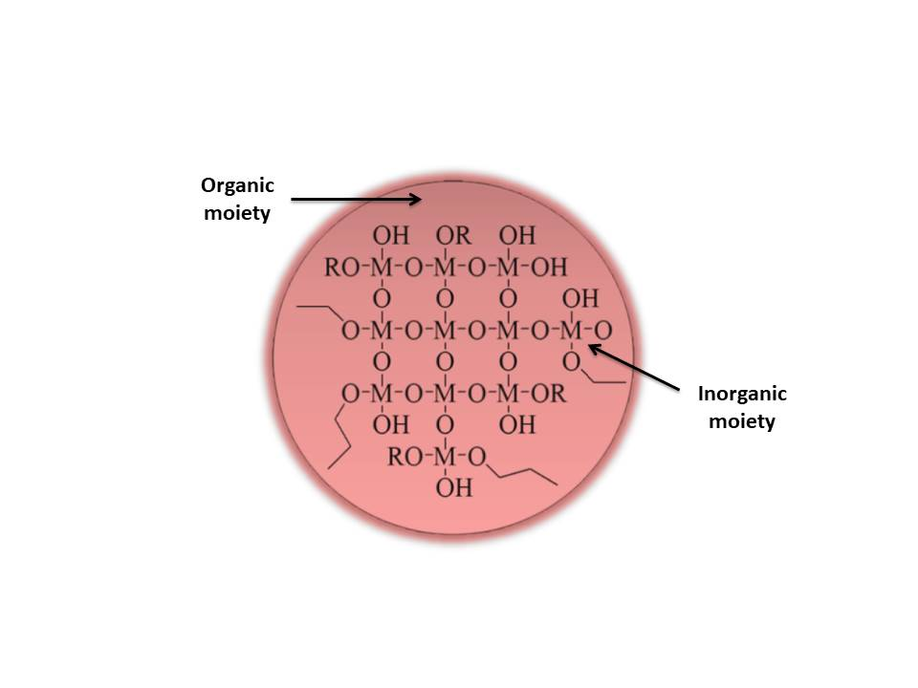
Figure 1. Schematic concept of organic-inorganic hybrid material

This review outlines the information on the use of organic-inorganic hybrid materials for adsorption of different types of pollutants from aqueous solutions. Recent findings are critically reviewed in order to reveal the efficiency of organic-inorganic hybrid materials as adsorbents for water treatment applications. This review consists of three aspects. Firstly, a highlight on classification and synthesis routes of organic-inorganic hybrid sorbents is described. Secondly, the physiochemical properties such as chemical stability, morphology surface characteristic and interaction mechanism of the synthesized organic-inorganic hybrid materials are described. Finally, the review discusses the application of the hybrid materials as sorbents for the analysis and removal of environmental pollutants from aqueous matrices. Here, the adsorption characteristics and analytical performances of the sorbents are listed, compared and described.

Classification of organic-inorganic hybrid materials: Classification based on type of interaction
Organic-inorganic hybrid materials are not simply physical mixtures. Indeed, they are either a homogenous mixture consisting of monomers and miscible organic/inorganic components, or heterogeneous mixture, where at least one of the components has a characteristic length in the order of nanometer (a few Å to several tens of nanometers) [8, 9]. The properties of these materials are not only the sum of the individual contributions from both components, but the strong synergy created by a hybrid interface can be predominant. Hence, organic-inorganic hybrid materials are grossly classified on the basis of the nature of the interface; class I and class II (Figure 2). In class I, organic and inorganic compounds are interacted by weak bonds such as hydrogen, van der Waals, π-π interaction or ionic bonds. Class II is associated with the hybrid materials in which the components are linked together through strong chemical bonds (covalent or ionic-covalent bonds). Nevertheless, many hybrid materials of class II can also have the same kind of weak bonds that define the class I hybrids.

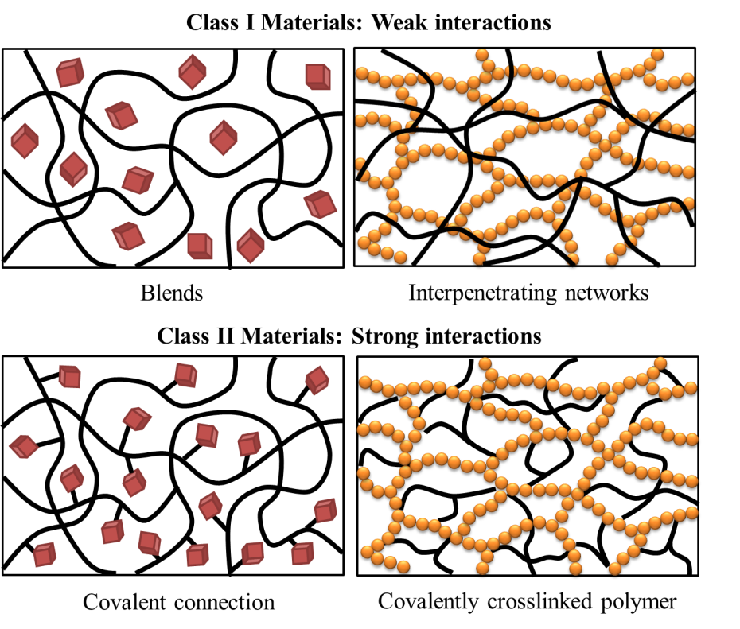
Figure 2. Types of inorganic-organic hybrid materials

General preparation of hybrid materials
Irrespective of types of interface between organic and inorganic components, there are a number of chemical pathways that can be performed to synthesize a given organic-inorganic hybrid material using different experimental conditions or molecular precursors. The fundamental synthetic strategies for all types of hybrids are illustrated in Figure 3.

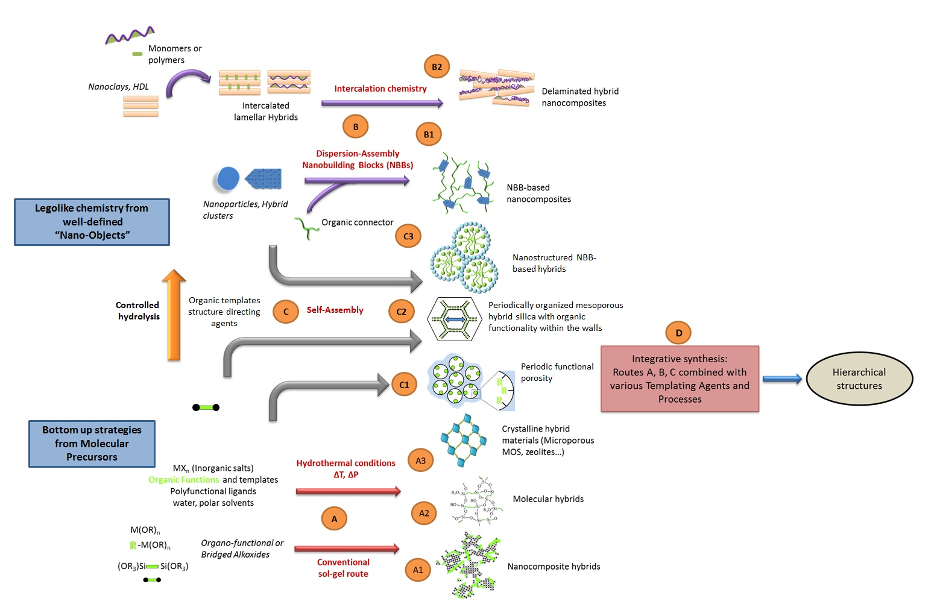

Figure 3. Main chemical routes for the synthesis of organic–inorganic hybrids

Path A corresponds to the soft chemistry-based approaches including conventional sol-gel method (by using specific bridge and polyfunctional precursors) and hydrothermal synthesis. In conventional sol-gel pathways (route A1) amorphous hybrid networks are obtained through hydrolysis and condensation reactions from alkoxyorganosilanes or alkoxyorganostannanes (R’Si(OR)₃, R’-Sn(OR)₃ where R’ is an organic functionality) of alkoxides or metal halides (M’(OR)_{n},MX_{n} with M = Sn, Ce, Zr, Nb, Al etc.) and mixtures thereof. It can take into account that the solvent used may contain diverse organic or biological components (chromophores, polyfunctional macromonomers, biopolymers, viruses, enzymes, etc.) that can interact or trapped within the inorganic component via H-bonding, π-π and van der Waals interactions. The procedures are simple, inexpensive and able to produce amorphous nanocomposite hybrid materials which can be easily shaped into films or bulks. However, these materials are also polydisperse in size and locally heterogeneous in chemical composition, making it difficult to understand their structure-properties relationships [9, 10].

In route A2, sol−gel method has been carried out using specific bridged and poly functionalized precursors such as silsesquioxanes X₃Si-R′-SiX₃ (R′ is an organic spacer, X = Cl, Br, −OR) to prepare homogeneous organic-inorganic hybrid materials with better degree of local organization. In particular, the organic spacer is complemented by using two terminal functional groups of urea. The combination of aromatic bridges framed or alkyl groups and urea groups allows better self-assembly through the capability of the organic components to establish both strong hydrogen bond networks and efficient packing via π-π or hydrophobic interactions.

Another synthetic methodology for hybrid materials in path A is hydrothermal synthesis (route A3) performed in polar solvents (water, formamide, etc.) in the presence of organic templates. This method has been used to develop numerous microporous hybrid materials such as zeolites with wide range of applications in the domain of adsorbents or catalysts. Also, metal organic frameworks (MOFs) with a high and tunable porosity and a crystalline architecture have been prepared via this method.

Path B illustrates strategies based on the assembling (route B1) or the dispersion (route B2) of well-defined nanobuilding blocks (NBB) which provide nanostructured hybrid networks with better structural definition [11]. These NBB are often inorganic moieties such as clusters or nanoparticles (metal oxides, metals and alloys, chalcogenides), nanoparticle composite type core/shell, or nano-sheets of lamellar compounds (clays, double hydroxides, phosphates, oxides and lamellar chalcogenides) that able to intercalate organic compounds. The NBB are capped with polymerizable ligands or connected by organic spacers of telechelic molecules, polymers, or functional dendrimers. This approach of NBB presents two major advantages; 1) Prefabricated NBB often show a lower reactivity compared to that of molecular precursors; 2) The nanobuilding components that are nanometric, monodispersed, and have well-defined structures and shapes facilitate characterization and control over the quality of the final material.

Depending on the nature, structure and functionality of the nanobuilding blocks, various organic-inorganic hybrid materials with tunable electrical and optical properties can be prepared, associated with different assembling methods. Furthermore, the step by-step preparation of these materials allows for a better control over their structure on the semi-local scale.

Path C represents self-assembling procedures [9, 11]. Self-assembling has gained interests as it involves the organization or the texturation of growing inorganic or hybrid networks, templated growth by organic surfactants (route C1). The success of this approach is related to the ability to control and tune hybrid interfaces. It also allows the construction of a continuous ensemble of nanocomposites from ordered dispersions of inorganic bricks in a hybrid matrix to highly controlled nanosegregation of organic polymers within inorganic matrices. One of the striking examples is the synthesis of mesostructured hybrid networks. Recently, the template growth of mesoporous hybrids has been proposed by using bridged silsesquioxanes as precursors in presence of surfactants (route C2). The approach yields a new class of periodically organized mesoporous hybrid silicas with organic functionality within the walls. These nanoporous materials show a high degree of order and their mesoporosity is added advantage for further organic functionalization via grafting reactions.

Meanwhile, route C3 explores the combination of self-assembly and NBB methods. The procedures shows the combination of NBB approach with the use of organic template that self-assemble allow one to control the assembling step. Moreover, they yield a large variety of interfaces between the organic and the inorganic components such as covalent bondings, complexations, electrostatic interactions, and many more. These NBB with tunable functionalities can, through molecular recognition processes, permit the development of a new field in chemistry.

The final pathway in tailoring hybrid materials (path D) is an integrative synthesis [9, 11]. The approaches mentioned above mainly offer the controlled design and assembling of hybrid materials in the 1 to 500 Å range. However, the development of micro-molding methods, in which the use of controlled phase separation phenomena, emulsion droplets, latex beads, bacterial threads, colloidal minerals or organo-gelifiers lead to controlling the shapes of complex objects in the micron scale. This path describes the combination of these methods and those above described along paths A, B, and C to produce hierarchically organized materials in terms of structure and functions.

Application of organic-inorganic hybrid sorbents for environmental pollutants in aqueous matrices
Environmental pollution issues have existed for many years. It was caused by the discharge of hazardous species into surrounding environment in excess of permitted limits. This phenomenon is of concern as the discharge of these materials is high in toxicity and a serious threat to public health. Examples of environmental pollutants include heavy metals, dyes, triazine herbicides, polycyclic aromatic hydrocarbons (PAHs), polychlorinated biphenyls (PCBs), organophosphorus pesticides (OPPs), tricyclic antidepressants (TCA), organochlorine pesticides (OCPs), endocrine disrupting chemicals, phenolic compounds, etc. Analysis of these leached contaminants into environmental water is challenging since they usually exist at trace levels (mg/L – μg/L) thus demanding more elaborate analytical procedures [4]. Tedious sample preparation is usually necessary for the preconcentration of targeted species to meet the sensitivity of a particular analytical instrument for getting reliable experimental data.

Organic-inorganic hybrid sorbents employed in solid phase extraction or water treatment are highly advantageous as the sorbent chemistry tailored to a particular analyte can be controlled well by manipulating both the organic and inorganic units of the resulting hybrid materials [7]. This is important for the promotion of good homogeneity and alteration of chemical or physical properties of an organic-inorganic hybrid sorbent to share the common properties (polarity, porosity, hydrophobicity, etc.) and suit for the adsorption of certain groups of analytes. With this in mind, investigation of such hybrid materials has gained considerable attention from analytical chemists for the fabrication of sorbents employed in different types of solid phase extraction methods such as micro-solid phase extraction, dispersive-solid phase extraction, magnetic-solid phase extraction, stir bar sorption extraction, rotating disk sorption extraction, etc. The developed organic-inorganic hybrid sorbents have proved to be a new powerful tool to improve sensitivity, accuracy, selectivity, recoveries, precision and linearity of an analytical procedure. For this reason, a variety of organic-inorganic hybrid sorbents have been developed and applied in the analysis of a wide range of environmental pollutants include pharmaceutical compounds, agricultural products, heavy metals and many other organic compounds present in environmental water samples (Table 1).

Table 1. Recent organic-inorganic hybrids sorbents for the extraction of several common environmental pollutants
Sorbent | Analyte | Real Sample | LOD | q_{max} | Method of Extraction/  Water Treatment | Reference
Palmitic acid coated magnetic nanoparticles | 38 pesticides | Tap water, bottled drinking water and pool water | 20 - 30 ng/L | - | M-SPE | [12]
Poly(methacrylic acid)/SiO₂/Al₂O₃ | imazethapyr herbicide | - | - | 4.5 mg/g | Batch adsorption | [13]
Graphene-based tetraethoxysilane-methyltrimethoxysilane sol-gel hybrid magnetic nanocomposite | polar and non-polar OPPs | Tap water, river water, lake water and seawater | 1.40 -23.7 pg/mL | 37.18 -76.30 mg/g | M-SPE | [14]
Chrysin-functionalized silica-core shell magnetic nanoparticles | Copper(II) | River water, lake water and tap water | 0.3 ng/mL | 114.25 mg/g | M-SPE | [15]

Table 1 (cont’d). Recent organic-inorganic hybrids sorbents for the extraction of several common environmental pollutants
Sorbent | Analyte | Real Sample | LOD | q_{max} | Method of Extraction/  Water Treatment | Reference
Ion-imprinted iodole-functionalized silica-supported sorbent | Antimony(III) | Tap water, river water and lake water | 40 ng/L | 39.6 mg/g | SPE | [16]
Mercapto-functionalized hybrid sorbent | Antimony(III) | Tap water, river water, mineral wastewater and seawater | 2.5 ng/L | - | SPE | [17]
Hybrid organic-inorganic nafion intercalated layered double hydroxide | Mercury(II) | Drinking water | 0.004 μg/L | 302.14 mg/g | SPE | [18]
Surface Cr(VI)-imprinted magnetic nanoparticles | Chromium(VI) | Tap water, river water and lake water | 0.29 μg/L | 2.50 mg/g | M-SPE | [19]
Piperazine functionalized magnetic sporopollenin | Lead(II) and arsenic(III) | - | - | 13.36 mg/g (lead ion) and 69.86 mg/g (arsenic ion) | Batch adsorption | [20]
Magnetite–Polypyrrole Composite | Naproxen, diclofenac sodium, and mefenamic acid | Tap water, river water and wastewater | 0.9 - 3.5 μg/L | - | M-SPE | [21]
Magnetic sporopollenin-cyanopropyltriethoxys-ilane | Ketoprofen, ibuprofen, diclofenac and mefenamic acid | Tap water, lake water, river water and wastewater | 0.21 -0.51 μg/L | - | M-SPE | [22]
Ionic liquids intercalated in montmorillonite | Polychlorinated biphenyls | Wastewater | 3 - 43 ng/L | - | RDSE | [23]
SPE: Solid phase extraction; M-SPE: Magnetic solid phase extraction; RDSE: Rotating disk sorption extraction

Environmental monitoring is performed to monitor the quality of surrounding water matrices and fully understand its level of water contamination by harmful pesticide and herbicide compounds. Many organic-inorganic hybrid sorbents are made up of magnetite and organic units. Other than providing simple sorbent separation by applying magnetic force, functionalization of organic part on magnetite also provides magnetite protection for the prevention of leaching of magnetite. Tavakoli et al. [12] had successfully synthesized palmitic acid coated magnetic nanoparticles for the extraction, preconcentration and analysis of 38 pesticides with gas chromatographic detection. The limits of detection (LOD) were found to be as low as 20-30 ng/L and excellent preconcentration factor (PF) was as high as 1000. Good linearity with coefficient of determination, R² > 0.98, and satisfactory relative recoveries (%RR) in the range of 63-110% with low relative standard deviation (%RSD) in between 3.67-6.57% were achieved in the investigation. The developed sorbent was applied in the analysis of real samples, namely tap water, bottled drinking water and pool water. For real sample analysis, no pesticide residues were detected in tap water and bottled drinking water as the quantity of targeted pesticides compounds could be lower than the LOD of the developed method. On the other hand, diazinon and permethrin I, II were found in pool water at concentrations of 81 ng/L and 159 ng/L, respectively. In Iran, the maximum residual limit (MRL) of entire pesticides is 100 ng/kg except for methoxychlor at 20 000 ng/kg and permethrin I, II total value at 300 000 ng/L.

Outstanding analytical performance of the developed fatty acid coated magnetite sorbent towards selected pesticides was achieved, this could be due to the changes in the overall hydrophobicity of the developed sorbents resulted from the interaction of highly lypophilic surfactant surface and highly hydrophilic magnetite surface during the synthesis steps. The method was compared to classical solid phase extraction (SPE) employed C₁₈ cartridge. Indeed, in some cases, SPE could be more efficient than the developed method in terms of analytical performances. However, the developed method showed advantages as being faster, cheaper and easier to perform than the classical SPE method and only little amount of organic solvents was used. Accordingly, the presence of diazinon and permethrin I, II in pool water is worrisome. There was possibility that the water contamination was due to the pest-repellent or personal care product wore by the pool users or leaking of nearby farmland effluent water into the pool. The issue should be paid significant attention as some pesticides are very toxic to aquatic life and nearby beneficial insects to avoid the imbalance of affected ecosystem. Human beings could be poisoned by absorbing toxic pesticide compounds through the skin and respiration.

Another organic-inorganic composite was synthesized via template magnetite on sorbent or vice versa. Omastová and Mičušík [24] reported combination of polypyrrole (PPy) and magnetite could increase the processability and mechanical properties of resulted polymer. The anions from oxides of metal bounded to PPy structure and acted as a co-dopant, similar to anion of the oxidizing agent. The presence of metal oxides in PPy minimized the surface energy of the PPy particles, thus increasing the conductivity and thermo-oxidative stability than samples without additive. In a recent study by Faridah and co-workers [21] showed that the magnetic separation and dispersibility of magnetite combined with the electrostatic interaction by PPy have been applied for successful extraction of selected non-steroidal anti-inflammatory drugs (NSAIDs) with high sensitivity and precision (LOD of 0.9-3.5 μg/L; %RSD of <7.16%), good accuracy (%RR of 97.87-100.42%) and good linearity (R² of 0.88–0.94). The developed magnetized PPy sorbent was successfully applied to the determination of NSAIDs naproxen, diclofenac sodium and mefenamic acid in tap water, river water, and wastewater samples. NSAIDs are among the highly produced and globally well-known pharmaceutical product due to their good analgesic, antipyretic and other good properties to reduce pain and anti-inflammation. Although NSAIDs are not classified as hazardous contaminant yet, their potential toxicity remains as an arising concern regarding their continuous leaching into the surrounding environments derived from human usage, improper disposal or excretion.

Another type of well-known environmental pollutants is the heavy metals. These are elements that have high atomic weight and five times greater density compared to water. They have high toxicity at low concentration and are naturally found on earth and can be leaching out to surrounding via human activities in the form of industrial or mining wastes. Due to their high stability, these pollutants are highly persistent in environment and cannot be degraded easily [25]. Thus, investigation of economical and efficient analytical procedures or water remediation steps tailored on heavy metals is always a joint attention and shared goal for scientists worldwide. It has been shown that adsorption is one of the most efficient ways for the uptake of heavy metals in marine environment in both laboratory-scaled sample preparation step and industrial-scaled water treatment system [26]. Therefore, sorbents with outstanding adsorption characteristics, mechanical and physical properties are of high demand for monitoring purposes. A surface Cr(VI)-imprinted magnetic nanoparticles sorbent was developed by Qi et al. [19] for preconcentration and determination of toxic Cr(VI) in tap water, lake water and river water samples. The prepared sorbent was synthesised by combining both surface ion-imprinted and sol-gel techniques. Under optimized environment, the preconcentration factor, linearity, LOD, %RR and %RSD of the developed extraction method were found to be 98, R²=0.994, 0.29 μg/L, 96.1-99.2% and 2.1-3.4%, respectively. Non-imprinted polymers and the developed sorbent were studied to compare their selectivity towards Cr(VI). In the presence of seven interference ions, the developed sorbent showed excellent selectivity toward Cr(VI) with %RR in the range of 96.5%-99.8% while non-imprinted polymer offered only 24.4%0-39.8% for the recovery of Cr(VI). For real sample analysis, Cr(VI) was found in both lake water and river water samples at concentrations of 19.32 μg/L and 8.36 μg/L, respectively.

Conclusion and Outlooks
In this review, classification of organic-inorganic hybrids and their major synthesis routes, namely sol-gel, self-assembly, assembling of nanobuilding blocks and interpenetrating networks were discussed. A broad range of organic-inorganic hybrids materials are highly potential for applications in different aspects such as analytical, medical, mechanics, electronics and etc. This is due to easy handling of their physico-chemical properties, mechanical and chemical stabilities, morphological and surface characteristics, type of functional groups and bondings by manipulating their synthesis conditions, quantity and type of organic and inorganic materials used for their synthesis process. These properties should be studied carefully to ensure the compatibility of the developed sorbents with the corresponding sorbate and to fully understand the physical or chemical interactions of the sorbent-sorbate pairs. Under proper fabrication condition, the adsorption or extraction performance of the resulted hybrid material would be largely improved and served as an excellent sorbent in real environmental samples with high matrix effect. As discussed in this article, organic-inorganic hybrid sorbents are highly capable to be employed in the analysis of real environmental waters without significant matrix effects.

In brief, organic-inorganic hybrid sorbents will be an important and fascinating research aspect in analytical field. Under proper development, organic-inorganic hybrid sorbents with advantages of eco-friendly and low cost could be fulfilled. Therefore, these sorbents are expected to be mass-produced and marketed for the use of researchers for environmental monitoring purpose and wastewater treatment industry. Stability of the resulted sorbent should be highlighted to avoid any leaching substances forming secondary pollutants enter into the surrounding environment. Certainly, the use of natural organic polymer (biopolymers such as cellulose, sodium alginate, chitosan etc.) and inorganic substances (clay) are highly encouraged. Overall, such materials should be studied extensively because of their easy, fast, low cost and flexible production system as well as their unique features formed.

Acknowledgement
The authors would like to thank Universiti Teknologi Malaysia for facilitations and the Ministry of Higher Education Malaysia for financial support through vote number Q.J130000.2509.09H84. The authors declared no conflict of interest.

References
- Halder, J. N. and Islam, M. N. (2015). Water pollution and its impact on the human health. Journal of Environment and Human, 2(1): 36-46.
- Khatun, R. (2017). Water pollution: Causes, consequences, prevention method and role of wbphed with special reference from Murshidabad district. International Journal of Scientific and Research Publications, 7(8): 269-277.
- Prüss-Üstün, A., Bonjour, S. and Corvalán, C. (2008). The impact of the environment on health by country: A meta-synthesis. Environmental Health, 7(1): 7.
- Ng, N. T., Kamaruddin, A. F., Wan Ibrahim, W. A., Sanagi, M. M. and Abdul Keyon, A. S. (2018). Advances in organic–inorganic hybrid sorbents for the extraction of organic and inorganic pollutants in different types of food and environmental samples. Journal of Separation Science, 41(1): 195-208.
- Xu, L. and Wang, J. (2017). The application of graphene-based materials for the removal of heavy metals and radionuclides from water and wastewater. Critical Reviews in Environmental Science and Technology, 47(12): 1042-1105.
- Zvonkina, I. and Soucek, M. (2016). Inorganic–organic hybrid coatings: Common and new approaches. Current Opinion in Chemical Engineering, 11: 123-127.
- Samiey, B., Cheng, C.-H. and Wu, J. (2014). Organic-inorganic hybrid polymers as adsorbents for removal of heavy metal ions from solutions: A review. Materials, 7(2): 673-726.
- Judeinstein, P. and Sanchez, C. (1996). Hybrid organic–inorganic materials: A land of multidisciplinarity. Journal of Materials Chemistry, 6(4): 511-525.
- Sanchez, C., Julián, B., Belleville, P. and Popall, M. (2005). Applications of hybrid organic–inorganic nanocomposites. Journal of Materials Chemistry, 15(35-36): 3559-3592.
- Kaushik, A., Kumar, R., Arya, S. K., Nair, M., Malhotra, B. and Bhansali, S. (2015). Organic–inorganic hybrid nanocomposite-based gas sensors for environmental monitoring. Chemical Reviews, 115(11): 4571-4606.
- Mir, S. H., Nagahara, L. A., Thundat, T., Mokarian-Tabari, P., Furukawa, H. and Khosla, A. (2018). Organic-inorganic hybrid functional materials: An integrated platform for applied technologies. Journal of The Electrochemical Society, 165(8): B3137-B3156.
- Tavakoli, M., Hajimahmoodi, M. and Shemirani, F. (2014). Trace level monitoring of pesticides in water samples using fatty acid coated magnetic nanoparticles prior to GC-MS. Analytical Methods, 6 (9): 2988-2997.
- Casarin, J., Gonçalves, A. C., Segatelli, M. G. and Tarley, C. R. T. (2017). Poly(methacrylic acid)/SiO₂/Al₂O₃ based organic-inorganic hybrid adsorbent for adsorption of imazethapyr herbicide from aqueous medium. Reactive and Functional Polymers, 121: 101-109.
- Nodeh, H. R., Ibrahim, W. A. W., Kamboh, M. A. and Sanagi, M. M. (2017). New magnetic graphene-based inorganic–organic sol-gel hybrid nanocomposite for simultaneous analysis of polar and non-polar organophosphorus pesticides from water samples using solid-phase extraction. Chemosphere, 166: 21-30.
- Ali, L. I. A., Ibrahim, W. A. W., Sulaiman, A., Kamboh, M. A. and Sanagi, M. M. (2016). New chrysin-functionalized silica-core shell magnetic nanoparticles for the magnetic solid phase extraction of copper ions from water samples. Talanta, 148: 191-199.
- Zhang, D., Zhao, Y. and Xu, H.-B. (2017). Hydrothermal-assisted derived ion-imprinted sorbent for preconcentration of antimony(III) in water samples. Separation Science and Technology, 52(12): 1938-1945.
- You, N., Liu, T.-H., Fan, H.-T. and Shen, H. (2018). An efficient mercapto-functionalized organic–inorganic hybrid sorbent for selective separation and preconcentration of antimony(III) in water samples. RSC Advances, 8(10): 5106-5113.
- Shamsayei, M., Yamini, Y. and Asiabi, H. (2018). Evaluation of reusable organic-inorganic nafion/layered double hydroxide nanohybrids for highly efficient uptake of mercury ions from aqueous solution. Applied Clay Science, 162: 534-542.
- Qi, X., Gao, S., Ding, G. and Tang, A.-N. (2017). Synthesis of surface Cr (VI)-imprinted magnetic nanoparticles for selective dispersive solid-phase extraction and determination of Cr(VI) in water samples. Talanta, 162: 345-353.
- Ahmad, N. F., Kamboh, M. A., Nodeh, H. R., Halim, S. N. B. A. and Mohamad, S. (2017). Synthesis of piperazine functionalized magnetic sporopollenin: a new organic-inorganic hybrid material for the removal of lead (II) and arsenic (III) from aqueous solution. Environmental Science and Pollution Research, 24(27): 21846-21858.
- Mohd Marsin, F., Wan Ibrahim, W. A., Abdul Keyon, A. S. and Sanagi, M. M. (2018). box–behnken experimental design for the synthesis of magnetite–polypyrrole composite for the magnetic solid phase extraction of non-steroidal anti-inflammatory drug residues. Analytical Letters, 51(14): 2221-2239.
- Wahib, S. M. A., Ibrahim, W. A. W., Sanagi, M. M., Kamboh, M. A. and Keyon, A. S. A. (2018). Magnetic sporopollenin-cyanopropyltriethoxysilane-dispersive micro-solid phase extraction coupled with high performance liquid chromatography for the determination of selected non-steroidal anti-inflammatory drugs in water samples. Journal of Chromatography A, 1532: 50-57.
- Fiscal-Ladino, J. A., Obando-Ceballos, M., Rosero-Moreano, M., Montaño, D. F., Cardona, W., Giraldo, L. F. and Richter, P. (2017). Ionic liquids intercalated in montmorillonite as the sorptive phase for the extraction of low-polarity organic compounds from water by rotating-disk sorptive extraction. Analytica Chimica Acta, 953: 23-31.
- Omastová, M. and Mičušík, M. (2012). Polypyrrole coating of inorganic and organic materials by chemical oxidative polymerisation. Chemical Papers, 66(5): 392-414.
- Tchounwou, P. B., Yedjou, C. G., Patlolla, A. K. and Sutton, D. J. (2012). Heavy metal toxicity and the environment. Springer Basel, Basel: pp. 133-164.
- Fu, F. and Wang, Q. (2011). Removal of heavy metal ions from wastewaters: A review. Journal of Environmental Management, 92(3): 407-418.

