

MALAYSIAN JOURNAL OF ANALYTICAL SCIENCES
ISSN 1394 - 2506

Published by The Malaysian Analytical Sciences Society

Kinetic Degradation of Total Phenolic Content, DPPH RadicAl Scavenging and Xanthine Oxidase Inhibitory ActivitIES in Yanang (Tiliacora triandra) Leaf Extract during preparation process

(Degradasi Kinetik Kandungan Jumlah Fenolik, Aktiviti Pemerangkapan Radikal DPPH dan Xantin Oksidase dalam Ekstrak Daun Yanang (Tiliacora triandra) Semasa Proses Penyediaan)

Sunee Eadmusik¹*, Chanthima Phungamngoen¹, Natthaya Choosuk²

¹Department of Agro-industry Technology and Management, Faculty of Agro-industry
²Department of Innovation and Product Development Technology, Faculty of Agro-industry
King Mongkut’s University of Technology North Bangkok, 25230 Prachinburi, Thailand

*Corresponding author: sunee.e@agro.kmutnb.ac.th

Received: 25 October 2017; Accepted: 22 January 2019

Abstract
Presently, canned bamboo shoots in Yanang (Tiliacora triandra (Colebr.) Diels) leaf extract is produced in order to expand shelf-life and ease to prepare food. The objectives of this research were to investigate the effect of different thermal processing during Yanang leaf extract preparation on total phenolic content, DPPH radical scavenging and xanthine oxidase inhibitory activities and to determine kinetics of the extract’s quality alterations. The preparation included 1:12 (w/v) leaves to water ratio, 32,000 rpm blending speed and different heating temperature at 60, 70 or 80 ºC for 15 minutes. Data were collected at 0, 1, 3, 6, 9, 12 and 15 minutes of heating time. The results showed that fresh Yanang leaf extract had total phenolic content of 680.16 ± 19.57 mg GAE/100 mg db. and it possessed DPPH radical scavenging and xanthine oxidase inhibitory activities at 163.53 ± 0.87 µg BHT/mL and 78.58 ± 0.17%, respectively. The results revealed that an increase in heating temperature and time decreased total phenolic content and the DPPH radical scavenging and xanthine oxidase inhibitory activities of Yanang leaf extract. During 15 minutes heating, the total phenolic content of Yanang leaf extract ranged from 526.33 ± 28.79 to 638.93 ± 29.69 mg GAE/100 mg db., DPPH radical scavenging activity ranged from 92.86 ± 1.66 to 136.41 ± 5.70 µg BHT/mL and xanthine oxidase inhibitory activity ranged from 72.64 ± 0.34 to 76.65 ± 0.50%. The change of total phenolic content (R² = 0.809-0.959) followed zero-order kinetic model and that of DPPH radical scavenging activity (R²=0.783-0.920) while xanthine oxidase inhibitory activity (R² = 0.864-0.922) followed second-order kinetic model.

Keywords: Yanang, Tiliacora triandra, total phenolic content, xanthine oxidase, kinetic model

Abstrak
Pada masa ini, pucuk buluh dalam ekstrak daun Yanang (Tiliacora triandra (Colebr.) Diels) yang ditinkan dihasilkan untuk meningkatkan hayat simpanan dan kemudahan untuk menyediakan makanan. Objektif penyelidikan ini adalah untuk mengkaji kesan pemprosesan terma yang berbeza semasa penyediaan ekstrak daun Yanang terhadap kandungan jumlah fenolik, aktiviti pemerangkapan radikal DPPH dan xantin oksidase dan untuk menentukan kinetik perubahan kualiti ekstrak. Penyediaan melibatkan nisbah daun kepada air, 1:12 (w/v) 32,000 rpm halaju adunan dan suhu pemanasan yang berbeza pada 60, 70 atau 80 ºC selama 15 minit. Data dikumpulkan pada masa pemanasan 0, 1, 3, 6, 9, 12 dan 15 minit. Keputusan menunjukkan bahawa ekstrak daun Yanang segar mempunyai kandungan jumlah fenolik sebanyak 680.16 ± 19.57 mg GAE/100 mg berat kering dan aktiviti pemerangkapan radikal DPPH dan xantin oksidase ialah 163.53 ± 0.87 μg BHT/mL dan 78.58 ± 0.17%. Keputusan menunjukkan bahawa peningkatan suhu pemanasan dan masa menurunkan kandungan jumlah fenolik dan aktiviti ekstrak daun Yanang. Selepas 15 minit pemanasan, kandungan fenolik jumlah ekstrak daun Yanang ialah dari 526.33 ± 28.79 hingga 638.93 ± 29.69 mg GAE/100 mg berat kering, aktiviti perencatan radikal DPPH adalah daripada 92.86 ± 1.66 hingga 136.41 ± 5.70 μg BHT/mL dan aktiviti perencatan xantin oksidase dalam julat 72.64 ± 0.34 hingga 76.65 ± 0.50%. Perubahan kandungan fenolik jumlah (R² = 0.809-0.959) adalah mengikut model kinetik tertib sifar dan aktiviti pemerangkapan radikal DPPH (R² = 0.783-0.920) sementara aktiviti penghambatan xantin oksidase (R² = 0.864-0.922) adalah mengikut modeltertib kedua.

Kata kunci: Yanang, Tiliacora triandra, kandungan jumlah fenolik, xantin oksidase, model kinetik

Introduction
Tiliacora triandra (Colebr.) Diels belongs to the family of Menispermaceae. It is known in Thai as Yanang. Its leaf and root are widely used in the Southeast Asia countries due to its health benefits [1]. Traditionally, Yanang root has been used as antipyretic and antimalarial agents [2] while Yanang leaf has been used for anticancer and immune modulator [3]. Previous studies reveal that tiliacorinine, tiliacorine and nor-tiliacorinine are bisbenzylisoquinoline alkaloids found in Yanang [4, 5] and gum from Yanang has a similar structure to xylan according to their FTIR spectra [2]. Several studies also show that Yanang contains bioactive compounds, such as phenolic compounds, which possess significant antioxidant properties [6]. Ferulic acid, p-coumaric acid, sinapic acid and syringic acid are specific phenolic compounds presented in Yanang leaf extract. The ability to stabilize free radicals and break the oxidation chain of these phenolic compounds has been reported [7]. Yanang leaves are usually extracted with water to be cooked especially with bamboo shoots because of its remedy for gout (gouty arthritis). The treatment for gout involves the use of therapeutic agent such as xanthine oxidase inhibitors [8]. The enzyme, xanthine oxidase, converts hypoxanthine into xanthine and sequent into uric acid which can accumulate in human body and cause gout. However, the stability of bioactive compounds is unstable depending on the pH, light, oxygen, temperature and enzymatic activities [9].

Several studies reported the degradation of phenolic compounds and antioxidant activity in fruits and vegetables during thermal processing [10, 11, 12]. Tian et al. [10] revealed that up to 72% of total phenolic content and 61% of 2,2-diphyneyl-2-picryl-hydrazyl (DPPH) radical scavenging activity in purple-fleshed potatoes decreased during cooking. Recently, Méndez Lagunas et al. [12] reported losses of 78% total phenolic content and 74% DPPH radical scavenging in strawberry during convective drying. Nevertheless, no information related with alteration of xanthine oxidase during thermal processing.

Presently, canned bamboo shoots in Yanang leaf extract is produced in order to expand shelf-life and ease to prepare food. The preparation process of Yanang leaf extract could impair the stabilities of bioactive compounds and properties. Therefore, the aims of this study were to investigate the effect of different thermal processing during Yanang leaf extract preparation on total phenolic content, DPPH radical scavenging and xanthine oxidase inhibitory (XOI) activities and to determine kinetics of the extract’s property degradations.

Materials and Methods

Chemicals and reagents

All chemicals and reagent were analytical grade. Folin-Ciocalteu reagent was purchased from Loba Chemie Pvt Ltd. (Mumbai, India) while Na₂CO₃ was purchased from Ajax Finechem Pty Ltd. (Auckland, New Zealand). Tablets of sodium phosphate buffer were obtained from Amresco LLC (Ohio, USA). Xanthine and xanthine oxidase were obtained from Himedia Laboratories Pvt. Ltd. (Mumbai, India). Dimethyl sulfoxide (DMSO) was obtained from Sigma-Aldrich (Missouri, USA).

Plant material and extraction

Yanang (Tiliacora triandra) leaves, obtained from the local market in Prachinburi province of Thailand, were washed with excess water to remove dust and the infected leaves were discarded. Only consistent green-colored leaves with more than 3 cm width x 5 cm length were collected. The collected leaves were then naturally dried and kept at 6 ºC until used within 7 days. Fifty grams of Yanang leaves were mixed with 600 mL water (leaves to water ratio is 1:12) and blended using a Buono-17778P blender (Taiwan, ROC) at 32,000 rpm for 1 minute. The Yanang leaf extract was obtained by filtering through 2 layer-muslin cloth and adjusted to 600 mL with water. The Yanang leaf extract was freshly prepared before each experiment.

In order to determine the kinetic degradation of chemical properties of Yanang leaf extract, the extract was heated at 60, 70 and 80 ºC. The samples were collected at 0, 1, 3, 6, 9, 12 and 15 minutes after heating and total phenolic content, DPPH radical scavenging activity and XOI activity were determined.

Determination of total phenolic content

Total phenolic content determination was performed following the method described by Singthong et al. [6]. Briefly, 20 µL of Yanang leaf extract were mixed with 1.58 mL of water and 100 µL of Folin-Ciocalteu reagent. After 5 minutes incubation at room temperature, the mixture was added with 300 µL of 2% (w/v) Na₂CO₃ and then placed in the dark at room temperature for 2 hours. Absorbance of the mixture was measured at 765 nm using an Optima SP-300 spectrophotometer from Optima Inc. (Tokyo, Japan). Gallic acid (0-200 mg/L) was used as a standard for the calibration curve. Total phenolic content of Yanang leaf extract was expressed as mg Gallic acid equivalent/100 mg dry basis (mg GAE/ 100 mg db.).

Determination of DPPH radical scavenging activity

DPPH radical scavenging activity was measured following the method described by De Ancos et al. [13]. Ten µL of Yanang leaf extract were diluted with 90 µL of water, mixed with 3.9 mL of 25 mM DPPH and placed in the dark for 30 minutes. Absorbance of the mixture was measured at 515 nm. Butylhydroxytoluene (BHT) was used as a standard. DPPH radical scavenging activity of Yanang leaf extract was expressed as µg BHT/mL.

XOI activity assay
XOI activity with xanthine as the substrate was measured with the method described by Azmi et al. [8]. The assay mixture consisted of 300 μL of 50 mM sodium phosphate buffer pH 7.5, 100 μL of Yanang leaf extract sample, 100 μL of 0.2 U/mL freshly prepared xanthine oxidase in phosphate buffer and 100 μL of distilled water. After pre-incubation at 37 °C for 15 minutes, 200 μL of 0.15 mM xanthine was added into the mixture. The mixture was then incubated at 37 °C for 30 minutes. The reaction was stopped with the addition of 200 μL of 0.5 M HCl. The absorbance was measured spectrophotometrically at 295 nm against a blank which was prepared in the same way but the enzyme solution was replaced with phosphate buffer. An assay of control sample prepared by using 100 μL DMSO instead of Yanang leaf extract sample was also performed in order to have a maximum uric acid formation. Allopurinol, a well-known xanthine oxidase inhibitor, was used as a positive control at a concentration of 100 µg/mL. Percentage of XOI activity was calculated as following (equation 1):

(1)

where Abs_{control} is absorbance of control sample when DMSO was used. Abs_{sample} is absorbance of Yanang leaf extract sample.

Statistical analysis and development of kinetic model

Experiments were carried out in triplicate. The data were expressed as mean ± standard deviation. The means of all parameters were examined using analysis of variance (One-way ANOVA). Duncan’s New Multiple Range Test (DMRT) was used to determine the multiple comparison of mean values at a level of P < 0.05. Correlations were established by regression analysis. A SPSS statistical program version 16 was used to perform the calculation.

The data of degradation (quality-time curve) were fitted to three different kinetic models according to the following equations (2-4):

The zero order reaction; C = C₀ – kt (2)

The first order reaction; ln C = ln C₀ – kt (3)

The second order reaction; (4)
where C is quality (total phenolic content, DPPH radical scavenging activity or XOI activity) of Yanang leaf extract at time t. C₀ is initial quality (total phenolic content, DPPH radical scavenging activity or XOI activity) of Yanang leaf extract at time 0. k is reaction rate constant and t is time (minutes)

The effect of temperature on the degradation rate constant was assumed to follow the Arrhenius equation 5;

k = k₀ exp [-E_{a}/RT] (5)

where as k is rate constant, k₀ is pre-exponential factor, E_{a} is activation energy for the degradation (J/mol), R is gas constant (8.314 J/mol.K), and T is absolute temperature (K).

Results and Discussion

Total phenolic content

The total phenolic content of Yanang leaf extract is shown in Figure 1(a). It varied from 526.33 ± 28.79 to 733.74 ± 21.63 mg GAE/100 mg db. depending on the heating temperature and time. The preparation process at 80 ºC for 15 minutes gave the least total phenolic content, 526.33 ± 28.79 mg GAE/100 mg db. During 15 minutes heating at 60 ºC, the total phenolic content of Yanang leaf extract ranged from 594.85 ± 28.32 to 623.74 ± 17.62 mg GAE/100 mg db. It ranged from 638.93 ± 29.69 to 680.78 ± 43.54 mg GAE/100 mg db. and from 526.33 ± 28.79 to 733.74 ± 21.63 mg GAE/100 mg db. for heating at 70 ºC and 80 ºC, respectively. The results showed that an increase in heating temperature and time decreases the total phenolic content in Yanang leaf extract due to the fact that phenolic compounds are heat labile [14]. Compared with fresh Yanang leaf extract, a reduction of 2.03-22.62% in total phenolic content was observed in Yanang leaf extract after 15 minutes heating.

A previous study reported that the total phenolic content of 1:10 (w/v) ethanolic Yanang leaf extract incubated at 70 ºC for 15 minutes was 8.60 mg GAE/g db. [15]. Other study determined total phenolic content and antioxidant activities of 100 mg Yanang leaf powder extracted separately with 12 mL water, ethanol or acetone in a shaking water bath at 25 ºC for 15 minutes. It was found that, among the three solvents, the water extraction gave a great amount of phenolic compounds and high antioxidant activities [6]. The total phenolic content of the water extract was the highest (97.90 mg GAE/g) compared with the ethanol and acetone extracts which was 26.70 and 16.46 mg GAE/g, respectively.

The difference in total phenolic content was a result of different extraction methods including sample preparation, type of solvent used, extraction temperature and extraction time. Based on the same solvent used and same basis (mg GAE/100 mg db.), the total phenolic content of Yanang leaf extract reported in the present study was much higher than that reported by Singthong et al. [6] (526.33-733.74 compared to 9.79 mg GAE/100 mg db.). This finding might due to a different extraction method. According to Singthong et al. [6], Yanang leaves were dried at 60 ºC for 3 hours and ground into powder before the extraction using a shaking water bath at 25 ºC for 15 minutes whereas this present study extracted fresh Yanang leaves using a high speed blender at 32,000 rpm for 1 minute.

DPPH radical scavenging activity
The DPPH radical scavenging assay was performed to determine an antioxidant potential of Yanang leaf extract by donating a hydrogen atom to DPPH radical. The DPPH radical scavenging activity of Yanang leaf extract ranged from 92.86 ± 1.66 to 163.53 ± 0.87 µg BHT/mL as shown in Figure 1(b). The preparation process at 80 ºC for 15 minutes gave the least DPPH radical scavenging activity, 92.86 ± 1.66 µg BHT/mL. During 15 minutes heating at 60 ºC, the DPPH radical scavenging activity of Yanang leaf extract ranged from 136.41 ± 5.70 to 160.49 ± 2.60 µg BHT/mL. The DPPH radical scavenging activity ranged from 109.54 ± 1.41 to 154.01 ± 1.72 µg BHT/mL and from 92.86 ± 1.66 to 121.99 ± 3.07 µg BHT/mL for heating at 70 ºC and 80 ºC, respectively. Compared with fresh Yanang leaf extract, a reduction of 1.86 - 43.22% in DPPH radical scavenging activity was observed in Yanang leaf extract after 15 minutes heating.

Considering the results, an increasing in heating temperature and time led to a decrease in the DPPH radical scavenging activity of Yanang leaf extract along with its total phenolic content (Figure 1a-b). This could be due to the fact that phenolic compounds possess an antioxidant activity. Thus, a reduction of total phenolic content subsequently resulted in a decrease in the DPPH radical scavenging activity. A rise in heating temperature and time not only diminished phenolic compounds but also accelerated a radical formation through the oxidation reaction [14].

Previous researches have studied on DPPH radical scavenging activity in Yanang leaf extract. Singthong et al. [6] investigated the DPPH radical scavenging activity of Yanang leaf powder extracted separately with water, ethanol or acetone and revealed that IC₅₀ value of the extract was 0.197, 0.333 and 0.419 mg/g, respectively. Other study reported the IC₅₀ value of 16.19 ppm in Yanang leaf extracted with water compared to that of 9.63 ppm in Yanang leaf extracted with methanol [3]. However, Taejarerniriyakul et al. indicated that Yanang leaf extracted with methanol has an IC₅₀ value of 68.83 µg/mL [16].

XOI activity

The XOI activity is associated with gout incident. XOI inhibits the biosynthesis of uric acid from purine in the body and it has been assumed that either by increasing the excretion of uric acid or reducing the uric acid production helps to reduce the risk of gout [8]. The XOI activity of Yanang leaf extract is shown in Figure 1(c). The XOI activity varied from 72.64 ± 0.34 to 79.95 ± 0.35% depending on heating temperature and time. The preparation process at 80 ºC for 15 minutes gave the lowest activity at 72.64 ± 0.34%. During 15 minutes heating at 60 ºC, the XOI activity of Yanang leaf extract ranged from 76.65 ± 0.50 to 79.95 ± 0.35%. It ranged from 74.87 ± 0.27 to 77.31 ± 0.37% and from 72.64 ± 0.34 to 76.92 ± 0.44% for heating at 70 ºC and 80 ºC, respectively. The results showed that an increase in heating temperature and time decreases the XOI activity of Yanang leaf extract. Compared with fresh Yanang leaf extract, a reduction of 1.25-7.90% in XOI activity was observed in Yanang leaf extract after 15 minutes heating. No research has studied the XOI activity in Yanang leaf extracted with water. However, none XOI activity of methanolic and ethanolic Yanang leaf extracts was reported [16, 17]. According to the results, heating temperature and time considerably gave huge effect on the chemical properties of Yanang leaf extract. An increase in heating temperature and time decreased total phenolic content, DPPH radical scavenging and XOI activities of Yanang leaf extract.

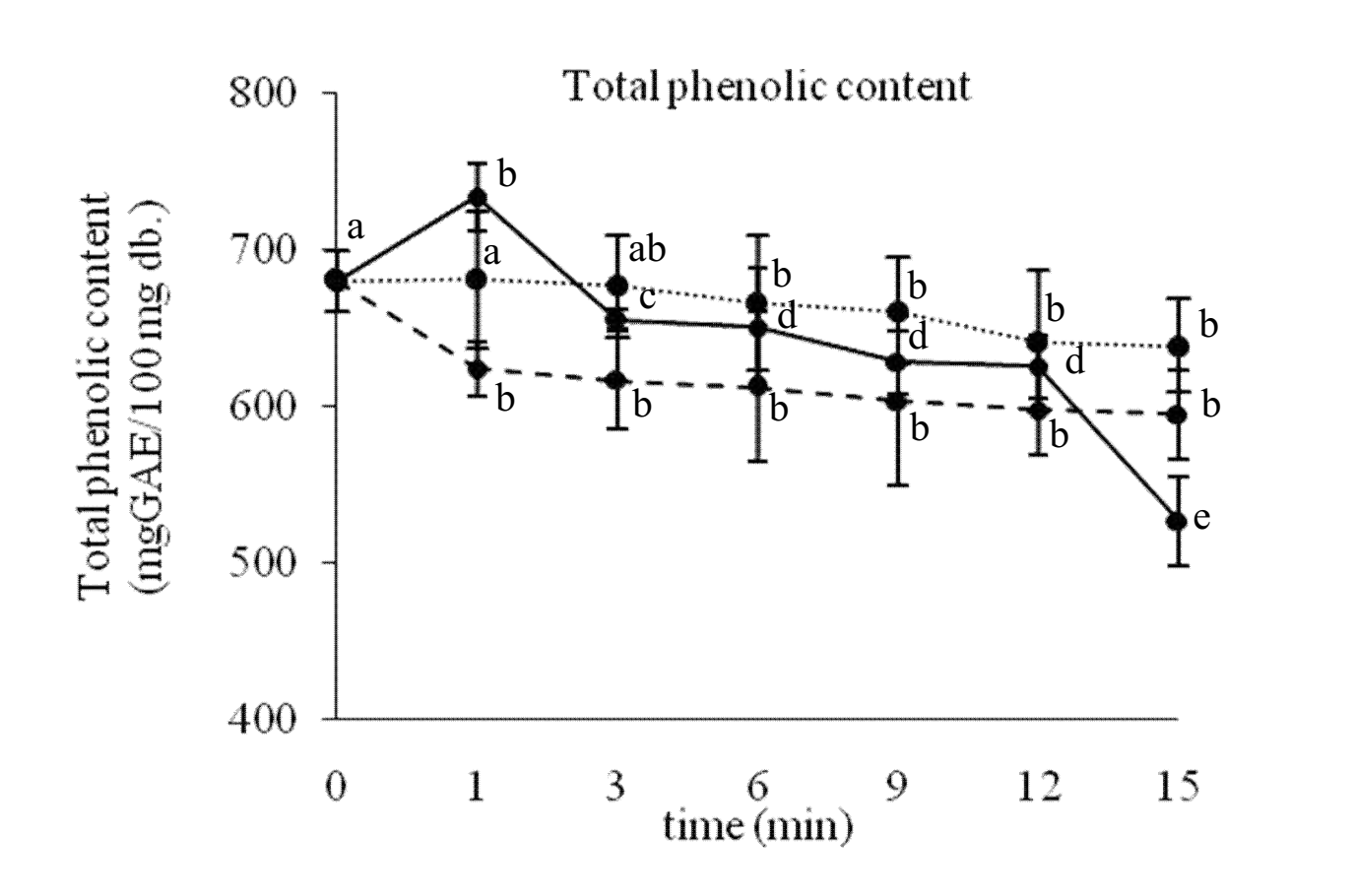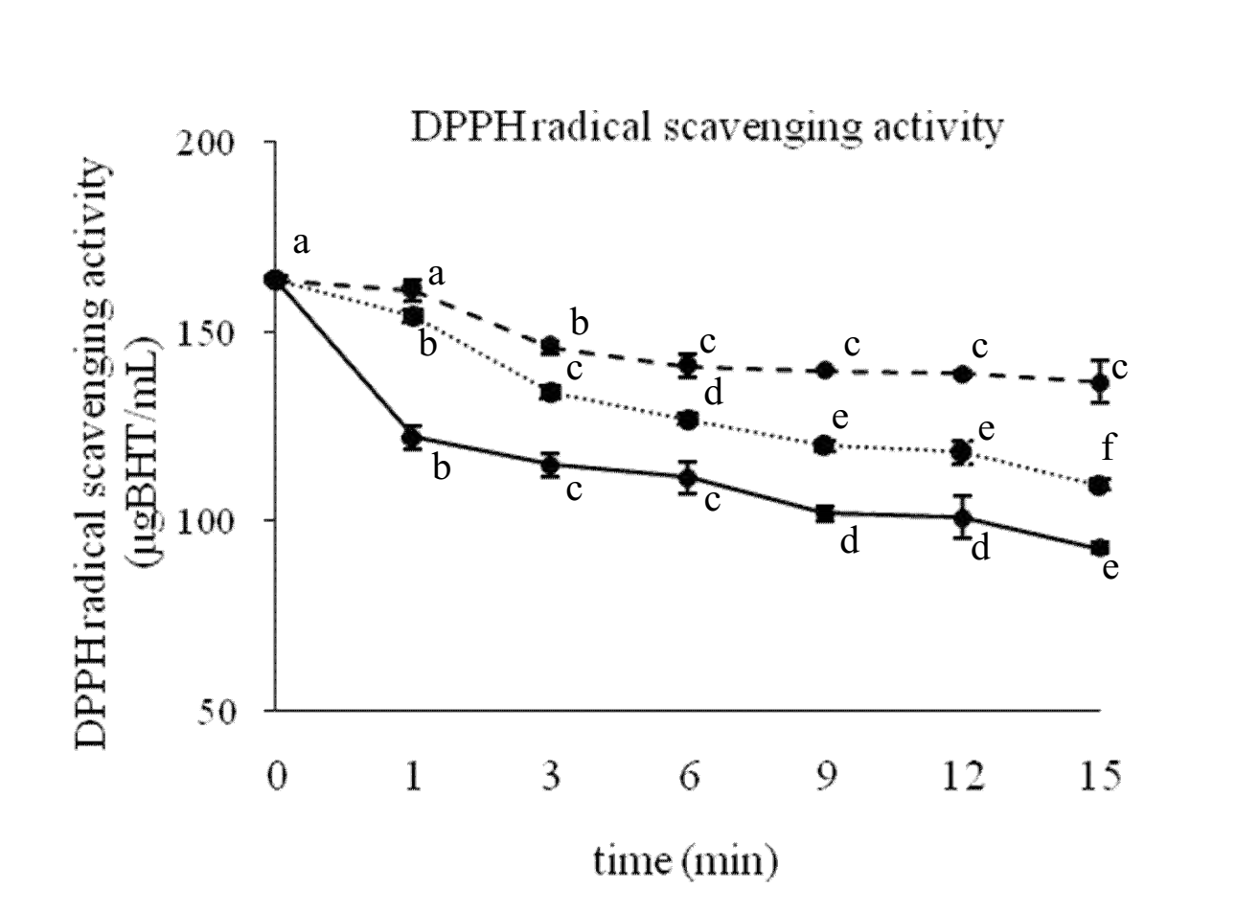
(a)
(b)

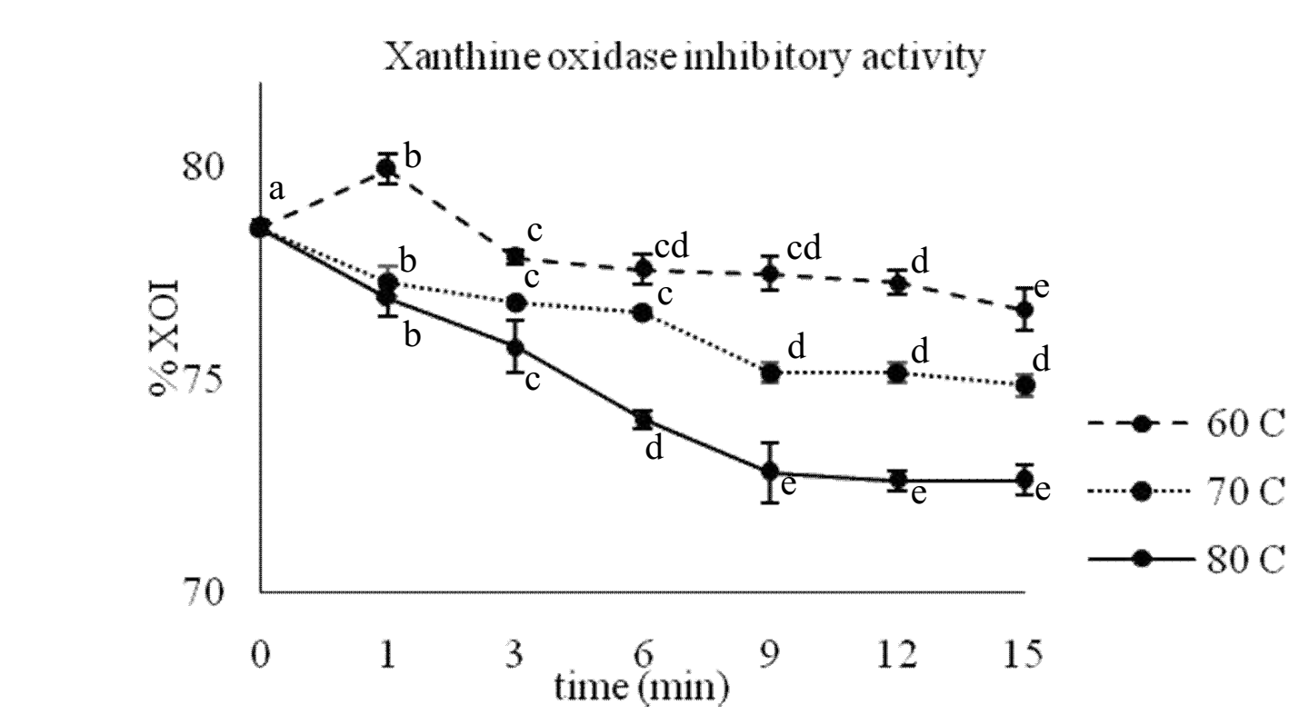
(c)

Figure 1. (a) Total phenolic content (b) DPPH radical scavenging activity and (c) XOI activity of Yanang leaf extract during heating at 60 ºC, 70 ºC and 80 ºC for 15 minutes.

Kinetic degradation of Yanang leaf extract’s properties

Kinetic degradations of total phenolic content, DPPH radical scavenging activity and XOI activity in Yanang leaf extract were determined by performing a regression analysis. The data of degradation were then fitted to three different kinetic models as previous mentioned in equation 2-4. The results revealed that the degradation of total phenolic content at all heating temperatures was described as a zero-order reaction with coefficient of determination between 0.809 and 0.959 (Table 1). The degradations of DPPH radical scavenging and XOI activities were second-order reactions with coefficient of determination between 0.783 and 0.920 and between 0.864 and 0.922, respectively.

Table 1. Reaction rate constant (k) and coefficient of determination (R²) of total phenolic content, DPPH radical scavenging activity and XOI activity in Yanang leaf extract during preparation process
Temperature | Zero-Order |  |  |  | Second-Order
Temperature | Total Phenolic Content |  |  |  | DPPH Scavenging Activity |  |  | XOI Activity
Temperature | k (mg GAE/100  mg.min) |  | R² |  | k (mL/μg BHT.min) | R² |  | k(1/%.min) | R²
60 ºC | 2.354 | 0.945 |  |  | 8 ×10⁻⁵ | 0.783 |  | 2×10⁻⁵ | 0.922
70 ºC | 3.035 | 0.959 |  |  | 2×10⁻⁴ | 0.920 |  | 4×10⁻⁵ | 0.886
80 ºC | 12.770 | 0.809 |  |  | 2×10⁻⁴ | 0.810 |  | 7×10⁻⁵ | 0.864

Temperature dependence of the degradations was determined by using Arrhenius equation as described in equation 5. A ln k - 1/T graph was plotted in order to express an effect of temperature on reaction rate constant. As shown in Figure 2, the temperature dependence of rate constants followed Arrhenius relationship as indicated by high correlation coefficient which was 0.848, 0.764 and 0.998 for total phenolic content, DPPH radical scavenging activity and XOI activity, respectively. The Arrhenius equations for Yanang leaf extract’s properties are shown in Table 2.

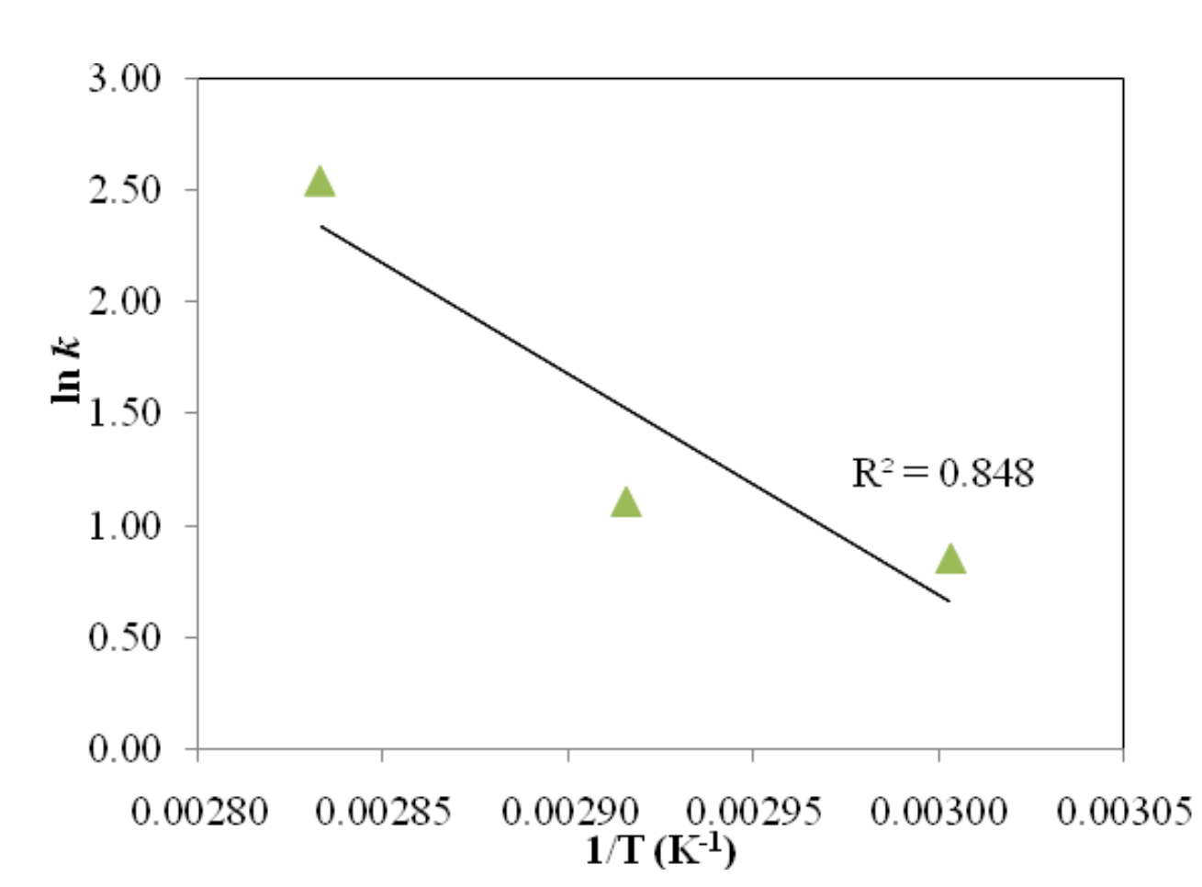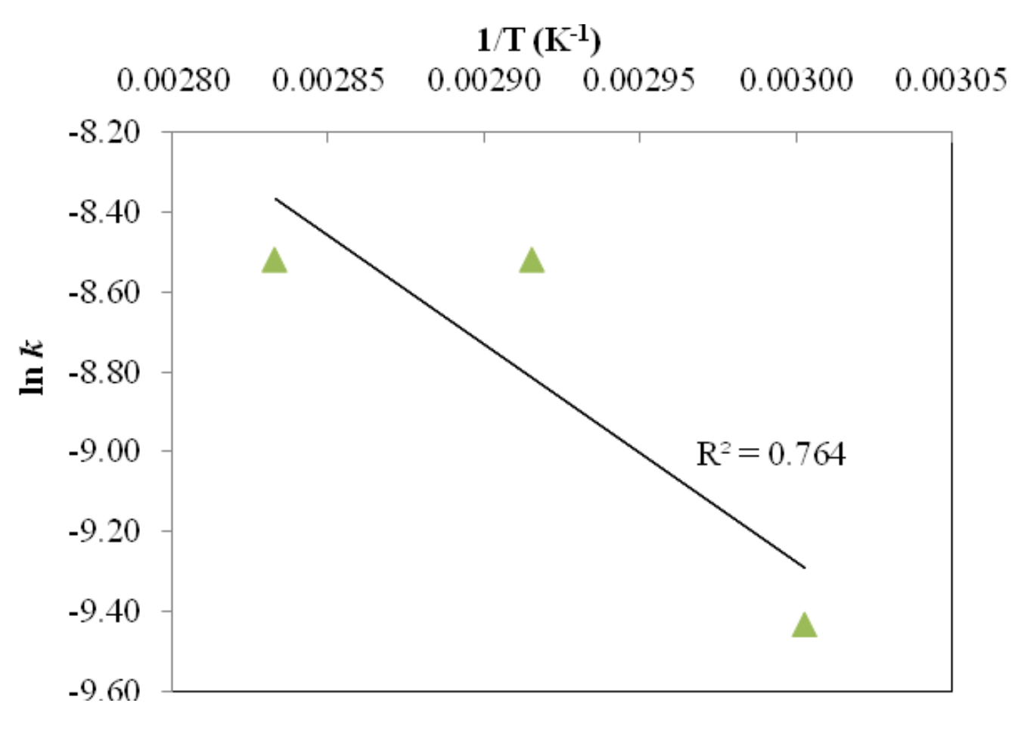
(b)
(a)

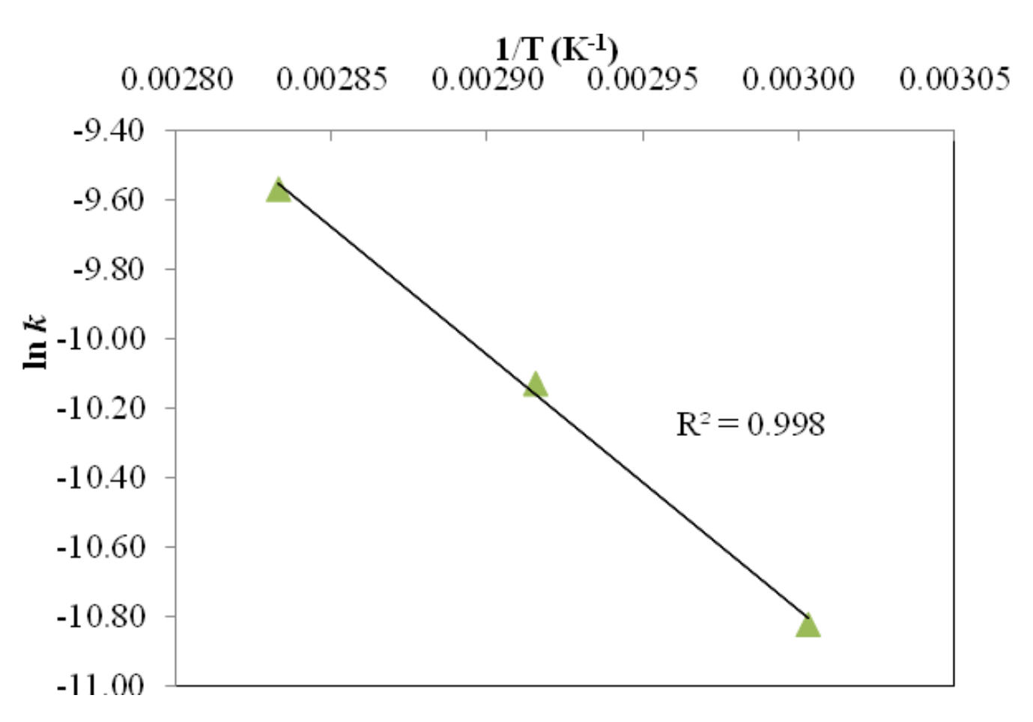
(c)

Figure 2. Arrhenius plots of (a) total phenolic content (b) DPPH radical scavenging activity and (c) XOI activity in Yanang leaf extract

Table 2. Arrhenius equation of total phenolic content, DPPH radical scavenging activity and XOI activity degradations in Yanang leaf extract
Property | R² | Arrhenius Equation
Total phenolic content | 0.848 | k = exp [(-1186.91/T) + 30.291]
DPPH scavenging activity | 0.764 | k = exp [(-653.86/T) + 7.0355]
XOI activity | 0.998 | k = exp [(-886.29/T) + 11.324]

Conclusion

The preparation process of Yanang leaf extract for canned bamboo shoots production degraded its chemical properties. An increase in heating temperature and time decreased the total phenolic content, DPPH radical scavenging activity and XOI activity of the extract. The results showed that Yanang leaf extract contained total phenolic content at 526.33-638.93 mg GAE/100 mg db., DPPH radical scavenging activity at 92.86-136.41 µg BHT/mL and XOI activity at 72.64-76.65%. After 15 minutes heating, the total phenolic content, DPPH radical scavenging activity and XOI activity decreased 2.03-22.62%, 1.86-43.22% and 2.80-7.90%, respectively. The degradation of total phenolic content was a zero-order reaction (R²=0.809-0.959) while that of DPPH radical scavenging activity (R²=0.783-0.920) and XOI activity (R²=0.864-0.922) were second-order reactions. Arrhenius plots exhibited high coefficient of determination which were 0.848, 0.764 and 0.998 for total phenolic content, DPPH radical scavenging activity and XOI activity, respectively.

Acknowledgement

This research was funded by King Mongkut’s University of Technology North Bangkok (KMUTNB), Thailand. Contract no. KMUTNB-GOV-58-42.1. Authors also would like to thank the Faculty of Agro-industry, KMUTNB Prachinburi campus for the facilities and support.

References
- Rattana, S., Cushine, B., Taepongsorat, L. and Phadungkit, M. (2016). Chemical constituents and in vitro anticancer activity of Tiliacora triandra leaves. Pharmacognosy Journal, 8(1): 1-3.
- Singthong, J., Ningsanond, S. and Cui, S.W. (2009). Extraction and physicochemical characterisation of polysaccharide gum from Yanang (Tiliacora triandra) leaves. Food Chemistry, 114(4): 1301-1307.
- Rattana, S., Padungkit, M. and Cushnie, B. (2010). Phytochemical screening, flavonoid content, and antioxidant activity of Tiliacora triandra leaf extracts. Proceedings of the 2nd Annual International Conference of Northeast Pharmacy Research: pp. 60-63.
- Mahidol, C., Sahakitpichan, P. and Ruchirawat, S. (1994). Bioactive natural products from thai plants. Pure and Applied Chemistry, 66(10-11): 2353-2356.
- Saiin, C. and Markmee, S. (2003). Isolation of anti-malarial active compound from Yanang (Tiliacora triandra Diels). Kasetsart Journal (Natural Science), 37(1): 47-51.
- Singthong, J., Oonsivilai, R., Oonmetta-aree, J. and Ningsanond, S. (2014). Bioactive compounds and encapsulation of Yanang (Tiliacora triandra) leaves. African Journal of Traditional, Complementary and Alternative Medicine, 11(3): 76-84.
- Sriket, P. (2014). Chemical components and antioxidant activities of Thai local vegetables. KMITL Science and Technology Journal Part B, 14(1): 18-24.
- Azmi, S. M. N., Jamal, P. and Amid, A. (2012). Xanthine oxidase inhibitory activity from potential malaysian medicinal plant as remedies for gout. International Food Research Journal, 19(1): 159-165.
- Saénz, C., Tapia, S., Chávez, J. and Robert, P. (2009). Microencapsulation by spray drying of bioactive compounds from cactus pear (Opuntia ficus-indica). Food Chemistry, 114(2): 616-622.
- Tian, J., Chen, J., Lv, F., Chen, S., Chen, J., Liu, D. and Ye, X. (2016). Domestic cooking methods affect the phytochemical composition and antioxidant activity of purple-fleshed potatoes. Food Chemistry, 197(Part B): 1264-1270.
- Turturică, M., Stănciuc, N., Bahrim, G. and Râpeanu, G. (2016). Effect of thermal treatment on phenolic compounds from plum (prunus domestica) extracts – A kinetic study. Journal of Food Engineering, 171: 200-207.
- Méndez-Lagunas, L., Rodríguez-Ramírez, J., Cruz-Gracida, M., Sandoval-Torres, S. and Barriada-Bernal, G. (2017). Convective drying kinetics of strawberry (Fragaria ananassa): Effects on antioxidant activity, anthocyanins and total phenolic content. Food Chemistry, 230: 174-181.
- De Ancos, B., Sgroppo, S., Plaza, L. and Cano, M.P. (2002). Possible nutritional and health-related value promotion in orange juice preserved by high-pressure treatment. Journal of the Science of Food and Agriculture, 82(8): 790-796.
- Kalt, W. (2005). Effects of production and processing factors on major fruit and vegetable antioxidants. Journal of Food Sciences, 70(1): R11-R19.
- Phomkaivon, N. and Areekul, V. (2009). Screening for antioxidant activity in selected thai wild plants. Asian Journal of Food and Agro-Industry, 2(4): 433-440.
- Taejarernwiriyakul, O., Buasai, M., Rattanatranurak, I., Sriyod, P. and Chanluang, S. (2011). Xanthine oxidase inhibitory activity of medicinal plants. Thai Pharmaceutical and Health Science Journal, 6(1): 1-6.
- Jiwajinda, S., Santisopasri, V., Murakami, A., Kim, O-K., Kim, H.W. and Ohigashi, H. (2002). Suppressive effects of edible thai plants on superoxide and nitric oxide generation. Asian Pacific Journal of Cancer Prevention, 3(3): 215-223.

