BIOHYDROGEN PURIFICATION FROM PALM OIL MILL EFFLUENT FERMENTATION FOR FUEL CELL APPLICATION

(Penulenan Gas Biohidrogen yang Terhasil dari Fermentasi Efluen
Kilang Minyak Kelapa Sawit Untuk Aplikasi Sel Bahan Api)

Ying Tao Chung ^{1,2}, Rosiah Rohani ^{1*}, Izzati Nadia Mohamad ¹,
Mohd Shahbudin Mastar@Masdar ^{1,2}, Mohd Sobri Takriff ¹

¹Chemical Engineering Program & Research Centre for Sustainable Process Technology,
Faculty of Engineering and Built Environment,
Universiti Kebangsaan Malaysia, 43600 UKM Bangi, Selangor, Malaysia
²Fuel Cell Institute,
Universiti Kebangsaan Malaysia, 43600 UKM Bangi, Selangor, Malaysia

*Corresponding author: rosiah@ukm.edu.my

Abstract
Palm Oil Mill Effluent (POME) is one of the major pollutants generated from palm oil mills. In Malaysia, POME is recognised as a promising source for producing biogas through a controlled fermentation process, which can be used as a source of renewable energy. Therefore, this research was conducted to upgrade the biohydrogen produced from POME fermentation via (i) absorption and (ii) membrane techniques. In this study, the current and power capacity of the purified biohydrogen was verified by using fuel cell. From the results, POME fermentation was found to consist of mainly H₂ and CO₂ of equal amounts. Therefore, biohydrogen purification using the absorption technique was next performed using three different solvents: methyl ethanol amine (MEA), ammonia (NH₃) and potassium hydroxide (KOH) solutions and compared with the membrane permeation method using polysulfone (PSF) membrane. The highest H₂ purity for MEA solutions was found to be 99%, at 1 M concentration and 5.0 mL/s feed mixed gas flow rate at 60 minutes absorption time. The purified biohydrogen using PSF membrane possessed the highest H₂ purity at nearly 77% at the pressure of 3 bar. The purified biohydrogen obtained from the two separation techniques were next tested in a proton exchange membrane (PEM) fuel cell and directly compared with the original biohydrogen mixture obtained from POME fermentation (50% H₂), where the gas ratios were represented using simulated gas composition. The findings in this study identified that the current and power produced at 100% H₂ (similar H₂ purity from the absorption technique) was 1.66 A and 9.31 W while at 75% H₂ (similar H₂ purity from the membrane technique) the current was 0.69 A and 3.01 W. Therefore, the results prove that both purification techniques demonstrate the significant potential for H₂ purification efficiency.

Keywords: absorption, alkaline solvent, biohydrogen, carbon dioxide, palm oil mill effluent, treatment

Abstrak
Efluen kilang minyak kelapa sawit (POME) merupakan salah satu daripada pencemar utama yang dihasilkan daripada kilang minyak sawit. Terkini, ianya telah dikenalpasti sebagai salah satu sumber yang berpotensi untuk menghasilkan biogas di Malaysia melalui kaedah fermentasi di dalam bioreaktor dalam keadaan terkawal, yang boleh dijadikan sebagai sumber tenaga diperbaharui. Oleh itu, kajian ini dijalankan bagi menambahbaik biohidrogen yang dihasilkan dari fermentasi POME menerusi (i) teknik penyerapan dan (ii) teknik membran. Kapasiti arus dan kuasa yang terhasil menerusi penulenan biohidrogen kemudiannya telah ditentukan menggunakan sel bahan api. Daripada keputusan yang diperoleh, fermentasi POME mengandungi gas H₂ dan CO₂ sahaja, dengan jumlah yang sama. Oleh itu, penulenan biohidrogen menggunakan teknik penyerapan telah dilakukan menggunakan tiga jenis pelarut iaitu larutan metil etanol amina (MEA), ammonia (NH₃) dan kalium hidroksida (KOH) dan kaedah ini kemudiannya dibandingkan dengan teknik pemisahan membran, iaitu dengan menggunakan membran polisulfon (PSF). Peratusan tertinggi bagi H₂ yang telah ditulenkan menggunakan pelarut MEA adalah 99% pada kepekatan 1 M, kelajuan gas 5.0 mL/s dan masa penyerapan 60 minit. Sementara itu, penulenan biohidrogen menggunakan membran PSF mempunyai peratusan tertinggi penulenan H₂ hampir 77% pada tekanan 3 bar. Biohidrogen yang telah ditulenkan melalui kedua-dua teknik pemisahan telah diuji dalam sel bahan api PEM dan ianya telah dibandingkan secara langsung dengan campuran biohidrogen asal dari fermentasi POME (50% H₂), yang mana kesemua nisbah gas telah diwakili oleh komposisi gas tersimulasi. Arus dan kuasa yang telah dihasilkan pada 100% H₂ (ketulenan H₂ menyerupai peratusan dari teknik penyerapan) adalah 1.66 A dan 9.31 W manakala pada 75% H₂ (ketulenan H₂ menyerupai peratusan dari teknik membran) adalah 0.69 A dan 3.01 W. Keputusan ini telah membuktikan bahawa kedua-dua teknik penulenan biogas berpotensi tinggi bagi meninggikan kecekapan penulenan gas H₂.

Kata kunci: penyerapan, pelarut alkali, biohidrogen, karbon dioksida, efluen minyak kelapa sawit, rawatan

Introduction
The treatment of palm oil mill effluent (POME) has been an acceptable and widely used technique in the production of biogas as a potential source of renewable energy. The treatment process of POME is a method used to reduce its biochemical oxygen demand (BOD) and chemical oxygen demand (COD) before being discharged into the environment, releasing mixed gases comprising of CH4, H₂ and CO₂ [1]. The increasing concentrations of CO₂ into the atmosphere have raised concerns with respect to the environment. Notably, this prompted the need to consider new methods to control the emission of greenhouse gases (GHG). CO₂ is considered as the main anthropogenic contributor to the GHG effect, which is allegedly responsible for 60% of the increase in atmospheric temperature, commonly referred to as global warming [2]. Among the various sources of CO₂, fossil-fuel power plants are one of the major CO₂ contributors regarding this issue, generating approximately 30% of CO₂ from the production process into the earth’s atmosphere [1]. Indeed, the POME treatment process under the anaerobic condition is believed to produce valuable biogases such as biohydrogen, which could be further upgraded to high value biohydrogen which could be utilised as alternative energy sources for the future sustainable development of energy [3]. The composition of biogas produced is highly dependent on the hydraulic retention time (HRT), in which HRT produced over 3 days would produce an equal amount of H₂ and CO₂ [4]. Thus, critical development of effective methods for the capture of CO₂ and biohydrogen purification has become a significant concern. The physical properties of CO₂ and H₂ (the major gases from POME treatment) are listed in Table 1.

Table 1. Physical properties of CO₂ and H₂ [5]

Gas | Molecular Weight  (g mol⁻¹) | Kinetic Diameter  (Å) | Critical Pressure  (kPa) | Critical Temperature  (K)
CO₂ | 44.0 | 3.30 | 7386 | 304.2
H₂ | 2.0 | 2.89 | 1296 | 33.14

To date, numerous gas upgrading methods have been developed globally, including absorption, adsorption and membrane technology [6]. Gas absorption using alkanolamine has been used for CO₂ scrubbing on an industrial scale for decades. However, several drawbacks such as high energy consumption and severe corrosion problems are inherent in this process. Hence, the exploration of improved gas separation technology by researchers in this area is of great significant. Currently, the novel technology associated with membrane separation has emerged as one of the most feasible technologies for biohydrogen separation and purification processes [7]. Membrane technology in the development of biological systems can play multiple roles, including in fermentative biohydrogen technology. For example, a membrane bioreactor which employed submerged or externally connected porous-water filtration (microfiltration (MF), ultrafiltration (UF), nanofiltration (NF), and reverse osmosis (RO)) membranes could retain active biomass efficiently within the fermenter. Furthermore, it has been discovered that membrane technology could also assist in overcoming the issue of low reaction yields by allowing in situ and continuous removal of biohydrogen using membranes from the membrane bioreactor [7]. Gas upgrading for H₂ and CO₂ capture via absorption, membrane permeation and membrane contactor were reported as shown in Table 2.

Table 2. Summary of gas upgrading via absorption and membrane techniques

Technique | Gas Composition | Condition | Recovery | Reference
Absorption | 10- 14 v/v% CO₂ | Ammonia, sieve plate, 25 -55 ºC | 95-99% CO₂ capture | Diao et al. [8]
Absorption | 8- 16 v/v% CO₂ | MEA, 10-40 ºC | >97% CO₂ capture | Ma et al. [9]
Membrane | Pure gases of H₂ and CO₂ were tested in sequence | Polybenzimidazole based asymmetric hollow fiber membrane, 400ºC | H₂ permeance 2.6 GPU  CO₂ permeance 0.096 GPU Selectivity (H₂/ CO₂) 27.28 | Kumbharkar et al. [10]
Membrane | 79% CO₂, 21% H₂ | Membrane Contactor, MEA as liquid carriers | 92% H₂ purity | Modigell et al. [11]

Materials and Methods
The initial work on POME anaerobic fermentation to produce biogas was carried out by the Biohydrogen Research Group in Universiti Kebangsaan Malaysia (UKM) [4, 13]. The composition of the biogas mixture produced during the process mainly consisted of 39% H₂ and 49% CO₂ as reported by the literature and in previous work with no presence of H₂S [13, 14]. Since the capacity of biogas produced from fermentation in one day (24 hours) is limited to only 15 - 20 L/d and considered insufficient for continuous upgrading mode, a simulated model gas of H₂ and CO₂ was used with similar composition found in the literature. A mixed gas of H₂ and CO₂ at 50v%/50v% and single gases of H₂ gas (99.5%) and CO₂ gas (99.8%) were used and supplied by NIG Gas Sdn. Bhd. A mixed gas of H₂ and CO₂ (ratio 50:50) was also used in both absorption and membrane separation for H₂ purification evaluation.

Absorption
The absorption process was conducted using three types of alkaline solution, i.e. potassium hydroxide (KOH), mono-ethanolamine (MEA) and ammonia (NH₃). The absorption began by allowing the fixed feed mixture flow rate of gas comprising fixed gas of H₂/CO₂ with 50%/50% to enter the bubble glass reactor filled with an alkaline solution of different molarity. Next, the purified H₂ permeated at the outlet point was collected in a gas syringe to determine its final composition. For each experiment, data were averaged from two replicates for reproducibility. The parameters involved in the absorption process are listed in Table 3. The range of each parameter used was adapted from the study by Maceiras et al. where the solvent concentration, solvent temperature, gas mixture flow rate, and absorption time was in the range of 0 to 1 M, 25 to 70 ºC, 2 to 7 mL/s and 0 to 100 min, respectively [15]. For the experiment, the solvent volume was kept constant at 1 L.

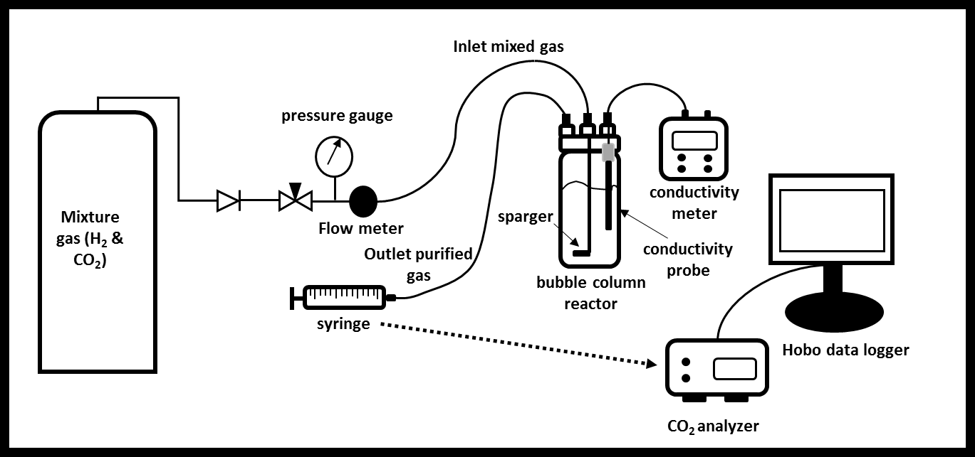
Figure 1. Schematic diagram of CO₂ absorption technique

Table 3. List of parameters for absorption technique

Parameter | Range of Parameter
Feed mixture gas flow rate (mL/s) | 5.0
Feed mixture gas composition (H₂/CO₂) | 50%/50%
Type of alkaline solution | KOH, NH₃, MEA
Concentration of solution (M) | 1.0
Temperature of solution (ºC)  Time data recorded (min) | 28  2,5,15,30 and 60
Diameter and height of reactor (cm)  Volume of solution (ml) | 8 and 22  500

Membrane separation
Polysulfone (PSF) membranes were used in this study to determine the permeability and selectivity of H₂ and CO₂ during the gas separation and purification process. The PSF asymmetric membranes were supplied by the Advanced Membrane Research Centre (AMTEC), The University of Technology Malaysia (UTM), which was synthesised from PSF granules (Udel-P1700) in a solvent mixture of N,N dimethylacetamide, tetrahydrofuran and ethanol at an appropriate composition.
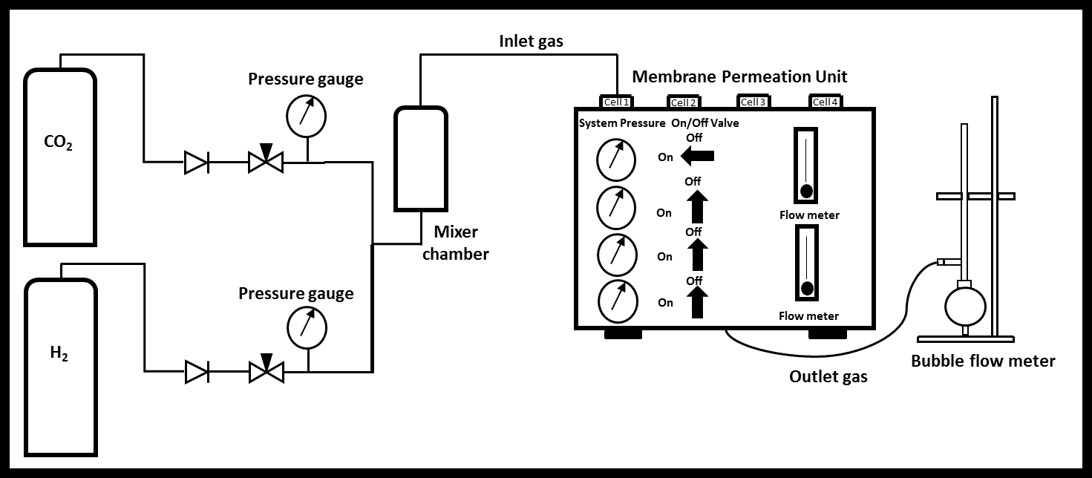

Figure 2. Schematic diagram of Membrane Permeation Unit

Gas permeation rate can be calculated by using pressure normalized flux in Eq. (1):

$\frac{P}{l}i= \frac{Q_{i}}{(ΔP)(A)}$ (1)

where (P/l) is defined as pressure-normalized flux or permeability for gas i in GPU unit; Q_{i} is volumetric flow rate of gas i, ΔP is the pressure difference across membrane, A is the membrane effective surface area and l the membrane skin thickness.

Membrane selectivity (α) can be determined by dividing the permeability,$p$ of H₂ over CO₂ as stated in Eq. (2):

$α=\frac{pH_{2}}{{pCO}_{2}}$ (2)
The gas composition was determined by using Gas Chromatography (GC, model SRI 8600C, USA) to measure the composition of the mixed gases of H₂ and CO₂.

Fuel cell application
Finally, the purified H₂ mixture from the simulated model gas (using a similar composition obtained from the absorption and membrane separation technique) was tested in a fuel cell system supplied by the PEMFC stack from the Horizon Fuel Cell, model FCS-B20 with a maximum power capacity of 10 W. The effect of CO₂ the concentration on the PEMFC performance (voltage, current and power) was monitored to determine the optimum composition of H₂ with CO₂ existence for the fuel cell application. For each experiment, the power, current and voltage data were obtained from the average value of duplicate experiments. The data were presented in the plotted graph of power versus current, voltage versus time and power versus percentage of CO₂. The summary of the parameters involved in the H₂ PEMFC testing is listed in Table 4.

Table 4. List of parameters for PEMFC application

Parameters | Range of parameters
Composition mixture of H₂ and CO₂ (v%/v%)  Feed mixture gas flow rate (cc/min)  Time of application (min) | 50/50, 75/25, 90/10 and 100/0 of H₂ & CO₂  55  30

Results and Discussion
The absorption and membrane separation techniques were employed to compare the H₂/CO₂ separation and purification efficiency in this work. The purified H₂ (simulated gas composition with the purity obtained via these methods) was then utilised in the fuel cell application for performance evaluation.

Absorption
In this study, the absorbents effects (KOH, NH₃, MEA) at 1 M concentration towards H₂ purification was performed at the highest feed gas flow rate (5.0 mL/s). The findings indicated a significant effect of 1 M solution concentration to the purification of H₂. The H₂ purity had reduced significantly at 1 M of KOH and MEA after 30 minutes of absorption, in which the reduction from 99% to 64% and 75% was observed for KOH and MEA solutions. While the purity for ammonia absorption was found relatively higher at 79% after 60 min of absorption. Also, the higher absorbent concentration could release more free ionic species which contributed to a greater CO₂ reaction in the absorption process. However, the decrement trend of gas purity indicated the presence of a CO₂ saturation stage during absorption [15]. Moreover, a higher feed flow rate was used to create turbulence effects for a rapid reaction between the gas and free ionic species contained in the solution [16].

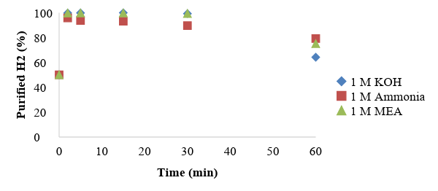

Figure 3. Purified H₂ composition via absorption technique with different alkaline solutions (KOH, NH₃, MEA) at 1 M concentration

Among these three solvents, MEA was preferred due to its excellent absorption performance in comparison to NH₃ and KOH solutions regarding its H₂ purification percentage. Although MEA exhibited similar absorption performance as KOH, MEA was more reliable and preferable in the market. Possibly due to its low cost and its ability to handle low CO₂ partial pressure gas stream during the absorption [2, 17]. Hence, MEA was concluded as a potential absorbent candidate for better absorption efficiency and to be further utilised instead of KOH.

Membrane separation
The separation performance of PSF membranes regarding CO₂ and H₂ permeance rate and selectivity at the pressure range of 1 to 8 bar was successfully measured. According to Figure 4, the highest permeance rate for H₂ for PSF membrane was indicated at 13.08 GPU (at 2 bar) while the highest permeability for CO₂ was recorded at 7.24 GPU (at 1 bar). Additionally, the selectivity for H₂/CO₂ was increasing proportionately concerning the pressure increment, in which the best selectivity was observed at 4.07 (tested at 4 bar). The PSF membrane was known as a glassy polymer and the permeant diffusion coefficient was more dominant than the solubility coefficient. Therefore, the smaller and non-condensable H₂ gas with a molecular diameter of 2.9 Å, was preferentially permeated through PSF polymer instead of CO₂ with a larger molecular diameter (3.3 Å) [18]. Hence, the permeance rate for H₂ was always higher than CO₂. In addition to the decrement trend of H₂ and CO₂ permeance against pressure, this could be explained based on the competitive solubility effects between the gas and polymer structures and the saturation of the polymer sorption site with gas molecules which resulted in membrane compaction [19, 20]. The plasticisation effect was not detected in this study due to the absence of CO₂ permeance increment with pressure.

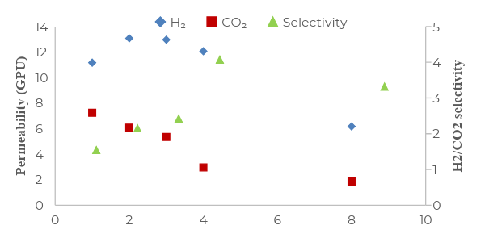
Figure 4. Gas permeation rate and selectivity for PSF Membrane
On the other hand, Figure 5 depicts the pressure effect on the H₂ and CO₂ gas composition in the permeate stream with different pressure using a fixed composition of 50%/ 50% of H₂/CO₂ feed gas mixture. The findings indicated that the H₂ purity increased significantly from 68 % to 77 % from the pressure of 1 to 3 bar. However, when the applied pressure increased from 4 to 8 bars, the H₂ purity began to gradually reduce with the lowest recorded at 52% (8 bar). This scenario was possibly due to the flux increment which enhanced the solubility and diffusion rates of H₂ [21]. Also, the optimum pressure for the satisfactory H₂ permeance rate was within the range of 1 to 3 bar. Thus, the integration between the membrane and bioreactor system was observed as being a practical approach since the internal pressure range was similar for both systems [22]. Therefore, this work has proven the separation efficiency of PSF membrane in the biohydrogen purification process with high permeability, the selectivity of H₂/CO₂ and high H₂ purity (77%).
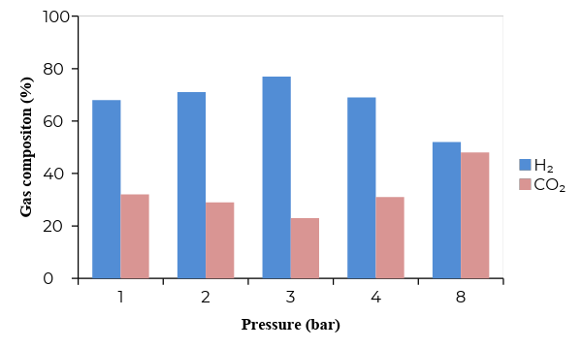

Figure 5. Gas composition in permeate stream after gas permeation test for PSF membrane
Fuel cell application
The purified biohydrogen from the two separation techniques was tested in the PEM fuel cell and compared with the original biohydrogen mixture from POME fermentation. Indeed, this composition was important to observe the fuel cell performance profile, when the fermented gas was used without further purification. Based on the results as shown in Figure 6, the profiles of stack power with current were found to be similar. At the beginning of the cell operation, the power increased steadily with the current, until a maximum power peak was achieved before the power decreased with the current. The highest current recorded was in parallel with the H₂ composition, where the highest H₂ purity gave the highest current value and vice versa. The highest current recorded was 1.66 A for 100% H₂ purity while the lowest current was 0.32 A for 50% H₂ purity. Accordingly, this has proven that higher H₂ % supplied into PEMFC could generate a higher amount of current, which resulted in the higher amount of power. Hence, in a real fuel cell operation, the supply of high purity H₂ into the fuel cell is essential to ensure higher power generation.

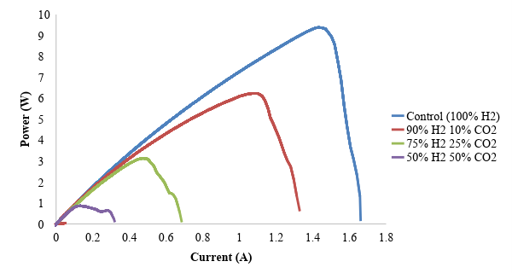
Figure 6. Power profile with current at different H₂ concentration
Meanwhile, Figure 6 also shows the average power produced by different CO₂ compositions. The power produced reached the highest value which was close to 9 W and conversely, the power recorded was less than 1 W for the lowest H₂ composition. The graph plotted showed a linear pattern of power produced with CO₂ composition present in the PEMFC. Therefore, it proved that the existence of CO₂ in the PEMFC gave a significant effect on PEMFC performance. Further, the CO₂ had obviously decreased the amount of power produced by PEMFC. The CO₂ presence in the PEMFC would affect the electrochemical catalytic rates, which interfere with proton transport across the polymer electrolyte or prevent the flow of reactants to or the reaction of products away from the anode or cathode charge transfer interfaces. Also, the presence of impurities may also decrease the operational lifetime of the fuel cell by increasing the component failure rate. Ahluwalia et al. suggested that any CO₂ impurity in the fuel adsorbs weakly on the platinum (Pt) catalyst [23]. According to Chew et al., at low CO₂ concentrations, the observed degradation in cell power can be explained based on CO produced from CO₂ on the active Pt surface and the subsequent adsorption of CO on the active Pt sites via the reverse water gas shift reaction (RWGSR) between CO₂ and the adsorbed H₂ [24]. Furthermore, at higher CO₂ concentrations, the decrease in cell potential due to the dilution of the H₂ also contributed to performance degradation. Therefore, it was essential to minimise the amount of CO₂ in the H₂ mixture to gain more power produced from the PEMFC.

Hence, this study has revealed that different H₂ concentrations supplied into the PEMFC would present different performances on the current and power produced. It was also proven that biohydrogen separation using the absorption technique could provide the best purification (close to 100% H₂ purity) and in turn, demonstrated the higher capacity of current and power (1.66 A and 9.31 W) in comparison to the membrane technique.

Conclusion
The absorption and membrane separation techniques were successfully investigated in H₂/CO₂ separation and the purification process where the highly-purified H₂ was further utilised in the fuel cell application. The observations and separation performance between the two separation techniques were satisfactory. Therefore, it could be concluded that MEA is the best alkaline solvent for absorption due to the high percentage of purified H₂ produced (99% for 1 M MEA). The PSF membranes possessed high H₂ permeance rate and H₂/CO₂ selectivity, which was obtained at 13.08 GPU (at 2 bar) and 4.07 (tested at 4 bar), respectively. The absorption technique possessed better H₂ purity as the percentage of purified H₂ was close to 100% purity, while for membrane technique it was close to 80%. The highest current and power generated were 1.66 A and 9.31 W respectively from the feed mixture gas with 100%/0% of H₂/CO₂.

Acknowledgement
The authors gratefully acknowledge Kursi UKM-YSD for financial support of the project PKT 6/2012 and Universiti Kebangsaan Malaysia for research grant GUP-086-2016.

References

1. Sayari, A., Belmabkhout, Y. and Serna-Guerrero, R. (2011). Flue gas treatment via CO₂ adsorption. Chemical Engineering Journal, 171: 760–774.
2. Luis, P. (2016). Use of monoethanolamine (MEA) for CO₂ capture in a global scenario: Consequences and alternatives. Desalination, 380: 93–99.
3. Chin, M. J., Poh, P. E., Tey, B. T., Chan, E. S. and Chin, K. L. (2013). Biogas from palm oil mill effluent (POME): Opportunities and challenges from Malaysia’s perspective. Renewable Sustainable Energy Revision, 26: 717–726.
4. Badiei, M., Jahim, J. M., Anuar, N. and Sheikh Abdullah, S. R. (2011). Effect of hydraulic retention time on biohydrogen production from palm oil mill effluent in anaerobic sequencing batch reactor. International Journal of Hydrogen Energy, 36: 5912–5919.
5. Kim, K., Ingole, P. G., Kim, J. and Lee, H. (2013). Separation performance of PEBAX/PEI hollow fiber composite membrane for SO₂/CO₂/N₂ mixed gas. Chemical Engineering Journal, 233: 242–250.
6. Rufford, T. E., Smart, S., Watson, G. C. Y., Graham, B. F., Boxall, J. , Diniz da Costa, J. C. and May, E. F. (2012). The removal of CO₂ and N₂ from natural gas: A review of conventional and emerging process technologies. Journal of Petroleum Science and Engineering, 94–95: 123–154.
7. Bakonyi, P., Nemestóthy, N. and Bélafi-Bakó, K. (2013). Biohydrogen purification by membranes: An overview on the operational conditions affecting the performance of non-porous, polymeric and ionic liquid-based gas separation membranes. International Journal of Hydrogen Energy, 38: 9673–9687.
8. Diao, Y.-F., Zheng, X.-Y., He, B.-S., Chen, C.-H. and Xu, X.-C. (2004). Experimental study on capturing CO₂ greenhouse gas by ammonia scrubbing. Energy Conversion Management, 45: 2283–2296.
9. Ma, S., Song, H., Wang, M., Yang, J. and Zang, B. (2013). Research on mechanism of ammonia escaping and control in the process of CO₂ capture using ammonia solution. Chemical Engineering Research Design. 91: 1327–1334.
10. Kumbharkar, S. C., Liu, Y. and Li, K. (2011). High performance polybenzimidazole based asymmetric hollow fibre membranes for H₂/CO₂ separation. Journal of Membrane Science, 375: 231–240.
11. Modigell, M., Schumacher, M., Teplyakov, V. V. and Zenkevich, V. B. (2008). A membrane contactor for efficient CO₂ removal in biohydrogen production. Desalination, 224: 186–190.
12. Mohamad, I. N., Rohani, R., Nor, M. T. M., Claassen, P., Muhammad, M. S., Masdar, M. S. and Rosli, M. I. (2017). An overview of gas-upgrading technologies for biohydrogen produced from treatment of palm oil mill effluent. Journal Engineering Science and Technology, 12: 725–755.
13. Chong, P. S., Jahim, J. M., Harun, S., Lim, S. S., Mutalib, S. A., Hassan, O. and Nor, M. T. M. (2013). Enhancement of batch biohydrogen production from prehydrolysate of acid treated oil palm empty fruit bunch. International Journal of Hydrogen Energy, 38: 9592–9599.
14. Mohamad, I. N., Rohani, R., Masdar, M. S. M., Nor, M. M. T. and Jahim, J. (2015). Permeation properties of polymeric membranes for biohydrogen purification. International Journal of Hydrogen Energy. 41: 4474–4488.
15. Maceiras, R., Alves, S. S., Cancela, M. Á. and Álvarez, E. (2008). Effect of bubble contamination on gas–liquid mass transfer coefficient on CO₂ absorption in amine solutions. Chemical Engineering Journal. 137: 422–427.
16. Zhao, B., Su, Y. and Peng, Y. (2013). Effect of reactor geometry on aqueous ammonia-based carbon dioxide capture in bubble column reactors. International Journal of Greenhouse Gas Control, 17: 481–487.
17. Spigarelli, B. P. and Kawatra, S. K. (2013). Opportunities and challenges in carbon dioxide capture. Journal of CO₂ Utility, 1: 69–87.
18. Choi, S., Lee, M., Oh, S. and Koo, J. (2003). Gas sorption and transport of ozone-treated polysulfone, Journal of Membrane Science, 221: 37–46.
19. Rezakazemi, M., Ebadi Amooghin, A., Montazer-Rahmati, M. M., Ismail, A. F. and Matsuura, T. (2014). State-of-the-art membrane-based CO₂ separation using mixed matrix membranes (MMMs): An overview on current status and future directions. Progress in Polymer Science. 39: 817–861.
20. David, O. C., Gorri, D., Urtiaga, A. and Ortiz, I. (2011). Mixed gas separation study for the hydrogen recovery from H₂/CO/N₂/CO₂ post combustion mixtures using a Matrimid membrane. Journal of Membrane Science. 378: 359–368.
21. Ebert, K., Fritsch, D., Koll, J. and Tjahjawiguna, C. (2004). Influence of inorganic fillers on the compaction behaviour of porous polymer based membranes, Journal of Membrane Science, 233: 71–78.
22. Bakonyi, P., Nemestóthy, N., Lankó, J., Rivera, I., Buitrón, G. and Bélafi-Bakó, K. (2015). Simultaneous biohydrogen production and purification in a double-membrane bioreactor system, International Journal of Hydrogen Energy, 40: 1690–1697.
23. Ahluwalia, R. K. and Wang, X. (2008). Effect of CO and CO₂ impurities on performance of direct hydrogen polymer-electrolyte fuel cells, Journal of Power Sources. 180: 122–131.
24. Chew, L. W., Masdar, M. S. and Kamarudin, S. K. (2015). Purification of bio-hydrogen using absorption techniques and the effect of CO₂ impurity on the PEMFC performance. American Journal of Chemistry, 5: 24–34.

