EFFECT OF DEPOSITION TIME ON STRUCTURAL AND CATALYTIC PROPERTIES OF Pt FILMS ELECTRODEPOSITED ON Ti SUBSTRATE

(Kesan Masa Enapan Terhadap Sifat-sifat Struktur dan Katalitik
bagi Filem Pt Dielektroenapan di atas Substrat Ti)

Siti Norsafurah Ab Malek and Yusairie Mohd*

Faculty of Applied Sciences,
Universiti Teknologi MARA, 40450 Shah Alam, Selangor, Malaysia

*Corresponding author: yusairie@salam.uitm.edu.my

Abstract
Platinum (Pt) films were prepared on Titanium (Ti) surface at various deposition times ranging from 30 to 90 minutes using the electrodeposition technique. The morphology of the Pt films was determined using field emission scanning electron microscope (FESEM). Furthermore, the electrocatalytic activity of the prepared Pt films towards methanol oxidation in alkaline medium was investigated using cyclic voltammetry. The surface morphology changed with different deposition times from less compact durian-like structure at shorter times (< 60 minutes) to more compact durian-like structure at longer times (> 60 minutes). The loading amount and surface coverage of Pt on the Ti surface were increased as the deposition time increased. The calculated values of electrochemically active surface area (ECSA) for the Pt films were increased with increasing deposition time as evident in 30 minutes (6.54 m² g⁻¹), 45 minutes (7.34 m² g⁻¹) and 60 minutes (8.08 m² g⁻¹). Nevertheless, the ECSA value dropped to 7.70 m² g⁻¹ for longer deposition time (90 minutes). This may be caused by the coagulation of the Pt centres with the growth of neighbouring centres, which decreasing the available active surface area on the films. This film also demonstrated the highest stability for methanol oxidation reaction (MOR) in alkaline medium with the result of 5.18 mA cm⁻² at 1 hour.

Keywords: Pt films, deposition time, methanol oxidation, alkaline medium

Abstrak
Filem Platinum (Pt) telah dienapkan ke atas titanium (Ti) untuk jangka masa yang berbeza dari 30 sehingga 90 minit menggunakan teknik elektroenapan. Morfologi filem Pt telah ditentukan menggunakan medan pancaran imbasan elektron mikroskop (FESEM). Tambahan lagi, aktiviti filem Pt terhadap pengoksidaan metanol dalam medium beralkali telah disiasat menggunakan voltammetri berkitar. Morfologi filem Pt telah berubah daripada kurang padat struktur durian (< 60 minit) kepada struktur durian yang lebih padat pada masa pengenapan Pt yang lebih lama (>60 minit). Jumlah muatan dan liputan permukaan filem Pt di atas permukaan Ti telah bertambah dengan penambahan masa enapan. Nilai-nilai kiraan kawasan permukaan aktif secara electrokimia (ECSA) untuk filem-filem Pt telah bertambah dengan pertambahan masa enapan seperti dibuktikan dalam 30 minit (6.54 m² g⁻¹), 45 minit (7.34 m² g⁻¹) dan 60 minit (8.08 m² g⁻¹). Walaubagaimanapun, nilai ECSA telah jatuh ke 7.70 m² g⁻¹ bagi masa enapan yang lebih lama (90 minit). Ini mungkin disebabkan oleh pengumpalan pusat-pusat Pt dengan ketumbuhan pusat-pusat sekitaran di mana ini mengurangkan kawasan permukaan yang aktif sedia ada atas filem tersebut. Filem ini juga telah menunjukkan kestabilan tertinggi untuk tindak balas pengoksidaan metanol (MOR) dalam medium beralkali dengan keputusan 5.18 mA cm⁻² pada 1 jam.

Kata kunci: Filem Pt, masa enapan, pengoksidaan metanol, medium beralkali

Introduction
The study of methanol oxidation reaction (MOR) at Platinum (Pt) electrode has received great attentions from numerous researchers [1-6]. Generally, Pt is known to be a very stable and the most active metal for the oxidation of methanol [7-10]. Nevertheless, the usage of Pt catalyst in the practical application of direct methanol fuel cell (DMFC) is constrained mainly by the cost of Pt and its limited supply. In addition, Pt decays easily during methanol oxidation because its surface is poisoned by intermediate species like CO. This causes further methanol oxidation to be decayed over time.

Notably, Pt film may be deposited on a cheap substrate instead of using bulk or solid Pt because the electrooxidation of methanol occurs only on the surface of Pt. For this reason, Pt deposited on Titanium (Ti) substrate is ideal to minimise the cost of Pt-based electrodes. Ti has excellent properties as a substrate due to its high mechanical strength, reasonable cost, high corrosion resistance, wide electrochemical potential window, and good chemical stability [11].

Under comparable chemical and physical conditions, the catalytic activity of Pt film is shown to be highly dependent on its surface morphology [12]. The electrodeposition technique is one of the promising methods to produce the Pt film because of its low cost. The technique also provides better selections for the placement of the Pt particles onto the substrate. Furthermore, many parameters in the electrodeposition process such as deposition potential, deposition time, pH and electrolyte concentration can be manipulated in order to control the surface coverage, morphology, and particle size which can affect the electrocatalytic properties of the Pt films. For instance, Yin et al. [13] reported that the morphology of the Pt film is dependent on many factors such as deposition potential, deposition time, and concentration of electrolytes. Moreover, Ott et al. [14] claimed that an appropriate management of deposition time and current density during the galvanostatic process allows the morphology of the film produced on the substrate to be controlled accordingly.

The objective of this research is to investigate the effect of deposition time on the electrodeposition of Pt films on Ti substrate with high utilisation of Pt loadings, maximum performance in catalytic activity, and high stability towards methanol oxidation in alkaline medium. In this study, Pt films with different Pt loadings were deposited on the Ti substrate using the electrodeposition method at various deposition times (30, 45, 60, and 90 minutes) while the applied potential is kept at -0.20 V. Accordingly, this research is expected to provide better understanding on the effect of deposition time and Pt loadings on Ti substrate in the production of Pt electrocatalyst for DMFC.

Materials and Methods
Electrodeposition of Pt on Ti substrate
Firstly, the Ti substrate was etched in HCl at 80 °C for 15 minutes to remove the oxide layer on the Ti and to increase the roughness of the Ti surface to ensure better adhesion of the Pt films. Subsequently, the Pt films were deposited on the etched Ti substrate using the electrodeposition technique. A three-electrode Autolab Potentiostat (model Aut302 FRA2) controlled by a computer software (Nova 1.11) was used for this process. Notably, the three-electrode electrochemical cell consisted of the etched Ti substrate as the working electrode, Pt rod as the counter electrode, and the saturated calomel electrode (SCE) as the reference electrode. A bath solution containing 0.01 M hydrogen hexachloroplatinate(IV) hydrate in 0.3 M H₂SO₄ was used for the electrochemical deposition of Pt on the etched Ti substrate. Different deposition times (30, 45, 60, and 90 minutes) were implemented and the applied potential was kept constant at -0.20 V. After the electrodeposition process was completed, the Pt films were rinsed twice in water and then air-dried at room temperature for characterisation and further use.

Physical characterisation
The morphology of the Pt films was examined using field emission scanning electron microscope (FESEM, Carl Zeiss SMT Supra 40VP) in order to investigate the nucleation and growth of the Pt centres on the Ti substrate. FESEM images were recorded at an accelerating voltage of 5 kV with 5000x and 25 000x magnifications.

Electrochemical measurement
A three-electrode electrochemical cell - Pt rod as the counter electrode, the SCE as the reference electrode, and the Pt film-coated Ti with 1 cm² surface area prepared at different deposition times as the working electrode was used to perform the electrochemical analysis in alkaline medium. The alkaline medium of 0.5 M KOH contained 1.0 M CH₃OH solution. The stability of the prepared Pt films in the electrooxidation of methanol was investigated using chronoamperometry at a fixed potential of -0.50 V for 3600 s. Moreover, cyclic voltammetry technique was employed to study the catalytic activity of the Pt films with different deposition times for methanol oxidation reaction (MOR) at a scan rate of 50 mV s⁻¹. The specific electrochemically active surface area (ECSA) was calculated using the following equation:

$ECSA= \frac{Q_{H}}{Q_{mono} ×L_{Pt}}$ (1)

Accordingly, Q_{H} (µC cm⁻²) is the charge corresponding to the area under hydrogen adsorption/desorption, Q_{mono} (210 µC cm⁻²) is the charge required for adsorbing/desorbing a monolayer of hydrogen on a Pt surface, and L_{Pt} (µg cm⁻²) is the Pt loading [15].

Results and Discussion
FESEM images of the Pt films deposited electrochemically at -0.20 V from 0.01 M H₂PtCl₆.6H₂O + 0.3 M H₂SO₄ solution are shown in Figure 1. Images (a), (b), (c), and (d) illustrate 5000x magnification during the deposition times of 30, 45, 60, and 90 minutes, respectively. Conversely, images (a’), (b’), (c’), and (d’) illustrate 25 000x magnification during the deposition times of 30, 45, 60, and 90 minutes, respectively.
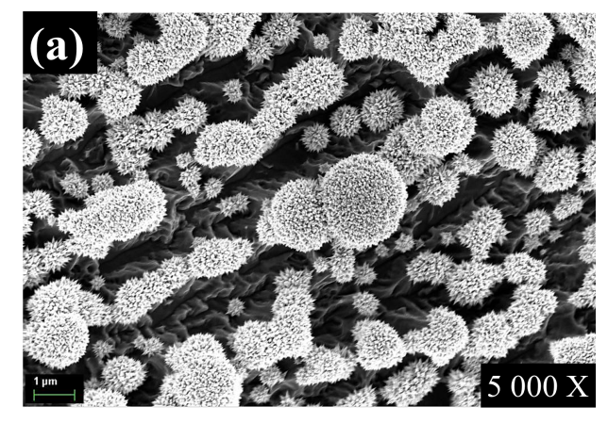 | 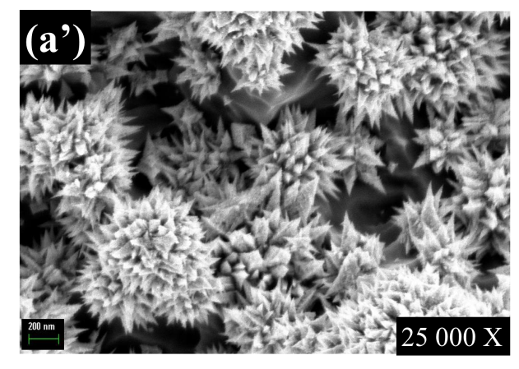
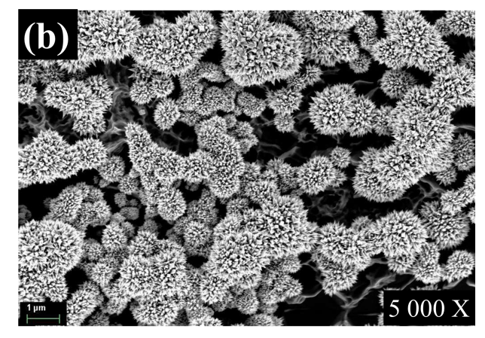 | 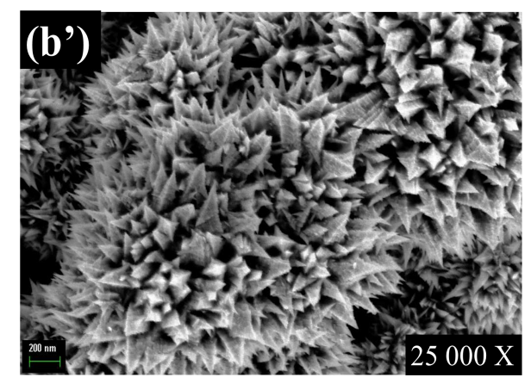
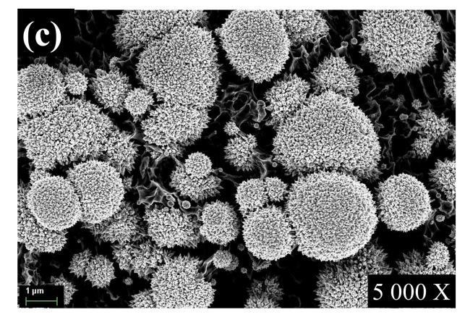 | 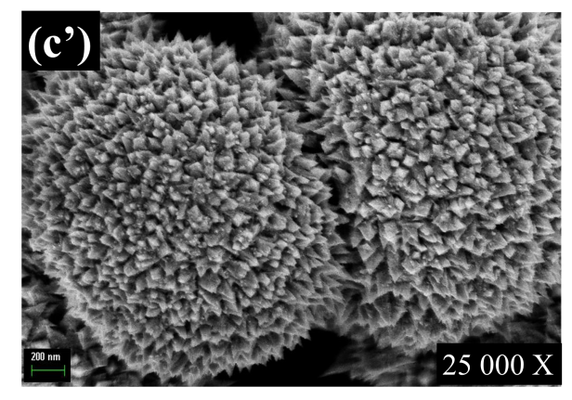
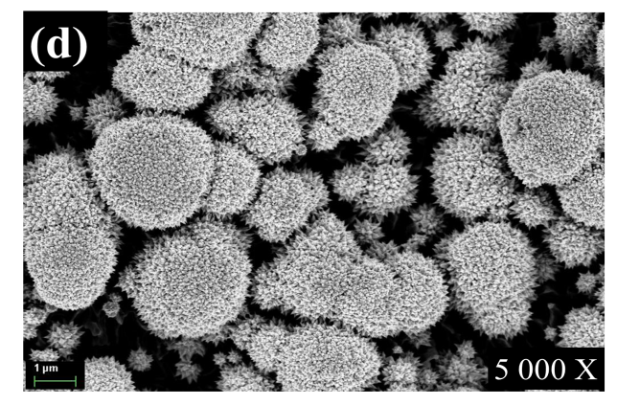 | 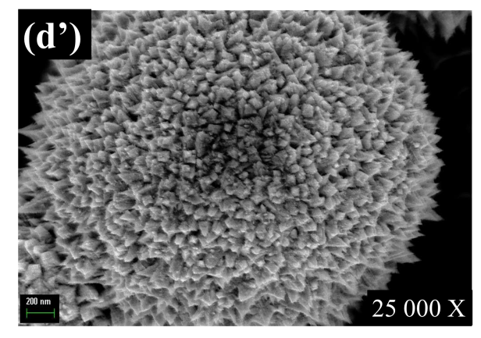
Figure 1. FESEM images of the Pt films at 5000x magnification deposited electrochemically at -0.20 V vs SCE for (a) 30 (b) 45 (c) 60 and (d) 90 minutes from 0.01 M H₂PtCl₆.6H₂O + 0.3 M H₂SO₄ solution. Magnification at 25 000x for (a’), (b’), (c’), and (d’).

As depicted in Figure 1(a) and (a’), highly scattered durian-like Pt centres were formed on Ti surface after deposition time of 30 minutes. The Ti surface was not completely covered by Pt films at this deposition time. As the deposition time was prolonged to 45 minutes, similar but denser and larger durian-like structure of Pt centres were formed on the Ti surface as displayed in Figure 1(b) and (b’). Increasing the deposition time to 60 minutes resulted in a gradual change in the structure of the deposited Pt films. The morphology of the Pt films prepared at 60 minutes was significantly different as compared to the Pt films prepared at shorter deposition times. As the result, a more compact durian-like with increasing surface coverage was formed as shown in Figure 1(c) and (c’).

Subsequently, as the deposition time was increased to 90 minutes, the growth of cauliflower-like Pt centres can be clearly seen on the Ti surface as illustrated by Figure 1(d) and (d’). Moreover, the Pt centres agglomerated with each other like clusters. Notably, the FESEM images demonstrated that the Ti surface was almost covered by Pt centres and the amount of Pt loading increased with increasing deposition time. In conclusion, the deposition time significantly influenced the formation of surface morphology and the amount of Pt loading on the Ti substrate.

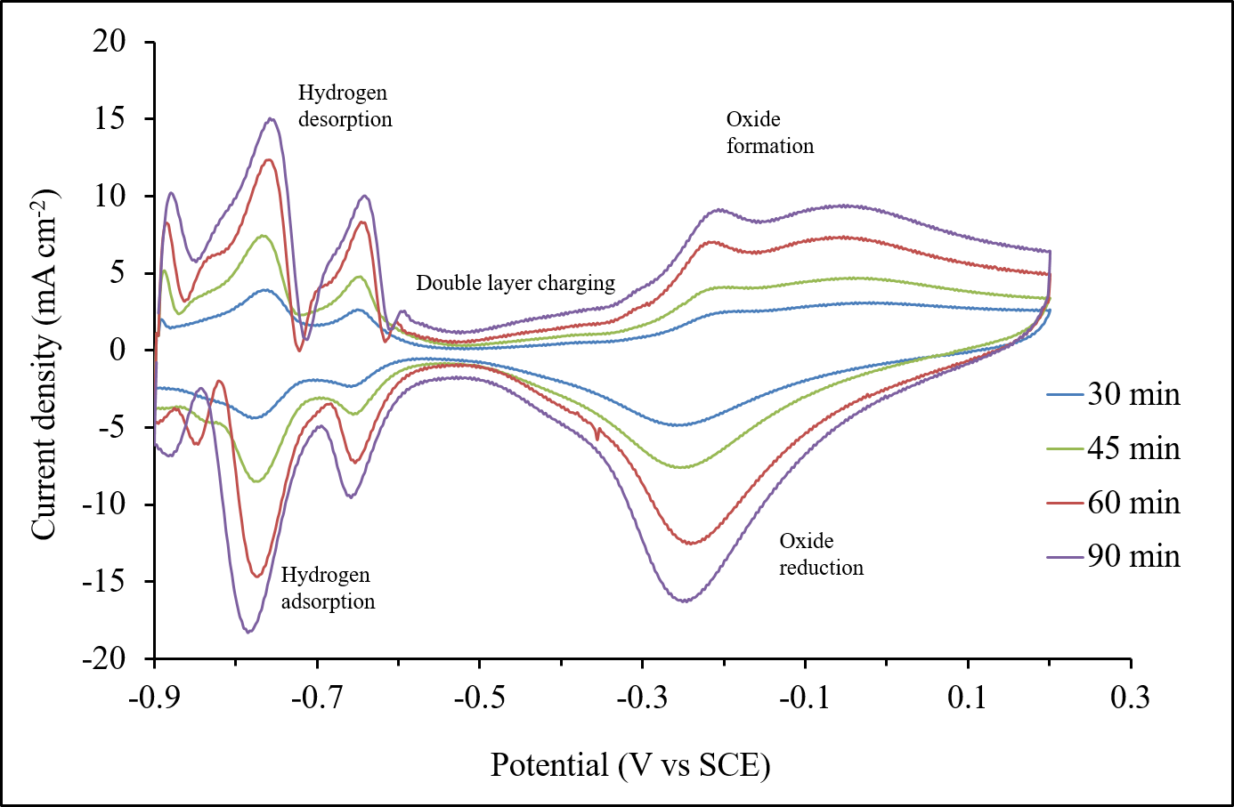

Figure 2. Cyclic voltammograms of Pt films deposited on Ti substrate at different deposition times (30, 45, 60, and 90 minutes) in 0.5 M KOH at scan rate of 50 mVs⁻¹.

Figure 2 illustrates the cyclic voltammetry responses of electrodeposited Pt films (i.e. Pt_{-0.20 V}, _{30 min}, Pt_{-0.20 V}, _{45 min,} Pt_{-0.20 V, 60 min} and Pt_{-0.20 V, 90 min}) in 0.5 M KOH solution. The cyclic voltammetry was scanned from -0.90 V to +0.20 V and back to -0.90 V at scan rate of 50 mV s⁻¹. From the cyclic voltammograms, it was found that the processes can be associated with: i) hydrogen adsorption/desorption region between -0.9 V and -0.56 V, ii) double layer region between -0.56 V and -0.4 V and iii) oxidation and reduction of PtO between -0.4 V and 0.2 V [16-18]. The hydrogen adsorption/desorption and Pt oxide reduction/oxidation peaks increased with increasing the deposition time during electrodeposition of Pt on Ti substrate. The ECSA of each prepared Pt films was calculated to identify the most optimum amount of Pt loadings that needs to be deposited on the substrate in order to achieve the optimum catalytic performance for electrochemical reaction in alkaline medium. Among these prepared Pt films, the lowest ECSA belongs to Pt film prepared at 30 minutes (i.e. Pt_{-0.20 V, 30 min}) was 6.54 m² g⁻¹ due to the lowest amount of Pt loading on the Ti substrate. As the deposition time increased to 45 minutes, the ECSA was increased to 7.34 m² g^{-1.} Then, the maximum ECSA of 8.08 m² g⁻¹ was achieved as Pt films prepared at deposition time of 60 minutes (i.e. Pt_{-0.20 V, 60 min}).

Nevertheless, when the deposition time was increased to 90 minutes, the ECSA decreased to 7.70 m² g⁻¹, indicating less Pt active surface area available for electrochemical reaction in alkaline medium. These findings agree well with the morphological observation by FESEM as in Figure 1(d), displaying more Pt centres are arranged closely to each other to form cluster. Thus, this leads to a decrease in the ECSA and limits its catalytic function. Based on the literature, it was found that higher ECSA values were reported by Tripkovic [19] and Doan [20] which were 10.8 m² g⁻¹ and 8.2 m² g⁻¹, respectively for hydrogen adsorption/desorption on Pt films coated on glassy carbon. Table 1 shows a summary for the deposition charge, Pt loading per geometrical area of the electrode, charge value of hydrogen desorption and corresponding ECSA for Pt films prepared at -0.20 V at different deposition times

Table 1. Deposition charge, Pt loading per geometrical area of the electrode, charge value of hydrogen desorption and corresponding ECSA for Pt films prepared at -0.20 V at different deposition times

Deposition Time  (min) | Deposition Charge  (C cm⁻²) | Pt Loading  (µg cm⁻²) | Charge Value of  Hydrogen Desorption (µC cm⁻¹) | ECSA  (m² g⁻¹)
30 | 2.2 | 1009 | 13800 | 6.54
45 | 3.9 | 1567 | 24200 | 7.34
60 | 5.3 | 2104 | 35600 | 8.08
90 | 7.7 | 2963 | 47800 | 7.70

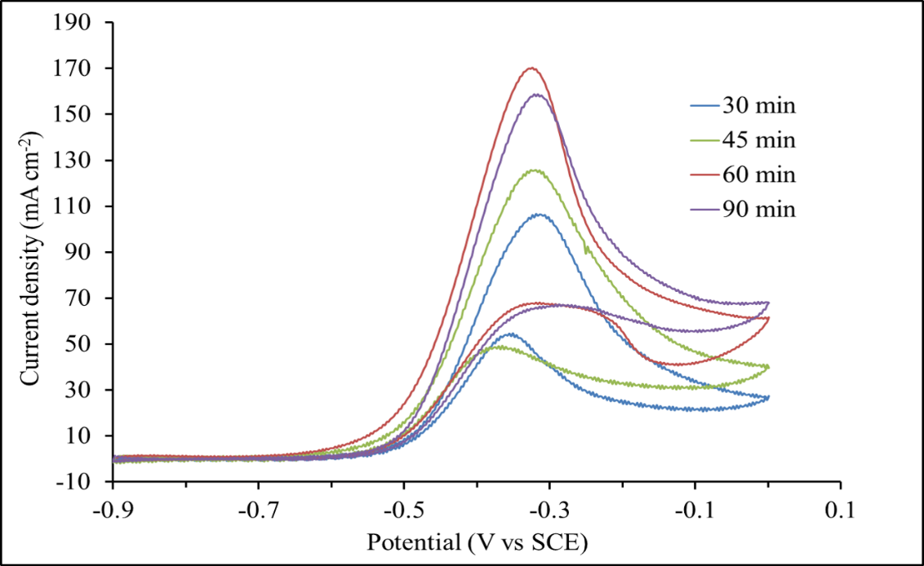

Figure 3. Cyclic voltammograms of methanol oxidation on Pt films deposited on Ti substrate at different deposition times (i.e. 30, 45, 60, and 90 minutes) in 0.5 M KOH containing 1.0 M CH₃OH, scan rate: 50 mV s⁻¹.

Figure 3 shows the cyclic voltammograms of Pt films prepared at different deposition times (Pt_{-0.20 V}, _{30 min}, Pt_{-0.20 V}, _{45 min,} Pt_{-0.20 V, 60 min}, Pt_{-0.20 V, 90 min}) in 0.5 M KOH containing 1.0 M CH₃OH at scanning rate of 50 mV s⁻¹. The cyclic voltammetry was conducted to investigate the performance of the prepared Pt films towards methanol oxidation in alkaline medium. Two anodic peaks are observed in the forward and backward scan, which correspond to the oxidations of methanol and intermediate species, respectively. The findings indicate that the current densities peaks at forward scan for methanol oxidation reaction were 106.69 mA cm⁻², 125.76 mA cm⁻², 170.30 mA cm⁻² and 158.78 mA cm⁻² on Pt_{-0.20 V}, _{30 min}, Pt_{-0.20 V}, _{45 min,} Pt_{-0.20 V, 60 min} and Pt_{-0.20 V, 90 min}, respectively. Interestingly, the current density peak at forward scan of methanol oxidation increased with increasing deposition time during electrodeposition process from 30 min to 60 min (i.e., Pt_{-0.20 V, 30 min} < Pt_{-0.20 V, 45 min} < Pt_{-0.20 V, 60 min}).

Nevertheless, the current density peak for methanol oxidation was decreased for Pt film prepared at 90 minutes deposition time (Pt_{-0.20 V, 90 min}). This could be attributed to the heavily aggregation of Pt centres on Ti substrate (refer Figure 2(d)), thus substantially reducing the available active catalytic sites of the resulting Pt film. Figure 4 illustrates the maximum current density at forward scan for methanol oxidation on different prepared Pt films for comparison. It can be concluded that a high amount of Pt loadings on substrate does not contribute to a maximum catalytic activity of the methanol oxidation but importantly the morphology and structure of the Pt itself (Pt_{-0.20 V}, _{30 min} = 1009 µg cm⁻², Pt_{-0.20 V}, _{45 min} =1567 µg cm⁻², Pt_{-0.20 V, 60 min} = 2104 µg cm⁻², Pt_{-0.20 V, 90 min} = 2963 µg cm⁻²). Therefore, these results suggest that the Pt films prepared at 60 minutes had the largest active surface area for methanol oxidation as shown by the highest current density produced during methanol oxidation. This result is consistent with the highest ECSA (8.08 m² g⁻¹) recorded for Pt_{-0.20 V, 60 min} films than other Pt films as discussed earlier.

The ratio of I_{f}/I_{b} is used to evaluate the tolerance of the Pt film towards poisoning species (CO). The I_{f}/I_{b} value for Pt_{-0.20 V}, _{30 min}, Pt_{-0.20 V}, _{45 min,} Pt_{-0.20 V, 60 min} and Pt_{-0.20 V, 90 min} coatings were 1.95, 2.54, 2.63 and 2.36, respectively. These results demonstrate that the Pt film prepared at 60 minutes deposition time exhibits better resistance to the poisoning species as compared to other the prepared Pt films. Table 2 shows the comparison of electrochemical performance of methanol oxidation on prepared Pt films.

Table 2. Comparison of electrochemical performance of methanol oxidation on Pt films deposited at different deposition times in 0.5 M KOH containing 1.0 M CH₃OH

Pt films | E_{f}  (V) | I_{f}  (mA cm⁻²) | E_{b}  (V) | I_{b}  (mA cm⁻²) | Onset potential (V) | Ratio  I_{f} /I_{b}
Pt_{-0.20 V}, _{30 min} | -0.32 | 106.69 | -0.35 | 54.75 | -0.48 | 1.95
Pt_{-0.20 V}, _{45 min} | -0.32 | 125.76 | -0.37 | 49.35 | -0.50 | 2.54
Pt_{-0.20 V}, _{60 min} | -0.32 | 170.38 | -0.34 | 64.67 | -0.50 | 2.63
Pt_{-0.20 V}, _{90 min} | -0.32 | 158.78 | -0.29 | 67.26 | -0.50 | 2.36
E_{f}: potential peak for forward scan; I_{f}: current density peak for forward scan; E_{b}: potential peak for backward scan; I_{b}: current density for backward scan.

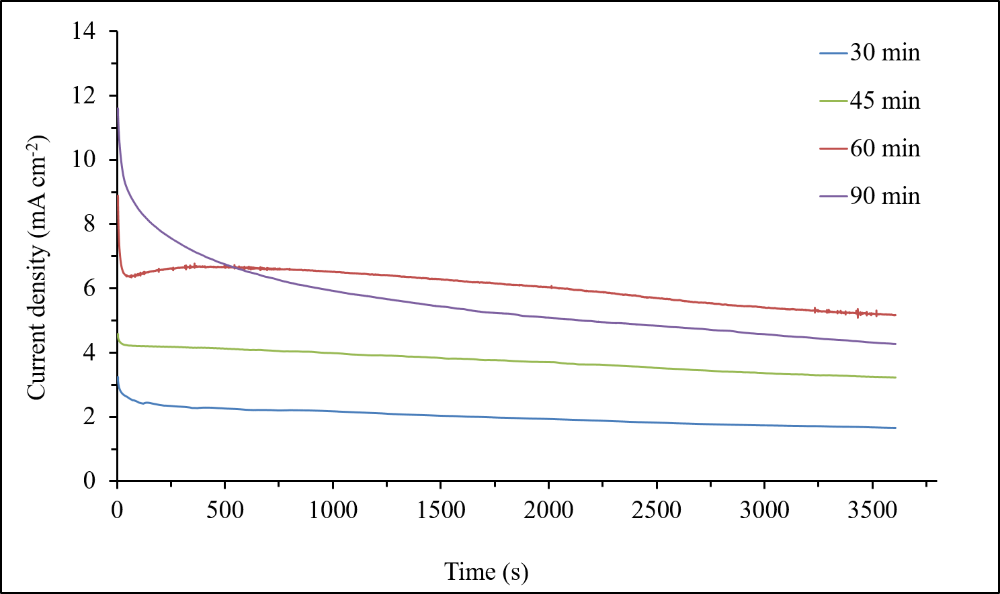

Figure 4. Chronoamperometric curves at -0.50 V of Pt films prepared at different deposition times (i.e. 30, 45, 60, and 90 minutes) in 0.5 M KOH containing 1.0 M CH₃OH

The stability of the prepared Pt films towards methanol oxidation in alkaline medium was investigated by chronoamperometry. Figure 4 illustrates the chronoamperograms of the prepared Pt films (Pt_{-0.20 V}, _{30 min}, Pt_{-0.20 V}, _{45 min,} Pt_{-0.20 V, 60 min} and Pt_{-0.20 V, 90 min}) for methanol oxidation in 0.5 M KOH containing 1.0 M CH₃OH at a fixed potential of -0.50 V for a duration of 1 hour. Notably, Pt films prepared at 60 minutes demonstrated the highest stability compared to the other Pt films. At 3600 s, the oxidation current densities were 1.67 mA cm⁻², 3.23 mA cm⁻², 5.18 mA cm⁻² and 4.28 mA cm⁻² for Pt_{-0.20 V}, _{30 min}, Pt_{-0.20 V}, _{45 min,} Pt_{-0.20 V, 60 min} and Pt_{-0.20 V, 90 min} coatings, respectively. These results suggest that the Pt film prepared at 60 minutes deposition time exhibited high stability due to their tolerance with the poisoning species (CO) during methanol oxidation.

Conclusion
Pt films were successfully prepared on Ti substrate using the electrodeposition technique. The investigation on the effect of deposition time towards surface properties and catalytic activity of pure Pt coatings were studied. Based on the results, the best condition in producing pure Pt coating on Ti substrate was at -0.2 V for 60 minutes, at which this deposition condition has produced highest ECSA (8.08 m² g⁻¹), the lowest onset potential, (-0.5 V), the highest current density peak (170.38 mA cm⁻²) and I_{f}/I_{b} ratio (2.63) for methanol oxidation. The morphology and the loading amount of Pt on Ti substrate were significantly influenced by the deposition time. Furthermore, the experiments revealed that by varying deposition time (30, 45, 60 and 90 minutes) at a constant deposition potential of -0.20 V was an effective way to control the amount of Pt loadings on the Ti substrate. Notably, a good electrocatalyst should have at least two from these three features: (i) high current density for methanol oxidation, (ii) occurrence of methanol oxidation at low potential, and (iii) high stability of the electrode during methanol oxidation.
Acknowledgement
The authors wish to express their utmost gratitude to Universiti Teknologi MARA (UiTM), Malaysia for the financial support through Initiative Research Grant (600-IRMI/GIP 5/3 (0026/2016). Apart from that, the Faculty of Applied Sciences (UiTM) had also played a vital role by providing the necessary facilities.

References
- Lima, A., Hahn, F. and Léger, J.-M. (2004). Oxidation of methanol on Pt, Pt–Ru, and Pt–Ru–Mo electrocatalysts dispersed in polyaniline: an in situ infrared reflectance spectroscopy study. Russian Journal of Electrochemistry, 40(3): 326-336.
- Aramata, A., Kodera, T. and Masuda, M. (1988). Electrooxidation of methanol on platinum bonded to the solid polymer electrolyte, Nafion. Journal of Applied Electrochemistry, 18(4): 577-582.
- Beden, B., Kadirgan, F., Lamy, C. and Leger, J. (1982). Oxidation of methanol on a platinum electrode in alkaline medium: Effect of metal ad-atoms on the electrocatalytic activity. Journal of Electroanalytical Chemistry and Interfacial Electrochemistry, 142(1-2): 171-190.
- Prabhuram, J. and Manoharan, R. (1998). Investigation of methanol oxidation on unsupported platinum electrodes in strong alkali and strong acid. Journal of Power Sources, 74(1): 54-61.
- Ordóñez, L., Roquero, P., Ramírez, J. and Sebastian, P. (2016). Methanol electro-oxidation on bimetallic PtMo/C catalysts and Pt/C-Mo/C mechanical mixtures. International Journal of Electrochemical Science, 11: 5364-5379.
- Wang, H., Ji, S., Wang, W., Linkov, V., Pasupathi, S. and Wang, R. (2012). Pt decorated PdFe/C: extremely high electrocatalytic activity for methanol oxidation. International Journal of Electrochemical Science, 7: 3390-3398.
- Antolini, E., Salgado, J. R. and Gonzalez, E. R. (2006). The methanol oxidation reaction on platinum alloys with the first-row transition metals: the case of Pt–Co and–Ni alloy electrocatalysts for DMFCs: A short review. Applied Catalysis B: Environmental, 63(1): 137-149.
- Greeley, J. and Mavrikakis, M. (2004). Competitive paths for methanol decomposition on Pt(111). Journal of the American Chemical Society, 126(12): 3910-3919.
- Greeley, J. and Mavrikakis, M. (2002). A first-principles study of methanol decomposition on Pt(111). Journal of the American Chemical Society, 124(24): 7193-7201.
- Cao, D., Lu, G.-Q., Wieckowski, A., Wasileski, S. A. and Neurock, M. (2005). Mechanisms of methanol decomposition on platinum: A combined experimental and ab initio approach. The Journal of Physical Chemistry B, 109(23): 11622-11633.
- Yi, Q., Huang, W., Zhang, J., Liu, X. and Li, L. (2008). Methanol oxidation on titanium-supported nano-scale Ni flakes. Catalysis Communications, 9(10): 2053-2058.
- Kim, H. B., Ahn, S., Jang, H. J., Sim, S. B. and Kim, K. W. (2007). Evaluation of corrosion behaviors and surface profiles of platinum-coated electrodes by electrochemistry and complementary microscopy: Biomedical implications for anticancer therapy. Micron, 38(7): 747-753.
- Yin, J., Jia, J. and Zhu, L. (2009). Double-template synthesis of platinum nanomaterials for oxygen reduction. Microchimica Acta, 166(1-2): 151-156.
- Ott, A., Jones, L. A. and Bhargava, S. K. (2011). Direct electrodeposition of porous platinum honeycomb structures. Electrochemistry communications, 13(11): 1248-1251.
- Pozio, A., De Francesco, M., Cemmi, A., Cardellini, F. and Giorgi, L. (2002). Comparison of high surface Pt/C catalysts by cyclic voltammetry. Journal of Power Sources, 105(1): 13-19.
- Pletcher, D. (2009). A first course in electrode processes. Royal Society of Chemistry.
- Solla-Gullón, J., Vidal-Iglesias, F., Herrero, E., Feliu, J. and Aldaz, A. (2006). CO monolayer oxidation on semi-spherical and preferentially oriented(100) and (111) platinum nanoparticles. Electrochemistry communications, 8(1): 189-194.
- Attard, G., Gillies, J., Harris, C., Jenkins, D., Johnston, P., Price, M. and Wells, P. (2001). Electrochemical evaluation of the morphology and enantioselectivity of Pt/graphite. Applied Catalysis A: General, 222(1): 393-405.
- Tripković, A. V., Popović, K. D., Lović, J., Jovanović, V. and Kowal, A. (2004). Methanol oxidation at platinum electrodes in alkaline solution: Comparison between supported catalysts and model systems. Journal of Electroanalytical Chemistry, 572(1): 119-128.
- Doan, N., Sundqvist, T., Hiekkataipale, P., Korhonen, J., Kallio, T., Ruokolainen and Johans, C. (2015). Electrodeposited mesoporous Pt and Pt@ cb films as electrocatalysts for the oxygen reduction reactions and ethanol electrooxidation in both acid and alkaline media. International Journal of Electrochemical Science, 10: 2535-2553.

