

MALAYSIAN JOURNAL OF ANALYTICAL SCIENCES
ISSN 1394 - 2506

Published by The Malaysian Analytical Sciences Society

PRODUCTION OF ETHYL LEVULINATE VIA ESTERIFICATION
REACTION OF LEVULINIC ACID IN THE PRESENCE OF ZrO₂
BASED CATALYST

(Penghasilan Etil Levulinat Melalui Pengesteran Asid Levulinik dengan Kehadiran Mangkin Berasaskan ZrO₂)

Dorairaaj Sivasubramaniam¹, Nor Aishah Saidina Amin¹*, Khairuddin Ahmad¹, Nur Aainaa Syahirah Ramli²

¹Chemical Reaction Engineering Group (CREG), Faculty of Chemical Engineering,
Universiti Teknologi Malaysia, 81300 Skudai, Johor, Malaysia
²Advanced Oleochemical Technology Division,
Malaysian Palm Oil Board (MPOB), 6, Persiaran Institusi, Bandar Baru Bangi, 43000 Kajang, Selangor, Malaysia

*Corresponding author: noraishah@cheme.utm.my

Received: 13 April 2017; Accepted: 17 April 2018

Abstract
Ethyl levulinate is widely used as a fuel additive, flavor or fragrance and as a component of fuel blending. This study focused on the production of ethyl levulinate from levulinic acid via esterification reaction in the presence of HPW/ZrO₂.The catalyst was prepared using the wet impregnation method, characterized by using FTIR, BET and NH₃-TPD and screened based on 20%, 40% and 60% HPW/ZrO₂. The 40% HPW/ZrO₂ catalyst exhibited the highest catalytic performance during the parameter screening stage which included catalyst loading (0.25‒1.25g) and volume ratio of levulinic acid to ethanol (1:4 – 1:8). The highest ethyl levulinate yield of 99% corresponded to a catalyst loading of 0.5 g and volume ratio of levulinic acid to ethanol of 1:5 with reaction conditions at 150 °C for 3 hours. The esterification reaction of levulinic acid revealed that the catalytic performance was influenced by the acid sites and surface area of the catalyst. In addition, volume ratio was also a major factor in enhancing the ethyl levulinate yield.

Keywords: levulinic acid, ethyl levulinate, wet impregnation, esterification, phosphotungstic acid

Abstrak
Etil levulinat digunakan secara meluas sebagai komponen penting dalam bahan kosmetik, bahan tambahan dalam bahan api dan campuran bahan api. Kajian ini memberi tumpuan dengan penghasilan etil levulinat daripada asid levulinik melalui tindak balas pengesteran dengan kehadiran pemangkin HPW/ZrO₂. Pemangkin ini disediakan dengan menggunakan kaedah impregnasi basah dan dicirikan dengan menggunakan FTIR, BET dan NH₃-TPD, pemangkin ini ditapis berdasarkan 20%, 40%,dan 60% HPW/ZrO₂. Akhirnya, didapati 40% HPW/ZrO₂ menunjukkan mangkinan tinggi yang sesuai digunakan untuk pemeriksaan parameter melibatkan berat pemangkin (0.25‒1.25g) dan nisbah isipadu LA kepada etanol (1:4 ‒ 1:8). Penghasilan terbaik ditunjukkan dengan muatan pemangkin (0.5 g) dan nisbah isipadu asid levulinik kepada etanol (1:5) yang diperolehi hasil 99% EL pada 150 °C selama 3 jam. Penggunaan HPW/ZrO₂ sebagai pemangkin dalam tindak balas pengesteran LA mendedahkan bahawa reaktiviti pemangkin sangat dipengaruhi oleh bahagian asid dan luas permukaan pemangkin tersebut.

Kata kunci: asid levulinik, etil levulinate, impregnasi basah, pengesteran, asid fosfotungstik

Introduction
Biomass is required for the production of many bio-based chemicals, which are utilized as an alternative source to fossil fuels. One of the top ten platform chemicals that is in high demand is levulinic acid (LA). LA is produced via the acid hydrolysis reaction of lignocellulosic biomass [1-3]. The LA molecule contains two functional groups- a ketone and a carboxyl group. Therefore, LA can be used for the synthesis of organic chemicals such as levulinate ester, γ-valerolactone, α-agelica lactone, acrylic acid and 1,4-pentanediol [4]. Moreover, LA, known as one of the top twelve building blocks, is also widely used as chiral reagents, inks, coatings and chemical components in batteries. [5]. Many useful compounds are derived from LA, especially ethyl levulinate (EL), which is synthesized via esterification of LA with ethanol as shown in Figure 1. This highly promising chemical can act as an oxygenate additive in fuels [1].

EL is considered as one of the top biomass-derived chemical which can potentially replace fossil fuels in the synthesis of various industrial chemicals and blending components for transportation fuels. EL is also used as a flavoring agent, fuel oxygenate additive and feed to produce γ-valerolactone, which is another potential chemical that can be used as a fuel additive [6]. The production of EL from LA has attracted considerable attention because LA is one of the top biomass-derived platform molecules that is produced from C₆ carbohydrates derived from renewable ligno-cellulose [7].

EL is produced via the acid-catalyzed esterification of LA. Conventionally, mineral acids such as H₂SO₄ and H₃PO₄ have been utilized in the production of ethyl levulinate with high yields [8]. However, these catalysts are considered as not only harmful to the environment but also uneconomical and difficult to recycle. Hence, a heterogeneous catalyst was introduced as an alternative to eliminate the disadvantages of using a homogeneous catalyst.

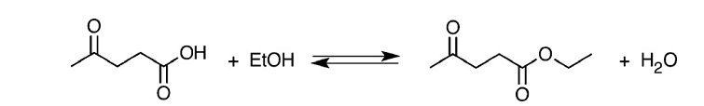
Figure 1. The reaction pathway to produce EL via esterification reaction of LA with ethanol [4].

Recently, Keggin-type heteropolyacids such as phophotungstic acid (HPW) has been widely used in acid- catalyzed reactions due to its strong Brønsted acidity site, high proton mobility and ability to accept electrons [8]. However, HPW had some characteristics that limited its application such as its low surface area and difficulty in separating from reaction mixtures. Many studies reported that a solution to the problem is by using metal oxide catalysts (e.g. SiO₂, SnO₂, TiO₂ and MgO) with HPW which makes it a heterogeneous acid catalyst. This paper investigates the production of EL via the esterification reaction of LA in the presence of HPW/ZrO₂ in different percentages of weight (wt.%), i.e. 20%, 40% and 60%. Parameter screening was conducted using a catalyst loading range of 0.25‒1.25g and volume ratio of LA to ethanol (EtOH) in the range of 1:4 ‒ 1:8.

Materials and Methods
Chemicals
All chemicals were obtained from Merck, Germany. The Keggin-type heteropolyacid used in the reaction was phosphotungstic acid (HPW) while zirconium oxide (ZrO₂) was used for the catalyst preparation. LA and ethanol were used as feedstock for the esterification reaction. The EL standard was used as a standard in GC analysis.

Catalyst preparation
The catalyst was prepared via wet impregnation method and employed the unit of percentage of weight (wt.%). Zirconium oxide (ZrO₂) was mixed with Keggin-type heteropolyacid (HPW). Zirconium oxide powder was weighed and added to 30 mL of water, following the stated amount of HPW. The mixture was then stirred at 80 ºC for 2 hours and dried in an oven for 12 hours at 100 ºC to remove excess water. Finally, the prepared catalyst was calcined at 500 ºC for 3 hours.

Catalyst characterization
FTIR spectra was used to identify the chemical bonds and functional groups in the sample. The FTIR spectra (KBr pellets) was recorded using Perkin Elmer in the range of 400-4000 cm⁻¹. The acidity properties of the catalysts were analyzed using NH₃-temperature program desorption (NH₃-TPD). The Brunauer-Emmet-Teller (BET) method was used to determine the surface area using Micrometrics ASAP2020 analyzer.

Catalytic activity
The conversion of LA to EL was carried out in the presence of 30 mL of ethanol as a solvent for the reaction. The solid acid catalyst and the reaction were carried out in a high pressure stirred autoclave reactor at 150 ºC. Finally, the product was analyzed using GC-FID to obtain the yield of products formed. The reactions were repeated at various temperatures and the reaction time was taken.

Product analysis
Samples were filtered with micropore filtrate to remove impurities and were analyzed by using Agilent 7820A as chromatography equipped with a flame ionization detector (FID) operating at 543 K. EL was separated using HP5 column (30m x 320 µm x 25 µm). N₂ was the carrier gas used in GC at a flow rate of 1.0 mL min⁻¹. The yield of EL was calculated using the following equation 1:

EL yield (%) = Mole of EL/ Initial mole of LA × 100% (1)

Results and Discussion
Catalyst characterization
To study the catalysis of HPW/ZrO₂ in the esterification reaction of LA, the characterization of different wt.% of HPW/ZrO₂ was carried out. Three characterization tests were conducted on the catalyst to determine its physical and chemical properties. Figure 2 represents Fourier transform-infrared spectroscopy (FTIR) spectra for parent ZrO₂, 20% HPW/ZrO₂, 40% HPW/ZrO₂ and 60% HPW/ZrO₂. The peak at 1076 and 977.91 cm⁻¹ shows the bond between P-O and W=O in the structure after the wet impregnation of ZrO₂ as a support catalyst to HPW. In addition, when the loading of HPW increases, a weak peak appears at 729.09 cm⁻¹ and becomes narrower, which confirms the content of HPW. The FTIR spectra of all the catalysts shows absorption peaks ranging from 500 cm⁻¹ to 2000 cm⁻¹, which represents heteropolyacids anions of the Keggin structure.

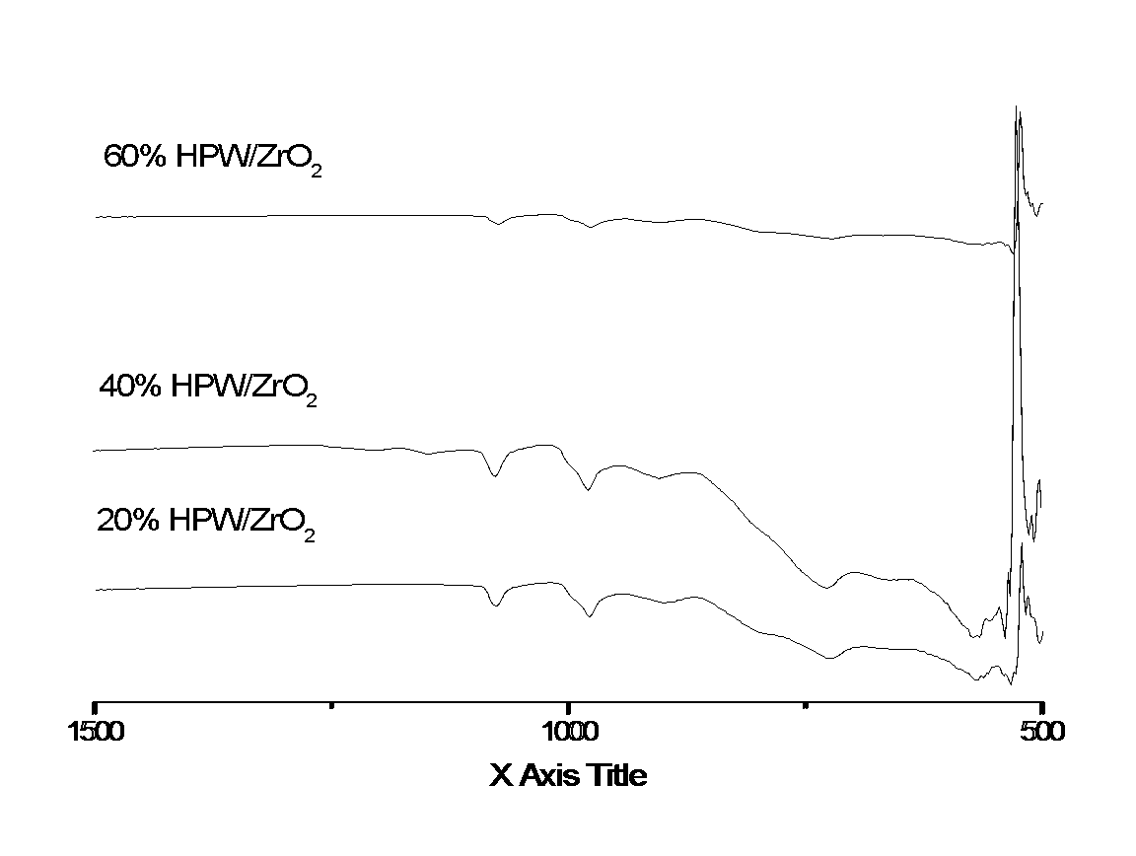
Figure 2. FTIR results for HPW/ ZrO₂ of 20%, 40% and 60% HPW/ZrO₂

BET was used to analyze the surface area of the catalyst when the loading of HPW was increased in the reaction that was supported by ZrO₂. Table 1 shows the total surface area of the solid catalyst. The surface area of the catalyst increases due to the porous characteristic of ZrO₂ that enables it to increase its own surface area when impregnated with other catalysts [9]. Based on the total surface area obtained, it has been concluded that the surface area influences the catalytic performance in the production of EL.

Table 1. BET analysis based on the total surface area of the parent and impregnated catalysts
Catalyst | Total surface Area  (m²/g)
HPW | 4.55
ZrO₂ | 14.95
20% HPW/ ZrO₂ | 16.3
40% HPW/ ZrO₂ | 18.81
60% HPW/ ZrO₂ | 21.65

The acidity of the catalyst strongly affects the production of EL via the esterification reaction of LA. The total number of acidity sites of the HPW contributed to the Brønsted acidity site of the catalyst which enhances the esterification reaction to favour high selectivity of EL. Table 2 depicts the comparison of total acidity sites of both parent catalysts and impregnated ones. The acidity of ZrO₂ catalyst impregnated with HPW was higher because HPW is a super acid that increases the acidity of the catalyst.

Table 2. NH₃-TPD of the parent catalyst with impregnated catalyst
Catalyst | NH₃-TPD  (mmol/g)
HPW | 1.68
ZrO₂ | 0.27
20% HPW/ ZrO₂ | 0.93
40% HPW/ ZrO₂ | 0.64
60% HPW/ ZrO₂ | 0.79

Catalytic activity
The prepared HPW/ZrO₂ materials were tested for the production of EL from the esterification reaction of LA and ethanol at 150 °C for 3 hours. In this reaction scheme, the conversion of LA was tested using 20%, 40% and 60% of catalyst in the catalytic screening stage. This was followed by the parameter screening utilizing the catalyst that gave the highest yield of EL in the catalytic screening. 40% HPW/ZrO₂ gave the highest EL yield of 99%. Hence, 40% HPW/ZrO₂ was chosen for the parameter study which covered catalyst loading and volume ratio of LA to ethanol. Catalyst screening was conducted in the first stage to obtain the most suitable catalyst for the next stage, known as parameter screening. Figure 3 shows a comparison of the effect of three different wt.% of HPW on EL yield.

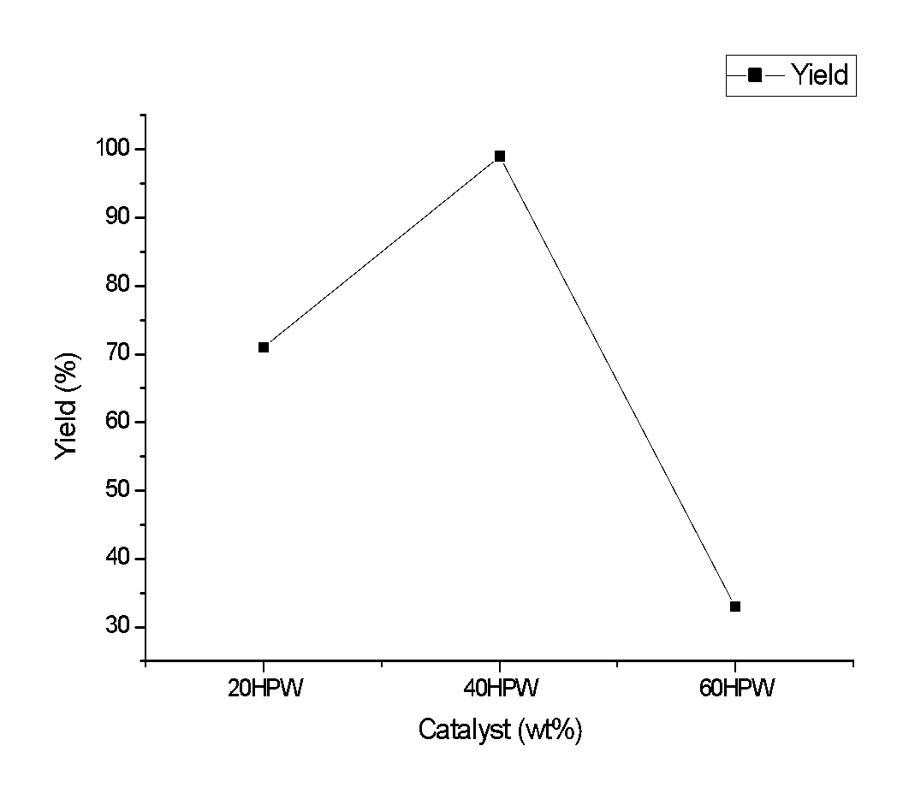
Figure 3. Effect of different HPW/ZrO₂ catalyst on EL yield

Based on the graph in Figure 3, 60% HPW/ZrO₂ only gave a yield of 33% of EL. This was due to the large amount of HPW impregnated in ZrO₂, which resulted in the catalyst becoming more active and converted to the other products. Moreover, high Brønsted acidity site is highly required by the catalyst for the conversion of LA to EL via esterification. Hence, HPW is highly favorable for the production of EL from LA [7]. Based on the catalyst screening, the effect of parameters was studied including the catalyst loading and volume ratio. This paper describes the application of heteropoly HPW in the direct conversion of LA with excess ethanol.

Effect of catalyst loading
Based on Figure 4, yield of EL increased when the catalyst loading was increased to the optimum point of 0.5 g, after which the yield decreased. The initial increase was due to the presence of the catalyst which increased the production of EL. However, excess loading might have caused leaching of the catalyst, thus causing the sharp fall in yield, Moreover, a high catalyst loading might have also caused formation of side-products and caused oxidation reactions to take place, thus reducing EL yield.

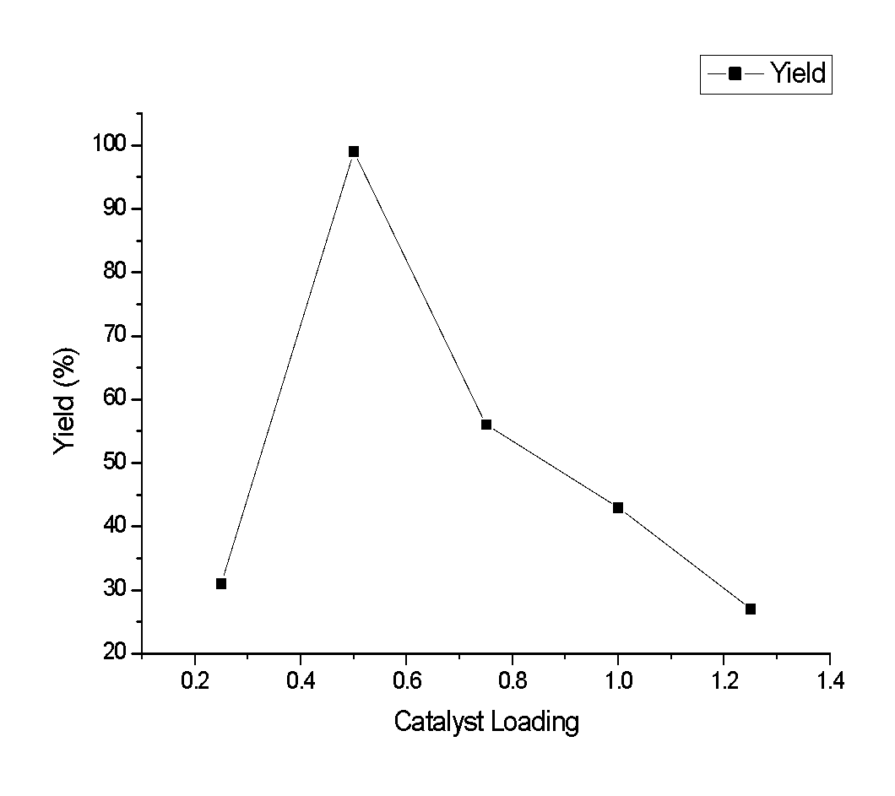
Figure 4. Effect of catalyst loading on yield of EL
0.5 g of catalyst gave the highest yield, which is 99%, thus making it the optimum loading for the reaction. The yield of EL decreased when a loading range of 0.75 to 1.25g was used. A decreasing trend of EL yield from 99% to 56% was observed when the catalyst loading increased from 0.5 to 0.75g. Moreover, HPW/ZrO₂ possesses strong Brønsted acid properties. There were many factors that influenced the catalytic activity of the esterification of LA but strong Brønsted acid properties of the catalyst played an important role in its catalytic activity. HPW/ZrO₂ has strong Brønsted acidity properties mainly due to the presence of both HPW.

Effect of volume ratio
The volume ratio parameter also affected the production of EL where a large quantity of ethanol diluted the LA and gave a low yield of EL [7]. Figure 5 shows that the yield decreased after the 1:5 volume ratio mark. The esterification reaction of LA with alcohol was a reversible reaction. High yield of the EL could be obtained when the reverse reaction was reduced [7]. The reduction of backward reaction occurred when the excess amount of ethanol was used in the reaction. Similarly, another study reported on the effect of large amount of ethanol that has been used in the reaction causing inhibition of the catalyst [10].

Continuous increase of the volume ratio from 1:5 to 1: 8 resulted in the yield to decrease from 99% to 42%, which is due to the fact that the esterification reaction is a reversible reaction and excessive ethanol favors ester production but too much ethanol may dilute the reactant, thereby resulting in lower ethyl levulinate yield. Additionally, excess ethanol in the reaction mixture may lead to side reactions such as ether formation and ethanol.

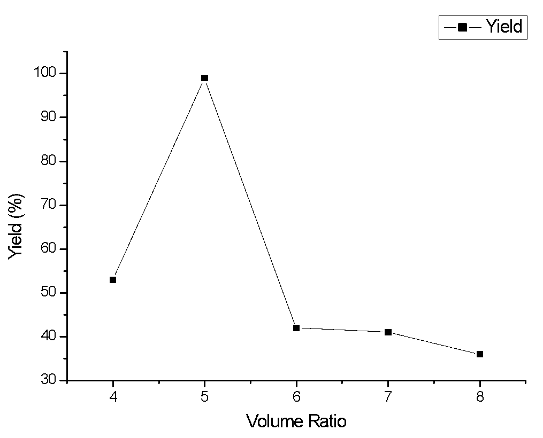
Figure 5. Effect of volume ratio of LA to ethanol on the production of EL

Conclusion
The esterification reaction of LA with ethanol to ethyl levulinate, a promising renewable biofuel, was systematically studied over super solid acid catalyst. The synthesis of EL from the esterification reaction of LA with ethanol at 150 °C for 3 hours using a loading of 0.5 g and volume ratio of LA to ethanol of 1:5 were the best conditions as it yielded 99% of EL. The catalyst exhibited best catalytic activity towards the esterification reaction of LA to produce EL. The unique performance of this catalyst, which is also known as a super solid acidity catalyst, was due to the combined characteristics of its strong Brønsted acidity and homogeneous dispersion of its active sites.

Acknowledgement
The authors would like to express their gratitude to Universiti Teknologi Malaysia and Ministry of Higher Education (MOHE), Malaysia for supporting the research under the Research University Grant (RUG), vote no 07H14.

References
- Pasquale, G., Vázquez, P., Romanelli, G. and Baronetti G. (2012). Catalytic upgrading of levulinic acid to ethyl levulinate using reusable silica-included Wells-Dawson heteropolyacid as catalyst. Catalysis Communications, 18: 115-120.
- Ya’aini, N., Amin, N. A. S. and Endud, S. (2013). Characterization and performance of hybrid catalysts for levulinic acid production from glucose. Microporous and Mesoporous Materials, 171: 14-23.
- Ramli, N. A. S. and Amin, N. A. S. (2014). Catalytic hydrolysis of cellulose and oil palm biomass in ionic liquid to reducing sugar for levulinic acid production. Fuel Processing Technology, 128: 490-498.
- Fernandes, D. R., Rocha, A. S., Mai, E. F., Claudio, J. A. and Mota, T. d. S. V. (2012). Levulinic acid esterification with ethanol to ethyl levulinate production over solid acid catalysts. Applied Catalysis A: General, 425–426: 199-204.
- Serrano-Ruiz, J. C., Pineda, A., Balu, A. M., Luque, R., Campelo, J. M., Romero, A. A. and Ramos-Fernández J.M., 2012, Catalytic transformations of biomass-derived acids into advanced biofuels. Catalysis Today, 195 (1): 162-168.
- Maldonado, G. M. G., Assary, R. S., Dumesic, J. A., Curtiss, L. A. (2012). Acid-catalyzed conversion of furfuryl alcohol to ethyl levulinate in liquid ethanol. Energy & Environmental Science, 5(10): 8990-8997.
- Nandiwale, K. Y., Sonar, S. K., Niphadkar, P. S., Joshi, P. N., Deshpande, S. S., Patil, V. S. and Bokade, V.V. (2013). Catalytic upgrading of renewable levulinic acid to ethyl levulinate biodiesel using dodecatungstophosphoric acid supported on desilicated H-ZSM-5 as catalyst. Applied Catalysis A: General, 460–461: 90-98.
- Zhao, G., Hu, L., Sun, Y., Zeng, X. and Lin, L. (2014). Conversion of biomass-derived furfuryl alcohol into ethyl levulinate catalyzed by solid acid in ethanol. BioResources, 9(2): 2634-2644.
- Katryniok, B., Paul, S., Capron, M., Lancelot, C., Bellière-Baca, V., Rey, P. and Dumeignil F. (2010). A long-life catalyst for glycerol dehydration to acrolein. Green Chemistry, 12(11): 1922-1925.
- Lee, A., Chaibakhsh, N., Rahman, M. B. A. and Tejo, B. A. (2010). Optimized enzymatic synthesis of levulinate ester in solvent-free system. Industrial Crops and Products, 32(3): 246-251.

