

MALAYSIAN JOURNAL OF ANALYTICAL SCIENCES
ISSN 1394 - 2506

Published by The Malaysian Analytical Sciences Society

FACILE TECHNIQUE FOR THE IMMOBILISATION OF TIO₂ NANOPARTICLES ON GLASS SUBSTRATES FOR APPLICATIONS
IN THE PHOTOCATALYTIC SELF-CLEANING OF INDOOR AIR POLLUTANTS

(Salutan nanopartikel TiO₂ ke atas Substrat Kaca Melalui Teknik Mudah untuk Penyingkiran Bahan Pencemar Udara dalaman Melalui Proses Fotokatalisis)

Kah Hon Leong¹*, Jia Quan Lee², A. Ashok Kumar³, Lan Ching Sim¹, Saravanan Pichiah⁴

¹Department of Environmental Engineering, Faculty of Engineering and Green Technology,
Universiti Tunku Abdul Rahman, Jalan Universiti, Bandar Barat, 31900 Kampar, Perak, Malaysia
²Environmental Engineering Laboratory, Department of Civil Engineering, Faculty of Engineering,
University of Malaya, 50603 Kuala Lumpur, Malaysia
³Department of Chemical Engineering, School of Engineering and Technology,
Periyar Maniammai University, Thanjavur - 613 403, India
⁴Department of Environmental Science and Engineering,
Indian Institute of Technology (ISM) Dhanbad- 826004, Jharkhand, India

*Corresponding author: khleong@utar.edu.my

Received: 13 April 2017; Accepted: 17 April 2018

Abstract
Self-cleaning technology employing titania (TiO₂) photocatalysts has major applications in the removal of indoor air pollutants. Pollutant removal efficiency significantly depends on the properties of the photocatalyst thin film, which is deposited on substrates. The present work developed a facile immobilisation technique that is based on simple sol–gel process. In this technique, TiO₂ nanoparticles are spray-coated onto a porous glass substrate. The uniformity of the TiO₂ coating on the glass surface was studied using a dynamic flowsense charge-coupled device camera. The influence of different TiO₂ nanoparticle concentrations in the ethanol phase was identified through rheological analysis, which showed that nanoparticle concentration is a crucial factor that affects the uniformity of the coating layer. The ability of the obtained material to catalyse formaldehyde photodegradation in presence of artificial UV light was investigated. Results demonstrated that >15.0 g/L TiO₂ is required to activate formaldehyde photodegradation and that uniform surface coatings with sufficient surface thickness can be obtained by spraying TiO₂ nanoparticles on glass substrates at concentrations of more than 15.0 g/L. This study demonstrated that uniformly coated photocatalysts for the efficient self-cleaning of indoor air pollutants can be fabricated through a facile technique.

Keywords: self-cleaning, TiO₂, sol-gel, formaldehyde, photocatalysis

Abstrak
Teknologi pembersihan menggunakan TiO₂ sebagai fotokatalis yang memainkan peranan penting terutamanya dalam menyingkirkan bahan pencemar udara dalaman. Pembersihan bahan pencemar ini sangat bergantung kepada ketebalan filem salutan terbentuk pada substrat. Dalam kajian ini teknik mudah dapat dicapai melalui proses sol-gel dan diikuti dengan salutan semburan TiO₂ berliang nanopartikel ke atas substrat kaca. Keseragaman pembentukan titania bersalut pada permukaan kaca dikaji menggunakan kamera “gabungan cas dinamik flowsense. Pengaruh kepekatan nanopartikle TiO₂ yang berbeza-beza dalam fasa etanol membawa kepada analisis reologi. Kajian reologi menunjukkan keberkesanan kepekatan nanopartikel bagi mendapatkan lapisan salutan yang seragam. Keberkesanan salutan dinilai dengan penyingkiran formaldehid dalam kehadiran cahaya UV tiruan. Keputusan penyingkiran menunjukkan bahawa kepekatan TiO₂ yang tinggi dengan melebihi 15.0 g/L menunjukkan penyingkiran formaldehid pada tahap yang ketara disebabkan oleh keseragaman salutan pada permukaan kaca serta ketebalan permukaan yang mencukupi. Kajian ini menunjukkan prestasi yang baik dalam mengesahkan salutan fotokatalis yang seragam untuk meningkat keberkesanan penyingkiran bahan pencemar udara dalaman.

Kata kunci: penyingkiran, TiO₂, sol-gel, formaldehid, fotokatalisis

Introduction
Indoor air pollution is a growing concern and has emerged as a major health threat in numerous countries. Thus, indoor air pollution requires immediate resolution. On average, every human being spends approximately 90% of their daily life indoors. Therefore, humans are constantly exposed to indoor air pollutants. Exposure to indoor air pollutants can cause health issues, such as sick building syndrome. The most ubiquitous indoor air pollutants include CO₂, NO₂, formaldehyde and volatile organic compounds (VOCs) [1]. These pollutants can be found easily in any commercial or industrial building. Among these pollutants, formaldehyde is most common. The major sources of formaldehyde pollutants include formaldehyde-emitting building materials and consumer products, such as furniture and other wooden products. Combustion processes, such as smoking, cooking and incense burning, are also sources of formaldehyde emissions. The secondary formation of formaldehyde is triggered by the oxidation of VOCs and the reactions between ozone and terpenes. Researchers have only recently considered photocatalyst-based self-cleaning technology as a feasible solution to indoor air pollution [2].

Self-cleaning surface coatings that employ metal oxides are used as alternative approaches for the remediation of indoor air pollutants [3]. Self-cleaning coatings can be classified in two different categories, namely, superhydrophilic and superhydrophobic coatings [4–11]. Superhydrophilic coatings are progressive and are based on suitable metal oxides. They chemically degrade complex pollutants through a photon energy-assisted cleaning mechanism [4]. Superhydrophilic TiO₂-coated glass substrates provide a new way to clean indoor air pollutants. TiO₂ is a popular and widely studied semiconductor photocatalyst given its various superior advantages [12–14]. It exhibits excellent photocatalytic activity in the photodegradation of harmful and toxic organic aquatic pollutants [15–20]. Developed or modified TiO₂ composites have been used in water and energy-related applications, including the removal of toxic aquatic pollutants, the photoreduction of CO₂ and the production of hydrogen through hydrolysis.

Nevertheless, the application of TiO₂ to remediate air pollution, particularly indoor air pollution, has not been extensively studied. The use of TiO₂ as an immediate remedy for indoor air pollutants has attracted increased attention because of its superior photostability, photoactivity and superhydrophilicity compared with other photocatalysts [21, 22]. These unique qualities set a strong foundation for the effective removal of indoor air pollutants. However, the removal of air pollutants is a gas-phase reaction. Thus, the TiO₂ suspension technique used in water treatment is inappropriate for air pollution treatment because it will not facilitate the photocatalytic reaction in air. TiO₂ nanoparticles must be immobilised onto substrates, such as glass and walls, before they can be used to remove air pollutants. However, immobilising TiO₂ nanoparticles onto surfaces is difficult. Thus, an appropriate and cost-effective technique for the immobilisation of TiO₂ is needed. Coating has emerged as a facile approach for the immobilisation of TiO₂ nanoparticles on substrates.

Various coating techniques have been adopted by many researchers. These coating techniques include sputtering, chemical vapour deposition and thermal spraying [23–29]. However, all these methods have their own drawbacks, such as high temperature requirements that can change the TiO₂ microstructure. Moreover, all of these coating techniques are economically nonviable [23,30]. Hence, the present work demonstrates the deposition of a uniform, transparent, photocatalytic and superhydrophilic TiO₂ coating on a glass substrate through a simple spraying technique. The TiO₂-coated glass substrates have potential applications in the removal of indoor air pollutants, particularly formaldehyde.

Materials and Methods
Materials
Titania (TiO₂) powder (P25 Degussa), ethanol, acetone and isopropanol were purchased from R & M Chemicals. Deionised water was used in all experiments. All chemicals were of analytical grade and used without any further purification.

Spray coating
TiO₂ solutions with concentrations of 2.5, 5.0, 10.0, 15.0 and 20.0 g/L were prepared by mixing 0.5, 1, 2, 3 or 4 g of P-25 TiO₂ powder with 200 mL of ethanol, respectively. The solutions were stirred vigorously until homogenous and white in colour. Soda lime glass plates (20 mm × 20 mm × 2 mm) were first cleaned and washed several times with deionised water, then washed with acetone, ethanol and isopropanol in a sonicator. Then, the cleaned glass plates were dried in an oven at 80 °C to ensure that all surface contaminants were removed. Each prepared TiO₂ nanoparticle solution was loaded into a controlled pneumatic spray gun and carefully sprayed onto the cleaned soda lime glass for 10 s. Spraying was repeated five times to ensure that the coating solution was uniformly coated onto the glass surface. Then, the coated glass substrates were sintered.

Characterization
Film thickness was measured using a surface profilometer. Dynamics FlowSense Charge-coupled Device (CCD) camera (Dantech Dynamics, Denmark) was used to capture images of the TiO₂-coated glass substrates under cold light sources. Surroundings were kept dark to ensure that cold light passed through the glass surfaces coated with various TiO₂ concentrations at the same intensity. Image processing was performed for the analysis of surface properties. Images were converted to greyscale mode for surface plot and three-dimensional (3D) surface analysis. The intensity of images varied from 0 to 255 on the basis of the coated properties. Rheological experiments were performed with Anton Paar Physica MCR 302 with suitable geometry.

Photocatalytic experiment
The schematic of the experimental setup used in this study is shown in Figure 1. A compressor (MACO) with a capacity of 0 CFM to 6.3 CFM was used to provide steady-flow conditions. The air stream from the compressor was filtered using a filter regulator (SHAKO) and a 5 µm air filter (SMC) to filter out any dust particulates and excessive water vapour. The flow rate was manually adjusted by using a flowmeter (Dwyer, USA). Formaldehyde was aerosolised by forcing a stream of air through an aerating unit containing 37% formaldehyde solution (R & M Chemicals). UV-A light (HPMV 400V, NIKKON) was used as the radiation source for the photoreactor. Photocatalytic experiments were performed under a fume chamber with proper closure to prevent the dispersion of airborne formaldehyde and UV light radiation to the surroundings. Formaldehyde concentration was measured by using a Formaldemeter™ htV-m (PPM Technology, UK) every 15 minutes for 3 hours. Removal efficiency was calculated in accordance with the following equation 1:

(Initial Concentration (C_{i}) – Final Concentration (C_{f}) × Air flow rate (Q)
Removal = (1)
Coating Surface Area (A) × Removal Time (t)

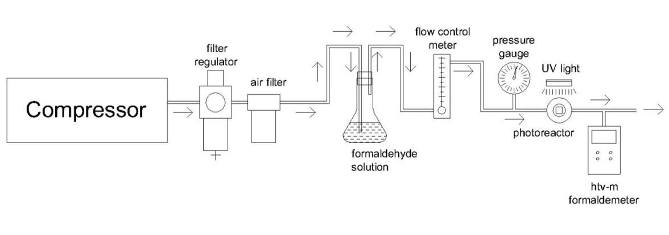
Figure 1. Photocatalysis experimental setup

Results and Discussion
Surface coating
Coating uniformity is an important criterion in the present study. The optimal TiO₂ concentration required to produce a uniform coating on the substrate was identified by depositing different concentrations of TiO₂ nanoparticles on glass substrates and by analysing the properties of the TiO₂-coated substrates. Analytical results indicated that the optimal TiO₂ concentration is >15.0 g/L. Figure 2 shows glass substrates coated with different TiO₂ concentrations, and Figure 3 shows the CCD camera images of these samples. As shown in these images, the surfaces of the substrates coated with less than 15.0 g/L TiO₂ appear rough and uneven. The substrate coated with 2.5 g/L TiO₂ exhibits a small pothole defect, as shown in Figure 3a. These defects decrease photocatalytic efficiency. The roughness of the coating surface decreases as TiO₂ concentration increases.

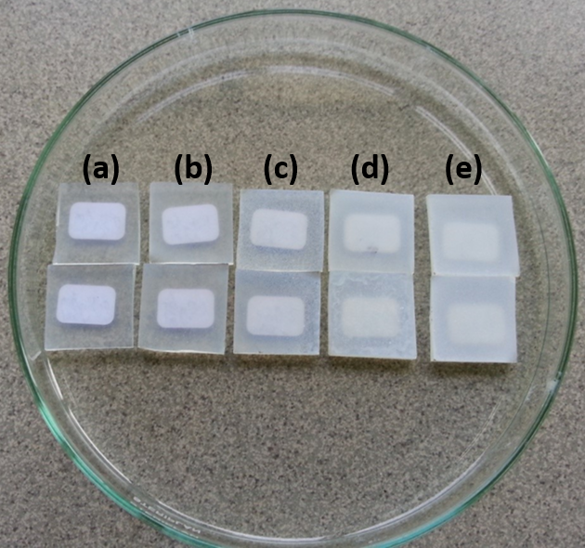
Figure 2. Images of glass surface coated with TiO₂ at different concentration (a) 2.5 g/L, (b) 5.0 g/L, (c) 10.0 g/L, (d) 15.0 g/L and (e) 20.0g/L

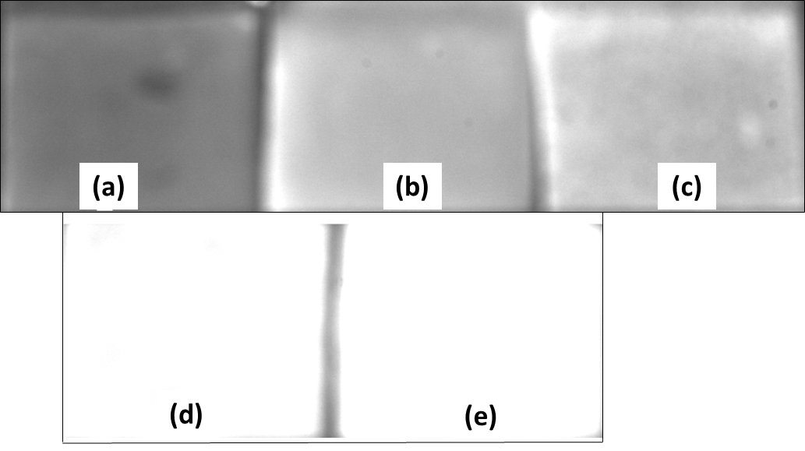
Figure 3. CCD images of different concentration coated on glass surface (a) 2.5 g/L, (b) 5.0 g/L, (c) 10.0 g/L, (d) 15.0 g/L and (e) 20.0 g/L

Figure 4 shows the two-dimensional (2D) perspective of coating thickness obtained by plotting the surfaces of substrates coated with different TiO₂ concentrations. The plot shows that surface coating intensity increases as TiO₂ concentration increases. In contrast to the surface of the glass substrate coated with <15.0 g/L TiO₂, that of the glass substrate coated with 15.0 g/L TiO₂ is highly uniform without any observable surface defects. The uniformity of the surface coatings is further verified by the 3D surface plot shown in Figure 5. Similar to the 2D plot, the 3D plot indicates that rough coatings are obtained when TiO₂ is deposited at low concentrations, whereas smooth, even coatings without defects are obtained when TiO₂ is deposited at concentrations greater than 15.0 g/L. These results prove the robustness of the simple spraying technique adopted in this study.

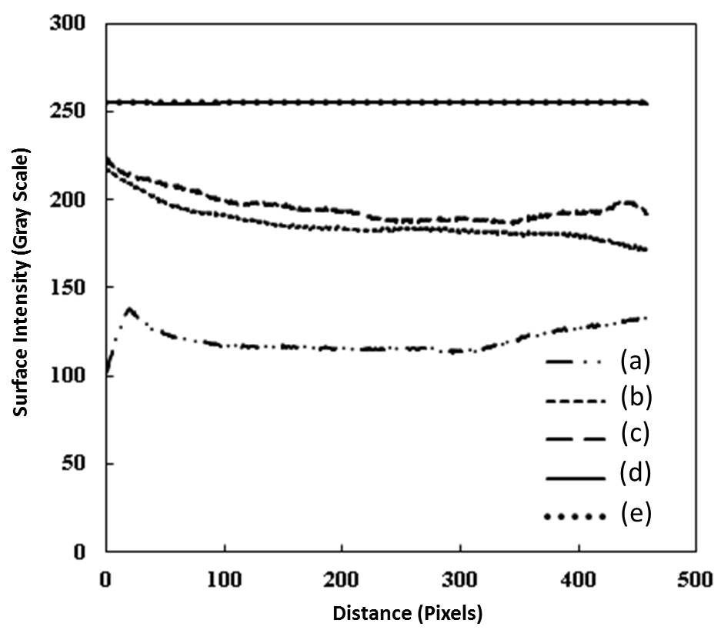
Figure 4. 2-D surface plotting for coating of different concentration (a) 2.5 g/L, (b) 5.0 g/L, (c) 10.0 g/L, (d) 15.0 g/L and (e) 20.0 g/L

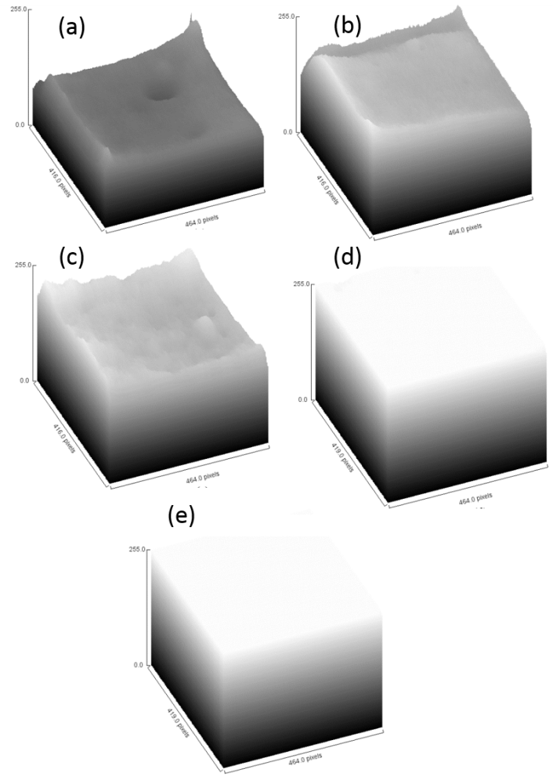
Figure 5. 3-D surface plotting for coating of different concentration (a) 2.5 g/L, (b) 5.0 g/L, (c) 10.0 g/L, (d) 15.0 g/L and (e) 20.0 g/L
The rheological behaviour of the suspension was inferred from the plot of shear stress versus shear rate shown in Figure 6a. As shown in the figure, all concentrations follow a linear trend, indicating Newtonian behaviour. Figure 6b shows the viscosity versus shear rate of different TiO₂ concentrations. Viscosity marginally increases as TiO₂ concentration increases, and the coating solution concentration of 20.0 g/L exhibits the highest viscosity. This phenomenon indicates that the increase in the degree of nanoparticle interaction in the colloidal suspension increases solvent immobilisation [31, 32]. Therefore, coating uniformity will be improved by increasing viscosity, as proven by the 2D and 3D surface plots.

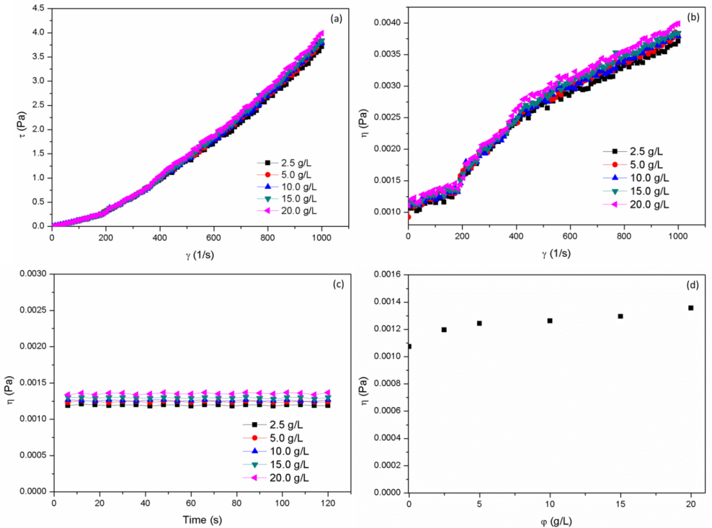
Figure 6. Rheological study (a) Shear stress versus shear rate, (b) Viscosity versus shear rate, (c) Viscosity versus time and (d) Viscosity versus TiO₂ concentration

Effect of Concentration on Formaldehyde Photocatalysis Efficiency
Figure 7 shows the photodegradation of formaldehyde over 3 hours of irradiation with artificial UV light. Formaldehyde concentration was recorded immediately once the airborne formaldehyde concentration had stabilised. As shown in the figure, coatings fabricated with TiO₂ concentrations of less than 15.0 g/L do not successfully remove formaldehyde and instead contribute to the overall level of airborne formaldehyde. Airborne formaldehyde levels have increased because nondegraded formaldehyde evaporates under heat emitted by UV light and becomes airborne once photon energy is activated. This phenomenon indicates that low amounts of TiO₂ cannot effectively photocatalyse formaldehyde degradation even after 3 hours of photodegradation and instead increases the levels of nondegraded formaldehyde in the chamber.

Meanwhile, coatings fabricated with TiO₂ concentrations of >15.0 g/L significantly decrease airborne formaldehyde levels after 3 h. On average, coatings prepared with 15.0 and 20.0 g/L TiO₂ decrease airborne formaldehyde levels to 0.15 and 0.30 ppm, respectively. This significant decrease may be attributed to photodegradation in the reaction chamber. Formaldehyde levels stabilise at the initial stage of photocatalysis induced by coatings containing 15.0 g/L TiO₂ because photodegradation capacity offsets the constant increase in airborne formaldehyde level attributed to evaporation. An overdosage of 20.0 g/L TiO₂ improves removal rate and overcomes the ongoing formaldehyde flow. The outperformance of formaldehyde increases the humidity level inside the reaction chamber. Humidity improves photodegradation. Sun et al. observed similar results [33]. The increase in humidity is attributed to water evaporation in the reaction chamber. The residual water that has not evaporated forms •OH on the coated surfaces. The hydroxyl radical is a powerful oxidant given its high redox potential, and its presence increases the photodegradation rate. However, some of the residual water will evaporate because of the strong heat radiation from the light source, thus causing the degradation rate to fluctuate (Figure 7).

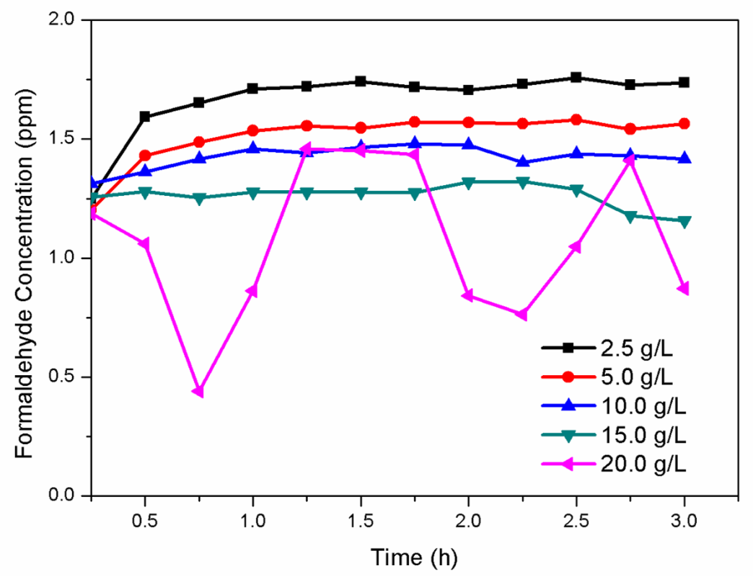
Figure 7. Photodegradation of formaldehyde airborne

Formaldehyde removal rate
As shown in Figure 7, the removal rate obtained with 15.0 g/L TiO₂ is 0.15 ppm, and 1 ppm of formaldehyde is equivalent to 1.23 mg/m³ at room temperature. Therefore, the concentration of formaldehyde is 0.1845 mg/m³. By taking airflow into account, where 50 mL/min = 3000 mL/h = 0.003 m³/h, the amount of formaldehyde oxidised in 1 hour can be calculated as follows:

Oxidised formaldehyde | = 0.1845 mg/m³ × 0.003 m³/h  = 0.000554 mg/h  = 0.554 µg/h
Given that the area of the coated surface is 0.0004 m², the removal rate of the airborne formaldehyde in 1 hour will be as follows:

Formaldehyde removal rate | = (0.554 μg/h)/0.004 m²  = 138.5 μg m⁻² h⁻¹  = 1.385 mg m⁻² h⁻¹

Ichiura et al. reported that TiO₂ sheets fabricated by mixing pure TiO₂ with pulp obtained similar average removal rates of 10.0%–15.0% [34]. Yu et al. reported that TiO₂ nanoparticles deposited onto PTFE filters can catalyse formaldehyde photodegradation in the presence of UV light [35]. Liang et al. studied formaldehyde removal by TiO₂-coated thin films [36]. The present results indicate that the significant and rapid removal of formaldehyde will improve air and environmental quality.

Conclusion
Titania (TiO₂) nanoparticles were successfully immobilised on glass substrates through a simple spraying technique. Dynamic flow-sense images showed that highly uniform coatings can be obtained by spraying TiO₂ nanoparticles at concentrations exceeding 15.0 g/L. This result is further supported by 2D and 3D surface plots, wherein no surface defects were observed on coatings prepared with >15.0 g/L TiO₂. This result implies that the simple coating technique adopted in this study can yield TiO₂ coatings with high quality. Higher formaldehyde removal rates were obtained with coatings prepared with higher TiO₂ concentrations than those obtained with coatings prepared with lower TiO₂ concentrations.

Acknowledgement
This research work was supported by the Fundamental Research Grant (FP051-2013B), the Ministry of Education Malaysia and Universiti Tunku Abdul Rahman (UTAR) Research Fund (IPSR/RMC/UTARRF/2016-C2/L05).

References
- George, C., Beeldens, A., Barmpas, F., Doussin, J-F., Manganelli, G., Herrmann, H., Kleffmann, J. and Mellouki, A. (2016). Impact of photocatalytic remediation of pollutants on urban air quality. Frontiers of Environmental Science & Engineering, 10(5): 2-11.
- Chi, C., Chen, W., Guo, M., Weng, M., Yan, G. and Shen X. (2016). Law and features of TVOC and formaldehyde pollution in urban indoor air. Atmospheric Environment, 132: 85-90.
- Romeas, V., Pichat, P., Guillard, C., Chopin, T. and Lehaut. C. (1999). Testing the efficacy and the potential effect on indoor air quality of a transparent self-cleaning TiO₂-coated glass through the degradation of a fluoranthene layer. Industrial and Engineering Chemistry Research, 38: 3878-3885.
- Ganesh, V. A., Nair, A. S., Raut, H. K., Walsh, T. M. and Ramakrishna, S. (2012). Photocatalytic superhydrophilic TiO₂ coating on glass by electrospinning. RSC Advances, 2: 2067-2072.
- Nishimoto, S., Kubo, A., Zhang, X., Liu, Z., Taneichi, N., Okui, T., Murakami, T., Komine, T. and Fujishima, A. (2008). Novel hydrophobic/hydrophilic patterning process by photocatalytic Ag nucleation on TiO₂ thin film and electroless Cu deposition. Applied Surface Science, 254: 5891-5894.
- Nishimoto, S., Kubo, A., Nohara, K., Zhang, X., Taneichi, N., Okui, T., Liu, Z., Nakata, K., Sakai, H. and Murakami, T. (2009). TiO₂-based superhydrophobic–superhydrophilic patterns: Fabrication via an ink-jet technique and application in offset printing. Applied Surface Science, 255: 6221-6225.
- Nakata, K., Udagawa, K., Ochiai, T., Sakai, H., Murakami, T., Abe, M. and Fujishima, A. (2011). Rapid erasing of wettability patterns based on TiO₂-PDMS composite films. Materials Chemistry Physics, 126: 484-487.
- Fujishima, A., Rao, T. N. and Tryk, D. A. (2000). Titanium dioxide photocatalysis. Journal of Photochemistry and Photobiology C: Photochemistry Reviews, 1: 1-21.
- Guo, Z., Liu, W. and Su, B.-L. (2011). Superhydrophobic surfaces: From natural to biomimetic to functional. Journal of Colloid and Interface Science, 353: 335-355.
- Wang, X., Ding, B., Yu, J. and Wang, M. (2011). Engineering biomimetic superhydrophobic surfaces of electrospun nanomaterials. Nano Today, 6: 510-530.
- Yu, J., Zhao, X., Yu, J. C., Zhong, G., Han, J. and Zhao, Q. (2001). The grain size and surface hydroxyl content of super-hydrophilic TiO₂/SiO₂ composite nanometer thin films. Journal of Materials Science Letters, 20: 1745-1748.
- Leong, K. H., Monash, P., Ibrahim, S. and Saravanan, P. (2014). Solar photocatalytic activity of anatase TiO₂ nanocrystals synthesized by non-hydrolitic sol–gel method. Solar Energy, 101: 321-332.
- Powell, M. J., Quesada-Cabrera, R., Taylor, A., Teixeira, D., Papakonstantinou, I. G., Palgrave, R., Sankar, G. and Parkin. I. (2016). Intelligent multifunctional VO₂/SiO₂/TiO₂ coatings for self-cleaning, energy-saving window panels. Chemistry of Materials, 28(5): 1369-1376.
- Choi, Y., Kim, H-I., Moon, G-H., Jo, S. and Choi, W. (2016). Boosting up the low catalytic activity of silver for H₂ production on Ag/TiO₂ photocatalyst: Thiocyanate as a selective modifier. ACS Catalysis, 6(2): 821-828.
- Leong, K. H., Gan, B. L., Ibrahim, S. and Saravanan, P. (2014). Synthesis of surface plasmon resonance (SPR) triggered Ag/TiO₂ photocatalyst for degradation of endocrine disturbing compounds. Applied Surface Science, 319: 128-135.
- Han, D., Li, Y. and Jia, W. (2010). Preparation and characterization of molecularly imprinted SiO₂-TiO₂ and photo-catalysis for 2, 4-dichlorophenol. Advanced Materials Letters, 1: 188-192.
- Weon, S. and Choi, W. (2016). TiO₂ nanotubes with open channels as deactivation-resistant photocatalyst for the degradation of volatile organic compounds. Environmental Science & Technology, 50(5): 2556-2563.
- Singh, P., Vishnu, M. C., Sharma, K. K., Singh, R., Madhav, S., Tiwary, D. and Mishra, P. K. (2016). Comparative study of dye degradation using TiO₂-activated carbon nanocomposites as catalysts in photocatalytic, sonocatalytic, and photosonocatalytic reactor. Journal of Desalination and Water Treatment, 57(43): 20552-20564.
- Sampaio, M., Silva, C. G., Silva, A. M. T. and Faria, J. L. (2016). Kinetic modelling for the photocatalytic degradation of phenol by using TiO₂-coated glass Raschig rings under simulated solar light. Journal of Chemical Technology and Biotechnology, 91(2): 346-352.
- Paz, Y. and Heller, A. (1997). Photo-oxidatively self-cleaning transparent titanium dioxide films on soda lime glass: The deleterious effect of sodium contamination and its prevention. Journal of Materials Research, 12: 2759-2766.
- Negishi, N., Matsuzawa, S., Takeuchi, K. and Pichat, P. (2007). Transparent micrometer-thick TiO₂ films on SiO₂-coated glass prepared by repeated dip-coating/calcination: characteristics and photocatalytic activities for removing acetaldehyde or toluene in air. Chemistry of Materials, 19: 3808-3814.
- Thiruvenkatachari, R., Vigneswaran, S. and Moon, I. S. (2008). A review on UV/TiO₂ photocatalytic oxidation process. Korean Journal of Chemical Engineering, 25: 64-72.
- Fan, S.-Q., Yang, G.-J., Li, C., Liu, G., Li, C. and Zhang, L.-Z. (2006). Characterization of microstructure of nano-TiO₂ coating deposited by vacuum cold spraying. Journal of Thermal Spray Technology, 15: 513-517.
- Yu, J. and Zhao, X. (2001). Effect of surface treatment on the photocatalytic activity and hydrophilic property of the sol-gel derived TiO₂ thin films. Materials Research Bulletin, 36: 97-107.
- O'Regan, B., Moser, J., Anderson, M. and Graetzel, M. (1990). Vectorial electron injection into transparent semiconductor membranes and electric field effects on the dynamics of light-induced charge separation. Journal of Physical Chemistry, 94: 8720-8726.
- Takeda, S., Suzuki, S., Odaka, H. and Hosono, H. (2001). Photocatalytic TiO₂ thin film deposited onto glass by DC magnetron sputtering. Thin Solid Film, 392: 338-344.
- Yang, G.-J., Li, C.-J., Han, F. and Ohmori, A. (2004). Microstructure and photocatalytic performance of high velocity oxy-fuel sprayed TiO₂ coatings. Thin Solid Films, 466: 81-85.
- Seo, K.-L., Hyun, Y. and Lee, C.-S. (2014). Ultrasonochemical coating and characterization of TiO₂-coated zirconia fine particles. Journal of Industrial and Engineering, 20: 1819-1824.
- Park, J. H., Kim, W.S., Jo, D.-H., Kim, J. S. and Park, J. M. (2014). Effect of Ce conversion underlayer coating on the photo-catalytic activity of TiO₂ sol–gel film deposited on hot-dip GI. Journal of Industrial and Engineering, 20: 1965-1972.
- Zhang, X., Cooke, K., Carmichael, P. and Parkin, I. (2013). The deposition of crystallized TiO₂ coatings by closed field unbalanced magnetron sputter ion plating. Surface Coatings Technology, 236: 290-295.
- Santillán, M. J., Membrives, F., Quaranta, N. and Boccaccini, A. R. (2008). Characterization of TiO₂ nanoparticle suspensions for electrophoretic deposition. Journal of Nanoparticle Research, 10: 787-793.
- Barreto, P. L. M., Roeder, J., Crespo, J. S., Maciel, G. R., Terenzi, H., Pires, A. T. N. and Soldi, V. (2003). Effect of concentration, temperature and plasticizer content on rheological properties of sodium caseinate and sodium caseinate/sorbitol solutions and glass transition of their films. Food Chemistry, 82: 425-431.
- Sun, S., Ding, J., Bao, J., Gao, C., Qi, Z. and Li, C. (2010). Photocatalytic oxidation of gaseous formaldehyde on TiO₂: An in situ DRIFTS study. Catalysis Letters, 137: 239-246.
- Ichiura, H., Kitaoka, T. and Tanaka, H. (2003). Removal of indoor pollutants under UV irradiation by a composite TiO₂–zeolite sheet prepared using a papermaking technique. Chemosphere, 50: 79-83.

- Yu, H., Zhang, K. and Rossi, C. (2007). Experimental study of the photocatalytic degradation of formaldehyde in indoor air using a nano-particulate titanium dioxide photocatalyst. Indoor and Built Environment, 16: 529-537.
- Liang, W., Li, J. and Jin, Y. (2012). Photo-catalytic degradation of gaseous formaldehyde by TiO₂/UV, Ag/TiO₂/UV and Ce/TiO₂/UV. Building and Environment, 51: 345-350.

