EFFECTS OF FIBRE SIZE ON Sansevieria trifasciata/NATURAL RUBBER/HIGH DENSITY POLYETHYLENE BIOCOMPOSITES

(Kesan Perbezaan Saiz Serat Terhadap Biokomposit Sansevieria Trifasciata/
Getah Asli/Polietilena Berketumpatan Tinggi)

Nurzam Ezdiani Zakaria^{1,2}, Ishak Ahmad^{1,3}, Wan Zarina Wan Mohamad², Azizah Baharum^{1,3*}

¹School of Chemical Sciences and Food Technology, Faculty of Science and Technology,
Universiti Kebangsaan Malaysia, 43600 UKM Bangi, Selangor, Malaysia
²Food Processing and Packaging Programme, Food Science Technology Research Centre,
Malaysian Agricultural Research and Development Institute,
P.O Box 12301 General Post Office, 50774 Kuala Lumpur, Malaysia
³Polymer Research Centre, Faculty of Science and Technology,
Universiti Kebangsaan Malaysia, 43600 UKM Bangi, Selangor, Malaysia

*Corresponding author: azeiss@ukm.edu.my

Abstract
This research was done to study the effects of different fibre sizes (1 mm, 500 µm, 250 µm and 125 µm) on the mechanical, morphological and thermal properties of Sansevieria trifasciata fibre/natural rubber/high density polyethylene (STF/NR/HDPE) composites. Processing of STF/NR/HDPE composites was done by using an internal mixer machine. The processing parameters used were 135 °C for temperature and a mixing rotor speed of 55 rpm for 15 minutes. Filler loading was varied from 10% to 40% of STF. The composite blends obtained were pressed with a hot press machine to get test samples of 1 mm and 3 mm in thickness. Samples were evaluated via tensile tests, Izod impact test and differential scanning calorimeter (DSC). Morphological studies were carried out via scanning electron microscope (SEM). Results showed that tensile strength and impact strength decreased while tensile modulus increased when filler loading increased. Smaller particle size will give more interfacial interaction between fibre and matrix. Adding a higher amount of filler will also increase the viscosity and the stiffness of the materials. Overall, it showed that 125 µm of fibre size has given higher values/stable results of tensile strength and modulus. Thermal behaviour of the materials was not affected much by fibre size.
Keywords: polymer composites, fibre size, natural fibre, mechanical properties, thermal properties

Abstrak
Kajian ini dilakukan untuk mengkaji kesan perbezaan saiz serat (1 mm, 500 µm, 250 µm and 125 µm) ke atas sifat mekanikal, morfologi dan terma komposit Sansevieria trifasciata/getah asli/polietilena ketumpatan tinggi (STF/NR/HDPE). Pemprosesan komposit STF/NR/HDPE dilakukan dengan menggunakan mesin pengadun dalaman. Parameter pemprosesan yang digunakan adalah 135°C untuk suhu dan kelajuan rotor pada 55 rpm selama 15 minit. Penambahan pengisi telah divariasikan antara 10% hingga 40% STF. Adunan komposit yang terhasil ditekan dengan mesin penekan panas untuk mendapatkan sampel ujian berketebalan 1 mm dan 3 mm. Sampel dinilai melalui ujian regangan, ujian hentaman Izod dan kalorimetri pengimbasan berbeza (DSC). Kajian morfologi dijalankan dengan menggunakan SEM. Keputusan menunjukkan bahawa kekuatan regangan dan kekuatan hentaman menurun manakala modulus regangan meningkat dengan penambahan pengisi. Saiz partikel pengisi yang lebih kecil akan memberi interaksi antaramuka yang lebih baik antara serat dan matriks. Penambahan pengisi juga akan meningkatkan kelikatan dan kekakuan bahan. Secara keseluruhannya, keputusan menunjukkan bahawa saiz serat 125 µm telah memberikan nilai yang lebih tinggi atau keputusan yang lebih stabil bagi kekuatan regangan dan modulus. Sifat terma bahan pula didapati tidak banyak dipengaruhi oleh perbezaan saiz serat yang digunakan.

Kata kunci: komposit polimer, saiz serat, serat semula jadi, sifat mekanik, sifat terma

Introduction
The world is facing a serious problem developing new technologies and methods to treat solid wastes, especially for non-naturally-reversible polymers. Decomposing process of those wastes is usually not cost-effective and will produce harmful chemicals [1]. Incorporating natural filler into polymer matrix has gained a lot of attention nowadays. Many types of filler have been used in the plastic industry, either to cut the production costs or to tailor the mechanical properties of the materials. Environmental awareness research groups all over the world have focused their attention on the use of natural fibres to reinforce polymer matrixes. The attractive features of using natural fibres include light weight, low density, recyclable, moderate strength, high specific modulus, renewable, biodegradable, lack of health hazards, eco-friendly material, amenability to chemical modification and can be obtained at low cost [1, 2, 3]. Natural fibres also possess better electrical resistance, higher resistance to fracture, and good thermal and acoustic insulation properties [4].

There are many types of natural fibre from plant resources. Most of them are agrowaste. Natural fibres like flax, hemp, jute, sisal, kenaf, coir, kapok, banana, henequen, rice husk, pineapple leaf, oil palm, wood pulp and many more are commonly used as reinforcement in polymer matrixes [1, 2, 5]. Thus, new fibre resources should be explored. Sansevieria trifasciata (ST) are usually used as decoration plants in parks or homes. Sansevieria plants can also grow in wild environments [2]. Common names for ST are snake’s tongue, devil’s tongue, mother in laws’ tongue, bow string hemp or snake’s plant. Current research showed that utilising the Sansevieria trifasciata fibre (STF) as reinforcement filler in composites is still at the preliminary stage. STF has a lot of potentials to be explored. Therefore, the effect of fibre size is important to characterise the composites. Fibre length will play an important role in a homogenous distribution of mechanical strength in a composite system [6, 7]. It is observed that Sansevieria trifasciata fibres have good mechanical and thermal insulation properties [8]. A study by NASA found that ST is one of the best plants for improving indoor air quality by absorbing toxins [4]. This plant also offers properties that are similar to pineapple leaf fibre with lower lignin content [9].

Adding natural rubber (NR) into the composite blend will also modify its characteristic. It was reported that better tensile properties were obtained when NR and thermoplastics were combined in the system due to some structure similarity, compatibility and phase interaction [10]. The objectives of this research are to produce STF/NR/HDPE biocomposites, to evaluate the performance of the composites obtained and to study the effect of fibre size to the composite system. Fibre size plays an important role in the determination of strength and properties of composites.

Materials and Methods
Materials
High density polyethylene (HDPE) Etilinas HD5301AA grade was obtained from Polyethylene (M) Sdn. Bhd. Natural rubber (NR) SMR-L grade was bought from Chemolab Supplies. Sansevieria trifasciata trees, aged more than 2 years were bought from Sungai Buloh Nursery. The leaves were cut and washed in order to remove dirt and adhering soil. The leaves were then chopped by using a slicer machine (Emura, Japan), dried by using a drum dryer at 60 °C for 5 hours and ground to produce smaller sized fibres. The fibres were then sieved to the sizes of 1 mm, 500 µm, 250 µm and 125 µm.

Composite blending was done by using an internal mixer (Brabender W50EHT, Germany). Processing parameters used were 135 °C for temperature and rotor speed at 55 rpm for 15 minutes. These are the optimum processing parameters obtained from a previous experiment. NR/HDPE composition of 40/60 was used in the system while filler loading was 10-40% of STF. HDPE was added into the internal mixer, followed by NR. After 8 minutes, STF was added into the mixer’s chamber. Composites obtained were pressed in a hot press machine (Labtech, Sweden) at 145 °C to produce samples with 1 mm and 3 mm of thickness. The total pressing time was 12 minutes.

Testing: Tensile test
Tensile tests were carried out according to ASTM D412 on an Instron Universal Testing Machine (model 5567, United Kingdom). Dumb-bell specimens of 1 mm thickness were cut from the hot press sheets by using a die cutter. A crosshead speed of 50 mm/min was used and the test was performed at 25±3 °C. Seven specimens were used and the average was calculated respectively.

Impact test
Izod impact test was done according to ASTM D256 by using a Tinius Olsen Impact Tester (model 104, USA). Specimens of 64 x 12.7 x 3 mm were cut by using a Hollow Die Punch cutter. Notched samples (1 mm) were clamped into the pendulum impact test fixture with the notched side facing the striking edge of the pendulum. The test was done at 25 ± 3 °C. Five specimens were used and the average was calculated respectively.

Differential scanning calorimeter analysis
Thermal analysis of the samples was done via the Mettler Toledo differential scanning calorimeter machine (model 823e, USA). Differential scanning calorimeter (DSC) was used to measure the crystallisation and melting temperatures (T_{c} and T_{m}, respectively) of STF-NR-HDPE composites. Analysis was done on the samples used for the tensile tests. Around 12 mg of samples were placed on aluminium pans and hermetically sealed. Each sample was first heated for 1 minute at 200 °C, then cooled at 10 °C per minutes until the temperature reached -40 °C and finally heated from -40 °C to 200 °C at a heating rate of 10 °C min ⁻¹. The thermogram obtained from the analysis displayed the variation of heat flow per gram of samples (W g⁻¹) towards temperature (°C).

Morphological study
Morphological study was done by using a scanning electron microscopy (Zeiss LEO1450VP, Germany). Fractured samples from the impact test were used in this study. Samples were mounted on an aluminium stub and sputter-coated with a thin layer of gold before analysis.
Results and Discussion
Mechanical properties
Figure 1 shows the value of tensile stress at 10-40% of STF composition in the matrix with a variation of fibre sizes (1 mm, 500 µm, 250 µm and 125 µm). Adding STF into the composites decreased the value of tensile strength for all of fibre sizes. Tensile strength decreased as STF composition increased due to weaker interaction between hydrophilic fibre (contains OH group) and hydrophobic matrix (hydrocarbons). From the results obtained, it is shown that STF at 125 µm gave the highest value of tensile strength compared to all other sizes. Tensile properties are strongly influenced by the fibre length [2]. Smaller size of fibre will increase interfacial interaction between fibre and matrix. It will also improve fibre orientation.

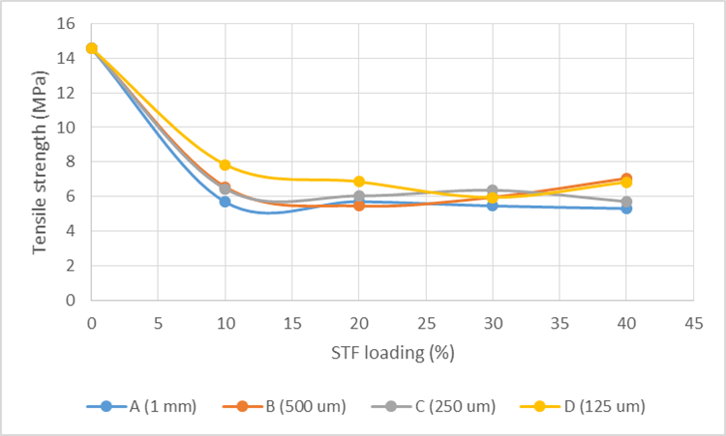

Figure 1. Tensile strength with filler loading from 0-40% of STF

Figure 2 shows the value of tensile modulus at 10-40% of STF composition in the matrix with a variation of fibre sizes (1 mm, 500 µm, 250 µm and 125 µm). Overall, tensile modulus increased as STF composition increased because of material rigidity that also increased when more fillers were incorporated into the composite system. At 10% of filler loading, an unstable trend was observed due to the amount of filler content. Results showed that the fibre size of 125 µm can contribute to the stiffness effect, even at 10% of filler loading. Modulus is slightly decreased at 20% of STF composition but kept increasing after 30% onwards for fibre size of 125 µm. Young’s modulus is closely related to particle loading and particle size [11]. But at 20% of filler loading, tensile modulus has given a similar reading for all sizes. This showed that at 20% incorporation of STF into 80% of matrix (40/60 of NR and HDPE), the rigidity and stiffness of the materials were not affected much by different fibre sizes (range from 1mm to 125 µm). It also showed that at 20% of STF composition, the fibre-matrix interaction in the composites’ system has been saturated with the amount of 40% NR in 60% HDPE. From the graph, it shows that 125 µm has given the highest value of tensile modulus compared to other sizes.

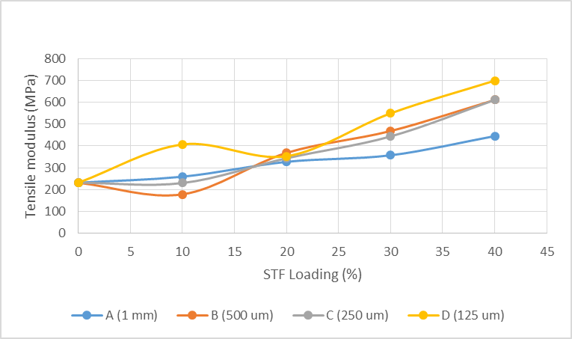

Figure 2. Tensile modulus with filler loading from 0-40% of STF

Figure 3 shows the value of impact strength at 10-40% of STF composition in the matrix with a variation of fibre sizes (1 mm, 500 µm, 250 µm and 125 µm). Impact strength is an important parameter to measure the plasticity of materials. The impact values are the reflection of the ability of materials to absorb the energy transferred from the pendulum [12]. Notched samples were used in this test. Sudden droppage was observed when 10% of STF was added into the composites’ system for all sizes. However, impact strength began to increase at 20% of filler loading before starting to decrease afterwards. At 10%, STF tended to interact more with NR, therefore the values of impact strength decreased. NR is a natural polymer compared to HDPE which is a synthetic polymer. The degree of hydrophobicity of NR is lower than HDPE [13]. Therefore, at lower amount of filler, it tends to interact more with NR compared to HDPE. After 20% onwards, the amount of filler for all sizes was increased and impact value decreased because the amount of 40% NR in the matrix was unable to absorb the energy transferred from the pendulum. Thus, the physical interaction between fibre and matrix became weaker due to the hydrophilic properties of fibre and hydrophobicity properties of the matrix. Composite with the fibre size of 1 mm gave the highest value of impact strength.

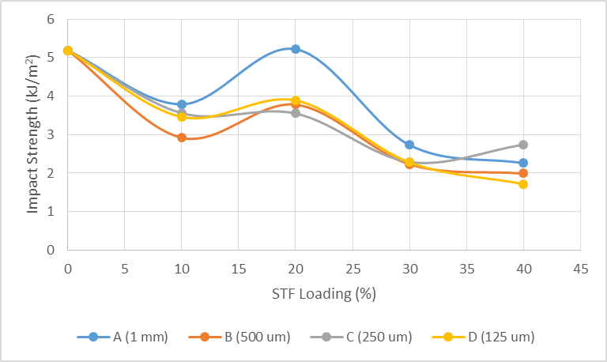

Figure 3. Impact strength value with filler loading from 0-40% of STF

Thermal properties
Figure 4 shows the DSC curves for all sizes (1 mm, 500 µm, 250 µm and 125 µm). Composition of 20% STF was used in this analysis. It is shown that thermal properties were not affected much by different fibre sizes. No significant changes were observed for melting temperature of materials obtained. No appearance of crystallinity peak in the thermograms was observed. This showed that HDPE become more amorphous by adding NR and STF (all sizes) in the system.

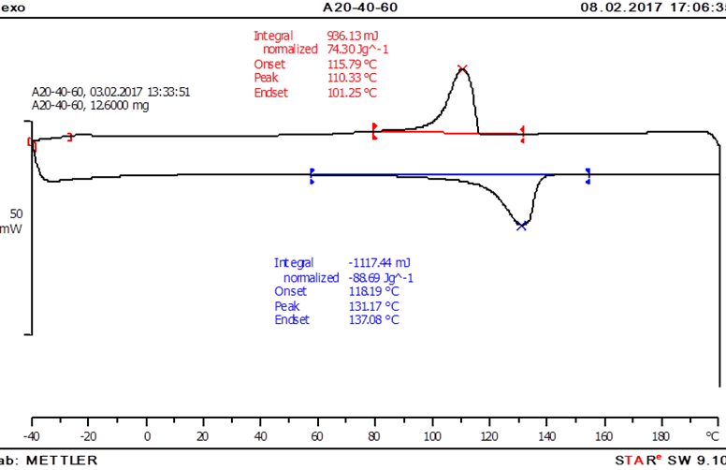
(a)

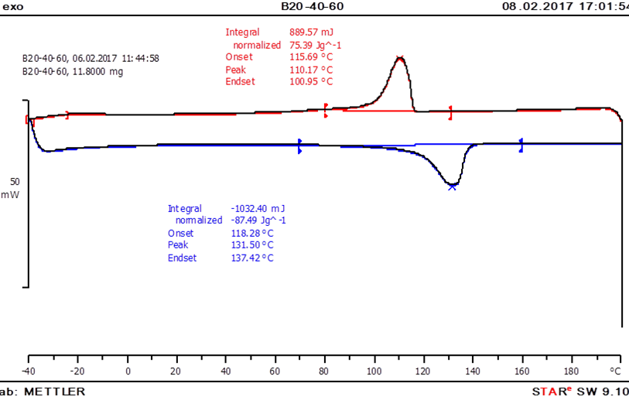
(b)

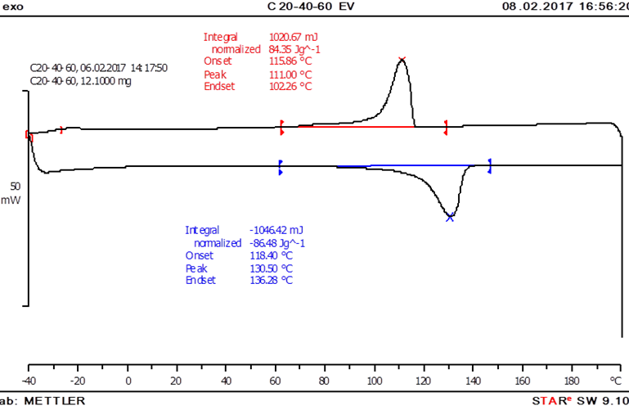
(c)

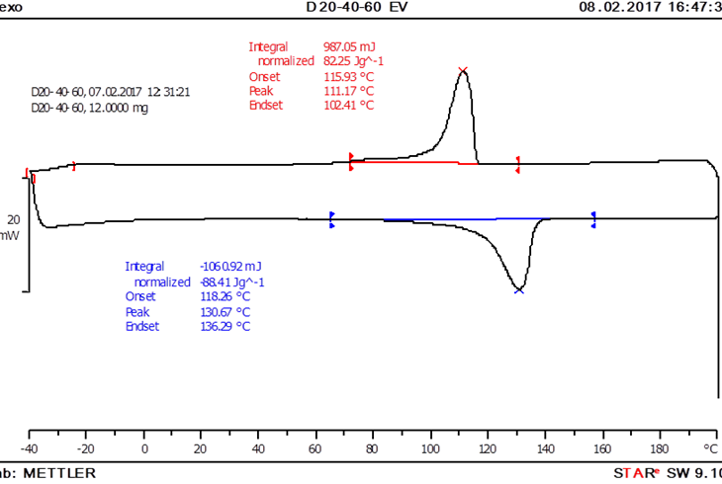
(d)

Figure 4. DSC curves of STF/NR/HDPE at different sizes of fibre (a) 1 mm, (b) 500 µm, (c) 250 µm and (d) 125 µm

Morphological study
Figure 5 shows the SEM micrograph of composites for all fibre sizes (1 mm, 500 µm, 250 µm and 125 µm) at 500 times magnification. Composition of 20% STF was used in this analysis, with a matrix combination of 40% NR and 60% HDPE. Good interaction between fibre and matrix was observed from the fractured samples. This clearly indicates that the filler distribution was homogeneous with less voids and pull-outs as the filler size was decreased.

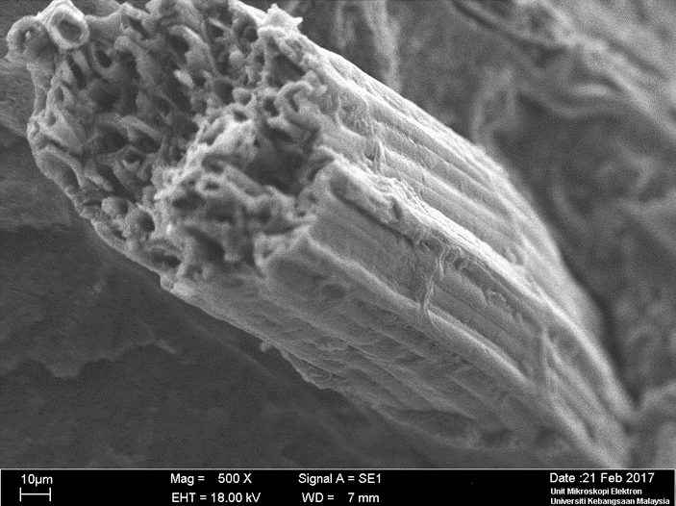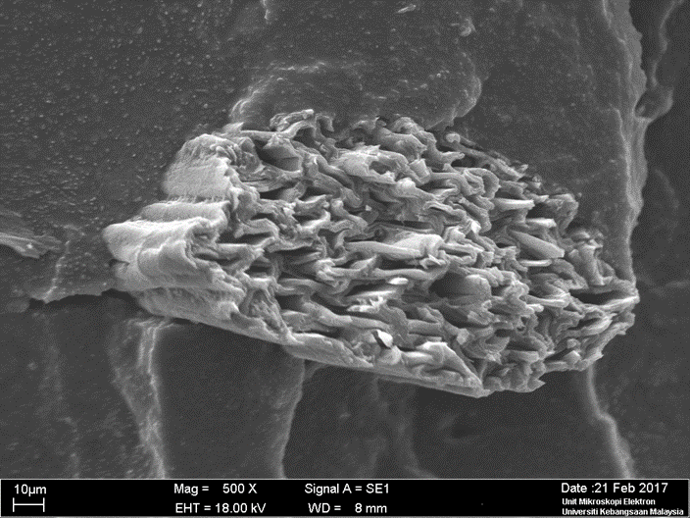
500 µm
1 mm
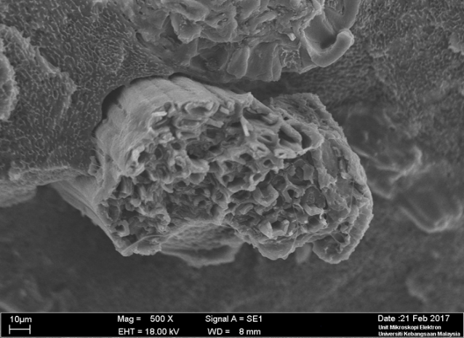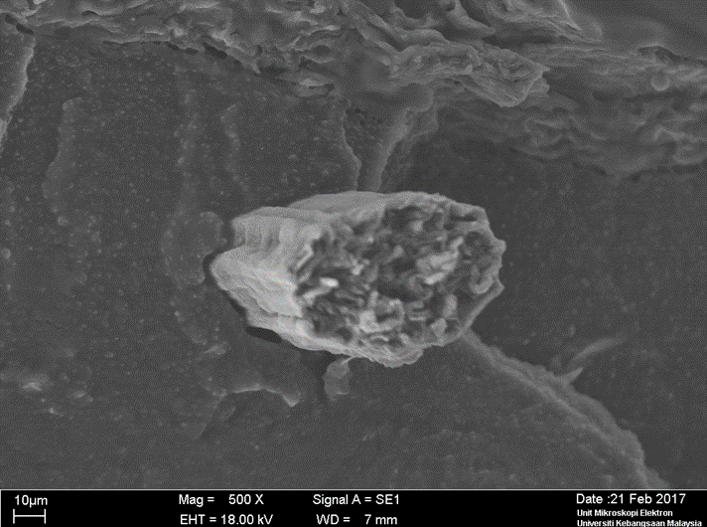
250 µm
125 µm

Figure 5. SEM micrographs of STF/NR/HDPE at different sizes of fibre

Conclusion
The samples obtained showed that blending STF/NR/HDPE together has produced homogenous composites at all level of fibre sizes. Adding NR to the composite system has produced a less rigid and softer surface composite. Overall, it is shown that 125 µm of fibre size has given higher values/stable results for tensile strength and tensile modulus. Different fibre sizes with a range from 1mm to 125 µm did not give a significant effect to the thermal behaviour of the composites. Morphological study done on the composites has supported the results from mechanical testing.

Acknowledgments
The authors would like to thank the Ministry of Higher Education (MHE) for providing the research grant (FRGS/2/2014/TK04/UKM/02/1), Universiti Kebangsaan Malaysia (GUP-2017-123) and the Malaysian Agricultural Research and Development Institute for making this research work possible.

References

- Ku, H., Wang, H., Pattarachaiyakoop, N. and Trada, M. (2011). A review on the tensile properties of natural fiber reinforced polymer composites. Composites: Part B, 42: 856-873.
- Sreenivasan, V. S., Ravindran, D., Manikandan, V. and Narayanasamy R. (2011). Mechanical properties of randomly oriented short Sansevieria cylindrica fiber/polyester composites. Materials and Design, 32: 2444-2455.
- Faruk, O., Bledzki, A. K., Fink, H. P. and Sain, M. (2012). Biocomposites reinforced with natural fibers: 2000-2010. Progress in Polymer Science, 37: 1552-1596.
- Sameer, B. R. K., Kumar, M. A, Murthy, V. N. and Karthikeyan N. (2015). Development of Sansevieria trifasciata-carbon fiber reinforced polymer hybrid nanocomposites. International Letters of Chemistry, Physics and Astronomy, 50: 179-187.
- Sreenivasan, V. S., Somasundaram, S., Ravindran, D., Manikandan, V. and Narayanasamy, R. (2011). Microstructural, physico-chemical and mechanical characterization of Sansevieria cylindrica fibres – An exploratory investigation. Materials and Design, 32: 453-461.
- Singha, A. S. and Rana, R. K. (2012). Natural fiber reinforced polystyrene composites: Effect of fiber loading, fiber dimensions and surface modification on mechanical properties. Materials and Design, 41: 289-297.
- Sreenivasan, V. S., Rajini, N., Alvudeen, A. and Arumugaprabu, V. (2015). Dynamic mechanical and thermo-gravimetric analysis of Sansevieria cylindrica/polyester composite: Effect of fiber length, fiber loading and chemical treatment. Composites: Part B, 69: 76-86.
- Ramanaiah, K., Prasad, A. R. and Reddy, K. H. C. (2013). Mechanical, thermophysical and fire properties of sansevieria fiber-reinforced polyester composites. Materials & Design, 49: 986-991.
- Kanimozhi M. (2011). Investigating the physical characteristics of Sansevieria trifasciata fibre. International Journal of Scientific and Research Publications, 1: 1-4.
- Hanafi, I., Nizam, J. M. and Abdul Khalil, H. P. S. (2001). The effect of a compatibilizer on the mechanical properties and mass swell of white rice husk ash filled natural rubber/linear low density polyethylene blends. Polymer Testing, 20: 125-133.
- Fu, S. Y., Feng, X. Q, Lauke, B. and Mai Y. W. (2008). Effect of particle size, particle/matrix interface adhesion and particle loading on mechanical properties of particulate-polymer composites. Composites: Part B, 39: 933-961.
- Sahin, S. and Yayla P. (2005). Effects of testing parameters on the mechanical properties of polypropylene random copolymer. Polymer Testing, 24: 613-619.
- Goosey, M. (1999). Plastics for electronics. Springer-Science-Business Media, United Kingdom: pp. 19-21.

