BLENDS OF LINEAR LOW-DENSITY POLYETHYLENE, NATURAL RUBBER AND POLYANILINE: TENSILE PROPERTIES AND

THERMAL STABILITY

(Adunan Polimer Polietilina Lelurus Berketumpatan Rendah, Getah Asli dan Polianilina: Sifat Regangan dan Kestabilan Terma)

Farrah Diyana Zailan, Ruey Shan Chen*, Sahrim Ahmad, Dalila Shahdan, Adilah Mat Ali,

Mohd Farid Hakim Mohd Ruf

School of Physics and Materials Novel, Faculty of Science and Technology

Universiti Kebangsaan Malaysia, 43600 UKM Bangi, Selangor, Malaysia

*Corresponding author: rueyshanchen@hotmail.com

Abstract
The thermoplastic natural rubber (TPNR) blends made up of linear low-density polyethylene (LLDPE) and natural rubber (NR) were mixed using internal mixer at 130 °C, 30 rpm and for 13 minutes. Liquid natural rubber (LNR) was added as a compatibilizer for an immiscible blend of TPNR. The effect of polyaniline (PANI) content (1–5 wt.%) on the tensile and thermal properties of TPNR blend was investigated. The mechanical property results showed that the tensile strength increased 21% as compared to TPNR. Thermogravimetric analysis (TGA) measurement proved that the incorporation of PANI, even though in low content, had enhanced the thermal stability of TPNR blend. The glass transition temperature (T_{g}) and melting temperature (T_{m}) of the TPNR and TPNR/PANI blends were studied by differential scanning calorimeter (DSC) analysis. Scanning electron microscopy (SEM) micrograph confirmed the good dispersion of PANI within the TPNR phases and the well interaction among the components in TPNR/PANI blends.

Keywords: polymer blend, thermoplastic natural rubber, liquid natural rubber, morphology

Abstrak

Adunan getah asli termoplastik (TPNR) yang terdiri daripada campuran polietelina lelurus berketumpatan rendah (LLDPE) dan getah asli (NR) telah diadun dengan menggunakan mesin pengadun dalaman pada suhu 130 °C, 30 ppm dan selama 13 minit. Cecair getah asli (LNR) telah ditambah sebagai pengserasi terhadap adunan TPNR yang tak terlarutcampur. Kesan kandungan polianilina (PANI) (1-5 wt.%) terhadap sifat regangan dan terma bagi adunan TPNR/PANI telah dikaji. Keputusan sifat mekanik menunjukkan bahawa kekuatan regangan telah ditambahbaik sebanyak 21% berbanding dengan TPNR. Analisis termogravimetri (TGA) membuktikan bahawa penggabungan PANI, walaupun pada kandungan yang rendah, dapat meningkatkan kestabilan terma adunan TPNR/PANI. Suhu peralihan kaca (T_{g}) dan suhu peleburan (T_{m} ) bagi adunan TPNR dan TPNR/PANI telah dikaji melalui analisis kalorimetri imbasan perbezaan (DSC). Mikrograf mikroskop elektron pengimbas mengesahkan penyebaran PANI yang baik dalam fasa TPNR serta interaksi yang baik antara komponen-komponen dalam adunan TPNR/PANI.

Kata kunci: polimer adunan, getah asli termoplastik, cecair getah asli, morfologi

Introduction
The development of rubber industry has attracted high interests from many researchers in the use of natural rubber (NR) as main material. Thermoplastic natural rubber (TPNR) is classified as a new class material with the combined properties via blending of vulcanized rubbers with the ease processable thermoplastics [1, 2]. NR has been used to mix with various types of polyethylene (PE), for instance, linear low-density polyethylene (LLDPE) exhibits the most prominent properties by having a good compatibility with NR [3, 4, 5], owing to its low melting temperature. In which this can prevent the thermal degradation of rubber [5]. In this context, the intention of NR/PE blend preparation was to recycle wastes rubber or NR, thereby overcome global wastage problems of rubber and severe environmental problems [6]. In decades, TPNR has been studied by blending the NR and thermoplastic polyolefins, such as the blends of natural rubber/linear low density polyethylene (NR/LLDPE) [7], NR/LLDPE/liquid natural rubber (LNR) [8], NR/polypropylene (PP) [1], or etc. The fabricated TPNR blend with certain composition improves the overall mechanical properties and are widely used for different applications (i.e. film packaging) [9, 10]. However, TPNR is lack of conductive properties. As for that, a conductive material can be made from the insulating polymer matrix by filling with conductive filler such as carbon- or metal-based materials. Besides that, conducting polymers such as polyaniline (PANI) and polypyrole are now an alternative source to promote the excellent electrical and mechanical properties [11, 12].

Polyaniline (PANI) is one of conductive polymer materials which is also known as a conductive additive. PANI is considered as a potential candidate to produce new conductive blends because of its high conductivity, stability, easy to synthesize and low-cost. A number of research works have been published on electrically conductive PANI/elastomer blends such as PANI doped with dodecyl-benzene sulfonic acid (PANI-DBSA)/NR [1], PANI/nitrile rubber (NBR) [8], PANI/NR [2], PANI coated with nylon fiber/NR [3] and etc. However, there was a lack of scientific papers reported in mechanical properties of the PANI/elastomer blends. As reported by Sukitpaneenit et al., PANI/NR doped in hydrochloric acid exhibited poor mechanical properties which was due to the inhomogeneous distribution of PANI in NR matrix [2].

The blending of PANI with those thermoplastics has led to the positive effect on the resultant blends’ properties. For instance, Annala et al. studied the blend of low-density polyethylene (LDPE)/PANI with different contents of functionalized metallocane PE which acted as a compatibilizer, and the findings showed that the mechanical properties of the blend were improved but the electrical conductivity remained the same [4]. Cote et al. proved that LDPE/PANI blend promoted the improvement in the mechanical properties [5]. The concentration of PANI is one of the most important factors that influences the mechanical properties and electrical conductivity [5]. Due to the high difference in the polarity of PANI (polar) and PE matrix (non-polar), the increasing content of PANI can lead to the reduction of elongation and brittle fracture of LLDPE as there is a lack of adhesion between both phases. In contrast, Youngs Modulus was found to increase with the PANI content in blends as PANI was expected to positively contribute in the stiffness of the blend [10]. From the aspect of thermal stability, it was proved that the existence of PANI in NR/PANI blend did not change the thermal stability in which the NR degraded before PANI [12]. According to Kazimi et al. who investigated on LDPE/PANI blend, it was claimed that the increasing of PANI caused an increment in the thermal stability of LDPE which was due to uniform integration of PANI within the matrix [9].

In this context, the direction of the current research was to fabricate PANI-filled NR/LLDPE/LNR blend with the combined mechanical properties and ease of processibility (obtained from LLDPE and NR) as well as the electrical properties (imparted by PANI, conductive polymer). Particular emphasis was placed on investigating the effect of PANI content on the tensile, electrical conductivity and thermal behaviour of TPNR/PANI blend.

Materials and Methods
Raw materials
Natural rubber (NR) SMR-L grade was obtained from Malaysian Rubber Board (MRB) and used to prepare liquid natural rubber (LNR). Linear low-density polyethylene (LLDPE) was used as thermoplastic resin in this study. It was purchased from Exxon Mobile Chemical Corporation. It has density of 0.918 g/cm³, melt flow index of 1.0g/10 min and the melting temperature in the range between 120-160 ºC. Emeraldine oxidation state of polyaniline (PANI), needle-like green powders, the half oxidized form, was purchased from E-TEK Co.Ltd , Kyengki-Do, Korea.

Preparation of liquid natural rubber (LNR)
LNR was synthesized via photochemical degradation or oxidation technique on the NR. Approximately 1.5 kg of NR was cut into small pieces and soaked in a glass flask filled with toluene, 0.3 g methylene blue, 0.39 g rose Bengal and 15 ml methanol for 24 hours. The mixture in glass flask was then stirred continuously with a mechanical stirrer rod at 10 rpm under the exposure of fluorescent light for 10 days.

Preparation of blends
Indirect mixing technique (IDT) was applied to prepare the blends where it involved a manual pre-mixing of PANI powders with LNR using a glass rod prior to the melt blending process. The NR was first placed into the mixer and allowed to melt for about 3 minutes, the pre-mixture of LNR and PANI was then added into the mixer. Lastly, the LLDPE pellets were added into the mixture after 5 minutes and the whole mixing process took about 13 minutes. The TPNR (based on composition of NR/LLDPE/LNR at 50:40:10) and 1-5 wt.% PANI powders were compounded using an internal mixer (Haake Rheomix 600P) with the processing parameter as follows: processing temperature of 130 °C, rotor speed of 30 rpm and processing time of 13 minutes. The addition of PANI powders was varied in the range of 1 – 5 wt.% PANI. After the blending process, the samples were prepared by compression moulding via hot and cold pressing (LP50, LABTECH Engineering Company LTD) under the pressure of 6.9 MPa at 130 °C.

Characterization
The mechanical property of TPNR/PANI samples was tested using a tensile machine (model Testometric M350-10CT) with a 5 kN load cell. The tensile test was carried out according to ISO 37-2 standard specification procedure. In which the test samples were cut in the thickness of 1 mm and a crosshead speed of 50 mm min⁻¹ was applied during the test. Differential scanning calorimetry (DSC) was conducted to study the effect of different PANI content (0-4 wt.% PANI) on the glass transition temperature (T_{g}) and melting temperature (T_{m}) of TPNR-based blend. The samples were scanned from the temperature of -120 to 200 ºC. The morphology characterization of TPNR/PANI blends sample was examined under the scanning electron microscope (SEM) using the tensile-fractured surfaces of blend sample. Before the examination, the samples were sputter-coated with a thin layer of gold to avoid electrostatic charging during the morphology examination.

Results and Discussion
Figure 1 shows the effect of PANI content (1 – 5 wt.%) on the tensile properties of TPNR blend. As can be seen in the Figure 1(a), the highest tensile strength (1.92 MPa) was achieved at 3 wt.% of PANI where this content can be considered as the optimal level of PANI in this TPNR blend. The increment was recorded for about 28% as compared to the control sample, TPNR without PANI. This could be due to which the inclusion of PANI aided in the increase of the crosslinking interaction within the polymeric chains by increasing the amount of hydrogen bonding between polymer and PANI component [14]. Fabio et al. reported that the incorporation of 40 wt.% PANI into the LLDPE blend had promoted a positive effect on the composite strength [10]. Based on the previous research by Nehad et al. who investigated the immiscibility of polystyrene (PS)/polymethyl methacrylate (PMMA) blend, the tensile strength was improved by the addition of PANI (1, 3, 5, 10, 15, 20 wt.%) with 3% pluronic, and this was because of the well dispersion of PANI in polymers that filled the voids and interface position as well as could act as cross-linking centre between the molecules [15]. Thus, the interaction between the polymer molecules was improved due to the increase of the interfacial surface area.

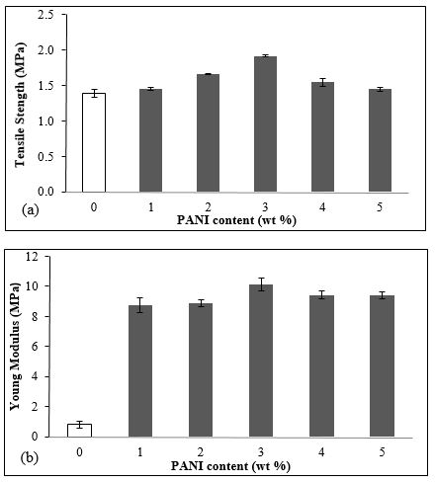
Figure 1. Effect of PANI content in TPNR blend on a) tensile strength and b) Young modulus

However, the tensile strength of TPNR blend reduced gradually by increasing the PANI up to 4-5 wt.%. This is attributed to the PANI aggregation within the polymer matrix. This trend was similarly observed in the study by Nehad et al. who reported that the initial reduction of tensile strength was occurred after 1 wt.% PANI was added in PS/PMMA blend [15]. As the PANI content increased in the blend, the brittle fracture occurred [10, 11], as shown in Figure 1(c). The large deviation in polarity of PANI and LLDPE was negatively affecting the adhesion behaviour between the phases, thereby resulted in a downward trend in the mechanical properties. This phenomenon was obvious to be revealed as the added PANI exceeded the optimum PANI content, which was 3 wt.% in this case. Figure 1(b) shows that the Young modulus of TPNR blend increased drastically as the PANI was incorporated in the blend. This is attributed to the contribution of PANI in increasing the blend stiffness [10].

Figure 2 shows DSC thermogram curves for all tested samples. The existence of two endothermic peaks was observed in Figure 2. The first small shallow peak was displayed at approximately -60 °C, which refers to the glass transition temperature (T_{g}) of natural rubber component where herein the amorphous regions become rubbery. This is in agreement with the previous report [2, 11]. As the heating temperature further increased to reach melting temperature (T_{m}), a transition from a crystalline or semi-crystalline phase to a solid amorphous phase occurred. The T_{m} of the TPNR / PANI blend was recorded at 126 ºC, as shown in Figure 2. With the exception of slightly higher T_{m} for TPNR containing 2 and 3 wt.% PANI (which supported the tensile strength trend), the other T_{g} and T_{m} values for the blends containing various loadings of PANI showed insignificant changes. This was possibly because of the relatively small range of loadings was involved in the investigation. The similar finding has been reported by Fabio et al. who studied on the LLDPE blend with PANI [10].

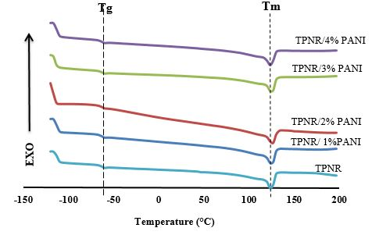
Figure 2. DSC thermogram for different of PANI content in TPNR/PANI blend

The thermal stability of blends was analyzed using thermogravimetric analysis (TGA) measurement. The TGA curves of TPNR/PANI with various PANI contents are illustrated in Figure 3. By increasing the temperature, the weight loss changed when the degradation of materials occurred. Figure 3 displays two steps of degradation process for TPNR/PANI blends with various PANI content (1-5 wt.%) and TPNR as control sample.

The first degradation step occurred in the temperature range between 330 °C and 350 °C, which corresponding to the degradation of NR component. According to Dwi Puryanti et al. who carried out research on TPNR filled with Ni-Co-Zn Ferrite, it was reported that the degradation temperature of NR occurred at 340 °C [16]. Jonas da Silva et al. stated that in NR/ PANI-DBSA, the evaporation and degradation of DBSA and the oxidation of PANI structure occurred in the temperature range of 200 – 350 °C [1]. In this study, this degradation peak of the PLA/LNR/PANI samples was found to shift to the right with higher degradation temperature as PANI loading increased, and the increasing trend was as follows: from 363 °C (TPNR) to 369 °C (TPNR/ 1 wt.% PANI), 369 °C (TPNR/ 2 wt.% PANI), 370 °C (TPNR/ 3 wt.% PANI), 375 °C (TPNR/ 4 wt.% PANI) and 375 °C (TPNR/ 5 wt.% PANI). This suggests an enhancement of thermal stability of the blends is due to the uniform integration of PANI nanofiber in the matrix as agreed by the previous study on LDPE/PANI [9].

The second degradation step occured at around 380 - 460 °C which corresponds to PANI degradation. Interestingly, this degradation temperature peak displayed an inverted trend as compared to the first degradation peak, which was shifted to the lower temperature with the increasing PANI content, as follows: from 456 °C (TPNR) to 450 °C (TPNR/ 1 wt.% PANI and TPNR/ 2 wt.% PANI), 446 °C (TPNR/ 3 wt.% PANI), 445 °C (TPNR/ 4 wt.% PANI) and 445 °C (TPNR/ 5 wt.% PANI). This degradation temperature range was similarly reported by da Silva et al. which that the degradation of the bound PANI-DBSA and the decomposition of PANI occurred in 400 – 500 °C [1]. This was also reported by Saritha et al. who investigated on PANI-nylon fiber with NR which the degradation temperature of PANI started at ~415 °C and ended at 581 °C [3].

Table 1 summarizes the data obtained from TGA curve, the temperature of weight loss at 3% (T₃), 50% (T₅₀) and residue level left after 500 °C. As compared to neat TPNR blend (T₃ = 316 °C and T₅₀ = 386 °C ), the TPNR/ 1 wt.% PANI blend (T₃ = 305 °C and T₅₀ = 398 °C), TPNR/ 2 wt.% PANI blend (T₃ = 299 °C and T₅₀ = 401 °C), TPNR/ 3 wt.% PANI blend (T₃ = 277 °C and T₅₀ = 404 °C), TPNR/ 4 wt.% PANI blend (T₃ = 258 °C and T₅₀ = 410 °C) and TPNR/5 wt.% PANI exhibited T₃ = 252 °C and T₅₀ = 415 °C. As shown in Table 1, the T₅₀ of TPNR blends was getting higher as the PANI contents increased from 1 to 5 wt.%. These phenomena showed that the late degradation of PANI and the uniform integration of PANI in TPNR blend played roles in improving the thermal stability [12, 16].

The residues of the samples upon heating of 600 °C are shown in percentages (%). From the Table 1, the TPNR exhibited 0.85% of residues. This amount of residues increased gradually as the PANI content increased from 1 to 5 wt.%, which increased up to 2.55%.

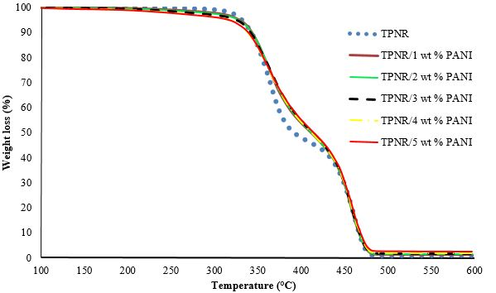
Figure 3. TGA curves of TPNR/PANI with various PANI content

Table 1. TGA data of TPNR/PANI with different PANI content
Sample | T₃  (°C) | T₅₀  (°C) | Residue (%)
TPNR | 316 | 386 | 0.85
TPNR/1 wt % PANI | 305 | 398 | 1.47
TPNR/2 wt % PANI | 299 | 401 | 1.63
TPNR/3 w % PANI | 277 | 404 | 1.77
TPNR/4 wt % PANI | 258 | 410 | 1.89
TPNR/5 wt % PANI | 252 | 415 | 2.55
Note: T₃ means the temperature of weight loss at 3 %; T₅₀ means the temperature of weight loss at 50%

The SEM micrographs in Figure 4(a) and (b) show the morphological views for the tensile fractured surfaces of the samples. For the control sample in Figure 4(a), the large voids can be clearly seen on the rough surface which was induced by the rubbery material as compared to the TPNR/PANI sample in Figure 4(b). In Figure 4 (b), the morphology showed lower roughness of surface area with the presence of small voids and this indicates a good interaction of PANI propagation through rubber domain matrix phases and the efficient stress transfer within the rubber blend [16]. As compared to Figure 4(a), the morphology for the TPNR/3 wt.% PANI in Figure 4(b) displays a more compact structure which suggesting the filling of holes by PANI component [7, 10] and this led to a good blending and the increased mechanical properties. As the PANI content exceeded the optimum level (3 wt.%), that was for TPNR/4 wt.% PANI, the morphology in Figure 4(c) shows an existence of agglomeration of PANI particles and large voids within the polymer matrix. This indicates the non-uniform distribution and a lack of adhesion between different phase because of the great polarity difference between PANI and LLDPE [10], as discussed earlier, and thus resulted in the brittleness property, as proven in the deteriorated tensile properties at this composition.
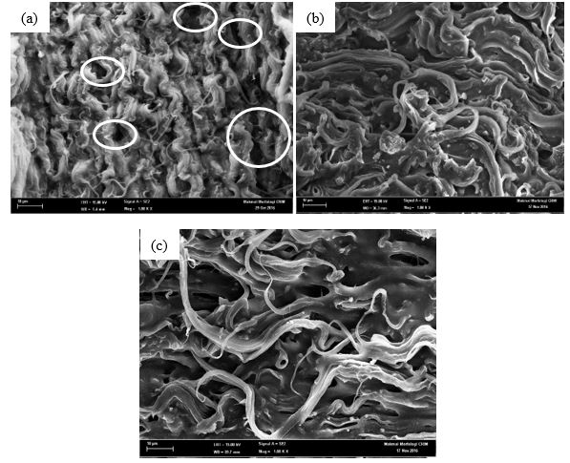
Figure 4. SEM micrograph of (a) TPNR, (b) TPNR/3 wt.% PANI blends and (c) TPNR/4 wt.% PANI blend

Conclusion
TPNR blends with various loadings of PANI were fabricated via melt blending method. The mechanical and thermal analysis results showed that the optimum PANI content for the fabrication of TPNR/PANI was 3 wt.%. The thermal stability of the TPNR/PANI blend was improved significantly by the incorporation of PANI, irrespective of PANI content. SEM micrograph showed a good dispersion of PANI within the TPNR matrix and a good interfacial interaction among the components. From the aspect of the improved mechanical and thermal properties, the fabricated TPNR/PANI blend acts as a potential candidate in the future application such as sensors, electromagnetic shielding, light emitting diodes and field-effect transistors.

Acknowledgement
The authors would like to be obliged to Universiti Kebangsaan Malaysia (UKM) for providing laboratory facilities at Materials Science laboratory (FST), Electron Microscopy Unit and financial assistance under project no. DIP-2016-023.

References

- Silva, M. J., Sanches, A. O., Malmonge, L. F. and Malmonge, J. A. (2014). Electrical, mechanical and thermal analysis of NR-PANI-DBSA composites. Materials Research Bulletin, 17(1): 59-63.
- Sukitpaneenit, P., Thanpitcha, T., Sirivat, A., Weder, C. and Rujiravanit, R. (2007). Electrical conductivity and mechanical properties of polyaniline/natural rubber fomposite fibers. Journal of Applied Polymer Sciences, 106(6): 4038-4046.
- Saritha, C. A. and Sunil, K. N. (2011). Polyaniline-coated short nylon fiber/natural rubber conducting composites. Polymer Plastics Technology Engineering, 50(5): 443-452
- Annala, M. and Lofgren, B. (2006). Compatibilization of conductive polyethylene/polyaniline blends. Macromolecules Materials Engineering, 291(7): 848-857.
- Cote, M., Cortes, M. T., Bletran, D. and Ortiz, P. (2009). PANI-LDPE composites: Effect of blending conditions. Polymer Composites, 30(1): 22-28.
- Dahlan, H. M., Khairul Zaman, M. D. and Ibrahim, A. (2002). The morphology and thermal properties liquid natural rubber (LNR)-compatibilized 60/40 NR/LLDPE blends. Polymer Testing, 21(8): 905-911.
- Hassan, N. A., Hassan, N., Ahmad, S. H., Rasid, R., Hazleen, A., Najmi, B. N. and Surip, S. N. (2012). Physical and mechanical properties of thermoplastic natural rubber (TPNR) nanocomposites. Advanced Materials Research, 576: 394-397.
- Camillo, E. C., Constantino, C. J. L., Teruya, M. Y., Alves, N., Mattoso, L. H.C. and Job, A. E. (2005). Dependence of the electrical conductivity and elastomeric properties on sample preparation of blends of polyaniline and natural rubber. Journal of Applied Polymer Sciences, 97(4): 1498-1503.
- Kazimi, M. R., Tahir, S., Shima, J. and Faizal, C. K. M. (2014). Characterization of functionalized LDPE/PANI nanofiber composite. Journal of Medical Bioengineering, 3(4): 307-310.
- Fabio, R. P., Patrick V., d. F., Eduardo, H. B., Larissa, S. M., Simone, d. S. P., Luiz, A. P. and Mirabel C. R. (2017). Thermal, mechanical and electromagnetic properties of LLDPE/PANI composites. Polymer Bulletin, 74(7): 2701-2717.
- Abdullah, I., Ahmad, S. and Sulaiman, C. S. (1995). Blending of natural rubber with linear low-density polyethylene. Journal of Applied Polymer Sciences, 58(7): 1125-1133.
- Ahmad. S., Abdullah, I., Sulaiman, C. S., Kohjiya, S. and Yoon, J. R (1994). Natural rubber-HDPE blends with liquid natural rubber as compatibilizer on thermal and mechanical properties. Journal of Applied Polymer Sciences, 51(8): 1357-1363.
- Ozturk, A., Kaynak, C. and Tincer, T. (2001). Effects of liquid rubber modification on the epoxy resin. European Polymer Journal, 37(12): 2353-2363.
- Dopico-Garcia, M. S., Ares, A., Lasagabaster-Latorre, A. and Garcia, X. (2014). Extruder polyaniline/EVA blends: Enhancing electrical conductivity using gallate compatibilizers. Synthetic Metals, 189: 193-202.
- Nehad, N. R., Aman, I. K. and Azza, A. W. (2016). Studies the behavior of polyaniline on the properties of PS/PMMA blends. Journal of Materials Design and Application, 230(2): 526-536.
- Dwi, P., Ahmad, S., Abdullah, H. M. and Yusoff, H. A. N. (2007). Effect of nickel-cobalt-zinc-ferrite filler on magnetic and thermal properties of thermoplastic natural rubber composites. International Journal of Polymeric Materials and Polymeric Biomaterials, 56(3): 327-338.

